**Homework #7**

Python is a fantastic language to learn in my opinion. It’s so robust with so many libraries that it makes it fun to code. Things like UI development, create charts and statistical graphs, and data manipulations are so easy in Python. Also, Python provides you the ability to combine code logic into one or two lines. I’ve been watch some of the helpful hints in Python and am just amazed at what you can do with one or two lines of code. I’ve worked with Microsoft .NET in the past. It was cumbersome to reference other API, COM services, and other plugin components. You had to declare variables before you use them. List and JSON files were difficult to navigate. Python made it a breeze. Once I learn how to navigate the Visual Studio Code IDE, the development and troubleshooting became natural to me.

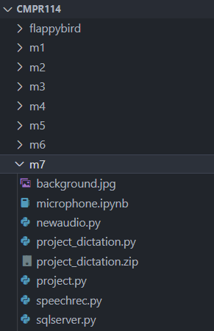Visual Studio Code should be the standard for the class (in my opinion). I can manage multiple modules in one project without create new projects. I can add new files in each folder easily. I can run a selected section of the code or the entire file. I can even run it in debug mode (by setting break points) to determine the place of the error as well as the variable values. Though I don’t have a complete mastery of the IDE yet, I still find it extremely useful.

**So, I would definitely take this class again!**

What other features or topics would I like to see included? From a real-world point of view, I would like to see the utilization of source code management like Github or Microsoft Team Foundation Version Control (TFVC). I would like to see Python Integration with Cloud Platforms (AWS, Google, Microsoft, IBM), utilizing services like S3, Blob Storage, database as a service. and infrastructure as a service. Also, Python access to various external API and Web Services (REST API, CLOUD services).