Priority

Remap cmd_vel to yocs_cmd_vel_mux/output/cmd_vel
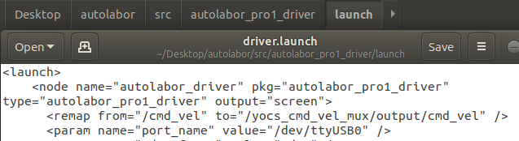
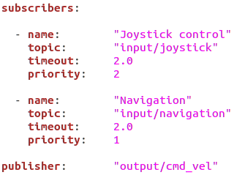

Autolabor Pro1 里程計標定方法
https://www.twblogs.net/a/5cff26b9bd9eee14644f21d0

roslaunch autolabor_pro1_driver autolabor_driver.launch
rosrun tf tf_echo /odom /base_link
get value of degree(0,0,x)
If clockwise, y= 360-x
If anticlockwise, y=360+x

new_model_param =model_param_cw*y/360
redo until x=0;

In demo_pioneer/src/joy2twist_pioneer.cpp
