Table 1. Training set：Case & Control相关变量总表(837samples)

|  |  |  |  |  |  |  |
| --- | --- | --- | --- | --- | --- | --- |
| **Vars** | **n** | **mean** | **sd** | **median** | **sem** | **P（wilcoxon）** |
| **Right.Ovary.L** | 837 | 2.747 | 0.407 | 2.7 | 0.014 | 5.48E-173 |
| **Right.Ovary.T** | 837 | 1.167 | 0.236 | 1.2 | 0.008 | 6.16E-171 |
| **Right.Ovary.volume** | 836 | 2.572 | 1.193 | 2.355 | 0.041 | 9.39E-168 |
| **Left.Ovary.volume** | 837 | 2.507 | 1.205 | 2.286 | 0.042 | 9.67E-165 |
| **Uterus.T** | 837 | 0.984 | 0.288 | 0.92 | 0.01 | 3.82E-155 |
| **Left.Ovary.AP** | 837 | 1.441 | 0.289 | 1.4 | 0.01 | 5.64E-154 |
| **Left.Ovary.L** | 837 | 2.724 | 0.41 | 2.7 | 0.014 | 5.15E-152 |
| **BMI** | 837 | 16.912 | 2.128 | 16.568 | 0.074 | 3.05E-147 |
| **Uterus.AP** | 836 | 1.625 | 0.41 | 1.6 | 0.014 | 2.89E-146 |
| **Left.Ovary.T** | 837 | 1.155 | 0.241 | 1.1 | 0.008 | 1.64E-142 |
| **E2** | 686 | 109.391 | 73.256 | 93.83 | 2.797 | 8.68E-127 |
| **Weight** | 837 | 29.108 | 5.149 | 28.5 | 0.178 | 1.75E-118 |
| **Right.Ovary.AP** | 836 | 1.454 | 0.304 | 1.4 | 0.011 | 4.76E-92 |
| **SHBG** | 834 | 81.757 | 33.504 | 78.73 | 1.16 | 8.84E-54 |
| **BA** | 837 | 9.695 | 1.153 | 9.5 | 0.04 | 1.10E-32 |
| **Breast** | 835 | 2.344 | 0.548 | 2 | 0.019 | 5.94E-32 |
| **BA.CA** | 837 | 1.837 | 0.936 | 1.8 | 0.032 | 1.03E-13 |
| **Uterus.L** | 837 | 2.333 | 0.389 | 2.3 | 0.013 | 0.002712191 |
| **Height** | 837 | 130.876 | 6.893 | 131.5 | 0.238 | 0.312571863 |
| **T** | 656 | 1.047 | 5.301 | 0.7 | 0.207 | 0.446407112 |

Table 2. Testing set：Case & Control相关变量总表(369samples)

|  |  |  |  |  |  |  |
| --- | --- | --- | --- | --- | --- | --- |
| **Vars** | **n** | **mean** | **sd** | **median** | **sem** | **P（wilcoxon）** |
| **Uterus.L** | 369 | 2.296 | 0.383 | 2.26 | 0.02 | 1.24E-77 |
| **Left.Ovary.AP** | 369 | 1.403 | 0.295 | 1.4 | 0.015 | 2.04E-66 |
| **E2** | 300 | 100.822 | 61.844 | 90.31 | 3.571 | 1.12E-65 |
| **SHBG** | 365 | 80.368 | 34.803 | 74.53 | 1.822 | 4.36E-57 |
| **BA.CA** | 368 | 1.882 | 0.976 | 1.9 | 0.051 | 4.88E-52 |
| **Left.Ovary.volume** | 369 | 2.378 | 1.095 | 2.177 | 0.057 | 1.08E-42 |
| **Right.Ovary.T** | 369 | 1.149 | 0.243 | 1.1 | 0.013 | 2.33E-40 |
| **T** | 290 | 0.981 | 2.678 | 0.625 | 0.157 | 1.93E-35 |
| **Right.Ovary.AP** | 369 | 1.43 | 0.294 | 1.4 | 0.015 | 6.28E-34 |
| **Uterus.AP** | 369 | 1.576 | 0.4 | 1.54 | 0.021 | 6.40E-34 |
| **Left.Ovary.T** | 369 | 1.145 | 0.225 | 1.1 | 0.012 | 1.23E-31 |
| **Uterus.T** | 369 | 0.963 | 0.278 | 0.9 | 0.014 | 7.14E-19 |
| **Height** | 369 | 130.196 | 6.958 | 131 | 0.362 | 6.22E-16 |
| **BA** | 368 | 9.626 | 1.287 | 10 | 0.067 | 3.48E-09 |
| **Breast** | 369 | 2.286 | 0.51 | 2 | 0.027 | 1.08E-08 |
| **Left.Ovary.L** | 369 | 2.694 | 0.391 | 2.7 | 0.02 | 5.20E-05 |
| **Weight** | 369 | 28.914 | 5.193 | 28.5 | 0.27 | 0.00811061 |
| **Right.Ovary.L** | 369 | 2.736 | 0.422 | 2.7 | 0.022 | 0.315049058 |
| **Right.Ovary.volume** | 369 | 2.49 | 1.242 | 2.17 | 0.065 | 0.621033306 |
| **BMI** | 369 | 16.963 | 2.125 | 16.638 | 0.111 | 0.869444605 |

Table 3. Logistic regression model

|  |  |  |  |  |
| --- | --- | --- | --- | --- |
| Cofficients | Estimate | Std.Error | z value | P(>|z|)（似然比检验） |
| Intercept | 1.424 | 0.118 | 12.09 | <2e-16 |
| CA | 0.625 | 0.106 | 5.89 | 3.1e-08 |
| BA-CA | 0.247 | 0.106 | 2.33 | 0.02001 |
| SHBG | 0.444 | 0.111 | 4.00 | 6.4e-06 |
| Breast | 0.198 | 0.109 | 1.81 | 0.06979 |
| Uterus L | 0.390 | 0.133 | 2.94 | 0.00327 |
| Uterus T | 0.491 | 0.131 | 3.75 | 0.00018 |
| E2 | 0.574 | 0.149 | 3.86 | 0.00011 |

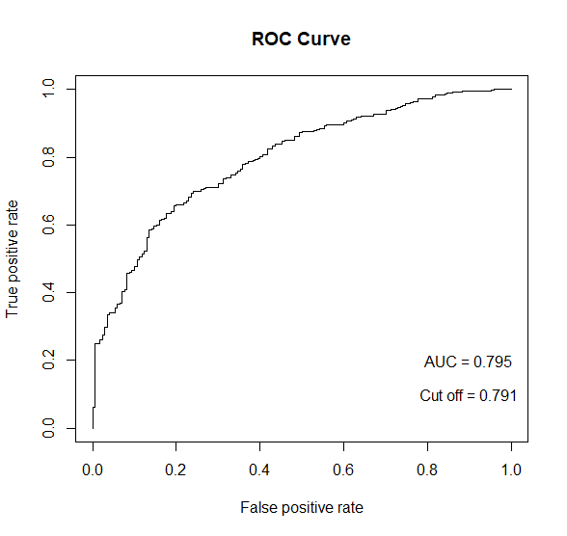

图1 训练集ROC

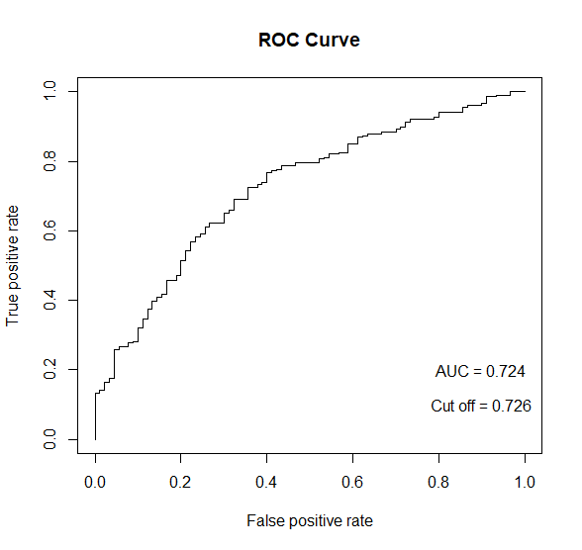

图2 测试集ROC

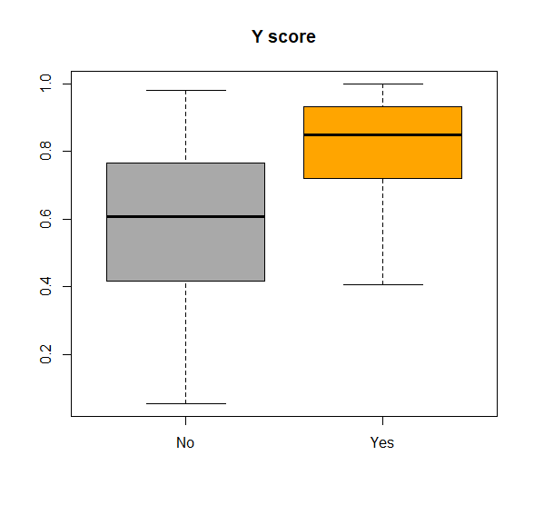

图3 训练集箱线图

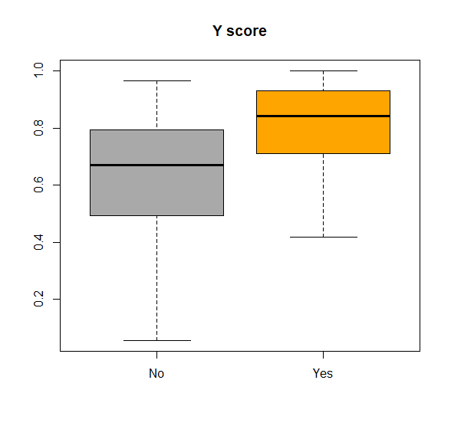

图4 测试集箱线图

Table 5.预测结果（296个非缺失测试样本,Cutoff = 0.791）

|  |  |  |
| --- | --- | --- |
| Predictive | Control(n,%) | Case(n,%) |
| Negative | 67（74.4） | 84（40.8） |
| Positive | 23（25.6） | 122（59.2） |
|  | Mean(95%CI) |  |
| Sensitive, % | 56.8(52.4-66.5) |  |
| Specificity, % | 65.5(64.4-83.3) |  |
| Youden index | 0.223 |  |