Graph Theory:

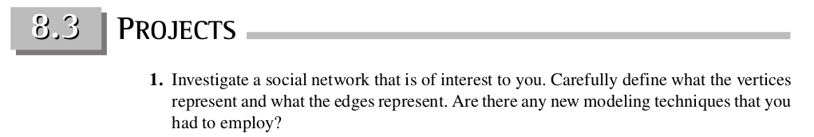

The social media site of interest will be Twitter. We will show nodes can represent users and edges represent follow relationships. This basic model can describe the structure of relationships, but we can expand it even further. This would require us to create a graph where we have different kinds of nodes and different kinds of edges (which expands on the graphs learned in class to property graphs). For example, we would have nodes representing individual tweets, with edges to the users who created them, favorited them, re-tweeted them, etc, as well as edges to other tweets they may be in response to. We will also show how one can approach modeling more abstract concepts like ‘topics’. We will show how to download data from twitter via the API and to come up with a graph visualization.