BUG: ASP.Net 2.0 Page Scroll code is triggering the jQuery event handler causing jQuery to throw a JavaScript error “this.events is undefined”

Description: ASP.Net 2.0 makes use of an automatic resource files generation via a server side web page called WebResource.axd and this is common across the entire industry. Changing how Microsoft renders these resource files and JavaScript is unlikely to happen so it is up to the community to provide workarounds.

Steps to reproduce: (Sorry I had to put a patch into the jQuery code to ensure our enterprise operations here at Intel Corp so the page below will not throw the error now. If you want to schedule some time with me I can set the error condition back up or perhaps you could use Microsoft Fiddler to do an inline replace for the jQuery Script source reference.)

Step 1: Load the following webpage - http://serverconfigurator.intel.com/configure.aspx?id=1194

Step 2: Make your browser into a smaller scrolling footprint like the following screen print with images and set your scrollbar somewhere in the middle like shown below
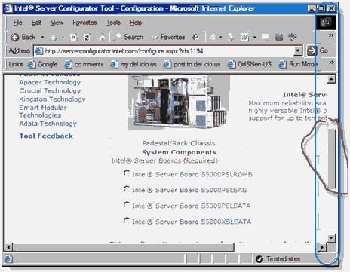
Detail Note: ASP.Net 2.0 PostBack event's are automatically triggered when you click on any any of the radio button on this web page.

Step 3: Clicking on a radio button with the screen setup in the above format causes an ASP.Net PostBack event to fire re-loading the page. When the page is loaded on a postback a call is made to WebResource.axd that load some Javascript that is used to attempt to reposition the scroll bar.
Detail Note: The page postback adds javascript code to the page to assist in repositioning the scrollbar, here is the stub of code rendered right before the closing HTML’s </body> tag. This auto-rendered script grabs the windows onload and places it in theForm.oldOnLoad.
<script type="text/javascript">
<!--

theForm.oldSubmit = theForm.submit;
theForm.submit = WebForm_SaveScrollPositionSubmit;

theForm.oldOnSubmit = theForm.onsubmit;
theForm.onsubmit = WebForm_SaveScrollPositionOnSubmit;

theForm.oldOnLoad = window.onload;
window.onload = WebForm_RestoreScrollPosition;
// -->
</script>

Detail Note: This file is referenced also referenced (http://serverconfigurator.intel.com/WebResource.axd?d=p6mYeAhud6PI4_X9tDzOXw2&amp;t=632777119425110309) which contains the following snippet of code. The BOLD item below is triggered in the code snippet

function WebForm_RestoreScrollPosition() {
362 if (__nonMSDOMBrowser) {
363 window.scrollTo(theForm.elements['__SCROLLPOSITIONX'].value, theForm.elements['__SCROLLPOSITIONY'].value);
364 }
365 else {
366 window.scrollTo(theForm.__SCROLLPOSITIONX.value, theForm.__SCROLLPOSITIONY.value);
367 }
368 if ((typeof(theForm.oldOnLoad) != "undefined") && (theForm.oldOnLoad != null)) {
369 return theForm.oldOnLoad();
370 }
371 return true;
372}

Detail Notes: Screen print of Internet Explorer JavaScript debugging session trace - Notice in the Call stack below. The Resource JavaScript supplied by “WebResource.axd” is attempting to execute the old window.onload function call. In this scripts context “this.events” has a valid value.

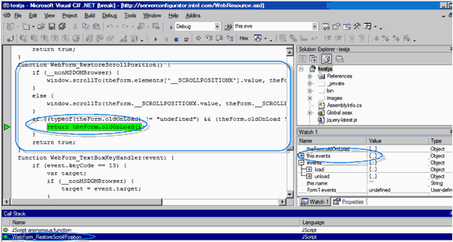

Detail Notes: The following screen-print shows the call-stack for jQuery right before the break occurs. Note that “this.events” in jQuery’s context is undefined. Below are a couple more screen captures showing that the jQuery handle: function(event) is getting a good parameter and event.type is populated

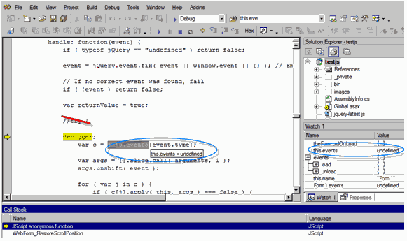

Detail Notes: Below are a couple more screen captures showing that the jQuery handle: function(event) is getting a good parameter and event.type is populated

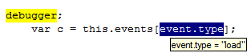
-------------------------------
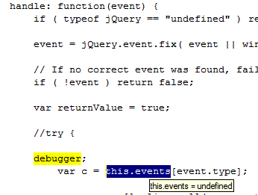

-------------------------

Final Thoughts & Fix Suggestion: I am not 100% sure about jQuery’s event handling structure or the actual entry point that get triggered when the HTML in the page calls theForm.oldOnLoad() and I only had time to get to the actual point where the error was happening in jQuery. Sorry about that. You will have noticed that I had put in a try/catch originally but opted on the following single line of code change

Changed code from this -

// If no correct event was found, fail
if ( !event) return false;
to this –

// If no correct event was found, fail
if ( !event || !this.events) return false;

I am not sure that this was the best way to handle this problem but it appears to be working and the problem seems to be gone. I will know in a couple of days as we are using jQuery over somewhere between 5-10 thousand content pages for Page Voting, Page Tags retrieval and Page Comments.

Kevin Pirkl

