Help Required, am I doing something Wrong, or is there a BUG?

<script src="jquery-3.6.0.min.js"></script>
<!-- <script src="jquery-1.11.3.js"></script> -->
<script>
$("img").load(function(){
alert("the image has been loaded");
});
$(window).load(function(){
alert("the Window has been loaded");
});
//This Works with "jquery-1.11.3.js"
//However Dose NOT work with "jquery-3.6.0.min.js"
</script>

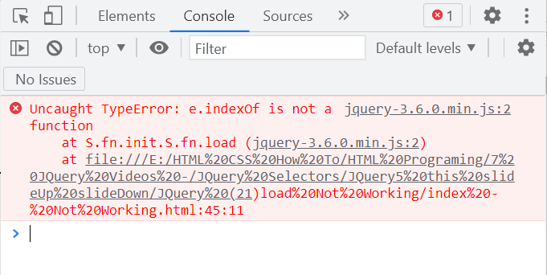

File Name = style.css

#title {
width: 500px;
padding: 15px;
margin: auto;
background: #f0efef;
border: solid 4px black;}

#left {
width: 300px;
float: left;
padding: 5px;
margin: 10px;
background: #f8f8f8;
border: solid 2px black;}

#center {
width: 300px;
float: left;
padding: 5px;
margin: 10px;
border: solid 2px black;}

#right {
width: 300px;
padding: 5px;
margin: 10px;
float: left;
background: #f0efef;
border: solid 2px black;
//visibility: hidden;}

#test {
width: 300px;
padding: 15px;
position: absolute;
left: 10px;
bottom: 20px;
margin: 10px;
background: #f0efef;
border: solid 2px black;
clear:both;}

.para {
color: blue;
background-color: yellow;}

.para2 {
color: pink;
background-color: grey;}

End File Name = style.css

File Name = index - Not Working.html

<!DOCTYPE html>

<html>
<head>
<Meta charset="UTF-8">
<meta name="viewport" content="width=device-width, initial-scale=0.5">
<title>JQuery1 Selectors\JQuery (4)</title>
<link type="text/css" rel="stylesheet" href="style.css">
</head>

<body>

<div id="title">
<h4>The Ready Function.</h4>
<h4>jquery Selectors.</h4>
<h4>Hide function.</h4>
</div><br>

<div id="left">
<h2>This is a heading</h2>
<p class="para2">This is FIRST para </p>
<p>This is Second para </p>
</div>

<div id="center">
<ul>
<li>Bobcats</li>
<li>Wildcats</li>
</ul>
</div>

<div id="right">
<p>This area will contain the <b>right content</b> area.</p>
<img src="../caesar.jpg" width="150px">
</div>

<div id="test">
<button> Hit button to change something </button>
</div>

<script src="../../jquery\jquery-3.6.0.min.js"></script>
<!-- <script src="jquery-1.11.3.js"></script> -->
<script>

$("img").load(function(){
alert("the image has been loaded");
});

$(window).load(function(){
alert("the Window has been loaded");
});

// This Works with "jquery-1.11.3.js"
// However Dose NOT work with "jquery-3.6.0.min.js"
</script>

</body>
</html>

End File Name = File Name = index - Not Working.html

