MkDocs
Project documentation with Markdown.

https://www.mkdocs.org/#installation

Overview
MkDocs is a fast, simple and downright gorgeous static site generator that's geared towards building project documentation. Documentation source files are written in Markdown, and configured with a single YAML configuration file.

Host anywhere
MkDocs builds completely static HTML sites that you can host on GitHub pages, Amazon S3, or anywhere else you choose.

Great themes available
There's a stack of good looking themes available for MkDocs. Choose between the built in themes: mkdocs and readthedocs, select one of the 3rd party themes in the MkDocs wiki, or build your own.

Preview your site as you work
The built-in dev-server allows you to preview your documentation as you're writing it. It will even auto-reload and refresh your browser whenever you save your changes.

Easy to customize
Get your project documentation looking just the way you want it by customizing the theme.

Installation

Install with a Package Manager
If you have and use a package manager (such as apt-get, dnf, homebrew, yum, chocolatey, etc.) to install packages on your system, then you may want to search for a "MkDocs" package and, if a recent version is available, install it with your package manager (check your system's documentation for details). That's it, you're done! Skip down to Getting Started.
If your package manager does not have a recent "MkDocs" package, you can still use your package manager to install "Python" and "pip". Then you can use pip to install MkDocs.

Manual Installation
In order to manually install MkDocs you'll need Python installed on your system, as well as the Python package manager, pip. You can check if you have these already installed from the command line:
$ python --version
Python 2.7.2
$ pip --version
pip 1.5.2
MkDocs supports Python versions 2.7, 3.4, 3.5, 3.6, 3.7 and pypy.

Installing Python
Install Python by downloading an installer appropriate for your system from python.org and running it.
Note
If you are installing Python on Windows, be sure to check the box to have Python added to your PATH if the installer offers such an option (it's normally off by default).
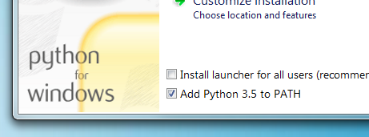

Installing pip
If you're using a recent version of Python, the Python package manager, pip, is most likely installed by default. However, you may need to upgrade pip to the lasted version:
sudo apt install python-pip
sudo pip install --upgrade pip
If you need to install pip for the first time, download get-pip.py. Then run the following command to install it:
sudo python get-pip.py

Installing MkDocs
Install the mkdocs package using pip:
sudo pip install mkdocs
You should now have the mkdocs command installed on your system. Run mkdocs --version to check that everything worked okay.
$ mkdocs --version
mkdocs, version 0.15.3
Note
If you would like manpages installed for MkDocs, the click-man tool can generate and install them for you. Simply run the following two commands:
pip install click-man
click-man --target path/to/man/pages mkdocs
See the click-man documentation for an explaination of why manpages are not automaticaly generated and installed by pip.
Note
If you are using Windows, some of the above commands may not work out-of-the-box.
A quick solution may be to preface every Python command with python -m like this:
python -m pip install mkdocs
python -m mkdocs
For a more permanent solution, you may need to edit your PATH environment variable to include the Scripts directory of your Python installation. Recent versions of Python include a script to do this for you. Navigate to your Python installation directory (for example C:\Python34\), open the Tools, then Scripts folder, and run the win_add2path.py file by double clicking on it. Alternatively, you can download the script and run it (python win_add2path.py).

Getting Started
Getting started is super easy.
mkdocs new my-project
cd my-project
Take a moment to review the initial project that has been created for you.
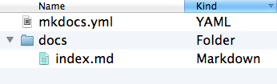
There's a single configuration file named mkdocs.yml, and a folder named docs that will contain your documentation source files. Right now the docs folder just contains a single documentation page, named index.md.
MkDocs comes with a built-in dev-server that lets you preview your documentation as you work on it. Make sure you're in the same directory as the mkdocs.yml configuration file, and then start the server by running the mkdocs serve command:
$ mkdocs serve
INFO - Building documentation...
INFO - Cleaning site directory
[I 160402 15:50:43 server:271] Serving on http://127.0.0.1:8000
[I 160402 15:50:43 handlers:58] Start wahttp://127.0.0.1:8000/tching changes
[I 160402 15:50:43 handlers:60] Start detecting changes
Open up in your browser, and you'll see the default home page being displayed:
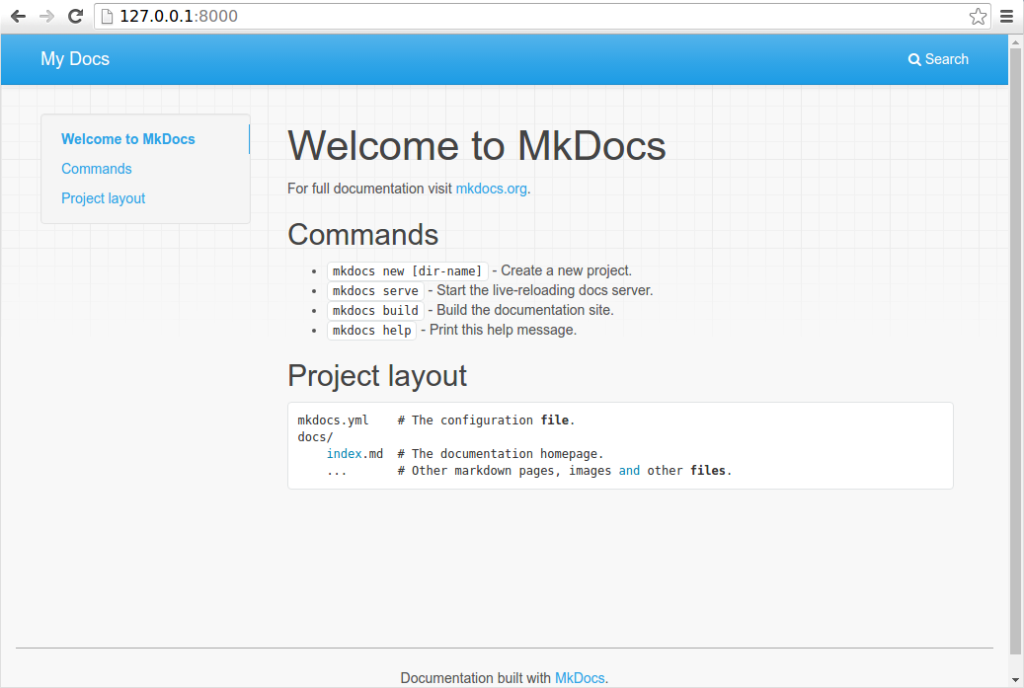
The dev-server also supports auto-reloading, and will rebuild your documentation whenever anything in the configuration file, documentation directory, or theme directory changes.
Open the docs/index.md document in your text editor of choice, change the initial heading to MkLorum, and save your changes. Your browser will auto-reload and you should see your updated documentation immediately.
Now try editing the configuration file: mkdocs.yml. Change the site_name setting to MkLorum and save the file.
site_name: MkLorum
Your browser should immediately reload, and you'll see your new site name take effect.
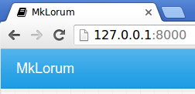

Adding pages
Now add a second page to your documentation:
curl 'https://jaspervdj.be/lorem-markdownum/markdown.txt' > docs/about.md
As our documentation site will include some navigation headers, you may want to edit the configuration file and add some information about the order, title, and nesting of each page in the navigation header by adding a pages setting:
site_name: MkLorum
nav:
- Home: index.md
- About: about.md
Save your changes and you'll now see a navigation bar with Home and About items on the left as well as Search, Previous, and Next items on the right.
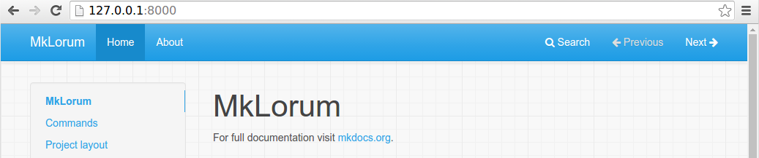
Try the menu items and navigate back and forth between pages. Then click on Search. A search dialog will appear, allowing you to search for any text on any page. Notice that the search results include every occurrence of the search term on the site and links directly to the section of the page in which the search term appears. You get of all that with no effort or configuration on your part!
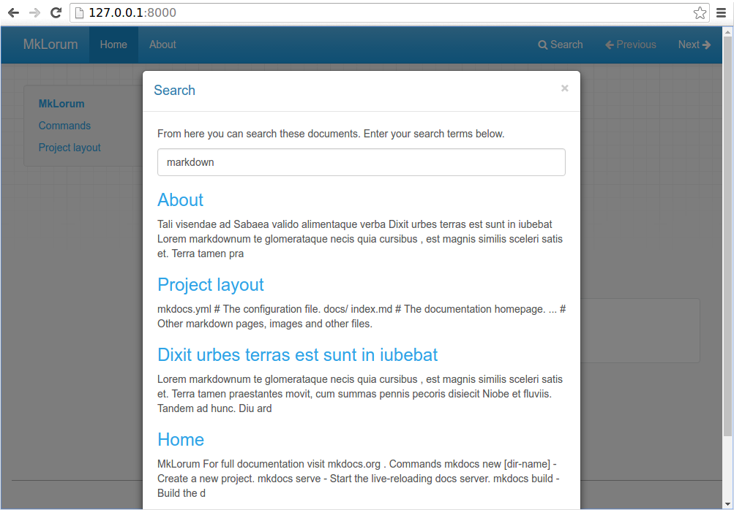

Theming our documentation
Now change the configuration file to alter how the documentation is displayed by changing the theme. Edit the mkdocs.yml file and add a theme setting:
site_name: MkLorum
nav:
- Home: index.md
- About: about.md
theme: readthedocs
Save your changes, and you'll see the ReadTheDocs theme being used.
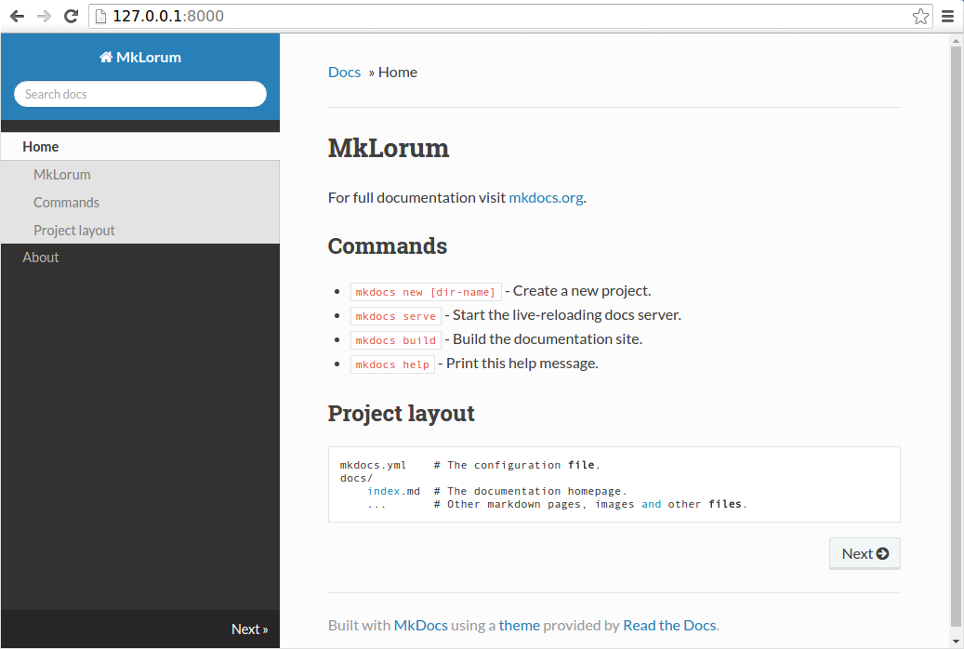

Changing the Favicon Icon
By default, MkDocs uses the MkDocs favicon icon. To use a different icon, create an img subdirectory in your docs_dir and copy your custom favicon.ico file to that directory. MkDocs will automatically detect and use that file as your favicon icon.

Building the site
That's looking good. You're ready to deploy the first pass of your MkLorum documentation. First build the documentation:
mkdocs build
This will create a new directory, named site. Take a look inside the directory:
$ ls site
about fonts index.html license search.html
css img js mkdocs sitemap.xml
Notice that your source documentation has been output as two HTML files named index.html and about/index.html. You also have various other media that's been copied into the site directory as part of the documentation theme. You even have a sitemap.xml file and mkdocs/search_index.json.
If you're using source code control such as git you probably don't want to check your documentation builds into the repository. Add a line containing site/ to your .gitignore file.
echo "site/" >> .gitignore
If you're using another source code control tool you'll want to check its documentation on how to ignore specific directories.
After some time, files may be removed from the documentation but they will still reside in the site directory. To remove those stale files, just run mkdocs with the --clean switch.
mkdocs build --clean

Other Commands and Options
There are various other commands and options available. For a complete list of commands, use the --help flag:
mkdocs --help
To view a list of options available on a given command, use the --help flag with that command. For example, to get a list of all options available for the build command run the following:
mkdocs build --help

Deploying
The documentation site that you just built only uses static files so you'll be able to host it from pretty much anywhere. GitHub project pages and Amazon S3 may be good hosting options, depending upon your needs. Upload the contents of the entire site directory to wherever you're hosting your website from and you're done. For specific instructions on a number of common hosts, see the Deploying your Docs page.

Getting help
To get help with MkDocs, please use the discussion group, GitHub issues or the MkDocs IRC channel #mkdocs on freenode.

Writing your docs
How to layout and write your Markdown source files.

File layout
Your documentation source should be written as regular Markdown files (see Writing with Markdown below), and placed in the documentation directory. By default, this directory will be named docs and will exist at the top level of your project, alongside the mkdocs.yml configuration file.
The simplest project you can create will look something like this:
mkdocs.yml
docs/
index.md
By convention your project homepage should always be named index. Any of the following extensions may be used for your Markdown source files: markdown, mdown, mkdn, mkd, md. All Markdown files included in your documentation directory will be rendered in the built site regardless of any settings.
You can also create multi-page documentation, by creating several Markdown files:
mkdocs.yml
docs/
index.md
about.md
license.md
The file layout you use determines the URLs that are used for the generated pages. Given the above layout, pages would be generated for the following URLs:
/
/about/
/license/
You can also include your Markdown files in nested directories if that better suits your documentation layout.
docs/
index.md
user-guide/getting-started.md
user-guide/configuration-options.md
license.md
Source files inside nested directories will cause pages to be generated with nested URLs, like so:
/
/user-guide/getting-started/
/user-guide/configuration-options/
/license/

Index pages
When a directory is requested, by default, most web servers will return an index file (usually named index.html) contained within that directory if one exists. For that reason, the homepage in all of the examples above has been named index.md, which MkDocs will render to index.html when building the site.
Many repository hosting sites provide special treatment for README files by displaying the contents of the README file when browsing the contents of a directory. Therefore, MkDocs will allow you to name your index pages as README.md instead of index.md. In that way, when users are browsing your source code, the repository host can display the index page of that directory as it is a README file. However, when MkDocs renders your site, the file will be renamed to index.html so that the server will serve it as a proper index file.
If both an index.md file and a README.md file are found in the same directory, then the index.md file is used and the README.md file is ignored.

Configure Pages and Navigation
The nav configuration setting in your mkdocs.yml file defines which pages are included in the global site navigation menu as well as the structure of that menu. If not provided, the navigation will be automatically created by discovering all the Markdown files in the documentation directory. An automatically created navigation configuration will always be sorted alphanumerically by file name (except that index files will always be listed first within a sub-section). You will need to manually define your navigation configuration if you would like your navigation menu sorted differently.
A simple navigation configuration looks like this:
nav:
- 'index.md'
- 'about.md'
All paths in the navigation configuration must be relative to the docs_dir configuration option. If that option is set to the default value, docs, the source files for the above configuration would be located at docs/index.md and docs/about.md.
The above example will result in two navigation items being created at the top level and with their titles inferred from the contents of the file (or the filename if no title is defined within the file). To define a custom title for the pages, the title can be added before the filename.
nav:
- Home: 'index.md'
- About: 'about.md'
Note that if a title is defined for a page in the navigation, that title will be used throughout the site for that page and will override any title defined within the page itself.
Navigation sub-sections can be created by listing related pages together under a section title. For example:
nav:
- Home: 'index.md'
- User Guide:
- 'Writing your docs': 'writing-your-docs.md'
- 'Styling your docs': 'styling-your-docs.md'
- About:
- 'License': 'license.md'
- 'Release Notes': 'release-notes.md'
With the above configuration we have three top level items: "Home", "User Guide" and "About." "Home" is a link to the homepage for the site. Under the "User Guide" section two pages are listed: "Writing your docs" and "Styling your docs." Under the "About" section two more pages are listed: "License" and "Release Notes."
Note that a section cannot have a page assigned to it. Sections are only containers for child pages and sub-sections. You may nest sections as deeply as you like. However, be careful that you don't make it too difficult for your users to navigate through the site navigation by over-complicating the nesting. While sections may mirror your directory structure, they do not have to.
Any pages not listed in your navigation configuration will still be rendered and included with the built site, however, they will not be linked from the global navigation and will not be included in the previous and next links. Such pages will be "hidden" unless linked to directly.

Writing with Markdown
MkDocs pages must be authored in Markdown, a lightweight markup language which results in easy-to-read, easy-to-write plain text documents that can be converted to valid HTML documents in a predictable manner.
MkDocs uses the Python-Markdown library to render Markdown documents to HTML. Python-Markdown is almost completely compliant with the reference implementation, although there are a few very minor differences.
In addition to the base Markdown syntax which is common across all Markdown implementations, MkDocs includes support for extending the Markdown syntax with Python-Markdown extensions. See the MkDocs' markdown_extensions configuration setting for details on how to enable extensions.
MkDocs includes some extensions by default, which are highlighted below.

Internal links
MkDocs allows you to interlink your documentation by using regular Markdown links. However, there are a few additional benefits to formatting those links specifically for MkDocs as outlined below.

Linking to pages
When linking between pages in the documentation you can simply use the regular Markdown linking syntax, including the relative path to the Markdown document you wish to link to.
Please see the [project license](license.md) for further details.
When the MkDocs build runs, these Markdown links will automatically be transformed into an HTML hyperlink to the appropriate HTML page.
If the target documentation file is in another directory you'll need to make sure to include any relative directory path in the link.
Please see the [project license](../about/license.md) for further details.
The toc extension is used by MkDocs to generate an ID for every header in your Markdown documents. You can use that ID to link to a section within a target document by using an anchor link. The generated HTML will correctly transform the path portion of the link, and leave the anchor portion intact.
Please see the [project license](about.md#license) for further details.
Note that IDs are created from the text of a header. All text is converted to lowercase and any disallowed characters, including white-space, are converted to dashes. Consecutive dashes are then reduced to a single dash.
There are a few configuration settings provided by the toc extension which you can set in your mkdocs.yml configuration file to alter the default behavior:
permalink:
Generate permanent links at the end of each header. Default: False.
When set to True the paragraph symbol (¶ or &para;) is used as the link text. When set to a string, the provided string is used as the link text. For example, to use the hash symbol (#) instead, do:
markdown_extensions:
- toc:
permalink: "#"
baselevel:
Base level for headers. Default: 1.
This setting allows the header levels to be automatically adjusted to fit within the hierarchy of your HTML templates. For example, if the Markdown text for a page should not contain any headers higher than level 2 (<h2>), do:
markdown_extensions:
- toc:
baselevel: 2
Then any headers in your document would be increased by 1. For example, the header # Header would be rendered as a level 2 header (<h2>) in the HTML output.
separator:
Word separator. Default: -.
Character which replaces white-space in generated IDs. If you prefer underscores, then do:
markdown_extensions:
- toc:
separator: "_"
Note that if you would like to define multiple of the above settings, you must do so under a single toc entry in the markdown_extensions configuration option.
markdown_extensions:
- toc:
permalink: "#"
baselevel: 2
separator: "_"

Linking to images and media
As well as the Markdown source files, you can also include other file types in your documentation, which will be copied across when generating your documentation site. These might include images and other media.
For example, if your project documentation needed to include a GitHub pages CNAME file and a PNG formatted screenshot image then your file layout might look as follows:
mkdocs.yml
docs/
CNAME
index.md
about.md
license.md
img/
screenshot.png
To include images in your documentation source files, simply use any of the regular Markdown image syntaxes:
Cupcake indexer is a snazzy new project for indexing small cakes.

![Screenshot](img/screenshot.png)

*Above: Cupcake indexer in progress*
Your image will now be embedded when you build the documentation, and should also be previewed if you're working on the documentation with a Markdown editor.

Linking from raw HTML
Markdown allows document authors to fall back to raw HTML when the Markdown syntax does not meets the author's needs. MkDocs does not limit Markdown in this regard. However, as all raw HTML is ignored by the Markdown parser, MkDocs is not able to validate or convert links contained in raw HTML. When including internal links within raw HTML, you will need to manually format the link appropriately for the rendered document.

Meta-Data
MkDocs includes support for both YAML and MultiMarkdown style meta-data (often called front-matter). Meta-data consists of a series of keywords and values defined at the beginning of a Markdown document, which are stripped from the document prior to it being processing by Python-Markdown. The key/value pairs are passed by MkDocs to the page template. Therefore, if a theme includes support, the values of any keys can be displayed on the page or used to control the page rendering. See your theme's documentation for information about which keys may be supported, if any.
In addition to displaying information in a template, MkDocs includes support for a few predefined meta-data keys which can alter the behavior of MkDocs for that specific page. The following keys are supported:
template:
The template to use with the current page.
By default, MkDocs uses the main.html template of a theme to render Markdown pages. You can use the template meta-data key to define a different template file for that specific page. The template file must be available on the path(s) defined in the theme's environment.
title:
The "title" to use for the document.
MkDocs will attempt to determine the title of a document in the following ways, in order:
- A title defined in the nav configuration setting for a document.
- A title defined in the title meta-data key of a document.
- A level 1 Markdown header on the first line of the document body.
- The filename of a document.
Upon finding a title for a page, MkDoc does not continue checking any additional sources in the above list.

YAML Style Meta-Data
YAML style meta-data consists of YAML key/value pairs wrapped in YAML style deliminators to mark the start and/or end of the meta-data. The first line of a document must be ---. The meta-data ends at the first line containing an end deliminator (either --- or ...). The content between the deliminators is parsed as YAML.
---
title: My Document
summary: A brief description of my document.
authors:
- Waylan Limberg
- Tom Christie
date: 2018-07-10
some_url: https://example.com
---
This is the first paragraph of the document.
YAML is able to detect data types. Therefore, in the above example, the values of title, summary and some_url are strings, the value of authors is a list of strings and the value of date is a datetime.date object. Note that the YAML keys are case sensitive and MkDocs expects keys to be all lowercase. The top level of the YAML must be a collection of key/value pairs, which results in a Python dict being returned. If any other type is returned or the YAML parser encounters an error, then MkDocs does not recognize the section as meta-data, the page's meta attribute will be empty, and the section is not removed from the document.

MultiMarkdown Style Meta-Data
MultiMarkdown style meta-data uses a format first introduced by the MultiMarkdown project. The data consists of a series of keywords and values defined at the beginning of a Markdown document, like this:
Title: My Document
Summary: A brief description of my document.
Authors: Waylan Limberg
Tom Christie
Date: January 23, 2018
blank-value:
some_url: https://example.com

This is the first paragraph of the document.
The keywords are case-insensitive and may consist of letters, numbers, underscores and dashes and must end with a colon. The values consist of anything following the colon on the line and may even be blank.
If a line is indented by 4 or more spaces, that line is assumed to be an additional line of the value for the previous keyword. A keyword may have as many lines as desired. All lines are joined into a single string.
The first blank line ends all meta-data for the document. Therefore, the first line of a document must not be blank.
Note
MkDocs does not support YAML style deliminators (--- or ...) for MultiMarkdown style meta-data. In fact, MkDocs relies on the the presence or absence of the deliminators to determine whether YAML style meta-data or MultiMarkdown style meta-data is being used. If the deliminators are detected, but the content between the deliminators is not valid YAML meta-data, MkDocs does not attempt to parse the content as MultiMarkdown style meta-data.

Tables
The tables extension adds a basic table syntax to Markdown which is popular across multiple implementations. The syntax is rather simple and is generally only useful for simple tabular data.
A simple table looks like this:
First Header | Second Header | Third Header
------------ | ------------- | ------------
Content Cell | Content Cell | Content Cell
Content Cell | Content Cell | Content Cell
If you wish, you can add a leading and tailing pipe to each line of the table:
| First Header | Second Header | Third Header |
| ------------ | ------------- | ------------ |
| Content Cell | Content Cell | Content Cell |
| Content Cell | Content Cell | Content Cell |
Specify alignment for each column by adding colons to separator lines:
First Header | Second Header | Third Header
:----------- |:-------------:| -----------:
Left | Center | Right
Left | Center | Right
Note that table cells cannot contain any block level elements and cannot contain multiple lines of text. They can, however, include inline Markdown as defined in Markdown's syntax rules.
Additionally, a table must be surrounded by blank lines. There must be a blank line before and after the table.

Fenced code blocks
The fenced code blocks extension adds an alternate method of defining code blocks without indentation.
The first line should contain 3 or more backtick (`) characters, and the last line should contain the same number of backtick characters (`):
```
Fenced code blocks are like Standard
Markdown’s regular code blocks, except that
they’re not indented and instead rely on
start and end fence lines to delimit the
code block.
```
With this approach, the language can optionally be specified on the first line after the backticks which informs any syntax highlighters of the language used:
```python
def fn():
pass
```
Note that fenced code blocks can not be indented. Therefore, they cannot be nested inside list items, blockquotes, etc.

Styling your docs
How to style and theme your documentation.

MkDocs includes a couple built-in themes as well as various third party themes, all of which can easily be customized with extra CSS or JavaScript or overridden from the theme's custom_dir. You can also create your own custom theme from the ground up for your documentation.
To use a theme that is included in MkDocs, simply add this to your mkdocs.yml config file.
theme: readthedocs
Replace readthedocs with any of the built-in themes listed below.
To create a new custom theme see the Custom Themes page, or to more heavily customize an existing theme, see the Customizing a Theme section below.

Built-in themes

mkdocs
The default theme, which was built as a custom Bootstrap theme, supports most every feature of MkDocs. It only officially supports two levels in the navigation (see #1107).
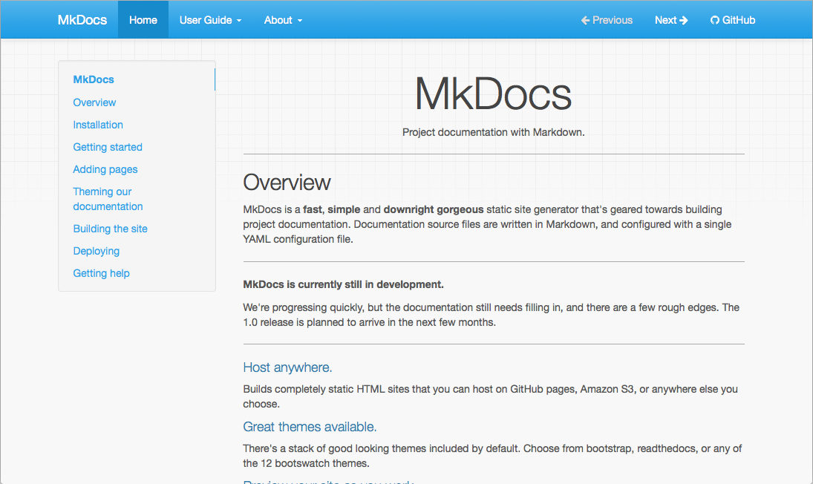
In addition to the default theme configuration options, the mkdocs theme supports the following options:
- highlightjs: Enables highlighting of source code in code blocks using the highlight.js JavaScript library. Default: True.
- hljs_style: The highlight.js library provides 79 different styles (color variations) for highlighting source code in code blocks. Set this to the name of the desired style. Default: github.
- hljs_languages: By default, highlight.js only supports 23 common languages. List additional languages here to include support for them.
theme:
name: mkdocs
highlightjs: true
hljs_languages:
- yaml
- rust
- shortcuts: Defines keyboard shortcut keys.
theme:
name: mkdocs
shortcuts:
help: 191 # ?
next: 78 # n
previous: 80 # p
search: 83 # s
All values much be numeric key codes. It is best to use keys which are available on all keyboards. You may use http://keycode.info/ to determine the key code for a given key.
  - help: Display a help modal which lists the keyboard shortcuts. Default: 191 (?)
  - next: Navigate to the "next" page. Default: 78 (n)
  - previous: Navigate to the "previous" page. Default: 80 (p)
  - search: Display the search modal. Default: 83 (s)

readthedocs
A clone of the default theme used by the Read the Docs service, which offers the same restricted feature-set as its parent theme. Like its parent theme, only two levels of navigation are supported.
In addition to the default theme configuration options, the readthedocs theme supports the following options:
- highlightjs: Enables highlighting of source code in code blocks using the highlight.js JavaScript library. Default: True.
- hljs_languages: By default, highlight.js only supports 23 common languages. List additional languages here to include support for them.
theme:
name: readthedocs
highlightjs: true
hljs_languages:
- yaml
- rust

Third Party Themes
A list of third party themes can be found in the MkDocs community wiki. If you have created your own, please feel free to add it to the list.

Customizing a Theme
If you would like to make a few tweaks to an existing theme, there is no need to create your own theme from scratch. For minor tweaks which only require some CSS and/or JavaScript, you can use the docs_dir. However, for more complex customizations, including overriding templates, you will need to use the theme custom_dir setting.

Using the docs_dir
The extra_css and extra_javascript configuration options can be used to make tweaks and customizations to existing themes. To use these, you simply need to include either CSS or JavaScript files within your documentation directory.
For example, to change the colour of the headers in your documentation, create a file called extra.css and place it next to the documentation Markdown. In that file add the following CSS.
h1 {
color: red;
}
Note
If you are deploying your documentation with ReadTheDocs. You will need to explicitly list the CSS and JavaScript files you want to include in your config. To do this, add the following to your mkdocs.yml.
extra_css: [extra.css]
After making these changes, they should be visible when you run mkdocs serve - if you already had this running, you should see that the CSS changes were automatically picked up and the documentation will be updated.
Note
Any extra CSS or JavaScript files will be added to the generated HTML document after the page content. If you desire to include a JavaScript library, you may have better success including the library by using the theme custom_dir.

Using the theme custom_dir
The theme.custom_dir configuration option can be used to point to a directory of files which override the files in a parent theme. The parent theme would be the theme defined in the theme.name configuration option. Any file in the custom_dir with the same name as a file in the parent theme will replace the file of the same name in the parent theme. Any additional files in the custom_dir will be added to the parent theme. The contents of the custom_dir should mirror the directory structure of the parent theme. You may include templates, JavaScript files, CSS files, images, fonts, or any other media included in a theme.
Note
For this to work, the theme name setting must be set to a known installed theme. If the name setting is instead set to null (or not defined), then there is no theme to override and the contents of the custom_dir must be a complete, standalone theme. See Custom Themes for more information.
For example, the mkdocs theme (browse source), contains the following directory structure (in part):
- css\
- fonts\
- img\
- favicon.ico
- grid.png
- js\
- 404.html
- base.html
- content.html
- nav-sub.html
- nav.html
- toc.html
To override any of the files contained in that theme, create a new directory next to your docs_dir:
mkdir custom_theme
And then point your mkdocs.yml configuration file at the new directory:
theme:
name: mkdocs
custom_dir: custom_theme/
To override the 404 error page ("file not found"), add a new template file named 404.html to the custom_theme directory. For information on what can be included in a template, review the documentation for building a custom theme.
To override the favicon, you can add a new icon file at custom_theme/img/favicon.ico.
To include a JavaScript library, copy the library to the custom_theme/js/ directory.
Your directory structure should now look like this:
- docs/
- index.html
- custom_theme/
- img/
- favicon.ico
- js/
- somelib.js
- 404.html
- config.yml
Note
Any files included in the parent theme (defined in name) but not included in the custom_dir will still be utilized. The custom_dir will only override/replace files in the parent theme. If you want to remove files, or build a theme from scratch, then you should review the documentation for building a custom theme.

Overriding Template Blocks
The built-in themes implement many of their parts inside template blocks which can be individually overridden in the main.html template. Simply create a main.html template file in your custom_dir and define replacement blocks within that file. Just make sure that the main.html extends base.html. For example, to alter the title of the MkDocs theme, your replacement main.html template would contain the following:
{% extends "base.html" %}

{% block title %}
<title>Custom title goes here</title>
{% endblock %}
In the above example, the title block defined in your custom main.html file will be used in place of the default title block defined in the parent theme. You may re-define as many blocks as you desire, as long as those blocks are defined in the parent. For example, you could replace the Google Analytics script with one for a different service or replace the search feature with your own. You will need to consult the parent theme you are using to determine what blocks are available to override. The MkDocs and ReadTheDocs themes provide the following blocks:
- site_meta: Contains meta tags in the document head.
- htmltitle: Contains the page title in the document head.
- styles: Contains the link tags for stylesheets.
- libs: Contains the JavaScript libraries (jQuery, etc) included in the page header.
- scripts: Contains JavaScript scripts which should execute after a page loads.
- analytics: Contains the analytics script.
- extrahead: An empty block in the <head> to insert custom tags/scripts/etc.
- site_name: Contains the site name in the navigation bar.
- site_nav: Contains the site navigation in the navigation bar.
- search_box: Contains the search box in the navigation bar.
- next_prev: Contains the next and previous buttons in the navigation bar.
- repo: Contains the repository link in the navigation bar.
- content: Contains the page content and table of contents for the page.
- footer: Contains the page footer.
You may need to view the source template files to ensure your modifications will work with the structure of the site. See Template Variables for a list of variables you can use within your custom blocks. For a more complete explanation of blocks, consult the Jinja documentation.

Combining the custom_dir and Template Blocks
Adding a JavaScript library to the custom_dir will make it available, but won't include it in the pages generated by MkDocs. Therefore, a link needs to be added to the library from the HTML.
Starting the with directory structure above (truncated):
- docs/
- custom_theme/
- js/
- somelib.js
- config.yml
A link to the custom_theme/js/somelib.js file needs to be added to the template. As somelib.js is a JavaScript library, it would logically go in the libs block. However, a new libs block that only includes the new script will replace the block defined in the parent template and any links to libraries in the parent template will be removed. To avoid breaking the template, a super block can be used with a call to super from within the block:
{% extends "base.html" %}

{% block libs %}
{{ super() }}
<script src="{{ base_url }}/js/somelib.js"></script>
{% endblock %}
Note that the base_url template variable was used to ensure that the link is always relative to the current page.
Now the generated pages will include links to the template provided libraries as well as the library included in the custom_dir. The same would be required for any additional CSS files included in the custom_dir.

Configuration
Guide to all available configuration settings.

Introduction
Project settings are always configured by using a YAML configuration file in the project directory named mkdocs.yml.
As a minimum this configuration file must contain the site_name setting. All other settings are optional.

Project information

site_name
This is a required setting, and should be a string that is used as the main title for the project documentation. For example:
site_name: Marshmallow Generator
When rendering the theme this setting will be passed as the site_name context variable.

site_url
Set the canonical URL of the site. This will add a link tag with the canonical URL to the generated HTML header.
default: null

repo_url
When set, provides a link to your repository (GitHub, Bitbucket, GitLab, ...) on each page.
repo_url: https://github.com/example/repository/
default: null

repo_name
When set, provides the name for the link to your repository on each page.
default: 'GitHub', 'Bitbucket' or 'GitLab' if the repo_url matches those domains, otherwise the hostname from the repo_url.

edit_uri
Path from the base repo_url to the docs directory when directly viewing a page, accounting for specifics of the repository host (e.g. GitHub, Bitbucket, etc), the branch, and the docs directory itself. MkDocs concatenates repo_url and edit_uri, and appends the input path of the page.
When set, and if your theme supports it, provides a link directly to the page in your source repository. This makes it easier to find and edit the source for the page. If repo_url is not set, this option is ignored. On some themes, setting this option may cause an edit link to be used in place of a repository link. Other themes may show both links.
The edit_uri supports query ('?') and fragment ('#') characters. For repository hosts that use a query or a fragment to access the files, the edit_uri might be set as follows. (Note the ? and # in the URI...)
# Query string example
edit_uri: '?query=root/path/docs/'
# Hash fragment example
edit_uri: '#root/path/docs/'
For other repository hosts, simply specify the relative path to the docs directory.
# Query string example
edit_uri: root/path/docs/
Note
On a few known hosts (specifically GitHub, Bitbucket and GitLab), the edit_uri is derived from the 'repo_url' and does not need to be set manually. Simply defining a repo_url will automatically populate the edit_uri configs setting.
For example, for a GitHub- or GitLab-hosted repository, the edit_uri would be automatically set as edit/master/docs/ (Note the edit path and master branch).
For a Bitbucket-hosted repository, the equivalent edit_uri would be automatically set as src/default/docs/ (note the src path and default branch).
To use a different URI than the default (for example a different branch), simply set the edit_uri to your desired string. If you do not want any "edit URL link" displayed on your pages, then set edit_uri to an empty string to disable the automatic setting.
Warning
On GitHub and GitLab, the default "edit" path (edit/master/docs/) opens the page in the online editor. This functionality requires that the user have and be logged in to a GitHub/GitLab account. Otherwise, the user will be redirected to a login/signup page. Alternatively, use the "blob" path (blob/master/docs/) to open a read-only view, which supports anonymous access.
default: edit/master/docs/ for GitHub and GitLab repos or src/default/docs/ for a Bitbucket repo, if repo_url matches those domains, otherwise null

site_description
Set the site description. This will add a meta tag to the generated HTML header.
default: null

site_author
Set the name of the author. This will add a meta tag to the generated HTML header.
default: null

copyright
Set the copyright information to be included in the documentation by the theme.
default: null

google_analytics
Set the Google analytics tracking configuration.
google_analytics: ['UA-36723568-3', 'mkdocs.org']
default: null

remote_branch
Set the remote branch to commit to when using gh-deploy to deploy to Github Pages. This option can be overridden by a command line option in gh-deploy.
default: gh-pages

remote_name
Set the remote name to push to when using gh-deploy to deploy to Github Pages. This option can be overridden by a command line option in gh-deploy.
default: origin

Documentation layout

nav
This setting is used to determine the format and layout of the global navigation for the site. For example, the following would create "Introduction", "User Guide" and "About" navigation items.
nav:
- 'Introduction': 'index.md'
- 'User Guide': 'user-guide.md'
- 'About': 'about.md'
All paths must be relative to the mkdocs.yml configuration file. See the section on configuring pages and navigation for a more detailed breakdown, including how to create sub-sections.
Navigation items may also include links to external sites. While titles are optional for internal links, they are required for external links. An external link may be a full URL or a relative URL. Any path which is not found in the files is assumed to be an external link.
nav:
- Home: index.md
- User Guide: user-guide.md
- Bug Tracker: https://example.com/
In the above example, the first two items point to local files while the third points to an external site.
However, sometimes the MkDocs site is hosted in a subdirectory of a project's site and you may want to link to other parts of the same site without including the full domain. In that case, you may use and appropriate relative URL.
site_url: https://example.com/foo/

nav:
- Home: ../
- User Guide: user-guide.md
- Bug Tracker: /bugs/
In the above example, two different styles of external links are used. First note that the site_url indicates that the MkDocs site is hosted in the /foo/ subdirectory of the domain. Therefore, the Home navigation item is a relative link which steps up one level to the server root and effectively points to https://example.com/. The Bug Tracker item uses an absolute path from the server root and effectively points to https://example.com/bugs/. Of course, the User Guide points to a local MkDocs page.
default: By default nav will contain an alphanumerically sorted, nested list of all the Markdown files found within the docs_dir and its sub-directories. If none are found it will be [] (an empty list).

Build directories

theme
Sets the theme and theme specific configuration of your documentation site. May be either a string or a set of key/value pairs.
If a string, it must be the string name of a known installed theme. For a list of available themes visit styling your docs.
An example set of key/value pairs might look something like this:
theme:
name: mkdocs
custom_dir: my_theme_customizations/
static_templates:
- sitemap.html
include_sidebar: false
If a set of key/value pairs, the following nested keys can be defined:

name:
The string name of a known installed theme. For a list of available themes visit styling your docs.

custom_dir:
A directory containing a custom theme. This can either be a relative directory, in which case it is resolved relative to the directory containing your configuration file, or it can be an absolute directory path from the root of your local file system.
See styling your docs for details if you would like to tweak an existing theme.
See custom themes if you would like to build your own theme from the ground up.

static_templates:
A list of templates to render as static pages. The templates must be located in either the theme's template directory or in the custom_dir defined in the theme configuration.

(theme specific keywords)
Any additional keywords supported by the theme can also be defined. See the documentation for the theme you are using for details.
default: 'mkdocs'

docs_dir
The directory containing the documentation source markdown files. This can either be a relative directory, in which case it is resolved relative to the directory containing your configuration file, or it can be an absolute directory path from the root of your local file system.
default: 'docs'

site_dir
The directory where the output HTML and other files are created. This can either be a relative directory, in which case it is resolved relative to the directory containing your configuration file, or it can be an absolute directory path from the root of your local file system.
default: 'site'
Note:
If you are using source code control you will normally want to ensure that your build output files are not committed into the repository, and only keep the source files under version control. For example, if using git you might add the following line to your .gitignore file:
site/
If you're using another source code control tool, you'll want to check its documentation on how to ignore specific directories.

extra_css
Set a list of CSS files in your docs_dir to be included by the theme. For example, the following example will include the extra.css file within the css subdirectory in your docs_dir.
extra_css:
- css/extra.css
- css/second_extra.css
default: [] (an empty list).

extra_javascript
Set a list of JavaScript files in your docs_dir to be included by the theme. See the example in extra_css for usage.
default: [] (an empty list).

extra_templates
Set a list of templates in your docs_dir to be built by MkDocs. To see more about writing templates for MkDocs read the documentation about custom themes and specifically the section about the variables that are available to templates. See the example in extra_css for usage.
default: [] (an empty list).

extra
A set of key value pairs, where the values can be any valid YAML construct, that will be passed to the template. This allows for great flexibility when creating custom themes.
For example, if you are using a theme that supports displaying the project version, you can pass it to the theme like this:
extra:
version: 1.0
default: By default extra will be an empty key value mapping.

Preview controls

use_directory_urls
This setting controls the style used for linking to pages within the documentation.
The following table demonstrates how the URLs used on the site differ when setting use_directory_urls to true or false.
Source file | use_directory_urls: true | use_directory_urls: false
index.md | / | /index.html
api-guide.md | /api-guide/ | /api-guide.html
about/license.md | /about/license/ | /about/license.html
The default style of use_directory_urls: true creates more user friendly URLs, and is usually what you'll want to use.
The alternate style can occasionally be useful if you want your documentation to remain properly linked when opening pages directly from the file system, because it creates links that point directly to the target file rather than the target directory.
default: true

strict
Determines how warnings are handled. Set to true to halt processing when a warning is raised. Set to false to print a warning and continue processing.
default: false

dev_addr
Determines the address used when running mkdocs serve. Must be of the format IP:PORT.
Allows a custom default to be set without the need to pass it through the --dev_addr option every time the mkdocs serve command is called.
default: '127.0.0.1:8000'

Formatting options

markdown_extensions
MkDocs uses the Python Markdown library to translate Markdown files into HTML. Python Markdown supports a variety of extensions that customize how pages are formatted. This setting lets you enable a list of extensions beyond the ones that MkDocs uses by default (meta, toc, tables, and fenced_code).
For example, to enable the SmartyPants typography extension, use:
markdown_extensions:
- smarty
Some extensions provide configuration options of their own. If you would like to set any configuration options, then you can nest a key/value mapping (option_name: option value) of any options that a given extension supports. See the documentation for the extension you are using to determine what options they support.
For example, to enable permalinks in the (included) toc extension, use:
markdown_extensions:
- toc:
permalink: True
Note that a colon (:) must follow the extension name (toc) and then on a new line the option name and value must be indented and separated by a colon. If you would like to define multiple options for a single extension, each option must be defined on a separate line:
markdown_extensions:
- toc:
permalink: True
separator: "_"
Add an additional item to the list for each extension. If you have no configuration options to set for a specific extension, then simply omit options for that extension:
markdown_extensions:
- smarty
- toc:
permalink: True
- sane_lists
See Also:
The Python-Markdown documentation provides a list of extensions which are available out-of-the-box. For a list of configuration options available for a given extension, see the documentation for that extension.
You may also install and use various third party extensions. Consult the documentation provided by those extensions for installation instructions and available configuration options.
default: [] (an empty list).

plugins
A list of plugins (with optional configuration settings) to use when building the site . See the Plugins documentation for full details.
If the plugins config setting is defined in the mkdocs.yml config file, then any defaults (such as search) are ignored and you need to explicitly re-enable the defaults if you would like to continue using them:
plugins:
- search
- your_other_plugin
To completely disable all plugins, including any defaults, set the plugins setting to an empty list:
plugins: []
default: ['search'] (the "search" plugin included with MkDocs).

Search
A search plugin is provided by default with MkDocs which uses lunr.js as a search engine. The following config options are available to alter the behavior of the search plugin:

separator
A regular expression which matches the characters used as word separators when building the index. By default whitespace and the hyphen (-) are used. To add the dot (.) as a word separator you might do this:
plugins:
- search:
separator: '[\s\-\.]+'
default: '[\s\-]+'

lang
A list of languages to use when building the search index as identified by their ISO 639-1 language codes. With Lunr Languages, the following languages are supported:
- da: Danish
- du: Dutch
- en: English
- fi: Finnish
- fr: French
- de: German
- hu: Hungarian
- it: Italian
- jp: Japanese
- no: Norwegian
- pt: Portuguese
- ro: Romanian
- ru: Russian
- es: Spanish
- sv: Swedish
- th: Thai
- tr: Turkish
You may contribute additional languages.
Warning
While search does support using multiple languages together, it is best not to add additional languages unless you really need them. Each additional language adds significant bandwidth requirements and uses more browser resources. Generally it is best to keep each instance of MkDocs to a single language.
Note
Lunr Languages does not currently include support for Chinese or other Asian languages. However, some users have reported decent results using Japanese.
default: ['en']

prebuild_index
Optionally generates a pre-built index of all pages, which provides some performance improvements for larger sites. Before enabling, check that the theme you are using explicitly supports using a prebuilt index (the builtin themes do). The pre-build script requires that Node.js be installed and the command node be on the system path. If this feature is enabled and fails for any reason, a warning is issued. You may use the --strict flag when building to cause such a failure to raise an error instead.
Note
On smaller sites, using a pre-built index is not recommended as it creates a significant increase is bandwidth requirements with little to no noticeable improvement to your users. However, for larger sites (hundreds of pages), the bandwidth increase is relatively small and your users will notice a significant improvement in search performance.
default: False

Deploying your docs
A basic guide to deploying your docs to various hosting providers

GitHub Pages
If you host the source code for a project on GitHub, you can easily use GitHub Pages to host the documentation for your project. There are two basic types of GitHub Pages sites: Project Pages sites, and User and Organization Pages sites. They are nearly identical but have some important differences, which require a different work flow when deploying.

Project Pages
Project Pages sites are simpler as the site files get deployed to a branch within the project repository (gh-pages by default). After you checkout the primary working branch (usually master) of the git repository where you maintain the source documentation for your project, run the following command:
mkdocs gh-deploy
That's it! Behind the scenes, MkDocs will build your docs and use the ghp-import tool to commit them to the gh-pages branch and push the gh-pages branch to GitHub.
Use mkdocs gh-deploy --help to get a full list of options available for the gh-deploy command.
Be aware that you will not be able to review the built site before it is pushed to GitHub. Therefore, you may want to verify any changes you make to the docs beforehand by using the build or serve commands and reviewing the built files locally.
Warning
You should never edit files in your pages repository by hand if you're using the gh-deploy command because you will lose your work the next time you run the command.

Organization and User Pages
User and Organization Pages sites are not tied to a specific project, and the site files are deployed to the master branch in a dedicated repository named with the GitHub account name. Therefore, you need working copies of two repositories on our local system. For example, consider the following file structure:
my-project/
mkdocs.yml
docs/
orgname.github.io/
After making and verifying updates to your project you need to change directories to the orgname.github.io repository and call the mkdocs gh-deploy command from there:
cd ../orgname.github.io/
mkdocs gh-deploy --config-file ../my-project/mkdocs.yml --remote-branch master
Note that you need to explicitly point to the mkdocs.yml configuration file as it is no longer in the current working directory. You also need to inform the deploy script to commit to the master branch. You may override the default with the remote_branch configuration setting, but if you forget to change directories before running the deploy script, it will commit to the master branch of your project, which you probably don't want.
Be aware that you will not be able to review the built site before it is pushed to GitHub. Therefore, you may want to verify any changes you make to the docs beforehand by using the build or serve commands and reviewing the built files locally.
Warning
You should never edit files in your pages repository by hand if you're using the gh-deploy command because you will lose your work the next time you run the command.

Custom Domains
GitHub Pages includes support for using a Custom Domain for your site. In addition to the steps documented by GitHub, you need to take one additional step so that MkDocs will work with your custom domain. You need to add a CNAME file to the root of your docs_dir. The file must contain a single bare domain or subdomain on a single line (see MkDocs' own CNAME file as an example). You may create the file manually, or use GitHub's web interface to set up the custom domain (under Settings / Custom Domain). If you use the web interface, GitHub will create the CNAME file for you and save it to the root of your "pages" branch. So that the file does not get removed the next time you deploy, you need to copy the file to your docs_dir. With the file properly included in your docs_dir, MkDocs will include the file in your built site and push it to your "pages" branch each time you run the gh-deploy command.
If you are having problems getting a custom domain to work, see GitHub's documentation on Troubleshooting custom domains.

Read the Docs
Read the Docs offers free documentation hosting. You can import your docs using any major version control system, including Mercurial, Git, Subversion, and Bazaar. Read the Docs supports MkDocs out-of-the-box. Follow the instructions on their site to arrange the files in your repository properly, create an account and point it at your publicly hosted repository. If properly configured, your documentation will update each time you push commits to your public repository.
Note
To benefit from all of the features offered by Read the Docs, you will need to use the Read the Docs theme which ships with MkDocs. The various themes which may be referenced in Read the Docs' documentation are Sphinx specific themes and will not work with MkDocs.

Other Providers
Any hosting provider which can serve static files can be used to serve documentation generated by MkDocs. While it would be impossible to document how to upload the docs to every hosting provider out there, the following guidelines should provide some general assistance.
When you build your site (using the mkdocs build command), all of the files are written to the directory assigned to the site_dir configuration option (defaults to "site") in your mkdocs.yaml config file. Generally, you will simply need to copy the contents of that directory to the root directory of your hosting provider's server. Depending on your hosting provider's setup, you may need to use a graphical or command line ftp, ssh or scp client to transfer the files.
For example, a typical set of commands from the command line might look something like this:
mkdocs build
scp -r ./site user@host:/path/to/server/root
Of course, you will need to replace user with the username you have with your hosting provider and host with the appropriate domain name. Additionally, you will need to adjust the /path/to/server/root to match the configuration of your hosts' file system.
See your host's documentation for specifics. You will likely want to search their documentation for "ftp" or "uploading site".

404 Pages
When MkDocs builds the documentation it will include a 404.html file in the build directory. This file will be automatically used when deploying to GitHub but only on a custom domain. Other web servers may be configured to use it but the feature won't always be available. See the documentation for your server of choice for more information.

Custom themes
A guide to creating and distributing custom themes.

Note
If you are looking for third party themes, they are listed in the MkDocs community wiki. If you want to share a theme you create, you should list it on the Wiki.
When creating a new theme, you can either follow the steps in this guide to create one from scratch or you can download the mkdocs-basic-theme as a basic, yet complete, theme with all the boilerplate required. You can find this base theme on GitHub. It contains detailed comments in the code to describe the different features and their usage.

Creating a custom theme
The bare minimum required for a custom theme is a main.html Jinja2 template file which is placed in a directory that is not a child of the docs_dir. Within mkdocs.yml, set the theme.custom_dir option to the path of the directory containing main.html. The path should be relative to the configuration file. For example, given this example project layout:
mkdocs.yml
docs/
index.md
about.md
custom_theme/
main.html
...
... you would include the following settings in mkdocs.yml to use the custom theme directory:
theme:
name: null
custom_dir: 'custom_theme/'
Note
Generally, when building your own custom theme, the theme.name configuration setting would be set to null. However, if the theme.custom_dir configuration value is used in combination with an existing theme, the theme.custom_dir can be used to replace only specific parts of a built-in theme. For example, with the above layout and if you set name: "mkdocs" then the main.html file in the theme.custom_dir would replace the file of the same name in the mkdocs theme but otherwise the mkdocs theme would remain unchanged. This is useful if you want to make small adjustments to an existing theme.
For more specific information, see styling your docs.

Basic theme
The simplest main.html file is the following:
<!DOCTYPE html>
<html>
<head>
<title>{% if page.title %}{{ page.title }} - {% endif %}{{ config.site_name }}</title>
</head>
<body>
{{ page.content }}
</body>
</html>
The body content from each page specified in mkdocs.yml is inserted using the {{ page.content }} tag. Style-sheets and scripts can be brought into this theme as with a normal HTML file. Navbars and tables of contents can also be generated and included automatically, through the nav and toc objects, respectively. If you wish to write your own theme, it is recommended to start with one of the built-in themes and modify it accordingly.
Note
As MkDocs uses Jinja as its template engine, you have access to all the power of Jinja, including template inheritance. You may notice that the themes included with MkDocs make extensive use of template inheritance and blocks, allowing users to easily override small bits and pieces of the templates from the theme custom_dir. Therefore, the built-in themes are implemented in a base.html file, which main.html extends. Although not required, third party template authors are encouraged to follow a similar pattern and may want to define the same blocks as are used in the built-in themes for consistency.

Template Variables
Each template in a theme is built with a template context. These are the variables that are available to themes. The context varies depending on the template that is being built. At the moment templates are either built with the global context or with a page specific context. The global context is used for HTML pages that don't represent an individual Markdown document, for example a 404.html page or search.html.

Global Context
The following variables are available globally on any template.

config
The config variable is an instance of MkDocs' config object generated from the mkdocs.yml config file. While you can use any config option, some commonly used options include:
- config.site_name
- config.site_url
- config.site_author
- config.site_description
- config.extra_javascript
- config.extra_css
- config.repo_url
- config.repo_name
- config.copyright
- config.google_analytics

nav
The nav variable is used to create the navigation for the documentation. The nav object is an iterable of navigation objects as defined by the nav configuration setting.
In addition to the iterable of navigation objects, the nav object contains the following attributes:

nav.homepage
The page object for the homepage of the site.

nav.pages
A flat list of all page objects contained in the navigation. This list is not necessarily a complete list of all site pages as it does not contain pages which are not included in the navigation. This list does match the list and order of pages used for all "next page" and "previous page" links. For a list of all pages, use the pages template variable.

Nav Example
Following is a basic usage example which outputs the first and second level navigation as a nested list.
{% if nav|length>1 %}
<ul>
{% for nav_item in nav %}
{% if nav_item.children %}
<li>{{ nav_item.title }}
<ul>
{% for nav_item in nav_item.children %}
<li class="{% if nav_item.active%}current{% endif %}">
<a href="{{ nav_item.url|url }}">{{ nav_item.title }}</a>
</li>
{% endfor %}
</ul>
</li>
{% else %}
<li class="{% if nav_item.active%}current{% endif %}">
<a href="{{ nav_item.url|url }}">{{ nav_item.title }}</a>
</li>
{% endif %}
{% endfor %}
</ul>
{% endif %}

base_url
The base_url provides a relative path to the root of the MkDocs project. While this can be used directly by prepending it to a local relative URL, it is best to use the url template filter, which is smarter about how it applies base_url.

mkdocs_version
Contains the current MkDocs version.

build_date_utc
A Python datetime object that represents the date and time the documentation was built in UTC. This is useful for showing how recently the documentation was updated.

pages
A list of page objects including all pages in the project. The list is a flat list with all pages sorted alphanumerically by directory and file name. Note that index pages sort to the top within a directory. This list can contain pages not included in the global navigation and may not match the order of pages within that navigation.

page
In templates which are not rendered from a Markdown source file, the page variable is None. In templates which are rendered from a Markdown source file, the page variable contains a page object. The same page objects are used as page navigation objects in the global navigation and in the pages template variable.
All page objects contain the following attributes:

page.title
Contains the Title for the current page.

page.content
The rendered Markdown as HTML, this is the contents of the documentation.

page.toc
An iterable object representing the Table of contents for a page. Each item in the toc is an AnchorLink which contains the following attributes:
- AnchorLink.title: The text of the item.
- AnchorLink.url: The hash fragment of a URL pointing to the item.
- AnchorLink.level: The zero-based level of the item.
- AnchorLink.children: An iterable of any child items.
The following example would display the top two levels of the Table of Contents for a page.
<ul>
{% for toc_item in page.toc %}
<li><a href="{{ toc_item.url }}">{{ toc_item.title }}</a></li>
{% for toc_item in toc_item.children %}
<li><a href="{{ toc_item.url }}">{{ toc_item.title }}</a></li>
{% endfor %}
{% endfor %}
</ul>

page.meta
A mapping of the metadata included at the top of the markdown page. In this example we define a source property above the page title.
source: generics.py
mixins.py

# Page title

Content...
A template can access this metadata for the page with the meta.source variable. This could then be used to link to source files related to the documentation page.
{% for filename in page.meta.source %}
<a class="github" href="https://github.com/.../{{ filename }}">
<span class="label label-info">{{ filename }}</span>
</a>
{% endfor %}

page.url
The URL of the page relative to the MkDocs site_dir. It is expected that this be used with the url filter to ensure the URL is relative to the current page.
<a href="{{ page.url|url }}">{{ page.title }}</a>

page.abs_url
The absolute URL of the page from the server root as determined by the value assigned to the site_url configuration setting. The value includes any subdirectory included in the site_url, but not the domain. base_url should not be used with this variable.
For example, if site_url: https://example.com/, then the value of page.abs_url for the page foo.md would be /foo/. However, if site_url: https://example.com/bar/, then the value of page.abs_url for the page foo.md would be /bar/foo/.

page.canonical_url
The full, canonical URL to the current page as determined by the value assigned to the site_url configuration setting. The value includes the domain and any subdirectory included in the site_url. base_url should not be used with this variable.

page.edit_url
The full URL to the source page in the source repository. Typically used to provide a link to edit the source page. base_url should not be used with this variable.

page.is_homepage
Evaluates to True for the homepage of the site and False for all other pages. This can be used in conjunction with other attributes of the page object to alter the behavior. For example, to display a different title on the homepage:
{% if not page.is_homepage %}{{ page.title }} - {% endif %}{{ site_name }}

page.previous_page
The page object for the previous page or None. The value will be None if the current page is the first item in the site navigation or if the current page is not included in the navigation at all. When the value is a page object, the usage is the same as for page.

page.next_page
The page object for the next page or None. The value will be None if the current page is the last item in the site navigation or if the current page is not included in the navigation at all. When the value is a page object, the usage is the same as for page.

page.parent
The immediate parent of the page in the site navigation. None if the page is at the top level.

page.children
Pages do not contain children and the attribute is always None.

page.active
When True, indicates that this page is the currently viewed page. Defaults to False.

page.is_section
Indicates that the navigation object is a "section" object. Always False for page objects.

page.is_page
Indicates that the navigation object is a "page" object. Always True for page objects.

page.is_link
Indicates that the navigation object is a "link" object. Always False for page objects.

Navigation Objects
Navigation objects contained in the nav template variable may be one of section objects, page objects, and link objects. While section objects may contain nested navigation objects, pages and links do not.
Page objects are the full page object as used for the current page with all of the same attributes available. Section and Link objects contain a subset of those attributes as defined below:

Section
A section navigation object defines a named section in the navigation and contains a list of child navigation objects. Note that sections do not contain URLs and are not links of any kind. However, by default, MkDocs sorts index pages to the top and the first child might be used as the URL for a section if a theme choses to do so.
The following attributes are available on section objects:

section.title
The title of the section.

section.parent
The immediate parent of the section or None if the section is at the top level.

section.children
An iterable of all child navigation objects. Children may include nested sections, pages and links.

section.active
When True, indicates that a child page of this section is the current page and can be used to highlight the section as the currently viewed section. Defaults to False.

section.is_section
Indicates that the navigation object is a "section" object. Always True for section objects.

section.is_page
Indicates that the navigation object is a "page" object. Always False for section objects.

section.is_link
Indicates that the navigation object is a "link" object. Always False for section objects.

Link
A link navigation object contains a link which does not point to an internal MkDocs page. The following attributes are available on link objects:

link.title
The title of the link. This would generally be used as the label of the link.

link.url
The URL that the link points to. The URL should always be an absolute URLs and should not need to have base_url prepened.

link.parent
The immediate parent of the link. None if the link is at the top level.

link.children
Links do not contain children and the attribute is always None.

link.active
External links cannot be "active" and the attribute is always False.

link.is_section
Indicates that the navigation object is a "section" object. Always False for link objects.

link.is_page
Indicates that the navigation object is a "page" object. Always False for link objects.

link.is_link
Indicates that the navigation object is a "link" object. Always True for link objects.

Extra Context
Additional variables can be passed to the template with the extra configuration option. This is a set of key value pairs that can make custom templates far more flexible.
For example, this could be used to include the project version of all pages and a list of links related to the project. This can be achieved with the following extra configuration:
extra:
version: 0.13.0
links:
- https://github.com/mkdocs
- https://docs.readthedocs.org/en/latest/builds.html#mkdocs
- https://www.mkdocs.org/
And then displayed with this HTML in the custom theme.
{{ config.extra.version }}

{% if config.extra.links %}
<ul>
{% for link in config.extra.links %}
<li>{{ link }}</li>
{% endfor %}
</ul>
{% endif %}

Template Filters
In addition to Jinja's default filters, the following custom filters are available to use in MkDocs templates:

url
Normalizes a URL. Absolute URLs are passed through unaltered. If the URL is relative and the template context includes a page object, then the URL is returned relative to the page object. Otherwise, the URL is returned with base_url prepended.
<a href="{{ page.url|url }}">{{ page.title }}</a>

tojson
Safety convert a Python object to a value in a JavaScript script.
<script>
var mkdocs_page_name = {{ page.title|tojson|safe }};
</script>

Search and themes
As of MkDocs version 0.17 client side search support has been added to MkDocs via the search plugin. A theme needs to provide a few things for the plugin to work with the theme.
While the search plugin is activated by default, users can disable the plugin and themes should account for this. It is recommended that theme templates wrap search specific markup with a check for the plugin:
{% if 'search' in config['plugins'] %}
search stuff here...
{% endif %}
At its most basic functionality, the search plugin will simply provide an index file which is no more than a JSON file containing the content of all pages. The theme would need to implement its own search functionality client-side. However, with a few settings and the necessary templates, the plugin can provide a complete functioning client-side search tool based on lunr.js.
The following HTML needs to be added to the theme so that the provided JavaScript is able to properly load the search scripts and make relative links to the search results from the current page.
<script>var base_url = '{{ base_url }}';</script>
With properly configured settings, the following HTML in a template will add a full search implementation to your theme.
<h1 id="search">Search Results</h1>

<form action="search.html">
<input name="q" id="mkdocs-search-query" type="text" >
</form>

<div id="mkdocs-search-results">
Sorry, page not found.
</div>
The JavaScript in the plugin works by looking for the specific ID's used in the above HTML. The form input for the user to type the search query must be identified with id="mkdocs-search-query" and the div where the results will be placed must be identified with id="mkdocs-search-results".
The plugin supports the following options being set in the theme's configuration file, mkdocs_theme.yml:

include_search_page
Determines whether the search plugin expects the theme to provide a dedicated search page via a template located at search/search.html.
When include_search_page is set to true, the search template will be built and available at search/search.html. This method is used by the readthedocs theme.
When include_search_page is set to false or not defined, it is expected that the theme provide some other mechanisms for displaying search results. For example, the mkdocs theme displays results on any page via a modal.

search_index_only
Determines whether the search plugin should only generate a search index or a complete search solution.
When search_index_only is set to false, then the search plugin modifies the Jinja environment by adding its own templates directory (with a lower precedence than the theme) and adds its scripts to the extra_javascript config setting.
When search_index_only is set to true or not defined, the search plugin makes no modifications to the Jinja environment. A complete solution using the provided index file is the responsibility of the theme.
The search index is written to a JSON file at search/search_index.json in the site_dir. The JSON object contained within the file may contain up to three objects.
{
config: {...},
data: [...],
index: {...}
}
If present, the config object contains the key/value pairs of config options defined for the plugin in the user's mkdocs.yml config file under plugings.search. The config object was new in MkDocs version 1.0.
The data object contains a list of document objects. Each document object is made up of a location (URL), a title, and text which can be used to create a search index and/or display search results.
If present, the index object contains a pre-built index which offers performance improvements for larger sites. Note that the pre-built index is only created if the user explicitly enables the prebuild_index config option. Themes should expect the index to not be present, but can choose to use the index when it is available. The index object was new in MkDocs version 1.0.

Packaging Themes
MkDocs makes use of Python packaging to distribute themes. This comes with a few requirements.
To see an example of a package containing one theme, see the MkDocs Bootstrap theme and to see a package that contains many themes, see the MkDocs Bootswatch theme.
Note
It is not strictly necessary to package a theme, as the entire theme can be contained in the custom_dir. If you have created a "one-off theme," that should be sufficient. However, if you intend to distribute your theme for others to use, packaging the theme has some advantages. By packaging your theme, your users can more easily install it and they can then take advantage of the custom_dir to make tweaks to your theme to better suit their needs.

Package Layout
The following layout is recommended for themes. Two files at the top level directory called MANIFEST.in and setup.py beside the theme directory which contains an empty __init__.py file, a theme configuration file (mkdocs-theme.yml), and your template and media files.
.
|-- MANIFEST.in
|-- theme_name
| |-- __init__.py
| |-- mkdocs-theme.yml
| |-- main.html
| |-- styles.css
`-- setup.py
The MANIFEST.in file should contain the following contents but with theme_name updated and any extra file extensions added to the include.
recursive-include theme_name *.ico *.js *.css *.png *.html *.eot *.svg *.ttf *.woff
recursive-exclude * __pycache__
recursive-exclude * *.py[co]
The setup.py should include the following text with the modifications described below.
from setuptools import setup, find_packages

VERSION = '0.0.1'

setup(
name="mkdocs-themename",
version=VERSION,
url='',
license='',
description='',
author='',
author_email='',
packages=find_packages(),
include_package_data=True,
entry_points={
'mkdocs.themes': [
'themename = theme_name',
]
},
zip_safe=False
)
Fill in the URL, license, description, author and author email address.
The name should follow the convention mkdocs-themename (like mkdocs- bootstrap and mkdocs-bootswatch), starting with MkDocs, using hyphens to separate words and including the name of your theme.
Most of the rest of the file can be left unedited. The last section we need to change is the entry_points. This is how MkDocs finds the theme(s) you are including in the package. The name on the left is the one that users will use in their mkdocs.yml and the one on the right is the directory containing your theme files.
The directory you created at the start of this section with the main.html file should contain all of the other theme files. The minimum requirement is that it includes a main.html for the theme. It must also include a __init__.py file which should be empty, this file tells Python that the directory is a package.

Theme Configuration
A packaged theme is required to include a configuration file named mkdocs_theme.yml which is placed in the root of your template files. The file should contain default configuration options for the theme. However, if the theme offers no configuration options, the file is still required and can be left blank.
The theme author is free to define any arbitrary options deemed necessary and those options will be made available in the templates to control behavior. For example, a theme might want to make a sidebar optional and include the following in the mkdocs_theme.yml file:
show_sidebar: true
Then in a template, that config option could be referenced:
{% if config.theme.show_sidebar %}
<div id="sidebar">...</div>
{% endif %}
And the user could override the default in their project's mkdocs.yml config file:
theme:
name: themename
show_sidebar: false
In addition to arbitrary options defined by the theme, MkDocs defines a few special options which alters its behavior:

static_templates
This option mirrors the theme config option of the same name and allows some defaults to be set by the theme. Note that while the user can add templates to this list, the user cannot remove templates included in the theme's config.

extends
Defines a parent theme that this theme inherits from. The value should be the string name of the parent theme. Normal Jinja inheritance rules apply.
Plugins may also define some options which allow the theme to inform a plugin about which set of plugin options it expects. See the documentation for any plugins you may wish to support in your theme.

Distributing Themes
With the above changes, your theme should now be ready to install. This can be done with pip, using pip install . if you are still in the same directory as the setup.py.
Most Python packages, including MkDocs, are distributed on PyPI. To do this, you should run the following command.
python setup.py register
If you don't have an account setup, you should be prompted to create one.
For a much more detailed guide, see the official Python packaging documentation for Packaging and Distributing Projects.

MkDocs Plugins
A Guide to installing, using and creating MkDocs Plugins

Installing Plugins
Before a plugin can be used, it must be installed on the system. If you are using a plugin which comes with MkDocs, then it was installed when you installed MkDocs. However, to install third party plugins, you need to determine the appropriate package name and install it using pip:
pip install mkdocs-foo-plugin
Once a plugin has been successfully installed, it is ready to use. It just needs to be enabled in the configuration file.

Using Plugins
The plugins configuration option should contain a list of plugins to use when building the site. Each "plugin" must be a string name assigned to the plugin (see the documentation for a given plugin to determine its "name"). A plugin listed here must already be installed.
plugins:
- search
Some plugins may provide configuration options of their own. If you would like to set any configuration options, then you can nest a key/value mapping (option_name: option value) of any options that a given plugin supports. Note that a colon (:) must follow the plugin name and then on a new line the option name and value must be indented and separated by a colon. If you would like to define multiple options for a single plugin, each option must be defined on a separate line.
plugins:
- search:
lang: en
foo: bar
For information regarding the configuration options available for a given plugin, see that plugin's documentation.
For a list of default plugins and how to override them, see the configuration documentation.

Developing Plugins
Like MkDocs, plugins must be written in Python. It is generally expected that each plugin would be distributed as a separate Python module, although it is possible to define multiple plugins in the same module. At a minimum, a MkDocs Plugin must consist of a BasePlugin subclass and an entry point which points to it.

BasePlugin
A subclass of mkdocs.plugins.BasePlugin should define the behavior of the plugin. The class generally consists of actions to perform on specific events in the build process as well as a configuration scheme for the plugin.
All BasePlugin subclasses contain the following attributes:

config_scheme
A tuple of configuration validation instances. Each item must consist of a two item tuple in which the first item is the string name of the configuration option and the second item is an instance of mkdocs.config.config_options.BaseConfigOption or any of its subclasses.
For example, the following config_scheme defines three configuration options: foo, which accepts a string; bar, which accepts an integer; and baz, which accepts a boolean value.
class MyPlugin(mkdocs.plugins.BasePlugin):
config_scheme = (
('foo', mkdocs.config.config_options.Type(mkdocs.utils.string_types, default='a default value')),
('bar', mkdocs.config.config_options.Type(int, default=0)),
('baz', mkdocs.config.config_options.Type(bool, default=True))
)
When the user's configuration is loaded, the above scheme will be used to validate the configuration and fill in any defaults for settings not provided by the user. The validation classes may be any of the classes provided in mkdocs.config.config_options or a third party subclass defined in the plugin.
Any settings provided by the user which fail validation or are not defined in the config_scheme will raise a mkdocs.config.base.ValidationError.

config
A dictionary of configuration options for the plugin, which is populated by the load_config method after configuration validation has completed. Use this attribute to access options provided by the user.
def on_pre_build(self, config):
if self.config['bool_option']:
# implement "bool_option" functionality here...
All BasePlugin subclasses contain the following method(s):

load_config(options)
Loads configuration from a dictionary of options. Returns a tuple of (errors, warnings). This method is called by MkDocs during configuration validation and should not need to be called by the plugin.

on_<event_name>()
Optional methods which define the behavior for specific events. The plugin should define its behavior within these methods. Replace <event_name> with the actual name of the event. For example, the pre_build event would be defined in the on_pre_build method.
Most events accept one positional argument and various keyword arguments. It is generally expected that the positional argument would be modified (or replaced) by the plugin and returned. If nothing is returned (the method returns None), then the original, unmodified object is used. The keyword arguments are simply provided to give context and/or supply data which may be used to determine how the positional argument should be modified. It is good practice to accept keyword arguments as **kwargs. In the event that additional keywords are provided to an event in a future version of MkDocs, there will be no need to alter your plugin.
For example, the following event would add an additional static_template to the theme config:
class MyPlugin(BasePlugin):
def on_config(self, config, **kwargs):
config['theme'].static_templates.add('my_template.html')
return config

Events
There are three kinds of events: Global Events, Page Events and Template Events.

Global Events
Global events are called once per build at either the beginning or end of the build process. Any changes made in these events will have a global effect on the entire site.

on_serve
The serve event is only called when the serve command is used during development. It is passed the Server instance which can be modified before it is activated. For example, additional files or directories could be added to the list of "watched" files for auto-reloading.
Parameters:
server: livereload.Server instance
config: global configuration object
Returns:
livereload.Server instance

on_config
The config event is the first event called on build and is run immediately after the user configuration is loaded and validated. Any alterations to the config should be made here.
Parameters:
config: global configuration object
Returns:
global configuration object

on_pre_build
The pre_build event does not alter any variables. Use this event to call pre-build scripts.
Parameters:
config: global configuration object

on_files
The files event is called after the files collection is populated from the docs_dir. Use this event to add, remove, or alter files in the collection. Note that Page objects have not yet been associated with the file objects in the collection. Use Page Events to manipulate page specific data.
Parameters:
files: global files collection
config: global configuration object
Returns:
global files collection

on_nav
The nav event is called after the site navigation is created and can be used to alter the site navigation.
Parameters:
nav: global navigation object
config: global configuration object
files: global files collection
Returns:
global navigation object

on_env
The env event is called after the Jinja template environment is created and can be used to alter the Jinja environment.
Parameters:
env: global Jinja environment
config: global configuration object
site_navigation: global navigation object
Returns:
global Jinja Environment

on_post_build
The post_build event does not alter any variables. Use this event to call post-build scripts.
Parameters:
config: global configuration object

Template Events
Template events are called once for each non-page template. Each template event will be called for each template defined in the extra_templates config setting as well as any static_templates defined in the theme. All template events are called after the env event and before any page events.

on_pre_template
The pre_template event is called immediately after the subject template is loaded and can be used to alter the content of the template.
Parameters:
template: the template contents as string
template_name: string filename of template
config: global configuration object
Returns:
template contents as string

on_template_context
The template_context event is called immediately after the context is created for the subject template and can be used to alter the context for that specific template only.
Parameters:
context: dict of template context variables
template_name: string filename of template
config: global configuration object
Returns:
dict of template context variables

on_post_template
The post_template event is called after the template is rendered, but before it is written to disc and can be used to alter the output of the template. If an empty string is returned, the template is skipped and nothing is is written to disc.
Parameters:
output_content: output of rendered template as string
template_name: string filename of template
config: global configuration object
Returns:
output of rendered template as string

Page Events
Page events are called once for each Markdown page included in the site. All page events are called after the post_template event and before the post_build event.

on_pre_page
The pre_page event is called before any actions are taken on the subject page and can be used to alter the Page instance.
Parameters:
page: mkdocs.nav.Page instance
config: global configuration object
site_navigation: global navigation object
Returns:
mkdocs.nav.Page instance

on_page_read_source
The on_page_read_source event can replace the default mechanism to read the contents of a page's source from the filesystem.
Parameters:
page: mkdocs.nav.Page instance
config: global configuration object
Returns:
The raw source for a page as unicode string. If None is returned, the default loading from a file will be performed.

on_page_markdown
The page_markdown event is called after the page's markdown is loaded from file and can be used to alter the Markdown source text. The meta- data has been stripped off and is available as page.meta at this point.
Parameters:
markdown: Markdown source text of page as string
page: mkdocs.nav.Page instance
config: global configuration object
site_navigation: global navigation object
Returns:
Markdown source text of page as string

on_page_content
The page_content event is called after the Markdown text is rendered to HTML (but before being passed to a template) and can be used to alter the HTML body of the page.
Parameters:
html: HTML rendered from Markdown source as string
page: mkdocs.nav.Page instance
config: global configuration object
site_navigation: global navigation object
Returns:
HTML rendered from Markdown source as string

on_page_context
The page_context event is called after the context for a page is created and can be used to alter the context for that specific page only.
Parameters:
context: dict of template context variables
page: mkdocs.nav.Page instance
config: global configuration object
site_navigation: global navigation object
Returns:
dict of template context variables

on_post_page
The post_template event is called after the template is rendered, but before it is written to disc and can be used to alter the output of the page. If an empty string is returned, the page is skipped and nothing is written to disc.
Parameters:
output_content: output of rendered template as string
page: mkdocs.nav.Page instance
config: global configuration object
site_navigation: global navigation object
Returns:
output of rendered template as string

Entry Point
Plugins need to be packaged as Python libraries (distributed on PyPI separate from MkDocs) and each must register as a Plugin via a setuptools entry_point. Add the following to your setup.py script:
entry_points={
'mkdocs.plugins': [
'pluginname = path.to.some_plugin:SomePluginClass',
]
}
The pluginname would be the name used by users (in the config file) and path.to.some_plugin:SomePluginClass would be the importable plugin itself (from path.to.some_plugin import SomePluginClass) where SomePluginClass is a subclass of BasePlugin which defines the plugin behavior. Naturally, multiple Plugin classes could exist in the same module. Simply define each as a separate entry_point.
entry_points={
'mkdocs.plugins': [
'featureA = path.to.my_plugins:PluginA',
'featureB = path.to.my_plugins:PluginB'
]
}
Note that registering a plugin does not activate it. The user still needs to tell MkDocs to use if via the config.
Temas
https://github.com/mkdocs/mkdocs/wiki/MkDocs-Themes
https://mkdocs.github.io/mkdocs-bootswatch/

pip install mkdocs-bootswatch

Installation & Usage
Install the collection of themes with pip, which is hopefully how you installed MkDocs.
pip install mkdocs-bootswatch
After installation is complete, edit your mkdocs.yml config file and set the theme to one of the following Bootwatch themes included. The full list is as follows:
- amelia
- cerulean
- cosmo
- cyborg
- flatly
- journal
- readable
- simplex
- slate
- spacelab
- united
- yeti
For example:
theme: amelia
Or:
theme: yeti
In addition, you can request an inverted navigation header:
extra:
theme_inverse: true

Screenshots
This documentation is rendered with the Bootswatch Flatly theme. Previews of the other themes can be seen below.

Here is part of the mkdocs.yml configuration used for this site:

markdown_extensions:
- admonition
- attr_list
- codehilite:
guess_lang: false
- def_list
- footnotes
- meta
- pymdownx.caret
- pymdownx.critic
- pymdownx.details
- pymdownx.extrarawhtml
- pymdownx.keys
- pymdownx.snippets
- pymdownx.superfences
- pymdownx.tasklist:
custom_checkbox: true
- pymdownx.tilde
theme:
name: 'material'
extra_css:
- 'extra.css'
extra:
social:
- type: 'github'
link: 'https://github.com/oronymzy'
repo_name: 'oronymzy/tips'
repo_url: 'https://github.com/oronymzy/tips'
edit_uri: ''
codehilite

using VSCodium
Note
VSCodium is a binary release of Visual Studio Code with any non-free parts removed. It comes from the freely-licensed source code of Visual Studio Code.
Note
It is seemingly not possible to manually refresh opened files in VSCodium.
Use Extensions to open a search bar, type code runner, select the relevant search result, then use Install to install the Code Runner extension, adding the ability to run code written in the following programming languages:
- AppleScript
- AutoHotkey
- AutoIt
- BASH/SH
- BAT/CMD
- C
- C# (.NET Core)
- C# Script
- C++
- Clojure
- CoffeeScript
- Crystal
- D
- Dart
- Elixir
- F# (.NET Core)
- F# Script
- Free Pascal
- Go
- Groovy
- Haskell
- Haxe
- Java
- JavaScript
- Julia
- Kit
- Kotlin
- Lisp
- Lua
- Nim
- OCaml Script
- Objective-C
- PHP
- Perl
- Perl 6
- PowerShell
- Python
- R
- Racket
- Ruby
- Rust
- Scala
- Swift
- TypeScript
- VBScript
- Visual Basic .NET
Additionally, to enable the running of code in the terminal, use File > Preferences > Settings to open a search bar, type run code, then scroll down until the Code-runner: Run In Terminal setting is found, and select it.
Install krita

sudo add-apt-repository ppa:kritalime/ppa -y && sudo apt-get update && sudo apt-get install krita -y

https://markdownmonster.west-wind.com/docs/_4sf0may9m.htm

https://github.com/squidfunk/mkdocs-material/issues/338

As far as the codehilite thing, MkDocs is providing its own Pygments theme in the stylesheets: https://github.com/squidfunk/mkdocs-material/blob/master/src/assets/stylesheets/extensions/_codehilite.scss#L112.
Calling Pygments with a style doesn't really do anything unless you also enable noclasses which should just inject all the styling into the style attributes of each span.
You could try to override the style by including your own CSS in extra_css, but there may be a little clashing with two themes included at the same time, but maybe not.
The only other thing I can think of is turning off use_pygments and then using a JavaScript highlighter that recognizes HTML5 style code blocks <pre><code class="language-python"></code></pre>. That would allow you style it with whatever color scheme you like. There is nothing that says you have to use CodeHilite. It's the easiest to get working out of the box, but your are free to use other things.
Lastly, you could just fork Material and directly put in your favorite Pygments code style.

https://squidfunk.github.io/mkdocs-material/getting-started/

https://github.com/fmaida/mkdocs-material-dark-theme

https://www.bountysource.com/issues/45392725-the-dark-side-of-material

https://support.codebasehq.com/articles/tips-tricks/syntax-highlighting-in-markdown

Após concluído o site, criar o build para publicar:

Deploying your docs
A basic guide to deploying your docs to various hosting providers

GitHub Pages
If you host the source code for a project on GitHub, you can easily use GitHub Pages to host the documentation for your project. After you checkout the primary working branch (usually master) of the git repository where you maintain the source documentation for your project, run the following command:
mkdocs gh-deploy --clean
That's it! Behind the scenes, MkDocs will build your docs and use the ghp-import tool to commit them to the gh-pages branch and push the gh-pages branch to GitHub.
Use mkdocs gh-deploy --help to get a full list of options available for the gh-deploy command.
Be aware that you will not be able to review the built site before it is pushed to GitHub. Therefore, you may want to verify any changes you make to the docs beforehand by using the build or serve commands and reviewing the built files locally.
Warning
You should never edit files in your gh-pages branch by hand if you're using the gh-deploy command because you will lose your work.

Read the Docs
Read the Docs offers free documentation hosting. You can import your docs using any major version control system, including Mercurial, Git, Subversion, and Bazaar. Read the Docs supports MkDocs out-of-the-box. Follow the instructions on their site to arrange the files in your repository properly, create an account and point it at your publicly hosted repository. If properly configured, your documentation will update each time you push commits to your public repository.
Note
To benefit from all of the features offered by Read the Docs, you will need to use the Read the Docs theme which ships with MkDocs. The various themes which may be referenced in Read the Docs' documentation are Sphinx specific themes and will not work with MkDocs.

PyPI
If you maintain a Python project which is hosted on the Python Package Index (PyPI), you can use the hosting provided at pythonhosted.org to host documentation for your project. Run the following commands from your project's root directory to upload your documentation:
mkdocs build --clean
python setup.py upload_docs --upload-dir=site
You documentation will be hosted at http://pythonhosted.org/<projectname>/ where <projectname> is the name you used to register your project with PyPI.
There are a few prerequisites for the above to work:
- You must be using Setuptools in your setup.py script (Distutils does not offer an upload_docs command).
- Your project must already be registered with PyPI (use python setup.py register).
- Your mkdocs.yml config file and your "docs" directory (value assigned to the docs_dir configuration option) are presumed to be in the root directory of your project alongside your setup.py script.
- It is assumed that the default value ("site") is assigned to the site_dir configuration option in your mkdocs.yaml config file. If you have set a different value, assign that value to the --upload-dir option.

Other Providers
Any hosting provider which can serve static files can be used to serve documentation generated by MkDocs. While it would be impossible to document how to upload the docs to every hosting provider out there, the following guidelines should provide some general assistance.
When you build your site (using the mkdocs build command), all of the files are written to the directory assigned to the site_dir configuration option (defaults to "site") in your mkdocs.yaml config file. Generally, you will simply need to copy the contents of that directory to the root directory of your hosting provider's server. Depending on your hosting provider's setup, you may need to use a graphical or command line ftp, ssh or scp client to transfer the files.
For example, a typical set of commands from the command line might look something like this:
mkdocs build --clean
scp -r ./site usr@host:/path/to/server/root
Of course, you will need to replace user with the username you have with your hosting provider and host with the appropriate domain name. Additionally, you will need to adjust the /path/to/server/root to match the configuration of your hosts' file system.
See your host's documentation for specifics. You will likely want to search their documentation for "ftp" or "uploading site".

Tutorial Mkdocs & Readthedocs
As soon as you have a repository, you might be interested to embed quickly and easily some documentation. At this level:
- Priviledge Markdown-based documentation since the corresponding files are:
  - easy to track over Git (they are regular text files, not Word/RFT etc.)
  - easy to read in raw mode (the syntax is simple)
  - easy to export to any format using pandoc / multimarkdown
  - you focus on writing, there are nice viewers available for all platforms:
    - Mac OS: MOU, Marked 2
    - Linux: Remarkable, Retext
    - Windows: MarkdownPad, Remarkable
Setting up a wiki can seems overkilling to display just a couple of notes, yet there exist some nice Git-based Markdown Wiki projects: Gollum, as embedded in GitLab, and Mkdocs. The main advantage of both tools is the possibility to serve the HTML rendering of the pages locally.
- with Gollum: just run gollum (from root directory) and then access in you favorite browser the URL http://localhost:4567;
- with Mkdocs: just run mkdocs serve (from root directory) and access the URL http://localhost:8000.
My personal preference goes to Mkdocs. The main reason is that Read the Docs, a web service dedicated to documentation management for the open source community, can natively interpret your configuration and offer an online rendering of the served pages for any public project – the this page for instance. Even more importantly, the Read the Docs site for your project will be automatically rebuilt upon every commits pushed on Github etc.
Here are a few notes to share my experience with these tools.

Mkdocs Installation and Usage
Reference:
- http://www.mkdocs.org/
- Installation guide

Mac OS X
Assuming you have Homebrew installed:
$> brew install python3
$> pip3 install mkdocs

Linux (Debian / Ubuntu / CentOS … )
The packaged version of Mkdocs ({apt-get | yum} install mkdocs), is rather old. To use the latest version (0.17.0), follow these instructions:
$> pip install --user mkdocs
# Adapt your PATH and PYTHONPATH environment variables
# Add this in your favorite shell config
export PYTHONPATH=$HOME/.local/lib/python2.7/site-packages:$PYTHONPATH
export PATH=$HOME/.local/bin:$PATH

Windows
Follow the instructions provided on this tutorial. In particular, install Chocolatey and use it to install pip and mkdocs
$> choco install pip
$> pip install mkdocs

Mkdocs usage
To initialise a project with mkdocs, just run the following command from the root directory of your repository:
mkdocs new # initialize 'mkdocs.yml' and docs/ directory
Then you just need to edit the mkdocs.yml file to reflect the left menu you wish to offer, with relative paths from the docs/ directory toward the markdown file you want to display:
# mkdocs.yml -- MkDocs configuration, all *.md files relative to docs/
site_name: UL HPC Developpers Documentaion
pages:
- Home: 'index.md'
- Tools:
- SSH: 'tools/ssh.md'
- Git: 'tools/git.md'
- Configuration:
- CA Certificates: 'config/certificates/README.md'
theme: readthedocs
Note that you can also create sym-links within the docs directory
You can preview your documentation from the project root by running:
# run a local webserver automatically updated upon file changes
$> mkdocs serve # ... and visit http://localhost:8000

# To use another port than the default 8000:
$> mkdocs serve --dev-addr localhost:8080
Again, all changes in the markdown sources will be taken into account dynamically.
You can build the full documentation locally by running mkdocs build.

Readthedocs
Read the Docs (RTFD for short) is defined as follows:
Read the Docs hosts documentation, making it fully searchable and easy to find. You can import your docs using any major version control system, including Mercurial, Git, Subversion, and Bazaar. We support webhooks so your docs get built when you commit code.
So assuming you have a project named <name> (under repository <name> typically), you probably want it to be served as <prefix>-<name>.readthedocs.org (since potentially several people might have their own implementation of the <name> project eventually served on RTFD), the setup of the documentation shall be done as follows:
First on Github:
- on your project page i.e. https://github.com/<login>/<name>, configure the binding to readthedocs as follows:
  - Go to Settings / Integrations & services, select “Add service” and select ‘ReadTheDocs’.
Now on Read the Docs
- Login as <login> on Read the Docs
- Go on the import page and select a MANUAL import
- Feed the project details:
  - Name: <login>-<prefix>-<name> (adapt <name> accordingly)
  - Repository URL: https://github.com/<login>/<name>
  - Repository type: Git
  - check ‘Edit advanced project options’
- Feed the (advanced) Project Extra Details:
  - Enter a description – most probably the one you placed as a description of the Github project, or in metadata.json for a Puppet module etc. Ex from the ULHPC/puppet-sudo:
`ULHPC/sudo <https://github.com/ULHPC/<prefix>-sudo>`_ is a Puppet module to manage sudo and sudoers files.
This module is also released on the `Puppet forge <https://forge.puppetlabs.com/ULHPC/sudo>`_
  - Documentation type: Mkdocs (Markdown)
  - Programming Language: Ruby (adapt accordingly – this is the setting for a puppet module)
  - Project homepage: https://github.com/<login>/<name>
  - Tags: <prefix>, <name> (complete as appropriate)
- Now you can customize the configuration by selecting the Admin tab on the newly created project.
  - Under Admin/Settings: change the name to a comprehensive subject **<Prefix> <name> and re-enter the tags. Submit your changes.
  - Under Admin/Advanced Settings: enter the Default branch (devel) to be used for the latest doc generation. Submit your changes.
  - Under Admin/Versions, you might wish to activate the production branch. Submit your changes.
  - Under Admin/Redirects, add a Prefix Redirect rules from the URL /docs/. Submit your changes.
  - Under Admin/Notifications, add the hpc-sysadmins@uni.lu email.
Finally you can now adapt the README.md of the project to add the new badge.

Setting up MkDocs
- Original tutorial by: Krisjanis Rijnieks
- Your lab name: Aalto Fablab
- License: CC-SA-BY
- Last Review Date: 18 Jan 2019
- Last Modified by: Krisjanis Rijnieks

Summary
This tutorial describes how to use MkDocs to build a skeleton for your Fab Academy documentation website.
HTML, CSS and JavaScript can take a long time to learn and many years to master. If you have no or little background in it, choose MkDocs and learn Markdown
MkDocs is an open source static website generator. Text files written in Markdown are used as input, complex HTML is generated as output.

Step 1. Installing MkDocs
To be able to build your documentation on your personal computer, you should install MkDocs on it. That will give you the opportunity to edit Markdown and preview final website side-by-side on your desktop (or laptop) computer.
If you use Terminal often and you know what a package manager is (such as apt-get, dnf, homebrew, yum, chocolatey, etc.), try to install mkdocs with it. Below is an example with Homebrew on MacOS X.
brew install mkdocs
You can also install MkDocs with Python. However make sure that you have Python installed first. Use the following line. It should output the version of Python installed on your system (output should look similar to Python 2.7.2).
python --version
You will also need the Pip package manager. Test if you have it first with the command below. It should output the version of your Pip (output should look similar to pip 1.5.2).
pip --version
If you do not have Python and/or Pip installed, follow instructions on the MkDocs website to install them first.
With Python and Pip installed, use the following command to install MkDocs.
pip install mkdocs
Confirm successfull installation of MkDocs by using the command below. It should output the current version of MkDocs installed on your system (such as mkdocs, version 0.15.3).
mkdocs --version

Step 2. Creating new MkDocs Project
If you have a ready MkDocs solution on your GitLab repository already, you can use that. However this tutorial will explain a bit more how it works.
In Terminal navigate to directory where you want to create your documentation website project. In my case I will assume it is /home/kris. Use the following command to create a new project.
mkdocs new fabacademy-docs
If you use ls (list) you will see a new directory fabacademy-docs. Use cd (change directory) to enter it.
cd fabacademy-docs
The following file structure should have been created inside.
- docs
- index.md
- mkdocs.yml
The mkdocs.yml file is a configuration file for your newly created MkDocs project. The docs directory is where you will write your actual documentation as text files in Markdown format.
Edit the mkdocs.yml file to change the name of your website.
site_name: Kris Does Fab Academy

Step 3. Launching Test Server
MkDocs can convert Markdown to HTML website and act as a webserver so you can see how changes will look on the generated website almost on-the-fly. Use the following command to try it out.
mkdocs serve
You should see interesting things showing up in your terminal.
INFO - Building documentation...
INFO - Cleaning site directory
[I 190118 22:15:30 server:292] Serving on http://127.0.0.1:8000
[I 190118 22:15:30 handlers:59] Start watching changes
[I 190118 22:15:30 handlers:61] Start detecting changes
Here you see that a server is started for IP address 127.0.0.1 and the MkDocs web server is accepting connections on port 8000. Usually the address 127.0.0.1 translates to localhost and you should be able to see your new MkDocs website by using http://localhost:8000 as the website address.
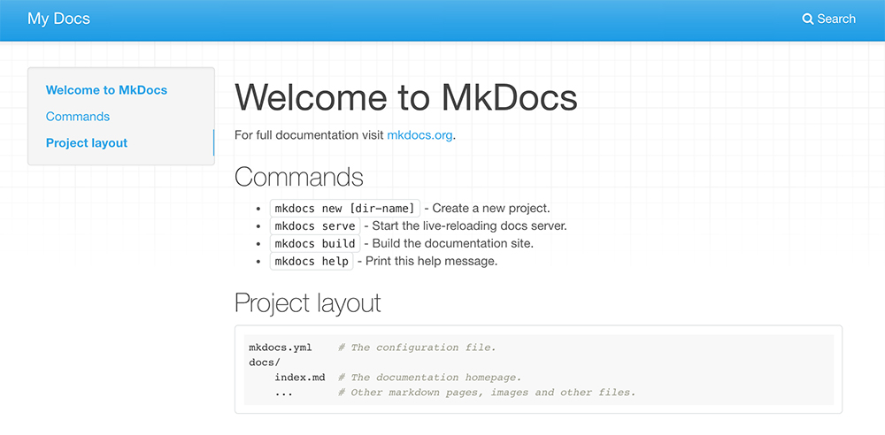

Step 4. Adding Structure
Usually a Fab Academy documentation website will have a page about you, your final project and assignments. Let's make a basic structure that will be enough for the first week of the academy (and probably for the whole course).
- About
- Final Project
- Assignments
- Week 01
The structure above is what we have to translate to a directory structure under docs.
- docs
- index.md
- final-project.md
- assignments
- week01.md
Note the index.md file. It will translate to index.html when HTML is going to be generated. It is usually the file name your web browser is going to look for first when loading a web page from a server. It should be there as an entry point to your documentation website. It will also be our About page.
Create this structure either by using Terminal or the file browser of your system. You can use the following commands in terminal.
cd docs
mkdir assignments
touch final-project.md assignments/week01.md
This will enter the docs directory, then use mkdir (make directory) for assignments and create empty files with the touch command (you add more filenames, separating them with a space, to create many files with one command).

Step 5. Adding Content
At this point you should open your favorite text editor and start adding content. Try adding content similar to the following in your index.md file.
# About

My name is Kris and this is my Fab Academy documentation website. This page will tell you more who I am and what are my intentions.

## Who am I

I am a humman.

## My Intentions

I want to build a CNC machine.
This is Markdown. Every line with a # in front of it is going to become wrapped in <h1> (heading 1) tags. In this case our # Hello! will become the following. Lines starting with ## will be translated to <h2> (heading 2) tags. Also, the first heading (About) is going to be the label of the section in the MkDocs website menu.
Check the Markdown Cheatsheet to learn its syntax. It is one of the easiest markup languages to learn. There are many more uses of it. Try Deckset or Remark to make presentations. Fast.
final-project.md
# Final Project

This page describes my final project idea. It is going to be an automated fishing system. I have made a first working prototype with an Arduino, but the wiring is all over the place and I have decided to improve.

![Final Project Sketch](images/final-project.jpg)
Here we use Markdown way of inserting images. The basic syntax is ![]().
- Exclamation mark.
- Square brackets.
- Round brackets.
Explamation mark tells MkDocs that there will be an image. In the square brackets we add text that should describe the image and will be seen if the image will fail to show up for whatever reason. Finally in the round brackets we enter the path to the image. In this case I made a new directory docs/images where I placed a image called final-project.jpg.
For this to work you also need to create a directory fabacademy-docs/images and put the final-project.jpg image in there.
assignments/week01.md
# Week 01. Principles and Practices

The first week of Fab Academy! I did a sketch of my project and added it to the [Final Project](../final-project.md) page.
Here I use a concept that is called the relative link. Notice the ../ part before final-project.md. Since the week01.md file is in the assignments directory, we have to tell MkDocs to look for the final-project.md file one level up from where week01.md file is. ../ does that - it is a common way to point to a directory one level up from the current directory level.

Step 6. Final Test
Now you should have a ready MkDocs skeleton for your Fab Academy documentation website. Do test and see how it looks like. Navigate to the root of the fabacademy-docs directory and use the following command to launch the MkDocs development server.
mkdocs serve
Open your web browser (Firefox, Chrome or other) and enter http://localhost:8000. You should see the following output.
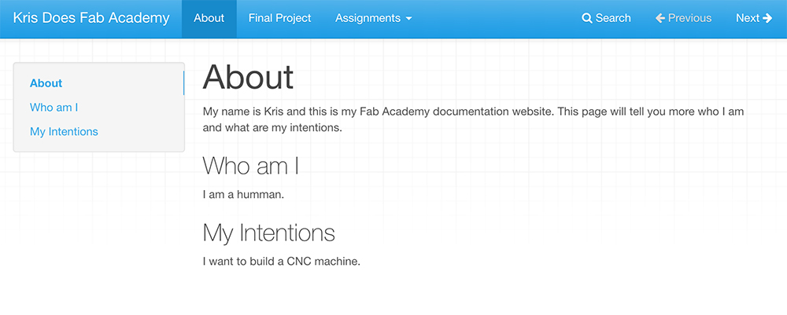

Problems Faced and Solutions
Now that you have a basic skeleton for documenting your Fab Academy progress, there will be a few challenges ahead.
Adding videos is one challenge. The consistent way is to add videos as files and use the <video> tag in Markdown (yes, HTML is allowed in Markdown) to load it as HTML5 video. Loading YouTube or Vimeo videos might be a bit more complicated. There are also Python Markdown plugins that can be used.
(More on that in a following tutorial)
Another problem you will possibly face is the integration of this MkDocs site with the Fab Academy GitLab.
(More on that in a following tutorial)
You might also want to tweak the appearance of your website. Use the official MkDocs documentation website. You should be able to find solutions there.

Sources
- MkDocs Website
- Markdown Cheatsheet

Files
- MkDocs Project

En vez de note es posible utilizar las siguientes etiquetas: summary, info, tip, success, question, warning, failure, danger, bug y quote.

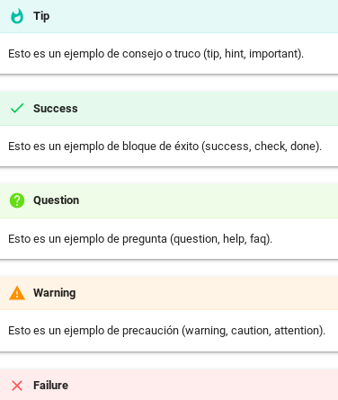

Markdown editor online
https://jbt.github.io/markdown-editor/

https://github.com/mkdocs/mkdocs/wiki/MkDocs-Plugins

