|  |  |  |
| --- | --- | --- |
| 席夫碱2 | 席夫碱3 | 收率 |
|  |  | 88.73% |
| 2a | 3a |  |
|  |  | 81.56% |
| 2b | 3b |  |
|  |  | 66.56% |
| 2c | 3c |  |
|  |  | 64.75% |
| 2d | 3d |  |
|  |  | 67.23% |
| 2e | 3e |  |
|  |  | 75.43% |

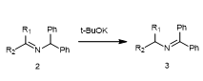，上面是使用叔丁醇钾作催化剂的结果。

下面是微波促进的反应