Paper Title* (use style: paper title)
Subtitle as needed (paper subtitle)

Authors Name/s per 1st Affiliation (Author)
line 1 (of Affiliation): dept. name of organization
line 2-name of organization, acronyms acceptable
line 3-City, Country
line 4-e-mail address if desired
Authors Name/s per 2nd Affiliation (Author)
line 1 (of Affiliation): dept. name of organization
line 2-name of organization, acronyms acceptable
line 3-City, Country
line 4-e-mail address if desired

Abstract— We present DRISHTI, an android application designed to aid the visually impaired in their everyday state of affairs. Ability to see and recognize is one of the most important and rudimentary skills a visually impaired is deprived off. This project is tailor made to provide the ability to identify and recognize objects. We have included three features in this project: Object Recognition, Emotion (facial expression) Recognition and Barcode Scanning. Building on the principles of image processing, convolutional neural networks and data science, we have accomplished a working version of this application which is capable of classifying 100 objects through the object recognition module, 7 emotions through the emotion recognition module and scanning and identification of bar codes of 1000 objects through the barcode scanning module.

Introduction
With a recent surge in Artificial Intelligence systems, applications of the same competant in recognizing objects and emotions(facial expressions) have been of much research interest and have spanned across domains such as interactive customer marketing, robotic interfaces , health monitoring, image & video stabilization, optical character recognition and many more. In light of the substantial role that object and emotion recognition systems have played across such varied domains, it has been a common mistake to generalize the ease of use of such systems for all community groups. Such computer vision systems have not been able to make any substantial impact on those groups which lack the rudimentary skills required to use them. This has served as a motivation for us to develop an application which is specifically configured to cater to the needs of one such group (visually impaired). Our objective is to use deep learning and barcode scanning to span the repertoire of objects that a visually challenged individual is capable to recognizing. In the following sections, we will discuss the currently available systems and solutions, research done, give an overview and description of the modules that we have implemented, analyze and conclude from the results that we have obtained and will finally discuss the future scope of this project.
.

Literature Survey

Object Recognition
Convolutional Neural Networks have been used for classifying images but for a long period, they were capable of classifying just a single object in the image. Inorder to classify multiple objects, one approach is to slide the classifier from left to right, evaluating the corresponding windows and integrate the results together. The aforementioned approach is not feasible for us as we need faster processing and response times. Thus we decided to use YOLO (you only look once) which predicts class probabilities from image pixels and creates bounding boxes.

Emoiton Recognition
Convolutional neural networks have been used in the facial recognition analyses. We have used Kaggle’s Facial Expression Recognition Challenge Dataset. Accuracies ranging from a lower threshold of 0.48 to a higher threshold of 0.61 has been achieved on the aforementioned dataset.

Barcode Scanning
CNN’s have also been used in the facial recognition analyses. We have used Kaggle’s Facial Expression Recognition Challenge.

Esisting Systems
Recently Microsoft has released an application – Seeing AI, which can recognize people and can predict their emotion. The application also offers scanning of barcodes, documents and is capable of recognizing US currency. But the major limitation is that the application is developed only for IOS and has not been developed for Android. This application is not capable of recognizing objects which are likely to be encountered by people in their everyday state of affairs.

Object Recognition

Dataset
We have used the Open Images Dataset V3 which has approximately 9 million URLs to images of more than 1000 images. Out of the several options available we have used the human-verified-image-level annotations for training. We have used the already pre-trained tiny yolo model which is capable of classification of 20 class of objects. Inorder to expand this list to include more relevant objects, we decided to train the model for 80 more object classes. The selection of these classes has been done by taking into consideration factors such as frequency of encounter, resemblance to similar objects, relevance in frequent scenarios and so on. For each class of object, we have used a minimum of 2000 and a maximum of 3000 images for training.

Tiny Yolo Architecture
We have used the tiny yolo architecture instead of the original yolo architecture since the former has faster processing power than the later. As we are going to deploy the model on an android device, we need a model that can process the image at a higher fps to give back results with minimal latency. Tiny Yolo is lightweight with the number of layers being reduced to 15. The architecture can be represented as :

Layer | Kernel | Stride | Output Shape
Input |  |  | (416,416,3)
Convolution | 3X3 | 1 | (416,416,16)
MaxPooling | 2X2 | 2 | (208,208,16)
Convolution | 3X3 | 1 | (208,208,32)
MaxPooling | 2X2 | 2 | (104,104,32)
Convolution | 3X3 | 1 | (104,104,64)
MaxPooling | 2X2 | 2 | (52,52,64)
Convolution | 3X3 | 1 | (52,52,128)
MaxPooling | 2X2 | 2 | (26,26,128)
Convolution | 3X3 | 1 | (26,26,256)
MaxPooling | 2X2 | 2 | (13,13,256)
Convolution | 3X3 | 1 | (13,13,512)
MaxPooling | 2X2 | 1 | (13,13,512)
Convolution | 3X3 | 1 | (13,13,1024)
Convolution | 3X3 | 1 | (13,13,1024)
Convolution | 1X1 | 1 | (13,13,125)

Implementation Details
The Open Images Dataset assigned a unique code to each object category. So our first step was to get the mappings between objects and corresponding codes. Every image in the dataset is given a unique ID. Using this, we obtained text files for each image which contained multiple rows of text with each row containing the class name, xmin, xmax, ymin, and ymax. But yolo requires all it’s metadata to be in xml format. We converted these text files into corresponding xml files while also using the urls to scrape the internet and fetch the corresponding images. Yolo needs the coordinate values in absolute terms but the dataset had values in relative terms. So we used the following conversion to bring the data in the required format.

Xmin/Xmax = Xmin/Xmax * width of image
Ymin/Ymax = Ymin/Ymax * height of image

We then fed the images into the tiny yolo neural network. The system is divided into 7*7 grids with each box containing 2 bounding boxes and corresponding confidence scores. Each bounding box consists of 5 predictions: x, y, w, h, and conﬁdence. Each grid cell also predicts 80 conditional class probabilities, Pr(Classi|Object). Thus the class specific confidence scores are given by :

Output And Results
The model was used to predict the test images present in the Open Images dataset. A collection of 962 images where chosen in such a way that each contained atleast of the classes that the model was trained for. Predicting objects in each of those 962 images, there were 899 instances or images where the predictions about the objects made overlapped with the human verified labels assigned to the images. Thus an accuracy of 93.45% was achieved with the trained model.

Initial parameter setting yield the following proceeding graph where loss is plotted as a function of epochs. The model failed to converge with it getting stuck around a local optimum after a few initial epochs.
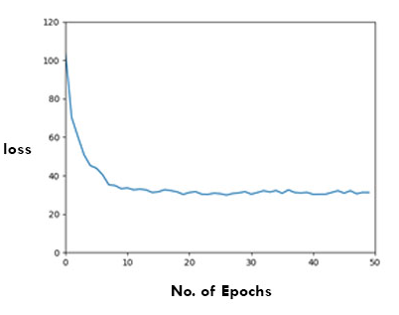

Using tensorflow’s tensorboard, we created a visualization of kernel values and scalar values such as learning rate, accuracy and error loss. This led us to modify the parameters which resulted in a model that converged and reached stabilization point after 60 epochs. The proceeding graph where loss is plotted as a function of epochs illustrates the same.
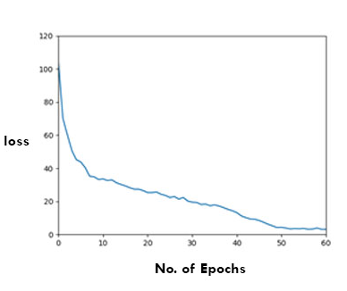

Facial Expression recognition

Dataset
We have used the Fer Dataset which was specifically created for facial expression recognition. The dataset consists of 48x48 pixel grayscale images of faces. We have classified each image (containing a person’s face) into one of the 7 predefined categories. The training images are in the form of pixels separated by spaces in one column of a csv file while the corresponding emotion (a number in the range 0-6) is in the next column. The training set consists of 28,709 examples while the test set consists of 3,589 examples.

Proposed Architecture

Layer | Kernel | Stride | Output Shape
Input |  |  | (48,48,1)
Convolution | 5X5 | 1 | (48,48,128)
MaxPooling | 2X2 | 2 | (24,24,128)
Convolution | 5X5 | 1 | (24,24,256)
MaxPooling | 2X2 | 2 | (12,12,256)
Convolution | 5X5 | 1 | (12,12,512)
MaxPooling | 2X2 | 2 | (6,6,512)
Flat Layer |  |  | (6*6*512)
Dropout Layer |  |  | (0.3*6*6*512)
Flat Layer |  |  | (2048*1)
Flat Layer |  |  | (3072*1)
Flat Layer |  |  | (7*1)

.

Implementation Details
We tried a total of seven cnn models and wrote a class for each. The training was done on a google cloud server with 8 vCPUs and 30 GB ram memory. The training was initially set for 200 epochs but the model which gave the best accuracy reached a stabilization point after 30 epochs. The training took a minimum of 1 to a maximum of 3 days depending on how heavy the model was. We have used rectified linear unit activation function for the all the layers except for the last one.

f(x) = max(0,x)

For the last layer in our best model, we used a softmax activation function:

//softmax equation

Implementation Details
We tried a total of 7 cnn models, with models from 1-6 having three convolutional and three max pooling layers followed by two 3 fully connected layers while model 7 had 4 fully connected layers instead of 3. For all 7 models, we used rectified linear unit activation function for all the layers except the last layer and varied the number of kernels. For the 1st three models, we used tanh as the activation function for the last layer. What we observed was as we increased the number of kernels from Model1 to Model2, the accuracy increased while the error rate dipped but as we increased from Model2 to Model3, the accuracy decreased. Thus we concluded that we could achieve a maximum accuracy of 53.38% with Model2. From Models 4-6, we used softmax activation function for the last year and progressively added more filters in multiples of 2 to the preceding layers. The accuracy increased linearly with the number of filters used. However when we added one more full connected layer, the accuracy decreased. The accuracies for all the models tried have been summarized in the following graph.

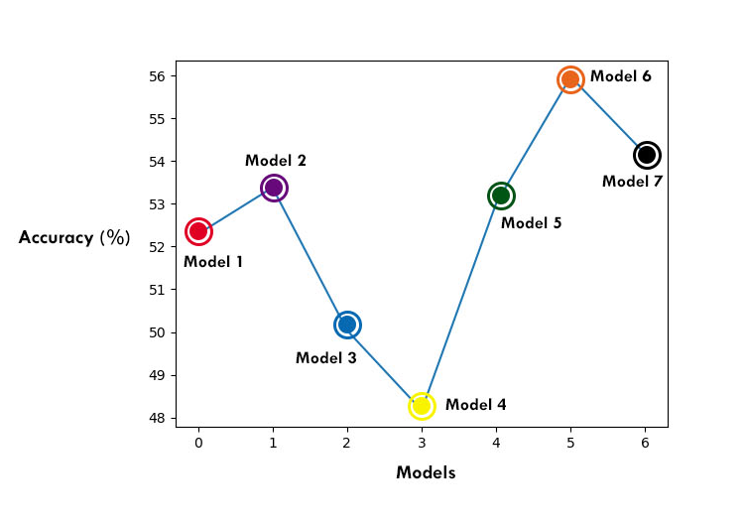

The learning rate was initially set to 0.001. But we observed that the model got stuck at a local optimum without being able to escape from the same. When we increased the learning rate to 0.01, the model was able to go beyond the local optimum and finally converged and stabilized around the global optimum. Thus the best accuracy of 55.97% was achieved with Model 6 where the learning rate was set to 0.01. The loss function values as a function of epochs is plotted as follows:

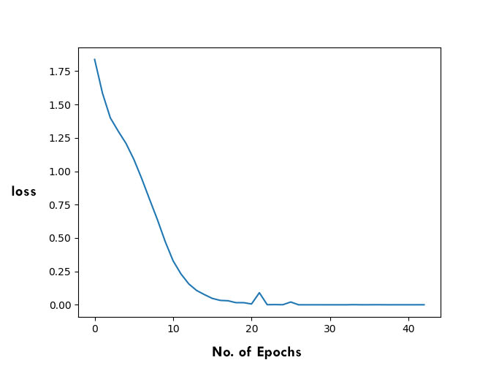

Barcode Scanning
//Content

Integration

The object recognition module, emotion (facial expression) recognition module and barcode scanning module integrated together will facilitate a user in recognizing a diverse variety of objects spanning across multiple domains. Inorder to facilitate easy use, each of these modules can be activated with a single swipe. – right swipe for object and emotion(facial expression) modules and left swipe for barcode scanning module. The high level architectures have been shown below:

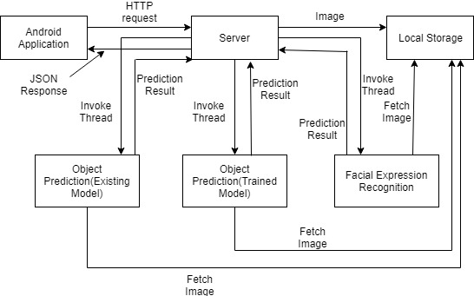

References
The template will number citations consecutively within brackets [1]. The sentence punctuation follows the bracket [2]. Refer simply to the reference number, as in [3]—do not use “Ref. [3]” or “reference [3]” except at the beginning of a sentence: “Reference [3] was the first ...”
Number footnotes separately in superscripts. Place the actual footnote at the bottom of the column in which it was cited. Do not put footnotes in the reference list. Use letters for table footnotes.
Unless there are six authors or more give all authors’ names; do not use “et al.”. Papers that have not been published, even if they have been submitted for publication, should be cited as “unpublished” [4]. Papers that have been accepted for publication should be cited as “in press” [5]. Capitalize only the first word in a paper title, except for proper nouns and element symbols.
For papers published in translation journals, please give the English citation first, followed by the original foreign-language citation [6].

- G. Eason, B. Noble, and I.N. Sneddon, “On certain integrals of Lipschitz-Hankel type involving products of Bessel functions,” Phil. Trans. Roy. Soc. London, vol. A247, pp. 529-551, April 1955. (references)
- J. Clerk Maxwell, A Treatise on Electricity and Magnetism, 3rd ed., vol. 2. Oxford: Clarendon, 1892, pp.68-73.
- I.S. Jacobs and C.P. Bean, “Fine particles, thin films and exchange anisotropy,” in Magnetism, vol. III, G.T. Rado and H. Suhl, Eds. New York: Academic, 1963, pp. 271-350.
- K. Elissa, “Title of paper if known,” unpublished.
- R. Nicole, “Title of paper with only first word capitalized,” J. Name Stand. Abbrev., in press.
- Y. Yorozu, M. Hirano, K. Oka, and Y. Tagawa, “Electron spectroscopy studies on magneto-optical media and plastic substrate interface,” IEEE Transl. J. Magn. Japan, vol. 2, pp. 740-741, August 1987 [Digests 9th Annual Conf. Magnetics Japan, p. 301, 1982].
- M. Young, The Technical Writer’s Handbook. Mill Valley, CA: University Science, 1989.

High Level Architecture

