EIR3705 Customer Registration: New Session Cookie

Summary

What
A new Cust Reg Session Cookie (rztovDDKjcKR7pWb) is being introduced to replace the legacy/existing Cust Reg Session Cookie (TINTCYALF).

Why
The existing Cust Reg Session Cookie (TINTCYALF) is vulnerable due to insufficient encryption strength.
A new Cust Reg Session Cookie with sufficient encryption will be introduced to remediate the vulnerability. The new Cust Reg Session Cookie is named “rztovDDKjcKR7pWb” and will be the same in all environments.

Who
All integrating applications must cease use of the TINTCYALF Session Cookie.
Integrating applications can either upgrade to the new Cust Reg Session Cookie or to the CIAM Session Token (EIR 9385). There is no impact to integrating applications that do not use the Cust Reg Session Cookie.

When
The new Cust Reg Session Cookie is expected to be available in PROD as a part of Cust Reg Release 26.2.2. The tentative schedule is below:
- SIT: mid-January​
- CAT: early February
- PROD: 2/19/26
Cust Reg will continue to support the existing TINTCYALF Session Cookie for a period of time (TBD, but likely through the end of March 2026) per CISO/CASI direction. All impacted applications will be expected to come up with a plan/schedule. The Cust Reg team will announce when the existing TINTCYALF Session Cookie will stop being issued in each environment. Appropriate time will be allotted for application teams to confirm.

Background

Vulnerability
Cust Reg has been flagged with a DevSecOps "Xray Critical Finding" for the encryption strength of the Cust Reg Session Cookie (TINTCYALF) currently used to manage Single-Sign On to USPS.com. Please reference CWE-327 (https://cwe.mitre.org/data/definitions/327).
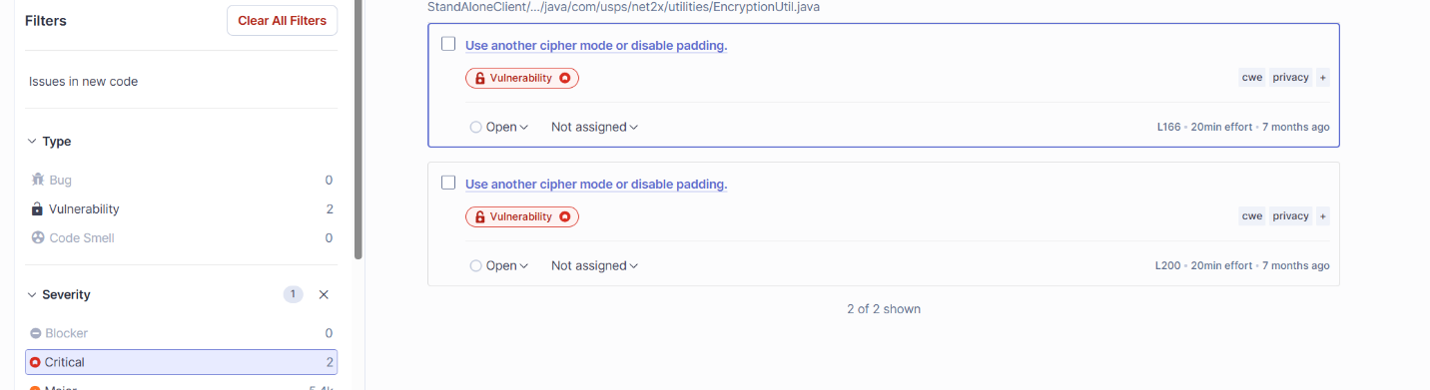
The current Session Cookie uses AES/CBC/PKC5PADDING encryption, which has been flagged. As a part of ongoing refactoring, the Cust Reg Dev team has already developed and implemented in DEV/SIT a New Session Cookie that uses stronger AES/GCM/NoPadding encryption (the New Session Cookie name is encrypted and is a PBKDF2-generated value. That value is “rztovDDKjcKR7pWb”).
Per DevSecOps rules, Critical Xray Blockers may prevent future Application Builds. Cust Reg will work with NCT on a vulnerability exception with NCT/DevSecOps team through March 31, 2026.

Implementation Options
All impacted integrating applications who utilize Single-Sign On (SSO) on USPS.com will have a choice:
- If the integrating application is already using CIAM for SSO (e.g. CNS, Informed Delivery, etc), the application should ensure that they do not rely on the TINTCYALF Cust Reg Session Cookie.
  - These applications should only reference the CIAM/Ping Session Token.

- If the integrating application still relies on the TINTCYALF Cust Reg Session Cookie, the application is encouraged to migrate to the CIAM Session Token (long-term goal for USPS.com SSO).
  - In the meantime, the application can choose to implement the new Cust Reg Session Cookie, but must do so by March 31, 2025.

Validation Process

Integrating Apps Moving to CIAM Session Token
For Integrating Applications who do not plan to use Cust Reg Session Cookie moving forward (i.e. rely only on the CIAM Session Token for USPS.com SSO), the following steps can validate that they are not reliant on the existing TINTCYALF Cust Reg Session Cookie by performing the following steps:
- Uninstall/Remove your existing Cust Reg EntRegClient.zip package (StandAloneClient-#.#.#.jar, EntRegWebFilters-#.#.#.jar, EntRegTAI-#.#.#.jar)
- Access the new Cust Reg EntRegClient.zip package from Artifactory (currently available in all environments).
- Only install the following .jar files:
  - StandAloneClient-10.0.14.jar (Java) OR StandAloneClientJakarta-10.0.14.jar (Jakarta)
- Do not install the following .jar files:
  - EntRegWebFilters-#.#.#.jar (Java) OR EntRegWebFiltersJakarta-10.0.14.jar (Jarkarta)
  - EntRegTAI-#.#.#.jar (Java only)
If your application has issues after the latest version of the StandAloneClient-10.0.14.jar is installed, then your application is likely still relying on the existing TINTCYALF Cust Reg Session Cookie and additional changes are needed to reference the new Cookie name.

Integrating Apps Migrating to New Cust Reg Session Cookie
For Integrating Applications who plan to migrate to the new Cust Reg Session Cookie moving forward, the following steps must be taken to be able to use the new Cookie:
- Uninstall/Remove your existing Cust Reg EntRegClient package (StandAloneClient-#.#.#.jar, EntRegWebFilters-#.#.#.jar, EntRegTAI-#.#.#.jar)
- Access the new Cust Reg EntRegClient .jar files from Artifactory (currently available in all environments).
- Install the following .jar files:
  - StandAloneClient-10.0.14.jar (Java) or StandAloneClientJakarta-10.0.14.jar (Jakarta)
  - EntRegWebFilters-10.0.14.jar (Java) or EntRegWebFiltersJakarta-10.0.14.jar (Jarkarta)
  - EntRegTAI-10.0.14..jar (Java only; but optional, most applications should not need this)
After the new .jar files are installed, your application should see both the existing TINTCYALF Cust Reg Session Cookie and the new Cust Reg Session Cookie (rztovDDKjcKR7pWb).
Cust Reg will retire the existing TINTCYALF Cust Reg Session Cookie after March 31, 2026. Please ensure that any internal references to TINTCYALF are replaced with rztovDDKjcKR7pWb.

Detailed Schedule:
- February 2, 2026 (DONE):
  - Cust Reg will begin publishing the new (rztovDDKjcKR7pWb) Cookie in CAT. The old (TINTCYALF) will continue to be published in CAT.
- Thursday, February 19, 2026:
  - Cust Reg will begin publishing the new (rztovDDKjcKR7pWb) Cookie in PROD. The old (TINTCYALF) will continue to be published in PROD.
- Tuesday, March 3, 2026:
  - Cust Reg will stop publishing the old (TINTCYALF) Cookie in DEV and SIT. All applications teams should test to confirm that all SSO-related workflows are working with only the new (rztovDDKjcKR7pWb) Cookie.
- Mid-March (Tentative, pending DEV & SIT results):
  - Cust Reg will stop publishing the old (TINTCYALF) Cookie in CAT. All applications teams should test to confirm that all SSO-related workflows are working with only the new (rztovDDKjcKR7pWb) Cookie.
- March 31, 2026 (Tentative, pending CAT results):
  - If all applications have confirmed functionality in CAT without the old (TINTCYALF) Cookie, Cust Reg will stop issuing the old (TINTCYALF) Cookie in PROD. Only the new (rztovDDKjcKR7pWb) Cookie will be issued in PROD.

