12/11/2015

Aragona, M.;Baltezar, P.;Barros, M.;Dunphy, H.;Rodriguez, J.

Humboldt State University

Bathymetry of Eureka Slough

GSP. 370 Final Project Assessment

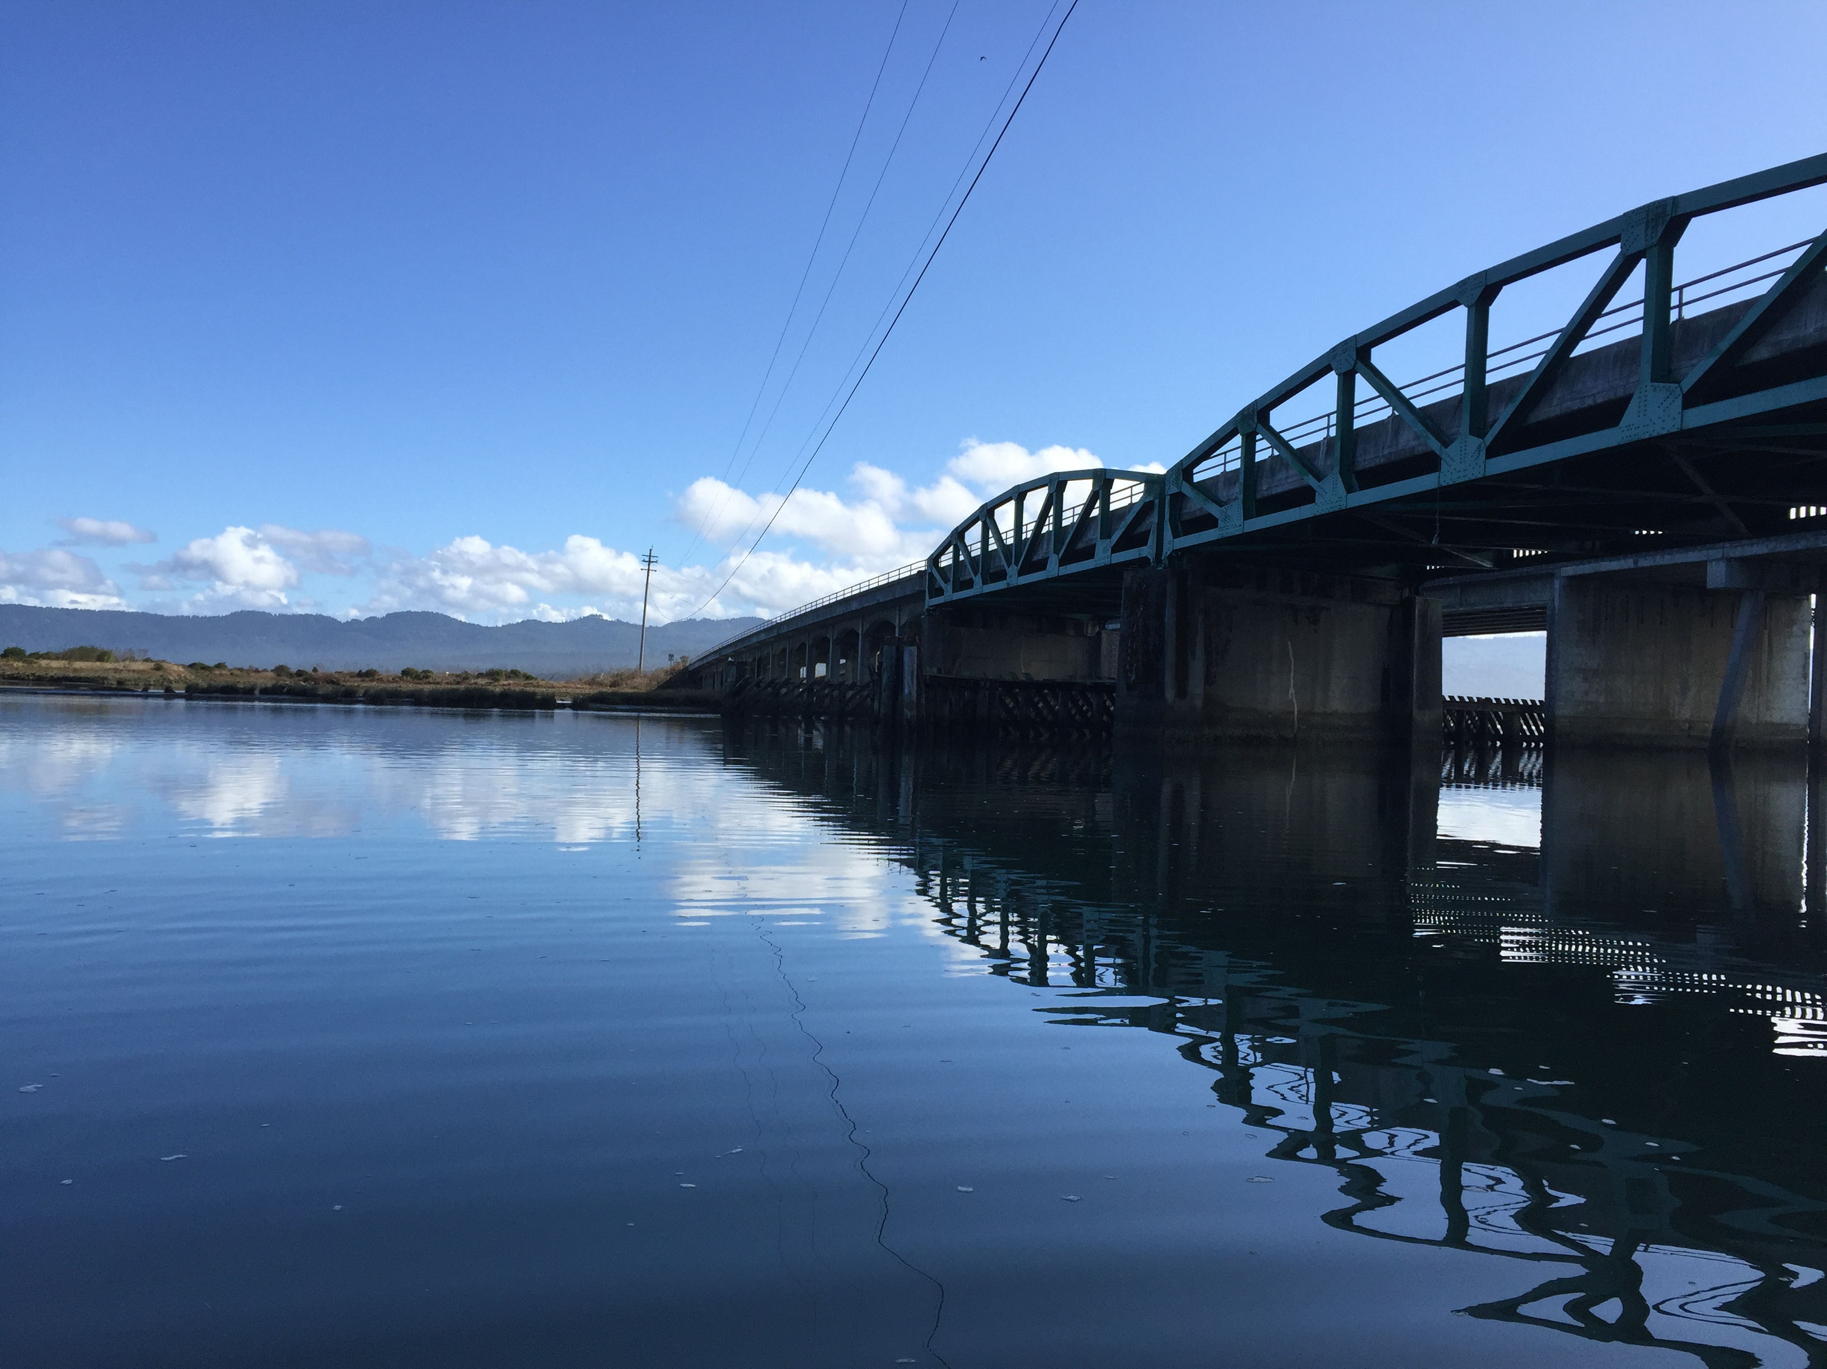

Table of Contents

**Introduction** 3

Figure 1 4

Figure 2 5

**Materials and Methods** 5

**Results** 6

Figure 3 6

Figure 4 7

Figure 5 7

Table 1 8

Table 2 8

Table 3 9

**Conclusion/Discussion** 9

**References** 10

**Acknowledgements** 10

**Abstract**

Accurate bathymetric measurements are pertinent information regarding nautical travel due to varying environmental changes. Bathymetric surveys are a main component of nautical charts that provide ships the most safe, economical, and shortest route (Basu 2002). Former techniques for gathering bathymetric data consisted of utilizing a knotted lead rope to remote Light Detection and Ranging (LIDAR) systems. However, LIDAR data is difficult to obtain, and when it is available it usually covers the coast or major bodies of water, not inland sloughs. This proves the difficulty in obtaining accurate LIDAR data for the slough of interest. Another disadvantage is that due to runoff, the flow of water, and movement of tides, sediment is deposited into the river and can obscure the LIDAR signal. To correct this disadvantage, echosounder measurements were taken to obtain more accurate readings of the slough floor without heaving sediment interference. Our specific study area comprised of the two edges of the river, as well as extending to the south edge of the abandoned railway, and the north edge of the existing freeway entering the city of Eureka as seen in figure 1. The 2-D model of the Eureka Slough bathymetry was visualized through the use of ArcMap, and the 3-D model comprised from ArcScene. These models were generated from three interpolation methods such as: Inverse Distance Weighted (IDW), Spline, and Kriging. The three model methods were manipulated with different property settings. In order to delineate the best model the values had to be compared based on the least amount of error. The Root Mean Square (RMS) values are able to take the difference between known and predicted points and provide an excellent indicator of ideal modeling. The modeling method with the least amount of Root Mean Square Error (RMSE) was the Optimized Regular Spline with Tension with a RMSE value of 1.498208413.

# **Introduction**

Bathymetry is the study of the underwater depths of the seafloor, in which bathymetric surveys are essential components to nautical navigations (Basu at al, 2002). Bathymetric surveying is becoming increasingly important due to the need for habitat mapping and conservation of oceanic ecosystems. Fortunately, advances in remote sensing technology has allowed for the advent of LIDAR. According to Dost et, al, monitoring lake bathymetry is becoming increasingly relevant in advances in Global Positioning Systems (GPS), geospatial analysis tools, sonar sounders ,and remote sensed data. Bathymetric LIDAR typically makes precise measurements of sea floor and riverbed elevations surfaces (NOAA, 2015). The estimation of the elevation of a surface can utilize LIDAR to retrieve sample points of an area. A surface modeling technique called Interpolation is the estimation of surface values at unsampled points based on known surface values of surrounding points (ESRI, 2015). There are two categories of interpolation, deterministic and geostatistical. The deterministic technique creates a surface based on measured points or mathematical functions, and geostatistical is based on statistics. Surface modeling is an estimate of a surface based on point samples, which can be used to make continuous measurements across an unknown surface.

In this project, bathymetric data was gathered for the Eureka Slough located right before incoming traffic enters the city of Eureka, CA in the upper north-east of town (figure 2). There’s no known LIDAR data readily available to analyze the features of the slough, and for this reason, a model was comprised using a handheld echosounder and a GPS unit. The drawback to using LIDAR data is turbidity of the water, sediment is disrupted and does not allow the LIDAR to penetrate far below the surface. This could cause inaccurate measurements. To adjust for accuracy, surface modeling interpolation techniques were utilized to aid in the construction of the surface visualization.

This analysis will demand interpolation techniques to generate both 2-D and 3-D models of the area of interest, where a polygon perimeter was surmised by the two edges of the river, as well as extending to the south edge of the abandoned railway, and the north edge of the existing freeway entering the city of Eureka  (figure 1). The 2-D Digital Elevation Model (DEM) was created in ArcMap from the interpolation results, and the 3-D image is portrayed from the resulting DEM in ArcScene. The center point of this area has a geographic coordinate of 40.806141, -124.141996. The goal is to test the accuracy of these techniques and compare them to each other. The interpolation methods are as followed: Inverse Distance Weight (IDW), Spline and Kriging. The IDW and Spline are deterministic techniques and Kriging is a geostatistical technique. The intent is to improve these results and find the true contour boundaries of the Eureka Slough bathymetry.

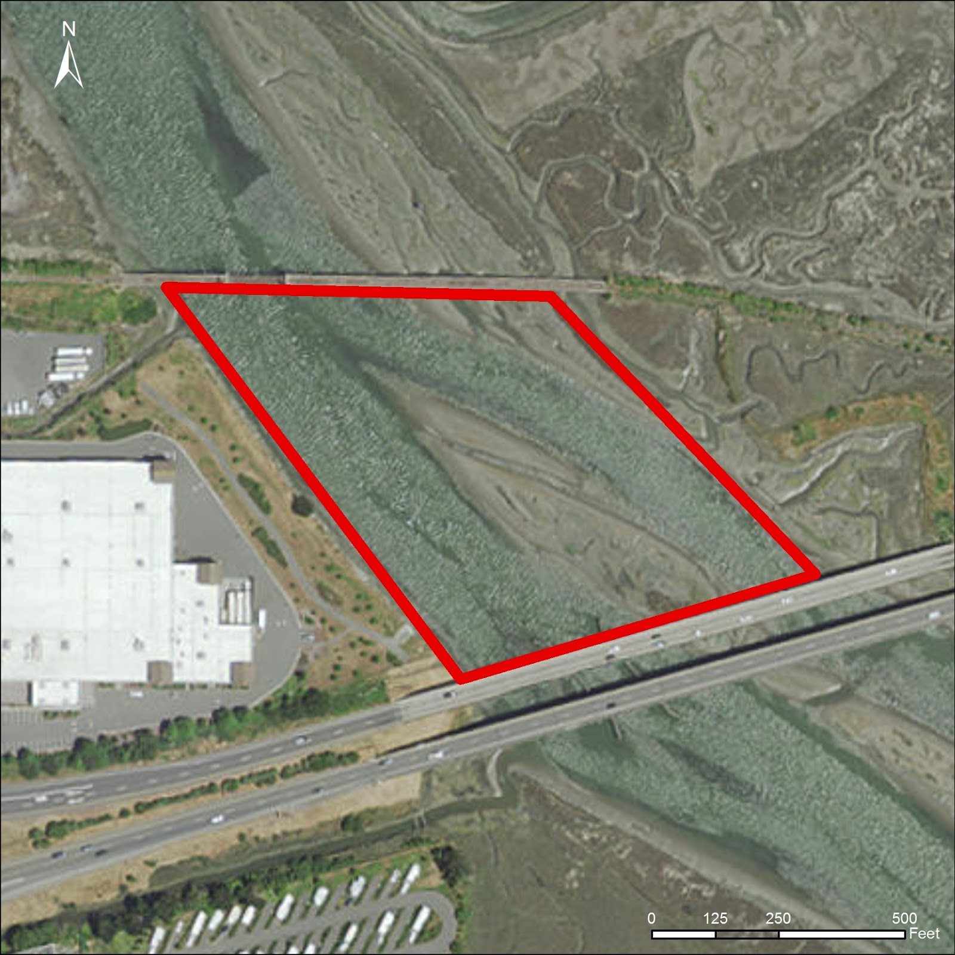

Figure 1**:** The Eureka Slough’s area of interest for this analysis.

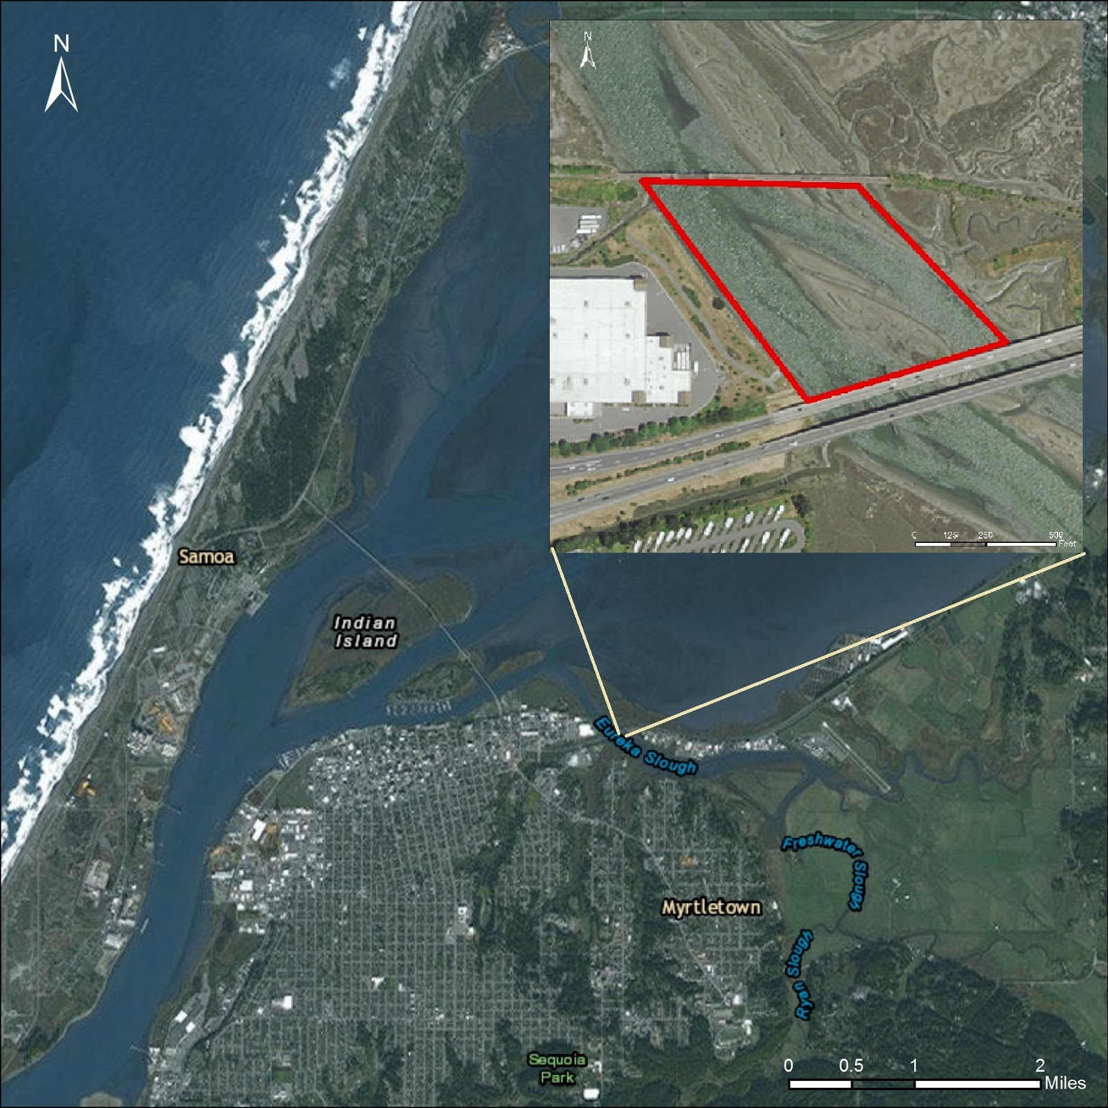

Figure 2**:** Location of Eureka Slough as indicated above.

# **Materials and Methods**

In order to obtain the sample points, a strategy had to be devised to access the study area. A canoe was rented from the Humboldt State University Center of Activities. A Vexilar Inc. Hand Held Sonar unit was used to obtain the depth (Z value) of each sample point, while the X and Y values were obtained with a Trimble Juno SB Unit. Based on the nature of the analysis, interpolation methods were used in order to approximate elevation values across the entire surface of the slough. The X, Y, and Z values were then manipulated using the three different interpolation settings. The surface values were approximated through the use of the Inverse Distance Weighted (IDW), Spline, and Kriging Method. The interpolation method inputs were then optimized by attempting to improve any of the predicted error values with different model settings (tables 1-3). A cross comparison of each method was executed in order to obtain the ideal modeling method.

The optimization for each of the methods were executed by seeking the lowest root mean square error (RMSE). For the first interpolation created, IDW, the first parameter to be changed is the sector type. This is done by changing the maximum and minimum neighbors in the same trial run, in order to find a combination that resulted in the lowest RMSE. Next, the major and minor semi axis were modified to enhance the optimization. When the RMSE started to be more constant, the previous parameters were changed again to see if the error would decrease. If this condition was met, all the parameters were re-modified, otherwise the optimization was concluded. The same methodology was applied for the other two methods. However, the parameters were quite different. In the spline method, the kernel function must also be selected by the user. In this case, the value of the best optimization was the spline method with tension. Furthermore, for the kriging method, parameters were set to incorporate smoothness, which in this case, a value of zero provided a decreased RMSE.

# **Results**

The three model methods were manipulated with different property settings. In order to delineate the best model the values had to be compared based on the least amount of error. The Root Mean Square (RMS) values are able to take the difference between known and predicted points and provide an excellent indicator of ideal modeling. The modeling method with the least amount of Root Mean Square Error (RMSE) was the Optimized Regular Spline with Tension with a RMSE value of 1.498208413.

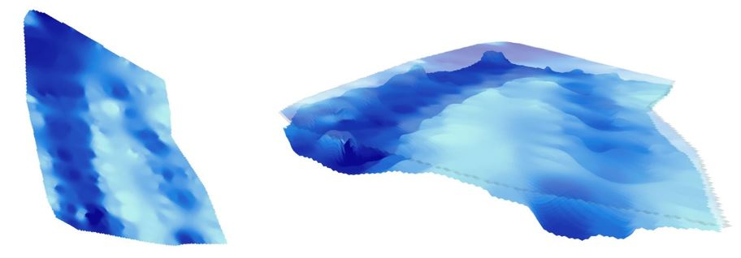

Figure 3**:** 2-D and 3-D models of IDW interpolation.

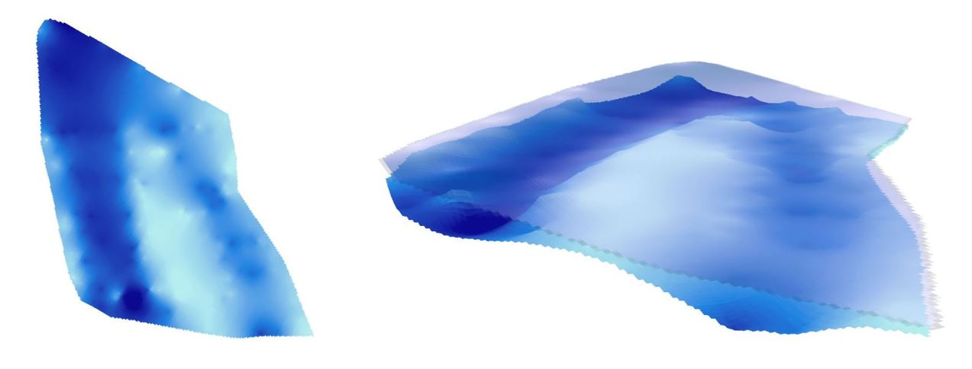

Figure 4**:** 2-D and 3-D models of Kriging interpolation.

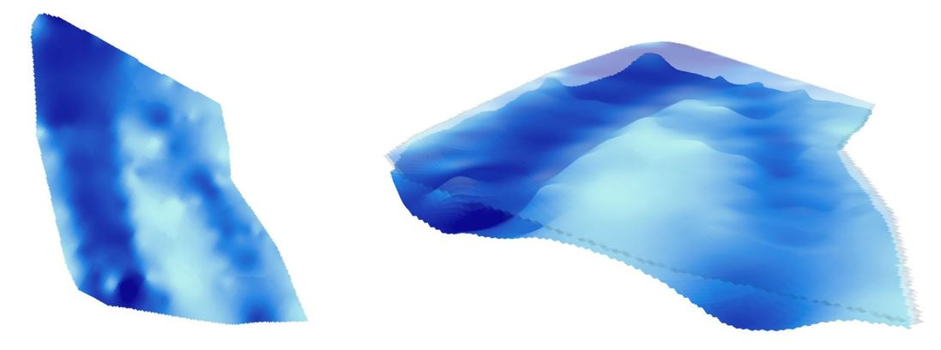

Figure 5**:** 2-D and 3-D models of Spline interpolation.

Table 1**:** Optimized IDW Results

|  |  |
| --- | --- |
| **Optimized IDW** | |
| **Power** | 4.093177205 |
| **Neighborhood Type** | Standard |
| **Maximum Neighbors** | 20 |
| **Minimum Neighbors** | 5 |
| **Sector Type** | 1 Sector |
| **Angle** | 0 |
| **Major semiaxis** | 30 |
| **Minor Semi Axis** | 50 |
| **RMSE** | 1.915385918 |

Table 2**:**  Optimized Kriging Results

|  |  |
| --- | --- |
| **Optimized Kriging** | |
| **Type** | K-Bessel (Smoothing =0) |
| **Root-Mean-Square Standardized** | 0.708995994 |
| **Mean Standardized** | 0.00435641 |
| **Average Standard Error** | 2.387507879 |
| **Root-Mean-Square** | 1.689166105 |

Table 3**:**  Optimized Spline Results

|  |  |
| --- | --- |
| **Optimized Regular Spline** | |
| **Kernel Function** | Spline with Tension |
| **Kernel Parameter** | 0.129303609 |
| **Maximum Neighbors** | 16 |
| **Minimum Neighbors** | 1 |
| **Sector Type** | 1 Sector |
| **Angle** | 0 |
| **Major semi axis** | 70 |
| **Minor Semi Axis** | 70 |
| **RMSE** | 1.498208413 |

# **Conclusion/Discussion**

During the data collection phase, human errors were influenced and intensified by environmental conditions, time constraints, and cost. Collecting marine data is known to be a difficult task, this is due to its extreme environmental fluctuations (Basu 2002). The canoes used for this task didn’t possess engines, thus data collection proved to be less precise and time-consuming. Throughout the day, the tide fluctuates a great deal between low and high. The initial data points were collected during low tide, but as the day progressed, so did the tide. This means that the depth, or the Z values, increased as well. These environmental changes fluctuated the river’s depth, decreasing the precision of the collected data as the day progressed.

The instruments that were used to collect data consisted of a Trimble Juno SB Unit and a Vexilar Inc. Hand Held Sonar unit. Both of these instruments were used simultaneously to obtain the lat/long coordinates (X and Y data), as well as the depth (Z-value). However, the echosounder isn’t a precise instrument and exhibited collection error as a result of canoe movement from river flow and wind strength, thus each data point wasn’t collected at its initial location. Another error that arose was the amount of data points collected, which was approximately just over 200 data points. However, for the size of the area of interest, well over 2,000 points would have been ideal for the interpolation methods to produce a highly accurate model of the bathymetry. Another source of error could be the accuracy of the GPS unit. GPS signals can fluctuate in accuracy depending on the receiving signal, and the canoe is in constant motion, which the geographical accuracy is greatly reduced. In this study, one researcher took a waypoint while another collected the sonar data. Great effort was placed into quickly recording these data points as close to the proximity of the respective locations as much as possible. Regardless, the amount of errors encountered in this study did not affect the production of a 3-D model of the Eureka Slough that is far more accurate than the absence of LIDAR data. Regardless as to how many errors have occurred from this analysis, there is no readily available data suggesting how accurate these models are. Another method to possibly successfully execute the model is to utilize Unmanned Aircraft Vehicles (UAVs) which have a greater capacity for 3-D modeling. UAVs are able to produce high resolution georeference orthophotos in order to create highly detailed DEMs. This would allow for a more integrated environment to process aerial imagery.

# **References**

Basu, A. & Shivani, M.“Error detection of bathymetry data by visualization using GIS*”. ICES Journal of Marine Science*, 59: 226–234. 2002

B.M. Costa, T.A. Battista, S.J. Pittman. “Comparative evaluation of airborne LiDAR and ship-based multibeam SoNAR bathymetry and intensity for mapping coral reef ecosystems”. *ELSEVIER.* (2009). Print.

Dost. R.J.J and C.M.M. Mannaerts. “GENERATION OF LAKE BATHYMETRY USING SONAR, SATELLITE IMAGERY AND GIS.” *International Institute for Geo-Information Science and Earth Observation (ITC).* (2005). Print.

Hamano, A.,Tanoue, A. & Kieser, R. “The three-dimensional GIS using sonar information for coastal Fisheries”. (2005). *ICES CM2005/U:19.* Print.

Hilldale, R. and Raff, D.“Assessing the Ability of Airborne LiDAR to Map River Bathymetry”. [*Earth Surface Processes and Landforms*](http://www.researchgate.net/journal/1096-9837_Earth_Surface_Processes_and_Landforms) (Impact Factor: 2.85). 04/2008; 33(5):773 - 783.

National Oceanic and Atmospheric Administration. (NOAA) (2015). What is LIDAR? *Ocean Facts*. Retrieved from <http://oceanservice.noaa.gov/facts/lidar.html>

# **Acknowledgements**

Special thanks to Nick Malloy for being able to provide technical support and guidance with the content of the surface modeling process.