Homework12

Jun Rao

11/2/2020

Principal components analysis. The goal of this homework is to use PCA for dimensionality reduction in a data set of handwritten digit images.

library(ggplot2)  
library(data.table)  
dt<- fread("zip.train.gz")

1.use prcomp(scale=TRUE) on 100 rows of the zip.train data from the ESL book (10 from each class). Make a ggplot with a geom_text that shows each row with its corresponding class label (x=PC1, y=PC2, label=class). Do the classes cluster together in the plot?

sub.dt <- data.table()  
  
index_seq <- sort(unique(dt$V1))  
  
for (index in index_seq) {  
  
 sub <- subset(dt, dt$V1 == index)  
 row.dt <- sub[sample(nrow(sub), 10),]  
  
 # rotation.dt <- rbind(rotation.dt,temp.dt)  
 sub.dt <- rbind(sub.dt,row.dt)  
}  
  
  
pc.fit <- prcomp(sub.dt)  
  
class <- rep(0:9, each=10)  
  
PC1 = pc.fit[["rotation"]][,1]  
PC2 = pc.fit[["rotation"]][,2]  
  
digit.dt <- data.table(  
 PC1 = PC1,  
 PC2 = PC2,  
 class  
)

ggplot()+  
 geom_text(aes(x=PC1, y=PC2, label=class),  
 data=digit.dt) +   
 xlim(-0.15,0.15) + ylim(-0.15,0.15)

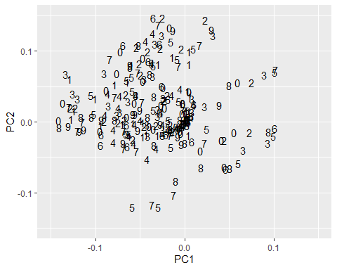

***Yes. It is cluster***

2.For each number of principal components from 1 to 100, compute the reconstruction error (sum of squares between the data and model). Then plot y=error as a function of x=number of components. Is the reconstruction error zero at 100 components as expected?

max.components <- 100  
  
error.dt <- data.table()  
  
for (component in 1:max.components) {  
 lambda.vec <- pc.fit$x[,1] ## this is lambda from the book!  
 PC <- pc.fit[["rotation"]][,1]  
 PC.mat <- matrix(PC, nrow=nrow(sub.dt), ncol=ncol(sub.dt), byrow=TRUE)  
 mean.vec <- colMeans(sub.dt)  
 mean.mat <- matrix(mean.vec, nrow=nrow(sub.dt), ncol=ncol(sub.dt), byrow=TRUE)  
 pred.mat <- mean.mat + PC.mat * pc.fit[["x"]][,1]  
 temp.error.dt <- data.table()  
 temp.error.dt[, error := sum( (pred.mat - sub.dt)^2)/component]  
 temp.error.dt[, components := component]  
 temp.error.dt[, name := "prcomp/2"]  
   
 error.dt <- rbind(error.dt,temp.error.dt)  
   
}  
ggplot()+  
 geom_line(aes(x=components, y=error),  
 error.dt)

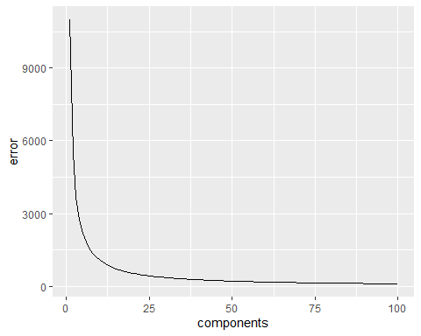

***Yes. The reconstruction error zero at 100 components as we expected.***

3.Choose one image/row from the 100 data you used in problem 1. For each number of components in {1, 5, 10, 50, 100} plot the reconstruction of that image in a different panel, using geom_tile. For comparison also include a panel for the original image. Is the original image equal to the model with 100 components, as expected?

obs.i <- 1  
#Choose one image/row from the 100 data you used in problem 1  
sub.one.image <- sub.dt[V1== obs.i,]  
  
pixels <- c(1,5,10,50,100,256)  
  
pr.one.image <- prcomp(sub.one.image, rank=2)  
  
all.digit.list <- list()  
  
for (n.pixels in pixels) {  
   
  
 all.digit.list[[paste(n.pixels)]] <-   
 data.table(  
 n.pixels,  
 intensity=pr.one.image$center + pr.one.image$rotation[,1] *pr.one.image$x[obs.i,1],  
 row=rep(1:n.pixels, n.pixels),  
 col=rep(1:n.pixels, each=n.pixels)   
 )  
  
}

all.digit.dt <- do.call(rbind,all.digit.list )  
  
ggplot()+  
 facet_grid(n.pixels ~ .)+  
 geom_tile(aes(col, -row, fill=intensity),data=all.digit.dt) +  
 scale_fill_gradient(low="black", high="white")

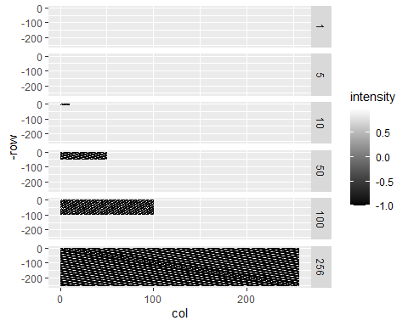

***We used 256 to represent the original image.***

***Yes. the original image equal to the model with 100 components, as expected***

Your task this week is to implement a function PCA which computes principal components analysis “from scratch” using the base::svd function in R. Use the text and equations in the book, and make sure to center each column before using svd, via scale(X, center=TRUE, scale=FALSE). Use can use u %*% diag(d) to convert the svd output to the principal components matrix (rotation element of prcomp output). Use your function on the same data set as problem 1 above. Plot the reconstruction error as in problem 2 using different colors/sizes for different functions (e.g., black=prcomp/2, red=PCA/1). Does your function result in the same values for the reconstruction error?

pca <- function(dt){  
 #center each column  
 sca.dt <- scale(dt, center=TRUE, scale=FALSE)  
 #calculate the Covariance matrix  
 cov.sca.dt <- cov(sca.dt)  
  
 #Singular value decomposition  
 svd.dt <- svd(cov.sca.dt)  
   
 svd.value <- svd.dt$d  
 svd.vector <-svd.dt$u  
   
 order_value <- order(svd.value,decreasing = T)  
 values <- svd.value[order_value]  
 valueSum <- sum(values)  
 cumVar <- cumsum(values)/valueSum * 100  
   
 order_vector <- svd.vector[,order_value]  
   
 principal <- sca.dt %*% order_vector  
  
  
 return(list(PCA=principal, cumVar=cumVar ))  
}  
  
  
  
my.pc.fit <-pca(sub.dt)  
  
  
my.error.dt <- data.table()  
  
for (component in 1:max.components) {  
 temp.error.dt <- data.table()  
 temp.error.dt[, error := sum( my.pc.fit$cumVar[1:max.components])/component]  
 temp.error.dt[, components := component]  
 temp.error.dt[, name := "PCA/1"]  
 my.error.dt <- rbind(my.error.dt,temp.error.dt)  
}  
  
final.error.dt <- data.table()  
  
final.error.dt <- rbind(error.dt,my.error.dt)  
  
  
ggplot()+  
 geom_line(aes(x=components, y=error, color = name),  
 final.error.dt)

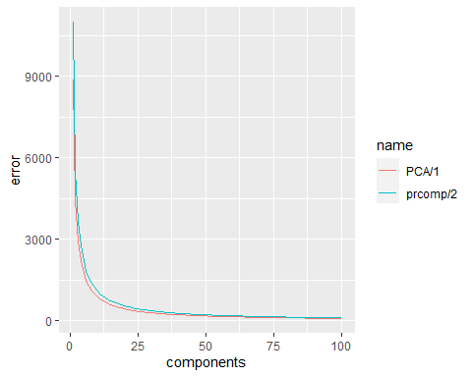

***Yes. My function isthe same values for the reconstruction error.***