Homework13

Jun Rao

11/10/2020

The goal of this homework is to use an auto-encoder to learn a low dimensional nonlinear mapping of a high dimensional data set and compare to the PCA linear mapping.

library(keras)

library(digest)

library(ggplot2)  
library(data.table)  
library(tidyverse)

1.first select 100 rows of the zip.train data from the ESL book (10 from each class).

# use data.table::fread to read the compressed CSV data file into R as a data table.  
dt<- fread("zip.train.gz")  
  
sub.dt <- data.table()  
  
index_seq <- sort(unique(dt$V1))  
  
for (index in index_seq) {  
  
 sub <- subset(dt, dt$V1 == index)  
 row.dt <- sub[sample(nrow(sub), 10),]  
  
 sub.dt <- rbind(sub.dt,row.dt)  
}  
  
sub.dt$class <- rep(0:9, each=10)

For these data use the keras R package to define an auto-encoder with only one hidden layer with two units, using keras::keras_model_sequential and keras::layer_dense. How many parameters are there to learn in this nonlinear model? How many parameters are there to learn in the corresponding PCA linear model with rank=2? Is the number of parameters in the auto-encoder larger as expected?

# use data.table::fread to read the compressed CSV data file into R as a data table.  
n.input <- ncol(sub.dt)  
n.code.units <- 2  
  
model <- keras::keras_model_sequential() %>%  
 keras::layer_dense(  
 input_shape = n.input, units = n.code.units, name="code") %>%  
 keras::layer_dense(units = n.input)  
  
summary(model)

## ________________________________________________________________________________  
## Layer (type) Output Shape Param #   
## ================================================================================  
## code (Dense) (None, 2) 518   
## ________________________________________________________________________________  
## dense_1 (Dense) (None, 258) 774   
## ================================================================================  
## Total params: 1,292  
## Trainable params: 1,292  
## Non-trainable params: 0  
## ________________________________________________________________________________

***There are 516 parameters to nonlinear model.***

***And there 771 parameters to learn in the corresponding PCA linear model with rank=2 Yes, the auto-encoder has more parameter, because the auto-enccoder is more complicated than nonlinear.***

Now learn the auto-encoder parameters using keras::compile (with keras::loss_mean_squared_error) and keras::fit. Use the predict function to compute the predicted values. Also compute a PCA with rank=2 and compute its predicted values. What is the reconstruction error (mean squared error between data and predicted values) for the two methods? Is the auto-encoder more accurate as expected?

#compute the predit value for keras::compile function  
compiled.model <- keras::compile(  
 model,  
 optimizer=keras::optimizer_sgd(),  
 loss=keras::loss_mean_squared_error)  
  
  
i.mat <- as.matrix(sub.dt)  
compile.fit.model <- keras::fit(compiled.model, x=i.mat, y=i.mat)  
  
compile.fit.model[["metrics"]][["loss"]]

## [1] 1.072825 1.069979 1.067164 1.065277 1.063297 1.061531 1.060275 1.058962  
## [9] 1.057791 1.056649

compile.pred.mat <- predict(compiled.model, i.mat)#last layer.  
compile.pred.dt <- data.table(compile.pred.mat)  
names(compile.pred.dt) <- names(sub.dt)  
  
  
  
  
  
#compute a PCA with rank=2 and compute its predicted values  
pc.fit <- prcomp(sub.dt, rank = 2)  
class <- rep(0:9, each=10)  
PC1 <- pc.fit[["rotation"]][,1]  
PC1.mat <- matrix(PC1, nrow=nrow(sub.dt), ncol=ncol(sub.dt), byrow=TRUE)  
  
  
  
mean.vec <- colMeans(sub.dt)  
mean.mat <- matrix(mean.vec, nrow=nrow(sub.dt), ncol=ncol(sub.dt), byrow=TRUE)  
pc.pred.mat <- mean.mat + PC1.mat * pc.fit[["x"]][, 1]  
colnames(pc.pred.mat) <- colnames(sub.dt)  
pc.pred.dt <- data.table(pc.pred.mat)  
  
  
  
## sum of squared error.  
compile.mse <- sum((compile.pred.mat - sub.dt)^2)  
pca.mse <- sum((pc.pred.mat - sub.dt)^2)  
  
  
compile.mse

## [1] 27244.18

pca.mse

## [1] 11108.47

***the reconstruction error for auto-encoder is 27244.18***

***the reconstruction error for PCA is 11108.47***

***Yes, the auto-encoder more accurate as expected***

Now use keras::keras_model, keras::get_layer, and predict functions to compute the low-dimensional embedding of the original train data. Make a ggplot with these auto-encoder embeddings in one panel, and the PCA in another panel. Use geom_text(label=digit) or geom_point(color=digit) to visualize the different digit classes. Which of the two methods results in better separation between digit classes?

# code layer predictions.  
intermediate_layer_model <- keras::keras_model(  
 inputs = compiled.model$input,  
 outputs = keras::get_layer(compiled.model, "code")$output)  
  
code.output <- data.table(  
 predict(intermediate_layer_model,i.mat),  
 data.type = "code",  
 sub.dt  
)  
  
  
  
  
pc.output <- data.table(pc.fit$x,data.type = "PCA", sub.dt)  
  
  
  
  
my.dt <- rbind(pc.output,code.output,use.names=FALSE)  
  
# (my.dt <- my.dt[1:200,1:3])  
ggplot() +   
 facet_grid(data.type ~ .)+  
 geom_text(aes(x=PC1, y=PC2,label=class),  
 data = my.dt)

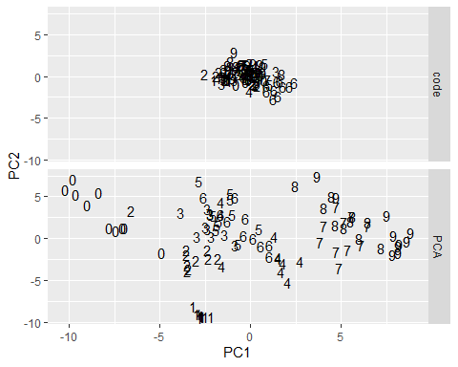

# intermediate_output <- predict(intermediate_layer_model, i.mat)

***The PCA methods results in better separation between digit classes***

Your job is to investigate a deep auto-encoder and see whether or not it is more prone to overfitting than the shallow auto-encoder described above.

First decide on a number of hidden units U to use in the intermediate layers. If your input data dimension is D then there should be five neural network layers with sizes (D, U, 2, U, D). Typically U should be chosen such that 2<U<D. Create a variable named model.list, which should be a list of two keras models (shallow=previous model with three layers described above, deep=new model with five layers). Make sure that in the five layer model there are non-linear activations for all layers but the last. Make a for loop over these two models, and use keras::fit(validation_split=0.5) to learn parameters for each model using a 50% subtrain, 50% validation split. Make a ggplot of y=square loss as a function of x=iterations, with different sets in different colors (e.g., subtrain=black, validation=red), and the two different models in two different panels, facet_grid(. ~ model). Does either model overfit? Finally make another ggplot which displays the low dimensional embeddings, as in problem 3 above. Which of the two methods results in better separation between digit classes?

#To exclude the label column (that is the first column)  
df<-as.matrix(dt[, -1])  
D <- 256  
U <- 128  
enc_input = layer_input(shape = D)  
enc_output = enc_input %>%   
 layer_dense(units=U, activation = "relu") %>%   
 layer_activation_leaky_relu() %>%   
 layer_dense(units=2)   
  
encoder = keras_model(enc_input, enc_output)  
summary(encoder)

## ________________________________________________________________________________  
## Layer (type) Output Shape Param #   
## ================================================================================  
## input_1 (InputLayer) (None, 256) 0   
## ________________________________________________________________________________  
## dense_2 (Dense) (None, 128) 32896   
## ________________________________________________________________________________  
## leaky_re_lu_1 (LeakyReLU) (None, 128) 0   
## ________________________________________________________________________________  
## dense_3 (Dense) (None, 2) 258   
## ================================================================================  
## Total params: 33,154  
## Trainable params: 33,154  
## Non-trainable params: 0  
## ________________________________________________________________________________

Next, compile the model with appropriate loss function, optimizer, and metrics:

dec_input = layer_input(shape = 2)  
dec_output = dec_input %>%   
 layer_dense(units=U, activation = "relu") %>%   
 layer_activation_leaky_relu() %>%   
 layer_dense(units = D, activation = "sigmoid")   
 # inputsize dimensions for the output layer  
decoder = keras_model(dec_input, dec_output)  
summary(decoder)

## ________________________________________________________________________________  
## Layer (type) Output Shape Param #   
## ================================================================================  
## input_2 (InputLayer) (None, 2) 0   
## ________________________________________________________________________________  
## dense_4 (Dense) (None, 128) 384   
## ________________________________________________________________________________  
## leaky_re_lu_2 (LeakyReLU) (None, 128) 0   
## ________________________________________________________________________________  
## dense_5 (Dense) (None, 256) 33024   
## ================================================================================  
## Total params: 33,408  
## Trainable params: 33,408  
## Non-trainable params: 0  
## ________________________________________________________________________________

Use the fit() function to train the model for 30 epochs using batches of 100 images:

aen_input = layer_input(shape = D)  
  
aen_output = aen_input %>%   
 encoder() %>%   
 decoder()  
  
autoencoder_model = keras_model(aen_input, aen_output)  
  
summary(autoencoder_model)

## ________________________________________________________________________________  
## Layer (type) Output Shape Param #   
## ================================================================================  
## input_3 (InputLayer) (None, 256) 0   
## ________________________________________________________________________________  
## model_2 (Model) (None, 2) 33154   
## ________________________________________________________________________________  
## model_3 (Model) (None, 256) 33408   
## ================================================================================  
## Total params: 66,562  
## Trainable params: 66,562  
## Non-trainable params: 0  
## ________________________________________________________________________________

Use the fit() function to train the model for 500 epochs using batches of 1000 images:

compile.aen <- autoencoder_model %>% compile(optimizer="rmsprop", loss="binary_crossentropy")  
  
history <-compile.aen %>% fit(df,df, epochs=500, batch_size=1000,validation_split = 0.5 )  
  
plot(history)

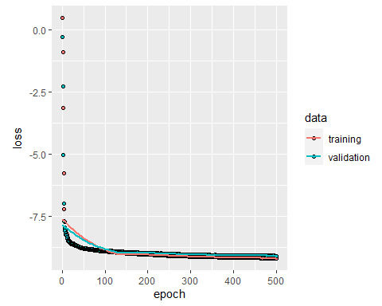

There is no method at here over fit.