**3D Game Zigzag**

1. Design

I used the Luidchart to design our game. The workflow looks like:

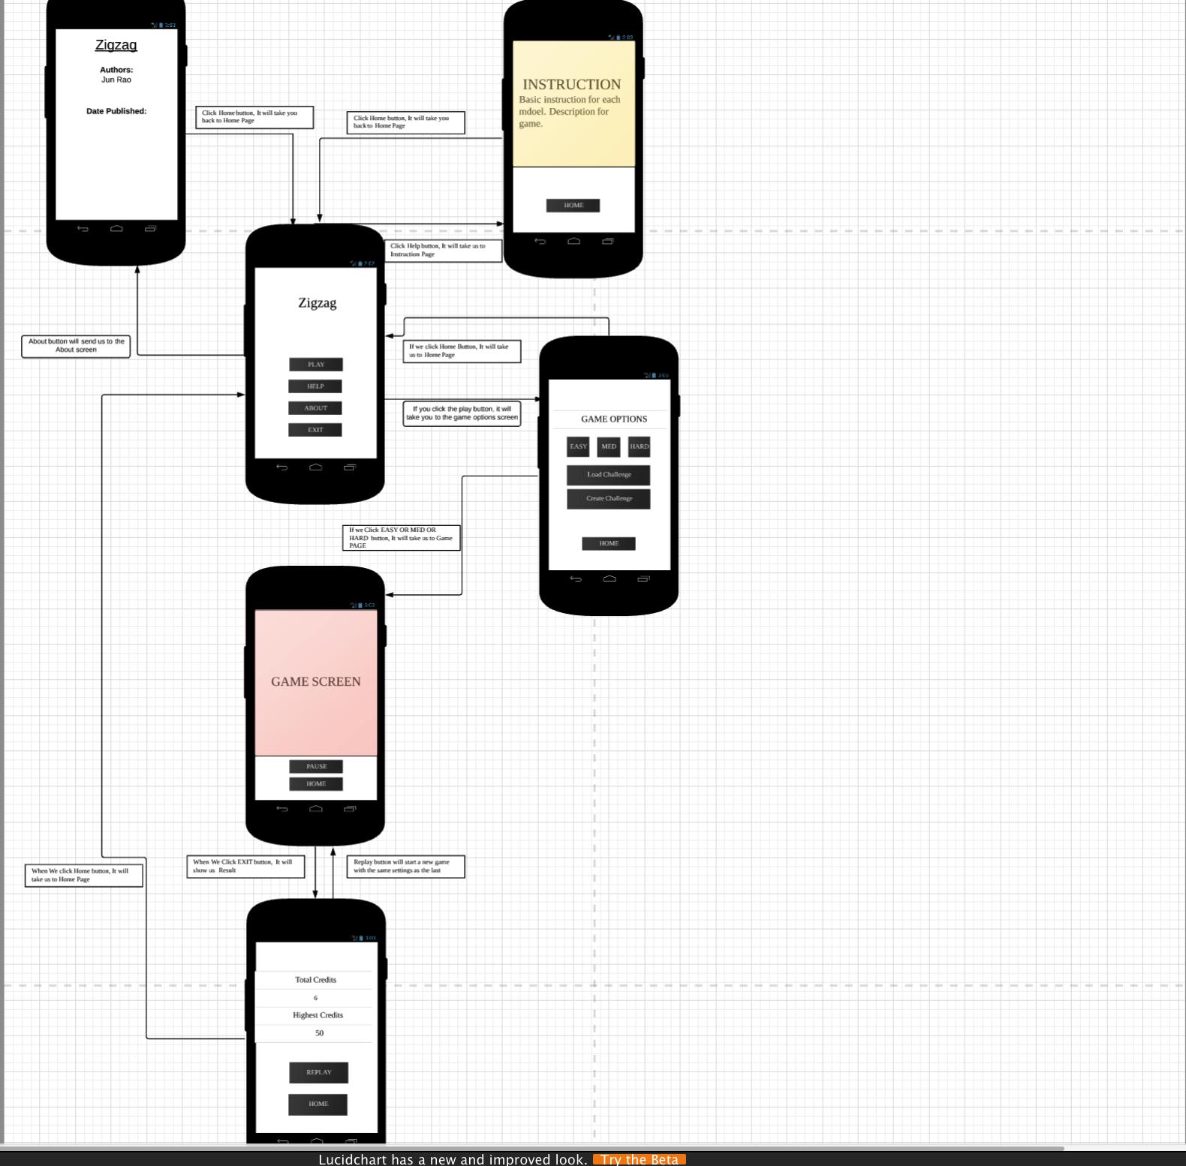

Due to I already have used Luidchart to design workflow for angular game in our project 2, hence I just followed the project2’s step to design our workflow at her.

2.Introduction

Zigzag is a maze video game written by Ed Hickman and published by dk’tronics in 1984. It was released for the ZX Spectrum and the Commodore 64. In Zig Zag, the player must explore a maze from first-person perspective searching for Scarabaqs. Scarabaqs are creatures that hold sector entry data that the player needs to continue to the next level. Scarabaqs flee from the player, who must exploit their behavior to chase them into dead ends. [1]

But most of Zig Zag Game are 2D version. In this project, we will design an 3D Zigzag game.

3.Game Objective

Zigzag is a 3D endless ball runner game and only one player accept.

How to play [2]:

1. Tap the screen to change the direction.

2. Collect crystals to level up

You can upgrade the speed and size of the ball from 3 different color crystals.  
Each crystal has special ability that affects the ball such as speed or size.

4.Interface

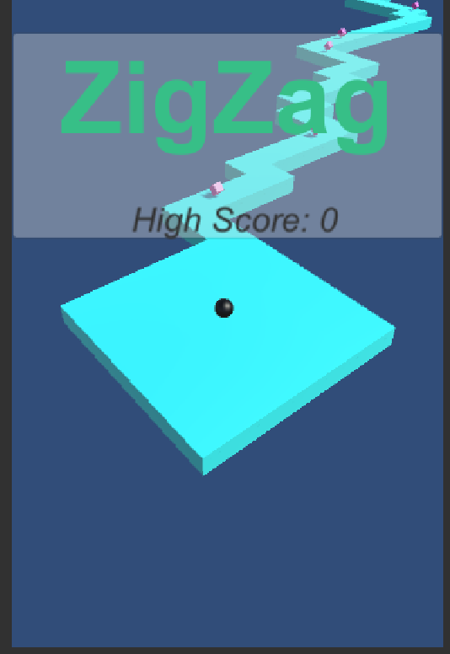 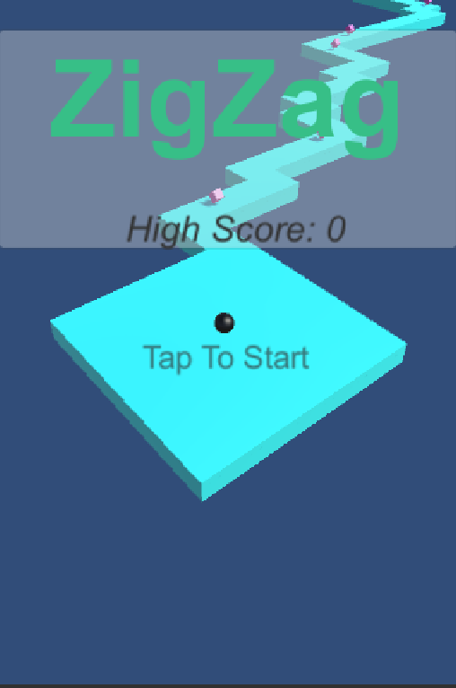

Figure 1 Figure 2

We have a flushing button, which let us to tap it to start our game.

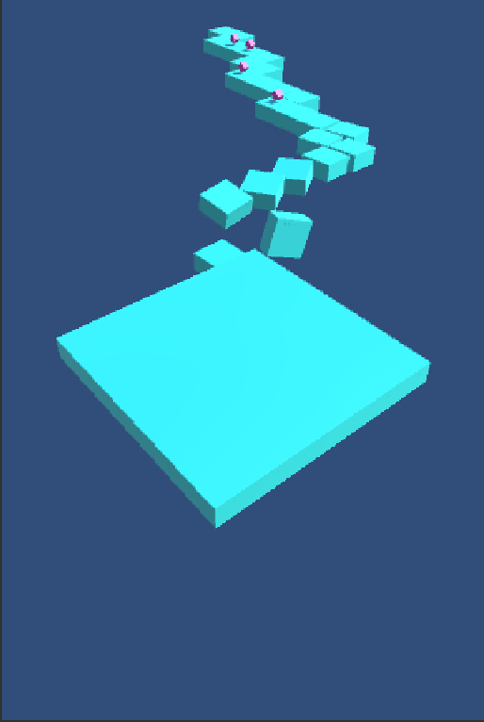 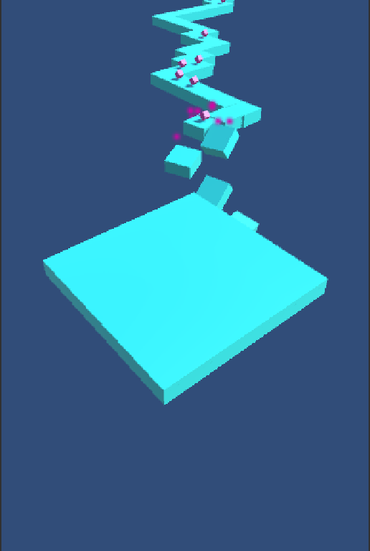

Figure 3 Figure 4

When we tap the start button, the processing of the game should be looks like the picture was provided. If we get one crystal, we will see something in Figure4.

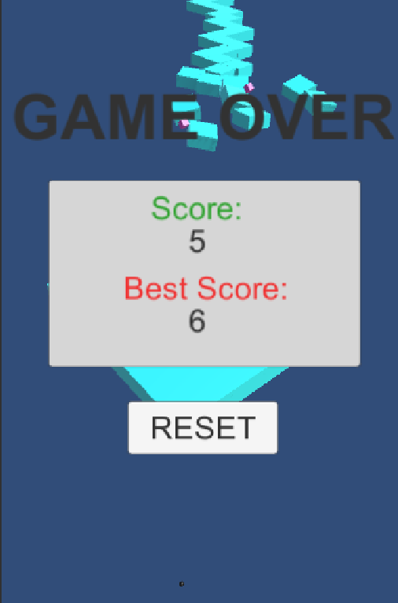 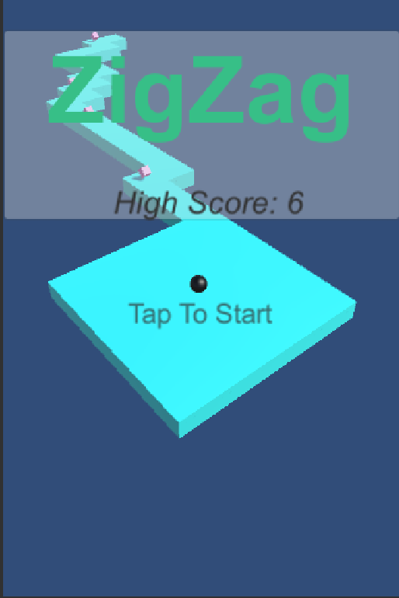

Figure 5 Figure 6

After ball fall off, we will see the Figure 5, we can see our score and the best score. If we want to play this game again, we tap RESET button, and Figure 6 will be shown again.

5.Challenges

Due to this is 3D game, the challenge for me how to let camera follow with the ball in our game. And Computer Graphics (CS430) is very useful for me to design this game.

6.References:

[1] ZiBo - Zigzag 3D <https://play.google.com/store/apps/details?id=com.xllusion.game.zibo&hl=en>

[2] Zigzag (video game)

<https://en.wikipedia.org/wiki/Zig_Zag_(video_game)>