Jun Rao

INF 501

Dr. Igor Steinmacher

**Integrating experiments, field data, and models to understand infectious disease ecology**

In infectious disease ecology, the classical mathematical models have provided valuable insights into infectious disease spread in animal populations, but sometimes these models can not accurately represent these dynamics mathematically. Part of the reason may be that the classical mathematical models have focused on general model predictions and did not consider about mechanisms of disease transmission which mean detailed knowledge of epidemiological theory is not required to use these models. If the traditional mathematical models don’t fit the data very well, we can’t use these models to predict future disease spread, develop disease control strategies, and test hypotheses. Hence, we need to build new models based on hypotheses, test the models by using a combination of experiments(lab, field) and observational data(lab, field), and use the best models to make forecasts (see Figure1). In the presentation, professor Mihaljevic gives us two examples which are Douglas-fir tussock moth nuclear polyhedrosis virus and Amphibian ranaviruses.

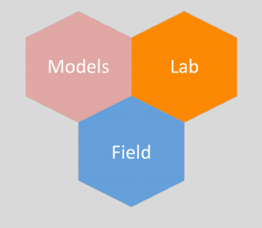

Figure1: Models, Field Experiment, and Lab Experiment

Part I: Douglas-fir tussock moth nuclear polyhedrosis virus (NPV)

The traditional epidemiological model (SIR model) can be used to describe natural baculovirus epizootics, which lead to population crashes in Douglas-fir tussock moth (DFTM) populations. However, the spray works in the research show that mortality in the unsprayed (control) plots the same as spray plots even though control plots had an initially undetectable level of virus infection (see Figure2).

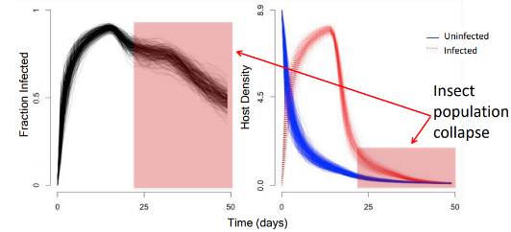 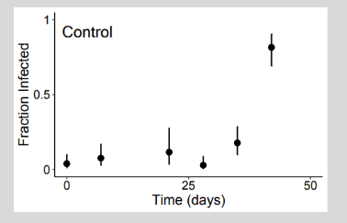

Figure2: The Spray Works

These findings suggest that additional considerations may be warranted in the research. Using a combination of experiments, observational data, and nonlinear-fitting algorithms,we find that when host density is high, even very low initial virus densities can lead to high cumulative infection rates, which means, in some cases, baculovirus sprays may have been applied to populations that would have collapsed from natural epizootics, even without any intervention. The research illustrates that there is a new stage between S stage and I stage and shows that SEIR models can provide valuable guidance for microbial control programs (see Figure3).

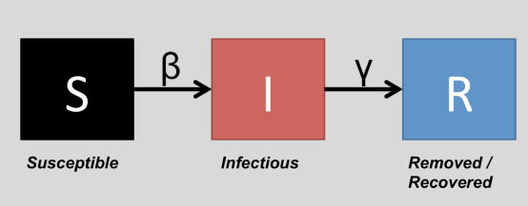 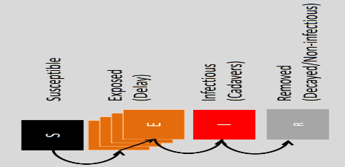

Figure3: SEIR Model

Part II: Amphibian ranaviruses

The research uses historical data to parameterize a model of ATV transmission in Arizona tiger salamander populations. Amphibian ranaviruses grow faster at higher temperatures in cell culture, and viral shedding rate from infected animals also increases. Hence, it is necessary to analyze an effect of heat to explain data in this case. However, the historical data are insufficient to support an essential role of temperature-dependent shedding rate to explain epizootics(see Figure 5).

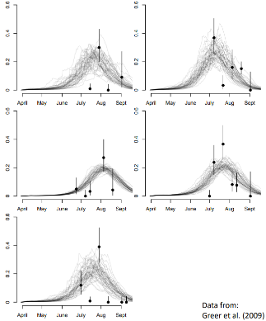 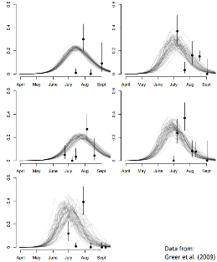

Figure5: The model with a temperature-dependent

Using the model with a temperature dependent shedding rate, we fit well with the data. However, a model without this effect fits equally well, assuming a shallow initial viral concentration in the water. There are insufficient data to support a necessary role of temperature-dependent shedding rate to explain epizootics. Hence we need to collect more data. In future, we need to measure the shedding rate and estimates of initial conditions (host densities and viral concentrations) in the field. But the historical data are insufficient.