**Integrating experiments, field data, and models to understand infectious disease ecology**

**Research Topic Overview**

In infectious disease ecology, the classical mathematical models have provided valuable insights into infectious disease spread in animal populations, but sometimes these models can not accurately represent these dynamics mathematically. Part of the reason may be that the classical mathematical models have focused on general model predictions and did not consider about mechanisms of disease transmission which mean detailed knowledge of epidemiological theory is not required to use these models. If the traditional mathematical models don’t fit the data very well, we can’t use these models to predict future disease spread, develop disease control strategies, and test hypotheses. Hence, we need to build new models based on assumptions, test the models by using a combination of experiments(lab, field) and observational data(lab, field), and use the best models to make forecasts. In the presentation, professor Mihaljevic gives us two examples which are Douglas-fir tussock moth nuclear polyhedrosis virus and Amphibian ranaviruses.

The traditional epidemiological model (SIR model: susceptible-infectious-removed) can be used to describe natural baculovirus epizootics, which lead to population crashes in Douglas-fir tussock moth (DFTM) populations. However, the spray works (see Figure2) in the research show that mortality in the unsprayed (control) plots the same as spray plots even

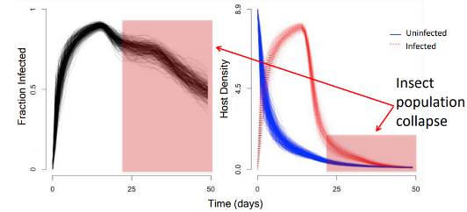

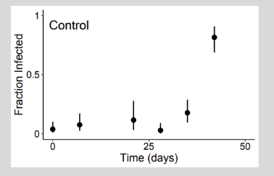

Figure2: The Spray Works

though control plots had an initially undetectable level of virus infection. These findings suggest that additional considerations may be warranted in the research. Using a combination of experiments, observational data, and nonlinear-fitting algorithms, we find that when host density is high, even very low initial virus densities can lead to high cumulative infection rates, which

means, in some cases, baculovirus sprays may have been applied to populations that would have collapsed from natural epizootics, even without any intervention.The research illustrates that there is a new stage between S stage and I stage and shows that SEIR models can provide valuable guidance for microbial control programs (see Figure3).

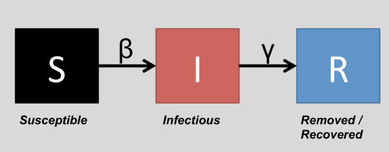

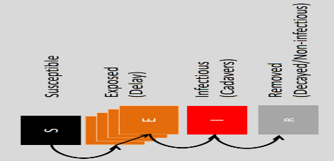

Figure3: SEIR Model

In Amphibian ranaviruses, the research uses historical data to parameterize a model of ATV transmission in Arizona tiger salamander populations. Amphibian ranaviruses grow faster

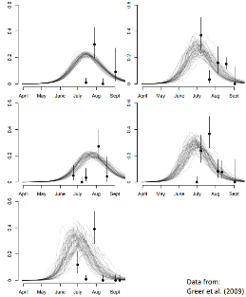 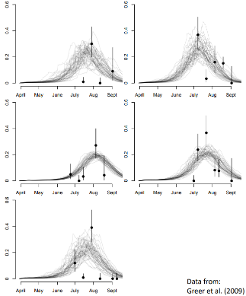

Figure5: temperature dependent model

higher temperatures in cell culture, and viral shedding rate from infected animals also increases. Hence, it is necessary to analyze an effect of heat to explain data in this case. However, the historical data are insufficient to support an essential role of temperature-dependent shedding rate to explain epizootics(see Figure 5).

at

Using the model with a temperature shedding rate, dependent the researcher fit well with the data. However, a model without this effect fits equally well, assuming a shallow initial viral concentration in the water. There are insufficient data to support a necessary role of temperature-dependent shedding rate to explain epizootics. In the future, the researcher needs to measure the shedding rate and estimates of initial conditions (host densities and viral concentrations).

**Research Questions**

-How can the available model ( the classical mathematical models )be optimized through consider more parameter in the research?

-What combination of strategies will yield the most effective model if we can’t find a classical model to be used?

**Research Connections**

Dr. Mihaljevic’s analysis and presentation are centered on the application of a complicated situation, like the traditional model do not fit data very well, data size is insufficient. Using such an approach to uncover alternative methods to find a new model based on the traditional model will significantly enhance the capabilities of the model. Since a significant portion of my research will be focused on pair programming, understanding the interaction of the data to determine the method of pair programming could be of vital importance once movement was incorporated. More specifically, both of us are analyzing the data and trying to find a model to fit the data which means expose the new model to make relatively minimal sacrifices for the greater good (i.e., most efficient outcome) the most useful data fitting. Expanding on the traditional model, to consider the integrity of the study (data, field, and the parameters of the research), the future, decision history, and time as factors to be seen. In essence, establishing a new model which are incentivized by using the traditional model will create a deeper, broader, and more resilient system.

**Conclusion**

As discussed previously, Dr. Mihaljevic’s research seeks to find a better model to fit the research data based on the classical mathematical models (if we have). As he discussed, there are some significant challenges to be addressed before this concept will become realized, and researchers can mutually benefit from being continually interconnected. Some of the obstacles are maintaining the parameter of the research and the data. The other difficulties are data size is too small to reflect the relationship between the data and conditions of the investigation.