Jun Rao

INF 501

Dr. Igor Steinmacher

**Comparative Genomics and the Evolution of Cancer Suppression**

Each type of cell has its lifespan, and when it dies off, it will be replaced by the new one, which makes replication of DNA essential. DNA replication is the biological process of producing two identical replicas of DNA from one original DNA molecule. Cancer results from the somatic accumulation of mutations in cells which means the replication of DNA in somewhere are wrong. Current sequencing efforts of cancer genomes have revealed that many kinds of cancers contain mutations in DNA damage response pathways and genes, including the p53 pathway. And some studies have shown variations in common genes recurring in many different types of cancer. A primary goal of the most genomic research is to translate knowledge of life’s genetic code into positive clinical outcomes for human diseases, including cancer. Cancer suppression is an essential feature in the evolution of large and long-lived animals.

The professor reviews theory and methods of comparative cancer genomics and highlights highlight species whose biology evolved mechanisms of tumor suppression, and discuss related genomic efforts to understand the basis of this tumor suppression. As a CS student, such genetic knowledge arms the biomedical fields with clues to the origins of cancer are similar as the theory of move and copy file in the Linux operating system (see Figure 1). While most DNA replicates with reasonably high fidelity, mistakes(mutations)do happen which can lead to cancer. In computer science, when there is an error in the file move and copy, then we have to open two files, compare each word and find the mistakes. Hence, if there are mutations in DNA replicates, we need to analyze this two DNA and check each nucleotide which means comparative genomics.

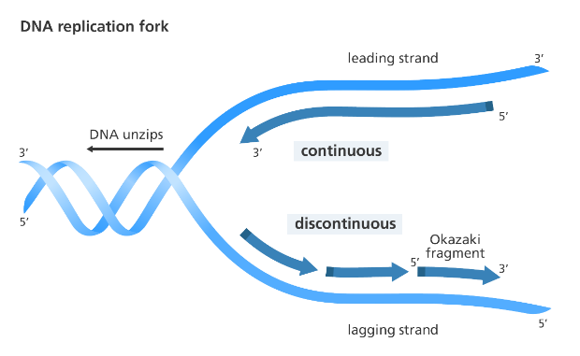

cp source_DNA Target_DNA

Source DNA

Target DNA

Figure 1: DNA replication VS move and copy file

Comparative genomics is a powerful tool to discover these unique and shared molecular adaptations in respect to cancer suppression. A comparative genomics approach to studying cancer can provide insight into both the common cancer suppression pathways of large and long-lived animals and highlight lineage- or clade -distinct adaptations.

By identifying how certain species (Tutara in the research) evolved mechanisms of cancer suppression, we can begin to recognize which underlying molecular targets are potentially more exploitable for human cancer prevention and treatment. Many of the species discussed in the presentation contain molecular adaptations (via gene expansion or adaptive evolution) integral to the increased maintenance of genomic stability and control of cell proliferation. The hypothesis of the research is that large, long-lived animals to have more chance to get cancer.

The data incidence of cancer was found to be lower in small size animals (such as birds) than mammals. Also, the slow developmental rates and long lives of large reptiles indicate that they may hold further clues for cancer suppression. In addition to studying cancer resistant wild taxa, we can also gain valuable insights into lineages that have a high prevalence of cancer. However, the result of the study has a limited understanding of the rate of occurrence and types of cancers in other species, especially for amniote taxa outside of the mammalian orders.