Part1 C Code Hash Table Implement

This is part of my output

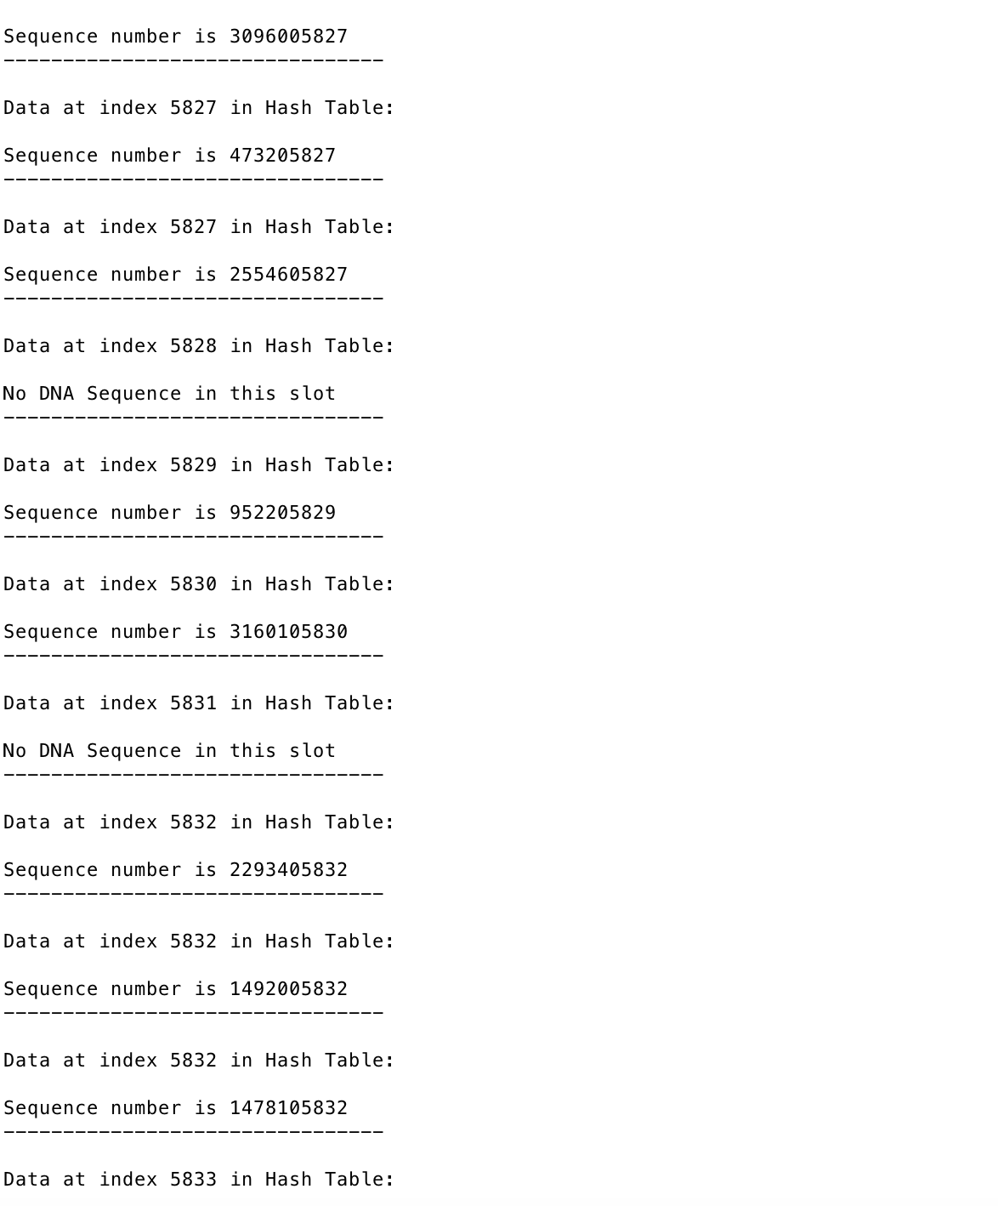

We can find in Hash Table 5827 slot; we have 2 DNA sequence insert to this slot.

We didn’t insert DNA Sequence in to slot 5831 at the Hash Table

We have three DNA Sequence in slot 5832 at the Hash Table

Part 1 Python code Implement

This is my input code, which I have 100 DNA Sequence and each DNA Sequence has 16 letters

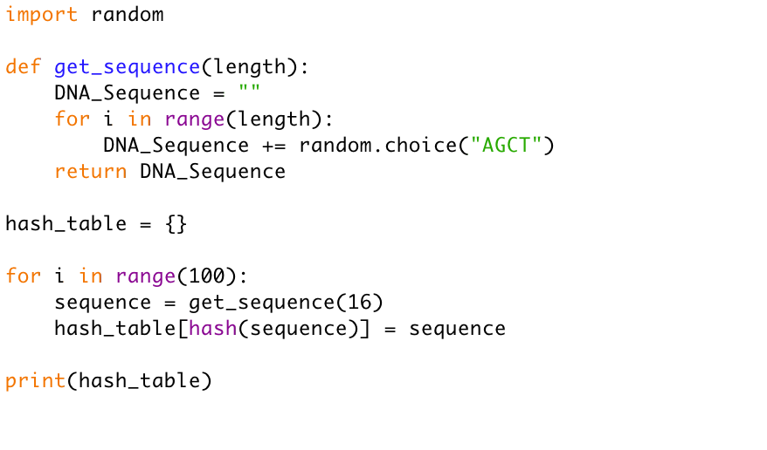

The output looks like:

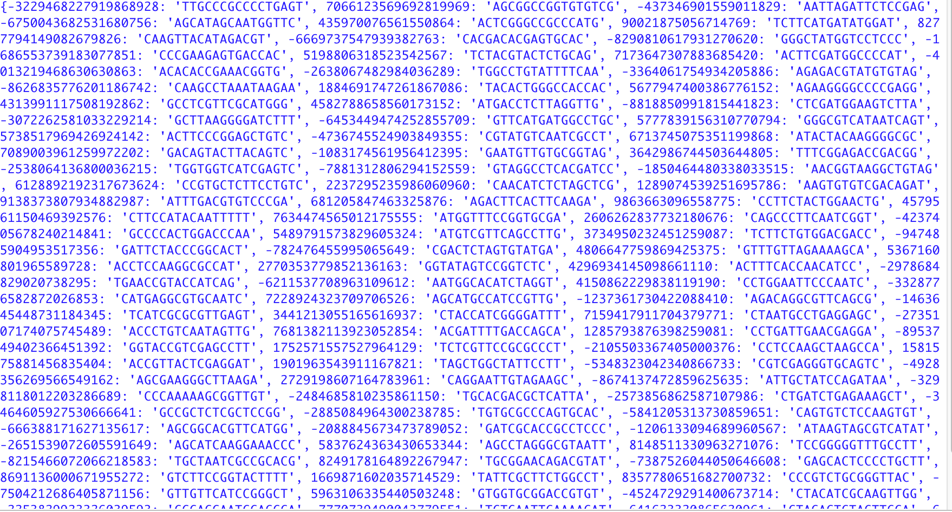

Part2

Because 16 letters will take me a long time, I will pass the length at here is 8.

If I print the Hexadecimal in the bit array, it gives me:

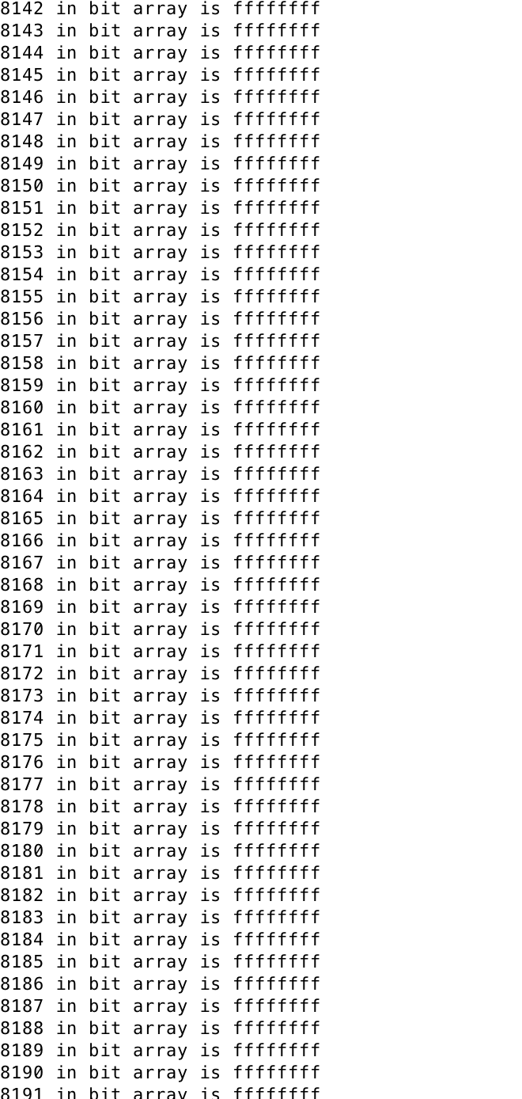

Which means in my bit array, each bit is 1.