Lab5

Jun Rao

9/25/2019

# Linear Regression in R and Stan

Today we are going to simulate data following the assumptions of linear regression, and we’re going to conduct a Bayesian linear regression using Stan.

## Simulating the data

Each time you run this code chunk, you’ll come up with a new data set and a new linear relationship. However, each time you will still be following the assumptions of linear regression.

# Here are the required parameters:  
alpha = rnorm(1, 0, 50)  
beta = rnorm(1, 0, 50)  
sigma = abs(rcauchy(1, 0, 2.5))  
  
# We also need to know how many data points to generate:  
n_sample = 75  
  
# What are the values of our X variable?  
# Let's assume we're dealing with elevation, measured in meters:  
x_raw = runif(n_sample, 0, 3500)  
  
# Now center and standardize:  
x_mean = mean(x_raw)  
x_sd = sd(x_raw)  
  
x_scaled = (x_raw - x_mean) / (2 * x_sd)  
  
# Create our residuals:  
epsilon = rnorm(n_sample, 0, sigma)  
  
# Now we can finally create our data:  
y_hat = alpha + x_scaled * beta  
y_obs = y_hat + epsilon  
  
# A quick plot:  
plot(y_obs ~ x_scaled, type = "p", pch = 19, xlim = c(-1, 1))  
points(x = 0, y = alpha, pch = 19, col = "red")  
abline(v = 0, lty = 2)  
abline(h = alpha, lty = 2)  
abline(a = alpha, b = beta, lty = 1, col = "black")

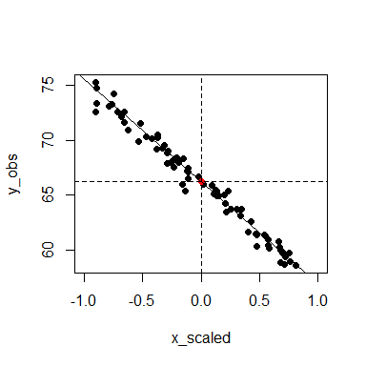

## Set up the Stan analysis

#--------------------------------------  
#--------------------------------------  
# Import/Load the rstan library:  
library(rstan)  
rstan_options(auto_write = TRUE)  
options(mc.cores = parallel::detectCores())  
#--------------------------------------  
#--------------------------------------  
  
# Specify the data inputs:  
  
  
stan_data = list(n_sample = n_sample,  
 x_vec = x_scaled,  
 y_vec = y_obs)  
  
# Now we have to specify which parameters to "monitor"  
# in the sampler.  
  
params_monitor = c("beta", "alpha", "sigma")  
  
# First, we will test whether our code compiles correctly:  
test_fit =   
 stan(file = "LinReg.stan",  
 data = stan_data,  
 pars = params_monitor,  
 chains = 1, # How many chains to run  
 iter = 10, # How many iterations per chain  
 # Algorithm: No-U-Turn Sampler (NUTS)  
 # Variant of Hamiltonian Monte Carlo  
 algorithm="NUTS")

##   
## SAMPLING FOR MODEL 'LinReg' NOW (CHAIN 1).  
## Chain 1:   
## Chain 1: Gradient evaluation took 0 seconds  
## Chain 1: 1000 transitions using 10 leapfrog steps per transition would take 0 seconds.  
## Chain 1: Adjust your expectations accordingly!  
## Chain 1:   
## Chain 1:   
## Chain 1: WARNING: No variance estimation is  
## Chain 1: performed for num_warmup < 20  
## Chain 1:   
## Chain 1: Iteration: 1 / 10 [ 10%] (Warmup)  
## Chain 1: Iteration: 2 / 10 [ 20%] (Warmup)  
## Chain 1: Iteration: 3 / 10 [ 30%] (Warmup)  
## Chain 1: Iteration: 4 / 10 [ 40%] (Warmup)  
## Chain 1: Iteration: 5 / 10 [ 50%] (Warmup)  
## Chain 1: Iteration: 6 / 10 [ 60%] (Sampling)  
## Chain 1: Iteration: 7 / 10 [ 70%] (Sampling)  
## Chain 1: Iteration: 8 / 10 [ 80%] (Sampling)  
## Chain 1: Iteration: 9 / 10 [ 90%] (Sampling)  
## Chain 1: Iteration: 10 / 10 [100%] (Sampling)  
## Chain 1:   
## Chain 1: Elapsed Time: 0.001 seconds (Warm-up)  
## Chain 1: 0 seconds (Sampling)  
## Chain 1: 0.001 seconds (Total)  
## Chain 1:

## Now we will run our full model:  
  
# How many samples do we want of each parameter, from each chain?  
n_mc_samples = 1000  
# How much burn-in?  
n_burn = 500  
# How much thinning? (take the ith value of the chain)  
n_thin = 3  
# Total iterations needed:  
n_iter_total = (n_mc_samples * n_thin) + n_burn  
  
model_fit =  
 stan(fit = test_fit, # So it knows we're already compiled  
 file = "LinReg.stan",  
 data = stan_data,  
 pars = params_monitor,  
 chains = 3,  
 warmup = n_burn,  
 thin = n_thin,  
 iter = n_iter_total,   
 algorithm="NUTS")

## Check the output of the sampler

model_out = rstan::extract(model_fit)  
str(model_out)

## List of 4  
## $ beta : num [1:3000(1d)] -9.23 -8.96 -8.98 -9.06 -9.15 ...  
## ..- attr(*, "dimnames")=List of 1  
## .. ..$ iterations: NULL  
## $ alpha: num [1:3000(1d)] 66 66.1 65.9 66.1 66.1 ...  
## ..- attr(*, "dimnames")=List of 1  
## .. ..$ iterations: NULL  
## $ sigma: num [1:3000(1d)] 0.714 0.676 0.721 0.619 0.624 ...  
## ..- attr(*, "dimnames")=List of 1  
## .. ..$ iterations: NULL  
## $ lp__ : num [1:3000(1d)] -90.3 -89.1 -91.6 -89.1 -88.8 ...  
## ..- attr(*, "dimnames")=List of 1  
## .. ..$ iterations: NULL

# Traceplot with burn-in:  
rstan::traceplot(model_fit, pars = params_monitor, inc_warmup = TRUE)

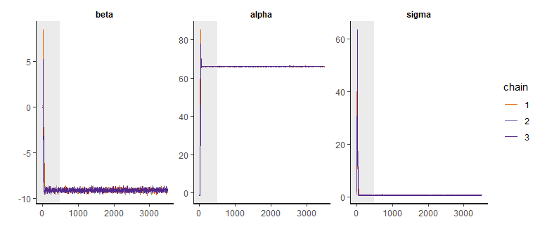

# Traceplot without burn-in:  
rstan::traceplot(model_fit, pars = params_monitor, inc_warmup = FALSE)

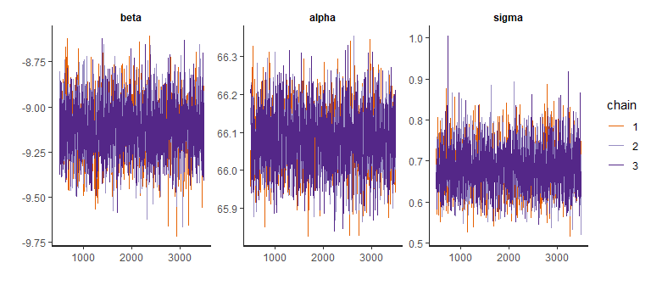

# Summary Report:  
# Note the 2.5 and 97.5 quantiles give you the 95% credible interval  
# Are are "true" values within these bounds?  
# "lp__" represents log-posterior (the joint posterior),   
# up to a constant of proportionality  
summary(model_fit)$summary

## mean se_mean sd 2.5% 25%  
## beta -9.1132786 0.002799411 0.15633242 -9.4181188 -9.2206557  
## alpha 66.0820790 0.001532737 0.07946263 65.9314507 66.0296513  
## sigma 0.6810568 0.001102266 0.05717647 0.5797594 0.6413683  
## lp__ -89.9539286 0.024589208 1.19589665 -92.9313924 -90.5368861  
## 50% 75% 97.5% n_eff Rhat  
## beta -9.1125286 -9.0083770 -8.8025733 3118.637 0.9997222  
## alpha 66.0804417 66.1355948 66.2377625 2687.762 1.0001642  
## sigma 0.6780642 0.7185916 0.8007651 2690.677 0.9993470  
## lp__ -89.6531030 -89.0809488 -88.5687958 2365.365 1.0001323

# Check Convergence:  
summary(model_fit)$summary[, "Rhat"]

## beta alpha sigma lp__   
## 0.9997222 1.0001642 0.9993470 1.0001323

# Note that our n_eff < n_iter_total

## 

## Task 1 (5 points)

For each parameter:

1. Plot a histogram of the marginal posterior samples from the Stan output.
2. Use the () function to draw a vertical line that represents the value of each parameter.

hist(model_out$alpha,main="the marginal posterior samples of alpha",xlab = expression(alpha))  
abline(v = alpha, lty = 1, lwd = 2, col = "blue")

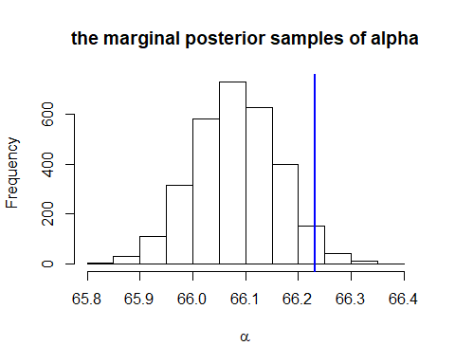

hist(model_out$beta,main="the marginal posterior samples of beta",xlab = expression(beta))  
abline(v = beta, lty = 1, lwd = 2, col = "blue")

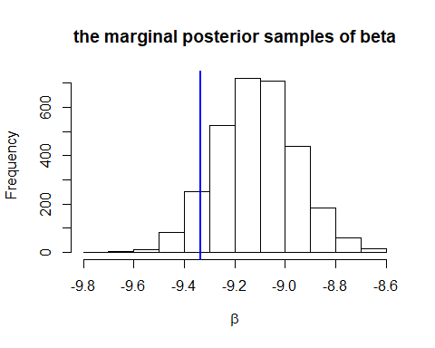

hist(model_out$sigma,main="the marginal posterior samples of sigma",xlab = expression(sigma))  
abline(v = sigma, lty = 1, lwd = 2, col = "blue")

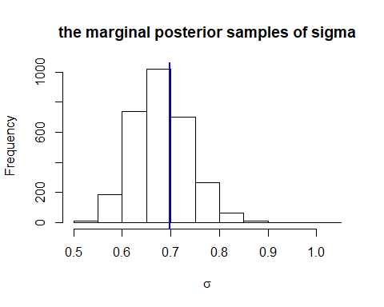

1. Think about what this tells you. The blue verrTical line in each histogram is very close to the center.The generated posterior value based on the give value is very close to the true vale and acceptable.

## The joint marginal

# Plot the joint marginal samples of slope and intercept:  
  
beta_est = model_out$beta  
alpha_est = model_out$alpha  
sigma_est = model_out$sigma  
  
plot(beta_est ~ alpha_est, type = "p", pch = 19,  
 xlab = expression(hat(alpha)), ylab = expression(hat(beta)))  
points(x = median(alpha_est), y = median(beta_est), col = "red", pch = 19, cex = 2)  
# Does this match the true?  
points(x = alpha, y = beta, col = "blue", pch = 19, cex = 1.25)

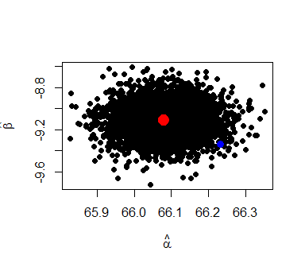

## Visualizing the estimated model fit, with error

plot(y_obs ~ x_scaled, type = "p", pch = 19, xlim = c(-1, 1))  
abline(v = 0, lty = 2)  
abline(h = alpha, lty = 2)  
  
# How many estimated lines to plot?  
n_lines = 100  
  
for(i in 1:n_lines){  
 this_sample = sample(c(1:length(alpha_est)), size = 1)  
   
 alpha_temp = alpha_est[this_sample]  
 beta_temp = beta_est[this_sample]  
   
 abline(a = alpha_temp, b = beta_temp, col = scales::alpha("gray", alpha = 0.2))  
   
   
}  
  
# Add the median estimate:  
abline(a = median(alpha_est), b = median(beta_est), col = "black")

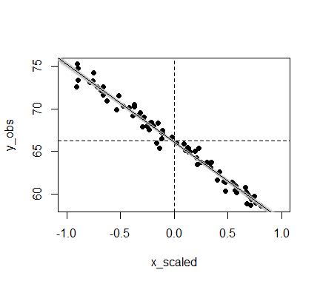

## Predicting outcome ($\tilde{y}$) at unobserved values of input

# A future observation of X, outside the original range of X (forecasting)  
x_future = 5000   
# Scale it:  
x_future_scaled = (x_future - x_mean) / (2 * x_sd)  
  
# Now, generate possible values of unobserved y, given our observed y  
n_pred = 1000  
y_pred = NULL  
for(i in 1:n_pred){  
   
 this_sample = sample(c(1:length(alpha_est)), size = 1)  
   
 alpha_temp = alpha_est[this_sample]  
 beta_temp = beta_est[this_sample]  
 sigma_temp = sigma_est[this_sample]  
   
 y_pred[i] = alpha_temp + beta_temp * x_future_scaled + rnorm(1, 0, sigma_temp)  
   
}  
  
hist(y_pred, ylab = "Frequency", xlab = expression(tilde(y)), main = "")  
abline(v = median(y_pred), lty = 1, lwd = 2, col = "blue")  
abline(v = quantile(y_pred, probs = c(0.025, 0.975)), lty = 2, lwd = 2, col = "blue")

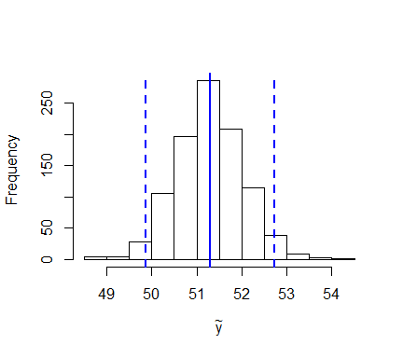

## Task 2 (10 points)

1. Re-code your data simulation so that you are not centering your input variable.
2. Instead of standardizing by dividing by 2 standard deviations, standardize by dividing the input variable by 1000.

# Here are the required parameters:  
alpha = rnorm(1, 0, 50)  
beta = rnorm(1, 0, 50)  
sigma = abs(rcauchy(1, 0, 2.5))  
  
# We also need to know how many data points to generate:  
n_sample = 75  
  
# What are the values of our X variable?  
# Let's assume we're dealing with elevation, measured in meters:  
x_raw = runif(n_sample, 0, 3500)  
  
# Now center and standardize:  
x_mean = mean(x_raw)  
x_sd = sd(x_raw)  
  
x_scaled = x_raw / 1000  
  
# Create our residuals:  
epsilon = rnorm(n_sample, 0, sigma)  
  
# Now we can finally create our data:  
y_hat = alpha + x_scaled * beta  
y_obs = y_hat + epsilon  
  
# A quick plot:  
plot(y_obs ~ x_scaled, type = "p", pch = 19, xlim = c(-1, 1))  
points(x = 0, y = alpha, pch = 19, col = "red")  
abline(v = 0, lty = 2)  
abline(h = alpha, lty = 2)  
abline(a = alpha, b = beta, lty = 1, col = "black")

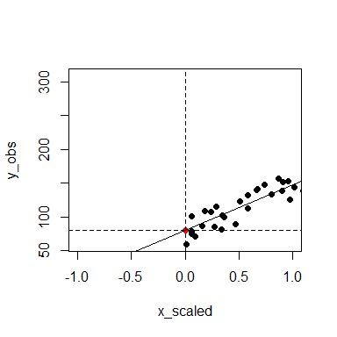

1. Re-run your Bayesian analysis on this new data set. ## Set up the Stan analysis

#--------------------------------------  
#--------------------------------------  
# Import/Load the rstan library:  
library(rstan)  
rstan_options(auto_write = TRUE)  
options(mc.cores = parallel::detectCores())  
#--------------------------------------  
#--------------------------------------  
  
# Specify the data inputs:  
  
  
stan_data = list(n_sample = n_sample,  
 x_vec = x_scaled,  
 y_vec = y_obs)  
  
# Now we have to specify which parameters to "monitor"  
# in the sampler.  
  
params_monitor = c("beta", "alpha", "sigma")  
  
# First, we will test whether our code compiles correctly:  
test_fit =   
 stan(file = "LinReg.stan",  
 data = stan_data,  
 pars = params_monitor,  
 chains = 1, # How many chains to run  
 iter = 10, # How many iterations per chain  
 # Algorithm: No-U-Turn Sampler (NUTS)  
 # Variant of Hamiltonian Monte Carlo  
 algorithm="NUTS")

##   
## SAMPLING FOR MODEL 'LinReg' NOW (CHAIN 1).  
## Chain 1:   
## Chain 1: Gradient evaluation took 0 seconds  
## Chain 1: 1000 transitions using 10 leapfrog steps per transition would take 0 seconds.  
## Chain 1: Adjust your expectations accordingly!  
## Chain 1:   
## Chain 1:   
## Chain 1: WARNING: No variance estimation is  
## Chain 1: performed for num_warmup < 20  
## Chain 1:   
## Chain 1: Iteration: 1 / 10 [ 10%] (Warmup)  
## Chain 1: Iteration: 2 / 10 [ 20%] (Warmup)  
## Chain 1: Iteration: 3 / 10 [ 30%] (Warmup)  
## Chain 1: Iteration: 4 / 10 [ 40%] (Warmup)  
## Chain 1: Iteration: 5 / 10 [ 50%] (Warmup)  
## Chain 1: Iteration: 6 / 10 [ 60%] (Sampling)  
## Chain 1: Iteration: 7 / 10 [ 70%] (Sampling)  
## Chain 1: Iteration: 8 / 10 [ 80%] (Sampling)  
## Chain 1: Iteration: 9 / 10 [ 90%] (Sampling)  
## Chain 1: Iteration: 10 / 10 [100%] (Sampling)  
## Chain 1:   
## Chain 1: Elapsed Time: 0 seconds (Warm-up)  
## Chain 1: 0 seconds (Sampling)  
## Chain 1: 0 seconds (Total)  
## Chain 1:

## Now we will run our full model:  
  
# How many samples do we want of each parameter, from each chain?  
n_mc_samples = 1000  
# How much burn-in?  
n_burn = 500  
# How much thinning? (take the ith value of the chain)  
n_thin = 3  
# Total iterations needed:  
n_iter_total = (n_mc_samples * n_thin) + n_burn  
  
model_fit =  
 stan(fit = test_fit, # So it knows we're already compiled  
 file = "LinReg.stan",  
 data = stan_data,  
 pars = params_monitor,  
 chains = 3,  
 warmup = n_burn,  
 thin = n_thin,  
 iter = n_iter_total,   
 algorithm="NUTS")

## Check the output of the sampler

model_out = rstan::extract(model_fit)  
str(model_out)

## List of 4  
## $ beta : num [1:3000(1d)] 69.6 66.2 62.4 65.5 70.8 ...  
## ..- attr(*, "dimnames")=List of 1  
## .. ..$ iterations: NULL  
## $ alpha: num [1:3000(1d)] 75.7 81 86.2 85.5 75.8 ...  
## ..- attr(*, "dimnames")=List of 1  
## .. ..$ iterations: NULL  
## $ sigma: num [1:3000(1d)] 15.2 16 15 14.9 16.1 ...  
## ..- attr(*, "dimnames")=List of 1  
## .. ..$ iterations: NULL  
## $ lp__ : num [1:3000(1d)] -328 -326 -329 -327 -329 ...  
## ..- attr(*, "dimnames")=List of 1  
## .. ..$ iterations: NULL

# Traceplot with burn-in:  
rstan::traceplot(model_fit, pars = params_monitor, inc_warmup = TRUE)

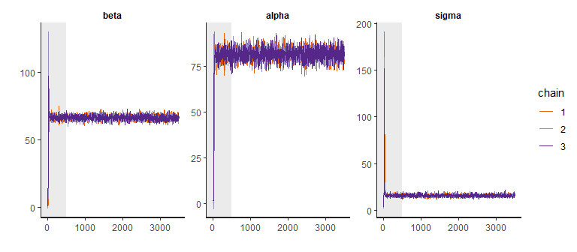

# Traceplot without burn-in:  
rstan::traceplot(model_fit, pars = params_monitor, inc_warmup = FALSE)

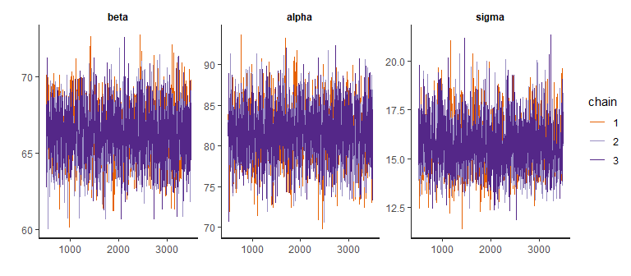

# Note that our n_eff < n_iter_total

1. Look at the number of effective samples in each chain. How does this compare to when you properly centered and scaled?

# Summary Report:  
# Note the 2.5 and 97.5 quantiles give you the 95% credible interval  
# Are are "true" values within these bounds?  
# "lp__" represents log-posterior (the joint posterior),   
# up to a constant of proportionality  
summary(model_fit)$summary

## mean se_mean sd 2.5% 25% 50%  
## beta 66.26997 0.03661323 1.856145 62.75135 64.96848 66.25827  
## alpha 81.73594 0.06742776 3.406587 74.89169 79.47588 81.82035  
## sigma 15.64319 0.02561276 1.334347 13.32900 14.72965 15.56593  
## lp__ -327.78359 0.02635896 1.303031 -331.21088 -328.38193 -327.43139  
## 75% 97.5% n_eff Rhat  
## beta 67.48743 69.86583 2570.085 1.002180  
## alpha 84.04939 88.35113 2552.476 1.001703  
## sigma 16.43991 18.59381 2714.095 1.000372  
## lp__ -326.82729 -326.32268 2443.728 1.001116

# Check Convergence:  
summary(model_fit)$summary[, "Rhat"]

## beta alpha sigma lp__   
## 1.002180 1.001703 1.000372 1.001116

# Note that our n_eff < n_iter_total

1. Plot the joint marginal posterior samples of $α$ and $β$. What differences do you observed compared to when we properly centered and scaled the input? ## The joint marginal

# Plot the joint marginal samples of slope and intercept:  
  
beta_est = model_out$beta  
alpha_est = model_out$alpha  
sigma_est = model_out$sigma  
  
plot(beta_est ~ alpha_est, type = "p", pch = 19,  
 xlab = expression(hat(alpha)), ylab = expression(hat(beta)))  
points(x = median(alpha_est), y = median(beta_est), col = "red", pch = 19, cex = 2)  
# Does this match the true?  
points(x = alpha, y = beta, col = "blue", pch = 19, cex = 1.25)

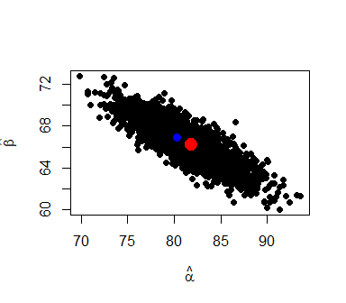

When we didn’t center and scale the input, the joint marginal posterior samples of alpha and beta are different. The graphic od the paired alpha-beta in the question 1 is a circle, however, at here is a ellipsoid. It looks like alpha has a hihger effect on posterior.