Homework2

Jun Rao

INF 638

${GF}_{19}$ = {0,1,2,3,4,5,6,7,8,9,10,11,12,13,14,15,16,17,18}

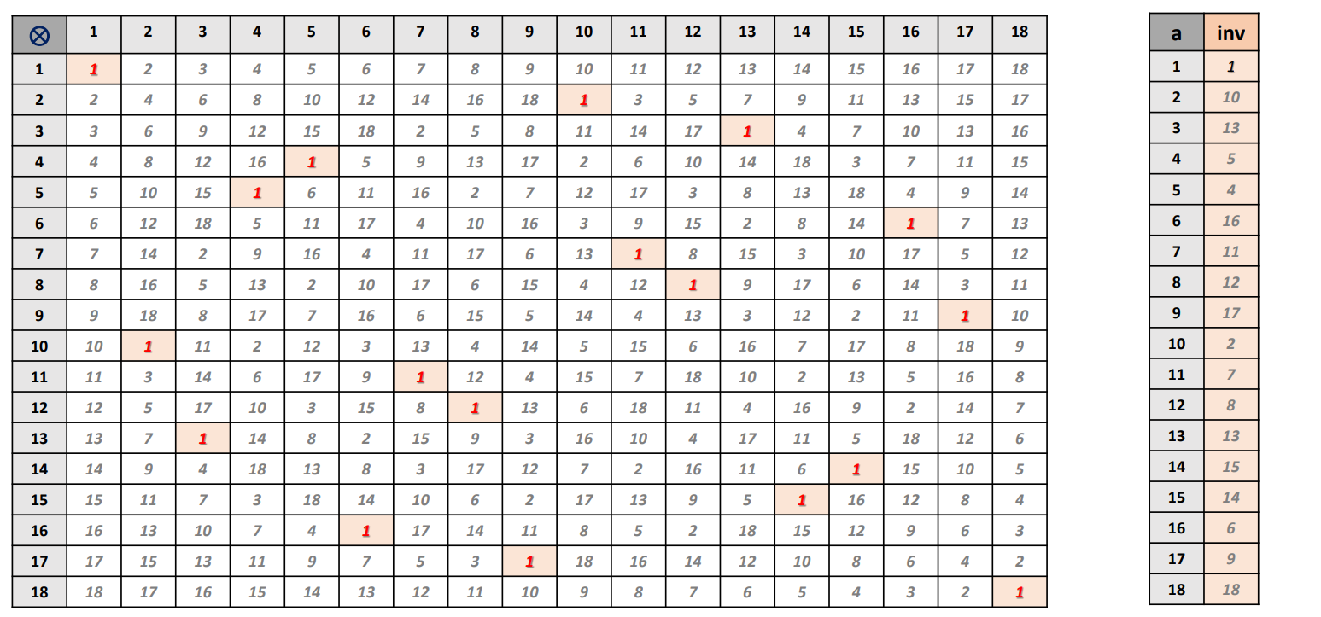

B.

12/3 = 12 $×$ 13 = 156 $≡$ 4 (mod 19)

3/12 = 3 $×$ 8 = 24 $≡$ 5 (mod 19)

1/ (3/12) = 12/3 $≡$ 4 (mod 19)

A.

$8/4$ = 8 $×$ 5 =40 $≡$ 2 (mod 19)

4/8= 4 $×$ 12 = 48 $≡$ 10 (mod 19)

1/ (8/4) = 1/2 = 10 $≡$ 10 (mod 19)

D.

9/3 = 9 $×$ 13= 117 $≡$ 3 (mod 19)

3/9 = 3 $×$ 17=51 $≡$ 13 (mod 19)

1/ (3/9) = 9/3 $≡$ 3 (mod 19)

C.

14/7 = 14 $×$ 11 =154 $≡$ 2 (mod 19)

7/14 = 7 $×$ 15=105 $≡$ 10 (mod 19)

1/ (7/14) = 14/7 $≡$ 2 (mod 19)

F.

15/3 = 15 $×$ 13 = 195 $≡$ 5 (mod 19)

3/15 = 3 $×$ 14 = 42 $≡$ 4 (mod 19)

1/ (5/15) = 15/3 $≡$ 5 (mod 19)

E.

15/5 = 15 $×$ 4 = 60 $≡$ 3 (mod 19)

5/15 = 5 $×$ 14 = 70 $≡$ 13 (mod 19)

1/ (5/15) = 15/5 $≡$ 3 (mod 19)

H.

$18/3$ = 18 $×$ 13 =234 $≡$ 6 (mod 19)

3/18= 3 $×$ 18 = 54 $≡$ 16 (mod 19)

1/ (3/18) = 18/3 $≡$ 6 (mod 19)

G.

$10/5$ = 10 $×$ 4 =40 $≡$ 2 (mod 19)

5/10= 5 $×$ 2 = 10 $≡$ 10 (mod 19)

1/ (5/10) = 10/5 $≡$ 2 (mod 19)

I.

$16/4$ = 16 $×$ 5 =80 $≡$ 4 (mod 19)

4/16= 4 $×$ 6 = 24 $≡$ 5 (mod 19)

1/ (4/16) = 16/4 $≡$ 4 (mod 19)