ReRAM2

library(ggplot2)  
library(tidyverse)

## -- Attaching packages ------------------------------------------------------------------------------------------------------------------------------------------------------------------------------------------ tidyverse 1.3.0 --

## v tibble 2.1.3 v dplyr 0.8.5  
## v tidyr 1.0.2 v stringr 1.4.0  
## v readr 1.3.1 v forcats 0.5.0  
## v purrr 0.3.3

## -- Conflicts --------------------------------------------------------------------------------------------------------------------------------------------------------------------------------------------- tidyverse_conflicts() --  
## x dplyr::filter() masks stats::filter()  
## x dplyr::lag() masks stats::lag()

my_data <- read.csv(file = "Wafer_1_60C.csv",header = TRUE)  
#head(my_data)

# Select columns whose names contains "1.1"  
d_1.1<-my_data %>% select(contains("1.1."))  
#head(d_1.1)

d1_1.1<-d_1.1[,c(1:8)]  
d1_1.1 <- head(d1_1.1,51)  
colnames(d1_1.1) <- c("V1", "V2","V3","V4","V5","V6","V7","V8")  
#head(d1_1.1)

index = which(is.na(d1_1.1$V1))  
d1_1.1$V1[index]=0  
hist(d1_1.1$V1,  
 cex.main=0.5,  
 freq = FALSE,  
 main = paste('Model:Waf1_F2.3_60C_.1.1,Inject:100NA,mean is:', mean(d1_1.1$V1),' sd is:', sd(d1_1.1$V1)),  
 xlab = "Input",  
 ylab = "Density",  
 col="grey")  
#plot density curve  
lines(density(d1_1.1$V1), # density plot  
 lwd = 2, # thickness of line  
 col = "red")

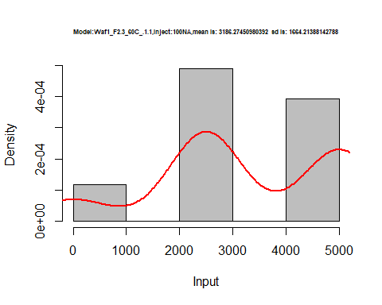

hist(d1_1.1$V2,  
 freq = FALSE,  
 cex.main=0.5,  
 main = paste('Model:Waf1_F2.3_60C_.1.1,Inject:200NA,mean is:', mean(d1_1.1$V2),' sd is:', sd(d1_1.1$V2)),  
 xlab = "Input",  
 ylab = "Density",  
 col="grey")  
#plot density curve  
lines(density(d1_1.1$V2), # density plot  
 lwd = 2, # thickness of line  
 col = "red")

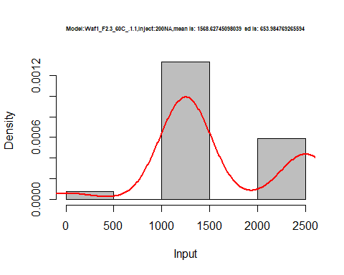

hist(d1_1.1$V3,  
 freq = FALSE,  
 cex.main=0.5,  
 main = paste('Model:Waf1_F2.3_60C_.1.1,Inject:300NA,mean is:', mean(d1_1.1$V3),' sd is:', sd(d1_1.1$V3)),  
 xlab = "Input",  
 ylab = "Density",  
 col="grey")  
  
#plot density curve  
lines(density(d1_1.1$V3), # density plot  
 lwd = 2, # thickness of line  
 col = "red")

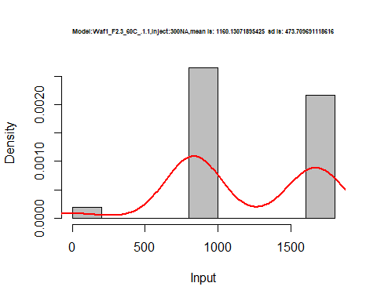

hist(d1_1.1$V4,  
 freq = FALSE,  
 cex.main=0.5,  
 main = paste('Model:Waf1_F2.3_60C_.1.1,Inject:400NA,mean is:', mean(d1_1.1$V4),' sd is:', sd(d1_1.1$V4)),  
 xlab = "Input",  
 ylab = "Density",  
 col="grey")  
#plot density curve  
lines(density(d1_1.1$V4), # density plot  
 lwd = 2, # thickness of line  
 col = "red")

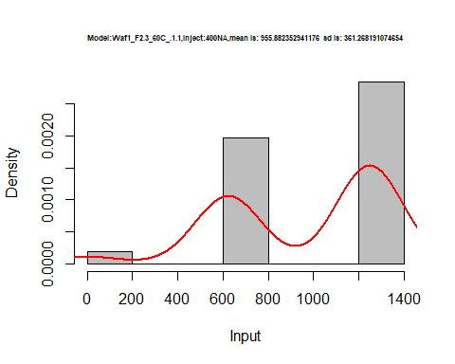

hist(d1_1.1$V5,  
 freq = FALSE,  
 cex.main=0.5,  
 main = paste('Model:Waf1_F2.3_60C_.1.1,Inject:500NA,mean is:', mean(d1_1.1$V5),' sd is:', sd(d1_1.1$V5)),  
 xlab = "Input",  
 ylab = "Density",  
 col="grey")  
#plot density curve  
lines(density(d1_1.1$V5), # density plot  
 lwd = 2, # thickness of line  
 col = "red")

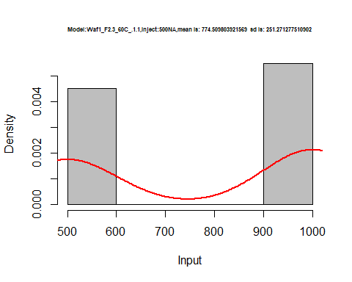

hist(d1_1.1$V6,  
 freq = FALSE,  
 cex.main=0.5,  
 main = paste('Model:Waf1_F2.3_60C_.1.1,Inject:600NA,mean is:', mean(d1_1.1$V6),' sd is:', sd(d1_1.1$V6)),  
 xlab = "Input",  
 ylab = "Density",  
 col="grey")  
#plot density curve  
lines(density(d1_1.1$V6), # density plot  
 lwd = 2, # thickness of line  
 col = "red")

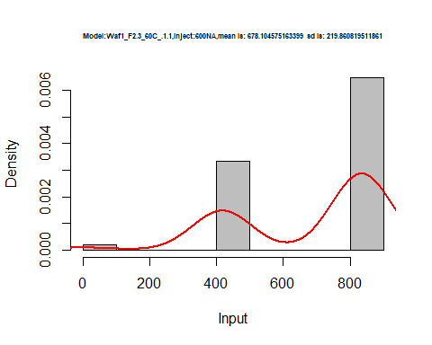

hist(d1_1.1$V7,  
 freq = FALSE,  
 cex.main=0.5,  
 main = paste('Model:Waf1_F2.3_60C_.1.1,Inject:700NA,mean is:', mean(d1_1.1$V7),' sd is:', sd(d1_1.1$V7)),  
 xlab = "Input",  
 ylab = "Density",  
 col="grey")  
#plot density curve  
lines(density(d1_1.1$V7), # density plot  
 lwd = 2, # thickness of line  
 col = "red")

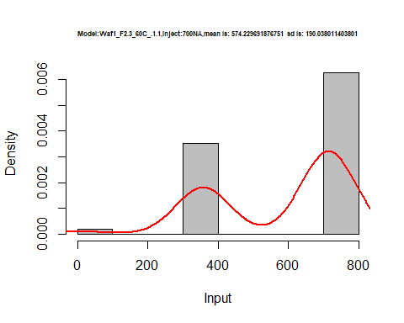

hist(d1_1.1$V8,  
 freq = FALSE,  
 cex.main=0.5,  
 main = paste('Model:Waf1_F2.3_60C_.1.1,Inject:800NA,mean is:', mean(d1_1.1$V8),' sd is:', sd(d1_1.1$V8)),  
 xlab = "Input",  
 ylab = "Density",  
 col="grey")  
#plot density curve  
lines(density(d1_1.1$V8), # density plot  
 lwd = 2, # thickness of line  
 col = "red")

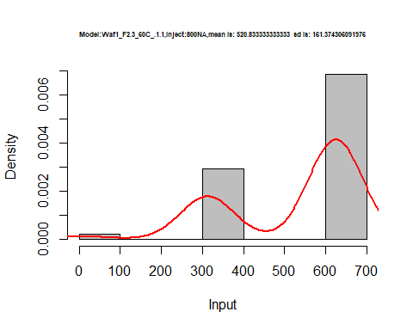

dens <- apply(d1_1.1, 2, density)  
plot(NA, xlim=range(sapply(dens, "[", "x")), ylim=range(sapply(dens, "[", "y")))  
mapply(lines, dens, col=1:length(dens))

## $V1  
## NULL  
##   
## $V2  
## NULL  
##   
## $V3  
## NULL  
##   
## $V4  
## NULL  
##   
## $V5  
## NULL  
##   
## $V6  
## NULL  
##   
## $V7  
## NULL  
##   
## $V8  
## NULL

legend("topright", legend=names(dens), fill=1:length(dens))

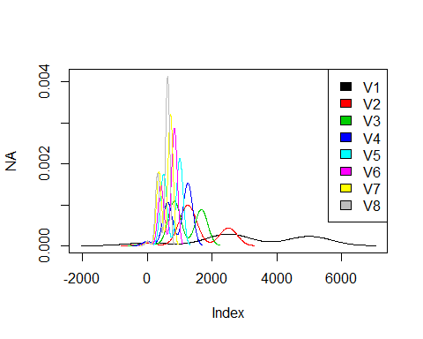

d2_1.1<-d_1.1[,c(9:16)]  
d2_1.1 <- head(d2_1.1,51)  
colnames(d2_1.1) <- c("V1", "V2","V3","V4","V5","V6","V7","V8")  
head(d2_1.1)

## V1 V2 V3 V4 V5 V6 V7 V8  
## 1 16005000 9727500 6962500 5555625 4804500 4080000 3571429 3125937  
## 2 15997500 9728750 6972500 5554375 4803500 4093750 3571071 3125625  
## 3 16015000 9731250 6977500 5551875 4799500 4094167 3570714 3125625  
## 4 16042500 9732500 6975833 5551875 4803500 4102500 3571429 3125937  
## 5 16040000 9737500 6970000 5553125 4800500 4114583 3571429 3125937  
## 6 16042500 9733750 6968333 5554375 4800000 4106667 3572143 3125937

hist(d2_1.1$V1,  
 cex.main=0.5,  
 freq = FALSE,  
 main = paste('Model:Waf1_F2.3_F_60C_.1.1.,Inject:100NA,mean is:', mean(d2_1.1$V1),' sd is:', sd(d2_1.1$V1)),  
 xlab = "Input",  
 ylab = "Density",  
 col="grey")  
#plot density curve  
lines(density(d2_1.1$V1), # density plot  
 lwd = 2, # thickness of line  
 col = "red")

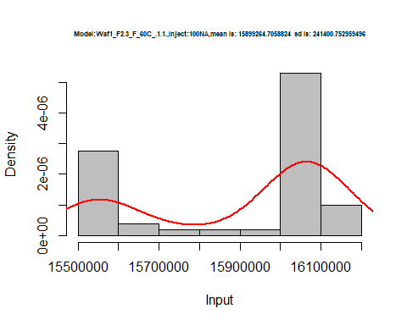

hist(d2_1.1$V2,  
 freq = FALSE,  
 cex.main=0.5,  
 main = paste('Model:Waf1_F2.3_F_60C_.1.1.,Inject:200NA,mean is:', mean(d2_1.1$V2),' sd is:', sd(d2_1.1$V2)),  
 xlab = "Input",  
 ylab = "Density",  
 col="grey")  
#plot density curve  
lines(density(d2_1.1$V2), # density plot  
 lwd = 2, # thickness of line  
 col = "red")

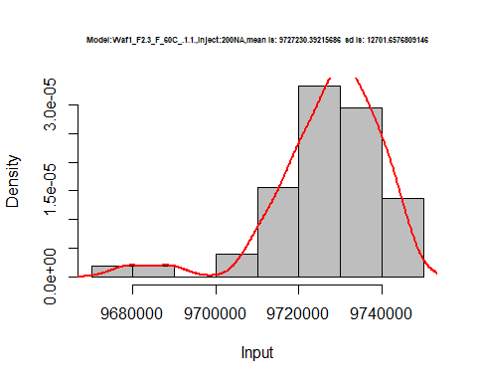

hist(d2_1.1$V3,  
 freq = FALSE,  
 cex.main=0.5,  
 main = paste('Model:Waf1_F2.3_F_60C_.1.1.,Inject:300NA,mean is:', mean(d2_1.1$V3),' sd is:', sd(d2_1.1$V3)),  
 xlab = "Input",  
 ylab = "Density",  
 col="grey")  
  
#plot density curve  
lines(density(d2_1.1$V3), # density plot  
 lwd = 2, # thickness of line  
 col = "red")

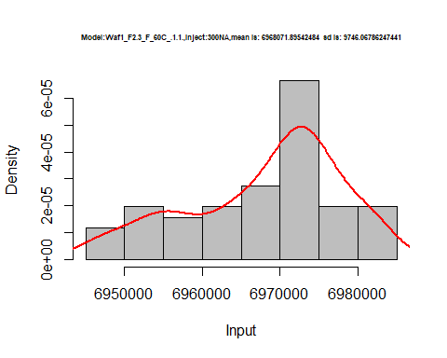

hist(d2_1.1$V4,  
 freq = FALSE,  
 cex.main=0.5,  
 main = paste('Model:Waf1_F2.3_F_60C_.1.1.,Inject:400NA,mean is:', mean(d2_1.1$V4),' sd is:', sd(d2_1.1$V4)),  
 xlab = "Input",  
 ylab = "Density",  
 col="grey")  
#plot density curve  
lines(density(d2_1.1$V4), # density plot  
 lwd = 2, # thickness of line  
 col = "red")

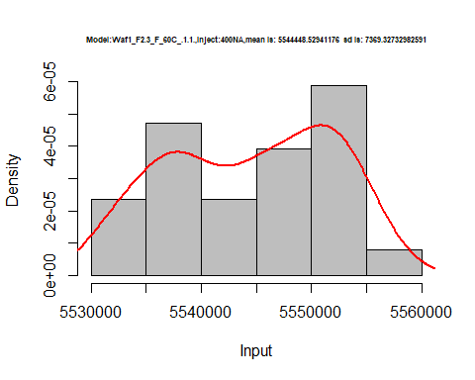

hist(d2_1.1$V5,  
 freq = FALSE,  
 cex.main=0.5,  
 main = paste('Model:Waf1_F2.3_F_60C_.1.1.,Inject:500NA,mean is:', mean(d2_1.1$V5),' sd is:', sd(d2_1.1$V5)),  
 xlab = "Input",  
 ylab = "Density",  
 col="grey")  
#plot density curve  
lines(density(d2_1.1$V5), # density plot  
 lwd = 2, # thickness of line  
 col = "red")

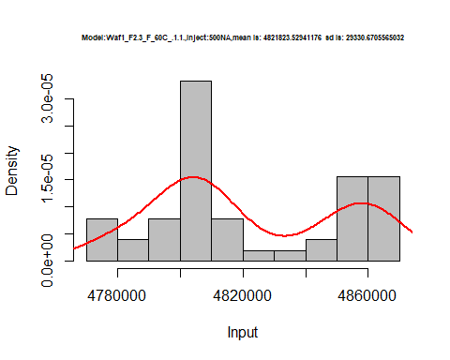

hist(d2_1.1$V6,  
 freq = FALSE,  
 cex.main=0.5,  
 main = paste('Model:Waf1_F2.3_F_60C_.1.1.,Inject:600NA,mean is:', mean(d2_1.1$V6),' sd is:', sd(d2_1.1$V6)),  
 xlab = "Input",  
 ylab = "Density",  
 col="grey")  
#plot density curve  
lines(density(d2_1.1$V6), # density plot  
 lwd = 2, # thickness of line  
 col = "red")

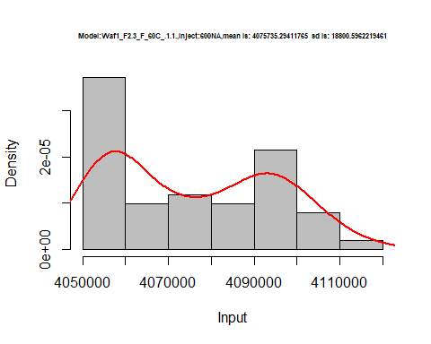

hist(d2_1.1$V7,  
 freq = FALSE,  
 cex.main=0.5,  
 main = paste('Model:Waf1_F2.3_F_60C_.1.1.,Inject:700NA,mean is:', mean(d2_1.1$V7),' sd is:', sd(d2_1.1$V7)),  
 xlab = "Input",  
 ylab = "Density",  
 col="grey")  
#plot density curve  
lines(density(d2_1.1$V7), # density plot  
 lwd = 2, # thickness of line  
 col = "red")

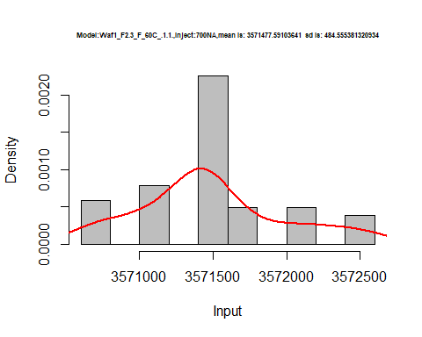

hist(d2_1.1$V8,  
 freq = FALSE,  
 cex.main=0.5,  
 main = paste('Model:Waf1_F2.3_F_60C_.1.1.,Inject:800NA,mean is:', mean(d2_1.1$V8),' sd is:', sd(d2_1.1$V8)),  
 xlab = "Input",  
 ylab = "Density",  
 col="grey")  
#plot density curve  
lines(density(d2_1.1$V8), # density plot  
 lwd = 2, # thickness of line  
 col = "red")

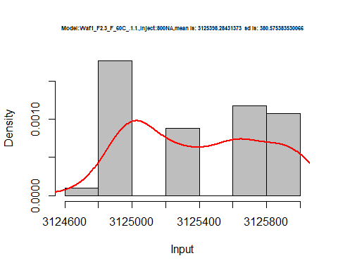

dens <- apply(d2_1.1, 2, density)  
plot('Waf1_F4.6_60C_.1.1.', xlim=range(sapply(dens, "[", "x")), ylim=range(sapply(dens, "[", "y")))

## Warning in xy.coords(x, y, xlabel, ylabel, log): NAs introduced by coercion

mapply(lines, dens, col=1:length(dens))

## $V1  
## NULL  
##   
## $V2  
## NULL  
##   
## $V3  
## NULL  
##   
## $V4  
## NULL  
##   
## $V5  
## NULL  
##   
## $V6  
## NULL  
##   
## $V7  
## NULL  
##   
## $V8  
## NULL

legend("topright", legend=names(dens), fill=1:length(dens))

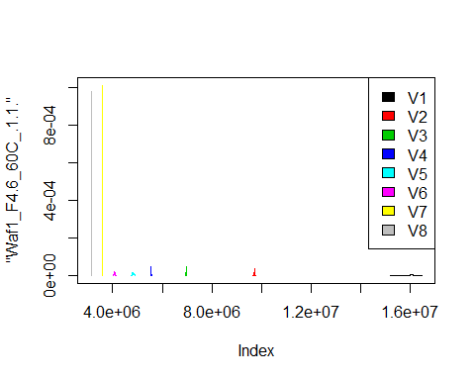

d3_1.1<-d_1.1[,c(17:24)]  
d3_1.1 <- head(d3_1.1,51)  
colnames(d3_1.1) <- c("V1", "V2","V3","V4","V5","V6","V7","V8")  
head(d3_1.1)

## V1 V2 V3 V4 V5 V6 V7 V8  
## 1 4227500 2600000 2128333 1800625 1617500 1445000 1356429 1215625  
## 2 4155000 2597500 2126667 1803125 1614000 1444583 1353571 1209063  
## 3 4072500 2597500 2125833 1803125 1616000 1440000 1348929 1217500  
## 4 4037500 2602500 2120833 1805000 1617000 1448333 1348571 1223438  
## 5 4022500 2602500 2140000 1803750 1615500 1450000 1351071 1215938  
## 6 4015000 2600000 2146667 1796250 1617500 1445000 1352857 1216250

hist(d3_1.1$V1,  
 freq = FALSE,  
 cex.main=0.5,  
 main = paste('Model:Waf1_F5.2_60C_.1.1.,Inject:100NA,mean is:', mean(d3_1.1$V1),' sd is:', sd(d3_1.1$V1)),  
 xlab = "Input",  
 ylab = "Density",  
 col="grey")  
#plot density curve  
lines(density(d3_1.1$V1), # density plot  
 lwd = 2, # thickness of line  
 col = "red")

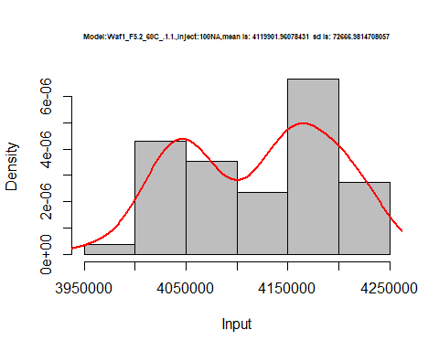

hist(d3_1.1$V2,  
 freq = FALSE,  
 cex.main=0.5,  
 main = paste('Model:Waf1_F5.2_60C_.1.1.,Inject:200NA,mean is:', mean(d3_1.1$V2),' sd is:', sd(d3_1.1$V2)),  
 xlab = "Input",  
 ylab = "Density",  
 col="grey")  
#plot density curve  
lines(density(d3_1.1$V2), # density plot  
 lwd = 2, # thickness of line  
 col = "red")

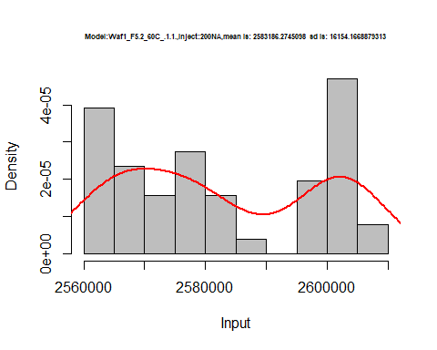

hist(d3_1.1$V3,  
 freq = FALSE,  
 cex.main=0.5,  
 main = paste('Model:Waf1_F5.2_60C_.1.1.,Inject:100NA,mean is:', mean(d3_1.1$V3),' sd is:', sd(d3_1.1$V3)),  
 xlab = "Input",  
 ylab = "Density",  
 col="grey")  
#plot density curve  
lines(density(d3_1.1$V3), # density plot  
 lwd = 2, # thickness of line  
 col = "red")

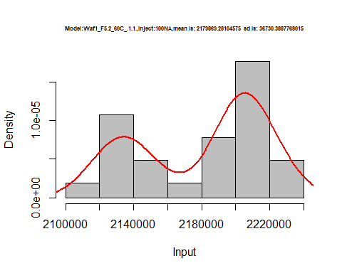

hist(d3_1.1$V4,  
 freq = FALSE,  
 cex.main=0.5,  
 main = paste('Model:Waf1_F5.2_60C_.1.1..,Inject:400NA,mean is:', mean(d3_1.1$V4),' sd is:', sd(d3_1.1$V4)),  
 xlab = "Input",  
 ylab = "Density",  
 col="grey")  
#plot density curve  
lines(density(d3_1.1$V4), # density plot  
 lwd = 2, # thickness of line  
 col = "red")

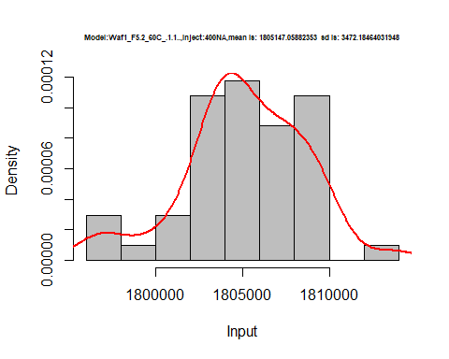

hist(d3_1.1$V5,  
 freq = FALSE,  
 cex.main=0.5,  
 main = paste('Model:Waf1_F5.2_60C_.1.1.,Inject:500NA,mean is:', mean(d3_1.1$V5),' sd is:', sd(d3_1.1$V5)),  
 xlab = "Input",  
 ylab = "Density",  
 col="grey")  
#plot density curve  
lines(density(d3_1.1$V5), # density plot  
 lwd = 2, # thickness of line  
 col = "red")

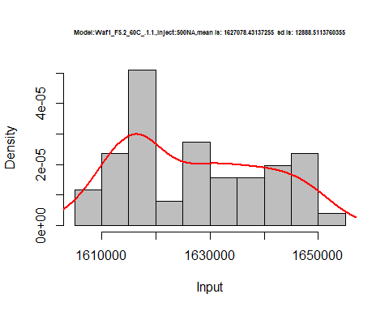

hist(d3_1.1$V6,  
 freq = FALSE,  
 cex.main=0.5,  
 main = paste('Model:Waf1_F5.2_60C_.1.1.,Inject:600NA,mean is:', mean(d3_1.1$V6),' sd is:', sd(d3_1.1$V6)),  
 xlab = "Input",  
 ylab = "Density",  
 col="grey")  
#plot density curve  
lines(density(d3_1.1$V6), # density plot  
 lwd = 2, # thickness of line  
 col = "red")

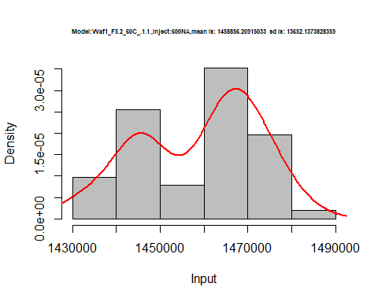

hist(d3_1.1$V7,  
 freq = FALSE,  
 cex.main=0.5,  
 main = paste('Model:Waf1_F5.2_60C_.1.1.,Inject:700NA,mean is:', mean(d3_1.1$V7),' sd is:', sd(d3_1.1$V7)),  
 xlab = "Input",  
 ylab = "Density",  
 col="grey")  
#plot density curve  
lines(density(d3_1.1$V7), # density plot  
 lwd = 2, # thickness of line  
 col = "red")

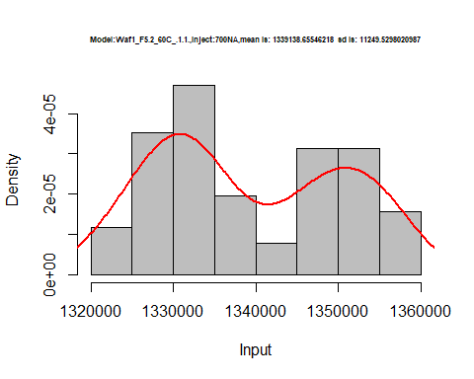

hist(d3_1.1$V8,  
 freq = FALSE,  
 cex.main=0.5,  
 main = paste('Model:Waf1_F5.2_60C_.1.1.,Inject:100NA,mean is:', mean(d3_1.1$V8),' sd is:', sd(d3_1.1$V8)),  
 xlab = "Input",  
 ylab = "Density",  
 col="grey")  
#plot density curve  
lines(density(d3_1.1$V8), # density plot  
 lwd = 2, # thickness of line  
 col = "red")

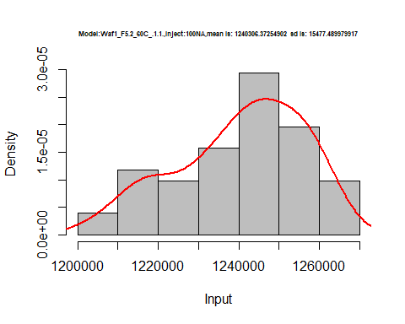

dens <- apply(d3_1.1, 2, density)  
plot('Waf1_F5.2_60C_.1.1.', xlim=range(sapply(dens, "[", "x")), ylim=range(sapply(dens, "[", "y")))

## Warning in xy.coords(x, y, xlabel, ylabel, log): NAs introduced by coercion

mapply(lines, dens, col=1:length(dens))

## $V1  
## NULL  
##   
## $V2  
## NULL  
##   
## $V3  
## NULL  
##   
## $V4  
## NULL  
##   
## $V5  
## NULL  
##   
## $V6  
## NULL  
##   
## $V7  
## NULL  
##   
## $V8  
## NULL

legend("topright", legend=names(dens), fill=1:length(dens))

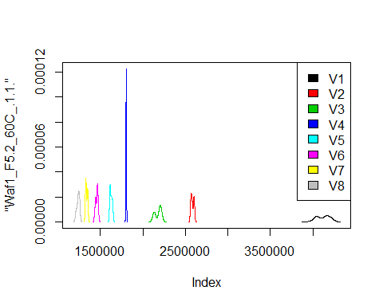

# Select columns whose names contains "2.2"  
d_2.2<-my_data %>% select(contains("2.2."))  
d_2.2 <- head(d_2.2,51)  
colnames(d_2.2) <- c("V1", "V2","V3","V4","V5","V6","V7","V8")  
head(d_2.2)

## V1 V2 V3 V4 V5 V6 V7 V8  
## 1 2.5e+07 12503750 8333333 6250000 5000000 4166250 3571071 3125625  
## 2 2.5e+07 12502500 8334167 6250000 5000000 4165833 3571429 3125312  
## 3 2.5e+07 12503750 8334167 6249375 5000000 4166250 3571071 3125937  
## 4 2.5e+07 12502500 8333333 6250000 5000000 4166250 3571429 3125937  
## 5 2.5e+07 12503750 8333333 6250000 5000000 4166667 3571071 3125937  
## 6 2.5e+07 12503750 8334167 6249375 5000500 4166667 3571071 3124062

hist(d_2.2$V1,  
 freq = FALSE,  
 cex.main=0.5,  
 main = paste('Model:Waf1_F4.3_F_60C_.2.2.,Inject:100NA,mean is:', mean(d_2.2$V1),' sd is:', sd(d_2.2$V1)),  
 xlab = "Input",  
 ylab = "Density",  
 col="grey")  
#plot density curve  
lines(density(d_2.2$V1), # density plot  
 lwd = 2, # thickness of line  
 col = "red")

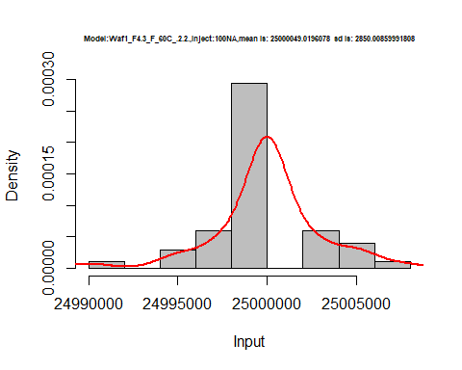

hist(d_2.2$V2,  
 freq = FALSE,  
 cex.main=0.5,  
 main = paste('Model:Waf1_F4.3_F_60C_.2.2.,Inject:200NA,mean is:', mean(d_2.2$V2),' sd is:', sd(d_2.2$V2)),  
 xlab = "Input",  
 ylab = "Density",  
 col="grey")  
#plot density curve  
lines(density(d_2.2$V2), # density plot  
 lwd = 2, # thickness of line  
 col = "red")

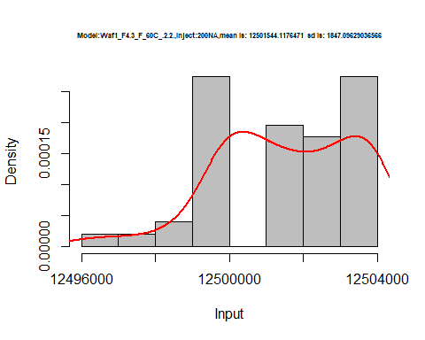

hist(d_2.2$V3,  
 freq = FALSE,  
 cex.main=0.5,  
 main = paste('Model:Waf1_F4.3_F_60C_.2.2.,Inject:300NA,mean is:', mean(d_2.2$V3),' sd is:', sd(d_2.2$V3)),  
 xlab = "Input",  
 ylab = "Density",  
 col="grey")  
#plot density curve  
lines(density(d_2.2$V3), # density plot  
 lwd = 2, # thickness of line  
 col = "red")

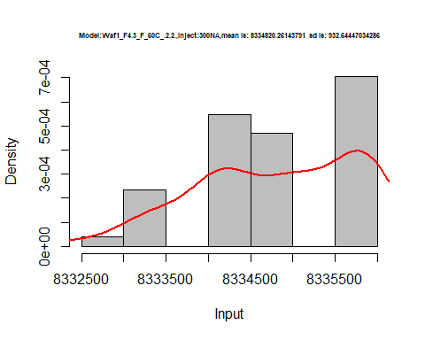

hist(d_2.2$V4,  
 freq = FALSE,  
 cex.main=0.5,  
 main = paste('Model:Waf1_F4.3_F_60C_.2.2.,Inject:400NA,mean is:', mean(d_2.2$V4),' sd is:', sd(d_2.2$V4)),  
 xlab = "Input",  
 ylab = "Density",  
 col="grey")  
#plot density curve  
lines(density(d_2.2$V4), # density plot  
 lwd = 2, # thickness of line  
 col = "red")

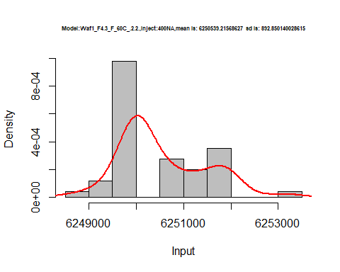

hist(d_2.2$V5,  
 freq = FALSE,  
 cex.main=0.5,  
 main = paste('Model:Waf1_F4.3_F_60C_.2.2.,Inject:100NA,mean is:', mean(d_2.2$V5),' sd is:', sd(d_2.2$V5)),  
 xlab = "Input",  
 ylab = "Density",  
 col="grey")  
#plot density curve  
lines(density(d_2.2$V5), # density plot  
 lwd = 2, # thickness of line  
 col = "red")

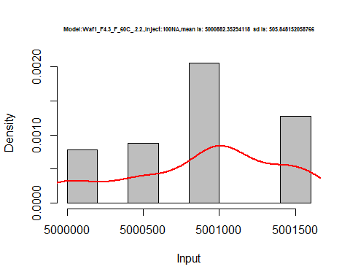

hist(d_2.2$V6,  
 freq = FALSE,  
 cex.main=0.5,  
 main = paste('Model:Waf1_F4.3_F_60C_.2.2.,Inject:600NA,mean is:', mean(d_2.2$V6),' sd is:', sd(d_2.2$V6)),  
 xlab = "Input",  
 ylab = "Density",  
 col="grey")  
#plot density curve  
lines(density(d_2.2$V6), # density plot  
 lwd = 2, # thickness of line  
 col = "red")

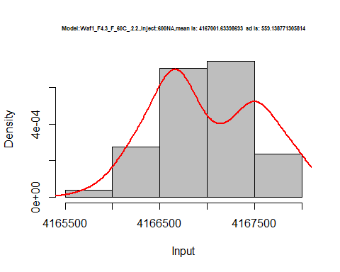

hist(d_2.2$V7,  
 freq = FALSE,  
 cex.main=0.5,  
 main = paste('Model:Waf1_F4.3_F_60C_.2.2.,Inject:700NA,mean is:', mean(d_2.2$V7),' sd is:', sd(d_2.2$V7)),  
 xlab = "Input",  
 ylab = "Density",  
 col="grey")  
#plot density curve  
lines(density(d_2.2$V7), # density plot  
 lwd = 2, # thickness of line  
 col = "red")

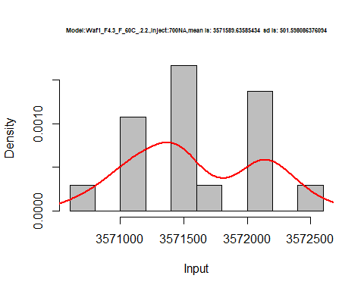

hist(d_2.2$V8,  
 freq = FALSE,  
 cex.main=0.5,  
 main = paste('Model:Waf1_F4.3_F_60C_.2.2.,Inject:800NA,mean is:', mean(d_2.2$V8),' sd is:', sd(d_2.2$V8)),  
 xlab = "Input",  
 ylab = "Density",  
 col="grey")  
#plot density curve  
lines(density(d_2.2$V8), # density plot  
 lwd = 2, # thickness of line  
 col = "red")

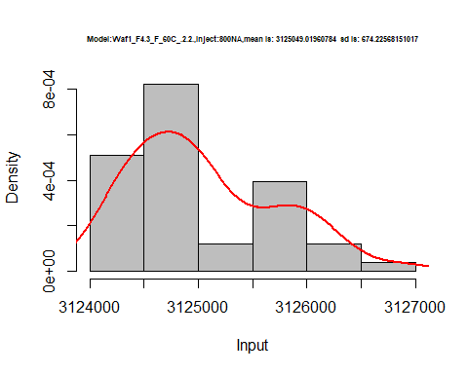

dens <- apply(d_2.2, 2, density)  
plot('Waf1_F4.3_60C_.2.2.', xlim=range(sapply(dens, "[", "x")), ylim=range(sapply(dens, "[", "y")))

## Warning in xy.coords(x, y, xlabel, ylabel, log): NAs introduced by coercion

mapply(lines, dens, col=1:length(dens))

## $V1  
## NULL  
##   
## $V2  
## NULL  
##   
## $V3  
## NULL  
##   
## $V4  
## NULL  
##   
## $V5  
## NULL  
##   
## $V6  
## NULL  
##   
## $V7  
## NULL  
##   
## $V8  
## NULL

legend("topright", legend=names(dens), fill=1:length(dens))

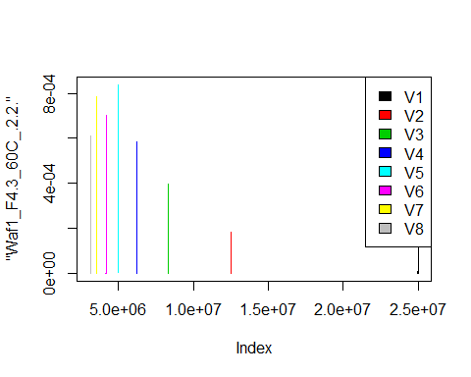

# Select columns whose names contains "3.3"  
d_3.3<-my_data %>% select(contains("3.3."))  
head(d_3.3)

## Waf1_F3.5_60C_.100nA_.3.3. Waf1_F3.5_60C_.200nA_.3.3.  
## 1 3202500 1826250  
## 2 3202500 1877500  
## 3 3205000 1880000  
## 4 3212500 1881250  
## 5 3192500 1883750  
## 6 3205000 1858750  
## Waf1_F3.5_60C_.300nA_.3.3. Waf1_F3.5_60C_.400nA_.3.3.  
## 1 1325000 1166250  
## 2 1325000 1167500  
## 3 1328333 1168125  
## 4 1324167 1165000  
## 5 1320000 1163125  
## 6 1327500 1164375  
## Waf1_F3.5_60C_.500nA_.3.3. Waf1_F3.5_60C_.600nA_.3.3.  
## 1 1170000 1075417  
## 2 1169000 1077083  
## 3 1173000 961250  
## 4 1167500 1065833  
## 5 1169500 1075417  
## 6 1163000 1071667  
## Waf1_F3.5_60C_.700nA_.3.3. Waf1_F3.5_60C_.800nA_.3.3.  
## 1 917142.9 841562.5  
## 2 917500.0 844687.5  
## 3 914642.9 843750.0  
## 4 958214.3 839062.5  
## 5 913214.3 842812.5  
## 6 971785.7 845625.0  
## Waf1_F4.3_F_60C_.100nA_.3.3. Waf1_F4.3_F_60C_.200nA_.3.3.  
## 1 25005000 12500000  
## 2 25005000 12501250  
## 3 25007500 12501250  
## 4 25007500 12501250  
## 5 25007500 12500000  
## 6 25005000 12501250  
## Waf1_F4.3_F_60C_.300nA_.3.3. Waf1_F4.3_F_60C_.400nA_.3.3.  
## 1 8332500 6250000  
## 2 8333333 6250625  
## 3 8332500 6250000  
## 4 8332500 6250000  
## 5 8332500 6250000  
## 6 8333333 6250000  
## Waf1_F4.3_F_60C_.500nA_.3.3. Waf1_F4.3_F_60C_.600nA_.3.3.  
## 1 5000000 4166667  
## 2 5000000 4166250  
## 3 5000000 4166250  
## 4 4999500 4166667  
## 5 4999500 4166667  
## 6 4999500 4166667  
## Waf1_F4.3_F_60C_.700nA_.3.3. Waf1_F4.3_F_60C_.800nA_.3.3.  
## 1 3572500 3125937  
## 2 3572500 3125937  
## 3 3572500 3125625  
## 4 3572500 3125625  
## 5 3572500 3125625  
## 6 3572143 3125312  
## Waf1_F7.4_F_60C_.100nA_.3.3. Waf1_F7.4_F_60C_.200nA_.3.3.  
## 1 4147500 2333750  
## 2 4147500 2543750  
## 3 4125000 2562500  
## 4 4007500 2427500  
## 5 3997500 2433750  
## 6 4022500 2606250  
## Waf1_F7.4_F_60C_.300nA_.3.3. Waf1_F7.4_F_60C_.400nA_.3.3.  
## 1 1611667 1317500  
## 2 1640833 1305000  
## 3 1694167 1295000  
## 4 1690000 1322500  
## 5 1633333 1242500  
## 6 1630000 1325625  
## Waf1_F7.4_F_60C_.500nA_.3.3. Waf1_F7.4_F_60C_.600nA_.3.3.  
## 1 958000 908750.0  
## 2 850000 930000.0  
## 3 850500 941666.7  
## 4 866500 895416.7  
## 5 855000 836250.0  
## 6 853000 862083.3  
## Waf1_F7.4_F_60C_.700nA_.3.3. Waf1_F7.4_F_60C_.800nA_.3.3.  
## 1 839285.7 720000.0  
## 2 836785.7 715312.5  
## 3 855714.3 713750.0  
## 4 845357.1 711875.0  
## 5 821428.6 730937.5  
## 6 843571.4 719062.5

d1_3.3<-d_3.3[,c(1:8)]  
d1_3.3 <- head(d1_3.3,51)  
colnames(d1_3.3) <- c("V1", "V2","V3","V4","V5","V6","V7","V8")  
head(d1_3.3)

## V1 V2 V3 V4 V5 V6 V7 V8  
## 1 3202500 1826250 1325000 1166250 1170000 1075417 917142.9 841562.5  
## 2 3202500 1877500 1325000 1167500 1169000 1077083 917500.0 844687.5  
## 3 3205000 1880000 1328333 1168125 1173000 961250 914642.9 843750.0  
## 4 3212500 1881250 1324167 1165000 1167500 1065833 958214.3 839062.5  
## 5 3192500 1883750 1320000 1163125 1169500 1075417 913214.3 842812.5  
## 6 3205000 1858750 1327500 1164375 1163000 1071667 971785.7 845625.0

hist(d1_3.3$V1,  
 freq = FALSE,  
 cex.main=0.5,  
 main = paste('Model:Waf1_F3.5_60C_.3.3.,Inject:100NA,mean is:', mean(d1_3.3$V1),' sd is:', sd(d1_3.3$V1)),  
 xlab = "Input",  
 ylab = "Density",  
 col="grey")  
#plot density curve  
lines(density(d1_3.3$V1), # density plot  
 lwd = 2, # thickness of line  
 col = "red")

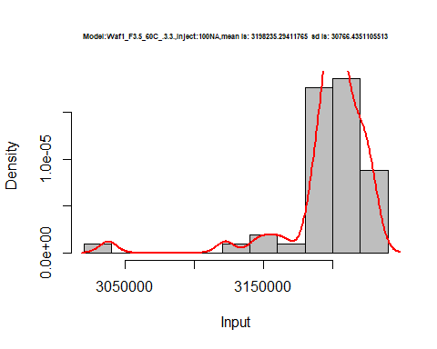

hist(d1_3.3$V2,  
 freq = FALSE,  
 cex.main=0.5,  
 main = paste('Model:Model:Waf1_F3.5_60C_.3.3.,Inject:200NA,mean is:', mean(d1_3.3$V2),' sd is:', sd(d1_3.3$V2)),  
 xlab = "Input",  
 ylab = "Density",  
 col="grey")  
#plot density curve  
lines(density(d1_3.3$V2), # density plot  
 lwd = 2, # thickness of line  
 col = "red")

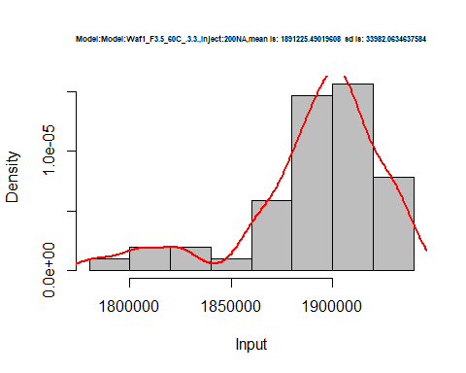

hist(d1_3.3$V3,  
 freq = FALSE,  
 cex.main=0.5,  
 main = paste('Model:Model:Waf1_F3.5_60C_.3.3,Inject:300NA,mean is:', mean(d1_3.3$V3),' sd is:', sd(d1_3.3$V3)),  
 xlab = "Input",  
 ylab = "Density",  
 col="grey")  
#plot density curve  
lines(density(d1_3.3$V3), # density plot  
 lwd = 2, # thickness of line  
 col = "red")

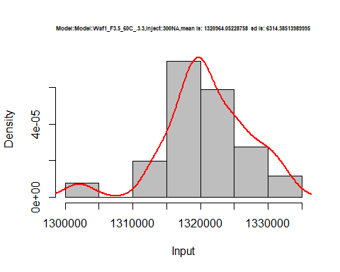

hist(d1_3.3$V4,  
 freq = FALSE,  
 cex.main=0.5,  
 main = paste('Model:Waf1_F3.5_60C_.3.3.,Inject:400NA,mean is:', mean(d1_3.3$V4),' sd is:', sd(d1_3.3$V4)),  
 xlab = "Input",  
 ylab = "Density",  
 col="grey")  
#plot density curve  
lines(density(d1_3.3$V4), # density plot  
 lwd = 2, # thickness of line  
 col = "red")

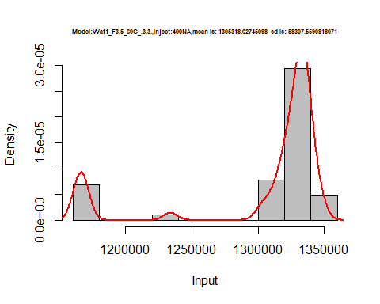

hist(d1_3.3$V5,  
 freq = FALSE,  
 cex.main=0.5,  
 main = paste('Model:Waf1_F3.5_60C_.3.3.,Inject:500NA,mean is:', mean(d1_3.3$V5),' sd is:', sd(d1_3.3$V5)),  
 xlab = "Input",  
 ylab = "Density",  
 col="grey")  
#plot density curve  
lines(density(d1_3.3$V5), # density plot  
 lwd = 2, # thickness of line  
 col = "red")

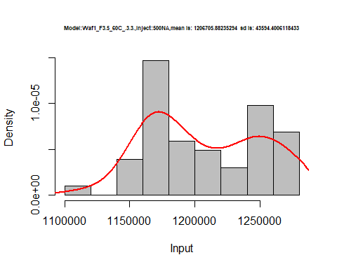

hist(d1_3.3$V6,  
 freq = FALSE,  
 cex.main=0.5,  
 main = paste('Model:Waf1_F3.5_60C_.3.3.,Inject:600NA,mean is:', mean(d1_3.3$V6),' sd is:', sd(d1_3.3$V6)),  
 xlab = "Input",  
 ylab = "Density",  
 col="grey")  
#plot density curve  
lines(density(d1_3.3$V6), # density plot  
 lwd = 2, # thickness of line  
 col = "red")

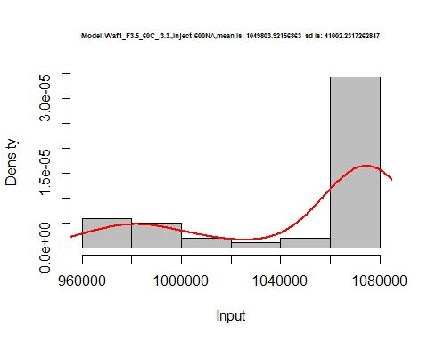

hist(d1_3.3$V7,  
 freq = FALSE,  
 cex.main=0.5,  
 main = paste('Model:Waf1_F3.5_60C_.3.3.,Inject:700NA,mean is:', mean(d1_3.3$V7),' sd is:', sd(d1_3.3$V7)),  
 xlab = "Input",  
 ylab = "Density",  
 col="grey")  
#plot density curve  
lines(density(d1_3.3$V7), # density plot  
 lwd = 2, # thickness of line  
 col = "red")

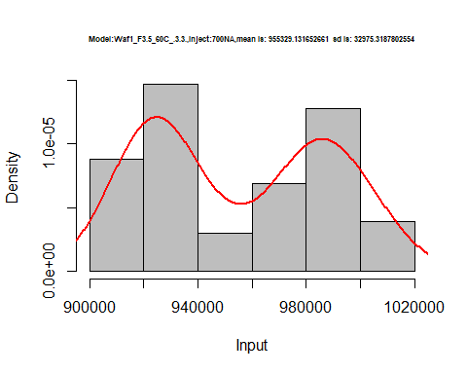

hist(d1_3.3$V8,  
 freq = FALSE,  
 cex.main=0.5,  
 main = paste('Model:Waf1_F3.5_60C_.3.3.,Inject:800NA,mean is:', mean(d1_3.3$V8),' sd is:', sd(d1_3.3$V8)),  
 xlab = "Input",  
 ylab = "Density",  
 col="grey")  
#plot density curve  
lines(density(d1_3.3$V8), # density plot  
 lwd = 2, # thickness of line  
 col = "red")

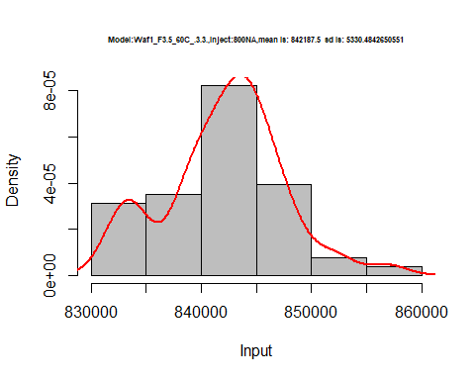

dens <- apply(d1_3.3, 2, density)  
plot('Waf1_F3.5_60C_.3.3.', xlim=range(sapply(dens, "[", "x")), ylim=range(sapply(dens, "[", "y")))

## Warning in xy.coords(x, y, xlabel, ylabel, log): NAs introduced by coercion

mapply(lines, dens, col=1:length(dens))

## $V1  
## NULL  
##   
## $V2  
## NULL  
##   
## $V3  
## NULL  
##   
## $V4  
## NULL  
##   
## $V5  
## NULL  
##   
## $V6  
## NULL  
##   
## $V7  
## NULL  
##   
## $V8  
## NULL

legend("topright", legend=names(dens), fill=1:length(dens))

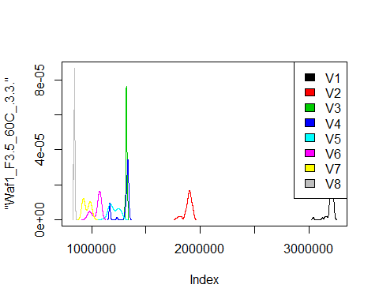

d2_3.3<-d_3.3[,c(9:16)]  
d2_3.3 <- head(d2_3.3,51)  
colnames(d2_3.3) <- c("V1", "V2","V3","V4","V5","V6","V7","V8")  
head(d2_3.3)

## V1 V2 V3 V4 V5 V6 V7 V8  
## 1 25005000 12500000 8332500 6250000 5000000 4166667 3572500 3125937  
## 2 25005000 12501250 8333333 6250625 5000000 4166250 3572500 3125937  
## 3 25007500 12501250 8332500 6250000 5000000 4166250 3572500 3125625  
## 4 25007500 12501250 8332500 6250000 4999500 4166667 3572500 3125625  
## 5 25007500 12500000 8332500 6250000 4999500 4166667 3572500 3125625  
## 6 25005000 12501250 8333333 6250000 4999500 4166667 3572143 3125312

hist(d2_3.3$V1,  
 freq = FALSE,  
 cex.main=0.5,  
 main = paste('Model:Waf1_F4.3_60C_.3.3.,Inject:100NA,mean is:', mean(d2_3.3$V1),' sd is:', sd(d2_3.3$V1)),  
 xlab = "Input",  
 ylab = "Density",  
 col="grey")  
#plot density curve  
lines(density(d2_3.3$V1), # density plot  
 lwd = 2, # thickness of line  
 col = "red")

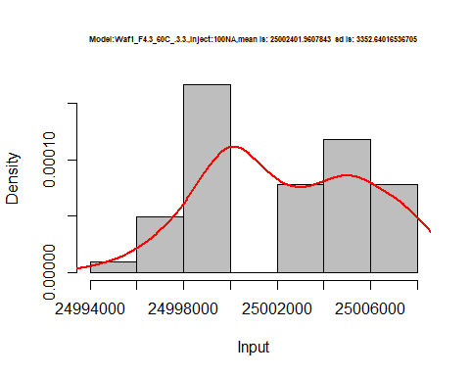

hist(d2_3.3$V2,  
 freq = FALSE,  
 cex.main=0.5,  
 main = paste('Model:Waf1_F4.3_60C_.3.3.,Inject:200NA,mean is:', mean(d2_3.3$V2),' sd is:', sd(d2_3.3$V2)),  
 xlab = "Input",  
 ylab = "Density",  
 col="grey")  
#plot density curve  
lines(density(d2_3.3$V2), # density plot  
 lwd = 2, # thickness of line  
 col = "red")

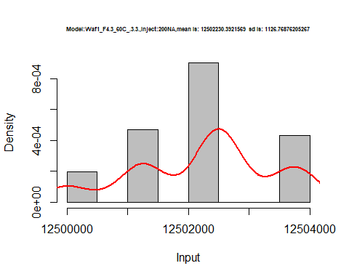

hist(d2_3.3$V3,  
 freq = FALSE,  
 cex.main=0.5,  
 main = paste('Model:Waf1_F4.3_60C_.3.3.,Inject:300NA,mean is:', mean(d2_3.3$V3),' sd is:', sd(d2_3.3$V3)),  
 xlab = "Input",  
 ylab = "Density",  
 col="grey")  
#plot density curve  
lines(density(d2_3.3$V3), # density plot  
 lwd = 2, # thickness of line  
 col = "red")

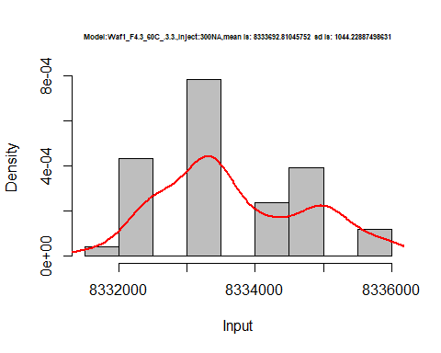

hist(d2_3.3$V4,  
 freq = FALSE,  
 cex.main=0.5,  
 main = paste('Model:Waf1_F4.3_60C_.3.3.,Inject:400NA,mean is:', mean(d2_3.3$V4),' sd is:', sd(d2_3.3$V4)),  
 xlab = "Input",  
 ylab = "Density",  
 col="grey")  
#plot density curve  
lines(density(d2_3.3$V4), # density plot  
 lwd = 2, # thickness of line  
 col = "red")

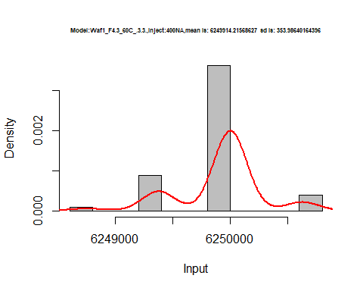

hist(d2_3.3$V5,  
 freq = FALSE,  
 cex.main=0.5,  
 main = paste('Model:Waf1_F4.3_60C_.3.3.,Inject:500NA,mean is:', mean(d2_3.3$V5),' sd is:', sd(d2_3.3$V5)),  
 xlab = "Input",  
 ylab = "Density",  
 col="grey")  
#plot density curve  
lines(density(d2_3.3$V5), # density plot  
 lwd = 2, # thickness of line  
 col = "red")

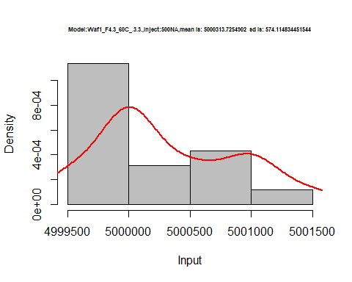

hist(d2_3.3$V6,  
 freq = FALSE,  
 cex.main=0.5,  
 main = paste('Model:Waf1_F4.3_60C_.3.3.,Inject:600NA,mean is:', mean(d2_3.3$V6),' sd is:', sd(d2_3.3$V6)),  
 xlab = "Input",  
 ylab = "Density",  
 col="grey")  
#plot density curve  
lines(density(d2_3.3$V6), # density plot  
 lwd = 2, # thickness of line  
 col = "red")

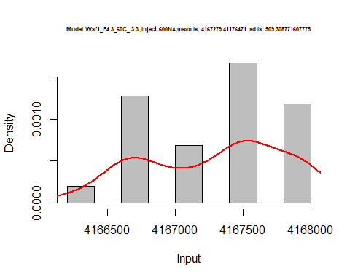

hist(d2_3.3$V7,  
 freq = FALSE,  
 cex.main=0.5,  
 main = paste('Model:Waf1_F4.3_60C_.3.3.,Inject:700NA,mean is:', mean(d2_3.3$V7),' sd is:', sd(d2_3.3$V7)),  
 xlab = "Input",  
 ylab = "Density",  
 col="grey")  
#plot density curve  
lines(density(d2_3.3$V7), # density plot  
 lwd = 2, # thickness of line  
 col = "red")

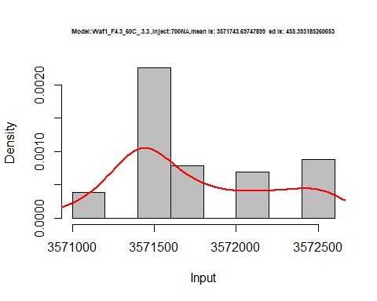

hist(d2_3.3$V8,  
 freq = FALSE,  
 cex.main=0.5,  
 main = paste('Model:Waf1_F4.3_60C_.3.3.,Inject:800NA,mean is:', mean(d2_3.3$V8),' sd is:', sd(d2_3.3$V8)),  
 xlab = "Input",  
 ylab = "Density",  
 col="grey")  
#plot density curve  
lines(density(d2_3.3$V8), # density plot  
 lwd = 2, # thickness of line  
 col = "red")

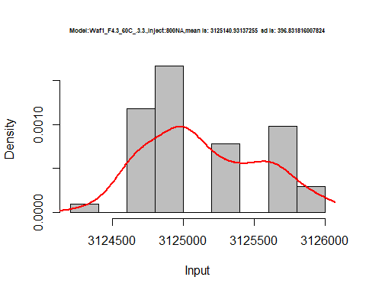

dens <- apply(d2_3.3, 2, density)  
plot('Waf1_F4.3_60C_.3.3.', xlim=range(sapply(dens, "[", "x")), ylim=range(sapply(dens, "[", "y")))

## Warning in xy.coords(x, y, xlabel, ylabel, log): NAs introduced by coercion

mapply(lines, dens, col=1:length(dens))

## $V1  
## NULL  
##   
## $V2  
## NULL  
##   
## $V3  
## NULL  
##   
## $V4  
## NULL  
##   
## $V5  
## NULL  
##   
## $V6  
## NULL  
##   
## $V7  
## NULL  
##   
## $V8  
## NULL

legend("topright", legend=names(dens), fill=1:length(dens))

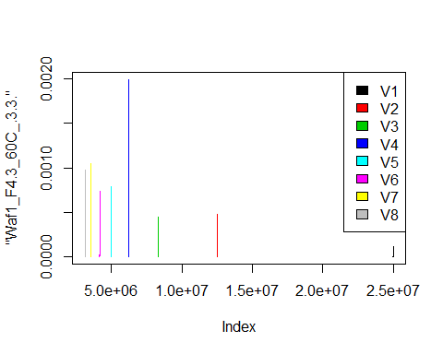

# Select columns whose names contains "4.4"  
d_4.4<-my_data %>% select(contains("4.4."))  
head(d_4.4)

## Waf1_F4.2_F_60C_.100nA_.4.4. Waf1_F4.2_F_60C_.200nA_.4.4.  
## 1 17490000 12503750  
## 2 17472500 12502500  
## 3 17440000 12502500  
## 4 17430000 12498750  
## 5 17395000 12500000  
## 6 17377500 12503750  
## Waf1_F4.2_F_60C_.300nA_.4.4. Waf1_F4.2_F_60C_.400nA_.4.4.  
## 1 8333333 6251250  
## 2 8335000 6251250  
## 3 8335000 6251250  
## 4 8335000 6251250  
## 5 8333333 6251250  
## 6 8334167 6251250  
## Waf1_F4.2_F_60C_.500nA_.4.4. Waf1_F4.2_F_60C_.600nA_.4.4.  
## 1 5000000 4167083  
## 2 5000000 4166667  
## 3 4999500 4167917  
## 4 4999500 4167500  
## 5 5000000 4167500  
## 6 5000000 4167500  
## Waf1_F4.2_F_60C_.700nA_.4.4. Waf1_F4.2_F_60C_.800nA_.4.4.  
## 1 3572143 3124688  
## 2 3572143 3124688  
## 3 3572500 3125000  
## 4 3571786 3124688  
## 5 3572143 3125000  
## 6 3572500 3125000  
## Waf1_F4.4_F_60C_.100nA_.4.4. Waf1_F4.4_F_60C_.200nA_.4.4.  
## 1 25000000 12500000  
## 2 25000000 12500000  
## 3 25000000 12500000  
## 4 25000000 12500000  
## 5 25002500 12501250  
## 6 25002500 12500000  
## Waf1_F4.4_F_60C_.300nA_.4.4. Waf1_F4.4_F_60C_.400nA_.4.4.  
## 1 8334167 6250000  
## 2 8333333 6250000  
## 3 8333333 6249375  
## 4 8330833 6249375  
## 5 8334167 6248750  
## 6 8333333 6249375  
## Waf1_F4.4_F_60C_.500nA_.4.4. Waf1_F4.4_F_60C_.600nA_.4.4.  
## 1 4999500 4167917  
## 2 5000000 4166667  
## 3 5000000 4166667  
## 4 4999500 4167917  
## 5 5000000 4167500  
## 6 5000000 4168333  
## Waf1_F4.4_F_60C_.700nA_.4.4. Waf1_F4.4_F_60C_.800nA_.4.4.  
## 1 3571429 3125000  
## 2 3571429 3125312  
## 3 3571429 3125625  
## 4 3571429 3125312  
## 5 3571429 3125312  
## 6 3571429 3125625  
## Waf1_F8.3_F_60C_.100nA_.4.4. Waf1_F8.3_F_60C_.200nA_.4.4.  
## 1 5880000 3717500  
## 2 5880000 3713750  
## 3 5880000 3717500  
## 4 5882500 3712500  
## 5 5882500 3711250  
## 6 5880000 3708750  
## Waf1_F8.3_F_60C_.300nA_.4.4. Waf1_F8.3_F_60C_.400nA_.4.4.  
## 1 2900833 2425000  
## 2 2888333 2421875  
## 3 2901667 2430625  
## 4 2917500 2424375  
## 5 2904167 2444375  
## 6 2900000 2419375  
## Waf1_F8.3_F_60C_.500nA_.4.4. Waf1_F8.3_F_60C_.600nA_.4.4.  
## 1 2138500 1872500  
## 2 2141000 1876250  
## 3 2159500 1872500  
## 4 2161500 1872500  
## 5 2157500 1871250  
## 6 2122500 1872500  
## Waf1_F8.3_F_60C_.700nA_.4.4. Waf1_F8.3_F_60C_.800nA_.4.4.  
## 1 1711071 1583750  
## 2 1709643 1585000  
## 3 1710357 1574375  
## 4 1710357 1574062  
## 5 1726071 1574375  
## 6 1711786 1574375

d1_4.4<-d_4.4[,c(1:8)]  
d1_4.4 <- head(d1_4.4,51)  
colnames(d1_4.4) <- c("V1", "V2","V3","V4","V5","V6","V7","V8")  
head(d1_4.4)

## V1 V2 V3 V4 V5 V6 V7 V8  
## 1 17490000 12503750 8333333 6251250 5000000 4167083 3572143 3124688  
## 2 17472500 12502500 8335000 6251250 5000000 4166667 3572143 3124688  
## 3 17440000 12502500 8335000 6251250 4999500 4167917 3572500 3125000  
## 4 17430000 12498750 8335000 6251250 4999500 4167500 3571786 3124688  
## 5 17395000 12500000 8333333 6251250 5000000 4167500 3572143 3125000  
## 6 17377500 12503750 8334167 6251250 5000000 4167500 3572500 3125000

hist(d1_4.4$V1,  
 freq = FALSE,  
 cex.main=0.5,  
 main = paste('Model:Waf1_F4.2_60C_.4.4..,Inject:100NA,mean is:', mean(d1_4.4$V1),' sd is:', sd(d1_4.4$V1)),  
 xlab = "Input",  
 ylab = "Density",  
 col="grey")  
#plot density curve  
lines(density(d1_4.4$V1), # density plot  
 lwd = 2, # thickness of line  
 col = "red")

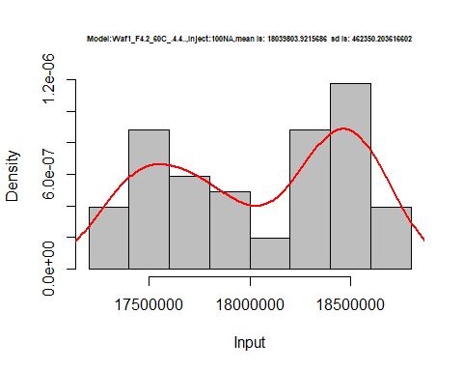

hist(d1_4.4$V2,  
 freq = FALSE,  
 cex.main=0.5,  
 main = paste('Model:Waf1_F4.2_60C_.4.4..,Inject:200NA,mean is:', mean(d1_4.4$V2),' sd is:', sd(d1_4.4$V2)),  
 xlab = "Input",  
 ylab = "Density",  
 col="grey")  
#plot density curve  
lines(density(d1_4.4$V2), # density plot  
 lwd = 2, # thickness of line  
 col = "red")

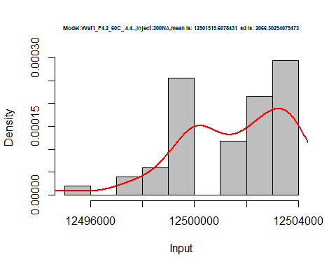

hist(d1_4.4$V3,  
 freq = FALSE,  
 cex.main=0.5,  
 main = paste('Model:Waf1_F4.2_60C_.4.4..,Inject:300NA,mean is:', mean(d1_4.4$V3),' sd is:', sd(d1_4.4$V3)),  
 xlab = "Input",  
 ylab = "Density",  
 col="grey")  
#plot density curve  
lines(density(d1_4.4$V3), # density plot  
 lwd = 2, # thickness of line  
 col = "red")

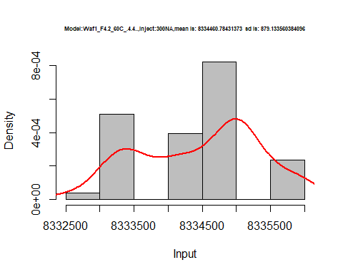

hist(d1_4.4$V4,  
 freq = FALSE,  
 cex.main=0.5,  
 main = paste('Model:Waf1_F4.2_60C_.4.4..,Inject:400NA,mean is:', mean(d1_4.4$V4),' sd is:', sd(d1_4.4$V4)),  
 xlab = "Input",  
 ylab = "Density",  
 col="grey")  
#plot density curve  
lines(density(d1_4.4$V4), # density plot  
 lwd = 2, # thickness of line  
 col = "red")

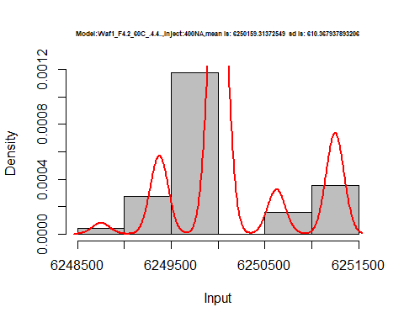

hist(d1_4.4$V5,  
 freq = FALSE,  
 cex.main=0.5,  
 main = paste('Model:Waf1_F4.2_60C_.4.4..,Inject:500NA,mean is:', mean(d1_4.4$V5),' sd is:', sd(d1_4.4$V5)),  
 xlab = "Input",  
 ylab = "Density",  
 col="grey")  
#plot density curve  
lines(density(d1_4.4$V5), # density plot  
 lwd = 2, # thickness of line  
 col = "red")

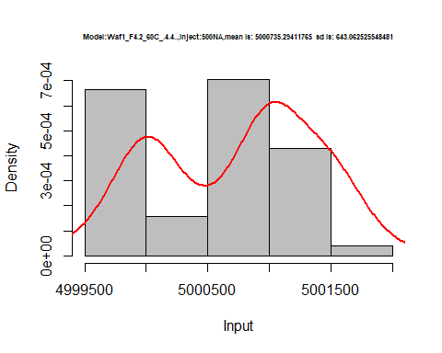

hist(d1_4.4$V6,  
 freq = FALSE,  
 cex.main=0.5,  
 main = paste('Model:Waf1_F4.2_60C_.4.4..,Inject:600NA,mean is:', mean(d1_4.4$V6),' sd is:', sd(d1_4.4$V6)),  
 xlab = "Input",  
 ylab = "Density",  
 col="grey")  
#plot density curve  
lines(density(d1_4.4$V6), # density plot  
 lwd = 2, # thickness of line  
 col = "red")

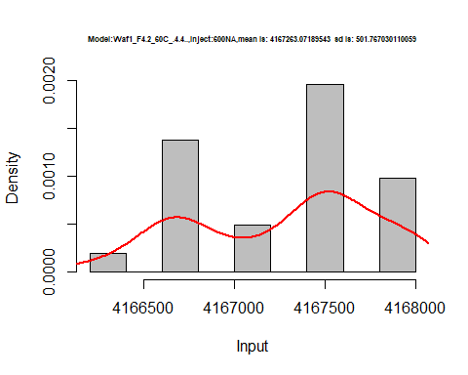

hist(d1_4.4$V7,  
 freq = FALSE,  
 cex.main=0.5,  
 main = paste('Model:Waf1_F4.2_60C_.4.4..,Inject:700NA,mean is:', mean(d1_4.4$V7),' sd is:', sd(d1_4.4$V7)),  
 xlab = "Input",  
 ylab = "Density",  
 col="grey")  
#plot density curve  
lines(density(d1_4.4$V7), # density plot  
 lwd = 2, # thickness of line  
 col = "red")

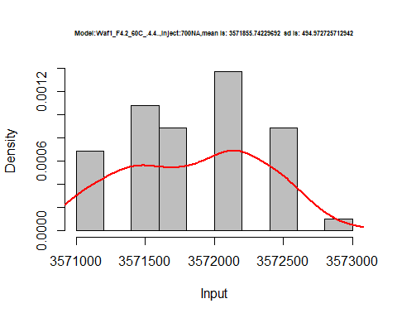

hist(d1_4.4$V8,  
 freq = FALSE,  
 cex.main=0.5,  
 main = paste('Model:Waf1_F4.2_60C_.4.4.,Inject:800NA,mean is:', mean(d1_4.4$V8),' sd is:', sd(d1_4.4$V8)),  
 xlab = "Input",  
 ylab = "Density",  
 col="grey")  
#plot density curve  
lines(density(d1_4.4$V8), # density plot  
 lwd = 2, # thickness of line  
 col = "red")

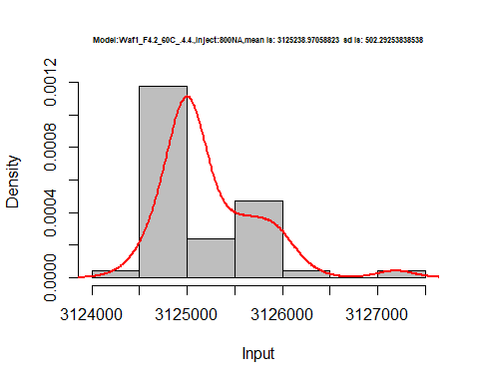

dens <- apply(d1_4.4, 2, density)  
plot('Model:Waf1_F4.2_60C_.4.4.', xlim=range(sapply(dens, "[", "x")), ylim=range(sapply(dens, "[", "y")))

## Warning in xy.coords(x, y, xlabel, ylabel, log): NAs introduced by coercion

mapply(lines, dens, col=1:length(dens))

## $V1  
## NULL  
##   
## $V2  
## NULL  
##   
## $V3  
## NULL  
##   
## $V4  
## NULL  
##   
## $V5  
## NULL  
##   
## $V6  
## NULL  
##   
## $V7  
## NULL  
##   
## $V8  
## NULL

legend("topright", legend=names(dens), fill=1:length(dens))

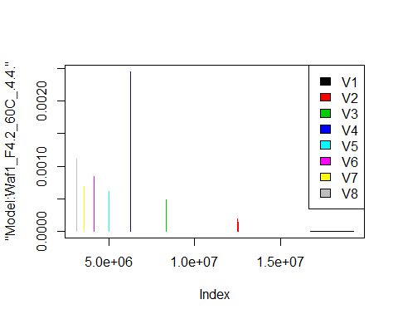

d2_4.4<-d_4.4[,c(9:16)]  
d2_4.4 <- head(d2_4.4,51)  
colnames(d2_4.4) <- c("V1", "V2","V3","V4","V5","V6","V7","V8")  
head(d2_4.4)

## V1 V2 V3 V4 V5 V6 V7 V8  
## 1 25000000 12500000 8334167 6250000 4999500 4167917 3571429 3125000  
## 2 25000000 12500000 8333333 6250000 5000000 4166667 3571429 3125312  
## 3 25000000 12500000 8333333 6249375 5000000 4166667 3571429 3125625  
## 4 25000000 12500000 8330833 6249375 4999500 4167917 3571429 3125312  
## 5 25002500 12501250 8334167 6248750 5000000 4167500 3571429 3125312  
## 6 25002500 12500000 8333333 6249375 5000000 4168333 3571429 3125625

hist(d2_4.4$V1,  
 freq = FALSE,  
 cex.main=0.5,  
 main = paste('Model:Waf1_F4.4_60C_.4.4..,Inject:100NA,mean is:', mean(d2_4.4$V1),' sd is:', sd(d2_4.4$V1)),  
 xlab = "Input",  
 ylab = "Density",  
 col="grey")  
#plot density curve  
lines(density(d2_4.4$V1), # density plot  
 lwd = 2, # thickness of line  
 col = "red")

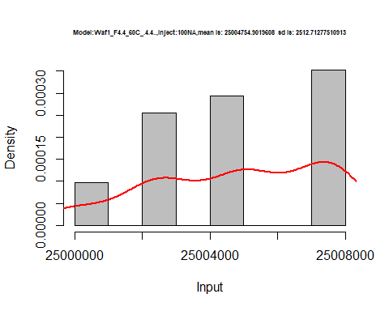

hist(d2_4.4$V2,  
 freq = FALSE,  
 cex.main=0.5,  
 main = paste('Model:Waf1_F4.4_60C_.4.4..,Inject:200NA,mean is:', mean(d2_4.4$V2),' sd is:', sd(d2_4.4$V2)),  
 xlab = "Input",  
 ylab = "Density",  
 col="grey")  
#plot density curve  
lines(density(d2_4.4$V2), # density plot  
 lwd = 2, # thickness of line  
 col = "red")

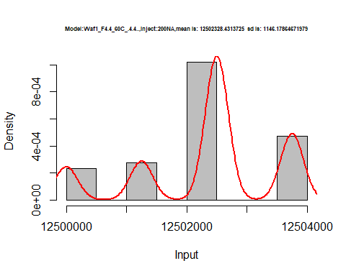

hist(d2_4.4$V3,  
 freq = FALSE,  
 cex.main=0.5,  
 main = paste('Model:Waf1_F4.4_60C_.4.4..,Inject:300NA,mean is:', mean(d2_4.4$V3),' sd is:', sd(d2_4.4$V3)),  
 xlab = "Input",  
 ylab = "Density",  
 col="grey")  
#plot density curve  
lines(density(d2_4.4$V3), # density plot  
 lwd = 2, # thickness of line  
 col = "red")

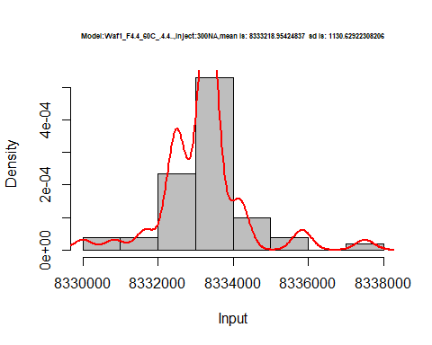

hist(d2_4.4$V4,  
 freq = FALSE,  
 cex.main=0.5,  
 main = paste('Model:Waf1_F4.4_60C_.4.4..,Inject:400NA,mean is:', mean(d2_4.4$V4),' sd is:', sd(d2_4.4$V4)),  
 xlab = "Input",  
 ylab = "Density",  
 col="grey")  
#plot density curve  
lines(density(d2_4.4$V4), # density plot  
 lwd = 2, # thickness of line  
 col = "red")

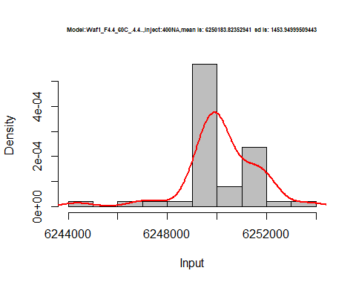

hist(d2_4.4$V5,  
 freq = FALSE,  
 cex.main=0.5,  
 main = paste('Model:Waf1_F4.4_60C_.4.4..,Inject:500NA,mean is:', mean(d2_4.4$V5),' sd is:', sd(d2_4.4$V5)),  
 xlab = "Input",  
 ylab = "Density",  
 col="grey")  
#plot density curve  
lines(density(d2_4.4$V5), # density plot  
 lwd = 2, # thickness of line  
 col = "red")

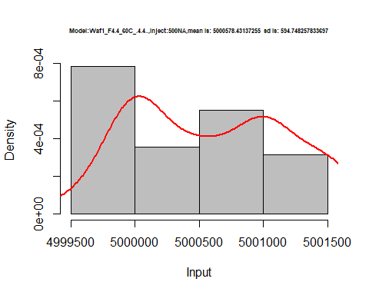

hist(d2_4.4$V6,  
 freq = FALSE,  
 cex.main=0.5,  
 main = paste('Model:Waf1_F4.4_60C_.4.4..,Inject:600NA,mean is:', mean(d2_4.4$V6),' sd is:', sd(d2_4.4$V6)),  
 xlab = "Input",  
 ylab = "Density",  
 col="grey")  
#plot density curve  
lines(density(d2_4.4$V6), # density plot  
 lwd = 2, # thickness of line  
 col = "red")

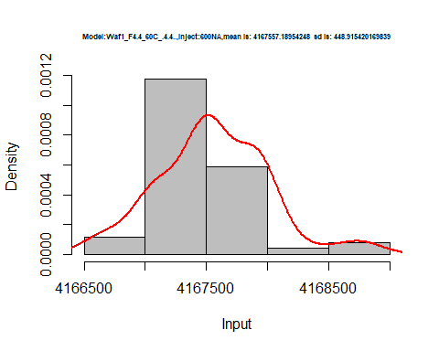

hist(d2_4.4$V7,  
 freq = FALSE,  
 cex.main=0.5,  
 main = paste('Model:Waf1_F4.4_60C_.4.4..,Inject:700NA,mean is:', mean(d2_4.4$V7),' sd is:', sd(d2_4.4$V7)),  
 xlab = "Input",  
 ylab = "Density",  
 col="grey")  
#plot density curve  
lines(density(d2_4.4$V7), # density plot  
 lwd = 2, # thickness of line  
 col = "red")

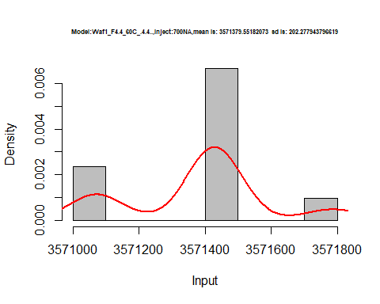

hist(d2_4.4$V8,  
 freq = FALSE,  
 cex.main=0.5,  
 main = paste('Model:Waf1_F4.4_60C_.4.4..,Inject:800NA,mean is:', mean(d2_4.4$V8),' sd is:', sd(d2_4.4$V8)),  
 xlab = "Input",  
 ylab = "Density",  
 col="grey")  
#plot density curve  
lines(density(d2_4.4$V8), # density plot  
 lwd = 2, # thickness of line  
 col = "red")

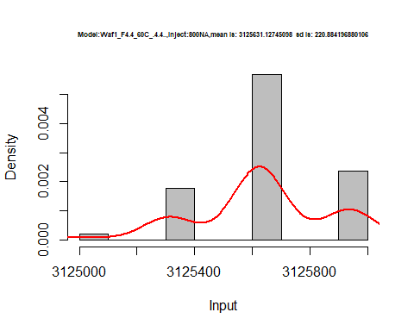

dens <- apply(d2_4.4, 2, density)  
plot('Model:Waf1_F4.4_60C_.4.4.', xlim=range(sapply(dens, "[", "x")), ylim=range(sapply(dens, "[", "y")))

## Warning in xy.coords(x, y, xlabel, ylabel, log): NAs introduced by coercion

mapply(lines, dens, col=1:length(dens))

## $V1  
## NULL  
##   
## $V2  
## NULL  
##   
## $V3  
## NULL  
##   
## $V4  
## NULL  
##   
## $V5  
## NULL  
##   
## $V6  
## NULL  
##   
## $V7  
## NULL  
##   
## $V8  
## NULL

legend("topright", legend=names(dens), fill=1:length(dens))

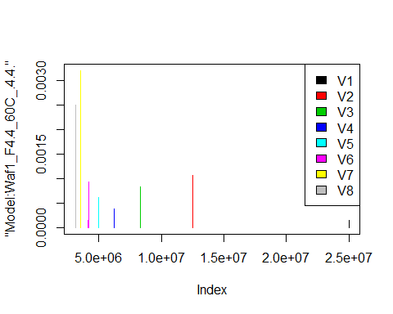

# Select columns whose names contains "5.5"  
d_5.5<-my_data %>% select(contains("5.5."))  
head(d_5.5)

## Waf1_F3.4_F_60C_.100nA_.5.5. Waf1_F3.4_F_60C_.200nA_.5.5.  
## 1 2470000 1592500  
## 2 2472500 1586250  
## 3 2470000 1592500  
## 4 2467500 1587500  
## 5 2472500 1532500  
## 6 2467500 1532500  
## Waf1_F3.4_F_60C_.300nA_.5.5. Waf1_F3.4_F_60C_.400nA_.5.5.  
## 1 1213333 1015625  
## 2 1221667 1026250  
## 3 1218333 1015625  
## 4 1220000 1010000  
## 5 1220000 1013125  
## 6 1220000 1015625  
## Waf1_F3.4_F_60C_.500nA_.5.5. Waf1_F3.4_F_60C_.600nA_.5.5.  
## 1 862500 754166.7  
## 2 864000 758750.0  
## 3 864000 757083.3  
## 4 866500 758333.3  
## 5 863500 755833.3  
## 6 865000 757916.7  
## Waf1_F3.4_F_60C_.700nA_.5.5. Waf1_F3.4_F_60C_.800nA_.5.5.  
## 1 668214.3 617500.0  
## 2 666428.6 618437.5  
## 3 664285.7 619375.0  
## 4 670000.0 619687.5  
## 5 669642.9 619062.5  
## 6 669642.9 618750.0  
## Waf1_F7.3_F_60C_.100nA_.5.5. Waf1_F7.3_F_60C_.200nA_.5.5.  
## 1 2415000 1780000  
## 2 2415000 1780000  
## 3 2415000 1780000  
## 4 2417500 1780000  
## 5 2417500 1778750  
## 6 2415000 1777500  
## Waf1_F7.3_F_60C_.300nA_.5.5. Waf1_F7.3_F_60C_.400nA_.5.5.  
## 1 1457500 1251250  
## 2 1456667 1252500  
## 3 1459167 1253750  
## 4 1455833 1253750  
## 5 1453333 1249375  
## 6 1455000 1251875  
## Waf1_F7.3_F_60C_.500nA_.5.5. Waf1_F7.3_F_60C_.600nA_.5.5.  
## 1 1110500 993333.3  
## 2 1113500 990000.0  
## 3 1114500 999583.3  
## 4 1114000 994166.7  
## 5 1115000 991666.7  
## 6 1115000 996666.7  
## Waf1_F7.3_F_60C_.700nA_.5.5. Waf1_F7.3_F_60C_.800nA_.5.5.  
## 1 928571.4 806250.0  
## 2 926071.4 806250.0  
## 3 926428.6 804375.0  
## 4 927142.9 805937.5  
## 5 928214.3 805312.5  
## 6 926428.6 805937.5  
## Waf1_F7.4_F_60C_.100nA_.5.5. Waf1_F7.4_F_60C_.200nA_.5.5.  
## 1 14552500 1976250  
## 2 14632500 1982500  
## 3 14772500 1991250  
## 4 14885000 1991250  
## 5 14965000 1982500  
## 6 15057500 1966250  
## Waf1_F7.4_F_60C_.300nA_.5.5. Waf1_F7.4_F_60C_.400nA_.5.5.  
## 1 1858333 1899375  
## 2 1860000 1893125  
## 3 1841667 1888125  
## 4 1835833 1893750  
## 5 1830000 1899375  
## 6 1822500 1900000  
## Waf1_F7.4_F_60C_.500nA_.5.5. Waf1_F7.4_F_60C_.600nA_.5.5.  
## 1 1836500 1840000  
## 2 1845000 1852083  
## 3 1908000 1835000  
## 4 1927000 1830000  
## 5 1937500 1802083  
## 6 1932500 1795000  
## Waf1_F7.4_F_60C_.700nA_.5.5. Waf1_F7.4_F_60C_.800nA_.5.5.  
## 1 1838929 1575313  
## 2 1831786 1569687  
## 3 1835714 1564062  
## 4 1852500 1556562  
## 5 1848929 1550000  
## 6 1848929 1553438

d1_5.5<-d_5.5[,c(1:8)]  
d1_5.5 <- head(d1_5.5,51)  
colnames(d1_5.5) <- c("V1", "V2","V3","V4","V5","V6","V7","V8")  
head(d1_5.5)

## V1 V2 V3 V4 V5 V6 V7 V8  
## 1 2470000 1592500 1213333 1015625 862500 754166.7 668214.3 617500.0  
## 2 2472500 1586250 1221667 1026250 864000 758750.0 666428.6 618437.5  
## 3 2470000 1592500 1218333 1015625 864000 757083.3 664285.7 619375.0  
## 4 2467500 1587500 1220000 1010000 866500 758333.3 670000.0 619687.5  
## 5 2472500 1532500 1220000 1013125 863500 755833.3 669642.9 619062.5  
## 6 2467500 1532500 1220000 1015625 865000 757916.7 669642.9 618750.0

hist(d1_5.5$V1,  
 freq = FALSE,  
 cex.main=0.5,  
 main = paste('Model:Waf1_F3.4_60C_.5.5.,Inject:800NA,mean is:', mean(d1_5.5$V1),' sd is:', sd(d1_5.5$V1)),  
 xlab = "Input",  
 ylab = "Density",  
 col="grey")  
#plot density curve  
lines(density(d1_5.5$V1), # density plot  
 lwd = 2, # thickness of line  
 col = "red")

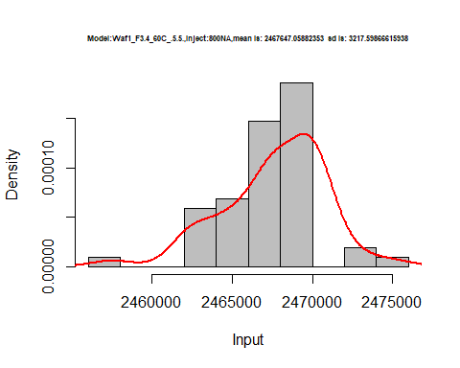

hist(d1_5.5$V2,  
 freq = FALSE,  
 cex.main=0.5,  
 main = paste('Model:Waf1_F3.4_60C_.5.5.,Inject:200NA,mean is:', mean(d1_5.5$V2),' sd is:', sd(d1_5.5$V2)),  
 xlab = "Input",  
 ylab = "Density",  
 col="grey")  
#plot density curve  
lines(density(d1_5.5$V2), # density plot  
 lwd = 2, # thickness of line  
 col = "red")

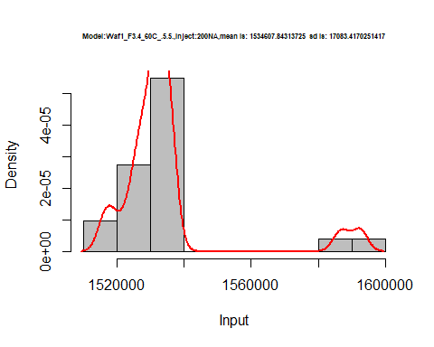

hist(d1_5.5$V3,  
 freq = FALSE,  
 cex.main=0.5,  
 main = paste('Model:Waf1_F3.4_60C_.5.5.,Inject:300NA,mean is:', mean(d1_5.5$V3),' sd is:', sd(d1_5.5$V3)),  
 xlab = "Input",  
 ylab = "Density",  
 col="grey")  
#plot density curve  
lines(density(d1_5.5$V3), # density plot  
 lwd = 2, # thickness of line  
 col = "red")

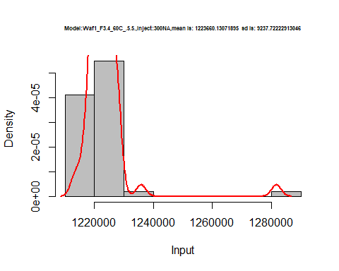

hist(d1_5.5$V4,  
 freq = FALSE,  
 cex.main=0.5,  
 main = paste('Model:Waf1_F3.4_60C_.5.5.,Inject:400NA,mean is:', mean(d1_5.5$V4),' sd is:', sd(d1_5.5$V4)),  
 xlab = "Input",  
 ylab = "Density",  
 col="grey")  
#plot density curve  
lines(density(d1_5.5$V4), # density plot  
 lwd = 2, # thickness of line  
 col = "red")

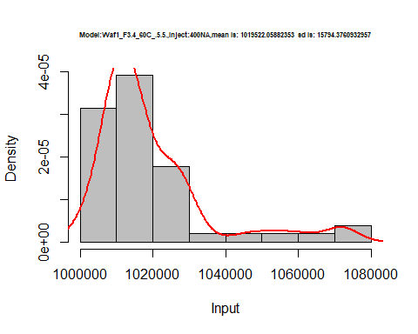

hist(d1_5.5$V5,  
 freq = FALSE,  
 cex.main=0.5,  
 main = paste('Model:Waf1_F3.4_60C_.5.5.,Inject500NA,mean is:', mean(d1_5.5$V5),' sd is:', sd(d1_5.5$V5)),  
 xlab = "Input",  
 ylab = "Density",  
 col="grey")  
#plot density curve  
lines(density(d1_5.5$V5), # density plot  
 lwd = 2, # thickness of line  
 col = "red")

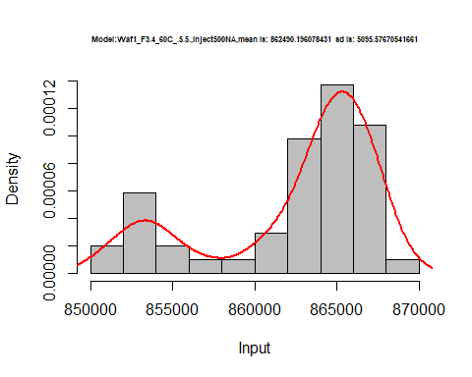

hist(d1_5.5$V6,  
 freq = FALSE,  
 cex.main=0.5,  
 main = paste('Model:Waf1_F3.4_60C_.5.5.,Inject:600NA,mean is:', mean(d1_5.5$V6),' sd is:', sd(d1_5.5$V6)),  
 xlab = "Input",  
 ylab = "Density",  
 col="grey")  
#plot density curve  
lines(density(d1_5.5$V6), # density plot  
 lwd = 2, # thickness of line  
 col = "red")

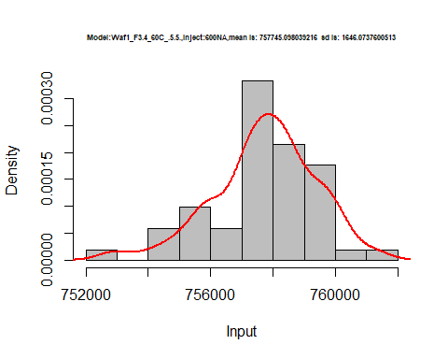

hist(d1_5.5$V7,  
 freq = FALSE,  
 cex.main=0.5,  
 main = paste('Model:Waf1_F3.4_60C_.5.5.,Inject:700NA,mean is:', mean(d1_5.5$V7),' sd is:', sd(d1_5.5$V7)),  
 xlab = "Input",  
 ylab = "Density",  
 col="grey")  
#plot density curve  
lines(density(d1_5.5$V7), # density plot  
 lwd = 2, # thickness of line  
 col = "red")

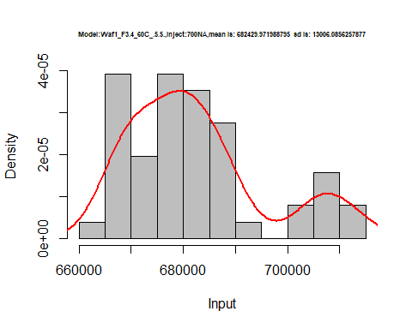

hist(d1_5.5$V8,  
 freq = FALSE,  
 cex.main=0.5,  
 main = paste('Model:Waf1_F3.4_60C_.5.5.,Inject:800NA,mean is:', mean(d1_5.5$V8),' sd is:', sd(d1_5.5$V8)),  
 xlab = "Input",  
 ylab = "Density",  
 col="grey")  
#plot density curve  
lines(density(d1_5.5$V8), # density plot  
 lwd = 2, # thickness of line  
 col = "red")

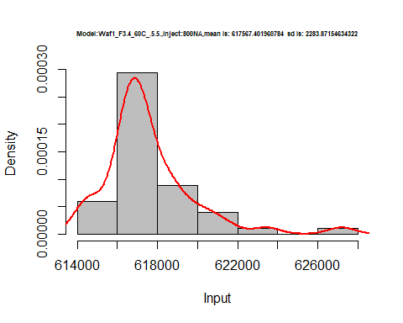

dens <- apply(d1_5.5, 2, density)  
plot('Model:Waf1_F4.4_60C_.4.4.', xlim=range(sapply(dens, "[", "x")), ylim=range(sapply(dens, "[", "y")))

## Warning in xy.coords(x, y, xlabel, ylabel, log): NAs introduced by coercion

mapply(lines, dens, col=1:length(dens))

## $V1  
## NULL  
##   
## $V2  
## NULL  
##   
## $V3  
## NULL  
##   
## $V4  
## NULL  
##   
## $V5  
## NULL  
##   
## $V6  
## NULL  
##   
## $V7  
## NULL  
##   
## $V8  
## NULL

legend("topright", legend=names(dens), fill=1:length(dens))

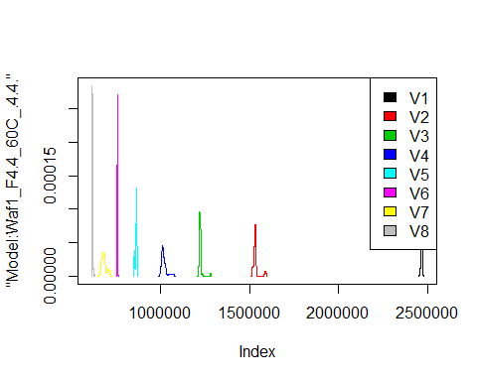

d2_5.5<-d_5.5[,c(9:16)]  
d2_5.5 <- head(d2_5.5,51)  
colnames(d2_5.5) <- c("V1", "V2","V3","V4","V5","V6","V7","V8")  
head(d2_5.5)

## V1 V2 V3 V4 V5 V6 V7 V8  
## 1 2415000 1780000 1457500 1251250 1110500 993333.3 928571.4 806250.0  
## 2 2415000 1780000 1456667 1252500 1113500 990000.0 926071.4 806250.0  
## 3 2415000 1780000 1459167 1253750 1114500 999583.3 926428.6 804375.0  
## 4 2417500 1780000 1455833 1253750 1114000 994166.7 927142.9 805937.5  
## 5 2417500 1778750 1453333 1249375 1115000 991666.7 928214.3 805312.5  
## 6 2415000 1777500 1455000 1251875 1115000 996666.7 926428.6 805937.5

hist(d2_5.5$V1,  
 freq = FALSE,  
 cex.main=0.5,  
 main = paste('Model:Waf1_F7.3_F_60C_.5.5.,Inject:100NA,mean is:', mean(d2_5.5$V1),' sd is:', sd(d2_5.5$V1)),  
 xlab = "Input",  
 ylab = "Density",  
 col="grey")  
#plot density curve  
lines(density(d2_5.5$V1), # density plot  
 lwd = 2, # thickness of line  
 col = "red")

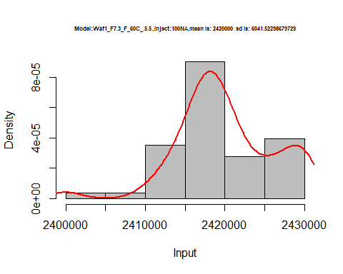

hist(d2_5.5$V2,  
 freq = FALSE,  
 cex.main=0.5,  
 main = paste('Model:Waf1_F7.3_F_60C_.5.5.,Inject:200NA,mean is:', mean(d2_5.5$V2),' sd is:', sd(d2_5.5$V2)),  
 xlab = "Input",  
 ylab = "Density",  
 col="grey")  
#plot density curve  
lines(density(d2_5.5$V2), # density plot  
 lwd = 2, # thickness of line  
 col = "red")

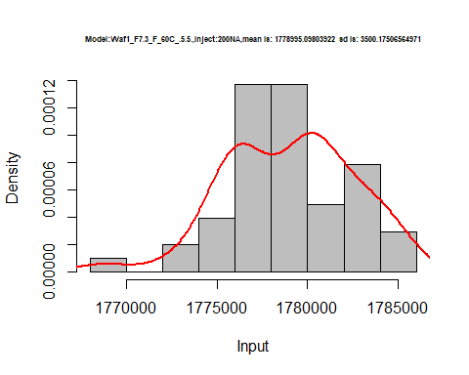

hist(d2_5.5$V3,  
 freq = FALSE,  
 cex.main=0.5,  
 main = paste('Model:Waf1_F7.3_F_60C_.5.5.,Inject:300NA,mean is:', mean(d2_5.5$V3),' sd is:', sd(d2_5.5$V3)),  
 xlab = "Input",  
 ylab = "Density",  
 col="grey")  
#plot density curve  
lines(density(d2_5.5$V3), # density plot  
 lwd = 2, # thickness of line  
 col = "red")

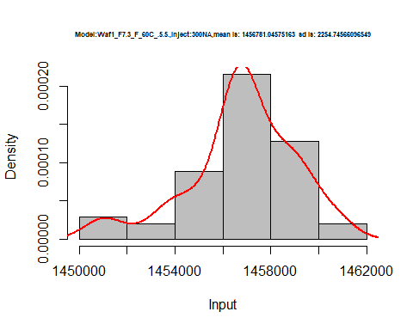

hist(d2_5.5$V4,  
 freq = FALSE,  
 cex.main=0.5,  
 main = paste('Model:Waf1_F7.3_F_60C_.5.5.,Inject:400NA,mean is:', mean(d2_5.5$V4),' sd is:', sd(d2_5.5$V4)),  
 xlab = "Input",  
 ylab = "Density",  
 col="grey")  
#plot density curve  
lines(density(d2_5.5$V4), # density plot  
 lwd = 2, # thickness of line  
 col = "red")

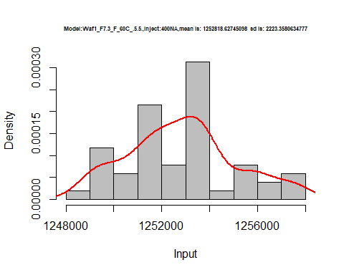

hist(d2_5.5$V5,  
 freq = FALSE,  
 cex.main=0.5,  
 main = paste('Model:Waf1_F7.3_F_60C_.5.5.,Inject:500NA,mean is:', mean(d2_5.5$V5),' sd is:', sd(d2_5.5$V5)),  
 xlab = "Input",  
 ylab = "Density",  
 col="grey")  
#plot density curve  
lines(density(d2_5.5$V5), # density plot  
 lwd = 2, # thickness of line  
 col = "red")

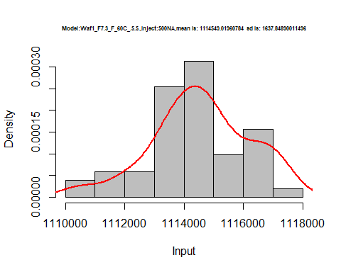

hist(d2_5.5$V6,  
 freq = FALSE,  
 cex.main=0.5,  
 main = paste('Model:Waf1_F7.3_F_60C_.5.5.,Inject:600NA,mean is:', mean(d2_5.5$V6),' sd is:', sd(d2_5.5$V6)),  
 xlab = "Input",  
 ylab = "Density",  
 col="grey")  
#plot density curve  
lines(density(d2_5.5$V6), # density plot  
 lwd = 2, # thickness of line  
 col = "red")

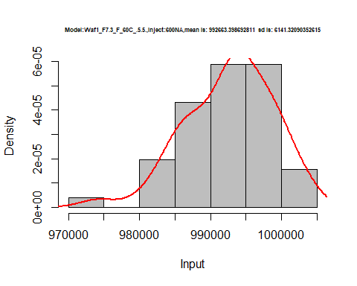

hist(d2_5.5$V7,  
 freq = FALSE,  
 cex.main=0.5,  
 main = paste('Model:Waf1_F7.3_F_60C_.5.5.,Inject:700NA,mean is:', mean(d2_5.5$V7),' sd is:', sd(d2_5.5$V7)),  
 xlab = "Input",  
 ylab = "Density",  
 col="grey")  
#plot density curve  
lines(density(d2_5.5$V7), # density plot  
 lwd = 2, # thickness of line  
 col = "red")

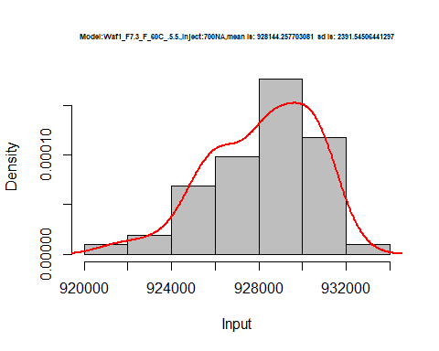

hist(d2_5.5$V8,  
 freq = FALSE,  
 cex.main=0.5,  
 main = paste('Model:Waf1_F7.3_F_60C_.5.5.,Inject:800NA,mean is:', mean(d2_5.5$V8),' sd is:', sd(d2_5.5$V8)),  
 xlab = "Input",  
 ylab = "Density",  
 col="grey")  
#plot density curve  
lines(density(d2_5.5$V8), # density plot  
 lwd = 2, # thickness of line  
 col = "red")

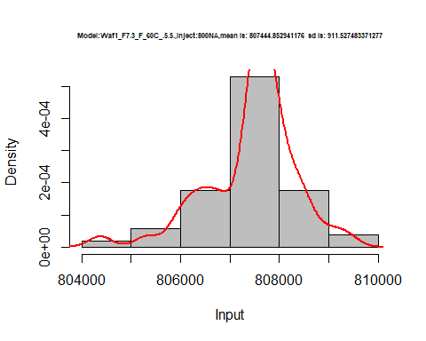

dens <- apply(d2_5.5, 2, density)  
plot('Model:Waf1_F7.3_F_60C_.5.5', xlim=range(sapply(dens, "[", "x")), ylim=range(sapply(dens, "[", "y")))

## Warning in xy.coords(x, y, xlabel, ylabel, log): NAs introduced by coercion

mapply(lines, dens, col=1:length(dens))

## $V1  
## NULL  
##   
## $V2  
## NULL  
##   
## $V3  
## NULL  
##   
## $V4  
## NULL  
##   
## $V5  
## NULL  
##   
## $V6  
## NULL  
##   
## $V7  
## NULL  
##   
## $V8  
## NULL

legend("topright", legend=names(dens), fill=1:length(dens))

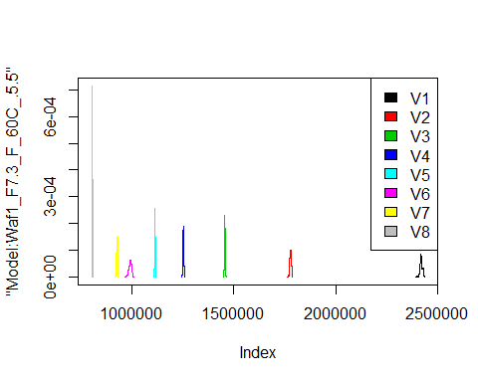

d3_5.5<-d_5.5[,c(17:24)]  
d3_5.5 <- head(d3_5.5,51)  
colnames(d3_5.5) <- c("V1", "V2","V3","V4","V5","V6","V7","V8")  
head(d3_5.5)

## V1 V2 V3 V4 V5 V6 V7 V8  
## 1 14552500 1976250 1858333 1899375 1836500 1840000 1838929 1575313  
## 2 14632500 1982500 1860000 1893125 1845000 1852083 1831786 1569687  
## 3 14772500 1991250 1841667 1888125 1908000 1835000 1835714 1564062  
## 4 14885000 1991250 1835833 1893750 1927000 1830000 1852500 1556562  
## 5 14965000 1982500 1830000 1899375 1937500 1802083 1848929 1550000  
## 6 15057500 1966250 1822500 1900000 1932500 1795000 1848929 1553438

index = which(is.na(d3_5.5$V1))  
d3_5.5$V1[index]=0  
hist(d3_5.5$V1,  
 freq = FALSE,  
 cex.main=0.5,  
 main = paste('Model:Waf1_F7.4_F_60C_.5.5.,Inject:800NA,mean is:', mean(d3_5.5$V1),' sd is:', sd(d3_5.5$V1)),  
 xlab = "Input",  
 ylab = "Density",  
 col="grey")  
#plot density curve  
lines(density(d3_5.5$V1), # density plot  
 lwd = 2, # thickness of line  
 col = "red")

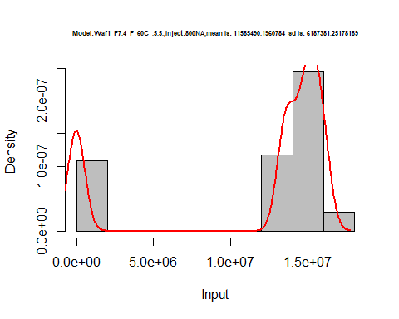

hist(d3_5.5$V2,  
 freq = FALSE,  
 cex.main=0.5,  
 main = paste('Model:Waf1_F7.4_F_60C_.5.5.,Inject:200NA,mean is:', mean(d3_5.5$V2),' sd is:', sd(d3_5.5$V2)),  
 xlab = "Input",  
 ylab = "Density",  
 col="grey")  
#plot density curve  
lines(density(d3_5.5$V2), # density plot  
 lwd = 2, # thickness of line  
 col = "red")

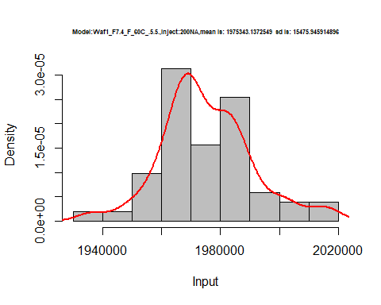

hist(d3_5.5$V3,  
 freq = FALSE,  
 cex.main=0.5,  
 main = paste('Model:Waf1_F7.4_F_60C_.5.5.,Inject:300NA,mean is:', mean(d3_5.5$V3),' sd is:', sd(d3_5.5$V3)),  
 xlab = "Input",  
 ylab = "Density",  
 col="grey")  
#plot density curve  
lines(density(d3_5.5$V3), # density plot  
 lwd = 2, # thickness of line  
 col = "red")

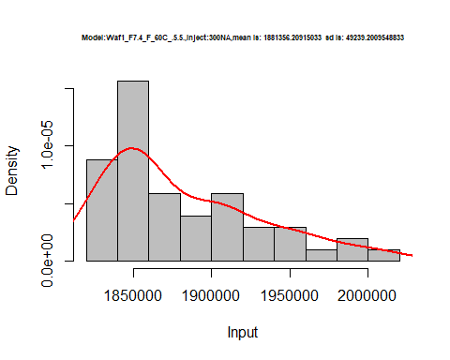

hist(d3_5.5$V4,  
 freq = FALSE,  
 cex.main=0.5,  
 main = paste('Model:Waf1_F7.4_F_60C_.5.5.,Inject:400NA,mean is:', mean(d3_5.5$V4),' sd is:', sd(d3_5.5$V4)),  
 xlab = "Input",  
 ylab = "Density",  
 col="grey")  
#plot density curve  
lines(density(d3_5.5$V4), # density plot  
 lwd = 2, # thickness of line  
 col = "red")

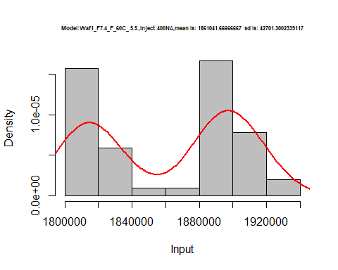

hist(d3_5.5$V5,  
 freq = FALSE,  
 cex.main=0.5,  
 main = paste('Model:Waf1_F7.4_F_60C_.5.5.,Inject:500NA,mean is:', mean(d3_5.5$V5),' sd is:', sd(d3_5.5$V5)),  
 xlab = "Input",  
 ylab = "Density",  
 col="grey")  
#plot density curve  
lines(density(d3_5.5$V5), # density plot  
 lwd = 2, # thickness of line  
 col = "red")

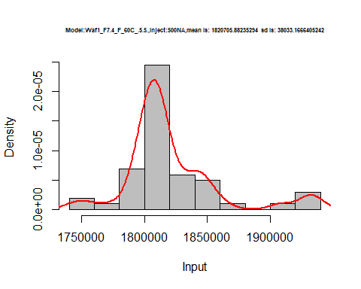

hist(d3_5.5$V6,  
 freq = FALSE,  
 cex.main=0.5,  
 main = paste('Model:Waf1_F7.4_F_60C_.5.5.,Inject:600NA,mean is:', mean(d3_5.5$V6),' sd is:', sd(d3_5.5$V6)),  
 xlab = "Input",  
 ylab = "Density",  
 col="grey")  
#plot density curve  
lines(density(d3_5.5$V6), # density plot  
 lwd = 2, # thickness of line  
 col = "red")

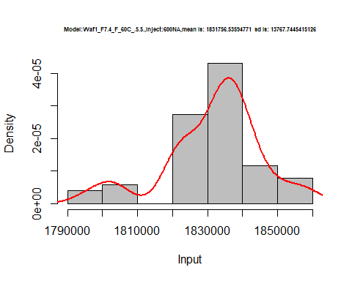

hist(d3_5.5$V7,  
 freq = FALSE,  
 cex.main=0.5,  
 main = paste('Model:Waf1_F7.4_F_60C_.5.5.,Inject:700NA,mean is:', mean(d3_5.5$V7),' sd is:', sd(d3_5.5$V7)),  
 xlab = "Input",  
 ylab = "Density",  
 col="grey")  
#plot density curve  
lines(density(d3_5.5$V7), # density plot  
 lwd = 2, # thickness of line  
 col = "red")

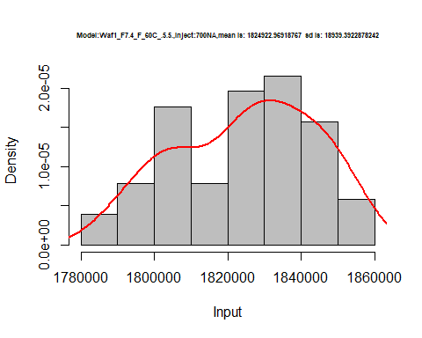

hist(d3_5.5$V8,  
 freq = FALSE,  
 cex.main=0.5,  
 main = paste('Model:Waf1_F7.4_F_60C_.5.5.,Inject:800NA,mean is:', mean(d3_5.5$V8),' sd is:', sd(d3_5.5$V8)),  
 xlab = "Input",  
 ylab = "Density",  
 col="grey")  
#plot density curve  
lines(density(d3_5.5$V8), # density plot  
 lwd = 2, # thickness of line  
 col = "red")

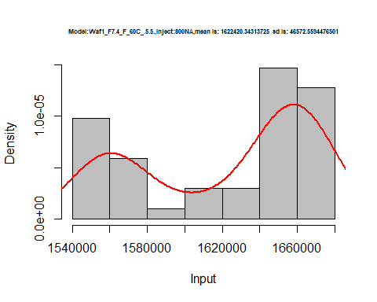

dens <- apply(d3_5.5, 2, density)  
plot('Model:Waf1_F7.4_F_60C_.5.5', xlim=range(sapply(dens, "[", "x")), ylim=range(sapply(dens, "[", "y")))

## Warning in xy.coords(x, y, xlabel, ylabel, log): NAs introduced by coercion

mapply(lines, dens, col=1:length(dens))

## $V1  
## NULL  
##   
## $V2  
## NULL  
##   
## $V3  
## NULL  
##   
## $V4  
## NULL  
##   
## $V5  
## NULL  
##   
## $V6  
## NULL  
##   
## $V7  
## NULL  
##   
## $V8  
## NULL

legend("topright", legend=names(dens), fill=1:length(dens))

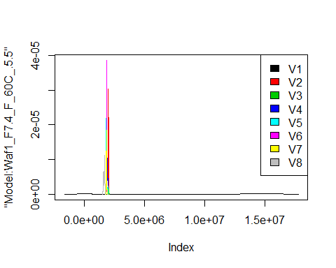

# Select columns whose names contains "6.6"  
d_6.6<-my_data %>% select(contains("6.6."))  
d_6.6 <- head(d_6.6,51)  
colnames(d_6.6) <- c("V1", "V2","V3","V4","V5","V6","V7","V8")  
head(d_6.6)

## V1 V2 V3 V4 V5 V6 V7 V8  
## 1 2627500 1403750 1506667 1216250 1085500 969166.7 905000.0 826250.0  
## 2 2627500 1416250 1505833 1265625 1085000 987916.7 905000.0 826250.0  
## 3 2620000 1412500 1504167 1263125 1086000 988333.3 905000.0 825000.0  
## 4 2617500 1412500 1505000 1262500 941500 988333.3 905000.0 825000.0  
## 5 2520000 1412500 1505833 1260000 917500 988333.3 903928.6 825625.0  
## 6 2537500 1410000 1505833 1260000 913500 987500.0 903928.6 826562.5

hist(d_6.6$V1,  
 freq = FALSE,  
 cex.main=0.5,  
 main = paste('Model:Waf1_F2.6_60C_.6.6.,Inject:100NA,mean is:', mean(d_6.6$V1),' sd is:', sd(d_6.6$V1)),  
 xlab = "Input",  
 ylab = "Density",  
 col="grey")  
#plot density curve  
lines(density(d_6.6$V1), # density plot  
 lwd = 2, # thickness of line  
 col = "red")

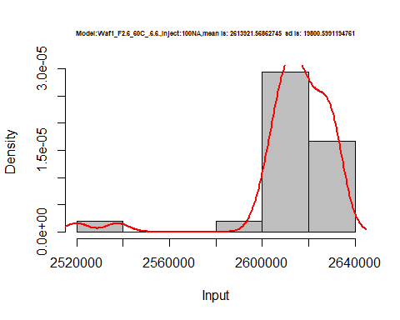

hist(d_6.6$V2,  
 freq = FALSE,  
 cex.main=0.5,  
 main = paste('Model:Waf1_F2.6_60C_.6.6.,Inject:200NA,mean is:', mean(d_6.6$V2),' sd is:', sd(d_6.6$V2)),  
 xlab = "Input",  
 ylab = "Density",  
 col="grey")  
#plot density curve  
lines(density(d_6.6$V2), # density plot  
 lwd = 2, # thickness of line  
 col = "red")

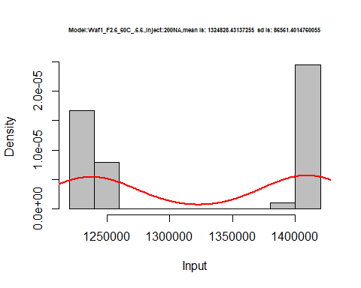

hist(d_6.6$V3,  
 freq = FALSE,  
 cex.main=0.5,  
 main = paste('Model:Waf1_F2.6_60C_.6.6.,Inject:300NA,mean is:', mean(d_6.6$V3),' sd is:', sd(d_6.6$V3)),  
 xlab = "Input",  
 ylab = "Density",  
 col="grey")  
#plot density curve  
lines(density(d_6.6$V3), # density plot  
 lwd = 2, # thickness of line  
 col = "red")

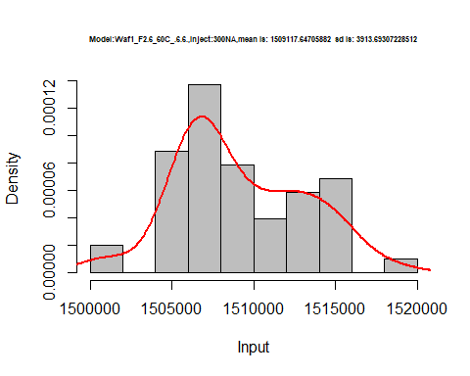

hist(d_6.6$V4,  
 freq = FALSE,  
 cex.main=0.5,  
 main = paste('Model:Waf1_F2.6_60C_.6.6.,Inject:400NA,mean is:', mean(d_6.6$V4),' sd is:', sd(d_6.6$V4)),  
 xlab = "Input",  
 ylab = "Density",  
 col="grey")  
#plot density curve  
lines(density(d_6.6$V4), # density plot  
 lwd = 2, # thickness of line  
 col = "red")

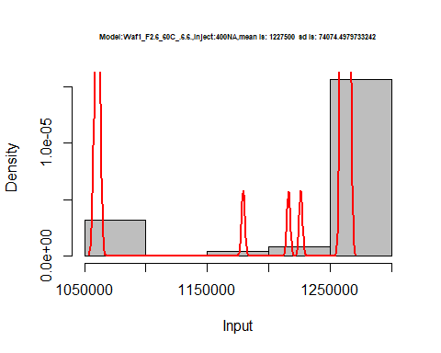

hist(d_6.6$V5,  
 freq = FALSE,  
 cex.main=0.5,  
 main = paste('Model:Waf1_F2.6_60C_.6.6.,Inject:500NA,mean is:', mean(d_6.6$V5),' sd is:', sd(d_6.6$V5)),  
 xlab = "Input",  
 ylab = "Density",  
 col="grey")  
#plot density curve  
lines(density(d_6.6$V5), # density plot  
 lwd = 2, # thickness of line  
 col = "red")

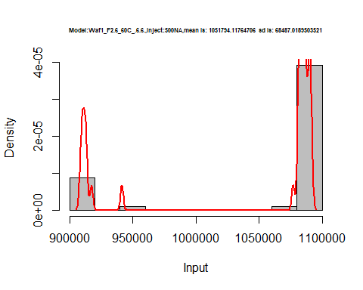

hist(d_6.6$V6,  
 freq = FALSE,  
 cex.main=0.5,  
 main = paste('Model:Waf1_F2.6_60C_.6.6.,Inject:600NA,mean is:', mean(d_6.6$V6),' sd is:', sd(d_6.6$V6)),  
 xlab = "Input",  
 ylab = "Density",  
 col="grey")  
#plot density curve  
lines(density(d_6.6$V6), # density plot  
 lwd = 2, # thickness of line  
 col = "red")

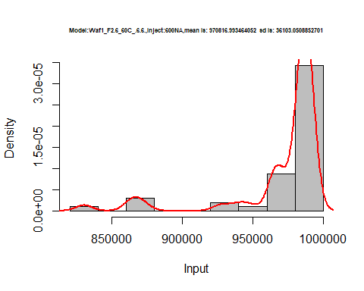

hist(d_6.6$V7,  
 freq = FALSE,  
 cex.main=0.5,  
 main = paste('Model:Waf1_F2.6_60C_.6.6.,Inject:700NA,mean is:', mean(d_6.6$V7),' sd is:', sd(d_6.6$V7)),  
 xlab = "Input",  
 ylab = "Density",  
 col="grey")  
#plot density curve  
lines(density(d_6.6$V7), # density plot  
 lwd = 2, # thickness of line  
 col = "red")

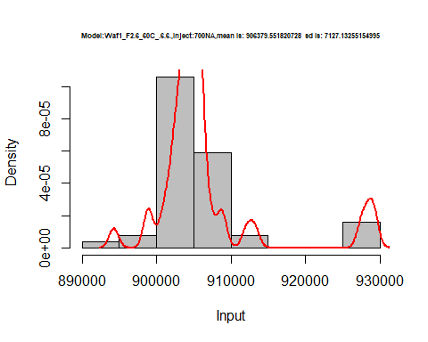

hist(d_6.6$V8,  
 freq = FALSE,  
 cex.main=0.5,  
 main = paste('Model:Waf1_F2.6_60C_.6.6.,Inject:800NA,mean is:', mean(d_6.6$V8),' sd is:', sd(d_6.6$V8)),  
 xlab = "Input",  
 ylab = "Density",  
 col="grey")  
#plot density curve  
lines(density(d_6.6$V8), # density plot  
 lwd = 2, # thickness of line  
 col = "red")

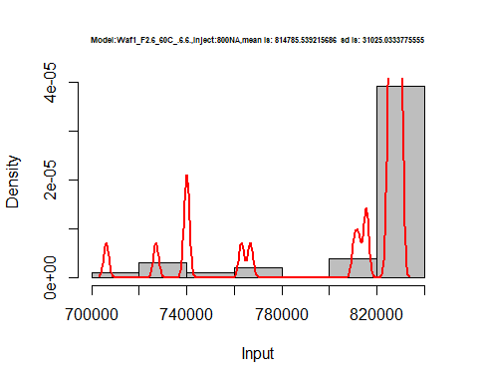

dens <- apply(d_6.6, 2, density)  
plot('Waf1_F2.6_60C_.6.6.', xlim=range(sapply(dens, "[", "x")), ylim=range(sapply(dens, "[", "y")))

## Warning in xy.coords(x, y, xlabel, ylabel, log): NAs introduced by coercion

mapply(lines, dens, col=1:length(dens))

## $V1  
## NULL  
##   
## $V2  
## NULL  
##   
## $V3  
## NULL  
##   
## $V4  
## NULL  
##   
## $V5  
## NULL  
##   
## $V6  
## NULL  
##   
## $V7  
## NULL  
##   
## $V8  
## NULL

legend("topright", legend=names(dens), fill=1:length(dens))

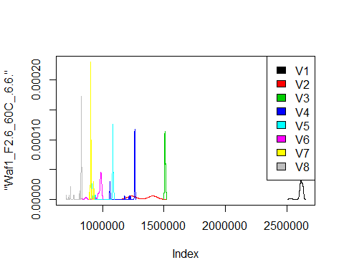

# Select columns whose names contains "7.7"  
d_7.7<-my_data %>% select(contains("7.7."))  
#head(d_7.7)

d1_7.7<-d_7.7[,c(1:8)]  
d1_7.7 <- head(d1_7.7,51)  
colnames(d1_7.7) <- c("V1", "V2","V3","V4","V5","V6","V7","V8")  
#head(d1_7.7)

hist(d1_7.7$V1,  
 cex.main=0.5,  
 freq = FALSE,  
 main = paste('Model:Waf1_F2.6_60C_.7.7.,Inject:100NA,mean is:', mean(d1_7.7$V1),' sd is:', sd(d1_7.7$V1)),  
 xlab = "Input",  
 ylab = "Density",  
 col="grey")  
#plot density curve  
lines(density(d1_7.7$V1), # density plot  
 lwd = 2, # thickness of line  
 col = "red")

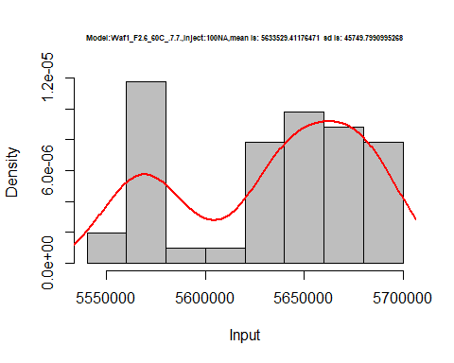

hist(d1_7.7$V2,  
 cex.main=0.5,  
 freq = FALSE,  
 main = paste('Model:Waf1_F2.6_60C_.7.7.,Inject:200NA,mean is:', mean(d1_7.7$V2),' sd is:', sd(d1_7.7$V2)),  
 xlab = "Input",  
 ylab = "Density",  
 col="grey")  
#plot density curve  
lines(density(d1_7.7$V2), # density plot  
 lwd = 2, # thickness of line  
 col = "red")

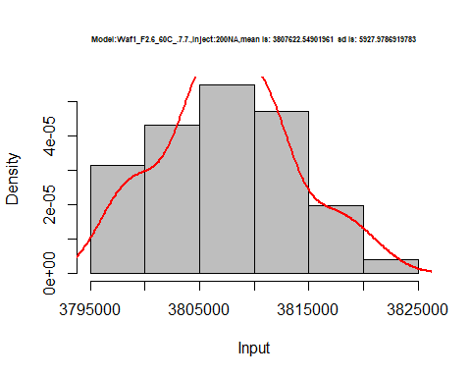

hist(d1_7.7$V3,  
 cex.main=0.5,  
 freq = FALSE,  
 main = paste('Model:Waf1_F2.6_60C_.7.7.,Inject:300NA,mean is:', mean(d1_7.7$V3),' sd is:', sd(d1_7.7$V3)),  
 xlab = "Input",  
 ylab = "Density",  
 col="grey")  
#plot density curve  
lines(density(d1_7.7$V3), # density plot  
 lwd = 2, # thickness of line  
 col = "red")

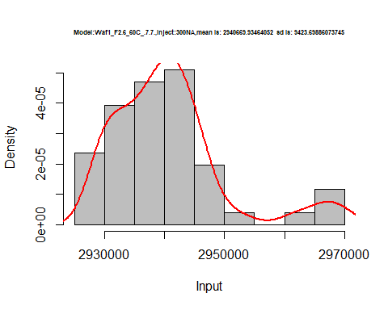

hist(d1_7.7$V4,  
 cex.main=0.5,  
 freq = FALSE,  
 main = paste('Model:Waf1_F2.6_60C_.7.7.,Inject:400NA,mean is:', mean(d1_7.7$V4),' sd is:', sd(d1_7.7$V4)),  
 xlab = "Input",  
 ylab = "Density",  
 col="grey")  
#plot density curve  
lines(density(d1_7.7$V4), # density plot  
 lwd = 2, # thickness of line  
 col = "red")

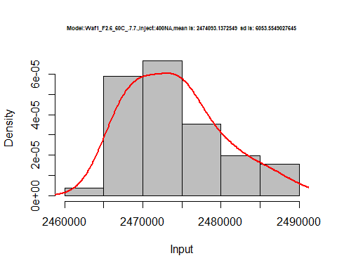

hist(d1_7.7$V5,  
 cex.main=0.5,  
 freq = FALSE,  
 main = paste('Model:Waf1_F2.6_60C_.7.7.,Inject:500NA,mean is:', mean(d1_7.7$V5),' sd is:', sd(d1_7.7$V5)),  
 xlab = "Input",  
 ylab = "Density",  
 col="grey")  
#plot density curve  
lines(density(d1_7.7$V5), # density plot  
 lwd = 2, # thickness of line  
 col = "red")

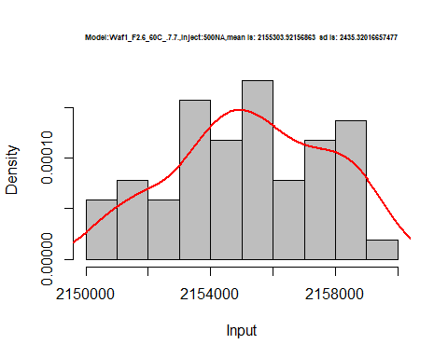

hist(d1_7.7$V6,  
 cex.main=0.5,  
 freq = FALSE,  
 main = paste('Model:Waf1_F2.6_60C_.7.7.,Inject:100NA,mean is:', mean(d1_7.7$V6),' sd is:', sd(d1_7.7$V6)),  
 xlab = "Input",  
 ylab = "Density",  
 col="grey")  
#plot density curve  
lines(density(d1_7.7$V6), # density plot  
 lwd = 2, # thickness of line  
 col = "red")

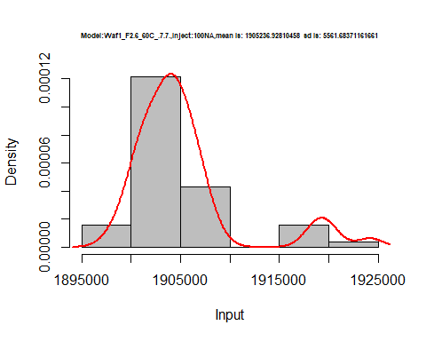

hist(d1_7.7$V7,  
 cex.main=0.5,  
 freq = FALSE,  
 main = paste('Model:Waf1_F2.6_60C_.7.7.,Inject:700NA,mean is:', mean(d1_7.7$V7),' sd is:', sd(d1_7.7$V7)),  
 xlab = "Input",  
 ylab = "Density",  
 col="grey")  
#plot density curve  
lines(density(d1_7.7$V7), # density plot  
 lwd = 2, # thickness of line  
 col = "red")

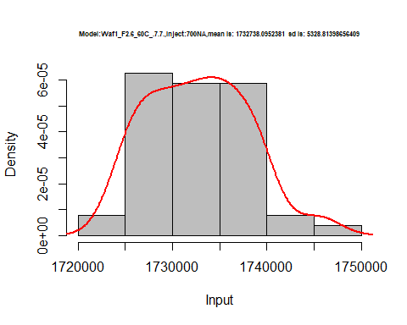

hist(d1_7.7$V8,  
 cex.main=0.5,  
 freq = FALSE,  
 main = paste('Model:Waf1_F2.6_60C_.7.7.,Inject:800NA,mean is:', mean(d1_7.7$V8),' sd is:', sd(d1_7.7$V8)),  
 xlab = "Input",  
 ylab = "Density",  
 col="grey")  
#plot density curve  
lines(density(d1_7.7$V8), # density plot  
 lwd = 2, # thickness of line  
 col = "red")

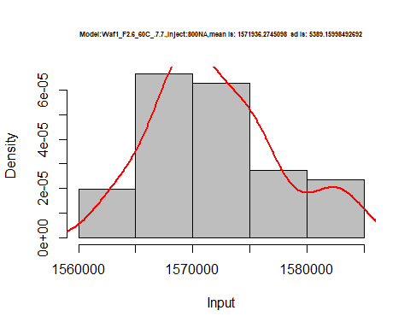

dens <- apply(d1_7.7, 2, density)  
plot('Waf1_F2.6_60C_.7.7.', xlim=range(sapply(dens, "[", "x")), ylim=range(sapply(dens, "[", "y")))

## Warning in xy.coords(x, y, xlabel, ylabel, log): NAs introduced by coercion

mapply(lines, dens, col=1:length(dens))

## $V1  
## NULL  
##   
## $V2  
## NULL  
##   
## $V3  
## NULL  
##   
## $V4  
## NULL  
##   
## $V5  
## NULL  
##   
## $V6  
## NULL  
##   
## $V7  
## NULL  
##   
## $V8  
## NULL

legend("topright", legend=names(dens), fill=1:length(dens))

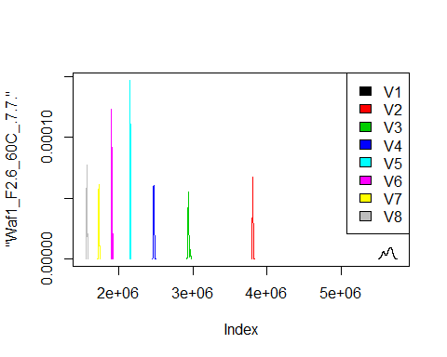

d2_7.7<-d_7.7[,c(9:16)]  
d2_7.7 <- head(d2_7.7,51)  
colnames(d2_7.7) <- c("V1", "V2","V3","V4","V5","V6","V7","V8")  
# head(d2_7.7)

hist(d2_7.7$V1,  
 cex.main=0.5,  
 freq = FALSE,  
 main = paste('Model:Waf1_F5.3_60C_.7.7.,Inject:100NA,mean is:', mean(d2_7.7$V1),' sd is:', sd(d2_7.7$V1)),  
 xlab = "Input",  
 ylab = "Density",  
 col="grey")  
#plot density curve  
lines(density(d2_7.7$V1), # density plot  
 lwd = 2, # thickness of line  
 col = "red")

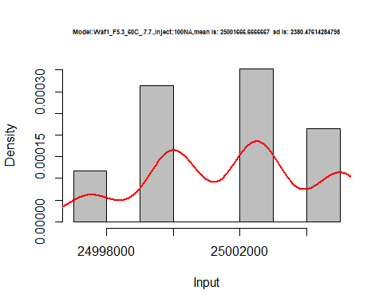

hist(d2_7.7$V2,  
 cex.main=0.5,  
 freq = FALSE,  
 main = paste('Model:Waf1_F5.3_60C_.7.7.,Inject:200NA,mean is:', mean(d2_7.7$V2),' sd is:', sd(d2_7.7$V2)),  
 xlab = "Input",  
 ylab = "Density",  
 col="grey")  
#plot density curve  
lines(density(d2_7.7$V2), # density plot  
 lwd = 2, # thickness of line  
 col = "red")

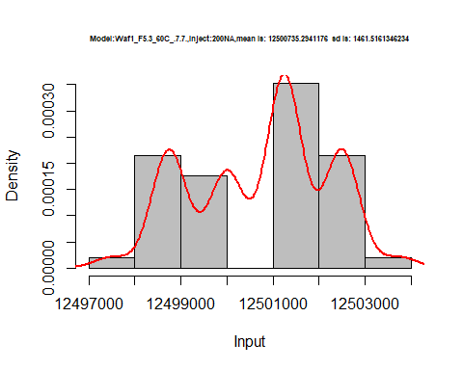

hist(d2_7.7$V3,  
 cex.main=0.5,  
 freq = FALSE,  
 main = paste('Model:Waf1_F5.3_60C_.7.7.,Inject:300NA,mean is:', mean(d2_7.7$V3),' sd is:', sd(d2_7.7$V3)),  
 xlab = "Input",  
 ylab = "Density",  
 col="grey")  
#plot density curve  
lines(density(d2_7.7$V3), # density plot  
 lwd = 2, # thickness of line  
 col = "red")

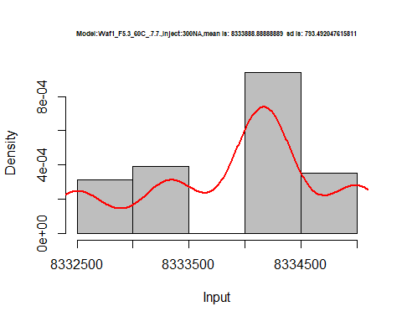

hist(d2_7.7$V4,  
 cex.main=0.5,  
 freq = FALSE,  
 main = paste('Model:Waf1_F5.3_60C_.7.7.,Inject:400NA,mean is:', mean(d2_7.7$V4),' sd is:', sd(d2_7.7$V4)),  
 xlab = "Input",  
 ylab = "Density",  
 col="grey")  
#plot density curve  
lines(density(d2_7.7$V4), # density plot  
 lwd = 2, # thickness of line  
 col = "red")

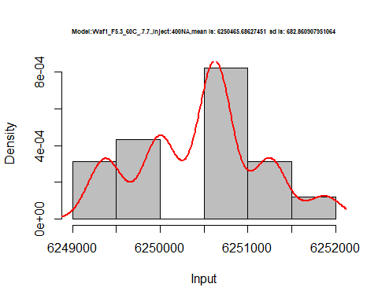

hist(d2_7.7$V5,  
 cex.main=0.5,  
 freq = FALSE,  
 main = paste('Model:Waf1_F5.3_60C_.7.7.,Inject:500NA,mean is:', mean(d2_7.7$V5),' sd is:', sd(d2_7.7$V5)),  
 xlab = "Input",  
 ylab = "Density",  
 col="grey")  
#plot density curve  
lines(density(d2_7.7$V5), # density plot  
 lwd = 2, # thickness of line  
 col = "red")

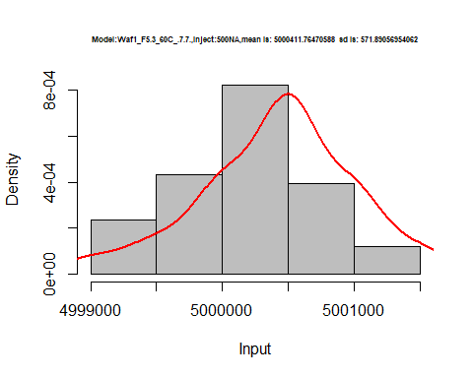

hist(d2_7.7$V6,  
 cex.main=0.5,  
 freq = FALSE,  
 main = paste('Model:Waf1_F5.3_60C_.7.7.,Inject:600NA,mean is:', mean(d2_7.7$V6),' sd is:', sd(d2_7.7$V6)),  
 xlab = "Input",  
 ylab = "Density",  
 col="grey")  
#plot density curve  
lines(density(d2_7.7$V6), # density plot  
 lwd = 2, # thickness of line  
 col = "red")

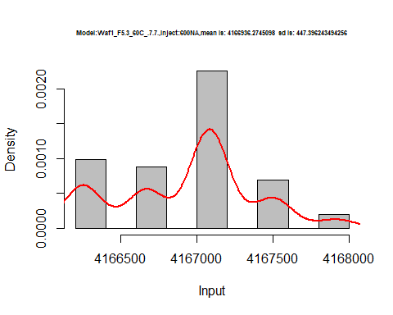

hist(d2_7.7$V7,  
 cex.main=0.5,  
 freq = FALSE,  
 main = paste('Model:Waf1_F5.3_60C_.7.7.,Inject:700NA,mean is:', mean(d2_7.7$V7),' sd is:', sd(d2_7.7$V7)),  
 xlab = "Input",  
 ylab = "Density",  
 col="grey")  
#plot density curve  
lines(density(d2_7.7$V7), # density plot  
 lwd = 2, # thickness of line  
 col = "red")

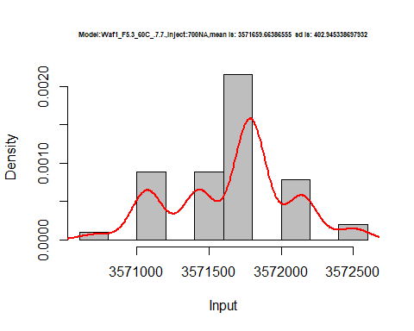

hist(d2_7.7$V8,  
 cex.main=0.5,  
 freq = FALSE,  
 main = paste('Model:Waf1_F5.3_60C_.7.7.,Inject:800NA,mean is:', mean(d2_7.7$V8),' sd is:', sd(d2_7.7$V8)),  
 xlab = "Input",  
 ylab = "Density",  
 col="grey")  
#plot density curve  
lines(density(d2_7.7$V8), # density plot  
 lwd = 2, # thickness of line  
 col = "red")

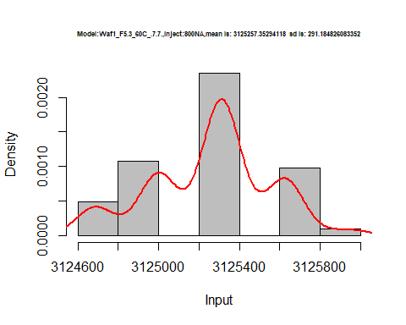

dens <- apply(d2_7.7, 2, density)  
plot('Waf1_F5.3_60C_.7.7.', xlim=range(sapply(dens, "[", "x")), ylim=range(sapply(dens, "[", "y")))

## Warning in xy.coords(x, y, xlabel, ylabel, log): NAs introduced by coercion

mapply(lines, dens, col=1:length(dens))

## $V1  
## NULL  
##   
## $V2  
## NULL  
##   
## $V3  
## NULL  
##   
## $V4  
## NULL  
##   
## $V5  
## NULL  
##   
## $V6  
## NULL  
##   
## $V7  
## NULL  
##   
## $V8  
## NULL

legend("topright", legend=names(dens), fill=1:length(dens))

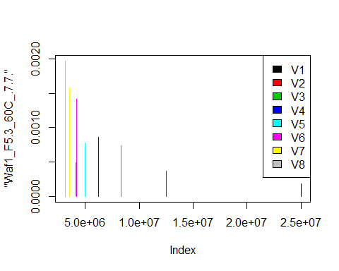

d3_7.7<-d_7.7[,c(17:24)]  
d3_7.7 <- head(d3_7.7,51)  
colnames(d3_7.7) <- c("V1", "V2","V3","V4","V5","V6","V7","V8")  
#head(d3_7.7)

hist(d3_7.7$V1,  
 cex.main=0.5,  
 freq = FALSE,  
 main = paste('Model:Waf1_F6.2_60C_.7.7.,Inject:100NA,mean is:', mean(d3_7.7$V1),' sd is:', sd(d3_7.7$V1)),  
 xlab = "Input",  
 ylab = "Density",  
 col="grey")  
#plot density curve  
lines(density(d3_7.7$V1), # density plot  
 lwd = 2, # thickness of line  
col = "red")

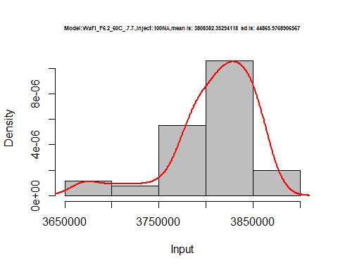

hist(d3_7.7$V2,  
 cex.main=0.5,  
 freq = FALSE,  
 main = paste('Model:Waf1_F6.2_60C_.7.7.,Inject:200NA,mean is:', mean(d3_7.7$V2),' sd is:', sd(d3_7.7$V2)),  
 xlab = "Input",  
 ylab = "Density",  
 col="grey")  
#plot density curve  
lines(density(d3_7.7$V2), # density plot  
 lwd = 2, # thickness of line  
 col = "red")

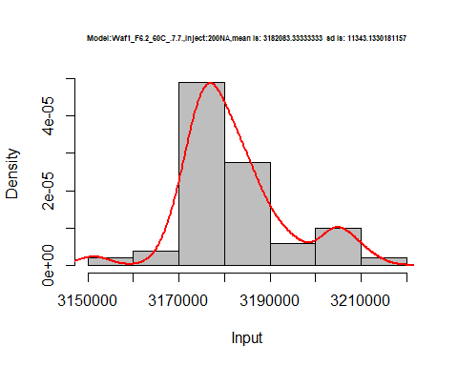

hist(d3_7.7$V3,  
 cex.main=0.5,  
 freq = FALSE,  
 main = paste('Model:Waf1_F6.2_60C_.7.7.,Inject:300NA,mean is:', mean(d3_7.7$V3),' sd is:', sd(d3_7.7$V3)),  
 xlab = "Input",  
 ylab = "Density",  
 col="grey")  
#plot density curve  
lines(density(d3_7.7$V3), # density plot  
 lwd = 2, # thickness of line  
 col = "red")

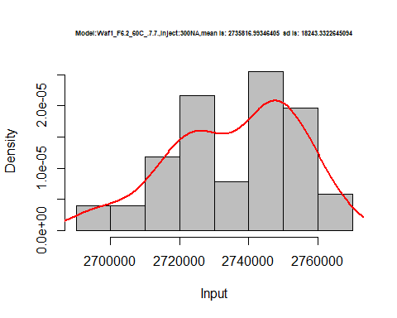

hist(d3_7.7$V4,  
 cex.main=0.5,  
 freq = FALSE,  
 main = paste('Model:Waf1_F6.2_60C_.7.7.,Inject:400NA,mean is:', mean(d3_7.7$V4),' sd is:', sd(d3_7.7$V4)),  
 xlab = "Input",  
 ylab = "Density",  
 col="grey")  
#plot density curve  
lines(density(d3_7.7$V4), # density plot  
 lwd = 2, # thickness of line  
 col = "red")

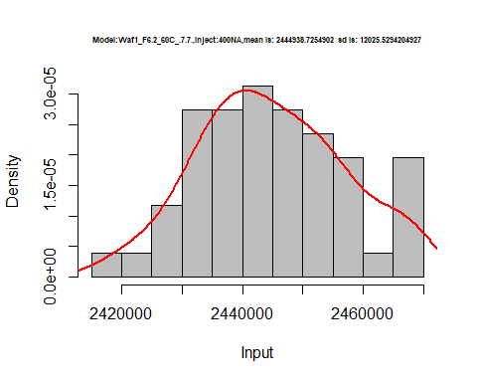

hist(d3_7.7$V5,  
 cex.main=0.5,  
 freq = FALSE,  
 main = paste('Model:Waf1_F6.2_60C_.7.7.,Inject:500NA,mean is:', mean(d3_7.7$V5),' sd is:', sd(d3_7.7$V5)),  
 xlab = "Input",  
 ylab = "Density",  
 col="grey")  
#plot density curve  
lines(density(d3_7.7$V5), # density plot  
 lwd = 2, # thickness of line  
 col = "red")

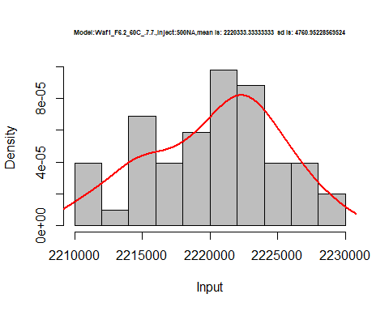

hist(d3_7.7$V6,  
 cex.main=0.5,  
 freq = FALSE,  
 main = paste('Model:Waf1_F6.2_60C_.7.7.,Inject:600NA,mean is:', mean(d3_7.7$V6),' sd is:', sd(d3_7.7$V6)),  
 xlab = "Input",  
 ylab = "Density",  
 col="grey")  
#plot density curve  
lines(density(d3_7.7$V6), # density plot  
 lwd = 2, # thickness of line  
 col = "red")

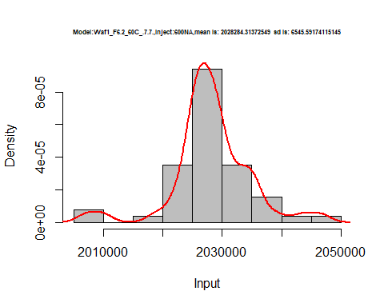

hist(d3_7.7$V7,  
 cex.main=0.5,  
 freq = FALSE,  
 main = paste('Model:Waf1_F6.2_60C_.7.7.,Inject:700NA,mean is:', mean(d3_7.7$V7),' sd is:', sd(d3_7.7$V7)),  
 xlab = "Input",  
 ylab = "Density",  
 col="grey")  
#plot density curve  
lines(density(d3_7.7$V7), # density plot  
 lwd = 2, # thickness of line  
 col = "red")

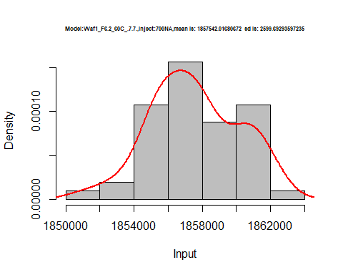

hist(d3_7.7$V8,  
 cex.main=0.5,  
 freq = FALSE,  
 main = paste('Model:Waf1_F6.2_60C_.7.7.,Inject:800NA,mean is:', mean(d3_7.7$V8),' sd is:', sd(d3_7.7$V8)),  
 xlab = "Input",  
 ylab = "Density",  
 col="grey")  
#plot density curve  
lines(density(d3_7.7$V8), # density plot  
 lwd = 2, # thickness of line  
 col = "red")

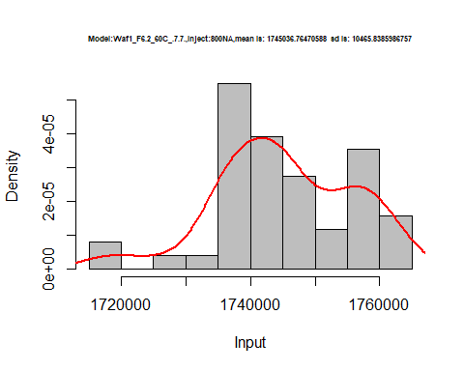

dens <- apply(d3_7.7, 2, density)  
plot('Waf1_F5.3_60C_.7.7.', xlim=range(sapply(dens, "[", "x")), ylim=range(sapply(dens, "[", "y")))

## Warning in xy.coords(x, y, xlabel, ylabel, log): NAs introduced by coercion

mapply(lines, dens, col=1:length(dens))

## $V1  
## NULL  
##   
## $V2  
## NULL  
##   
## $V3  
## NULL  
##   
## $V4  
## NULL  
##   
## $V5  
## NULL  
##   
## $V6  
## NULL  
##   
## $V7  
## NULL  
##   
## $V8  
## NULL

legend("topright", legend=names(dens), fill=1:length(dens))

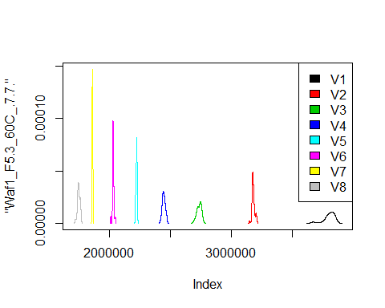

d4_7.7<-d_7.7[,c(25:32)]  
d4_7.7 <- head(d4_7.7,51)  
colnames(d4_7.7) <- c("V1", "V2","V3","V4","V5","V6","V7","V8")  
# head(d4_7.7)

hist(d4_7.7$V1,  
 cex.main=0.5,  
 freq = FALSE,  
 main = paste('Model:Waf1_F6.3_60C_.7.7.,Inject:100NA,mean is:', mean(d4_7.7$V1),' sd is:', sd(d4_7.7$V1)),  
 xlab = "Input",  
 ylab = "Density",  
 col="grey")  
#plot density curve  
lines(density(d4_7.7$V1), # density plot  
 lwd = 2, # thickness of line  
 col = "red")

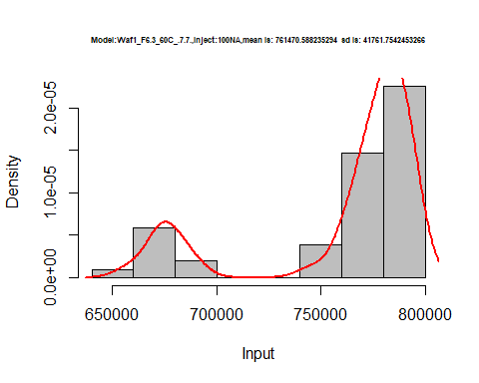

hist(d4_7.7$V2,  
 cex.main=0.5,  
 freq = FALSE,  
 main = paste('Model:Waf1_F6.3_60C_.7.7.,Inject:200NA,mean is:', mean(d4_7.7$V2),' sd is:', sd(d4_7.7$V2)),  
 xlab = "Input",  
 ylab = "Density",  
 col="grey")  
#plot density curve  
lines(density(d4_7.7$V2), # density plot  
 lwd = 2, # thickness of line  
 col = "red")

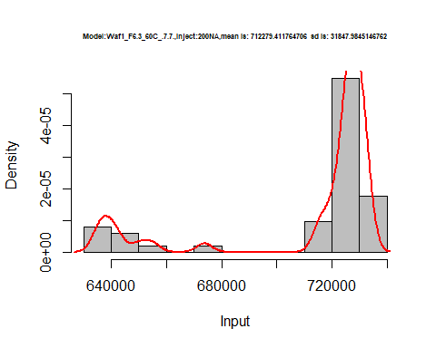

hist(d4_7.7$V3,  
 cex.main=0.5,  
 freq = FALSE,  
 main = paste('Model:Waf1_F6.3_60C_.7.7.,Inject:300NA,mean is:', mean(d4_7.7$V3),' sd is:', sd(d4_7.7$V3)),  
 xlab = "Input",  
 ylab = "Density",  
 col="grey")  
#plot density curve  
lines(density(d4_7.7$V3), # density plot  
 lwd = 2, # thickness of line  
 col = "red")

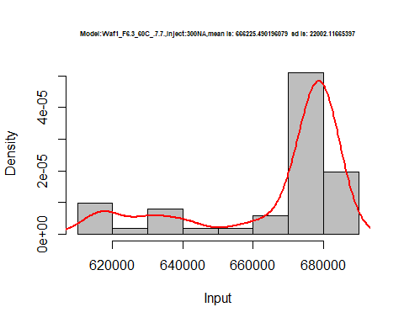

hist(d4_7.7$V4,  
 cex.main=0.5,  
 freq = FALSE,  
 main = paste('Model:Waf1_F6.3_60C_.7.7.,Inject:400NA,mean is:', mean(d4_7.7$V4),' sd is:', sd(d4_7.7$V4)),  
 xlab = "Input",  
 ylab = "Density",  
 col="grey")  
#plot density curve  
lines(density(d4_7.7$V4), # density plot  
 lwd = 2, # thickness of line  
 col = "red")

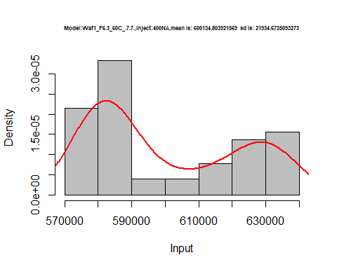

hist(d4_7.7$V5,  
 cex.main=0.5,  
 freq = FALSE,  
 main = paste('Model:Waf1_F6.3_60C_.7.7.,Inject:500NA,mean is:', mean(d4_7.7$V5),' sd is:', sd(d4_7.7$V5)),  
 xlab = "Input",  
 ylab = "Density",  
 col="grey")  
#plot density curve  
lines(density(d4_7.7$V5), # density plot  
 lwd = 2, # thickness of line  
 col = "red")

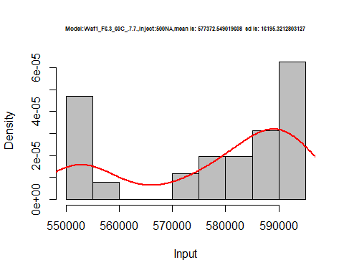

hist(d4_7.7$V6,  
 cex.main=0.5,  
 freq = FALSE,  
 main = paste('Model:Waf1_F6.3_60C_.7.7.,Inject:600NA,mean is:', mean(d4_7.7$V6),' sd is:', sd(d4_7.7$V6)),  
 xlab = "Input",  
 ylab = "Density",  
 col="grey")  
#plot density curve  
lines(density(d4_7.7$V6), # density plot  
 lwd = 2, # thickness of line  
 col = "red")

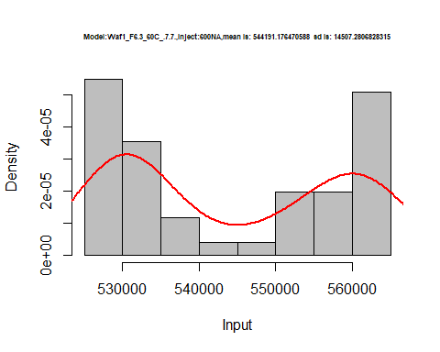

hist(d4_7.7$V7,  
 cex.main=0.5,  
 freq = FALSE,  
 main = paste('Model:Waf1_F6.3_60C_.7.7.,Inject:700NA,mean is:', mean(d4_7.7$V7),' sd is:', sd(d4_7.7$V7)),  
 xlab = "Input",  
 ylab = "Density",  
 col="grey")  
#plot density curve  
lines(density(d4_7.7$V7), # density plot  
 lwd = 2, # thickness of line  
 col = "red")

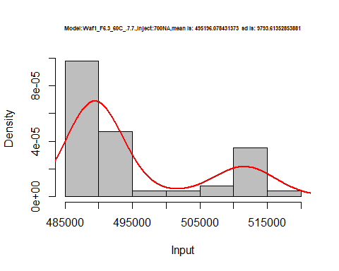

hist(d4_7.7$V8,  
 cex.main=0.5,  
 freq = FALSE,  
 main = paste('Model:Waf1_F6.3_60C_.7.7.,Inject:800NA,mean is:', mean(d4_7.7$V8),' sd is:', sd(d4_7.7$V8)),  
 xlab = "Input",  
 ylab = "Density",  
 col="grey")  
#plot density curve  
lines(density(d4_7.7$V8), # density plot  
 lwd = 2, # thickness of line  
 col = "red")

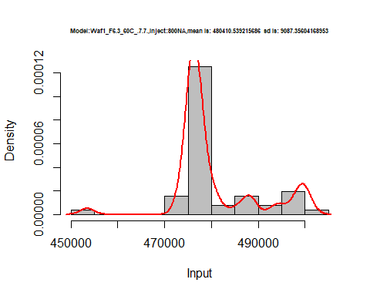

dens <- apply(d4_7.7, 2, density)  
plot('Waf1_F6.3_60C_.7.7.', xlim=range(sapply(dens, "[", "x")), ylim=range(sapply(dens, "[", "y")))

## Warning in xy.coords(x, y, xlabel, ylabel, log): NAs introduced by coercion

mapply(lines, dens, col=1:length(dens))

## $V1  
## NULL  
##   
## $V2  
## NULL  
##   
## $V3  
## NULL  
##   
## $V4  
## NULL  
##   
## $V5  
## NULL  
##   
## $V6  
## NULL  
##   
## $V7  
## NULL  
##   
## $V8  
## NULL

legend("topright", legend=names(dens), fill=1:length(dens))

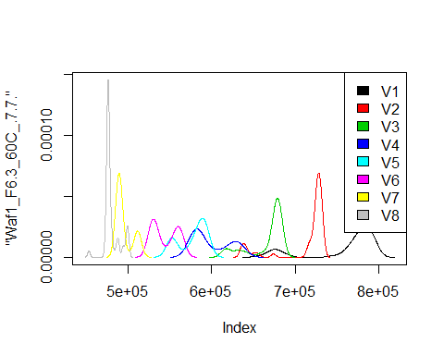

d5_7.7<-d_7.7[,c(33:40)]  
d5_7.7 <- head(d5_7.7,51)  
colnames(d5_7.7) <- c("V1", "V2","V3","V4","V5","V6","V7","V8")  
# head(d5_7.7)

hist(d5_7.7$V1,  
 cex.main=0.5,  
 freq = FALSE,  
 main = paste('Model:Waf1_F6.4_60C_.7.7.,Inject:100NA,mean is:', mean(d5_7.7$V1),' sd is:', sd(d5_7.7$V1)),  
 xlab = "Input",  
 ylab = "Density",  
 col="grey")  
#plot density curve  
lines(density(d5_7.7$V1), # density plot  
 lwd = 2, # thickness of line  
 col = "red")

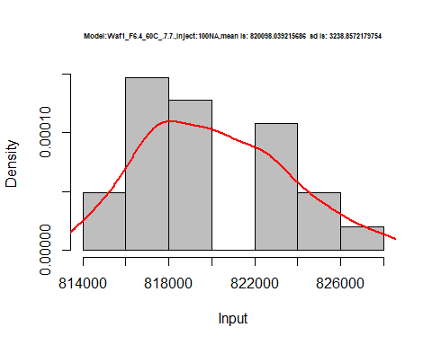

hist(d5_7.7$V2,  
 cex.main=0.5,  
 freq = FALSE,  
 main = paste('Model:Waf1_F6.4_60C_.7.7.,Inject:200NA,mean is:', mean(d5_7.7$V2),' sd is:', sd(d5_7.7$V2)),  
 xlab = "Input",  
 ylab = "Density",  
 col="grey")  
#plot density curve  
lines(density(d5_7.7$V2), # density plot  
 lwd = 2, # thickness of line  
 col = "red")

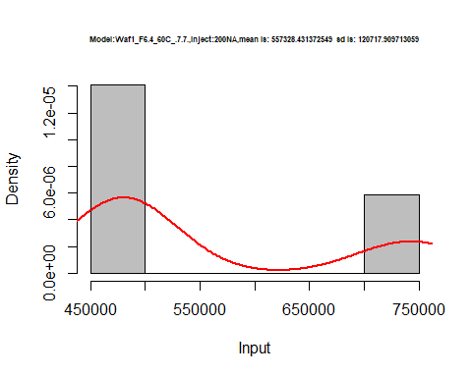

hist(d5_7.7$V3,  
 cex.main=0.5,  
 freq = FALSE,  
 main = paste('Model:Waf1_F6.4_60C_.7.7.,Inject:300NA,mean is:', mean(d5_7.7$V3),' sd is:', sd(d5_7.7$V3)),  
 xlab = "Input",  
 ylab = "Density",  
 col="grey")  
#plot density curve  
lines(density(d5_7.7$V3), # density plot  
 lwd = 2, # thickness of line  
 col = "red")

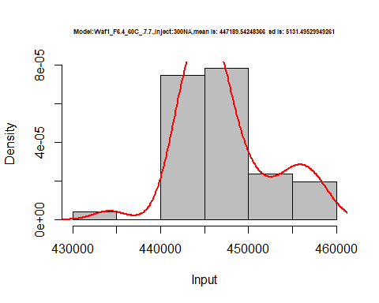

hist(d5_7.7$V4,  
 cex.main=0.5,  
 freq = FALSE,  
 main = paste('Model:Waf1_F6.4_60C_.7.7.,Inject:400NA,mean is:', mean(d5_7.7$V4),' sd is:', sd(d5_7.7$V4)),  
 xlab = "Input",  
 ylab = "Density",  
 col="grey")  
#plot density curve  
lines(density(d5_7.7$V4), # density plot  
 lwd = 2, # thickness of line  
 col = "red")

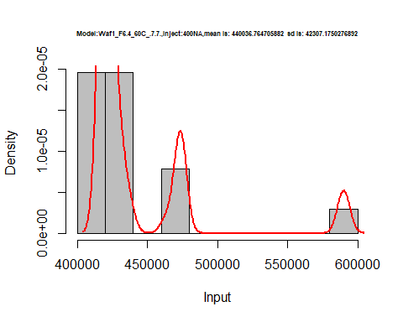

hist(d5_7.7$V5,  
 cex.main=0.5,  
 freq = FALSE,  
 main = paste('Model:Waf1_F6.4_60C_.7.7.,Inject:500NA,mean is:', mean(d5_7.7$V5),' sd is:', sd(d5_7.7$V5)),  
 xlab = "Input",  
 ylab = "Density",  
 col="grey")  
#plot density curve  
lines(density(d5_7.7$V5), # density plot  
 lwd = 2, # thickness of line  
 col = "red")

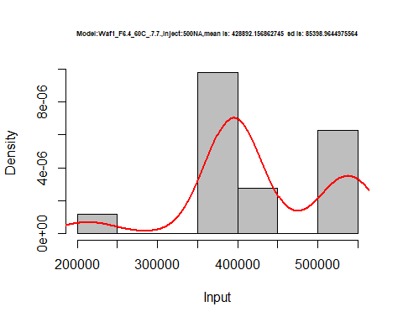

hist(d5_7.7$V6,  
 cex.main=0.5,  
 freq = FALSE,  
 main = paste('Model:Waf1_F6.4_60C_.7.7.,Inject:600NA,mean is:', mean(d5_7.7$V6),' sd is:', sd(d5_7.7$V6)),  
 xlab = "Input",  
 ylab = "Density",  
 col="grey")  
#plot density curve  
lines(density(d5_7.7$V6), # density plot  
 lwd = 2, # thickness of line  
 col = "red")

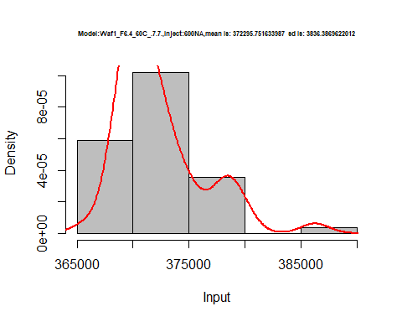

hist(d5_7.7$V7,  
 cex.main=0.5,  
 freq = FALSE,  
 main = paste('Model:Waf1_F6.4_60C_.7.7.,Inject:700NA,mean is:', mean(d5_7.7$V7),' sd is:', sd(d5_7.7$V7)),  
 xlab = "Input",  
 ylab = "Density",  
 col="grey")  
#plot density curve  
lines(density(d5_7.7$V7), # density plot  
 lwd = 2, # thickness of line  
 col = "red")

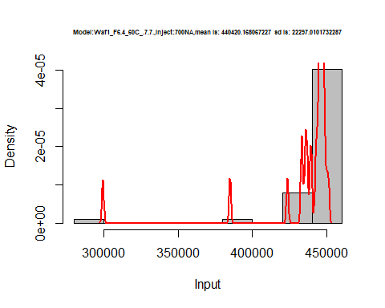

hist(d5_7.7$V8,  
 cex.main=0.5,  
 freq = FALSE,  
 main = paste('Model:Waf1_F6.4_60C_.7.7.,Inject:800NA,mean is:', mean(d5_7.7$V8),' sd is:', sd(d5_7.7$V8)),  
 xlab = "Input",  
 ylab = "Density",  
 col="grey")  
#plot density curve  
lines(density(d5_7.7$V8), # density plot  
 lwd = 2, # thickness of line  
 col = "red")

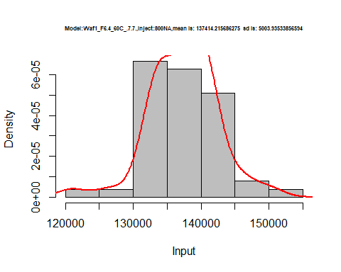

dens <- apply(d5_7.7, 2, density)  
plot('Waf1_F6.3_60C_.7.7.', xlim=range(sapply(dens, "[", "x")), ylim=range(sapply(dens, "[", "y")))

## Warning in xy.coords(x, y, xlabel, ylabel, log): NAs introduced by coercion

mapply(lines, dens, col=1:length(dens))

## $V1  
## NULL  
##   
## $V2  
## NULL  
##   
## $V3  
## NULL  
##   
## $V4  
## NULL  
##   
## $V5  
## NULL  
##   
## $V6  
## NULL  
##   
## $V7  
## NULL  
##   
## $V8  
## NULL

legend("topright", legend=names(dens), fill=1:length(dens))

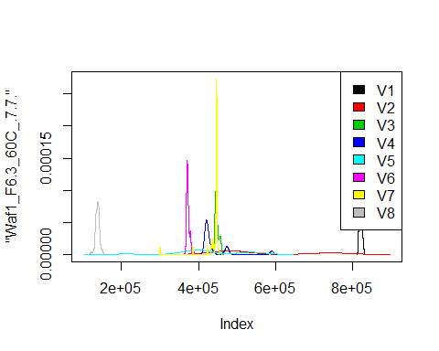

# Select columns whose names contains "8.8"  
d_8.8<-my_data %>% select(contains("8.8."))  
# head(d_8.8)

d1_8.8<-d_8.8[,c(1:8)]  
d1_8.8 <- head(d1_8.8,51)  
colnames(d1_8.8) <- c("V1", "V2","V3","V4","V5","V6","V7","V8")  
# head(d1_8.8)

hist(d1_8.8$V1,  
 cex.main=0.5,  
 freq = FALSE,  
 main = paste('Model:Waf1_F3.3_60C_.8.8..,Inject:100NA,mean is:', mean(d1_8.8$V1),' sd is:', sd(d1_8.8$V1)),  
 xlab = "Input",  
 ylab = "Density",  
 col="grey")  
#plot density curve  
lines(density(d1_8.8$V1), # density plot  
 lwd = 2, # thickness of line  
 col = "red")

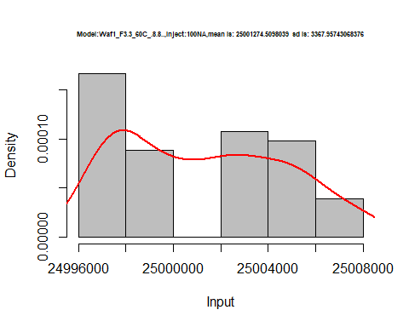

hist(d1_8.8$V2,  
 cex.main=0.5,  
 freq = FALSE,  
 main = paste('Model:Waf1_F3.3_60C_.8.8..,Inject:200NA,mean is:', mean(d1_8.8$V2),' sd is:', sd(d1_8.8$V2)),  
 xlab = "Input",  
 ylab = "Density",  
 col="grey")  
#plot density curve  
lines(density(d1_8.8$V2), # density plot  
 lwd = 2, # thickness of line  
 col = "red")

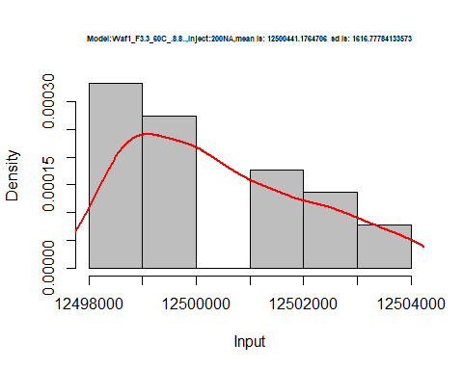

hist(d1_8.8$V3,  
 cex.main=0.5,  
 freq = FALSE,  
 main = paste('Model:Waf1_F3.3_60C_.8.8..,Inject:300NA,mean is:', mean(d1_8.8$V3),' sd is:', sd(d1_8.8$V3)),  
 xlab = "Input",  
 ylab = "Density",  
 col="grey")  
#plot density curve  
lines(density(d1_8.8$V3), # density plot  
 lwd = 2, # thickness of line  
 col = "red")

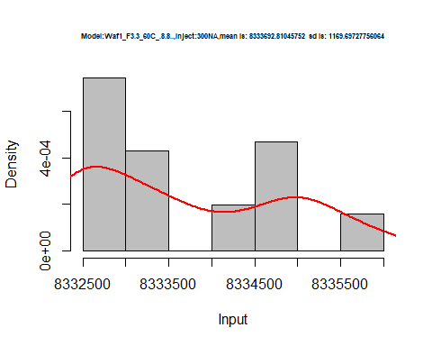

hist(d1_8.8$V4,  
 cex.main=0.5,  
 freq = FALSE,  
 main = paste('Model:Waf1_F3.3_60C_.8.8..,Inject:400NA,mean is:', mean(d1_8.8$V4),' sd is:', sd(d1_8.8$V4)),  
 xlab = "Input",  
 ylab = "Density",  
 col="grey")  
#plot density curve  
lines(density(d1_8.8$V4), # density plot  
 lwd = 2, # thickness of line  
 col = "red")

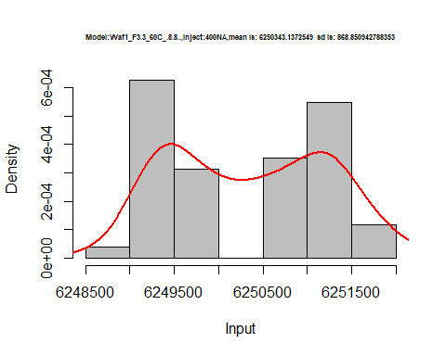

hist(d1_8.8$V5,  
 cex.main=0.5,  
 freq = FALSE,  
 main = paste('Model:Waf1_F3.3_60C_.8.8..,Inject:500NA,mean is:', mean(d1_8.8$V5),' sd is:', sd(d1_8.8$V5)),  
 xlab = "Input",  
 ylab = "Density",  
 col="grey")  
#plot density curve  
lines(density(d1_8.8$V5), # density plot  
 lwd = 2, # thickness of line  
 col = "red")

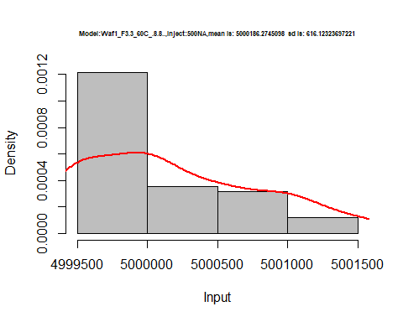

hist(d1_8.8$V6,  
 cex.main=0.5,  
 freq = FALSE,  
 main = paste('Model:Waf1_F3.3_60C_.8.8..,Inject:600NA,mean is:', mean(d1_8.8$V6),' sd is:', sd(d1_8.8$V6)),  
 xlab = "Input",  
 ylab = "Density",  
 col="grey")  
#plot density curve  
lines(density(d1_8.8$V6), # density plot  
 lwd = 2, # thickness of line  
 col = "red")

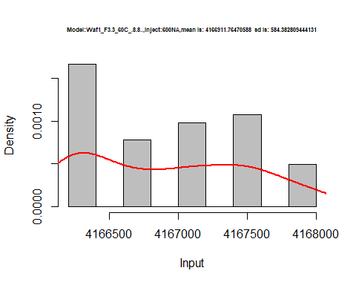

hist(d1_8.8$V7,  
 cex.main=0.5,  
 freq = FALSE,  
 main = paste('Model:Waf1_F3.3_60C_.8.8..,Inject:700NA,mean is:', mean(d1_8.8$V7),' sd is:', sd(d1_8.8$V7)),  
 xlab = "Input",  
 ylab = "Density",  
 col="grey")  
#plot density curve  
lines(density(d1_8.8$V7), # density plot  
 lwd = 2, # thickness of line  
 col = "red")

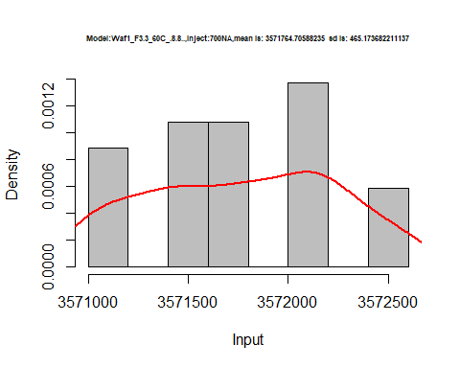

hist(d1_8.8$V8,  
 cex.main=0.5,  
 freq = FALSE,  
 main = paste('Model:Waf1_F3.3_60C_.8.8.,Inject:800NA,mean is:', mean(d1_8.8$V8),' sd is:', sd(d1_8.8$V8)),  
 xlab = "Input",  
 ylab = "Density",  
 col="grey")  
#plot density curve  
lines(density(d1_8.8$V8), # density plot  
 lwd = 2, # thickness of line  
 col = "red")

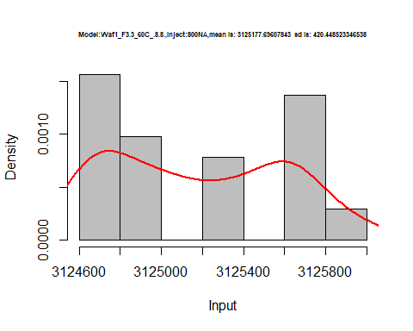

dens <- apply(d1_8.8, 2, density)  
plot('Waf1_F3.3_60C_.8.8.', xlim=range(sapply(dens, "[", "x")), ylim=range(sapply(dens, "[", "y")))

## Warning in xy.coords(x, y, xlabel, ylabel, log): NAs introduced by coercion

mapply(lines, dens, col=1:length(dens))

## $V1  
## NULL  
##   
## $V2  
## NULL  
##   
## $V3  
## NULL  
##   
## $V4  
## NULL  
##   
## $V5  
## NULL  
##   
## $V6  
## NULL  
##   
## $V7  
## NULL  
##   
## $V8  
## NULL

legend("topright", legend=names(dens), fill=1:length(dens))

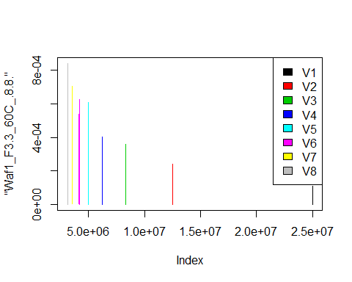

d2_8.8<-d_8.8[,c(9:17)]  
d2_8.8 <- head(d2_8.8,51)  
colnames(d2_8.8) <- c("V1", "V2","V3","V4","V5","V6","V7","V8")  
# head(d2_8.8)

hist(d2_8.8$V1,  
 cex.main=0.5,  
 freq = FALSE,  
 main = paste('Model:Waf1_F3.5_60C_.8.8.,Inject:100NA,mean is:', mean(d2_8.8$V1),' sd is:', sd(d2_8.8$V1)),  
 xlab = "Input",  
 ylab = "Density",  
 col="grey")  
#plot density curve  
lines(density(d2_8.8$V1), # density plot  
 lwd = 2, # thickness of line  
 col = "red")

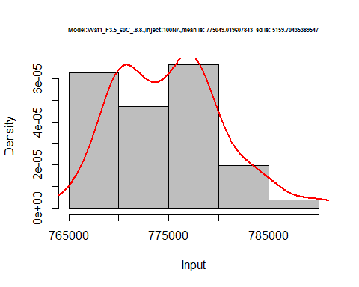

hist(d2_8.8$V2,  
 cex.main=0.5,  
 freq = FALSE,  
 main = paste('Model:Waf1_F3.5_60C_.8.8.,Inject:200NA,mean is:', mean(d2_8.8$V2),' sd is:', sd(d2_8.8$V2)),  
 xlab = "Input",  
 ylab = "Density",  
 col="grey")  
#plot density curve  
lines(density(d2_8.8$V2), # density plot  
 lwd = 2, # thickness of line  
 col = "red")

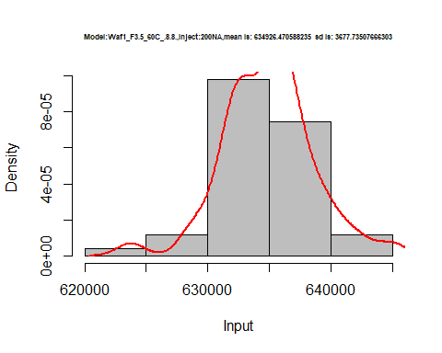

hist(d2_8.8$V3,  
 cex.main=0.5,  
 freq = FALSE,  
 main = paste('Model:Waf1_F3.5_60C_.8.8.,Inject:300NA,mean is:', mean(d2_8.8$V3),' sd is:', sd(d2_8.8$V3)),  
 xlab = "Input",  
 ylab = "Density",  
 col="grey")  
#plot density curve  
lines(density(d2_8.8$V3), # density plot  
 lwd = 2, # thickness of line  
 col = "red")

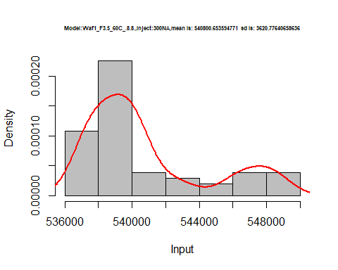

hist(d2_8.8$V4,  
 cex.main=0.5,  
 freq = FALSE,  
 main = paste('Model:Waf1_F3.5_60C_.8.8.,Inject:400NA,mean is:', mean(d2_8.8$V4),' sd is:', sd(d2_8.8$V4)),  
 xlab = "Input",  
 ylab = "Density",  
 col="grey")  
#plot density curve  
lines(density(d2_8.8$V4), # density plot  
 lwd = 2, # thickness of line  
 col = "red")

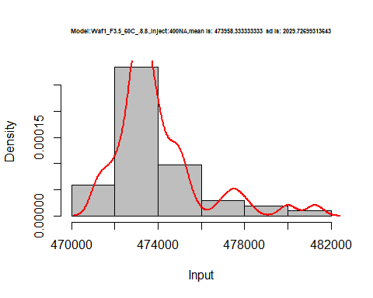

hist(d2_8.8$V5,  
 cex.main=0.5,  
 freq = FALSE,  
 main = paste('Model:Waf1_F3.5_60C_.8.8.,Inject:500NA,mean is:', mean(d2_8.8$V5),' sd is:', sd(d2_8.8$V5)),  
 xlab = "Input",  
 ylab = "Density",  
 col="grey")  
#plot density curve  
lines(density(d2_8.8$V5), # density plot  
 lwd = 2, # thickness of line  
 col = "red")

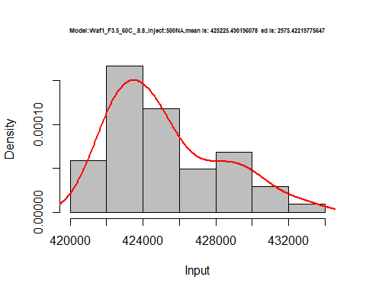

hist(d2_8.8$V6,  
 cex.main=0.5,  
 freq = FALSE,  
 main = paste('Model:Waf1_F3.5_60C_.8.8.,Inject:600NA,mean is:', mean(d2_8.8$V6),' sd is:', sd(d2_8.8$V6)),  
 xlab = "Input",  
 ylab = "Density",  
 col="grey")  
#plot density curve  
lines(density(d2_8.8$V6), # density plot  
 lwd = 2, # thickness of line  
 col = "red")

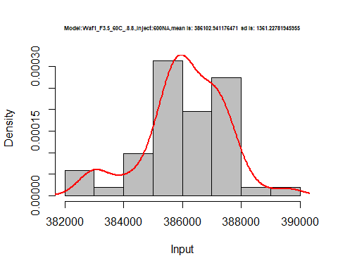

hist(d2_8.8$V7,  
 cex.main=0.5,  
 freq = FALSE,  
 main = paste('Model:Waf1_F3.5_60C_.8.8.,Inject:700NA,mean is:', mean(d2_8.8$V7),' sd is:', sd(d2_8.8$V7)),  
 xlab = "Input",  
 ylab = "Density",  
 col="grey")  
#plot density curve  
lines(density(d2_8.8$V7), # density plot  
 lwd = 2, # thickness of line  
 col = "red")

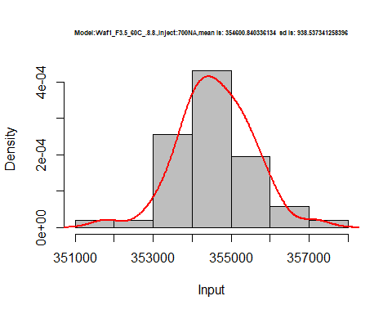

hist(d2_8.8$V8,  
 cex.main=0.5,  
 freq = FALSE,  
 main = paste('Model:Waf1_F3.5_60C_.8.8.,Inject:800NA,mean is:', mean(d2_8.8$V8),' sd is:', sd(d2_8.8$V8)),  
 xlab = "Input",  
 ylab = "Density",  
 col="grey")  
#plot density curve  
lines(density(d2_8.8$V8), # density plot  
 lwd = 2, # thickness of line  
 col = "red")

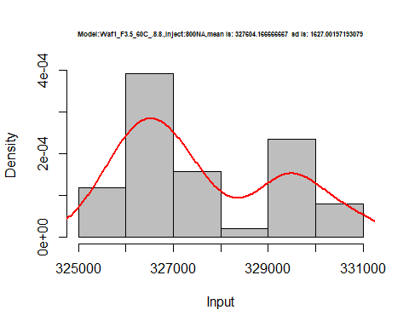

dens <- apply(d2_8.8, 2, density)  
plot('Waf1_F3.3_60C_.8.8.', xlim=range(sapply(dens, "[", "x")), ylim=range(sapply(dens, "[", "y")))

## Warning in xy.coords(x, y, xlabel, ylabel, log): NAs introduced by coercion

mapply(lines, dens, col=1:length(dens))

## $V1  
## NULL  
##   
## $V2  
## NULL  
##   
## $V3  
## NULL  
##   
## $V4  
## NULL  
##   
## $V5  
## NULL  
##   
## $V6  
## NULL  
##   
## $V7  
## NULL  
##   
## $V8  
## NULL  
##   
## $<NA>  
## NULL

legend("topright", legend=names(dens), fill=1:length(dens))

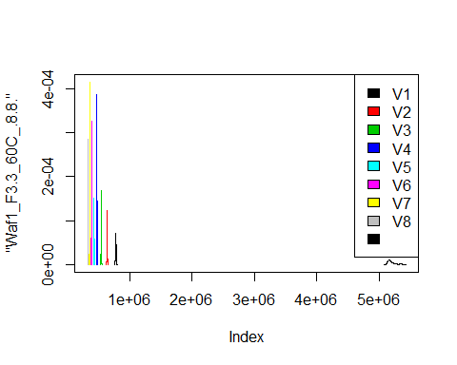

d3_8.8<-d_8.8[,c(17:24)]  
d3_8.8 <- head(d3_8.8,51)  
colnames(d3_8.8) <- c("V1", "V2","V3","V4","V5","V6","V7","V8")  
# head(d3_8.8)

hist(d3_8.8$V1,  
 cex.main=0.5,  
 freq = FALSE,  
 main = paste('Model:Waf1_F5.3_60C_.8.8,Inject:100NA,mean is:', mean(d3_8.8$V1),' sd is:', sd(d3_8.8$V1)),  
 xlab = "Input",  
 ylab = "Density",  
 col="grey")  
#plot density curve  
lines(density(d3_8.8$V1), # density plot  
 lwd = 2, # thickness of line  
 col = "red")

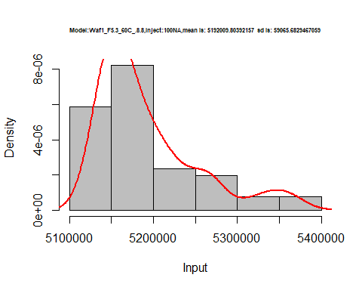

hist(d3_8.8$V2,  
 cex.main=0.5,  
 freq = FALSE,  
 main = paste('Model:Waf1_F5.3_60C_.8.8,Inject:200NA,mean is:', mean(d3_8.8$V2),' sd is:', sd(d3_8.8$V2)),  
 xlab = "Input",  
 ylab = "Density",  
 col="grey")  
#plot density curve  
lines(density(d3_8.8$V2), # density plot  
 lwd = 2, # thickness of line  
 col = "red")

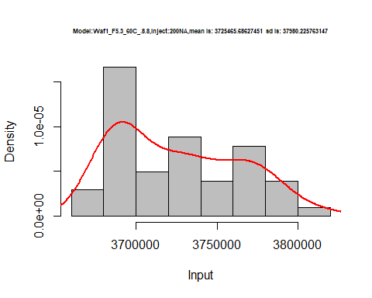

hist(d3_8.8$V3,  
 cex.main=0.5,  
 freq = FALSE,  
 main = paste('Model:Waf1_F5.3_60C_.8.8,Inject:300NA,mean is:', mean(d3_8.8$V3),' sd is:', sd(d3_8.8$V3)),  
 xlab = "Input",  
 ylab = "Density",  
 col="grey")  
#plot density curve  
lines(density(d3_8.8$V3), # density plot  
 lwd = 2, # thickness of line  
 col = "red")

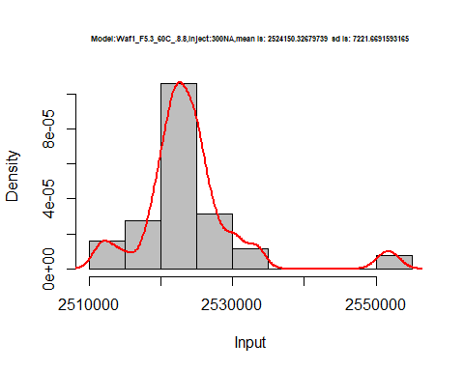

hist(d3_8.8$V4,  
 cex.main=0.5,  
 freq = FALSE,  
 main = paste('Model:Waf1_F5.3_60C_.8.8,Inject:400NA,mean is:', mean(d3_8.8$V4),' sd is:', sd(d3_8.8$V4)),  
 xlab = "Input",  
 ylab = "Density",  
 col="grey")  
#plot density curve  
lines(density(d3_8.8$V4), # density plot  
 lwd = 2, # thickness of line  
 col = "red")

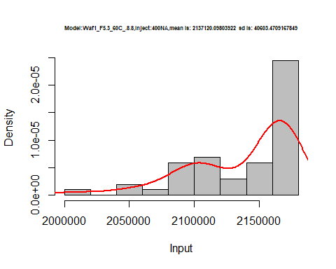

hist(d3_8.8$V5,  
 cex.main=0.5,  
 freq = FALSE,  
 main = paste('Model:Waf1_F5.3_60C_.8.8,Inject:500NA,mean is:', mean(d3_8.8$V5),' sd is:', sd(d3_8.8$V5)),  
 xlab = "Input",  
 ylab = "Density",  
 col="grey")  
#plot density curve  
lines(density(d3_8.8$V5), # density plot  
 lwd = 2, # thickness of line  
 col = "red")

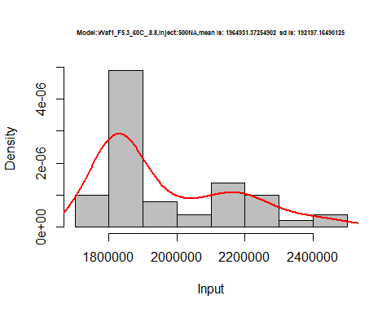

hist(d3_8.8$V6,  
 cex.main=0.5,  
 freq = FALSE,  
 main = paste('Model:Waf1_F5.3_60C_.8.8,Inject:600NA,mean is:', mean(d3_8.8$V6),' sd is:', sd(d3_8.8$V6)),  
 xlab = "Input",  
 ylab = "Density",  
 col="grey")  
#plot density curve  
lines(density(d3_8.8$V6), # density plot  
 lwd = 2, # thickness of line  
 col = "red")

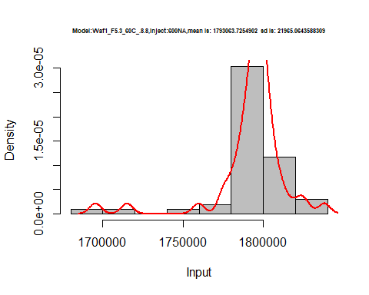

hist(d3_8.8$V7,  
 cex.main=0.5,  
 freq = FALSE,  
 main = paste('Model:Waf1_F5.3_60C_.8.8,Inject:700NA,mean is:', mean(d3_8.8$V7),' sd is:', sd(d3_8.8$V7)),  
 xlab = "Input",  
 ylab = "Density",  
 col="grey")  
#plot density curve  
lines(density(d3_8.8$V7), # density plot  
 lwd = 2, # thickness of line  
 col = "red")

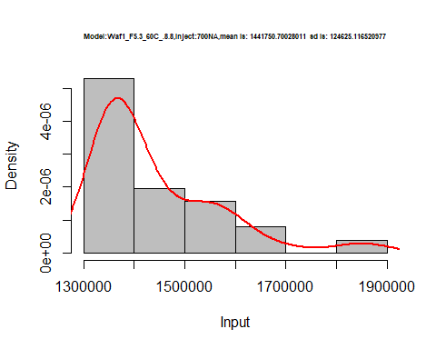

hist(d3_8.8$V8,  
 cex.main=0.5,  
 freq = FALSE,  
 main = paste('Model:Waf1_F5.3_60C_.8.8,Inject:800NA,mean is:', mean(d3_8.8$V8),' sd is:', sd(d3_8.8$V8)),  
 xlab = "Input",  
 ylab = "Density",  
 col="grey")  
#plot density curve  
lines(density(d3_8.8$V8), # density plot  
 lwd = 2, # thickness of line  
 col = "red")

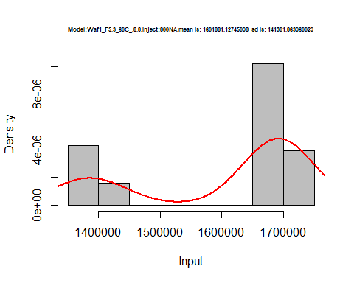

dens <- apply(d3_8.8, 2, density)  
plot('Waf1_F5.3_60C_.8.8.', xlim=range(sapply(dens, "[", "x")), ylim=range(sapply(dens, "[", "y")))

## Warning in xy.coords(x, y, xlabel, ylabel, log): NAs introduced by coercion

mapply(lines, dens, col=1:length(dens))

## $V1  
## NULL  
##   
## $V2  
## NULL  
##   
## $V3  
## NULL  
##   
## $V4  
## NULL  
##   
## $V5  
## NULL  
##   
## $V6  
## NULL  
##   
## $V7  
## NULL  
##   
## $V8  
## NULL

legend("topright", legend=names(dens), fill=1:length(dens))

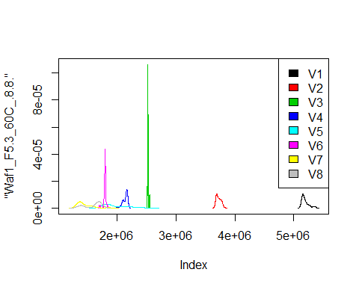

# Select columns whose names contains "9.9"  
d_9.9<-my_data %>% select(contains("9.9."))  
# head(d_9.9)

d1_9.9<-d_9.9[,c(1:8)]  
d1_9.9 <- head(d1_9.9,51)  
colnames(d1_9.9) <- c("V1", "V2","V3","V4","V5","V6","V7","V8")  
# head(d1_9.9)

hist(d1_9.9$V1,  
 cex.main=0.5,  
 freq = FALSE,  
 main = paste('Model:Waf1_F3.2_60C_.9.9,Inject:100NA,mean is:', mean(d1_9.9$V1),' sd is:', sd(d1_9.9$V1)),  
 xlab = "Input",  
 ylab = "Density",  
 col="grey")  
#plot density curve  
lines(density(d1_9.9$V1), # density plot  
 lwd = 2, # thickness of line  
 col = "red")

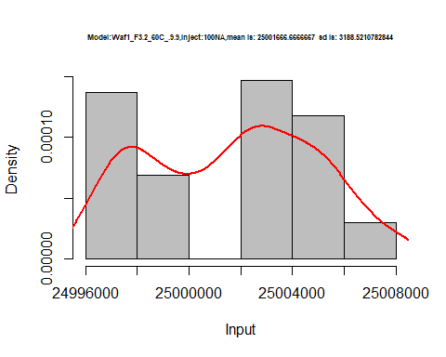

hist(d1_9.9$V2,  
 cex.main=0.5,  
 freq = FALSE,  
 main = paste('Model:Waf1_F3.2_60C_.9.9,Inject:200NA,mean is:', mean(d1_9.9$V2),' sd is:', sd(d1_9.9$V2)),  
 xlab = "Input",  
 ylab = "Density",  
 col="grey")  
#plot density curve  
lines(density(d1_9.9$V2), # density plot  
 lwd = 2, # thickness of line  
 col = "red")

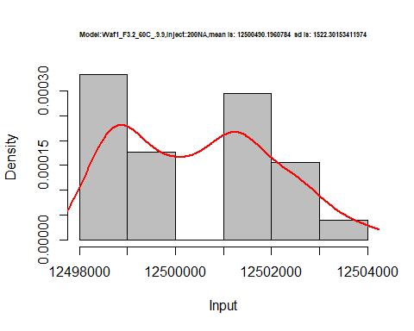

hist(d1_9.9$V3,  
 cex.main=0.5,  
 freq = FALSE,  
 main = paste('Model:Waf1_F3.2_60C_.9.9,Inject:300NA,mean is:', mean(d1_9.9$V3),' sd is:', sd(d1_9.9$V3)),  
 xlab = "Input",  
 ylab = "Density",  
 col="grey")  
#plot density curve  
lines(density(d1_9.9$V3), # density plot  
 lwd = 2, # thickness of line  
 col = "red")

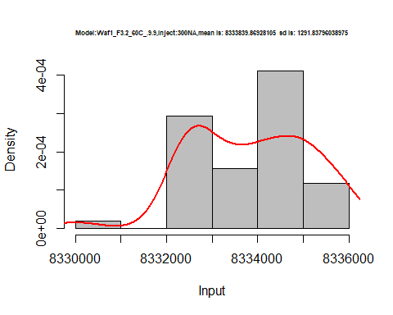

hist(d1_9.9$V4,  
 cex.main=0.5,  
 freq = FALSE,  
 main = paste('Model:Waf1_F3.2_60C_.9.9,Inject:400NA,mean is:', mean(d1_9.9$V4),' sd is:', sd(d1_9.9$V4)),  
 xlab = "Input",  
 ylab = "Density",  
 col="grey")  
#plot density curve  
lines(density(d1_9.9$V4), # density plot  
 lwd = 2, # thickness of line  
 col = "red")

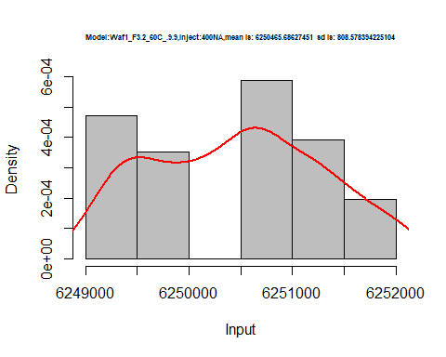

hist(d1_9.9$V5,  
 cex.main=0.5,  
 freq = FALSE,  
 main = paste('Model:Waf1_F3.2_60C_.9.9,Inject:500NA,mean is:', mean(d1_9.9$V5),' sd is:', sd(d1_9.9$V5)),  
 xlab = "Input",  
 ylab = "Density",  
 col="grey")  
#plot density curve  
lines(density(d1_9.9$V5), # density plot  
 lwd = 2, # thickness of line  
 col = "red")

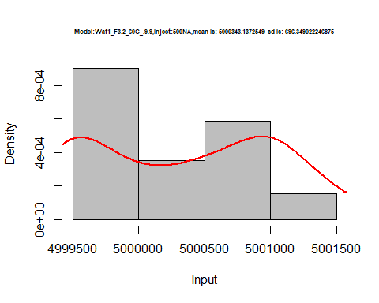

hist(d1_9.9$V6,  
 cex.main=0.5,  
 freq = FALSE,  
 main = paste('Model:Waf1_F3.2_60C_.9.9,Inject:600NA,mean is:', mean(d1_9.9$V6),' sd is:', sd(d1_9.9$V6)),  
 xlab = "Input",  
 ylab = "Density",  
 col="grey")  
#plot density curve  
lines(density(d1_9.9$V6), # density plot  
 lwd = 2, # thickness of line  
 col = "red")

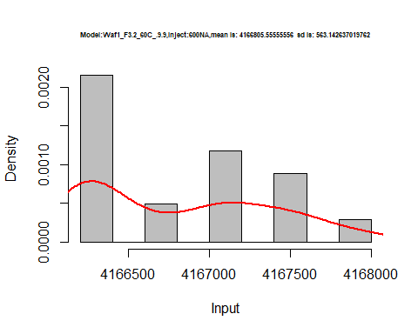

hist(d1_9.9$V7,  
 cex.main=0.5,  
 freq = FALSE,  
 main = paste('Model:Waf1_F3.2_60C_.9.9,Inject:700NA,mean is:', mean(d1_9.9$V7),' sd is:', sd(d1_9.9$V7)),  
 xlab = "Input",  
 ylab = "Density",  
 col="grey")  
#plot density curve  
lines(density(d1_9.9$V7), # density plot  
 lwd = 2, # thickness of line  
 col = "red")

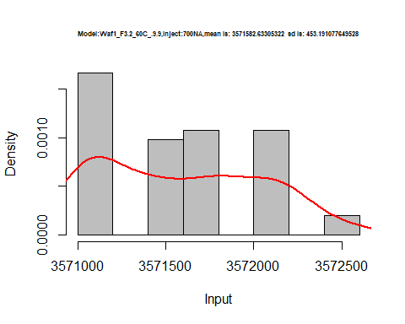

hist(d1_9.9$V8,  
 cex.main=0.5,  
 freq = FALSE,  
 main = paste('Model:Waf1_F3.2_60C_.9.9,Inject:800NA,mean is:', mean(d1_9.9$V8),' sd is:', sd(d1_9.9$V8)),  
 xlab = "Input",  
 ylab = "Density",  
 col="grey")  
#plot density curve  
lines(density(d1_9.9$V8), # density plot  
 lwd = 2, # thickness of line  
 col = "red")

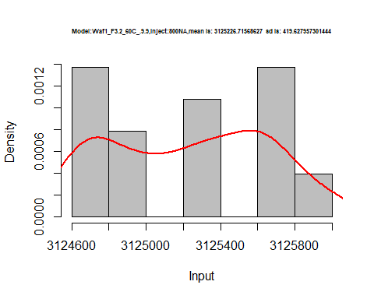

dens <- apply(d1_9.9, 2, density)  
plot('Waf1_F3.2_60C_.100nA_.9.9', xlim=range(sapply(dens, "[", "x")), ylim=range(sapply(dens, "[", "y")))

## Warning in xy.coords(x, y, xlabel, ylabel, log): NAs introduced by coercion

mapply(lines, dens, col=1:length(dens))

## $V1  
## NULL  
##   
## $V2  
## NULL  
##   
## $V3  
## NULL  
##   
## $V4  
## NULL  
##   
## $V5  
## NULL  
##   
## $V6  
## NULL  
##   
## $V7  
## NULL  
##   
## $V8  
## NULL

legend("topright", legend=names(dens), fill=1:length(dens))

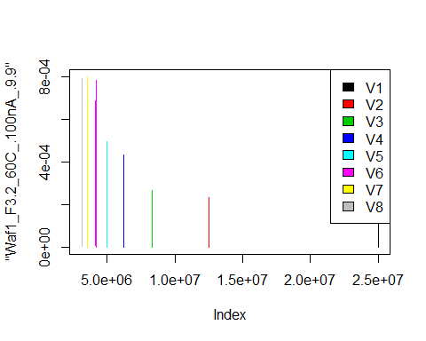

d2_9.9<-d_9.9[,c(9:16)]  
d2_9.9 <- head(d2_9.9,51)  
colnames(d2_9.9) <- c("V1", "V2","V3","V4","V5","V6","V7","V8")  
# head(d2_9.9)

hist(d2_9.9$V1,  
 cex.main=0.5,  
 freq = FALSE,  
 main = paste('Model:Waf1_F5.3_60C_.9.9,Inject:100NA,mean is:', mean(d2_9.9$V1),' sd is:', sd(d2_9.9$V1)),  
 xlab = "Input",  
 ylab = "Density",  
 col="grey")  
#plot density curve  
lines(density(d2_9.9$V1), # density plot  
 lwd = 2, # thickness of line  
 col = "red")

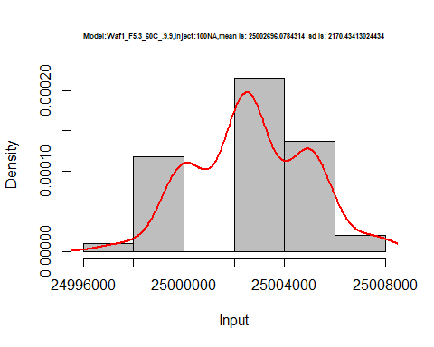

hist(d2_9.9$V2,  
 cex.main=0.5,  
 freq = FALSE,  
 main = paste('Model:Waf1_F5.3_60C_.9.9,Inject:200NA,mean is:', mean(d2_9.9$V2),' sd is:', sd(d2_9.9$V2)),  
 xlab = "Input",  
 ylab = "Density",  
 col="grey")  
#plot density curve  
lines(density(d2_9.9$V2), # density plot  
 lwd = 2, # thickness of line  
 col = "red")

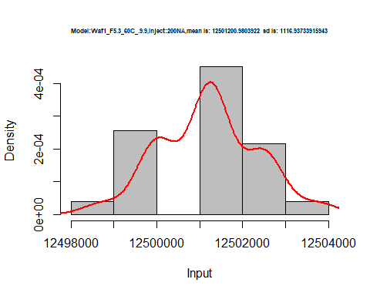

hist(d2_9.9$V3,  
 cex.main=0.5,  
 freq = FALSE,  
 main = paste('Model:Waf1_F5.3_60C_.9.9,Inject:300NA,mean is:', mean(d2_9.9$V3),' sd is:', sd(d2_9.9$V3)),  
 xlab = "Input",  
 ylab = "Density",  
 col="grey")  
#plot density curve  
lines(density(d2_9.9$V3), # density plot  
 lwd = 2, # thickness of line  
 col = "red")

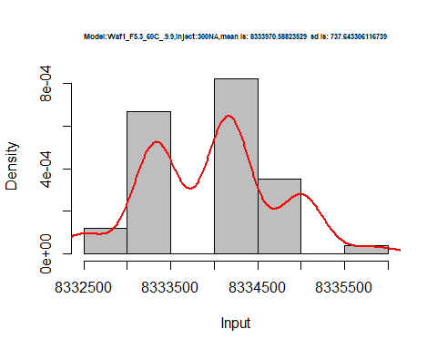

hist(d2_9.9$V4,  
 cex.main=0.5,  
 freq = FALSE,  
 main = paste('Model:Waf1_F5.3_60C_.9.9,Inject:400NA,mean is:', mean(d2_9.9$V4),' sd is:', sd(d2_9.9$V4)),  
 xlab = "Input",  
 ylab = "Density",  
 col="grey")  
#plot density curve  
lines(density(d2_9.9$V4), # density plot  
 lwd = 2, # thickness of line  
 col = "red")

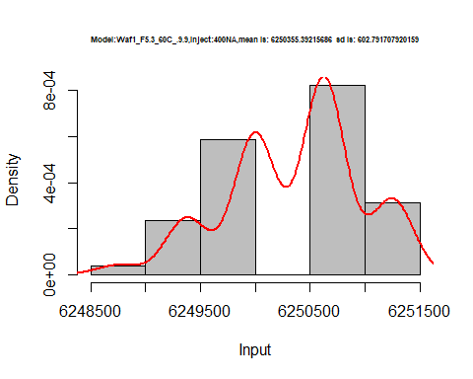

hist(d2_9.9$V5,  
 cex.main=0.5,  
 freq = FALSE,  
 main = paste('Model:Waf1_F5.3_60C_.9.9,Inject:500NA,mean is:', mean(d2_9.9$V5),' sd is:', sd(d2_9.9$V5)),  
 xlab = "Input",  
 ylab = "Density",  
 col="grey")  
#plot density curve  
lines(density(d2_9.9$V5), # density plot  
 lwd = 2, # thickness of line  
 col = "red")

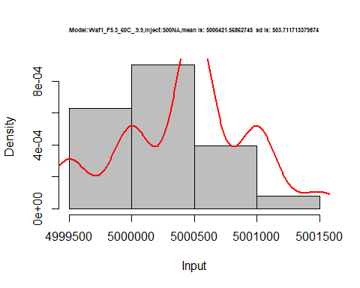

hist(d2_9.9$V6,  
 cex.main=0.5,  
 freq = FALSE,  
 main = paste('Model:Waf1_F5.3_60C_.9.9,Inject:600NA,mean is:', mean(d2_9.9$V6),' sd is:', sd(d2_9.9$V6)),  
 xlab = "Input",  
 ylab = "Density",  
 col="grey")  
#plot density curve  
lines(density(d2_9.9$V6), # density plot  
 lwd = 2, # thickness of line  
 col = "red")

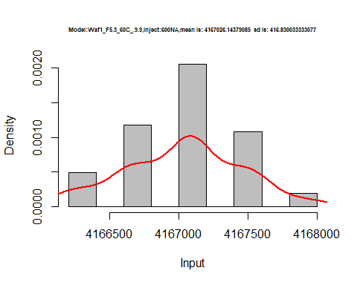

hist(d2_9.9$V7,  
 cex.main=0.5,  
 freq = FALSE,  
 main = paste('Model:Waf1_F5.3_60C_.9.9,Inject:700NA,mean is:', mean(d2_9.9$V7),' sd is:', sd(d2_9.9$V7)),  
 xlab = "Input",  
 ylab = "Density",  
 col="grey")  
#plot density curve  
lines(density(d2_9.9$V7), # density plot  
 lwd = 2, # thickness of line  
 col = "red")

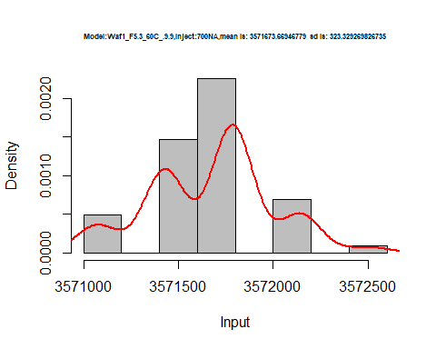

hist(d2_9.9$V8,  
 cex.main=0.5,  
 freq = FALSE,  
 main = paste('Model:Waf1_F5.3_60C_.100nA_.9.9,Inject:800NA,mean is:', mean(d2_9.9$V8),' sd is:', sd(d2_9.9$V8)),  
 xlab = "Input",  
 ylab = "Density",  
 col="grey")  
#plot density curve  
lines(density(d2_9.9$V8), # density plot  
 lwd = 2, # thickness of line  
 col = "red")

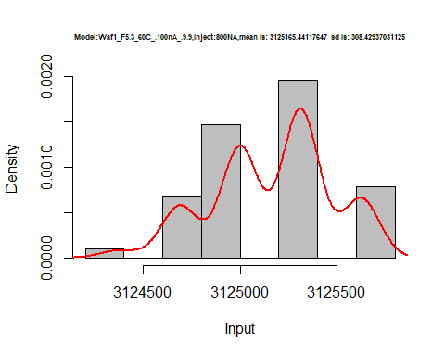

dens <- apply(d2_9.9, 2, density)  
plot('Waf1_F5.3_60C_.9.9', xlim=range(sapply(dens, "[", "x")), ylim=range(sapply(dens, "[", "y")))

## Warning in xy.coords(x, y, xlabel, ylabel, log): NAs introduced by coercion

mapply(lines, dens, col=1:length(dens))

## $V1  
## NULL  
##   
## $V2  
## NULL  
##   
## $V3  
## NULL  
##   
## $V4  
## NULL  
##   
## $V5  
## NULL  
##   
## $V6  
## NULL  
##   
## $V7  
## NULL  
##   
## $V8  
## NULL

legend("topright", legend=names(dens), fill=1:length(dens))

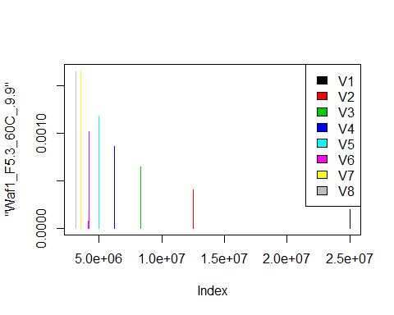

d3_9.9<-d_9.9[,c(17:24)]  
d3_9.9 <- head(d3_9.9,51)  
colnames(d3_9.9) <- c("V1", "V2","V3","V4","V5","V6","V7","V8")  
# head(d3_9.9)

hist(d3_9.9$V1,  
 cex.main=0.5,  
 freq = FALSE,  
 main = paste('Model:Waf1_F6.2_60C_.9.9,Inject:100NA,mean is:', mean(d3_9.9$V1),' sd is:', sd(d3_9.9$V1)),  
 xlab = "Input",  
 ylab = "Density",  
 col="grey")  
#plot density curve  
lines(density(d3_9.9$V1), # density plot  
 lwd = 2, # thickness of line  
 col = "red")

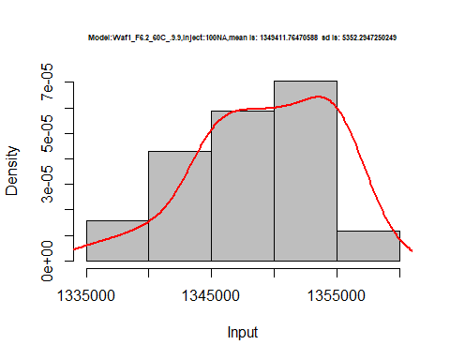

hist(d3_9.9$V2,  
 cex.main=0.5,  
 freq = FALSE,  
 main = paste('Model:Waf1_F6.2_60C_.9.9,Inject:100NA,mean is:', mean(d3_9.9$V2),' sd is:', sd(d3_9.9$V2)),  
 xlab = "Input",  
 ylab = "Density",  
 col="grey")  
#plot density curve  
lines(density(d3_9.9$V2), # density plot  
 lwd = 2, # thickness of line  
 col = "red")

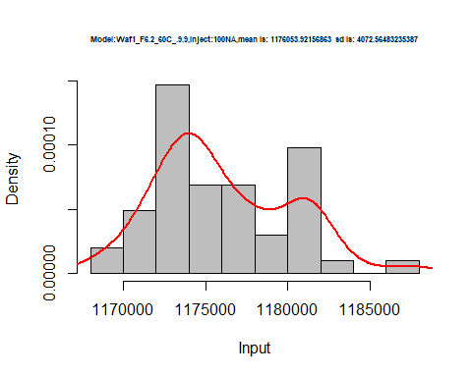

hist(d3_9.9$V3,  
 cex.main=0.5,  
 freq = FALSE,  
 main = paste('Model:Waf1_F6.2_60C_.9.9,Inject:300NA,mean is:', mean(d3_9.9$V3),' sd is:', sd(d3_9.9$V3)),  
 xlab = "Input",  
 ylab = "Density",  
 col="grey")  
#plot density curve  
lines(density(d3_9.9$V3), # density plot  
 lwd = 2, # thickness of line  
 col = "red")

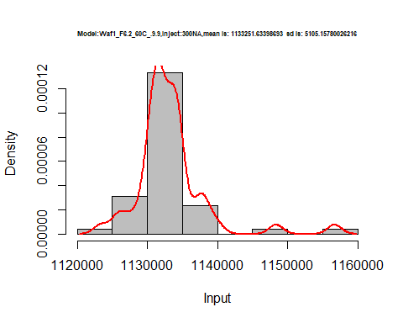

hist(d3_9.9$V4,  
 cex.main=0.5,  
 freq = FALSE,  
 main = paste('Model:Waf1_F6.2_60C_.9.9,Inject:400NA,mean is:', mean(d3_9.9$V4),' sd is:', sd(d3_9.9$V4)),  
 xlab = "Input",  
 ylab = "Density",  
 col="grey")  
#plot density curve  
lines(density(d3_9.9$V4), # density plot  
 lwd = 2, # thickness of line  
 col = "red")

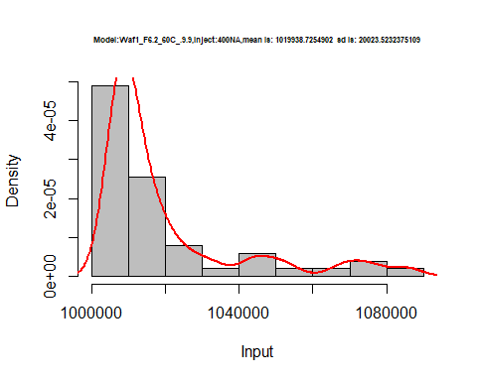

hist(d3_9.9$V5,  
 cex.main=0.5,  
 freq = FALSE,  
 main = paste('Model:Waf1_F6.2_60C_.9.9,Inject:500NA,mean is:', mean(d3_9.9$V5),' sd is:', sd(d3_9.9$V5)),  
 xlab = "Input",  
 ylab = "Density",  
 col="grey")  
#plot density curve  
lines(density(d3_9.9$V5), # density plot  
 lwd = 2, # thickness of line  
 col = "red")

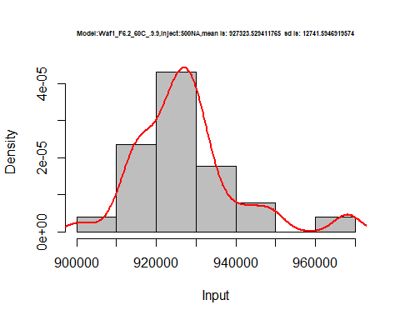

hist(d3_9.9$V6,  
 cex.main=0.5,  
 freq = FALSE,  
 main = paste('Model:Waf1_F6.2_60C_.9.9,Inject:600NA,mean is:', mean(d3_9.9$V6),' sd is:', sd(d3_9.9$V6)),  
 xlab = "Input",  
 ylab = "Density",  
 col="grey")  
#plot density curve  
lines(density(d3_9.9$V6), # density plot  
 lwd = 2, # thickness of line  
 col = "red")

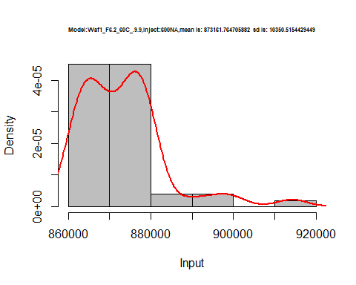

hist(d3_9.9$V7,  
 cex.main=0.5,  
 freq = FALSE,  
 main = paste('Model:Waf1_F6.2_60C_.9.9,Inject:100NA,mean is:', mean(d3_9.9$V7),' sd is:', sd(d3_9.9$V7)),  
 xlab = "Input",  
 ylab = "Density",  
 col="grey")  
#plot density curve  
lines(density(d3_9.9$V7), # density plot  
 lwd = 2, # thickness of line  
 col = "red")

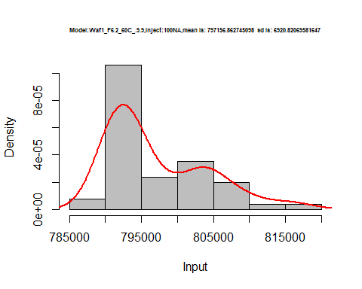

hist(d3_9.9$V8,  
 cex.main=0.5,  
 freq = FALSE,  
 main = paste('Model:Waf1_F6.2_60C_.9.9,Inject:800NA,mean is:', mean(d3_9.9$V8),' sd is:', sd(d3_9.9$V8)),  
 xlab = "Input",  
 ylab = "Density",  
 col="grey")  
#plot density curve  
lines(density(d3_9.9$V8), # density plot  
 lwd = 2, # thickness of line  
 col = "red")

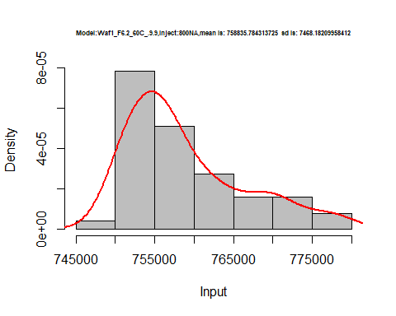

dens <- apply(d3_9.9, 2, density)  
plot('Model:Waf1_F6.2_60C_.100nA_.9.9', xlim=range(sapply(dens, "[", "x")), ylim=range(sapply(dens, "[", "y")))

## Warning in xy.coords(x, y, xlabel, ylabel, log): NAs introduced by coercion

mapply(lines, dens, col=1:length(dens))

## $V1  
## NULL  
##   
## $V2  
## NULL  
##   
## $V3  
## NULL  
##   
## $V4  
## NULL  
##   
## $V5  
## NULL  
##   
## $V6  
## NULL  
##   
## $V7  
## NULL  
##   
## $V8  
## NULL

legend("topright", legend=names(dens), fill=1:length(dens))

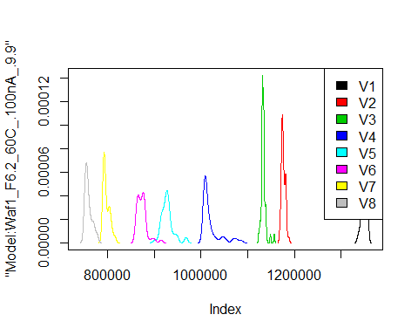

# Select columns whose names contains "10.10"  
d_10.10<-my_data %>% select(contains("10.10."))  
d_10.10 <- head(d_10.10,51)  
colnames(d_10.10) <- c("V1", "V2","V3","V4","V5","V6","V7","V8")  
# head(d_10.10)

hist(d_10.10$V1,  
 cex.main=0.5,  
 freq = FALSE,  
 main = paste('Model:Waf1_F4.3_60C_.10.10,Inject:100NA,mean is:', mean(d_10.10$V1),' sd is:', sd(d_10.10$V1)),  
 xlab = "Input",  
 ylab = "Density",  
 col="grey")  
#plot density curve  
lines(density(d_10.10$V1), # density plot  
 lwd = 2, # thickness of line  
 col = "red")

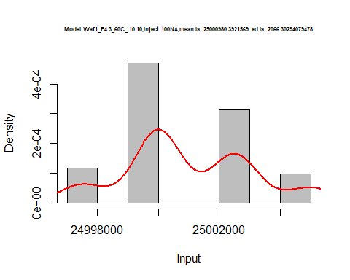

hist(d_10.10$V2,  
 cex.main=0.5,  
 freq = FALSE,  
 main = paste('Model:Waf1_F4.3_60C_.10.10,Inject:200NA,mean is:', mean(d_10.10$V2),' sd is:', sd(d_10.10$V2)),  
 xlab = "Input",  
 ylab = "Density",  
 col="grey")  
#plot density curve  
lines(density(d_10.10$V2), # density plot  
 lwd = 2, # thickness of line  
 col = "red")

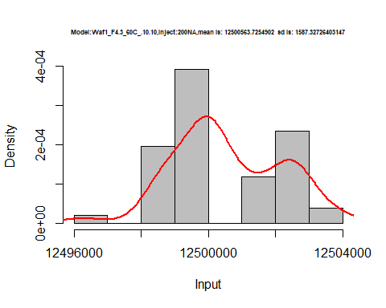

hist(d_10.10$V3,  
 cex.main=0.5,  
 freq = FALSE,  
 main = paste('Model:Waf1_F4.3_60C_.10.10,Inject:300NA,mean is:', mean(d_10.10$V3),' sd is:', sd(d_10.10$V3)),  
 xlab = "Input",  
 ylab = "Density",  
 col="grey")  
#plot density curve  
lines(density(d_10.10$V3), # density plot  
 lwd = 2, # thickness of line  
 col = "red")

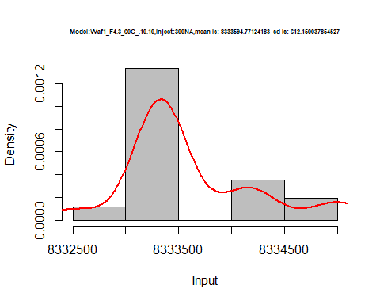

hist(d_10.10$V4,  
 cex.main=0.5,  
 freq = FALSE,  
 main = paste('Model:Waf1_F4.3_60C_.10.10,Inject:400NA,mean is:', mean(d_10.10$V4),' sd is:', sd(d_10.10$V4)),  
 xlab = "Input",  
 ylab = "Density",  
 col="grey")  
#plot density curve  
lines(density(d_10.10$V4), # density plot  
 lwd = 2, # thickness of line  
 col = "red")

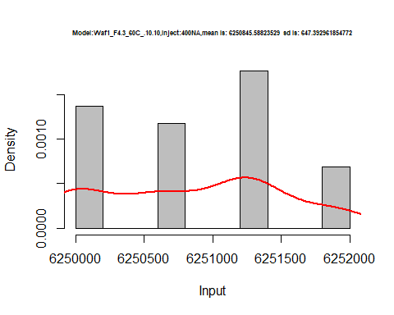

hist(d_10.10$V5,  
 cex.main=0.5,  
 freq = FALSE,  
 main = paste('Model:Waf1_F4.3_60C_.10.10,Inject:500NA,mean is:', mean(d_10.10$V5),' sd is:', sd(d_10.10$V5)),  
 xlab = "Input",  
 ylab = "Density",  
 col="grey")  
#plot density curve  
lines(density(d_10.10$V5), # density plot  
 lwd = 2, # thickness of line  
 col = "red")

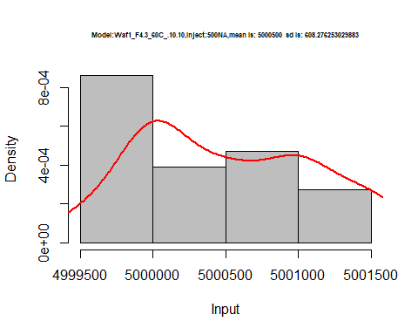

hist(d_10.10$V6,  
 cex.main=0.5,  
 freq = FALSE,  
 main = paste('Model:Waf1_F4.3_60C_.10.10,Inject:600NA,mean is:', mean(d_10.10$V6),' sd is:', sd(d_10.10$V6)),  
 xlab = "Input",  
 ylab = "Density",  
 col="grey")  
#plot density curve  
lines(density(d_10.10$V6), # density plot  
 lwd = 2, # thickness of line  
 col = "red")

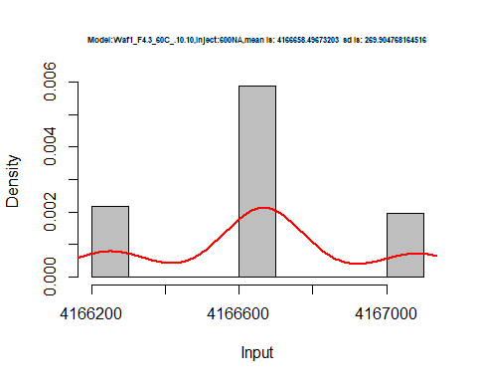

hist(d_10.10$V7,  
 cex.main=0.5,  
 freq = FALSE,  
 main = paste('Model:Waf1_F4.3_60C_.10.10,Inject:700NA,mean is:', mean(d_10.10$V7),' sd is:', sd(d_10.10$V7)),  
 xlab = "Input",  
 ylab = "Density",  
 col="grey")  
#plot density curve  
lines(density(d_10.10$V7), # density plot  
 lwd = 2, # thickness of line  
 col = "red")

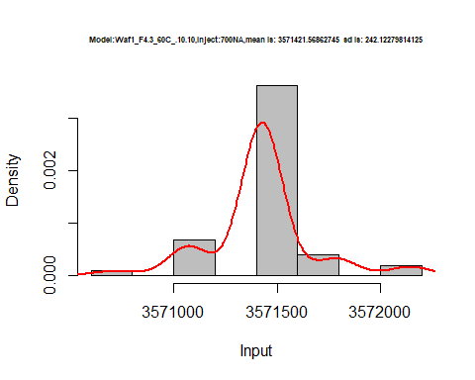

hist(d_10.10$V8,  
 cex.main=0.5,  
 freq = FALSE,  
 main = paste('Model:Waf1_F4.3_60C_.10.10,Inject:800NA,mean is:', mean(d_10.10$V8),' sd is:', sd(d_10.10$V8)),  
 xlab = "Input",  
 ylab = "Density",  
 col="grey")  
#plot density curve  
lines(density(d_10.10$V8), # density plot  
 lwd = 2, # thickness of line  
 col = "red")

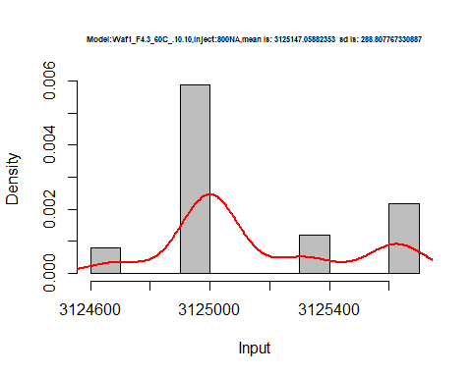

dens <- apply(d_10.10, 2, density)  
plot('Model:Waf1_F4.3_60C_.10.10', xlim=range(sapply(dens, "[", "x")), ylim=range(sapply(dens, "[", "y")))

## Warning in xy.coords(x, y, xlabel, ylabel, log): NAs introduced by coercion

mapply(lines, dens, col=1:length(dens))

## $V1  
## NULL  
##   
## $V2  
## NULL  
##   
## $V3  
## NULL  
##   
## $V4  
## NULL  
##   
## $V5  
## NULL  
##   
## $V6  
## NULL  
##   
## $V7  
## NULL  
##   
## $V8  
## NULL

legend("topright", legend=names(dens), fill=1:length(dens))

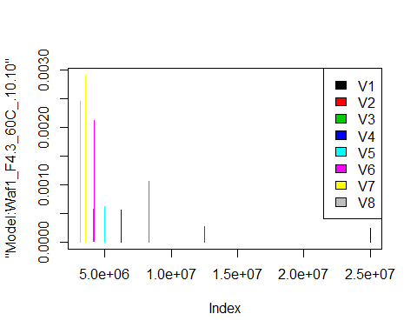

# Select columns whose names contains "11.11"  
d_11.11<-my_data %>% select(contains("11.11."))  
# head(d_11.11)

d1_11.11<-d_11.11[,c(1:8)]  
d1_11.11 <- head(d1_11.11,51)  
colnames(d1_11.11) <- c("V1", "V2","V3","V4","V5","V6","V7","V8")  
# head(d1_11.11)

hist(d1_11.11$V1,  
 cex.main=0.5,  
 freq = FALSE,  
 main = paste('Model:Waf1_F3.5_60C_.11.11.,Inject:100NA,mean is:', mean(d1_11.11$V1),' sd is:', sd(d1_11.11$V1)),  
 xlab = "Input",  
 ylab = "Density",  
 col="grey")  
#plot density curve  
lines(density(d1_11.11$V1), # density plot  
 lwd = 2, # thickness of line  
 col = "red")

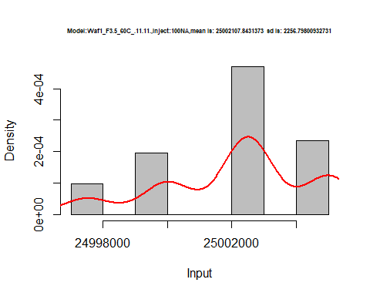

hist(d1_11.11$V2,  
 cex.main=0.5,  
 freq = FALSE,  
 main = paste('Model:Waf1_F3.5_60C_.11.11.,Inject:200NA,mean is:', mean(d1_11.11$V2),' sd is:', sd(d1_11.11$V2)),  
 xlab = "Input",  
 ylab = "Density",  
 col="grey")  
#plot density curve  
lines(density(d1_11.11$V2), # density plot  
 lwd = 2, # thickness of line  
 col = "red")

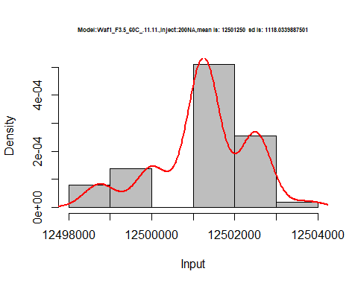

hist(d1_11.11$V3,  
 cex.main=0.5,  
 freq = FALSE,  
 main = paste('Model:Waf1_F3.5_60C_.11.11.,Inject:300NA,mean is:', mean(d1_11.11$V3),' sd is:', sd(d1_11.11$V3)),  
 xlab = "Input",  
 ylab = "Density",  
 col="grey")  
#plot density curve  
lines(density(d1_11.11$V3), # density plot  
 lwd = 2, # thickness of line  
 col = "red")

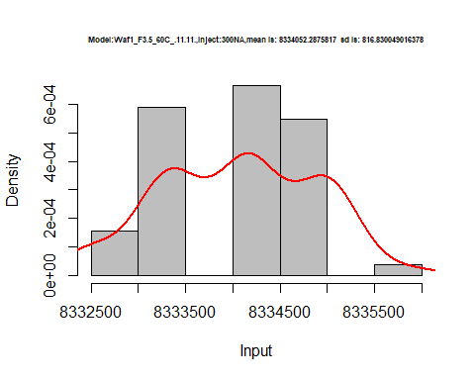

hist(d1_11.11$V4,  
 cex.main=0.5,  
 freq = FALSE,  
 main = paste('Model:Waf1_F3.5_60C_.11.11.,Inject:400NA,mean is:', mean(d1_11.11$V4),' sd is:', sd(d1_11.11$V4)),  
 xlab = "Input",  
 ylab = "Density",  
 col="grey")  
#plot density curve  
lines(density(d1_11.11$V4), # density plot  
 lwd = 2, # thickness of line  
 col = "red")

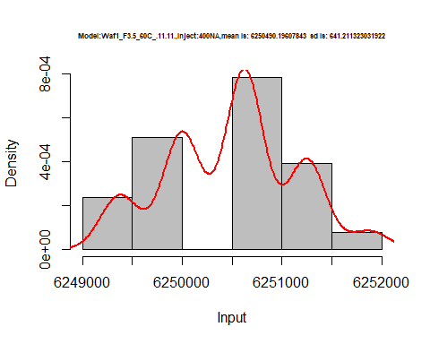

hist(d1_11.11$V5,  
 cex.main=0.5,  
 freq = FALSE,  
 main = paste('Model:Waf1_F3.5_60C_.11.11.,Inject:500NA,mean is:', mean(d1_11.11$V5),' sd is:', sd(d1_11.11$V5)),  
 xlab = "Input",  
 ylab = "Density",  
 col="grey")  
#plot density curve  
lines(density(d1_11.11$V5), # density plot  
 lwd = 2, # thickness of line  
 col = "red")

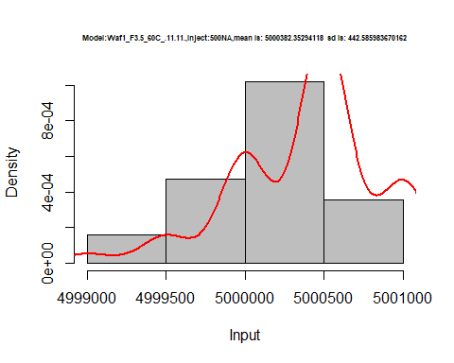

hist(d1_11.11$V6,  
 cex.main=0.5,  
 freq = FALSE,  
 main = paste('Model:Waf1_F3.5_60C_.11.11.,Inject:600NA,mean is:', mean(d1_11.11$V6),' sd is:', sd(d1_11.11$V6)),  
 xlab = "Input",  
 ylab = "Density",  
 col="grey")  
#plot density curve  
lines(density(d1_11.11$V6), # density plot  
 lwd = 2, # thickness of line  
 col = "red")

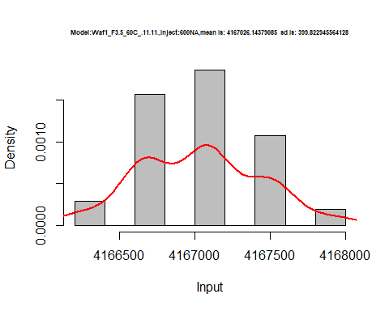

hist(d1_11.11$V7,  
 cex.main=0.5,  
 freq = FALSE,  
 main = paste('Model:Waf1_F3.5_60C_.11.11.,Inject:700NA,mean is:', mean(d1_11.11$V7),' sd is:', sd(d1_11.11$V7)),  
 xlab = "Input",  
 ylab = "Density",  
 col="grey")  
#plot density curve  
lines(density(d1_11.11$V7), # density plot  
 lwd = 2, # thickness of line  
 col = "red")

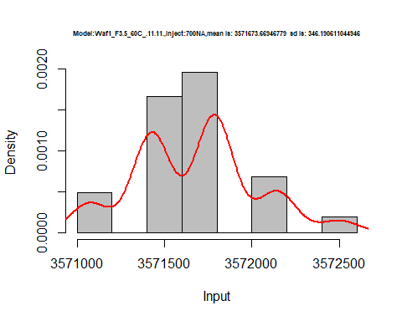

hist(d1_11.11$V8,  
 cex.main=0.5,  
 freq = FALSE,  
 main = paste('Model:Waf1_F3.5_60C_.11.11.,Inject:800NA,mean is:', mean(d1_11.11$V8),' sd is:', sd(d1_11.11$V8)),  
 xlab = "Input",  
 ylab = "Density",  
 col="grey")  
#plot density curve  
lines(density(d1_11.11$V8), # density plot  
 lwd = 2, # thickness of line  
 col = "red")

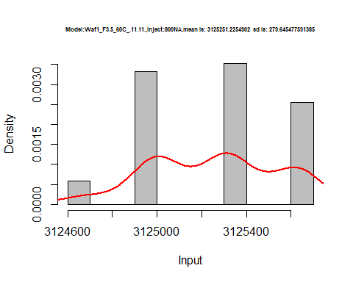

dens <- apply(d1_11.11, 2, density)  
plot('Model:Waf1_F3.5_60C_.11.11', xlim=range(sapply(dens, "[", "x")), ylim=range(sapply(dens, "[", "y")))

## Warning in xy.coords(x, y, xlabel, ylabel, log): NAs introduced by coercion

mapply(lines, dens, col=1:length(dens))

## $V1  
## NULL  
##   
## $V2  
## NULL  
##   
## $V3  
## NULL  
##   
## $V4  
## NULL  
##   
## $V5  
## NULL  
##   
## $V6  
## NULL  
##   
## $V7  
## NULL  
##   
## $V8  
## NULL

legend("topright", legend=names(dens), fill=1:length(dens))

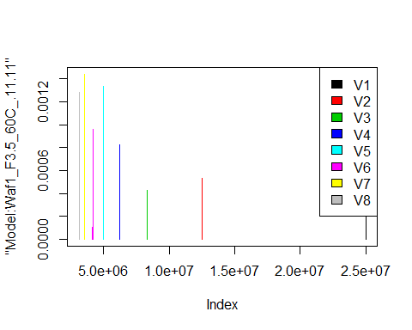

d2_11.11<-d_11.11[,c(9:16)]  
d2_11.11 <- head(d2_11.11,51)  
colnames(d2_11.11) <- c("V1", "V2","V3","V4","V5","V6","V7","V8")  
# head(d2_11.11)

hist(d2_11.11$V1,  
 cex.main=0.5,  
 freq = FALSE,  
 main = paste('Model:Waf1_F4.3_60C_.11.11.,Inject:100NA,mean is:', mean(d2_11.11$V1),' sd is:', sd(d2_11.11$V1)),  
 xlab = "Input",  
 ylab = "Density",  
 col="grey")  
#plot density curve  
lines(density(d2_11.11$V1), # density plot  
 lwd = 2, # thickness of line  
 col = "red")

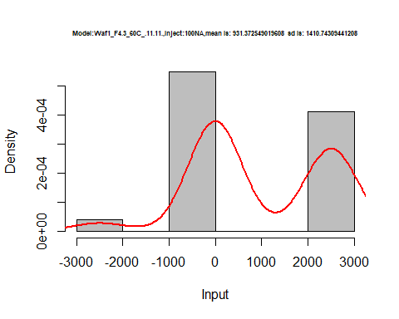

hist(d2_11.11$V2,  
 cex.main=0.5,  
 freq = FALSE,  
 main = paste('Model:Waf1_F4.3_60C_.11.11.,Inject:200NA,mean is:', mean(d2_11.11$V2),' sd is:', sd(d2_11.11$V2)),  
 xlab = "Input",  
 ylab = "Density",  
 col="grey")  
#plot density curve  
lines(density(d2_11.11$V2), # density plot  
 lwd = 2, # thickness of line  
 col = "red")

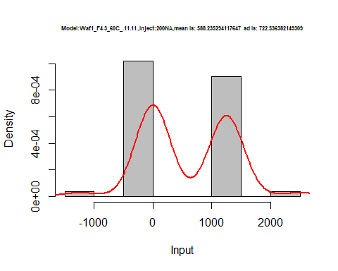

hist(d2_11.11$V3,  
 cex.main=0.5,  
 freq = FALSE,  
 main = paste('Model:Waf1_F4.3_60C_.11.11.,Inject:300NA,mean is:', mean(d2_11.11$V3),' sd is:', sd(d2_11.11$V3)),  
 xlab = "Input",  
 ylab = "Density",  
 col="grey")  
#plot density curve  
lines(density(d2_11.11$V3), # density plot  
 lwd = 2, # thickness of line  
 col = "red")

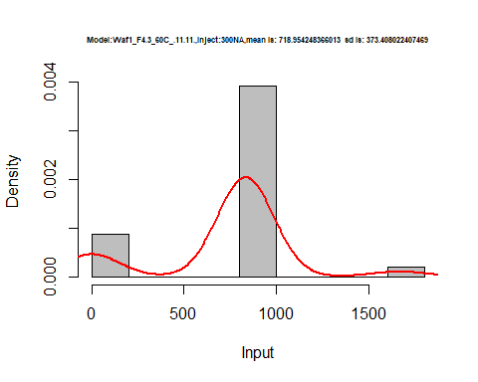

hist(d2_11.11$V4,  
 cex.main=0.5,  
 freq = FALSE,  
 main = paste('Model:Waf1_F4.3_60C_.11.11.,Inject:400NA,mean is:', mean(d2_11.11$V4),' sd is:', sd(d2_11.11$V4)),  
 xlab = "Input",  
 ylab = "Density",  
 col="grey")  
#plot density curve  
lines(density(d2_11.11$V4), # density plot  
 lwd = 2, # thickness of line  
 col = "red")

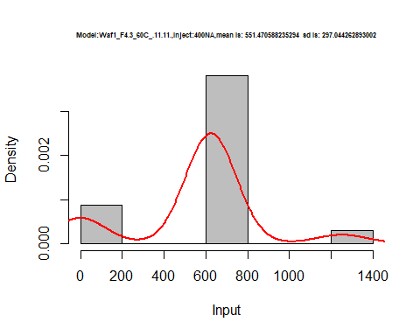

hist(d2_11.11$V5,  
 cex.main=0.5,  
 freq = FALSE,  
 main = paste('Model:Waf1_F4.3_60C_.11.11.,Inject:500NA,mean is:', mean(d2_11.11$V5),' sd is:', sd(d2_11.11$V5)),  
 xlab = "Input",  
 ylab = "Density",  
 col="grey")  
#plot density curve  
lines(density(d2_11.11$V5), # density plot  
 lwd = 2, # thickness of line  
 col = "red")

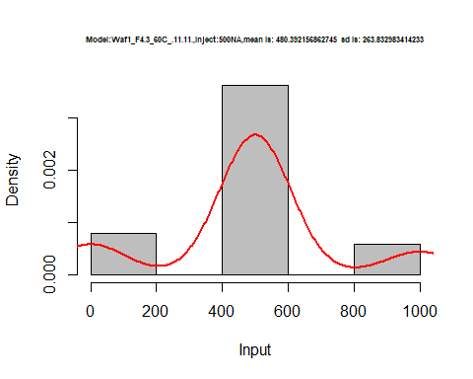

hist(d2_11.11$V6,  
 cex.main=0.5,  
 freq = FALSE,  
 main = paste('Model:Waf1_F4.3_60C_.11.11.,Inject:600NA,mean is:', mean(d2_11.11$V6),' sd is:', sd(d2_11.11$V6)),  
 xlab = "Input",  
 ylab = "Density",  
 col="grey")  
#plot density curve  
lines(density(d2_11.11$V6), # density plot  
 lwd = 2, # thickness of line  
 col = "red")

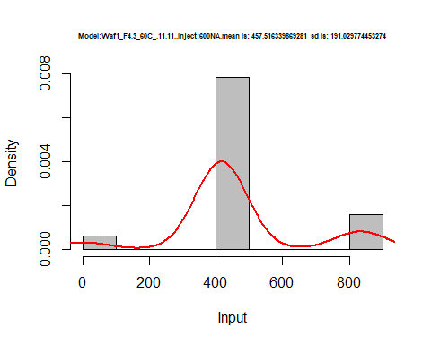

hist(d2_11.11$V7,  
 cex.main=0.5,  
 freq = FALSE,  
 main = paste('Model:Waf1_F4.3_60C_.11.11.,Inject:700NA,mean is:', mean(d2_11.11$V7),' sd is:', sd(d2_11.11$V7)),  
 xlab = "Input",  
 ylab = "Density",  
 col="grey")  
#plot density curve  
lines(density(d2_11.11$V7), # density plot  
 lwd = 2, # thickness of line  
 col = "red")

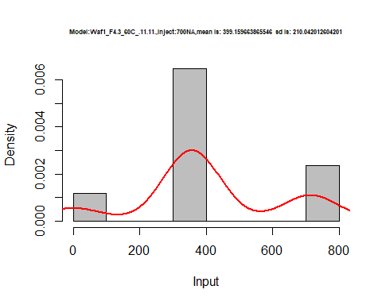

hist(d2_11.11$V8,  
 cex.main=0.5,  
 freq = FALSE,  
 main = paste('Model:Waf1_F4.3_60C_.11.11.,Inject:800NA,mean is:', mean(d2_11.11$V8),' sd is:', sd(d2_11.11$V8)),  
 xlab = "Input",  
 ylab = "Density",  
 col="grey")  
#plot density curve  
lines(density(d2_11.11$V8), # density plot  
 lwd = 2, # thickness of line  
 col = "red")

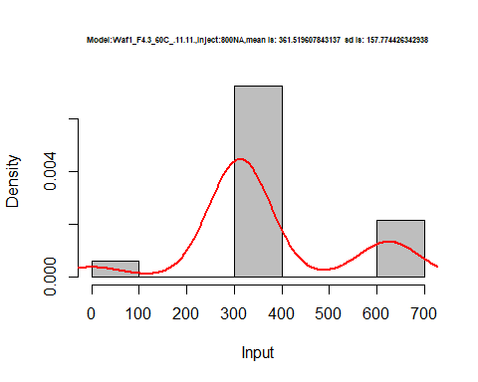

dens <- apply(d2_11.11, 2, density)  
plot('Model:Waf1_F3.5_60C_.11.11', xlim=range(sapply(dens, "[", "x")), ylim=range(sapply(dens, "[", "y")))

## Warning in xy.coords(x, y, xlabel, ylabel, log): NAs introduced by coercion

mapply(lines, dens, col=1:length(dens))

## $V1  
## NULL  
##   
## $V2  
## NULL  
##   
## $V3  
## NULL  
##   
## $V4  
## NULL  
##   
## $V5  
## NULL  
##   
## $V6  
## NULL  
##   
## $V7  
## NULL  
##   
## $V8  
## NULL

legend("topright", legend=names(dens), fill=1:length(dens))

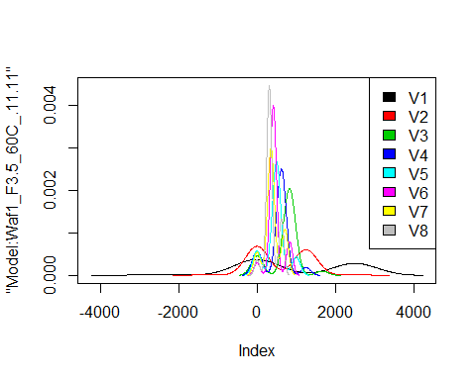

d3_11.11<-d_11.11[,c(17:24)]  
d3_11.11 <- head(d3_11.11,51)  
colnames(d3_11.11) <- c("V1", "V2","V3","V4","V5","V6","V7","V8")  
# head(d3_11.11)

hist(d3_11.11$V1,  
 cex.main=0.5,  
 freq = FALSE,  
 main = paste('Model:Waf1_F6.3_60C_.11.11.,Inject:100NA,mean is:', mean(d3_11.11$V1),' sd is:', sd(d3_11.11$V1)),  
 xlab = "Input",  
 ylab = "Density",  
 col="grey")  
#plot density curve  
lines(density(d3_11.11$V1), # density plot  
 lwd = 2, # thickness of line  
 col = "red")

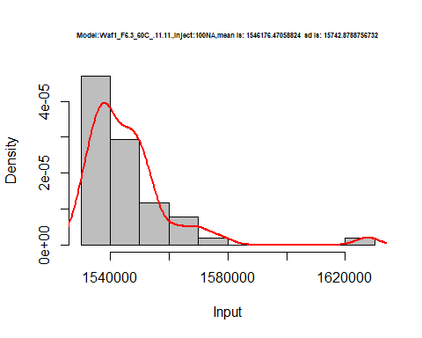

hist(d3_11.11$V2,  
 cex.main=0.5,  
 freq = FALSE,  
 main = paste('Model:Waf1_F6.3_60C_.11.11.,Inject:200NA,mean is:', mean(d3_11.11$V2),' sd is:', sd(d3_11.11$V2)),  
 xlab = "Input",  
 ylab = "Density",  
 col="grey")  
#plot density curve  
lines(density(d3_11.11$V2), # density plot  
 lwd = 2, # thickness of line  
 col = "red")

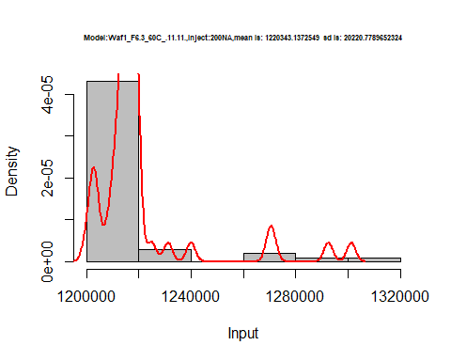

hist(d3_11.11$V3,  
 cex.main=0.5,  
 freq = FALSE,  
 main = paste('Model:Waf1_F6.3_60C_.11.11.,Inject:300NA,mean is:', mean(d3_11.11$V3),' sd is:', sd(d3_11.11$V3)),  
 xlab = "Input",  
 ylab = "Density",  
 col="grey")  
#plot density curve  
lines(density(d3_11.11$V3), # density plot  
 lwd = 2, # thickness of line  
 col = "red")

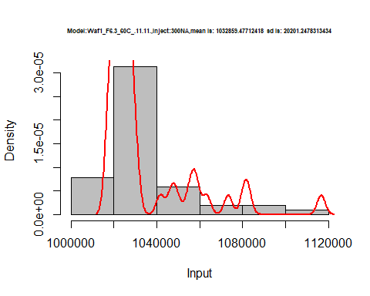

hist(d3_11.11$V4,  
 cex.main=0.5,  
 freq = FALSE,  
 main = paste('Model:Waf1_F6.3_60C_.11.11.,Inject:400NA,mean is:', mean(d3_11.11$V4),' sd is:', sd(d3_11.11$V4)),  
 xlab = "Input",  
 ylab = "Density",  
 col="grey")  
#plot density curve  
lines(density(d3_11.11$V4), # density plot  
 lwd = 2, # thickness of line  
 col = "red")

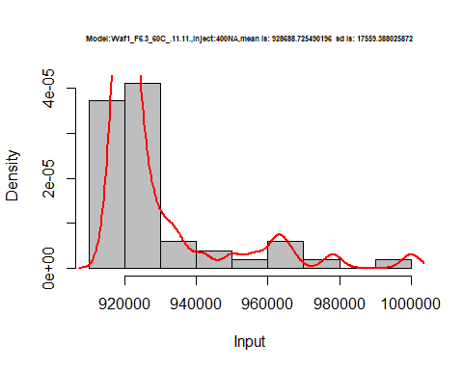

hist(d3_11.11$V5,  
 cex.main=0.5,  
 freq = FALSE,  
 main = paste('Model:Waf1_F6.3_60C_.11.11.,Inject:500NA,mean is:', mean(d3_11.11$V5),' sd is:', sd(d3_11.11$V5)),  
 xlab = "Input",  
 ylab = "Density",  
 col="grey")  
#plot density curve  
lines(density(d3_11.11$V5), # density plot  
 lwd = 2, # thickness of line  
 col = "red")

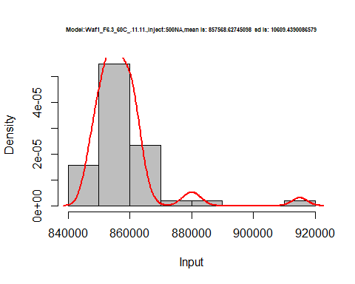

hist(d3_11.11$V6,  
 cex.main=0.5,  
 freq = FALSE,  
 main = paste('Model:Waf1_F6.3_60C_.11.11.,Inject:300NA,mean is:', mean(d3_11.11$V6),' sd is:', sd(d3_11.11$V6)),  
 xlab = "Input",  
 ylab = "Density",  
 col="grey")  
#plot density curve  
lines(density(d3_11.11$V6), # density plot  
 lwd = 2, # thickness of line  
 col = "red")

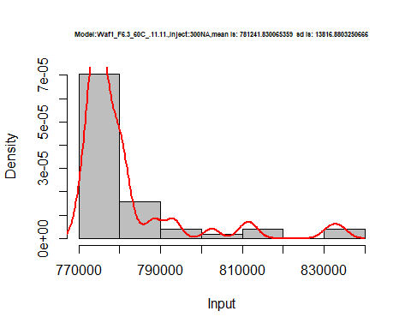

hist(d3_11.11$V7,  
 cex.main=0.5,  
 freq = FALSE,  
 main = paste('Model:Waf1_F6.3_60C_.11.11.,Inject:300NA,mean is:', mean(d3_11.11$V7),' sd is:', sd(d3_11.11$V7)),  
 xlab = "Input",  
 ylab = "Density",  
 col="grey")  
#plot density curve  
lines(density(d3_11.11$V7), # density plot  
 lwd = 2, # thickness of line  
 col = "red")

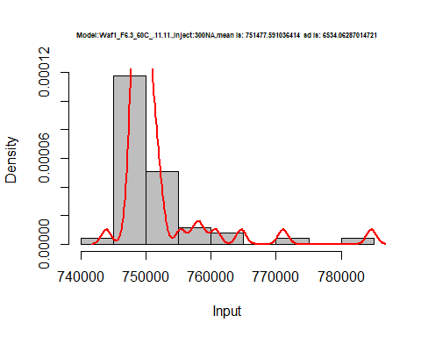

hist(d3_11.11$V8,  
 cex.main=0.5,  
 freq = FALSE,  
 main = paste('Model:Waf1_F6.3_60C_.11.11.,Inject:800NA,mean is:', mean(d3_11.11$V8),' sd is:', sd(d3_11.11$V8)),  
 xlab = "Input",  
 ylab = "Density",  
 col="grey")  
#plot density curve  
lines(density(d3_11.11$V8), # density plot  
 lwd = 2, # thickness of line  
 col = "red")

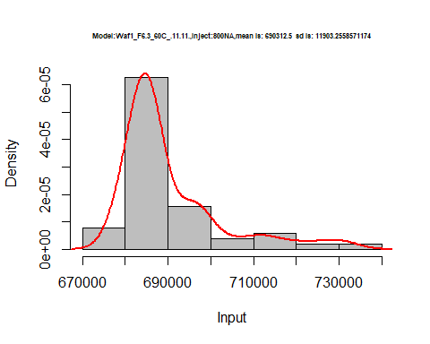

dens <- apply(d3_11.11, 2, density)  
plot('Model:Waf1_F3.5_60C_.11.11', xlim=range(sapply(dens, "[", "x")), ylim=range(sapply(dens, "[", "y")))

## Warning in xy.coords(x, y, xlabel, ylabel, log): NAs introduced by coercion

mapply(lines, dens, col=1:length(dens))

## $V1  
## NULL  
##   
## $V2  
## NULL  
##   
## $V3  
## NULL  
##   
## $V4  
## NULL  
##   
## $V5  
## NULL  
##   
## $V6  
## NULL  
##   
## $V7  
## NULL  
##   
## $V8  
## NULL

legend("topright", legend=names(dens), fill=1:length(dens))

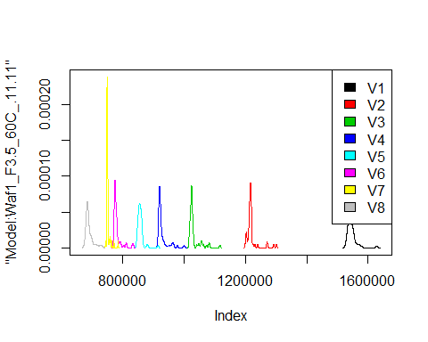

d4_11.11<-d_11.11[,c(25:32)]  
d4_11.11 <- head(d4_11.11,51)  
colnames(d4_11.11) <- c("V1", "V2","V3","V4","V5","V6","V7","V8")  
# head(d4_11.11)

hist(d4_11.11$V1,  
 cex.main=0.5,  
 freq = FALSE,  
 main = paste('Model:Waf1_F9.5_60C_.11.11,Inject:100NA,mean is:', mean(d4_11.11$V1),' sd is:', sd(d3_11.11$V1)),  
 xlab = "Input",  
 ylab = "Density",  
 col="grey")  
#plot density curve  
lines(density(d4_11.11$V1), # density plot  
 lwd = 2, # thickness of line  
 col = "red")

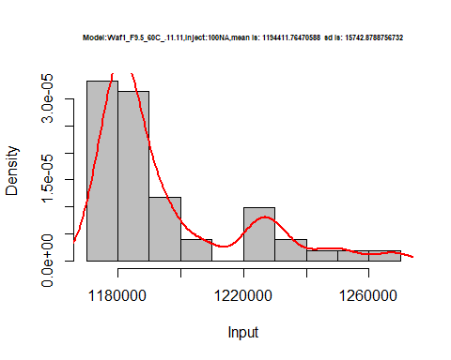

hist(d4_11.11$V2,  
 cex.main=0.5,  
 freq = FALSE,  
 main = paste('Model:Waf1_F9.5_60C_.11.11,Inject:200NA,mean is:', mean(d4_11.11$V2),' sd is:', sd(d3_11.11$V2)),  
 xlab = "Input",  
 ylab = "Density",  
 col="grey")  
#plot density curve  
lines(density(d4_11.11$V2), # density plot  
 lwd = 2, # thickness of line  
 col = "red")

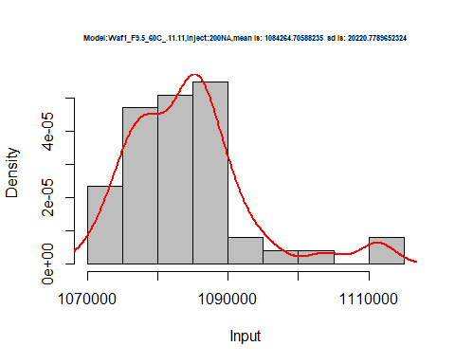

hist(d4_11.11$V3,  
 cex.main=0.5,  
 freq = FALSE,  
 main = paste('Model:Waf1_F9.5_60C_.11.11,Inject:300NA,mean is:', mean(d4_11.11$V3),' sd is:', sd(d3_11.11$V3)),  
 xlab = "Input",  
 ylab = "Density",  
 col="grey")  
#plot density curve  
lines(density(d4_11.11$V3), # density plot  
 lwd = 2, # thickness of line  
 col = "red")

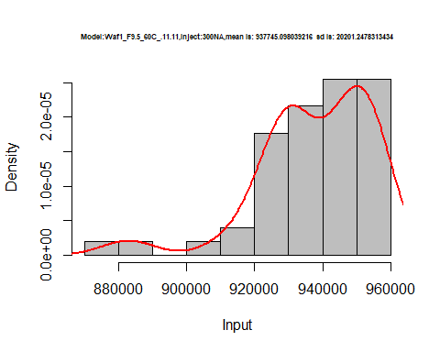

hist(d4_11.11$V4,  
 cex.main=0.5,  
 freq = FALSE,  
 main = paste('Model:Waf1_F9.5_60C_.11.11,Inject:400NA,mean is:', mean(d4_11.11$V4),' sd is:', sd(d3_11.11$V4)),  
 xlab = "Input",  
 ylab = "Density",  
 col="grey")  
#plot density curve  
lines(density(d4_11.11$V4), # density plot  
 lwd = 2, # thickness of line  
 col = "red")

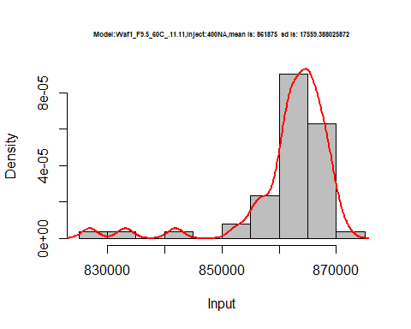

hist(d4_11.11$V5,  
 cex.main=0.5,  
 freq = FALSE,  
 main = paste('Model:Waf1_F9.5_60C_.11.11,Inject:500NA,mean is:', mean(d4_11.11$V5),' sd is:', sd(d3_11.11$V5)),  
 xlab = "Input",  
 ylab = "Density",  
 col="grey")  
#plot density curve  
lines(density(d4_11.11$V5), # density plot  
 lwd = 2, # thickness of line  
 col = "red")

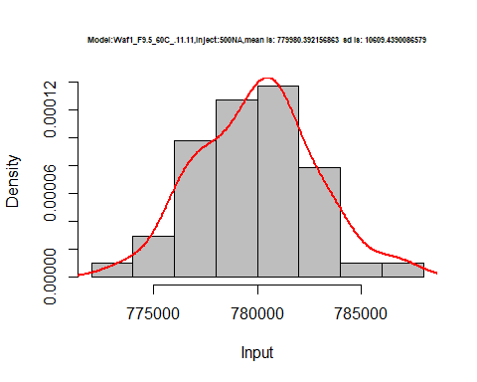

hist(d4_11.11$V6,  
 cex.main=0.5,  
 freq = FALSE,  
 main = paste('Model:Waf1_F9.5_60C_.11.11,Inject:600NA,mean is:', mean(d4_11.11$V6),' sd is:', sd(d3_11.11$V6)),  
 xlab = "Input",  
 ylab = "Density",  
 col="grey")  
#plot density curve  
lines(density(d4_11.11$V6), # density plot  
 lwd = 2, # thickness of line  
 col = "red")

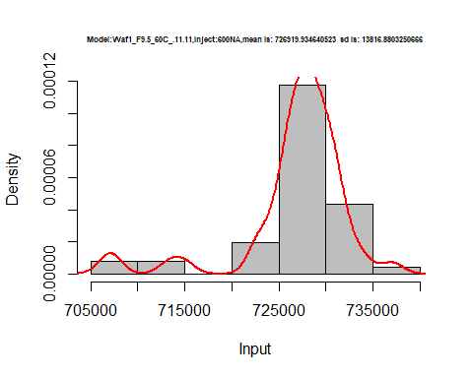

hist(d4_11.11$V7,  
 cex.main=0.5,  
 freq = FALSE,  
 main = paste('Model:Waf1_F9.5_60C_.11.11,Inject:700NA,mean is:', mean(d4_11.11$V7),' sd is:', sd(d3_11.11$V7)),  
 xlab = "Input",  
 ylab = "Density",  
 col="grey")  
#plot density curve  
lines(density(d4_11.11$V7), # density plot  
 lwd = 2, # thickness of line  
 col = "red")

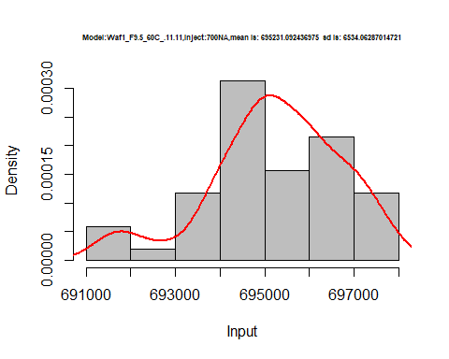

hist(d4_11.11$V8,  
 cex.main=0.5,  
 freq = FALSE,  
 main = paste('Model:Waf1_F9.5_60C_.11.11,Inject:800NA,mean is:', mean(d4_11.11$V8),' sd is:', sd(d3_11.11$V8)),  
 xlab = "Input",  
 ylab = "Density",  
 col="grey")  
#plot density curve  
lines(density(d4_11.11$V8), # density plot  
 lwd = 2, # thickness of line  
 col = "red")

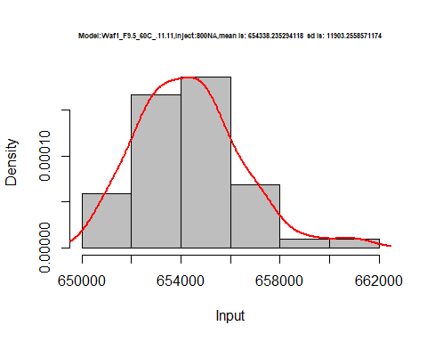

dens <- apply(d4_11.11, 2, density)  
plot('Model:Waf1_F9.5_60C_.11.11', xlim=range(sapply(dens, "[", "x")), ylim=range(sapply(dens, "[", "y")))

## Warning in xy.coords(x, y, xlabel, ylabel, log): NAs introduced by coercion

mapply(lines, dens, col=1:length(dens))

## $V1  
## NULL  
##   
## $V2  
## NULL  
##   
## $V3  
## NULL  
##   
## $V4  
## NULL  
##   
## $V5  
## NULL  
##   
## $V6  
## NULL  
##   
## $V7  
## NULL  
##   
## $V8  
## NULL

legend("topright", legend=names(dens), fill=1:length(dens))

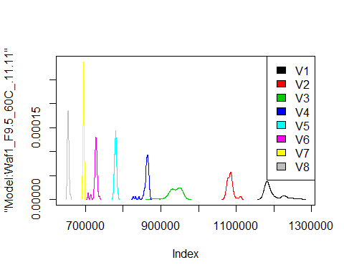

# Select columns whose names contains "12.12"  
d_12.12<-my_data %>% select(contains("12.12."))  
# head(d_12.12)

d1_12.12<-d_12.12[,c(1:8)]  
d1_12.12 <- head(d1_12.12,51)  
colnames(d1_12.12) <- c("V1", "V2","V3","V4","V5","V6","V7","V8")  
# head(d1_12.12)

hist(d1_12.12$V1,  
 cex.main=0.5,  
 freq = FALSE,  
 main = paste('Model:Waf1_F2.4_60C_.12.12,Inject:100NA,mean is:', mean(d1_12.12$V1),' sd is:', sd(d1_12.12$V1)),  
 xlab = "Input",  
 ylab = "Density",  
 col="grey")  
#plot density curve  
lines(density(d1_12.12$V1), # density plot  
 lwd = 2, # thickness of line  
 col = "red")

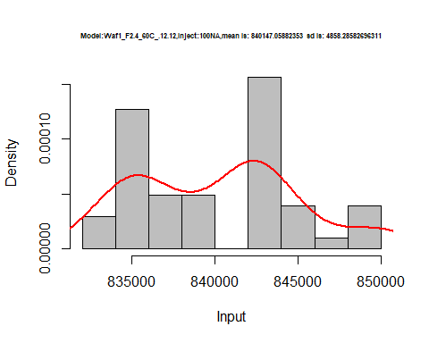

hist(d1_12.12$V2,  
 cex.main=0.5,  
 freq = FALSE,  
 main = paste('Model:Waf1_F2.4_60C_.12.12,Inject:200NA,mean is:', mean(d1_12.12$V2),' sd is:', sd(d1_12.12$V2)),  
 xlab = "Input",  
 ylab = "Density",  
 col="grey")  
#plot density curve  
lines(density(d1_12.12$V2), # density plot  
 lwd = 2, # thickness of line  
 col = "red")

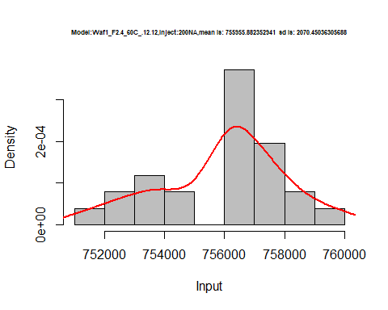

hist(d1_12.12$V3,  
 cex.main=0.5,  
 freq = FALSE,  
 main = paste('Model:Waf1_F2.4_60C_.12.12,Inject:300NA,mean is:', mean(d1_12.12$V3),' sd is:', sd(d1_12.12$V3)),  
 xlab = "Input",  
 ylab = "Density",  
 col="grey")  
#plot density curve  
lines(density(d1_12.12$V3), # density plot  
 lwd = 2, # thickness of line  
 col = "red")

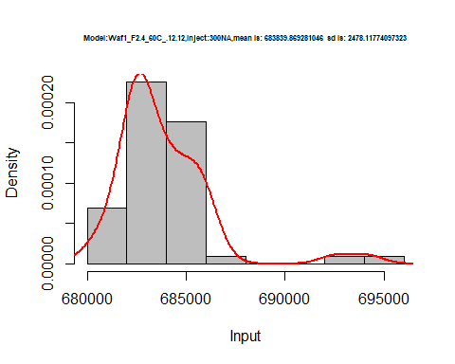

hist(d1_12.12$V4,  
 cex.main=0.5,  
 freq = FALSE,  
 main = paste('Model:Waf1_F2.4_60C_.12.12,Inject:400NA,mean is:', mean(d1_12.12$V4),' sd is:', sd(d1_12.12$V4)),  
 xlab = "Input",  
 ylab = "Density",  
 col="grey")  
#plot density curve  
lines(density(d1_12.12$V4), # density plot  
 lwd = 2, # thickness of line  
 col = "red")

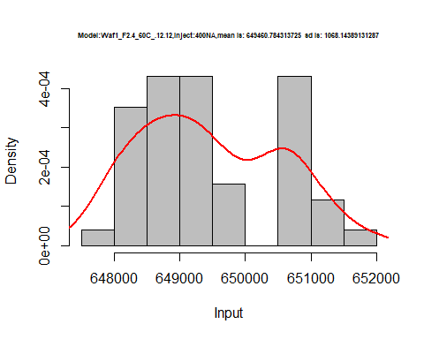

hist(d1_12.12$V5,  
 cex.main=0.5,  
 freq = FALSE,  
 main = paste('Model:Waf1_F2.4_60C_.12.12,Inject:500NA,mean is:', mean(d1_12.12$V5),' sd is:', sd(d1_12.12$V5)),  
 xlab = "Input",  
 ylab = "Density",  
 col="grey")  
#plot density curve  
lines(density(d1_12.12$V5), # density plot  
 lwd = 2, # thickness of line  
 col = "red")

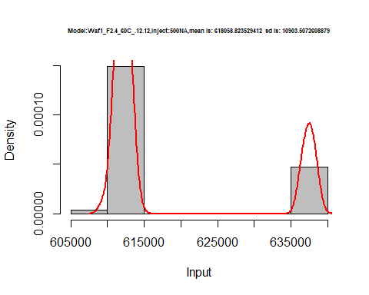

hist(d1_12.12$V6,  
 cex.main=0.5,  
 freq = FALSE,  
 main = paste('Model:Waf1_F2.4_60C_.12.12,Inject:600NA,mean is:', mean(d1_12.12$V6),' sd is:', sd(d1_12.12$V6)),  
 xlab = "Input",  
 ylab = "Density",  
 col="grey")  
#plot density curve  
lines(density(d1_12.12$V6), # density plot  
 lwd = 2, # thickness of line  
 col = "red")

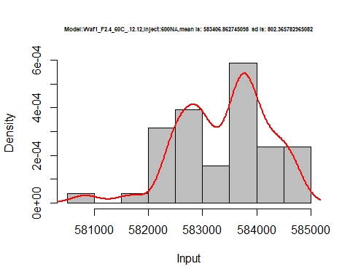

hist(d1_12.12$V7,  
 cex.main=0.5,  
 freq = FALSE,  
 main = paste('Model:Waf1_F2.4_60C_.12.12,Inject:700NA,mean is:', mean(d1_12.12$V7),' sd is:', sd(d1_12.12$V7)),  
 xlab = "Input",  
 ylab = "Density",  
 col="grey")  
#plot density curve  
lines(density(d1_12.12$V7), # density plot  
 lwd = 2, # thickness of line  
 col = "red")

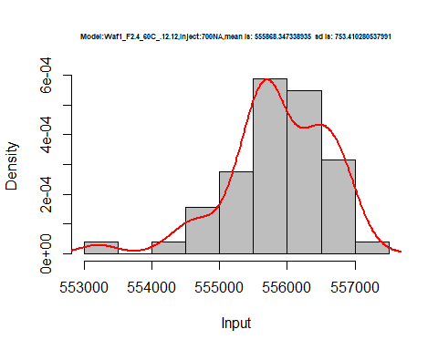

hist(d1_12.12$V8,  
 cex.main=0.5,  
 freq = FALSE,  
 main = paste('Model:Waf1_F2.4_60C_.12.12,Inject:100NA,mean is:', mean(d1_12.12$V8),' sd is:', sd(d1_12.12$V8)),  
 xlab = "Input",  
 ylab = "Density",  
 col="grey")  
#plot density curve  
lines(density(d1_12.12$V8), # density plot  
 lwd = 2, # thickness of line  
 col = "red")

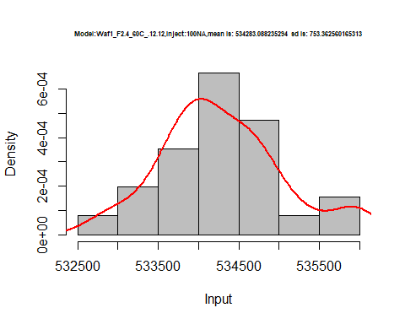

dens <- apply(d1_12.12, 2, density)  
plot('Model:Waf1_F2.4_60C_.12.12', xlim=range(sapply(dens, "[", "x")), ylim=range(sapply(dens, "[", "y")))

## Warning in xy.coords(x, y, xlabel, ylabel, log): NAs introduced by coercion

mapply(lines, dens, col=1:length(dens))

## $V1  
## NULL  
##   
## $V2  
## NULL  
##   
## $V3  
## NULL  
##   
## $V4  
## NULL  
##   
## $V5  
## NULL  
##   
## $V6  
## NULL  
##   
## $V7  
## NULL  
##   
## $V8  
## NULL

legend("topright", legend=names(dens), fill=1:length(dens))

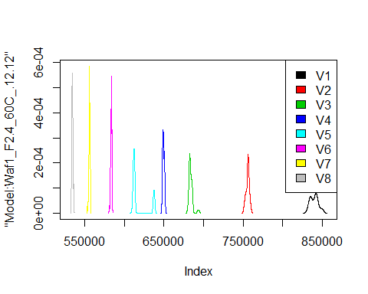

d2_12.12<-d_12.12[,c(9:16)]  
d2_12.12 <- head(d2_12.12,51)  
colnames(d2_12.12) <- c("V1", "V2","V3","V4","V5","V6","V7","V8")  
# head(d2_12.12)

hist(d2_12.12$V1,  
 cex.main=0.5,  
 freq = FALSE,  
 main = paste('Model:Waf1_F3.3_60C_.12.12,Inject:100NA,mean is:', mean(d2_12.12$V1),' sd is:', sd(d2_12.12$V1)),  
 xlab = "Input",  
 ylab = "Density",  
 col="grey")  
#plot density curve  
lines(density(d2_12.12$V1), # density plot  
 lwd = 2, # thickness of line  
 col = "red")

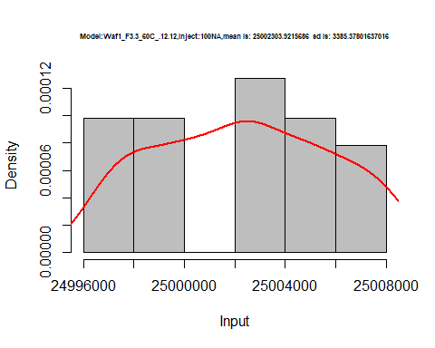

hist(d2_12.12$V2,  
 cex.main=0.5,  
 freq = FALSE,  
 main = paste('Model:Waf1_F3.3_60C_.12.12,Inject:200NA,mean is:', mean(d2_12.12$V2),' sd is:', sd(d2_12.12$V2)),  
 xlab = "Input",  
 ylab = "Density",  
 col="grey")  
#plot density curve  
lines(density(d2_12.12$V2), # density plot  
 lwd = 2, # thickness of line  
 col = "red")

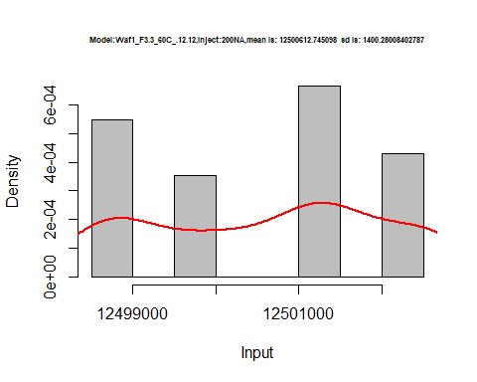

hist(d2_12.12$V3,  
 cex.main=0.5,  
 freq = FALSE,  
 main = paste('Model:Waf1_F3.3_60C_.12.12,Inject:300NA,mean is:', mean(d2_12.12$V3),' sd is:', sd(d2_12.12$V3)),  
 xlab = "Input",  
 ylab = "Density",  
 col="grey")  
#plot density curve  
lines(density(d2_12.12$V3), # density plot  
 lwd = 2, # thickness of line  
 col = "red")

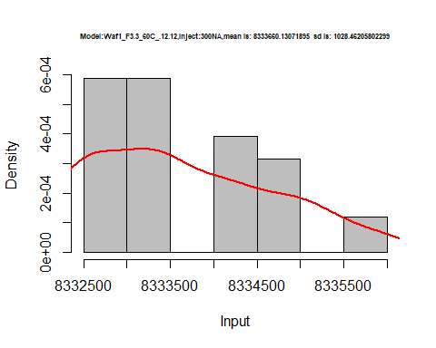

hist(d2_12.12$V4,  
 cex.main=0.5,  
 freq = FALSE,  
 main = paste('Model:Waf1_F3.3_60C_.12.12,Inject:400NA,mean is:', mean(d2_12.12$V4),' sd is:', sd(d2_12.12$V4)),  
 xlab = "Input",  
 ylab = "Density",  
 col="grey")  
#plot density curve  
lines(density(d2_12.12$V4), # density plot  
 lwd = 2, # thickness of line  
 col = "red")

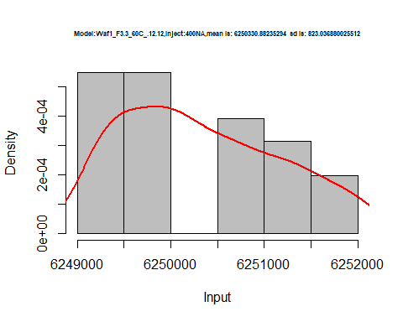

hist(d2_12.12$V5,  
 cex.main=0.5,  
 freq = FALSE,  
 main = paste('Model:Waf1_F3.3_60C_.12.12,Inject:500NA,mean is:', mean(d2_12.12$V5),' sd is:', sd(d2_12.12$V5)),  
 xlab = "Input",  
 ylab = "Density",  
 col="grey")  
#plot density curve  
lines(density(d2_12.12$V5), # density plot  
 lwd = 2, # thickness of line  
 col = "red")

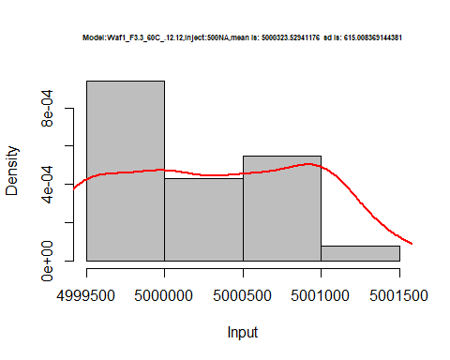

hist(d2_12.12$V6,  
 cex.main=0.5,  
 freq = FALSE,  
 main = paste('Model:Waf1_F3.3_60C_.12.12,Inject:600NA,mean is:', mean(d2_12.12$V6),' sd is:', sd(d2_12.12$V6)),  
 xlab = "Input",  
 ylab = "Density",  
 col="grey")  
#plot density curve  
lines(density(d2_12.12$V6), # density plot  
 lwd = 2, # thickness of line  
 col = "red")

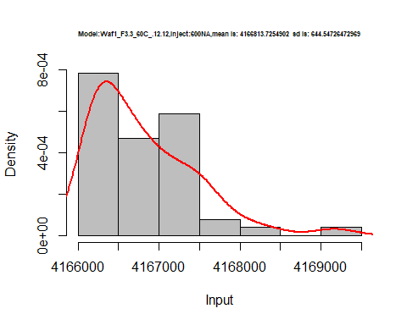

hist(d2_12.12$V7,  
 cex.main=0.5,  
 freq = FALSE,  
 main = paste('Model:Waf1_F3.3_60C_.12.12,Inject:700NA,mean is:', mean(d2_12.12$V7),' sd is:', sd(d2_12.12$V7)),  
 xlab = "Input",  
 ylab = "Density",  
 col="grey")  
#plot density curve  
lines(density(d2_12.12$V7), # density plot  
 lwd = 2, # thickness of line  
 col = "red")

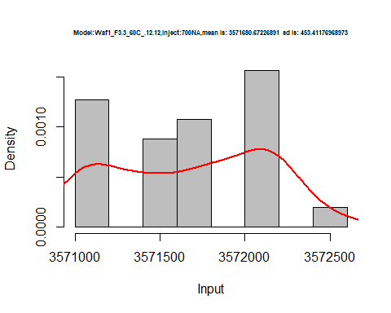

hist(d2_12.12$V8,  
 cex.main=0.5,  
 freq = FALSE,  
 main = paste('Model:Waf1_F3.3_60C_.12.12,Inject:100NA,mean is:', mean(d2_12.12$V8),' sd is:', sd(d2_12.12$V8)),  
 xlab = "Input",  
 ylab = "Density",  
 col="grey")  
#plot density curve  
lines(density(d2_12.12$V8), # density plot  
 lwd = 2, # thickness of line  
 col = "red")

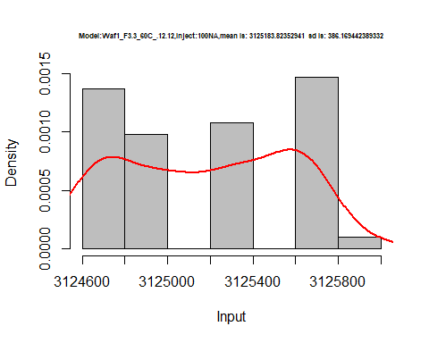

dens <- apply(d2_12.12, 2, density)  
plot('Model:Waf1_F3.3_60C_.12.12', xlim=range(sapply(dens, "[", "x")), ylim=range(sapply(dens, "[", "y")))

## Warning in xy.coords(x, y, xlabel, ylabel, log): NAs introduced by coercion

mapply(lines, dens, col=1:length(dens))

## $V1  
## NULL  
##   
## $V2  
## NULL  
##   
## $V3  
## NULL  
##   
## $V4  
## NULL  
##   
## $V5  
## NULL  
##   
## $V6  
## NULL  
##   
## $V7  
## NULL  
##   
## $V8  
## NULL

legend("topright", legend=names(dens), fill=1:length(dens))

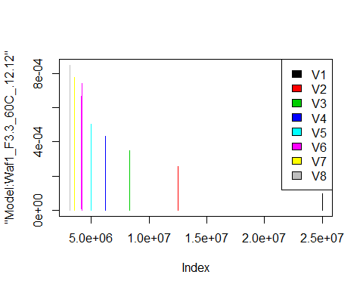

d3_12.12<-d_12.12[,c(17:24)]  
d3_12.12 <- head(d3_12.12,51)  
colnames(d3_12.12) <- c("V1", "V2","V3","V4","V5","V6","V7","V8")  
# head(d3_12.12)

hist(d3_12.12$V1,  
 cex.main=0.5,  
 freq = FALSE,  
 main = paste('Model:Waf1_F5.3_60C_12.12,Inject:100NA,mean is:', mean(d3_12.12$V1),' sd is:', sd(d3_12.12$V1)),  
 xlab = "Input",  
 ylab = "Density",  
 col="grey")  
#plot density curve  
lines(density(d3_12.12$V1), # density plot  
 lwd = 2, # thickness of line  
 col = "red")

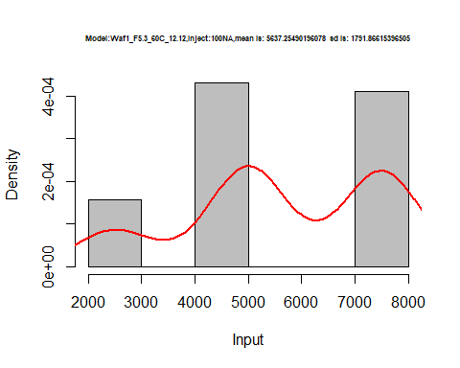

hist(d3_12.12$V2,  
 cex.main=0.5,  
 freq = FALSE,  
 main = paste('Model:Waf1_F5.3_60C_12.12,Inject:200NA,mean is:', mean(d3_12.12$V2),' sd is:', sd(d3_12.12$V2)),  
 xlab = "Input",  
 ylab = "Density",  
 col="grey")  
#plot density curve  
lines(density(d3_12.12$V2), # density plot  
 lwd = 2, # thickness of line  
 col = "red")

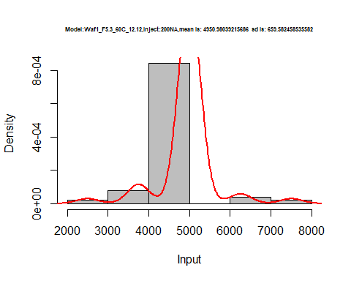

hist(d3_12.12$V3,  
 cex.main=0.5,  
 freq = FALSE,  
 main = paste('Model:Waf1_F5.3_60C_12.12,Inject:300NA,mean is:', mean(d3_12.12$V3),' sd is:', sd(d3_12.12$V3)),  
 xlab = "Input",  
 ylab = "Density",  
 col="grey")  
#plot density curve  
lines(density(d3_12.12$V3), # density plot  
 lwd = 2, # thickness of line  
 col = "red")

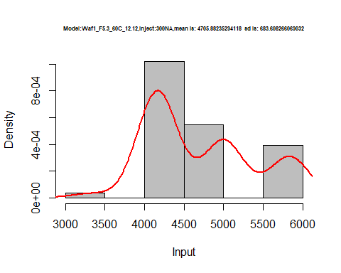

hist(d3_12.12$V4,  
 cex.main=0.5,  
 freq = FALSE,  
 main = paste('Model:Waf1_F5.3_60C_12.12,Inject:400NA,mean is:', mean(d3_12.12$V4),' sd is:', sd(d3_12.12$V4)),  
 xlab = "Input",  
 ylab = "Density",  
 col="grey")  
#plot density curve  
lines(density(d3_12.12$V4), # density plot  
 lwd = 2, # thickness of line  
 col = "red")

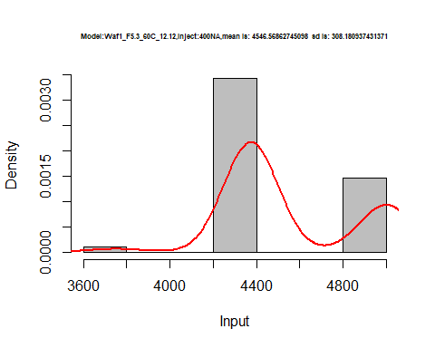

hist(d3_12.12$V5,  
 cex.main=0.5,  
 freq = FALSE,  
 main = paste('Model:Waf1_F5.3_60C_12.12,Inject:500NA,mean is:', mean(d3_12.12$V5),' sd is:', sd(d3_12.12$V5)),  
 xlab = "Input",  
 ylab = "Density",  
 col="grey")  
#plot density curve  
lines(density(d3_12.12$V5), # density plot  
 lwd = 2, # thickness of line  
 col = "red")

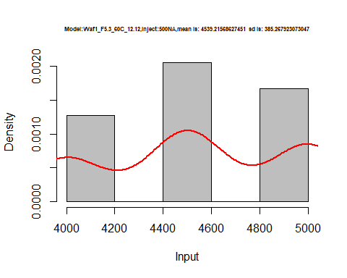

hist(d3_12.12$V6,  
 cex.main=0.5,  
 freq = FALSE,  
 main = paste('Model:Waf1_F5.3_60C_12.12,Inject:600NA,mean is:', mean(d3_12.12$V6),' sd is:', sd(d3_12.12$V6)),  
 xlab = "Input",  
 ylab = "Density",  
 col="grey")  
#plot density curve  
lines(density(d3_12.12$V6), # density plot  
 lwd = 2, # thickness of line  
 col = "red")

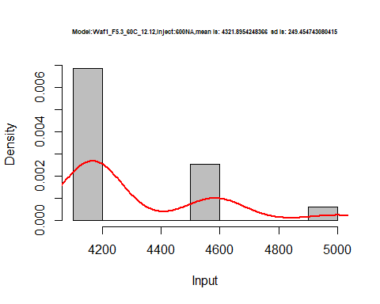

hist(d3_12.12$V7,  
 cex.main=0.5,  
 freq = FALSE,  
 main = paste('Model:Waf1_F5.3_60C_12.12,Inject:700NA,mean is:', mean(d3_12.12$V7),' sd is:', sd(d3_12.12$V7)),  
 xlab = "Input",  
 ylab = "Density",  
 col="grey")  
#plot density curve  
lines(density(d3_12.12$V7), # density plot  
 lwd = 2, # thickness of line  
 col = "red")

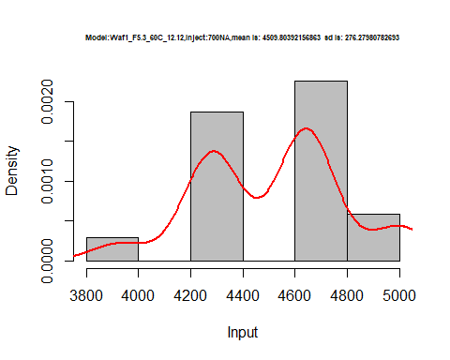

hist(d3_12.12$V8,  
 cex.main=0.5,  
 freq = FALSE,  
 main = paste('Model:Waf1_F5.3_60C_12.12,Inject:800NA,mean is:', mean(d3_12.12$V8),' sd is:', sd(d3_12.12$V8)),  
 xlab = "Input",  
 ylab = "Density",  
 col="grey")  
#plot density curve  
lines(density(d3_12.12$V8), # density plot  
 lwd = 2, # thickness of line  
 col = "red")

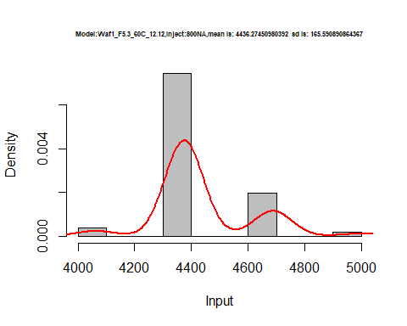

dens <- apply(d3_12.12, 2, density)  
plot('Model:Waf1_F5.3_60C_12.12', xlim=range(sapply(dens, "[", "x")), ylim=range(sapply(dens, "[", "y")))

## Warning in xy.coords(x, y, xlabel, ylabel, log): NAs introduced by coercion

mapply(lines, dens, col=1:length(dens))

## $V1  
## NULL  
##   
## $V2  
## NULL  
##   
## $V3  
## NULL  
##   
## $V4  
## NULL  
##   
## $V5  
## NULL  
##   
## $V6  
## NULL  
##   
## $V7  
## NULL  
##   
## $V8  
## NULL

legend("topright", legend=names(dens), fill=1:length(dens))

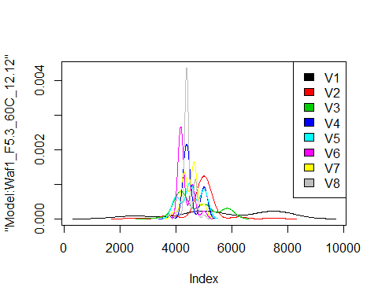

d4_12.12<-d_12.12[,c(25:32)]  
d4_12.12 <- head(d4_12.12,51)  
colnames(d4_12.12) <- c("V1", "V2","V3","V4","V5","V6","V7","V8")  
# head(d4_12.12)

hist(d4_12.12$V1,  
 cex.main=0.5,  
 freq = FALSE,  
 main = paste('Model:Waf1_F9.5_60C_.12.12,Inject:800NA,mean is:', mean(d4_12.12$V1),' sd is:', sd(d4_12.12$V1)),  
 xlab = "Input",  
 ylab = "Density",  
 col="grey")  
#plot density curve  
lines(density(d4_12.12$V1), # density plot  
 lwd = 2, # thickness of line  
 col = "red")

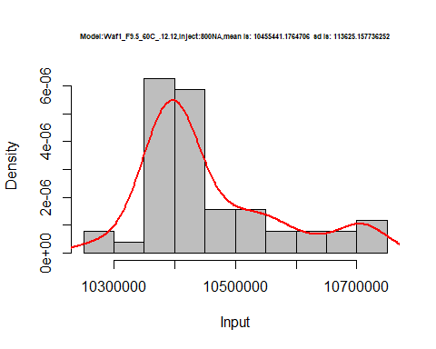

hist(d4_12.12$V3,  
 cex.main=0.5,  
 freq = FALSE,  
 main = paste('Model:Waf1_F9.5_60C_.12.12,Inject:300NA,mean is:', mean(d4_12.12$V3),' sd is:', sd(d4_12.12$V3)),  
 xlab = "Input",  
 ylab = "Density",  
 col="grey")  
#plot density curve  
lines(density(d4_12.12$V3), # density plot  
 lwd = 2, # thickness of line  
 col = "red")

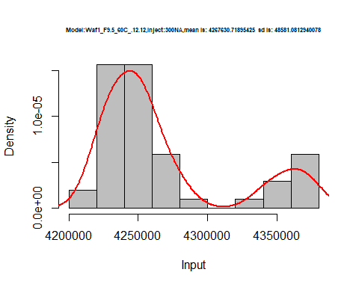

hist(d4_12.12$V4,  
 cex.main=0.5,  
 freq = FALSE,  
 main = paste('Model:Waf1_F9.5_60C_.12.12,Inject:400NA,mean is:', mean(d4_12.12$V4),' sd is:', sd(d4_12.12$V4)),  
 xlab = "Input",  
 ylab = "Density",  
 col="grey")  
#plot density curve  
lines(density(d4_12.12$V4), # density plot  
 lwd = 2, # thickness of line  
 col = "red")

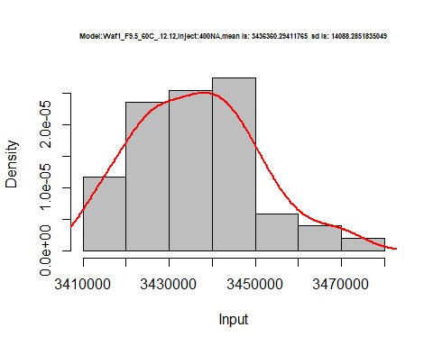

hist(d4_12.12$V5,  
 cex.main=0.5,  
 freq = FALSE,  
 main = paste('Model:Waf1_F9.5_60C_.12.12,Inject:500NA,mean is:', mean(d4_12.12$V5),' sd is:', sd(d4_12.12$V5)),  
 xlab = "Input",  
 ylab = "Density",  
 col="grey")  
#plot density curve  
lines(density(d4_12.12$V5), # density plot  
 lwd = 2, # thickness of line  
 col = "red")

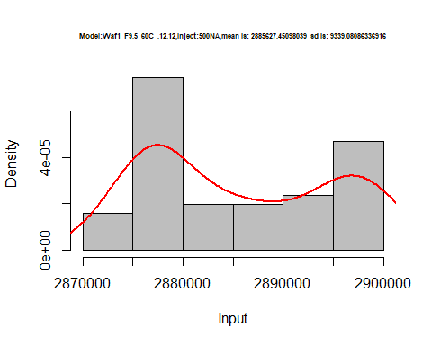

hist(d4_12.12$V6,  
 cex.main=0.5,  
 freq = FALSE,  
 main = paste('Model:Waf1_F9.5_60C_.12.12,Inject:600NA,mean is:', mean(d4_12.12$V6),' sd is:', sd(d4_12.12$V6)),  
 xlab = "Input",  
 ylab = "Density",  
 col="grey")  
#plot density curve  
lines(density(d4_12.12$V6), # density plot  
 lwd = 2, # thickness of line  
 col = "red")

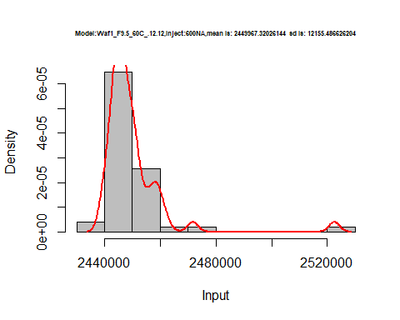

hist(d4_12.12$V7,  
 cex.main=0.5,  
 freq = FALSE,  
 main = paste('Model:Waf1_F9.5_60C_.12.12,Inject:700NA,mean is:', mean(d4_12.12$V7),' sd is:', sd(d4_12.12$V7)),  
 xlab = "Input",  
 ylab = "Density",  
 col="grey")  
#plot density curve  
lines(density(d4_12.12$V7), # density plot  
 lwd = 2, # thickness of line  
 col = "red")

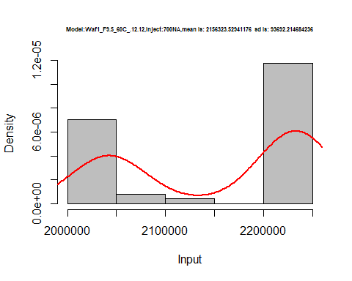

dens <- apply(d4_12.12, 2, density)  
plot('Model:Waf1_F5.3_60C_12.12', xlim=range(sapply(dens, "[", "x")), ylim=range(sapply(dens, "[", "y")))

## Warning in xy.coords(x, y, xlabel, ylabel, log): NAs introduced by coercion

mapply(lines, dens, col=1:length(dens))

## $V1  
## NULL  
##   
## $V2  
## NULL  
##   
## $V3  
## NULL  
##   
## $V4  
## NULL  
##   
## $V5  
## NULL  
##   
## $V6  
## NULL  
##   
## $V7  
## NULL  
##   
## $V8  
## NULL

legend("topright", legend=names(dens), fill=1:length(dens))

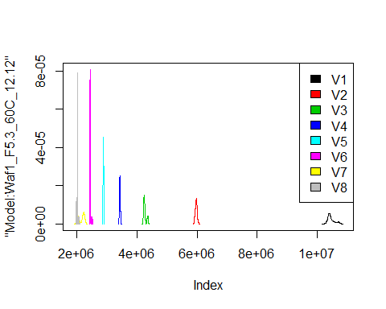

# Select columns whose names contains "13.13"  
d_13.13<-my_data %>% select(contains("13.13."))  
# head(d_13.13)

d1_13.13<-d_13.13[,c(1:8)]  
d1_13.13 <- head(d1_13.13,51)  
colnames(d1_13.13) <- c("V1", "V2","V3","V4","V5","V6","V7","V8")  
# head(d1_13.13)

hist(d1_13.13$V1,  
 cex.main=0.5,  
 freq = FALSE,  
 main = paste('Model:Waf1_F2.3_60C_.13.13,Inject:100NA,mean is:', mean(d1_13.13$V1),' sd is:', sd(d1_13.13$V1)),  
 xlab = "Input",  
 ylab = "Density",  
 col="grey")  
#plot density curve  
lines(density(d1_13.13$V1), # density plot  
 lwd = 2, # thickness of line  
 col = "red")

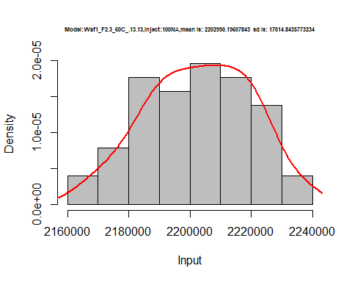

hist(d1_13.13$V2,  
 cex.main=0.5,  
 freq = FALSE,  
 main = paste('Model:Waf1_F2.3_60C_.13.13,Inject:200NA,mean is:', mean(d1_13.13$V2),' sd is:', sd(d1_13.13$V2)),  
 xlab = "Input",  
 ylab = "Density",  
 col="grey")  
#plot density curve  
lines(density(d1_13.13$V2), # density plot  
 lwd = 2, # thickness of line  
 col = "red")

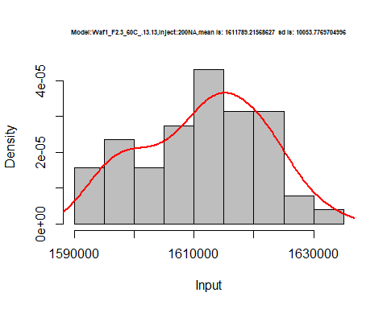

hist(d1_13.13$V3,  
 cex.main=0.5,  
 freq = FALSE,  
 main = paste('Model:Waf1_F2.3_60C_.13.13,Inject:300NA,mean is:', mean(d1_13.13$V3),' sd is:', sd(d1_13.13$V3)),  
 xlab = "Input",  
 ylab = "Density",  
 col="grey")  
#plot density curve  
lines(density(d1_13.13$V3), # density plot  
 lwd = 2, # thickness of line  
 col = "red")

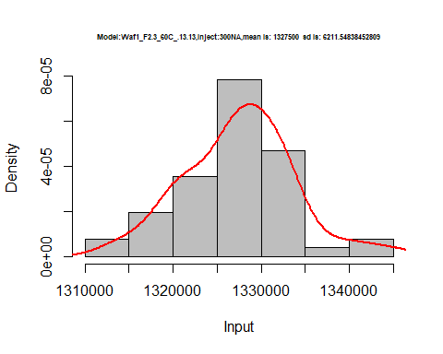

hist(d1_13.13$V4,  
 cex.main=0.5,  
 freq = FALSE,  
 main = paste('Model:Waf1_F2.3_60C_.13.13,Inject:400NA,mean is:', mean(d1_13.13$V4),' sd is:', sd(d1_13.13$V4)),  
 xlab = "Input",  
 ylab = "Density",  
 col="grey")  
#plot density curve  
lines(density(d1_13.13$V4), # density plot  
 lwd = 2, # thickness of line  
 col = "red")

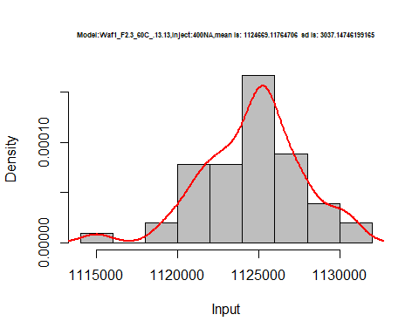

hist(d1_13.13$V5,  
 cex.main=0.5,  
 freq = FALSE,  
 main = paste('Model:Waf1_F2.3_60C_.13.13,Inject:500NA,mean is:', mean(d1_13.13$V5),' sd is:', sd(d1_13.13$V5)),  
 xlab = "Input",  
 ylab = "Density",  
 col="grey")  
#plot density curve  
lines(density(d1_13.13$V5), # density plot  
 lwd = 2, # thickness of line  
 col = "red")

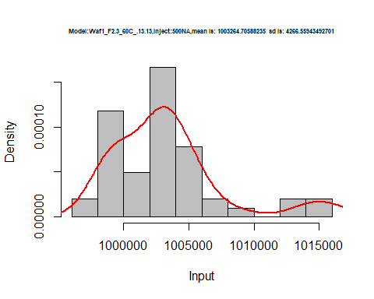

hist(d1_13.13$V6,  
 cex.main=0.5,  
 freq = FALSE,  
 main = paste('Model:Waf1_F2.3_60C_.13.13,Inject:600NA,mean is:', mean(d1_13.13$V6),' sd is:', sd(d1_13.13$V6)),  
 xlab = "Input",  
 ylab = "Density",  
 col="grey")  
#plot density curve  
lines(density(d1_13.13$V6), # density plot  
 lwd = 2, # thickness of line  
 col = "red")

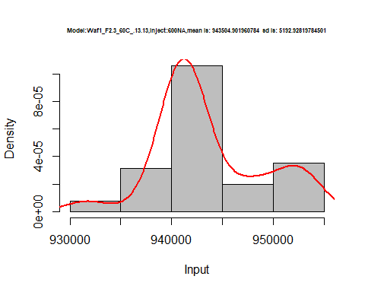

hist(d1_13.13$V7,  
 cex.main=0.5,  
 freq = FALSE,  
 main = paste('Model:Waf1_F2.3_60C_.13.13,Inject:700NA,mean is:', mean(d1_13.13$V7),' sd is:', sd(d1_13.13$V7)),  
 xlab = "Input",  
 ylab = "Density",  
 col="grey")  
#plot density curve  
lines(density(d1_13.13$V7), # density plot  
 lwd = 2, # thickness of line  
 col = "red")

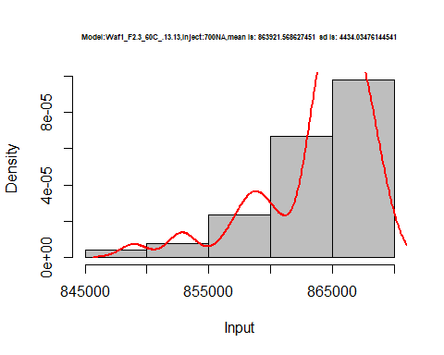

hist(d1_13.13$V8,  
 cex.main=0.5,  
 freq = FALSE,  
 main = paste('Model:Waf1_F2.3_60C_.13.13,Inject:800NA,mean is:', mean(d1_13.13$V8),' sd is:', sd(d1_13.13$V8)),  
 xlab = "Input",  
 ylab = "Density",  
 col="grey")  
#plot density curve  
lines(density(d1_13.13$V8), # density plot  
 lwd = 2, # thickness of line  
 col = "red")

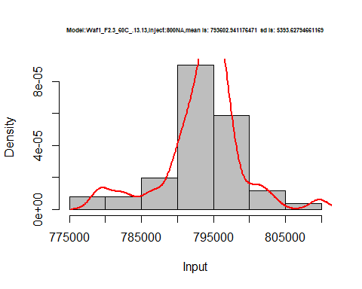

dens <- apply(d1_13.13, 2, density)  
plot('Model:Waf1_F5.3_60C_12.12', xlim=range(sapply(dens, "[", "x")), ylim=range(sapply(dens, "[", "y")))

## Warning in xy.coords(x, y, xlabel, ylabel, log): NAs introduced by coercion

mapply(lines, dens, col=1:length(dens))

## $V1  
## NULL  
##   
## $V2  
## NULL  
##   
## $V3  
## NULL  
##   
## $V4  
## NULL  
##   
## $V5  
## NULL  
##   
## $V6  
## NULL  
##   
## $V7  
## NULL  
##   
## $V8  
## NULL

legend("topright", legend=names(dens), fill=1:length(dens))

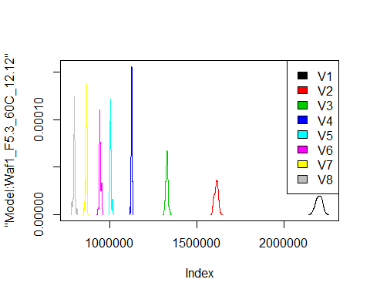

d2_13.13<-d_13.13[,c(9:16)]  
d2_13.13 <- head(d2_13.13,51)  
colnames(d2_13.13) <- c("V1", "V2","V3","V4","V5","V6","V7","V8")  
# head(d2_13.13)

hist(d2_13.13$V1,  
 cex.main=0.5,  
 freq = FALSE,  
 main = paste('Model:Waf1_F2.5_60C_.13.13,Inject:100NA,mean is:', mean(d2_13.13$V1),' sd is:', sd(d1_13.13$V1)),  
 xlab = "Input",  
 ylab = "Density",  
 col="grey")  
#plot density curve  
lines(density(d2_13.13$V1), # density plot  
 lwd = 2, # thickness of line  
 col = "red")

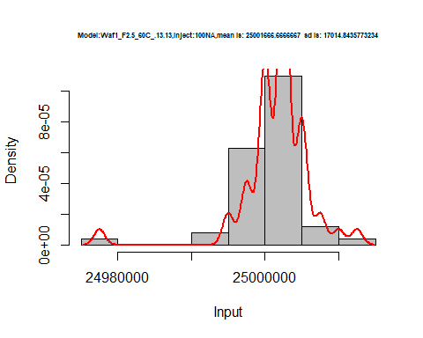

hist(d2_13.13$V2,  
 cex.main=0.5,  
 freq = FALSE,  
 main = paste('Model:Waf1_F2.5_60C_.13.13,Inject:200NA,mean is:', mean(d2_13.13$V2),' sd is:', sd(d2_13.13$V2)),  
 xlab = "Input",  
 ylab = "Density",  
 col="grey")  
#plot density curve  
lines(density(d2_13.13$V2), # density plot  
 lwd = 2, # thickness of line  
 col = "red")

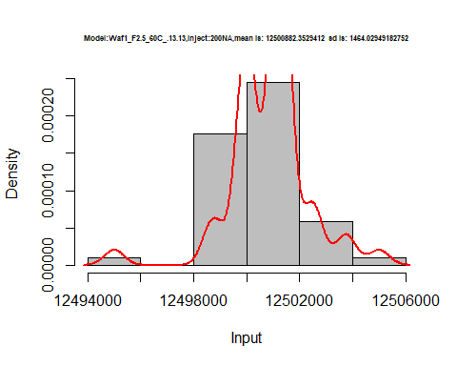

hist(d2_13.13$V3,  
 cex.main=0.5,  
 freq = FALSE,  
 main = paste('Model:Waf1_F2.5_60C_.13.13,Inject:300NA,mean is:', mean(d2_13.13$V3),' sd is:', sd(d2_13.13$V3)),  
 xlab = "Input",  
 ylab = "Density",  
 col="grey")  
#plot density curve  
lines(density(d2_13.13$V3), # density plot  
 lwd = 2, # thickness of line  
 col = "red")

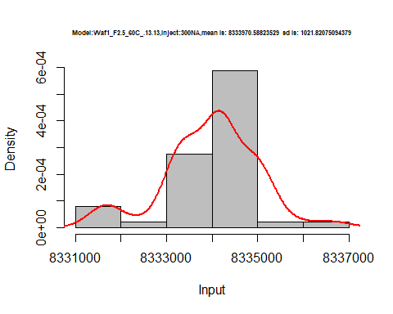

hist(d2_13.13$V4,  
 cex.main=0.5,  
 freq = FALSE,  
 main = paste('Model:Waf1_F2.5_60C_.13.13,Inject:400NA,mean is:', mean(d2_13.13$V4),' sd is:', sd(d2_13.13$V4)),  
 xlab = "Input",  
 ylab = "Density",  
 col="grey")  
#plot density curve  
lines(density(d2_13.13$V4), # density plot  
 lwd = 2, # thickness of line  
 col = "red")

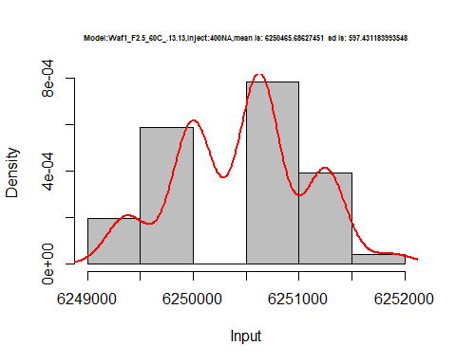

hist(d2_13.13$V5,  
 cex.main=0.5,  
 freq = FALSE,  
 main = paste('Model:Waf1_F2.5_60C_.13.13,Inject:500NA,mean is:', mean(d2_13.13$V5),' sd is:', sd(d2_13.13$V5)),  
 xlab = "Input",  
 ylab = "Density",  
 col="grey")  
#plot density curve  
lines(density(d2_13.13$V5), # density plot  
 lwd = 2, # thickness of line  
 col = "red")

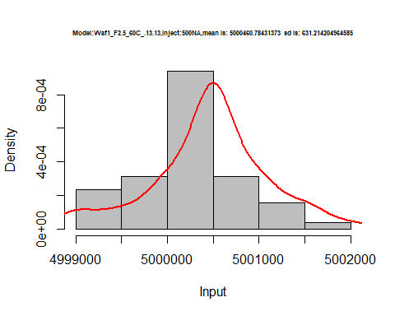

hist(d2_13.13$V6,  
 cex.main=0.5,  
 freq = FALSE,  
 main = paste('Model:Waf1_F2.5_60C_.13.13,Inject:600NA,mean is:', mean(d2_13.13$V6),' sd is:', sd(d2_13.13$V6)),  
 xlab = "Input",  
 ylab = "Density",  
 col="grey")  
#plot density curve  
lines(density(d2_13.13$V6), # density plot  
 lwd = 2, # thickness of line  
 col = "red")

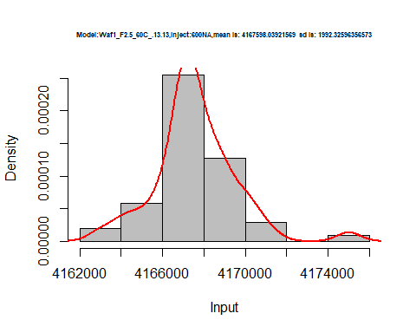

hist(d2_13.13$V7,  
 cex.main=0.5,  
 freq = FALSE,  
 main = paste('Model:Waf1_F2.5_60C_.13.13,Inject:700NA,mean is:', mean(d2_13.13$V7),' sd is:', sd(d2_13.13$V7)),  
 xlab = "Input",  
 ylab = "Density",  
 col="grey")  
#plot density curve  
lines(density(d2_13.13$V7), # density plot  
 lwd = 2, # thickness of line  
 col = "red")

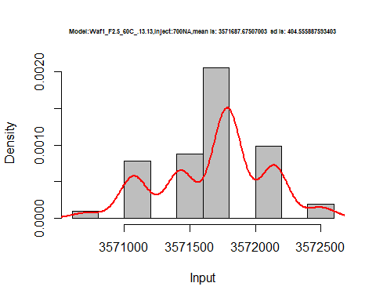

hist(d2_13.13$V8,  
 cex.main=0.5,  
 freq = FALSE,  
 main = paste('Model:Waf1_F2.5_60C_.13.13,Inject:800NA,mean is:', mean(d2_13.13$V8),' sd is:', sd(d2_13.13$V8)),  
 xlab = "Input",  
 ylab = "Density",  
 col="grey")  
#plot density curve  
lines(density(d2_13.13$V8), # density plot  
 lwd = 2, # thickness of line  
 col = "red")

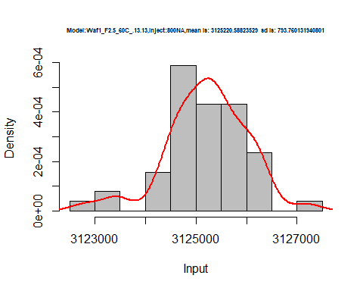

dens <- apply(d2_13.13, 2, density)  
plot('Model:Waf1_F2.5_60C_13.13', xlim=range(sapply(dens, "[", "x")), ylim=range(sapply(dens, "[", "y")))

## Warning in xy.coords(x, y, xlabel, ylabel, log): NAs introduced by coercion

mapply(lines, dens, col=1:length(dens))

## $V1  
## NULL  
##   
## $V2  
## NULL  
##   
## $V3  
## NULL  
##   
## $V4  
## NULL  
##   
## $V5  
## NULL  
##   
## $V6  
## NULL  
##   
## $V7  
## NULL  
##   
## $V8  
## NULL

legend("topright", legend=names(dens), fill=1:length(dens))

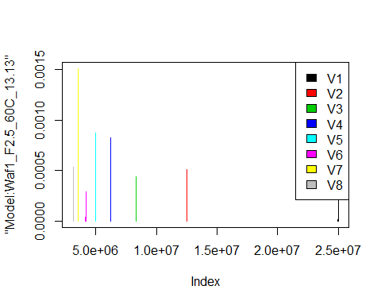

d3_13.13<-d_13.13[,c(17:24)]  
d3_13.13 <- head(d3_13.13,51)  
colnames(d3_13.13) <- c("V1", "V2","V3","V4","V5","V6","V7","V8")  
# head(d3_13.13)

hist(d3_13.13$V1,  
 cex.main=0.5,  
 freq = FALSE,  
 main = paste('Model:Waf1_F5.3_60C_.13.13.,Inject:100NA,mean is:', mean(d3_13.13$V1),' sd is:', sd(d3_13.13$V1)),  
 xlab = "Input",  
 ylab = "Density",  
 col="grey")  
#plot density curve  
lines(density(d3_13.13$V1), # density plot  
 lwd = 2, # thickness of line  
 col = "red")

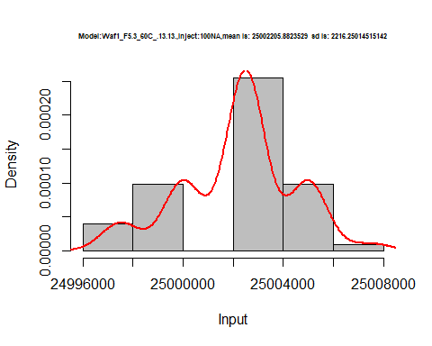

hist(d3_13.13$V2,  
 cex.main=0.5,  
 freq = FALSE,  
 main = paste('Model:Waf1_F5.3_60C_.13.13.,Inject:200NA,mean is:', mean(d3_13.13$V2),' sd is:', sd(d3_13.13$V2)),  
 xlab = "Input",  
 ylab = "Density",  
 col="grey")  
#plot density curve  
lines(density(d3_13.13$V2), # density plot  
 lwd = 2, # thickness of line  
 col = "red")

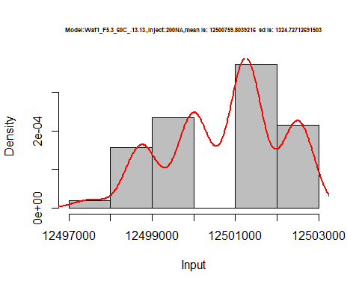

hist(d3_13.13$V3,  
 cex.main=0.5,  
 freq = FALSE,  
 main = paste('Model:Waf1_F5.3_60C_.13.13.,Inject:300NA,mean is:', mean(d3_13.13$V3),' sd is:', sd(d3_13.13$V3)),  
 xlab = "Input",  
 ylab = "Density",  
 col="grey")  
#plot density curve  
lines(density(d3_13.13$V3), # density plot  
 lwd = 2, # thickness of line  
 col = "red")

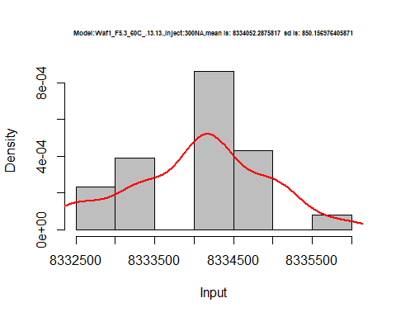

hist(d3_13.13$V4,  
 cex.main=0.5,  
 freq = FALSE,  
 main = paste('Model:Waf1_F5.3_60C_.13.13.,Inject:400NA,mean is:', mean(d3_13.13$V4),' sd is:', sd(d3_13.13$V4)),  
 xlab = "Input",  
 ylab = "Density",  
 col="grey")  
#plot density curve  
lines(density(d3_13.13$V4), # density plot  
 lwd = 2, # thickness of line  
 col = "red")

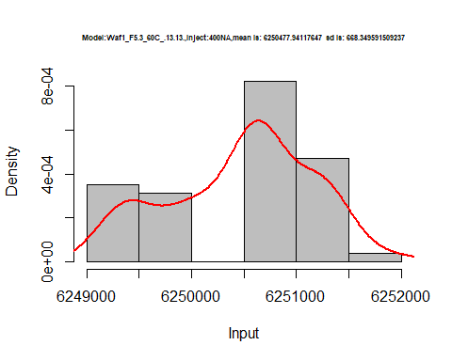

hist(d3_13.13$V5,  
 cex.main=0.5,  
 freq = FALSE,  
 main = paste('Model:Waf1_F5.3_60C_.13.13.,Inject:500NA,mean is:', mean(d3_13.13$V5),' sd is:', sd(d3_13.13$V5)),  
 xlab = "Input",  
 ylab = "Density",  
 col="grey")  
#plot density curve  
lines(density(d3_13.13$V5), # density plot  
 lwd = 2, # thickness of line  
 col = "red")

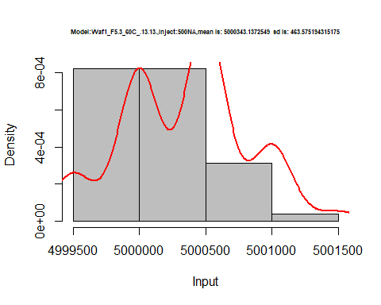

hist(d3_13.13$V6,  
 cex.main=0.5,  
 freq = FALSE,  
 main = paste('Model:Waf1_F5.3_60C_.13.13.,Inject:600NA,mean is:', mean(d3_13.13$V6),' sd is:', sd(d3_13.13$V6)),  
 xlab = "Input",  
 ylab = "Density",  
 col="grey")  
#plot density curve  
lines(density(d3_13.13$V6), # density plot  
 lwd = 2, # thickness of line  
 col = "red")

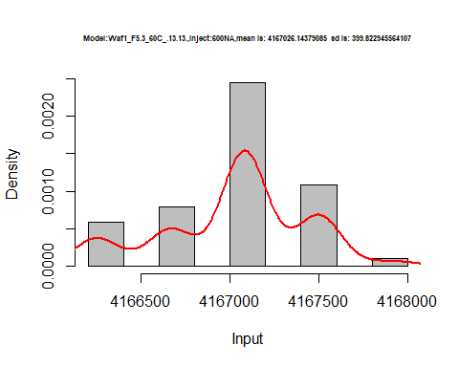

hist(d3_13.13$V7,  
 cex.main=0.5,  
 freq = FALSE,  
 main = paste('Model:Waf1_F5.3_60C_.13.13.,Inject:700NA,mean is:', mean(d3_13.13$V7),' sd is:', sd(d3_13.13$V7)),  
 xlab = "Input",  
 ylab = "Density",  
 col="grey")  
#plot density curve  
lines(density(d3_13.13$V7), # density plot  
 lwd = 2, # thickness of line  
 col = "red")

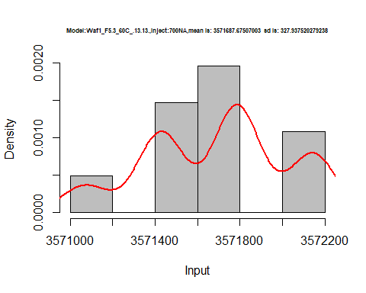

hist(d3_13.13$V8,  
 cex.main=0.5,  
 freq = FALSE,  
 main = paste('Model:Waf1_F5.3_60C_.13.13.,Inject:800NA,mean is:', mean(d3_13.13$V8),' sd is:', sd(d3_13.13$V8)),  
 xlab = "Input",  
 ylab = "Density",  
 col="grey")  
#plot density curve  
lines(density(d3_13.13$V8), # density plot  
 lwd = 2, # thickness of line  
 col = "red")

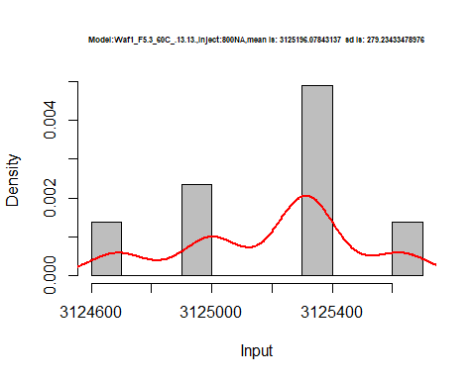

dens <- apply(d3_13.13, 2, density)  
plot('Model:Waf1_F5.3_60C_.13.13', xlim=range(sapply(dens, "[", "x")), ylim=range(sapply(dens, "[", "y")))

## Warning in xy.coords(x, y, xlabel, ylabel, log): NAs introduced by coercion

mapply(lines, dens, col=1:length(dens))

## $V1  
## NULL  
##   
## $V2  
## NULL  
##   
## $V3  
## NULL  
##   
## $V4  
## NULL  
##   
## $V5  
## NULL  
##   
## $V6  
## NULL  
##   
## $V7  
## NULL  
##   
## $V8  
## NULL

legend("topright", legend=names(dens), fill=1:length(dens))

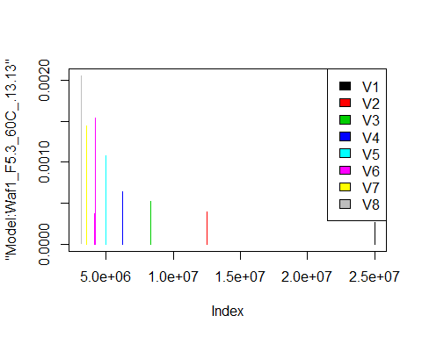

d4_13.13<-d_13.13[,c(25:32)]  
d4_13.13 <- head(d4_13.13,51)  
colnames(d4_13.13) <- c("V1", "V2","V3","V4","V5","V6","V7","V8")  
# head(d4_13.13)

hist(d4_13.13$V1,  
 cex.main=0.5,  
 freq = FALSE,  
 main = paste('Model:Waf1_F6.2_60C_.13.13.,Inject:100NA,mean is:', mean(d4_13.13$V1),' sd is:', sd(d4_13.13$V1)),  
 xlab = "Input",  
 ylab = "Density",  
 col="grey")  
#plot density curve  
lines(density(d4_13.13$V1), # density plot  
 lwd = 2, # thickness of line  
 col = "red")

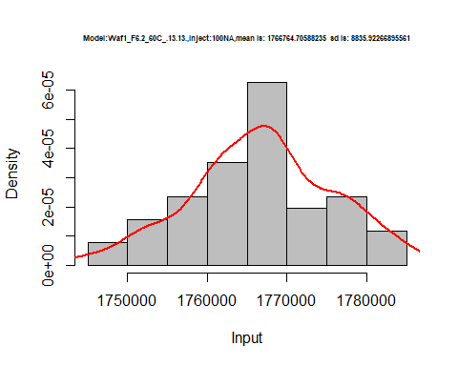

hist(d4_13.13$V2,  
 cex.main=0.5,  
 freq = FALSE,  
 main = paste('Model:Waf1_F6.2_60C_.13.13.,Inject:200NA,mean is:', mean(d4_13.13$V2),' sd is:', sd(d4_13.13$V2)),  
 xlab = "Input",  
 ylab = "Density",  
 col="grey")  
#plot density curve  
lines(density(d4_13.13$V2), # density plot  
 lwd = 2, # thickness of line  
 col = "red")

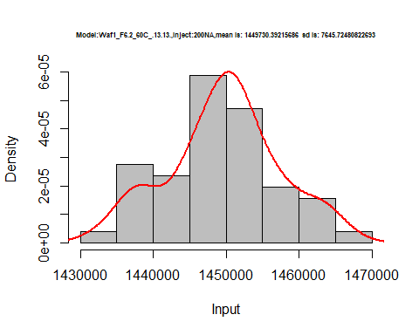

hist(d4_13.13$V3,  
 cex.main=0.5,  
 freq = FALSE,  
 main = paste('Model:Waf1_F6.2_60C_.13.13.,Inject:300NA,mean is:', mean(d4_13.13$V3),' sd is:', sd(d4_13.13$V3)),  
 xlab = "Input",  
 ylab = "Density",  
 col="grey")  
#plot density curve  
lines(density(d4_13.13$V3), # density plot  
 lwd = 2, # thickness of line  
 col = "red")

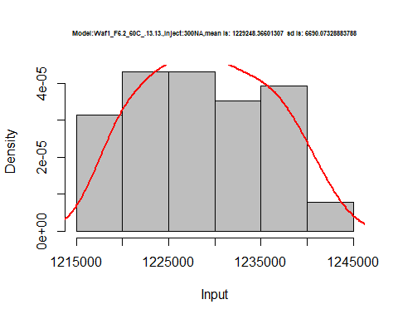

hist(d4_13.13$V4,  
 cex.main=0.5,  
 freq = FALSE,  
 main = paste('Model:Waf1_F6.2_60C_.13.13.,Inject:400NA,mean is:', mean(d4_13.13$V4),' sd is:', sd(d4_13.13$V4)),  
 xlab = "Input",  
 ylab = "Density",  
 col="grey")  
#plot density curve  
lines(density(d4_13.13$V4), # density plot  
 lwd = 2, # thickness of line  
 col = "red")

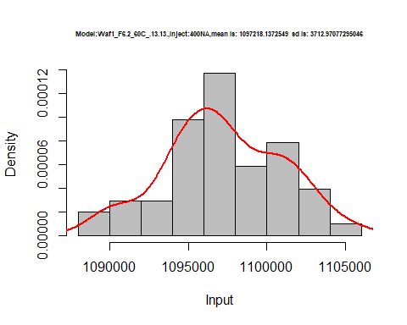

hist(d4_13.13$V5,  
 cex.main=0.5,  
 freq = FALSE,  
 main = paste('Model:Waf1_F6.2_60C_.13.13.,Inject:500NA,mean is:', mean(d4_13.13$V5),' sd is:', sd(d4_13.13$V5)),  
 xlab = "Input",  
 ylab = "Density",  
 col="grey")  
#plot density curve  
lines(density(d4_13.13$V5), # density plot  
 lwd = 2, # thickness of line  
 col = "red")

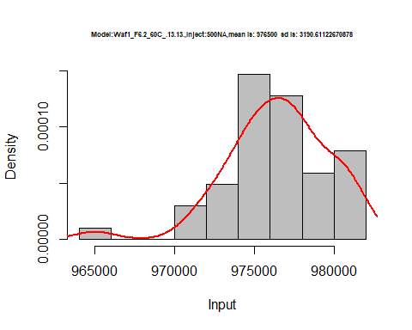

hist(d4_13.13$V6,  
 cex.main=0.5,  
 freq = FALSE,  
 main = paste('Model:Waf1_F6.2_60C_.13.13.,Inject:600NA,mean is:', mean(d4_13.13$V6),' sd is:', sd(d4_13.13$V6)),  
 xlab = "Input",  
 ylab = "Density",  
 col="grey")  
#plot density curve  
lines(density(d4_13.13$V6), # density plot  
 lwd = 2, # thickness of line  
 col = "red")

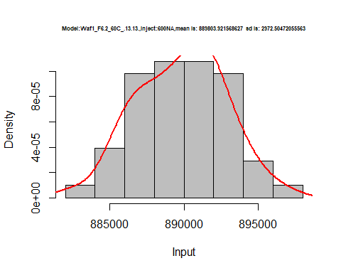

hist(d4_13.13$V7,  
 cex.main=0.5,  
 freq = FALSE,  
 main = paste('Model:Waf1_F6.2_60C_.13.13.,Inject:700NA,mean is:', mean(d4_13.13$V7),' sd is:', sd(d4_13.13$V7)),  
 xlab = "Input",  
 ylab = "Density",  
 col="grey")  
#plot density curve  
lines(density(d4_13.13$V7), # density plot  
 lwd = 2, # thickness of line  
 col = "red")

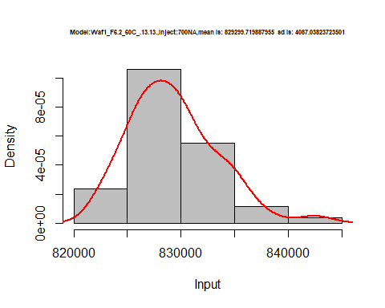

hist(d4_13.13$V8,  
 cex.main=0.5,  
 freq = FALSE,  
 main = paste('Model:Waf1_F6.2_60C_.13.13.,Inject:800NA,mean is:', mean(d4_13.13$V8),' sd is:', sd(d4_13.13$V8)),  
 xlab = "Input",  
 ylab = "Density",  
 col="grey")  
#plot density curve  
lines(density(d4_13.13$V8), # density plot  
 lwd = 2, # thickness of line  
 col = "red")

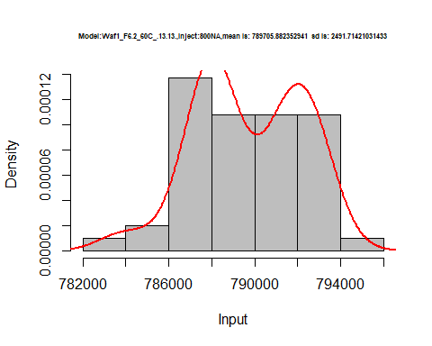

dens <- apply(d4_13.13, 2, density)  
plot('Model:Waf1_F6.2_60C_.13.13', xlim=range(sapply(dens, "[", "x")), ylim=range(sapply(dens, "[", "y")))

## Warning in xy.coords(x, y, xlabel, ylabel, log): NAs introduced by coercion

mapply(lines, dens, col=1:length(dens))

## $V1  
## NULL  
##   
## $V2  
## NULL  
##   
## $V3  
## NULL  
##   
## $V4  
## NULL  
##   
## $V5  
## NULL  
##   
## $V6  
## NULL  
##   
## $V7  
## NULL  
##   
## $V8  
## NULL

legend("topright", legend=names(dens), fill=1:length(dens))

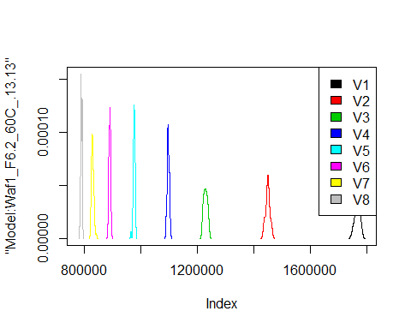

# Select columns whose names contains "14.14"  
d_14.14<-my_data %>% select(contains("14.14."))  
# head(d_14.14)

d1_14.14<-d_14.14[,c(1:8)]  
d1_14.14 <- head(d1_14.14,51)  
colnames(d1_14.14) <- c("V1", "V2","V3","V4","V5","V6","V7","V8")  
# head(d1_14.14)

hist(d1_14.14$V1,  
 cex.main=0.5,  
 freq = FALSE,  
 main = paste('Model:Waf1_F2.5_60C_.14.14.,Inject:100NA,mean is:', mean(d1_14.14$V1),' sd is:', sd(d1_14.14$V1)),  
 xlab = "Input",  
 ylab = "Density",  
 col="grey")  
#plot density curve  
lines(density(d1_14.14$V1), # density plot  
 lwd = 2, # thickness of line  
 col = "red")

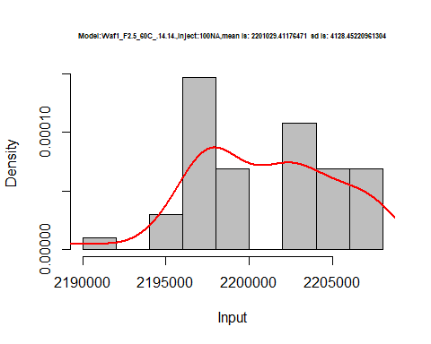

hist(d1_14.14$V2,  
 cex.main=0.5,  
 freq = FALSE,  
 main = paste('Model:Waf1_F2.5_60C_.14.14.,Inject:200NA,mean is:', mean(d1_14.14$V2),' sd is:', sd(d1_14.14$V2)),  
 xlab = "Input",  
 ylab = "Density",  
 col="grey")  
#plot density curve  
lines(density(d1_14.14$V2), # density plot  
 lwd = 2, # thickness of line  
 col = "red")

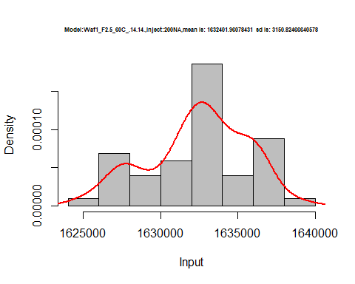

hist(d1_14.14$V3,  
 cex.main=0.5,  
 freq = FALSE,  
 main = paste('Model:Waf1_F2.5_60C_.14.14.,Inject:200NA,mean is:', mean(d1_14.14$V3),' sd is:', sd(d1_14.14$V3)),  
 xlab = "Input",  
 ylab = "Density",  
 col="grey")  
#plot density curve  
lines(density(d1_14.14$V3), # density plot  
 lwd = 2, # thickness of line  
 col = "red")

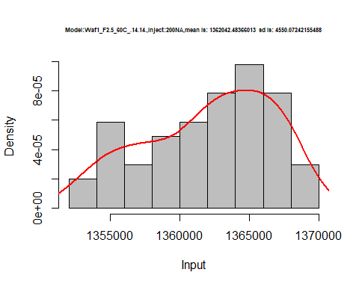

hist(d1_14.14$V4,  
 cex.main=0.5,  
 freq = FALSE,  
 main = paste('Model:Waf1_F2.5_60C_.14.14.,Inject:400NA,mean is:', mean(d1_14.14$V4),' sd is:', sd(d1_14.14$V4)),  
 xlab = "Input",  
 ylab = "Density",  
 col="grey")  
#plot density curve  
lines(density(d1_14.14$V4), # density plot  
 lwd = 2, # thickness of line  
 col = "red")

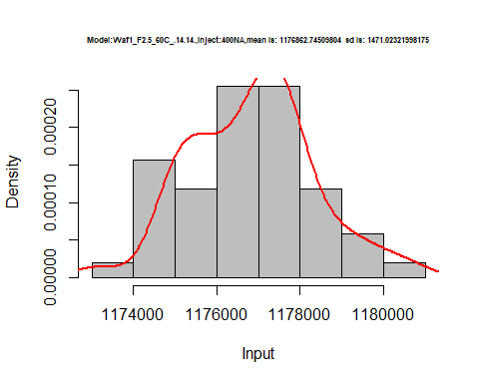

hist(d1_14.14$V5,  
 cex.main=0.5,  
 freq = FALSE,  
 main = paste('Model:Waf1_F2.5_60C_.14.14.,Inject:500NA,mean is:', mean(d1_14.14$V5),' sd is:', sd(d1_14.14$V5)),  
 xlab = "Input",  
 ylab = "Density",  
 col="grey")  
#plot density curve  
lines(density(d1_14.14$V5), # density plot  
 lwd = 2, # thickness of line  
 col = "red")

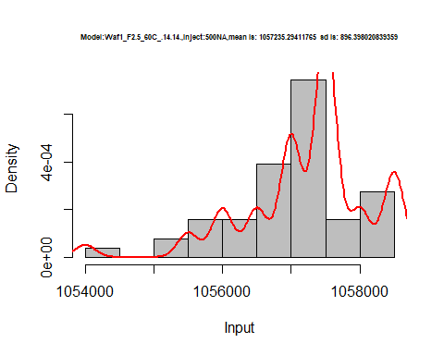

hist(d1_14.14$V6,  
 cex.main=0.5,  
 freq = FALSE,  
 main = paste('Model:Waf1_F2.5_60C_.14.14.,Inject:600NA,mean is:', mean(d1_14.14$V6),' sd is:', sd(d1_14.14$V6)),  
 xlab = "Input",  
 ylab = "Density",  
 col="grey")  
#plot density curve  
lines(density(d1_14.14$V6), # density plot  
 lwd = 2, # thickness of line  
 col = "red")

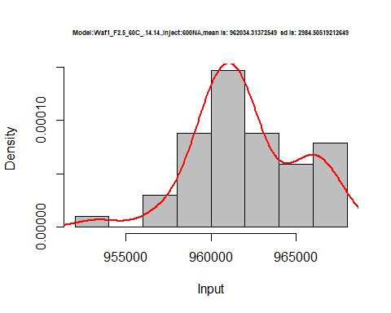

hist(d1_14.14$V7,  
 cex.main=0.5,  
 freq = FALSE,  
 main = paste('Model:Waf1_F2.5_60C_.14.14.,Inject:700NA,mean is:', mean(d1_14.14$V7),' sd is:', sd(d1_14.14$V7)),  
 xlab = "Input",  
 ylab = "Density",  
 col="grey")  
#plot density curve  
lines(density(d1_14.14$V7), # density plot  
 lwd = 2, # thickness of line  
 col = "red")

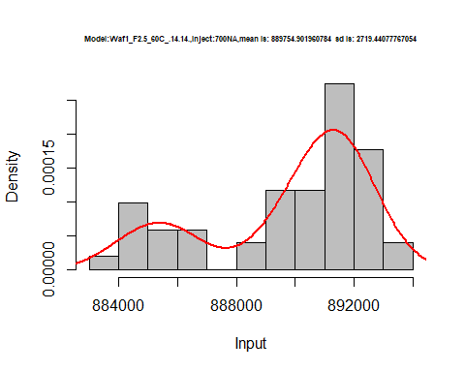

hist(d1_14.14$V8,  
 cex.main=0.5,  
 freq = FALSE,  
 main = paste('Model:Waf1_F2.5_60C_.14.14,Inject:800NA,mean is:', mean(d1_14.14$V8),' sd is:', sd(d1_14.14$V8)),  
 xlab = "Input",  
 ylab = "Density",  
 col="grey")  
#plot density curve  
lines(density(d1_14.14$V8), # density plot  
 lwd = 2, # thickness of line  
 col = "red")

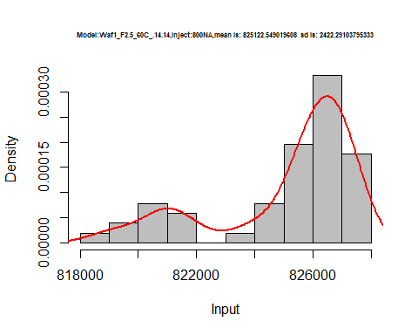

dens <- apply(d1_14.14, 2, density)  
plot('Model:Waf1_F2.5_60C_.14.14', xlim=range(sapply(dens, "[", "x")), ylim=range(sapply(dens, "[", "y")))

## Warning in xy.coords(x, y, xlabel, ylabel, log): NAs introduced by coercion

mapply(lines, dens, col=1:length(dens))

## $V1  
## NULL  
##   
## $V2  
## NULL  
##   
## $V3  
## NULL  
##   
## $V4  
## NULL  
##   
## $V5  
## NULL  
##   
## $V6  
## NULL  
##   
## $V7  
## NULL  
##   
## $V8  
## NULL

legend("topright", legend=names(dens), fill=1:length(dens))

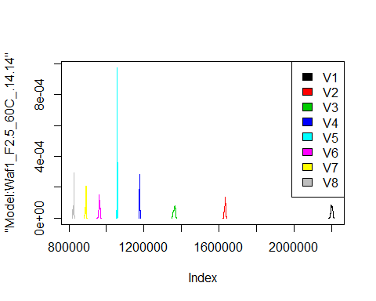

d2_14.14<-d_14.14[,c(9:16)]  
d2_14.14 <- head(d2_14.14,51)  
colnames(d2_14.14) <- c("V1", "V2","V3","V4","V5","V6","V7","V8")  
# head(d2_14.14)

hist(d2_14.14$V1,  
 cex.main=0.5,  
 freq = FALSE,  
 main = paste('Model:Waf1_F3.5_60C_.14.14.,Inject:100NA,mean is:', mean(d2_14.14$V1),' sd is:', sd(d2_14.14$V1)),  
 xlab = "Input",  
 ylab = "Density",  
 col="grey")  
#plot density curve  
lines(density(d2_14.14$V1), # density plot  
 lwd = 2, # thickness of line  
 col = "red")

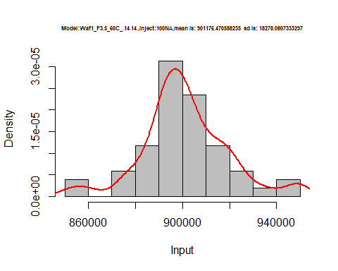

hist(d2_14.14$V2,  
 cex.main=0.5,  
 freq = FALSE,  
 main = paste('Model:Waf1_F3.5_60C_.14.14.,Inject:200NA,mean is:', mean(d2_14.14$V2),' sd is:', sd(d2_14.14$V2)),  
 xlab = "Input",  
 ylab = "Density",  
 col="grey")  
#plot density curve  
lines(density(d2_14.14$V2), # density plot  
 lwd = 2, # thickness of line  
 col = "red")

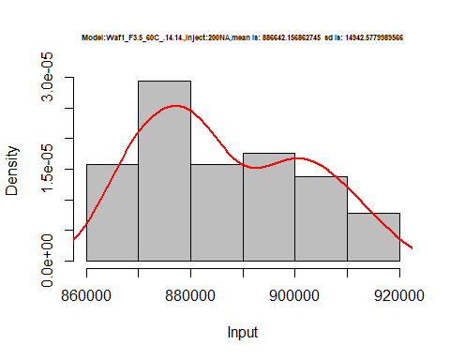

hist(d2_14.14$V3,  
 cex.main=0.5,  
 freq = FALSE,  
 main = paste('Model:Waf1_F3.5_60C_.14.14.,Inject:300NA,mean is:', mean(d2_14.14$V3),' sd is:', sd(d2_14.14$V3)),  
 xlab = "Input",  
 ylab = "Density",  
 col="grey")  
#plot density curve  
lines(density(d2_14.14$V3), # density plot  
 lwd = 2, # thickness of line  
 col = "red")

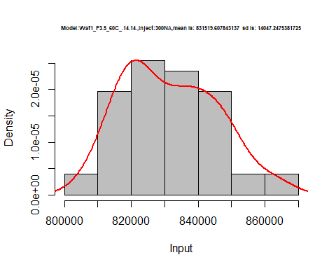

hist(d2_14.14$V4,  
 cex.main=0.5,  
 freq = FALSE,  
 main = paste('Model:Waf1_F3.5_60C_.14.14.,Inject:400NA,mean is:', mean(d2_14.14$V4),' sd is:', sd(d2_14.14$V4)),  
 xlab = "Input",  
 ylab = "Density",  
 col="grey")  
#plot density curve  
lines(density(d2_14.14$V4), # density plot  
 lwd = 2, # thickness of line  
 col = "red")

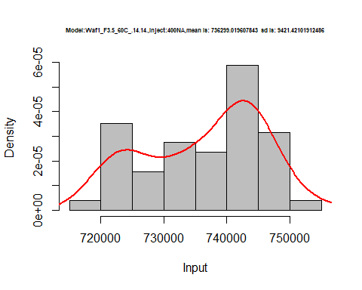

hist(d2_14.14$V5,  
 cex.main=0.5,  
 freq = FALSE,  
 main = paste('Model:Waf1_F3.5_60C_.14.14.,Inject:500NA,mean is:', mean(d2_14.14$V5),' sd is:', sd(d2_14.14$V5)),  
 xlab = "Input",  
 ylab = "Density",  
 col="grey")  
#plot density curve  
lines(density(d2_14.14$V5), # density plot  
 lwd = 2, # thickness of line  
 col = "red")

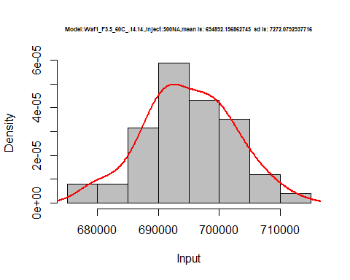

hist(d2_14.14$V6,  
 cex.main=0.5,  
 freq = FALSE,  
 main = paste('Model:Waf1_F3.5_60C_.14.14.,Inject:600NA,mean is:', mean(d2_14.14$V6),' sd is:', sd(d2_14.14$V6)),  
 xlab = "Input",  
 ylab = "Density",  
 col="grey")  
#plot density curve  
lines(density(d2_14.14$V6), # density plot  
 lwd = 2, # thickness of line  
 col = "red")

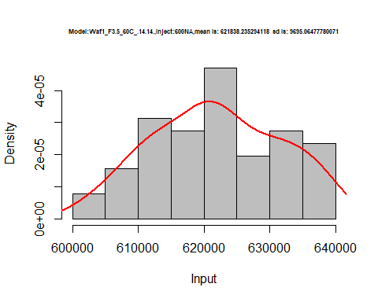

hist(d2_14.14$V7,  
 cex.main=0.5,  
 freq = FALSE,  
 main = paste('Model:Waf1_F3.5_60C_.14.14.,Inject:700NA,mean is:', mean(d2_14.14$V7),' sd is:', sd(d2_14.14$V7)),  
 xlab = "Input",  
 ylab = "Density",  
 col="grey")  
#plot density curve  
lines(density(d2_14.14$V7), # density plot  
 lwd = 2, # thickness of line  
 col = "red")

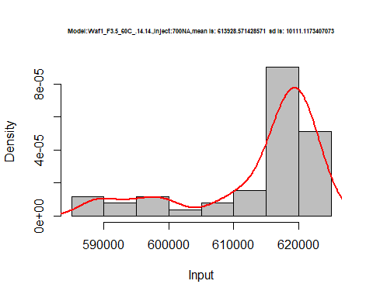

hist(d2_14.14$V8,  
 cex.main=0.5,  
 freq = FALSE,  
 main = paste('Model:Waf1_F3.5_60C_.14.14.,Inject:800NA,mean is:', mean(d2_14.14$V8),' sd is:', sd(d2_14.14$V8)),  
 xlab = "Input",  
 ylab = "Density",  
 col="grey")  
#plot density curve  
lines(density(d2_14.14$V8), # density plot  
 lwd = 2, # thickness of line  
 col = "red")

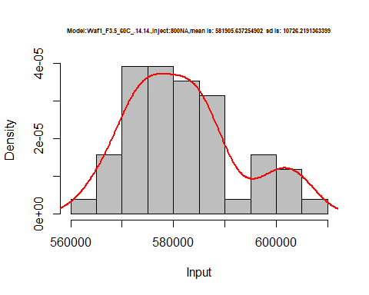

dens <- apply(d2_14.14, 2, density)  
plot('Model:Waf1_F6.2_60C_.13.13', xlim=range(sapply(dens, "[", "x")), ylim=range(sapply(dens, "[", "y")))

## Warning in xy.coords(x, y, xlabel, ylabel, log): NAs introduced by coercion

mapply(lines, dens, col=1:length(dens))

## $V1  
## NULL  
##   
## $V2  
## NULL  
##   
## $V3  
## NULL  
##   
## $V4  
## NULL  
##   
## $V5  
## NULL  
##   
## $V6  
## NULL  
##   
## $V7  
## NULL  
##   
## $V8  
## NULL

legend("topright", legend=names(dens), fill=1:length(dens))

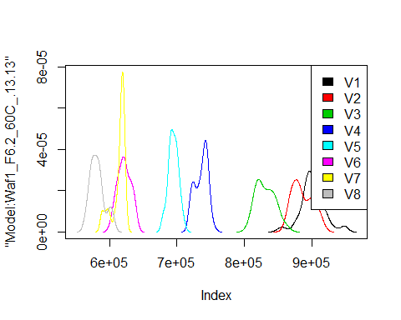

# Select columns whose names contains "15.15"  
d_15.15<-my_data %>% select(contains("15.15."))  
d_15.15 <- head(d_15.15,51)  
colnames(d_15.15) <- c("V1", "V2","V3","V4","V5","V6","V7","V8")  
# head(d_15.15)

hist(d_15.15$V1,  
 cex.main=0.5,  
 freq = FALSE,  
 main = paste('Model:Waf1_F6.7_60C_.15.15.,Inject:100NA,mean is:', mean(d_15.15$V1),' sd is:', sd(d_15.15$V1)),  
 xlab = "Input",  
 ylab = "Density",  
 col="grey")  
#plot density curve  
lines(density(d_15.15$V1), # density plot  
 lwd = 2, # thickness of line  
 col = "red")

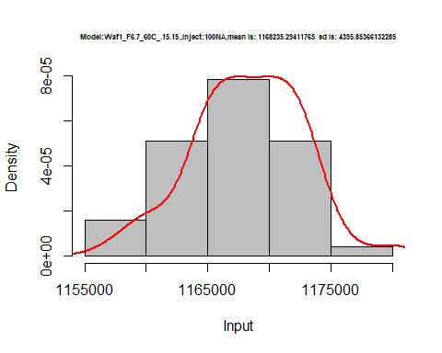

hist(d_15.15$V2,  
 cex.main=0.5,  
 freq = FALSE,  
 main = paste('Model:Waf1_F6.7_60C_.15.15.,Inject:200NA,mean is:', mean(d_15.15$V2),' sd is:', sd(d_15.15$V2)),  
 xlab = "Input",  
 ylab = "Density",  
 col="grey")  
#plot density curve  
lines(density(d_15.15$V2), # density plot  
 lwd = 2, # thickness of line  
 col = "red")

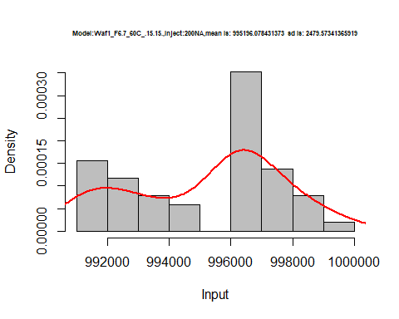

hist(d_15.15$V3,  
 cex.main=0.5,  
 freq = FALSE,  
 main = paste('Model:Waf1_F6.7_60C_.15.15.,Inject:300NA,mean is:', mean(d_15.15$V3),' sd is:', sd(d_15.15$V3)),  
 xlab = "Input",  
 ylab = "Density",  
 col="grey")  
#plot density curve  
lines(density(d_15.15$V3), # density plot  
 lwd = 2, # thickness of line  
 col = "red")

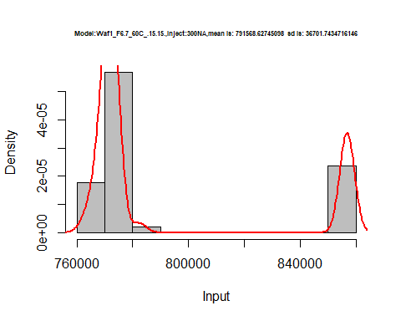

hist(d_15.15$V4,  
 cex.main=0.5,  
 freq = FALSE,  
 main = paste('Model:Waf1_F6.7_60C_.15.15..,Inject:400NA,mean is:', mean(d_15.15$V4),' sd is:', sd(d_15.15$V4)),  
 xlab = "Input",  
 ylab = "Density",  
 col="grey")  
#plot density curve  
lines(density(d_15.15$V4), # density plot  
 lwd = 2, # thickness of line  
 col = "red")

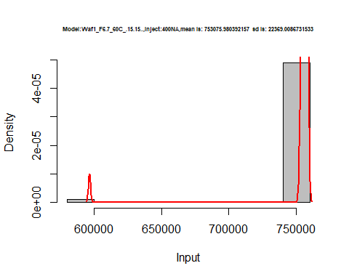

hist(d_15.15$V5,  
 cex.main=0.5,  
 freq = FALSE,  
 main = paste('Model:Waf1_F6.7_60C_.15.15.,Inject:500NA,mean is:', mean(d_15.15$V5),' sd is:', sd(d_15.15$V5)),  
 xlab = "Input",  
 ylab = "Density",  
 col="grey")  
#plot density curve  
lines(density(d_15.15$V5), # density plot  
 lwd = 2, # thickness of line  
 col = "red")

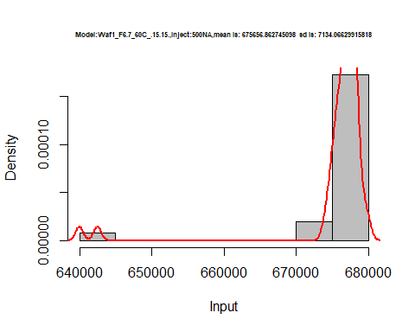

hist(d_15.15$V6,  
 cex.main=0.5,  
 freq = FALSE,  
 main = paste('Model:Waf1_F6.7_60C_.15.15.,Inject:600NA,mean is:', mean(d_15.15$V6),' sd is:', sd(d_15.15$V6)),  
 xlab = "Input",  
 ylab = "Density",  
 col="grey")  
#plot density curve  
lines(density(d_15.15$V6), # density plot  
 lwd = 2, # thickness of line  
 col = "red")

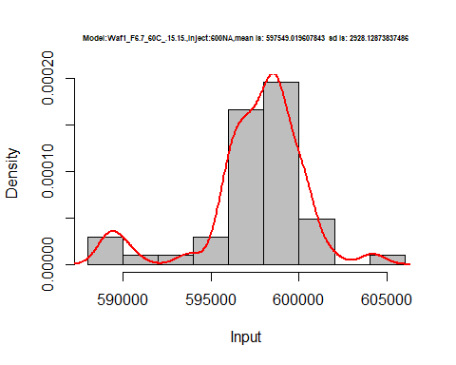

hist(d_15.15$V7,  
 cex.main=0.5,  
 freq = FALSE,  
 main = paste('Model:Waf1_F6.7_60C_.15.15.,Inject:700NA,mean is:', mean(d_15.15$V7),' sd is:', sd(d_15.15$V7)),  
 xlab = "Input",  
 ylab = "Density",  
 col="grey")  
#plot density curve  
lines(density(d_15.15$V7), # density plot  
 lwd = 2, # thickness of line  
 col = "red")

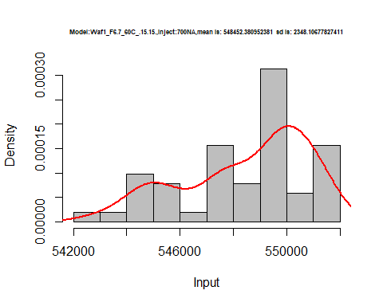

hist(d_15.15$V8,  
 cex.main=0.5,  
 freq = FALSE,  
 main = paste('Model:Waf1_F6.7_60C_.15.15.,Inject:800NA,mean is:', mean(d_15.15$V8),' sd is:', sd(d_15.15$V8)),  
 xlab = "Input",  
 ylab = "Density",  
 col="grey")  
#plot density curve  
lines(density(d_15.15$V8), # density plot  
 lwd = 2, # thickness of line  
 col = "red")

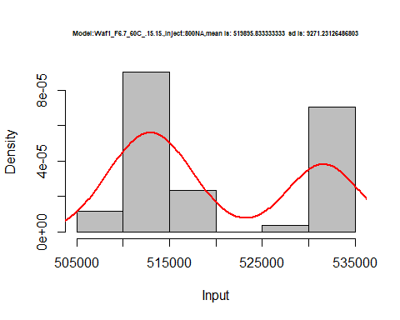

dens <- apply(d_15.15, 2, density)  
plot('Model:Waf1_F6.7_60C_.15.15', xlim=range(sapply(dens, "[", "x")), ylim=range(sapply(dens, "[", "y")))

## Warning in xy.coords(x, y, xlabel, ylabel, log): NAs introduced by coercion

mapply(lines, dens, col=1:length(dens))

## $V1  
## NULL  
##   
## $V2  
## NULL  
##   
## $V3  
## NULL  
##   
## $V4  
## NULL  
##   
## $V5  
## NULL  
##   
## $V6  
## NULL  
##   
## $V7  
## NULL  
##   
## $V8  
## NULL

legend("topright", legend=names(dens), fill=1:length(dens))

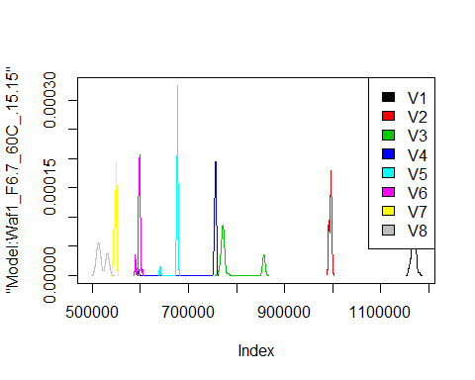

# Select columns whose names contains "16.16"  
d_16.16<-my_data %>% select(contains("16.16."))  
# head(d_16.16)

d1_16.16<-d_16.16[,c(1:8)]  
d1_16.16 <- head(d1_16.16,51)  
colnames(d1_16.16) <- c("V1", "V2","V3","V4","V5","V6","V7","V8")  
# head(d1_16.16)

hist(d1_16.16$V1,  
 cex.main=0.5,  
 freq = FALSE,  
 main = paste('Model:Waf1_F3.5_60C_.16.16.,Inject:100NA,mean is:', mean(d1_16.16$V1),' sd is:', sd(d1_16.16$V1)),  
 xlab = "Input",  
 ylab = "Density",  
 col="grey")  
#plot density curve  
lines(density(d1_16.16$V1), # density plot  
 lwd = 2, # thickness of line  
 col = "red")

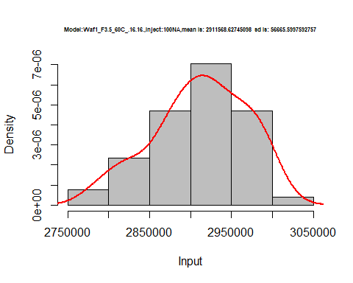

hist(d1_16.16$V2,  
 cex.main=0.5,  
 freq = FALSE,  
 main = paste('Model:Waf1_F3.5_60C_.16.16.,Inject:200NA,mean is:', mean(d1_16.16$V2),' sd is:', sd(d1_16.16$V2)),  
 xlab = "Input",  
 ylab = "Density",  
 col="grey")  
#plot density curve  
lines(density(d1_16.16$V2), # density plot  
 lwd = 2, # thickness of line  
 col = "red")

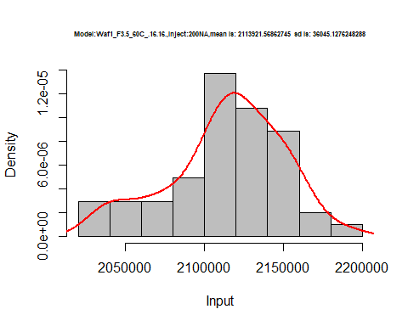

hist(d1_16.16$V3,  
 cex.main=0.5,  
 freq = FALSE,  
 main = paste('Model:Waf1_F3.5_60C_.16.16.,Inject:300NA,mean is:', mean(d1_16.16$V3),' sd is:', sd(d1_16.16$V3)),  
 xlab = "Input",  
 ylab = "Density",  
 col="grey")  
#plot density curve  
lines(density(d1_16.16$V3), # density plot  
 lwd = 2, # thickness of line  
 col = "red")

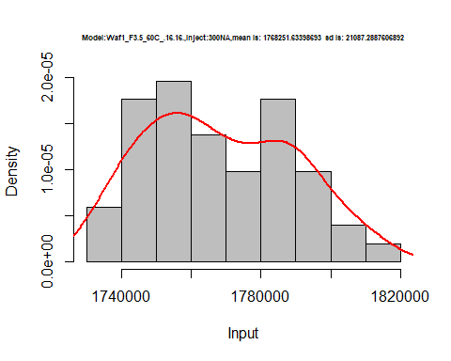

hist(d1_16.16$V4,  
 cex.main=0.5,  
 freq = FALSE,  
 main = paste('Model:Waf1_F3.5_60C_.16.16.,Inject:100NA,mean is:', mean(d1_16.16$V4),' sd is:', sd(d1_16.16$V4)),  
 xlab = "Input",  
 ylab = "Density",  
 col="grey")  
#plot density curve  
lines(density(d1_16.16$V4), # density plot  
 lwd = 2, # thickness of line  
 col = "red")

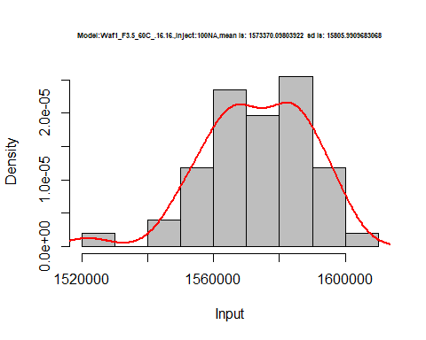

hist(d1_16.16$V5,  
 cex.main=0.5,  
 freq = FALSE,  
 main = paste('Model:Waf1_F3.5_60C_.16.16.,Inject:500NA,mean is:', mean(d1_16.16$V5),' sd is:', sd(d1_16.16$V5)),  
 xlab = "Input",  
 ylab = "Density",  
 col="grey")  
#plot density curve  
lines(density(d1_16.16$V5), # density plot  
 lwd = 2, # thickness of line  
 col = "red")

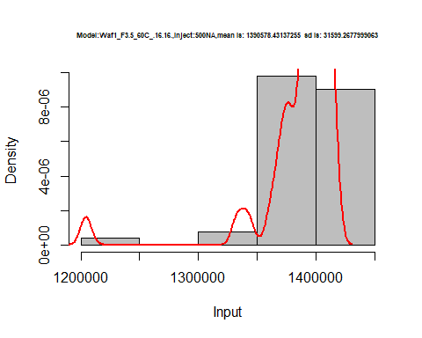

hist(d1_16.16$V6,  
 cex.main=0.5,  
 freq = FALSE,  
 main = paste('Model:Waf1_F3.5_60C_.16.16.,Inject:600NA,mean is:', mean(d1_16.16$V6),' sd is:', sd(d1_16.16$V6)),  
 xlab = "Input",  
 ylab = "Density",  
 col="grey")  
#plot density curve  
lines(density(d1_16.16$V6), # density plot  
 lwd = 2, # thickness of line  
 col = "red")

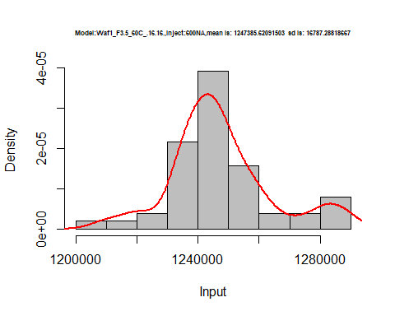

hist(d1_16.16$V7,  
 cex.main=0.5,  
 freq = FALSE,  
 main = paste('Model:Waf1_F3.5_60C_.16.16.,Inject:700NA,mean is:', mean(d1_16.16$V7),' sd is:', sd(d1_16.16$V7)),  
 xlab = "Input",  
 ylab = "Density",  
 col="grey")  
#plot density curve  
lines(density(d1_16.16$V7), # density plot  
 lwd = 2, # thickness of line  
 col = "red")

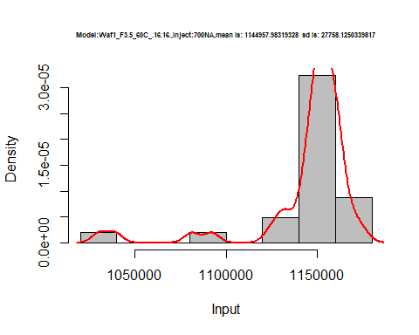

hist(d1_16.16$V8,  
 cex.main=0.5,  
 freq = FALSE,  
 main = paste('Model:Waf1_F3.5_60C_.16.16.,Inject:100NA,mean is:', mean(d1_16.16$V8),' sd is:', sd(d1_16.16$V8)),  
 xlab = "Input",  
 ylab = "Density",  
 col="grey")  
#plot density curve  
lines(density(d1_16.16$V8), # density plot  
 lwd = 2, # thickness of line  
 col = "red")

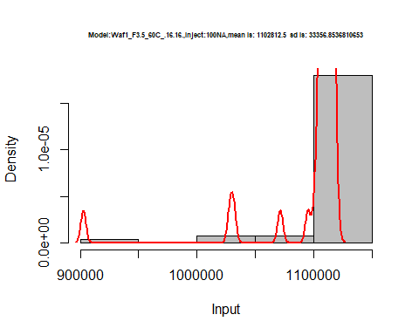

dens <- apply(d1_16.16, 2, density)  
plot('Model:Model:Waf1_F3.5_60C_.16.16', xlim=range(sapply(dens, "[", "x")), ylim=range(sapply(dens, "[", "y")))

## Warning in xy.coords(x, y, xlabel, ylabel, log): NAs introduced by coercion

mapply(lines, dens, col=1:length(dens))

## $V1  
## NULL  
##   
## $V2  
## NULL  
##   
## $V3  
## NULL  
##   
## $V4  
## NULL  
##   
## $V5  
## NULL  
##   
## $V6  
## NULL  
##   
## $V7  
## NULL  
##   
## $V8  
## NULL

legend("topright", legend=names(dens), fill=1:length(dens))

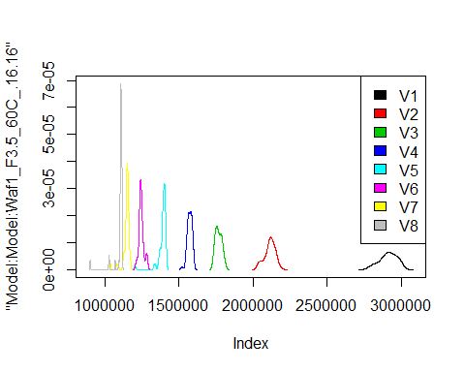

d2_16.16<-d_16.16[,c(9:16)]  
d2_16.16 <- head(d2_16.16,51)  
colnames(d2_16.16) <- c("V1", "V2","V3","V4","V5","V6","V7","V8")  
# head(d2_16.16)

hist(d2_16.16$V1,  
 cex.main=0.5,  
 freq = FALSE,  
 main = paste('Model:Waf1_F3.6_60C_.16.16,Inject:100NA,mean is:', mean(d2_16.16$V1),' sd is:', sd(d2_16.16$V1)),  
 xlab = "Input",  
 ylab = "Density",  
 col="grey")  
#plot density curve  
lines(density(d2_16.16$V1), # density plot  
 lwd = 2, # thickness of line  
 col = "red")

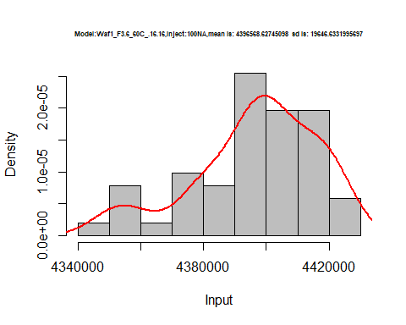

hist(d2_16.16$V2,  
 cex.main=0.5,  
 freq = FALSE,  
 main = paste('Model:Waf1_F3.6_60C_.16.16,Inject:200NA,mean is:', mean(d2_16.16$V2),' sd is:', sd(d2_16.16$V2)),  
 xlab = "Input",  
 ylab = "Density",  
 col="grey")  
#plot density curve  
lines(density(d2_16.16$V2), # density plot  
 lwd = 2, # thickness of line  
 col = "red")

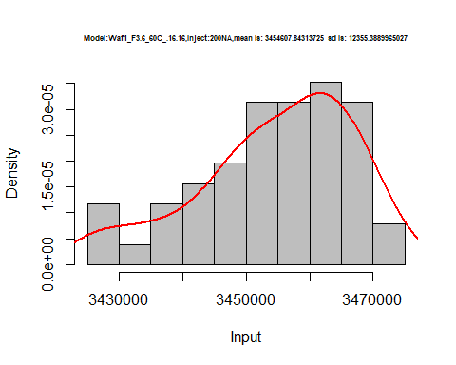

hist(d2_16.16$V3,  
 cex.main=0.5,  
 freq = FALSE,  
 main = paste('Model:Waf1_F3.6_60C_.16.16,Inject:300NA,mean is:', mean(d2_16.16$V3),' sd is:', sd(d2_16.16$V3)),  
 xlab = "Input",  
 ylab = "Density",  
 col="grey")  
#plot density curve  
lines(density(d2_16.16$V3), # density plot  
 lwd = 2, # thickness of line  
 col = "red")

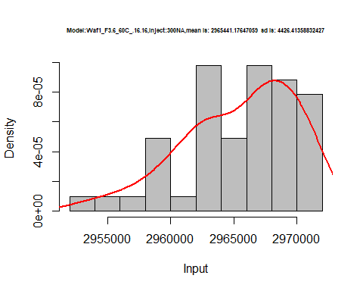

hist(d2_16.16$V4,  
 cex.main=0.5,  
 freq = FALSE,  
 main = paste('Model:Waf1_F3.6_60C_.16.16,Inject:400NA,mean is:', mean(d2_16.16$V4),' sd is:', sd(d2_16.16$V4)),  
 xlab = "Input",  
 ylab = "Density",  
 col="grey")  
#plot density curve  
lines(density(d2_16.16$V4), # density plot  
 lwd = 2, # thickness of line  
 col = "red")

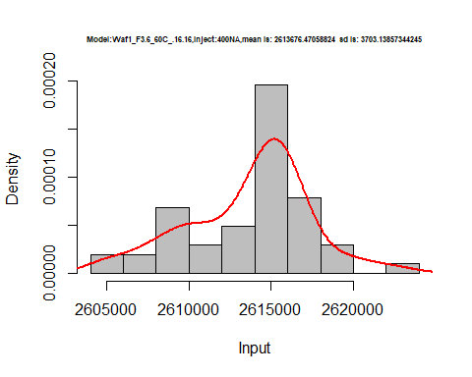

hist(d2_16.16$V5,  
 cex.main=0.5,  
 freq = FALSE,  
 main = paste('Model:Waf1_F3.6_60C_.16.16,Inject:500NA,mean is:', mean(d2_16.16$V5),' sd is:', sd(d2_16.16$V5)),  
 xlab = "Input",  
 ylab = "Density",  
 col="grey")  
#plot density curve  
lines(density(d2_16.16$V5), # density plot  
 lwd = 2, # thickness of line  
 col = "red")

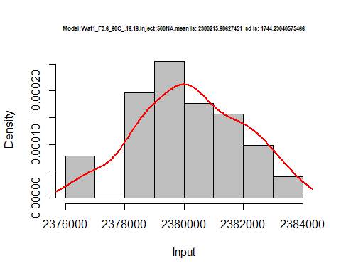

hist(d2_16.16$V6,  
 cex.main=0.5,  
 freq = FALSE,  
 main = paste('Model:Waf1_F3.6_60C_.16.16,Inject:600NA,mean is:', mean(d2_16.16$V6),' sd is:', sd(d2_16.16$V6)),  
 xlab = "Input",  
 ylab = "Density",  
 col="grey")  
#plot density curve  
lines(density(d2_16.16$V6), # density plot  
 lwd = 2, # thickness of line  
 col = "red")

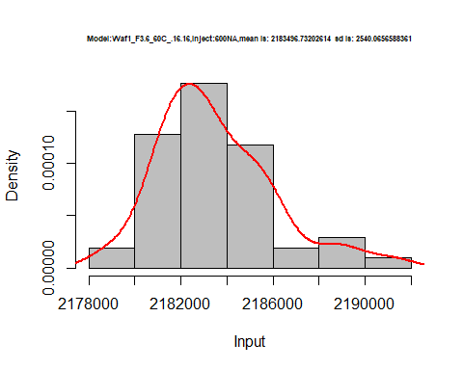

hist(d2_16.16$V7,  
 cex.main=0.5,  
 freq = FALSE,  
 main = paste('Model:Waf1_F3.6_60C_.16.16,Inject:700NA,mean is:', mean(d2_16.16$V7),' sd is:', sd(d2_16.16$V7)),  
 xlab = "Input",  
 ylab = "Density",  
 col="grey")  
#plot density curve  
lines(density(d2_16.16$V7), # density plot  
 lwd = 2, # thickness of line  
 col = "red")

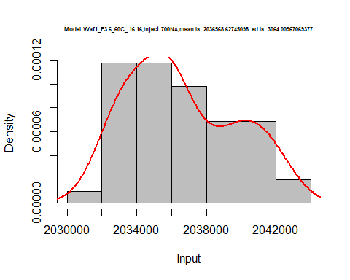

hist(d2_16.16$V8,  
 cex.main=0.5,  
 freq = FALSE,  
 main = paste('Model:Waf1_F3.6_60C_.16.16,Inject:800NA,mean is:', mean(d2_16.16$V8),' sd is:', sd(d2_16.16$V8)),  
 xlab = "Input",  
 ylab = "Density",  
 col="grey")  
#plot density curve  
lines(density(d2_16.16$V8), # density plot  
 lwd = 2, # thickness of line  
 col = "red")

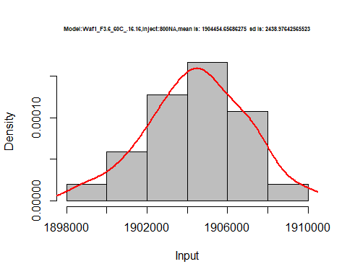

dens <- apply(d2_16.16, 2, density)  
plot('Model:Model:Waf1_F3.6_60C_.16.16', xlim=range(sapply(dens, "[", "x")), ylim=range(sapply(dens, "[", "y")))

## Warning in xy.coords(x, y, xlabel, ylabel, log): NAs introduced by coercion

mapply(lines, dens, col=1:length(dens))

## $V1  
## NULL  
##   
## $V2  
## NULL  
##   
## $V3  
## NULL  
##   
## $V4  
## NULL  
##   
## $V5  
## NULL  
##   
## $V6  
## NULL  
##   
## $V7  
## NULL  
##   
## $V8  
## NULL

legend("topright", legend=names(dens), fill=1:length(dens))

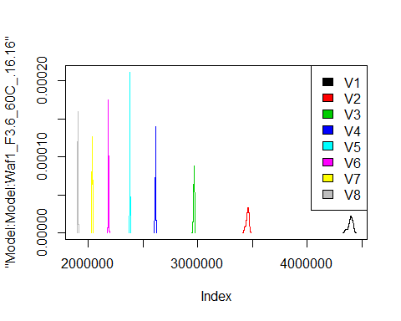

d3_16.16<-d_16.16[,c(17:24)]  
d3_16.16 <- head(d3_16.16,51)  
colnames(d3_16.16) <- c("V1", "V2","V3","V4","V5","V6","V7","V8")  
# head(d3_16.16)

hist(d3_16.16$V1,  
 cex.main=0.5,  
 freq = FALSE,  
 main = paste('Model:Waf1_F6.2_60C_.16.16,Inject:100NA,mean is:', mean(d3_16.16$V1),' sd is:', sd(d3_16.16$V1)),  
 xlab = "Input",  
 ylab = "Density",  
 col="grey")  
#plot density curve  
lines(density(d3_16.16$V1), # density plot  
 lwd = 2, # thickness of line  
 col = "red")

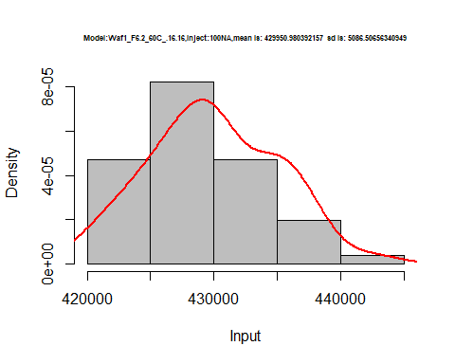

hist(d3_16.16$V2,  
 cex.main=0.5,  
 freq = FALSE,  
 main = paste('Model:Waf1_F6.2_60C_.16.16,Inject:200NA,mean is:', mean(d3_16.16$V2),' sd is:', sd(d3_16.16$V2)),  
 xlab = "Input",  
 ylab = "Density",  
 col="grey")  
#plot density curve  
lines(density(d3_16.16$V2), # density plot  
 lwd = 2, # thickness of line  
 col = "red")

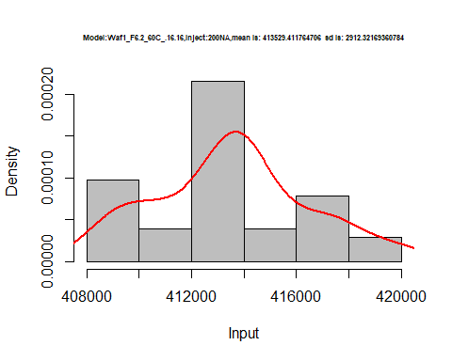

hist(d3_16.16$V3,  
 cex.main=0.5,  
 freq = FALSE,  
 main = paste('Model:Waf1_F6.2_60C_.16.16,Inject:300NA,mean is:', mean(d3_16.16$V3),' sd is:', sd(d3_16.16$V3)),  
 xlab = "Input",  
 ylab = "Density",  
 col="grey")  
#plot density curve  
lines(density(d3_16.16$V3), # density plot  
 lwd = 2, # thickness of line  
 col = "red")

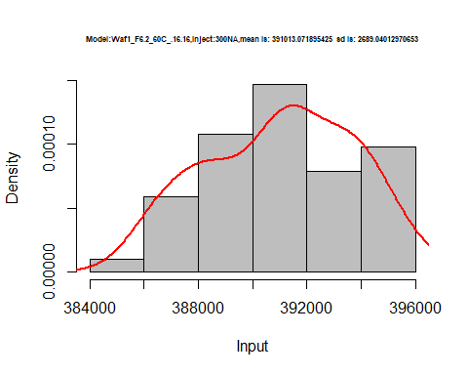

hist(d3_16.16$V4,  
 cex.main=0.5,  
 freq = FALSE,  
 main = paste('Model:Waf1_F6.2_60C_.16.16,Inject:400NA,mean is:', mean(d3_16.16$V4),' sd is:', sd(d3_16.16$V4)),  
 xlab = "Input",  
 ylab = "Density",  
 col="grey")  
#plot density curve  
lines(density(d3_16.16$V4), # density plot  
 lwd = 2, # thickness of line  
 col = "red")

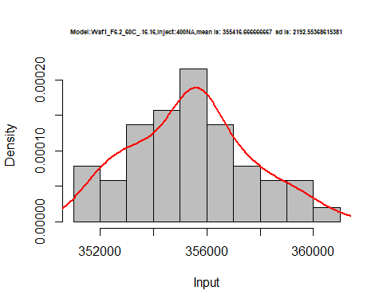

hist(d3_16.16$V5,  
 cex.main=0.5,  
 freq = FALSE,  
 main = paste('Model:Waf1_F6.2_60C_.16.16,Inject:500NA,mean is:', mean(d3_16.16$V5),' sd is:', sd(d3_16.16$V5)),  
 xlab = "Input",  
 ylab = "Density",  
 col="grey")  
#plot density curve  
lines(density(d3_16.16$V5), # density plot  
 lwd = 2, # thickness of line  
 col = "red")

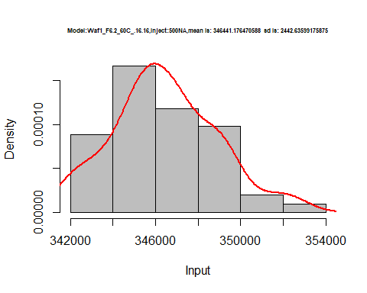

hist(d3_16.16$V6,  
 cex.main=0.5,  
 freq = FALSE,  
 main = paste('Model:Waf1_F6.2_60C_.16.16,Inject:600NA,mean is:', mean(d3_16.16$V6),' sd is:', sd(d3_16.16$V6)),  
 xlab = "Input",  
 ylab = "Density",  
 col="grey")  
#plot density curve  
lines(density(d3_16.16$V6), # density plot  
 lwd = 2, # thickness of line  
 col = "red")

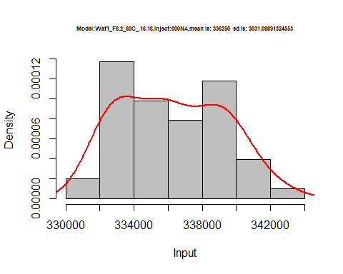

hist(d3_16.16$V7,  
 cex.main=0.5,  
 freq = FALSE,  
 main = paste('Model:Waf1_F6.2_60C_.16.16,Inject:700NA,mean is:', mean(d3_16.16$V7),' sd is:', sd(d3_16.16$V7)),  
 xlab = "Input",  
 ylab = "Density",  
 col="grey")  
#plot density curve  
lines(density(d3_16.16$V7), # density plot  
 lwd = 2, # thickness of line  
 col = "red")

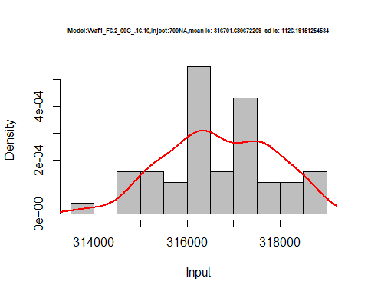

hist(d3_16.16$V8,  
 cex.main=0.5,  
 freq = FALSE,  
 main = paste('Model:Waf1_F6.2_60C_.16.16,Inject:800NA,mean is:', mean(d3_16.16$V8),' sd is:', sd(d3_16.16$V8)),  
 xlab = "Input",  
 ylab = "Density",  
 col="grey")  
#plot density curve  
lines(density(d3_16.16$V8), # density plot  
 lwd = 2, # thickness of line  
 col = "red")

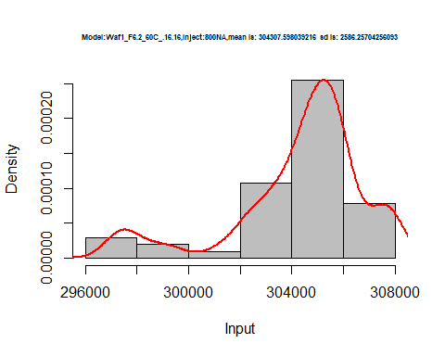

dens <- apply(d3_16.16, 2, density)  
plot('Model:Model:Waf1_F3.6_60C_.16.16', xlim=range(sapply(dens, "[", "x")), ylim=range(sapply(dens, "[", "y")))

## Warning in xy.coords(x, y, xlabel, ylabel, log): NAs introduced by coercion

mapply(lines, dens, col=1:length(dens))

## $V1  
## NULL  
##   
## $V2  
## NULL  
##   
## $V3  
## NULL  
##   
## $V4  
## NULL  
##   
## $V5  
## NULL  
##   
## $V6  
## NULL  
##   
## $V7  
## NULL  
##   
## $V8  
## NULL

legend("topright", legend=names(dens), fill=1:length(dens))

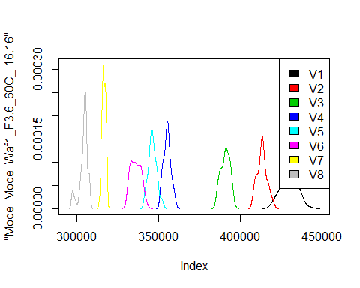

# Select columns whose names contains "17.17"  
d_17.17<-my_data %>% select(contains("17.17."))  
# head(d_17.17)

d1_17.17<-d_17.17[,c(1:8)]  
d1_17.17 <- head(d1_17.17,51)  
colnames(d1_17.17) <- c("V1", "V2","V3","V4","V5","V6","V7","V8")  
# head(d1_17.17)

hist(d1_17.17$V1,  
 cex.main=0.5,  
 freq = FALSE,  
 main = paste('Model:Waf1_F3.3_60C_17.17,Inject:100NA,mean is:', mean(d1_17.17$V1),' sd is:', sd(d1_17.17$V1)),  
 xlab = "Input",  
 ylab = "Density",  
 col="grey")  
#plot density curve  
lines(density(d1_17.17$V1), # density plot  
 lwd = 2, # thickness of line  
 col = "red")

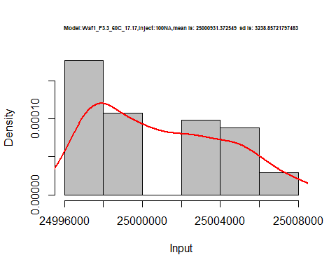

hist(d1_17.17$V2,  
 cex.main=0.5,  
 freq = FALSE,  
 main = paste('Model:Waf1_F3.3_60C_17.17,Inject:200NA,mean is:', mean(d1_17.17$V2),' sd is:', sd(d1_17.17$V2)),  
 xlab = "Input",  
 ylab = "Density",  
 col="grey")  
#plot density curve  
lines(density(d1_17.17$V2), # density plot  
 lwd = 2, # thickness of line  
 col = "red")

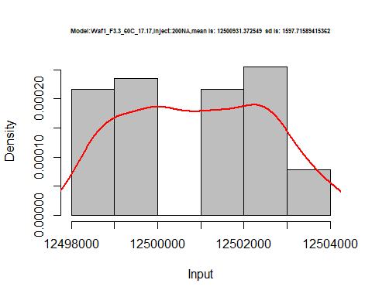

hist(d1_17.17$V3,  
 cex.main=0.5,  
 freq = FALSE,  
 main = paste('Model:Waf1_F3.3_60C_17.17,Inject:300NA,mean is:', mean(d1_17.17$V3),' sd is:', sd(d1_17.17$V3)),  
 xlab = "Input",  
 ylab = "Density",  
 col="grey")  
#plot density curve  
lines(density(d1_17.17$V3), # density plot  
 lwd = 2, # thickness of line  
 col = "red")

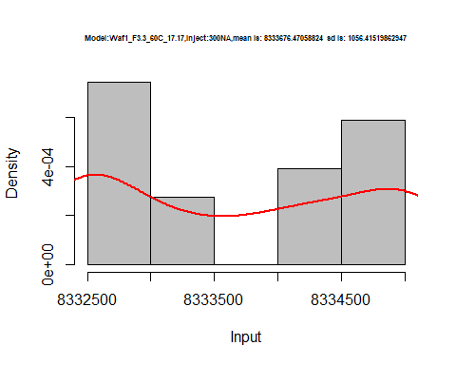

hist(d1_17.17$V4,  
 cex.main=0.5,  
 freq = FALSE,  
 main = paste('Model:Waf1_F3.3_60C_17.17,Inject:400NA,mean is:', mean(d1_17.17$V4),' sd is:', sd(d1_17.17$V4)),  
 xlab = "Input",  
 ylab = "Density",  
 col="grey")  
#plot density curve  
lines(density(d1_17.17$V4), # density plot  
 lwd = 2, # thickness of line  
 col = "red")

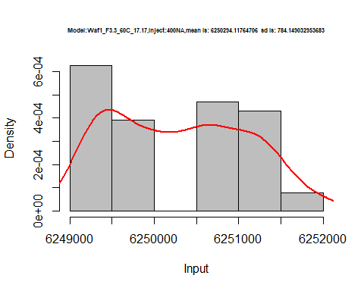

hist(d1_17.17$V5,  
 cex.main=0.5,  
 freq = FALSE,  
 main = paste('Model:Waf1_F3.3_60C_17.17,Inject:500NA,mean is:', mean(d1_17.17$V5),' sd is:', sd(d1_17.17$V5)),  
 xlab = "Input",  
 ylab = "Density",  
 col="grey")  
#plot density curve  
lines(density(d1_17.17$V5), # density plot  
 lwd = 2, # thickness of line  
 col = "red")

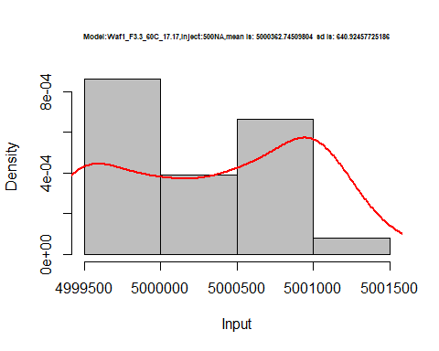

hist(d1_17.17$V6,  
 cex.main=0.5,  
 freq = FALSE,  
 main = paste('Model:Waf1_F3.3_60C_17.17,Inject:600NA,mean is:', mean(d1_17.17$V6),' sd is:', sd(d1_17.17$V6)),  
 xlab = "Input",  
 ylab = "Density",  
 col="grey")  
#plot density curve  
lines(density(d1_17.17$V6), # density plot  
 lwd = 2, # thickness of line  
 col = "red")

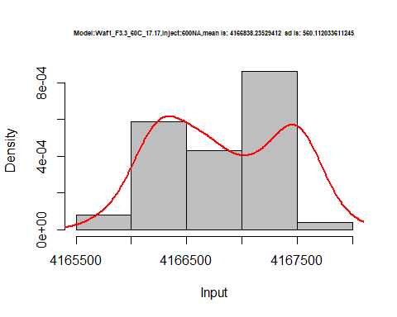

hist(d1_17.17$V7,  
 cex.main=0.5,  
 freq = FALSE,  
 main = paste('Model:Waf1_F3.3_60C_17.17,Inject:700NA,mean is:', mean(d1_17.17$V7),' sd is:', sd(d1_17.17$V7)),  
 xlab = "Input",  
 ylab = "Density",  
 col="grey")  
#plot density curve  
lines(density(d1_17.17$V7), # density plot  
 lwd = 2, # thickness of line  
 col = "red")

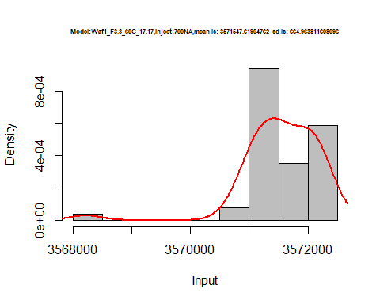

hist(d1_17.17$V8,  
 cex.main=0.5,  
 freq = FALSE,  
 main = paste('Model:Waf1_F3.3_60C_17.17,Inject:800NA,mean is:', mean(d1_17.17$V8),' sd is:', sd(d1_17.17$V8)),  
 xlab = "Input",  
 ylab = "Density",  
 col="grey")  
#plot density curve  
lines(density(d1_17.17$V8), # density plot  
 lwd = 2, # thickness of line  
 col = "red")

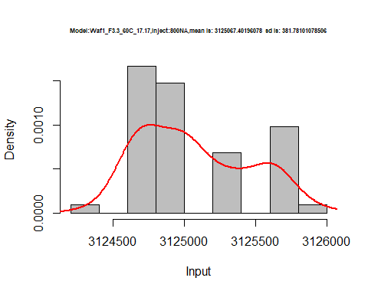

dens <- apply(d1_17.17, 2, density)  
plot('Model:Model:Waf1_F3.3_60C_17.17', xlim=range(sapply(dens, "[", "x")), ylim=range(sapply(dens, "[", "y")))

## Warning in xy.coords(x, y, xlabel, ylabel, log): NAs introduced by coercion

mapply(lines, dens, col=1:length(dens))

## $V1  
## NULL  
##   
## $V2  
## NULL  
##   
## $V3  
## NULL  
##   
## $V4  
## NULL  
##   
## $V5  
## NULL  
##   
## $V6  
## NULL  
##   
## $V7  
## NULL  
##   
## $V8  
## NULL

legend("topright", legend=names(dens), fill=1:length(dens))

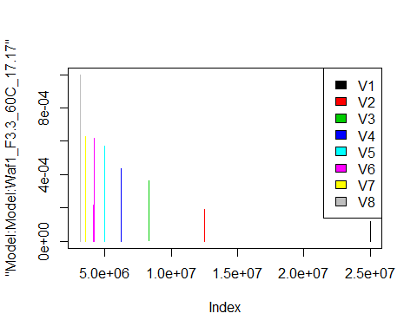

d2_17.17<-d_17.17[,c(9:16)]  
d2_17.17 <- head(d2_17.17,51)  
colnames(d2_17.17) <- c("V1", "V2","V3","V4","V5","V6","V7","V8")  
# head(d2_17.17)

hist(d2_17.17$V1,  
 cex.main=0.5,  
 freq = FALSE,  
 main = paste('Model:Waf1_F4.2_60C_.17.17,Inject:100NA,mean is:', mean(d2_17.17$V1),' sd is:', sd(d2_17.17$V1)),  
 xlab = "Input",  
 ylab = "Density",  
 col="grey")  
#plot density curve  
lines(density(d2_17.17$V1), # density plot  
 lwd = 2, # thickness of line  
 col = "red")

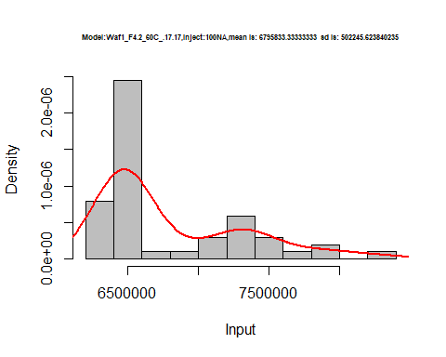

hist(d2_17.17$V2,  
 cex.main=0.5,  
 freq = FALSE,  
 main = paste('Model:Waf1_F4.2_60C_.17.17,Inject:200NA,mean is:', mean(d2_17.17$V2),' sd is:', sd(d2_17.17$V2)),  
 xlab = "Input",  
 ylab = "Density",  
 col="grey")  
#plot density curve  
lines(density(d2_17.17$V2), # density plot  
 lwd = 2, # thickness of line  
 col = "red")

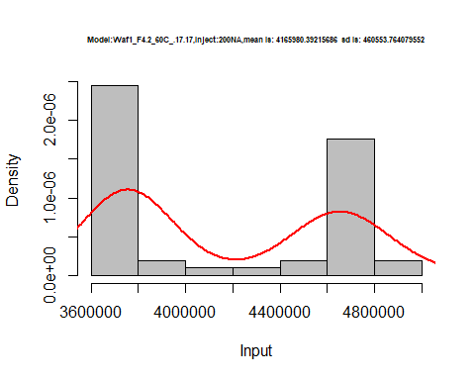

hist(d2_17.17$V3,  
 cex.main=0.5,  
 freq = FALSE,  
 main = paste('Model:Waf1_F4.2_60C_.17.17,Inject:300NA,mean is:', mean(d2_17.17$V3),' sd is:', sd(d2_17.17$V3)),  
 xlab = "Input",  
 ylab = "Density",  
 col="grey")  
#plot density curve  
lines(density(d2_17.17$V3), # density plot  
 lwd = 2, # thickness of line  
 col = "red")

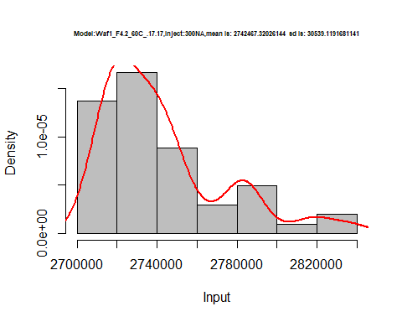

hist(d2_17.17$V4,  
 cex.main=0.5,  
 freq = FALSE,  
 main = paste('Model:Waf1_F4.2_60C_.17.17,Inject:400NA,mean is:', mean(d2_17.17$V4),' sd is:', sd(d2_17.17$V4)),  
 xlab = "Input",  
 ylab = "Density",  
 col="grey")  
#plot density curve  
lines(density(d2_17.17$V4), # density plot  
 lwd = 2, # thickness of line  
 col = "red")

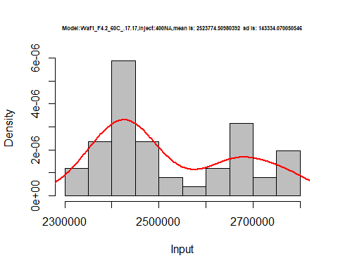

hist(d2_17.17$V5,  
 cex.main=0.5,  
 freq = FALSE,  
 main = paste('Model:Waf1_F4.2_60C_.17.17,Inject:500NA,mean is:', mean(d2_17.17$V5),' sd is:', sd(d2_17.17$V5)),  
 xlab = "Input",  
 ylab = "Density",  
 col="grey")  
#plot density curve  
lines(density(d2_17.17$V5), # density plot  
 lwd = 2, # thickness of line  
 col = "red")

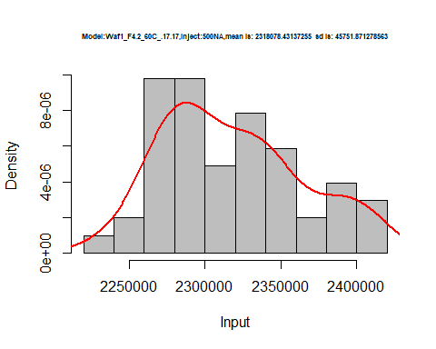

hist(d2_17.17$V6,  
 cex.main=0.5,  
 freq = FALSE,  
 main = paste('Model:Waf1_F4.2_60C_.17.17,Inject:600NA,mean is:', mean(d2_17.17$V6),' sd is:', sd(d2_17.17$V6)),  
 xlab = "Input",  
 ylab = "Density",  
 col="grey")  
#plot density curve  
lines(density(d2_17.17$V6), # density plot  
 lwd = 2, # thickness of line  
 col = "red")

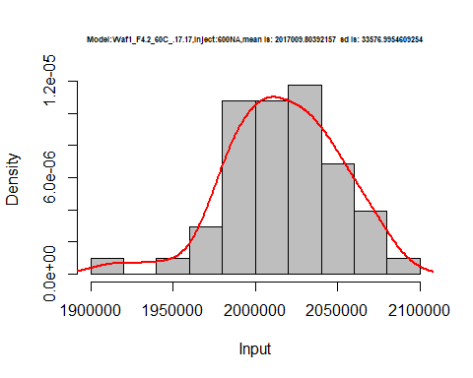

hist(d2_17.17$V7,  
 cex.main=0.5,  
 freq = FALSE,  
 main = paste('Model:Waf1_F4.2_60C_.17.17,Inject:700NA,mean is:', mean(d2_17.17$V7),' sd is:', sd(d2_17.17$V7)),  
 xlab = "Input",  
 ylab = "Density",  
 col="grey")  
#plot density curve  
lines(density(d2_17.17$V7), # density plot  
 lwd = 2, # thickness of line  
 col = "red")

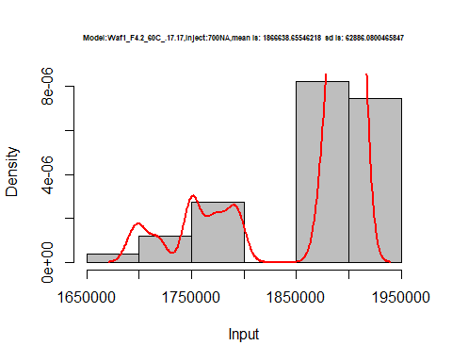

hist(d2_17.17$V8,  
 cex.main=0.5,  
 freq = FALSE,  
 main = paste('Model:Waf1_F4.2_60C_.17.17,Inject:800NA,mean is:', mean(d2_17.17$V8),' sd is:', sd(d2_17.17$V8)),  
 xlab = "Input",  
 ylab = "Density",  
 col="grey")  
#plot density curve  
lines(density(d2_17.17$V8), # density plot  
 lwd = 2, # thickness of line  
 col = "red")

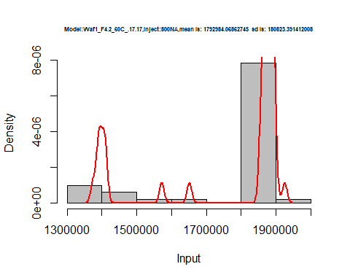

dens <- apply(d2_17.17, 2, density)  
plot('Model:Waf1_F4.2_60C_.17.17', xlim=range(sapply(dens, "[", "x")), ylim=range(sapply(dens, "[", "y")))

## Warning in xy.coords(x, y, xlabel, ylabel, log): NAs introduced by coercion

mapply(lines, dens, col=1:length(dens))

## $V1  
## NULL  
##   
## $V2  
## NULL  
##   
## $V3  
## NULL  
##   
## $V4  
## NULL  
##   
## $V5  
## NULL  
##   
## $V6  
## NULL  
##   
## $V7  
## NULL  
##   
## $V8  
## NULL

legend("topright", legend=names(dens), fill=1:length(dens))

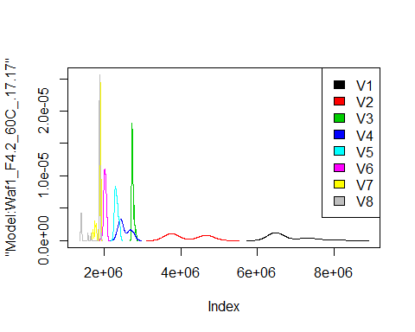

d3_17.17<-d_17.17[,c(17:24)]  
d3_17.17 <- head(d3_17.17,51)  
colnames(d3_17.17) <- c("V1", "V2","V3","V4","V5","V6","V7","V8")  
# head(d3_17.17)

hist(d3_17.17$V1,  
 cex.main=0.5,  
 freq = FALSE,  
 main = paste('Model:Waf1_F6.3_60C_.17.17,Inject:100NA,mean is:', mean(d3_17.17$V1),' sd is:', sd(d3_17.17$V1)),  
 xlab = "Input",  
 ylab = "Density",  
 col="grey")  
#plot density curve  
lines(density(d3_17.17$V1), # density plot  
 lwd = 2, # thickness of line  
 col = "red")

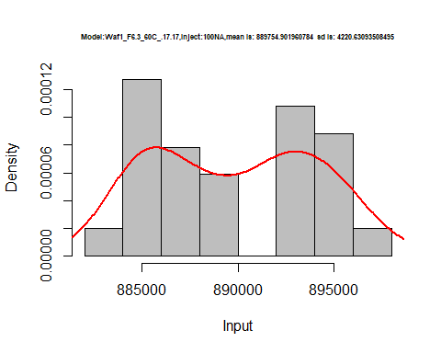

hist(d3_17.17$V2,  
 cex.main=0.5,  
 freq = FALSE,  
 main = paste('Model:Waf1_F6.3_60C_.17.17,Inject:200NA,mean is:', mean(d3_17.17$V2),' sd is:', sd(d3_17.17$V2)),  
 xlab = "Input",  
 ylab = "Density",  
 col="grey")  
#plot density curve  
lines(density(d3_17.17$V2), # density plot  
 lwd = 2, # thickness of line  
 col = "red")

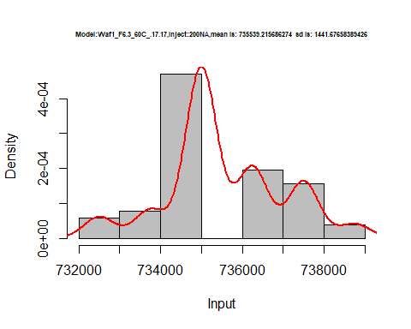

hist(d3_17.17$V3,  
 cex.main=0.5,  
 freq = FALSE,  
 main = paste('Model:Waf1_F6.3_60C_.17.17,Inject:300NA,mean is:', mean(d3_17.17$V3),' sd is:', sd(d3_17.17$V3)),  
 xlab = "Input",  
 ylab = "Density",  
 col="grey")  
#plot density curve  
lines(density(d3_17.17$V3), # density plot  
 lwd = 2, # thickness of line  
 col = "red")

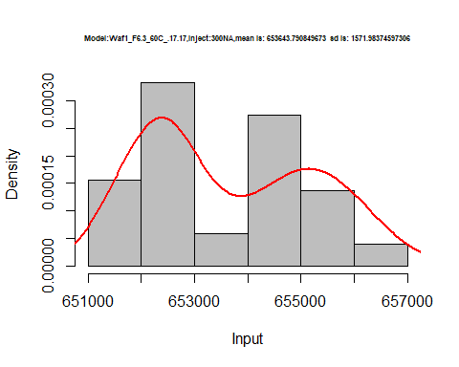

hist(d3_17.17$V4,  
 cex.main=0.5,  
 freq = FALSE,  
 main = paste('Model:Waf1_F6.3_60C_.17.17,Inject:400NA,mean is:', mean(d3_17.17$V4),' sd is:', sd(d3_17.17$V4)),  
 xlab = "Input",  
 ylab = "Density",  
 col="grey")  
#plot density curve  
lines(density(d3_17.17$V4), # density plot  
 lwd = 2, # thickness of line  
 col = "red")

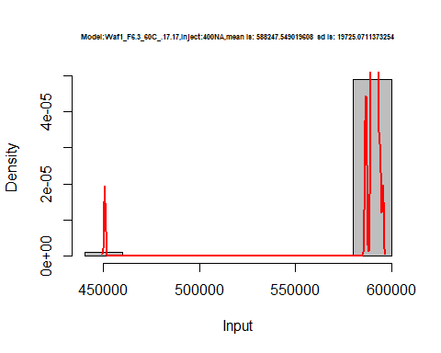

hist(d3_17.17$V5,  
 cex.main=0.5,  
 freq = FALSE,  
 main = paste('Model:Waf1_F6.3_60C_.17.17,Inject:500NA,mean is:', mean(d3_17.17$V5),' sd is:', sd(d3_17.17$V5)),  
 xlab = "Input",  
 ylab = "Density",  
 col="grey")  
#plot density curve  
lines(density(d3_17.17$V5), # density plot  
 lwd = 2, # thickness of line  
 col = "red")

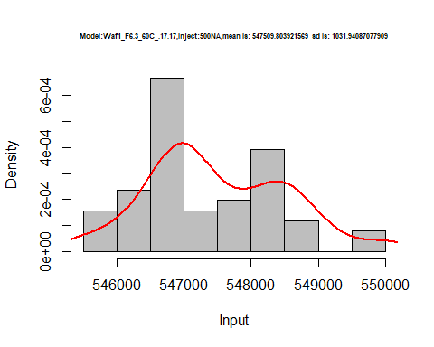

hist(d3_17.17$V6,  
 cex.main=0.5,  
 freq = FALSE,  
 main = paste('Model:Waf1_F6.3_60C_.17.17,Inject:600NA,mean is:', mean(d3_17.17$V6),' sd is:', sd(d3_17.17$V6)),  
 xlab = "Input",  
 ylab = "Density",  
 col="grey")  
#plot density curve  
lines(density(d3_17.17$V6), # density plot  
 lwd = 2, # thickness of line  
 col = "red")

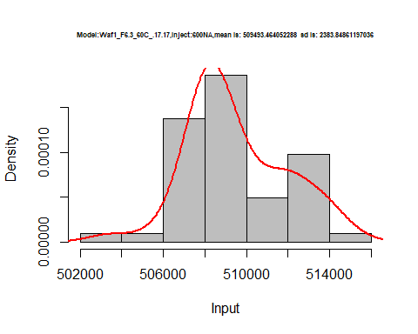

hist(d3_17.17$V7,  
 cex.main=0.5,  
 freq = FALSE,  
 main = paste('Model:Waf1_F6.3_60C_.17.17,Inject:700NA,mean is:', mean(d3_17.17$V7),' sd is:', sd(d3_17.17$V7)),  
 xlab = "Input",  
 ylab = "Density",  
 col="grey")  
#plot density curve  
lines(density(d3_17.17$V7), # density plot  
 lwd = 2, # thickness of line  
 col = "red")

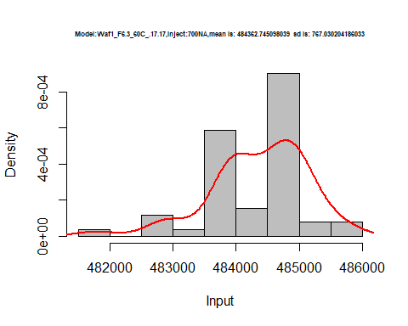

hist(d3_17.17$V8,  
 cex.main=0.5,  
 freq = FALSE,  
 main = paste('Model:Waf1_F6.3_60C_.17.17,Inject:800NA,mean is:', mean(d3_17.17$V8),' sd is:', sd(d3_17.17$V8)),  
 xlab = "Input",  
 ylab = "Density",  
 col="grey")  
#plot density curve  
lines(density(d3_17.17$V8), # density plot  
 lwd = 2, # thickness of line  
 col = "red")

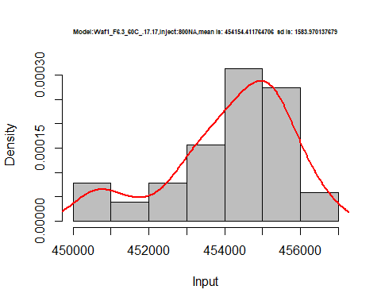

dens <- apply(d3_17.17, 2, density)  
plot('Model:Waf1_F6.3_60C_.17.17', xlim=range(sapply(dens, "[", "x")), ylim=range(sapply(dens, "[", "y")))

## Warning in xy.coords(x, y, xlabel, ylabel, log): NAs introduced by coercion

mapply(lines, dens, col=1:length(dens))

## $V1  
## NULL  
##   
## $V2  
## NULL  
##   
## $V3  
## NULL  
##   
## $V4  
## NULL  
##   
## $V5  
## NULL  
##   
## $V6  
## NULL  
##   
## $V7  
## NULL  
##   
## $V8  
## NULL

legend("topright", legend=names(dens), fill=1:length(dens))

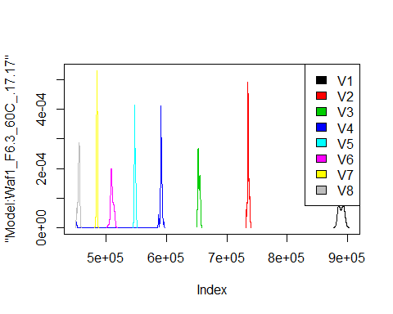

# Select columns whose names contains "18.18"  
d_18.18<-my_data %>% select(contains("18.18."))  
#head(d_18.18)

d1_18.18<-d_18.18[,c(1:8)]  
d1_18.18 <- head(d1_18.18,51)  
colnames(d1_18.18) <- c("V1", "V2","V3","V4","V5","V6","V7","V8")  
# head(d1_18.18)

hist(d1_18.18$V1,  
 cex.main=0.5,  
 freq = FALSE,  
 main = paste('Model:Waf1_F5.1_60C_.18.18,Inject:100NA,mean is:', mean(d1_18.18$V1),' sd is:', sd(d1_18.18$V1)),  
 xlab = "Input",  
 ylab = "Density",  
 col="grey")  
#plot density curve  
lines(density(d1_18.18$V1), # density plot  
 lwd = 2, # thickness of line  
 col = "red")

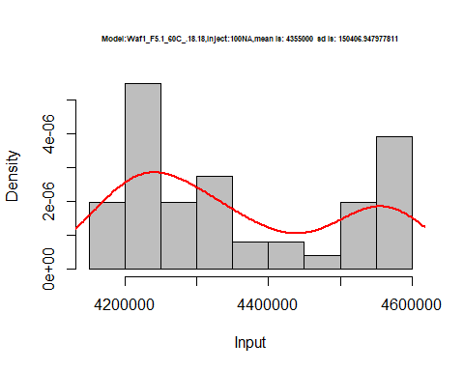

hist(d1_18.18$V2,  
 cex.main=0.5,  
 freq = FALSE,  
 main = paste('Model:Waf1_F5.1_60C_.18.18,Inject:200NA,mean is:', mean(d1_18.18$V2),' sd is:', sd(d1_18.18$V2)),  
 xlab = "Input",  
 ylab = "Density",  
 col="grey")  
#plot density curve  
lines(density(d1_18.18$V2), # density plot  
 lwd = 2, # thickness of line  
 col = "red")

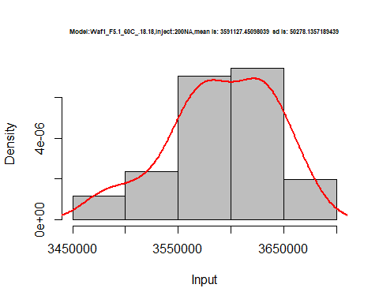

hist(d1_18.18$V3,  
 cex.main=0.5,  
 freq = FALSE,  
 main = paste('Model:Waf1_F5.1_60C_.18.18,Inject:300NA,mean is:', mean(d1_18.18$V3),' sd is:', sd(d1_18.18$V3)),  
 xlab = "Input",  
 ylab = "Density",  
 col="grey")  
#plot density curve  
lines(density(d1_18.18$V3), # density plot  
 lwd = 2, # thickness of line  
 col = "red")

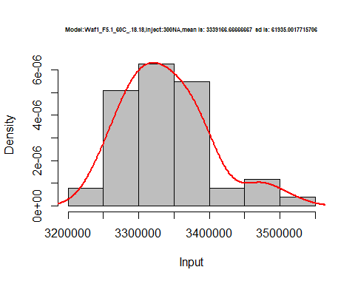

hist(d1_18.18$V4,  
 cex.main=0.5,  
 freq = FALSE,  
 main = paste('Model:Waf1_F5.1_60C_.18.18,Inject:400NA,mean is:', mean(d1_18.18$V4),' sd is:', sd(d1_18.18$V4)),  
 xlab = "Input",  
 ylab = "Density",  
 col="grey")  
#plot density curve  
lines(density(d1_18.18$V4), # density plot  
 lwd = 2, # thickness of line  
 col = "red")

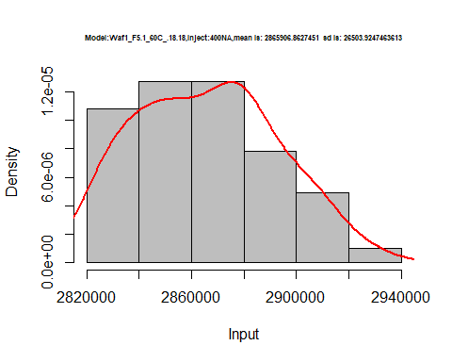

hist(d1_18.18$V5,  
 cex.main=0.5,  
 freq = FALSE,  
 main = paste('Model:Waf1_F5.1_60C_.18.18,Inject:500NA,mean is:', mean(d1_18.18$V5),' sd is:', sd(d1_18.18$V5)),  
 xlab = "Input",  
 ylab = "Density",  
 col="grey")  
#plot density curve  
lines(density(d1_18.18$V5), # density plot  
 lwd = 2, # thickness of line  
 col = "red")

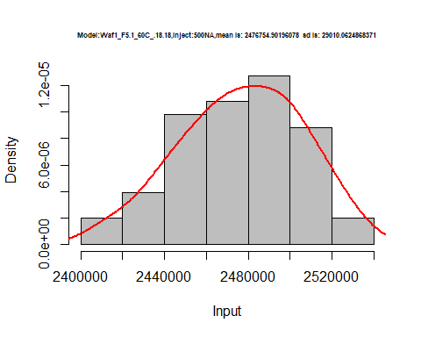

hist(d1_18.18$V6,  
 cex.main=0.5,  
 freq = FALSE,  
 main = paste('Model:Waf1_F5.1_60C_.18.18,Inject:600NA,mean is:', mean(d1_18.18$V6),' sd is:', sd(d1_18.18$V6)),  
 xlab = "Input",  
 ylab = "Density",  
 col="grey")  
#plot density curve  
lines(density(d1_18.18$V6), # density plot  
 lwd = 2, # thickness of line  
 col = "red")

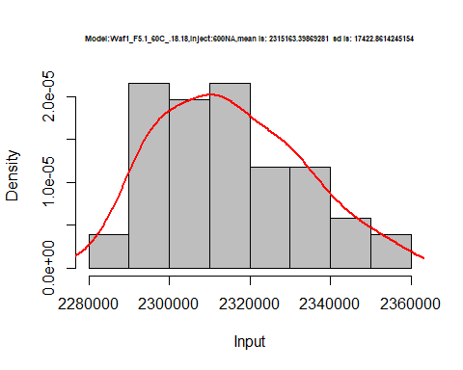

hist(d1_18.18$V7,  
 cex.main=0.5,  
 freq = FALSE,  
 main = paste('Model:Waf1_F5.1_60C_.18.18,Inject:700NA,mean is:', mean(d1_18.18$V7),' sd is:', sd(d1_18.18$V7)),  
 xlab = "Input",  
 ylab = "Density",  
 col="grey")  
#plot density curve  
lines(density(d1_18.18$V7), # density plot  
 lwd = 2, # thickness of line  
 col = "red")

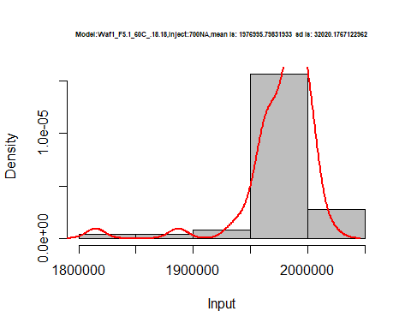

hist(d1_18.18$V8,  
 cex.main=0.5,  
 freq = FALSE,  
 main = paste('Model:Waf1_F5.1_60C_.18.18,Inject:800NA,mean is:', mean(d1_18.18$V8),' sd is:', sd(d1_18.18$V8)),  
 xlab = "Input",  
 ylab = "Density",  
 col="grey")  
#plot density curve  
lines(density(d1_18.18$V8), # density plot  
 lwd = 2, # thickness of line  
 col = "red")

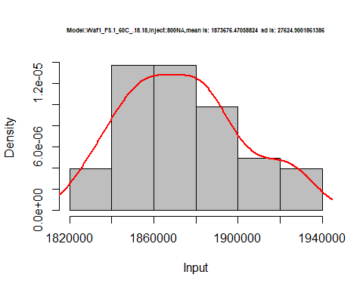

dens <- apply(d1_18.18, 2, density)  
plot('Model:Waf1_F5.1_60C_.18.18', xlim=range(sapply(dens, "[", "x")), ylim=range(sapply(dens, "[", "y")))

## Warning in xy.coords(x, y, xlabel, ylabel, log): NAs introduced by coercion

mapply(lines, dens, col=1:length(dens))

## $V1  
## NULL  
##   
## $V2  
## NULL  
##   
## $V3  
## NULL  
##   
## $V4  
## NULL  
##   
## $V5  
## NULL  
##   
## $V6  
## NULL  
##   
## $V7  
## NULL  
##   
## $V8  
## NULL

legend("topright", legend=names(dens), fill=1:length(dens))

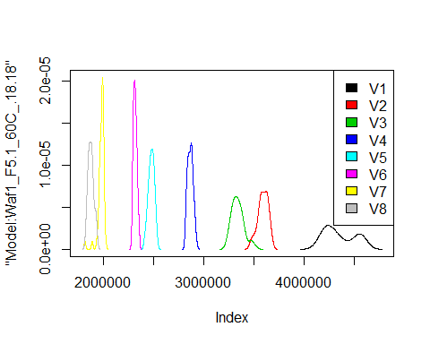

# Select columns whose names contains "19.19"  
d_19.19<-my_data %>% select(contains("19.19."))  
#head(d_19.19)

d1_19.19<-d_19.19[,c(1:8)]  
d1_19.19 <- head(d1_19.19,51)  
colnames(d1_19.19) <- c("V1", "V2","V3","V4","V5","V6","V7","V8")  
# head(d1_19.19)

hist(d1_19.19$V1,  
 cex.main=0.5,  
 freq = FALSE,  
 main = paste('Model:Waf1_F2.5_60C_.19.19,Inject:100NA,mean is:', mean(d1_19.19$V1),' sd is:', sd(d1_19.19$V1)),  
 xlab = "Input",  
 ylab = "Density",  
 col="grey")  
#plot density curve  
lines(density(d1_19.19$V1), # density plot  
 lwd = 2, # thickness of line  
 col = "red")

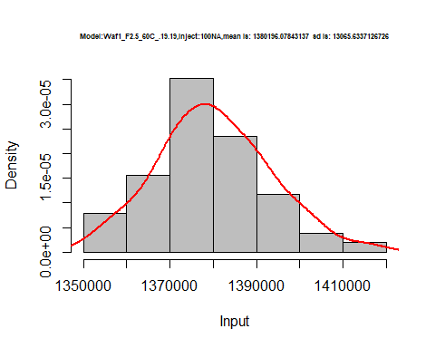

hist(d1_19.19$V2,  
 cex.main=0.5,  
 freq = FALSE,  
 main = paste('Model:Waf1_F2.5_60C_.19.19,Inject:200NA,mean is:', mean(d1_19.19$V2),' sd is:', sd(d1_19.19$V2)),  
 xlab = "Input",  
 ylab = "Density",  
 col="grey")  
#plot density curve  
lines(density(d1_19.19$V2), # density plot  
 lwd = 2, # thickness of line  
 col = "red")

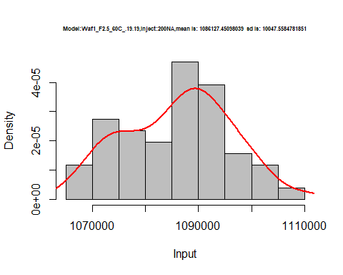

hist(d1_19.19$V3,  
 cex.main=0.5,  
 freq = FALSE,  
 main = paste('Model:Waf1_F2.5_60C_.19.19,Inject:300NA,mean is:', mean(d1_19.19$V3),' sd is:', sd(d1_19.19$V3)),  
 xlab = "Input",  
 ylab = "Density",  
 col="grey")  
#plot density curve  
lines(density(d1_19.19$V3), # density plot  
 lwd = 2, # thickness of line  
 col = "red")

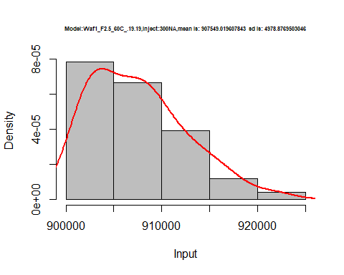

hist(d1_19.19$V4,  
 cex.main=0.5,  
 freq = FALSE,  
 main = paste('Model:Waf1_F2.5_60C_.19.19,Inject:400NA,mean is:', mean(d1_19.19$V4),' sd is:', sd(d1_19.19$V4)),  
 xlab = "Input",  
 ylab = "Density",  
 col="grey")  
#plot density curve  
lines(density(d1_19.19$V4), # density plot  
 lwd = 2, # thickness of line  
 col = "red")

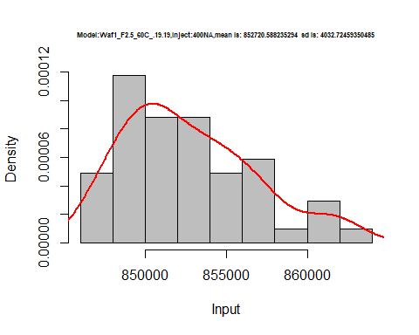

hist(d1_19.19$V5,  
 cex.main=0.5,  
 freq = FALSE,  
 main = paste('Model:Waf1_F2.5_60C_.19.19,Inject:500NA,mean is:', mean(d1_19.19$V5),' sd is:', sd(d1_19.19$V5)),  
 xlab = "Input",  
 ylab = "Density",  
 col="grey")  
#plot density curve  
lines(density(d1_19.19$V5), # density plot  
 lwd = 2, # thickness of line  
 col = "red")

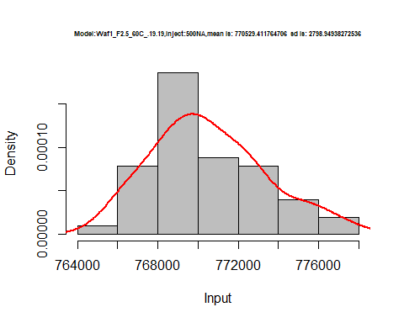

hist(d1_19.19$V6,  
 cex.main=0.5,  
 freq = FALSE,  
 main = paste('Model:Waf1_F2.5_60C_.19.19,Inject:600NA,mean is:', mean(d1_19.19$V6),' sd is:', sd(d1_19.19$V6)),  
 xlab = "Input",  
 ylab = "Density",  
 col="grey")  
#plot density curve  
lines(density(d1_19.19$V6), # density plot  
 lwd = 2, # thickness of line  
 col = "red")

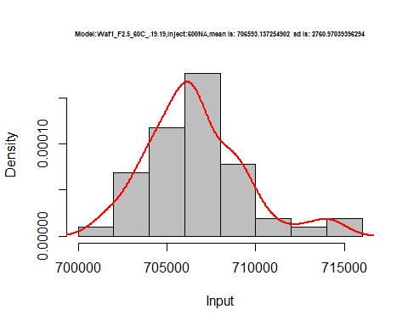

hist(d1_19.19$V7,  
 cex.main=0.5,  
 freq = FALSE,  
 main = paste('Model:Waf1_F2.5_60C_.19.19,Inject:700NA,mean is:', mean(d1_19.19$V7),' sd is:', sd(d1_19.19$V7)),  
 xlab = "Input",  
 ylab = "Density",  
 col="grey")  
#plot density curve  
lines(density(d1_19.19$V7), # density plot  
 lwd = 2, # thickness of line  
 col = "red")

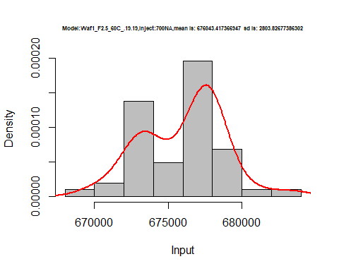

hist(d1_19.19$V8,  
 cex.main=0.5,  
 freq = FALSE,  
 main = paste('Model:Waf1_F2.5_60C_.19.19,Inject:800NA,mean is:', mean(d1_19.19$V8),' sd is:', sd(d1_19.19$V8)),  
 xlab = "Input",  
 ylab = "Density",  
 col="grey")  
#plot density curve  
lines(density(d1_19.19$V8), # density plot  
 lwd = 2, # thickness of line  
 col = "red")

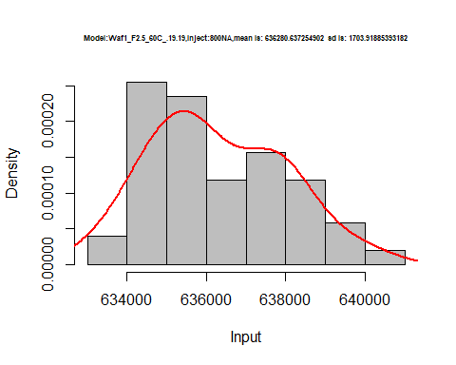

dens <- apply(d1_19.19, 2, density)  
plot('Model:Waf1_F2.5_60C_.19.19', xlim=range(sapply(dens, "[", "x")), ylim=range(sapply(dens, "[", "y")))

## Warning in xy.coords(x, y, xlabel, ylabel, log): NAs introduced by coercion

mapply(lines, dens, col=1:length(dens))

## $V1  
## NULL  
##   
## $V2  
## NULL  
##   
## $V3  
## NULL  
##   
## $V4  
## NULL  
##   
## $V5  
## NULL  
##   
## $V6  
## NULL  
##   
## $V7  
## NULL  
##   
## $V8  
## NULL

legend("topright", legend=names(dens), fill=1:length(dens))

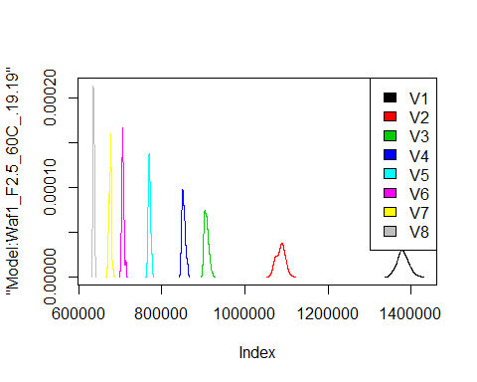

d2_19.19<-d_19.19[,c(9:16)]  
d2_19.19 <- head(d2_19.19,51)  
colnames(d2_19.19) <- c("V1", "V2","V3","V4","V5","V6","V7","V8")  
# head(d2_19.19)

hist(d2_19.19$V1,  
 cex.main=0.5,  
 freq = FALSE,  
 main = paste('Model:Waf1_F4.4_60C_.19.19,Inject:100NA,mean is:', mean(d2_19.19$V1),' sd is:', sd(d2_19.19$V1)),  
 xlab = "Input",  
 ylab = "Density",  
 col="grey")  
#plot density curve  
lines(density(d2_19.19$V1), # density plot  
 lwd = 2, # thickness of line  
 col = "red")

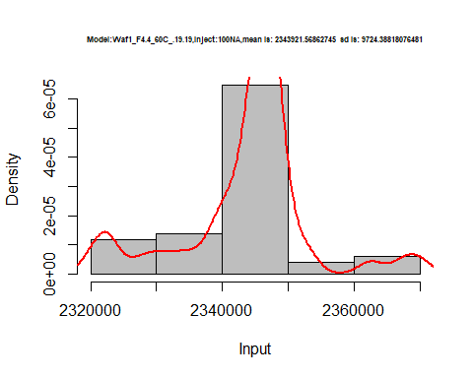

hist(d2_19.19$V2,  
 cex.main=0.5,  
 freq = FALSE,  
 main = paste('Model:Waf1_F4.4_60C_.19.19,Inject:200NA,mean is:', mean(d2_19.19$V2),' sd is:', sd(d2_19.19$V2)),  
 xlab = "Input",  
 ylab = "Density",  
 col="grey")  
#plot density curve  
lines(density(d2_19.19$V2), # density plot  
 lwd = 2, # thickness of line  
 col = "red")

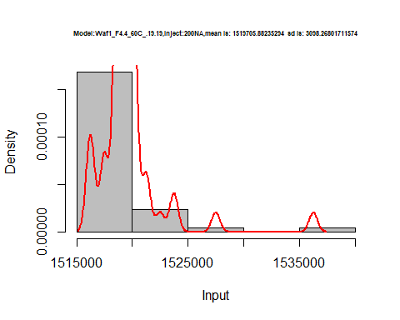

hist(d2_19.19$V3,  
 cex.main=0.5,  
 freq = FALSE,  
 main = paste('Model:Waf1_F4.4_60C_.19.19,Inject:300NA,mean is:', mean(d2_19.19$V3),' sd is:', sd(d2_19.19$V3)),  
 xlab = "Input",  
 ylab = "Density",  
 col="grey")  
#plot density curve  
lines(density(d2_19.19$V3), # density plot  
 lwd = 2, # thickness of line  
 col = "red")

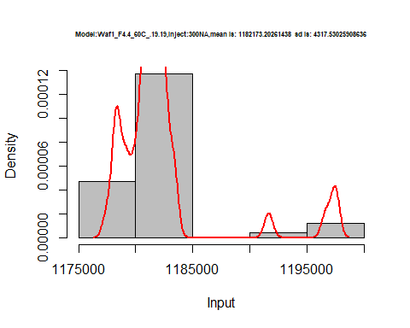

hist(d2_19.19$V4,  
 cex.main=0.5,  
 freq = FALSE,  
 main = paste('Model:Waf1_F4.4_60C_.19.19,Inject:400NA,mean is:', mean(d2_19.19$V4),' sd is:', sd(d2_19.19$V4)),  
 xlab = "Input",  
 ylab = "Density",  
 col="grey")  
#plot density curve  
lines(density(d2_19.19$V4), # density plot  
 lwd = 2, # thickness of line  
 col = "red")

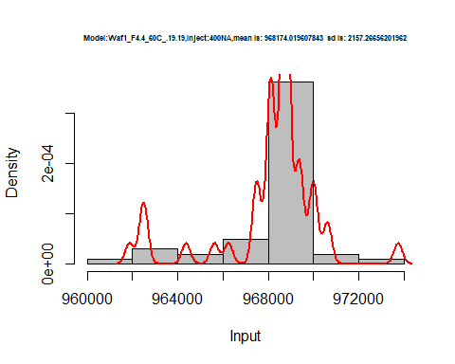

hist(d2_19.19$V5,  
 cex.main=0.5,  
 freq = FALSE,  
 main = paste('Model:Waf1_F4.4_60C_.19.19,Inject:500NA,mean is:', mean(d2_19.19$V5),' sd is:', sd(d2_19.19$V5)),  
 xlab = "Input",  
 ylab = "Density",  
 col="grey")  
#plot density curve  
lines(density(d2_19.19$V5), # density plot  
 lwd = 2, # thickness of line  
 col = "red")

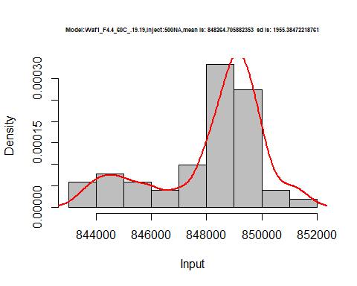

hist(d2_19.19$V6,  
 cex.main=0.5,  
 freq = FALSE,  
 main = paste('Model:Waf1_F4.4_60C_.19.19,Inject:600NA,mean is:', mean(d2_19.19$V6),' sd is:', sd(d2_19.19$V6)),  
 xlab = "Input",  
 ylab = "Density",  
 col="grey")  
#plot density curve  
lines(density(d2_19.19$V6), # density plot  
 lwd = 2, # thickness of line  
 col = "red")

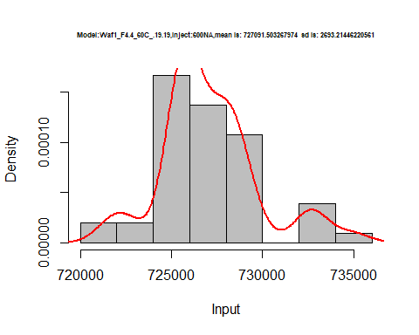

hist(d2_19.19$V7,  
 cex.main=0.5,  
 freq = FALSE,  
 main = paste('Model:Waf1_F4.4_60C_.19.19,Inject:700NA,mean is:', mean(d2_19.19$V7),' sd is:', sd(d2_19.19$V7)),  
 xlab = "Input",  
 ylab = "Density",  
 col="grey")  
#plot density curve  
lines(density(d2_19.19$V7), # density plot  
 lwd = 2, # thickness of line  
 col = "red")

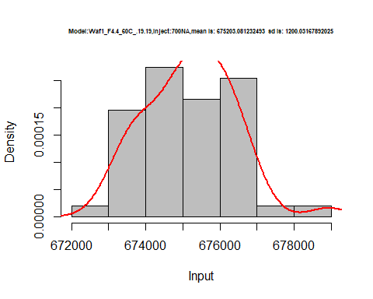

hist(d2_19.19$V8,  
 cex.main=0.5,  
 freq = FALSE,  
 main = paste('Model:Waf1_F4.4_60C_.19.19,Inject:800NA,mean is:', mean(d2_19.19$V8),' sd is:', sd(d2_19.19$V8)),  
 xlab = "Input",  
 ylab = "Density",  
 col="grey")  
#plot density curve  
lines(density(d2_19.19$V8), # density plot  
 lwd = 2, # thickness of line  
 col = "red")

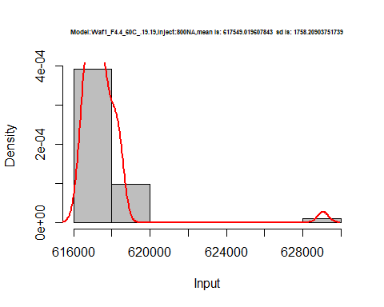

dens <- apply(d2_19.19, 2, density)  
plot('Model:Waf1_F4.4_60C_.19.19', xlim=range(sapply(dens, "[", "x")), ylim=range(sapply(dens, "[", "y")))

## Warning in xy.coords(x, y, xlabel, ylabel, log): NAs introduced by coercion

mapply(lines, dens, col=1:length(dens))

## $V1  
## NULL  
##   
## $V2  
## NULL  
##   
## $V3  
## NULL  
##   
## $V4  
## NULL  
##   
## $V5  
## NULL  
##   
## $V6  
## NULL  
##   
## $V7  
## NULL  
##   
## $V8  
## NULL

legend("topright", legend=names(dens), fill=1:length(dens))

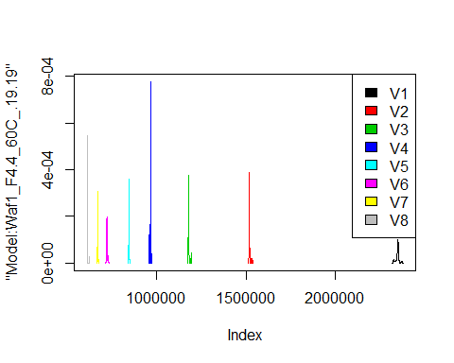

d3_19.19<-d_19.19[,c(17:24)]  
d3_19.19 <- head(d3_19.19,51)  
colnames(d3_19.19) <- c("V1", "V2","V3","V4","V5","V6","V7","V8")  
# head(d3_19.19)

hist(d3_19.19$V1,  
 cex.main=0.5,  
 freq = FALSE,  
 main = paste('Model:Waf1_F4.7_60C_.19.19,Inject:100NA,mean is:', mean(d3_19.19$V1),' sd is:', sd(d3_19.19$V1)),  
 xlab = "Input",  
 ylab = "Density",  
 col="grey")  
#plot density curve  
lines(density(d3_19.19$V1), # density plot  
 lwd = 2, # thickness of line  
 col = "red")

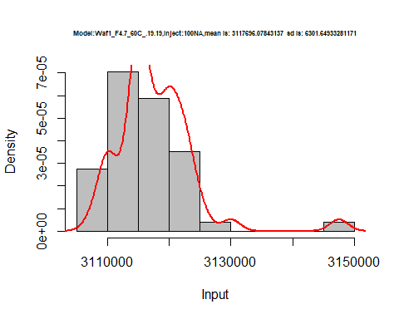

hist(d3_19.19$V2,  
 cex.main=0.5,  
 freq = FALSE,  
 main = paste('Model:Waf1_F4.7_60C_.19.19,Inject:200NA,mean is:', mean(d3_19.19$V2),' sd is:', sd(d3_19.19$V2)),  
 xlab = "Input",  
 ylab = "Density",  
 col="grey")  
#plot density curve  
lines(density(d3_19.19$V2), # density plot  
 lwd = 2, # thickness of line  
 col = "red")

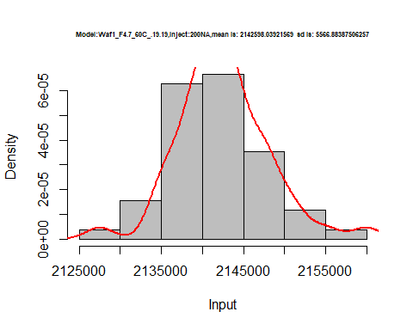

hist(d3_19.19$V3,  
 cex.main=0.5,  
 freq = FALSE,  
 main = paste('Model:Waf1_F4.7_60C_.19.19,Inject:300NA,mean is:', mean(d3_19.19$V3),' sd is:', sd(d3_19.19$V3)),  
 xlab = "Input",  
 ylab = "Density",  
 col="grey")  
#plot density curve  
lines(density(d3_19.19$V3), # density plot  
 lwd = 2, # thickness of line  
 col = "red")

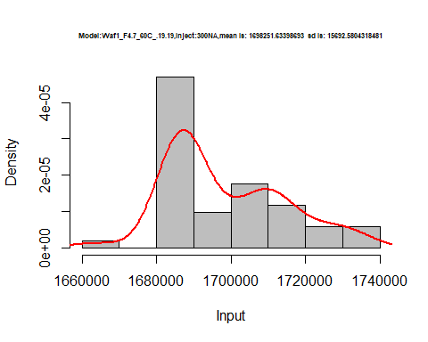

hist(d3_19.19$V4,  
 cex.main=0.5,  
 freq = FALSE,  
 main = paste('Model:Waf1_F4.7_60C_.19.19,Inject:400NA,mean is:', mean(d3_19.19$V4),' sd is:', sd(d3_19.19$V4)),  
 xlab = "Input",  
 ylab = "Density",  
 col="grey")  
#plot density curve  
lines(density(d3_19.19$V4), # density plot  
 lwd = 2, # thickness of line  
 col = "red")

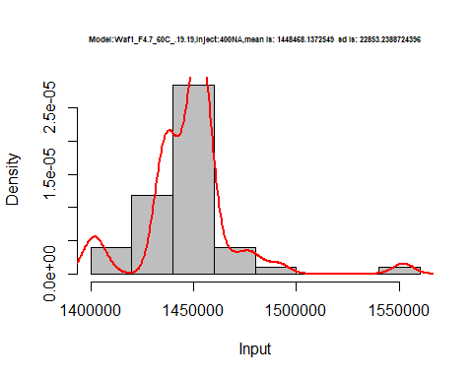

hist(d3_19.19$V5,  
 cex.main=0.5,  
 freq = FALSE,  
 main = paste('Model:Waf1_F4.7_60C_.19.19,Inject:500NA,mean is:', mean(d3_19.19$V5),' sd is:', sd(d3_19.19$V5)),  
 xlab = "Input",  
 ylab = "Density",  
 col="grey")  
#plot density curve  
lines(density(d3_19.19$V5), # density plot  
 lwd = 2, # thickness of line  
 col = "red")

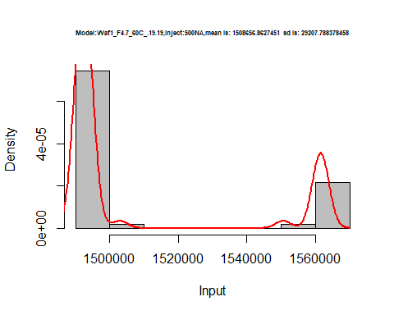

hist(d3_19.19$V6,  
 cex.main=0.5,  
 freq = FALSE,  
 main = paste('Model:Waf1_F4.7_60C_.19.19,Inject:600NA,mean is:', mean(d3_19.19$V6),' sd is:', sd(d3_19.19$V6)),  
 xlab = "Input",  
 ylab = "Density",  
 col="grey")  
#plot density curve  
lines(density(d3_19.19$V6), # density plot  
 lwd = 2, # thickness of line  
 col = "red")

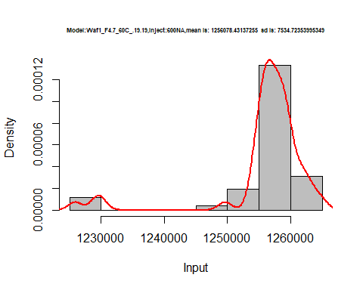

hist(d3_19.19$V7,  
 cex.main=0.5,  
 freq = FALSE,  
 main = paste('Model:Waf1_F4.7_60C_.19.19,Inject:700NA,mean is:', mean(d3_19.19$V7),' sd is:', sd(d3_19.19$V7)),  
 xlab = "Input",  
 ylab = "Density",  
 col="grey")  
#plot density curve  
lines(density(d3_19.19$V7), # density plot  
 lwd = 2, # thickness of line  
 col = "red")

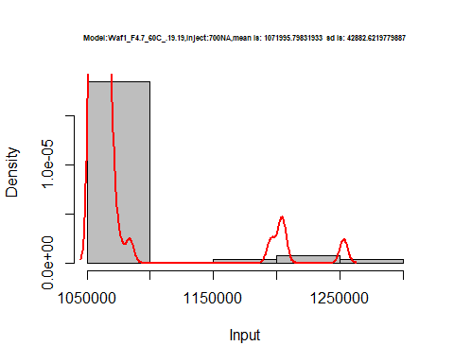

hist(d3_19.19$V8,  
 cex.main=0.5,  
 freq = FALSE,  
 main = paste('Model:Waf1_F4.7_60C_.19.19,Inject:800NA,mean is:', mean(d3_19.19$V8),' sd is:', sd(d3_19.19$V8)),  
 xlab = "Input",  
 ylab = "Density",  
 col="grey")  
#plot density curve  
lines(density(d3_19.19$V8), # density plot  
 lwd = 2, # thickness of line  
 col = "red")

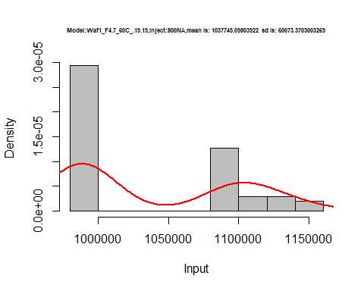

dens <- apply(d3_19.19, 2, density)  
plot('Model:Waf1_F4.7_60C_.19.19', xlim=range(sapply(dens, "[", "x")), ylim=range(sapply(dens, "[", "y")))

## Warning in xy.coords(x, y, xlabel, ylabel, log): NAs introduced by coercion

mapply(lines, dens, col=1:length(dens))

## $V1  
## NULL  
##   
## $V2  
## NULL  
##   
## $V3  
## NULL  
##   
## $V4  
## NULL  
##   
## $V5  
## NULL  
##   
## $V6  
## NULL  
##   
## $V7  
## NULL  
##   
## $V8  
## NULL

legend("topright", legend=names(dens), fill=1:length(dens))

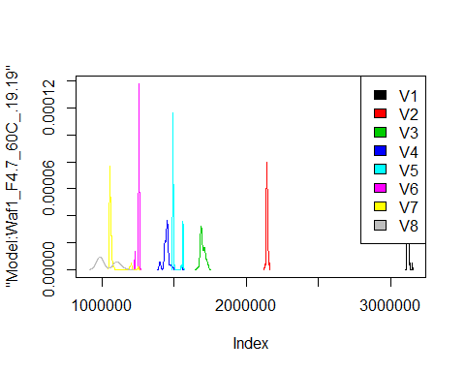

d4_19.19<-d_19.19[,c(25:32)]  
d4_19.19 <- head(d4_19.19,51)  
colnames(d4_19.19) <- c("V1", "V2","V3","V4","V5","V6","V7","V8")  
# head(d4_19.19)

hist(d4_19.19$V1,  
 cex.main=0.5,  
 freq = FALSE,  
 main = paste('Model:Waf1_F5.7_60C_.19.19.,Inject:100NA,mean is:', mean(d4_19.19$V1),' sd is:', sd(d4_19.19$V1)),  
 xlab = "Input",  
 ylab = "Density",  
 col="grey")  
#plot density curve  
lines(density(d4_19.19$V1), # density plot  
 lwd = 2, # thickness of line  
 col = "red")

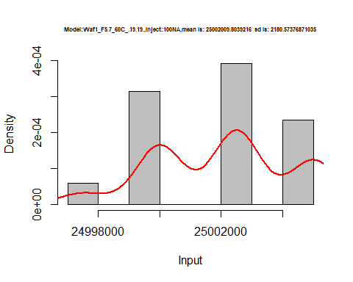

hist(d4_19.19$V2,  
 cex.main=0.5,  
 freq = FALSE,  
 main = paste('Model:Waf1_F5.7_60C_.19.19.,Inject:100NA,mean is:', mean(d4_19.19$V2),' sd is:', sd(d4_19.19$V2)),  
 xlab = "Input",  
 ylab = "Density",  
 col="grey")  
#plot density curve  
lines(density(d4_19.19$V2), # density plot  
 lwd = 2, # thickness of line  
 col = "red")

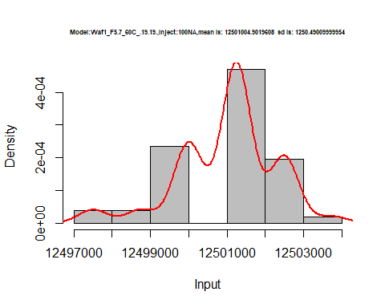

hist(d4_19.19$V3,  
 cex.main=0.5,  
 freq = FALSE,  
 main = paste('Model:Waf1_F5.7_60C_.19.19.,Inject:300NA,mean is:', mean(d4_19.19$V3),' sd is:', sd(d4_19.19$V3)),  
 xlab = "Input",  
 ylab = "Density",  
 col="grey")  
#plot density curve  
lines(density(d4_19.19$V3), # density plot  
 lwd = 2, # thickness of line  
 col = "red")

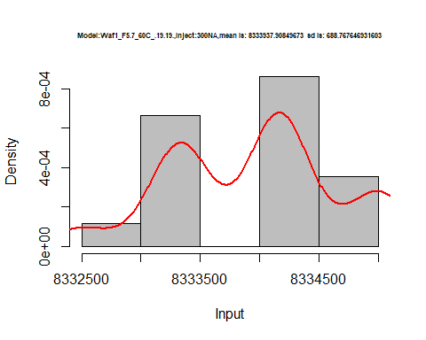

hist(d4_19.19$V4,  
 cex.main=0.5,  
 freq = FALSE,  
 main = paste('Model:Waf1_F5.7_60C_.19.19.,Inject:400NA,mean is:', mean(d4_19.19$V4),' sd is:', sd(d4_19.19$V4)),  
 xlab = "Input",  
 ylab = "Density",  
 col="grey")  
#plot density curve  
lines(density(d4_19.19$V4), # density plot  
 lwd = 2, # thickness of line  
 col = "red")

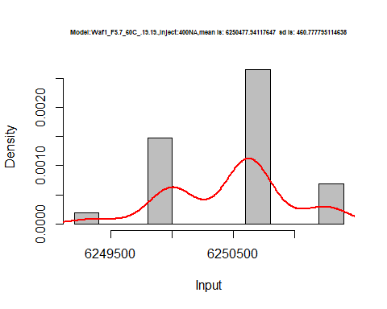

hist(d4_19.19$V5,  
 cex.main=0.5,  
 freq = FALSE,  
 main = paste('Model:Waf1_F5.7_60C_.19.19.,Inject:500NA,mean is:', mean(d4_19.19$V5),' sd is:', sd(d4_19.19$V5)),  
 xlab = "Input",  
 ylab = "Density",  
 col="grey")  
#plot density curve  
lines(density(d4_19.19$V5), # density plot  
 lwd = 2, # thickness of line  
 col = "red")

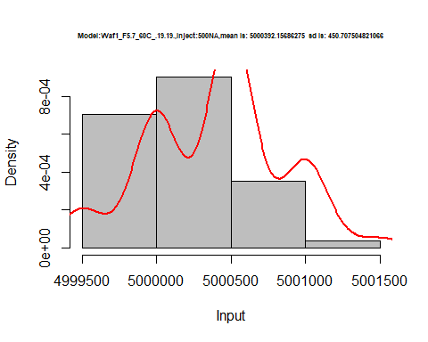

hist(d4_19.19$V6,  
 cex.main=0.5,  
 freq = FALSE,  
 main = paste('Model:Waf1_F5.7_60C_.19.19.,Inject:100NA,mean is:', mean(d4_19.19$V6),' sd is:', sd(d4_19.19$V6)),  
 xlab = "Input",  
 ylab = "Density",  
 col="grey")  
#plot density curve  
lines(density(d4_19.19$V6), # density plot  
 lwd = 2, # thickness of line  
 col = "red")

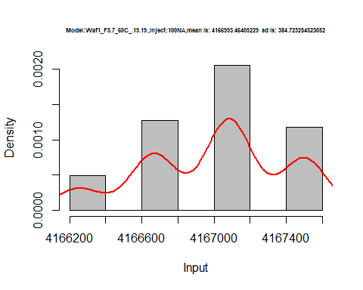

hist(d4_19.19$V7,  
 cex.main=0.5,  
 freq = FALSE,  
 main = paste('Model:Waf1_F5.7_60C_.19.19.,Inject:700NA,mean is:', mean(d4_19.19$V7),' sd is:', sd(d4_19.19$V7)),  
 xlab = "Input",  
 ylab = "Density",  
 col="grey")  
#plot density curve  
lines(density(d4_19.19$V7), # density plot  
 lwd = 2, # thickness of line  
 col = "red")

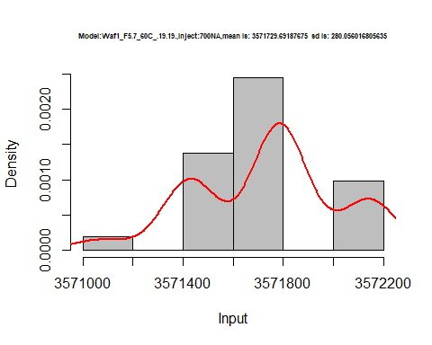

hist(d4_19.19$V8,  
 cex.main=0.5,  
 freq = FALSE,  
 main = paste('Model:Waf1_F5.7_60C_.19.19.,Inject:800NA,mean is:', mean(d4_19.19$V8),' sd is:', sd(d4_19.19$V8)),  
 xlab = "Input",  
 ylab = "Density",  
 col="grey")  
#plot density curve  
lines(density(d4_19.19$V8), # density plot  
 lwd = 2, # thickness of line  
 col = "red")

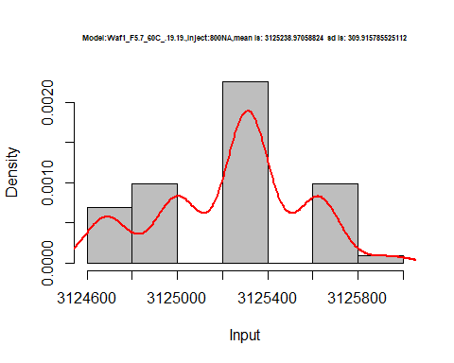

dens <- apply(d4_19.19, 2, density)  
plot('Model:Waf1_F5.7_60C_.19.19', xlim=range(sapply(dens, "[", "x")), ylim=range(sapply(dens, "[", "y")))

## Warning in xy.coords(x, y, xlabel, ylabel, log): NAs introduced by coercion

mapply(lines, dens, col=1:length(dens))

## $V1  
## NULL  
##   
## $V2  
## NULL  
##   
## $V3  
## NULL  
##   
## $V4  
## NULL  
##   
## $V5  
## NULL  
##   
## $V6  
## NULL  
##   
## $V7  
## NULL  
##   
## $V8  
## NULL

legend("topright", legend=names(dens), fill=1:length(dens))

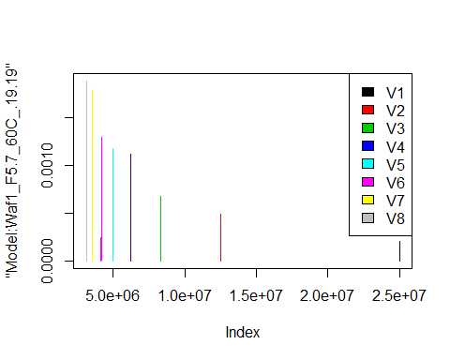

d5_19.19<-d_19.19[,c(33:40)]  
d5_19.19 <- head(d5_19.19,51)  
colnames(d5_19.19) <- c("V1", "V2","V3","V4","V5","V6","V7","V8")  
# head(d5_19.19)

hist(d5_19.19$V1,  
 cex.main=0.5,  
 freq = FALSE,  
 main = paste('Model:Waf1_F6.4_60C_.19.19,Inject:100NA,mean is:', mean(d5_19.19$V1),' sd is:', sd(d5_19.19$V1)),  
 xlab = "Input",  
 ylab = "Density",  
 col="grey")  
#plot density curve  
lines(density(d5_19.19$V1), # density plot  
 lwd = 2, # thickness of line  
 col = "red")

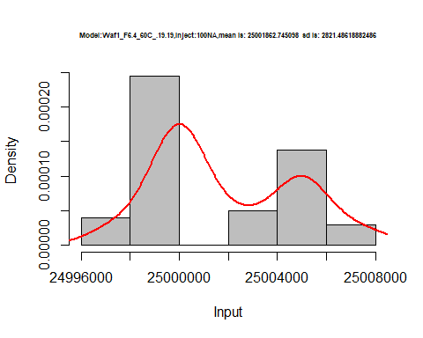

hist(d5_19.19$V2,  
 cex.main=0.5,  
 freq = FALSE,  
 main = paste('Model:Waf1_F6.4_60C_.19.19,Inject:200NA,mean is:', mean(d5_19.19$V2),' sd is:', sd(d5_19.19$V2)),  
 xlab = "Input",  
 ylab = "Density",  
 col="grey")  
#plot density curve  
lines(density(d5_19.19$V2), # density plot  
 lwd = 2, # thickness of line  
 col = "red")

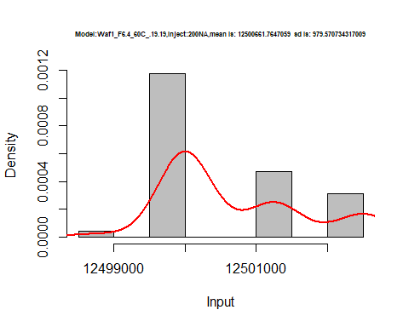

hist(d5_19.19$V3,  
 cex.main=0.5,  
 freq = FALSE,  
 main = paste('Model:Waf1_F6.4_60C_.19.19,Inject:300NA,mean is:', mean(d5_19.19$V3),' sd is:', sd(d5_19.19$V3)),  
 xlab = "Input",  
 ylab = "Density",  
 col="grey")  
#plot density curve  
lines(density(d5_19.19$V3), # density plot  
 lwd = 2, # thickness of line  
 col = "red")

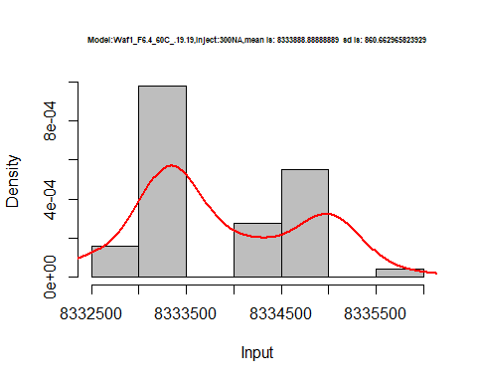

hist(d5_19.19$V4,  
 cex.main=0.5,  
 freq = FALSE,  
 main = paste('Model:Waf1_F6.4_60C_.19.19,Inject:300NA,mean is:', mean(d5_19.19$V4),' sd is:', sd(d5_19.19$V4)),  
 xlab = "Input",  
 ylab = "Density",  
 col="grey")  
#plot density curve  
lines(density(d5_19.19$V4), # density plot  
 lwd = 2, # thickness of line  
 col = "red")

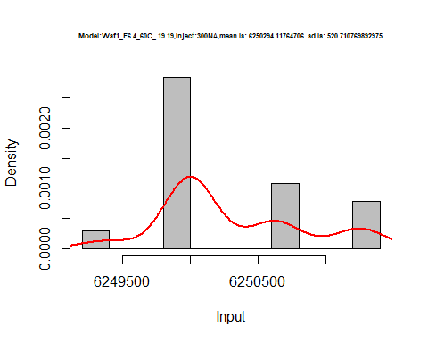

hist(d5_19.19$V5,  
 cex.main=0.5,  
 freq = FALSE,  
 main = paste('Model:Waf1_F6.4_60C_.19.19,Inject:300NA,mean is:', mean(d5_19.19$V5),' sd is:', sd(d5_19.19$V5)),  
 xlab = "Input",  
 ylab = "Density",  
 col="grey")  
#plot density curve  
lines(density(d5_19.19$V5), # density plot  
 lwd = 2, # thickness of line  
 col = "red")

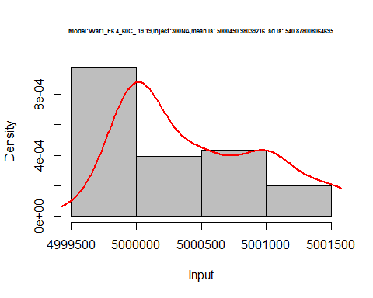

hist(d5_19.19$V6,  
 cex.main=0.5,  
 freq = FALSE,  
 main = paste('Model:Waf1_F6.4_60C_.19.19,Inject:600NA,mean is:', mean(d5_19.19$V6),' sd is:', sd(d5_19.19$V6)),  
 xlab = "Input",  
 ylab = "Density",  
 col="grey")  
#plot density curve  
lines(density(d5_19.19$V6), # density plot  
 lwd = 2, # thickness of line  
 col = "red")

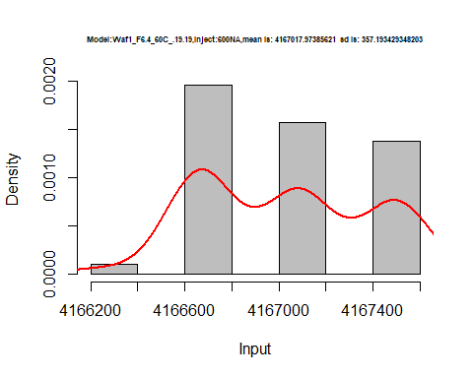

hist(d5_19.19$V7,  
 cex.main=0.5,  
 freq = FALSE,  
 main = paste('Model:Waf1_F6.4_60C_.19.19,Inject:700NA,mean is:', mean(d5_19.19$V7),' sd is:', sd(d5_19.19$V7)),  
 xlab = "Input",  
 ylab = "Density",  
 col="grey")  
#plot density curve  
lines(density(d5_19.19$V7), # density plot  
 lwd = 2, # thickness of line  
 col = "red")

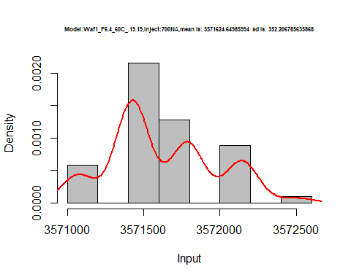

hist(d5_19.19$V8,  
 cex.main=0.5,  
 freq = FALSE,  
 main = paste('Model:Waf1_F6.4_60C_.19.19,Inject:300NA,mean is:', mean(d5_19.19$V8),' sd is:', sd(d5_19.19$V8)),  
 xlab = "Input",  
 ylab = "Density",  
 col="grey")  
#plot density curve  
lines(density(d5_19.19$V8), # density plot  
 lwd = 2, # thickness of line  
 col = "red")

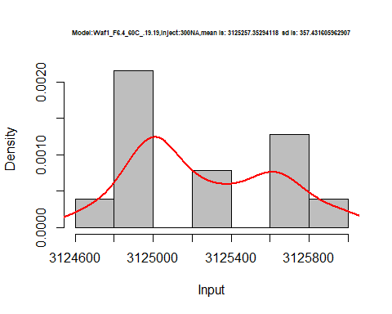

dens <- apply(d5_19.19, 2, density)  
plot('Model:Waf1_F6.4_60C_.19.19', xlim=range(sapply(dens, "[", "x")), ylim=range(sapply(dens, "[", "y")))

## Warning in xy.coords(x, y, xlabel, ylabel, log): NAs introduced by coercion

mapply(lines, dens, col=1:length(dens))

## $V1  
## NULL  
##   
## $V2  
## NULL  
##   
## $V3  
## NULL  
##   
## $V4  
## NULL  
##   
## $V5  
## NULL  
##   
## $V6  
## NULL  
##   
## $V7  
## NULL  
##   
## $V8  
## NULL

legend("topright", legend=names(dens), fill=1:length(dens))

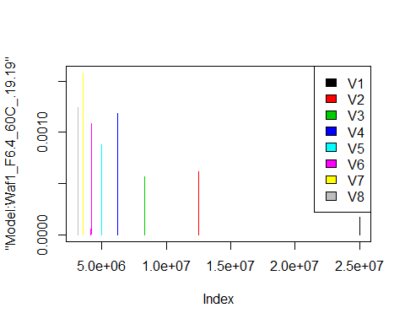

# Select columns whose names contains "20.20"  
d_20.20<-my_data %>% select(contains("20.20."))  
d_20.20 <- head(d_20.20,51)  
colnames(d_20.20) <- c("V1", "V2","V3","V4","V5","V6","V7","V8")  
# head(d_20.20)

hist(d_20.20$V1,  
 cex.main=0.5,  
 freq = FALSE,  
 main = paste('Model:Waf1_F6.2_60C_.20.20,Inject:100NA,mean is:', mean(d_20.20$V1),' sd is:', sd(d_20.20$V1)),  
 xlab = "Input",  
 ylab = "Density",  
 col="grey")  
#plot density curve  
lines(density(d_20.20$V1), # density plot  
 lwd = 2, # thickness of line  
 col = "red")

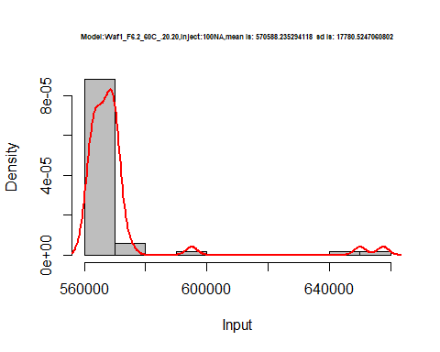

hist(d_20.20$V2,  
 cex.main=0.5,  
 freq = FALSE,  
 main = paste('Model:Waf1_F6.2_60C_.20.20,Inject:200NA,mean is:', mean(d_20.20$V2),' sd is:', sd(d_20.20$V2)),  
 xlab = "Input",  
 ylab = "Density",  
 col="grey")  
#plot density curve  
lines(density(d_20.20$V2), # density plot  
 lwd = 2, # thickness of line  
 col = "red")

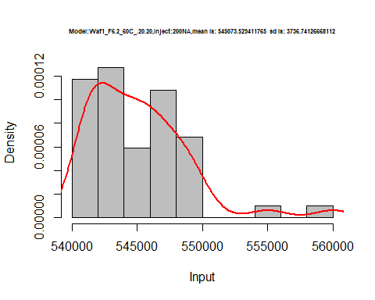

hist(d_20.20$V3,  
 cex.main=0.5,  
 freq = FALSE,  
 main = paste('Model:Waf1_F6.2_60C_.20.20,Inject:300NA,mean is:', mean(d_20.20$V3),' sd is:', sd(d_20.20$V3)),  
 xlab = "Input",  
 ylab = "Density",  
 col="grey")  
#plot density curve  
lines(density(d_20.20$V3), # density plot  
 lwd = 2, # thickness of line  
 col = "red")

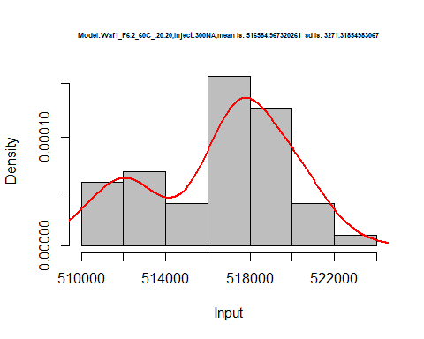

hist(d_20.20$V4,  
 cex.main=0.5,  
 freq = FALSE,  
 main = paste('Model:Waf1_F6.2_60C_.20.20,Inject:400NA,mean is:', mean(d_20.20$V4),' sd is:', sd(d_20.20$V4)),  
 xlab = "Input",  
 ylab = "Density",  
 col="grey")  
#plot density curve  
lines(density(d_20.20$V4), # density plot  
 lwd = 2, # thickness of line  
 col = "red")

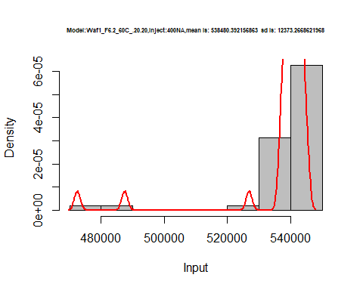

hist(d_20.20$V5,  
 cex.main=0.5,  
 freq = FALSE,  
 main = paste('Model:Waf1_F6.2_60C_.20.20,Inject:500NA,mean is:', mean(d_20.20$V5),' sd is:', sd(d_20.20$V5)),  
 xlab = "Input",  
 ylab = "Density",  
 col="grey")  
#plot density curve  
lines(density(d_20.20$V5), # density plot  
 lwd = 2, # thickness of line  
 col = "red")

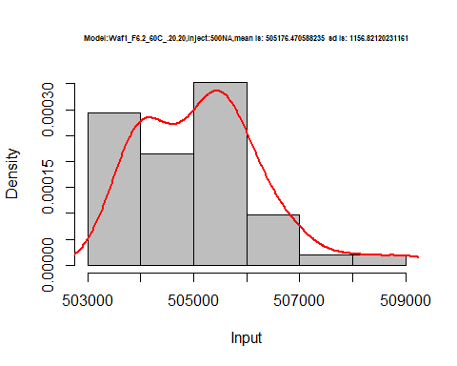

hist(d_20.20$V6,  
 cex.main=0.5,  
 freq = FALSE,  
 main = paste('Model:Waf1_F6.2_60C_.20.20,Inject:600NA,mean is:', mean(d_20.20$V6),' sd is:', sd(d_20.20$V6)),  
 xlab = "Input",  
 ylab = "Density",  
 col="grey")  
#plot density curve  
lines(density(d_20.20$V6), # density plot  
 lwd = 2, # thickness of line  
 col = "red")

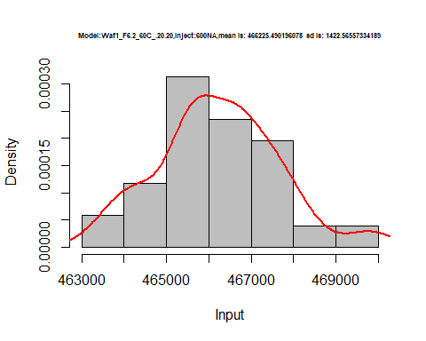

hist(d_20.20$V7,  
 cex.main=0.5,  
 freq = FALSE,  
 main = paste('Model:Waf1_F6.2_60C_.20.20,Inject:700NA,mean is:', mean(d_20.20$V7),' sd is:', sd(d_20.20$V7)),  
 xlab = "Input",  
 ylab = "Density",  
 col="grey")  
#plot density curve  
lines(density(d_20.20$V7), # density plot  
 lwd = 2, # thickness of line  
 col = "red")

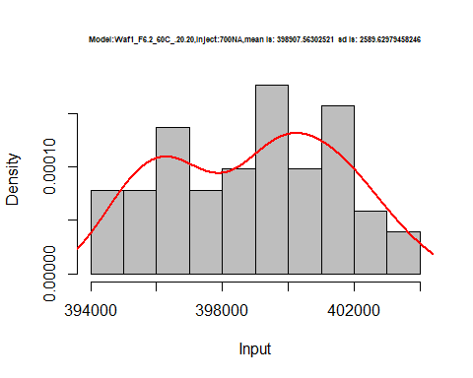

hist(d_20.20$V8,  
 cex.main=0.5,  
 freq = FALSE,  
 main = paste('Model:Waf1_F6.2_60C_.20.20,Inject:800NA,mean is:', mean(d_20.20$V8),' sd is:', sd(d_20.20$V8)),  
 xlab = "Input",  
 ylab = "Density",  
 col="grey")  
#plot density curve  
lines(density(d_20.20$V8), # density plot  
 lwd = 2, # thickness of line  
 col = "red")

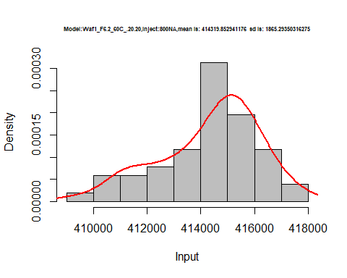

dens <- apply(d_20.20, 2, density)  
plot('Model:Waf1_F6.2_60C_.20.20', xlim=range(sapply(dens, "[", "x")), ylim=range(sapply(dens, "[", "y")))

## Warning in xy.coords(x, y, xlabel, ylabel, log): NAs introduced by coercion

mapply(lines, dens, col=1:length(dens))

## $V1  
## NULL  
##   
## $V2  
## NULL  
##   
## $V3  
## NULL  
##   
## $V4  
## NULL  
##   
## $V5  
## NULL  
##   
## $V6  
## NULL  
##   
## $V7  
## NULL  
##   
## $V8  
## NULL

legend("topright", legend=names(dens), fill=1:length(dens))

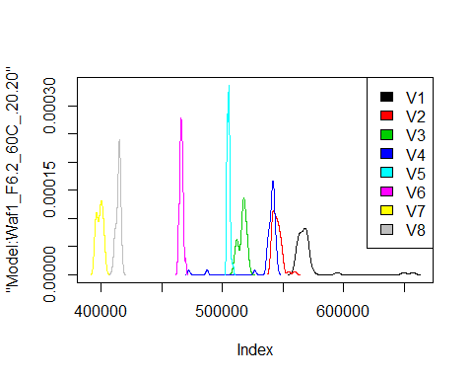

# Select columns whose names contains "21.21"  
d_21.21<-my_data %>% select(contains("21.21."))  
d_21.21 <- head(d_21.21,51)  
colnames(d_21.21) <- c("V1", "V2","V3","V4","V5","V6","V7","V8")  
head(d_21.21)

## V1 V2 V3 V4 V5 V6 V7 V8  
## 1 11615000 6712500 4694167 3774375 3214500 2720833 2525357 2238125  
## 2 11595000 6710000 4678333 3801875 3203500 2640833 2506429 2233438  
## 3 11625000 6705000 4673333 3811250 3212000 2476250 2510000 2228125  
## 4 11595000 6705000 4696667 3809375 3213000 2447500 2512857 2237187  
## 5 11572500 6697500 4681667 3813125 3215500 2448333 2510714 2231250  
## 6 11562500 6705000 4675000 3813125 3208500 2442917 2507143 2230938

hist(d_21.21$V1,  
 cex.main=0.5,  
 freq = FALSE,  
 main = paste('Model:Waf1_F2.3_60C_.21.21.,Inject:100NA,mean is:', mean(d_21.21$V1),' sd is:', sd(d_21.21$V1)),  
 xlab = "Input",  
 ylab = "Density",  
 col="grey")  
#plot density curve  
lines(density(d_21.21$V1), # density plot  
 lwd = 2, # thickness of line  
 col = "red")

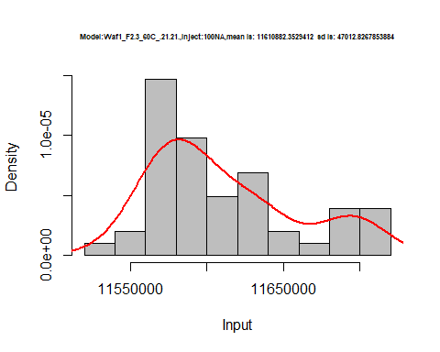

hist(d_21.21$V2,  
 cex.main=0.5,  
 freq = FALSE,  
 main = paste('Model:Waf1_F2.3_60C_.21.21.,Inject:200NA,mean is:', mean(d_21.21$V2),' sd is:', sd(d_21.21$V2)),  
 xlab = "Input",  
 ylab = "Density",  
 col="grey")  
#plot density curve  
lines(density(d_21.21$V2), # density plot  
 lwd = 2, # thickness of line  
 col = "red")

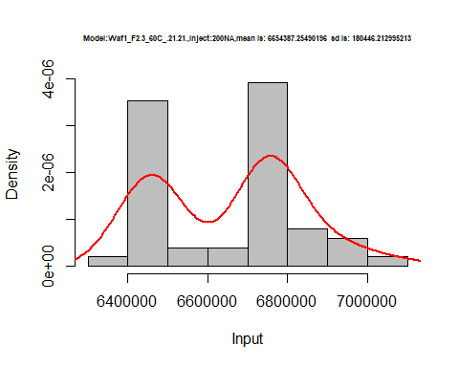

hist(d_21.21$V3,  
 cex.main=0.5,  
 freq = FALSE,  
 main = paste('Model:Waf1_F2.3_60C_.21.21.,Inject:300NA,mean is:', mean(d_21.21$V3),' sd is:', sd(d_21.21$V3)),  
 xlab = "Input",  
 ylab = "Density",  
 col="grey")  
#plot density curve  
lines(density(d_21.21$V3), # density plot  
 lwd = 2, # thickness of line  
 col = "red")

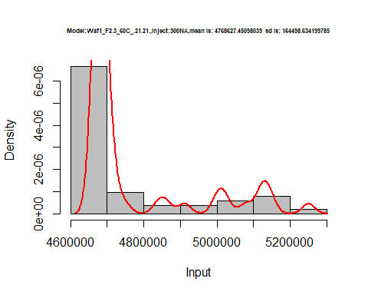

hist(d_21.21$V4,  
 cex.main=0.5,  
 freq = FALSE,  
 main = paste('Model:Waf1_F2.3_60C_.21.21.,Inject:400NA,mean is:', mean(d_21.21$V4),' sd is:', sd(d_21.21$V4)),  
 xlab = "Input",  
 ylab = "Density",  
 col="grey")  
#plot density curve  
lines(density(d_21.21$V4), # density plot  
 lwd = 2, # thickness of line  
 col = "red")

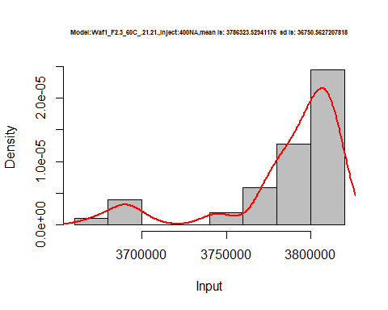

hist(d_21.21$V5,  
 cex.main=0.5,  
 freq = FALSE,  
 main = paste('Model:Waf1_F2.3_60C_.21.21.,Inject:500NA,mean is:', mean(d_21.21$V5),' sd is:', sd(d_21.21$V5)),  
 xlab = "Input",  
 ylab = "Density",  
 col="grey")  
#plot density curve  
lines(density(d_21.21$V5), # density plot  
 lwd = 2, # thickness of line  
 col = "red")

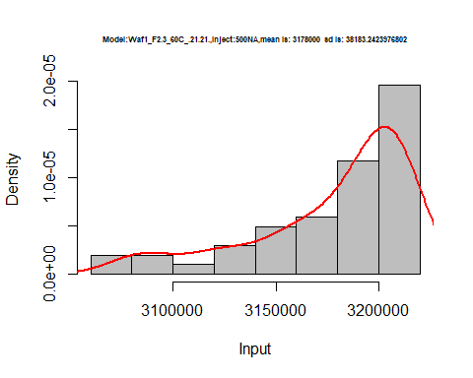

hist(d_21.21$V6,  
 cex.main=0.5,  
 freq = FALSE,  
 main = paste('Model:Waf1_F2.3_60C_.21.21.,Inject:600NA,mean is:', mean(d_21.21$V6),' sd is:', sd(d_21.21$V6)),  
 xlab = "Input",  
 ylab = "Density",  
 col="grey")  
#plot density curve  
lines(density(d_21.21$V6), # density plot  
 lwd = 2, # thickness of line  
 col = "red")

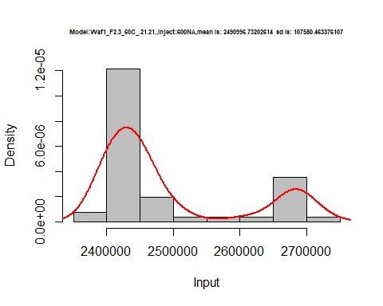

hist(d_21.21$V7,  
 cex.main=0.5,  
 freq = FALSE,  
 main = paste('Model:Waf1_F2.3_60C_.21.21.,Inject:700NA,mean is:', mean(d_21.21$V7),' sd is:', sd(d_21.21$V7)),  
 xlab = "Input",  
 ylab = "Density",  
 col="grey")  
#plot density curve  
lines(density(d_21.21$V7), # density plot  
 lwd = 2, # thickness of line  
 col = "red")

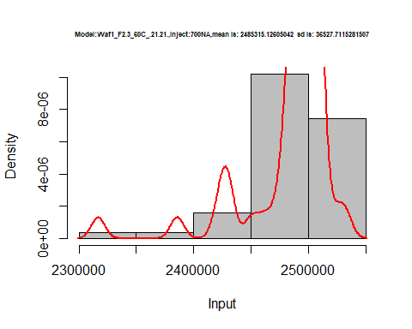

hist(d_21.21$V8,  
 cex.main=0.5,  
 freq = FALSE,  
 main = paste('Model:Waf1_F2.3_60C_.21.21.,Inject:800NA,mean is:', mean(d_21.21$V8),' sd is:', sd(d_21.21$V8)),  
 xlab = "Input",  
 ylab = "Density",  
 col="grey")  
#plot density curve  
lines(density(d_21.21$V8), # density plot  
 lwd = 2, # thickness of line  
 col = "red")

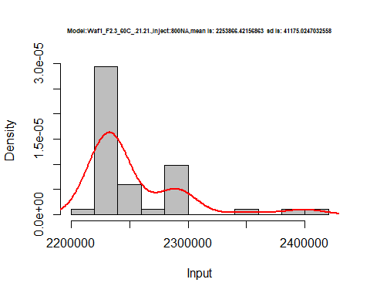

dens <- apply(d_21.21, 2, density)  
plot('Model:Waf1_F2.3_60C_.21.21', xlim=range(sapply(dens, "[", "x")), ylim=range(sapply(dens, "[", "y")))

## Warning in xy.coords(x, y, xlabel, ylabel, log): NAs introduced by coercion

mapply(lines, dens, col=1:length(dens))

## $V1  
## NULL  
##   
## $V2  
## NULL  
##   
## $V3  
## NULL  
##   
## $V4  
## NULL  
##   
## $V5  
## NULL  
##   
## $V6  
## NULL  
##   
## $V7  
## NULL  
##   
## $V8  
## NULL

legend("topright", legend=names(dens), fill=1:length(dens))

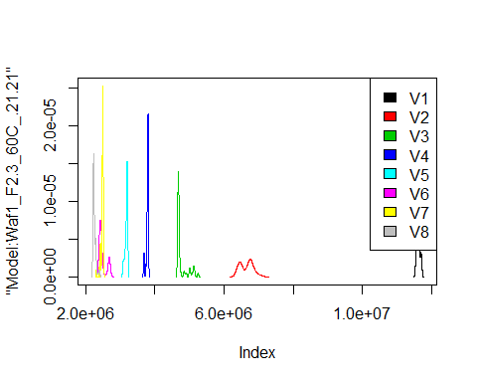

# Select columns whose names contains "23.23"  
d_23.23<-my_data %>% select(contains("23.23."))  
#d_22.22 <- head(d_22.22,51)  
#colnames(d_22.22) <- c("V1", "V2","V3","V4","V5","V6","V7","V8")  
head(d_23.23)

## Waf1_F2.3_F_60C_.100nA_.23.23. Waf1_F2.3_F_60C_.200nA_.23.23.  
## 1 25007500 12500000  
## 2 25005000 12501250  
## 3 25007500 12501250  
## 4 25007500 12501250  
## 5 25005000 12502500  
## 6 25005000 12502500  
## Waf1_F2.3_F_60C_.300nA_.23.23. Waf1_F2.3_F_60C_.400nA_.23.23.  
## 1 8335000 6250625  
## 2 8335000 6251250  
## 3 8335000 6251250  
## 4 8334167 6251250  
## 5 8335000 6251875  
## 6 8335000 6251250  
## Waf1_F2.3_F_60C_.500nA_.23.23. Waf1_F2.3_F_60C_.600nA_.23.23.  
## 1 4999500 4166250  
## 2 4999500 4166250  
## 3 4999500 4166250  
## 4 4999500 4166250  
## 5 4999500 4166667  
## 6 4999500 4166250  
## Waf1_F2.3_F_60C_.700nA_.23.23. Waf1_F2.3_F_60C_.800nA_.23.23.  
## 1 3571071 3124688  
## 2 3571071 3124688  
## 3 3571071 3124688  
## 4 3571071 3124688  
## 5 3571071 3124688  
## 6 3571071 3125000  
## Waf1_F2.7_F_60C_.100nA_.23.23. Waf1_F2.7_F_60C_.200nA_.23.23.  
## 1 6360000 4026250  
## 2 6357500 4026250  
## 3 6355000 4032500  
## 4 6342500 4033750  
## 5 6320000 4030000  
## 6 6317500 4028750  
## Waf1_F2.7_F_60C_.300nA_.23.23. Waf1_F2.7_F_60C_.400nA_.23.23.  
## 1 3031667 2538750  
## 2 3038333 2540625  
## 3 3049167 2545625  
## 4 3052500 2553125  
## 5 3047500 2553125  
## 6 3055833 2553750  
## Waf1_F2.7_F_60C_.500nA_.23.23. Waf1_F2.7_F_60C_.600nA_.23.23.  
## 1 2215000 1962083  
## 2 2215000 1962083  
## 3 2213500 1960000  
## 4 2214500 1957500  
## 5 2212000 1956250  
## 6 2215000 1955417  
## Waf1_F2.7_F_60C_.700nA_.23.23. Waf1_F2.7_F_60C_.800nA_.23.23.  
## 1 1797857 1655000  
## 2 1800000 1653438  
## 3 1798929 1652500  
## 4 1796786 1655312  
## 5 1796786 1656875  
## 6 1797857 1655938

d1_23.23<-d_23.23[,c(1:8)]  
d1_23.23 <- head(d1_23.23,51)  
colnames(d1_23.23) <- c("V1", "V2","V3","V4","V5","V6","V7","V8")  
head(d1_23.23)

## V1 V2 V3 V4 V5 V6 V7 V8  
## 1 25007500 12500000 8335000 6250625 4999500 4166250 3571071 3124688  
## 2 25005000 12501250 8335000 6251250 4999500 4166250 3571071 3124688  
## 3 25007500 12501250 8335000 6251250 4999500 4166250 3571071 3124688  
## 4 25007500 12501250 8334167 6251250 4999500 4166250 3571071 3124688  
## 5 25005000 12502500 8335000 6251875 4999500 4166667 3571071 3124688  
## 6 25005000 12502500 8335000 6251250 4999500 4166250 3571071 3125000

hist(d1_23.23$V1,  
 cex.main=0.5,  
 freq = FALSE,  
 main = paste('Model:Waf1_F2.3_60C_.23.23.,Inject:100NA,mean is:', mean(d1_23.23$V1),' sd is:', sd(d1_23.23$V1)),  
 xlab = "Input",  
 ylab = "Density",  
 col="grey")  
#plot density curve  
lines(density(d1_23.23$V1), # density plot  
 lwd = 2, # thickness of line  
 col = "red")

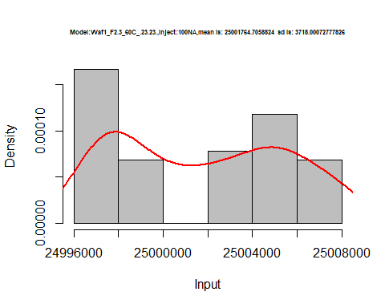

hist(d1_23.23$V2,  
 cex.main=0.5,  
 freq = FALSE,  
 main = paste('Model:Waf1_F2.3_60C_.23.23.,Inject:200NA,mean is:', mean(d1_23.23$V2),' sd is:', sd(d1_23.23$V2)),  
 xlab = "Input",  
 ylab = "Density",  
 col="grey")  
#plot density curve  
lines(density(d1_23.23$V2), # density plot  
 lwd = 2, # thickness of line  
 col = "red")

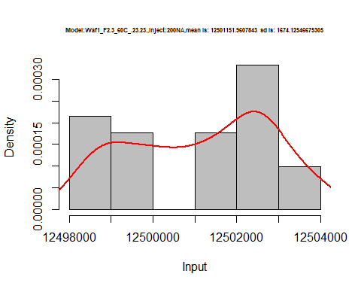

hist(d1_23.23$V3,  
 cex.main=0.5,  
 freq = FALSE,  
 main = paste('Model:Waf1_F2.3_60C_.23.23.,Inject:300NA,mean is:', mean(d1_23.23$V3),' sd is:', sd(d1_23.23$V3)),  
 xlab = "Input",  
 ylab = "Density",  
 col="grey")  
#plot density curve  
lines(density(d1_23.23$V3), # density plot  
 lwd = 2, # thickness of line  
 col = "red")

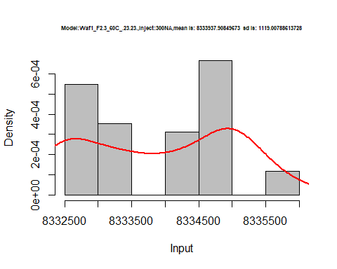

hist(d1_23.23$V4,  
 cex.main=0.5,  
 freq = FALSE,  
 main = paste('Model:Waf1_F2.3_60C_.23.23.,Inject:400NA,mean is:', mean(d1_23.23$V4),' sd is:', sd(d1_23.23$V4)),  
 xlab = "Input",  
 ylab = "Density",  
 col="grey")  
#plot density curve  
lines(density(d1_23.23$V4), # density plot  
 lwd = 2, # thickness of line  
 col = "red")

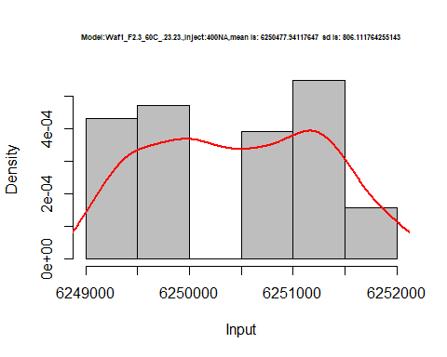

hist(d1_23.23$V5,  
 cex.main=0.5,  
 freq = FALSE,  
 main = paste('Model:Waf1_F2.3_60C_.23.23.,Inject:500NA,mean is:', mean(d1_23.23$V5),' sd is:', sd(d1_23.23$V5)),  
 xlab = "Input",  
 ylab = "Density",  
 col="grey")  
#plot density curve  
lines(density(d1_23.23$V5), # density plot  
 lwd = 2, # thickness of line  
 col = "red")

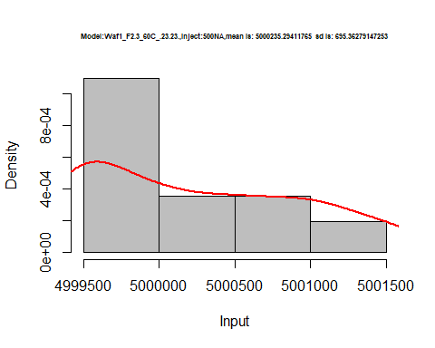

hist(d1_23.23$V6,  
 cex.main=0.5,  
 freq = FALSE,  
 main = paste('Model:Waf1_F2.3_60C_.23.23.,Inject:600NA,mean is:', mean(d1_23.23$V6),' sd is:', sd(d1_23.23$V6)),  
 xlab = "Input",  
 ylab = "Density",  
 col="grey")  
#plot density curve  
lines(density(d1_23.23$V6), # density plot  
 lwd = 2, # thickness of line  
 col = "red")

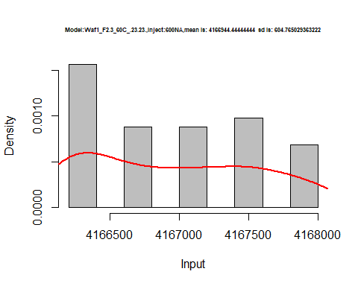

hist(d1_23.23$V7,  
 cex.main=0.5,  
 freq = FALSE,  
 main = paste('Model:Waf1_F2.3_60C_.23.23.,Inject:700NA,mean is:', mean(d1_23.23$V7),' sd is:', sd(d1_23.23$V7)),  
 xlab = "Input",  
 ylab = "Density",  
 col="grey")  
#plot density curve  
lines(density(d1_23.23$V7), # density plot  
 lwd = 2, # thickness of line  
 col = "red")

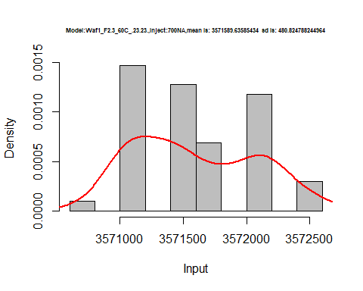

hist(d1_23.23$V8,  
 cex.main=0.5,  
 freq = FALSE,  
 main = paste('Model:Waf1_F2.3_60C_.23.23.,Inject:800NA,mean is:', mean(d1_23.23$V8),' sd is:', sd(d1_23.23$V8)),  
 xlab = "Input",  
 ylab = "Density",  
 col="grey")  
#plot density curve  
lines(density(d1_23.23$V8), # density plot  
 lwd = 2, # thickness of line  
 col = "red")

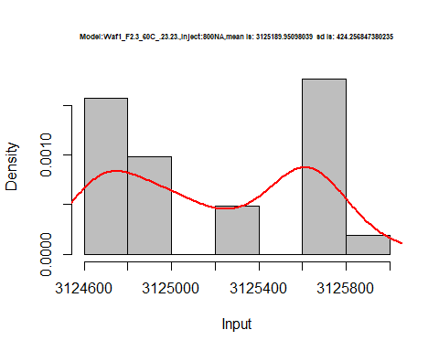

dens <- apply(d1_23.23, 2, density)  
plot('Model:Waf1_F2.3_60C_.23.23', xlim=range(sapply(dens, "[", "x")), ylim=range(sapply(dens, "[", "y")))

## Warning in xy.coords(x, y, xlabel, ylabel, log): NAs introduced by coercion

mapply(lines, dens, col=1:length(dens))

## $V1  
## NULL  
##   
## $V2  
## NULL  
##   
## $V3  
## NULL  
##   
## $V4  
## NULL  
##   
## $V5  
## NULL  
##   
## $V6  
## NULL  
##   
## $V7  
## NULL  
##   
## $V8  
## NULL

legend("topright", legend=names(dens), fill=1:length(dens))

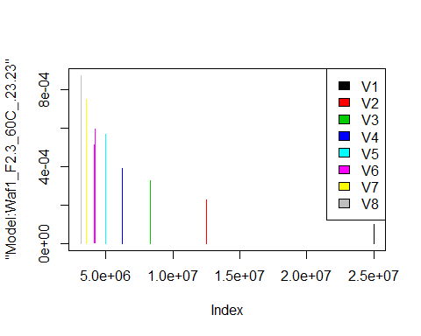

d2_23.23<-d_23.23[,c(9:16)]  
d2_23.23 <- head(d2_23.23,51)  
colnames(d2_23.23) <- c("V1", "V2","V3","V4","V5","V6","V7","V8")  
head(d2_23.23)

## V1 V2 V3 V4 V5 V6 V7 V8  
## 1 6360000 4026250 3031667 2538750 2215000 1962083 1797857 1655000  
## 2 6357500 4026250 3038333 2540625 2215000 1962083 1800000 1653438  
## 3 6355000 4032500 3049167 2545625 2213500 1960000 1798929 1652500  
## 4 6342500 4033750 3052500 2553125 2214500 1957500 1796786 1655312  
## 5 6320000 4030000 3047500 2553125 2212000 1956250 1796786 1656875  
## 6 6317500 4028750 3055833 2553750 2215000 1955417 1797857 1655938

hist(d2_23.23$V1,  
 cex.main=0.5,  
 freq = FALSE,  
 main = paste('Model:Waf1_F2.7_60C_.100nA_.23.23.,Inject:100NA,mean is:', mean(d2_23.23$V1),' sd is:', sd(d2_23.23$V1)),  
 xlab = "Input",  
 ylab = "Density",  
 col="grey")  
#plot density curve  
lines(density(d2_23.23$V1), # density plot  
 lwd = 2, # thickness of line  
 col = "red")

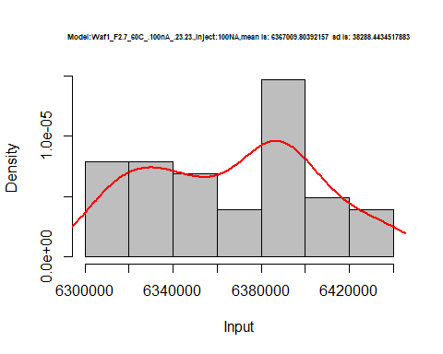

hist(d2_23.23$V2,  
 cex.main=0.5,  
 freq = FALSE,  
 main = paste('Model:Waf1_F2.7_60C_..23.23.,Inject:200NA,mean is:', mean(d2_23.23$V2),' sd is:', sd(d2_23.23$V2)),  
 xlab = "Input",  
 ylab = "Density",  
 col="grey")  
#plot density curve  
lines(density(d2_23.23$V2), # density plot  
 lwd = 2, # thickness of line  
 col = "red")

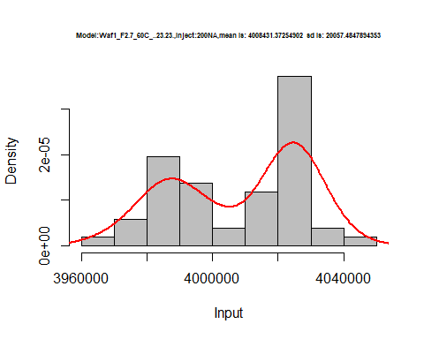

hist(d2_23.23$V3,  
 cex.main=0.5,  
 freq = FALSE,  
 main = paste('Model:Waf1_F2.7_60C_.23.23.,Inject:300NA,mean is:', mean(d2_23.23$V3),' sd is:', sd(d2_23.23$V3)),  
 xlab = "Input",  
 ylab = "Density",  
 col="grey")  
#plot density curve  
lines(density(d2_23.23$V3), # density plot  
 lwd = 2, # thickness of line  
 col = "red")

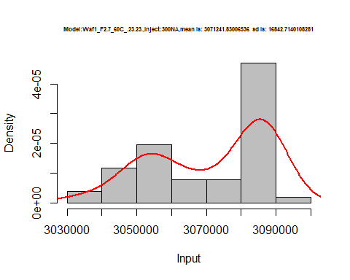

hist(d2_23.23$V4,  
 cex.main=0.5,  
 freq = FALSE,  
 main = paste('Model:Waf1_F2.7_60C_.23.23.,Inject:400NA,mean is:', mean(d2_23.23$V4),' sd is:', sd(d2_23.23$V4)),  
 xlab = "Input",  
 ylab = "Density",  
 col="grey")  
#plot density curve  
lines(density(d2_23.23$V4), # density plot  
 lwd = 2, # thickness of line  
 col = "red")

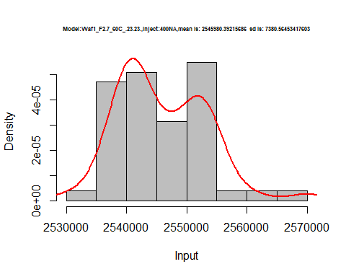

hist(d2_23.23$V5,  
 cex.main=0.5,  
 freq = FALSE,  
 main = paste('Model:Waf1_F2.7_60C_.23.23.,Inject:500NA,mean is:', mean(d2_23.23$V5),' sd is:', sd(d2_23.23$V5)),  
 xlab = "Input",  
 ylab = "Density",  
 col="grey")  
#plot density curve  
lines(density(d2_23.23$V5), # density plot  
 lwd = 2, # thickness of line  
 col = "red")

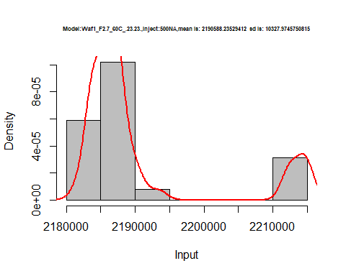

hist(d2_23.23$V6,  
 cex.main=0.5,  
 freq = FALSE,  
 main = paste('Model:Waf1_F2.7_60C_.23.23.,Inject:500NA,mean is:', mean(d2_23.23$V6),' sd is:', sd(d2_23.23$V6)),  
 xlab = "Input",  
 ylab = "Density",  
 col="grey")  
#plot density curve  
lines(density(d2_23.23$V6), # density plot  
 lwd = 2, # thickness of line  
 col = "red")

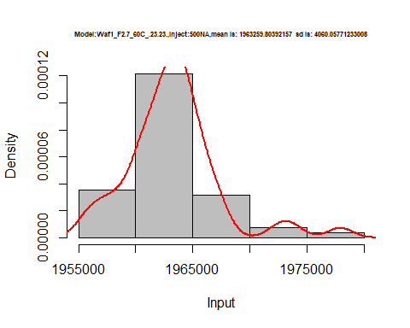

hist(d2_23.23$V7,  
 cex.main=0.5,  
 freq = FALSE,  
 main = paste('Model:Waf1_F2.7_60C_.23.23.,Inject:700NA,mean is:', mean(d2_23.23$V7),' sd is:', sd(d2_23.23$V7)),  
 xlab = "Input",  
 ylab = "Density",  
 col="grey")  
#plot density curve  
lines(density(d2_23.23$V7), # density plot  
 lwd = 2, # thickness of line  
 col = "red")

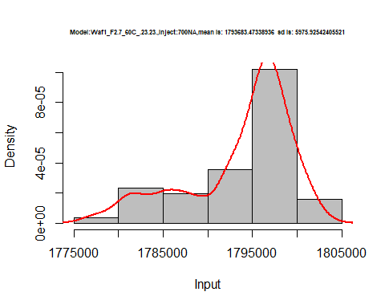

hist(d2_23.23$V8,  
 cex.main=0.5,  
 freq = FALSE,  
 main = paste('Model:Waf1_F2.7_60C_.23.23.,Inject:800NA,mean is:', mean(d2_23.23$V8),' sd is:', sd(d2_23.23$V8)),  
 xlab = "Input",  
 ylab = "Density",  
 col="grey")  
#plot density curve  
lines(density(d2_23.23$V8), # density plot  
 lwd = 2, # thickness of line  
 col = "red")

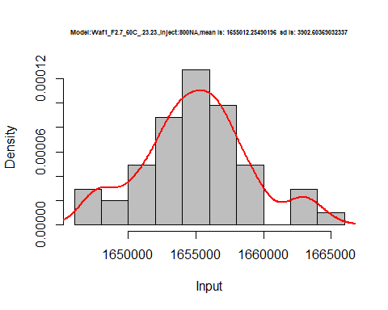

dens <- apply(d2_23.23, 2, density)  
plot('Model:Waf1_F2.7_60C_.23.23', xlim=range(sapply(dens, "[", "x")), ylim=range(sapply(dens, "[", "y")))

## Warning in xy.coords(x, y, xlabel, ylabel, log): NAs introduced by coercion

mapply(lines, dens, col=1:length(dens))

## $V1  
## NULL  
##   
## $V2  
## NULL  
##   
## $V3  
## NULL  
##   
## $V4  
## NULL  
##   
## $V5  
## NULL  
##   
## $V6  
## NULL  
##   
## $V7  
## NULL  
##   
## $V8  
## NULL

legend("topright", legend=names(dens), fill=1:length(dens))

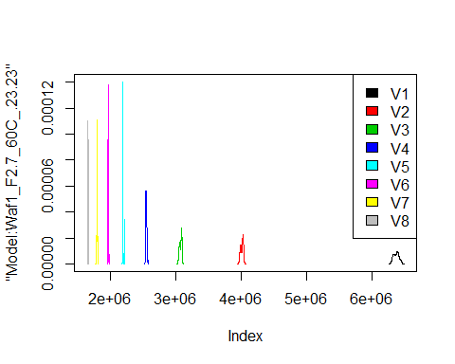

# Select columns whose names contains "24.24"  
d_24.24<-my_data %>% select(contains("24.24."))  
d_24.24 <- head(d_24.24,51)  
colnames(d_24.24) <- c("V1", "V2","V3","V4","V5","V6","V7","V8")  
head(d_24.24)

## V1 V2 V3 V4 V5 V6 V7 V8 NA  
## 1 25002500 12502500 8333333 6250000 5001000 4167083 3571786 6250313 835000  
## 2 25005000 12501250 8332500 6249375 5000500 4167083 3571429 6250625 830000  
## 3 25002500 12501250 8332500 6250625 5001000 4167083 3571071 6250625 830000  
## 4 25002500 12501250 8332500 6250625 5001000 4166250 3571429 6250625 827500  
## 5 25000000 12501250 8333333 6250625 5001000 4166667 3571429 6250625 830000  
## 6 25002500 12501250 8333333 6250625 5000500 4166667 3571429 6250625 832500  
## NA NA NA NA NA NA NA  
## 1 760000 675000.0 685625 645000 542916.7 536785.7 497812.5  
## 2 756250 675000.0 686250 644500 542500.0 537142.9 499062.5  
## 3 752500 680000.0 686250 647000 544166.7 538214.3 497812.5  
## 4 751250 680000.0 685625 645500 542916.7 537500.0 496562.5  
## 5 750000 680833.3 688125 644500 542500.0 538214.3 498437.5  
## 6 752500 676666.7 689375 647500 543333.3 538571.4 496562.5

hist(d_24.24$V1,  
 cex.main=0.5,  
 freq = FALSE,  
 main = paste('Model:Waf1_F1.5_60C_.24.24.,Inject:100NA,mean is:', mean(d_24.24$V1),' sd is:', sd(d_24.24$V1)),  
 xlab = "Input",  
 ylab = "Density",  
 col="grey")  
#plot density curve  
lines(density(d_24.24$V1), # density plot  
 lwd = 2, # thickness of line  
 col = "red")

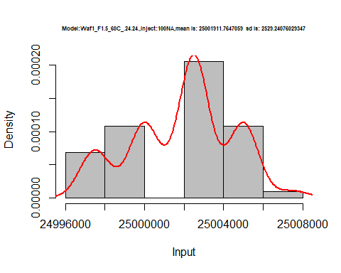

hist(d_24.24$V2,  
 cex.main=0.5,  
 freq = FALSE,  
 main = paste('Model:Waf1_F1.5_60C_.24.24.,Inject:200NA,mean is:', mean(d_24.24$V2),' sd is:', sd(d_24.24$V2)),  
 xlab = "Input",  
 ylab = "Density",  
 col="grey")  
#plot density curve  
lines(density(d_24.24$V2), # density plot  
 lwd = 2, # thickness of line  
 col = "red")

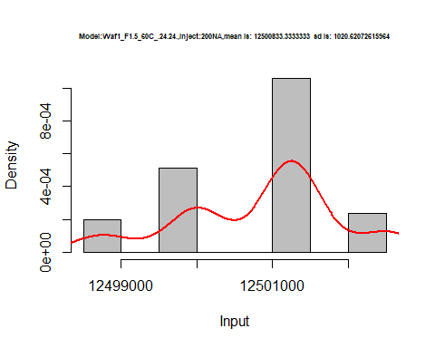

hist(d_24.24$V3,  
 cex.main=0.5,  
 freq = FALSE,  
 main = paste('Model:Waf1_F1.5_60C_.24.24.,Inject:300NA,mean is:', mean(d_24.24$V3),' sd is:', sd(d_24.24$V3)),  
 xlab = "Input",  
 ylab = "Density",  
 col="grey")  
#plot density curve  
lines(density(d_24.24$V3), # density plot  
 lwd = 2, # thickness of line  
 col = "red")

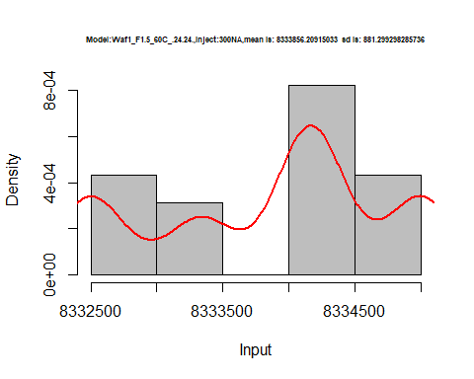

hist(d_24.24$V4,  
 cex.main=0.5,  
 freq = FALSE,  
 main = paste('Model:Waf1_F1.5_60C_.24.24.,Inject:400NA,mean is:', mean(d_24.24$V4),' sd is:', sd(d_24.24$V4)),  
 xlab = "Input",  
 ylab = "Density",  
 col="grey")  
#plot density curve  
lines(density(d_24.24$V4), # density plot  
 lwd = 2, # thickness of line  
 col = "red")

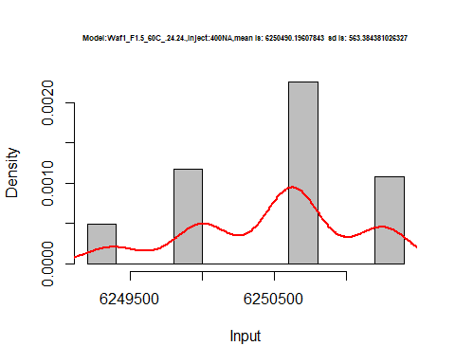

hist(d_24.24$V5,  
 cex.main=0.5,  
 freq = FALSE,  
 main = paste('Model:Waf1_F1.5_60C_.24.24.,Inject:500NA,mean is:', mean(d_24.24$V5),' sd is:', sd(d_24.24$V5)),  
 xlab = "Input",  
 ylab = "Density",  
 col="grey")  
#plot density curve  
lines(density(d_24.24$V5), # density plot  
 lwd = 2, # thickness of line  
 col = "red")

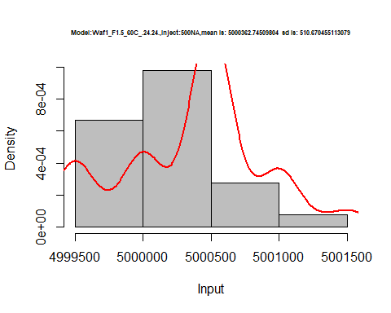

hist(d_24.24$V6,  
 cex.main=0.5,  
 freq = FALSE,  
 main = paste('Model:Waf1_F1.5_60C_.24.24.,Inject:600NA,mean is:', mean(d_24.24$V6),' sd is:', sd(d_24.24$V6)),  
 xlab = "Input",  
 ylab = "Density",  
 col="grey")  
#plot density curve  
lines(density(d_24.24$V6), # density plot  
 lwd = 2, # thickness of line  
 col = "red")

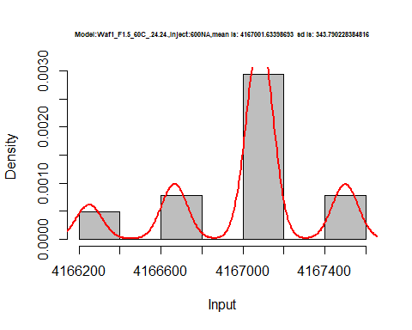

hist(d_24.24$V7,  
 cex.main=0.5,  
 freq = FALSE,  
 main = paste('Model:Waf1_F1.5_60C_.24.24.,Inject:700NA,mean is:', mean(d_24.24$V7),' sd is:', sd(d_24.24$V7)),  
 xlab = "Input",  
 ylab = "Density",  
 col="grey")  
#plot density curve  
lines(density(d_24.24$V7), # density plot  
 lwd = 2, # thickness of line  
 col = "red")

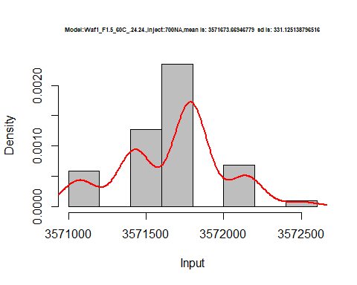

hist(d_24.24$V8,  
 cex.main=0.5,  
 freq = FALSE,  
 main = paste('Model:Waf1_F1.5_60C_.24.24.,Inject:800NA,mean is:', mean(d_24.24$V8),' sd is:', sd(d_24.24$V7)),  
 xlab = "Input",  
 ylab = "Density",  
 col="grey")  
#plot density curve  
lines(density(d_24.24$V8), # density plot  
 lwd = 2, # thickness of line  
 col = "red")

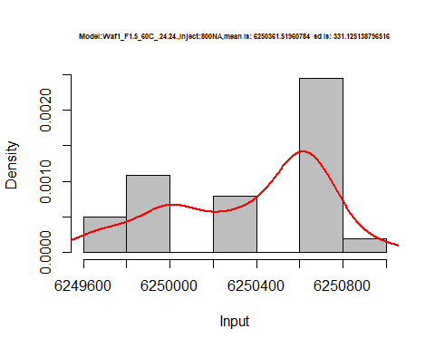

dens <- apply(d_24.24, 2, density)  
plot('Model:Waf1_F1.5_60C_.24.24', xlim=range(sapply(dens, "[", "x")), ylim=range(sapply(dens, "[", "y")))

## Warning in xy.coords(x, y, xlabel, ylabel, log): NAs introduced by coercion

mapply(lines, dens, col=1:length(dens))

## $V1  
## NULL  
##   
## $V2  
## NULL  
##   
## $V3  
## NULL  
##   
## $V4  
## NULL  
##   
## $V5  
## NULL  
##   
## $V6  
## NULL  
##   
## $V7  
## NULL  
##   
## $V8  
## NULL  
##   
## $<NA>  
## NULL  
##   
## $<NA>  
## NULL  
##   
## $<NA>  
## NULL  
##   
## $<NA>  
## NULL  
##   
## $<NA>  
## NULL  
##   
## $<NA>  
## NULL  
##   
## $<NA>  
## NULL  
##   
## $<NA>  
## NULL

legend("topright", legend=names(dens), fill=1:length(dens))

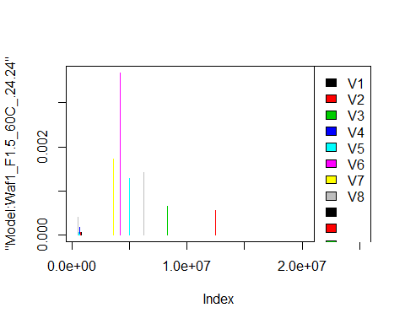

# Select columns whose names contains "25.25"  
d_25.25<-my_data %>% select(contains("25.25."))  
d_25.25 <- head(d_25.25,51)  
colnames(d_25.25) <- c("V1", "V2","V3","V4","V5","V6","V7","V8")  
head(d_25.25)

## V1 V2 V3 V4 V5 V6 V7 V8  
## 1 25002500 12498750 8332500 6249375 5000500 4166250 3572143 3124688  
## 2 25000000 12498750 8332500 6249375 5000500 4166250 3572143 3124688  
## 3 25002500 12498750 8332500 6249375 5001000 4166250 3571429 3125312  
## 4 25005000 12500000 8333333 6249375 5001500 4166250 3571429 3124688  
## 5 25002500 12498750 8333333 6249375 5001500 4166667 3571071 3125000  
## 6 25007500 12498750 8333333 6249375 5000500 4166667 3571429 3125312

hist(d_25.25$V1,  
 cex.main=0.5,  
 freq = FALSE,  
 main = paste('Model:Waf1_F3.4_60C_.25.25.,Inject:800NA,mean is:', mean(d_25.25$V1),' sd is:', sd(d_25.25$V1)),  
 xlab = "Input",  
 ylab = "Density",  
 col="grey")  
#plot density curve  
lines(density(d_25.25$V1), # density plot  
 lwd = 2, # thickness of line  
 col = "red")

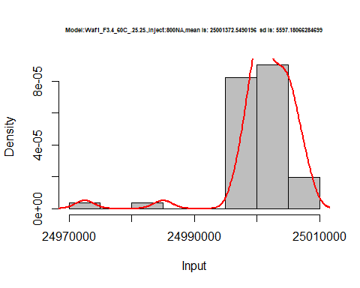

hist(d_25.25$V2,  
 cex.main=0.5,  
 freq = FALSE,  
 main = paste('Model:Waf1_F3.4_60C_.25.25.,Inject:200NA,mean is:', mean(d_25.25$V2),' sd is:', sd(d_25.25$V2)),  
 xlab = "Input",  
 ylab = "Density",  
 col="grey")  
#plot density curve  
lines(density(d_25.25$V2), # density plot  
 lwd = 2, # thickness of line  
 col = "red")

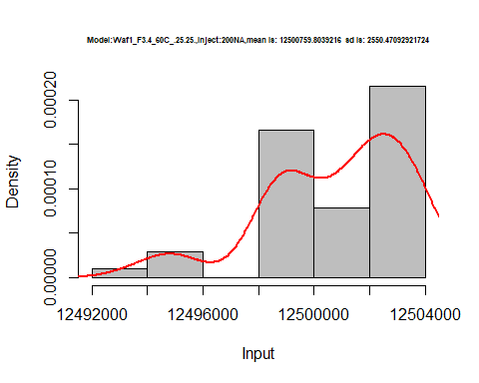

hist(d_25.25$V3,  
 cex.main=0.5,  
 freq = FALSE,  
 main = paste('Model:Waf1_F3.4_60C_.25.25.,Inject:300NA,mean is:', mean(d_25.25$V3),' sd is:', sd(d_25.25$V3)),  
 xlab = "Input",  
 ylab = "Density",  
 col="grey")  
#plot density curve  
lines(density(d_25.25$V3), # density plot  
 lwd = 2, # thickness of line  
 col = "red")

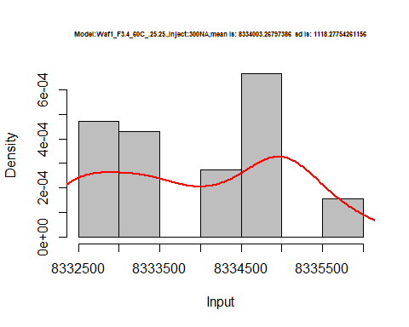

hist(d_25.25$V4,  
 cex.main=0.5,  
 freq = FALSE,  
 main = paste('Model:Waf1_F3.4_60C_.25.25.,Inject:400NA,mean is:', mean(d_25.25$V4),' sd is:', sd(d_25.25$V4)),  
 xlab = "Input",  
 ylab = "Density",  
 col="grey")  
#plot density curve  
lines(density(d_25.25$V4), # density plot  
 lwd = 2, # thickness of line  
 col = "red")

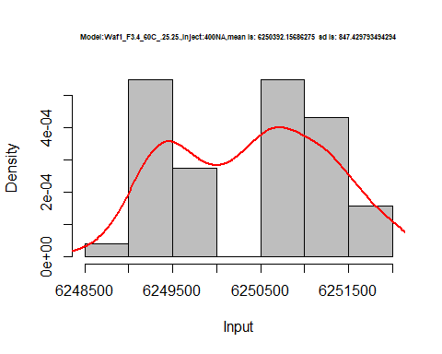

hist(d_25.25$V5,  
 cex.main=0.5,  
 freq = FALSE,  
 main = paste('Model:Waf1_F3.4_60C_.25.25.,Inject:500NA,mean is:', mean(d_25.25$V5),' sd is:', sd(d_25.25$V5)),  
 xlab = "Input",  
 ylab = "Density",  
 col="grey")  
#plot density curve  
lines(density(d_25.25$V5), # density plot  
 lwd = 2, # thickness of line  
 col = "red")

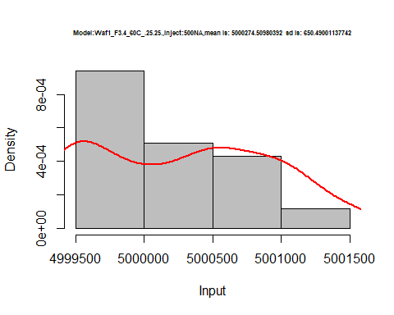

hist(d_25.25$V6,  
 cex.main=0.5,  
 freq = FALSE,  
 main = paste('Model:Waf1_F3.4_60C_.25.25.,Inject:600NA,mean is:', mean(d_25.25$V6),' sd is:', sd(d_25.25$V6)),  
 xlab = "Input",  
 ylab = "Density",  
 col="grey")  
#plot density curve  
lines(density(d_25.25$V6), # density plot  
 lwd = 2, # thickness of line  
 col = "red")

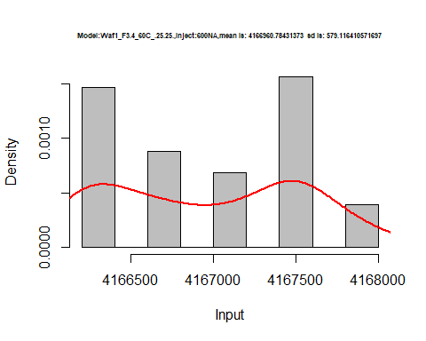

hist(d_25.25$V7,  
 cex.main=0.5,  
 freq = FALSE,  
 main = paste('Model:Waf1_F3.4_60C_.25.25.,Inject:700NA,mean is:', mean(d_25.25$V7),' sd is:', sd(d_25.25$V7)),  
 xlab = "Input",  
 ylab = "Density",  
 col="grey")  
#plot density curve  
lines(density(d_25.25$V7), # density plot  
 lwd = 2, # thickness of line  
 col = "red")

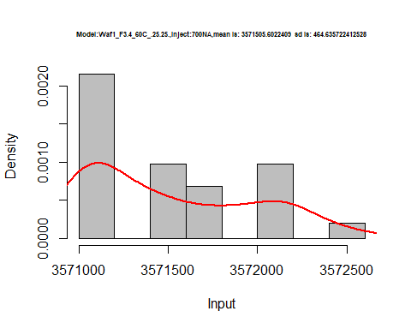

hist(d_25.25$V8,  
 cex.main=0.5,  
 freq = FALSE,  
 main = paste('Model:Waf1_F3.4_60C_.25.25.,Inject:800NA,mean is:', mean(d_25.25$V8),' sd is:', sd(d_25.25$V8)),  
 xlab = "Input",  
 ylab = "Density",  
 col="grey")  
#plot density curve  
lines(density(d_25.25$V8), # density plot  
 lwd = 2, # thickness of line  
 col = "red")

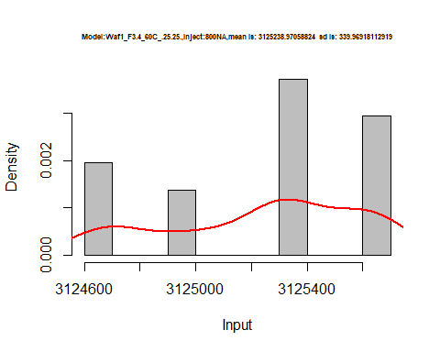

dens <- apply(d_25.25, 2, density)  
plot('Model:Waf1_F3.4_60C_.25.25', xlim=range(sapply(dens, "[", "x")), ylim=range(sapply(dens, "[", "y")))

## Warning in xy.coords(x, y, xlabel, ylabel, log): NAs introduced by coercion

mapply(lines, dens, col=1:length(dens))

## $V1  
## NULL  
##   
## $V2  
## NULL  
##   
## $V3  
## NULL  
##   
## $V4  
## NULL  
##   
## $V5  
## NULL  
##   
## $V6  
## NULL  
##   
## $V7  
## NULL  
##   
## $V8  
## NULL

legend("topright", legend=names(dens), fill=1:length(dens))

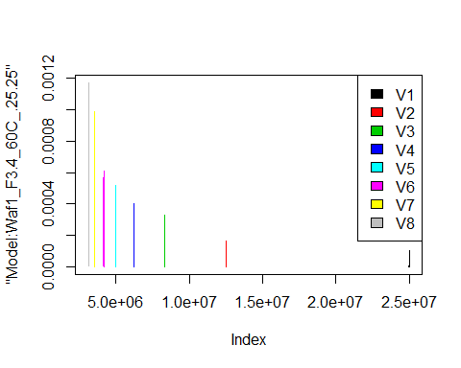

# Select columns whose names contains "26.26"  
d_26.26<-my_data %>% select(contains("26.26."))  
#d_26.26 <- head(d_26.26,51)  
#colnames(d_26.26) <- c("V1", "V2","V3","V4","V5","V6","V7","V8")  
head(d_26.26)

## Waf1_F2.4_F_60C_.100nA_.26.26. Waf1_F2.4_F_60C_.200nA_.26.26.  
## 1 7695000 4975000  
## 2 7685000 4975000  
## 3 7687500 4972500  
## 4 7687500 4977500  
## 5 7690000 4976250  
## 6 7690000 4978750  
## Waf1_F2.4_F_60C_.300nA_.26.26. Waf1_F2.4_F_60C_.400nA_.26.26.  
## 1 3824167 3156875  
## 2 3832500 3155625  
## 3 3831667 3158125  
## 4 3827500 3158125  
## 5 3830000 3165000  
## 6 3829167 3161250  
## Waf1_F2.4_F_60C_.500nA_.26.26. Waf1_F2.4_F_60C_.600nA_.26.26.  
## 1 2715000 2397083  
## 2 2725000 2396250  
## 3 2720500 2393333  
## 4 2728500 2404167  
## 5 2741000 2404583  
## 6 2741500 2410417  
## Waf1_F2.4_F_60C_.700nA_.26.26. Waf1_F2.4_F_60C_.800nA_.26.26.  
## 1 2171786 1950000  
## 2 2152143 1947500  
## 3 2154286 1948438  
## 4 2148929 1945625  
## 5 2148571 1944062  
## 6 2161429 1942500  
## Waf1_F2.6_F_60C_.100nA_.26.26. Waf1_F2.6_F_60C_.200nA_.26.26.  
## 1 1662500 1510000  
## 2 1657500 1510000  
## 3 1652500 1510000  
## 4 1652500 1507500  
## 5 1652500 1508750  
## 6 1652500 1510000  
## Waf1_F2.6_F_60C_.300nA_.26.26. Waf1_F2.6_F_60C_.400nA_.26.26.  
## 1 1365833 1264375  
## 2 1365833 1262500  
## 3 1365000 1261250  
## 4 1366667 1263750  
## 5 1364167 1261875  
## 6 1362500 1259375  
## Waf1_F2.6_F_60C_.500nA_.26.26. Waf1_F2.6_F_60C_.600nA_.26.26.  
## 1 1169000 1102500  
## 2 1169500 1107083  
## 3 1171500 1109167  
## 4 1175500 1106667  
## 5 1174500 1106250  
## 6 1173500 1105833  
## Waf1_F2.6_F_60C_.700nA_.26.26. Waf1_F2.6_F_60C_.800nA_.26.26.  
## 1 1041786 1001250  
## 2 1042857 1001250  
## 3 1042857 1001250  
## 4 1042857 1002812  
## 5 1043571 1001875  
## 6 1042857 1001250  
## Waf1_F3.5_60C_.100nA_.26.26. Waf1_F3.5_60C_.200nA_.26.26.  
## 1 25005000 12502500  
## 2 25002500 12502500  
## 3 25002500 12501250  
## 4 25002500 12502500  
## 5 25002500 12502500  
## 6 25002500 12503750  
## Waf1_F3.5_60C_.300nA_.26.26. Waf1_F3.5_60C_.400nA_.26.26.  
## 1 8332500 6250000  
## 2 8333333 6250000  
## 3 8333333 6250625  
## 4 8333333 6250625  
## 5 8334167 6250625  
## 6 8334167 6251250  
## Waf1_F3.5_60C_.500nA_.26.26. Waf1_F3.5_60C_.600nA_.26.26.  
## 1 5000000 4166667  
## 2 5000000 4166250  
## 3 5000500 4166667  
## 4 5000500 4167083  
## 5 5001000 4167083  
## 6 5001000 4167083  
## Waf1_F3.5_60C_.700nA_.26.26. Waf1_F3.5_60C_.800nA_.26.26.  
## 1 3571786 3125312  
## 2 3571786 3125312  
## 3 3571071 3125312  
## 4 3571071 3125625  
## 5 3571429 3125625  
## 6 3571071 3125312  
## Waf1_F6.3_F_60C_.100nA_.26.26. Waf1_F6.3_F_60C_.200nA_.26.26.  
## 1 1627500 1463750  
## 2 1632500 1463750  
## 3 1652500 1462500  
## 4 1637500 1458750  
## 5 1637500 1453750  
## 6 1635000 1461250  
## Waf1_F6.3_F_60C_.300nA_.26.26. Waf1_F6.3_F_60C_.400nA_.26.26.  
## 1 1197500 1146250  
## 2 1197500 1153750  
## 3 1195833 1152500  
## 4 1199167 1156250  
## 5 1196667 1151250  
## 6 1197500 1155625  
## Waf1_F6.3_F_60C_.500nA_.26.26. Waf1_F6.3_F_60C_.600nA_.26.26.  
## 1 1098000 1017083  
## 2 1095500 1017500  
## 3 1096500 1017500  
## 4 1095500 1022917  
## 5 1097500 1023750  
## 6 1097500 1023750  
## Waf1_F6.3_F_60C_.700nA_.26.26. Waf1_F6.3_F_60C_.800nA_.26.26.  
## 1 974642.9 915937.5  
## 2 976071.4 917812.5  
## 3 972142.9 919375.0  
## 4 971785.7 919687.5  
## 5 972500.0 920312.5  
## 6 972500.0 920000.0

d1_26.26<-d_26.26[,c(1:8)]  
d1_26.26 <- head(d1_26.26,51)  
colnames(d1_26.26) <- c("V1", "V2","V3","V4","V5","V6","V7","V8")  
head(d1_26.26)

## V1 V2 V3 V4 V5 V6 V7 V8  
## 1 7695000 4975000 3824167 3156875 2715000 2397083 2171786 1950000  
## 2 7685000 4975000 3832500 3155625 2725000 2396250 2152143 1947500  
## 3 7687500 4972500 3831667 3158125 2720500 2393333 2154286 1948438  
## 4 7687500 4977500 3827500 3158125 2728500 2404167 2148929 1945625  
## 5 7690000 4976250 3830000 3165000 2741000 2404583 2148571 1944062  
## 6 7690000 4978750 3829167 3161250 2741500 2410417 2161429 1942500

hist(d1_26.26$V1,  
 cex.main=0.5,  
 freq = FALSE,  
 main = paste('Model:Waf1_F2.4_60C_.26.26.,Inject:100NA,mean is:', mean(d1_26.26$V1),' sd is:', sd(d1_26.26$V1)),  
 xlab = "Input",  
 ylab = "Density",  
 col="grey")  
#plot density curve  
lines(density(d1_26.26$V1), # density plot  
 lwd = 2, # thickness of line  
 col = "red")

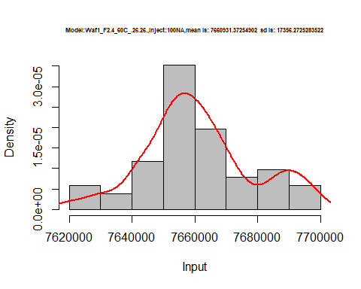

hist(d1_26.26$V2,  
 cex.main=0.5,  
 freq = FALSE,  
 main = paste('Model:Waf1_F2.4_60C_.26.26.,Inject:200NA,mean is:', mean(d1_26.26$V2),' sd is:', sd(d1_26.26$V2)),  
 xlab = "Input",  
 ylab = "Density",  
 col="grey")  
#plot density curve  
lines(density(d1_26.26$V2), # density plot  
 lwd = 2, # thickness of line  
 col = "red")

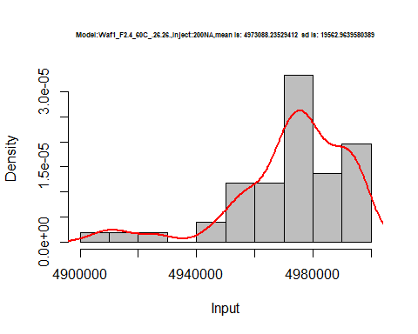

hist(d1_26.26$V3,  
 cex.main=0.5,  
 freq = FALSE,  
 main = paste('Model:Waf1_F2.4_60C_.26.26.,Inject:300NA,mean is:', mean(d1_26.26$V3),' sd is:', sd(d1_26.26$V3)),  
 xlab = "Input",  
 ylab = "Density",  
 col="grey")  
#plot density curve  
lines(density(d1_26.26$V3), # density plot  
 lwd = 2, # thickness of line  
 col = "red")

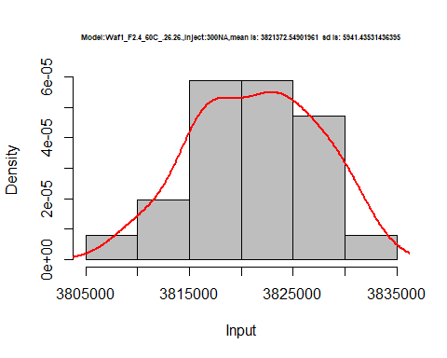

hist(d1_26.26$V4,  
 cex.main=0.5,  
 freq = FALSE,  
 main = paste('Model:Waf1_F2.4_60C_.26.26.,Inject:400NA,mean is:', mean(d1_26.26$V4),' sd is:', sd(d1_26.26$V4)),  
 xlab = "Input",  
 ylab = "Density",  
 col="grey")  
#plot density curve  
lines(density(d1_26.26$V4), # density plot  
 lwd = 2, # thickness of line  
 col = "red")

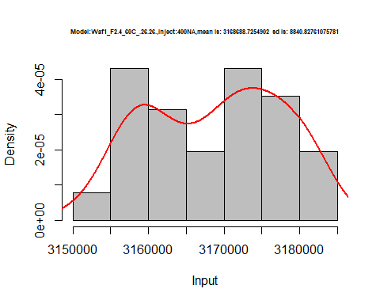

hist(d1_26.26$V5,  
 cex.main=0.5,  
 freq = FALSE,  
 main = paste('Model:Waf1_F2.4_60C_.26.26.,Inject:500NA,mean is:', mean(d1_26.26$V5),' sd is:', sd(d1_26.26$V5)),  
 xlab = "Input",  
 ylab = "Density",  
 col="grey")  
#plot density curve  
lines(density(d1_26.26$V5), # density plot  
 lwd = 2, # thickness of line  
 col = "red")

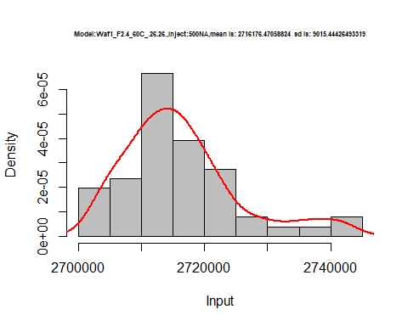

hist(d1_26.26$V6,  
 cex.main=0.5,  
 freq = FALSE,  
 main = paste('Model:Waf1_F2.4_60C_.26.26.,Inject:600NA,mean is:', mean(d1_26.26$V6),' sd is:', sd(d1_26.26$V6)),  
 xlab = "Input",  
 ylab = "Density",  
 col="grey")  
#plot density curve  
lines(density(d1_26.26$V6), # density plot  
 lwd = 2, # thickness of line  
 col = "red")

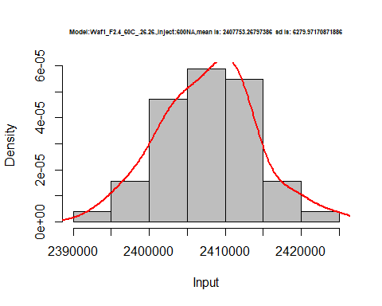

hist(d1_26.26$V7,  
 cex.main=0.5,  
 freq = FALSE,  
 main = paste('Model:Waf1_F2.4_60C_.26.26.,Inject:700NA,mean is:', mean(d1_26.26$V7),' sd is:', sd(d1_26.26$V7)),  
 xlab = "Input",  
 ylab = "Density",  
 col="grey")  
#plot density curve  
lines(density(d1_26.26$V7), # density plot  
 lwd = 2, # thickness of line  
 col = "red")

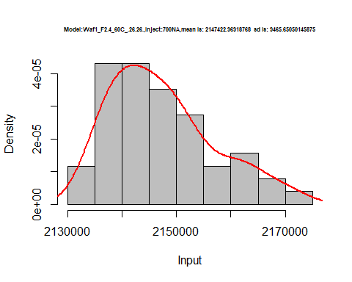

hist(d1_26.26$V8,  
 cex.main=0.5,  
 freq = FALSE,  
 main = paste('Model:Waf1_F2.4_60C_.26.26.,Inject:800NA,mean is:', mean(d1_26.26$V8),' sd is:', sd(d1_26.26$V8)),  
 xlab = "Input",  
 ylab = "Density",  
 col="grey")  
#plot density curve  
lines(density(d1_26.26$V8), # density plot  
 lwd = 2, # thickness of line  
 col = "red")

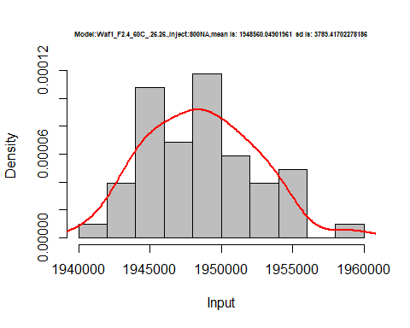

dens <- apply(d1_26.26, 2, density)  
plot('Model:Waf1_F2.4_60C_.26.26', xlim=range(sapply(dens, "[", "x")), ylim=range(sapply(dens, "[", "y")))

## Warning in xy.coords(x, y, xlabel, ylabel, log): NAs introduced by coercion

mapply(lines, dens, col=1:length(dens))

## $V1  
## NULL  
##   
## $V2  
## NULL  
##   
## $V3  
## NULL  
##   
## $V4  
## NULL  
##   
## $V5  
## NULL  
##   
## $V6  
## NULL  
##   
## $V7  
## NULL  
##   
## $V8  
## NULL

legend("topright", legend=names(dens), fill=1:length(dens))

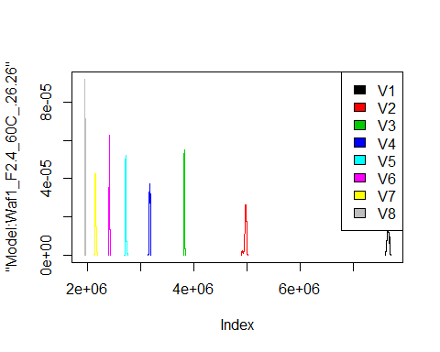

d2_26.26<-d_26.26[,c(9:16)]  
d2_26.26 <- head(d2_26.26,51)  
colnames(d2_26.26) <- c("V1", "V2","V3","V4","V5","V6","V7","V8")  
head(d2_26.26)

## V1 V2 V3 V4 V5 V6 V7 V8  
## 1 1662500 1510000 1365833 1264375 1169000 1102500 1041786 1001250  
## 2 1657500 1510000 1365833 1262500 1169500 1107083 1042857 1001250  
## 3 1652500 1510000 1365000 1261250 1171500 1109167 1042857 1001250  
## 4 1652500 1507500 1366667 1263750 1175500 1106667 1042857 1002812  
## 5 1652500 1508750 1364167 1261875 1174500 1106250 1043571 1001875  
## 6 1652500 1510000 1362500 1259375 1173500 1105833 1042857 1001250

hist(d2_26.26$V1,  
 cex.main=0.5,  
 freq = FALSE,  
 main = paste('Model:Waf1_F2.6_60C_.26.26.,Inject:100NA,mean is:', mean(d2_26.26$V1),' sd is:', sd(d2_26.26$V1)),  
 xlab = "Input",  
 ylab = "Density",  
 col="grey")  
#plot density curve  
lines(density(d2_26.26$V1), # density plot  
 lwd = 2, # thickness of line  
 col = "red")

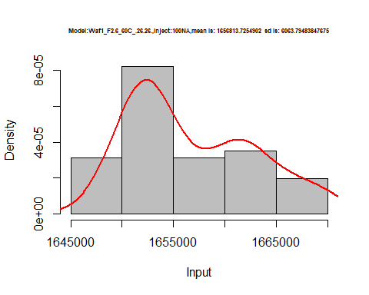

hist(d2_26.26$V2,  
 cex.main=0.5,  
 freq = FALSE,  
 main = paste('Model:Waf1_F2.6_60C_.26.26.,Inject:200NA,mean is:', mean(d2_26.26$V2),' sd is:', sd(d2_26.26$V2)),  
 xlab = "Input",  
 ylab = "Density",  
 col="grey")  
#plot density curve  
lines(density(d2_26.26$V2), # density plot  
 lwd = 2, # thickness of line  
 col = "red")

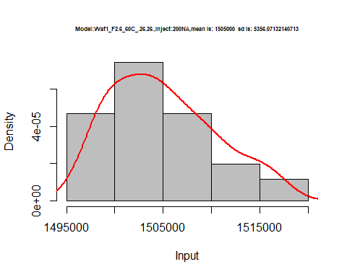

hist(d2_26.26$V3,  
 cex.main=0.5,  
 freq = FALSE,  
 main = paste('Model:Waf1_F2.6_60C_.26.26.,Inject:300NA,mean is:', mean(d2_26.26$V3),' sd is:', sd(d2_26.26$V3)),  
 xlab = "Input",  
 ylab = "Density",  
 col="grey")  
#plot density curve  
lines(density(d2_26.26$V3), # density plot  
 lwd = 2, # thickness of line  
 col = "red")

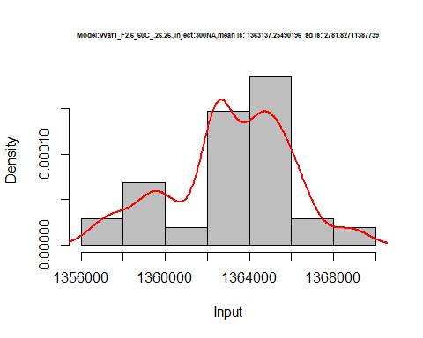

hist(d2_26.26$V4,  
 cex.main=0.5,  
 freq = FALSE,  
 main = paste('Model:Waf1_F2.6_60C_.26.26.,Inject:400NA,mean is:', mean(d2_26.26$V4),' sd is:', sd(d2_26.26$V4)),  
 xlab = "Input",  
 ylab = "Density",  
 col="grey")  
#plot density curve  
lines(density(d2_26.26$V4), # density plot  
 lwd = 2, # thickness of line  
 col = "red")

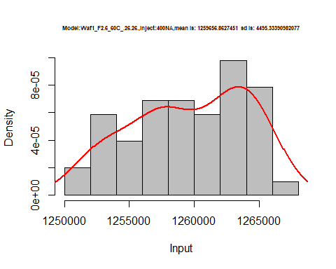

hist(d2_26.26$V5,  
 cex.main=0.5,  
 freq = FALSE,  
 main = paste('Model:Waf1_F2.6_60C_.26.26.,Inject:500NA,mean is:', mean(d2_26.26$V5),' sd is:', sd(d2_26.26$V5)),  
 xlab = "Input",  
 ylab = "Density",  
 col="grey")  
#plot density curve  
lines(density(d2_26.26$V5), # density plot  
 lwd = 2, # thickness of line  
 col = "red")

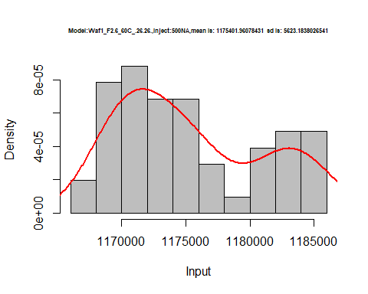

hist(d2_26.26$V6,  
 cex.main=0.5,  
 freq = FALSE,  
 main = paste('Model:Waf1_F2.6_60C_.26.26.,Inject:600NA,mean is:', mean(d2_26.26$V6),' sd is:', sd(d2_26.26$V6)),  
 xlab = "Input",  
 ylab = "Density",  
 col="grey")  
#plot density curve  
lines(density(d2_26.26$V6), # density plot  
 lwd = 2, # thickness of line  
 col = "red")

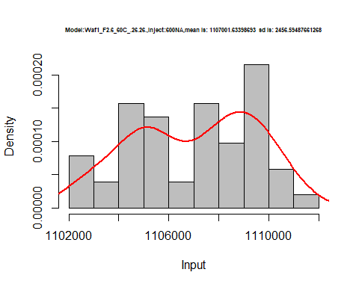

hist(d2_26.26$V7,  
 cex.main=0.5,  
 freq = FALSE,  
 main = paste('Model:Waf1_F2.6_60C_.26.26.,Inject:700NA,mean is:', mean(d2_26.26$V7),' sd is:', sd(d2_26.26$V7)),  
 xlab = "Input",  
 ylab = "Density",  
 col="grey")  
#plot density curve  
lines(density(d2_26.26$V7), # density plot  
 lwd = 2, # thickness of line  
 col = "red")

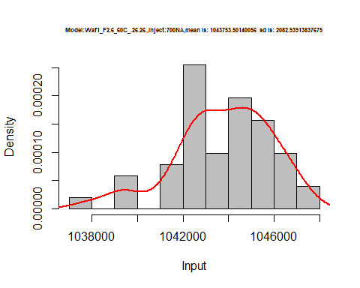

hist(d2_26.26$V8,  
 cex.main=0.5,  
 freq = FALSE,  
 main = paste('Model:Waf1_F2.6_60C_.26.26.,Inject:800NA,mean is:', mean(d2_26.26$V8),' sd is:', sd(d2_26.26$V8)),  
 xlab = "Input",  
 ylab = "Density",  
 col="grey")  
#plot density curve  
lines(density(d2_26.26$V8), # density plot  
 lwd = 2, # thickness of line  
 col = "red")

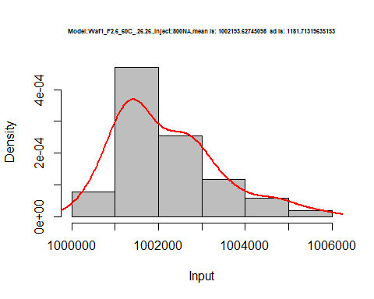

dens <- apply(d2_26.26, 2, density)  
plot('Model:Waf1_F2.6_60C_.26.26', xlim=range(sapply(dens, "[", "x")), ylim=range(sapply(dens, "[", "y")))

## Warning in xy.coords(x, y, xlabel, ylabel, log): NAs introduced by coercion

mapply(lines, dens, col=1:length(dens))

## $V1  
## NULL  
##   
## $V2  
## NULL  
##   
## $V3  
## NULL  
##   
## $V4  
## NULL  
##   
## $V5  
## NULL  
##   
## $V6  
## NULL  
##   
## $V7  
## NULL  
##   
## $V8  
## NULL

legend("topright", legend=names(dens), fill=1:length(dens))

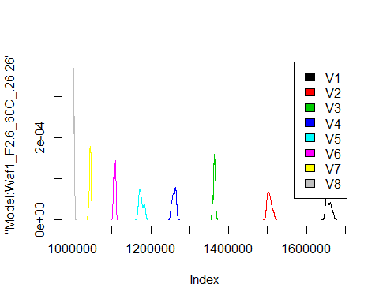

d3_26.26<-d_26.26[,c(17:24)]  
d3_26.26 <- head(d3_26.26,51)  
colnames(d3_26.26) <- c("V1", "V2","V3","V4","V5","V6","V7","V8")  
head(d3_26.26)

## V1 V2 V3 V4 V5 V6 V7 V8  
## 1 25005000 12502500 8332500 6250000 5000000 4166667 3571786 3125312  
## 2 25002500 12502500 8333333 6250000 5000000 4166250 3571786 3125312  
## 3 25002500 12501250 8333333 6250625 5000500 4166667 3571071 3125312  
## 4 25002500 12502500 8333333 6250625 5000500 4167083 3571071 3125625  
## 5 25002500 12502500 8334167 6250625 5001000 4167083 3571429 3125625  
## 6 25002500 12503750 8334167 6251250 5001000 4167083 3571071 3125312

hist(d3_26.26$V1,  
 cex.main=0.5,  
 freq = FALSE,  
 main = paste('Model:Waf1_F3.5_60C_.26.26.,Inject:100NA,mean is:', mean(d3_26.26$V1),' sd is:', sd(d3_26.26$V1)),  
 xlab = "Input",  
 ylab = "Density",  
 col="grey")  
#plot density curve  
lines(density(d3_26.26$V1), # density plot  
 lwd = 2, # thickness of line  
 col = "red")

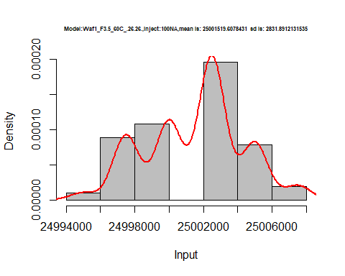

hist(d3_26.26$V2,  
 cex.main=0.5,  
 freq = FALSE,  
 main = paste('Model:Waf1_F3.5_60C_.26.26.,Inject:200NA,mean is:', mean(d3_26.26$V2),' sd is:', sd(d3_26.26$V2)),  
 xlab = "Input",  
 ylab = "Density",  
 col="grey")  
#plot density curve  
lines(density(d3_26.26$V2), # density plot  
 lwd = 2, # thickness of line  
 col = "red")

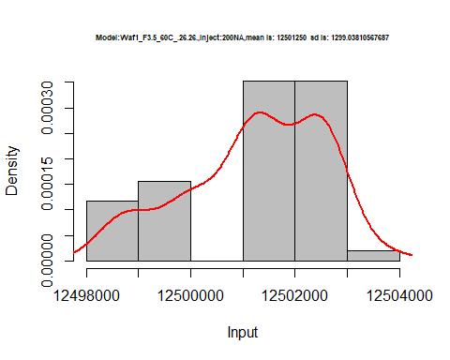

hist(d3_26.26$V3,  
 cex.main=0.5,  
 freq = FALSE,  
 main = paste('Model:Waf1_F3.5_60C_.26.26.,Inject:300NA,mean is:', mean(d3_26.26$V3),' sd is:', sd(d3_26.26$V3)),  
 xlab = "Input",  
 ylab = "Density",  
 col="grey")  
#plot density curve  
lines(density(d3_26.26$V3), # density plot  
 lwd = 2, # thickness of line  
 col = "red")

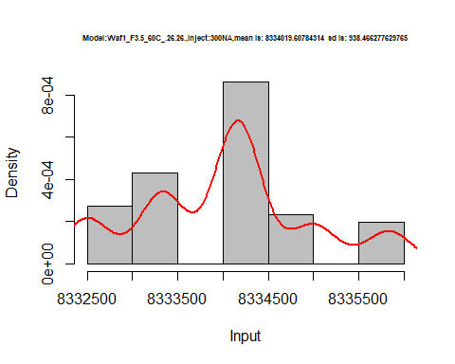

hist(d3_26.26$V4,  
 cex.main=0.5,  
 freq = FALSE,  
 main = paste('Model:Waf1_F3.5_60C_.26.26.,Inject:400NA,mean is:', mean(d3_26.26$V4),' sd is:', sd(d3_26.26$V4)),  
 xlab = "Input",  
 ylab = "Density",  
 col="grey")  
#plot density curve  
lines(density(d3_26.26$V4), # density plot  
 lwd = 2, # thickness of line  
 col = "red")

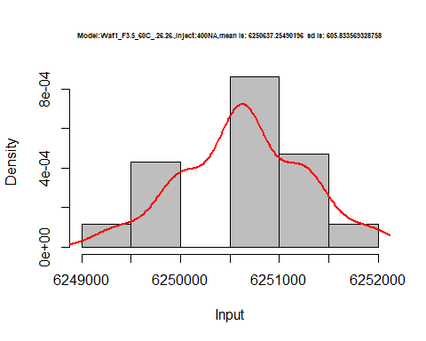

hist(d3_26.26$V5,  
 cex.main=0.5,  
 freq = FALSE,  
 main = paste('Model:Waf1_F3.5_60C_.26.26.,Inject:500NA,mean is:', mean(d3_26.26$V5),' sd is:', sd(d3_26.26$V5)),  
 xlab = "Input",  
 ylab = "Density",  
 col="grey")  
#plot density curve  
lines(density(d3_26.26$V5), # density plot  
 lwd = 2, # thickness of line  
 col = "red")

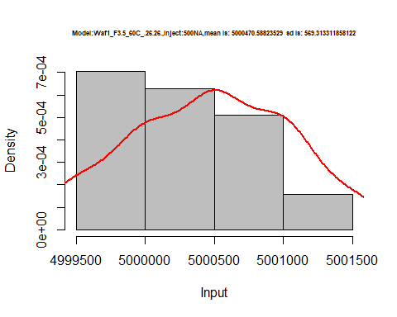

hist(d3_26.26$V6,  
 cex.main=0.5,  
 freq = FALSE,  
 main = paste('Model:Waf1_F3.5_60C_.26.26.,Inject:600NA,mean is:', mean(d3_26.26$V6),' sd is:', sd(d3_26.26$V6)),  
 xlab = "Input",  
 ylab = "Density",  
 col="grey")  
#plot density curve  
lines(density(d3_26.26$V6), # density plot  
 lwd = 2, # thickness of line  
 col = "red")

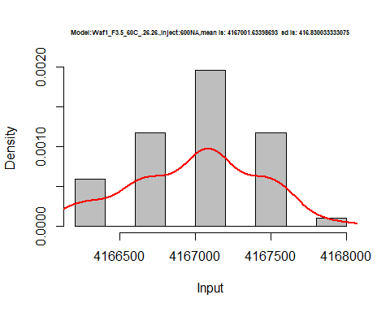

hist(d3_26.26$V7,  
 cex.main=0.5,  
 freq = FALSE,  
 main = paste('Model:Waf1_F3.5_60C_.26.26.,Inject:700NA,mean is:', mean(d3_26.26$V7),' sd is:', sd(d3_26.26$V7)),  
 xlab = "Input",  
 ylab = "Density",  
 col="grey")  
#plot density curve  
lines(density(d3_26.26$V7), # density plot  
 lwd = 2, # thickness of line  
 col = "red")

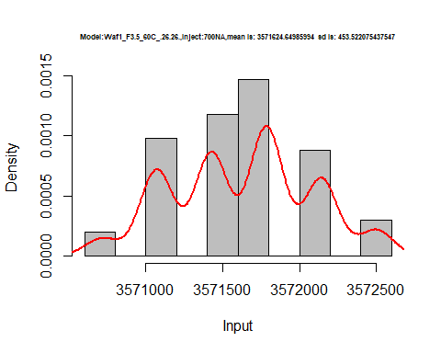

hist(d3_26.26$V8,  
 cex.main=0.5,  
 freq = FALSE,  
 main = paste('Model:Waf1_F3.5_60C_.26.26.,Inject:800NA,mean is:', mean(d3_26.26$V8),' sd is:', sd(d3_26.26$V8)),  
 xlab = "Input",  
 ylab = "Density",  
 col="grey")  
#plot density curve  
lines(density(d3_26.26$V8), # density plot  
 lwd = 2, # thickness of line  
 col = "red")

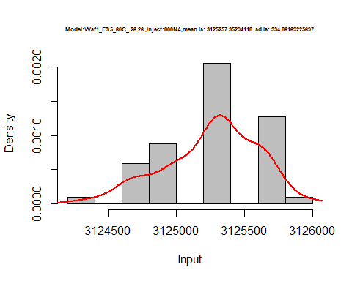

dens <- apply(d3_26.26, 2, density)  
plot('Model:Waf1_F3.5_60C_.26.26', xlim=range(sapply(dens, "[", "x")), ylim=range(sapply(dens, "[", "y")))

## Warning in xy.coords(x, y, xlabel, ylabel, log): NAs introduced by coercion

mapply(lines, dens, col=1:length(dens))

## $V1  
## NULL  
##   
## $V2  
## NULL  
##   
## $V3  
## NULL  
##   
## $V4  
## NULL  
##   
## $V5  
## NULL  
##   
## $V6  
## NULL  
##   
## $V7  
## NULL  
##   
## $V8  
## NULL

legend("topright", legend=names(dens), fill=1:length(dens))

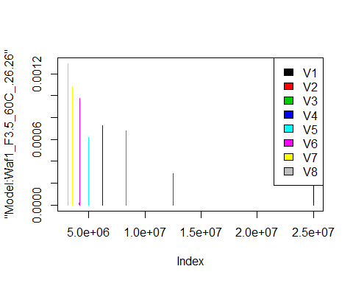

d4_26.26<-d_26.26[,c(25:32)]  
d4_26.26 <- head(d4_26.26,51)  
colnames(d4_26.26) <- c("V1", "V2","V3","V4","V5","V6","V7","V8")  
head(d4_26.26)

## V1 V2 V3 V4 V5 V6 V7 V8  
## 1 1627500 1463750 1197500 1146250 1098000 1017083 974642.9 915937.5  
## 2 1632500 1463750 1197500 1153750 1095500 1017500 976071.4 917812.5  
## 3 1652500 1462500 1195833 1152500 1096500 1017500 972142.9 919375.0  
## 4 1637500 1458750 1199167 1156250 1095500 1022917 971785.7 919687.5  
## 5 1637500 1453750 1196667 1151250 1097500 1023750 972500.0 920312.5  
## 6 1635000 1461250 1197500 1155625 1097500 1023750 972500.0 920000.0

hist(d4_26.26$V1,  
 cex.main=0.5,  
 freq = FALSE,  
 main = paste('Model:Waf1_F6.3_60C_.26.26.,Inject:100NA,mean is:', mean(d4_26.26$V1),' sd is:', sd(d4_26.26$V1)),  
 xlab = "Input",  
 ylab = "Density",  
 col="grey")  
#plot density curve  
lines(density(d4_26.26$V1), # density plot  
 lwd = 2, # thickness of line  
 col = "red")

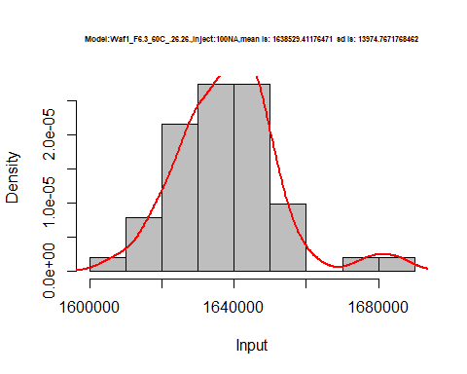

hist(d4_26.26$V2,  
 cex.main=0.5,  
 freq = FALSE,  
 main = paste('Model:Waf1_F6.3_60C_.26.26.,Inject:200NA,mean is:', mean(d4_26.26$V2),' sd is:', sd(d4_26.26$V2)),  
 xlab = "Input",  
 ylab = "Density",  
 col="grey")  
#plot density curve  
lines(density(d4_26.26$V2), # density plot  
 lwd = 2, # thickness of line  
 col = "red")

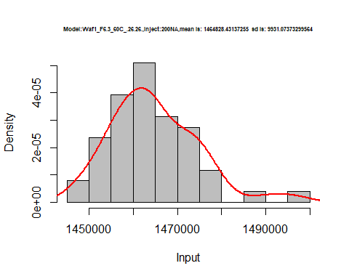

hist(d4_26.26$V3,  
 cex.main=0.5,  
 freq = FALSE,  
 main = paste('Model:Waf1_F6.3_60C_.26.26.,Inject:300NA,mean is:', mean(d4_26.26$V3),' sd is:', sd(d4_26.26$V3)),  
 xlab = "Input",  
 ylab = "Density",  
 col="grey")  
#plot density curve  
lines(density(d4_26.26$V3), # density plot  
 lwd = 2, # thickness of line  
 col = "red")

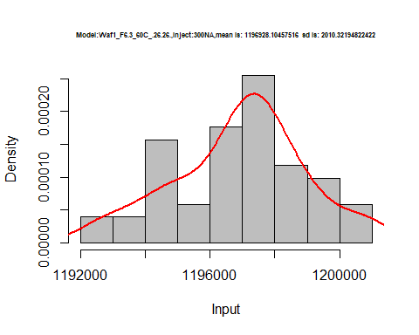

hist(d4_26.26$V4,  
 cex.main=0.5,  
 freq = FALSE,  
 main = paste('Model:Waf1_F6.3_60C_.26.26.,Inject:400NA,mean is:', mean(d4_26.26$V4),' sd is:', sd(d4_26.26$V4)),  
 xlab = "Input",  
 ylab = "Density",  
 col="grey")  
#plot density curve  
lines(density(d4_26.26$V4), # density plot  
 lwd = 2, # thickness of line  
 col = "red")

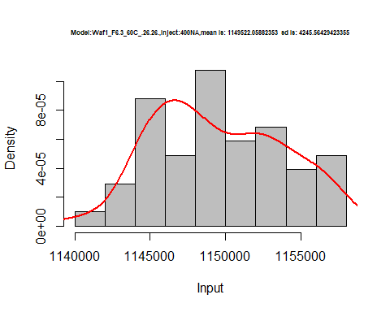

hist(d4_26.26$V5,  
 cex.main=0.5,  
 freq = FALSE,  
 main = paste('Model:Waf1_F6.3_60C_.26.26.,Inject:500NA,mean is:', mean(d4_26.26$V5),' sd is:', sd(d4_26.26$V5)),  
 xlab = "Input",  
 ylab = "Density",  
 col="grey")  
#plot density curve  
lines(density(d4_26.26$V5), # density plot  
 lwd = 2, # thickness of line  
 col = "red")

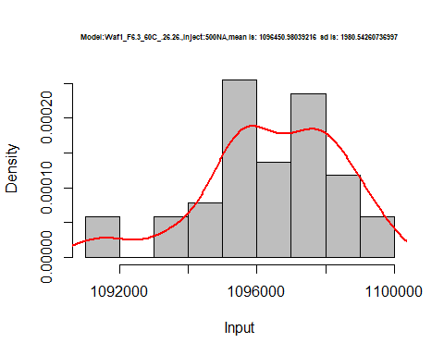

hist(d4_26.26$V6,  
 cex.main=0.5,  
 freq = FALSE,  
 main = paste('Model:Waf1_F6.3_60C_.26.26.,Inject:600NA,mean is:', mean(d4_26.26$V6),' sd is:', sd(d4_26.26$V6)),  
 xlab = "Input",  
 ylab = "Density",  
 col="grey")  
#plot density curve  
lines(density(d4_26.26$V6), # density plot  
 lwd = 2, # thickness of line  
 col = "red")

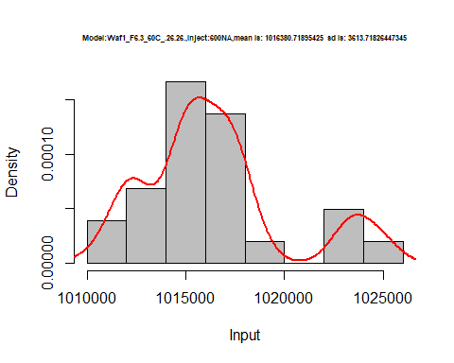

dens <- apply(d4_26.26, 2, density)  
plot('Model:Waf1_F6.3_60C_.26.26', xlim=range(sapply(dens, "[", "x")), ylim=range(sapply(dens, "[", "y")))

## Warning in xy.coords(x, y, xlabel, ylabel, log): NAs introduced by coercion

mapply(lines, dens, col=1:length(dens))

## $V1  
## NULL  
##   
## $V2  
## NULL  
##   
## $V3  
## NULL  
##   
## $V4  
## NULL  
##   
## $V5  
## NULL  
##   
## $V6  
## NULL  
##   
## $V7  
## NULL  
##   
## $V8  
## NULL

legend("topright", legend=names(dens), fill=1:length(dens))

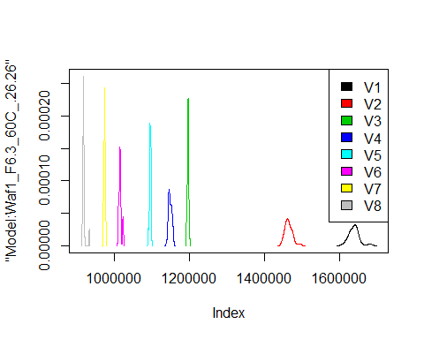

# Select columns whose names contains "27.27"  
d_27.27<-my_data %>% select(contains("27.27."))  
#d_26.26 <- head(d_26.26,51)  
#colnames(d_26.26) <- c("V1", "V2","V3","V4","V5","V6","V7","V8")  
head(d_27.27)

## Waf1_F3.4_F_60C_.100nA_.27.27. Waf1_F3.4_F_60C_.200nA_.27.27.  
## 1 5867500 4088750  
## 2 5865000 4090000  
## 3 5867500 4100000  
## 4 5887500 4103750  
## 5 5902500 4092500  
## 6 5900000 4088750  
## Waf1_F3.4_F_60C_.300nA_.27.27. Waf1_F3.4_F_60C_.400nA_.27.27.  
## 1 3223333 2706250  
## 2 3220000 2710625  
## 3 3221667 2706875  
## 4 3221667 2709375  
## 5 3219167 2709375  
## 6 3218333 2725625  
## Waf1_F3.4_F_60C_.500nA_.27.27. Waf1_F3.4_F_60C_.600nA_.27.27.  
## 1 2361500 2136250  
## 2 2360500 2134167  
## 3 2358500 2133333  
## 4 2357000 2134583  
## 5 2355500 2132917  
## 6 2357000 2132083  
## Waf1_F3.4_F_60C_.700nA_.27.27. Waf1_F3.4_F_60C_.800nA_.27.27.  
## 1 1909286 1780312  
## 2 1905357 1789063  
## 3 1910000 1780937  
## 4 1908929 1785937  
## 5 1908929 1790937  
## 6 1911429 1791875  
## Waf1_F3.5_60C_.100nA_.27.27. Waf1_F3.5_60C_.200nA_.27.27.  
## 1 0 1250  
## 2 0 0  
## 3 0 1250  
## 4 0 1250  
## 5 0 1250  
## 6 0 1250  
## Waf1_F3.5_60C_.300nA_.27.27. Waf1_F3.5_60C_.400nA_.27.27.  
## 1 0.0000 0  
## 2 -833.3333 625  
## 3 0.0000 625  
## 4 1666.6667 0  
## 5 0.0000 0  
## 6 833.3333 625  
## Waf1_F3.5_60C_.500nA_.27.27. Waf1_F3.5_60C_.600nA_.27.27.  
## 1 500 416.6667  
## 2 500 416.6667  
## 3 500 833.3333  
## 4 0 833.3333  
## 5 500 416.6667  
## 6 500 0.0000  
## Waf1_F3.5_60C_.700nA_.27.27. Waf1_F3.5_60C_.800nA_.27.27.  
## 1 357.1429 312.5  
## 2 0.0000 312.5  
## 3 357.1429 312.5  
## 4 357.1429 312.5  
## 5 714.2857 625.0  
## 6 357.1429 312.5  
## Waf1_F8.3_F_60C_.100nA_.27.27. Waf1_F8.3_F_60C_.200nA_.27.27.  
## 1 9142500 6281250  
## 2 9155000 6228750  
## 3 9117500 6278750  
## 4 9117500 6301250  
## 5 9147500 6338750  
## 6 9192500 6347500  
## Waf1_F8.3_F_60C_.300nA_.27.27. Waf1_F8.3_F_60C_.400nA_.27.27.  
## 1 4439167 3785000  
## 2 4442500 3785000  
## 3 4455833 3725625  
## 4 4463333 3741250  
## 5 4442500 3723750  
## 6 4460000 3744375  
## Waf1_F8.3_F_60C_.500nA_.27.27. Waf1_F8.3_F_60C_.600nA_.27.27.  
## 1 3126000 2765417  
## 2 3126000 2767083  
## 3 3162000 2750833  
## 4 3187000 2755000  
## 5 3187000 2757500  
## 6 3185500 2759167  
## Waf1_F8.3_F_60C_.700nA_.27.27. Waf1_F8.3_F_60C_.800nA_.27.27.  
## 1 3343214 1734688  
## 2 3492143 1751563  
## 3 3364643 1744688  
## 4 3283571 1756563  
## 5 3309643 1737500  
## 6 3281071 1751250

d1_27.27<-d_27.27[,c(1:8)]  
d1_27.27 <- head(d1_27.27,51)  
colnames(d1_27.27) <- c("V1", "V2","V3","V4","V5","V6","V7","V8")  
head(d1_27.27)

## V1 V2 V3 V4 V5 V6 V7 V8  
## 1 5867500 4088750 3223333 2706250 2361500 2136250 1909286 1780312  
## 2 5865000 4090000 3220000 2710625 2360500 2134167 1905357 1789063  
## 3 5867500 4100000 3221667 2706875 2358500 2133333 1910000 1780937  
## 4 5887500 4103750 3221667 2709375 2357000 2134583 1908929 1785937  
## 5 5902500 4092500 3219167 2709375 2355500 2132917 1908929 1790937  
## 6 5900000 4088750 3218333 2725625 2357000 2132083 1911429 1791875

hist(d1_27.27$V1,  
 cex.main=0.5,  
 freq = FALSE,  
 main = paste('Model:Waf1_F3.4_60C_.27.27.,Inject:100NA,mean is:', mean(d1_27.27$V1),' sd is:', sd(d1_27.27$V1)),  
 xlab = "Input",  
 ylab = "Density",  
 col="grey")  
#plot density curve  
lines(density(d1_27.27$V1), # density plot  
 lwd = 2, # thickness of line  
 col = "red")

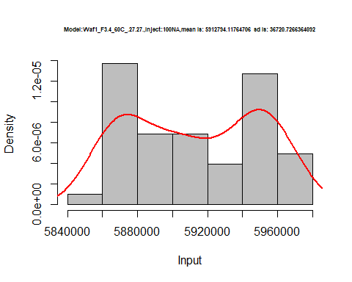

hist(d1_27.27$V2,  
 cex.main=0.5,  
 freq = FALSE,  
 main = paste('Model:Waf1_F3.4_60C_.27.27.,Inject:200NA,mean is:', mean(d1_27.27$V2),' sd is:', sd(d1_27.27$V2)),  
 xlab = "Input",  
 ylab = "Density",  
 col="grey")  
#plot density curve  
lines(density(d1_27.27$V2), # density plot  
 lwd = 2, # thickness of line  
 col = "red")

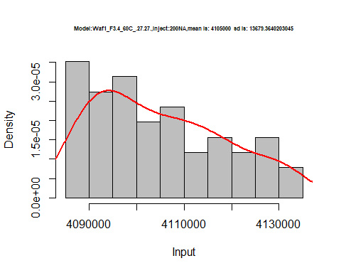

hist(d1_27.27$V3,  
 cex.main=0.5,  
 freq = FALSE,  
 main = paste('Model:Waf1_F3.4_60C_.27.27.,Inject:300NA,mean is:', mean(d1_27.27$V3),' sd is:', sd(d1_27.27$V3)),  
 xlab = "Input",  
 ylab = "Density",  
 col="grey")  
#plot density curve  
lines(density(d1_27.27$V3), # density plot  
 lwd = 2, # thickness of line  
 col = "red")

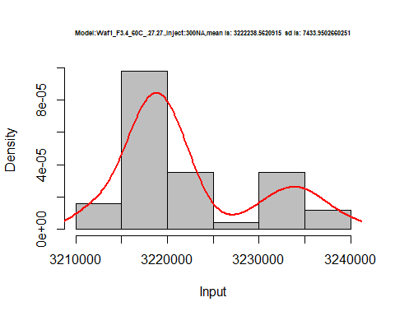

hist(d1_27.27$V4,  
 cex.main=0.5,  
 freq = FALSE,  
 main = paste('Model:Waf1_F3.4_60C_.27.27.,Inject:400NA,mean is:', mean(d1_27.27$V4),' sd is:', sd(d1_27.27$V4)),  
 xlab = "Input",  
 ylab = "Density",  
 col="grey")  
#plot density curve  
lines(density(d1_27.27$V4), # density plot  
 lwd = 2, # thickness of line  
 col = "red")

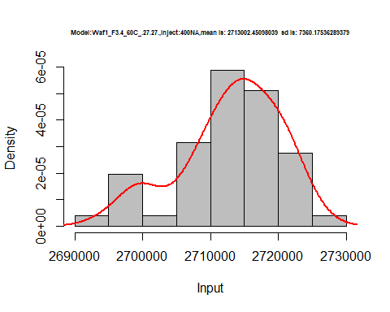

hist(d1_27.27$V5,  
 cex.main=0.5,  
 freq = FALSE,  
 main = paste('Model:Waf1_F3.4_60C_.27.27.,Inject:500NA,mean is:', mean(d1_27.27$V5),' sd is:', sd(d1_27.27$V5)),  
 xlab = "Input",  
 ylab = "Density",  
 col="grey")  
#plot density curve  
lines(density(d1_27.27$V5), # density plot  
 lwd = 2, # thickness of line  
 col = "red")

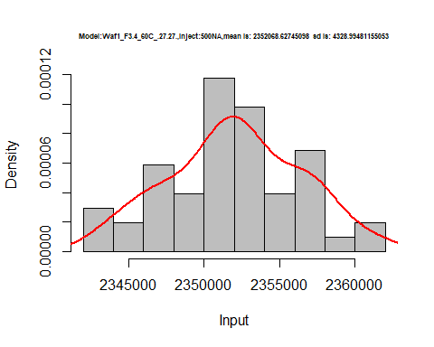

hist(d1_27.27$V6,  
 cex.main=0.5,  
 freq = FALSE,  
 main = paste('Model:Waf1_F3.4_60C_.27.27.,Inject:600NA,mean is:', mean(d1_27.27$V6),' sd is:', sd(d1_27.27$V6)),  
 xlab = "Input",  
 ylab = "Density",  
 col="grey")  
#plot density curve  
lines(density(d1_27.27$V6), # density plot  
 lwd = 2, # thickness of line  
 col = "red")

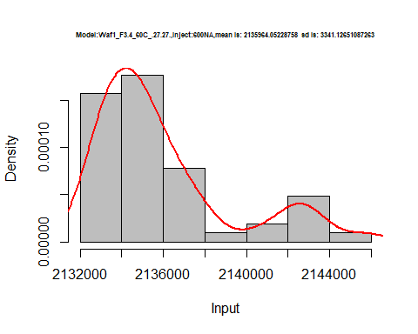

hist(d1_27.27$V7,  
 cex.main=0.5,  
 freq = FALSE,  
 main = paste('Model:Waf1_F3.4_60C_.27.27.,Inject:700NA,mean is:', mean(d1_27.27$V7),' sd is:', sd(d1_27.27$V7)),  
 xlab = "Input",  
 ylab = "Density",  
 col="grey")  
#plot density curve  
lines(density(d1_27.27$V7), # density plot  
 lwd = 2, # thickness of line  
 col = "red")

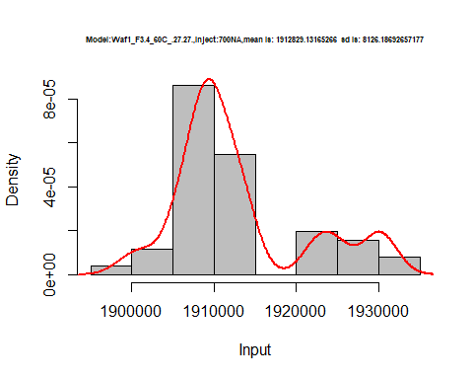

hist(d1_27.27$V8,  
 cex.main=0.5,  
 freq = FALSE,  
 main = paste('Model:Waf1_F3.4_60C_.27.27.,Inject:800NA,mean is:', mean(d1_27.27$V8),' sd is:', sd(d1_27.27$V8)),  
 xlab = "Input",  
 ylab = "Density",  
 col="grey")  
#plot density curve  
lines(density(d1_27.27$V8), # density plot  
 lwd = 2, # thickness of line  
 col = "red")

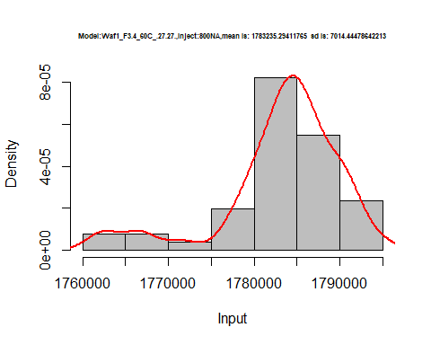

dens <- apply(d1_27.27, 2, density)  
plot('Model:Waf1_F3.4_60C_.27.27', xlim=range(sapply(dens, "[", "x")), ylim=range(sapply(dens, "[", "y")))

## Warning in xy.coords(x, y, xlabel, ylabel, log): NAs introduced by coercion

mapply(lines, dens, col=1:length(dens))

## $V1  
## NULL  
##   
## $V2  
## NULL  
##   
## $V3  
## NULL  
##   
## $V4  
## NULL  
##   
## $V5  
## NULL  
##   
## $V6  
## NULL  
##   
## $V7  
## NULL  
##   
## $V8  
## NULL

legend("topright", legend=names(dens), fill=1:length(dens))

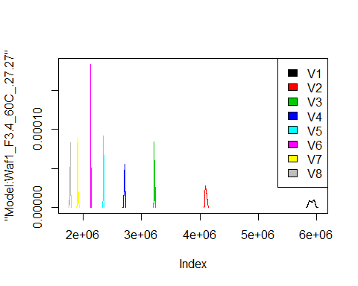

d2_27.27<-d_27.27[,c(9:16)]  
d2_27.27 <- head(d2_27.27,51)  
colnames(d2_27.27) <- c("V1", "V2","V3","V4","V5","V6","V7","V8")  
head(d2_27.27)

## V1 V2 V3 V4 V5 V6 V7 V8  
## 1 0 1250 0.0000 0 500 416.6667 357.1429 312.5  
## 2 0 0 -833.3333 625 500 416.6667 0.0000 312.5  
## 3 0 1250 0.0000 625 500 833.3333 357.1429 312.5  
## 4 0 1250 1666.6667 0 0 833.3333 357.1429 312.5  
## 5 0 1250 0.0000 0 500 416.6667 714.2857 625.0  
## 6 0 1250 833.3333 625 500 0.0000 357.1429 312.5

hist(d2_27.27$V1,  
 cex.main=0.5,  
 freq = FALSE,  
 main = paste('Model:Waf1_F3.5_60C_.27.27.,Inject:100NA,mean is:', mean(d2_27.27$V1),' sd is:', sd(d2_27.27$V1)),  
 xlab = "Input",  
 ylab = "Density",  
 col="grey")  
#plot density curve  
lines(density(d2_27.27$V1), # density plot  
 lwd = 2, # thickness of line  
 col = "red")

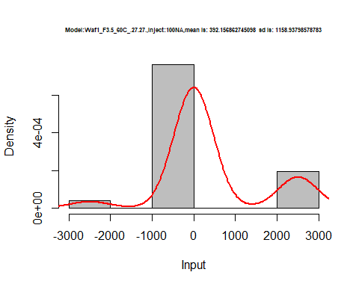

hist(d2_27.27$V2,  
 cex.main=0.5,  
 freq = FALSE,  
 main = paste('Model:Waf1_F3.5_60C_.27.27.,Inject:200NA,mean is:', mean(d2_27.27$V2),' sd is:', sd(d2_27.27$V2)),  
 xlab = "Input",  
 ylab = "Density",  
 col="grey")  
#plot density curve  
lines(density(d2_27.27$V2), # density plot  
 lwd = 2, # thickness of line  
 col = "red")

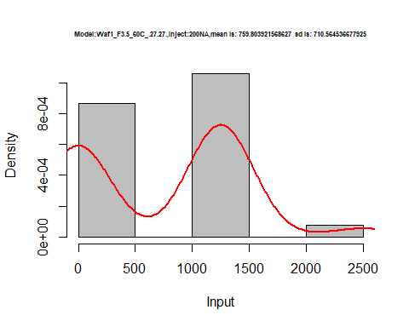

hist(d2_27.27$V3,  
 cex.main=0.5,  
 freq = FALSE,  
 main = paste('Model:Waf1_F3.5_60C_.27.27.,Inject:300NA,mean is:', mean(d2_27.27$V3),' sd is:', sd(d2_27.27$V3)),  
 xlab = "Input",  
 ylab = "Density",  
 col="grey")  
#plot density curve  
lines(density(d2_27.27$V3), # density plot  
 lwd = 2, # thickness of line  
 col = "red")

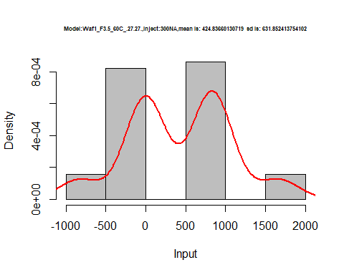

hist(d2_27.27$V4,  
 cex.main=0.5,  
 freq = FALSE,  
 main = paste('Model:Waf1_F3.5_60C_.27.27.,Inject:400NA,mean is:', mean(d2_27.27$V4),' sd is:', sd(d2_27.27$V4)),  
 xlab = "Input",  
 ylab = "Density",  
 col="grey")  
#plot density curve  
lines(density(d2_27.27$V4), # density plot  
 lwd = 2, # thickness of line  
 col = "red")

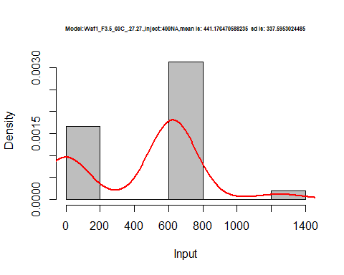

hist(d2_27.27$V5,  
 cex.main=0.5,  
 freq = FALSE,  
 main = paste('Model:Waf1_F3.5_60C_.27.27.,Inject:500NA,mean is:', mean(d2_27.27$V5),' sd is:', sd(d2_27.27$V5)),  
 xlab = "Input",  
 ylab = "Density",  
 col="grey")  
#plot density curve  
lines(density(d2_27.27$V5), # density plot  
 lwd = 2, # thickness of line  
 col = "red")

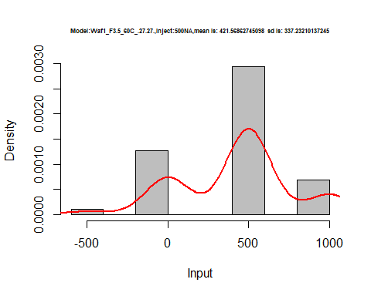

hist(d2_27.27$V6,  
 cex.main=0.5,  
 freq = FALSE,  
 main = paste('Model:Waf1_F3.5_60C_.27.27.,Inject:600NA,mean is:', mean(d2_27.27$V6),' sd is:', sd(d2_27.27$V6)),  
 xlab = "Input",  
 ylab = "Density",  
 col="grey")  
#plot density curve  
lines(density(d2_27.27$V6), # density plot  
 lwd = 2, # thickness of line  
 col = "red")

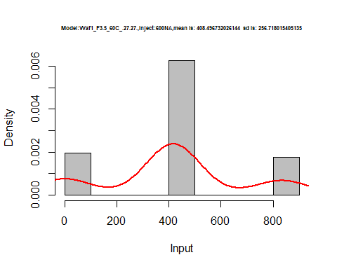

hist(d2_27.27$V7,  
 cex.main=0.5,  
 freq = FALSE,  
 main = paste('Model:Waf1_F3.5_60C_.27.27.,Inject:700NA,mean is:', mean(d2_27.27$V7),' sd is:', sd(d2_27.27$V7)),  
 xlab = "Input",  
 ylab = "Density",  
 col="grey")  
#plot density curve  
lines(density(d2_27.27$V7), # density plot  
 lwd = 2, # thickness of line  
 col = "red")

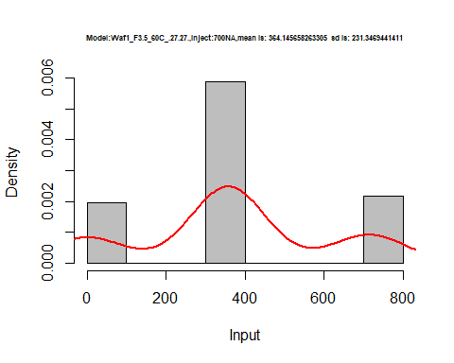

hist(d2_27.27$V8,  
 cex.main=0.5,  
 freq = FALSE,  
 main = paste('Model:Waf1_F3.5_60C_.27.27.,Inject:800NA,mean is:', mean(d2_27.27$V8),' sd is:', sd(d2_27.27$V8)),  
 xlab = "Input",  
 ylab = "Density",  
 col="grey")  
#plot density curve  
lines(density(d2_27.27$V8), # density plot  
 lwd = 2, # thickness of line  
 col = "red")

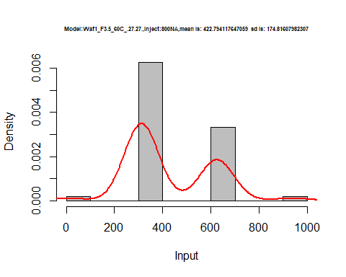

dens <- apply(d2_27.27, 2, density)  
plot('Model:Waf1_F3.5_60C_.27.27', xlim=range(sapply(dens, "[", "x")), ylim=range(sapply(dens, "[", "y")))

## Warning in xy.coords(x, y, xlabel, ylabel, log): NAs introduced by coercion

mapply(lines, dens, col=1:length(dens))

## $V1  
## NULL  
##   
## $V2  
## NULL  
##   
## $V3  
## NULL  
##   
## $V4  
## NULL  
##   
## $V5  
## NULL  
##   
## $V6  
## NULL  
##   
## $V7  
## NULL  
##   
## $V8  
## NULL

legend("topright", legend=names(dens), fill=1:length(dens))

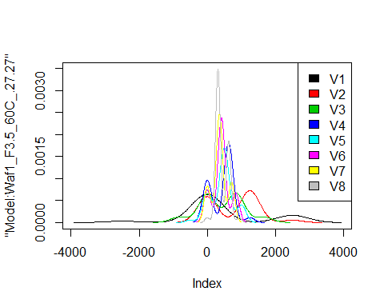

# Select columns whose names contains "28.28"  
d_28.28<-my_data %>% select(contains("28.28."))  
#d_28.28 <- head(d_28.28,51)  
#colnames(d_28.28) <- c("V1", "V2","V3","V4","V5","V6","V7","V8")  
head(d_28.28)

## Waf1_F2.7_F_60C_.100nA_.28.28. Waf1_F2.7_F_60C_.200nA_.28.28.  
## 1 5077500 3312500  
## 2 5072500 3298750  
## 3 5027500 3295000  
## 4 4947500 3291250  
## 5 4922500 3291250  
## 6 4915000 3275000  
## Waf1_F2.7_F_60C_.300nA_.28.28. Waf1_F2.7_F_60C_.400nA_.28.28.  
## 1 2415833 1974375  
## 2 2415833 1971875  
## 3 2415833 1975625  
## 4 2415000 1974375  
## 5 2415000 1975625  
## 6 2414167 1976875  
## Waf1_F2.7_F_60C_.500nA_.28.28. Waf1_F2.7_F_60C_.600nA_.28.28.  
## 1 1736500 1499167  
## 2 1742500 1501250  
## 3 1735000 1499167  
## 4 1740500 1502083  
## 5 1736000 1500417  
## 6 1734000 1499167  
## Waf1_F2.7_F_60C_.700nA_.28.28. Waf1_F2.7_F_60C_.800nA_.28.28.  
## 1 1358929 1250313  
## 2 1358214 1227500  
## 3 1359643 1216563  
## 4 1362500 1214375  
## 5 1362143 1216250  
## 6 1360714 1231250  
## Waf1_F3.3_F_60C_.100nA_.28.28. Waf1_F3.3_F_60C_.200nA_.28.28.  
## 1 24997500 12498750  
## 2 24997500 12498750  
## 3 24997500 12498750  
## 4 25002500 12500000  
## 5 25000000 12500000  
## 6 25000000 12502500  
## Waf1_F3.3_F_60C_.300nA_.28.28. Waf1_F3.3_F_60C_.400nA_.28.28.  
## 1 8332500 6249375  
## 2 8332500 6250625  
## 3 8333333 6249375  
## 4 8332500 6249375  
## 5 8332500 6249375  
## 6 8332500 6249375  
## Waf1_F3.3_F_60C_.500nA_.28.28. Waf1_F3.3_F_60C_.600nA_.28.28.  
## 1 5000000 4167917  
## 2 5000000 4167500  
## 3 5000000 4167917  
## 4 4999500 4167500  
## 5 5000000 4167917  
## 6 4999500 4167500  
## Waf1_F3.3_F_60C_.700nA_.28.28. Waf1_F3.3_F_60C_.800nA_.28.28.  
## 1 3571786 3125625  
## 2 3571786 3125312  
## 3 3571429 3125625  
## 4 3571429 3125937  
## 5 3571429 3125937  
## 6 3571071 3125937  
## Waf1_F5.3_60C_.100nA_.28.28. Waf1_F5.3_60C_.200nA_.28.28.  
## 1 25005000 12498750  
## 2 25005000 12498750  
## 3 25005000 12500000  
## 4 25002500 12500000  
## 5 25005000 12501250  
## 6 25002500 12501250  
## Waf1_F5.3_60C_.300nA_.28.28. Waf1_F5.3_60C_.400nA_.28.28.  
## 1 8335000 6249375  
## 2 8334167 6250000  
## 3 8334167 6249375  
## 4 8333333 6250625  
## 5 8333333 6250625  
## 6 8331667 6250625  
## Waf1_F5.3_60C_.500nA_.28.28. Waf1_F5.3_60C_.600nA_.28.28.  
## 1 5000500 4166667  
## 2 5000500 4166667  
## 3 5000500 4165833  
## 4 5000500 4166667  
## 5 5001000 4166250  
## 6 5001000 4166250  
## Waf1_F5.3_60C_.700nA_.28.28. Waf1_F5.3_60C_.800nA_.28.28.  
## 1 3571429 3125000  
## 2 3571071 3124688  
## 3 3571429 3125312  
## 4 3571786 3125312  
## 5 3571429 3125312  
## 6 3571786 3125312  
## Waf1_F6.7_F_60C_.100nA_.28.28. Waf1_F6.7_F_60C_.200nA_.28.28.  
## 1 1767500 1271250  
## 2 1762500 1272500  
## 3 1752500 1277500  
## 4 1817500 1291250  
## 5 1817500 1290000  
## 6 1770000 1280000  
## Waf1_F6.7_F_60C_.300nA_.28.28. Waf1_F6.7_F_60C_.400nA_.28.28.  
## 1 1134167 1063750  
## 2 1133333 1068750  
## 3 1140000 1067500  
## 4 1134167 1070000  
## 5 1156667 1071875  
## 6 1172500 1066250  
## Waf1_F6.7_F_60C_.500nA_.28.28. Waf1_F6.7_F_60C_.600nA_.28.28.  
## 1 978500 837500  
## 2 981500 1018333  
## 3 971500 1045417  
## 4 969500 1067500  
## 5 971500 1069583  
## 6 971500 1081667  
## Waf1_F6.7_F_60C_.700nA_.28.28. Waf1_F6.7_F_60C_.800nA_.28.28.  
## 1 977142.9 762812.5  
## 2 966428.6 755625.0  
## 3 973214.3 755625.0  
## 4 977857.1 796875.0  
## 5 978571.4 758750.0  
## 6 974642.9 760312.5

d1_28.28<-d_28.28[,c(1:8)]  
d1_28.28 <- head(d1_28.28,51)  
colnames(d1_28.28) <- c("V1", "V2","V3","V4","V5","V6","V7","V8")  
head(d1_28.28)

## V1 V2 V3 V4 V5 V6 V7 V8  
## 1 5077500 3312500 2415833 1974375 1736500 1499167 1358929 1250313  
## 2 5072500 3298750 2415833 1971875 1742500 1501250 1358214 1227500  
## 3 5027500 3295000 2415833 1975625 1735000 1499167 1359643 1216563  
## 4 4947500 3291250 2415000 1974375 1740500 1502083 1362500 1214375  
## 5 4922500 3291250 2415000 1975625 1736000 1500417 1362143 1216250  
## 6 4915000 3275000 2414167 1976875 1734000 1499167 1360714 1231250

hist(d1_28.28$V1,  
 cex.main=0.5,  
 freq = FALSE,  
 main = paste('Model:Waf1_F2.7_60C_.28.28.,Inject:100NA,mean is:', mean(d1_28.28$V1),' sd is:', sd(d1_28.28$V1)),  
 xlab = "Input",  
 ylab = "Density",  
 col="grey")  
#plot density curve  
lines(density(d1_28.28$V1), # density plot  
 lwd = 2, # thickness of line  
 col = "red")

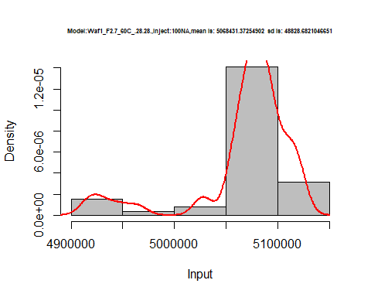

hist(d1_28.28$V2,  
 cex.main=0.5,  
 freq = FALSE,  
 main = paste('Model:Waf1_F2.7_60C_.28.28.,Inject:200NA,mean is:', mean(d1_28.28$V2),' sd is:', sd(d1_28.28$V2)),  
 xlab = "Input",  
 ylab = "Density",  
 col="grey")  
#plot density curve  
lines(density(d1_28.28$V2), # density plot  
 lwd = 2, # thickness of line  
 col = "red")

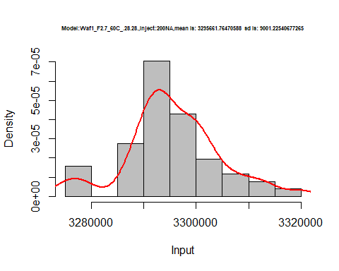

hist(d1_28.28$V3,  
 cex.main=0.5,  
 freq = FALSE,  
 main = paste('Model:Waf1_F2.7_60C_.28.28.,Inject:300NA,mean is:', mean(d1_28.28$V3),' sd is:', sd(d1_28.28$V3)),  
 xlab = "Input",  
 ylab = "Density",  
 col="grey")  
#plot density curve  
lines(density(d1_28.28$V3), # density plot  
 lwd = 2, # thickness of line  
 col = "red")

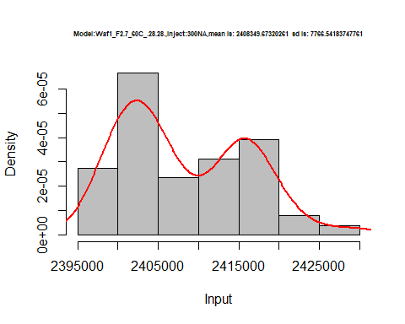

hist(d1_28.28$V4,  
 cex.main=0.5,  
 freq = FALSE,  
 main = paste('Model:Waf1_F2.7_60C_.28.28.,Inject:400NA,mean is:', mean(d1_28.28$V4),' sd is:', sd(d1_28.28$V4)),  
 xlab = "Input",  
 ylab = "Density",  
 col="grey")  
#plot density curve  
lines(density(d1_28.28$V4), # density plot  
 lwd = 2, # thickness of line  
 col = "red")

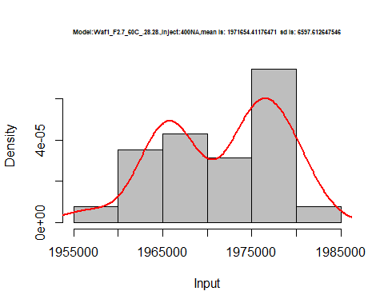

hist(d1_28.28$V5,  
 cex.main=0.5,  
 freq = FALSE,  
 main = paste('Model:Waf1_F2.7_60C_.28.28.,Inject:500NA,mean is:', mean(d1_28.28$V5),' sd is:', sd(d1_28.28$V5)),  
 xlab = "Input",  
 ylab = "Density",  
 col="grey")  
#plot density curve  
lines(density(d1_28.28$V5), # density plot  
 lwd = 2, # thickness of line  
 col = "red")

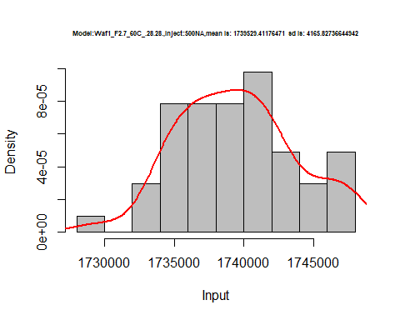

hist(d1_28.28$V6,  
 cex.main=0.5,  
 freq = FALSE,  
 main = paste('Model:Waf1_F2.7_60C_.28.28.,Inject:600NA,mean is:', mean(d1_28.28$V6),' sd is:', sd(d1_28.28$V6)),  
 xlab = "Input",  
 ylab = "Density",  
 col="grey")  
#plot density curve  
lines(density(d1_28.28$V6), # density plot  
 lwd = 2, # thickness of line  
 col = "red")

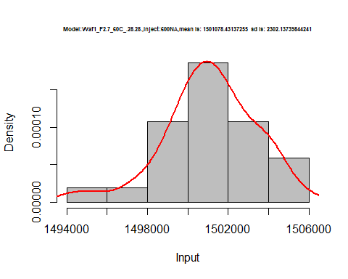

hist(d1_28.28$V7,  
 cex.main=0.5,  
 freq = FALSE,  
 main = paste('Model:Waf1_F2.7_60C_.28.28.,Inject:700NA,mean is:', mean(d1_28.28$V7),' sd is:', sd(d1_28.28$V7)),  
 xlab = "Input",  
 ylab = "Density",  
 col="grey")  
#plot density curve  
lines(density(d1_28.28$V7), # density plot  
 lwd = 2, # thickness of line  
 col = "red")

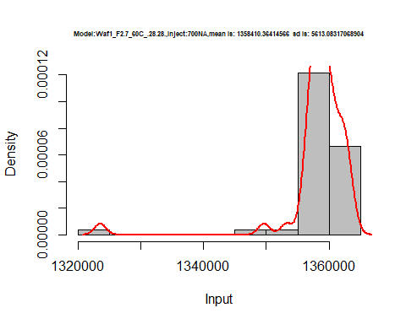

hist(d1_28.28$V8,  
 cex.main=0.5,  
 freq = FALSE,  
 main = paste('Model:Waf1_F2.7_60C_.28.28.,Inject:800NA,mean is:', mean(d1_28.28$V8),' sd is:', sd(d1_28.28$V8)),  
 xlab = "Input",  
 ylab = "Density",  
 col="grey")  
#plot density curve  
lines(density(d1_28.28$V8), # density plot  
 lwd = 2, # thickness of line  
 col = "red")

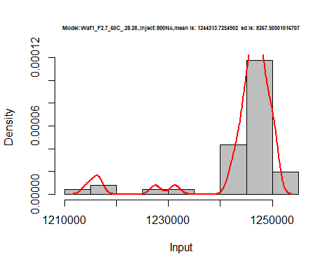

dens <- apply(d1_28.28, 2, density)  
plot('Model:Waf1_F2.7_60C_.28.28', xlim=range(sapply(dens, "[", "x")), ylim=range(sapply(dens, "[", "y")))

## Warning in xy.coords(x, y, xlabel, ylabel, log): NAs introduced by coercion

mapply(lines, dens, col=1:length(dens))

## $V1  
## NULL  
##   
## $V2  
## NULL  
##   
## $V3  
## NULL  
##   
## $V4  
## NULL  
##   
## $V5  
## NULL  
##   
## $V6  
## NULL  
##   
## $V7  
## NULL  
##   
## $V8  
## NULL

legend("topright", legend=names(dens), fill=1:length(dens))

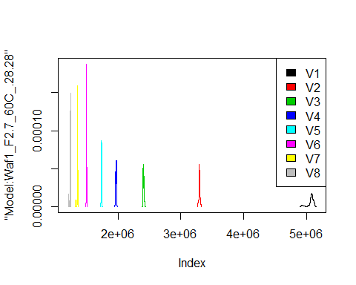

d2_28.28<-d_28.28[,c(9:16)]  
d2_28.28 <- head(d2_28.28,51)  
colnames(d2_28.28) <- c("V1", "V2","V3","V4","V5","V6","V7","V8")  
head(d2_28.28)

## V1 V2 V3 V4 V5 V6 V7 V8  
## 1 24997500 12498750 8332500 6249375 5000000 4167917 3571786 3125625  
## 2 24997500 12498750 8332500 6250625 5000000 4167500 3571786 3125312  
## 3 24997500 12498750 8333333 6249375 5000000 4167917 3571429 3125625  
## 4 25002500 12500000 8332500 6249375 4999500 4167500 3571429 3125937  
## 5 25000000 12500000 8332500 6249375 5000000 4167917 3571429 3125937  
## 6 25000000 12502500 8332500 6249375 4999500 4167500 3571071 3125937

hist(d2_28.28$V1,  
 cex.main=0.5,  
 freq = FALSE,  
 main = paste('Model:Waf1_F3.3_60C_.28.28.,Inject:100NA,mean is:', mean(d2_28.28$V1),' sd is:', sd(d2_28.28$V1)),  
 xlab = "Input",  
 ylab = "Density",  
 col="grey")  
#plot density curve  
lines(density(d2_28.28$V1), # density plot  
 lwd = 2, # thickness of line  
 col = "red")

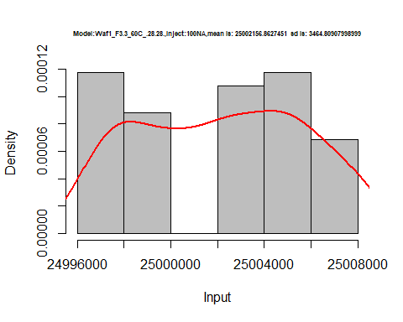

hist(d2_28.28$V2,  
 cex.main=0.5,  
 freq = FALSE,  
 main = paste('Model:Waf1_F3.3_60C_.28.28.,Inject:200NA,mean is:', mean(d2_28.28$V2),' sd is:', sd(d2_28.28$V2)),  
 xlab = "Input",  
 ylab = "Density",  
 col="grey")  
#plot density curve  
lines(density(d2_28.28$V2), # density plot  
 lwd = 2, # thickness of line  
 col = "red")

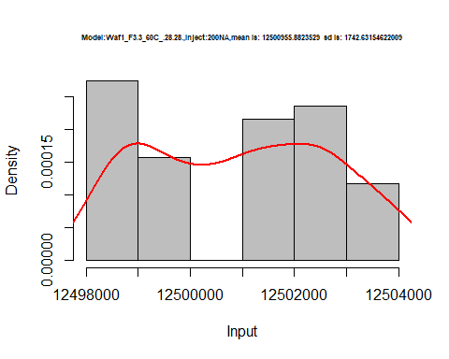

hist(d2_28.28$V2,  
 cex.main=0.5,  
 freq = FALSE,  
 main = paste('Model:Waf1_F3.3_60C_.28.28.,Inject:200NA,mean is:', mean(d2_28.28$V2),' sd is:', sd(d2_28.28$V2)),  
 xlab = "Input",  
 ylab = "Density",  
 col="grey")  
#plot density curve  
lines(density(d2_28.28$V2), # density plot  
 lwd = 2, # thickness of line  
 col = "red")



hist(d2_28.28$V3,  
 cex.main=0.5,  
 freq = FALSE,  
 main = paste('Model:Waf1_F3.3_60C_.28.28.,Inject:300NA,mean is:', mean(d2_28.28$V3),' sd is:', sd(d2_28.28$V3)),  
 xlab = "Input",  
 ylab = "Density",  
 col="grey")  
#plot density curve  
lines(density(d2_28.28$V3), # density plot  
 lwd = 2, # thickness of line  
 col = "red")

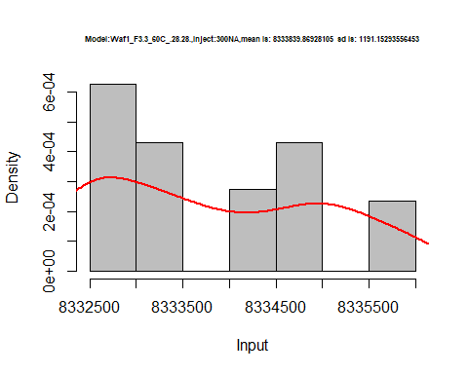

hist(d2_28.28$V4,  
 cex.main=0.5,  
 freq = FALSE,  
 main = paste('Model:Waf1_F3.3_60C_.28.28.,Inject:400NA,mean is:', mean(d2_28.28$V4),' sd is:', sd(d2_28.28$V4)),  
 xlab = "Input",  
 ylab = "Density",  
 col="grey")  
#plot density curve  
lines(density(d2_28.28$V4), # density plot  
 lwd = 2, # thickness of line  
 col = "red")

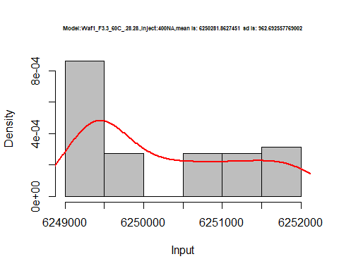

hist(d2_28.28$V5,  
 cex.main=0.5,  
 freq = FALSE,  
 main = paste('Model:Waf1_F3.3_60C_.28.28.,Inject:500NA,mean is:', mean(d2_28.28$V5),' sd is:', sd(d2_28.28$V5)),  
 xlab = "Input",  
 ylab = "Density",  
 col="grey")  
#plot density curve  
lines(density(d2_28.28$V5), # density plot  
 lwd = 2, # thickness of line  
 col = "red")

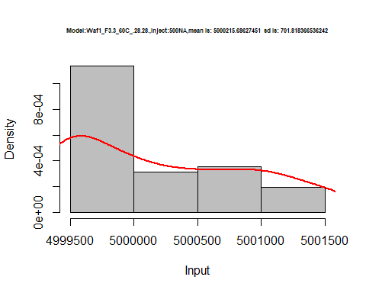

hist(d2_28.28$V6,  
 cex.main=0.5,  
 freq = FALSE,  
 main = paste('Model:Waf1_F3.3_60C_.28.28.,Inject:600NA,mean is:', mean(d2_28.28$V6),' sd is:', sd(d2_28.28$V6)),  
 xlab = "Input",  
 ylab = "Density",  
 col="grey")  
#plot density curve  
lines(density(d2_28.28$V6), # density plot  
 lwd = 2, # thickness of line  
 col = "red")

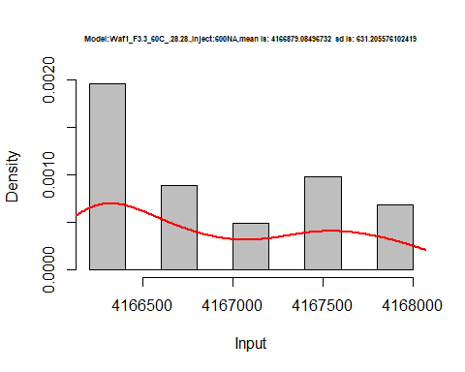

hist(d2_28.28$V7,  
 cex.main=0.5,  
 freq = FALSE,  
 main = paste('Model:Waf1_F3.3_60C_.28.28.,Inject:700NA,mean is:', mean(d2_28.28$V7),' sd is:', sd(d2_28.28$V7)),  
 xlab = "Input",  
 ylab = "Density",  
 col="grey")  
#plot density curve  
lines(density(d2_28.28$V7), # density plot  
 lwd = 2, # thickness of line  
 col = "red")

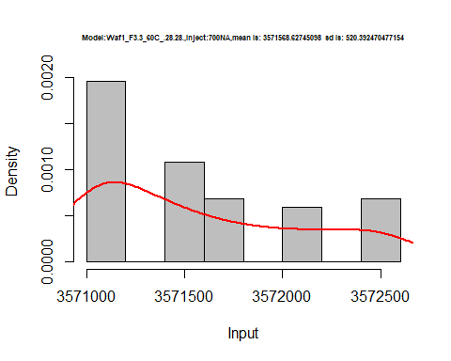

hist(d2_28.28$V8,  
 cex.main=0.5,  
 freq = FALSE,  
 main = paste('Model:Waf1_F3.3_60C_.28.28.,Inject:800NA,mean is:', mean(d2_28.28$V8),' sd is:', sd(d2_28.28$V8)),  
 xlab = "Input",  
 ylab = "Density",  
 col="grey")  
#plot density curve  
lines(density(d2_28.28$V8), # density plot  
 lwd = 2, # thickness of line  
 col = "red")

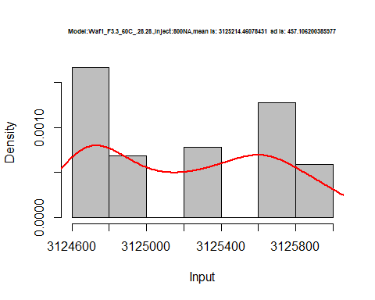

dens <- apply(d2_28.28, 2, density)  
plot('Model:Waf1_F3.3_60C_.28.28', xlim=range(sapply(dens, "[", "x")), ylim=range(sapply(dens, "[", "y")))

## Warning in xy.coords(x, y, xlabel, ylabel, log): NAs introduced by coercion

mapply(lines, dens, col=1:length(dens))

## $V1  
## NULL  
##   
## $V2  
## NULL  
##   
## $V3  
## NULL  
##   
## $V4  
## NULL  
##   
## $V5  
## NULL  
##   
## $V6  
## NULL  
##   
## $V7  
## NULL  
##   
## $V8  
## NULL

legend("topright", legend=names(dens), fill=1:length(dens))

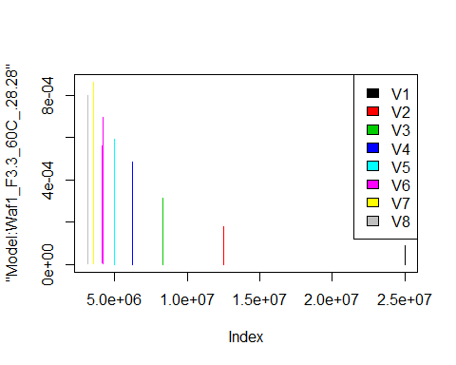

d3_28.28<-d_28.28[,c(17:24)]  
d3_28.28 <- head(d3_28.28,51)  
colnames(d3_28.28) <- c("V1", "V2","V3","V4","V5","V6","V7","V8")  
head(d3_28.28)

## V1 V2 V3 V4 V5 V6 V7 V8  
## 1 25005000 12498750 8335000 6249375 5000500 4166667 3571429 3125000  
## 2 25005000 12498750 8334167 6250000 5000500 4166667 3571071 3124688  
## 3 25005000 12500000 8334167 6249375 5000500 4165833 3571429 3125312  
## 4 25002500 12500000 8333333 6250625 5000500 4166667 3571786 3125312  
## 5 25005000 12501250 8333333 6250625 5001000 4166250 3571429 3125312  
## 6 25002500 12501250 8331667 6250625 5001000 4166250 3571786 3125312

hist(d3_28.28$V1,  
 cex.main=0.5,  
 freq = FALSE,  
 main = paste('Model:Waf1_F5.3_60C_.28.28.,Inject:100NA,mean is:', mean(d3_28.28$V1),' sd is:', sd(d3_28.28$V1)),  
 xlab = "Input",  
 ylab = "Density",  
 col="grey")  
#plot density curve  
lines(density(d3_28.28$V1), # density plot  
 lwd = 2, # thickness of line  
 col = "red")

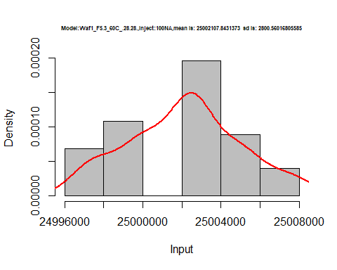

hist(d3_28.28$V2,  
 cex.main=0.5,  
 freq = FALSE,  
 main = paste('Model:Waf1_F5.3_60C_.28.28.,Inject:200NA,mean is:', mean(d3_28.28$V2),' sd is:', sd(d3_28.28$V2)),  
 xlab = "Input",  
 ylab = "Density",  
 col="grey")  
#plot density curve  
lines(density(d3_28.28$V2), # density plot  
 lwd = 2, # thickness of line  
 col = "red")

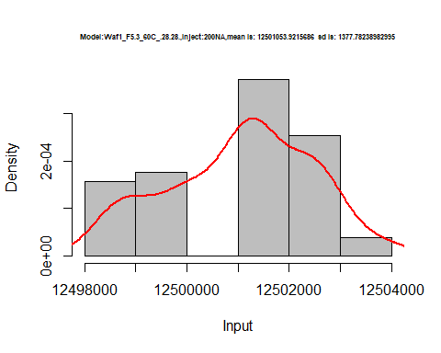

hist(d3_28.28$V3,  
 cex.main=0.5,  
 freq = FALSE,  
 main = paste('Model:Waf1_F5.3_60C_.28.28.,Inject:300NA,mean is:', mean(d3_28.28$V3),' sd is:', sd(d3_28.28$V3)),  
 xlab = "Input",  
 ylab = "Density",  
 col="grey")  
#plot density curve  
lines(density(d3_28.28$V3), # density plot  
 lwd = 2, # thickness of line  
 col = "red")

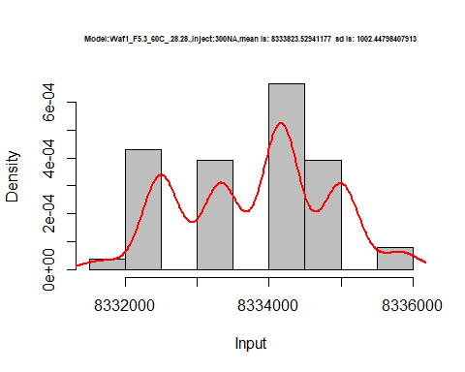

hist(d3_28.28$V4,  
 cex.main=0.5,  
 freq = FALSE,  
 main = paste('Model:Waf1_F5.3_60C_.28.28.,Inject:400NA,mean is:', mean(d3_28.28$V4),' sd is:', sd(d3_28.28$V4)),  
 xlab = "Input",  
 ylab = "Density",  
 col="grey")  
#plot density curve  
lines(density(d3_28.28$V4), # density plot  
 lwd = 2, # thickness of line  
 col = "red")

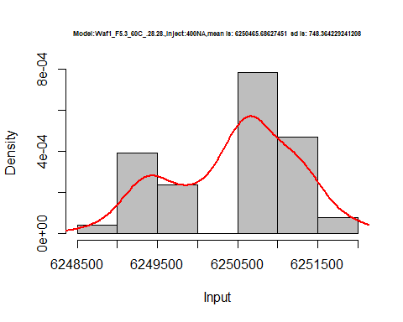

hist(d3_28.28$V5,  
 cex.main=0.5,  
 freq = FALSE,  
 main = paste('Model:Waf1_F5.3_60C_.28.28.,Inject:500NA,mean is:', mean(d3_28.28$V5),' sd is:', sd(d3_28.28$V5)),  
 xlab = "Input",  
 ylab = "Density",  
 col="grey")  
#plot density curve  
lines(density(d3_28.28$V5), # density plot  
 lwd = 2, # thickness of line  
 col = "red")

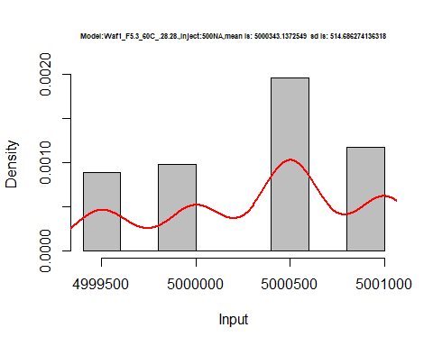

hist(d3_28.28$V6,  
 cex.main=0.5,  
 freq = FALSE,  
 main = paste('Model:Waf1_F5.3_60C_.28.28.,Inject:600NA,mean is:', mean(d3_28.28$V6),' sd is:', sd(d3_28.28$V6)),  
 xlab = "Input",  
 ylab = "Density",  
 col="grey")  
#plot density curve  
lines(density(d3_28.28$V6), # density plot  
 lwd = 2, # thickness of line  
 col = "red")

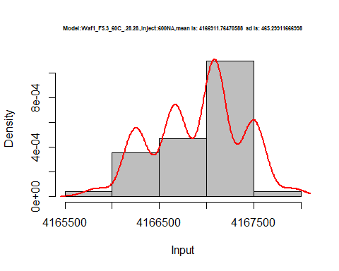

hist(d3_28.28$V7,  
 cex.main=0.5,  
 freq = FALSE,  
 main = paste('Model:Waf1_F5.3_60C_.28.28.,Inject:700NA,mean is:', mean(d3_28.28$V7),' sd is:', sd(d3_28.28$V7)),  
 xlab = "Input",  
 ylab = "Density",  
 col="grey")  
#plot density curve  
lines(density(d3_28.28$V7), # density plot  
 lwd = 2, # thickness of line  
 col = "red")

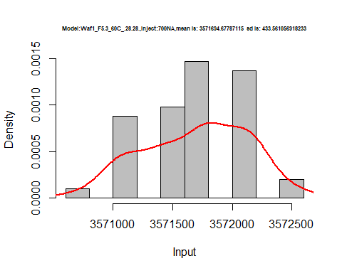

hist(d3_28.28$V8,  
 cex.main=0.5,  
 freq = FALSE,  
 main = paste('Model:Waf1_F5.3_60C_.28.28.,Inject:800NA,mean is:', mean(d3_28.28$V8),' sd is:', sd(d3_28.28$V8)),  
 xlab = "Input",  
 ylab = "Density",  
 col="grey")  
#plot density curve  
lines(density(d3_28.28$V8), # density plot  
 lwd = 2, # thickness of line  
 col = "red")

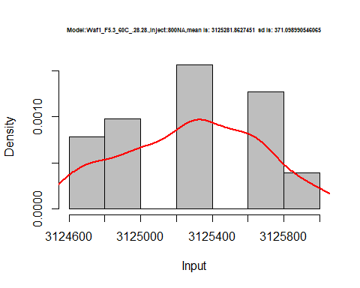

dens <- apply(d3_28.28, 2, density)  
plot('Model:Waf1_F5.3_60C_.28.28', xlim=range(sapply(dens, "[", "x")), ylim=range(sapply(dens, "[", "y")))

## Warning in xy.coords(x, y, xlabel, ylabel, log): NAs introduced by coercion

mapply(lines, dens, col=1:length(dens))

## $V1  
## NULL  
##   
## $V2  
## NULL  
##   
## $V3  
## NULL  
##   
## $V4  
## NULL  
##   
## $V5  
## NULL  
##   
## $V6  
## NULL  
##   
## $V7  
## NULL  
##   
## $V8  
## NULL

legend("topright", legend=names(dens), fill=1:length(dens))

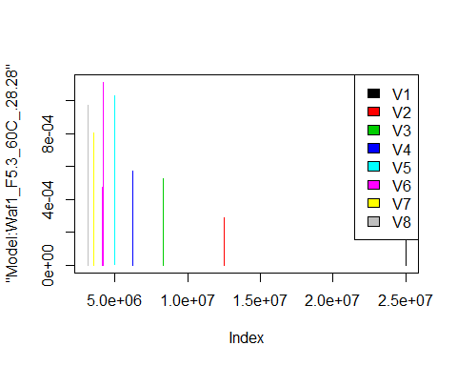

d4_28.28<-d_28.28[,c(25:32)]  
d4_28.28 <- head(d4_28.28,51)  
colnames(d4_28.28) <- c("V1", "V2","V3","V4","V5","V6","V7","V8")  
head(d4_28.28)

## V1 V2 V3 V4 V5 V6 V7 V8  
## 1 1767500 1271250 1134167 1063750 978500 837500 977142.9 762812.5  
## 2 1762500 1272500 1133333 1068750 981500 1018333 966428.6 755625.0  
## 3 1752500 1277500 1140000 1067500 971500 1045417 973214.3 755625.0  
## 4 1817500 1291250 1134167 1070000 969500 1067500 977857.1 796875.0  
## 5 1817500 1290000 1156667 1071875 971500 1069583 978571.4 758750.0  
## 6 1770000 1280000 1172500 1066250 971500 1081667 974642.9 760312.5

hist(d4_28.28$V1,  
 cex.main=0.5,  
 freq = FALSE,  
 main = paste('Model:Waf1_F6.8_60C_.28.28.,Inject:100NA,mean is:', mean(d4_28.28$V1),' sd is:', sd(d4_28.28$V1)),  
 xlab = "Input",  
 ylab = "Density",  
 col="grey")  
#plot density curve  
lines(density(d4_28.28$V1), # density plot  
 lwd = 2, # thickness of line  
 col = "red")

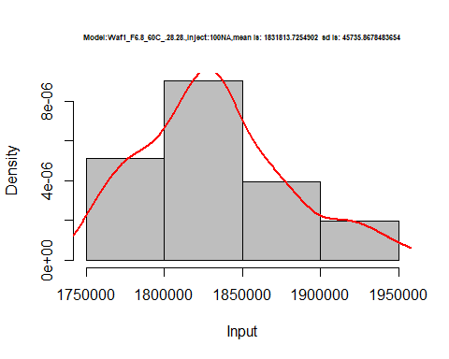

hist(d4_28.28$V2,  
 cex.main=0.5,  
 freq = FALSE,  
 main = paste('Model:Waf1_F6.8_60C_.28.28.,Inject:200NA,mean is:', mean(d4_28.28$V2),' sd is:', sd(d4_28.28$V2)),  
 xlab = "Input",  
 ylab = "Density",  
 col="grey")  
#plot density curve  
lines(density(d4_28.28$V2), # density plot  
 lwd = 2, # thickness of line  
 col = "red")

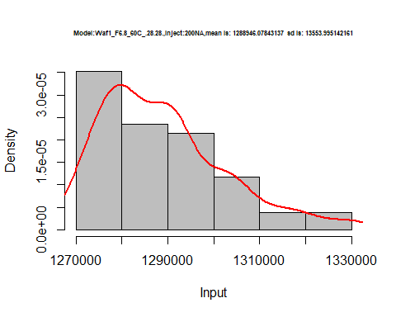

hist(d4_28.28$V3,  
 cex.main=0.5,  
 freq = FALSE,  
 main = paste('Model:Waf1_F6.8_60C_.28.28.,Inject:300NA,mean is:', mean(d4_28.28$V3),' sd is:', sd(d4_28.28$V3)),  
 xlab = "Input",  
 ylab = "Density",  
 col="grey")  
#plot density curve  
lines(density(d4_28.28$V3), # density plot  
 lwd = 2, # thickness of line  
 col = "red")

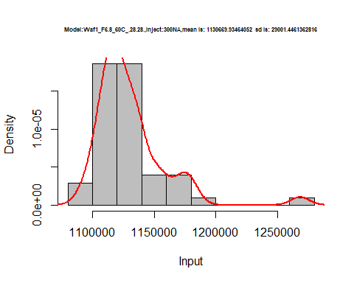

hist(d4_28.28$V4,  
 cex.main=0.5,  
 freq = FALSE,  
 main = paste('Model:Waf1_F6.8_60C_.28.28.,Inject:400NA,mean is:', mean(d4_28.28$V4),' sd is:', sd(d4_28.28$V4)),  
 xlab = "Input",  
 ylab = "Density",  
 col="grey")  
#plot density curve  
lines(density(d4_28.28$V4), # density plot  
 lwd = 2, # thickness of line  
 col = "red")

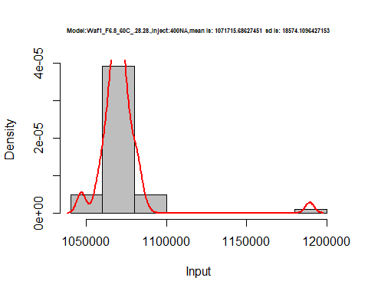

hist(d4_28.28$V5,  
 cex.main=0.5,  
 freq = FALSE,  
 main = paste('Model:Waf1_F6.8_60C_.28.28.,Inject:500NA,mean is:', mean(d4_28.28$V5),' sd is:', sd(d4_28.28$V5)),  
 xlab = "Input",  
 ylab = "Density",  
 col="grey")  
#plot density curve  
lines(density(d4_28.28$V5), # density plot  
 lwd = 2, # thickness of line  
 col = "red")

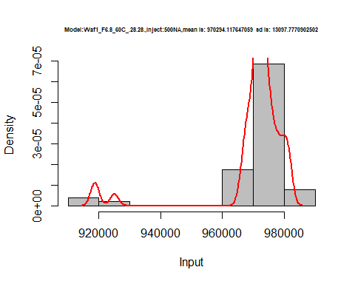

hist(d4_28.28$V6,  
 cex.main=0.5,  
 freq = FALSE,  
 main = paste('Model:Waf1_F6.8_60C_.28.28.,Inject:600NA,mean is:', mean(d4_28.28$V6),' sd is:', sd(d4_28.28$V6)),  
 xlab = "Input",  
 ylab = "Density",  
 col="grey")  
#plot density curve  
lines(density(d4_28.28$V6), # density plot  
 lwd = 2, # thickness of line  
 col = "red")

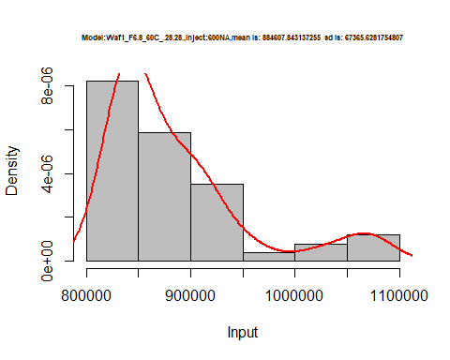

hist(d4_28.28$V7,  
 cex.main=0.5,  
 freq = FALSE,  
 main = paste('Model:Waf1_F6.8_60C_.28.28.,Inject:700NA,mean is:', mean(d4_28.28$V7),' sd is:', sd(d4_28.28$V7)),  
 xlab = "Input",  
 ylab = "Density",  
 col="grey")  
#plot density curve  
lines(density(d4_28.28$V7), # density plot  
 lwd = 2, # thickness of line  
 col = "red")

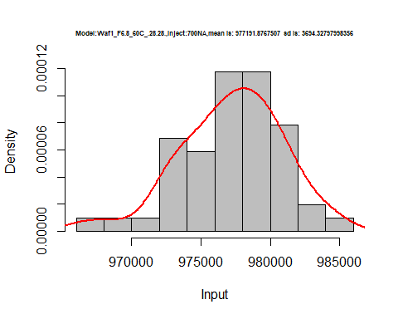

hist(d4_28.28$V8,  
 cex.main=0.5,  
 freq = FALSE,  
 main = paste('Model:Waf1_F6.8_60C_.28.28.,Inject:800NA,mean is:', mean(d4_28.28$V8),' sd is:', sd(d4_28.28$V8)),  
 xlab = "Input",  
 ylab = "Density",  
 col="grey")  
#plot density curve  
lines(density(d4_28.28$V8), # density plot  
 lwd = 2, # thickness of line  
 col = "red")

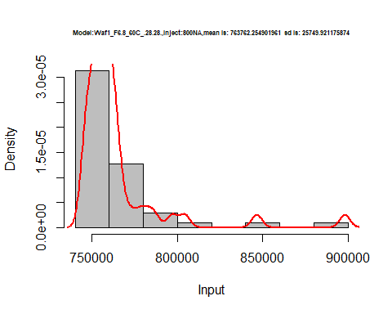

dens <- apply(d4_28.28, 2, density)  
plot('Model:Waf1_F6.8_60C_.28.28', xlim=range(sapply(dens, "[", "x")), ylim=range(sapply(dens, "[", "y")))

## Warning in xy.coords(x, y, xlabel, ylabel, log): NAs introduced by coercion

mapply(lines, dens, col=1:length(dens))

## $V1  
## NULL  
##   
## $V2  
## NULL  
##   
## $V3  
## NULL  
##   
## $V4  
## NULL  
##   
## $V5  
## NULL  
##   
## $V6  
## NULL  
##   
## $V7  
## NULL  
##   
## $V8  
## NULL

legend("topright", legend=names(dens), fill=1:length(dens))

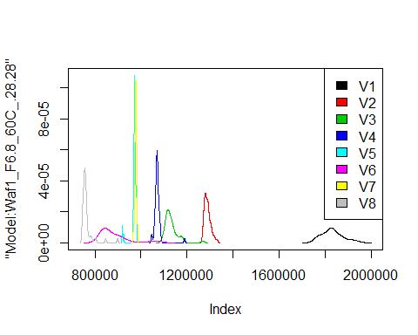

# Select columns whose names contains "29.29"  
d_29.29<-my_data %>% select(contains("29.29."))  
#d_28.28 <- head(d_28.28,51)  
#colnames(d_28.28) <- c("V1", "V2","V3","V4","V5","V6","V7","V8")  
head(d_29.29)

## Waf1_F2.6_F_60C_.100nA_.29.29. Waf1_F2.6_F_60C_.200nA_.29.29.  
## 1 5800000 3807500  
## 2 5782500 3807500  
## 3 5780000 3803750  
## 4 5782500 3811250  
## 5 5787500 3808750  
## 6 5790000 3803750  
## Waf1_F2.6_F_60C_.300nA_.29.29. Waf1_F2.6_F_60C_.400nA_.29.29.  
## 1 2752500 2355625  
## 2 2751667 2353750  
## 3 2751667 2355625  
## 4 2750833 2358750  
## 5 2749167 2355625  
## 6 2746667 2357500  
## Waf1_F2.6_F_60C_.500nA_.29.29. Waf1_F2.6_F_60C_.600nA_.29.29.  
## 1 2081000 1875417  
## 2 2079500 1875000  
## 3 2078000 1876250  
## 4 2078500 1880417  
## 5 2081500 1881667  
## 6 2079000 1880000  
## Waf1_F2.6_F_60C_.700nA_.29.29. Waf1_F2.6_F_60C_.800nA_.29.29.  
## 1 1742500 1601250  
## 2 1740714 1602187  
## 3 1742857 1602187  
## 4 1743929 1601250  
## 5 1743214 1601250  
## 6 1741429 1602813  
## Waf1_F3.3_F_60C_.100nA_.29.29. Waf1_F3.3_F_60C_.200nA_.29.29.  
## 1 25007500 12498750  
## 2 25002500 12498750  
## 3 25002500 12498750  
## 4 25000000 12498750  
## 5 24997500 12498750  
## 6 25000000 12501250  
## Waf1_F3.3_F_60C_.300nA_.29.29. Waf1_F3.3_F_60C_.400nA_.29.29.  
## 1 8335833 6251250  
## 2 8335833 6251875  
## 3 8335000 6251250  
## 4 8335000 6251250  
## 5 8335000 6251875  
## 6 8334167 6251875  
## Waf1_F3.3_F_60C_.500nA_.29.29. Waf1_F3.3_F_60C_.600nA_.29.29.  
## 1 4999500 4166250  
## 2 4999500 4166250  
## 3 4999500 4165833  
## 4 5001000 4166250  
## 5 5000500 4166250  
## 6 5001000 4166250  
## Waf1_F3.3_F_60C_.700nA_.29.29. Waf1_F3.3_F_60C_.800nA_.29.29.  
## 1 3571786 3124688  
## 2 3572143 3124688  
## 3 3571786 3124688  
## 4 3571429 3124688  
## 5 3571786 3125000  
## 6 3571429 3125000  
## Waf1_F4.3_F_60C_.100nA_.29.29. Waf1_F4.3_F_60C_.200nA_.29.29.  
## 1 2.5e+07 12502500  
## 2 2.5e+07 12501250  
## 3 2.5e+07 12500000  
## 4 2.5e+07 12500000  
## 5 2.5e+07 12500000  
## 6 2.5e+07 12500000  
## Waf1_F4.3_F_60C_.300nA_.29.29. Waf1_F4.3_F_60C_.400nA_.29.29.  
## 1 8333333 6251875  
## 2 8332500 6251875  
## 3 8331667 6251875  
## 4 8332500 6251250  
## 5 8333333 6251250  
## 6 8331667 6251875  
## Waf1_F4.3_F_60C_.500nA_.29.29. Waf1_F4.3_F_60C_.600nA_.29.29.  
## 1 5000000 4167500  
## 2 4999500 4167500  
## 3 4999500 4167917  
## 4 5000000 4167500  
## 5 4999500 4167500  
## 6 5000000 4167500  
## Waf1_F4.3_F_60C_.700nA_.29.29. Waf1_F4.3_F_60C_.800nA_.29.29.  
## 1 3571786 3125000  
## 2 3571786 3125312  
## 3 3571429 3125312  
## 4 3571429 3125000  
## 5 3571429 3125625  
## 6 3571429 3125312

d1_29.29<-d_29.29[,c(1:8)]  
d1_29.29 <- head(d1_29.29,51)  
colnames(d1_29.29) <- c("V1", "V2","V3","V4","V5","V6","V7","V8")  
head(d1_29.29)

## V1 V2 V3 V4 V5 V6 V7 V8  
## 1 5800000 3807500 2752500 2355625 2081000 1875417 1742500 1601250  
## 2 5782500 3807500 2751667 2353750 2079500 1875000 1740714 1602187  
## 3 5780000 3803750 2751667 2355625 2078000 1876250 1742857 1602187  
## 4 5782500 3811250 2750833 2358750 2078500 1880417 1743929 1601250  
## 5 5787500 3808750 2749167 2355625 2081500 1881667 1743214 1601250  
## 6 5790000 3803750 2746667 2357500 2079000 1880000 1741429 1602813

hist(d1_29.29$V1,  
 cex.main=0.5,  
 freq = FALSE,  
 main = paste('Model:Waf1_F2.6_60C_.29.29.,Inject:100NA,mean is:', mean(d1_29.29$V1),' sd is:', sd(d1_29.29$V1)),  
 xlab = "Input",  
 ylab = "Density",  
 col="grey")  
#plot density curve  
lines(density(d1_29.29$V1), # density plot  
 lwd = 2, # thickness of line  
 col = "red")

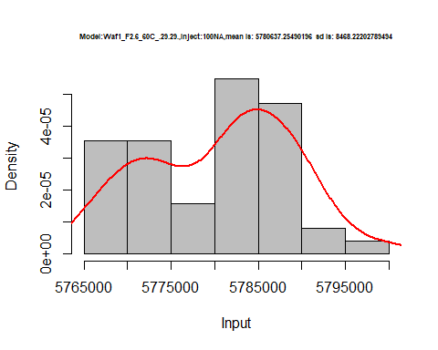

hist(d1_29.29$V2,  
 cex.main=0.5,  
 freq = FALSE,  
 main = paste('Model:Waf1_F2.6_60C_.29.29.,Inject:200NA,mean is:', mean(d1_29.29$V2),' sd is:', sd(d1_29.29$V2)),  
 xlab = "Input",  
 ylab = "Density",  
 col="grey")  
#plot density curve  
lines(density(d1_29.29$V2), # density plot  
 lwd = 2, # thickness of line  
 col = "red")

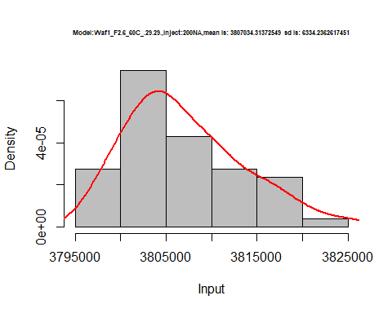

hist(d1_29.29$V3,  
 cex.main=0.5,  
 freq = FALSE,  
 main = paste('Model:Waf1_F2.6_60C_.29.29.,Inject:300NA,mean is:', mean(d1_29.29$V3),' sd is:', sd(d1_29.29$V3)),  
 xlab = "Input",  
 ylab = "Density",  
 col="grey")  
#plot density curve  
lines(density(d1_29.29$V3), # density plot  
 lwd = 2, # thickness of line  
 col = "red")

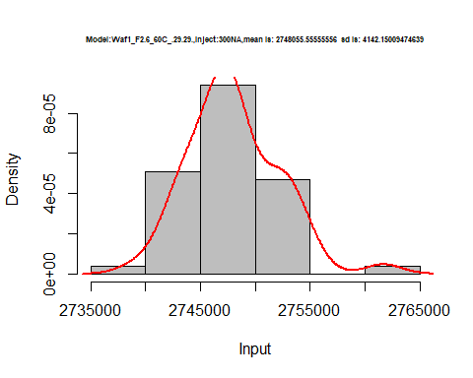

hist(d1_29.29$V4,  
 cex.main=0.5,  
 freq = FALSE,  
 main = paste('Model:Waf1_F2.6_60C_.29.29.,Inject:400NA,mean is:', mean(d1_29.29$V4),' sd is:', sd(d1_29.29$V4)),  
 xlab = "Input",  
 ylab = "Density",  
 col="grey")  
#plot density curve  
lines(density(d1_29.29$V4), # density plot  
 lwd = 2, # thickness of line  
 col = "red")

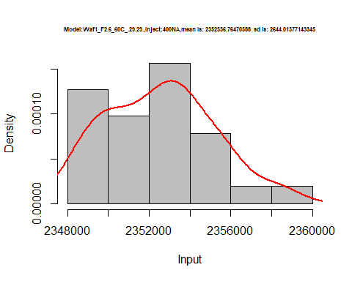

hist(d1_29.29$V5,  
 cex.main=0.5,  
 freq = FALSE,  
 main = paste('Model:Waf1_F2.6_60C_.29.29.,Inject:500NA,mean is:', mean(d1_29.29$V5),' sd is:', sd(d1_29.29$V5)),  
 xlab = "Input",  
 ylab = "Density",  
 col="grey")  
#plot density curve  
lines(density(d1_29.29$V5), # density plot  
 lwd = 2, # thickness of line  
 col = "red")

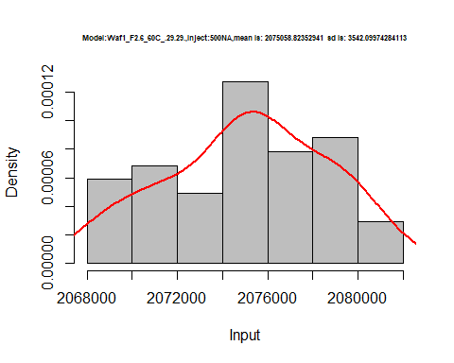

hist(d1_29.29$V6,  
 cex.main=0.5,  
 freq = FALSE,  
 main = paste('Model:Waf1_F2.6_60C_.29.29.,Inject:600NA,mean is:', mean(d1_29.29$V6),' sd is:', sd(d1_29.29$V6)),  
 xlab = "Input",  
 ylab = "Density",  
 col="grey")  
#plot density curve  
lines(density(d1_29.29$V6), # density plot  
 lwd = 2, # thickness of line  
 col = "red")

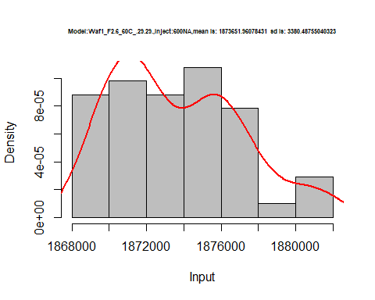

hist(d1_29.29$V7,  
 cex.main=0.5,  
 freq = FALSE,  
 main = paste('Model:Waf1_F2.6_60C_.29.29.,Inject:700NA,mean is:', mean(d1_29.29$V7),' sd is:', sd(d1_29.29$V7)),  
 xlab = "Input",  
 ylab = "Density",  
 col="grey")  
#plot density curve  
lines(density(d1_29.29$V7), # density plot  
 lwd = 2, # thickness of line  
 col = "red")

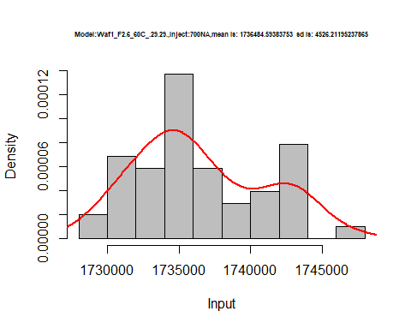

hist(d1_29.29$V8,  
 cex.main=0.5,  
 freq = FALSE,  
 main = paste('Model:Waf1_F2.6_60C_.29.29.,Inject:800NA,mean is:', mean(d1_29.29$V8),' sd is:', sd(d1_29.29$V8)),  
 xlab = "Input",  
 ylab = "Density",  
 col="grey")  
#plot density curve  
lines(density(d1_29.29$V8), # density plot  
 lwd = 2, # thickness of line  
 col = "red")

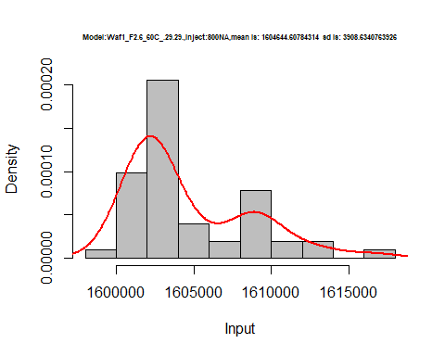

dens <- apply(d1_29.29, 2, density)  
plot('Model:Waf1_F2.6_60C_.29.29', xlim=range(sapply(dens, "[", "x")), ylim=range(sapply(dens, "[", "y")))

## Warning in xy.coords(x, y, xlabel, ylabel, log): NAs introduced by coercion

mapply(lines, dens, col=1:length(dens))

## $V1  
## NULL  
##   
## $V2  
## NULL  
##   
## $V3  
## NULL  
##   
## $V4  
## NULL  
##   
## $V5  
## NULL  
##   
## $V6  
## NULL  
##   
## $V7  
## NULL  
##   
## $V8  
## NULL

legend("topright", legend=names(dens), fill=1:length(dens))

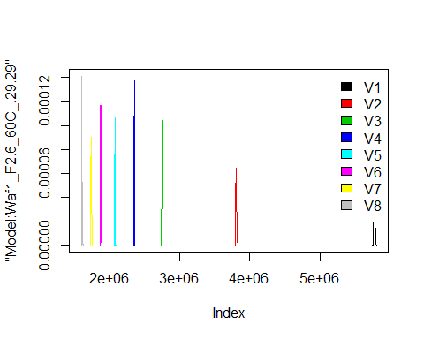

d2_29.29<-d_29.29[,c(9:16)]  
d2_29.29 <- head(d2_29.29,51)  
colnames(d2_29.29) <- c("V1", "V2","V3","V4","V5","V6","V7","V8")  
head(d2_29.29)

## V1 V2 V3 V4 V5 V6 V7 V8  
## 1 25007500 12498750 8335833 6251250 4999500 4166250 3571786 3124688  
## 2 25002500 12498750 8335833 6251875 4999500 4166250 3572143 3124688  
## 3 25002500 12498750 8335000 6251250 4999500 4165833 3571786 3124688  
## 4 25000000 12498750 8335000 6251250 5001000 4166250 3571429 3124688  
## 5 24997500 12498750 8335000 6251875 5000500 4166250 3571786 3125000  
## 6 25000000 12501250 8334167 6251875 5001000 4166250 3571429 3125000

hist(d2_29.29$V1,  
 cex.main=0.5,  
 freq = FALSE,  
 main = paste('Model:Waf1_F3.3_60C_.29.29.,Inject:100NA,mean is:', mean(d2_29.29$V1),' sd is:', sd(d2_29.29$V1)),  
 xlab = "Input",  
 ylab = "Density",  
 col="grey")  
#plot density curve  
lines(density(d2_29.29$V1), # density plot  
 lwd = 2, # thickness of line  
 col = "red")

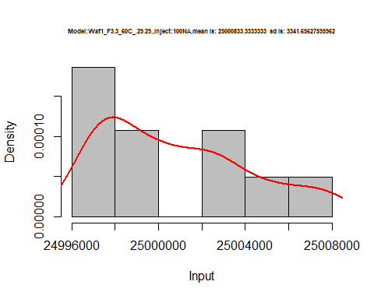

hist(d2_29.29$V2,  
 cex.main=0.5,  
 freq = FALSE,  
 main = paste('Model:Waf1_F3.3_60C_.29.29.,Inject:200NA,mean is:', mean(d2_29.29$V2),' sd is:', sd(d2_29.29$V2)),  
 xlab = "Input",  
 ylab = "Density",  
 col="grey")  
#plot density curve  
lines(density(d2_29.29$V2), # density plot  
 lwd = 2, # thickness of line  
 col = "red")

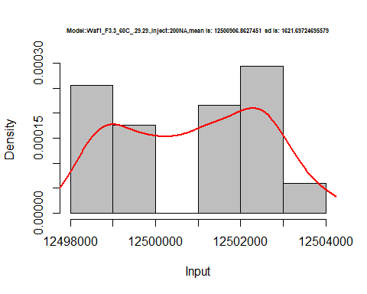

hist(d2_29.29$V3,  
 cex.main=0.5,  
 freq = FALSE,  
 main = paste('Model:Waf1_F3.3_60C_.29.29.,Inject:300NA,mean is:', mean(d2_29.29$V3),' sd is:', sd(d2_29.29$V3)),  
 xlab = "Input",  
 ylab = "Density",  
 col="grey")  
#plot density curve  
lines(density(d2_29.29$V3), # density plot  
 lwd = 2, # thickness of line  
 col = "red")

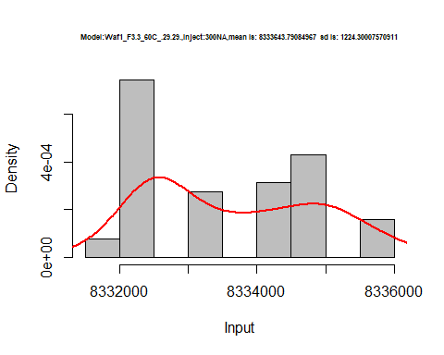

hist(d2_29.29$V4,  
 cex.main=0.5,  
 freq = FALSE,  
 main = paste('Model:Waf1_F3.3_60C_.29.29.,Inject:400NA,mean is:', mean(d2_29.29$V4),' sd is:', sd(d2_29.29$V4)),  
 xlab = "Input",  
 ylab = "Density",  
 col="grey")  
#plot density curve  
lines(density(d2_29.29$V4), # density plot  
 lwd = 2, # thickness of line  
 col = "red")

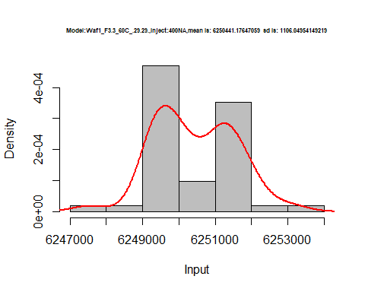

hist(d2_29.29$V5,  
 cex.main=0.5,  
 freq = FALSE,  
 main = paste('Model:Waf1_F3.3_60C_.29.29.,Inject:500NA,mean is:', mean(d2_29.29$V5),' sd is:', sd(d2_29.29$V5)),  
 xlab = "Input",  
 ylab = "Density",  
 col="grey")  
#plot density curve  
lines(density(d2_29.29$V5), # density plot  
 lwd = 2, # thickness of line  
 col = "red")

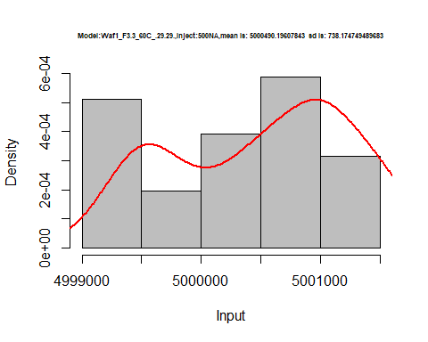

hist(d2_29.29$V6,  
 cex.main=0.5,  
 freq = FALSE,  
 main = paste('Model:Waf1_F3.3_60C_.29.29.,Inject:600NA,mean is:', mean(d2_29.29$V6),' sd is:', sd(d2_29.29$V6)),  
 xlab = "Input",  
 ylab = "Density",  
 col="grey")  
#plot density curve  
lines(density(d2_29.29$V6), # density plot  
 lwd = 2, # thickness of line  
 col = "red")

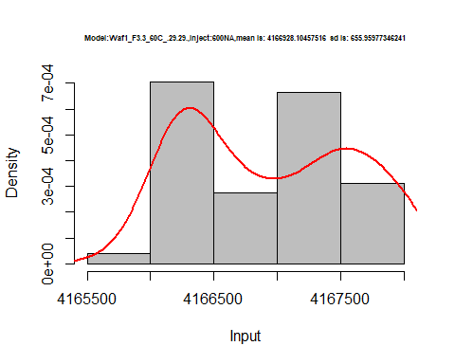

hist(d2_29.29$V7,  
 cex.main=0.5,  
 freq = FALSE,  
 main = paste('Model:Waf1_F3.3_60C_.29.29.,Inject:700NA,mean is:', mean(d2_29.29$V7),' sd is:', sd(d2_29.29$V7)),  
 xlab = "Input",  
 ylab = "Density",  
 col="grey")  
#plot density curve  
lines(density(d2_29.29$V7), # density plot  
 lwd = 2, # thickness of line  
 col = "red")

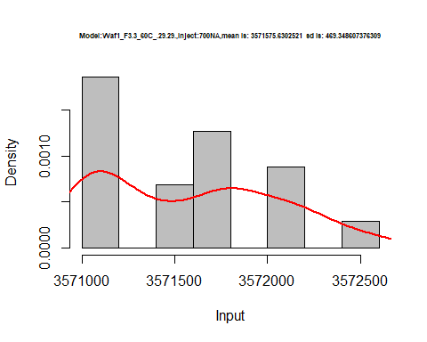

hist(d2_29.29$V8,  
 cex.main=0.5,  
 freq = FALSE,  
 main = paste('Model:Waf1_F3.3_60C_.29.29.,Inject:800NA,mean is:', mean(d2_29.29$V8),' sd is:', sd(d2_29.29$V8)),  
 xlab = "Input",  
 ylab = "Density",  
 col="grey")  
#plot density curve  
lines(density(d2_29.29$V8), # density plot  
 lwd = 2, # thickness of line  
 col = "red")

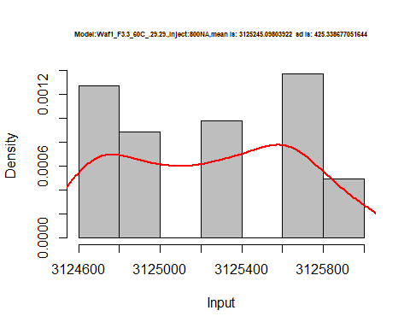

dens <- apply(d2_29.29, 2, density)  
plot('Model:Waf1_F3.3_60C_.29.29', xlim=range(sapply(dens, "[", "x")), ylim=range(sapply(dens, "[", "y")))

## Warning in xy.coords(x, y, xlabel, ylabel, log): NAs introduced by coercion

mapply(lines, dens, col=1:length(dens))

## $V1  
## NULL  
##   
## $V2  
## NULL  
##   
## $V3  
## NULL  
##   
## $V4  
## NULL  
##   
## $V5  
## NULL  
##   
## $V6  
## NULL  
##   
## $V7  
## NULL  
##   
## $V8  
## NULL

legend("topright", legend=names(dens), fill=1:length(dens))

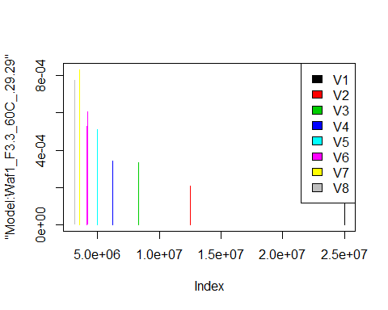

d3_29.29<-d_29.29[,c(17:24)]  
d3_29.29 <- head(d3_29.29,51)  
colnames(d3_29.29) <- c("V1", "V2","V3","V4","V5","V6","V7","V8")  
head(d3_29.29)

## V1 V2 V3 V4 V5 V6 V7 V8  
## 1 2.5e+07 12502500 8333333 6251875 5000000 4167500 3571786 3125000  
## 2 2.5e+07 12501250 8332500 6251875 4999500 4167500 3571786 3125312  
## 3 2.5e+07 12500000 8331667 6251875 4999500 4167917 3571429 3125312  
## 4 2.5e+07 12500000 8332500 6251250 5000000 4167500 3571429 3125000  
## 5 2.5e+07 12500000 8333333 6251250 4999500 4167500 3571429 3125625  
## 6 2.5e+07 12500000 8331667 6251875 5000000 4167500 3571429 3125312

hist(d3_29.29$V1,  
 cex.main=0.5,  
 freq = FALSE,  
 main = paste('Model:Waf1_F4.3_60C_.29.29.,Inject:100NA,mean is:', mean(d3_29.29$V1),' sd is:', sd(d3_29.29$V1)),  
 xlab = "Input",  
 ylab = "Density",  
 col="grey")  
#plot density curve  
lines(density(d3_29.29$V1), # density plot  
 lwd = 2, # thickness of line  
 col = "red")

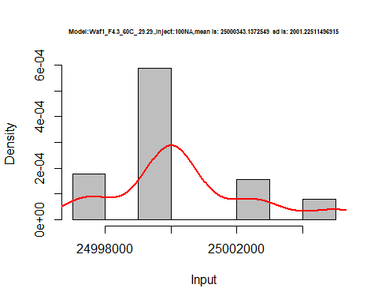

hist(d3_29.29$V2,  
 cex.main=0.5,  
 freq = FALSE,  
 main = paste('Model:Waf1_F4.3_60C_.29.29.,Inject:200NA,mean is:', mean(d3_29.29$V2),' sd is:', sd(d3_29.29$V2)),  
 xlab = "Input",  
 ylab = "Density",  
 col="grey")  
#plot density curve  
lines(density(d3_29.29$V2), # density plot  
 lwd = 2, # thickness of line  
 col = "red")

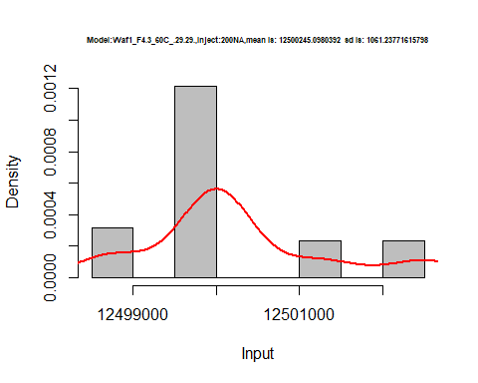

hist(d3_29.29$V3,  
 cex.main=0.5,  
 freq = FALSE,  
 main = paste('Model:Waf1_F4.3_60C_.29.29.,Inject:300NA,mean is:', mean(d3_29.29$V3),' sd is:', sd(d3_29.29$V3)),  
 xlab = "Input",  
 ylab = "Density",  
 col="grey")  
#plot density curve  
lines(density(d3_29.29$V3), # density plot  
 lwd = 2, # thickness of line  
 col = "red")

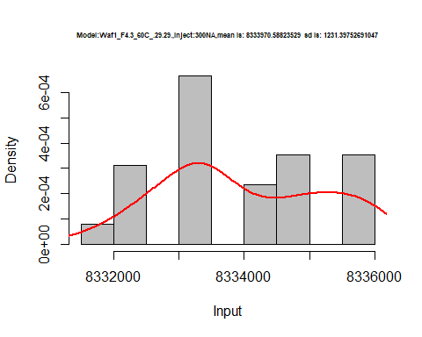

hist(d3_29.29$V4,  
 cex.main=0.5,  
 freq = FALSE,  
 main = paste('Model:Waf1_F4.3_60C_.29.29.,Inject:400NA,mean is:', mean(d3_29.29$V4),' sd is:', sd(d3_29.29$V4)),  
 xlab = "Input",  
 ylab = "Density",  
 col="grey")  
#plot density curve  
lines(density(d3_29.29$V4), # density plot  
 lwd = 2, # thickness of line  
 col = "red")

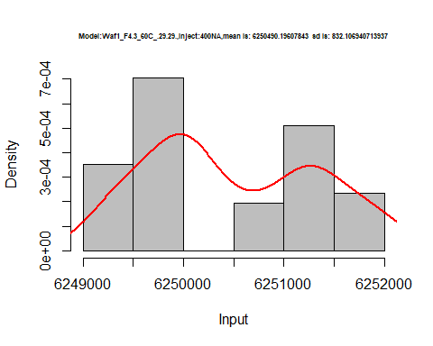

hist(d3_29.29$V5,  
 cex.main=0.5,  
 freq = FALSE,  
 main = paste('Model:Waf1_F4.3_60C_.29.29.,Inject:500NA,mean is:', mean(d3_29.29$V5),' sd is:', sd(d3_29.29$V5)),  
 xlab = "Input",  
 ylab = "Density",  
 col="grey")  
#plot density curve  
lines(density(d3_29.29$V5), # density plot  
 lwd = 2, # thickness of line  
 col = "red")

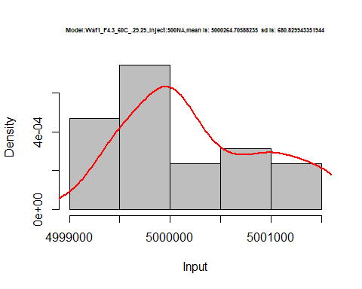

hist(d3_29.29$V6,  
 cex.main=0.5,  
 freq = FALSE,  
 main = paste('Model:Waf1_F4.3_60C_.29.29.,Inject:600NA,mean is:', mean(d3_29.29$V6),' sd is:', sd(d3_29.29$V6)),  
 xlab = "Input",  
 ylab = "Density",  
 col="grey")  
#plot density curve  
lines(density(d3_29.29$V6), # density plot  
 lwd = 2, # thickness of line  
 col = "red")

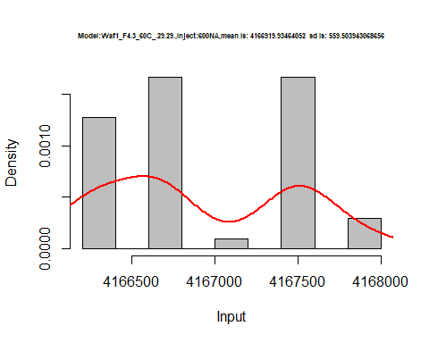

hist(d3_29.29$V7,  
 cex.main=0.5,  
 freq = FALSE,  
 main = paste('Model:Waf1_F4.3_60C_.29.29.,Inject:700NA,mean is:', mean(d3_29.29$V7),' sd is:', sd(d3_29.29$V7)),  
 xlab = "Input",  
 ylab = "Density",  
 col="grey")  
#plot density curve  
lines(density(d3_29.29$V7), # density plot  
 lwd = 2, # thickness of line  
 col = "red")

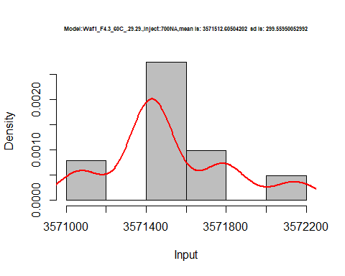

hist(d3_29.29$V8,  
 cex.main=0.5,  
 freq = FALSE,  
 main = paste('Model:Waf1_F4.3_60C_.29.29.,Inject:800NA,mean is:', mean(d3_29.29$V8),' sd is:', sd(d3_29.29$V8)),  
 xlab = "Input",  
 ylab = "Density",  
 col="grey")  
#plot density curve  
lines(density(d3_29.29$V8), # density plot  
 lwd = 2, # thickness of line  
 col = "red")

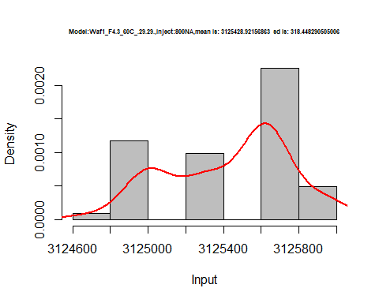

dens <- apply(d3_29.29, 2, density)  
plot('Model:Waf1_F4.3_60C_.29.29', xlim=range(sapply(dens, "[", "x")), ylim=range(sapply(dens, "[", "y")))

## Warning in xy.coords(x, y, xlabel, ylabel, log): NAs introduced by coercion

mapply(lines, dens, col=1:length(dens))

## $V1  
## NULL  
##   
## $V2  
## NULL  
##   
## $V3  
## NULL  
##   
## $V4  
## NULL  
##   
## $V5  
## NULL  
##   
## $V6  
## NULL  
##   
## $V7  
## NULL  
##   
## $V8  
## NULL

legend("topright", legend=names(dens), fill=1:length(dens))

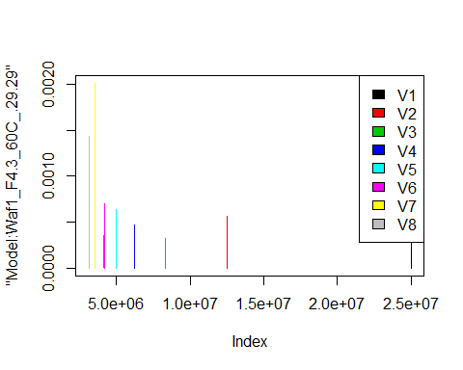

# Select columns whose names contains "30.30"  
d_30.30<-my_data %>% select(contains("30.30"))  
#d_22.22 <- head(d_22.22,51)  
#colnames(d_22.22) <- c("V1", "V2","V3","V4","V5","V6","V7","V8")  
head(d_30.30)

## Waf1_F5.2_60C_.100nA_.30.30. Waf1_F5.2_60C_.200nA_.30.30.  
## 1 25002500 12502500  
## 2 25000000 12501250  
## 3 25000000 12501250  
## 4 25000000 12502500  
## 5 24997500 12502500  
## 6 25000000 12502500  
## Waf1_F5.2_60C_.300nA_.30.30. Waf1_F5.2_60C_.400nA_.30.30.  
## 1 8332500 6249375  
## 2 8332500 6250000  
## 3 8333333 6249375  
## 4 8332500 6250000  
## 5 8332500 6250625  
## 6 8334167 6250625  
## Waf1_F5.2_60C_.500nA_.30.30. Waf1_F5.2_60C_.600nA_.30.30.  
## 1 5000500 4167500  
## 2 5000500 4167083  
## 3 5000500 4167083  
## 4 5000500 4167083  
## 5 5001500 4166667  
## 6 5001000 4166250  
## Waf1_F5.2_60C_.700nA_.30.30. Waf1_F5.2_60C_.800nA_.30.30.  
## 1 3572143 3125937  
## 2 3572143 3125937  
## 3 3571786 3125625  
## 4 3571786 3125312  
## 5 3571786 3125625  
## 6 3571429 3125312  
## Waf1_F5.7_60C_.100nA_.30.30. Waf1_F5.7_60C_.200nA_.30.30.  
## 1 3677500 2545000  
## 2 3687500 2547500  
## 3 3652500 2508750  
## 4 3672500 2510000  
## 5 3690000 2532500  
## 6 3710000 2540000  
## Waf1_F5.7_60C_.300nA_.30.30. Waf1_F5.7_60C_.400nA_.30.30.  
## 1 1994167 1697500  
## 2 1994167 1716250  
## 3 2021667 1711250  
## 4 2027500 1719375  
## 5 2017500 1707500  
## 6 2026667 1699375  
## Waf1_F5.7_60C_.500nA_.30.30. Waf1_F5.7_60C_.600nA_.30.30.  
## 1 1487000 1336667  
## 2 1494500 1330417  
## 3 1492000 1339583  
## 4 1495000 1346667  
## 5 1490500 1347917  
## 6 1490500 1347500  
## Waf1_F5.7_60C_.700nA_.30.30. Waf1_F5.7_60C_.800nA_.30.30.  
## 1 1234286 1128125  
## 2 1220000 1123438  
## 3 1228214 1135000  
## 4 1228214 1119375  
## 5 1227143 1137188  
## 6 1227143 1126250

d1_30.30<-d_30.30[,c(1:8)]  
d1_30.30 <- head(d1_30.30,51)  
colnames(d1_30.30) <- c("V1", "V2","V3","V4","V5","V6","V7","V8")  
head(d1_30.30)

## V1 V2 V3 V4 V5 V6 V7 V8  
## 1 25002500 12502500 8332500 6249375 5000500 4167500 3572143 3125937  
## 2 25000000 12501250 8332500 6250000 5000500 4167083 3572143 3125937  
## 3 25000000 12501250 8333333 6249375 5000500 4167083 3571786 3125625  
## 4 25000000 12502500 8332500 6250000 5000500 4167083 3571786 3125312  
## 5 24997500 12502500 8332500 6250625 5001500 4166667 3571786 3125625  
## 6 25000000 12502500 8334167 6250625 5001000 4166250 3571429 3125312

hist(d1_30.30$V1,  
 cex.main=0.5,  
 freq = FALSE,  
 main = paste('Model:Waf1_F5.2_60C_.30.30.,Inject:100NA,mean is:', mean(d1_30.30$V1),' sd is:', sd(d1_30.30$V1)),  
 xlab = "Input",  
 ylab = "Density",  
 col="grey")  
#plot density curve  
lines(density(d1_30.30$V1), # density plot  
 lwd = 2, # thickness of line  
 col = "red")

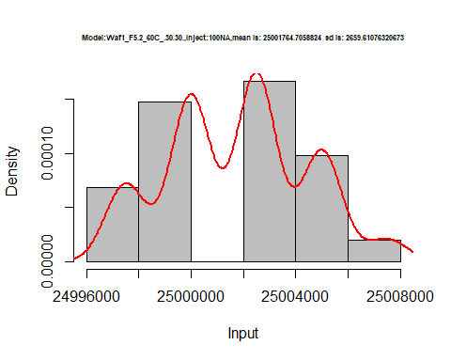

hist(d1_30.30$V2,  
 cex.main=0.5,  
 freq = FALSE,  
 main = paste('Model:Waf1_F5.2_60C_.30.30.,Inject:200NA,mean is:', mean(d1_30.30$V2),' sd is:', sd(d1_30.30$V2)),  
 xlab = "Input",  
 ylab = "Density",  
 col="grey")  
#plot density curve  
lines(density(d1_30.30$V2), # density plot  
 lwd = 2, # thickness of line  
 col = "red")

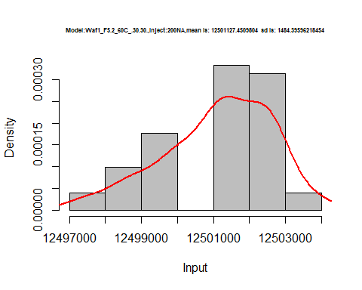

hist(d1_30.30$V3,  
 cex.main=0.5,  
 freq = FALSE,  
 main = paste('Model:Waf1_F5.2_60C_.30.30.,Inject:300NA,mean is:', mean(d1_30.30$V3),' sd is:', sd(d1_30.30$V3)),  
 xlab = "Input",  
 ylab = "Density",  
 col="grey")  
#plot density curve  
lines(density(d1_30.30$V3), # density plot  
 lwd = 2, # thickness of line  
 col = "red")

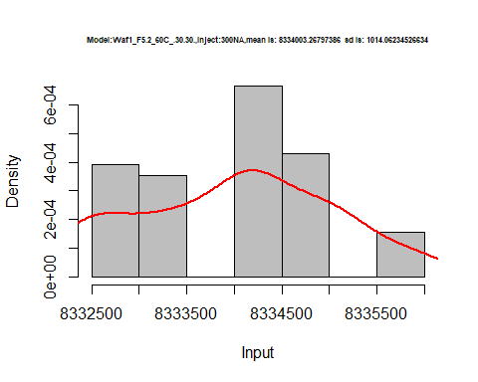

hist(d1_30.30$V4,  
 cex.main=0.5,  
 freq = FALSE,  
 main = paste('Model:Waf1_F5.2_60C_.30.30.,Inject:400NA,mean is:', mean(d1_30.30$V4),' sd is:', sd(d1_30.30$V4)),  
 xlab = "Input",  
 ylab = "Density",  
 col="grey")  
#plot density curve  
lines(density(d1_30.30$V4), # density plot  
 lwd = 2, # thickness of line  
 col = "red")

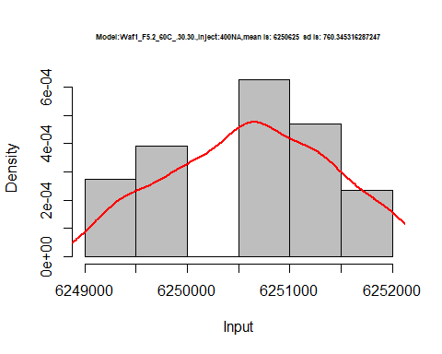

hist(d1_30.30$V5,  
 cex.main=0.5,  
 freq = FALSE,  
 main = paste('Model:Waf1_F5.2_60C_.30.30.,Inject:500NA,mean is:', mean(d1_30.30$V5),' sd is:', sd(d1_30.30$V5)),  
 xlab = "Input",  
 ylab = "Density",  
 col="grey")  
#plot density curve  
lines(density(d1_30.30$V5), # density plot  
 lwd = 2, # thickness of line  
 col = "red")

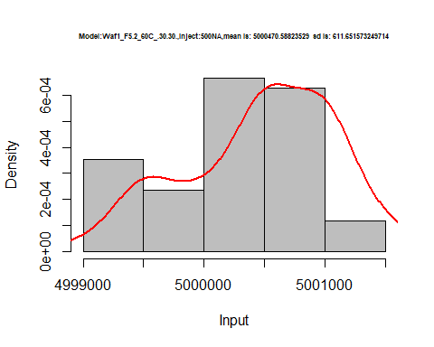

hist(d1_30.30$V6,  
 cex.main=0.5,  
 freq = FALSE,  
 main = paste('Model:Waf1_F5.2_60C_.30.30.,Inject:600NA,mean is:', mean(d1_30.30$V6),' sd is:', sd(d1_30.30$V6)),  
 xlab = "Input",  
 ylab = "Density",  
 col="grey")  
#plot density curve  
lines(density(d1_30.30$V6), # density plot  
 lwd = 2, # thickness of line  
 col = "red")

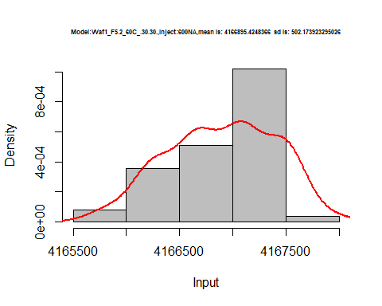

hist(d1_30.30$V7,  
 cex.main=0.5,  
 freq = FALSE,  
 main = paste('Model:Waf1_F5.2_60C_.30.30.,Inject:700NA,mean is:', mean(d1_30.30$V7),' sd is:', sd(d1_30.30$V7)),  
 xlab = "Input",  
 ylab = "Density",  
 col="grey")  
#plot density curve  
lines(density(d1_30.30$V7), # density plot  
 lwd = 2, # thickness of line  
 col = "red")

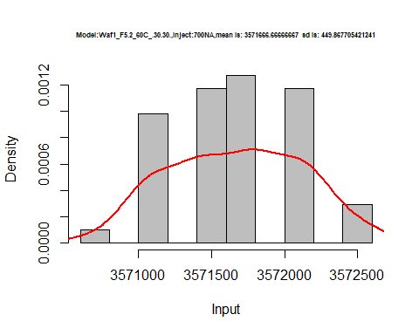

hist(d1_30.30$V8,  
 cex.main=0.5,  
 freq = FALSE,  
 main = paste('Model:Waf1_F5.2_60C_.30.30.,Inject:800NA,mean is:', mean(d1_30.30$V8),' sd is:', sd(d1_30.30$V8)),  
 xlab = "Input",  
 ylab = "Density",  
 col="grey")  
#plot density curve  
lines(density(d1_30.30$V8), # density plot  
 lwd = 2, # thickness of line  
 col = "red")

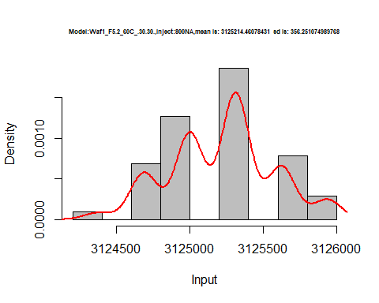

dens <- apply(d1_30.30, 2, density)  
plot('Model:Waf1_F5.2_60C_.30.30', xlim=range(sapply(dens, "[", "x")), ylim=range(sapply(dens, "[", "y")))

## Warning in xy.coords(x, y, xlabel, ylabel, log): NAs introduced by coercion

mapply(lines, dens, col=1:length(dens))

## $V1  
## NULL  
##   
## $V2  
## NULL  
##   
## $V3  
## NULL  
##   
## $V4  
## NULL  
##   
## $V5  
## NULL  
##   
## $V6  
## NULL  
##   
## $V7  
## NULL  
##   
## $V8  
## NULL

legend("topright", legend=names(dens), fill=1:length(dens))

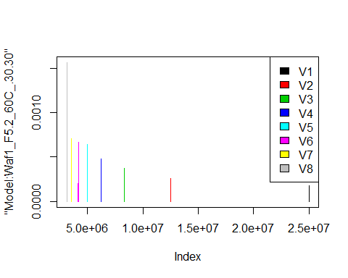

d2_30.30<-d_30.30[,c(9:16)]  
d2_30.30 <- head(d2_30.30,51)  
colnames(d2_30.30) <- c("V1", "V2","V3","V4","V5","V6","V7","V8")  
head(d2_30.30)

## V1 V2 V3 V4 V5 V6 V7 V8  
## 1 3677500 2545000 1994167 1697500 1487000 1336667 1234286 1128125  
## 2 3687500 2547500 1994167 1716250 1494500 1330417 1220000 1123438  
## 3 3652500 2508750 2021667 1711250 1492000 1339583 1228214 1135000  
## 4 3672500 2510000 2027500 1719375 1495000 1346667 1228214 1119375  
## 5 3690000 2532500 2017500 1707500 1490500 1347917 1227143 1137188  
## 6 3710000 2540000 2026667 1699375 1490500 1347500 1227143 1126250

hist(d2_30.30$V1,  
 cex.main=0.5,  
 freq = FALSE,  
 main = paste('Model:Waf1_F5.7_60C_.30.30.,Inject:100NA,mean is:', mean(d2_30.30$V1),' sd is:', sd(d2_30.30$V1)),  
 xlab = "Input",  
 ylab = "Density",  
 col="grey")  
#plot density curve  
lines(density(d2_30.30$V1), # density plot  
 lwd = 2, # thickness of line  
 col = "red")

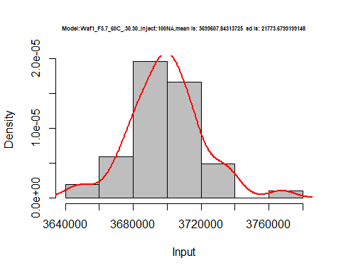

hist(d2_30.30$V2,  
 cex.main=0.5,  
 freq = FALSE,  
 main = paste('Model:Waf1_F5.7_60C_.30.30.,Inject:200NA,mean is:', mean(d2_30.30$V2),' sd is:', sd(d2_30.30$V2)),  
 xlab = "Input",  
 ylab = "Density",  
 col="grey")  
#plot density curve  
lines(density(d2_30.30$V2), # density plot  
 lwd = 2, # thickness of line  
 col = "red")

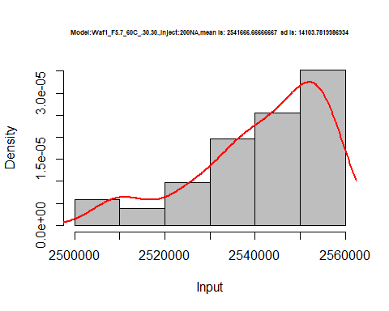

hist(d2_30.30$V3,  
 cex.main=0.5,  
 freq = FALSE,  
 main = paste('Model:Waf1_F5.7_60C_.30.30.,Inject:300NA,mean is:', mean(d2_30.30$V3),' sd is:', sd(d2_30.30$V3)),  
 xlab = "Input",  
 ylab = "Density",  
 col="grey")  
#plot density curve  
lines(density(d2_30.30$V3), # density plot  
 lwd = 2, # thickness of line  
 col = "red")

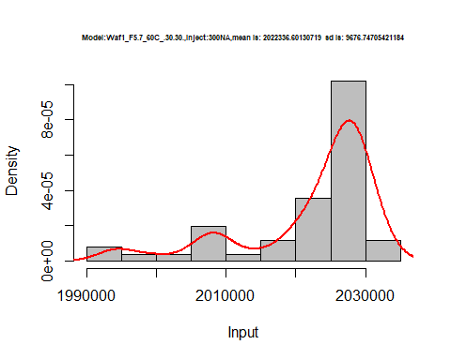

hist(d2_30.30$V4,  
 cex.main=0.5,  
 freq = FALSE,  
 main = paste('Model:Waf1_F5.7_60C_.30.30.,Inject:400NA,mean is:', mean(d2_30.30$V4),' sd is:', sd(d2_30.30$V4)),  
 xlab = "Input",  
 ylab = "Density",  
 col="grey")  
#plot density curve  
lines(density(d2_30.30$V4), # density plot  
 lwd = 2, # thickness of line  
 col = "red")

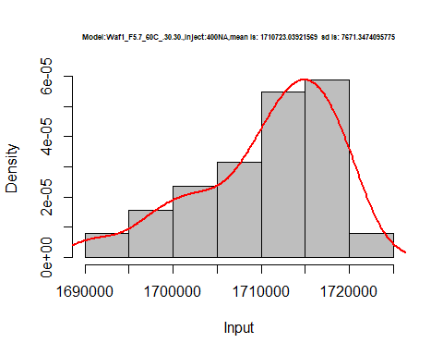

hist(d2_30.30$V5,  
 cex.main=0.5,  
 freq = FALSE,  
 main = paste('Model:Waf1_F5.7_60C_.30.30.,Inject:500NA,mean is:', mean(d2_30.30$V5),' sd is:', sd(d2_30.30$V5)),  
 xlab = "Input",  
 ylab = "Density",  
 col="grey")  
#plot density curve  
lines(density(d2_30.30$V5), # density plot  
 lwd = 2, # thickness of line  
 col = "red")

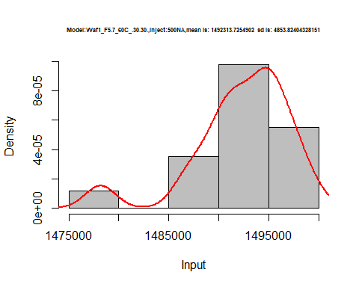

hist(d2_30.30$V6,  
 cex.main=0.5,  
 freq = FALSE,  
 main = paste('Model:Waf1_F5.7_60C_.30.30.,Inject:600NA,mean is:', mean(d2_30.30$V6),' sd is:', sd(d2_30.30$V6)),  
 xlab = "Input",  
 ylab = "Density",  
 col="grey")  
#plot density curve  
lines(density(d2_30.30$V6), # density plot  
 lwd = 2, # thickness of line  
 col = "red")

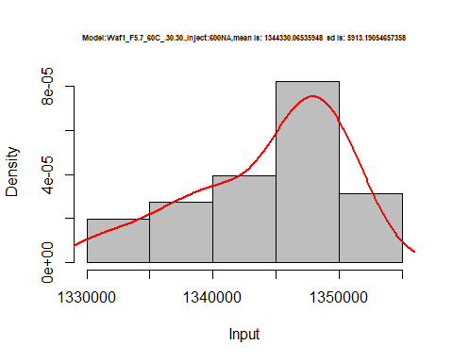

hist(d2_30.30$V7,  
 cex.main=0.5,  
 freq = FALSE,  
 main = paste('Model:Waf1_F5.7_60C_.30.30.,Inject:700NA,mean is:', mean(d2_30.30$V7),' sd is:', sd(d2_30.30$V7)),  
 xlab = "Input",  
 ylab = "Density",  
 col="grey")  
#plot density curve  
lines(density(d2_30.30$V7), # density plot  
 lwd = 2, # thickness of line  
 col = "red")

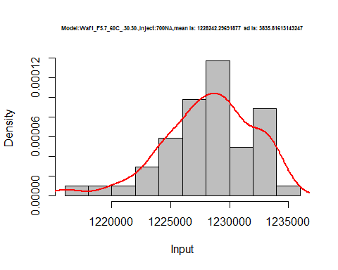

hist(d2_30.30$V8,  
 cex.main=0.5,  
 freq = FALSE,  
 main = paste('Model:Waf1_F5.7_60C_.30.30.,Inject:800NA,mean is:', mean(d2_30.30$V8),' sd is:', sd(d2_30.30$V8)),  
 xlab = "Input",  
 ylab = "Density",  
 col="grey")  
#plot density curve  
lines(density(d2_30.30$V8), # density plot  
 lwd = 2, # thickness of line  
 col = "red")

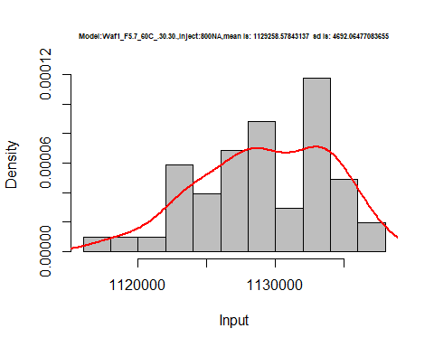

dens <- apply(d2_30.30, 2, density)  
plot('Model:Waf1_F5.7_60C_.30.30', xlim=range(sapply(dens, "[", "x")), ylim=range(sapply(dens, "[", "y")))

## Warning in xy.coords(x, y, xlabel, ylabel, log): NAs introduced by coercion

mapply(lines, dens, col=1:length(dens))

## $V1  
## NULL  
##   
## $V2  
## NULL  
##   
## $V3  
## NULL  
##   
## $V4  
## NULL  
##   
## $V5  
## NULL  
##   
## $V6  
## NULL  
##   
## $V7  
## NULL  
##   
## $V8  
## NULL

legend("topright", legend=names(dens), fill=1:length(dens))

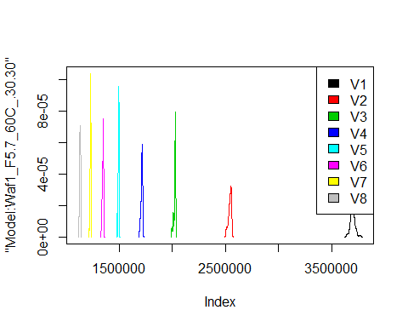

# Select columns whose names contains "31.31"  
d_31.31<-my_data %>% select(contains("31.31"))  
#d_22.22 <- head(d_22.22,51)  
#colnames(d_22.22) <- c("V1", "V2","V3","V4","V5","V6","V7","V8")  
head(d_31.31)

## Waf1_F2.6_F_60C_.100nA_.31.31. Waf1_F2.6_F_60C_.200nA_.31.31.  
## 1 660000 768750  
## 2 595000 793750  
## 3 755000 805000  
## 4 827500 802500  
## 5 857500 792500  
## 6 857500 768750  
## Waf1_F2.6_F_60C_.300nA_.31.31. Waf1_F2.6_F_60C_.400nA_.31.31.  
## 1 719166.7 633750  
## 2 718333.3 634375  
## 3 674166.7 618750  
## 4 677500.0 642500  
## 5 690833.3 643750  
## 6 706666.7 640000  
## Waf1_F2.6_F_60C_.500nA_.31.31. Waf1_F2.6_F_60C_.600nA_.31.31.  
## 1 560000 567500.0  
## 2 613000 567083.3  
## 3 608000 532500.0  
## 4 603500 572500.0  
## 5 604000 571250.0  
## 6 608500 567500.0  
## Waf1_F2.6_F_60C_.700nA_.31.31. Waf1_F2.6_F_60C_.800nA_.31.31.  
## 1 540357.1 507812.5  
## 2 541071.4 476250.0  
## 3 542142.9 513125.0  
## 4 535714.3 514687.5  
## 5 537500.0 510937.5  
## 6 538571.4 507500.0  
## Waf1_F3.3_F_60C_.100nA_.31.31. Waf1_F3.3_F_60C_.200nA_.31.31.  
## 1 14042500 11470000  
## 2 13925000 11532500  
## 3 13812500 11590000  
## 4 13765000 11665000  
## 5 13892500 11803750  
## 6 13970000 11815000  
## Waf1_F3.3_F_60C_.300nA_.31.31. Waf1_F3.3_F_60C_.400nA_.31.31.  
## 1 8335000 6251250  
## 2 8335000 6251875  
## 3 8335833 6249375  
## 4 8335833 6249375  
## 5 8334167 6250625  
## 6 8335833 6250625  
## Waf1_F3.3_F_60C_.500nA_.31.31. Waf1_F3.3_F_60C_.600nA_.31.31.  
## 1 4999500 4167500  
## 2 4999500 4167917  
## 3 4999500 4167500  
## 4 4999500 4161667  
## 5 4999500 4167917  
## 6 4999000 4167500  
## Waf1_F3.3_F_60C_.700nA_.31.31. Waf1_F3.3_F_60C_.800nA_.31.31.  
## 1 3571786 3125000  
## 2 3572143 3124062  
## 3 3571786 3125000  
## 4 3571786 3124688  
## 5 3571429 3124688  
## 6 3571429 3124688  
## Waf1_F3.5_60C_.100nA_.31.31. Waf1_F3.5_60C_.200nA_.31.31.  
## 1 25007500 12503750  
## 2 25005000 12502500  
## 3 25005000 12502500  
## 4 25007500 12501250  
## 5 25007500 12501250  
## 6 25002500 12501250  
## Waf1_F3.5_60C_.300nA_.31.31. Waf1_F3.5_60C_.400nA_.31.31.  
## 1 8335000 6250625  
## 2 8335000 6250000  
## 3 8336667 6249375  
## 4 8335000 6250000  
## 5 8335000 6249375  
## 6 8335000 6249375  
## Waf1_F3.5_60C_.500nA_.31.31. Waf1_F3.5_60C_.600nA_.31.31.  
## 1 5000500 4166250  
## 2 5000500 4166667  
## 3 5000500 4167083  
## 4 5000500 4167500  
## 5 5001000 4167083  
## 6 5001000 4167500  
## Waf1_F3.5_60C_.700nA_.31.31. Waf1_F3.5_60C_.800nA_.31.31.  
## 1 3571786 3124688  
## 2 3571786 3124688  
## 3 3572143 3125000  
## 4 3572143 3125000  
## 5 3572143 3125000  
## 6 3571786 3125625  
## Waf1_F7.3_F_60C_.100nA_.31.31. Waf1_F7.3_F_60C_.200nA_.31.31.  
## 1 8325000 5462500  
## 2 8680000 5430000  
## 3 8945000 5410000  
## 4 9157500 5397500  
## 5 9320000 5388750  
## 6 9440000 5377500  
## Waf1_F7.3_F_60C_.300nA_.31.31. Waf1_F7.3_F_60C_.400nA_.31.31.  
## 1 4676667 3138125  
## 2 4696667 3065625  
## 3 4716667 3039375  
## 4 4740000 3020625  
## 5 4739167 3012500  
## 6 4731667 3005000  
## Waf1_F7.3_F_60C_.500nA_.31.31. Waf1_F7.3_F_60C_.600nA_.31.31.  
## 1 1686000 1686667  
## 2 1719000 1682083  
## 3 1735000 1707083  
## 4 1777000 1667500  
## 5 1632000 1647083  
## 6 1552000 1598333  
## Waf1_F7.3_F_60C_.700nA_.31.31. Waf1_F7.3_F_60C_.800nA_.31.31.  
## 1 1568929 1484688  
## 2 1584643 1408750  
## 3 1536786 1510625  
## 4 1553929 1506250  
## 5 1523929 1417812  
## 6 1495714 1336875

d1_31.31<-d_31.31[,c(1:8)]  
d1_31.31 <- head(d1_31.31,51)  
colnames(d1_31.31) <- c("V1", "V2","V3","V4","V5","V6","V7","V8")  
head(d1_31.31)

## V1 V2 V3 V4 V5 V6 V7 V8  
## 1 660000 768750 719166.7 633750 560000 567500.0 540357.1 507812.5  
## 2 595000 793750 718333.3 634375 613000 567083.3 541071.4 476250.0  
## 3 755000 805000 674166.7 618750 608000 532500.0 542142.9 513125.0  
## 4 827500 802500 677500.0 642500 603500 572500.0 535714.3 514687.5  
## 5 857500 792500 690833.3 643750 604000 571250.0 537500.0 510937.5  
## 6 857500 768750 706666.7 640000 608500 567500.0 538571.4 507500.0

hist(d1_31.31$V1,  
 cex.main=0.5,  
 freq = FALSE,  
 main = paste('Model:Waf1_F2.6_60C_.31.31.,Inject:100NA,mean is:', mean(d1_31.31$V1),' sd is:', sd(d1_31.31$V1)),  
 xlab = "Input",  
 ylab = "Density",  
 col="grey")  
#plot density curve  
lines(density(d1_31.31$V1), # density plot  
 lwd = 2, # thickness of line  
 col = "red")

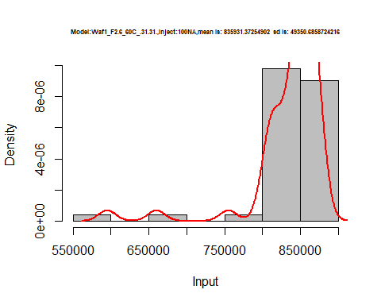

hist(d1_31.31$V2,  
 cex.main=0.5,  
 freq = FALSE,  
 main = paste('Model:Waf1_F2.6_60C_.31.31.,Inject:200NA,mean is:', mean(d1_31.31$V2),' sd is:', sd(d1_31.31$V2)),  
 xlab = "Input",  
 ylab = "Density",  
 col="grey")  
#plot density curve  
lines(density(d1_31.31$V2), # density plot  
 lwd = 2, # thickness of line  
 col = "red")

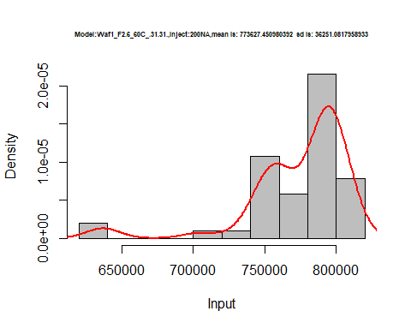

hist(d1_31.31$V3,  
 cex.main=0.5,  
 freq = FALSE,  
 main = paste('Model:Waf1_F2.6_60C_.31.31.,Inject:300NA,mean is:', mean(d1_31.31$V3),' sd is:', sd(d1_31.31$V3)),  
 xlab = "Input",  
 ylab = "Density",  
 col="grey")  
#plot density curve  
lines(density(d1_31.31$V3), # density plot  
 lwd = 2, # thickness of line  
 col = "red")

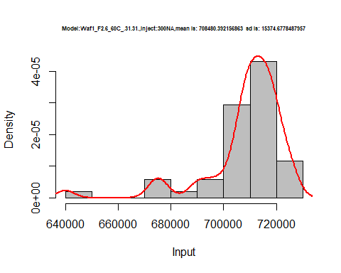

hist(d1_31.31$V4,  
 cex.main=0.5,  
 freq = FALSE,  
 main = paste('Model:Waf1_F2.6_60C_.31.31.,Inject:400NA,mean is:', mean(d1_31.31$V4),' sd is:', sd(d1_31.31$V4)),  
 xlab = "Input",  
 ylab = "Density",  
 col="grey")  
#plot density curve  
lines(density(d1_31.31$V4), # density plot  
 lwd = 2, # thickness of line  
 col = "red")

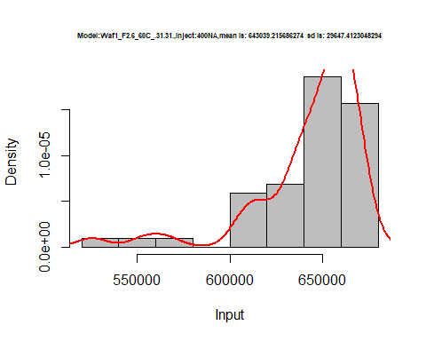

hist(d1_31.31$V5,  
 cex.main=0.5,  
 freq = FALSE,  
 main = paste('Model:Waf1_F2.6_60C_.31.31.,Inject:500NA,mean is:', mean(d1_31.31$V5),' sd is:', sd(d1_31.31$V5)),  
 xlab = "Input",  
 ylab = "Density",  
 col="grey")  
#plot density curve  
lines(density(d1_31.31$V5), # density plot  
 lwd = 2, # thickness of line  
 col = "red")

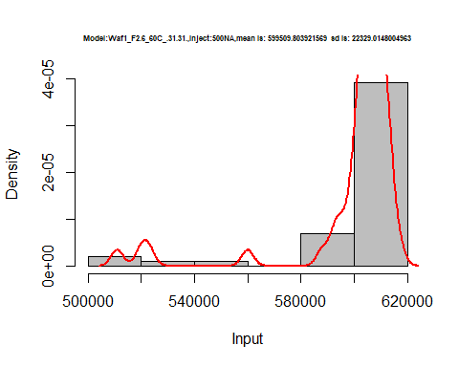

hist(d1_31.31$V6,  
 cex.main=0.5,  
 freq = FALSE,  
 main = paste('Model:Waf1_F2.6_60C_.31.31.,Inject:600NA,mean is:', mean(d1_31.31$V6),' sd is:', sd(d1_31.31$V6)),  
 xlab = "Input",  
 ylab = "Density",  
 col="grey")  
#plot density curve  
lines(density(d1_31.31$V6), # density plot  
 lwd = 2, # thickness of line  
 col = "red")

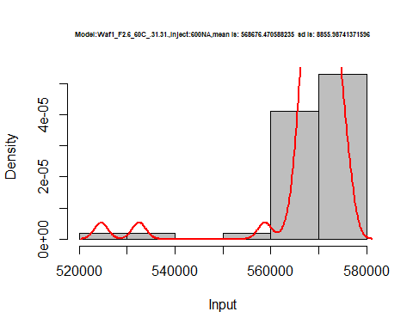

hist(d1_31.31$V7,  
 cex.main=0.5,  
 freq = FALSE,  
 main = paste('Model:Waf1_F2.6_60C_.31.31.,Inject:700NA,mean is:', mean(d1_31.31$V7),' sd is:', sd(d1_31.31$V7)),  
 xlab = "Input",  
 ylab = "Density",  
 col="grey")  
#plot density curve  
lines(density(d1_31.31$V7), # density plot  
 lwd = 2, # thickness of line  
 col = "red")

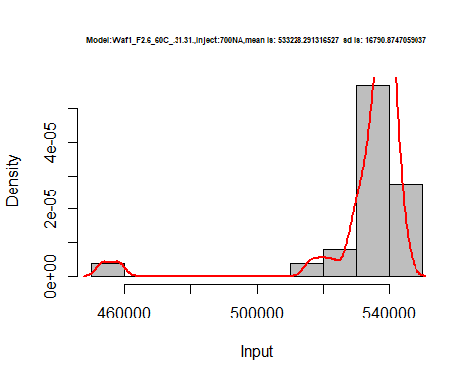

hist(d1_31.31$V8,  
 cex.main=0.5,  
 freq = FALSE,  
 main = paste('Model:Waf1_F2.6_60C_.31.31.,Inject:800NA,mean is:', mean(d1_31.31$V8),' sd is:', sd(d1_31.31$V8)),  
 xlab = "Input",  
 ylab = "Density",  
 col="grey")  
#plot density curve  
lines(density(d1_31.31$V8), # density plot  
 lwd = 2, # thickness of line  
 col = "red")

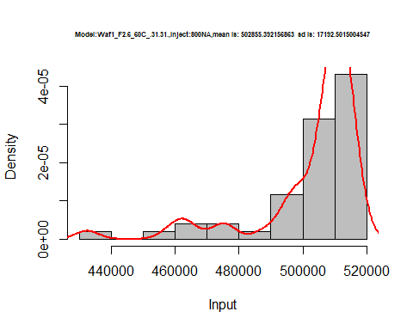

dens <- apply(d1_31.31, 2, density)  
plot('Model:Waf1_F2.6_60C_.31.31', xlim=range(sapply(dens, "[", "x")), ylim=range(sapply(dens, "[", "y")))

## Warning in xy.coords(x, y, xlabel, ylabel, log): NAs introduced by coercion

mapply(lines, dens, col=1:length(dens))

## $V1  
## NULL  
##   
## $V2  
## NULL  
##   
## $V3  
## NULL  
##   
## $V4  
## NULL  
##   
## $V5  
## NULL  
##   
## $V6  
## NULL  
##   
## $V7  
## NULL  
##   
## $V8  
## NULL

legend("topright", legend=names(dens), fill=1:length(dens))

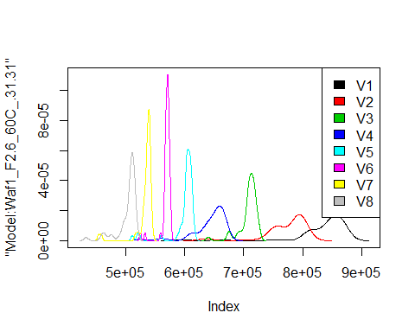

d2_31.31<-d_31.31[,c(9:16)]  
d2_31.31 <- head(d2_31.31,51)  
colnames(d2_31.31) <- c("V1", "V2","V3","V4","V5","V6","V7","V8")  
head(d2_31.31)

## V1 V2 V3 V4 V5 V6 V7 V8  
## 1 14042500 11470000 8335000 6251250 4999500 4167500 3571786 3125000  
## 2 13925000 11532500 8335000 6251875 4999500 4167917 3572143 3124062  
## 3 13812500 11590000 8335833 6249375 4999500 4167500 3571786 3125000  
## 4 13765000 11665000 8335833 6249375 4999500 4161667 3571786 3124688  
## 5 13892500 11803750 8334167 6250625 4999500 4167917 3571429 3124688  
## 6 13970000 11815000 8335833 6250625 4999000 4167500 3571429 3124688

hist(d2_31.31$V1,  
 cex.main=0.5,  
 freq = FALSE,  
 main = paste('Model:Waf1_F3.3_60C_.31.31.,Inject:100NA,mean is:', mean(d2_31.31$V1),' sd is:', sd(d2_31.31$V1)),  
 xlab = "Input",  
 ylab = "Density",  
 col="grey")  
#plot density curve  
lines(density(d2_31.31$V1), # density plot  
 lwd = 2, # thickness of line  
 col = "red")

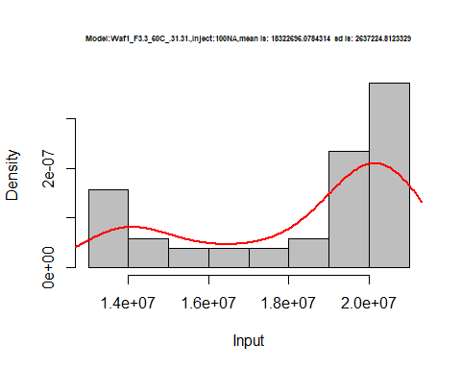

hist(d2_31.31$V2,  
 cex.main=0.5,  
 freq = FALSE,  
 main = paste('Model:Waf1_F3.3_60C_.31.31.,Inject:100NA,mean is:', mean(d2_31.31$V2),' sd is:', sd(d2_31.31$V2)),  
 xlab = "Input",  
 ylab = "Density",  
 col="grey")  
#plot density curve  
lines(density(d2_31.31$V2), # density plot  
 lwd = 2, # thickness of line  
 col = "red")

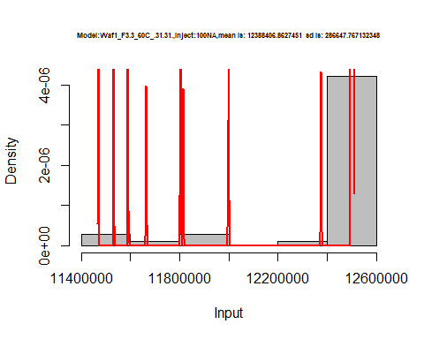

hist(d2_31.31$V3,  
 cex.main=0.5,  
 freq = FALSE,  
 main = paste('Model:Waf1_F3.3_60C_.31.31.,Inject:300NA,mean is:', mean(d2_31.31$V3),' sd is:', sd(d2_31.31$V3)),  
 xlab = "Input",  
 ylab = "Density",  
 col="grey")  
#plot density curve  
lines(density(d2_31.31$V3), # density plot  
 lwd = 2, # thickness of line  
 col = "red")

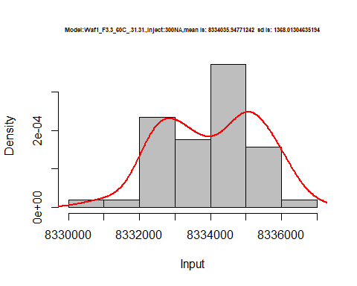

hist(d2_31.31$V4,  
 cex.main=0.5,  
 freq = FALSE,  
 main = paste('Model:Waf1_F3.3_60C_.31.31.,Inject:400NA,mean is:', mean(d2_31.31$V4),' sd is:', sd(d2_31.31$V4)),  
 xlab = "Input",  
 ylab = "Density",  
 col="grey")  
#plot density curve  
lines(density(d2_31.31$V4), # density plot  
 lwd = 2, # thickness of line  
 col = "red")

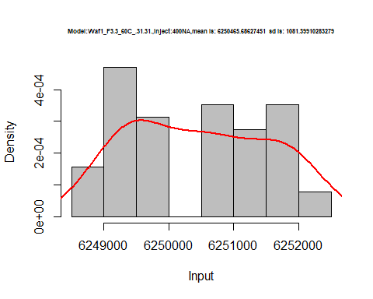

hist(d2_31.31$V5,  
 cex.main=0.5,  
 freq = FALSE,  
 main = paste('Model:Waf1_F3.3_60C_.31.31.,Inject:500NA,mean is:', mean(d2_31.31$V5),' sd is:', sd(d2_31.31$V5)),  
 xlab = "Input",  
 ylab = "Density",  
 col="grey")  
#plot density curve  
lines(density(d2_31.31$V5), # density plot  
 lwd = 2, # thickness of line  
 col = "red")

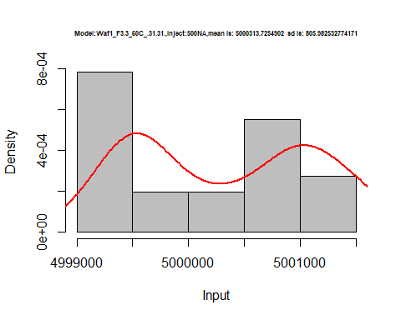

hist(d2_31.31$V6,  
 cex.main=0.5,  
 freq = FALSE,  
 main = paste('Model:Waf1_F3.3_60C_.31.31.,Inject:600NA,mean is:', mean(d2_31.31$V6),' sd is:', sd(d2_31.31$V6)),  
 xlab = "Input",  
 ylab = "Density",  
 col="grey")  
#plot density curve  
lines(density(d2_31.31$V6), # density plot  
 lwd = 2, # thickness of line  
 col = "red")

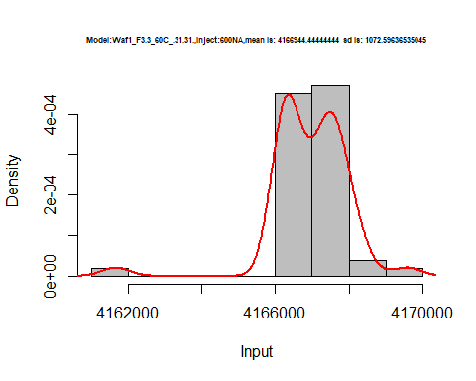

hist(d2_31.31$V7,  
 cex.main=0.5,  
 freq = FALSE,  
 main = paste('Model:Waf1_F3.3_60C_.31.31.,Inject:700NA,mean is:', mean(d2_31.31$V7),' sd is:', sd(d2_31.31$V7)),  
 xlab = "Input",  
 ylab = "Density",  
 col="grey")  
#plot density curve  
lines(density(d2_31.31$V7), # density plot  
 lwd = 2, # thickness of line  
 col = "red")

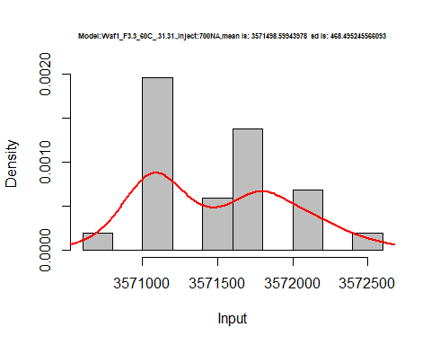

hist(d2_31.31$V8,  
 cex.main=0.5,  
 freq = FALSE,  
 main = paste('Model:Waf1_F3.3_60C_.31.31.,Inject:800NA,mean is:', mean(d2_31.31$V8),' sd is:', sd(d2_31.31$V8)),  
 xlab = "Input",  
 ylab = "Density",  
 col="grey")  
#plot density curve  
lines(density(d2_31.31$V8), # density plot  
 lwd = 2, # thickness of line  
 col = "red")

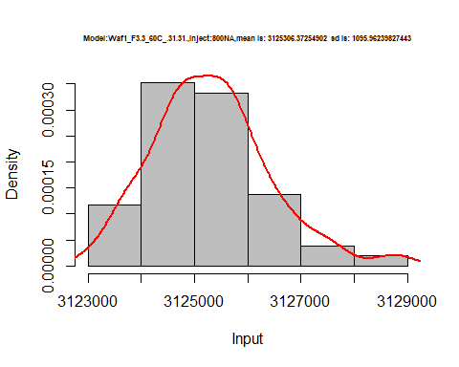

dens <- apply(d2_31.31, 2, density)  
plot('Model:Waf1_F3.3_60C_.31.31', xlim=range(sapply(dens, "[", "x")), ylim=range(sapply(dens, "[", "y")))

## Warning in xy.coords(x, y, xlabel, ylabel, log): NAs introduced by coercion

mapply(lines, dens, col=1:length(dens))

## $V1  
## NULL  
##   
## $V2  
## NULL  
##   
## $V3  
## NULL  
##   
## $V4  
## NULL  
##   
## $V5  
## NULL  
##   
## $V6  
## NULL  
##   
## $V7  
## NULL  
##   
## $V8  
## NULL

legend("topright", legend=names(dens), fill=1:length(dens))

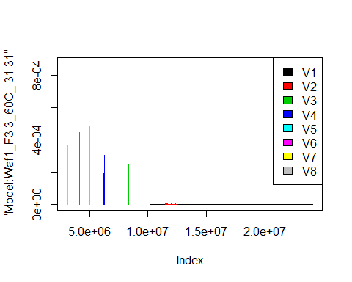

d3_31.31<-d_31.31[,c(17:24)]  
d3_31.31 <- head(d3_31.31,51)  
colnames(d3_31.31) <- c("V1", "V2","V3","V4","V5","V6","V7","V8")  
head(d3_31.31)

## V1 V2 V3 V4 V5 V6 V7 V8  
## 1 25007500 12503750 8335000 6250625 5000500 4166250 3571786 3124688  
## 2 25005000 12502500 8335000 6250000 5000500 4166667 3571786 3124688  
## 3 25005000 12502500 8336667 6249375 5000500 4167083 3572143 3125000  
## 4 25007500 12501250 8335000 6250000 5000500 4167500 3572143 3125000  
## 5 25007500 12501250 8335000 6249375 5001000 4167083 3572143 3125000  
## 6 25002500 12501250 8335000 6249375 5001000 4167500 3571786 3125625

hist(d3_31.31$V1,  
 cex.main=0.5,  
 freq = FALSE,  
 main = paste('Model:Waf1_F3.5_60C_.31.31.,Inject:100NA,mean is:', mean(d3_31.31$V1),' sd is:', sd(d3_31.31$V1)),  
 xlab = "Input",  
 ylab = "Density",  
 col="grey")  
#plot density curve  
lines(density(d3_31.31$V1), # density plot  
 lwd = 2, # thickness of line  
 col = "red")

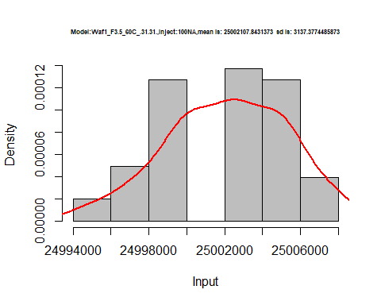

hist(d3_31.31$V2,  
 cex.main=0.5,  
 freq = FALSE,  
 main = paste('Model:Waf1_F3.5_60C_.31.31.,Inject:200NA,mean is:', mean(d3_31.31$V2),' sd is:', sd(d3_31.31$V2)),  
 xlab = "Input",  
 ylab = "Density",  
 col="grey")  
#plot density curve  
lines(density(d3_31.31$V2), # density plot  
 lwd = 2, # thickness of line  
 col = "red")

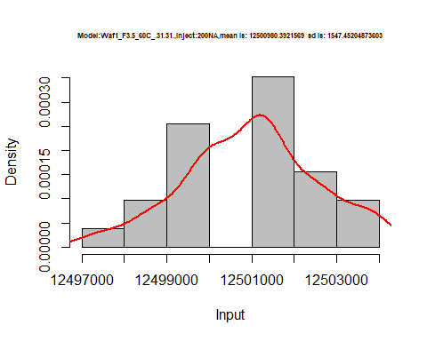

hist(d3_31.31$V3,  
 cex.main=0.5,  
 freq = FALSE,  
 main = paste('Model:Waf1_F3.5_60C_.31.31.,Inject:300NA,mean is:', mean(d3_31.31$V3),' sd is:', sd(d3_31.31$V3)),  
 xlab = "Input",  
 ylab = "Density",  
 col="grey")  
#plot density curve  
lines(density(d3_31.31$V3), # density plot  
 lwd = 2, # thickness of line  
 col = "red")

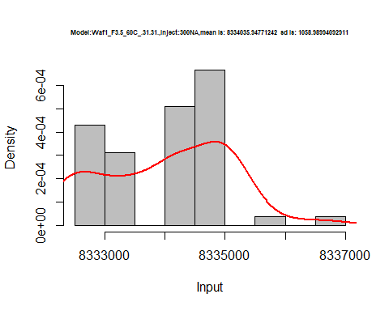

hist(d3_31.31$V4,  
 cex.main=0.5,  
 freq = FALSE,  
 main = paste('Model:Waf1_F3.5_60C_.31.31.,Inject:200NA,mean is:', mean(d3_31.31$V4),' sd is:', sd(d3_31.31$V4)),  
 xlab = "Input",  
 ylab = "Density",  
 col="grey")  
#plot density curve  
lines(density(d3_31.31$V4), # density plot  
 lwd = 2, # thickness of line  
 col = "red")

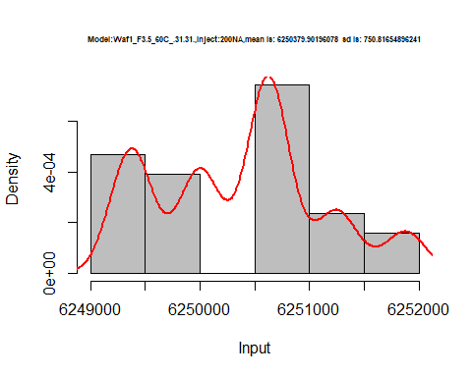

hist(d3_31.31$V5,  
 cex.main=0.5,  
 freq = FALSE,  
 main = paste('Model:Waf1_F3.5_60C_.31.31.,Inject:500NA,mean is:', mean(d3_31.31$V5),' sd is:', sd(d3_31.31$V5)),  
 xlab = "Input",  
 ylab = "Density",  
 col="grey")  
#plot density curve  
lines(density(d3_31.31$V5), # density plot  
 lwd = 2, # thickness of line  
 col = "red")

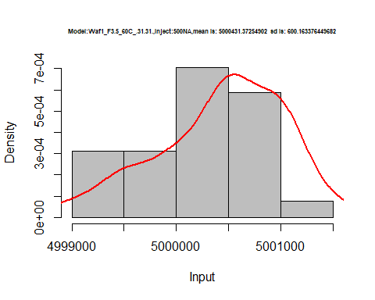

hist(d3_31.31$V6,  
 cex.main=0.5,  
 freq = FALSE,  
 main = paste('Model:Waf1_F3.5_60C_.31.31.,Inject:200NA,mean is:', mean(d3_31.31$V6),' sd is:', sd(d3_31.31$V6)),  
 xlab = "Input",  
 ylab = "Density",  
 col="grey")  
#plot density curve  
lines(density(d3_31.31$V6), # density plot  
 lwd = 2, # thickness of line  
 col = "red")

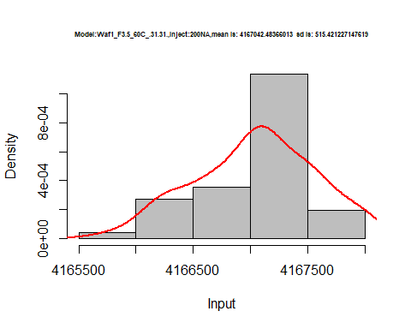

hist(d3_31.31$V7,  
 cex.main=0.5,  
 freq = FALSE,  
 main = paste('Model:Waf1_F3.5_60C_.31.31.,Inject:700NA,mean is:', mean(d3_31.31$V7),' sd is:', sd(d3_31.31$V7)),  
 xlab = "Input",  
 ylab = "Density",  
 col="grey")  
#plot density curve  
lines(density(d3_31.31$V7), # density plot  
 lwd = 2, # thickness of line  
 col = "red")

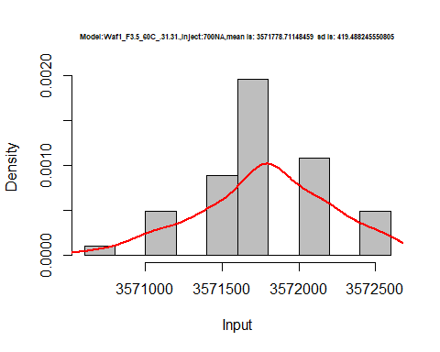

hist(d3_31.31$V8,  
 cex.main=0.5,  
 freq = FALSE,  
 main = paste('Model:Waf1_F3.5_60C_.31.31.,Inject:800NA,mean is:', mean(d3_31.31$V8),' sd is:', sd(d3_31.31$V8)),  
 xlab = "Input",  
 ylab = "Density",  
 col="grey")  
#plot density curve  
lines(density(d3_31.31$V8), # density plot  
 lwd = 2, # thickness of line  
 col = "red")

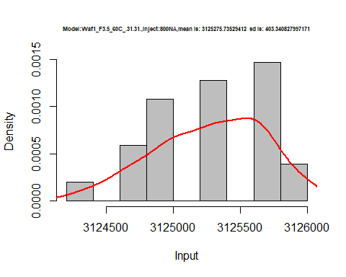

dens <- apply(d3_31.31, 2, density)  
plot('Model:Waf1_F3.5_60C_.31.31', xlim=range(sapply(dens, "[", "x")), ylim=range(sapply(dens, "[", "y")))

## Warning in xy.coords(x, y, xlabel, ylabel, log): NAs introduced by coercion

mapply(lines, dens, col=1:length(dens))

## $V1  
## NULL  
##   
## $V2  
## NULL  
##   
## $V3  
## NULL  
##   
## $V4  
## NULL  
##   
## $V5  
## NULL  
##   
## $V6  
## NULL  
##   
## $V7  
## NULL  
##   
## $V8  
## NULL

legend("topright", legend=names(dens), fill=1:length(dens))

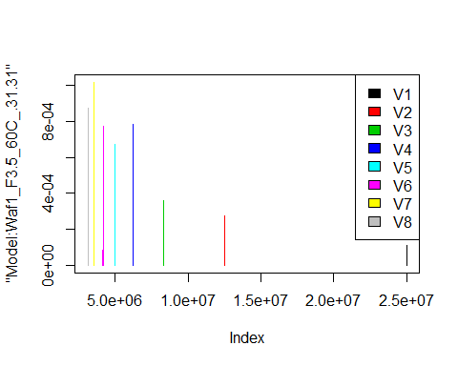

# Select columns whose names contains "32.32"  
d_32.32<-my_data %>% select(contains("32.32"))  
d_32.32 <- head(d_32.32,51)  
colnames(d_32.32) <- c("V1", "V2","V3","V4","V5","V6","V7","V8")  
head(d_32.32)

## V1 V2 V3 V4 V5 V6 V7 V8  
## 1 25002500 12502500 8332500 6250000 5000500 4166667 3571071 3125000  
## 2 25002500 12501250 8332500 6249375 4999500 4167083 3571071 3125000  
## 3 25002500 12501250 8333333 6249375 5000000 4167083 3571071 3125000  
## 4 25005000 12500000 8334167 6249375 4999500 4167083 3571071 3125625  
## 5 25007500 12500000 8334167 6249375 4999500 4167500 3571071 3125312  
## 6 25005000 12498750 8335000 6248750 4999500 4167500 3571071 3125312

hist(d_32.32$V1,  
 cex.main=0.5,  
 freq = FALSE,  
 main = paste('Model:Waf1_F3.3_60C_.32.32.,Inject:100NA,mean is:', mean(d_32.32$V1),' sd is:', sd(d_32.32$V1)),  
 xlab = "Input",  
 ylab = "Density",  
 col="grey")  
#plot density curve  
lines(density(d_32.32$V1), # density plot  
 lwd = 2, # thickness of line  
 col = "red")

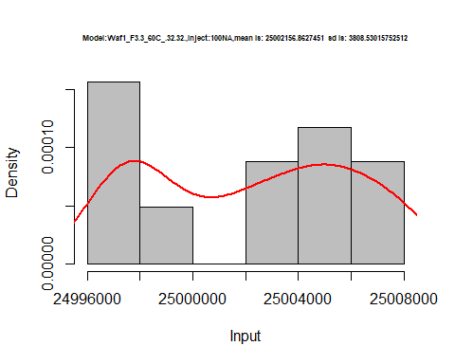

hist(d_32.32$V2,  
 cex.main=0.5,  
 freq = FALSE,  
 main = paste('Model:Waf1_F3.3_60C_.32.32.,Inject:200NA,mean is:', mean(d_32.32$V2),' sd is:', sd(d_32.32$V2)),  
 xlab = "Input",  
 ylab = "Density",  
 col="grey")  
#plot density curve  
lines(density(d_32.32$V2), # density plot  
 lwd = 2, # thickness of line  
 col = "red")

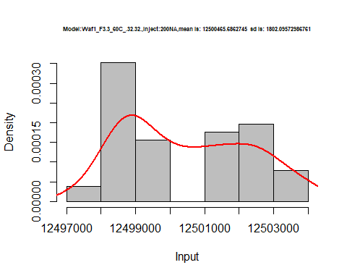

hist(d_32.32$V3,  
 cex.main=0.5,  
 freq = FALSE,  
 main = paste('Model:Waf1_F3.3_60C_.32.32.,Inject:300NA,mean is:', mean(d_32.32$V3),' sd is:', sd(d_32.32$V3)),  
 xlab = "Input",  
 ylab = "Density",  
 col="grey")  
#plot density curve  
lines(density(d_32.32$V3), # density plot  
 lwd = 2, # thickness of line  
 col = "red")

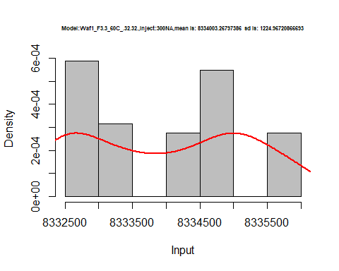

hist(d_32.32$V4,  
 cex.main=0.5,  
 freq = FALSE,  
 main = paste('Model:Waf1_F3.3_60C_.32.32.,Inject:400NA,mean is:', mean(d_32.32$V4),' sd is:', sd(d_32.32$V4)),  
 xlab = "Input",  
 ylab = "Density",  
 col="grey")  
#plot density curve  
lines(density(d_32.32$V4), # density plot  
 lwd = 2, # thickness of line  
 col = "red")

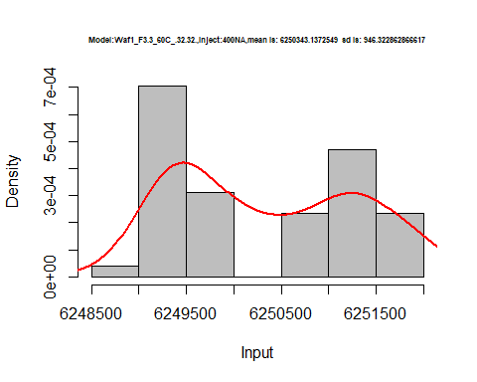

hist(d_32.32$V5,  
 cex.main=0.5,  
 freq = FALSE,  
 main = paste('Model:Waf1_F3.3_60C_.32.32.,Inject:300NA,mean is:', mean(d_32.32$V5),' sd is:', sd(d_32.32$V5)),  
 xlab = "Input",  
 ylab = "Density",  
 col="grey")  
#plot density curve  
lines(density(d_32.32$V5), # density plot  
 lwd = 2, # thickness of line  
 col = "red")

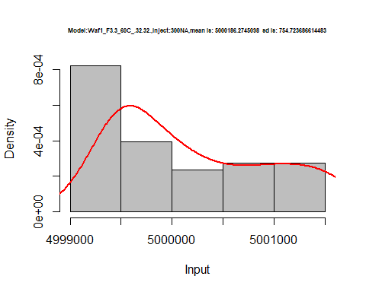

hist(d_32.32$V6,  
 cex.main=0.5,  
 freq = FALSE,  
 main = paste('Model:Waf1_F3.3_60C_.32.32.,Inject:600NA,mean is:', mean(d_32.32$V6),' sd is:', sd(d_32.32$V6)),  
 xlab = "Input",  
 ylab = "Density",  
 col="grey")  
#plot density curve  
lines(density(d_32.32$V6), # density plot  
 lwd = 2, # thickness of line  
 col = "red")

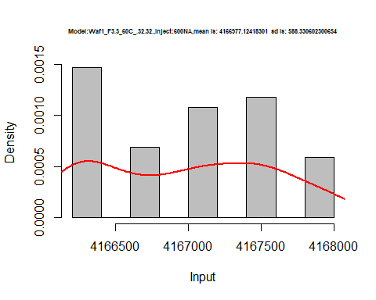

hist(d_32.32$V7,  
 cex.main=0.5,  
 freq = FALSE,  
 main = paste('Model:Waf1_F3.3_60C_.32.32.,Inject:700NA,mean is:', mean(d_32.32$V7),' sd is:', sd(d_32.32$V7)),  
 xlab = "Input",  
 ylab = "Density",  
 col="grey")  
#plot density curve  
lines(density(d_32.32$V7), # density plot  
 lwd = 2, # thickness of line  
 col = "red")

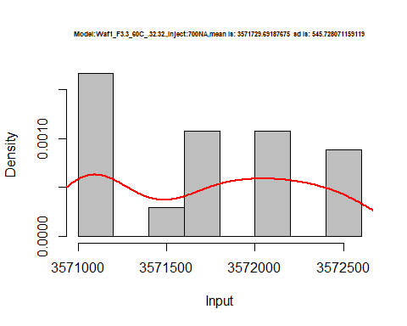

hist(d_32.32$V8,  
 cex.main=0.5,  
 freq = FALSE,  
 main = paste('Model:Waf1_F3.3_60C_.32.32.,Inject:800NA,mean is:', mean(d_32.32$V8),' sd is:', sd(d_32.32$V8)),  
 xlab = "Input",  
 ylab = "Density",  
 col="grey")  
#plot density curve  
lines(density(d_32.32$V8), # density plot  
 lwd = 2, # thickness of line  
 col = "red")

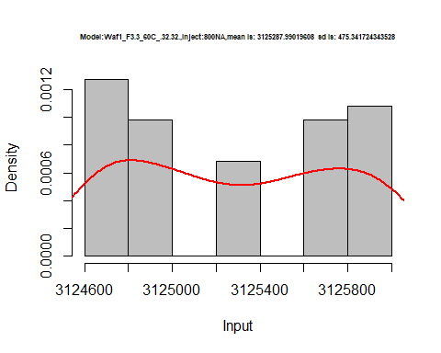

dens <- apply(d_32.32, 2, density)  
plot('Model:Waf1_F3.3_60C_.32.32', xlim=range(sapply(dens, "[", "x")), ylim=range(sapply(dens, "[", "y")))

## Warning in xy.coords(x, y, xlabel, ylabel, log): NAs introduced by coercion

mapply(lines, dens, col=1:length(dens))

## $V1  
## NULL  
##   
## $V2  
## NULL  
##   
## $V3  
## NULL  
##   
## $V4  
## NULL  
##   
## $V5  
## NULL  
##   
## $V6  
## NULL  
##   
## $V7  
## NULL  
##   
## $V8  
## NULL

legend("topright", legend=names(dens), fill=1:length(dens))

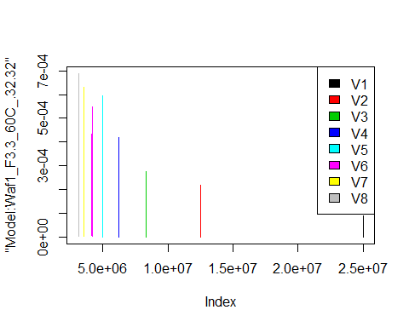

# Select columns whose names contains "34.34"  
#d_36.36<-my_data %>% select(contains("36.36"))  
#d_36.36 <- head(d_36.36,51)  
#colnames(d_33.33) <- c("V1", "V2","V3","V4","V5","V6","V7","V8")  
#head(d_36.36)