ReRAM

Jun Rao

2/19/2020

library(ggplot2)  
library(tidyverse)

## -- Attaching packages --------------------------------------- tidyverse 1.2.1 --

## v tibble 2.1.3 v purrr 0.3.2  
## v tidyr 0.8.3 v dplyr 0.8.3  
## v readr 1.3.1 v stringr 1.4.0  
## v tibble 2.1.3 v forcats 0.4.0

## -- Conflicts ------------------------------------------ tidyverse_conflicts() --  
## x dplyr::filter() masks stats::filter()  
## x dplyr::lag() masks stats::lag()

my_data <- read.csv(file = "Wafer1_23C.csv",header = TRUE)  
#head(my_data)

# Select columns whose names contains "1.1"  
d_1.1<-my_data %>% select(contains("1.1."))  
head(d_1.1)

## Waf1_F2.3_23C_.100nA_.1.1. Waf1_F2.3_23C_.200nA_.1.1.  
## 1 6400000 4005000  
## 2 6417500 4006250  
## 3 6400000 4006250  
## 4 6397500 4011250  
## 5 6375000 4010000  
## 6 6365000 4005000  
## Waf1_F2.3_23C_.300nA_.1.1. Waf1_F2.3_23C_.400nA_.1.1.  
## 1 3066667 2526875  
## 2 3060833 2525000  
## 3 3060833 2525000  
## 4 3063333 2525625  
## 5 3064167 2519375  
## 6 3071667 2524375  
## Waf1_F2.3_23C_.500nA_.1.1. Waf1_F2.3_23C_.600nA_.1.1.  
## 1 2178000 1902083  
## 2 2181500 1902917  
## 3 2183000 1902917  
## 4 2179000 1893750  
## 5 2181500 1895417  
## 6 2182000 1896667  
## Waf1_F2.3_23C_.700nA_.1.1. Waf1_F2.3_23C_.800nA_.1.1.  
## 1 1698571 1547500  
## 2 1701071 1549062  
## 3 1700714 1541562  
## 4 1700000 1541250  
## 5 1701071 1549688  
## 6 1700000 1545625  
## Waf1_F4.6_23C_.100nA_.1.1. Waf1_F4.6_23C_.200nA_.1.1.  
## 1 17060000 10165000  
## 2 17140000 10166250  
## 3 17207500 10167500  
## 4 17235000 10168750  
## 5 17187500 10168750  
## 6 17212500 10162500  
## Waf1_F4.6_23C_.300nA_.1.1. Waf1_F4.6_23C_.400nA_.1.1.  
## 1 7463333 5895000  
## 2 7452500 5890625  
## 3 7442500 5889375  
## 4 7435833 5888750  
## 5 7441667 5888750  
## 6 7456667 5889375  
## Waf1_F4.6_23C_.500nA_.1.1. Waf1_F4.6_23C_.600nA_.1.1.  
## 1 4999000 4166667  
## 2 5000000 4166667  
## 3 4999500 4166667  
## 4 4998500 4166667  
## 5 4997500 4166667  
## 6 4993500 4166667  
## Waf1_F4.6_23C_.700nA_.1.1. Waf1_F4.6_23C_.800nA_.1.1.  
## 1 3572143 3422188  
## 2 3572143 3425000  
## 3 3572143 3421875  
## 4 3571786 3418125  
## 5 3572143 3424375  
## 6 3571786 3428125  
## Waf1_F5.2_23C_.100nA_.1.1. Waf1_F5.2_23C_.200nA_.1.1.  
## 1 6567500 4260000  
## 2 6530000 4312500  
## 3 6512500 4411250  
## 4 6515000 4411250  
## 5 6545000 4392500  
## 6 6565000 4350000  
## Waf1_F5.2_23C_.300nA_.1.1. Waf1_F5.2_23C_.400nA_.1.1.  
## 1 2315833 1963750  
## 2 2298333 1961875  
## 3 2296667 1971250  
## 4 2290000 1959375  
## 5 2305000 1933750  
## 6 2294167 1931250  
## Waf1_F5.2_23C_.500nA_.1.1. Waf1_F5.2_23C_.600nA_.1.1.  
## 1 1806000 1634583  
## 2 1802500 1630000  
## 3 1781500 1612500  
## 4 1793000 1635833  
## 5 1794500 1672083  
## 6 1794500 1667083  
## Waf1_F5.2_23C_.700nA_.1.1. Waf1_F5.2_23C_.800nA_.1.1.  
## 1 1525000 1417500  
## 2 1528929 1414063  
## 3 1531786 1415937  
## 4 1531786 1414063  
## 5 1533214 1408750  
## 6 1533214 1407500

d1_1.1<-d_1.1[,c(1:8)]  
d1_1.1 <- head(d1_1.1,51)  
colnames(d1_1.1) <- c("V1", "V2","V3","V4","V5","V6","V7","V8")  
head(d1_1.1)

## V1 V2 V3 V4 V5 V6 V7 V8  
## 1 6400000 4005000 3066667 2526875 2178000 1902083 1698571 1547500  
## 2 6417500 4006250 3060833 2525000 2181500 1902917 1701071 1549062  
## 3 6400000 4006250 3060833 2525000 2183000 1902917 1700714 1541562  
## 4 6397500 4011250 3063333 2525625 2179000 1893750 1700000 1541250  
## 5 6375000 4010000 3064167 2519375 2181500 1895417 1701071 1549688  
## 6 6365000 4005000 3071667 2524375 2182000 1896667 1700000 1545625

hist(d1_1.1$V1,  
 cex.main=0.5,  
 freq = FALSE,  
 main = paste('Model:Waf1_F2.3_23C_.1.1,Inject:100NA,mean is:', mean(d1_1.1$V1),' sd is:', sd(d1_1.1$V1)),  
 xlab = "Input",  
 ylab = "Density",  
 col="grey")  
#plot density curve  
lines(density(d1_1.1$V1), # density plot  
 lwd = 2, # thickness of line  
 col = "red")

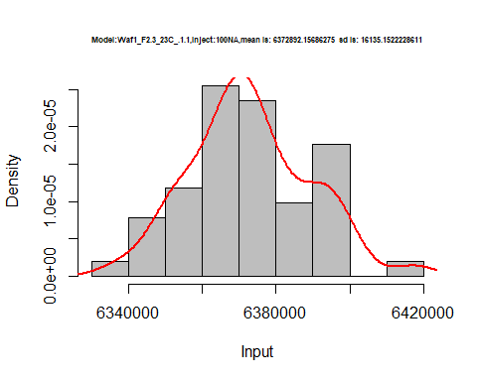

hist(d1_1.1$V2,  
 freq = FALSE,  
 cex.main=0.5,  
 main = paste('Model:Waf1_F2.3_23C_.1.1,Inject:200NA,mean is:', mean(d1_1.1$V2),' sd is:', sd(d1_1.1$V2)),  
 xlab = "Input",  
 ylab = "Density",  
 col="grey")  
#plot density curve  
lines(density(d1_1.1$V2), # density plot  
 lwd = 2, # thickness of line  
 col = "red")

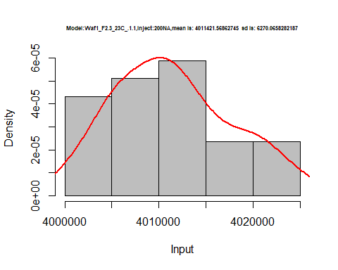

hist(d1_1.1$V3,  
 freq = FALSE,  
 cex.main=0.5,  
 main = paste('Model:Waf1_F2.3_23C_.1.1,Inject:300NA,mean is:', mean(d1_1.1$V3),' sd is:', sd(d1_1.1$V3)),  
 xlab = "Input",  
 ylab = "Density",  
 col="grey")  
  
#plot density curve  
lines(density(d1_1.1$V3), # density plot  
 lwd = 2, # thickness of line  
 col = "red")

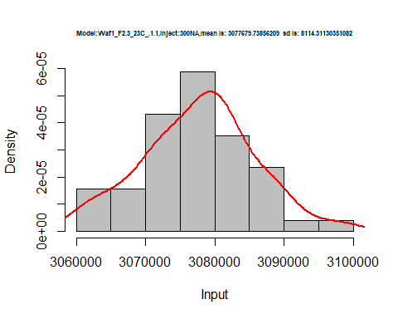

hist(d1_1.1$V4,  
 freq = FALSE,  
 cex.main=0.5,  
 main = paste('Model:Waf1_F2.3_23C_.1.1,Inject:400NA,mean is:', mean(d1_1.1$V4),' sd is:', sd(d1_1.1$V4)),  
 xlab = "Input",  
 ylab = "Density",  
 col="grey")  
#plot density curve  
lines(density(d1_1.1$V4), # density plot  
 lwd = 2, # thickness of line  
 col = "red")

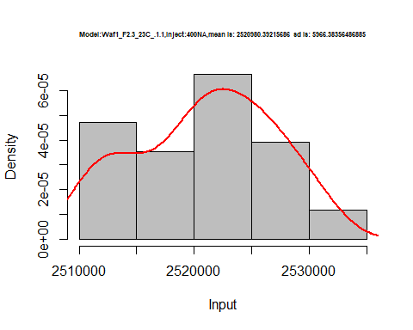

hist(d1_1.1$V5,  
 freq = FALSE,  
 cex.main=0.5,  
 main = paste('Model:Waf1_F2.3_23C_.1.1,Inject:500NA,mean is:', mean(d1_1.1$V5),' sd is:', sd(d1_1.1$V5)),  
 xlab = "Input",  
 ylab = "Density",  
 col="grey")  
#plot density curve  
lines(density(d1_1.1$V5), # density plot  
 lwd = 2, # thickness of line  
 col = "red")

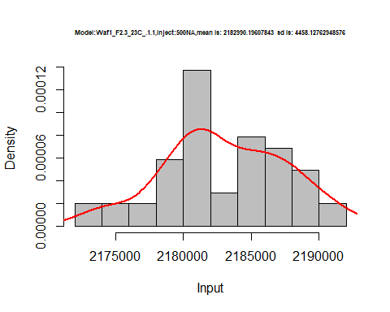

hist(d1_1.1$V6,  
 freq = FALSE,  
 cex.main=0.5,  
 main = paste('Model:Waf1_F2.3_23C_.1.1,Inject:600NA,mean is:', mean(d1_1.1$V6),' sd is:', sd(d1_1.1$V6)),  
 xlab = "Input",  
 ylab = "Density",  
 col="grey")  
#plot density curve  
lines(density(d1_1.1$V6), # density plot  
 lwd = 2, # thickness of line  
 col = "red")

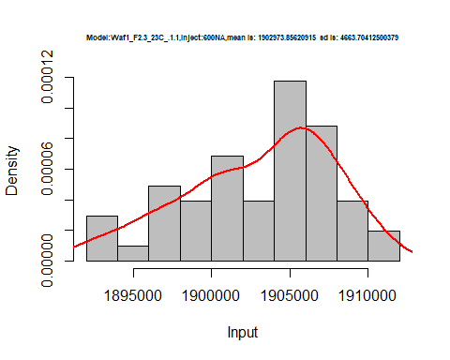

hist(d1_1.1$V7,  
 freq = FALSE,  
 cex.main=0.5,  
 main = paste('Model:Waf1_F2.3_23C_.1.1,Inject:700NA,mean is:', mean(d1_1.1$V7),' sd is:', sd(d1_1.1$V7)),  
 xlab = "Input",  
 ylab = "Density",  
 col="grey")  
#plot density curve  
lines(density(d1_1.1$V7), # density plot  
 lwd = 2, # thickness of line  
 col = "red")

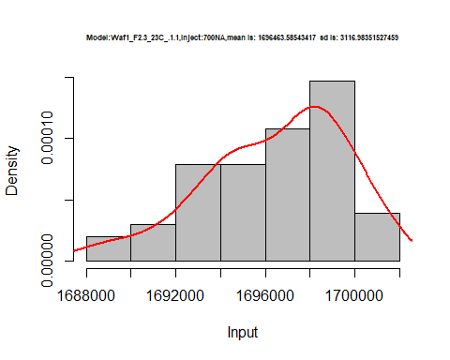

hist(d1_1.1$V8,  
 freq = FALSE,  
 cex.main=0.5,  
 main = paste('Model:Waf1_F2.3_23C_.1.1,Inject:800NA,mean is:', mean(d1_1.1$V8),' sd is:', sd(d1_1.1$V8)),  
 xlab = "Input",  
 ylab = "Density",  
 col="grey")  
#plot density curve  
lines(density(d1_1.1$V8), # density plot  
 lwd = 2, # thickness of line  
 col = "red")

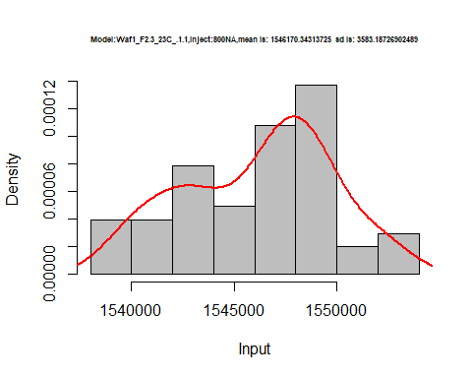

dens <- apply(d1_1.1, 2, density)  
plot(NA, xlim=range(sapply(dens, "[", "x")), ylim=range(sapply(dens, "[", "y")))  
mapply(lines, dens, col=1:length(dens))

## $V1  
## NULL  
##   
## $V2  
## NULL  
##   
## $V3  
## NULL  
##   
## $V4  
## NULL  
##   
## $V5  
## NULL  
##   
## $V6  
## NULL  
##   
## $V7  
## NULL  
##   
## $V8  
## NULL

legend("topright", legend=names(dens), fill=1:length(dens))

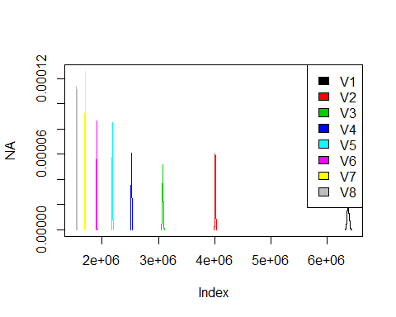

d2_1.1<-d_1.1[,c(9:16)]  
d2_1.1 <- head(d2_1.1,51)  
colnames(d2_1.1) <- c("V1", "V2","V3","V4","V5","V6","V7","V8")  
head(d2_1.1)

## V1 V2 V3 V4 V5 V6 V7 V8  
## 1 17060000 10165000 7463333 5895000 4999000 4166667 3572143 3422188  
## 2 17140000 10166250 7452500 5890625 5000000 4166667 3572143 3425000  
## 3 17207500 10167500 7442500 5889375 4999500 4166667 3572143 3421875  
## 4 17235000 10168750 7435833 5888750 4998500 4166667 3571786 3418125  
## 5 17187500 10168750 7441667 5888750 4997500 4166667 3572143 3424375  
## 6 17212500 10162500 7456667 5889375 4993500 4166667 3571786 3428125

hist(d2_1.1$V1,  
 cex.main=0.5,  
 freq = FALSE,  
 main = paste('Model:Waf1_F4.6_23C_.1.1.,Inject:100NA,mean is:', mean(d2_1.1$V1),' sd is:', sd(d2_1.1$V1)),  
 xlab = "Input",  
 ylab = "Density",  
 col="grey")  
#plot density curve  
lines(density(d2_1.1$V1), # density plot  
 lwd = 2, # thickness of line  
 col = "red")

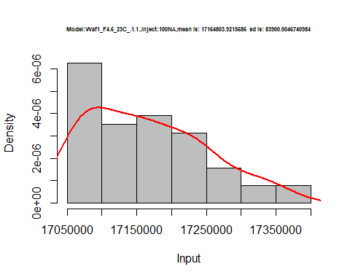

hist(d2_1.1$V2,  
 freq = FALSE,  
 cex.main=0.5,  
 main = paste('Model:Waf1_F4.6_23C_.1.1.,Inject:200NA,mean is:', mean(d2_1.1$V2),' sd is:', sd(d2_1.1$V2)),  
 xlab = "Input",  
 ylab = "Density",  
 col="grey")  
#plot density curve  
lines(density(d2_1.1$V2), # density plot  
 lwd = 2, # thickness of line  
 col = "red")

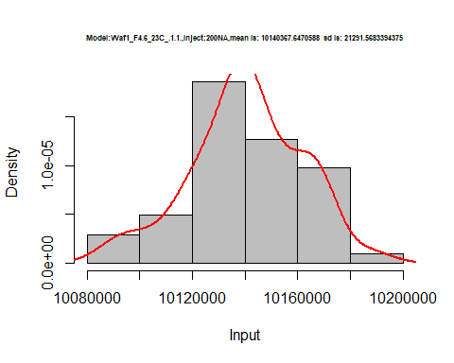

hist(d2_1.1$V3,  
 freq = FALSE,  
 cex.main=0.5,  
 main = paste('Model:Waf1_F4.6_23C_.1.1.,Inject:300NA,mean is:', mean(d2_1.1$V3),' sd is:', sd(d2_1.1$V3)),  
 xlab = "Input",  
 ylab = "Density",  
 col="grey")  
  
#plot density curve  
lines(density(d2_1.1$V3), # density plot  
 lwd = 2, # thickness of line  
 col = "red")

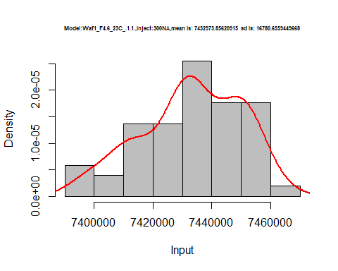

hist(d2_1.1$V4,  
 freq = FALSE,  
 cex.main=0.5,  
 main = paste('Model:Waf1_F4.6_23C_.1.1.,Inject:400NA,mean is:', mean(d2_1.1$V4),' sd is:', sd(d2_1.1$V4)),  
 xlab = "Input",  
 ylab = "Density",  
 col="grey")  
#plot density curve  
lines(density(d2_1.1$V4), # density plot  
 lwd = 2, # thickness of line  
 col = "red")

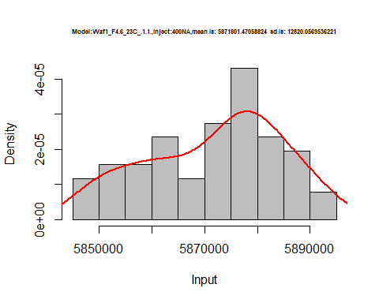

hist(d2_1.1$V5,  
 freq = FALSE,  
 cex.main=0.5,  
 main = paste('Model:Waf1_F4.6_23C_.1.1.,Inject:500NA,mean is:', mean(d2_1.1$V5),' sd is:', sd(d2_1.1$V5)),  
 xlab = "Input",  
 ylab = "Density",  
 col="grey")  
#plot density curve  
lines(density(d2_1.1$V5), # density plot  
 lwd = 2, # thickness of line  
 col = "red")

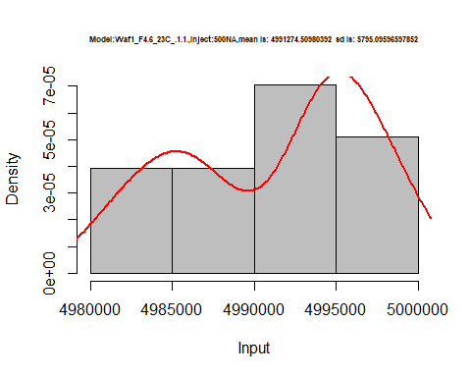

hist(d2_1.1$V6,  
 freq = FALSE,  
 cex.main=0.5,  
 main = paste('Model:Waf1_F4.6_23C_.1.1.,Inject:600NA,mean is:', mean(d2_1.1$V6),' sd is:', sd(d2_1.1$V6)),  
 xlab = "Input",  
 ylab = "Density",  
 col="grey")  
#plot density curve  
lines(density(d2_1.1$V6), # density plot  
 lwd = 2, # thickness of line  
 col = "red")

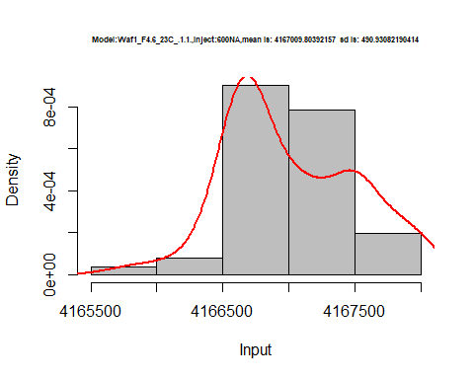

hist(d2_1.1$V7,  
 freq = FALSE,  
 cex.main=0.5,  
 main = paste('Model:Waf1_F4.6_23C_.1.1.,Inject:100NA,mean is:', mean(d2_1.1$V7),' sd is:', sd(d2_1.1$V7)),  
 xlab = "Input",  
 ylab = "Density",  
 col="grey")  
#plot density curve  
lines(density(d2_1.1$V7), # density plot  
 lwd = 2, # thickness of line  
 col = "red")

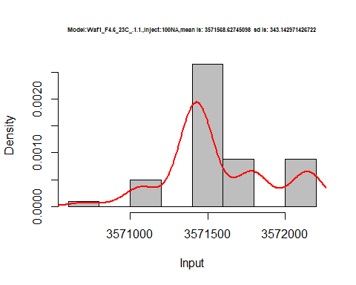

hist(d2_1.1$V8,  
 freq = FALSE,  
 cex.main=0.5,  
 main = paste('Model:Waf1_F4.6_23C_.1.1.,Inject:100NA,mean is:', mean(d2_1.1$V8),' sd is:', sd(d2_1.1$V8)),  
 xlab = "Input",  
 ylab = "Density",  
 col="grey")  
#plot density curve  
lines(density(d2_1.1$V8), # density plot  
 lwd = 2, # thickness of line  
 col = "red")

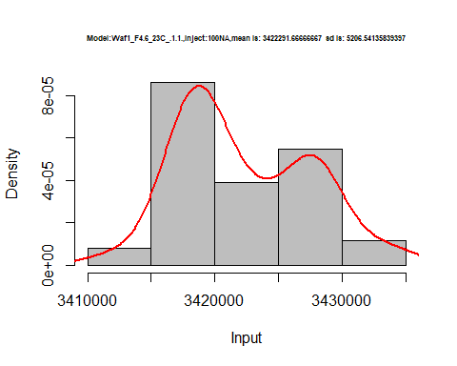

dens <- apply(d2_1.1, 2, density)  
plot('Waf1_F4.6_23C_.1.1.', xlim=range(sapply(dens, "[", "x")), ylim=range(sapply(dens, "[", "y")))

## Warning in xy.coords(x, y, xlabel, ylabel, log): NAs introduced by coercion

mapply(lines, dens, col=1:length(dens))

## $V1  
## NULL  
##   
## $V2  
## NULL  
##   
## $V3  
## NULL  
##   
## $V4  
## NULL  
##   
## $V5  
## NULL  
##   
## $V6  
## NULL  
##   
## $V7  
## NULL  
##   
## $V8  
## NULL

legend("topright", legend=names(dens), fill=1:length(dens))

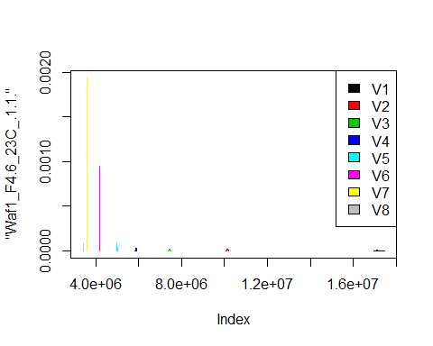

d3_1.1<-d_1.1[,c(17:24)]  
d3_1.1 <- head(d3_1.1,51)  
colnames(d3_1.1) <- c("V1", "V2","V3","V4","V5","V6","V7","V8")  
head(d3_1.1)

## V1 V2 V3 V4 V5 V6 V7 V8  
## 1 6567500 4260000 2315833 1963750 1806000 1634583 1525000 1417500  
## 2 6530000 4312500 2298333 1961875 1802500 1630000 1528929 1414063  
## 3 6512500 4411250 2296667 1971250 1781500 1612500 1531786 1415937  
## 4 6515000 4411250 2290000 1959375 1793000 1635833 1531786 1414063  
## 5 6545000 4392500 2305000 1933750 1794500 1672083 1533214 1408750  
## 6 6565000 4350000 2294167 1931250 1794500 1667083 1533214 1407500

hist(d3_1.1$V1,  
 freq = FALSE,  
 cex.main=0.5,  
 main = paste('Model:Waf1_F5.2_23C_.1.1.,Inject:100NA,mean is:', mean(d3_1.1$V1),' sd is:', sd(d3_1.1$V1)),  
 xlab = "Input",  
 ylab = "Density",  
 col="grey")  
#plot density curve  
lines(density(d3_1.1$V1), # density plot  
 lwd = 2, # thickness of line  
 col = "red")

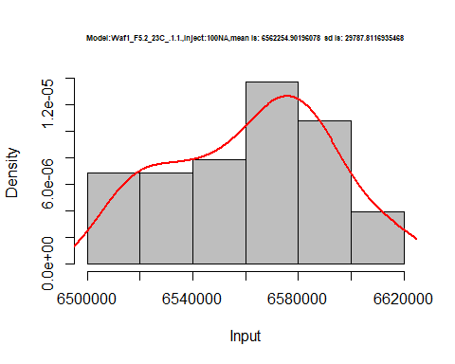

hist(d3_1.1$V2,  
 freq = FALSE,  
 cex.main=0.5,  
 main = paste('Model:Waf1_F5.2_23C_.1.1.,Inject:200NA,mean is:', mean(d3_1.1$V2),' sd is:', sd(d3_1.1$V2)),  
 xlab = "Input",  
 ylab = "Density",  
 col="grey")  
#plot density curve  
lines(density(d3_1.1$V2), # density plot  
 lwd = 2, # thickness of line  
 col = "red")

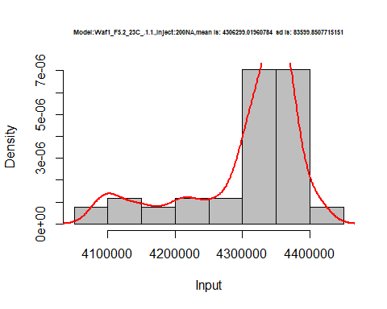

hist(d3_1.1$V3,  
 freq = FALSE,  
 cex.main=0.5,  
 main = paste('Model:Waf1_F5.2_23C_.1.1.,Inject:100NA,mean is:', mean(d3_1.1$V3),' sd is:', sd(d3_1.1$V3)),  
 xlab = "Input",  
 ylab = "Density",  
 col="grey")  
#plot density curve  
lines(density(d3_1.1$V3), # density plot  
 lwd = 2, # thickness of line  
 col = "red")

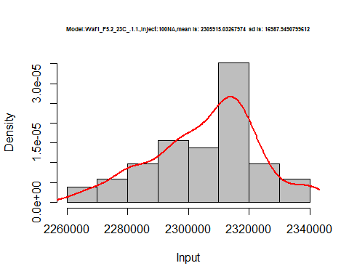

hist(d3_1.1$V4,  
 freq = FALSE,  
 cex.main=0.5,  
 main = paste('Model:Waf1_F5.2_23C_.1.1.,Inject:400NA,mean is:', mean(d3_1.1$V4),' sd is:', sd(d3_1.1$V4)),  
 xlab = "Input",  
 ylab = "Density",  
 col="grey")  
#plot density curve  
lines(density(d3_1.1$V4), # density plot  
 lwd = 2, # thickness of line  
 col = "red")

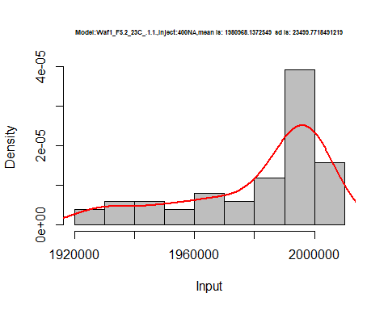

hist(d3_1.1$V5,  
 freq = FALSE,  
 cex.main=0.5,  
 main = paste('Model:Waf1_F5.2_23C_.1.1.,Inject:500NA,mean is:', mean(d3_1.1$V5),' sd is:', sd(d3_1.1$V5)),  
 xlab = "Input",  
 ylab = "Density",  
 col="grey")  
#plot density curve  
lines(density(d3_1.1$V5), # density plot  
 lwd = 2, # thickness of line  
 col = "red")

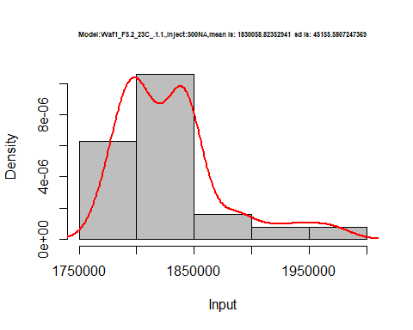

hist(d3_1.1$V6,  
 freq = FALSE,  
 cex.main=0.5,  
 main = paste('Model:Waf1_F5.2_23C_.1.1.,Inject:600NA,mean is:', mean(d3_1.1$V6),' sd is:', sd(d3_1.1$V6)),  
 xlab = "Input",  
 ylab = "Density",  
 col="grey")  
#plot density curve  
lines(density(d3_1.1$V6), # density plot  
 lwd = 2, # thickness of line  
 col = "red")

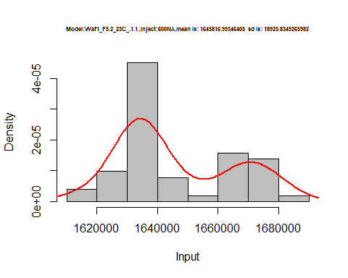

hist(d3_1.1$V7,  
 freq = FALSE,  
 cex.main=0.5,  
 main = paste('Model:Waf1_F5.2_23C_.1.1.,Inject:700NA,mean is:', mean(d3_1.1$V7),' sd is:', sd(d3_1.1$V7)),  
 xlab = "Input",  
 ylab = "Density",  
 col="grey")  
#plot density curve  
lines(density(d3_1.1$V7), # density plot  
 lwd = 2, # thickness of line  
 col = "red")

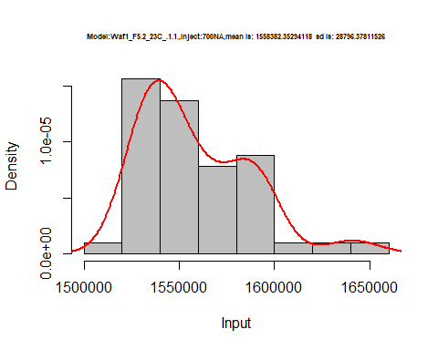

hist(d3_1.1$V8,  
 freq = FALSE,  
 cex.main=0.5,  
 main = paste('Model:Waf1_F5.2_23C_.1.1.,Inject:100NA,mean is:', mean(d3_1.1$V8),' sd is:', sd(d3_1.1$V8)),  
 xlab = "Input",  
 ylab = "Density",  
 col="grey")  
#plot density curve  
lines(density(d3_1.1$V8), # density plot  
 lwd = 2, # thickness of line  
 col = "red")

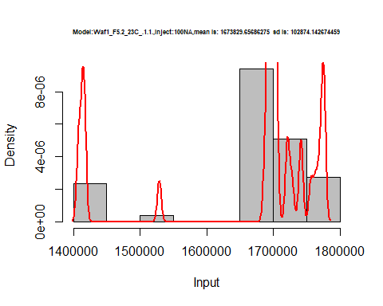

dens <- apply(d3_1.1, 2, density)  
plot('Waf1_F5.2_23C_.1.1.', xlim=range(sapply(dens, "[", "x")), ylim=range(sapply(dens, "[", "y")))

## Warning in xy.coords(x, y, xlabel, ylabel, log): NAs introduced by coercion

mapply(lines, dens, col=1:length(dens))

## $V1  
## NULL  
##   
## $V2  
## NULL  
##   
## $V3  
## NULL  
##   
## $V4  
## NULL  
##   
## $V5  
## NULL  
##   
## $V6  
## NULL  
##   
## $V7  
## NULL  
##   
## $V8  
## NULL

legend("topright", legend=names(dens), fill=1:length(dens))

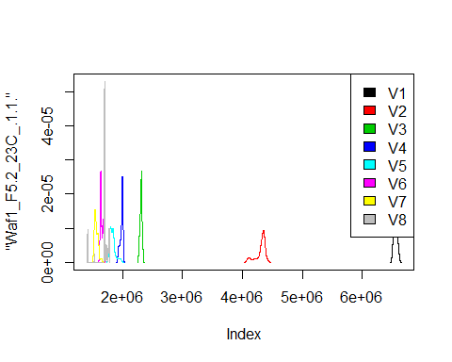

# Select columns whose names contains "2.2"  
d_2.2<-my_data %>% select(contains("2.2."))  
d_2.2 <- head(d_2.2,51)  
colnames(d_2.2) <- c("V1", "V2","V3","V4","V5","V6","V7","V8")  
head(d_2.2)

## V1 V2 V3 V4 V5 V6 V7 V8  
## 1 1197500 1078750 946666.7 863750 816000 763750.0 737142.9 696875.0  
## 2 1192500 1082500 947500.0 863750 816500 762083.3 737142.9 695312.5  
## 3 1197500 1080000 946666.7 863750 817000 761666.7 736785.7 696875.0  
## 4 1202500 1075000 948333.3 866875 814000 760833.3 736071.4 698750.0  
## 5 1197500 1077500 950000.0 865625 814000 765833.3 736071.4 697812.5  
## 6 1200000 1080000 946666.7 865000 814500 762500.0 733928.6 698437.5

hist(d_2.2$V1,  
 freq = FALSE,  
 cex.main=0.5,  
 main = paste('Model:Waf1_F4.3_23C_.2.2.,Inject:100NA,mean is:', mean(d_2.2$V1),' sd is:', sd(d_2.2$V1)),  
 xlab = "Input",  
 ylab = "Density",  
 col="grey")  
#plot density curve  
lines(density(d_2.2$V1), # density plot  
 lwd = 2, # thickness of line  
 col = "red")

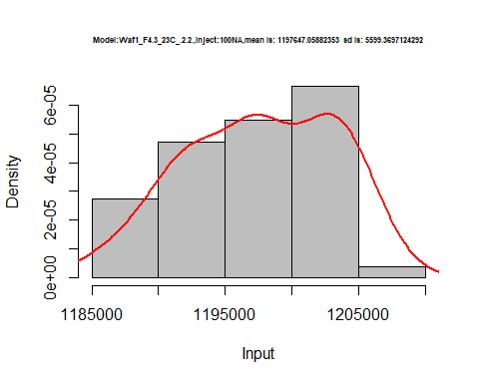

hist(d_2.2$V2,  
 freq = FALSE,  
 cex.main=0.5,  
 main = paste('Model:Waf1_F4.3_23C_.2.2.,Inject:200NA,mean is:', mean(d_2.2$V2),' sd is:', sd(d_2.2$V2)),  
 xlab = "Input",  
 ylab = "Density",  
 col="grey")  
#plot density curve  
lines(density(d_2.2$V2), # density plot  
 lwd = 2, # thickness of line  
 col = "red")

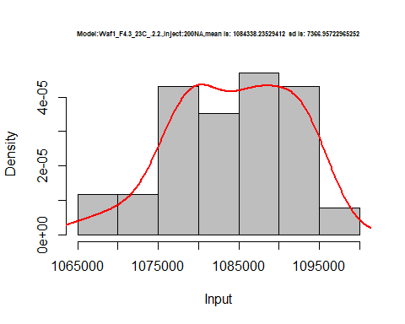

hist(d_2.2$V3,  
 freq = FALSE,  
 cex.main=0.5,  
 main = paste('Model:Waf1_F4.3_23C_.2.2.,Inject:300NA,mean is:', mean(d_2.2$V3),' sd is:', sd(d_2.2$V3)),  
 xlab = "Input",  
 ylab = "Density",  
 col="grey")  
#plot density curve  
lines(density(d_2.2$V3), # density plot  
 lwd = 2, # thickness of line  
 col = "red")

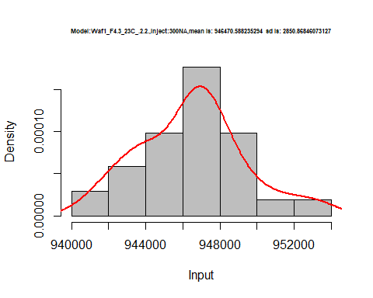

hist(d_2.2$V4,  
 freq = FALSE,  
 cex.main=0.5,  
 main = paste('Model:Waf1_F4.3_23C_.2.2.,Inject:400NA,mean is:', mean(d_2.2$V4),' sd is:', sd(d_2.2$V4)),  
 xlab = "Input",  
 ylab = "Density",  
 col="grey")  
#plot density curve  
lines(density(d_2.2$V4), # density plot  
 lwd = 2, # thickness of line  
 col = "red")

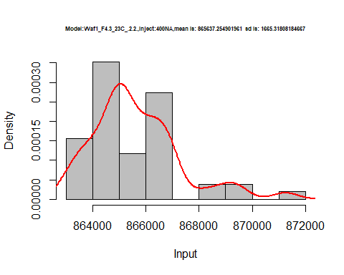

hist(d_2.2$V5,  
 freq = FALSE,  
 cex.main=0.5,  
 main = paste('Model:Waf1_F4.3_23C_.2.2.,Inject:100NA,mean is:', mean(d_2.2$V5),' sd is:', sd(d_2.2$V5)),  
 xlab = "Input",  
 ylab = "Density",  
 col="grey")  
#plot density curve  
lines(density(d_2.2$V5), # density plot  
 lwd = 2, # thickness of line  
 col = "red")

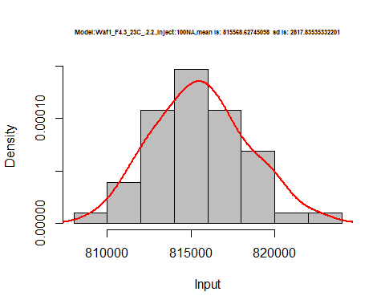

hist(d_2.2$V6,  
 freq = FALSE,  
 cex.main=0.5,  
 main = paste('Model:Waf1_F4.3_23C_.2.2.,Inject:600NA,mean is:', mean(d_2.2$V6),' sd is:', sd(d_2.2$V6)),  
 xlab = "Input",  
 ylab = "Density",  
 col="grey")  
#plot density curve  
lines(density(d_2.2$V6), # density plot  
 lwd = 2, # thickness of line  
 col = "red")

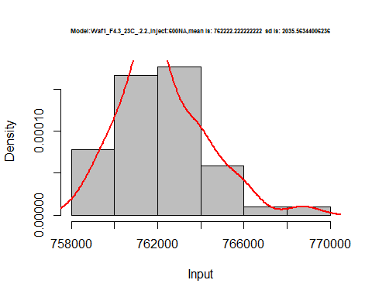

hist(d_2.2$V7,  
 freq = FALSE,  
 cex.main=0.5,  
 main = paste('Model:Waf1_F4.3_23C_.2.2.,Inject:700NA,mean is:', mean(d_2.2$V7),' sd is:', sd(d_2.2$V7)),  
 xlab = "Input",  
 ylab = "Density",  
 col="grey")  
#plot density curve  
lines(density(d_2.2$V7), # density plot  
 lwd = 2, # thickness of line  
 col = "red")

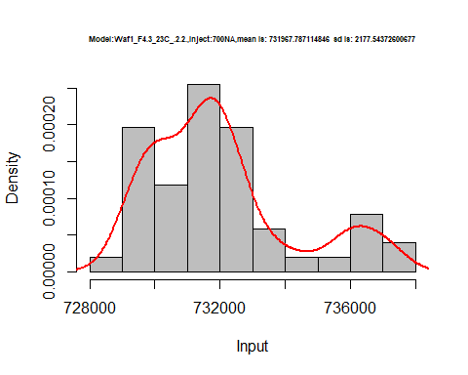

hist(d_2.2$V8,  
 freq = FALSE,  
 cex.main=0.5,  
 main = paste('Model:Waf1_F4.3_23C_.2.2.,Inject:800NA,mean is:', mean(d_2.2$V8),' sd is:', sd(d_2.2$V8)),  
 xlab = "Input",  
 ylab = "Density",  
 col="grey")  
#plot density curve  
lines(density(d_2.2$V8), # density plot  
 lwd = 2, # thickness of line  
 col = "red")

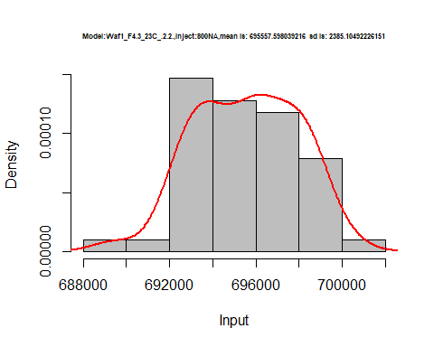

dens <- apply(d_2.2, 2, density)  
plot('Waf1_F4.3_23C_.2.2.', xlim=range(sapply(dens, "[", "x")), ylim=range(sapply(dens, "[", "y")))

## Warning in xy.coords(x, y, xlabel, ylabel, log): NAs introduced by coercion

mapply(lines, dens, col=1:length(dens))

## $V1  
## NULL  
##   
## $V2  
## NULL  
##   
## $V3  
## NULL  
##   
## $V4  
## NULL  
##   
## $V5  
## NULL  
##   
## $V6  
## NULL  
##   
## $V7  
## NULL  
##   
## $V8  
## NULL

legend("topright", legend=names(dens), fill=1:length(dens))

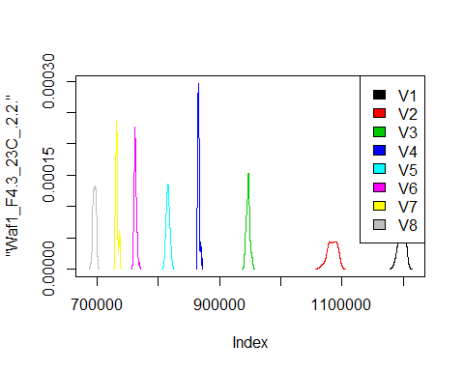

# Select columns whose names contains "3.3"  
d_3.3<-my_data %>% select(contains("3.3."))  
head(d_3.3)

## Waf1_F3.5_23C_.100nA_.3.3. Waf1_F3.5_23C_.200nA_.3.3.  
## 1 3392500 2406250  
## 2 3395000 2406250  
## 3 3392500 2408750  
## 4 3392500 2406250  
## 5 3392500 2403750  
## 6 3397500 2405000  
## Waf1_F3.5_23C_.300nA_.3.3. Waf1_F3.5_23C_.400nA_.3.3.  
## 1 1950000 1675625  
## 2 1949167 1677500  
## 3 1947500 1678125  
## 4 1948333 1674375  
## 5 1947500 1673750  
## 6 1945000 1673750  
## Waf1_F3.5_23C_.500nA_.3.3. Waf1_F3.5_23C_.600nA_.3.3.  
## 1 1474000 1320833  
## 2 1475000 1320833  
## 3 1475500 1319583  
## 4 1476500 1320000  
## 5 1479000 1319583  
## 6 1476500 1319583  
## Waf1_F3.5_23C_.700nA_.3.3. Waf1_F3.5_23C_.800nA_.3.3.  
## 1 1193571 1112500  
## 2 1193929 1111250  
## 3 1190357 1110000  
## 4 1185000 1109688  
## 5 1190000 1110312  
## 6 1191071 1107812  
## Waf1_F4.3_23C_.100nA_.3.3. Waf1_F4.3_23C_.200nA_.3.3.  
## 1 4277500 3043750  
## 2 4277500 3043750  
## 3 4280000 3041250  
## 4 4277500 3042500  
## 5 4285000 3047500  
## 6 4295000 3047500  
## Waf1_F4.3_23C_.300nA_.3.3. Waf1_F4.3_23C_.400nA_.3.3.  
## 1 2485833 2101250  
## 2 2484167 2100625  
## 3 2485833 2097500  
## 4 2485833 2099375  
## 5 2482500 2097500  
## 6 2480000 2096250  
## Waf1_F4.3_23C_.500nA_.3.3. Waf1_F4.3_23C_.600nA_.3.3.  
## 1 1873000 1676667  
## 2 1868000 1671667  
## 3 1868000 1681667  
## 4 1871500 1679167  
## 5 1872500 1676250  
## 6 1876000 1673750  
## Waf1_F4.3_23C_.700nA_.3.3. Waf1_F4.3_23C_.800nA_.3.3.  
## 1 1544286 1422188  
## 2 1544643 1427188  
## 3 1546429 1429063  
## 4 1545357 1421250  
## 5 1544286 1421250  
## 6 1543929 1423437

d1_3.3<-d_3.3[,c(1:8)]  
d1_3.3 <- head(d1_3.3,51)  
colnames(d1_3.3) <- c("V1", "V2","V3","V4","V5","V6","V7","V8")  
head(d1_3.3)

## V1 V2 V3 V4 V5 V6 V7 V8  
## 1 3392500 2406250 1950000 1675625 1474000 1320833 1193571 1112500  
## 2 3395000 2406250 1949167 1677500 1475000 1320833 1193929 1111250  
## 3 3392500 2408750 1947500 1678125 1475500 1319583 1190357 1110000  
## 4 3392500 2406250 1948333 1674375 1476500 1320000 1185000 1109688  
## 5 3392500 2403750 1947500 1673750 1479000 1319583 1190000 1110312  
## 6 3397500 2405000 1945000 1673750 1476500 1319583 1191071 1107812

hist(d1_3.3$V1,  
 freq = FALSE,  
 cex.main=0.5,  
 main = paste('Model:Waf1_F3.5_23C_.3.3.,Inject:100NA,mean is:', mean(d1_3.3$V1),' sd is:', sd(d1_3.3$V1)),  
 xlab = "Input",  
 ylab = "Density",  
 col="grey")  
#plot density curve  
lines(density(d1_3.3$V1), # density plot  
 lwd = 2, # thickness of line  
 col = "red")

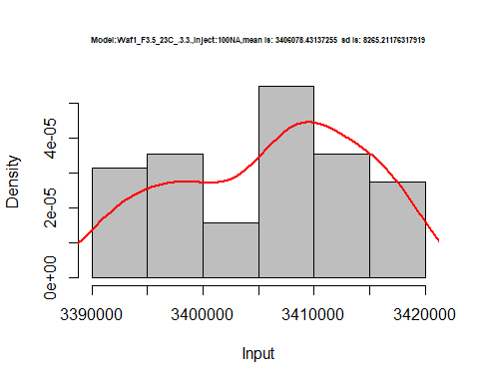

hist(d1_3.3$V2,  
 freq = FALSE,  
 cex.main=0.5,  
 main = paste('Model:Waf1_F3.5_23C_.3.3.,Inject:200NA,mean is:', mean(d1_3.3$V2),' sd is:', sd(d1_3.3$V2)),  
 xlab = "Input",  
 ylab = "Density",  
 col="grey")  
#plot density curve  
lines(density(d1_3.3$V2), # density plot  
 lwd = 2, # thickness of line  
 col = "red")

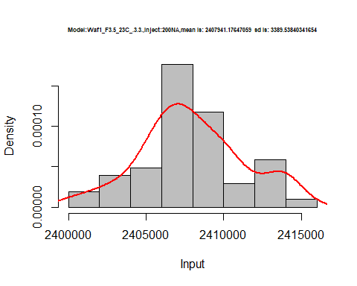

hist(d1_3.3$V3,  
 freq = FALSE,  
 cex.main=0.5,  
 main = paste('Model:Waf1_F3.5_23C_.3.3.,Inject:300NA,mean is:', mean(d1_3.3$V3),' sd is:', sd(d1_3.3$V3)),  
 xlab = "Input",  
 ylab = "Density",  
 col="grey")  
#plot density curve  
lines(density(d1_3.3$V3), # density plot  
 lwd = 2, # thickness of line  
 col = "red")

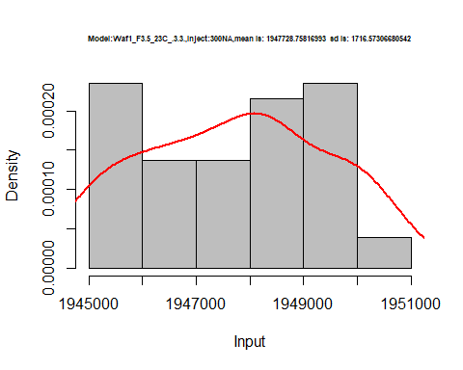

hist(d1_3.3$V4,  
 freq = FALSE,  
 cex.main=0.5,  
 main = paste('Model:Waf1_F3.5_23C_.3.3.,Inject:400NA,mean is:', mean(d1_3.3$V4),' sd is:', sd(d1_3.3$V4)),  
 xlab = "Input",  
 ylab = "Density",  
 col="grey")  
#plot density curve  
lines(density(d1_3.3$V4), # density plot  
 lwd = 2, # thickness of line  
 col = "red")

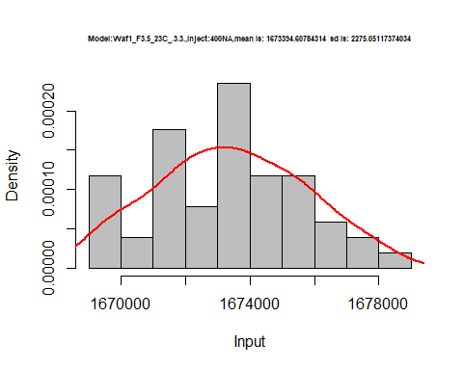

hist(d1_3.3$V5,  
 freq = FALSE,  
 cex.main=0.5,  
 main = paste('Model:Waf1_F3.5_23C_.3.3.,Inject:500NA,mean is:', mean(d1_3.3$V5),' sd is:', sd(d1_3.3$V5)),  
 xlab = "Input",  
 ylab = "Density",  
 col="grey")  
#plot density curve  
lines(density(d1_3.3$V5), # density plot  
 lwd = 2, # thickness of line  
 col = "red")

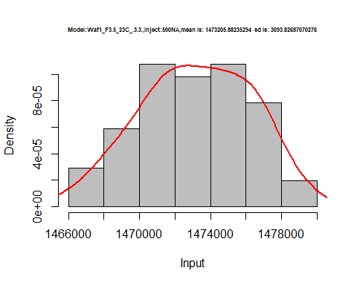

hist(d1_3.3$V6,  
 freq = FALSE,  
 cex.main=0.5,  
 main = paste('Model:Waf1_F3.5_23C_.3.3.,Inject:600NA,mean is:', mean(d1_3.3$V6),' sd is:', sd(d1_3.3$V6)),  
 xlab = "Input",  
 ylab = "Density",  
 col="grey")  
#plot density curve  
lines(density(d1_3.3$V6), # density plot  
 lwd = 2, # thickness of line  
 col = "red")

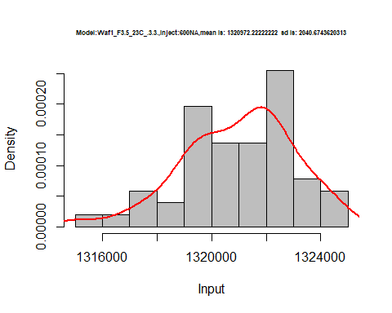

hist(d1_3.3$V7,  
 freq = FALSE,  
 cex.main=0.5,  
 main = paste('Model:Waf1_F3.5_23C_.3.3.,Inject:700NA,mean is:', mean(d1_3.3$V7),' sd is:', sd(d1_3.3$V7)),  
 xlab = "Input",  
 ylab = "Density",  
 col="grey")  
#plot density curve  
lines(density(d1_3.3$V7), # density plot  
 lwd = 2, # thickness of line  
 col = "red")

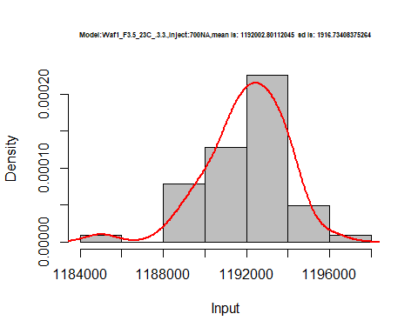

hist(d1_3.3$V8,  
 freq = FALSE,  
 cex.main=0.5,  
 main = paste('Model:Waf1_F3.5_23C_.3.3.,Inject:800NA,mean is:', mean(d1_3.3$V8),' sd is:', sd(d1_3.3$V8)),  
 xlab = "Input",  
 ylab = "Density",  
 col="grey")  
#plot density curve  
lines(density(d1_3.3$V8), # density plot  
 lwd = 2, # thickness of line  
 col = "red")

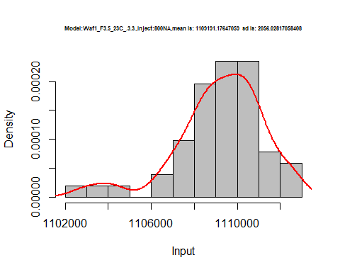

dens <- apply(d1_3.3, 2, density)  
plot('Waf1_F3.5_23C_.3.3.', xlim=range(sapply(dens, "[", "x")), ylim=range(sapply(dens, "[", "y")))

## Warning in xy.coords(x, y, xlabel, ylabel, log): NAs introduced by coercion

mapply(lines, dens, col=1:length(dens))

## $V1  
## NULL  
##   
## $V2  
## NULL  
##   
## $V3  
## NULL  
##   
## $V4  
## NULL  
##   
## $V5  
## NULL  
##   
## $V6  
## NULL  
##   
## $V7  
## NULL  
##   
## $V8  
## NULL

legend("topright", legend=names(dens), fill=1:length(dens))

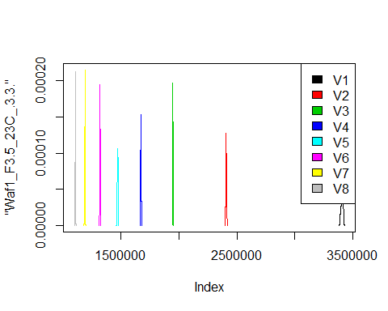

d2_3.3<-d_3.3[,c(9:16)]  
d2_3.3 <- head(d2_3.3,51)  
colnames(d2_3.3) <- c("V1", "V2","V3","V4","V5","V6","V7","V8")  
head(d2_3.3)

## V1 V2 V3 V4 V5 V6 V7 V8  
## 1 4277500 3043750 2485833 2101250 1873000 1676667 1544286 1422188  
## 2 4277500 3043750 2484167 2100625 1868000 1671667 1544643 1427188  
## 3 4280000 3041250 2485833 2097500 1868000 1681667 1546429 1429063  
## 4 4277500 3042500 2485833 2099375 1871500 1679167 1545357 1421250  
## 5 4285000 3047500 2482500 2097500 1872500 1676250 1544286 1421250  
## 6 4295000 3047500 2480000 2096250 1876000 1673750 1543929 1423437

hist(d2_3.3$V1,  
 freq = FALSE,  
 cex.main=0.5,  
 main = paste('Model:Waf1_F4.3_23C_.3.3.,Inject:100NA,mean is:', mean(d2_3.3$V1),' sd is:', sd(d2_3.3$V1)),  
 xlab = "Input",  
 ylab = "Density",  
 col="grey")  
#plot density curve  
lines(density(d2_3.3$V1), # density plot  
 lwd = 2, # thickness of line  
 col = "red")

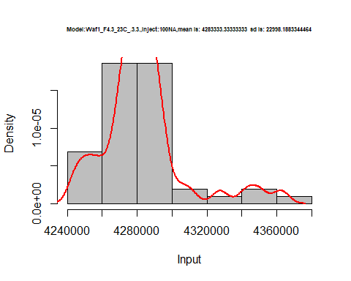

hist(d2_3.3$V2,  
 freq = FALSE,  
 cex.main=0.5,  
 main = paste('Model:Waf1_F4.3_23C_.3.3.,Inject:200NA,mean is:', mean(d2_3.3$V2),' sd is:', sd(d2_3.3$V2)),  
 xlab = "Input",  
 ylab = "Density",  
 col="grey")  
#plot density curve  
lines(density(d2_3.3$V2), # density plot  
 lwd = 2, # thickness of line  
 col = "red")

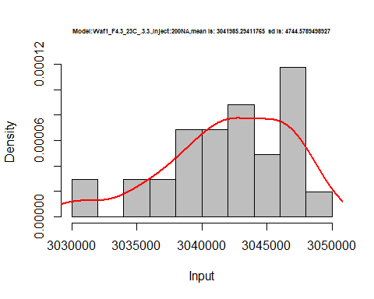

hist(d2_3.3$V3,  
 freq = FALSE,  
 cex.main=0.5,  
 main = paste('Model:Waf1_F4.3_23C_.3.3.,Inject:300NA,mean is:', mean(d2_3.3$V3),' sd is:', sd(d2_3.3$V3)),  
 xlab = "Input",  
 ylab = "Density",  
 col="grey")  
#plot density curve  
lines(density(d2_3.3$V3), # density plot  
 lwd = 2, # thickness of line  
 col = "red")

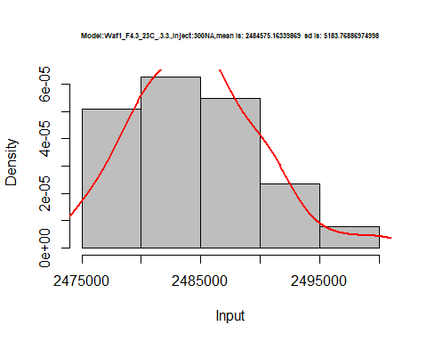

hist(d2_3.3$V4,  
 freq = FALSE,  
 cex.main=0.5,  
 main = paste('Model:Waf1_F4.3_23C_.3.3.,Inject:400NA,mean is:', mean(d2_3.3$V4),' sd is:', sd(d2_3.3$V4)),  
 xlab = "Input",  
 ylab = "Density",  
 col="grey")  
#plot density curve  
lines(density(d2_3.3$V4), # density plot  
 lwd = 2, # thickness of line  
 col = "red")

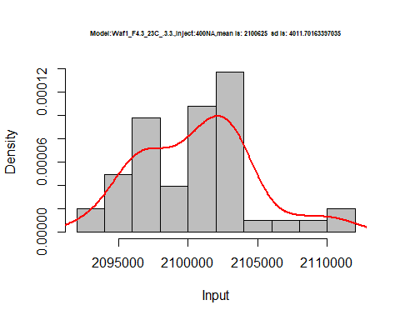

hist(d2_3.3$V5,  
 freq = FALSE,  
 cex.main=0.5,  
 main = paste('Model:Waf1_F4.3_23C_.3.3.,Inject:500NA,mean is:', mean(d2_3.3$V5),' sd is:', sd(d2_3.3$V5)),  
 xlab = "Input",  
 ylab = "Density",  
 col="grey")  
#plot density curve  
lines(density(d2_3.3$V5), # density plot  
 lwd = 2, # thickness of line  
 col = "red")

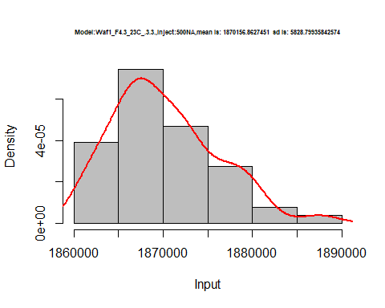

hist(d2_3.3$V6,  
 freq = FALSE,  
 cex.main=0.5,  
 main = paste('Model:Waf1_F4.3_23C_.3.3.,Inject:600NA,mean is:', mean(d2_3.3$V6),' sd is:', sd(d2_3.3$V6)),  
 xlab = "Input",  
 ylab = "Density",  
 col="grey")  
#plot density curve  
lines(density(d2_3.3$V6), # density plot  
 lwd = 2, # thickness of line  
 col = "red")

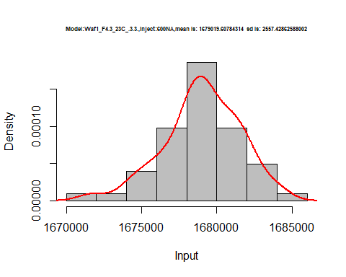

hist(d2_3.3$V7,  
 freq = FALSE,  
 cex.main=0.5,  
 main = paste('Model:Waf1_F4.3_23C_.3.3.,Inject:700NA,mean is:', mean(d2_3.3$V7),' sd is:', sd(d2_3.3$V7)),  
 xlab = "Input",  
 ylab = "Density",  
 col="grey")  
#plot density curve  
lines(density(d2_3.3$V7), # density plot  
 lwd = 2, # thickness of line  
 col = "red")

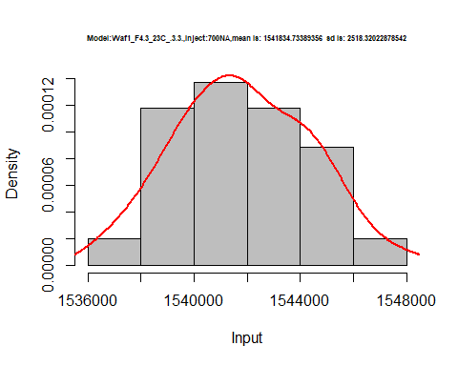

hist(d2_3.3$V8,  
 freq = FALSE,  
 cex.main=0.5,  
 main = paste('Model:Waf1_F4.3_23C_.3.3.,Inject:800NA,mean is:', mean(d2_3.3$V8),' sd is:', sd(d2_3.3$V8)),  
 xlab = "Input",  
 ylab = "Density",  
 col="grey")  
#plot density curve  
lines(density(d2_3.3$V8), # density plot  
 lwd = 2, # thickness of line  
 col = "red")

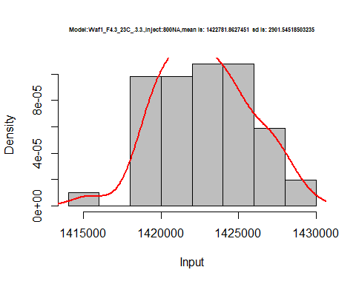

dens <- apply(d2_3.3, 2, density)  
plot('Waf1_F4.3_23C_.3.3.', xlim=range(sapply(dens, "[", "x")), ylim=range(sapply(dens, "[", "y")))

## Warning in xy.coords(x, y, xlabel, ylabel, log): NAs introduced by coercion

mapply(lines, dens, col=1:length(dens))

## $V1  
## NULL  
##   
## $V2  
## NULL  
##   
## $V3  
## NULL  
##   
## $V4  
## NULL  
##   
## $V5  
## NULL  
##   
## $V6  
## NULL  
##   
## $V7  
## NULL  
##   
## $V8  
## NULL

legend("topright", legend=names(dens), fill=1:length(dens))

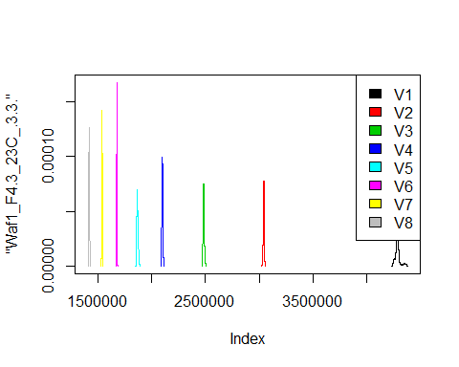

# Select columns whose names contains "4.4"  
d_4.4<-my_data %>% select(contains("4.4."))  
head(d_4.4)

## Waf1_F4.2_23C_.100nA_.4.4. Waf1_F4.2_23C_.200nA_.4.4.  
## 1 1155000 1008750  
## 2 1162500 1007500  
## 3 1165000 1010000  
## 4 1165000 1010000  
## 5 1167500 1020000  
## 6 1165000 1011250  
## Waf1_F4.2_23C_.300nA_.4.4. Waf1_F4.2_23C_.400nA_.4.4.  
## 1 885000.0 805625  
## 2 880833.3 801875  
## 3 875000.0 805000  
## 4 875000.0 803750  
## 5 875000.0 803750  
## 6 874166.7 805000  
## Waf1_F4.2_23C_.500nA_.4.4. Waf1_F4.2_23C_.600nA_.4.4.  
## 1 740000 704583.3  
## 2 737500 705833.3  
## 3 739000 705000.0  
## 4 736500 706250.0  
## 5 739500 706250.0  
## 6 740000 706666.7  
## Waf1_F4.2_23C_.700nA_.4.4. Waf1_F4.2_23C_.800nA_.4.4.  
## 1 654642.9 618437.5  
## 2 656071.4 616562.5  
## 3 654642.9 618125.0  
## 4 655714.3 616562.5  
## 5 653928.6 617187.5  
## 6 655714.3 617812.5  
## Waf1_F4.4_23C_.100nA_.4.4. Waf1_F4.4_23C_.200nA_.4.4.  
## 1 3412500 2346250  
## 2 3415000 2345000  
## 3 3427500 2346250  
## 4 3430000 2346250  
## 5 3417500 2352500  
## 6 3415000 2347500  
## Waf1_F4.4_23C_.300nA_.4.4. Waf1_F4.4_23C_.400nA_.4.4.  
## 1 1783333 1511875  
## 2 1783333 1513125  
## 3 1782500 1508750  
## 4 1781667 1512500  
## 5 1783333 1511250  
## 6 1786667 1512500  
## Waf1_F4.4_23C_.500nA_.4.4. Waf1_F4.4_23C_.600nA_.4.4.  
## 1 1332000 1185833  
## 2 1332000 1180833  
## 3 1333500 1177500  
## 4 1330500 1182917  
## 5 1331500 1179583  
## 6 1331000 1142917  
## Waf1_F4.4_23C_.700nA_.4.4. Waf1_F4.4_23C_.800nA_.4.4.  
## 1 1063571 979687.5  
## 2 1027500 981875.0  
## 3 1057143 978750.0  
## 4 1065357 978437.5  
## 5 1066429 981562.5  
## 6 1065357 982812.5

d1_4.4<-d_4.4[,c(1:8)]  
d1_4.4 <- head(d1_4.4,51)  
colnames(d1_4.4) <- c("V1", "V2","V3","V4","V5","V6","V7","V8")  
head(d1_4.4)

## V1 V2 V3 V4 V5 V6 V7 V8  
## 1 1155000 1008750 885000.0 805625 740000 704583.3 654642.9 618437.5  
## 2 1162500 1007500 880833.3 801875 737500 705833.3 656071.4 616562.5  
## 3 1165000 1010000 875000.0 805000 739000 705000.0 654642.9 618125.0  
## 4 1165000 1010000 875000.0 803750 736500 706250.0 655714.3 616562.5  
## 5 1167500 1020000 875000.0 803750 739500 706250.0 653928.6 617187.5  
## 6 1165000 1011250 874166.7 805000 740000 706666.7 655714.3 617812.5

hist(d1_4.4$V1,  
 freq = FALSE,  
 cex.main=0.5,  
 main = paste('Model:Waf1_F4.2_23C_.4.4..,Inject:100NA,mean is:', mean(d1_4.4$V1),' sd is:', sd(d1_4.4$V1)),  
 xlab = "Input",  
 ylab = "Density",  
 col="grey")  
#plot density curve  
lines(density(d1_4.4$V1), # density plot  
 lwd = 2, # thickness of line  
 col = "red")

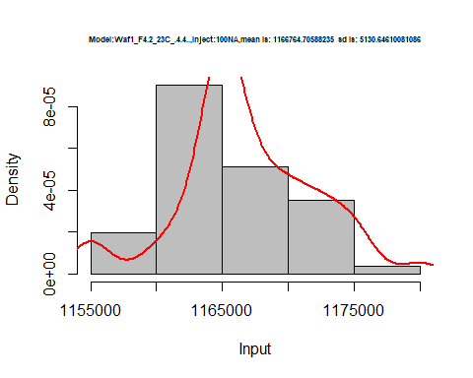

hist(d1_4.4$V2,  
 freq = FALSE,  
 cex.main=0.5,  
 main = paste('Model:Waf1_F4.2_23C_.4.4..,Inject:200NA,mean is:', mean(d1_4.4$V2),' sd is:', sd(d1_4.4$V2)),  
 xlab = "Input",  
 ylab = "Density",  
 col="grey")  
#plot density curve  
lines(density(d1_4.4$V2), # density plot  
 lwd = 2, # thickness of line  
 col = "red")

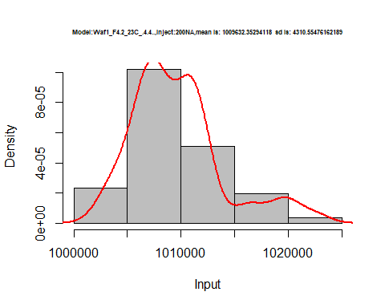

hist(d1_4.4$V3,  
 freq = FALSE,  
 cex.main=0.5,  
 main = paste('Model:Waf1_F4.2_23C_.4.4..,Inject:300NA,mean is:', mean(d1_4.4$V3),' sd is:', sd(d1_4.4$V3)),  
 xlab = "Input",  
 ylab = "Density",  
 col="grey")  
#plot density curve  
lines(density(d1_4.4$V3), # density plot  
 lwd = 2, # thickness of line  
 col = "red")

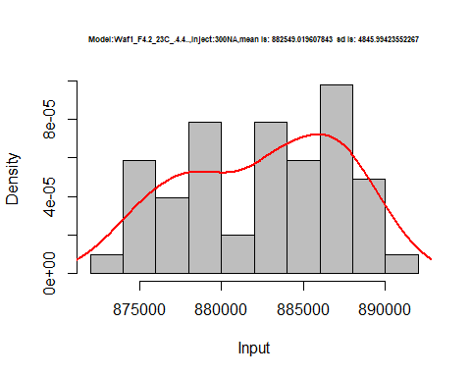

hist(d1_4.4$V4,  
 freq = FALSE,  
 cex.main=0.5,  
 main = paste('Model:Waf1_F4.2_23C_.4.4..,Inject:400NA,mean is:', mean(d1_4.4$V4),' sd is:', sd(d1_4.4$V4)),  
 xlab = "Input",  
 ylab = "Density",  
 col="grey")  
#plot density curve  
lines(density(d1_4.4$V4), # density plot  
 lwd = 2, # thickness of line  
 col = "red")

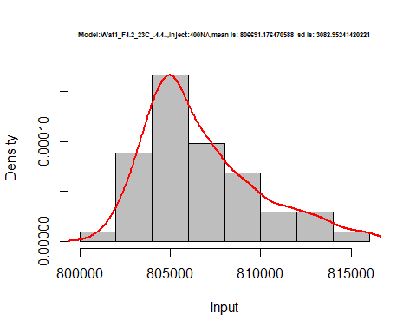

hist(d1_4.4$V5,  
 freq = FALSE,  
 cex.main=0.5,  
 main = paste('Model:Waf1_F4.2_23C_.4.4..,Inject:500NA,mean is:', mean(d1_4.4$V5),' sd is:', sd(d1_4.4$V5)),  
 xlab = "Input",  
 ylab = "Density",  
 col="grey")  
#plot density curve  
lines(density(d1_4.4$V5), # density plot  
 lwd = 2, # thickness of line  
 col = "red")

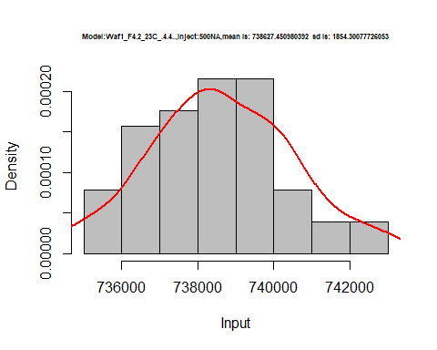

hist(d1_4.4$V6,  
 freq = FALSE,  
 cex.main=0.5,  
 main = paste('Model:Waf1_F4.2_23C_.4.4..,Inject:600NA,mean is:', mean(d1_4.4$V6),' sd is:', sd(d1_4.4$V6)),  
 xlab = "Input",  
 ylab = "Density",  
 col="grey")  
#plot density curve  
lines(density(d1_4.4$V6), # density plot  
 lwd = 2, # thickness of line  
 col = "red")

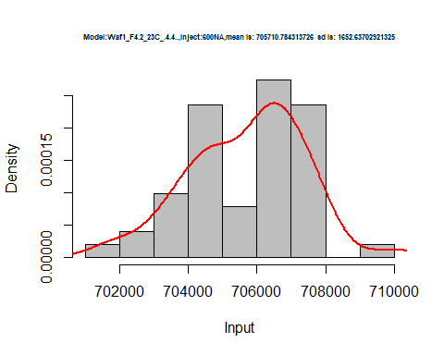

hist(d1_4.4$V7,  
 freq = FALSE,  
 cex.main=0.5,  
 main = paste('Model:Waf1_F4.2_23C_.4.4..,Inject:700NA,mean is:', mean(d1_4.4$V7),' sd is:', sd(d1_4.4$V7)),  
 xlab = "Input",  
 ylab = "Density",  
 col="grey")  
#plot density curve  
lines(density(d1_4.4$V7), # density plot  
 lwd = 2, # thickness of line  
 col = "red")

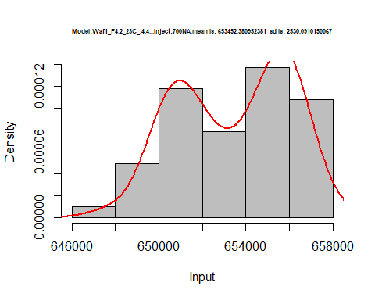

hist(d1_4.4$V8,  
 freq = FALSE,  
 cex.main=0.5,  
 main = paste('Model:Waf1_F4.2_23C_.4.4.,Inject:800NA,mean is:', mean(d1_4.4$V8),' sd is:', sd(d1_4.4$V8)),  
 xlab = "Input",  
 ylab = "Density",  
 col="grey")  
#plot density curve  
lines(density(d1_4.4$V8), # density plot  
 lwd = 2, # thickness of line  
 col = "red")

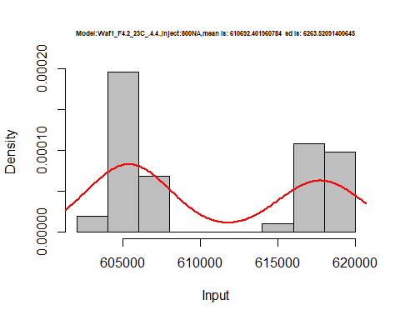

dens <- apply(d1_4.4, 2, density)  
plot('Model:Waf1_F4.2_23C_.4.4.', xlim=range(sapply(dens, "[", "x")), ylim=range(sapply(dens, "[", "y")))

## Warning in xy.coords(x, y, xlabel, ylabel, log): NAs introduced by coercion

mapply(lines, dens, col=1:length(dens))

## $V1  
## NULL  
##   
## $V2  
## NULL  
##   
## $V3  
## NULL  
##   
## $V4  
## NULL  
##   
## $V5  
## NULL  
##   
## $V6  
## NULL  
##   
## $V7  
## NULL  
##   
## $V8  
## NULL

legend("topright", legend=names(dens), fill=1:length(dens))

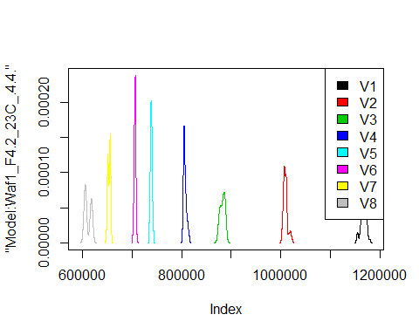

d2_4.4<-d_4.4[,c(9:16)]  
d2_4.4 <- head(d2_4.4,51)  
colnames(d2_4.4) <- c("V1", "V2","V3","V4","V5","V6","V7","V8")  
head(d2_4.4)

## V1 V2 V3 V4 V5 V6 V7 V8  
## 1 3412500 2346250 1783333 1511875 1332000 1185833 1063571 979687.5  
## 2 3415000 2345000 1783333 1513125 1332000 1180833 1027500 981875.0  
## 3 3427500 2346250 1782500 1508750 1333500 1177500 1057143 978750.0  
## 4 3430000 2346250 1781667 1512500 1330500 1182917 1065357 978437.5  
## 5 3417500 2352500 1783333 1511250 1331500 1179583 1066429 981562.5  
## 6 3415000 2347500 1786667 1512500 1331000 1142917 1065357 982812.5

hist(d2_4.4$V1,  
 freq = FALSE,  
 cex.main=0.5,  
 main = paste('Model:Waf1_F4.4_23C_.4.4..,Inject:100NA,mean is:', mean(d2_4.4$V1),' sd is:', sd(d2_4.4$V1)),  
 xlab = "Input",  
 ylab = "Density",  
 col="grey")  
#plot density curve  
lines(density(d2_4.4$V1), # density plot  
 lwd = 2, # thickness of line  
 col = "red")

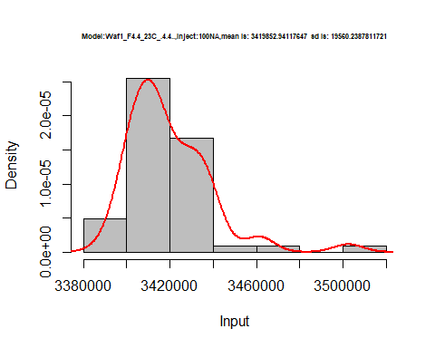

hist(d2_4.4$V2,  
 freq = FALSE,  
 cex.main=0.5,  
 main = paste('Model:Waf1_F4.4_23C_.4.4..,Inject:200NA,mean is:', mean(d2_4.4$V2),' sd is:', sd(d2_4.4$V2)),  
 xlab = "Input",  
 ylab = "Density",  
 col="grey")  
#plot density curve  
lines(density(d2_4.4$V2), # density plot  
 lwd = 2, # thickness of line  
 col = "red")

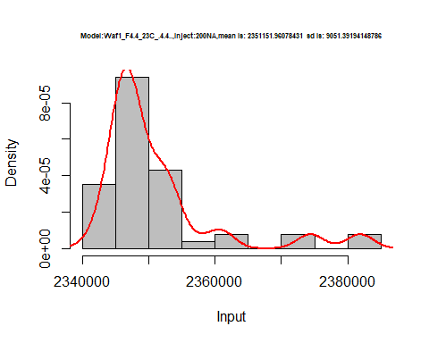

hist(d2_4.4$V3,  
 freq = FALSE,  
 cex.main=0.5,  
 main = paste('Model:Waf1_F4.4_23C_.4.4..,Inject:300NA,mean is:', mean(d2_4.4$V3),' sd is:', sd(d2_4.4$V3)),  
 xlab = "Input",  
 ylab = "Density",  
 col="grey")  
#plot density curve  
lines(density(d2_4.4$V3), # density plot  
 lwd = 2, # thickness of line  
 col = "red")

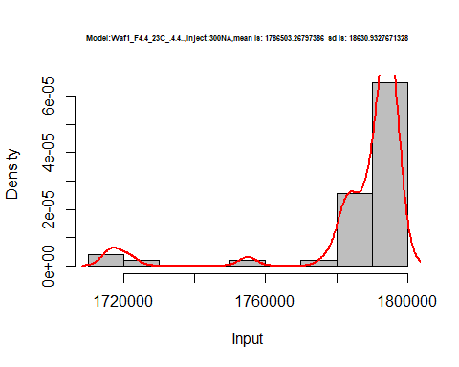

hist(d2_4.4$V4,  
 freq = FALSE,  
 cex.main=0.5,  
 main = paste('Model:Waf1_F4.4_23C_.4.4..,Inject:400NA,mean is:', mean(d2_4.4$V4),' sd is:', sd(d2_4.4$V4)),  
 xlab = "Input",  
 ylab = "Density",  
 col="grey")  
#plot density curve  
lines(density(d2_4.4$V4), # density plot  
 lwd = 2, # thickness of line  
 col = "red")

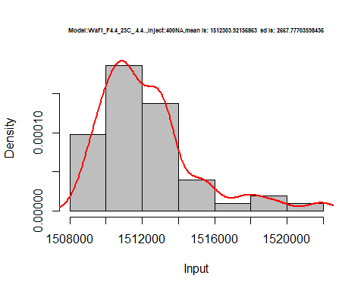

hist(d2_4.4$V5,  
 freq = FALSE,  
 cex.main=0.5,  
 main = paste('Model:Waf1_F4.4_23C_.4.4..,Inject:500NA,mean is:', mean(d2_4.4$V5),' sd is:', sd(d2_4.4$V5)),  
 xlab = "Input",  
 ylab = "Density",  
 col="grey")  
#plot density curve  
lines(density(d2_4.4$V5), # density plot  
 lwd = 2, # thickness of line  
 col = "red")

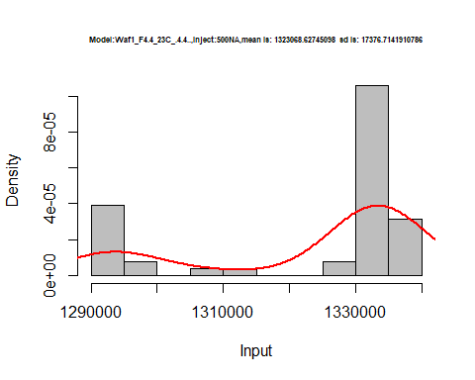

hist(d2_4.4$V6,  
 freq = FALSE,  
 cex.main=0.5,  
 main = paste('Model:Waf1_F4.4_23C_.4.4..,Inject:600NA,mean is:', mean(d2_4.4$V6),' sd is:', sd(d2_4.4$V6)),  
 xlab = "Input",  
 ylab = "Density",  
 col="grey")  
#plot density curve  
lines(density(d2_4.4$V6), # density plot  
 lwd = 2, # thickness of line  
 col = "red")

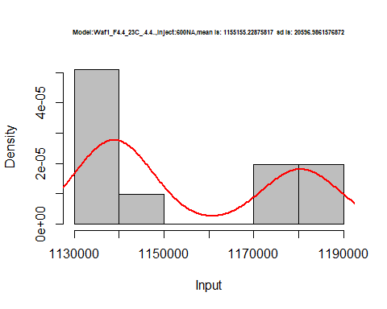

hist(d2_4.4$V7,  
 freq = FALSE,  
 cex.main=0.5,  
 main = paste('Model:Waf1_F4.4_23C_.4.4..,Inject:700NA,mean is:', mean(d2_4.4$V7),' sd is:', sd(d2_4.4$V7)),  
 xlab = "Input",  
 ylab = "Density",  
 col="grey")  
#plot density curve  
lines(density(d2_4.4$V7), # density plot  
 lwd = 2, # thickness of line  
 col = "red")

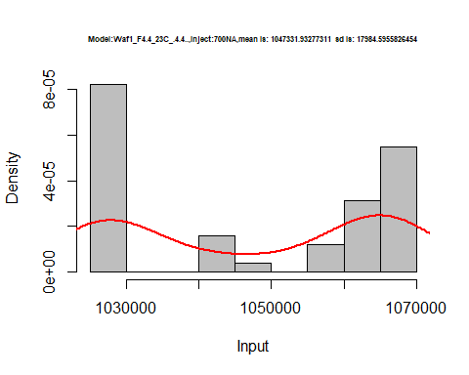

hist(d2_4.4$V8,  
 freq = FALSE,  
 cex.main=0.5,  
 main = paste('Model:Waf1_F4.4_23C_.4.4..,Inject:800NA,mean is:', mean(d2_4.4$V8),' sd is:', sd(d2_4.4$V8)),  
 xlab = "Input",  
 ylab = "Density",  
 col="grey")  
#plot density curve  
lines(density(d2_4.4$V8), # density plot  
 lwd = 2, # thickness of line  
 col = "red")

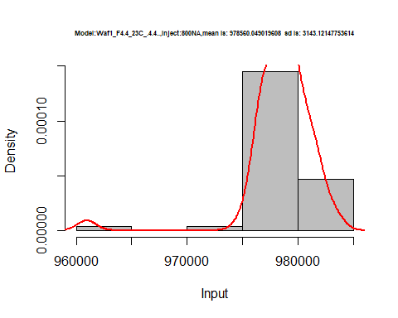

dens <- apply(d2_4.4, 2, density)  
plot('Model:Waf1_F4.4_23C_.4.4.', xlim=range(sapply(dens, "[", "x")), ylim=range(sapply(dens, "[", "y")))

## Warning in xy.coords(x, y, xlabel, ylabel, log): NAs introduced by coercion

mapply(lines, dens, col=1:length(dens))

## $V1  
## NULL  
##   
## $V2  
## NULL  
##   
## $V3  
## NULL  
##   
## $V4  
## NULL  
##   
## $V5  
## NULL  
##   
## $V6  
## NULL  
##   
## $V7  
## NULL  
##   
## $V8  
## NULL

legend("topright", legend=names(dens), fill=1:length(dens))

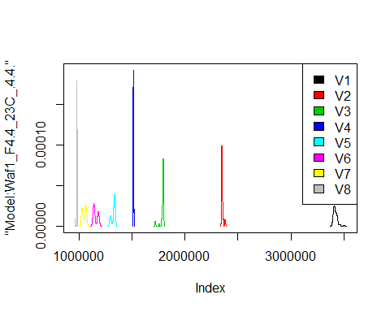

# Select columns whose names contains "5.5"  
d_5.5<-my_data %>% select(contains("5.5."))  
d_5.5 <- head(d_5.5,51)  
colnames(d_5.5) <- c("V1", "V2","V3","V4","V5","V6","V7","V8")  
head(d_5.5)

## V1 V2 V3 V4 V5 V6 V7 V8  
## 1 1580000 1466250 1300833 1186250 1075000 1015000 940000.0 884375.0  
## 2 1577500 1466250 1307500 1186875 1077000 1015833 940000.0 883437.5  
## 3 1577500 1466250 1303333 1186250 1083000 1015000 943928.6 883437.5  
## 4 1570000 1472500 1302500 1186875 1079500 1013333 942500.0 882500.0  
## 5 1575000 1473750 1304167 1190000 1080000 1013750 945714.3 883437.5  
## 6 1575000 1470000 1300000 1184375 1078000 1012917 946785.7 884062.5

hist(d_5.5$V1,  
 freq = FALSE,  
 cex.main=0.5,  
 main = paste('Model:Waf1_F3.4_23C_.5.5.,Inject:800NA,mean is:', mean(d_5.5$V1),' sd is:', sd(d_5.5$V1)),  
 xlab = "Input",  
 ylab = "Density",  
 col="grey")  
#plot density curve  
lines(density(d_5.5$V1), # density plot  
 lwd = 2, # thickness of line  
 col = "red")

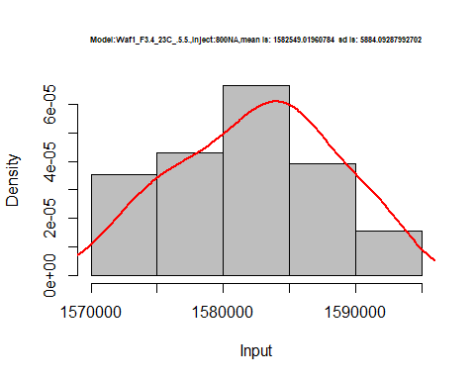

hist(d_5.5$V2,  
 freq = FALSE,  
 cex.main=0.5,  
 main = paste('Model:Waf1_F3.4_23C_.5.5.,Inject:200NA,mean is:', mean(d_5.5$V2),' sd is:', sd(d_5.5$V2)),  
 xlab = "Input",  
 ylab = "Density",  
 col="grey")  
#plot density curve  
lines(density(d_5.5$V2), # density plot  
 lwd = 2, # thickness of line  
 col = "red")

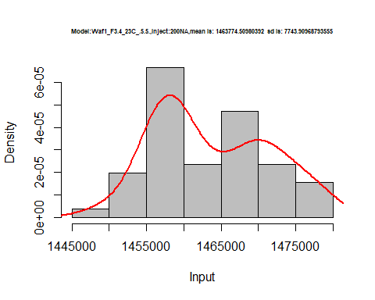

hist(d_5.5$V3,  
 freq = FALSE,  
 cex.main=0.5,  
 main = paste('Model:Waf1_F3.4_23C_.5.5.,Inject:300NA,mean is:', mean(d_5.5$V3),' sd is:', sd(d_5.5$V3)),  
 xlab = "Input",  
 ylab = "Density",  
 col="grey")  
#plot density curve  
lines(density(d_5.5$V3), # density plot  
 lwd = 2, # thickness of line  
 col = "red")

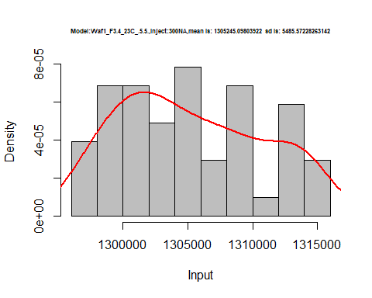

hist(d_5.5$V4,  
 freq = FALSE,  
 cex.main=0.5,  
 main = paste('Model:Waf1_F3.4_23C_.5.5.,Inject:400NA,mean is:', mean(d_5.5$V4),' sd is:', sd(d_5.5$V4)),  
 xlab = "Input",  
 ylab = "Density",  
 col="grey")  
#plot density curve  
lines(density(d_5.5$V4), # density plot  
 lwd = 2, # thickness of line  
 col = "red")

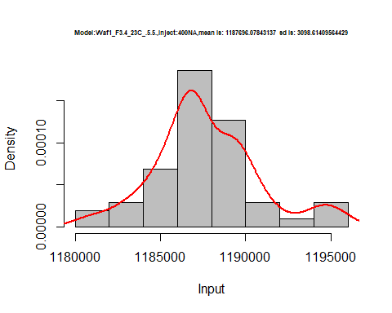

hist(d_5.5$V5,  
 freq = FALSE,  
 cex.main=0.5,  
 main = paste('Model:Waf1_F3.4_23C_.5.5.,Inject500NA,mean is:', mean(d_5.5$V5),' sd is:', sd(d_5.5$V5)),  
 xlab = "Input",  
 ylab = "Density",  
 col="grey")  
#plot density curve  
lines(density(d_5.5$V5), # density plot  
 lwd = 2, # thickness of line  
 col = "red")

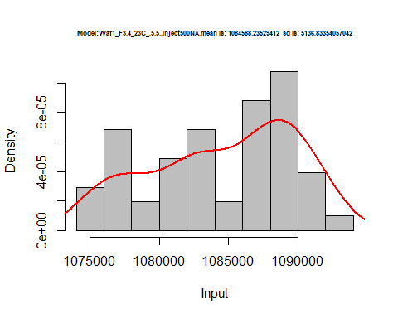

hist(d_5.5$V6,  
 freq = FALSE,  
 cex.main=0.5,  
 main = paste('Model:Waf1_F3.4_23C_.5.5.,Inject:600NA,mean is:', mean(d_5.5$V6),' sd is:', sd(d_5.5$V6)),  
 xlab = "Input",  
 ylab = "Density",  
 col="grey")  
#plot density curve  
lines(density(d_5.5$V6), # density plot  
 lwd = 2, # thickness of line  
 col = "red")

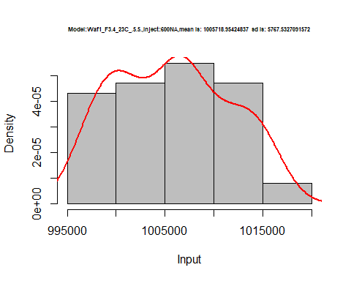

hist(d_5.5$V7,  
 freq = FALSE,  
 cex.main=0.5,  
 main = paste('Model:Waf1_F3.4_23C_.5.5.,Inject:700NA,mean is:', mean(d_5.5$V7),' sd is:', sd(d_5.5$V7)),  
 xlab = "Input",  
 ylab = "Density",  
 col="grey")  
#plot density curve  
lines(density(d_5.5$V7), # density plot  
 lwd = 2, # thickness of line  
 col = "red")

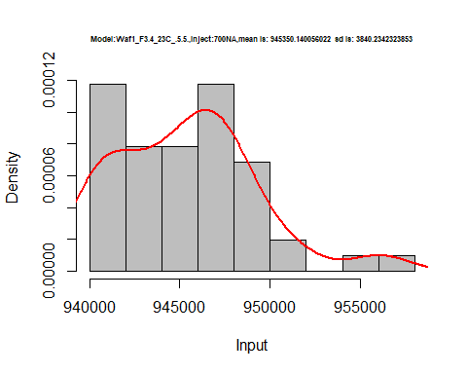

hist(d_5.5$V8,  
 freq = FALSE,  
 cex.main=0.5,  
 main = paste('Model:Waf1_F3.4_23C_.5.5.,Inject:800NA,mean is:', mean(d_5.5$V8),' sd is:', sd(d_5.5$V8)),  
 xlab = "Input",  
 ylab = "Density",  
 col="grey")  
#plot density curve  
lines(density(d_5.5$V8), # density plot  
 lwd = 2, # thickness of line  
 col = "red")

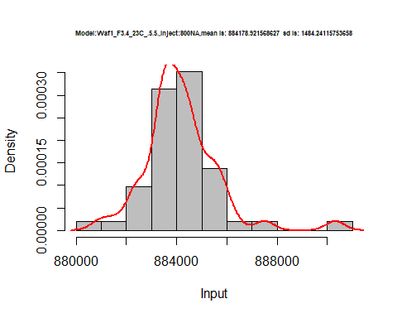

dens <- apply(d_5.5, 2, density)  
plot('Model:Waf1_F4.4_23C_.4.4.', xlim=range(sapply(dens, "[", "x")), ylim=range(sapply(dens, "[", "y")))

## Warning in xy.coords(x, y, xlabel, ylabel, log): NAs introduced by coercion

mapply(lines, dens, col=1:length(dens))

## $V1  
## NULL  
##   
## $V2  
## NULL  
##   
## $V3  
## NULL  
##   
## $V4  
## NULL  
##   
## $V5  
## NULL  
##   
## $V6  
## NULL  
##   
## $V7  
## NULL  
##   
## $V8  
## NULL

legend("topright", legend=names(dens), fill=1:length(dens))

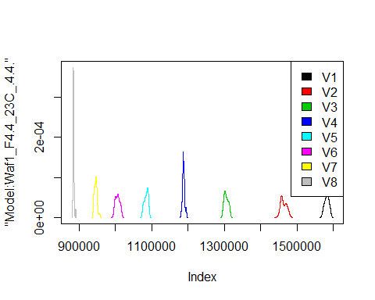

# Select columns whose names contains "6.6"  
d_6.6<-my_data %>% select(contains("6.6."))  
d_6.6 <- head(d_6.6,51)  
colnames(d_6.6) <- c("V1", "V2","V3","V4","V5","V6","V7","V8")  
head(d_6.6)

## V1 V2 V3 V4 V5 V6 V7 V8  
## 1 3232500 2092500 1652500 1413750 1226500 1103333 906785.7 938125  
## 2 3235000 2093750 1650000 1415000 1227500 1102083 903571.4 938125  
## 3 3237500 2105000 1653333 1416250 1227000 1099583 905000.0 938750  
## 4 3222500 2106250 1660000 1413750 1226500 1100833 905000.0 938750  
## 5 3227500 2105000 1678333 1413750 1228500 1101667 905357.1 938125  
## 6 3227500 2100000 1677500 1413750 1227500 1102500 905714.3 937500

hist(d_6.6$V1,  
 freq = FALSE,  
 cex.main=0.5,  
 main = paste('Model:Waf1_F2.6_23C_.6.6.,Inject:100NA,mean is:', mean(d_6.6$V1),' sd is:', sd(d_6.6$V1)),  
 xlab = "Input",  
 ylab = "Density",  
 col="grey")  
#plot density curve  
lines(density(d_6.6$V1), # density plot  
 lwd = 2, # thickness of line  
 col = "red")

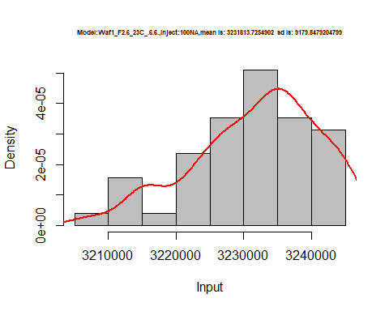

hist(d_6.6$V2,  
 freq = FALSE,  
 cex.main=0.5,  
 main = paste('Model:Waf1_F2.6_23C_.6.6.,Inject:200NA,mean is:', mean(d_6.6$V2),' sd is:', sd(d_6.6$V2)),  
 xlab = "Input",  
 ylab = "Density",  
 col="grey")  
#plot density curve  
lines(density(d_6.6$V2), # density plot  
 lwd = 2, # thickness of line  
 col = "red")

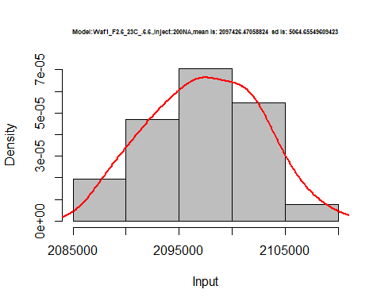

hist(d_6.6$V3,  
 freq = FALSE,  
 cex.main=0.5,  
 main = paste('Model:Waf1_F2.6_23C_.6.6.,Inject:300NA,mean is:', mean(d_6.6$V3),' sd is:', sd(d_6.6$V3)),  
 xlab = "Input",  
 ylab = "Density",  
 col="grey")  
#plot density curve  
lines(density(d_6.6$V3), # density plot  
 lwd = 2, # thickness of line  
 col = "red")

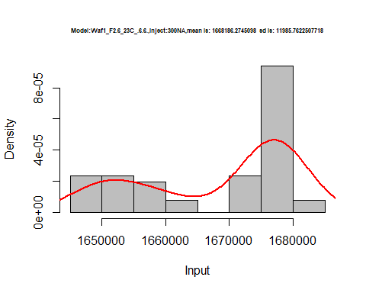

hist(d_6.6$V4,  
 freq = FALSE,  
 cex.main=0.5,  
 main = paste('Model:Waf1_F2.6_23C_.6.6.,Inject:400NA,mean is:', mean(d_6.6$V4),' sd is:', sd(d_6.6$V4)),  
 xlab = "Input",  
 ylab = "Density",  
 col="grey")  
#plot density curve  
lines(density(d_6.6$V4), # density plot  
 lwd = 2, # thickness of line  
 col = "red")

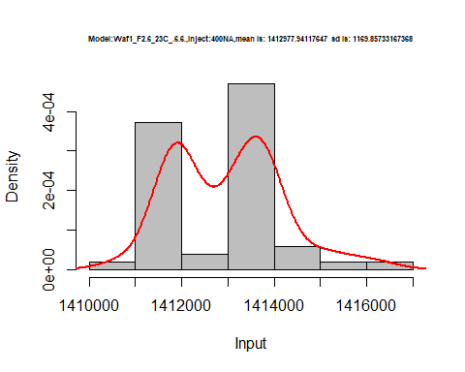

hist(d_6.6$V5,  
 freq = FALSE,  
 cex.main=0.5,  
 main = paste('Model:Waf1_F2.6_23C_.6.6.,Inject:500NA,mean is:', mean(d_6.6$V5),' sd is:', sd(d_6.6$V5)),  
 xlab = "Input",  
 ylab = "Density",  
 col="grey")  
#plot density curve  
lines(density(d_6.6$V5), # density plot  
 lwd = 2, # thickness of line  
 col = "red")

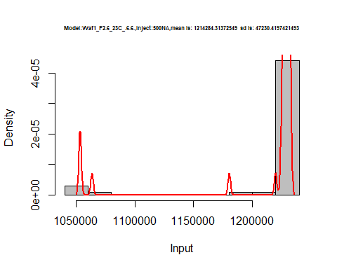

hist(d_6.6$V6,  
 freq = FALSE,  
 cex.main=0.5,  
 main = paste('Model:Waf1_F2.6_23C_.6.6.,Inject:600NA,mean is:', mean(d_6.6$V6),' sd is:', sd(d_6.6$V6)),  
 xlab = "Input",  
 ylab = "Density",  
 col="grey")  
#plot density curve  
lines(density(d_6.6$V6), # density plot  
 lwd = 2, # thickness of line  
 col = "red")

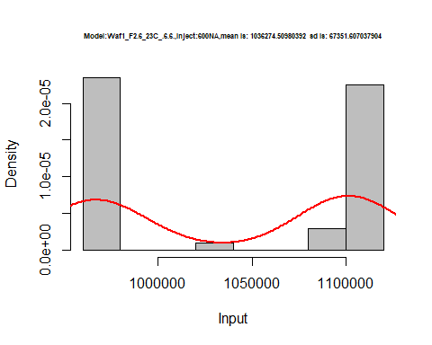

hist(d_6.6$V7,  
 freq = FALSE,  
 cex.main=0.5,  
 main = paste('Model:Waf1_F2.6_23C_.6.6.,Inject:700NA,mean is:', mean(d_6.6$V7),' sd is:', sd(d_6.6$V7)),  
 xlab = "Input",  
 ylab = "Density",  
 col="grey")  
#plot density curve  
lines(density(d_6.6$V7), # density plot  
 lwd = 2, # thickness of line  
 col = "red")

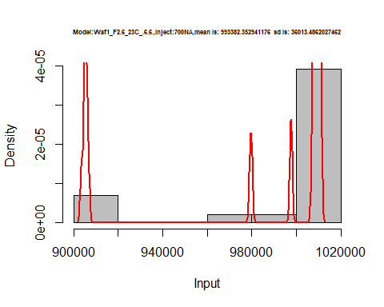

hist(d_6.6$V8,  
 freq = FALSE,  
 cex.main=0.5,  
 main = paste('Model:Waf1_F2.6_23C_.6.6.,Inject:800NA,mean is:', mean(d_6.6$V8),' sd is:', sd(d_6.6$V8)),  
 xlab = "Input",  
 ylab = "Density",  
 col="grey")  
#plot density curve  
lines(density(d_6.6$V8), # density plot  
 lwd = 2, # thickness of line  
 col = "red")

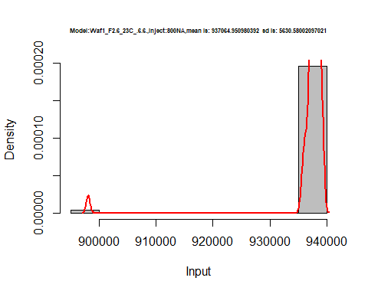

dens <- apply(d_6.6, 2, density)  
plot('Waf1_F2.6_23C_.6.6.', xlim=range(sapply(dens, "[", "x")), ylim=range(sapply(dens, "[", "y")))

## Warning in xy.coords(x, y, xlabel, ylabel, log): NAs introduced by coercion

mapply(lines, dens, col=1:length(dens))

## $V1  
## NULL  
##   
## $V2  
## NULL  
##   
## $V3  
## NULL  
##   
## $V4  
## NULL  
##   
## $V5  
## NULL  
##   
## $V6  
## NULL  
##   
## $V7  
## NULL  
##   
## $V8  
## NULL

legend("topright", legend=names(dens), fill=1:length(dens))

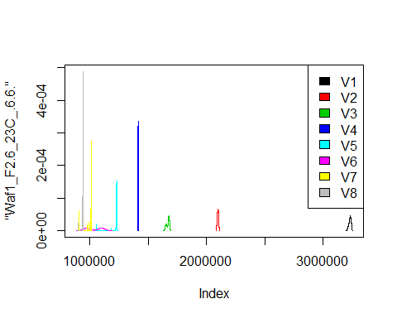

# Select columns whose names contains "7.7"  
d_7.7<-my_data %>% select(contains("7.7."))  
head(d_7.7)

## Waf1_F2.6_23C_.100nA_.7.7. Waf1_F2.6_23C_.200nA_.7.7.  
## 1 5727500 3908750  
## 2 5717500 3938750  
## 3 5722500 3965000  
## 4 5730000 3966250  
## 5 5745000 3945000  
## 6 5735000 3921250  
## Waf1_F2.6_23C_.300nA_.7.7. Waf1_F2.6_23C_.400nA_.7.7.  
## 1 3094167 2675000  
## 2 3096667 2674375  
## 3 3093333 2673750  
## 4 3080000 2676875  
## 5 3071667 2677500  
## 6 3070000 2676875  
## Waf1_F2.6_23C_.500nA_.7.7. Waf1_F2.6_23C_.600nA_.7.7.  
## 1 2297000 2077500  
## 2 2299500 2077500  
## 3 2301500 2078750  
## 4 2301000 2076667  
## 5 2300500 2079167  
## 6 2298500 2079167  
## Waf1_F2.6_23C_.700nA_.7.7. Waf1_F2.6_23C_.800nA_.7.7.  
## 1 1859286 1717188  
## 2 1861071 1716563  
## 3 1860357 1715938  
## 4 1860357 1715312  
## 5 1862143 1712812  
## 6 1861786 1713750  
## Waf1_F5.3_23C_.100nA_.7.7. Waf1_F5.3_23C_.200nA_.7.7.  
## 1 6847500 4507500  
## 2 6852500 4502500  
## 3 6852500 4501250  
## 4 6852500 4500000  
## 5 6852500 4503750  
## 6 6850000 4506250  
## Waf1_F5.3_23C_.300nA_.7.7. Waf1_F5.3_23C_.400nA_.7.7.  
## 1 3525833 2923125  
## 2 3528333 2920625  
## 3 3529167 2918750  
## 4 3525000 2921250  
## 5 3528333 2921250  
## 6 3532500 2922500  
## Waf1_F5.3_23C_.500nA_.7.7. Waf1_F5.3_23C_.600nA_.7.7.  
## 1 2611000 2357083  
## 2 2612500 2348333  
## 3 2614000 2343333  
## 4 2613000 2342083  
## 5 2609500 2342083  
## 6 2611500 2340417  
## Waf1_F5.3_23C_.700nA_.7.7. Waf1_F5.3_23C_.800nA_.7.7.  
## 1 2147500 1975312  
## 2 2143214 1976250  
## 3 2147143 1977500  
## 4 2148214 1979375  
## 5 2152500 1976562  
## 6 2152500 1977500  
## Waf1_F6.2_23C_.100nA_.7.7. Waf1_F6.2_23C_.200nA_.7.7.  
## 1 4370000 3482500  
## 2 4372500 3482500  
## 3 4372500 3481250  
## 4 4367500 3472500  
## 5 4367500 3476250  
## 6 4360000 3483750  
## Waf1_F6.2_23C_.300nA_.7.7. Waf1_F6.2_23C_.400nA_.7.7.  
## 1 2990000 2630000  
## 2 2981667 2628125  
## 3 2985833 2628750  
## 4 2986667 2625000  
## 5 2995000 2628125  
## 6 2995000 2626875  
## Waf1_F6.2_23C_.500nA_.7.7. Waf1_F6.2_23C_.600nA_.7.7.  
## 1 2345500 2158333  
## 2 2346500 2163333  
## 3 2343500 2160000  
## 4 2338500 2159167  
## 5 2344000 2161250  
## 6 2348500 2166250  
## Waf1_F6.2_23C_.700nA_.7.7. Waf1_F6.2_23C_.800nA_.7.7.  
## 1 1988571 1851875  
## 2 1987857 1854062  
## 3 1987500 1857813  
## 4 1984643 1854062  
## 5 1995000 1855937  
## 6 1996786 1858750  
## Waf1_F6.3_23C_.100nA_.7.7. Waf1_F6.3_23C_.200nA_.7.7.  
## 1 1077500 910000  
## 2 1077500 912500  
## 3 1082500 910000  
## 4 1082500 906250  
## 5 1080000 912500  
## 6 1080000 908750  
## Waf1_F6.3_23C_.300nA_.7.7. Waf1_F6.3_23C_.400nA_.7.7.  
## 1 835833.3 760625  
## 2 836666.7 763750  
## 3 825833.3 757500  
## 4 837500.0 760625  
## 5 840000.0 768125  
## 6 841666.7 768125  
## Waf1_F6.3_23C_.500nA_.7.7. Waf1_F6.3_23C_.600nA_.7.7.  
## 1 658000 615416.7  
## 2 656000 614583.3  
## 3 658500 616250.0  
## 4 652500 615000.0  
## 5 655500 617916.7  
## 6 657000 615833.3  
## Waf1_F6.3_23C_.700nA_.7.7. Waf1_F6.3_23C_.800nA_.7.7.  
## 1 589285.7 555625.0  
## 2 586428.6 556562.5  
## 3 585357.1 555625.0  
## 4 586071.4 555312.5  
## 5 584285.7 557187.5  
## 6 585000.0 558750.0  
## Waf1_F6.4_23C_.100nA_.7.7. Waf1_F6.4_23C_.200nA_.7.7.  
## 1 1262500 897500  
## 2 1270000 896250  
## 3 1267500 901250  
## 4 1265000 900000  
## 5 1267500 891250  
## 6 1265000 907500  
## Waf1_F6.4_23C_.300nA_.7.7. Waf1_F6.4_23C_.400nA_.7.7.  
## 1 718333.3 613750  
## 2 712500.0 614375  
## 3 724166.7 616250  
## 4 718333.3 616250  
## 5 720000.0 621250  
## 6 712500.0 619375  
## Waf1_F6.4_23C_.500nA_.7.7. Waf1_F6.4_23C_.600nA_.7.7.  
## 1 558500 492500.0  
## 2 585000 498750.0  
## 3 579000 498750.0  
## 4 555500 490416.7  
## 5 555500 487916.7  
## 6 554500 487500.0  
## Waf1_F6.4_23C_.700nA_.7.7. Waf1_F6.4_23C_.800nA_.7.7.  
## 1 459642.9 615625.0  
## 2 458214.3 461562.5  
## 3 448571.4 456250.0  
## 4 450000.0 461875.0  
## 5 460357.1 458125.0  
## 6 461071.4 461250.0

d1_7.7<-d_7.7[,c(1:8)]  
d1_7.7 <- head(d1_7.7,51)  
colnames(d1_7.7) <- c("V1", "V2","V3","V4","V5","V6","V7","V8")  
head(d1_7.7)

## V1 V2 V3 V4 V5 V6 V7 V8  
## 1 5727500 3908750 3094167 2675000 2297000 2077500 1859286 1717188  
## 2 5717500 3938750 3096667 2674375 2299500 2077500 1861071 1716563  
## 3 5722500 3965000 3093333 2673750 2301500 2078750 1860357 1715938  
## 4 5730000 3966250 3080000 2676875 2301000 2076667 1860357 1715312  
## 5 5745000 3945000 3071667 2677500 2300500 2079167 1862143 1712812  
## 6 5735000 3921250 3070000 2676875 2298500 2079167 1861786 1713750

hist(d1_7.7$V1,  
 cex.main=0.5,  
 freq = FALSE,  
 main = paste('Model:Waf1_F2.6_23C_.7.7.,Inject:100NA,mean is:', mean(d1_7.7$V1),' sd is:', sd(d1_7.7$V1)),  
 xlab = "Input",  
 ylab = "Density",  
 col="grey")  
#plot density curve  
lines(density(d1_7.7$V1), # density plot  
 lwd = 2, # thickness of line  
 col = "red")

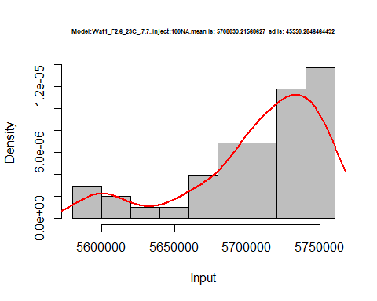

hist(d1_7.7$V2,  
 cex.main=0.5,  
 freq = FALSE,  
 main = paste('Model:Waf1_F2.6_23C_.7.7.,Inject:200NA,mean is:', mean(d1_7.7$V2),' sd is:', sd(d1_7.7$V2)),  
 xlab = "Input",  
 ylab = "Density",  
 col="grey")  
#plot density curve  
lines(density(d1_7.7$V2), # density plot  
 lwd = 2, # thickness of line  
 col = "red")

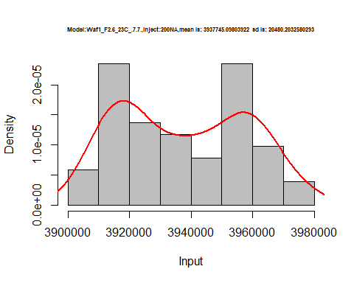

hist(d1_7.7$V3,  
 cex.main=0.5,  
 freq = FALSE,  
 main = paste('Model:Waf1_F2.6_23C_.7.7.,Inject:300NA,mean is:', mean(d1_7.7$V3),' sd is:', sd(d1_7.7$V3)),  
 xlab = "Input",  
 ylab = "Density",  
 col="grey")  
#plot density curve  
lines(density(d1_7.7$V3), # density plot  
 lwd = 2, # thickness of line  
 col = "red")

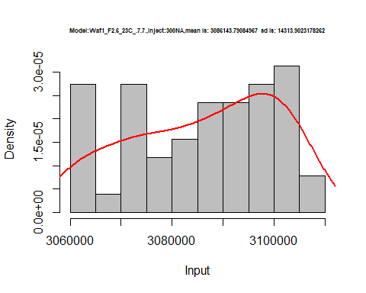

hist(d1_7.7$V4,  
 cex.main=0.5,  
 freq = FALSE,  
 main = paste('Model:Waf1_F2.6_23C_.7.7.,Inject:400NA,mean is:', mean(d1_7.7$V4),' sd is:', sd(d1_7.7$V4)),  
 xlab = "Input",  
 ylab = "Density",  
 col="grey")  
#plot density curve  
lines(density(d1_7.7$V4), # density plot  
 lwd = 2, # thickness of line  
 col = "red")

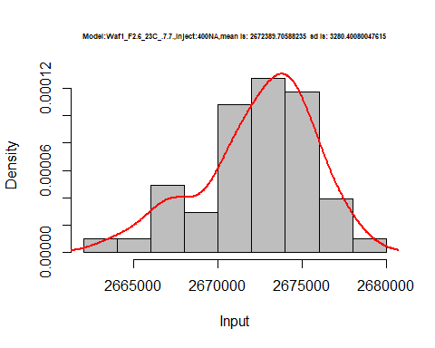

hist(d1_7.7$V5,  
 cex.main=0.5,  
 freq = FALSE,  
 main = paste('Model:Waf1_F2.6_23C_.7.7.,Inject:500NA,mean is:', mean(d1_7.7$V5),' sd is:', sd(d1_7.7$V5)),  
 xlab = "Input",  
 ylab = "Density",  
 col="grey")  
#plot density curve  
lines(density(d1_7.7$V5), # density plot  
 lwd = 2, # thickness of line  
 col = "red")

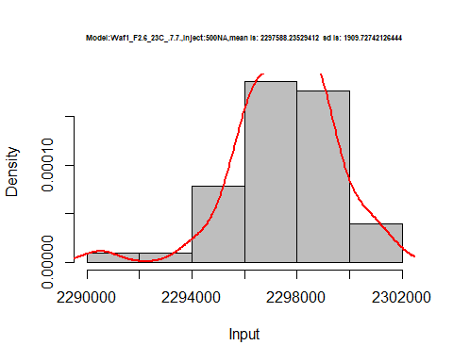

hist(d1_7.7$V6,  
 cex.main=0.5,  
 freq = FALSE,  
 main = paste('Model:Waf1_F2.6_23C_.7.7.,Inject:100NA,mean is:', mean(d1_7.7$V6),' sd is:', sd(d1_7.7$V6)),  
 xlab = "Input",  
 ylab = "Density",  
 col="grey")  
#plot density curve  
lines(density(d1_7.7$V6), # density plot  
 lwd = 2, # thickness of line  
 col = "red")

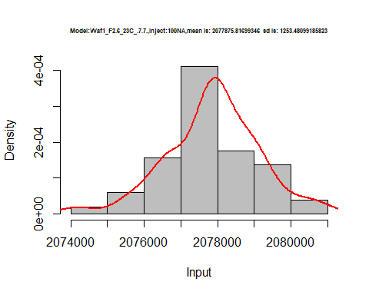

hist(d1_7.7$V7,  
 cex.main=0.5,  
 freq = FALSE,  
 main = paste('Model:Waf1_F2.6_23C_.7.7.,Inject:700NA,mean is:', mean(d1_7.7$V7),' sd is:', sd(d1_7.7$V7)),  
 xlab = "Input",  
 ylab = "Density",  
 col="grey")  
#plot density curve  
lines(density(d1_7.7$V7), # density plot  
 lwd = 2, # thickness of line  
 col = "red")

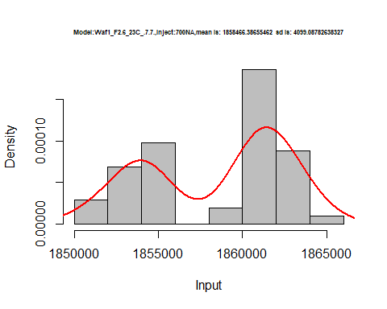

hist(d1_7.7$V8,  
 cex.main=0.5,  
 freq = FALSE,  
 main = paste('Model:Waf1_F2.6_23C_.7.7.,Inject:800NA,mean is:', mean(d1_7.7$V8),' sd is:', sd(d1_7.7$V8)),  
 xlab = "Input",  
 ylab = "Density",  
 col="grey")  
#plot density curve  
lines(density(d1_7.7$V8), # density plot  
 lwd = 2, # thickness of line  
 col = "red")

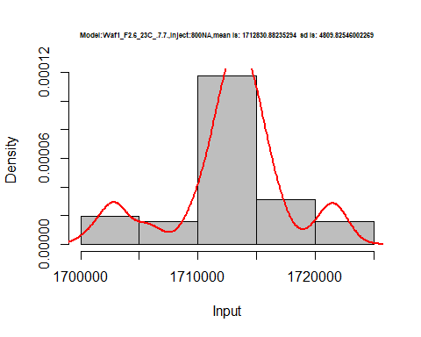

dens <- apply(d1_7.7, 2, density)  
plot('Waf1_F2.6_23C_.7.7.', xlim=range(sapply(dens, "[", "x")), ylim=range(sapply(dens, "[", "y")))

## Warning in xy.coords(x, y, xlabel, ylabel, log): NAs introduced by coercion

mapply(lines, dens, col=1:length(dens))

## $V1  
## NULL  
##   
## $V2  
## NULL  
##   
## $V3  
## NULL  
##   
## $V4  
## NULL  
##   
## $V5  
## NULL  
##   
## $V6  
## NULL  
##   
## $V7  
## NULL  
##   
## $V8  
## NULL

legend("topright", legend=names(dens), fill=1:length(dens))

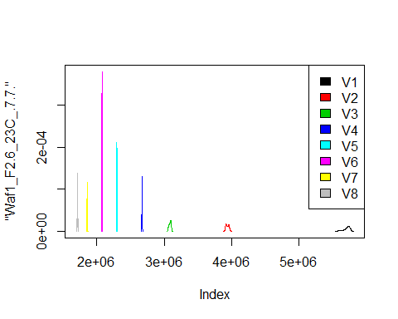

d2_7.7<-d_7.7[,c(9:16)]  
d2_7.7 <- head(d2_7.7,51)  
colnames(d2_7.7) <- c("V1", "V2","V3","V4","V5","V6","V7","V8")  
head(d2_7.7)

## V1 V2 V3 V4 V5 V6 V7 V8  
## 1 6847500 4507500 3525833 2923125 2611000 2357083 2147500 1975312  
## 2 6852500 4502500 3528333 2920625 2612500 2348333 2143214 1976250  
## 3 6852500 4501250 3529167 2918750 2614000 2343333 2147143 1977500  
## 4 6852500 4500000 3525000 2921250 2613000 2342083 2148214 1979375  
## 5 6852500 4503750 3528333 2921250 2609500 2342083 2152500 1976562  
## 6 6850000 4506250 3532500 2922500 2611500 2340417 2152500 1977500

hist(d2_7.7$V1,  
 cex.main=0.5,  
 freq = FALSE,  
 main = paste('Model:Waf1_F5.3_23C_.7.7.,Inject:100NA,mean is:', mean(d2_7.7$V1),' sd is:', sd(d2_7.7$V1)),  
 xlab = "Input",  
 ylab = "Density",  
 col="grey")  
#plot density curve  
lines(density(d2_7.7$V1), # density plot  
 lwd = 2, # thickness of line  
 col = "red")

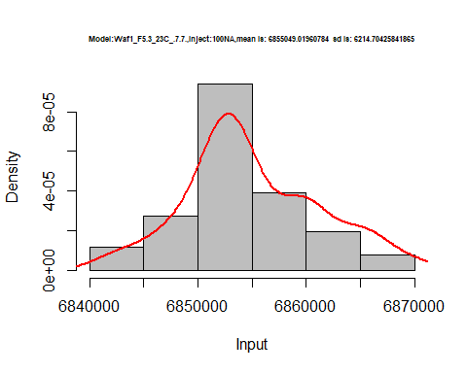

hist(d2_7.7$V2,  
 cex.main=0.5,  
 freq = FALSE,  
 main = paste('Model:Waf1_F5.3_23C_.7.7.,Inject:200NA,mean is:', mean(d2_7.7$V2),' sd is:', sd(d2_7.7$V2)),  
 xlab = "Input",  
 ylab = "Density",  
 col="grey")  
#plot density curve  
lines(density(d2_7.7$V2), # density plot  
 lwd = 2, # thickness of line  
 col = "red")

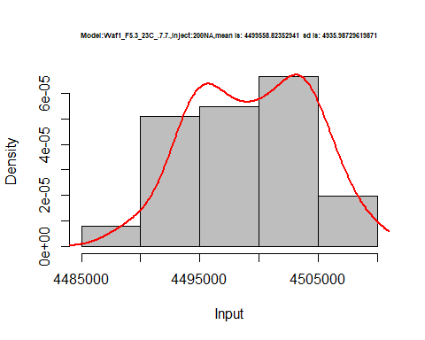

hist(d2_7.7$V3,  
 cex.main=0.5,  
 freq = FALSE,  
 main = paste('Model:Waf1_F5.3_23C_.7.7.,Inject:300NA,mean is:', mean(d2_7.7$V3),' sd is:', sd(d2_7.7$V3)),  
 xlab = "Input",  
 ylab = "Density",  
 col="grey")  
#plot density curve  
lines(density(d2_7.7$V3), # density plot  
 lwd = 2, # thickness of line  
 col = "red")

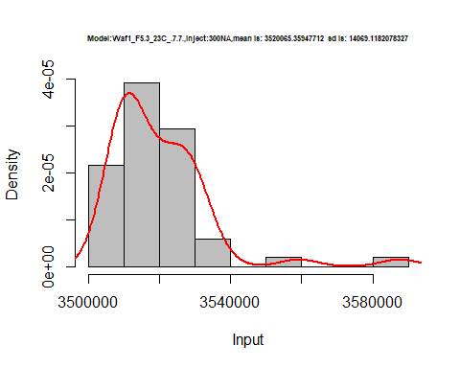

hist(d2_7.7$V4,  
 cex.main=0.5,  
 freq = FALSE,  
 main = paste('Model:Waf1_F5.3_23C_.7.7.,Inject:400NA,mean is:', mean(d2_7.7$V4),' sd is:', sd(d2_7.7$V4)),  
 xlab = "Input",  
 ylab = "Density",  
 col="grey")  
#plot density curve  
lines(density(d2_7.7$V4), # density plot  
 lwd = 2, # thickness of line  
 col = "red")

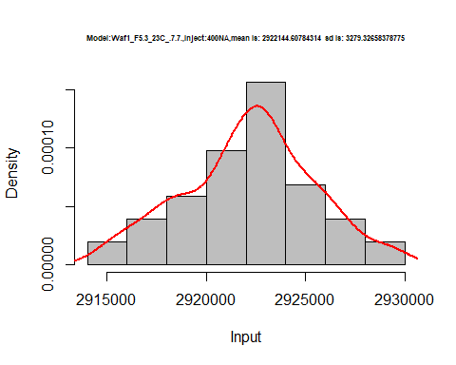

hist(d2_7.7$V5,  
 cex.main=0.5,  
 freq = FALSE,  
 main = paste('Model:Waf1_F5.3_23C_.7.7.,Inject:500NA,mean is:', mean(d2_7.7$V5),' sd is:', sd(d2_7.7$V5)),  
 xlab = "Input",  
 ylab = "Density",  
 col="grey")  
#plot density curve  
lines(density(d2_7.7$V5), # density plot  
 lwd = 2, # thickness of line  
 col = "red")

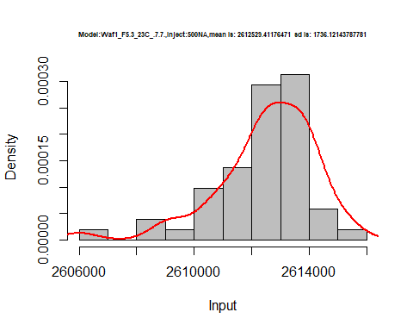

hist(d2_7.7$V6,  
 cex.main=0.5,  
 freq = FALSE,  
 main = paste('Model:Waf1_F5.3_23C_.7.7.,Inject:600NA,mean is:', mean(d2_7.7$V6),' sd is:', sd(d2_7.7$V6)),  
 xlab = "Input",  
 ylab = "Density",  
 col="grey")  
#plot density curve  
lines(density(d2_7.7$V6), # density plot  
 lwd = 2, # thickness of line  
 col = "red")

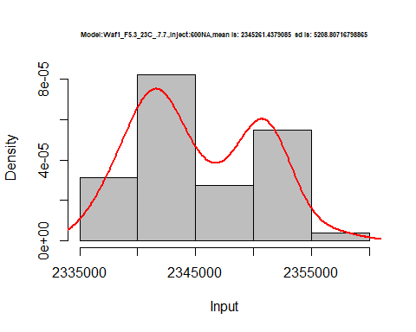

hist(d2_7.7$V7,  
 cex.main=0.5,  
 freq = FALSE,  
 main = paste('Model:Waf1_F5.3_23C_.7.7.,Inject:700NA,mean is:', mean(d2_7.7$V7),' sd is:', sd(d2_7.7$V7)),  
 xlab = "Input",  
 ylab = "Density",  
 col="grey")  
#plot density curve  
lines(density(d2_7.7$V7), # density plot  
 lwd = 2, # thickness of line  
 col = "red")

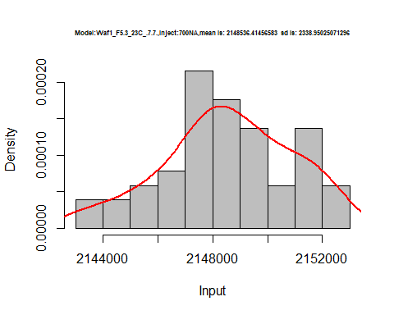

hist(d2_7.7$V8,  
 cex.main=0.5,  
 freq = FALSE,  
 main = paste('Model:Waf1_F5.3_23C_.7.7.,Inject:800NA,mean is:', mean(d2_7.7$V8),' sd is:', sd(d2_7.7$V8)),  
 xlab = "Input",  
 ylab = "Density",  
 col="grey")  
#plot density curve  
lines(density(d2_7.7$V8), # density plot  
 lwd = 2, # thickness of line  
 col = "red")

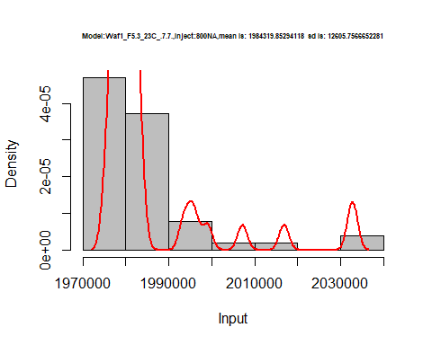

dens <- apply(d2_7.7, 2, density)  
plot('Waf1_F5.3_23C_.7.7.', xlim=range(sapply(dens, "[", "x")), ylim=range(sapply(dens, "[", "y")))

## Warning in xy.coords(x, y, xlabel, ylabel, log): NAs introduced by coercion

mapply(lines, dens, col=1:length(dens))

## $V1  
## NULL  
##   
## $V2  
## NULL  
##   
## $V3  
## NULL  
##   
## $V4  
## NULL  
##   
## $V5  
## NULL  
##   
## $V6  
## NULL  
##   
## $V7  
## NULL  
##   
## $V8  
## NULL

legend("topright", legend=names(dens), fill=1:length(dens))

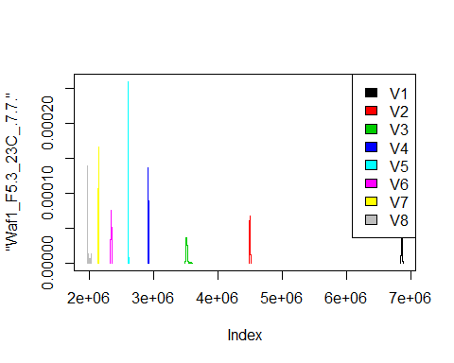

d3_7.7<-d_7.7[,c(17:24)]  
d3_7.7 <- head(d3_7.7,51)  
colnames(d3_7.7) <- c("V1", "V2","V3","V4","V5","V6","V7","V8")  
head(d3_7.7)

## V1 V2 V3 V4 V5 V6 V7 V8  
## 1 4370000 3482500 2990000 2630000 2345500 2158333 1988571 1851875  
## 2 4372500 3482500 2981667 2628125 2346500 2163333 1987857 1854062  
## 3 4372500 3481250 2985833 2628750 2343500 2160000 1987500 1857813  
## 4 4367500 3472500 2986667 2625000 2338500 2159167 1984643 1854062  
## 5 4367500 3476250 2995000 2628125 2344000 2161250 1995000 1855937  
## 6 4360000 3483750 2995000 2626875 2348500 2166250 1996786 1858750

hist(d3_7.7$V1,  
 cex.main=0.5,  
 freq = FALSE,  
 main = paste('Model:Waf1_F6.2_23C_.7.7.,Inject:100NA,mean is:', mean(d3_7.7$V1),' sd is:', sd(d3_7.7$V1)),  
 xlab = "Input",  
 ylab = "Density",  
 col="grey")  
#plot density curve  
lines(density(d3_7.7$V1), # density plot  
 lwd = 2, # thickness of line  
 col = "red")

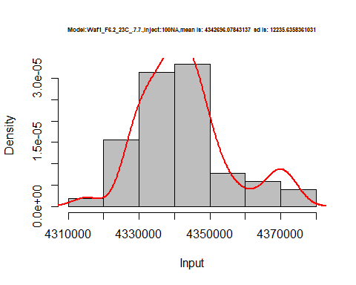

hist(d3_7.7$V2,  
 cex.main=0.5,  
 freq = FALSE,  
 main = paste('Model:Waf1_F6.2_23C_.7.7.,Inject:200NA,mean is:', mean(d3_7.7$V2),' sd is:', sd(d3_7.7$V2)),  
 xlab = "Input",  
 ylab = "Density",  
 col="grey")  
#plot density curve  
lines(density(d3_7.7$V2), # density plot  
 lwd = 2, # thickness of line  
 col = "red")

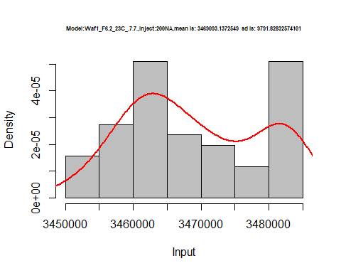

hist(d3_7.7$V3,  
 cex.main=0.5,  
 freq = FALSE,  
 main = paste('Model:Waf1_F6.2_23C_.7.7.,Inject:300NA,mean is:', mean(d3_7.7$V3),' sd is:', sd(d3_7.7$V3)),  
 xlab = "Input",  
 ylab = "Density",  
 col="grey")  
#plot density curve  
lines(density(d3_7.7$V3), # density plot  
 lwd = 2, # thickness of line  
 col = "red")

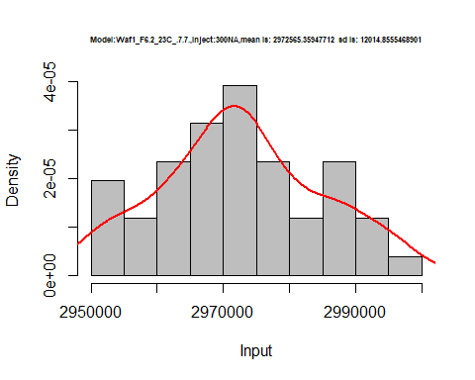

hist(d3_7.7$V4,  
 cex.main=0.5,  
 freq = FALSE,  
 main = paste('Model:Waf1_F6.2_23C_.7.7.,Inject:400NA,mean is:', mean(d3_7.7$V4),' sd is:', sd(d3_7.7$V4)),  
 xlab = "Input",  
 ylab = "Density",  
 col="grey")  
#plot density curve  
lines(density(d3_7.7$V4), # density plot  
 lwd = 2, # thickness of line  
 col = "red")

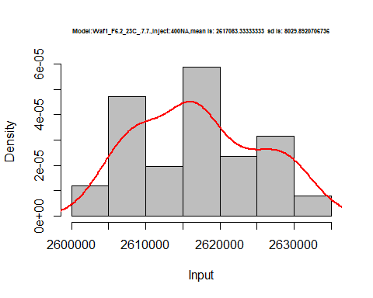

hist(d3_7.7$V5,  
 cex.main=0.5,  
 freq = FALSE,  
 main = paste('Model:Waf1_F6.2_23C_.7.7.,Inject:500NA,mean is:', mean(d3_7.7$V5),' sd is:', sd(d3_7.7$V5)),  
 xlab = "Input",  
 ylab = "Density",  
 col="grey")  
#plot density curve  
lines(density(d3_7.7$V5), # density plot  
 lwd = 2, # thickness of line  
 col = "red")

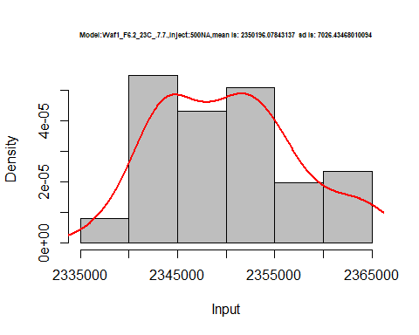

hist(d3_7.7$V6,  
 cex.main=0.5,  
 freq = FALSE,  
 main = paste('Model:Waf1_F6.2_23C_.7.7.,Inject:600NA,mean is:', mean(d3_7.7$V6),' sd is:', sd(d3_7.7$V6)),  
 xlab = "Input",  
 ylab = "Density",  
 col="grey")  
#plot density curve  
lines(density(d3_7.7$V6), # density plot  
 lwd = 2, # thickness of line  
 col = "red")

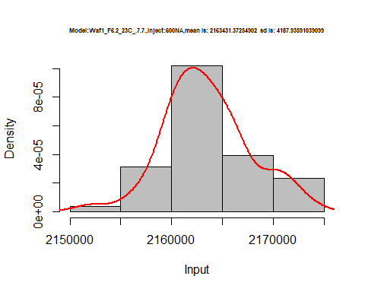

hist(d3_7.7$V7,  
 cex.main=0.5,  
 freq = FALSE,  
 main = paste('Model:Waf1_F6.2_23C_.7.7.,Inject:700NA,mean is:', mean(d3_7.7$V7),' sd is:', sd(d3_7.7$V7)),  
 xlab = "Input",  
 ylab = "Density",  
 col="grey")  
#plot density curve  
lines(density(d3_7.7$V7), # density plot  
 lwd = 2, # thickness of line  
 col = "red")

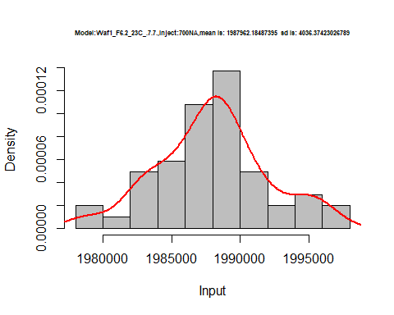

hist(d3_7.7$V8,  
 cex.main=0.5,  
 freq = FALSE,  
 main = paste('Model:Waf1_F6.2_23C_.7.7.,Inject:800NA,mean is:', mean(d3_7.7$V8),' sd is:', sd(d3_7.7$V8)),  
 xlab = "Input",  
 ylab = "Density",  
 col="grey")  
#plot density curve  
lines(density(d3_7.7$V8), # density plot  
 lwd = 2, # thickness of line  
 col = "red")

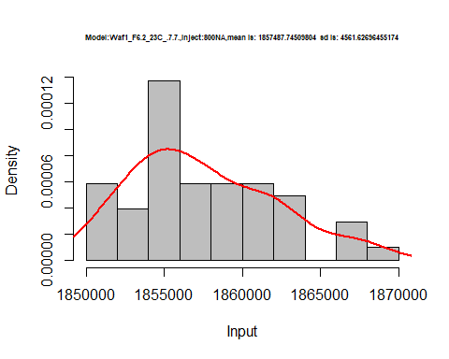

dens <- apply(d3_7.7, 2, density)  
plot('Waf1_F5.3_23C_.7.7.', xlim=range(sapply(dens, "[", "x")), ylim=range(sapply(dens, "[", "y")))

## Warning in xy.coords(x, y, xlabel, ylabel, log): NAs introduced by coercion

mapply(lines, dens, col=1:length(dens))

## $V1  
## NULL  
##   
## $V2  
## NULL  
##   
## $V3  
## NULL  
##   
## $V4  
## NULL  
##   
## $V5  
## NULL  
##   
## $V6  
## NULL  
##   
## $V7  
## NULL  
##   
## $V8  
## NULL

legend("topright", legend=names(dens), fill=1:length(dens))

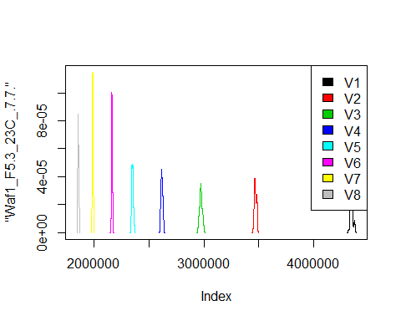

d4_7.7<-d_7.7[,c(25:32)]  
d4_7.7 <- head(d4_7.7,51)  
colnames(d4_7.7) <- c("V1", "V2","V3","V4","V5","V6","V7","V8")  
head(d4_7.7)

## V1 V2 V3 V4 V5 V6 V7 V8  
## 1 1077500 910000 835833.3 760625 658000 615416.7 589285.7 555625.0  
## 2 1077500 912500 836666.7 763750 656000 614583.3 586428.6 556562.5  
## 3 1082500 910000 825833.3 757500 658500 616250.0 585357.1 555625.0  
## 4 1082500 906250 837500.0 760625 652500 615000.0 586071.4 555312.5  
## 5 1080000 912500 840000.0 768125 655500 617916.7 584285.7 557187.5  
## 6 1080000 908750 841666.7 768125 657000 615833.3 585000.0 558750.0

hist(d4_7.7$V1,  
 cex.main=0.5,  
 freq = FALSE,  
 main = paste('Model:Waf1_F6.3_23C_.7.7.,Inject:100NA,mean is:', mean(d4_7.7$V1),' sd is:', sd(d4_7.7$V1)),  
 xlab = "Input",  
 ylab = "Density",  
 col="grey")  
#plot density curve  
lines(density(d4_7.7$V1), # density plot  
 lwd = 2, # thickness of line  
 col = "red")

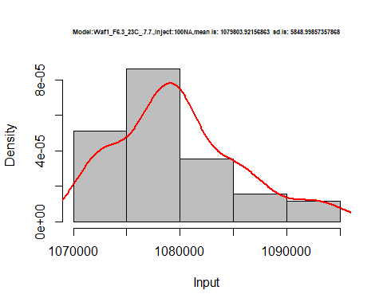

hist(d4_7.7$V2,  
 cex.main=0.5,  
 freq = FALSE,  
 main = paste('Model:Waf1_F6.3_23C_.7.7.,Inject:200NA,mean is:', mean(d4_7.7$V2),' sd is:', sd(d4_7.7$V2)),  
 xlab = "Input",  
 ylab = "Density",  
 col="grey")  
#plot density curve  
lines(density(d4_7.7$V2), # density plot  
 lwd = 2, # thickness of line  
 col = "red")

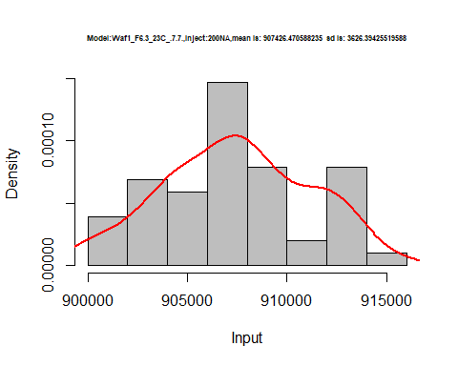

hist(d4_7.7$V3,  
 cex.main=0.5,  
 freq = FALSE,  
 main = paste('Model:Waf1_F6.3_23C_.7.7.,Inject:300NA,mean is:', mean(d4_7.7$V3),' sd is:', sd(d4_7.7$V3)),  
 xlab = "Input",  
 ylab = "Density",  
 col="grey")  
#plot density curve  
lines(density(d4_7.7$V3), # density plot  
 lwd = 2, # thickness of line  
 col = "red")

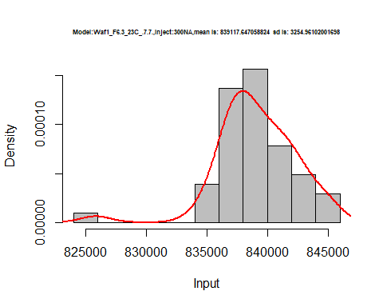

hist(d4_7.7$V4,  
 cex.main=0.5,  
 freq = FALSE,  
 main = paste('Model:Waf1_F6.3_23C_.7.7.,Inject:400NA,mean is:', mean(d4_7.7$V4),' sd is:', sd(d4_7.7$V4)),  
 xlab = "Input",  
 ylab = "Density",  
 col="grey")  
#plot density curve  
lines(density(d4_7.7$V4), # density plot  
 lwd = 2, # thickness of line  
 col = "red")

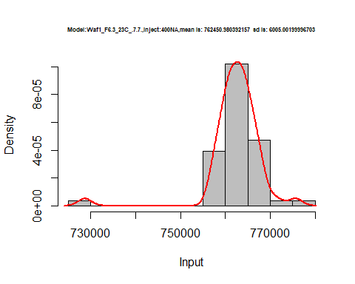

hist(d4_7.7$V5,  
 cex.main=0.5,  
 freq = FALSE,  
 main = paste('Model:Waf1_F6.3_23C_.7.7.,Inject:500NA,mean is:', mean(d4_7.7$V5),' sd is:', sd(d4_7.7$V5)),  
 xlab = "Input",  
 ylab = "Density",  
 col="grey")  
#plot density curve  
lines(density(d4_7.7$V5), # density plot  
 lwd = 2, # thickness of line  
 col = "red")

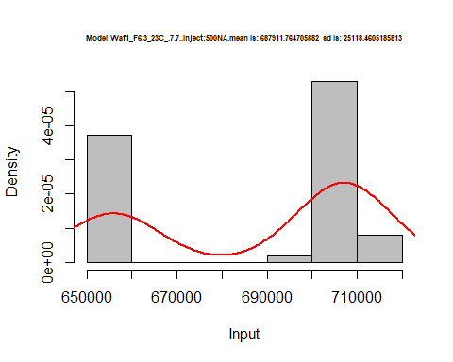

hist(d4_7.7$V6,  
 cex.main=0.5,  
 freq = FALSE,  
 main = paste('Model:Waf1_F6.3_23C_.7.7.,Inject:600NA,mean is:', mean(d4_7.7$V6),' sd is:', sd(d4_7.7$V6)),  
 xlab = "Input",  
 ylab = "Density",  
 col="grey")  
#plot density curve  
lines(density(d4_7.7$V6), # density plot  
 lwd = 2, # thickness of line  
 col = "red")

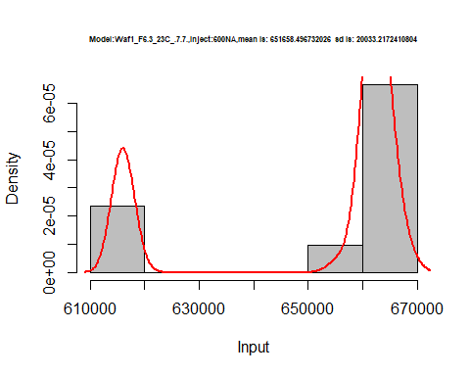

hist(d4_7.7$V7,  
 cex.main=0.5,  
 freq = FALSE,  
 main = paste('Model:Waf1_F6.3_23C_.7.7.,Inject:700NA,mean is:', mean(d4_7.7$V7),' sd is:', sd(d4_7.7$V7)),  
 xlab = "Input",  
 ylab = "Density",  
 col="grey")  
#plot density curve  
lines(density(d4_7.7$V7), # density plot  
 lwd = 2, # thickness of line  
 col = "red")

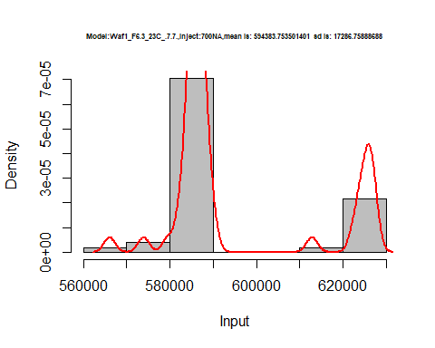

hist(d4_7.7$V8,  
 cex.main=0.5,  
 freq = FALSE,  
 main = paste('Model:Waf1_F6.3_23C_.7.7.,Inject:800NA,mean is:', mean(d4_7.7$V8),' sd is:', sd(d4_7.7$V8)),  
 xlab = "Input",  
 ylab = "Density",  
 col="grey")  
#plot density curve  
lines(density(d4_7.7$V8), # density plot  
 lwd = 2, # thickness of line  
 col = "red")

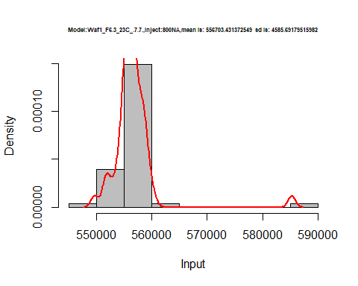

dens <- apply(d4_7.7, 2, density)  
plot('Waf1_F6.3_23C_.7.7.', xlim=range(sapply(dens, "[", "x")), ylim=range(sapply(dens, "[", "y")))

## Warning in xy.coords(x, y, xlabel, ylabel, log): NAs introduced by coercion

mapply(lines, dens, col=1:length(dens))

## $V1  
## NULL  
##   
## $V2  
## NULL  
##   
## $V3  
## NULL  
##   
## $V4  
## NULL  
##   
## $V5  
## NULL  
##   
## $V6  
## NULL  
##   
## $V7  
## NULL  
##   
## $V8  
## NULL

legend("topright", legend=names(dens), fill=1:length(dens))

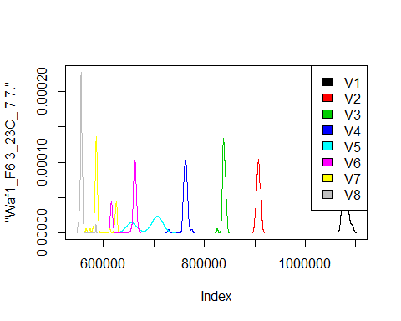

d5_7.7<-d_7.7[,c(33:40)]  
d5_7.7 <- head(d5_7.7,51)  
colnames(d5_7.7) <- c("V1", "V2","V3","V4","V5","V6","V7","V8")  
head(d5_7.7)

## V1 V2 V3 V4 V5 V6 V7 V8  
## 1 1262500 897500 718333.3 613750 558500 492500.0 459642.9 615625.0  
## 2 1270000 896250 712500.0 614375 585000 498750.0 458214.3 461562.5  
## 3 1267500 901250 724166.7 616250 579000 498750.0 448571.4 456250.0  
## 4 1265000 900000 718333.3 616250 555500 490416.7 450000.0 461875.0  
## 5 1267500 891250 720000.0 621250 555500 487916.7 460357.1 458125.0  
## 6 1265000 907500 712500.0 619375 554500 487500.0 461071.4 461250.0

hist(d5_7.7$V1,  
 cex.main=0.5,  
 freq = FALSE,  
 main = paste('Model:Waf1_F6.4_23C_.7.7.,Inject:100NA,mean is:', mean(d5_7.7$V1),' sd is:', sd(d5_7.7$V1)),  
 xlab = "Input",  
 ylab = "Density",  
 col="grey")  
#plot density curve  
lines(density(d5_7.7$V1), # density plot  
 lwd = 2, # thickness of line  
 col = "red")

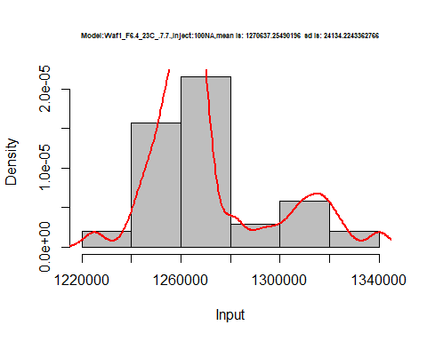

hist(d5_7.7$V2,  
 cex.main=0.5,  
 freq = FALSE,  
 main = paste('Model:Waf1_F6.4_23C_.7.7.,Inject:200NA,mean is:', mean(d5_7.7$V2),' sd is:', sd(d5_7.7$V2)),  
 xlab = "Input",  
 ylab = "Density",  
 col="grey")  
#plot density curve  
lines(density(d5_7.7$V2), # density plot  
 lwd = 2, # thickness of line  
 col = "red")

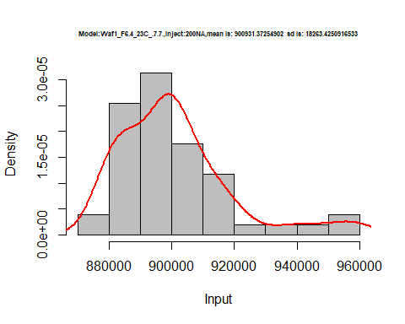

hist(d5_7.7$V3,  
 cex.main=0.5,  
 freq = FALSE,  
 main = paste('Model:Waf1_F6.4_23C_.7.7.,Inject:300NA,mean is:', mean(d5_7.7$V3),' sd is:', sd(d5_7.7$V3)),  
 xlab = "Input",  
 ylab = "Density",  
 col="grey")  
#plot density curve  
lines(density(d5_7.7$V3), # density plot  
 lwd = 2, # thickness of line  
 col = "red")

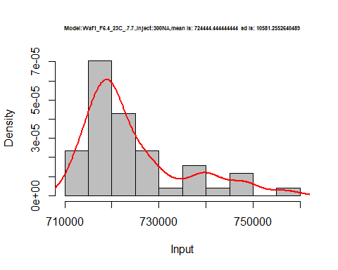

hist(d5_7.7$V4,  
 cex.main=0.5,  
 freq = FALSE,  
 main = paste('Model:Waf1_F6.4_23C_.7.7.,Inject:400NA,mean is:', mean(d5_7.7$V4),' sd is:', sd(d5_7.7$V4)),  
 xlab = "Input",  
 ylab = "Density",  
 col="grey")  
#plot density curve  
lines(density(d5_7.7$V4), # density plot  
 lwd = 2, # thickness of line  
 col = "red")

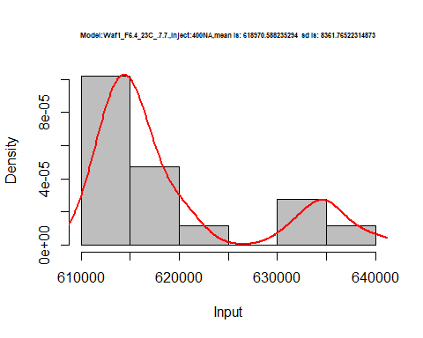

hist(d5_7.7$V5,  
 cex.main=0.5,  
 freq = FALSE,  
 main = paste('Model:Waf1_F6.4_23C_.7.7.,Inject:500NA,mean is:', mean(d5_7.7$V5),' sd is:', sd(d5_7.7$V5)),  
 xlab = "Input",  
 ylab = "Density",  
 col="grey")  
#plot density curve  
lines(density(d5_7.7$V5), # density plot  
 lwd = 2, # thickness of line  
 col = "red")

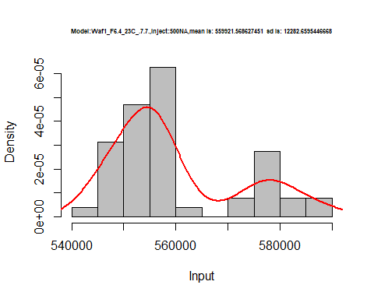

hist(d5_7.7$V6,  
 cex.main=0.5,  
 freq = FALSE,  
 main = paste('Model:Waf1_F6.4_23C_.7.7.,Inject:600NA,mean is:', mean(d5_7.7$V6),' sd is:', sd(d5_7.7$V6)),  
 xlab = "Input",  
 ylab = "Density",  
 col="grey")  
#plot density curve  
lines(density(d5_7.7$V6), # density plot  
 lwd = 2, # thickness of line  
 col = "red")

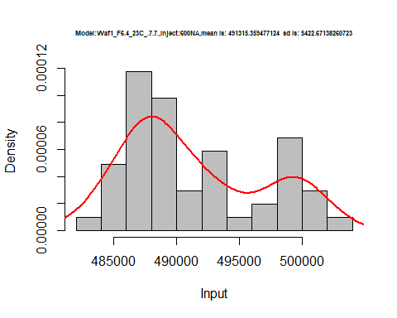

hist(d5_7.7$V7,  
 cex.main=0.5,  
 freq = FALSE,  
 main = paste('Model:Waf1_F6.4_23C_.7.7.,Inject:700NA,mean is:', mean(d5_7.7$V7),' sd is:', sd(d5_7.7$V7)),  
 xlab = "Input",  
 ylab = "Density",  
 col="grey")  
#plot density curve  
lines(density(d5_7.7$V7), # density plot  
 lwd = 2, # thickness of line  
 col = "red")

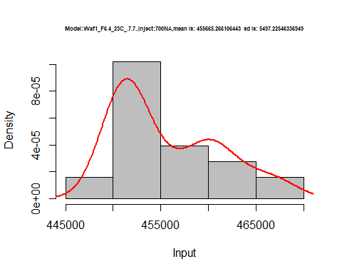

hist(d5_7.7$V8,  
 cex.main=0.5,  
 freq = FALSE,  
 main = paste('Model:Waf1_F6.4_23C_.7.7.,Inject:800NA,mean is:', mean(d5_7.7$V8),' sd is:', sd(d5_7.7$V8)),  
 xlab = "Input",  
 ylab = "Density",  
 col="grey")  
#plot density curve  
lines(density(d5_7.7$V8), # density plot  
 lwd = 2, # thickness of line  
 col = "red")

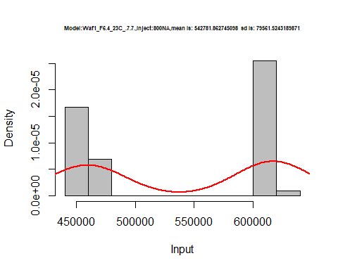

dens <- apply(d5_7.7, 2, density)  
plot('Waf1_F6.3_23C_.7.7.', xlim=range(sapply(dens, "[", "x")), ylim=range(sapply(dens, "[", "y")))

## Warning in xy.coords(x, y, xlabel, ylabel, log): NAs introduced by coercion

mapply(lines, dens, col=1:length(dens))

## $V1  
## NULL  
##   
## $V2  
## NULL  
##   
## $V3  
## NULL  
##   
## $V4  
## NULL  
##   
## $V5  
## NULL  
##   
## $V6  
## NULL  
##   
## $V7  
## NULL  
##   
## $V8  
## NULL

legend("topright", legend=names(dens), fill=1:length(dens))

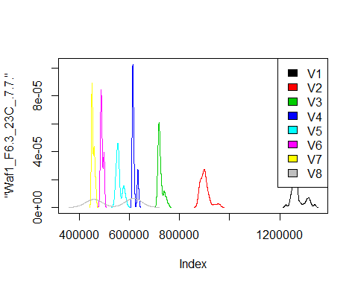

# Select columns whose names contains "8.8"  
d_8.8<-my_data %>% select(contains("8.8."))  
head(d_8.8)

## Waf1_F3.3_23C_.100nA_.8.8. Waf1_F3.3_23C_.200nA_.8.8.  
## 1 2440000 2112500  
## 2 2452500 2117500  
## 3 2462500 2113750  
## 4 2465000 2112500  
## 5 2462500 2117500  
## 6 2470000 2111250  
## Waf1_F3.3_23C_.300nA_.8.8. Waf1_F3.3_23C_.400nA_.8.8.  
## 1 1773333 1519375  
## 2 1772500 1520000  
## 3 1770000 1523750  
## 4 1767500 1522500  
## 5 1767500 1518750  
## 6 1768333 1523750  
## Waf1_F3.3_23C_.500nA_.8.8. Waf1_F3.3_23C_.600nA_.8.8.  
## 1 1348500 1223333  
## 2 1350500 1224167  
## 3 1347500 1224583  
## 4 1348000 1226667  
## 5 1347500 1225000  
## 6 1351000 1224583  
## Waf1_F3.3_23C_.700nA_.8.8. Waf1_F3.3_23C_.800nA_.8.8.  
## 1 1122143 1046563  
## 2 1124286 1051563  
## 3 1122857 1048437  
## 4 1121071 1047187  
## 5 1130000 1047500  
## 6 1120714 1048125  
## Waf1_F3.5_23C_.100nA_.8.8. Waf1_F3.5_23C_.200nA_.8.8.  
## 1 1462500 1015000  
## 2 1467500 1015000  
## 3 1470000 1018750  
## 4 1465000 1020000  
## 5 1462500 1021250  
## 6 1467500 1022500  
## Waf1_F3.5_23C_.300nA_.8.8. Waf1_F3.5_23C_.400nA_.8.8.  
## 1 809166.7 678125  
## 2 809166.7 677500  
## 3 810000.0 678750  
## 4 801666.7 680000  
## 5 812500.0 680625  
## 6 811666.7 681250  
## Waf1_F3.5_23C_.500nA_.8.8. Waf1_F3.5_23C_.600nA_.8.8.  
## 1 589500 528333.3  
## 2 594000 529583.3  
## 3 596000 529583.3  
## 4 587500 529583.3  
## 5 596000 525416.7  
## 6 582500 529583.3  
## Waf1_F3.5_23C_.700nA_.8.8. Waf1_F3.5_23C_.800nA_.8.8.  
## 1 477500.0 436875.0  
## 2 478571.4 439375.0  
## 3 477857.1 435937.5  
## 4 477500.0 435625.0  
## 5 477500.0 435312.5  
## 6 477857.1 436250.0  
## Waf1_F5.3_23C_.100nA_.8.8. Waf1_F5.3_23C_.200nA_.8.8.  
## 1 5045000 3788750  
## 2 5035000 3743750  
## 3 5032500 3743750  
## 4 5027500 3706250  
## 5 5032500 3703750  
## 6 5060000 3711250  
## Waf1_F5.3_23C_.300nA_.8.8. Waf1_F5.3_23C_.400nA_.8.8.  
## 1 2803333 1890625  
## 2 2810000 1917500  
## 3 2820833 1896250  
## 4 2815833 1911250  
## 5 2820833 1936875  
## 6 2840000 1943125  
## Waf1_F5.3_23C_.500nA_.8.8. Waf1_F5.3_23C_.600nA_.8.8.  
## 1 1681500 2187500  
## 2 1653000 2183750  
## 3 1677500 2185000  
## 4 1672500 2187917  
## 5 1683000 2191667  
## 6 1681000 2181250  
## Waf1_F5.3_23C_.700nA_.8.8. Waf1_F5.3_23C_.800nA_.8.8.  
## 1 956785.7 874375.0  
## 2 954285.7 870937.5  
## 3 956428.6 870312.5  
## 4 952857.1 872187.5  
## 5 956071.4 873125.0  
## 6 958571.4 870937.5

d1_8.8<-d_8.8[,c(1:8)]  
d1_8.8 <- head(d1_8.8,51)  
colnames(d1_8.8) <- c("V1", "V2","V3","V4","V5","V6","V7","V8")  
head(d1_8.8)

## V1 V2 V3 V4 V5 V6 V7 V8  
## 1 2440000 2112500 1773333 1519375 1348500 1223333 1122143 1046563  
## 2 2452500 2117500 1772500 1520000 1350500 1224167 1124286 1051563  
## 3 2462500 2113750 1770000 1523750 1347500 1224583 1122857 1048437  
## 4 2465000 2112500 1767500 1522500 1348000 1226667 1121071 1047187  
## 5 2462500 2117500 1767500 1518750 1347500 1225000 1130000 1047500  
## 6 2470000 2111250 1768333 1523750 1351000 1224583 1120714 1048125

hist(d1_8.8$V1,  
 cex.main=0.5,  
 freq = FALSE,  
 main = paste('Model:Waf1_F3.3_23C_.8.8..,Inject:100NA,mean is:', mean(d1_8.8$V1),' sd is:', sd(d1_8.8$V1)),  
 xlab = "Input",  
 ylab = "Density",  
 col="grey")  
#plot density curve  
lines(density(d1_8.8$V1), # density plot  
 lwd = 2, # thickness of line  
 col = "red")

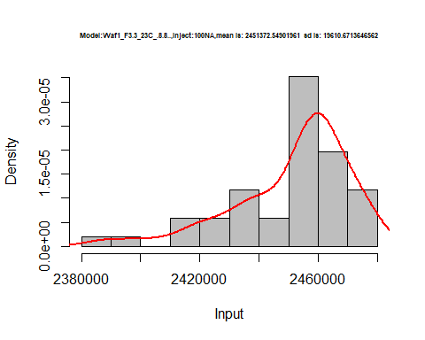

hist(d1_8.8$V2,  
 cex.main=0.5,  
 freq = FALSE,  
 main = paste('Model:Waf1_F3.3_23C_.8.8..,Inject:200NA,mean is:', mean(d1_8.8$V2),' sd is:', sd(d1_8.8$V2)),  
 xlab = "Input",  
 ylab = "Density",  
 col="grey")  
#plot density curve  
lines(density(d1_8.8$V2), # density plot  
 lwd = 2, # thickness of line  
 col = "red")

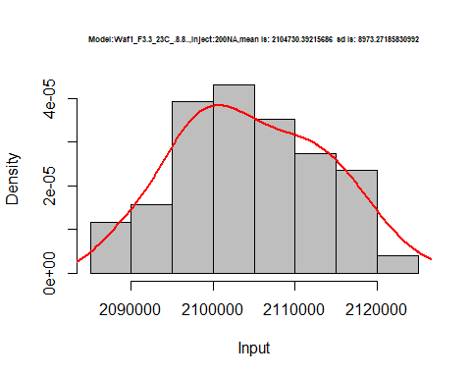

hist(d1_8.8$V3,  
 cex.main=0.5,  
 freq = FALSE,  
 main = paste('Model:Waf1_F3.3_23C_.8.8..,Inject:300NA,mean is:', mean(d1_8.8$V3),' sd is:', sd(d1_8.8$V3)),  
 xlab = "Input",  
 ylab = "Density",  
 col="grey")  
#plot density curve  
lines(density(d1_8.8$V3), # density plot  
 lwd = 2, # thickness of line  
 col = "red")

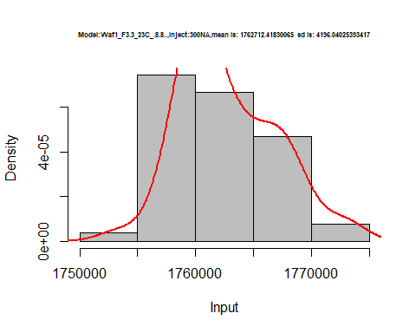

hist(d1_8.8$V4,  
 cex.main=0.5,  
 freq = FALSE,  
 main = paste('Model:Waf1_F3.3_23C_.8.8..,Inject:400NA,mean is:', mean(d1_8.8$V4),' sd is:', sd(d1_8.8$V4)),  
 xlab = "Input",  
 ylab = "Density",  
 col="grey")  
#plot density curve  
lines(density(d1_8.8$V4), # density plot  
 lwd = 2, # thickness of line  
 col = "red")

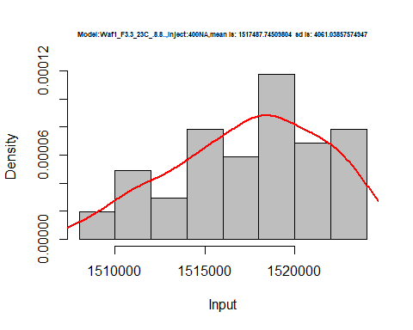

hist(d1_8.8$V5,  
 cex.main=0.5,  
 freq = FALSE,  
 main = paste('Model:Waf1_F3.3_23C_.8.8..,Inject:500NA,mean is:', mean(d1_8.8$V5),' sd is:', sd(d1_8.8$V5)),  
 xlab = "Input",  
 ylab = "Density",  
 col="grey")  
#plot density curve  
lines(density(d1_8.8$V5), # density plot  
 lwd = 2, # thickness of line  
 col = "red")

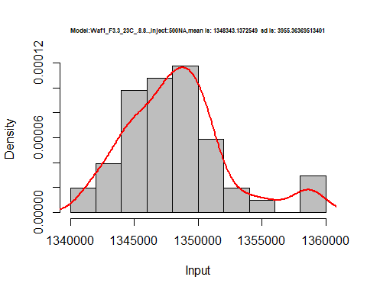

hist(d1_8.8$V6,  
 cex.main=0.5,  
 freq = FALSE,  
 main = paste('Model:Waf1_F3.3_23C_.8.8..,Inject:600NA,mean is:', mean(d1_8.8$V6),' sd is:', sd(d1_8.8$V6)),  
 xlab = "Input",  
 ylab = "Density",  
 col="grey")  
#plot density curve  
lines(density(d1_8.8$V6), # density plot  
 lwd = 2, # thickness of line  
 col = "red")

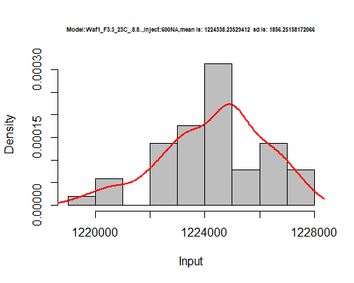

hist(d1_8.8$V7,  
 cex.main=0.5,  
 freq = FALSE,  
 main = paste('Model:Waf1_F3.3_23C_.8.8..,Inject:700NA,mean is:', mean(d1_8.8$V7),' sd is:', sd(d1_8.8$V7)),  
 xlab = "Input",  
 ylab = "Density",  
 col="grey")  
#plot density curve  
lines(density(d1_8.8$V7), # density plot  
 lwd = 2, # thickness of line  
 col = "red")

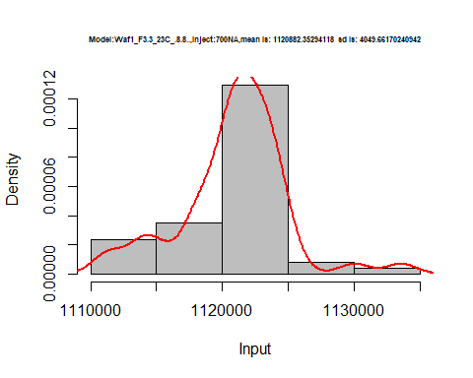

hist(d1_8.8$V8,  
 cex.main=0.5,  
 freq = FALSE,  
 main = paste('Model:Waf1_F3.3_23C_.8.8.,Inject:800NA,mean is:', mean(d1_8.8$V8),' sd is:', sd(d1_8.8$V8)),  
 xlab = "Input",  
 ylab = "Density",  
 col="grey")  
#plot density curve  
lines(density(d1_8.8$V8), # density plot  
 lwd = 2, # thickness of line  
 col = "red")

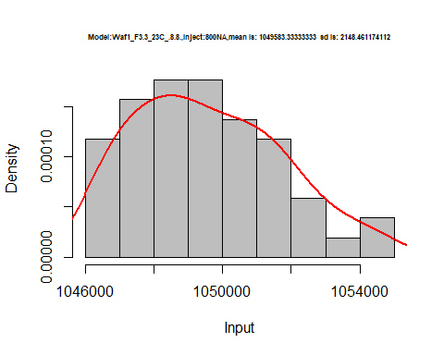

dens <- apply(d1_8.8, 2, density)  
plot('Waf1_F3.3_23C_.8.8.', xlim=range(sapply(dens, "[", "x")), ylim=range(sapply(dens, "[", "y")))

## Warning in xy.coords(x, y, xlabel, ylabel, log): NAs introduced by coercion

mapply(lines, dens, col=1:length(dens))

## $V1  
## NULL  
##   
## $V2  
## NULL  
##   
## $V3  
## NULL  
##   
## $V4  
## NULL  
##   
## $V5  
## NULL  
##   
## $V6  
## NULL  
##   
## $V7  
## NULL  
##   
## $V8  
## NULL

legend("topright", legend=names(dens), fill=1:length(dens))

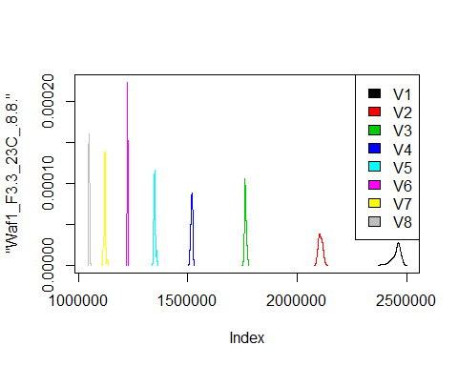

d2_8.8<-d_8.8[,c(9:17)]  
d2_8.8 <- head(d2_8.8,51)  
colnames(d2_8.8) <- c("V1", "V2","V3","V4","V5","V6","V7","V8")  
head(d2_8.8)

## V1 V2 V3 V4 V5 V6 V7 V8  
## 1 1462500 1015000 809166.7 678125 589500 528333.3 477500.0 436875.0  
## 2 1467500 1015000 809166.7 677500 594000 529583.3 478571.4 439375.0  
## 3 1470000 1018750 810000.0 678750 596000 529583.3 477857.1 435937.5  
## 4 1465000 1020000 801666.7 680000 587500 529583.3 477500.0 435625.0  
## 5 1462500 1021250 812500.0 680625 596000 525416.7 477500.0 435312.5  
## 6 1467500 1022500 811666.7 681250 582500 529583.3 477857.1 436250.0  
## NA  
## 1 5045000  
## 2 5035000  
## 3 5032500  
## 4 5027500  
## 5 5032500  
## 6 5060000

hist(d2_8.8$V1,  
 cex.main=0.5,  
 freq = FALSE,  
 main = paste('Model:Waf1_F3.5_23C_.8.8.,Inject:100NA,mean is:', mean(d2_8.8$V1),' sd is:', sd(d2_8.8$V1)),  
 xlab = "Input",  
 ylab = "Density",  
 col="grey")  
#plot density curve  
lines(density(d2_8.8$V1), # density plot  
 lwd = 2, # thickness of line  
 col = "red")

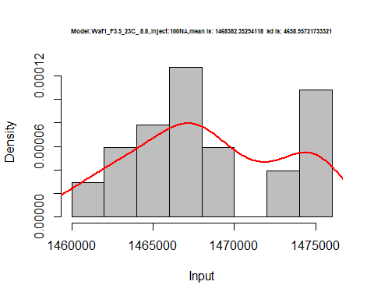

hist(d2_8.8$V2,  
 cex.main=0.5,  
 freq = FALSE,  
 main = paste('Model:Waf1_F3.5_23C_.8.8.,Inject:200NA,mean is:', mean(d2_8.8$V2),' sd is:', sd(d2_8.8$V2)),  
 xlab = "Input",  
 ylab = "Density",  
 col="grey")  
#plot density curve  
lines(density(d2_8.8$V2), # density plot  
 lwd = 2, # thickness of line  
 col = "red")

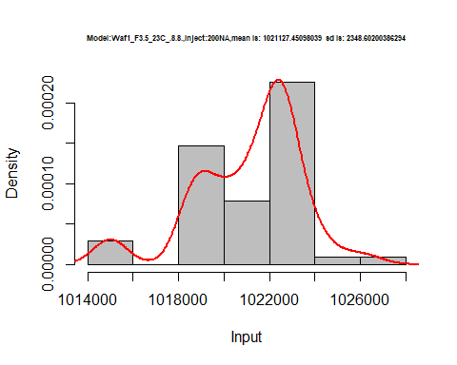

hist(d2_8.8$V3,  
 cex.main=0.5,  
 freq = FALSE,  
 main = paste('Model:Waf1_F3.5_23C_.8.8.,Inject:300NA,mean is:', mean(d2_8.8$V3),' sd is:', sd(d2_8.8$V3)),  
 xlab = "Input",  
 ylab = "Density",  
 col="grey")  
#plot density curve  
lines(density(d2_8.8$V3), # density plot  
 lwd = 2, # thickness of line  
 col = "red")

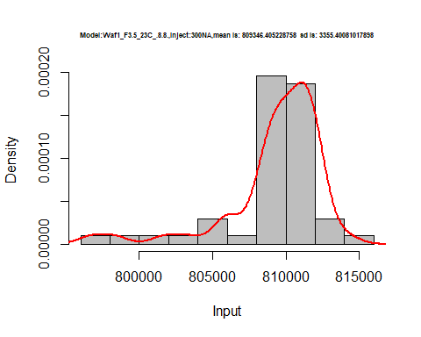

hist(d2_8.8$V4,  
 cex.main=0.5,  
 freq = FALSE,  
 main = paste('Model:Waf1_F3.5_23C_.8.8.,Inject:400NA,mean is:', mean(d2_8.8$V4),' sd is:', sd(d2_8.8$V4)),  
 xlab = "Input",  
 ylab = "Density",  
 col="grey")  
#plot density curve  
lines(density(d2_8.8$V4), # density plot  
 lwd = 2, # thickness of line  
 col = "red")

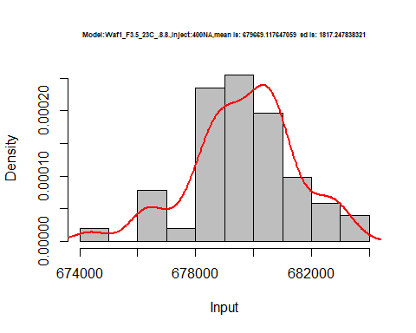

hist(d2_8.8$V5,  
 cex.main=0.5,  
 freq = FALSE,  
 main = paste('Model:Waf1_F3.5_23C_.8.8.,Inject:500NA,mean is:', mean(d2_8.8$V5),' sd is:', sd(d2_8.8$V5)),  
 xlab = "Input",  
 ylab = "Density",  
 col="grey")  
#plot density curve  
lines(density(d2_8.8$V5), # density plot  
 lwd = 2, # thickness of line  
 col = "red")

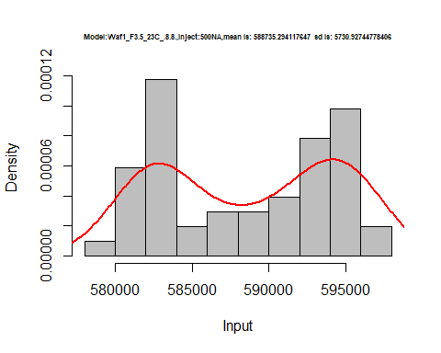

hist(d2_8.8$V6,  
 cex.main=0.5,  
 freq = FALSE,  
 main = paste('Model:Waf1_F3.5_23C_.8.8.,Inject:600NA,mean is:', mean(d2_8.8$V6),' sd is:', sd(d2_8.8$V6)),  
 xlab = "Input",  
 ylab = "Density",  
 col="grey")  
#plot density curve  
lines(density(d2_8.8$V6), # density plot  
 lwd = 2, # thickness of line  
 col = "red")

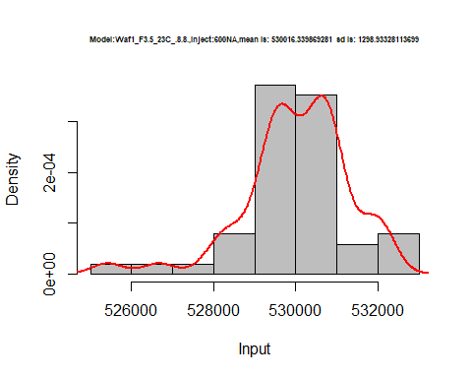

hist(d2_8.8$V7,  
 cex.main=0.5,  
 freq = FALSE,  
 main = paste('Model:Waf1_F3.5_23C_.8.8.,Inject:700NA,mean is:', mean(d2_8.8$V7),' sd is:', sd(d2_8.8$V7)),  
 xlab = "Input",  
 ylab = "Density",  
 col="grey")  
#plot density curve  
lines(density(d2_8.8$V7), # density plot  
 lwd = 2, # thickness of line  
 col = "red")

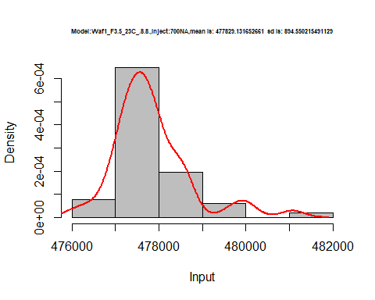

hist(d2_8.8$V8,  
 cex.main=0.5,  
 freq = FALSE,  
 main = paste('Model:Waf1_F3.5_23C_.8.8.,Inject:800NA,mean is:', mean(d2_8.8$V8),' sd is:', sd(d2_8.8$V8)),  
 xlab = "Input",  
 ylab = "Density",  
 col="grey")  
#plot density curve  
lines(density(d2_8.8$V8), # density plot  
 lwd = 2, # thickness of line  
 col = "red")

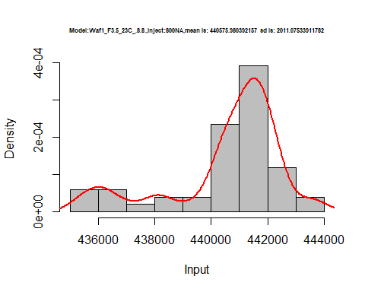

dens <- apply(d2_8.8, 2, density)  
plot('Waf1_F3.3_23C_.8.8.', xlim=range(sapply(dens, "[", "x")), ylim=range(sapply(dens, "[", "y")))

## Warning in xy.coords(x, y, xlabel, ylabel, log): NAs introduced by coercion

mapply(lines, dens, col=1:length(dens))

## $V1  
## NULL  
##   
## $V2  
## NULL  
##   
## $V3  
## NULL  
##   
## $V4  
## NULL  
##   
## $V5  
## NULL  
##   
## $V6  
## NULL  
##   
## $V7  
## NULL  
##   
## $V8  
## NULL  
##   
## $<NA>  
## NULL

legend("topright", legend=names(dens), fill=1:length(dens))

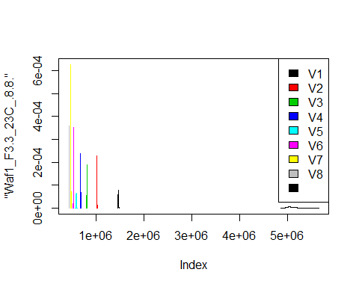

d3_8.8<-d_8.8[,c(17:24)]  
d3_8.8 <- head(d3_8.8,51)  
colnames(d3_8.8) <- c("V1", "V2","V3","V4","V5","V6","V7","V8")  
head(d3_8.8)

## V1 V2 V3 V4 V5 V6 V7 V8  
## 1 5045000 3788750 2803333 1890625 1681500 2187500 956785.7 874375.0  
## 2 5035000 3743750 2810000 1917500 1653000 2183750 954285.7 870937.5  
## 3 5032500 3743750 2820833 1896250 1677500 2185000 956428.6 870312.5  
## 4 5027500 3706250 2815833 1911250 1672500 2187917 952857.1 872187.5  
## 5 5032500 3703750 2820833 1936875 1683000 2191667 956071.4 873125.0  
## 6 5060000 3711250 2840000 1943125 1681000 2181250 958571.4 870937.5

hist(d3_8.8$V1,  
 cex.main=0.5,  
 freq = FALSE,  
 main = paste('Model:Waf1_F5.3_23C_.8.8,Inject:100NA,mean is:', mean(d3_8.8$V1),' sd is:', sd(d3_8.8$V1)),  
 xlab = "Input",  
 ylab = "Density",  
 col="grey")  
#plot density curve  
lines(density(d3_8.8$V1), # density plot  
 lwd = 2, # thickness of line  
 col = "red")

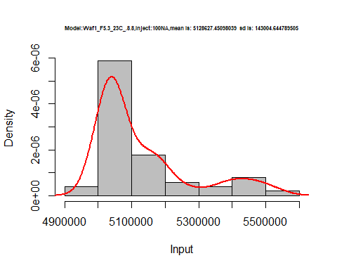

hist(d3_8.8$V2,  
 cex.main=0.5,  
 freq = FALSE,  
 main = paste('Model:Waf1_F5.3_23C_.8.8,Inject:200NA,mean is:', mean(d3_8.8$V2),' sd is:', sd(d3_8.8$V2)),  
 xlab = "Input",  
 ylab = "Density",  
 col="grey")  
#plot density curve  
lines(density(d3_8.8$V2), # density plot  
 lwd = 2, # thickness of line  
 col = "red")

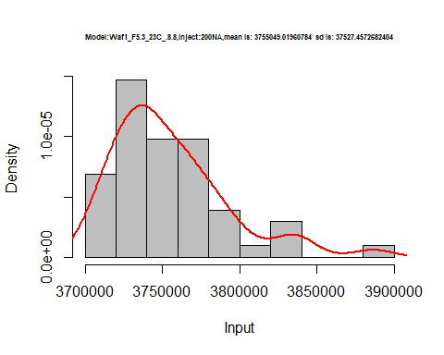

hist(d3_8.8$V3,  
 cex.main=0.5,  
 freq = FALSE,  
 main = paste('Model:Waf1_F5.3_23C_.8.8,Inject:300NA,mean is:', mean(d3_8.8$V3),' sd is:', sd(d3_8.8$V3)),  
 xlab = "Input",  
 ylab = "Density",  
 col="grey")  
#plot density curve  
lines(density(d3_8.8$V3), # density plot  
 lwd = 2, # thickness of line  
 col = "red")

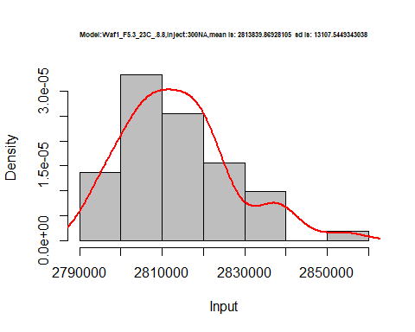

hist(d3_8.8$V4,  
 cex.main=0.5,  
 freq = FALSE,  
 main = paste('Model:Waf1_F5.3_23C_.8.8,Inject:400NA,mean is:', mean(d3_8.8$V4),' sd is:', sd(d3_8.8$V4)),  
 xlab = "Input",  
 ylab = "Density",  
 col="grey")  
#plot density curve  
lines(density(d3_8.8$V4), # density plot  
 lwd = 2, # thickness of line  
 col = "red")

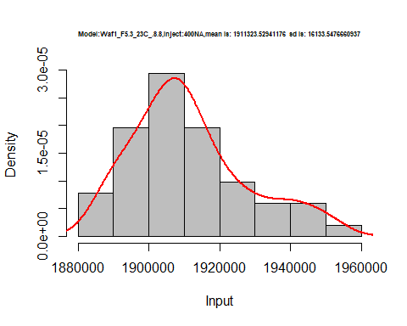

hist(d3_8.8$V5,  
 cex.main=0.5,  
 freq = FALSE,  
 main = paste('Model:Waf1_F5.3_23C_.8.8,Inject:500NA,mean is:', mean(d3_8.8$V5),' sd is:', sd(d3_8.8$V5)),  
 xlab = "Input",  
 ylab = "Density",  
 col="grey")  
#plot density curve  
lines(density(d3_8.8$V5), # density plot  
 lwd = 2, # thickness of line  
 col = "red")

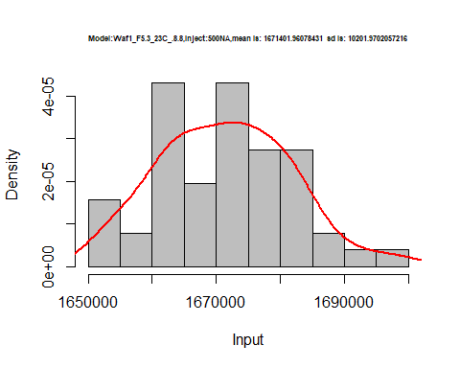

hist(d3_8.8$V6,  
 cex.main=0.5,  
 freq = FALSE,  
 main = paste('Model:Waf1_F5.3_23C_.8.8,Inject:600NA,mean is:', mean(d3_8.8$V6),' sd is:', sd(d3_8.8$V6)),  
 xlab = "Input",  
 ylab = "Density",  
 col="grey")  
#plot density curve  
lines(density(d3_8.8$V6), # density plot  
 lwd = 2, # thickness of line  
 col = "red")

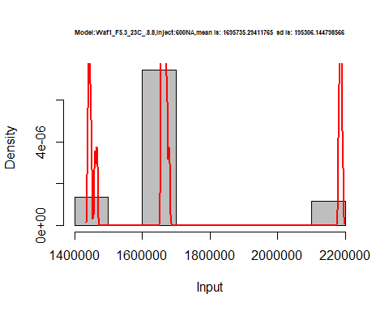

hist(d3_8.8$V7,  
 cex.main=0.5,  
 freq = FALSE,  
 main = paste('Model:Waf1_F5.3_23C_.8.8,Inject:700NA,mean is:', mean(d3_8.8$V7),' sd is:', sd(d3_8.8$V7)),  
 xlab = "Input",  
 ylab = "Density",  
 col="grey")  
#plot density curve  
lines(density(d3_8.8$V7), # density plot  
 lwd = 2, # thickness of line  
 col = "red")

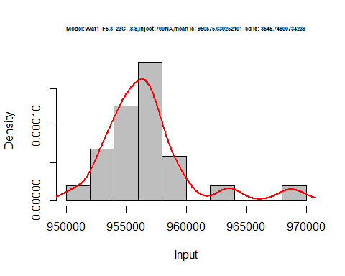

hist(d3_8.8$V8,  
 cex.main=0.5,  
 freq = FALSE,  
 main = paste('Model:Waf1_F5.3_23C_.8.8,Inject:800NA,mean is:', mean(d3_8.8$V8),' sd is:', sd(d3_8.8$V8)),  
 xlab = "Input",  
 ylab = "Density",  
 col="grey")  
#plot density curve  
lines(density(d3_8.8$V8), # density plot  
 lwd = 2, # thickness of line  
 col = "red")

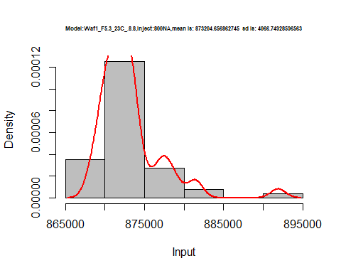

dens <- apply(d3_8.8, 2, density)  
plot('Waf1_F5.3_23C_.8.8.', xlim=range(sapply(dens, "[", "x")), ylim=range(sapply(dens, "[", "y")))

## Warning in xy.coords(x, y, xlabel, ylabel, log): NAs introduced by coercion

mapply(lines, dens, col=1:length(dens))

## $V1  
## NULL  
##   
## $V2  
## NULL  
##   
## $V3  
## NULL  
##   
## $V4  
## NULL  
##   
## $V5  
## NULL  
##   
## $V6  
## NULL  
##   
## $V7  
## NULL  
##   
## $V8  
## NULL

legend("topright", legend=names(dens), fill=1:length(dens))

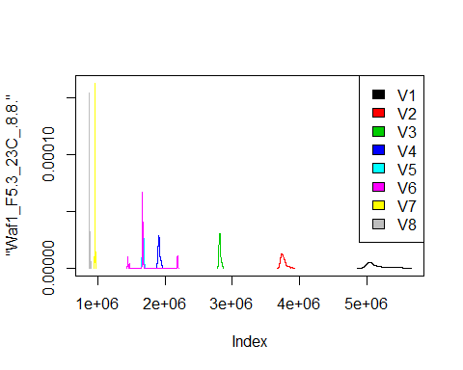

# Select columns whose names contains "9.9"  
d_9.9<-my_data %>% select(contains("9.9."))  
head(d_9.9)

## Waf1_F3.2_23C_.100nA_.9.9. Waf1_F3.2_23C_.200nA_.9.9.  
## 1 1470000 1248750  
## 2 1467500 1248750  
## 3 1470000 1251250  
## 4 1485000 1248750  
## 5 1485000 1247500  
## 6 1487500 1247500  
## Waf1_F3.2_23C_.300nA_.9.9. Waf1_F3.2_23C_.400nA_.9.9.  
## 1 1104167 1015000  
## 2 1102500 1011875  
## 3 1100833 1010000  
## 4 1102500 1011250  
## 5 1103333 1009375  
## 6 1100833 1010625  
## Waf1_F3.2_23C_.500nA_.9.9. Waf1_F3.2_23C_.600nA_.9.9.  
## 1 925000 862916.7  
## 2 924500 863333.3  
## 3 921000 864583.3  
## 4 921000 862916.7  
## 5 929000 862500.0  
## 6 929000 862916.7  
## Waf1_F3.2_23C_.700nA_.9.9. Waf1_F3.2_23C_.800nA_.9.9.  
## 1 810000.0 763750  
## 2 811071.4 763750  
## 3 811428.6 763750  
## 4 813571.4 763125  
## 5 814642.9 763750  
## 6 812857.1 763750  
## Waf1_F5.3_23C_.100nA_.9.9. Waf1_F5.3_23C_.200nA_.9.9.  
## 1 15167500 7293750  
## 2 15155000 7288750  
## 3 15140000 7285000  
## 4 15135000 7285000  
## 5 15135000 7278750  
## 6 15132500 7291250  
## Waf1_F5.3_23C_.300nA_.9.9. Waf1_F5.3_23C_.400nA_.9.9.  
## 1 5532500 4448125  
## 2 5532500 4450625  
## 3 5514167 4454375  
## 4 5507500 4448750  
## 5 5499167 4458125  
## 6 5499167 4450625  
## Waf1_F5.3_23C_.500nA_.9.9. Waf1_F5.3_23C_.600nA_.9.9.  
## 1 3873500 3362917  
## 2 3872500 3360833  
## 3 3872000 3361250  
## 4 3872000 3366250  
## 5 3869500 3362917  
## 6 3853000 3359583  
## Waf1_F5.3_23C_.700nA_.9.9. Waf1_F5.3_23C_.800nA_.9.9.  
## 1 3013929 2750625  
## 2 3010357 2749063  
## 3 2993571 2749063  
## 4 3009643 2749375  
## 5 3004286 2765625  
## 6 2966786 2754687  
## Waf1_F6.2_23C_.100nA_.9.9. Waf1_F6.2_23C_.200nA_.9.9.  
## 1 1602500 1405000  
## 2 1602500 1405000  
## 3 1597500 1407500  
## 4 1592500 1411250  
## 5 1600000 1416250  
## 6 1577500 1407500  
## Waf1_F6.2_23C_.300nA_.9.9. Waf1_F6.2_23C_.400nA_.9.9.  
## 1 1225833 1105000  
## 2 1230833 1105000  
## 3 1233333 1104375  
## 4 1233333 1106250  
## 5 1233333 1102500  
## 6 1236667 1094375  
## Waf1_F6.2_23C_.500nA_.9.9. Waf1_F6.2_23C_.600nA_.9.9.  
## 1 989500 909166.7  
## 2 991000 909583.3  
## 3 986000 912500.0  
## 4 987500 912500.0  
## 5 985000 912916.7  
## 6 988500 911666.7  
## Waf1_F6.2_23C_.700nA_.9.9. Waf1_F6.2_23C_.800nA_.9.9.  
## 1 857500.0 805000.0  
## 2 857500.0 803125.0  
## 3 857142.9 805625.0  
## 4 857857.1 807812.5  
## 5 861071.4 806562.5  
## 6 857857.1 806875.0

d1_9.9<-d_9.9[,c(1:8)]  
d1_9.9 <- head(d1_9.9,51)  
colnames(d1_9.9) <- c("V1", "V2","V3","V4","V5","V6","V7","V8")  
head(d1_9.9)

## V1 V2 V3 V4 V5 V6 V7 V8  
## 1 1470000 1248750 1104167 1015000 925000 862916.7 810000.0 763750  
## 2 1467500 1248750 1102500 1011875 924500 863333.3 811071.4 763750  
## 3 1470000 1251250 1100833 1010000 921000 864583.3 811428.6 763750  
## 4 1485000 1248750 1102500 1011250 921000 862916.7 813571.4 763125  
## 5 1485000 1247500 1103333 1009375 929000 862500.0 814642.9 763750  
## 6 1487500 1247500 1100833 1010625 929000 862916.7 812857.1 763750

hist(d1_9.9$V1,  
 cex.main=0.5,  
 freq = FALSE,  
 main = paste('Model:Waf1_F3.2_23C_.9.9,Inject:100NA,mean is:', mean(d1_9.9$V1),' sd is:', sd(d1_9.9$V1)),  
 xlab = "Input",  
 ylab = "Density",  
 col="grey")  
#plot density curve  
lines(density(d1_9.9$V1), # density plot  
 lwd = 2, # thickness of line  
 col = "red")

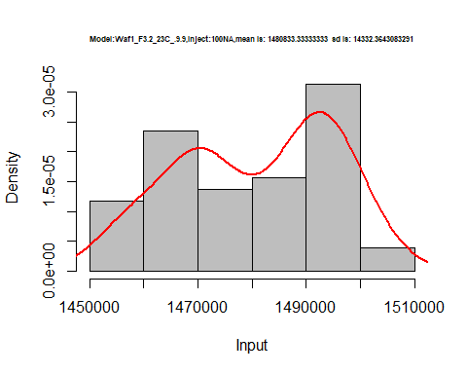

hist(d1_9.9$V2,  
 cex.main=0.5,  
 freq = FALSE,  
 main = paste('Model:Waf1_F3.2_23C_.9.9,Inject:200NA,mean is:', mean(d1_9.9$V2),' sd is:', sd(d1_9.9$V2)),  
 xlab = "Input",  
 ylab = "Density",  
 col="grey")  
#plot density curve  
lines(density(d1_9.9$V2), # density plot  
 lwd = 2, # thickness of line  
 col = "red")

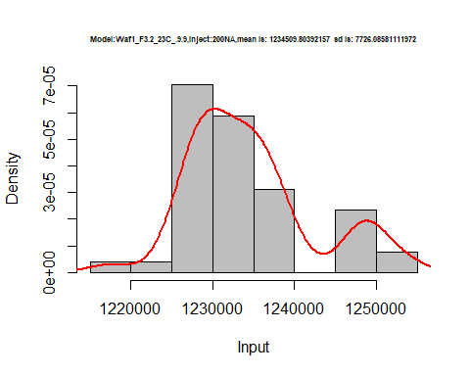

hist(d1_9.9$V3,  
 cex.main=0.5,  
 freq = FALSE,  
 main = paste('Model:Waf1_F3.2_23C_.9.9,Inject:300NA,mean is:', mean(d1_9.9$V3),' sd is:', sd(d1_9.9$V3)),  
 xlab = "Input",  
 ylab = "Density",  
 col="grey")  
#plot density curve  
lines(density(d1_9.9$V3), # density plot  
 lwd = 2, # thickness of line  
 col = "red")

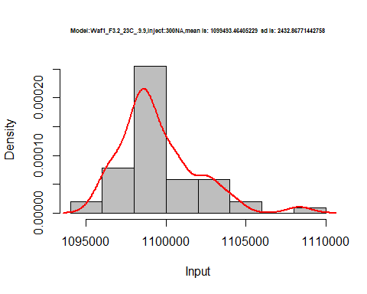

hist(d1_9.9$V4,  
 cex.main=0.5,  
 freq = FALSE,  
 main = paste('Model:Waf1_F3.2_23C_.9.9,Inject:400NA,mean is:', mean(d1_9.9$V4),' sd is:', sd(d1_9.9$V4)),  
 xlab = "Input",  
 ylab = "Density",  
 col="grey")  
#plot density curve  
lines(density(d1_9.9$V4), # density plot  
 lwd = 2, # thickness of line  
 col = "red")

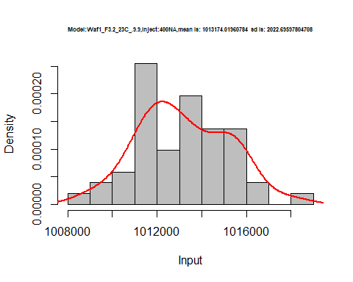

hist(d1_9.9$V5,  
 cex.main=0.5,  
 freq = FALSE,  
 main = paste('Model:Waf1_F3.2_23C_.9.9,Inject:500NA,mean is:', mean(d1_9.9$V5),' sd is:', sd(d1_9.9$V5)),  
 xlab = "Input",  
 ylab = "Density",  
 col="grey")  
#plot density curve  
lines(density(d1_9.9$V5), # density plot  
 lwd = 2, # thickness of line  
 col = "red")

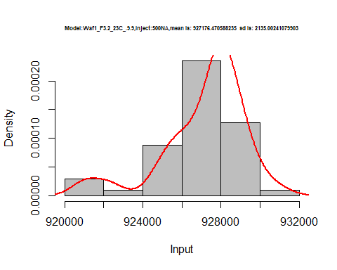

hist(d1_9.9$V6,  
 cex.main=0.5,  
 freq = FALSE,  
 main = paste('Model:Waf1_F3.2_23C_.9.9,Inject:600NA,mean is:', mean(d1_9.9$V6),' sd is:', sd(d1_9.9$V6)),  
 xlab = "Input",  
 ylab = "Density",  
 col="grey")  
#plot density curve  
lines(density(d1_9.9$V6), # density plot  
 lwd = 2, # thickness of line  
 col = "red")

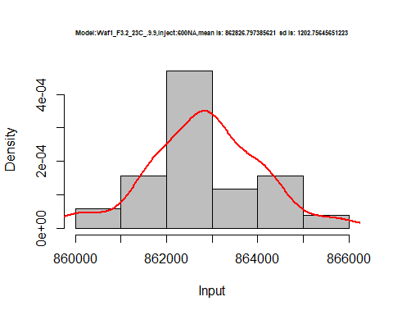

hist(d1_9.9$V7,  
 cex.main=0.5,  
 freq = FALSE,  
 main = paste('Model:Waf1_F3.2_23C_.9.9,Inject:700NA,mean is:', mean(d1_9.9$V7),' sd is:', sd(d1_9.9$V7)),  
 xlab = "Input",  
 ylab = "Density",  
 col="grey")  
#plot density curve  
lines(density(d1_9.9$V7), # density plot  
 lwd = 2, # thickness of line  
 col = "red")

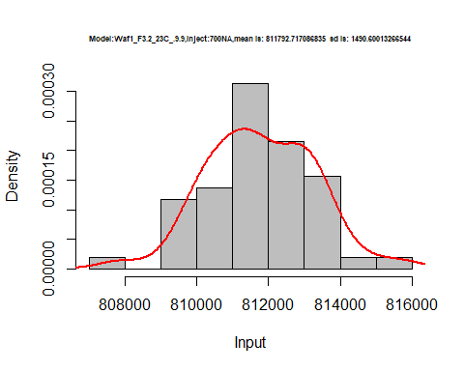

hist(d1_9.9$V8,  
 cex.main=0.5,  
 freq = FALSE,  
 main = paste('Model:Waf1_F3.2_23C_.9.9,Inject:800NA,mean is:', mean(d1_9.9$V8),' sd is:', sd(d1_9.9$V8)),  
 xlab = "Input",  
 ylab = "Density",  
 col="grey")  
#plot density curve  
lines(density(d1_9.9$V8), # density plot  
 lwd = 2, # thickness of line  
 col = "red")

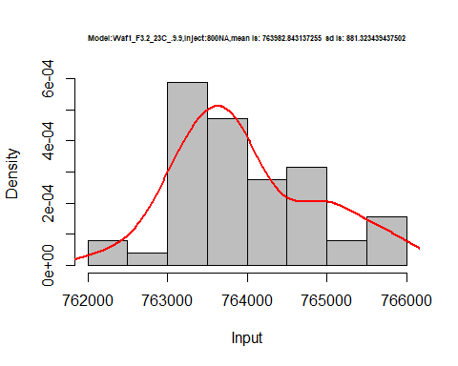

dens <- apply(d1_9.9, 2, density)  
plot('Waf1_F3.2_23C_.100nA_.9.9', xlim=range(sapply(dens, "[", "x")), ylim=range(sapply(dens, "[", "y")))

## Warning in xy.coords(x, y, xlabel, ylabel, log): NAs introduced by coercion

mapply(lines, dens, col=1:length(dens))

## $V1  
## NULL  
##   
## $V2  
## NULL  
##   
## $V3  
## NULL  
##   
## $V4  
## NULL  
##   
## $V5  
## NULL  
##   
## $V6  
## NULL  
##   
## $V7  
## NULL  
##   
## $V8  
## NULL

legend("topright", legend=names(dens), fill=1:length(dens))

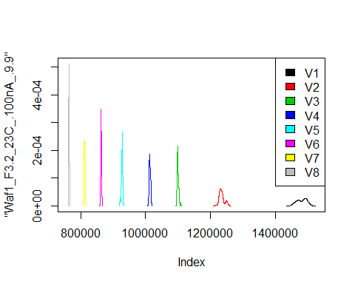

d2_9.9<-d_9.9[,c(9:16)]  
d2_9.9 <- head(d2_9.9,51)  
colnames(d2_9.9) <- c("V1", "V2","V3","V4","V5","V6","V7","V8")  
head(d2_9.9)

## V1 V2 V3 V4 V5 V6 V7 V8  
## 1 15167500 7293750 5532500 4448125 3873500 3362917 3013929 2750625  
## 2 15155000 7288750 5532500 4450625 3872500 3360833 3010357 2749063  
## 3 15140000 7285000 5514167 4454375 3872000 3361250 2993571 2749063  
## 4 15135000 7285000 5507500 4448750 3872000 3366250 3009643 2749375  
## 5 15135000 7278750 5499167 4458125 3869500 3362917 3004286 2765625  
## 6 15132500 7291250 5499167 4450625 3853000 3359583 2966786 2754687

hist(d2_9.9$V1,  
 cex.main=0.5,  
 freq = FALSE,  
 main = paste('Model:Waf1_F5.3_23C_.9.9,Inject:100NA,mean is:', mean(d2_9.9$V1),' sd is:', sd(d2_9.9$V1)),  
 xlab = "Input",  
 ylab = "Density",  
 col="grey")  
#plot density curve  
lines(density(d2_9.9$V1), # density plot  
 lwd = 2, # thickness of line  
 col = "red")

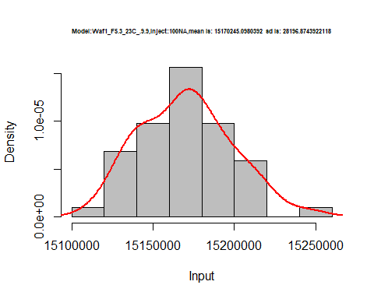

hist(d2_9.9$V2,  
 cex.main=0.5,  
 freq = FALSE,  
 main = paste('Model:Waf1_F5.3_23C_.9.9,Inject:200NA,mean is:', mean(d2_9.9$V2),' sd is:', sd(d2_9.9$V2)),  
 xlab = "Input",  
 ylab = "Density",  
 col="grey")  
#plot density curve  
lines(density(d2_9.9$V2), # density plot  
 lwd = 2, # thickness of line  
 col = "red")

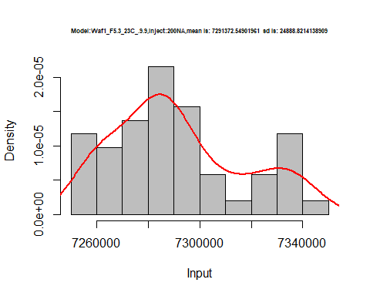

hist(d2_9.9$V3,  
 cex.main=0.5,  
 freq = FALSE,  
 main = paste('Model:Waf1_F5.3_23C_.9.9,Inject:300NA,mean is:', mean(d2_9.9$V3),' sd is:', sd(d2_9.9$V3)),  
 xlab = "Input",  
 ylab = "Density",  
 col="grey")  
#plot density curve  
lines(density(d2_9.9$V3), # density plot  
 lwd = 2, # thickness of line  
 col = "red")

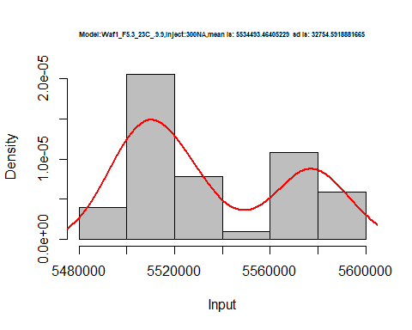

hist(d2_9.9$V4,  
 cex.main=0.5,  
 freq = FALSE,  
 main = paste('Model:Waf1_F5.3_23C_.9.9,Inject:400NA,mean is:', mean(d2_9.9$V4),' sd is:', sd(d2_9.9$V4)),  
 xlab = "Input",  
 ylab = "Density",  
 col="grey")  
#plot density curve  
lines(density(d2_9.9$V4), # density plot  
 lwd = 2, # thickness of line  
 col = "red")

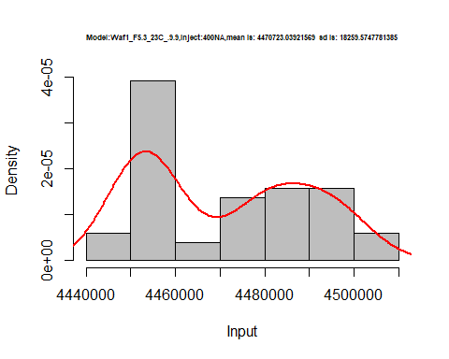

hist(d2_9.9$V5,  
 cex.main=0.5,  
 freq = FALSE,  
 main = paste('Model:Waf1_F5.3_23C_.9.9,Inject:500NA,mean is:', mean(d2_9.9$V5),' sd is:', sd(d2_9.9$V5)),  
 xlab = "Input",  
 ylab = "Density",  
 col="grey")  
#plot density curve  
lines(density(d2_9.9$V5), # density plot  
 lwd = 2, # thickness of line  
 col = "red")

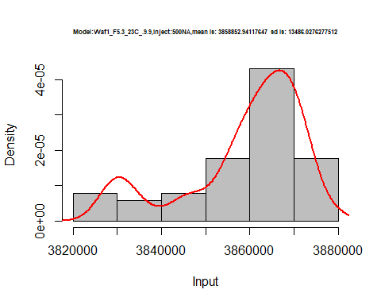

hist(d2_9.9$V6,  
 cex.main=0.5,  
 freq = FALSE,  
 main = paste('Model:Waf1_F5.3_23C_.9.9,Inject:600NA,mean is:', mean(d2_9.9$V6),' sd is:', sd(d2_9.9$V6)),  
 xlab = "Input",  
 ylab = "Density",  
 col="grey")  
#plot density curve  
lines(density(d2_9.9$V6), # density plot  
 lwd = 2, # thickness of line  
 col = "red")

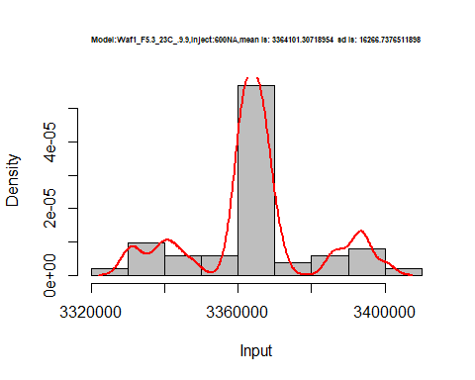

hist(d2_9.9$V7,  
 cex.main=0.5,  
 freq = FALSE,  
 main = paste('Model:Waf1_F5.3_23C_.9.9,Inject:700NA,mean is:', mean(d2_9.9$V7),' sd is:', sd(d2_9.9$V7)),  
 xlab = "Input",  
 ylab = "Density",  
 col="grey")  
#plot density curve  
lines(density(d2_9.9$V7), # density plot  
 lwd = 2, # thickness of line  
 col = "red")

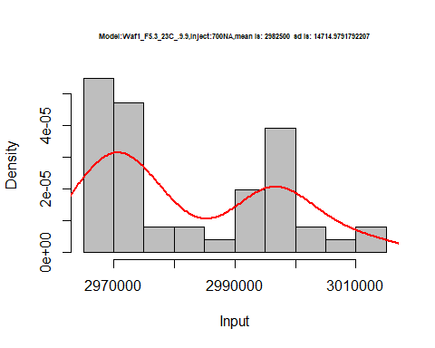

hist(d2_9.9$V8,  
 cex.main=0.5,  
 freq = FALSE,  
 main = paste('Model:Waf1_F5.3_23C_.100nA_.9.9,Inject:800NA,mean is:', mean(d2_9.9$V8),' sd is:', sd(d2_9.9$V8)),  
 xlab = "Input",  
 ylab = "Density",  
 col="grey")  
#plot density curve  
lines(density(d2_9.9$V8), # density plot  
 lwd = 2, # thickness of line  
 col = "red")

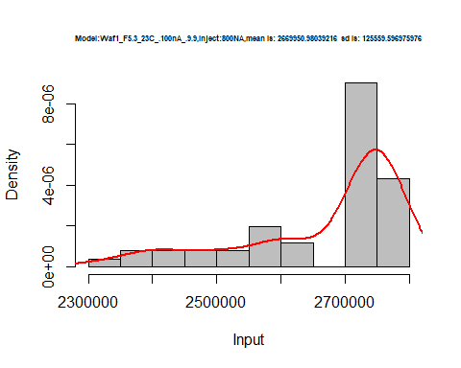

dens <- apply(d2_9.9, 2, density)  
plot('Waf1_F5.3_23C_.9.9', xlim=range(sapply(dens, "[", "x")), ylim=range(sapply(dens, "[", "y")))

## Warning in xy.coords(x, y, xlabel, ylabel, log): NAs introduced by coercion

mapply(lines, dens, col=1:length(dens))

## $V1  
## NULL  
##   
## $V2  
## NULL  
##   
## $V3  
## NULL  
##   
## $V4  
## NULL  
##   
## $V5  
## NULL  
##   
## $V6  
## NULL  
##   
## $V7  
## NULL  
##   
## $V8  
## NULL

legend("topright", legend=names(dens), fill=1:length(dens))

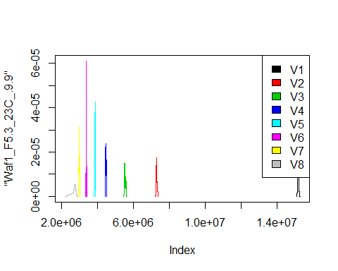

d3_9.9<-d_9.9[,c(17:24)]  
d3_9.9 <- head(d3_9.9,51)  
colnames(d3_9.9) <- c("V1", "V2","V3","V4","V5","V6","V7","V8")  
head(d3_9.9)

## V1 V2 V3 V4 V5 V6 V7 V8  
## 1 1602500 1405000 1225833 1105000 989500 909166.7 857500.0 805000.0  
## 2 1602500 1405000 1230833 1105000 991000 909583.3 857500.0 803125.0  
## 3 1597500 1407500 1233333 1104375 986000 912500.0 857142.9 805625.0  
## 4 1592500 1411250 1233333 1106250 987500 912500.0 857857.1 807812.5  
## 5 1600000 1416250 1233333 1102500 985000 912916.7 861071.4 806562.5  
## 6 1577500 1407500 1236667 1094375 988500 911666.7 857857.1 806875.0

hist(d3_9.9$V1,  
 cex.main=0.5,  
 freq = FALSE,  
 main = paste('Model:Waf1_F6.2_23C_.9.9,Inject:100NA,mean is:', mean(d3_9.9$V1),' sd is:', sd(d3_9.9$V1)),  
 xlab = "Input",  
 ylab = "Density",  
 col="grey")  
#plot density curve  
lines(density(d3_9.9$V1), # density plot  
 lwd = 2, # thickness of line  
 col = "red")

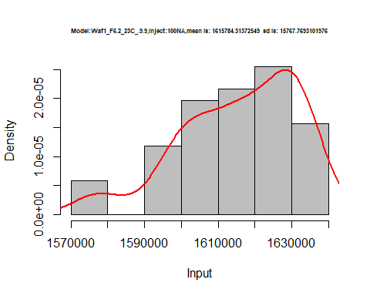

hist(d3_9.9$V2,  
 cex.main=0.5,  
 freq = FALSE,  
 main = paste('Model:Waf1_F6.2_23C_.9.9,Inject:100NA,mean is:', mean(d3_9.9$V2),' sd is:', sd(d3_9.9$V2)),  
 xlab = "Input",  
 ylab = "Density",  
 col="grey")  
#plot density curve  
lines(density(d3_9.9$V2), # density plot  
 lwd = 2, # thickness of line  
 col = "red")

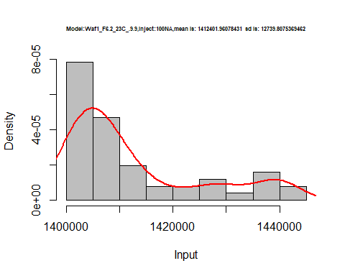

hist(d3_9.9$V3,  
 cex.main=0.5,  
 freq = FALSE,  
 main = paste('Model:Waf1_F6.2_23C_.9.9,Inject:300NA,mean is:', mean(d3_9.9$V3),' sd is:', sd(d3_9.9$V3)),  
 xlab = "Input",  
 ylab = "Density",  
 col="grey")  
#plot density curve  
lines(density(d3_9.9$V3), # density plot  
 lwd = 2, # thickness of line  
 col = "red")

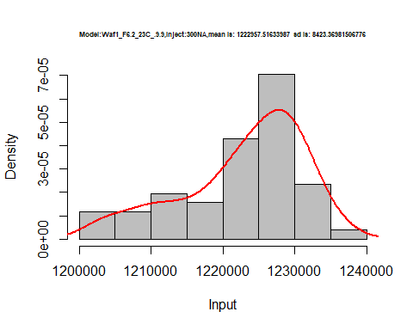

hist(d3_9.9$V4,  
 cex.main=0.5,  
 freq = FALSE,  
 main = paste('Model:Waf1_F6.2_23C_.9.9,Inject:400NA,mean is:', mean(d3_9.9$V4),' sd is:', sd(d3_9.9$V4)),  
 xlab = "Input",  
 ylab = "Density",  
 col="grey")  
#plot density curve  
lines(density(d3_9.9$V4), # density plot  
 lwd = 2, # thickness of line  
 col = "red")

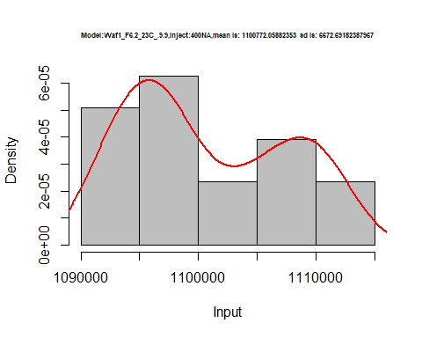

hist(d3_9.9$V5,  
 cex.main=0.5,  
 freq = FALSE,  
 main = paste('Model:Waf1_F6.2_23C_.9.9,Inject:500NA,mean is:', mean(d3_9.9$V5),' sd is:', sd(d3_9.9$V5)),  
 xlab = "Input",  
 ylab = "Density",  
 col="grey")  
#plot density curve  
lines(density(d3_9.9$V5), # density plot  
 lwd = 2, # thickness of line  
 col = "red")

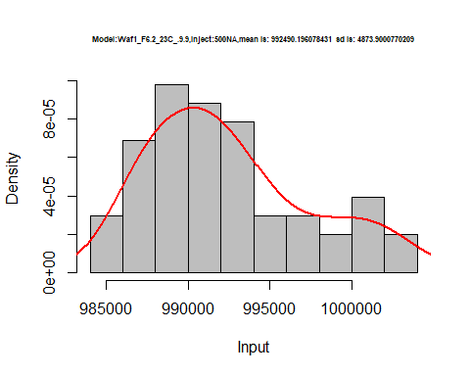

hist(d3_9.9$V6,  
 cex.main=0.5,  
 freq = FALSE,  
 main = paste('Model:Waf1_F6.2_23C_.9.9,Inject:600NA,mean is:', mean(d3_9.9$V6),' sd is:', sd(d3_9.9$V6)),  
 xlab = "Input",  
 ylab = "Density",  
 col="grey")  
#plot density curve  
lines(density(d3_9.9$V6), # density plot  
 lwd = 2, # thickness of line  
 col = "red")

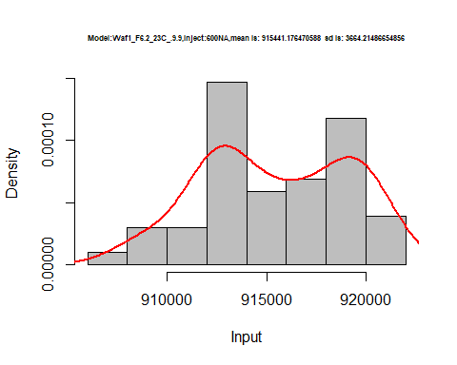

hist(d3_9.9$V7,  
 cex.main=0.5,  
 freq = FALSE,  
 main = paste('Model:Waf1_F6.2_23C_.9.9,Inject:100NA,mean is:', mean(d3_9.9$V7),' sd is:', sd(d3_9.9$V7)),  
 xlab = "Input",  
 ylab = "Density",  
 col="grey")  
#plot density curve  
lines(density(d3_9.9$V7), # density plot  
 lwd = 2, # thickness of line  
 col = "red")

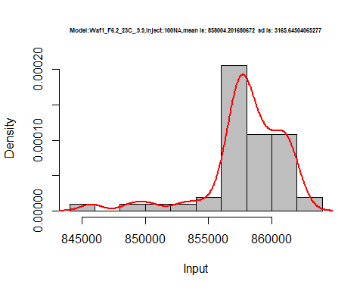

hist(d3_9.9$V8,  
 cex.main=0.5,  
 freq = FALSE,  
 main = paste('Model:Waf1_F6.2_23C_.9.9,Inject:800NA,mean is:', mean(d3_9.9$V8),' sd is:', sd(d3_9.9$V8)),  
 xlab = "Input",  
 ylab = "Density",  
 col="grey")  
#plot density curve  
lines(density(d3_9.9$V8), # density plot  
 lwd = 2, # thickness of line  
 col = "red")

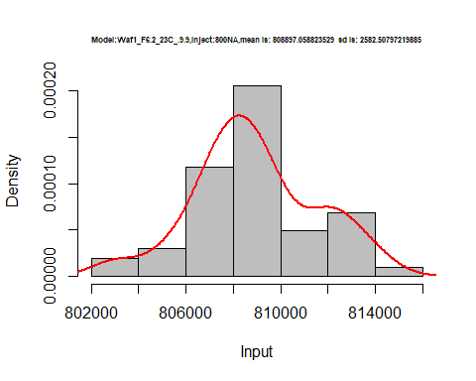

dens <- apply(d3_9.9, 2, density)  
plot('Model:Waf1_F6.2_23C_.100nA_.9.9', xlim=range(sapply(dens, "[", "x")), ylim=range(sapply(dens, "[", "y")))

## Warning in xy.coords(x, y, xlabel, ylabel, log): NAs introduced by coercion

mapply(lines, dens, col=1:length(dens))

## $V1  
## NULL  
##   
## $V2  
## NULL  
##   
## $V3  
## NULL  
##   
## $V4  
## NULL  
##   
## $V5  
## NULL  
##   
## $V6  
## NULL  
##   
## $V7  
## NULL  
##   
## $V8  
## NULL

legend("topright", legend=names(dens), fill=1:length(dens))

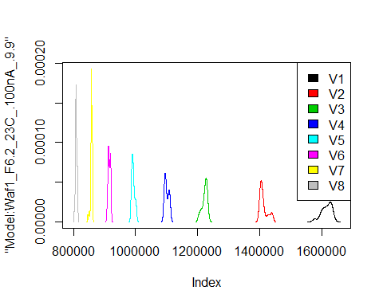

# Select columns whose names contains "10.10"  
d_10.10<-my_data %>% select(contains("10.10."))  
d_10.10 <- head(d_10.10,51)  
colnames(d_10.10) <- c("V1", "V2","V3","V4","V5","V6","V7","V8")  
head(d_10.10)

## V1 V2 V3 V4 V5 V6 V7 V8  
## 1 9420000 6030000 4702500 3946875 3361000 2431667 2284286 2126250  
## 2 9432500 6002500 4729167 3800000 3385500 2537083 2302857 2101875  
## 3 9477500 5998750 4728333 3404375 3331000 2686667 2312143 2151250  
## 4 9417500 5985000 4729167 3273125 3317000 2491250 2313929 2164688  
## 5 9347500 6023750 4723333 3249375 3374000 2441250 2313571 2160000  
## 6 9300000 6071250 4740000 3255625 3404000 2435833 2318571 2166562

hist(d_10.10$V1,  
 cex.main=0.5,  
 freq = FALSE,  
 main = paste('Model:Waf1_F4.3_23C_.10.10,Inject:100NA,mean is:', mean(d_10.10$V1),' sd is:', sd(d_10.10$V1)),  
 xlab = "Input",  
 ylab = "Density",  
 col="grey")  
#plot density curve  
lines(density(d_10.10$V1), # density plot  
 lwd = 2, # thickness of line  
 col = "red")

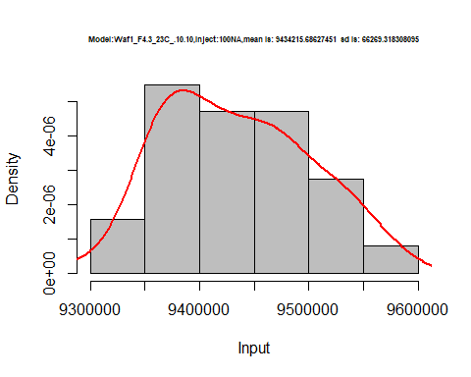

hist(d_10.10$V2,  
 cex.main=0.5,  
 freq = FALSE,  
 main = paste('Model:Waf1_F4.3_23C_.10.10,Inject:200NA,mean is:', mean(d_10.10$V2),' sd is:', sd(d_10.10$V2)),  
 xlab = "Input",  
 ylab = "Density",  
 col="grey")  
#plot density curve  
lines(density(d_10.10$V2), # density plot  
 lwd = 2, # thickness of line  
 col = "red")

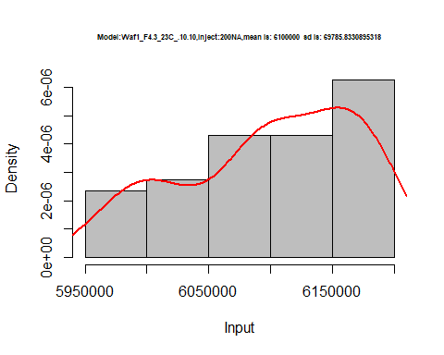

hist(d_10.10$V3,  
 cex.main=0.5,  
 freq = FALSE,  
 main = paste('Model:Waf1_F4.3_23C_.10.10,Inject:300NA,mean is:', mean(d_10.10$V3),' sd is:', sd(d_10.10$V3)),  
 xlab = "Input",  
 ylab = "Density",  
 col="grey")  
#plot density curve  
lines(density(d_10.10$V3), # density plot  
 lwd = 2, # thickness of line  
 col = "red")

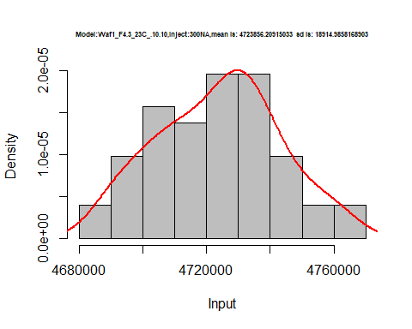

hist(d_10.10$V4,  
 cex.main=0.5,  
 freq = FALSE,  
 main = paste('Model:Waf1_F4.3_23C_.10.10,Inject:400NA,mean is:', mean(d_10.10$V4),' sd is:', sd(d_10.10$V4)),  
 xlab = "Input",  
 ylab = "Density",  
 col="grey")  
#plot density curve  
lines(density(d_10.10$V4), # density plot  
 lwd = 2, # thickness of line  
 col = "red")

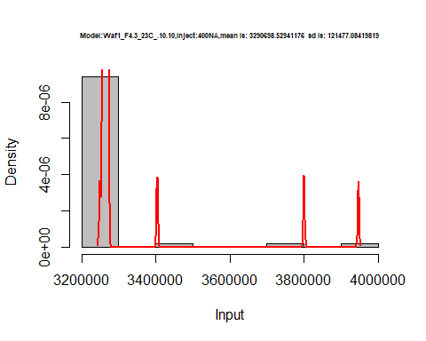

hist(d_10.10$V5,  
 cex.main=0.5,  
 freq = FALSE,  
 main = paste('Model:Waf1_F4.3_23C_.10.10,Inject:500NA,mean is:', mean(d_10.10$V5),' sd is:', sd(d_10.10$V5)),  
 xlab = "Input",  
 ylab = "Density",  
 col="grey")  
#plot density curve  
lines(density(d_10.10$V5), # density plot  
 lwd = 2, # thickness of line  
 col = "red")

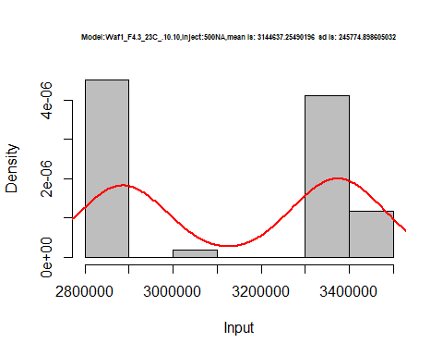

hist(d_10.10$V6,  
 cex.main=0.5,  
 freq = FALSE,  
 main = paste('Model:Waf1_F4.3_23C_.10.10,Inject:600NA,mean is:', mean(d_10.10$V6),' sd is:', sd(d_10.10$V6)),  
 xlab = "Input",  
 ylab = "Density",  
 col="grey")  
#plot density curve  
lines(density(d_10.10$V6), # density plot  
 lwd = 2, # thickness of line  
 col = "red")

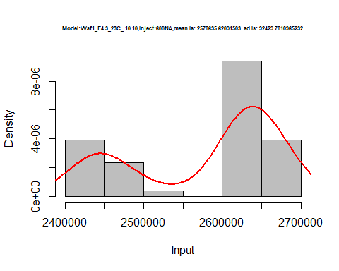

hist(d_10.10$V7,  
 cex.main=0.5,  
 freq = FALSE,  
 main = paste('Model:Waf1_F4.3_23C_.10.10,Inject:700NA,mean is:', mean(d_10.10$V7),' sd is:', sd(d_10.10$V7)),  
 xlab = "Input",  
 ylab = "Density",  
 col="grey")  
#plot density curve  
lines(density(d_10.10$V7), # density plot  
 lwd = 2, # thickness of line  
 col = "red")

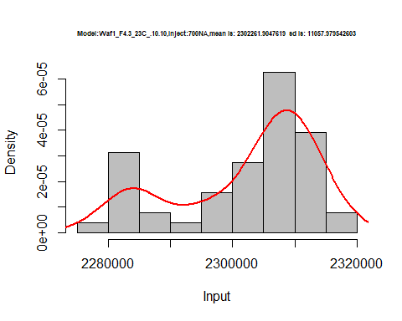

hist(d_10.10$V8,  
 cex.main=0.5,  
 freq = FALSE,  
 main = paste('Model:Waf1_F4.3_23C_.10.10,Inject:800NA,mean is:', mean(d_10.10$V8),' sd is:', sd(d_10.10$V8)),  
 xlab = "Input",  
 ylab = "Density",  
 col="grey")  
#plot density curve  
lines(density(d_10.10$V8), # density plot  
 lwd = 2, # thickness of line  
 col = "red")

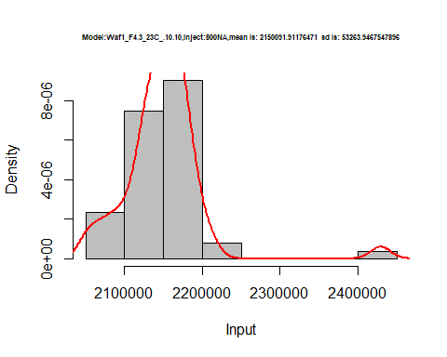

dens <- apply(d_10.10, 2, density)  
plot('Model:Waf1_F4.3_23C_.10.10', xlim=range(sapply(dens, "[", "x")), ylim=range(sapply(dens, "[", "y")))

## Warning in xy.coords(x, y, xlabel, ylabel, log): NAs introduced by coercion

mapply(lines, dens, col=1:length(dens))

## $V1  
## NULL  
##   
## $V2  
## NULL  
##   
## $V3  
## NULL  
##   
## $V4  
## NULL  
##   
## $V5  
## NULL  
##   
## $V6  
## NULL  
##   
## $V7  
## NULL  
##   
## $V8  
## NULL

legend("topright", legend=names(dens), fill=1:length(dens))

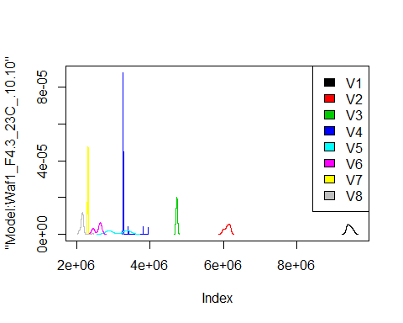

# Select columns whose names contains "11.11"  
d_11.11<-my_data %>% select(contains("11.11."))  
head(d_11.11)

## Waf1_F3.5_23C_.100nA_.11.11. Waf1_F3.5_23C_.200nA_.11.11.  
## 1 3937500 3005000  
## 2 3907500 3006250  
## 3 3932500 3007500  
## 4 3945000 3008750  
## 5 3950000 3008750  
## 6 3952500 3005000  
## Waf1_F3.5_23C_.300nA_.11.11. Waf1_F3.5_23C_.400nA_.11.11.  
## 1 2652500 2321875  
## 2 2650833 2323125  
## 3 2652500 2289375  
## 4 2652500 2275000  
## 5 2652500 2286875  
## 6 2650000 2311875  
## Waf1_F3.5_23C_.500nA_.11.11. Waf1_F3.5_23C_.600nA_.11.11.  
## 1 2087500 1881250  
## 2 2089000 1896250  
## 3 2089000 1902500  
## 4 2089500 1875417  
## 5 2086500 1897917  
## 6 2084000 1894167  
## Waf1_F3.5_23C_.700nA_.11.11. Waf1_F3.5_23C_.800nA_.11.11.  
## 1 1742143 1589375  
## 2 1739643 1592187  
## 3 1718571 1590313  
## 4 1725357 1586250  
## 5 1736071 1589375  
## 6 1741071 1595938  
## Waf1_F4.3_23C_.100nA_.11.11. Waf1_F4.3_23C_.200nA_.11.11.  
## 1 1490000 1258750  
## 2 1485000 1255000  
## 3 1480000 1261250  
## 4 1477500 1261250  
## 5 1477500 1261250  
## 6 1477500 1258750  
## Waf1_F4.3_23C_.300nA_.11.11. Waf1_F4.3_23C_.400nA_.11.11.  
## 1 1155833 1058125  
## 2 1160000 1058750  
## 3 1161667 1055000  
## 4 1160000 1057500  
## 5 1159167 1056250  
## 6 1159167 1058125  
## Waf1_F4.3_23C_.500nA_.11.11. Waf1_F4.3_23C_.600nA_.11.11.  
## 1 970000 905416.7  
## 2 974500 907916.7  
## 3 973500 906250.0  
## 4 974500 906666.7  
## 5 973000 910416.7  
## 6 976000 907083.3  
## Waf1_F4.3_23C_.700nA_.11.11. Waf1_F4.3_23C_.800nA_.11.11.  
## 1 853571.4 807187.5  
## 2 853214.3 808125.0  
## 3 856071.4 807187.5  
## 4 853928.6 807187.5  
## 5 854642.9 807187.5  
## 6 854285.7 810000.0  
## Waf1_F6.3_23C_.100nA_.11.11. Waf1_F6.3_23C_.200nA_.11.11.  
## 1 2122500 1548750  
## 2 2120000 1552500  
## 3 2117500 1553750  
## 4 2115000 1546250  
## 5 2115000 1548750  
## 6 2105000 1547500  
## Waf1_F6.3_23C_.300nA_.11.11. Waf1_F6.3_23C_.400nA_.11.11.  
## 1 1317500 1116875  
## 2 1318333 1118750  
## 3 1314167 1120625  
## 4 1315000 1116875  
## 5 1315000 1117500  
## 6 1311667 1113750  
## Waf1_F6.3_23C_.500nA_.11.11. Waf1_F6.3_23C_.600nA_.11.11.  
## 1 1007000 920833.3  
## 2 1006500 918750.0  
## 3 1005500 917500.0  
## 4 1005500 916666.7  
## 5 1006000 919166.7  
## 6 1005500 922083.3  
## Waf1_F6.3_23C_.700nA_.11.11. Waf1_F6.3_23C_.800nA_.11.11.  
## 1 858214.3 788750.0  
## 2 856785.7 789062.5  
## 3 860000.0 789687.5  
## 4 857857.1 788437.5  
## 5 857857.1 788750.0  
## 6 857500.0 789375.0  
## Waf1_F9.5_23C_.100nA_.11.11. Waf1_F9.5_23C_.200nA_.11.11.  
## 1 1250000 1140000  
## 2 1257500 1130000  
## 3 1257500 1122500  
## 4 1257500 1130000  
## 5 1260000 1135000  
## 6 1260000 1135000  
## Waf1_F9.5_23C_.300nA_.11.11. Waf1_F9.5_23C_.400nA_.11.11.  
## 1 1001666.7 900000  
## 2 998333.3 891875  
## 3 998333.3 897500  
## 4 995000.0 900000  
## 5 1002500.0 893125  
## 6 995833.3 891250  
## Waf1_F9.5_23C_.500nA_.11.11. Waf1_F9.5_23C_.600nA_.11.11.  
## 1 829500 772916.7  
## 2 832000 775833.3  
## 3 832000 767083.3  
## 4 827000 763750.0  
## 5 833500 766666.7  
## 6 825500 772500.0  
## Waf1_F9.5_23C_.700nA_.11.11. Waf1_F9.5_23C_.800nA_.11.11.  
## 1 722857.1 674687.5  
## 2 719285.7 673125.0  
## 3 715000.0 673750.0  
## 4 714642.9 678437.5  
## 5 716785.7 677812.5  
## 6 718928.6 672812.5

d1_11.11<-d_11.11[,c(1:8)]  
d1_11.11 <- head(d1_11.11,51)  
colnames(d1_11.11) <- c("V1", "V2","V3","V4","V5","V6","V7","V8")  
head(d1_11.11)

## V1 V2 V3 V4 V5 V6 V7 V8  
## 1 3937500 3005000 2652500 2321875 2087500 1881250 1742143 1589375  
## 2 3907500 3006250 2650833 2323125 2089000 1896250 1739643 1592187  
## 3 3932500 3007500 2652500 2289375 2089000 1902500 1718571 1590313  
## 4 3945000 3008750 2652500 2275000 2089500 1875417 1725357 1586250  
## 5 3950000 3008750 2652500 2286875 2086500 1897917 1736071 1589375  
## 6 3952500 3005000 2650000 2311875 2084000 1894167 1741071 1595938

hist(d1_11.11$V1,  
 cex.main=0.5,  
 freq = FALSE,  
 main = paste('Model:Waf1_F3.5_23C_.11.11.,Inject:100NA,mean is:', mean(d1_11.11$V1),' sd is:', sd(d1_11.11$V1)),  
 xlab = "Input",  
 ylab = "Density",  
 col="grey")  
#plot density curve  
lines(density(d1_11.11$V1), # density plot  
 lwd = 2, # thickness of line  
 col = "red")

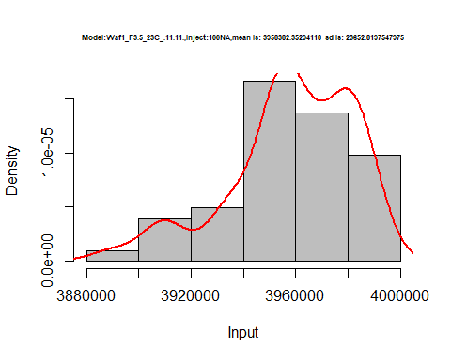

hist(d1_11.11$V2,  
 cex.main=0.5,  
 freq = FALSE,  
 main = paste('Model:Waf1_F3.5_23C_.11.11.,Inject:200NA,mean is:', mean(d1_11.11$V2),' sd is:', sd(d1_11.11$V2)),  
 xlab = "Input",  
 ylab = "Density",  
 col="grey")  
#plot density curve  
lines(density(d1_11.11$V2), # density plot  
 lwd = 2, # thickness of line  
 col = "red")

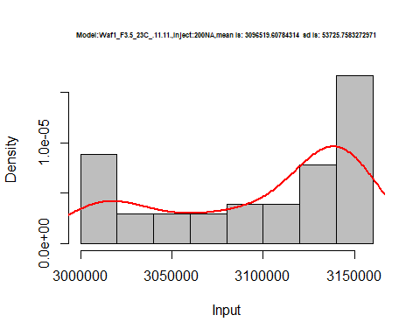

hist(d1_11.11$V3,  
 cex.main=0.5,  
 freq = FALSE,  
 main = paste('Model:Waf1_F3.5_23C_.11.11.,Inject:300NA,mean is:', mean(d1_11.11$V3),' sd is:', sd(d1_11.11$V3)),  
 xlab = "Input",  
 ylab = "Density",  
 col="grey")  
#plot density curve  
lines(density(d1_11.11$V3), # density plot  
 lwd = 2, # thickness of line  
 col = "red")

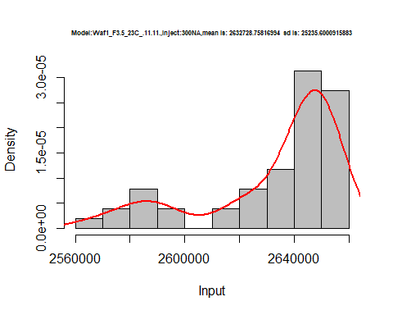

hist(d1_11.11$V4,  
 cex.main=0.5,  
 freq = FALSE,  
 main = paste('Model:Waf1_F3.5_23C_.11.11.,Inject:400NA,mean is:', mean(d1_11.11$V4),' sd is:', sd(d1_11.11$V4)),  
 xlab = "Input",  
 ylab = "Density",  
 col="grey")  
#plot density curve  
lines(density(d1_11.11$V4), # density plot  
 lwd = 2, # thickness of line  
 col = "red")

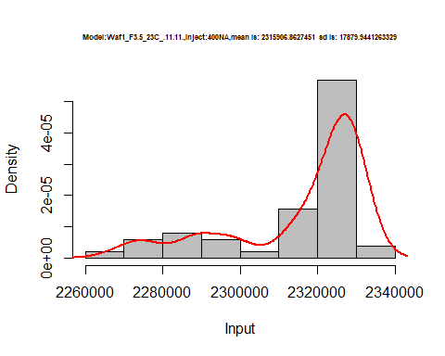

hist(d1_11.11$V5,  
 cex.main=0.5,  
 freq = FALSE,  
 main = paste('Model:Waf1_F3.5_23C_.11.11.,Inject:500NA,mean is:', mean(d1_11.11$V5),' sd is:', sd(d1_11.11$V5)),  
 xlab = "Input",  
 ylab = "Density",  
 col="grey")  
#plot density curve  
lines(density(d1_11.11$V5), # density plot  
 lwd = 2, # thickness of line  
 col = "red")

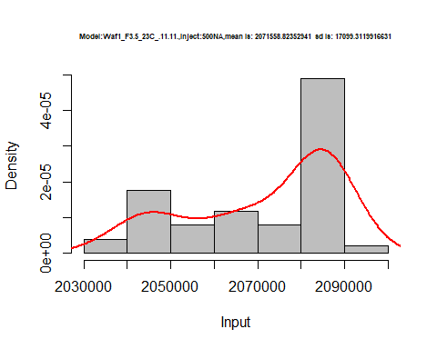

hist(d1_11.11$V6,  
 cex.main=0.5,  
 freq = FALSE,  
 main = paste('Model:Waf1_F3.5_23C_.11.11.,Inject:600NA,mean is:', mean(d1_11.11$V6),' sd is:', sd(d1_11.11$V6)),  
 xlab = "Input",  
 ylab = "Density",  
 col="grey")  
#plot density curve  
lines(density(d1_11.11$V6), # density plot  
 lwd = 2, # thickness of line  
 col = "red")

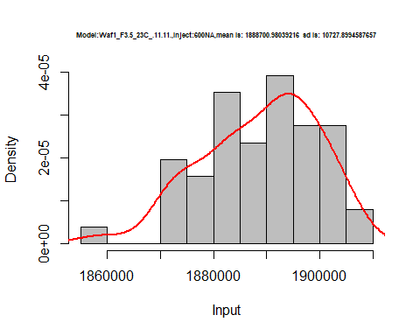

hist(d1_11.11$V7,  
 cex.main=0.5,  
 freq = FALSE,  
 main = paste('Model:Waf1_F3.5_23C_.11.11.,Inject:700NA,mean is:', mean(d1_11.11$V7),' sd is:', sd(d1_11.11$V7)),  
 xlab = "Input",  
 ylab = "Density",  
 col="grey")  
#plot density curve  
lines(density(d1_11.11$V7), # density plot  
 lwd = 2, # thickness of line  
 col = "red")

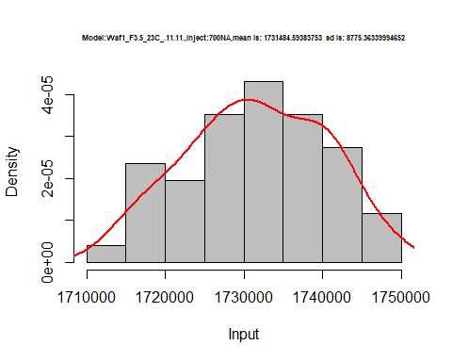

hist(d1_11.11$V8,  
 cex.main=0.5,  
 freq = FALSE,  
 main = paste('Model:Waf1_F3.5_23C_.11.11.,Inject:800NA,mean is:', mean(d1_11.11$V8),' sd is:', sd(d1_11.11$V8)),  
 xlab = "Input",  
 ylab = "Density",  
 col="grey")  
#plot density curve  
lines(density(d1_11.11$V8), # density plot  
 lwd = 2, # thickness of line  
 col = "red")

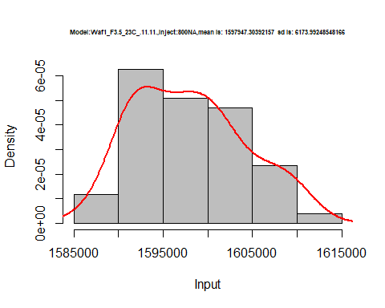

dens <- apply(d1_11.11, 2, density)  
plot('Model:Waf1_F3.5_23C_.11.11', xlim=range(sapply(dens, "[", "x")), ylim=range(sapply(dens, "[", "y")))

## Warning in xy.coords(x, y, xlabel, ylabel, log): NAs introduced by coercion

mapply(lines, dens, col=1:length(dens))

## $V1  
## NULL  
##   
## $V2  
## NULL  
##   
## $V3  
## NULL  
##   
## $V4  
## NULL  
##   
## $V5  
## NULL  
##   
## $V6  
## NULL  
##   
## $V7  
## NULL  
##   
## $V8  
## NULL

legend("topright", legend=names(dens), fill=1:length(dens))

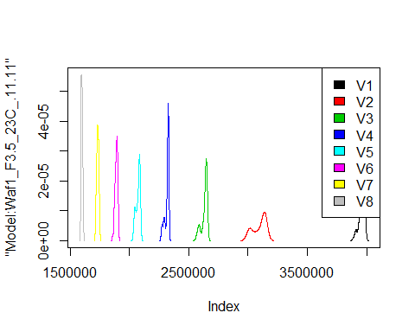

d2_11.11<-d_11.11[,c(9:16)]  
d2_11.11 <- head(d2_11.11,51)  
colnames(d2_11.11) <- c("V1", "V2","V3","V4","V5","V6","V7","V8")  
head(d2_11.11)

## V1 V2 V3 V4 V5 V6 V7 V8  
## 1 1490000 1258750 1155833 1058125 970000 905416.7 853571.4 807187.5  
## 2 1485000 1255000 1160000 1058750 974500 907916.7 853214.3 808125.0  
## 3 1480000 1261250 1161667 1055000 973500 906250.0 856071.4 807187.5  
## 4 1477500 1261250 1160000 1057500 974500 906666.7 853928.6 807187.5  
## 5 1477500 1261250 1159167 1056250 973000 910416.7 854642.9 807187.5  
## 6 1477500 1258750 1159167 1058125 976000 907083.3 854285.7 810000.0

hist(d2_11.11$V1,  
 cex.main=0.5,  
 freq = FALSE,  
 main = paste('Model:Waf1_F4.3_23C_.11.11.,Inject:100NA,mean is:', mean(d2_11.11$V1),' sd is:', sd(d2_11.11$V1)),  
 xlab = "Input",  
 ylab = "Density",  
 col="grey")  
#plot density curve  
lines(density(d2_11.11$V1), # density plot  
 lwd = 2, # thickness of line  
 col = "red")

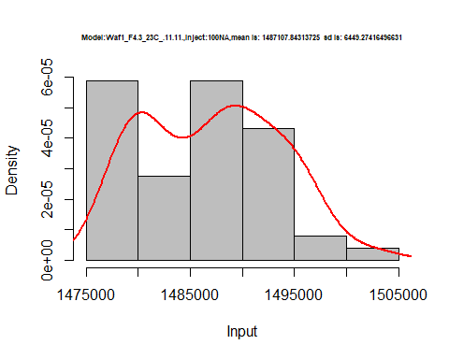

hist(d2_11.11$V2,  
 cex.main=0.5,  
 freq = FALSE,  
 main = paste('Model:Waf1_F4.3_23C_.11.11.,Inject:200NA,mean is:', mean(d2_11.11$V2),' sd is:', sd(d2_11.11$V2)),  
 xlab = "Input",  
 ylab = "Density",  
 col="grey")  
#plot density curve  
lines(density(d2_11.11$V2), # density plot  
 lwd = 2, # thickness of line  
 col = "red")

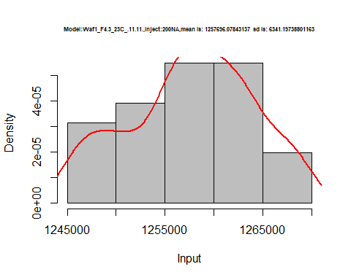

hist(d2_11.11$V3,  
 cex.main=0.5,  
 freq = FALSE,  
 main = paste('Model:Waf1_F4.3_23C_.11.11.,Inject:300NA,mean is:', mean(d2_11.11$V3),' sd is:', sd(d2_11.11$V3)),  
 xlab = "Input",  
 ylab = "Density",  
 col="grey")  
#plot density curve  
lines(density(d2_11.11$V3), # density plot  
 lwd = 2, # thickness of line  
 col = "red")

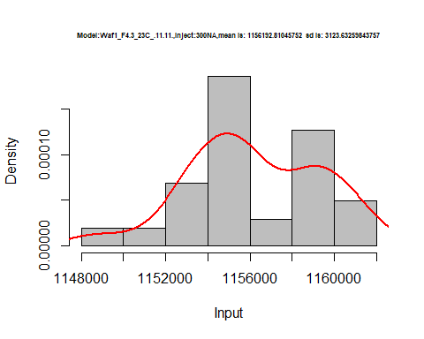

hist(d2_11.11$V4,  
 cex.main=0.5,  
 freq = FALSE,  
 main = paste('Model:Waf1_F4.3_23C_.11.11.,Inject:400NA,mean is:', mean(d2_11.11$V4),' sd is:', sd(d2_11.11$V4)),  
 xlab = "Input",  
 ylab = "Density",  
 col="grey")  
#plot density curve  
lines(density(d2_11.11$V4), # density plot  
 lwd = 2, # thickness of line  
 col = "red")

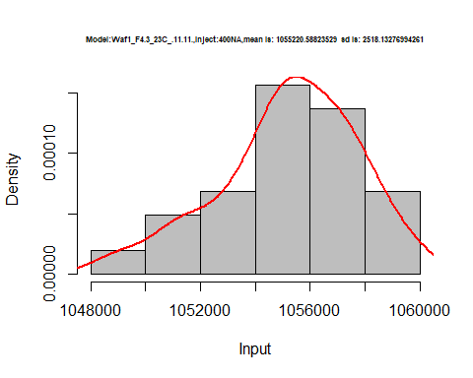

hist(d2_11.11$V5,  
 cex.main=0.5,  
 freq = FALSE,  
 main = paste('Model:Waf1_F4.3_23C_.11.11.,Inject:500NA,mean is:', mean(d2_11.11$V5),' sd is:', sd(d2_11.11$V5)),  
 xlab = "Input",  
 ylab = "Density",  
 col="grey")  
#plot density curve  
lines(density(d2_11.11$V5), # density plot  
 lwd = 2, # thickness of line  
 col = "red")

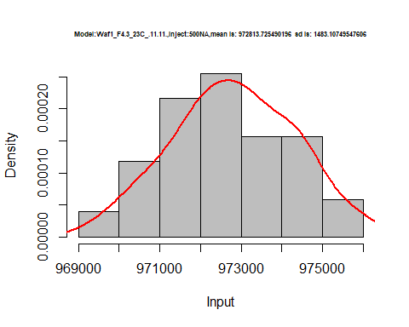

hist(d2_11.11$V6,  
 cex.main=0.5,  
 freq = FALSE,  
 main = paste('Model:Waf1_F4.3_23C_.11.11.,Inject:600NA,mean is:', mean(d2_11.11$V6),' sd is:', sd(d2_11.11$V6)),  
 xlab = "Input",  
 ylab = "Density",  
 col="grey")  
#plot density curve  
lines(density(d2_11.11$V6), # density plot  
 lwd = 2, # thickness of line  
 col = "red")

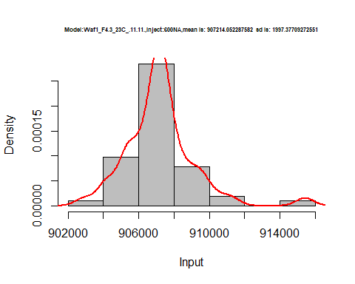

hist(d2_11.11$V7,  
 cex.main=0.5,  
 freq = FALSE,  
 main = paste('Model:Waf1_F4.3_23C_.11.11.,Inject:700NA,mean is:', mean(d2_11.11$V7),' sd is:', sd(d2_11.11$V7)),  
 xlab = "Input",  
 ylab = "Density",  
 col="grey")  
#plot density curve  
lines(density(d2_11.11$V7), # density plot  
 lwd = 2, # thickness of line  
 col = "red")

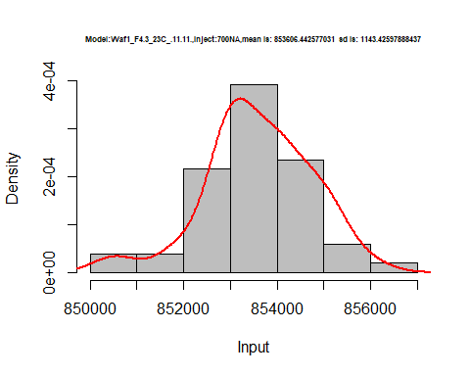

hist(d2_11.11$V8,  
 cex.main=0.5,  
 freq = FALSE,  
 main = paste('Model:Waf1_F4.3_23C_.11.11.,Inject:800NA,mean is:', mean(d2_11.11$V8),' sd is:', sd(d2_11.11$V8)),  
 xlab = "Input",  
 ylab = "Density",  
 col="grey")  
#plot density curve  
lines(density(d2_11.11$V8), # density plot  
 lwd = 2, # thickness of line  
 col = "red")

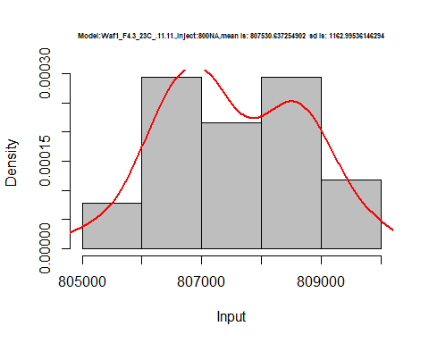

dens <- apply(d2_11.11, 2, density)  
plot('Model:Waf1_F3.5_23C_.11.11', xlim=range(sapply(dens, "[", "x")), ylim=range(sapply(dens, "[", "y")))

## Warning in xy.coords(x, y, xlabel, ylabel, log): NAs introduced by coercion

mapply(lines, dens, col=1:length(dens))

## $V1  
## NULL  
##   
## $V2  
## NULL  
##   
## $V3  
## NULL  
##   
## $V4  
## NULL  
##   
## $V5  
## NULL  
##   
## $V6  
## NULL  
##   
## $V7  
## NULL  
##   
## $V8  
## NULL

legend("topright", legend=names(dens), fill=1:length(dens))

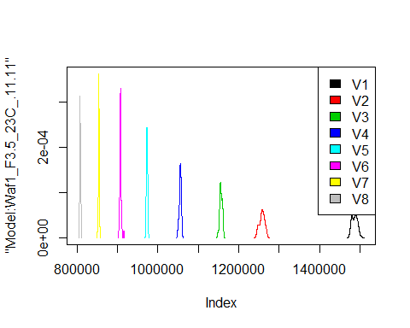

d3_11.11<-d_11.11[,c(17:24)]  
d3_11.11 <- head(d3_11.11,51)  
colnames(d3_11.11) <- c("V1", "V2","V3","V4","V5","V6","V7","V8")  
head(d3_11.11)

## V1 V2 V3 V4 V5 V6 V7 V8  
## 1 2122500 1548750 1317500 1116875 1007000 920833.3 858214.3 788750.0  
## 2 2120000 1552500 1318333 1118750 1006500 918750.0 856785.7 789062.5  
## 3 2117500 1553750 1314167 1120625 1005500 917500.0 860000.0 789687.5  
## 4 2115000 1546250 1315000 1116875 1005500 916666.7 857857.1 788437.5  
## 5 2115000 1548750 1315000 1117500 1006000 919166.7 857857.1 788750.0  
## 6 2105000 1547500 1311667 1113750 1005500 922083.3 857500.0 789375.0

hist(d3_11.11$V1,  
 cex.main=0.5,  
 freq = FALSE,  
 main = paste('Model:Waf1_F6.3_23C_.11.11.,Inject:100NA,mean is:', mean(d3_11.11$V1),' sd is:', sd(d3_11.11$V1)),  
 xlab = "Input",  
 ylab = "Density",  
 col="grey")  
#plot density curve  
lines(density(d3_11.11$V1), # density plot  
 lwd = 2, # thickness of line  
 col = "red")

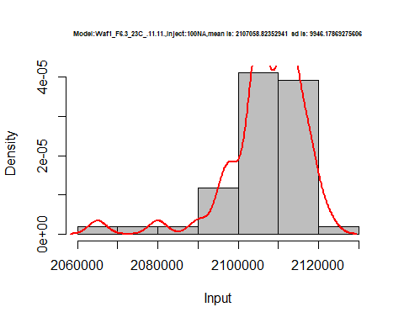

hist(d3_11.11$V2,  
 cex.main=0.5,  
 freq = FALSE,  
 main = paste('Model:Waf1_F6.3_23C_.11.11.,Inject:200NA,mean is:', mean(d3_11.11$V2),' sd is:', sd(d3_11.11$V2)),  
 xlab = "Input",  
 ylab = "Density",  
 col="grey")  
#plot density curve  
lines(density(d3_11.11$V2), # density plot  
 lwd = 2, # thickness of line  
 col = "red")

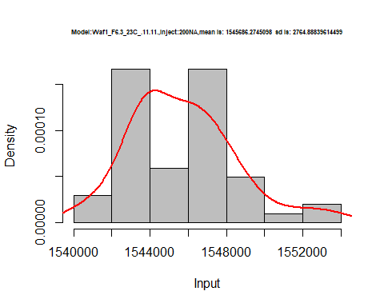

hist(d3_11.11$V3,  
 cex.main=0.5,  
 freq = FALSE,  
 main = paste('Model:Waf1_F6.3_23C_.11.11.,Inject:300NA,mean is:', mean(d3_11.11$V3),' sd is:', sd(d3_11.11$V3)),  
 xlab = "Input",  
 ylab = "Density",  
 col="grey")  
#plot density curve  
lines(density(d3_11.11$V3), # density plot  
 lwd = 2, # thickness of line  
 col = "red")

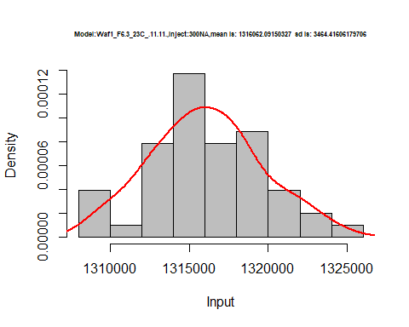

hist(d3_11.11$V4,  
 cex.main=0.5,  
 freq = FALSE,  
 main = paste('Model:Waf1_F6.3_23C_.11.11.,Inject:400NA,mean is:', mean(d3_11.11$V4),' sd is:', sd(d3_11.11$V4)),  
 xlab = "Input",  
 ylab = "Density",  
 col="grey")  
#plot density curve  
lines(density(d3_11.11$V4), # density plot  
 lwd = 2, # thickness of line  
 col = "red")

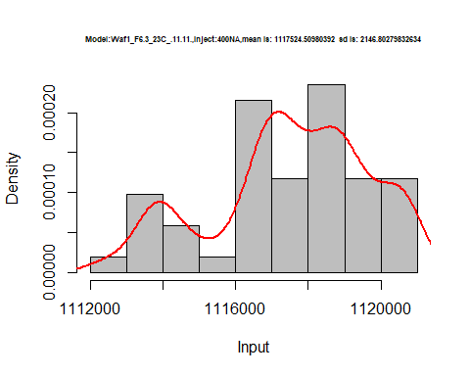

hist(d3_11.11$V5,  
 cex.main=0.5,  
 freq = FALSE,  
 main = paste('Model:Waf1_F6.3_23C_.11.11.,Inject:500NA,mean is:', mean(d3_11.11$V5),' sd is:', sd(d3_11.11$V5)),  
 xlab = "Input",  
 ylab = "Density",  
 col="grey")  
#plot density curve  
lines(density(d3_11.11$V5), # density plot  
 lwd = 2, # thickness of line  
 col = "red")

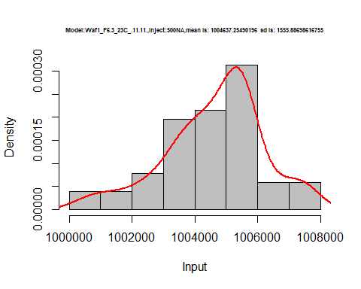

hist(d3_11.11$V6,  
 cex.main=0.5,  
 freq = FALSE,  
 main = paste('Model:Waf1_F6.3_23C_.11.11.,Inject:300NA,mean is:', mean(d3_11.11$V6),' sd is:', sd(d3_11.11$V6)),  
 xlab = "Input",  
 ylab = "Density",  
 col="grey")  
#plot density curve  
lines(density(d3_11.11$V6), # density plot  
 lwd = 2, # thickness of line  
 col = "red")

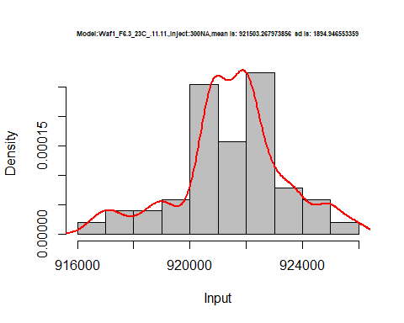

hist(d3_11.11$V7,  
 cex.main=0.5,  
 freq = FALSE,  
 main = paste('Model:Waf1_F6.3_23C_.11.11.,Inject:300NA,mean is:', mean(d3_11.11$V7),' sd is:', sd(d3_11.11$V7)),  
 xlab = "Input",  
 ylab = "Density",  
 col="grey")  
#plot density curve  
lines(density(d3_11.11$V7), # density plot  
 lwd = 2, # thickness of line  
 col = "red")

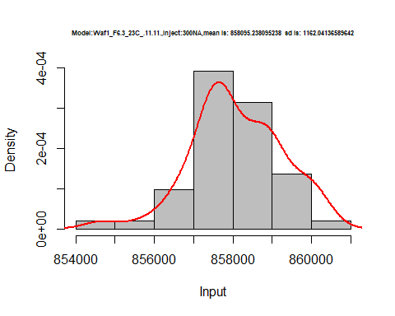

hist(d3_11.11$V8,  
 cex.main=0.5,  
 freq = FALSE,  
 main = paste('Model:Waf1_F6.3_23C_.11.11.,Inject:800NA,mean is:', mean(d3_11.11$V8),' sd is:', sd(d3_11.11$V8)),  
 xlab = "Input",  
 ylab = "Density",  
 col="grey")  
#plot density curve  
lines(density(d3_11.11$V8), # density plot  
 lwd = 2, # thickness of line  
 col = "red")

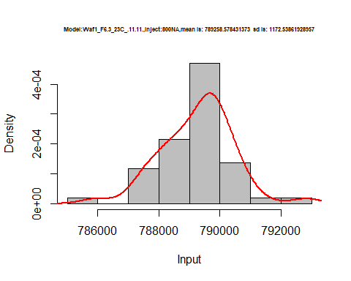

dens <- apply(d3_11.11, 2, density)  
plot('Model:Waf1_F3.5_23C_.11.11', xlim=range(sapply(dens, "[", "x")), ylim=range(sapply(dens, "[", "y")))

## Warning in xy.coords(x, y, xlabel, ylabel, log): NAs introduced by coercion

mapply(lines, dens, col=1:length(dens))

## $V1  
## NULL  
##   
## $V2  
## NULL  
##   
## $V3  
## NULL  
##   
## $V4  
## NULL  
##   
## $V5  
## NULL  
##   
## $V6  
## NULL  
##   
## $V7  
## NULL  
##   
## $V8  
## NULL

legend("topright", legend=names(dens), fill=1:length(dens))

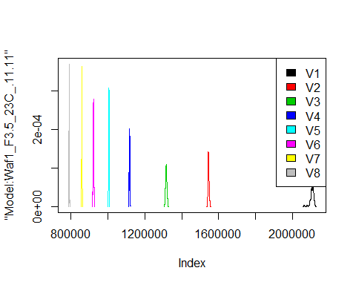

d4_11.11<-d_11.11[,c(25:32)]  
d4_11.11 <- head(d4_11.11,51)  
colnames(d4_11.11) <- c("V1", "V2","V3","V4","V5","V6","V7","V8")  
head(d4_11.11)

## V1 V2 V3 V4 V5 V6 V7 V8  
## 1 1250000 1140000 1001666.7 900000 829500 772916.7 722857.1 674687.5  
## 2 1257500 1130000 998333.3 891875 832000 775833.3 719285.7 673125.0  
## 3 1257500 1122500 998333.3 897500 832000 767083.3 715000.0 673750.0  
## 4 1257500 1130000 995000.0 900000 827000 763750.0 714642.9 678437.5  
## 5 1260000 1135000 1002500.0 893125 833500 766666.7 716785.7 677812.5  
## 6 1260000 1135000 995833.3 891250 825500 772500.0 718928.6 672812.5

hist(d4_11.11$V1,  
 cex.main=0.5,  
 freq = FALSE,  
 main = paste('Model:Waf1_F9.5_23C_.11.11,Inject:100NA,mean is:', mean(d4_11.11$V1),' sd is:', sd(d3_11.11$V1)),  
 xlab = "Input",  
 ylab = "Density",  
 col="grey")  
#plot density curve  
lines(density(d4_11.11$V1), # density plot  
 lwd = 2, # thickness of line  
 col = "red")

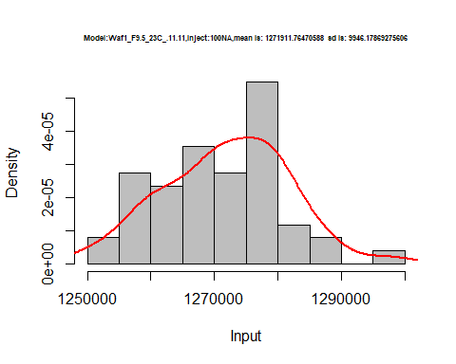

hist(d4_11.11$V2,  
 cex.main=0.5,  
 freq = FALSE,  
 main = paste('Model:Waf1_F9.5_23C_.11.11,Inject:200NA,mean is:', mean(d4_11.11$V2),' sd is:', sd(d3_11.11$V2)),  
 xlab = "Input",  
 ylab = "Density",  
 col="grey")  
#plot density curve  
lines(density(d4_11.11$V2), # density plot  
 lwd = 2, # thickness of line  
 col = "red")

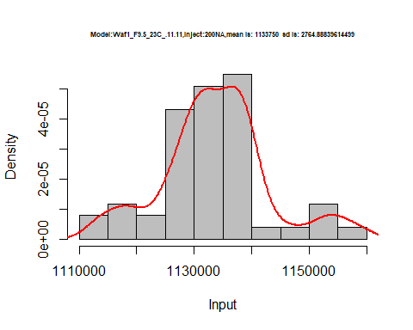

hist(d4_11.11$V3,  
 cex.main=0.5,  
 freq = FALSE,  
 main = paste('Model:Waf1_F9.5_23C_.11.11,Inject:300NA,mean is:', mean(d4_11.11$V3),' sd is:', sd(d3_11.11$V3)),  
 xlab = "Input",  
 ylab = "Density",  
 col="grey")  
#plot density curve  
lines(density(d4_11.11$V3), # density plot  
 lwd = 2, # thickness of line  
 col = "red")

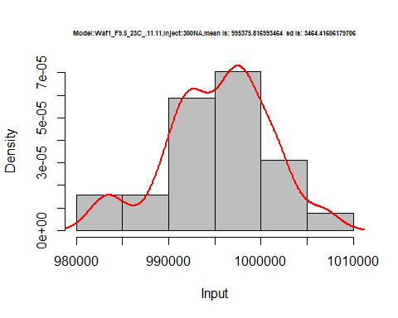

hist(d4_11.11$V4,  
 cex.main=0.5,  
 freq = FALSE,  
 main = paste('Model:Waf1_F9.5_23C_.11.11,Inject:400NA,mean is:', mean(d4_11.11$V4),' sd is:', sd(d3_11.11$V4)),  
 xlab = "Input",  
 ylab = "Density",  
 col="grey")  
#plot density curve  
lines(density(d4_11.11$V4), # density plot  
 lwd = 2, # thickness of line  
 col = "red")

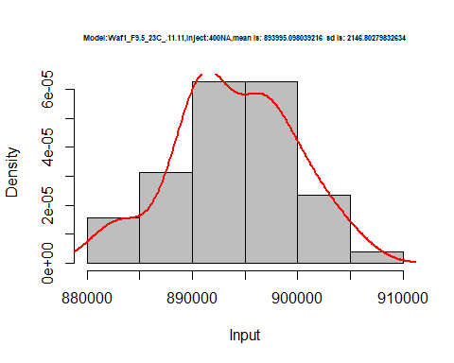

hist(d4_11.11$V5,  
 cex.main=0.5,  
 freq = FALSE,  
 main = paste('Model:Waf1_F9.5_23C_.11.11,Inject:500NA,mean is:', mean(d4_11.11$V5),' sd is:', sd(d3_11.11$V5)),  
 xlab = "Input",  
 ylab = "Density",  
 col="grey")  
#plot density curve  
lines(density(d4_11.11$V5), # density plot  
 lwd = 2, # thickness of line  
 col = "red")

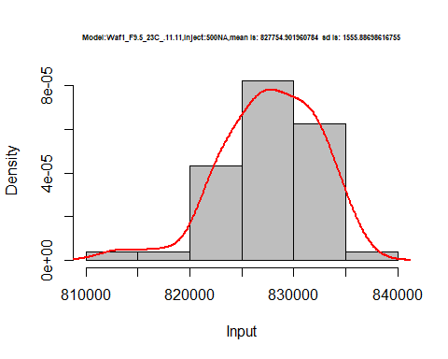

hist(d4_11.11$V6,  
 cex.main=0.5,  
 freq = FALSE,  
 main = paste('Model:Waf1_F9.5_23C_.11.11,Inject:600NA,mean is:', mean(d4_11.11$V6),' sd is:', sd(d3_11.11$V6)),  
 xlab = "Input",  
 ylab = "Density",  
 col="grey")  
#plot density curve  
lines(density(d4_11.11$V6), # density plot  
 lwd = 2, # thickness of line  
 col = "red")

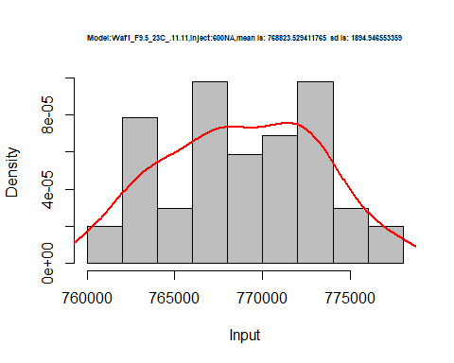

hist(d4_11.11$V7,  
 cex.main=0.5,  
 freq = FALSE,  
 main = paste('Model:Waf1_F9.5_23C_.11.11,Inject:700NA,mean is:', mean(d4_11.11$V7),' sd is:', sd(d3_11.11$V7)),  
 xlab = "Input",  
 ylab = "Density",  
 col="grey")  
#plot density curve  
lines(density(d4_11.11$V7), # density plot  
 lwd = 2, # thickness of line  
 col = "red")

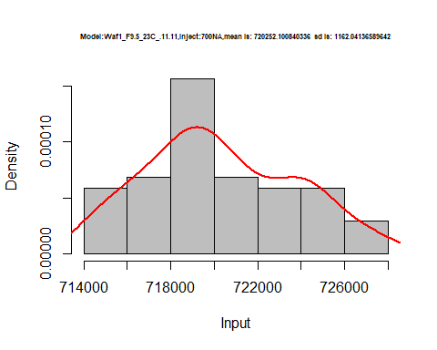

hist(d4_11.11$V8,  
 cex.main=0.5,  
 freq = FALSE,  
 main = paste('Model:Waf1_F9.5_23C_.11.11,Inject:800NA,mean is:', mean(d4_11.11$V8),' sd is:', sd(d3_11.11$V8)),  
 xlab = "Input",  
 ylab = "Density",  
 col="grey")  
#plot density curve  
lines(density(d4_11.11$V8), # density plot  
 lwd = 2, # thickness of line  
 col = "red")

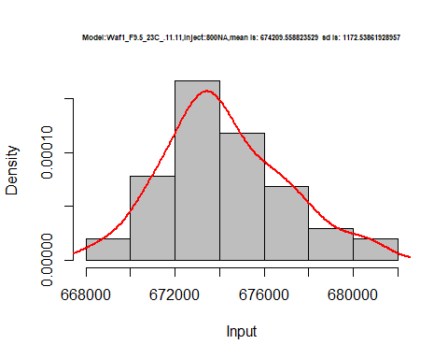

dens <- apply(d4_11.11, 2, density)  
plot('Model:Waf1_F9.5_23C_.11.11', xlim=range(sapply(dens, "[", "x")), ylim=range(sapply(dens, "[", "y")))

## Warning in xy.coords(x, y, xlabel, ylabel, log): NAs introduced by coercion

mapply(lines, dens, col=1:length(dens))

## $V1  
## NULL  
##   
## $V2  
## NULL  
##   
## $V3  
## NULL  
##   
## $V4  
## NULL  
##   
## $V5  
## NULL  
##   
## $V6  
## NULL  
##   
## $V7  
## NULL  
##   
## $V8  
## NULL

legend("topright", legend=names(dens), fill=1:length(dens))

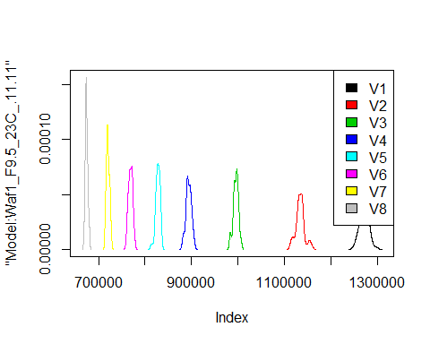

# Select columns whose names contains "12.12"  
d_12.12<-my_data %>% select(contains("12.12."))  
head(d_12.12)

## Waf1_F2.4_23C_.100nA_.12.12. Waf1_F2.4_23C_.200nA_.12.12.  
## 1 1315000 1042500  
## 2 1317500 1040000  
## 3 1320000 1041250  
## 4 1315000 1042500  
## 5 1315000 1042500  
## 6 1315000 1042500  
## Waf1_F2.4_23C_.300nA_.12.12. Waf1_F2.4_23C_.400nA_.12.12.  
## 1 905833.3 810625  
## 2 906666.7 809375  
## 3 905833.3 811875  
## 4 905833.3 810000  
## 5 906666.7 811250  
## 6 907500.0 809375  
## Waf1_F2.4_23C_.500nA_.12.12. Waf1_F2.4_23C_.600nA_.12.12.  
## 1 736500 684166.7  
## 2 737000 683333.3  
## 3 736500 684166.7  
## 4 737000 683750.0  
## 5 737500 684166.7  
## 6 736500 683333.3  
## Waf1_F2.4_23C_.700nA_.12.12. Waf1_F2.4_23C_.800nA_.12.12.  
## 1 647142.9 607812.5  
## 2 646785.7 605937.5  
## 3 646428.6 605000.0  
## 4 646785.7 605000.0  
## 5 647142.9 605000.0  
## 6 647500.0 604375.0  
## Waf1_F3.3_23C_.100nA_.12.12. Waf1_F3.3_23C_.200nA_.12.12.  
## 1 3330000 2157500  
## 2 3345000 2158750  
## 3 3282500 2173750  
## 4 3277500 2176250  
## 5 3295000 2180000  
## 6 3327500 2185000  
## Waf1_F3.3_23C_.300nA_.12.12. Waf1_F3.3_23C_.400nA_.12.12.  
## 1 1705000 1385000  
## 2 1699167 1383125  
## 3 1700000 1385625  
## 4 1697500 1388750  
## 5 1668333 1378125  
## 6 1663333 1386250  
## Waf1_F3.3_23C_.500nA_.12.12. Waf1_F3.3_23C_.600nA_.12.12.  
## 1 1237500 1108750  
## 2 1236500 1091250  
## 3 1238500 1110417  
## 4 1235500 1108750  
## 5 1239000 1110833  
## 6 1238500 1102083  
## Waf1_F3.3_23C_.700nA_.12.12. Waf1_F3.3_23C_.800nA_.12.12.  
## 1 1019642.9 911562.5  
## 2 1013571.4 931875.0  
## 3 985000.0 935625.0  
## 4 1015714.3 933125.0  
## 5 1010714.3 877500.0  
## 6 980357.1 896250.0  
## Waf1_F5.3_23C_.100nA_.12.12. Waf1_F5.3_23C_.200nA_.12.12.  
## 1 3107500 2436250  
## 2 3107500 2435000  
## 3 3115000 2427500  
## 4 3097500 2418750  
## 5 3112500 2427500  
## 6 3125000 2432500  
## Waf1_F5.3_23C_.300nA_.12.12. Waf1_F5.3_23C_.400nA_.12.12.  
## 1 2094167 1851875  
## 2 2095000 1856250  
## 3 2109167 1864375  
## 4 2095000 1843750  
## 5 2090833 1859375  
## 6 2090833 1858125  
## Waf1_F5.3_23C_.500nA_.12.12. Waf1_F5.3_23C_.600nA_.12.12.  
## 1 1674500 1537083  
## 2 1679000 1546250  
## 3 1671000 1550000  
## 4 1675000 1551667  
## 5 1666500 1547917  
## 6 1673000 1545833  
## Waf1_F5.3_23C_.700nA_.12.12. Waf1_F5.3_23C_.800nA_.12.12.  
## 1 1431071 1348750  
## 2 1428571 1353438  
## 3 1431071 1353438  
## 4 1440714 1351250  
## 5 1435000 1353750  
## 6 1430714 1353125  
## Waf1_F9.5_23C_.100nA_.12.12. Waf1_F9.5_23C_.200nA_.12.12.  
## 1 10987500 6297500  
## 2 10982500 6295000  
## 3 11027500 6308750  
## 4 11007500 6316250  
## 5 11012500 6318750  
## 6 11007500 6311250  
## Waf1_F9.5_23C_.300nA_.12.12. Waf1_F9.5_23C_.400nA_.12.12.  
## 1 4499167 3574375  
## 2 4497500 3581250  
## 3 4497500 3590625  
## 4 4515833 3601875  
## 5 4514167 3588750  
## 6 4512500 3598750  
## Waf1_F9.5_23C_.500nA_.12.12. Waf1_F9.5_23C_.600nA_.12.12.  
## 1 3001000 2465833  
## 2 3005500 2463333  
## 3 3003500 2465833  
## 4 3007000 2467917  
## 5 3002000 2465417  
## 6 2997000 2462500  
## Waf1_F9.5_23C_.700nA_.12.12. Waf1_F9.5_23C_.800nA_.12.12.  
## 1 2288929 2064375  
## 2 2286429 2052812  
## 3 2289286 2064063  
## 4 2288214 2064063  
## 5 2287500 2059375  
## 6 2290357 2058437

d1_12.12<-d_12.12[,c(1:8)]  
d1_12.12 <- head(d1_12.12,51)  
colnames(d1_12.12) <- c("V1", "V2","V3","V4","V5","V6","V7","V8")  
head(d1_12.12)

## V1 V2 V3 V4 V5 V6 V7 V8  
## 1 1315000 1042500 905833.3 810625 736500 684166.7 647142.9 607812.5  
## 2 1317500 1040000 906666.7 809375 737000 683333.3 646785.7 605937.5  
## 3 1320000 1041250 905833.3 811875 736500 684166.7 646428.6 605000.0  
## 4 1315000 1042500 905833.3 810000 737000 683750.0 646785.7 605000.0  
## 5 1315000 1042500 906666.7 811250 737500 684166.7 647142.9 605000.0  
## 6 1315000 1042500 907500.0 809375 736500 683333.3 647500.0 604375.0

hist(d1_12.12$V1,  
 cex.main=0.5,  
 freq = FALSE,  
 main = paste('Model:Waf1_F2.4_23C_.12.12,Inject:100NA,mean is:', mean(d1_12.12$V1),' sd is:', sd(d1_12.12$V1)),  
 xlab = "Input",  
 ylab = "Density",  
 col="grey")  
#plot density curve  
lines(density(d1_12.12$V1), # density plot  
 lwd = 2, # thickness of line  
 col = "red")

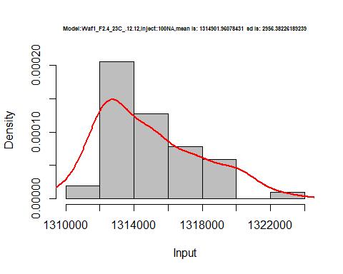

hist(d1_12.12$V2,  
 cex.main=0.5,  
 freq = FALSE,  
 main = paste('Model:Waf1_F2.4_23C_.12.12,Inject:200NA,mean is:', mean(d1_12.12$V2),' sd is:', sd(d1_12.12$V2)),  
 xlab = "Input",  
 ylab = "Density",  
 col="grey")  
#plot density curve  
lines(density(d1_12.12$V2), # density plot  
 lwd = 2, # thickness of line  
 col = "red")

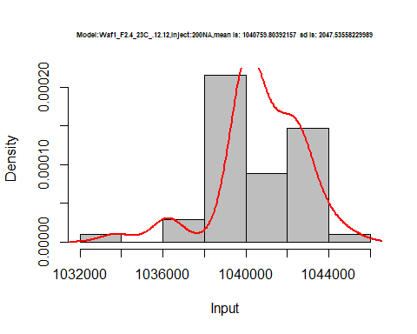

hist(d1_12.12$V3,  
 cex.main=0.5,  
 freq = FALSE,  
 main = paste('Model:Waf1_F2.4_23C_.12.12,Inject:300NA,mean is:', mean(d1_12.12$V3),' sd is:', sd(d1_12.12$V3)),  
 xlab = "Input",  
 ylab = "Density",  
 col="grey")  
#plot density curve  
lines(density(d1_12.12$V3), # density plot  
 lwd = 2, # thickness of line  
 col = "red")

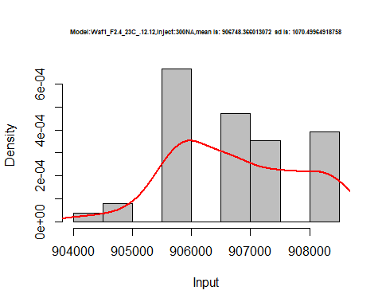

hist(d1_12.12$V4,  
 cex.main=0.5,  
 freq = FALSE,  
 main = paste('Model:Waf1_F2.4_23C_.12.12,Inject:400NA,mean is:', mean(d1_12.12$V4),' sd is:', sd(d1_12.12$V4)),  
 xlab = "Input",  
 ylab = "Density",  
 col="grey")  
#plot density curve  
lines(density(d1_12.12$V4), # density plot  
 lwd = 2, # thickness of line  
 col = "red")

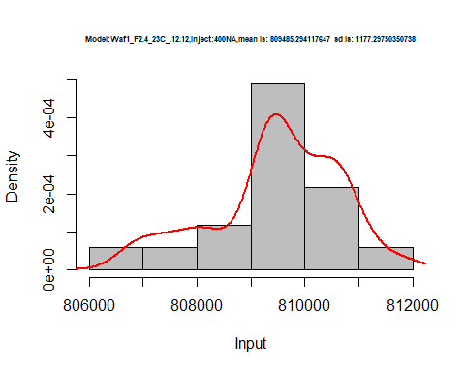

hist(d1_12.12$V5,  
 cex.main=0.5,  
 freq = FALSE,  
 main = paste('Model:Waf1_F2.4_23C_.12.12,Inject:500NA,mean is:', mean(d1_12.12$V5),' sd is:', sd(d1_12.12$V5)),  
 xlab = "Input",  
 ylab = "Density",  
 col="grey")  
#plot density curve  
lines(density(d1_12.12$V5), # density plot  
 lwd = 2, # thickness of line  
 col = "red")

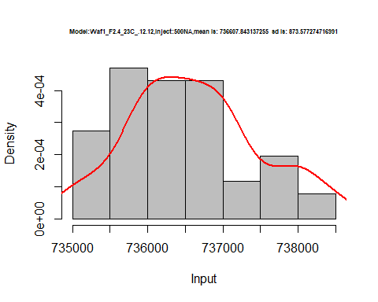

hist(d1_12.12$V6,  
 cex.main=0.5,  
 freq = FALSE,  
 main = paste('Model:Waf1_F2.4_23C_.12.12,Inject:600NA,mean is:', mean(d1_12.12$V6),' sd is:', sd(d1_12.12$V6)),  
 xlab = "Input",  
 ylab = "Density",  
 col="grey")  
#plot density curve  
lines(density(d1_12.12$V6), # density plot  
 lwd = 2, # thickness of line  
 col = "red")

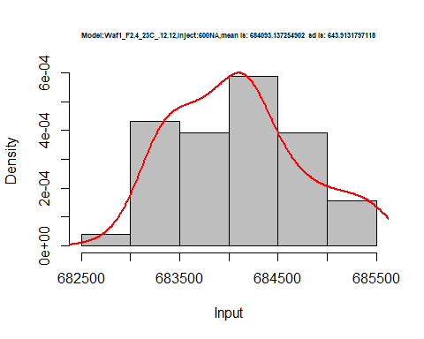

hist(d1_12.12$V7,  
 cex.main=0.5,  
 freq = FALSE,  
 main = paste('Model:Waf1_F2.4_23C_.12.12,Inject:700NA,mean is:', mean(d1_12.12$V7),' sd is:', sd(d1_12.12$V7)),  
 xlab = "Input",  
 ylab = "Density",  
 col="grey")  
#plot density curve  
lines(density(d1_12.12$V7), # density plot  
 lwd = 2, # thickness of line  
 col = "red")

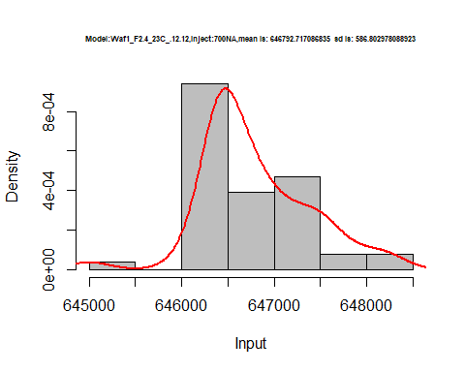

hist(d1_12.12$V8,  
 cex.main=0.5,  
 freq = FALSE,  
 main = paste('Model:Waf1_F2.4_23C_.12.12,Inject:100NA,mean is:', mean(d1_12.12$V8),' sd is:', sd(d1_12.12$V8)),  
 xlab = "Input",  
 ylab = "Density",  
 col="grey")  
#plot density curve  
lines(density(d1_12.12$V8), # density plot  
 lwd = 2, # thickness of line  
 col = "red")

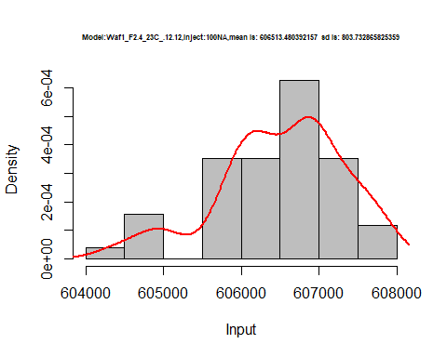

dens <- apply(d1_12.12, 2, density)  
plot('Model:Waf1_F2.4_23C_.12.12', xlim=range(sapply(dens, "[", "x")), ylim=range(sapply(dens, "[", "y")))

## Warning in xy.coords(x, y, xlabel, ylabel, log): NAs introduced by coercion

mapply(lines, dens, col=1:length(dens))

## $V1  
## NULL  
##   
## $V2  
## NULL  
##   
## $V3  
## NULL  
##   
## $V4  
## NULL  
##   
## $V5  
## NULL  
##   
## $V6  
## NULL  
##   
## $V7  
## NULL  
##   
## $V8  
## NULL

legend("topright", legend=names(dens), fill=1:length(dens))

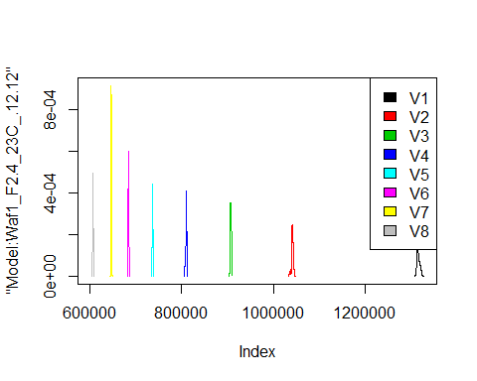

d2_12.12<-d_12.12[,c(9:16)]  
d2_12.12 <- head(d2_12.12,51)  
colnames(d2_12.12) <- c("V1", "V2","V3","V4","V5","V6","V7","V8")  
head(d2_12.12)

## V1 V2 V3 V4 V5 V6 V7 V8  
## 1 3330000 2157500 1705000 1385000 1237500 1108750 1019642.9 911562.5  
## 2 3345000 2158750 1699167 1383125 1236500 1091250 1013571.4 931875.0  
## 3 3282500 2173750 1700000 1385625 1238500 1110417 985000.0 935625.0  
## 4 3277500 2176250 1697500 1388750 1235500 1108750 1015714.3 933125.0  
## 5 3295000 2180000 1668333 1378125 1239000 1110833 1010714.3 877500.0  
## 6 3327500 2185000 1663333 1386250 1238500 1102083 980357.1 896250.0

hist(d2_12.12$V1,  
 cex.main=0.5,  
 freq = FALSE,  
 main = paste('Model:Waf1_F3.3_23C_.12.12,Inject:100NA,mean is:', mean(d2_12.12$V1),' sd is:', sd(d2_12.12$V1)),  
 xlab = "Input",  
 ylab = "Density",  
 col="grey")  
#plot density curve  
lines(density(d2_12.12$V1), # density plot  
 lwd = 2, # thickness of line  
 col = "red")

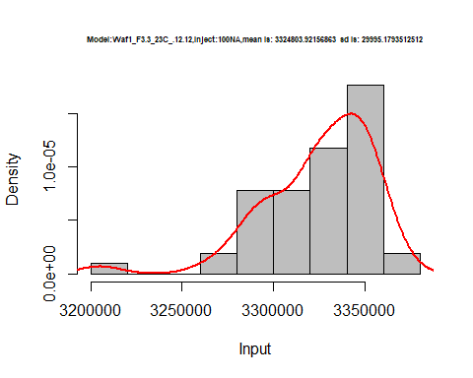

hist(d2_12.12$V2,  
 cex.main=0.5,  
 freq = FALSE,  
 main = paste('Model:Waf1_F3.3_23C_.12.12,Inject:200NA,mean is:', mean(d2_12.12$V2),' sd is:', sd(d2_12.12$V2)),  
 xlab = "Input",  
 ylab = "Density",  
 col="grey")  
#plot density curve  
lines(density(d2_12.12$V2), # density plot  
 lwd = 2, # thickness of line  
 col = "red")

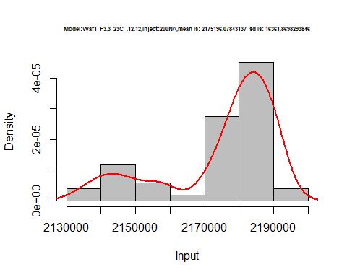

hist(d2_12.12$V3,  
 cex.main=0.5,  
 freq = FALSE,  
 main = paste('Model:Waf1_F3.3_23C_.12.12,Inject:300NA,mean is:', mean(d2_12.12$V3),' sd is:', sd(d2_12.12$V3)),  
 xlab = "Input",  
 ylab = "Density",  
 col="grey")  
#plot density curve  
lines(density(d2_12.12$V3), # density plot  
 lwd = 2, # thickness of line  
 col = "red")

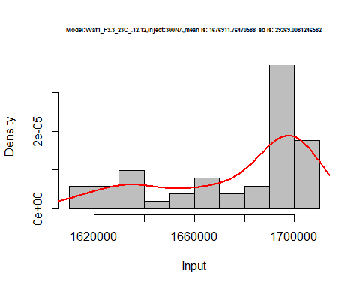

hist(d2_12.12$V4,  
 cex.main=0.5,  
 freq = FALSE,  
 main = paste('Model:Waf1_F3.3_23C_.12.12,Inject:400NA,mean is:', mean(d2_12.12$V4),' sd is:', sd(d2_12.12$V4)),  
 xlab = "Input",  
 ylab = "Density",  
 col="grey")  
#plot density curve  
lines(density(d2_12.12$V4), # density plot  
 lwd = 2, # thickness of line  
 col = "red")

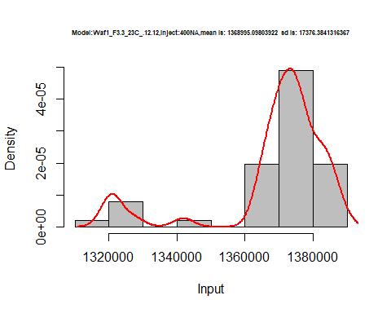

hist(d2_12.12$V5,  
 cex.main=0.5,  
 freq = FALSE,  
 main = paste('Model:Waf1_F3.3_23C_.12.12,Inject:500NA,mean is:', mean(d2_12.12$V5),' sd is:', sd(d2_12.12$V5)),  
 xlab = "Input",  
 ylab = "Density",  
 col="grey")  
#plot density curve  
lines(density(d2_12.12$V5), # density plot  
 lwd = 2, # thickness of line  
 col = "red")

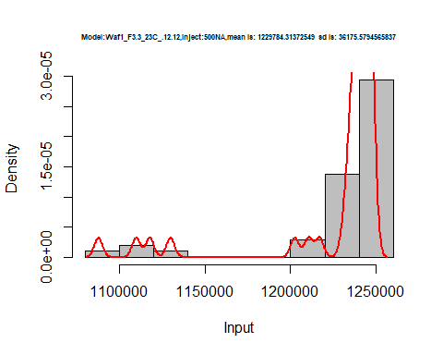

hist(d2_12.12$V6,  
 cex.main=0.5,  
 freq = FALSE,  
 main = paste('Model:Waf1_F3.3_23C_.12.12,Inject:600NA,mean is:', mean(d2_12.12$V6),' sd is:', sd(d2_12.12$V6)),  
 xlab = "Input",  
 ylab = "Density",  
 col="grey")  
#plot density curve  
lines(density(d2_12.12$V6), # density plot  
 lwd = 2, # thickness of line  
 col = "red")

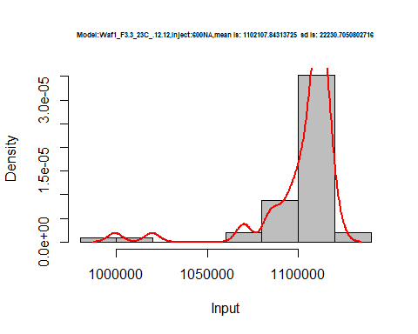

hist(d2_12.12$V7,  
 cex.main=0.5,  
 freq = FALSE,  
 main = paste('Model:Waf1_F3.3_23C_.12.12,Inject:700NA,mean is:', mean(d2_12.12$V7),' sd is:', sd(d2_12.12$V7)),  
 xlab = "Input",  
 ylab = "Density",  
 col="grey")  
#plot density curve  
lines(density(d2_12.12$V7), # density plot  
 lwd = 2, # thickness of line  
 col = "red")

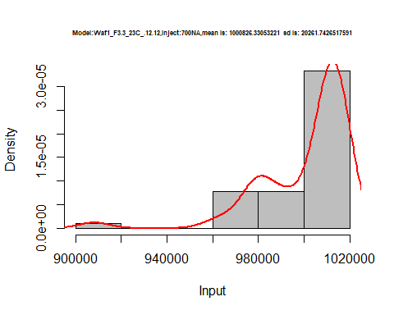

hist(d2_12.12$V8,  
 cex.main=0.5,  
 freq = FALSE,  
 main = paste('Model:Waf1_F3.3_23C_.12.12,Inject:100NA,mean is:', mean(d2_12.12$V8),' sd is:', sd(d2_12.12$V8)),  
 xlab = "Input",  
 ylab = "Density",  
 col="grey")  
#plot density curve  
lines(density(d2_12.12$V8), # density plot  
 lwd = 2, # thickness of line  
 col = "red")

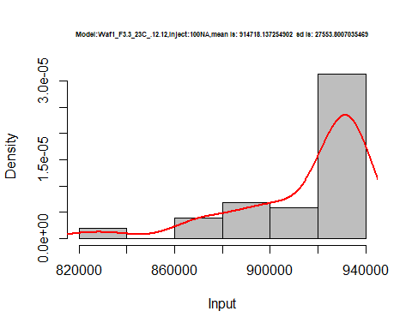

dens <- apply(d2_12.12, 2, density)  
plot('Model:Waf1_F3.3_23C_.12.12', xlim=range(sapply(dens, "[", "x")), ylim=range(sapply(dens, "[", "y")))

## Warning in xy.coords(x, y, xlabel, ylabel, log): NAs introduced by coercion

mapply(lines, dens, col=1:length(dens))

## $V1  
## NULL  
##   
## $V2  
## NULL  
##   
## $V3  
## NULL  
##   
## $V4  
## NULL  
##   
## $V5  
## NULL  
##   
## $V6  
## NULL  
##   
## $V7  
## NULL  
##   
## $V8  
## NULL

legend("topright", legend=names(dens), fill=1:length(dens))

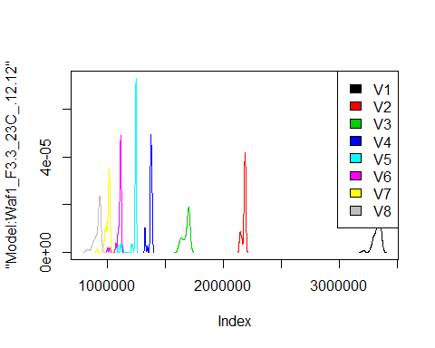

d3_12.12<-d_12.12[,c(17:24)]  
d3_12.12 <- head(d3_12.12,51)  
colnames(d3_12.12) <- c("V1", "V2","V3","V4","V5","V6","V7","V8")  
head(d3_12.12)

## V1 V2 V3 V4 V5 V6 V7 V8  
## 1 3107500 2436250 2094167 1851875 1674500 1537083 1431071 1348750  
## 2 3107500 2435000 2095000 1856250 1679000 1546250 1428571 1353438  
## 3 3115000 2427500 2109167 1864375 1671000 1550000 1431071 1353438  
## 4 3097500 2418750 2095000 1843750 1675000 1551667 1440714 1351250  
## 5 3112500 2427500 2090833 1859375 1666500 1547917 1435000 1353750  
## 6 3125000 2432500 2090833 1858125 1673000 1545833 1430714 1353125

hist(d3_12.12$V1,  
 cex.main=0.5,  
 freq = FALSE,  
 main = paste('Model:Waf1_F5.3_23C_12.12,Inject:100NA,mean is:', mean(d3_12.12$V1),' sd is:', sd(d3_12.12$V1)),  
 xlab = "Input",  
 ylab = "Density",  
 col="grey")  
#plot density curve  
lines(density(d3_12.12$V1), # density plot  
 lwd = 2, # thickness of line  
 col = "red")

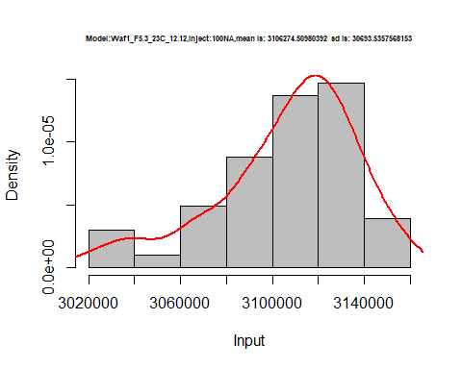

hist(d3_12.12$V2,  
 cex.main=0.5,  
 freq = FALSE,  
 main = paste('Model:Waf1_F5.3_23C_12.12,Inject:200NA,mean is:', mean(d3_12.12$V2),' sd is:', sd(d3_12.12$V2)),  
 xlab = "Input",  
 ylab = "Density",  
 col="grey")  
#plot density curve  
lines(density(d3_12.12$V2), # density plot  
 lwd = 2, # thickness of line  
 col = "red")

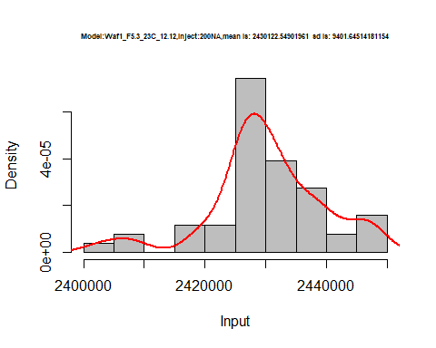

hist(d3_12.12$V3,  
 cex.main=0.5,  
 freq = FALSE,  
 main = paste('Model:Waf1_F5.3_23C_12.12,Inject:300NA,mean is:', mean(d3_12.12$V3),' sd is:', sd(d3_12.12$V3)),  
 xlab = "Input",  
 ylab = "Density",  
 col="grey")  
#plot density curve  
lines(density(d3_12.12$V3), # density plot  
 lwd = 2, # thickness of line  
 col = "red")

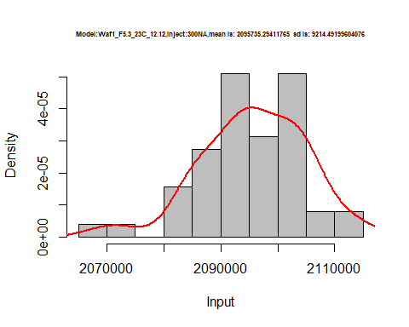

hist(d3_12.12$V4,  
 cex.main=0.5,  
 freq = FALSE,  
 main = paste('Model:Waf1_F5.3_23C_12.12,Inject:400NA,mean is:', mean(d3_12.12$V4),' sd is:', sd(d3_12.12$V4)),  
 xlab = "Input",  
 ylab = "Density",  
 col="grey")  
#plot density curve  
lines(density(d3_12.12$V4), # density plot  
 lwd = 2, # thickness of line  
 col = "red")

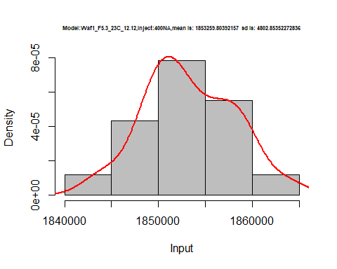

hist(d3_12.12$V5,  
 cex.main=0.5,  
 freq = FALSE,  
 main = paste('Model:Waf1_F5.3_23C_12.12,Inject:500NA,mean is:', mean(d3_12.12$V5),' sd is:', sd(d3_12.12$V5)),  
 xlab = "Input",  
 ylab = "Density",  
 col="grey")  
#plot density curve  
lines(density(d3_12.12$V5), # density plot  
 lwd = 2, # thickness of line  
 col = "red")

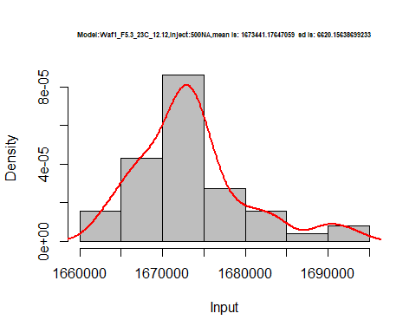

hist(d3_12.12$V6,  
 cex.main=0.5,  
 freq = FALSE,  
 main = paste('Model:Waf1_F5.3_23C_12.12,Inject:600NA,mean is:', mean(d3_12.12$V6),' sd is:', sd(d3_12.12$V6)),  
 xlab = "Input",  
 ylab = "Density",  
 col="grey")  
#plot density curve  
lines(density(d3_12.12$V6), # density plot  
 lwd = 2, # thickness of line  
 col = "red")

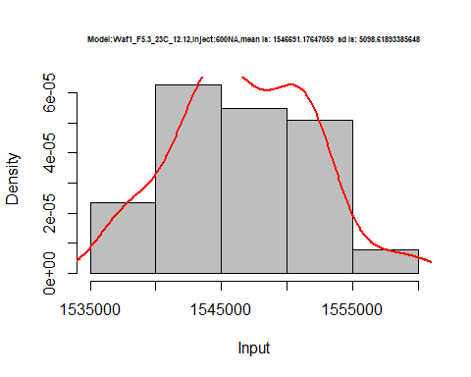

hist(d3_12.12$V7,  
 cex.main=0.5,  
 freq = FALSE,  
 main = paste('Model:Waf1_F5.3_23C_12.12,Inject:700NA,mean is:', mean(d3_12.12$V7),' sd is:', sd(d3_12.12$V7)),  
 xlab = "Input",  
 ylab = "Density",  
 col="grey")  
#plot density curve  
lines(density(d3_12.12$V7), # density plot  
 lwd = 2, # thickness of line  
 col = "red")

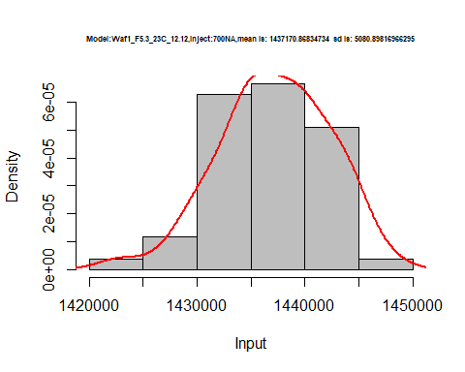

hist(d3_12.12$V8,  
 cex.main=0.5,  
 freq = FALSE,  
 main = paste('Model:Waf1_F5.3_23C_12.12,Inject:800NA,mean is:', mean(d3_12.12$V8),' sd is:', sd(d3_12.12$V8)),  
 xlab = "Input",  
 ylab = "Density",  
 col="grey")  
#plot density curve  
lines(density(d3_12.12$V8), # density plot  
 lwd = 2, # thickness of line  
 col = "red")

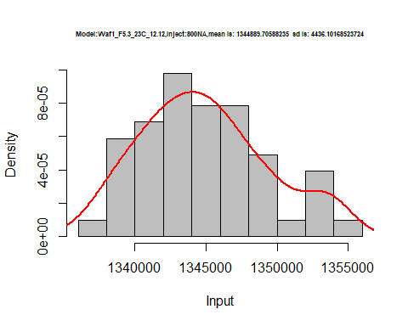

dens <- apply(d3_12.12, 2, density)  
plot('Model:Waf1_F5.3_23C_12.12', xlim=range(sapply(dens, "[", "x")), ylim=range(sapply(dens, "[", "y")))

## Warning in xy.coords(x, y, xlabel, ylabel, log): NAs introduced by coercion

mapply(lines, dens, col=1:length(dens))

## $V1  
## NULL  
##   
## $V2  
## NULL  
##   
## $V3  
## NULL  
##   
## $V4  
## NULL  
##   
## $V5  
## NULL  
##   
## $V6  
## NULL  
##   
## $V7  
## NULL  
##   
## $V8  
## NULL

legend("topright", legend=names(dens), fill=1:length(dens))

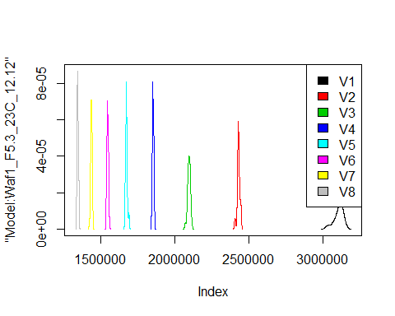

d4_12.12<-d_12.12[,c(25:32)]  
d4_12.12 <- head(d4_12.12,51)  
colnames(d4_12.12) <- c("V1", "V2","V3","V4","V5","V6","V7","V8")  
head(d4_12.12)

## V1 V2 V3 V4 V5 V6 V7 V8  
## 1 10987500 6297500 4499167 3574375 3001000 2465833 2288929 2064375  
## 2 10982500 6295000 4497500 3581250 3005500 2463333 2286429 2052812  
## 3 11027500 6308750 4497500 3590625 3003500 2465833 2289286 2064063  
## 4 11007500 6316250 4515833 3601875 3007000 2467917 2288214 2064063  
## 5 11012500 6318750 4514167 3588750 3002000 2465417 2287500 2059375  
## 6 11007500 6311250 4512500 3598750 2997000 2462500 2290357 2058437

hist(d4_12.12$V1,  
 cex.main=0.5,  
 freq = FALSE,  
 main = paste('Model:Waf1_F9.5_23C_.12.12,Inject:800NA,mean is:', mean(d4_12.12$V1),' sd is:', sd(d4_12.12$V1)),  
 xlab = "Input",  
 ylab = "Density",  
 col="grey")  
#plot density curve  
lines(density(d4_12.12$V1), # density plot  
 lwd = 2, # thickness of line  
 col = "red")

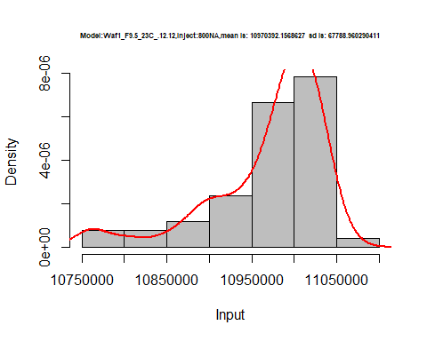

hist(d4_12.12$V3,  
 cex.main=0.5,  
 freq = FALSE,  
 main = paste('Model:Waf1_F9.5_23C_.12.12,Inject:300NA,mean is:', mean(d4_12.12$V3),' sd is:', sd(d4_12.12$V3)),  
 xlab = "Input",  
 ylab = "Density",  
 col="grey")  
#plot density curve  
lines(density(d4_12.12$V3), # density plot  
 lwd = 2, # thickness of line  
 col = "red")

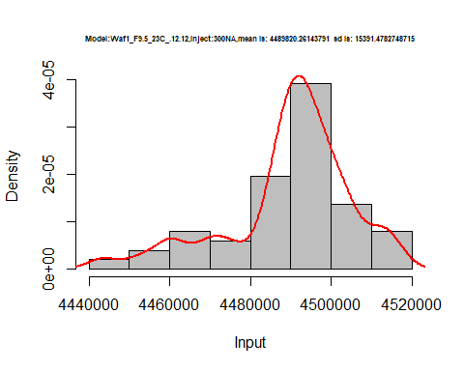

hist(d4_12.12$V4,  
 cex.main=0.5,  
 freq = FALSE,  
 main = paste('Model:Waf1_F9.5_23C_.12.12,Inject:400NA,mean is:', mean(d4_12.12$V4),' sd is:', sd(d4_12.12$V4)),  
 xlab = "Input",  
 ylab = "Density",  
 col="grey")  
#plot density curve  
lines(density(d4_12.12$V4), # density plot  
 lwd = 2, # thickness of line  
 col = "red")

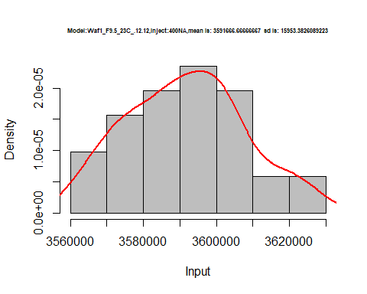

hist(d4_12.12$V5,  
 cex.main=0.5,  
 freq = FALSE,  
 main = paste('Model:Waf1_F9.5_23C_.12.12,Inject:500NA,mean is:', mean(d4_12.12$V5),' sd is:', sd(d4_12.12$V5)),  
 xlab = "Input",  
 ylab = "Density",  
 col="grey")  
#plot density curve  
lines(density(d4_12.12$V5), # density plot  
 lwd = 2, # thickness of line  
 col = "red")

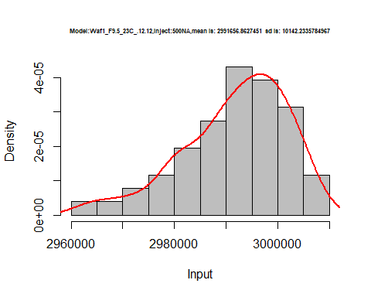

hist(d4_12.12$V6,  
 cex.main=0.5,  
 freq = FALSE,  
 main = paste('Model:Waf1_F9.5_23C_.12.12,Inject:600NA,mean is:', mean(d4_12.12$V6),' sd is:', sd(d4_12.12$V6)),  
 xlab = "Input",  
 ylab = "Density",  
 col="grey")  
#plot density curve  
lines(density(d4_12.12$V6), # density plot  
 lwd = 2, # thickness of line  
 col = "red")

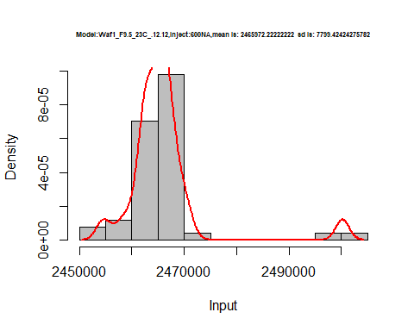

hist(d4_12.12$V7,  
 cex.main=0.5,  
 freq = FALSE,  
 main = paste('Model:Waf1_F9.5_23C_.12.12,Inject:700NA,mean is:', mean(d4_12.12$V7),' sd is:', sd(d4_12.12$V7)),  
 xlab = "Input",  
 ylab = "Density",  
 col="grey")  
#plot density curve  
lines(density(d4_12.12$V7), # density plot  
 lwd = 2, # thickness of line  
 col = "red")

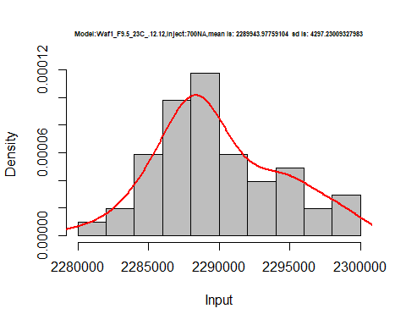

dens <- apply(d4_12.12, 2, density)  
plot('Model:Waf1_F5.3_23C_12.12', xlim=range(sapply(dens, "[", "x")), ylim=range(sapply(dens, "[", "y")))

## Warning in xy.coords(x, y, xlabel, ylabel, log): NAs introduced by coercion

mapply(lines, dens, col=1:length(dens))

## $V1  
## NULL  
##   
## $V2  
## NULL  
##   
## $V3  
## NULL  
##   
## $V4  
## NULL  
##   
## $V5  
## NULL  
##   
## $V6  
## NULL  
##   
## $V7  
## NULL  
##   
## $V8  
## NULL

legend("topright", legend=names(dens), fill=1:length(dens))

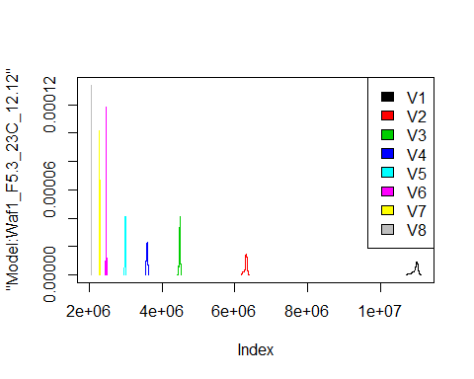

# Select columns whose names contains "13.13"  
d_13.13<-my_data %>% select(contains("13.13."))  
head(d_13.13)

## Waf1_F2.3_23C_.100nA_.13.13. Waf1_F2.3_23C_.200nA_.13.13.  
## 1 2172500 1616250  
## 2 2175000 1613750  
## 3 2175000 1615000  
## 4 2187500 1617500  
## 5 2182500 1616250  
## 6 2180000 1623750  
## Waf1_F2.3_23C_.300nA_.13.13. Waf1_F2.3_23C_.400nA_.13.13.  
## 1 1350833 1194375  
## 2 1349167 1192500  
## 3 1353333 1191250  
## 4 1356667 1190000  
## 5 1360000 1191250  
## 6 1360000 1185625  
## Waf1_F2.3_23C_.500nA_.13.13. Waf1_F2.3_23C_.600nA_.13.13.  
## 1 1072000 964583.3  
## 2 1068500 963333.3  
## 3 1073000 965833.3  
## 4 1069500 964583.3  
## 5 1074000 965833.3  
## 6 1073000 966250.0  
## Waf1_F2.3_23C_.700nA_.13.13. Waf1_F2.3_23C_.800nA_.13.13.  
## 1 888214.3 835625.0  
## 2 888214.3 835000.0  
## 3 892857.1 834687.5  
## 4 892500.0 834062.5  
## 5 892500.0 833750.0  
## 6 891785.7 836562.5  
## Waf1_F2.5_23C_.100nA_.13.13. Waf1_F2.5_23C_.200nA_.13.13.  
## 1 1682500 1396250  
## 2 1682500 1402500  
## 3 1682500 1410000  
## 4 1682500 1412500  
## 5 1672500 1416250  
## 6 1665000 1401250  
## Waf1_F2.5_23C_.300nA_.13.13. Waf1_F2.5_23C_.400nA_.13.13.  
## 1 1214167 1116250  
## 2 1215833 1113125  
## 3 1213333 1111875  
## 4 1212500 1100625  
## 5 1212500 1101875  
## 6 1210833 1103750  
## Waf1_F2.5_23C_.500nA_.13.13. Waf1_F2.5_23C_.600nA_.13.13.  
## 1 1007000 937500.0  
## 2 1005500 935833.3  
## 3 1007000 936666.7  
## 4 1006000 934166.7  
## 5 1005000 933333.3  
## 6 1004500 934166.7  
## Waf1_F2.5_23C_.700nA_.13.13. Waf1_F2.5_23C_.800nA_.13.13.  
## 1 884642.9 835312.5  
## 2 885357.1 835000.0  
## 3 885357.1 835625.0  
## 4 886428.6 836250.0  
## 5 885357.1 835625.0  
## 6 883571.4 838437.5  
## Waf1_F5.3_23C_.100nA_.13.13. Waf1_F5.3_23C_.200nA_.13.13.  
## 1 2242500 1642500  
## 2 2252500 1646250  
## 3 2260000 1643750  
## 4 2260000 1645000  
## 5 2257500 1645000  
## 6 2257500 1643750  
## Waf1_F5.3_23C_.300nA_.13.13. Waf1_F5.3_23C_.400nA_.13.13.  
## 1 1387500 1227500  
## 2 1390833 1228125  
## 3 1391667 1225000  
## 4 1390833 1225625  
## 5 1391667 1226250  
## 6 1391667 1222500  
## Waf1_F5.3_23C_.500nA_.13.13. Waf1_F5.3_23C_.600nA_.13.13.  
## 1 1103500 1010833  
## 2 1104500 1012500  
## 3 1101000 1013333  
## 4 1101000 1014583  
## 5 1101000 1015417  
## 6 1101500 1011667  
## Waf1_F5.3_23C_.700nA_.13.13. Waf1_F5.3_23C_.800nA_.13.13.  
## 1 929642.9 878437.5  
## 2 928214.3 880000.0  
## 3 930357.1 879062.5  
## 4 929285.7 878750.0  
## 5 928214.3 879062.5  
## 6 928928.6 879062.5  
## Waf1_F6.2_23C_.100nA_.13.13. Waf1_F6.2_23C_.200nA_.13.13.  
## 1 2205000 1730000  
## 2 2205000 1730000  
## 3 2207500 1735000  
## 4 2212500 1735000  
## 5 2200000 1735000  
## 6 2202500 1733750  
## Waf1_F6.2_23C_.300nA_.13.13. Waf1_F6.2_23C_.400nA_.13.13.  
## 1 1486667 1260000  
## 2 1484167 1259375  
## 3 1482500 1257500  
## 4 1486667 1263750  
## 5 1476667 1261250  
## 6 1475833 1259375  
## Waf1_F6.2_23C_.500nA_.13.13. Waf1_F6.2_23C_.600nA_.13.13.  
## 1 1138500 1030833  
## 2 1140500 1030833  
## 3 1138000 1029583  
## 4 1139000 1032083  
## 5 1138000 1026667  
## 6 1139500 1026667  
## Waf1_F6.2_23C_.700nA_.13.13. Waf1_F6.2_23C_.800nA_.13.13.  
## 1 961428.6 880312.5  
## 2 963928.6 881250.0  
## 3 961428.6 881250.0  
## 4 967857.1 881875.0  
## 5 967500.0 881875.0  
## 6 966071.4 881875.0

d1_13.13<-d_13.13[,c(1:8)]  
d1_13.13 <- head(d1_13.13,51)  
colnames(d1_13.13) <- c("V1", "V2","V3","V4","V5","V6","V7","V8")  
head(d1_13.13)

## V1 V2 V3 V4 V5 V6 V7 V8  
## 1 2172500 1616250 1350833 1194375 1072000 964583.3 888214.3 835625.0  
## 2 2175000 1613750 1349167 1192500 1068500 963333.3 888214.3 835000.0  
## 3 2175000 1615000 1353333 1191250 1073000 965833.3 892857.1 834687.5  
## 4 2187500 1617500 1356667 1190000 1069500 964583.3 892500.0 834062.5  
## 5 2182500 1616250 1360000 1191250 1074000 965833.3 892500.0 833750.0  
## 6 2180000 1623750 1360000 1185625 1073000 966250.0 891785.7 836562.5

hist(d1_13.13$V1,  
 cex.main=0.5,  
 freq = FALSE,  
 main = paste('Model:Waf1_F2.3_23C_.13.13,Inject:100NA,mean is:', mean(d1_13.13$V1),' sd is:', sd(d1_13.13$V1)),  
 xlab = "Input",  
 ylab = "Density",  
 col="grey")  
#plot density curve  
lines(density(d1_13.13$V1), # density plot  
 lwd = 2, # thickness of line  
 col = "red")

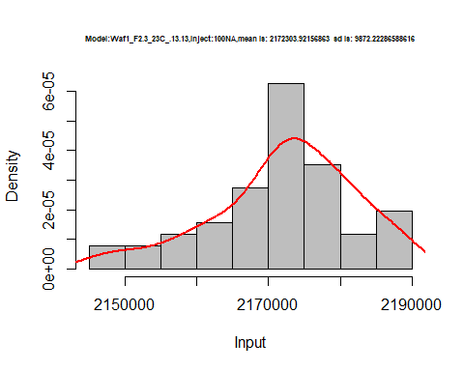

hist(d1_13.13$V2,  
 cex.main=0.5,  
 freq = FALSE,  
 main = paste('Model:Waf1_F2.3_23C_.13.13,Inject:200NA,mean is:', mean(d1_13.13$V2),' sd is:', sd(d1_13.13$V2)),  
 xlab = "Input",  
 ylab = "Density",  
 col="grey")  
#plot density curve  
lines(density(d1_13.13$V2), # density plot  
 lwd = 2, # thickness of line  
 col = "red")

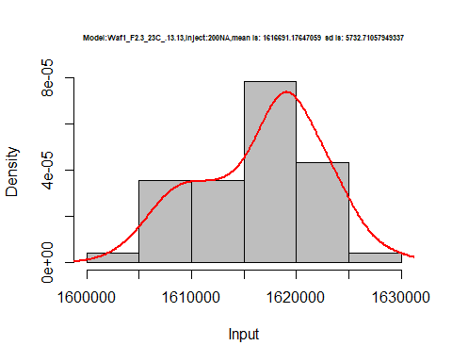

hist(d1_13.13$V3,  
 cex.main=0.5,  
 freq = FALSE,  
 main = paste('Model:Waf1_F2.3_23C_.13.13,Inject:300NA,mean is:', mean(d1_13.13$V3),' sd is:', sd(d1_13.13$V3)),  
 xlab = "Input",  
 ylab = "Density",  
 col="grey")  
#plot density curve  
lines(density(d1_13.13$V3), # density plot  
 lwd = 2, # thickness of line  
 col = "red")

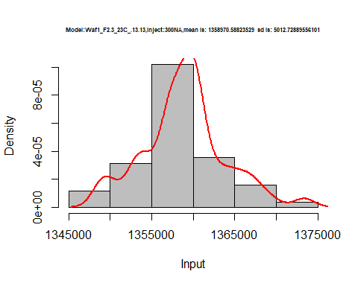

hist(d1_13.13$V4,  
 cex.main=0.5,  
 freq = FALSE,  
 main = paste('Model:Waf1_F2.3_23C_.13.13,Inject:400NA,mean is:', mean(d1_13.13$V4),' sd is:', sd(d1_13.13$V4)),  
 xlab = "Input",  
 ylab = "Density",  
 col="grey")  
#plot density curve  
lines(density(d1_13.13$V4), # density plot  
 lwd = 2, # thickness of line  
 col = "red")

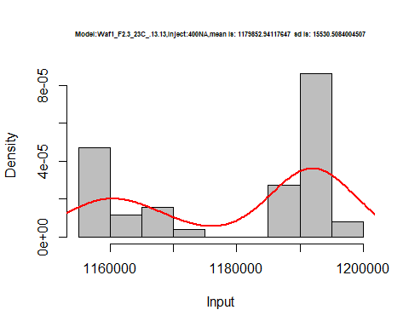

hist(d1_13.13$V5,  
 cex.main=0.5,  
 freq = FALSE,  
 main = paste('Model:Waf1_F2.3_23C_.13.13,Inject:500NA,mean is:', mean(d1_13.13$V5),' sd is:', sd(d1_13.13$V5)),  
 xlab = "Input",  
 ylab = "Density",  
 col="grey")  
#plot density curve  
lines(density(d1_13.13$V5), # density plot  
 lwd = 2, # thickness of line  
 col = "red")

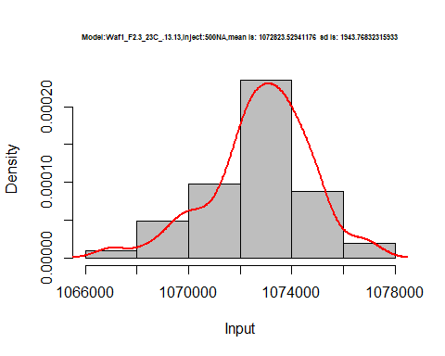

hist(d1_13.13$V6,  
 cex.main=0.5,  
 freq = FALSE,  
 main = paste('Model:Waf1_F2.3_23C_.13.13,Inject:600NA,mean is:', mean(d1_13.13$V6),' sd is:', sd(d1_13.13$V6)),  
 xlab = "Input",  
 ylab = "Density",  
 col="grey")  
#plot density curve  
lines(density(d1_13.13$V6), # density plot  
 lwd = 2, # thickness of line  
 col = "red")

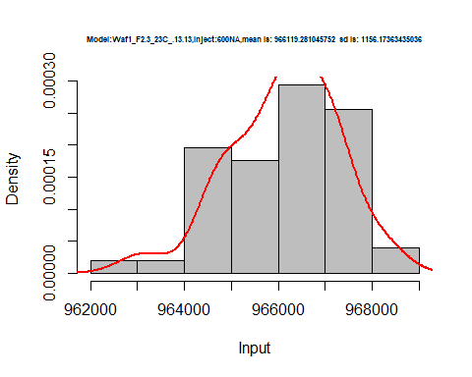

hist(d1_13.13$V7,  
 cex.main=0.5,  
 freq = FALSE,  
 main = paste('Model:Waf1_F2.3_23C_.13.13,Inject:700NA,mean is:', mean(d1_13.13$V7),' sd is:', sd(d1_13.13$V7)),  
 xlab = "Input",  
 ylab = "Density",  
 col="grey")  
#plot density curve  
lines(density(d1_13.13$V7), # density plot  
 lwd = 2, # thickness of line  
 col = "red")

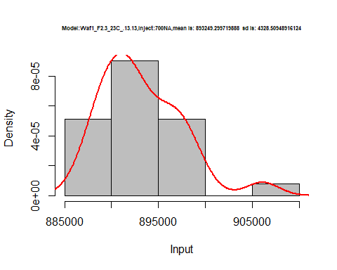

hist(d1_13.13$V8,  
 cex.main=0.5,  
 freq = FALSE,  
 main = paste('Model:Waf1_F2.3_23C_.13.13,Inject:800NA,mean is:', mean(d1_13.13$V8),' sd is:', sd(d1_13.13$V8)),  
 xlab = "Input",  
 ylab = "Density",  
 col="grey")  
#plot density curve  
lines(density(d1_13.13$V8), # density plot  
 lwd = 2, # thickness of line  
 col = "red")

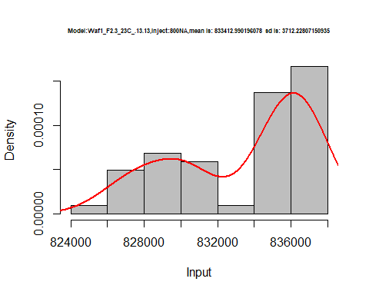

dens <- apply(d1_13.13, 2, density)  
plot('Model:Waf1_F5.3_23C_12.12', xlim=range(sapply(dens, "[", "x")), ylim=range(sapply(dens, "[", "y")))

## Warning in xy.coords(x, y, xlabel, ylabel, log): NAs introduced by coercion

mapply(lines, dens, col=1:length(dens))

## $V1  
## NULL  
##   
## $V2  
## NULL  
##   
## $V3  
## NULL  
##   
## $V4  
## NULL  
##   
## $V5  
## NULL  
##   
## $V6  
## NULL  
##   
## $V7  
## NULL  
##   
## $V8  
## NULL

legend("topright", legend=names(dens), fill=1:length(dens))

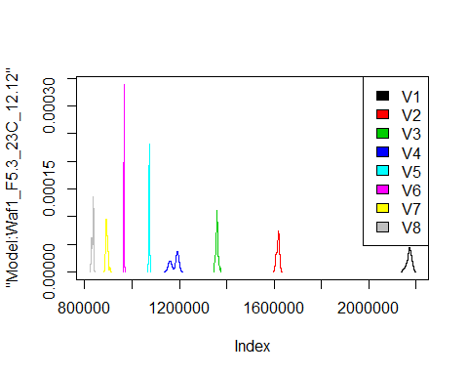

d2_13.13<-d_13.13[,c(9:16)]  
d2_13.13 <- head(d2_13.13,51)  
colnames(d2_13.13) <- c("V1", "V2","V3","V4","V5","V6","V7","V8")  
head(d2_13.13)

## V1 V2 V3 V4 V5 V6 V7 V8  
## 1 1682500 1396250 1214167 1116250 1007000 937500.0 884642.9 835312.5  
## 2 1682500 1402500 1215833 1113125 1005500 935833.3 885357.1 835000.0  
## 3 1682500 1410000 1213333 1111875 1007000 936666.7 885357.1 835625.0  
## 4 1682500 1412500 1212500 1100625 1006000 934166.7 886428.6 836250.0  
## 5 1672500 1416250 1212500 1101875 1005000 933333.3 885357.1 835625.0  
## 6 1665000 1401250 1210833 1103750 1004500 934166.7 883571.4 838437.5

hist(d2_13.13$V1,  
 cex.main=0.5,  
 freq = FALSE,  
 main = paste('Model:Waf1_F2.5_23C_.13.13,Inject:100NA,mean is:', mean(d2_13.13$V1),' sd is:', sd(d1_13.13$V1)),  
 xlab = "Input",  
 ylab = "Density",  
 col="grey")  
#plot density curve  
lines(density(d2_13.13$V1), # density plot  
 lwd = 2, # thickness of line  
 col = "red")

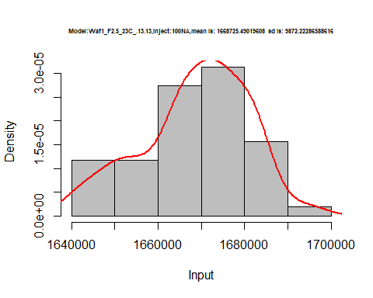

hist(d2_13.13$V2,  
 cex.main=0.5,  
 freq = FALSE,  
 main = paste('Model:Waf1_F2.5_23C_.13.13,Inject:200NA,mean is:', mean(d2_13.13$V2),' sd is:', sd(d2_13.13$V2)),  
 xlab = "Input",  
 ylab = "Density",  
 col="grey")  
#plot density curve  
lines(density(d2_13.13$V2), # density plot  
 lwd = 2, # thickness of line  
 col = "red")

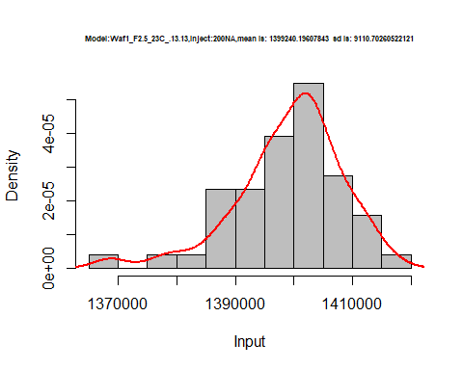

hist(d2_13.13$V3,  
 cex.main=0.5,  
 freq = FALSE,  
 main = paste('Model:Waf1_F2.5_23C_.13.13,Inject:300NA,mean is:', mean(d2_13.13$V3),' sd is:', sd(d2_13.13$V3)),  
 xlab = "Input",  
 ylab = "Density",  
 col="grey")  
#plot density curve  
lines(density(d2_13.13$V3), # density plot  
 lwd = 2, # thickness of line  
 col = "red")

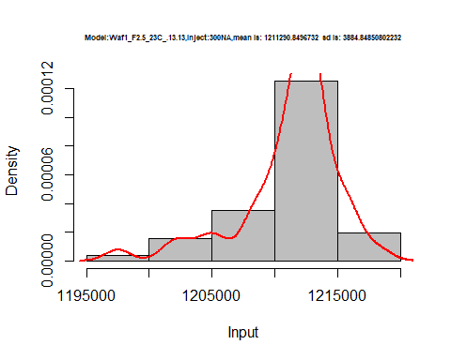

hist(d2_13.13$V4,  
 cex.main=0.5,  
 freq = FALSE,  
 main = paste('Model:Waf1_F2.5_23C_.13.13,Inject:400NA,mean is:', mean(d2_13.13$V4),' sd is:', sd(d2_13.13$V4)),  
 xlab = "Input",  
 ylab = "Density",  
 col="grey")  
#plot density curve  
lines(density(d2_13.13$V4), # density plot  
 lwd = 2, # thickness of line  
 col = "red")

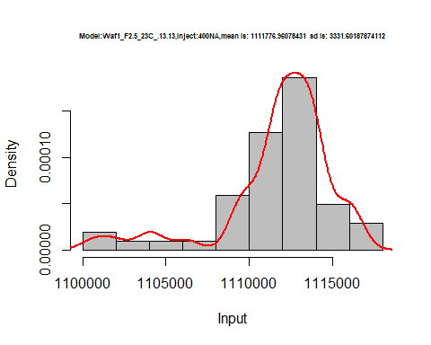

hist(d2_13.13$V5,  
 cex.main=0.5,  
 freq = FALSE,  
 main = paste('Model:Waf1_F2.5_23C_.13.13,Inject:500NA,mean is:', mean(d2_13.13$V5),' sd is:', sd(d2_13.13$V5)),  
 xlab = "Input",  
 ylab = "Density",  
 col="grey")  
#plot density curve  
lines(density(d2_13.13$V5), # density plot  
 lwd = 2, # thickness of line  
 col = "red")

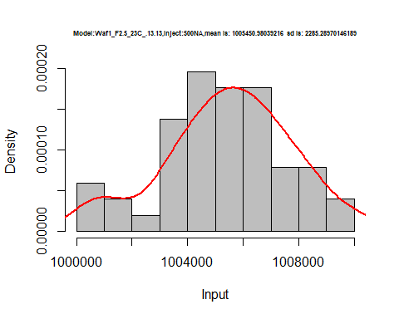

hist(d2_13.13$V6,  
 cex.main=0.5,  
 freq = FALSE,  
 main = paste('Model:Waf1_F2.5_23C_.13.13,Inject:600NA,mean is:', mean(d2_13.13$V6),' sd is:', sd(d2_13.13$V6)),  
 xlab = "Input",  
 ylab = "Density",  
 col="grey")  
#plot density curve  
lines(density(d2_13.13$V6), # density plot  
 lwd = 2, # thickness of line  
 col = "red")

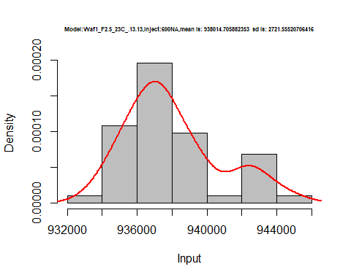

hist(d2_13.13$V7,  
 cex.main=0.5,  
 freq = FALSE,  
 main = paste('Model:Waf1_F2.5_23C_.13.13,Inject:700NA,mean is:', mean(d2_13.13$V7),' sd is:', sd(d2_13.13$V7)),  
 xlab = "Input",  
 ylab = "Density",  
 col="grey")  
#plot density curve  
lines(density(d2_13.13$V7), # density plot  
 lwd = 2, # thickness of line  
 col = "red")

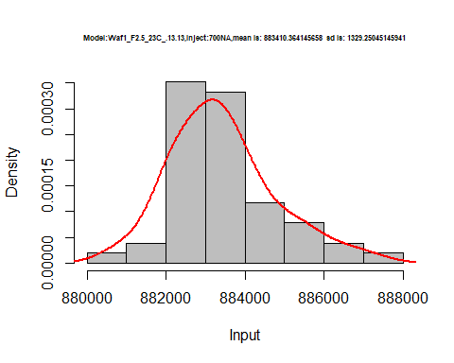

hist(d2_13.13$V8,  
 cex.main=0.5,  
 freq = FALSE,  
 main = paste('Model:Waf1_F2.5_23C_.13.13,Inject:800NA,mean is:', mean(d2_13.13$V8),' sd is:', sd(d2_13.13$V8)),  
 xlab = "Input",  
 ylab = "Density",  
 col="grey")  
#plot density curve  
lines(density(d2_13.13$V8), # density plot  
 lwd = 2, # thickness of line  
 col = "red")

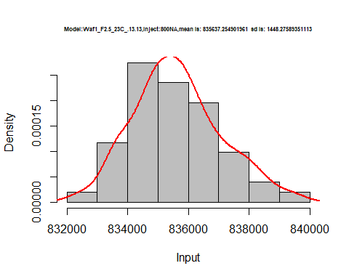

dens <- apply(d2_13.13, 2, density)  
plot('Model:Waf1_F2.5_23C_13.13', xlim=range(sapply(dens, "[", "x")), ylim=range(sapply(dens, "[", "y")))

## Warning in xy.coords(x, y, xlabel, ylabel, log): NAs introduced by coercion

mapply(lines, dens, col=1:length(dens))

## $V1  
## NULL  
##   
## $V2  
## NULL  
##   
## $V3  
## NULL  
##   
## $V4  
## NULL  
##   
## $V5  
## NULL  
##   
## $V6  
## NULL  
##   
## $V7  
## NULL  
##   
## $V8  
## NULL

legend("topright", legend=names(dens), fill=1:length(dens))

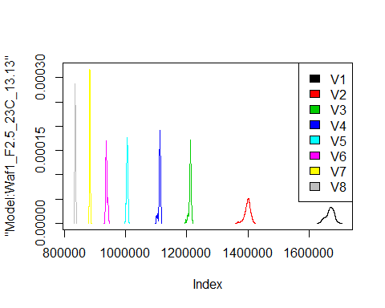

d3_13.13<-d_13.13[,c(17:24)]  
d3_13.13 <- head(d3_13.13,51)  
colnames(d3_13.13) <- c("V1", "V2","V3","V4","V5","V6","V7","V8")  
head(d3_13.13)

## V1 V2 V3 V4 V5 V6 V7 V8  
## 1 2242500 1642500 1387500 1227500 1103500 1010833 929642.9 878437.5  
## 2 2252500 1646250 1390833 1228125 1104500 1012500 928214.3 880000.0  
## 3 2260000 1643750 1391667 1225000 1101000 1013333 930357.1 879062.5  
## 4 2260000 1645000 1390833 1225625 1101000 1014583 929285.7 878750.0  
## 5 2257500 1645000 1391667 1226250 1101000 1015417 928214.3 879062.5  
## 6 2257500 1643750 1391667 1222500 1101500 1011667 928928.6 879062.5

hist(d3_13.13$V1,  
 cex.main=0.5,  
 freq = FALSE,  
 main = paste('Model:Waf1_F5.3_23C_.13.13.,Inject:100NA,mean is:', mean(d3_13.13$V1),' sd is:', sd(d3_13.13$V1)),  
 xlab = "Input",  
 ylab = "Density",  
 col="grey")  
#plot density curve  
lines(density(d3_13.13$V1), # density plot  
 lwd = 2, # thickness of line  
 col = "red")

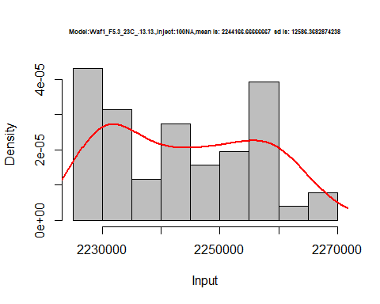

hist(d3_13.13$V2,  
 cex.main=0.5,  
 freq = FALSE,  
 main = paste('Model:Waf1_F5.3_23C_.13.13.,Inject:200NA,mean is:', mean(d3_13.13$V2),' sd is:', sd(d3_13.13$V2)),  
 xlab = "Input",  
 ylab = "Density",  
 col="grey")  
#plot density curve  
lines(density(d3_13.13$V2), # density plot  
 lwd = 2, # thickness of line  
 col = "red")

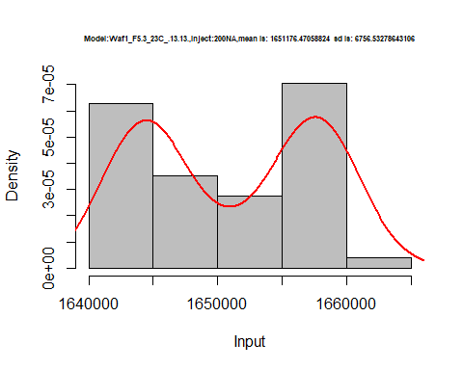

hist(d3_13.13$V3,  
 cex.main=0.5,  
 freq = FALSE,  
 main = paste('Model:Waf1_F5.3_23C_.13.13.,Inject:300NA,mean is:', mean(d3_13.13$V3),' sd is:', sd(d3_13.13$V3)),  
 xlab = "Input",  
 ylab = "Density",  
 col="grey")  
#plot density curve  
lines(density(d3_13.13$V3), # density plot  
 lwd = 2, # thickness of line  
 col = "red")

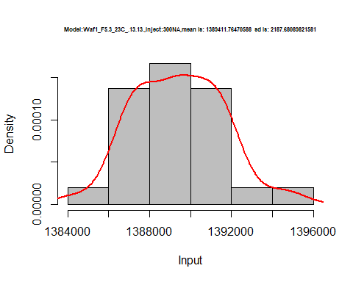

hist(d3_13.13$V4,  
 cex.main=0.5,  
 freq = FALSE,  
 main = paste('Model:Waf1_F5.3_23C_.13.13.,Inject:400NA,mean is:', mean(d3_13.13$V4),' sd is:', sd(d3_13.13$V4)),  
 xlab = "Input",  
 ylab = "Density",  
 col="grey")  
#plot density curve  
lines(density(d3_13.13$V4), # density plot  
 lwd = 2, # thickness of line  
 col = "red")

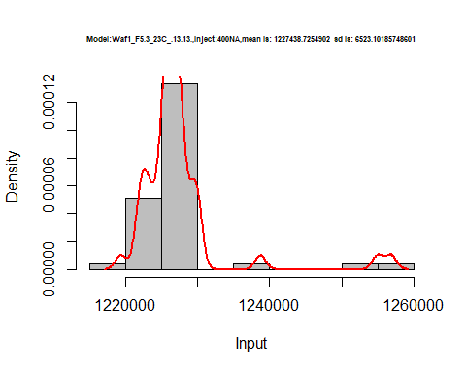

hist(d3_13.13$V5,  
 cex.main=0.5,  
 freq = FALSE,  
 main = paste('Model:Waf1_F5.3_23C_.13.13.,Inject:500NA,mean is:', mean(d3_13.13$V5),' sd is:', sd(d3_13.13$V5)),  
 xlab = "Input",  
 ylab = "Density",  
 col="grey")  
#plot density curve  
lines(density(d3_13.13$V5), # density plot  
 lwd = 2, # thickness of line  
 col = "red")

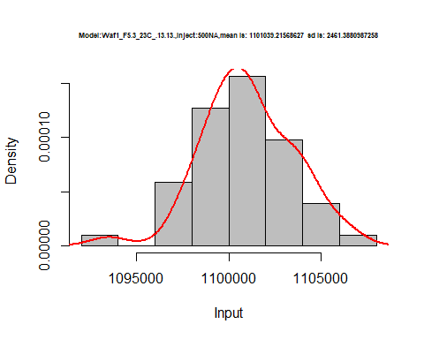

hist(d3_13.13$V6,  
 cex.main=0.5,  
 freq = FALSE,  
 main = paste('Model:Waf1_F5.3_23C_.13.13.,Inject:600NA,mean is:', mean(d3_13.13$V6),' sd is:', sd(d3_13.13$V6)),  
 xlab = "Input",  
 ylab = "Density",  
 col="grey")  
#plot density curve  
lines(density(d3_13.13$V6), # density plot  
 lwd = 2, # thickness of line  
 col = "red")

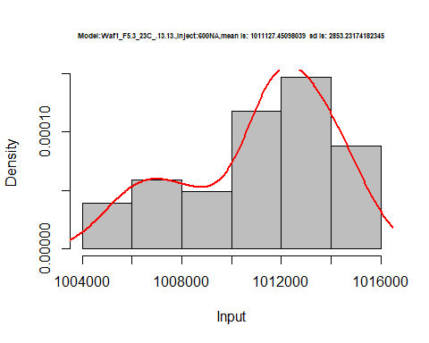

hist(d3_13.13$V7,  
 cex.main=0.5,  
 freq = FALSE,  
 main = paste('Model:Waf1_F5.3_23C_.13.13.,Inject:700NA,mean is:', mean(d3_13.13$V7),' sd is:', sd(d3_13.13$V7)),  
 xlab = "Input",  
 ylab = "Density",  
 col="grey")  
#plot density curve  
lines(density(d3_13.13$V7), # density plot  
 lwd = 2, # thickness of line  
 col = "red")

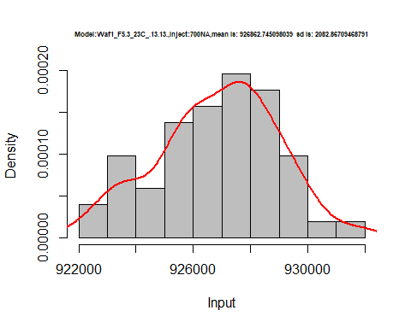

hist(d3_13.13$V8,  
 cex.main=0.5,  
 freq = FALSE,  
 main = paste('Model:Waf1_F5.3_23C_.13.13.,Inject:800NA,mean is:', mean(d3_13.13$V8),' sd is:', sd(d3_13.13$V8)),  
 xlab = "Input",  
 ylab = "Density",  
 col="grey")  
#plot density curve  
lines(density(d3_13.13$V8), # density plot  
 lwd = 2, # thickness of line  
 col = "red")

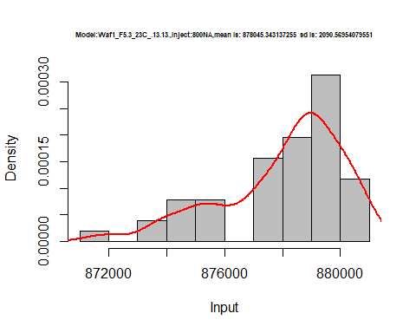

dens <- apply(d3_13.13, 2, density)  
plot('Model:Waf1_F5.3_23C_.13.13', xlim=range(sapply(dens, "[", "x")), ylim=range(sapply(dens, "[", "y")))

## Warning in xy.coords(x, y, xlabel, ylabel, log): NAs introduced by coercion

mapply(lines, dens, col=1:length(dens))

## $V1  
## NULL  
##   
## $V2  
## NULL  
##   
## $V3  
## NULL  
##   
## $V4  
## NULL  
##   
## $V5  
## NULL  
##   
## $V6  
## NULL  
##   
## $V7  
## NULL  
##   
## $V8  
## NULL

legend("topright", legend=names(dens), fill=1:length(dens))

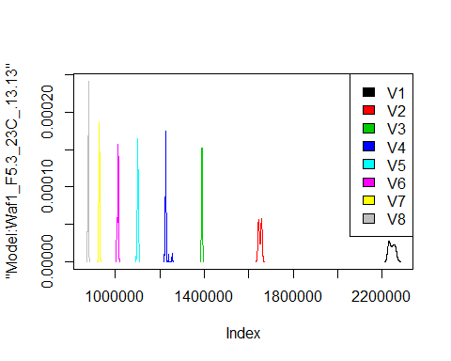

d4_13.13<-d_13.13[,c(25:32)]  
d4_13.13 <- head(d4_13.13,51)  
colnames(d4_13.13) <- c("V1", "V2","V3","V4","V5","V6","V7","V8")  
head(d4_13.13)

## V1 V2 V3 V4 V5 V6 V7 V8  
## 1 2205000 1730000 1486667 1260000 1138500 1030833 961428.6 880312.5  
## 2 2205000 1730000 1484167 1259375 1140500 1030833 963928.6 881250.0  
## 3 2207500 1735000 1482500 1257500 1138000 1029583 961428.6 881250.0  
## 4 2212500 1735000 1486667 1263750 1139000 1032083 967857.1 881875.0  
## 5 2200000 1735000 1476667 1261250 1138000 1026667 967500.0 881875.0  
## 6 2202500 1733750 1475833 1259375 1139500 1026667 966071.4 881875.0

hist(d4_13.13$V1,  
 cex.main=0.5,  
 freq = FALSE,  
 main = paste('Model:Waf1_F6.2_23C_.13.13.,Inject:100NA,mean is:', mean(d4_13.13$V1),' sd is:', sd(d4_13.13$V1)),  
 xlab = "Input",  
 ylab = "Density",  
 col="grey")  
#plot density curve  
lines(density(d4_13.13$V1), # density plot  
 lwd = 2, # thickness of line  
 col = "red")

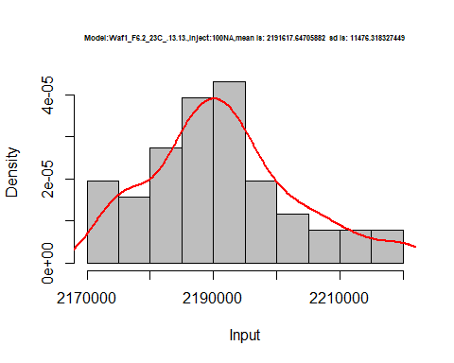

hist(d4_13.13$V2,  
 cex.main=0.5,  
 freq = FALSE,  
 main = paste('Model:Waf1_F6.2_23C_.13.13.,Inject:200NA,mean is:', mean(d4_13.13$V2),' sd is:', sd(d4_13.13$V2)),  
 xlab = "Input",  
 ylab = "Density",  
 col="grey")  
#plot density curve  
lines(density(d4_13.13$V2), # density plot  
 lwd = 2, # thickness of line  
 col = "red")

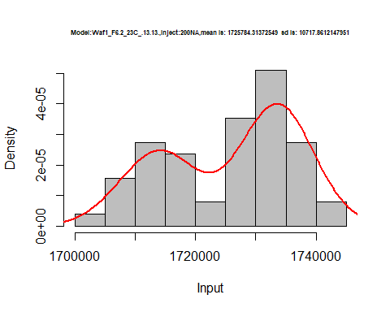

hist(d4_13.13$V3,  
 cex.main=0.5,  
 freq = FALSE,  
 main = paste('Model:Waf1_F6.2_23C_.13.13.,Inject:300NA,mean is:', mean(d4_13.13$V3),' sd is:', sd(d4_13.13$V3)),  
 xlab = "Input",  
 ylab = "Density",  
 col="grey")  
#plot density curve  
lines(density(d4_13.13$V3), # density plot  
 lwd = 2, # thickness of line  
 col = "red")

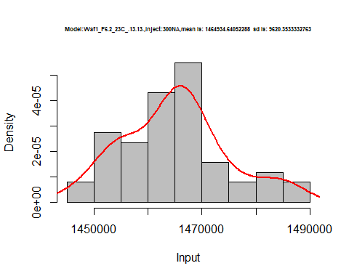

hist(d4_13.13$V4,  
 cex.main=0.5,  
 freq = FALSE,  
 main = paste('Model:Waf1_F6.2_23C_.13.13.,Inject:400NA,mean is:', mean(d4_13.13$V4),' sd is:', sd(d4_13.13$V4)),  
 xlab = "Input",  
 ylab = "Density",  
 col="grey")  
#plot density curve  
lines(density(d4_13.13$V4), # density plot  
 lwd = 2, # thickness of line  
 col = "red")

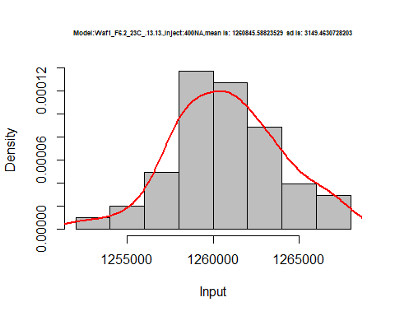

hist(d4_13.13$V5,  
 cex.main=0.5,  
 freq = FALSE,  
 main = paste('Model:Waf1_F6.2_23C_.13.13.,Inject:500NA,mean is:', mean(d4_13.13$V5),' sd is:', sd(d4_13.13$V5)),  
 xlab = "Input",  
 ylab = "Density",  
 col="grey")  
#plot density curve  
lines(density(d4_13.13$V5), # density plot  
 lwd = 2, # thickness of line  
 col = "red")

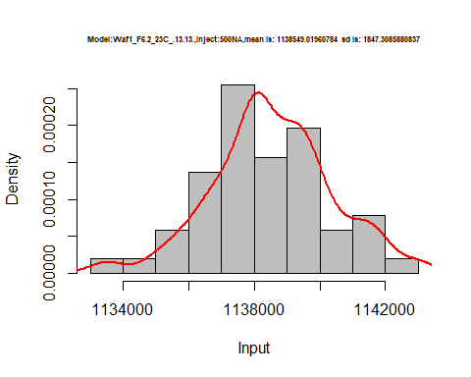

hist(d4_13.13$V6,  
 cex.main=0.5,  
 freq = FALSE,  
 main = paste('Model:Waf1_F6.2_23C_.13.13.,Inject:600NA,mean is:', mean(d4_13.13$V6),' sd is:', sd(d4_13.13$V6)),  
 xlab = "Input",  
 ylab = "Density",  
 col="grey")  
#plot density curve  
lines(density(d4_13.13$V6), # density plot  
 lwd = 2, # thickness of line  
 col = "red")

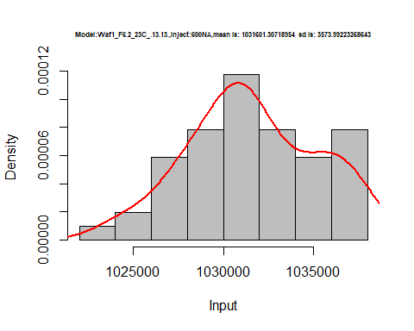

hist(d4_13.13$V7,  
 cex.main=0.5,  
 freq = FALSE,  
 main = paste('Model:Waf1_F6.2_23C_.13.13.,Inject:700NA,mean is:', mean(d4_13.13$V7),' sd is:', sd(d4_13.13$V7)),  
 xlab = "Input",  
 ylab = "Density",  
 col="grey")  
#plot density curve  
lines(density(d4_13.13$V7), # density plot  
 lwd = 2, # thickness of line  
 col = "red")

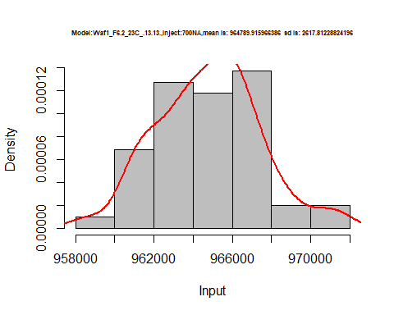

hist(d4_13.13$V8,  
 cex.main=0.5,  
 freq = FALSE,  
 main = paste('Model:Waf1_F6.2_23C_.13.13.,Inject:800NA,mean is:', mean(d4_13.13$V8),' sd is:', sd(d4_13.13$V8)),  
 xlab = "Input",  
 ylab = "Density",  
 col="grey")  
#plot density curve  
lines(density(d4_13.13$V8), # density plot  
 lwd = 2, # thickness of line  
 col = "red")

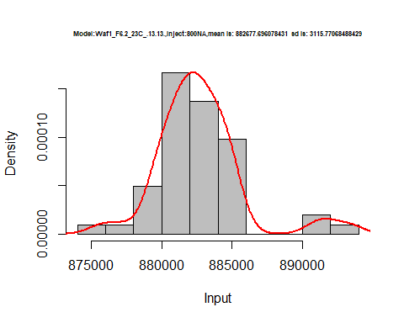

dens <- apply(d4_13.13, 2, density)  
plot('Model:Waf1_F6.2_23C_.13.13', xlim=range(sapply(dens, "[", "x")), ylim=range(sapply(dens, "[", "y")))

## Warning in xy.coords(x, y, xlabel, ylabel, log): NAs introduced by coercion

mapply(lines, dens, col=1:length(dens))

## $V1  
## NULL  
##   
## $V2  
## NULL  
##   
## $V3  
## NULL  
##   
## $V4  
## NULL  
##   
## $V5  
## NULL  
##   
## $V6  
## NULL  
##   
## $V7  
## NULL  
##   
## $V8  
## NULL

legend("topright", legend=names(dens), fill=1:length(dens))

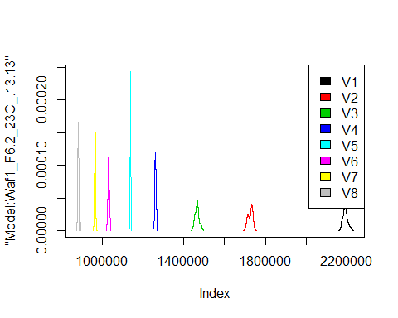

# Select columns whose names contains "14.14"  
d_14.14<-my_data %>% select(contains("14.14."))  
head(d_14.14)

## Waf1_F2.5_23C_.100nA_.14.14. Waf1_F2.5_23C_.200nA_.14.14.  
## 1 2457500 1802500  
## 2 2455000 1803750  
## 3 2457500 1802500  
## 4 2457500 1801250  
## 5 2460000 1800000  
## 6 2467500 1798750  
## Waf1_F2.5_23C_.300nA_.14.14. Waf1_F2.5_23C_.400nA_.14.14.  
## 1 1491667 1288750  
## 2 1491667 1287500  
## 3 1490833 1288125  
## 4 1488333 1287500  
## 5 1488333 1289375  
## 6 1490833 1288750  
## Waf1_F2.5_23C_.500nA_.14.14. Waf1_F2.5_23C_.600nA_.14.14.  
## 1 1149000 1042083  
## 2 1148500 1041250  
## 3 1148500 1040000  
## 4 1147500 1040417  
## 5 1149000 1040417  
## 6 1149000 1041250  
## Waf1_F2.5_23C_.700nA_.14.14. Waf1_F2.5_23C_.800nA_.14.14.  
## 1 963571.4 890625.0  
## 2 964285.7 890000.0  
## 3 963928.6 890937.5  
## 4 963571.4 890000.0  
## 5 962857.1 890312.5  
## 6 963214.3 891250.0  
## Waf1_F3.5_23C_.100nA_.14.14. Waf1_F3.5_23C_.200nA_.14.14.  
## 1 4257500 2793750  
## 2 4267500 2790000  
## 3 4195000 2787500  
## 4 4152500 2785000  
## 5 4117500 2781250  
## 6 4105000 2787500  
## Waf1_F3.5_23C_.300nA_.14.14. Waf1_F3.5_23C_.400nA_.14.14.  
## 1 2198333 1849375  
## 2 2210000 1852500  
## 3 2195833 1866875  
## 4 2205000 1853125  
## 5 2200000 1856875  
## 6 2201667 1857500  
## Waf1_F3.5_23C_.500nA_.14.14. Waf1_F3.5_23C_.600nA_.14.14.  
## 1 1631000 1479583  
## 2 1630000 1476250  
## 3 1635000 1476250  
## 4 1631500 1478333  
## 5 1633000 1477917  
## 6 1635500 1476250  
## Waf1_F3.5_23C_.700nA_.14.14. Waf1_F3.5_23C_.800nA_.14.14.  
## 1 1360357 1259062  
## 2 1360357 1261875  
## 3 1363571 1260625  
## 4 1361071 1258750  
## 5 1362500 1261250  
## 6 1363214 1259375

d1_14.14<-d_14.14[,c(1:8)]  
d1_14.14 <- head(d1_14.14,51)  
colnames(d1_14.14) <- c("V1", "V2","V3","V4","V5","V6","V7","V8")  
head(d1_14.14)

## V1 V2 V3 V4 V5 V6 V7 V8  
## 1 2457500 1802500 1491667 1288750 1149000 1042083 963571.4 890625.0  
## 2 2455000 1803750 1491667 1287500 1148500 1041250 964285.7 890000.0  
## 3 2457500 1802500 1490833 1288125 1148500 1040000 963928.6 890937.5  
## 4 2457500 1801250 1488333 1287500 1147500 1040417 963571.4 890000.0  
## 5 2460000 1800000 1488333 1289375 1149000 1040417 962857.1 890312.5  
## 6 2467500 1798750 1490833 1288750 1149000 1041250 963214.3 891250.0

hist(d1_14.14$V1,  
 cex.main=0.5,  
 freq = FALSE,  
 main = paste('Model:Waf1_F2.5_23C_.14.14.,Inject:100NA,mean is:', mean(d1_14.14$V1),' sd is:', sd(d1_14.14$V1)),  
 xlab = "Input",  
 ylab = "Density",  
 col="grey")  
#plot density curve  
lines(density(d1_14.14$V1), # density plot  
 lwd = 2, # thickness of line  
 col = "red")

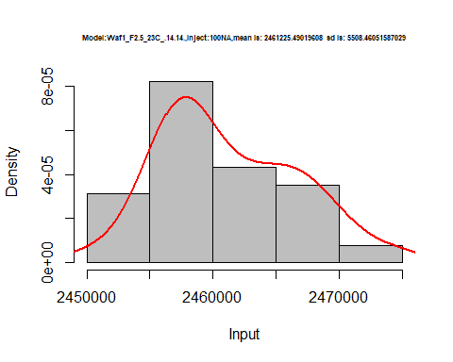

hist(d1_14.14$V2,  
 cex.main=0.5,  
 freq = FALSE,  
 main = paste('Model:Waf1_F2.5_23C_.14.14.,Inject:200NA,mean is:', mean(d1_14.14$V2),' sd is:', sd(d1_14.14$V2)),  
 xlab = "Input",  
 ylab = "Density",  
 col="grey")  
#plot density curve  
lines(density(d1_14.14$V2), # density plot  
 lwd = 2, # thickness of line  
 col = "red")

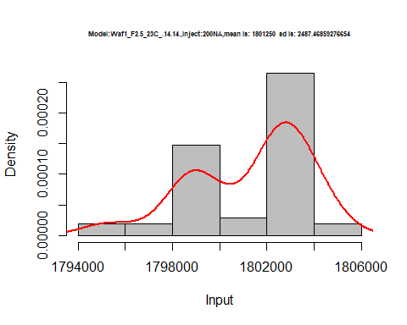

hist(d1_14.14$V3,  
 cex.main=0.5,  
 freq = FALSE,  
 main = paste('Model:Waf1_F2.5_23C_.14.14.,Inject:200NA,mean is:', mean(d1_14.14$V3),' sd is:', sd(d1_14.14$V3)),  
 xlab = "Input",  
 ylab = "Density",  
 col="grey")  
#plot density curve  
lines(density(d1_14.14$V3), # density plot  
 lwd = 2, # thickness of line  
 col = "red")

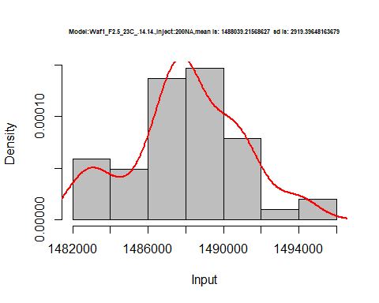

hist(d1_14.14$V4,  
 cex.main=0.5,  
 freq = FALSE,  
 main = paste('Model:Waf1_F2.5_23C_.14.14.,Inject:400NA,mean is:', mean(d1_14.14$V4),' sd is:', sd(d1_14.14$V4)),  
 xlab = "Input",  
 ylab = "Density",  
 col="grey")  
#plot density curve  
lines(density(d1_14.14$V4), # density plot  
 lwd = 2, # thickness of line  
 col = "red")

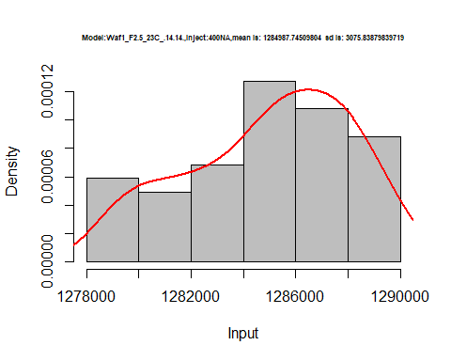

hist(d1_14.14$V5,  
 cex.main=0.5,  
 freq = FALSE,  
 main = paste('Model:Waf1_F2.5_23C_.14.14.,Inject:500NA,mean is:', mean(d1_14.14$V5),' sd is:', sd(d1_14.14$V5)),  
 xlab = "Input",  
 ylab = "Density",  
 col="grey")  
#plot density curve  
lines(density(d1_14.14$V5), # density plot  
 lwd = 2, # thickness of line  
 col = "red")

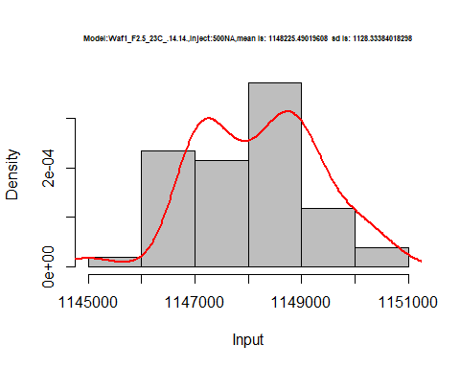

hist(d1_14.14$V6,  
 cex.main=0.5,  
 freq = FALSE,  
 main = paste('Model:Waf1_F2.5_23C_.14.14.,Inject:600NA,mean is:', mean(d1_14.14$V6),' sd is:', sd(d1_14.14$V6)),  
 xlab = "Input",  
 ylab = "Density",  
 col="grey")  
#plot density curve  
lines(density(d1_14.14$V6), # density plot  
 lwd = 2, # thickness of line  
 col = "red")

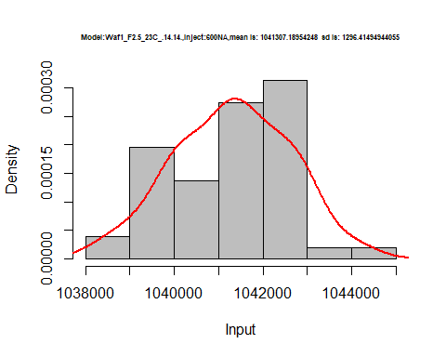

hist(d1_14.14$V7,  
 cex.main=0.5,  
 freq = FALSE,  
 main = paste('Model:Waf1_F2.5_23C_.14.14.,Inject:700NA,mean is:', mean(d1_14.14$V7),' sd is:', sd(d1_14.14$V7)),  
 xlab = "Input",  
 ylab = "Density",  
 col="grey")  
#plot density curve  
lines(density(d1_14.14$V7), # density plot  
 lwd = 2, # thickness of line  
 col = "red")

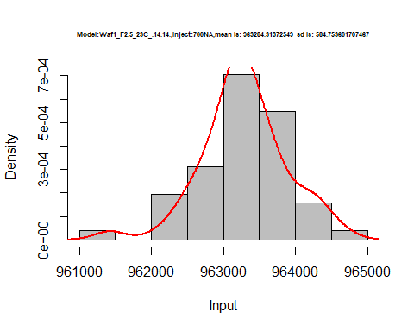

hist(d1_14.14$V8,  
 cex.main=0.5,  
 freq = FALSE,  
 main = paste('Model:Waf1_F2.5_23C_.14.14,Inject:800NA,mean is:', mean(d1_14.14$V8),' sd is:', sd(d1_14.14$V8)),  
 xlab = "Input",  
 ylab = "Density",  
 col="grey")  
#plot density curve  
lines(density(d1_14.14$V8), # density plot  
 lwd = 2, # thickness of line  
 col = "red")

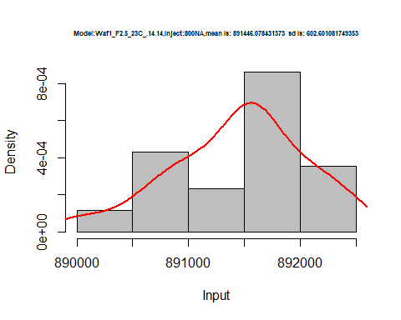

dens <- apply(d1_14.14, 2, density)  
plot('Model:Waf1_F2.5_23C_.14.14', xlim=range(sapply(dens, "[", "x")), ylim=range(sapply(dens, "[", "y")))

## Warning in xy.coords(x, y, xlabel, ylabel, log): NAs introduced by coercion

mapply(lines, dens, col=1:length(dens))

## $V1  
## NULL  
##   
## $V2  
## NULL  
##   
## $V3  
## NULL  
##   
## $V4  
## NULL  
##   
## $V5  
## NULL  
##   
## $V6  
## NULL  
##   
## $V7  
## NULL  
##   
## $V8  
## NULL

legend("topright", legend=names(dens), fill=1:length(dens))

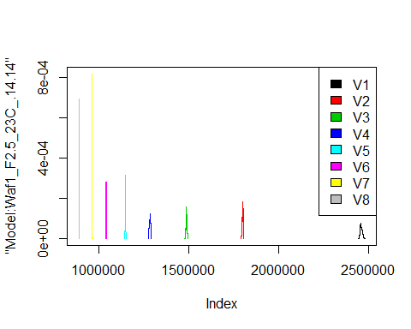

d2_14.14<-d_14.14[,c(9:16)]  
d2_14.14 <- head(d2_14.14,51)  
colnames(d2_14.14) <- c("V1", "V2","V3","V4","V5","V6","V7","V8")  
head(d2_14.14)

## V1 V2 V3 V4 V5 V6 V7 V8  
## 1 4257500 2793750 2198333 1849375 1631000 1479583 1360357 1259062  
## 2 4267500 2790000 2210000 1852500 1630000 1476250 1360357 1261875  
## 3 4195000 2787500 2195833 1866875 1635000 1476250 1363571 1260625  
## 4 4152500 2785000 2205000 1853125 1631500 1478333 1361071 1258750  
## 5 4117500 2781250 2200000 1856875 1633000 1477917 1362500 1261250  
## 6 4105000 2787500 2201667 1857500 1635500 1476250 1363214 1259375

hist(d2_14.14$V1,  
 cex.main=0.5,  
 freq = FALSE,  
 main = paste('Model:Waf1_F3.5_23C_.14.14.,Inject:100NA,mean is:', mean(d2_14.14$V1),' sd is:', sd(d2_14.14$V1)),  
 xlab = "Input",  
 ylab = "Density",  
 col="grey")  
#plot density curve  
lines(density(d2_14.14$V1), # density plot  
 lwd = 2, # thickness of line  
 col = "red")

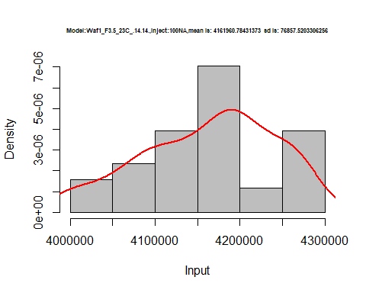

hist(d2_14.14$V2,  
 cex.main=0.5,  
 freq = FALSE,  
 main = paste('Model:Waf1_F3.5_23C_.14.14.,Inject:200NA,mean is:', mean(d2_14.14$V2),' sd is:', sd(d2_14.14$V2)),  
 xlab = "Input",  
 ylab = "Density",  
 col="grey")  
#plot density curve  
lines(density(d2_14.14$V2), # density plot  
 lwd = 2, # thickness of line  
 col = "red")

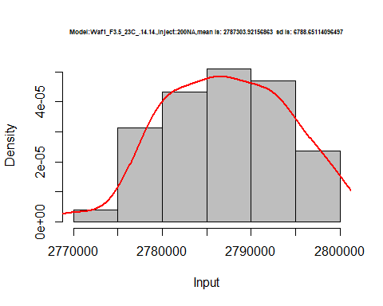

hist(d2_14.14$V3,  
 cex.main=0.5,  
 freq = FALSE,  
 main = paste('Model:Waf1_F3.5_23C_.14.14.,Inject:300NA,mean is:', mean(d2_14.14$V3),' sd is:', sd(d2_14.14$V3)),  
 xlab = "Input",  
 ylab = "Density",  
 col="grey")  
#plot density curve  
lines(density(d2_14.14$V3), # density plot  
 lwd = 2, # thickness of line  
 col = "red")

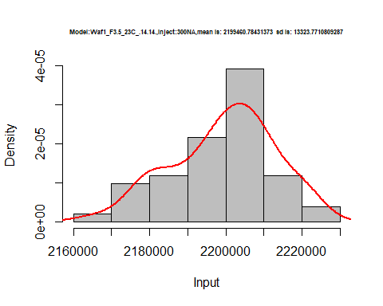

hist(d2_14.14$V4,  
 cex.main=0.5,  
 freq = FALSE,  
 main = paste('Model:Waf1_F3.5_23C_.14.14.,Inject:400NA,mean is:', mean(d2_14.14$V4),' sd is:', sd(d2_14.14$V4)),  
 xlab = "Input",  
 ylab = "Density",  
 col="grey")  
#plot density curve  
lines(density(d2_14.14$V4), # density plot  
 lwd = 2, # thickness of line  
 col = "red")

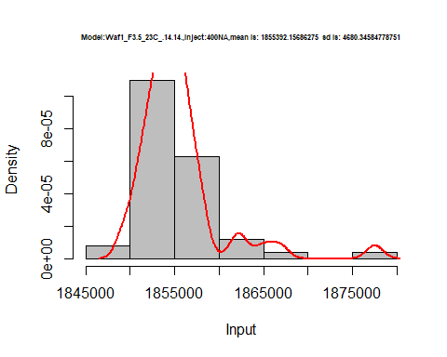

hist(d2_14.14$V5,  
 cex.main=0.5,  
 freq = FALSE,  
 main = paste('Model:Waf1_F3.5_23C_.14.14.,Inject:500NA,mean is:', mean(d2_14.14$V5),' sd is:', sd(d2_14.14$V5)),  
 xlab = "Input",  
 ylab = "Density",  
 col="grey")  
#plot density curve  
lines(density(d2_14.14$V5), # density plot  
 lwd = 2, # thickness of line  
 col = "red")

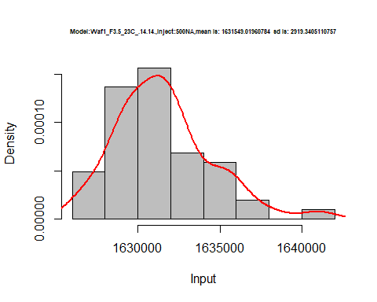

hist(d2_14.14$V6,  
 cex.main=0.5,  
 freq = FALSE,  
 main = paste('Model:Waf1_F3.5_23C_.14.14.,Inject:600NA,mean is:', mean(d2_14.14$V6),' sd is:', sd(d2_14.14$V6)),  
 xlab = "Input",  
 ylab = "Density",  
 col="grey")  
#plot density curve  
lines(density(d2_14.14$V6), # density plot  
 lwd = 2, # thickness of line  
 col = "red")

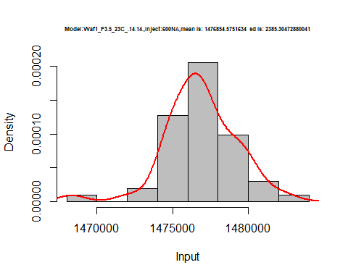

hist(d2_14.14$V7,  
 cex.main=0.5,  
 freq = FALSE,  
 main = paste('Model:Waf1_F3.5_23C_.14.14.,Inject:700NA,mean is:', mean(d2_14.14$V7),' sd is:', sd(d2_14.14$V7)),  
 xlab = "Input",  
 ylab = "Density",  
 col="grey")  
#plot density curve  
lines(density(d2_14.14$V7), # density plot  
 lwd = 2, # thickness of line  
 col = "red")

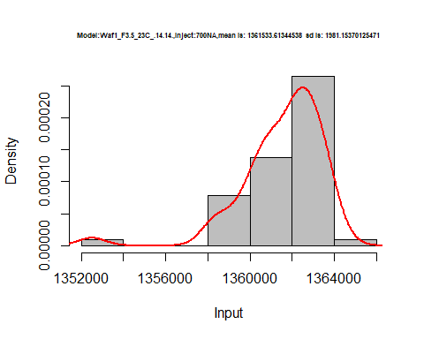

hist(d2_14.14$V8,  
 cex.main=0.5,  
 freq = FALSE,  
 main = paste('Model:Waf1_F3.5_23C_.14.14.,Inject:800NA,mean is:', mean(d2_14.14$V8),' sd is:', sd(d2_14.14$V8)),  
 xlab = "Input",  
 ylab = "Density",  
 col="grey")  
#plot density curve  
lines(density(d2_14.14$V8), # density plot  
 lwd = 2, # thickness of line  
 col = "red")

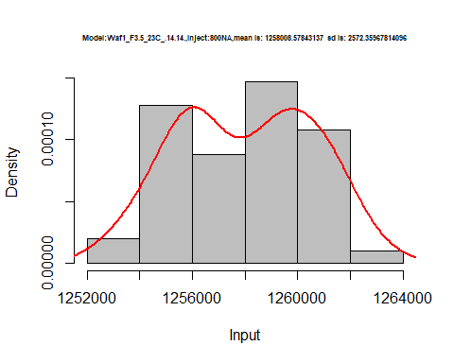

dens <- apply(d2_14.14, 2, density)  
plot('Model:Waf1_F6.2_23C_.13.13', xlim=range(sapply(dens, "[", "x")), ylim=range(sapply(dens, "[", "y")))

## Warning in xy.coords(x, y, xlabel, ylabel, log): NAs introduced by coercion

mapply(lines, dens, col=1:length(dens))

## $V1  
## NULL  
##   
## $V2  
## NULL  
##   
## $V3  
## NULL  
##   
## $V4  
## NULL  
##   
## $V5  
## NULL  
##   
## $V6  
## NULL  
##   
## $V7  
## NULL  
##   
## $V8  
## NULL

legend("topright", legend=names(dens), fill=1:length(dens))

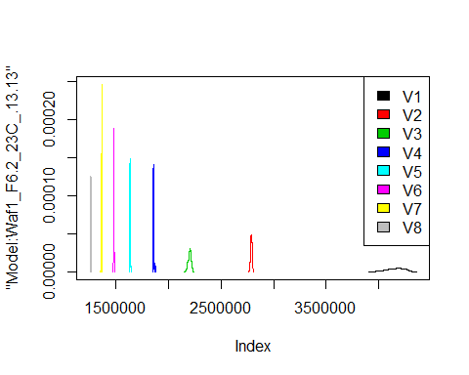

# Select columns whose names contains "15.15"  
d_15.15<-my_data %>% select(contains("15.15."))  
d_15.15 <- head(d_15.15,51)  
colnames(d_15.15) <- c("V1", "V2","V3","V4","V5","V6","V7","V8")  
head(d_15.15)

## V1 V2 V3 V4 V5 V6 V7 V8  
## 1 1312500 1046250 880833.3 782500 702500 627500.0 531785.7 490937.5  
## 2 1315000 1045000 895000.0 783125 703000 633750.0 529642.9 491875.0  
## 3 1312500 1047500 895833.3 784375 703500 633750.0 528928.6 489687.5  
## 4 1307500 1048750 898333.3 784375 702500 634583.3 530000.0 492500.0  
## 5 1305000 1048750 893333.3 783750 703500 633333.3 529642.9 493750.0  
## 6 1305000 1046250 891666.7 784375 702000 632916.7 530357.1 492812.5

hist(d_15.15$V1,  
 cex.main=0.5,  
 freq = FALSE,  
 main = paste('Model:Waf1_F6.7_23C_.15.15.,Inject:100NA,mean is:', mean(d_15.15$V1),' sd is:', sd(d_15.15$V1)),  
 xlab = "Input",  
 ylab = "Density",  
 col="grey")  
#plot density curve  
lines(density(d_15.15$V1), # density plot  
 lwd = 2, # thickness of line  
 col = "red")

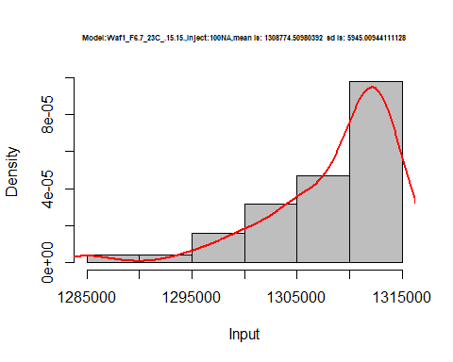

hist(d_15.15$V2,  
 cex.main=0.5,  
 freq = FALSE,  
 main = paste('Model:Waf1_F6.7_23C_.15.15.,Inject:200NA,mean is:', mean(d_15.15$V2),' sd is:', sd(d_15.15$V2)),  
 xlab = "Input",  
 ylab = "Density",  
 col="grey")  
#plot density curve  
lines(density(d_15.15$V2), # density plot  
 lwd = 2, # thickness of line  
 col = "red")

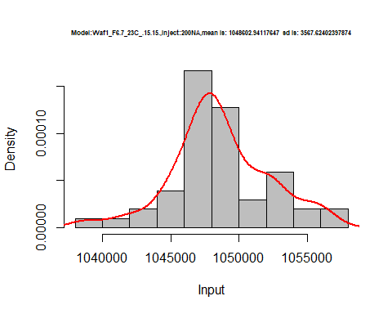

hist(d_15.15$V3,  
 cex.main=0.5,  
 freq = FALSE,  
 main = paste('Model:Waf1_F6.7_23C_.15.15.,Inject:300NA,mean is:', mean(d_15.15$V3),' sd is:', sd(d_15.15$V3)),  
 xlab = "Input",  
 ylab = "Density",  
 col="grey")  
#plot density curve  
lines(density(d_15.15$V3), # density plot  
 lwd = 2, # thickness of line  
 col = "red")

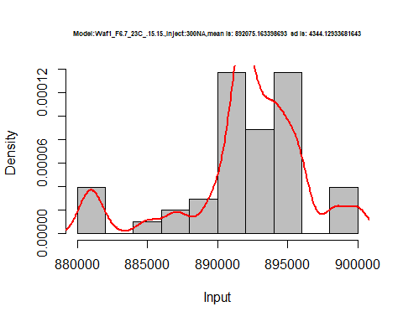

hist(d_15.15$V4,  
 cex.main=0.5,  
 freq = FALSE,  
 main = paste('Model:Waf1_F6.7_23C_.15.15..,Inject:400NA,mean is:', mean(d_15.15$V4),' sd is:', sd(d_15.15$V4)),  
 xlab = "Input",  
 ylab = "Density",  
 col="grey")  
#plot density curve  
lines(density(d_15.15$V4), # density plot  
 lwd = 2, # thickness of line  
 col = "red")

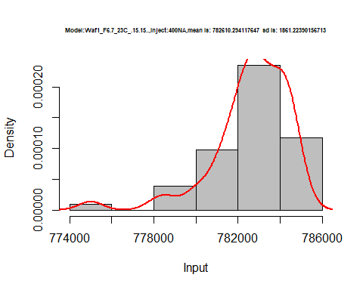

hist(d_15.15$V5,  
 cex.main=0.5,  
 freq = FALSE,  
 main = paste('Model:Waf1_F6.7_23C_.15.15.,Inject:500NA,mean is:', mean(d_15.15$V5),' sd is:', sd(d_15.15$V5)),  
 xlab = "Input",  
 ylab = "Density",  
 col="grey")  
#plot density curve  
lines(density(d_15.15$V5), # density plot  
 lwd = 2, # thickness of line  
 col = "red")

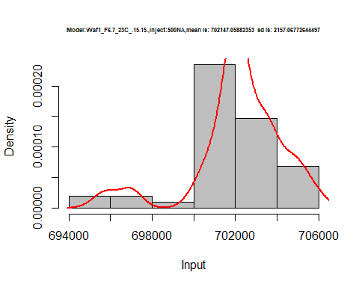

hist(d_15.15$V6,  
 cex.main=0.5,  
 freq = FALSE,  
 main = paste('Model:Waf1_F6.7_23C_.15.15.,Inject:600NA,mean is:', mean(d_15.15$V6),' sd is:', sd(d_15.15$V6)),  
 xlab = "Input",  
 ylab = "Density",  
 col="grey")  
#plot density curve  
lines(density(d_15.15$V6), # density plot  
 lwd = 2, # thickness of line  
 col = "red")

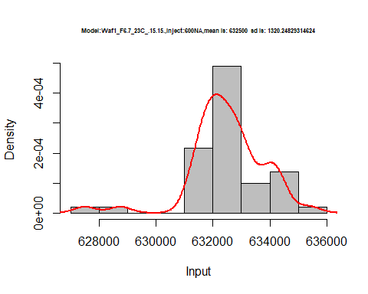

hist(d_15.15$V7,  
 cex.main=0.5,  
 freq = FALSE,  
 main = paste('Model:Waf1_F6.7_23C_.15.15.,Inject:700NA,mean is:', mean(d_15.15$V7),' sd is:', sd(d_15.15$V7)),  
 xlab = "Input",  
 ylab = "Density",  
 col="grey")  
#plot density curve  
lines(density(d_15.15$V7), # density plot  
 lwd = 2, # thickness of line  
 col = "red")

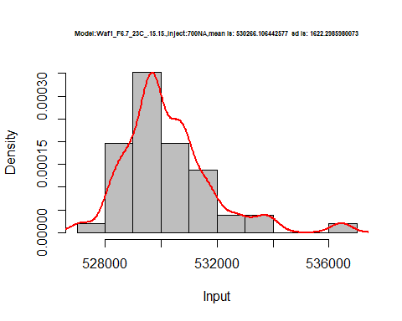

hist(d_15.15$V8,  
 cex.main=0.5,  
 freq = FALSE,  
 main = paste('Model:Waf1_F6.7_23C_.15.15.,Inject:800NA,mean is:', mean(d_15.15$V8),' sd is:', sd(d_15.15$V8)),  
 xlab = "Input",  
 ylab = "Density",  
 col="grey")  
#plot density curve  
lines(density(d_15.15$V8), # density plot  
 lwd = 2, # thickness of line  
 col = "red")

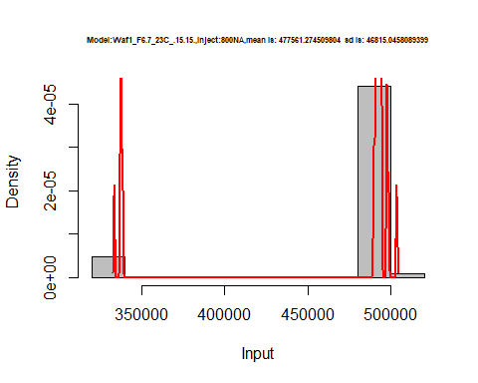

dens <- apply(d_15.15, 2, density)  
plot('Model:Waf1_F6.7_23C_.15.15', xlim=range(sapply(dens, "[", "x")), ylim=range(sapply(dens, "[", "y")))

## Warning in xy.coords(x, y, xlabel, ylabel, log): NAs introduced by coercion

mapply(lines, dens, col=1:length(dens))

## $V1  
## NULL  
##   
## $V2  
## NULL  
##   
## $V3  
## NULL  
##   
## $V4  
## NULL  
##   
## $V5  
## NULL  
##   
## $V6  
## NULL  
##   
## $V7  
## NULL  
##   
## $V8  
## NULL

legend("topright", legend=names(dens), fill=1:length(dens))

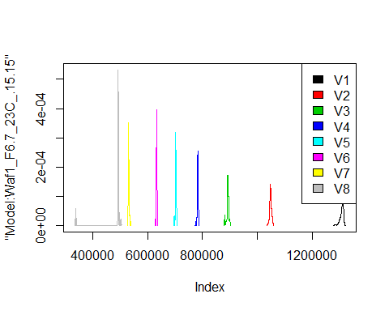

# Select columns whose names contains "16.16"  
d_16.16<-my_data %>% select(contains("16.16."))  
#d_15.15 <- head(d_15.15,51)  
#colnames(d_15.15) <- c("V1", "V2","V3","V4","V5","V6","V7","V8")  
head(d_16.16)

## Waf1_F3.5_23C_.100nA_.16.16. Waf1_F3.5_23C_.200nA_.16.16.  
## 1 4552500 2822500  
## 2 4582500 2822500  
## 3 4600000 2790000  
## 4 4592500 2775000  
## 5 4580000 2815000  
## 6 4592500 2818750  
## Waf1_F3.5_23C_.300nA_.16.16. Waf1_F3.5_23C_.400nA_.16.16.  
## 1 2185833 1832500  
## 2 2183333 1840000  
## 3 2185000 1833750  
## 4 2182500 1831875  
## 5 2195000 1838125  
## 6 2200000 1836875  
## Waf1_F3.5_23C_.500nA_.16.16. Waf1_F3.5_23C_.600nA_.16.16.  
## 1 1650500 1501250  
## 2 1630000 1500417  
## 3 1636500 1477083  
## 4 1657500 1479167  
## 5 1626500 1476667  
## 6 1621500 1484583  
## Waf1_F3.5_23C_.700nA_.16.16. Waf1_F3.5_23C_.800nA_.16.16.  
## 1 1372500 1305625  
## 2 1362857 1300313  
## 3 1368571 1316250  
## 4 1360000 1305938  
## 5 1370714 1310000  
## 6 1360357 1283750  
## Waf1_F3.6_23C_.100nA_.16.16. Waf1_F3.6_23C_.200nA_.16.16.  
## 1 12995000 8316250  
## 2 12992500 8316250  
## 3 12995000 8312500  
## 4 12992500 8305000  
## 5 12997500 8308750  
## 6 12995000 8308750  
## Waf1_F3.6_23C_.300nA_.16.16. Waf1_F3.6_23C_.400nA_.16.16.  
## 1 6309167 5134375  
## 2 6310000 5133125  
## 3 6310000 5130625  
## 4 6307500 5132500  
## 5 6307500 5136875  
## 6 6305000 5136875  
## Waf1_F3.6_23C_.500nA_.16.16. Waf1_F3.6_23C_.600nA_.16.16.  
## 1 4374000 2777500  
## 2 4377500 2796667  
## 3 4379000 2785000  
## 4 4377000 2785833  
## 5 4378000 2783333  
## 6 4379000 2782083  
## Waf1_F3.6_23C_.700nA_.16.16. Waf1_F3.6_23C_.800nA_.16.16.  
## 1 3576786 3404687  
## 2 3608929 3404375  
## 3 3575000 3405938  
## 4 3573571 3402812  
## 5 3573571 3401875  
## 6 3572500 3401875  
## Waf1_F6.2_23C_.100nA_.16.16. Waf1_F6.2_23C_.200nA_.16.16.  
## 1 675000 606250  
## 2 680000 610000  
## 3 675000 610000  
## 4 675000 607500  
## 5 675000 607500  
## 6 675000 606250  
## Waf1_F6.2_23C_.300nA_.16.16. Waf1_F6.2_23C_.400nA_.16.16.  
## 1 539166.7 486875  
## 2 542500.0 484375  
## 3 536666.7 486875  
## 4 537500.0 487500  
## 5 534166.7 489375  
## 6 532500.0 486875  
## Waf1_F6.2_23C_.500nA_.16.16. Waf1_F6.2_23C_.600nA_.16.16.  
## 1 449500 421666.7  
## 2 451000 422500.0  
## 3 447500 422083.3  
## 4 452500 422083.3  
## 5 451500 421666.7  
## 6 451000 423333.3  
## Waf1_F6.2_23C_.700nA_.16.16. Waf1_F6.2_23C_.800nA_.16.16.  
## 1 396785.7 362500.0  
## 2 396428.6 361562.5  
## 3 394642.9 362187.5  
## 4 397500.0 364375.0  
## 5 398214.3 363750.0  
## 6 397500.0 362812.5

# Select columns whose names contains "16.16"  
d_16.16<-my_data %>% select(contains("16.16."))  
#d_15.15 <- head(d_15.15,51)  
#colnames(d_15.15) <- c("V1", "V2","V3","V4","V5","V6","V7","V8")  
head(d_16.16)

## Waf1_F3.5_23C_.100nA_.16.16. Waf1_F3.5_23C_.200nA_.16.16.  
## 1 4552500 2822500  
## 2 4582500 2822500  
## 3 4600000 2790000  
## 4 4592500 2775000  
## 5 4580000 2815000  
## 6 4592500 2818750  
## Waf1_F3.5_23C_.300nA_.16.16. Waf1_F3.5_23C_.400nA_.16.16.  
## 1 2185833 1832500  
## 2 2183333 1840000  
## 3 2185000 1833750  
## 4 2182500 1831875  
## 5 2195000 1838125  
## 6 2200000 1836875  
## Waf1_F3.5_23C_.500nA_.16.16. Waf1_F3.5_23C_.600nA_.16.16.  
## 1 1650500 1501250  
## 2 1630000 1500417  
## 3 1636500 1477083  
## 4 1657500 1479167  
## 5 1626500 1476667  
## 6 1621500 1484583  
## Waf1_F3.5_23C_.700nA_.16.16. Waf1_F3.5_23C_.800nA_.16.16.  
## 1 1372500 1305625  
## 2 1362857 1300313  
## 3 1368571 1316250  
## 4 1360000 1305938  
## 5 1370714 1310000  
## 6 1360357 1283750  
## Waf1_F3.6_23C_.100nA_.16.16. Waf1_F3.6_23C_.200nA_.16.16.  
## 1 12995000 8316250  
## 2 12992500 8316250  
## 3 12995000 8312500  
## 4 12992500 8305000  
## 5 12997500 8308750  
## 6 12995000 8308750  
## Waf1_F3.6_23C_.300nA_.16.16. Waf1_F3.6_23C_.400nA_.16.16.  
## 1 6309167 5134375  
## 2 6310000 5133125  
## 3 6310000 5130625  
## 4 6307500 5132500  
## 5 6307500 5136875  
## 6 6305000 5136875  
## Waf1_F3.6_23C_.500nA_.16.16. Waf1_F3.6_23C_.600nA_.16.16.  
## 1 4374000 2777500  
## 2 4377500 2796667  
## 3 4379000 2785000  
## 4 4377000 2785833  
## 5 4378000 2783333  
## 6 4379000 2782083  
## Waf1_F3.6_23C_.700nA_.16.16. Waf1_F3.6_23C_.800nA_.16.16.  
## 1 3576786 3404687  
## 2 3608929 3404375  
## 3 3575000 3405938  
## 4 3573571 3402812  
## 5 3573571 3401875  
## 6 3572500 3401875  
## Waf1_F6.2_23C_.100nA_.16.16. Waf1_F6.2_23C_.200nA_.16.16.  
## 1 675000 606250  
## 2 680000 610000  
## 3 675000 610000  
## 4 675000 607500  
## 5 675000 607500  
## 6 675000 606250  
## Waf1_F6.2_23C_.300nA_.16.16. Waf1_F6.2_23C_.400nA_.16.16.  
## 1 539166.7 486875  
## 2 542500.0 484375  
## 3 536666.7 486875  
## 4 537500.0 487500  
## 5 534166.7 489375  
## 6 532500.0 486875  
## Waf1_F6.2_23C_.500nA_.16.16. Waf1_F6.2_23C_.600nA_.16.16.  
## 1 449500 421666.7  
## 2 451000 422500.0  
## 3 447500 422083.3  
## 4 452500 422083.3  
## 5 451500 421666.7  
## 6 451000 423333.3  
## Waf1_F6.2_23C_.700nA_.16.16. Waf1_F6.2_23C_.800nA_.16.16.  
## 1 396785.7 362500.0  
## 2 396428.6 361562.5  
## 3 394642.9 362187.5  
## 4 397500.0 364375.0  
## 5 398214.3 363750.0  
## 6 397500.0 362812.5

d1_16.16<-d_16.16[,c(1:8)]  
d1_16.16 <- head(d1_16.16,51)  
colnames(d1_16.16) <- c("V1", "V2","V3","V4","V5","V6","V7","V8")  
head(d1_16.16)

## V1 V2 V3 V4 V5 V6 V7 V8  
## 1 4552500 2822500 2185833 1832500 1650500 1501250 1372500 1305625  
## 2 4582500 2822500 2183333 1840000 1630000 1500417 1362857 1300313  
## 3 4600000 2790000 2185000 1833750 1636500 1477083 1368571 1316250  
## 4 4592500 2775000 2182500 1831875 1657500 1479167 1360000 1305938  
## 5 4580000 2815000 2195000 1838125 1626500 1476667 1370714 1310000  
## 6 4592500 2818750 2200000 1836875 1621500 1484583 1360357 1283750

hist(d1_16.16$V1,  
 cex.main=0.5,  
 freq = FALSE,  
 main = paste('Model:Waf1_F3.5_23C_.16.16.,Inject:100NA,mean is:', mean(d1_16.16$V1),' sd is:', sd(d1_16.16$V1)),  
 xlab = "Input",  
 ylab = "Density",  
 col="grey")  
#plot density curve  
lines(density(d1_16.16$V1), # density plot  
 lwd = 2, # thickness of line  
 col = "red")

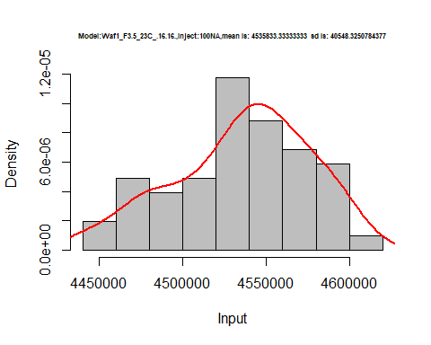

hist(d1_16.16$V2,  
 cex.main=0.5,  
 freq = FALSE,  
 main = paste('Model:Waf1_F3.5_23C_.16.16.,Inject:200NA,mean is:', mean(d1_16.16$V2),' sd is:', sd(d1_16.16$V2)),  
 xlab = "Input",  
 ylab = "Density",  
 col="grey")  
#plot density curve  
lines(density(d1_16.16$V2), # density plot  
 lwd = 2, # thickness of line  
 col = "red")

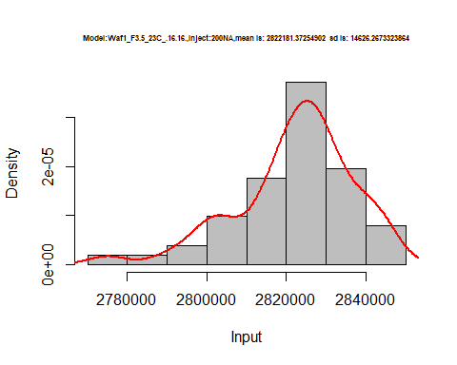

hist(d1_16.16$V3,  
 cex.main=0.5,  
 freq = FALSE,  
 main = paste('Model:Waf1_F3.5_23C_.16.16.,Inject:300NA,mean is:', mean(d1_16.16$V3),' sd is:', sd(d1_16.16$V3)),  
 xlab = "Input",  
 ylab = "Density",  
 col="grey")  
#plot density curve  
lines(density(d1_16.16$V3), # density plot  
 lwd = 2, # thickness of line  
 col = "red")

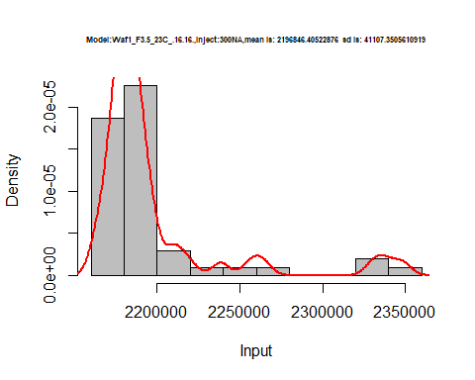

hist(d1_16.16$V4,  
 cex.main=0.5,  
 freq = FALSE,  
 main = paste('Model:Waf1_F3.5_23C_.16.16.,Inject:100NA,mean is:', mean(d1_16.16$V4),' sd is:', sd(d1_16.16$V4)),  
 xlab = "Input",  
 ylab = "Density",  
 col="grey")  
#plot density curve  
lines(density(d1_16.16$V4), # density plot  
 lwd = 2, # thickness of line  
 col = "red")

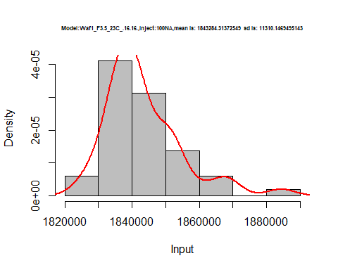

hist(d1_16.16$V5,  
 cex.main=0.5,  
 freq = FALSE,  
 main = paste('Model:Waf1_F3.5_23C_.16.16.,Inject:500NA,mean is:', mean(d1_16.16$V5),' sd is:', sd(d1_16.16$V5)),  
 xlab = "Input",  
 ylab = "Density",  
 col="grey")  
#plot density curve  
lines(density(d1_16.16$V5), # density plot  
 lwd = 2, # thickness of line  
 col = "red")

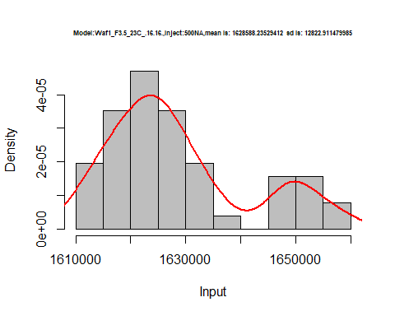

hist(d1_16.16$V6,  
 cex.main=0.5,  
 freq = FALSE,  
 main = paste('Model:Waf1_F3.5_23C_.16.16.,Inject:600NA,mean is:', mean(d1_16.16$V6),' sd is:', sd(d1_16.16$V6)),  
 xlab = "Input",  
 ylab = "Density",  
 col="grey")  
#plot density curve  
lines(density(d1_16.16$V6), # density plot  
 lwd = 2, # thickness of line  
 col = "red")

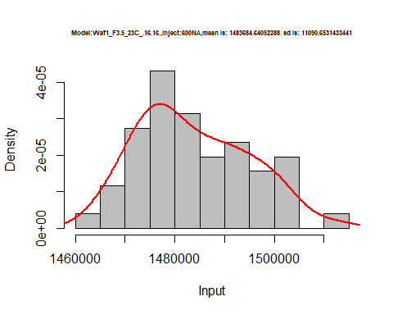

hist(d1_16.16$V7,  
 cex.main=0.5,  
 freq = FALSE,  
 main = paste('Model:Waf1_F3.5_23C_.16.16.,Inject:700NA,mean is:', mean(d1_16.16$V7),' sd is:', sd(d1_16.16$V7)),  
 xlab = "Input",  
 ylab = "Density",  
 col="grey")  
#plot density curve  
lines(density(d1_16.16$V7), # density plot  
 lwd = 2, # thickness of line  
 col = "red")

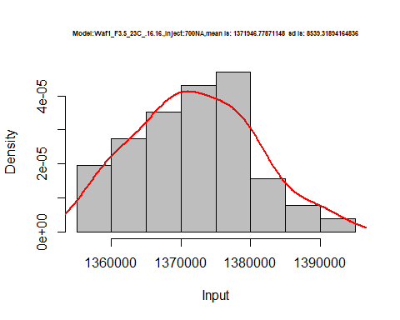

hist(d1_16.16$V8,  
 cex.main=0.5,  
 freq = FALSE,  
 main = paste('Model:Waf1_F3.5_23C_.16.16.,Inject:100NA,mean is:', mean(d1_16.16$V8),' sd is:', sd(d1_16.16$V8)),  
 xlab = "Input",  
 ylab = "Density",  
 col="grey")  
#plot density curve  
lines(density(d1_16.16$V8), # density plot  
 lwd = 2, # thickness of line  
 col = "red")

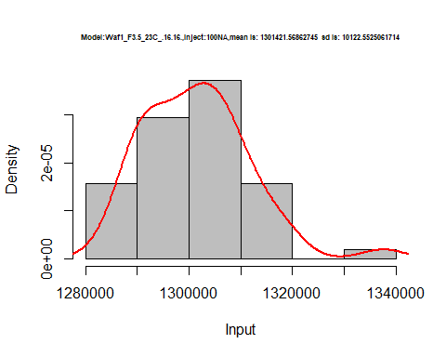

dens <- apply(d1_16.16, 2, density)  
plot('Model:Model:Waf1_F3.5_23C_.16.16', xlim=range(sapply(dens, "[", "x")), ylim=range(sapply(dens, "[", "y")))

## Warning in xy.coords(x, y, xlabel, ylabel, log): NAs introduced by coercion

mapply(lines, dens, col=1:length(dens))

## $V1  
## NULL  
##   
## $V2  
## NULL  
##   
## $V3  
## NULL  
##   
## $V4  
## NULL  
##   
## $V5  
## NULL  
##   
## $V6  
## NULL  
##   
## $V7  
## NULL  
##   
## $V8  
## NULL

legend("topright", legend=names(dens), fill=1:length(dens))

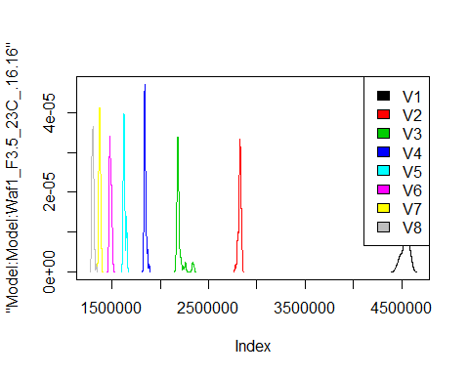

d2_16.16<-d_16.16[,c(9:16)]  
d2_16.16 <- head(d2_16.16,51)  
colnames(d2_16.16) <- c("V1", "V2","V3","V4","V5","V6","V7","V8")  
head(d2_16.16)

## V1 V2 V3 V4 V5 V6 V7 V8  
## 1 12995000 8316250 6309167 5134375 4374000 2777500 3576786 3404687  
## 2 12992500 8316250 6310000 5133125 4377500 2796667 3608929 3404375  
## 3 12995000 8312500 6310000 5130625 4379000 2785000 3575000 3405938  
## 4 12992500 8305000 6307500 5132500 4377000 2785833 3573571 3402812  
## 5 12997500 8308750 6307500 5136875 4378000 2783333 3573571 3401875  
## 6 12995000 8308750 6305000 5136875 4379000 2782083 3572500 3401875

hist(d2_16.16$V1,  
 cex.main=0.5,  
 freq = FALSE,  
 main = paste('Model:Waf1_F3.6_23C_.16.16,Inject:100NA,mean is:', mean(d2_16.16$V1),' sd is:', sd(d2_16.16$V1)),  
 xlab = "Input",  
 ylab = "Density",  
 col="grey")  
#plot density curve  
lines(density(d2_16.16$V1), # density plot  
 lwd = 2, # thickness of line  
 col = "red")

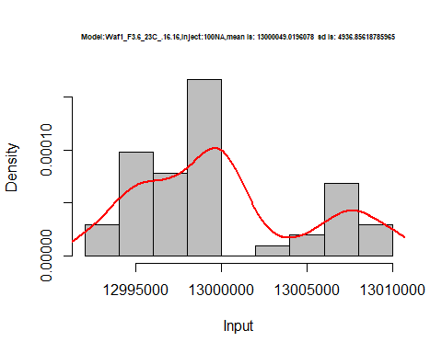

hist(d2_16.16$V2,  
 cex.main=0.5,  
 freq = FALSE,  
 main = paste('Model:Waf1_F3.6_23C_.16.16,Inject:200NA,mean is:', mean(d2_16.16$V2),' sd is:', sd(d2_16.16$V2)),  
 xlab = "Input",  
 ylab = "Density",  
 col="grey")  
#plot density curve  
lines(density(d2_16.16$V2), # density plot  
 lwd = 2, # thickness of line  
 col = "red")

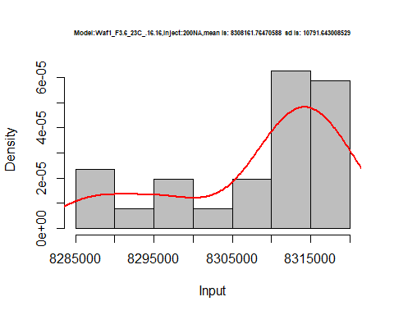

hist(d2_16.16$V3,  
 cex.main=0.5,  
 freq = FALSE,  
 main = paste('Model:Waf1_F3.6_23C_.16.16,Inject:300NA,mean is:', mean(d2_16.16$V3),' sd is:', sd(d2_16.16$V3)),  
 xlab = "Input",  
 ylab = "Density",  
 col="grey")  
#plot density curve  
lines(density(d2_16.16$V3), # density plot  
 lwd = 2, # thickness of line  
 col = "red")

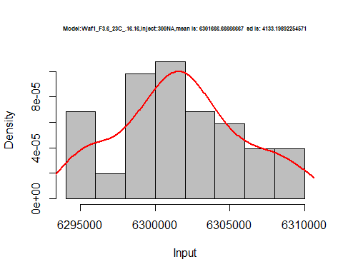

hist(d2_16.16$V4,  
 cex.main=0.5,  
 freq = FALSE,  
 main = paste('Model:Waf1_F3.6_23C_.16.16,Inject:400NA,mean is:', mean(d2_16.16$V4),' sd is:', sd(d2_16.16$V4)),  
 xlab = "Input",  
 ylab = "Density",  
 col="grey")  
#plot density curve  
lines(density(d2_16.16$V4), # density plot  
 lwd = 2, # thickness of line  
 col = "red")

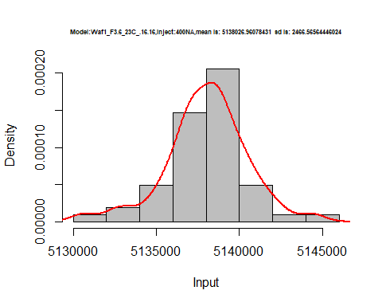

hist(d2_16.16$V5,  
 cex.main=0.5,  
 freq = FALSE,  
 main = paste('Model:Waf1_F3.6_23C_.16.16,Inject:500NA,mean is:', mean(d2_16.16$V5),' sd is:', sd(d2_16.16$V5)),  
 xlab = "Input",  
 ylab = "Density",  
 col="grey")  
#plot density curve  
lines(density(d2_16.16$V5), # density plot  
 lwd = 2, # thickness of line  
 col = "red")

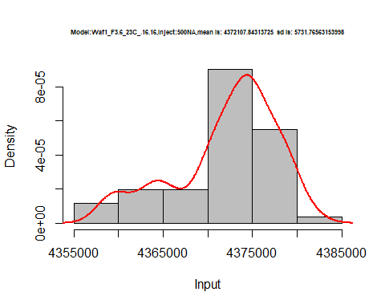

hist(d2_16.16$V6,  
 cex.main=0.5,  
 freq = FALSE,  
 main = paste('Model:Waf1_F3.6_23C_.16.16,Inject:600NA,mean is:', mean(d2_16.16$V6),' sd is:', sd(d2_16.16$V6)),  
 xlab = "Input",  
 ylab = "Density",  
 col="grey")  
#plot density curve  
lines(density(d2_16.16$V6), # density plot  
 lwd = 2, # thickness of line  
 col = "red")

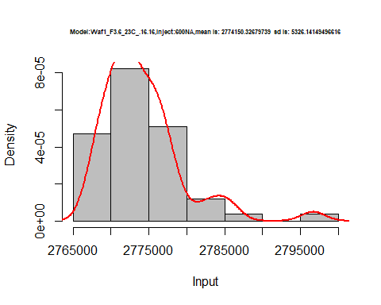

hist(d2_16.16$V7,  
 cex.main=0.5,  
 freq = FALSE,  
 main = paste('Model:Waf1_F3.6_23C_.16.16,Inject:700NA,mean is:', mean(d2_16.16$V7),' sd is:', sd(d2_16.16$V7)),  
 xlab = "Input",  
 ylab = "Density",  
 col="grey")  
#plot density curve  
lines(density(d2_16.16$V7), # density plot  
 lwd = 2, # thickness of line  
 col = "red")

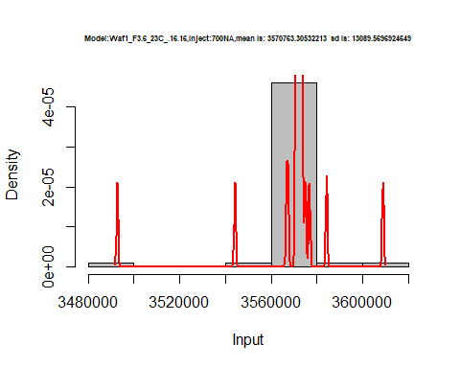

hist(d2_16.16$V8,  
 cex.main=0.5,  
 freq = FALSE,  
 main = paste('Model:Waf1_F3.6_23C_.16.16,Inject:800NA,mean is:', mean(d2_16.16$V8),' sd is:', sd(d2_16.16$V8)),  
 xlab = "Input",  
 ylab = "Density",  
 col="grey")  
#plot density curve  
lines(density(d2_16.16$V8), # density plot  
 lwd = 2, # thickness of line  
 col = "red")

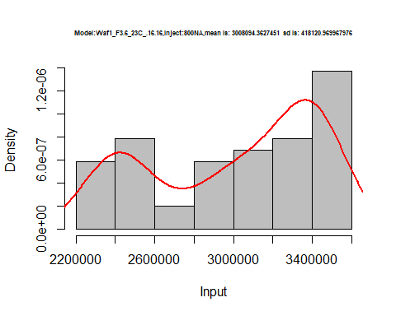

dens <- apply(d2_16.16, 2, density)  
plot('Model:Model:Waf1_F3.6_23C_.16.16', xlim=range(sapply(dens, "[", "x")), ylim=range(sapply(dens, "[", "y")))

## Warning in xy.coords(x, y, xlabel, ylabel, log): NAs introduced by coercion

mapply(lines, dens, col=1:length(dens))

## $V1  
## NULL  
##   
## $V2  
## NULL  
##   
## $V3  
## NULL  
##   
## $V4  
## NULL  
##   
## $V5  
## NULL  
##   
## $V6  
## NULL  
##   
## $V7  
## NULL  
##   
## $V8  
## NULL

legend("topright", legend=names(dens), fill=1:length(dens))

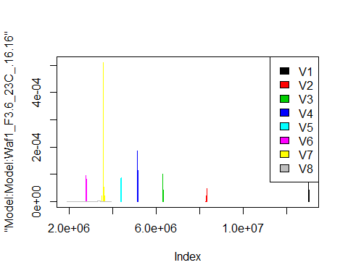

d3_16.16<-d_16.16[,c(17:24)]  
d3_16.16 <- head(d3_16.16,51)  
colnames(d3_16.16) <- c("V1", "V2","V3","V4","V5","V6","V7","V8")  
head(d3_16.16)

## V1 V2 V3 V4 V5 V6 V7 V8  
## 1 675000 606250 539166.7 486875 449500 421666.7 396785.7 362500.0  
## 2 680000 610000 542500.0 484375 451000 422500.0 396428.6 361562.5  
## 3 675000 610000 536666.7 486875 447500 422083.3 394642.9 362187.5  
## 4 675000 607500 537500.0 487500 452500 422083.3 397500.0 364375.0  
## 5 675000 607500 534166.7 489375 451500 421666.7 398214.3 363750.0  
## 6 675000 606250 532500.0 486875 451000 423333.3 397500.0 362812.5

hist(d3_16.16$V1,  
 cex.main=0.5,  
 freq = FALSE,  
 main = paste('Model:Waf1_F6.2_23C_.16.16,Inject:100NA,mean is:', mean(d3_16.16$V1),' sd is:', sd(d3_16.16$V1)),  
 xlab = "Input",  
 ylab = "Density",  
 col="grey")  
#plot density curve  
lines(density(d3_16.16$V1), # density plot  
 lwd = 2, # thickness of line  
 col = "red")

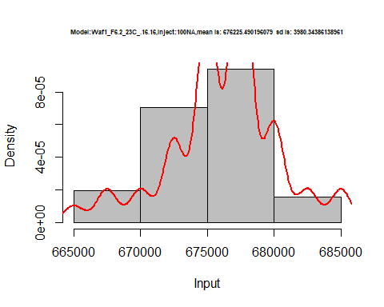

hist(d3_16.16$V2,  
 cex.main=0.5,  
 freq = FALSE,  
 main = paste('Model:Waf1_F6.2_23C_.16.16,Inject:200NA,mean is:', mean(d3_16.16$V2),' sd is:', sd(d3_16.16$V2)),  
 xlab = "Input",  
 ylab = "Density",  
 col="grey")  
#plot density curve  
lines(density(d3_16.16$V2), # density plot  
 lwd = 2, # thickness of line  
 col = "red")

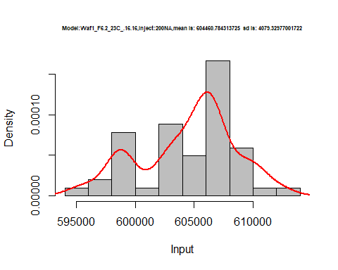

hist(d3_16.16$V3,  
 cex.main=0.5,  
 freq = FALSE,  
 main = paste('Model:Waf1_F6.2_23C_.16.16,Inject:300NA,mean is:', mean(d3_16.16$V3),' sd is:', sd(d3_16.16$V3)),  
 xlab = "Input",  
 ylab = "Density",  
 col="grey")  
#plot density curve  
lines(density(d3_16.16$V3), # density plot  
 lwd = 2, # thickness of line  
 col = "red")

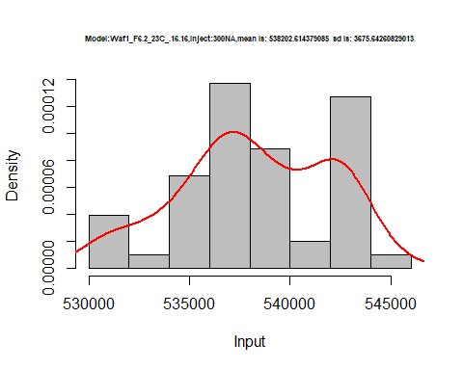

hist(d3_16.16$V4,  
 cex.main=0.5,  
 freq = FALSE,  
 main = paste('Model:Waf1_F6.2_23C_.16.16,Inject:400NA,mean is:', mean(d3_16.16$V4),' sd is:', sd(d3_16.16$V4)),  
 xlab = "Input",  
 ylab = "Density",  
 col="grey")  
#plot density curve  
lines(density(d3_16.16$V4), # density plot  
 lwd = 2, # thickness of line  
 col = "red")

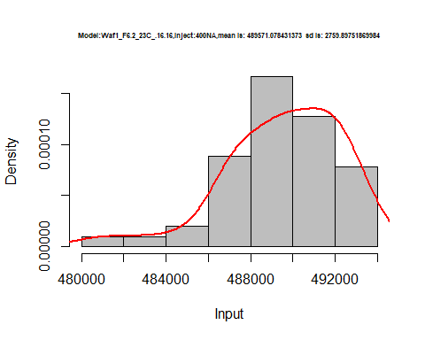

hist(d3_16.16$V5,  
 cex.main=0.5,  
 freq = FALSE,  
 main = paste('Model:Waf1_F6.2_23C_.16.16,Inject:500NA,mean is:', mean(d3_16.16$V5),' sd is:', sd(d3_16.16$V5)),  
 xlab = "Input",  
 ylab = "Density",  
 col="grey")  
#plot density curve  
lines(density(d3_16.16$V5), # density plot  
 lwd = 2, # thickness of line  
 col = "red")

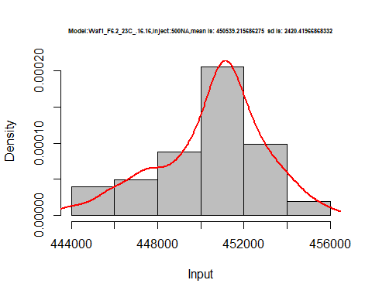

hist(d3_16.16$V6,  
 cex.main=0.5,  
 freq = FALSE,  
 main = paste('Model:Waf1_F6.2_23C_.16.16,Inject:600NA,mean is:', mean(d3_16.16$V6),' sd is:', sd(d3_16.16$V6)),  
 xlab = "Input",  
 ylab = "Density",  
 col="grey")  
#plot density curve  
lines(density(d3_16.16$V6), # density plot  
 lwd = 2, # thickness of line  
 col = "red")

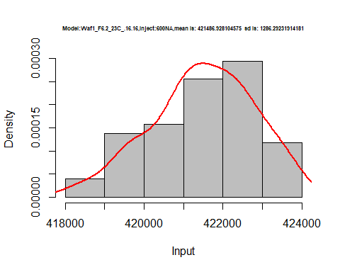

hist(d3_16.16$V7,  
 cex.main=0.5,  
 freq = FALSE,  
 main = paste('Model:Waf1_F6.2_23C_.16.16,Inject:700NA,mean is:', mean(d3_16.16$V7),' sd is:', sd(d3_16.16$V7)),  
 xlab = "Input",  
 ylab = "Density",  
 col="grey")  
#plot density curve  
lines(density(d3_16.16$V7), # density plot  
 lwd = 2, # thickness of line  
 col = "red")

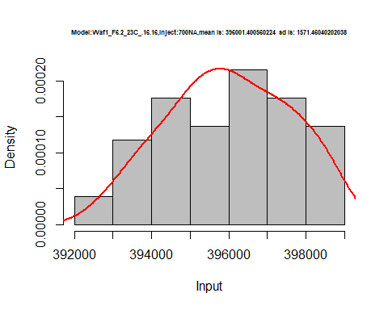

hist(d3_16.16$V8,  
 cex.main=0.5,  
 freq = FALSE,  
 main = paste('Model:Waf1_F6.2_23C_.16.16,Inject:800NA,mean is:', mean(d3_16.16$V8),' sd is:', sd(d3_16.16$V8)),  
 xlab = "Input",  
 ylab = "Density",  
 col="grey")  
#plot density curve  
lines(density(d3_16.16$V8), # density plot  
 lwd = 2, # thickness of line  
 col = "red")

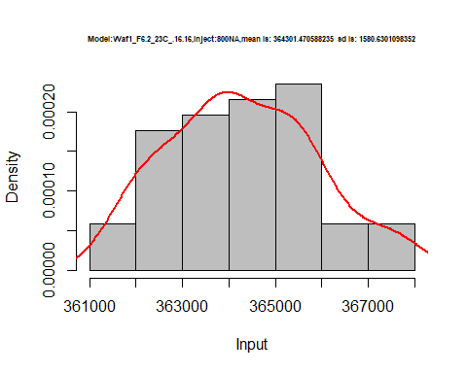

dens <- apply(d3_16.16, 2, density)  
plot('Model:Model:Waf1_F3.6_23C_.16.16', xlim=range(sapply(dens, "[", "x")), ylim=range(sapply(dens, "[", "y")))

## Warning in xy.coords(x, y, xlabel, ylabel, log): NAs introduced by coercion

mapply(lines, dens, col=1:length(dens))

## $V1  
## NULL  
##   
## $V2  
## NULL  
##   
## $V3  
## NULL  
##   
## $V4  
## NULL  
##   
## $V5  
## NULL  
##   
## $V6  
## NULL  
##   
## $V7  
## NULL  
##   
## $V8  
## NULL

legend("topright", legend=names(dens), fill=1:length(dens))

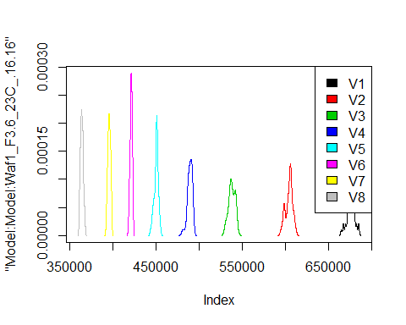

# Select columns whose names contains "17.17"  
d_17.17<-my_data %>% select(contains("17.17."))  
#d_15.15 <- head(d_15.15,51)  
#colnames(d_15.15) <- c("V1", "V2","V3","V4","V5","V6","V7","V8")  
head(d_17.17)

## Waf1_F3.3_23C_.100nA_.17.17. Waf1_F3.3_23C_.200nA_.17.17.  
## 1 1035000 910000  
## 2 1040000 912500  
## 3 1047500 912500  
## 4 1050000 908750  
## 5 1040000 906250  
## 6 1035000 907500  
## Waf1_F3.3_23C_.300nA_.17.17. Waf1_F3.3_23C_.400nA_.17.17.  
## 1 793333.3 713750  
## 2 792500.0 715000  
## 3 792500.0 715625  
## 4 792500.0 714375  
## 5 790000.0 713750  
## 6 790833.3 714375  
## Waf1_F3.3_23C_.500nA_.17.17. Waf1_F3.3_23C_.600nA_.17.17.  
## 1 657500 615000.0  
## 2 657500 614583.3  
## 3 656000 611250.0  
## 4 658000 611250.0  
## 5 656500 612500.0  
## 6 658000 614166.7  
## Waf1_F3.3_23C_.700nA_.17.17. Waf1_F3.3_23C_.800nA_.17.17.  
## 1 574285.7 542500.0  
## 2 573928.6 541562.5  
## 3 574285.7 542500.0  
## 4 573928.6 542812.5  
## 5 573571.4 542500.0  
## 6 574642.9 543750.0  
## Waf1_F4.2_23C_.100nA_.17.17. Waf1_F4.2_23C_.200nA_.17.17.  
## 1 8745000 5087500  
## 2 8742500 5050000  
## 3 8870000 5067500  
## 4 8847500 5165000  
## 5 8930000 5147500  
## 6 8802500 5163750  
## Waf1_F4.2_23C_.300nA_.17.17. Waf1_F4.2_23C_.400nA_.17.17.  
## 1 3846667 3066250  
## 2 3641667 3092500  
## 3 3468333 3073750  
## 4 3632500 3007500  
## 5 3705833 3041875  
## 6 3615833 3020000  
## Waf1_F4.2_23C_.500nA_.17.17. Waf1_F4.2_23C_.600nA_.17.17.  
## 1 2591500 2346250  
## 2 2469500 2311250  
## 3 2549000 2347500  
## 4 2627500 2343750  
## 5 2482000 2302500  
## 6 2612500 2315000  
## Waf1_F4.2_23C_.700nA_.17.17. Waf1_F4.2_23C_.800nA_.17.17.  
## 1 2245000 2055937  
## 2 2242500 2054375  
## 3 2245357 2053437  
## 4 2250714 2060312  
## 5 2239286 2053750  
## 6 2236071 2057187  
## Waf1_F6.3_23C_.100nA_.17.17. Waf1_F6.3_23C_.200nA_.17.17.  
## 1 1002500 837500  
## 2 1002500 837500  
## 3 1002500 838750  
## 4 1000000 837500  
## 5 1002500 837500  
## 6 1002500 838750  
## Waf1_F6.3_23C_.300nA_.17.17. Waf1_F6.3_23C_.400nA_.17.17.  
## 1 729166.7 658750  
## 2 729166.7 658750  
## 3 728333.3 659375  
## 4 727500.0 659375  
## 5 727500.0 658750  
## 6 728333.3 658750  
## Waf1_F6.3_23C_.500nA_.17.17. Waf1_F6.3_23C_.600nA_.17.17.  
## 1 603500 562916.7  
## 2 603500 562500.0  
## 3 604500 562916.7  
## 4 604500 563750.0  
## 5 603000 563750.0  
## 6 604000 563333.3  
## Waf1_F6.3_23C_.700nA_.17.17. Waf1_F6.3_23C_.800nA_.17.17.  
## 1 528214.3 500312.5  
## 2 528571.4 497500.0  
## 3 528571.4 497500.0  
## 4 527857.1 497812.5  
## 5 528928.6 498750.0  
## 6 528928.6 499687.5

d1_17.17<-d_17.17[,c(1:8)]  
d1_17.17 <- head(d1_17.17,51)  
colnames(d1_17.17) <- c("V1", "V2","V3","V4","V5","V6","V7","V8")  
head(d1_17.17)

## V1 V2 V3 V4 V5 V6 V7 V8  
## 1 1035000 910000 793333.3 713750 657500 615000.0 574285.7 542500.0  
## 2 1040000 912500 792500.0 715000 657500 614583.3 573928.6 541562.5  
## 3 1047500 912500 792500.0 715625 656000 611250.0 574285.7 542500.0  
## 4 1050000 908750 792500.0 714375 658000 611250.0 573928.6 542812.5  
## 5 1040000 906250 790000.0 713750 656500 612500.0 573571.4 542500.0  
## 6 1035000 907500 790833.3 714375 658000 614166.7 574642.9 543750.0

hist(d1_17.17$V1,  
 cex.main=0.5,  
 freq = FALSE,  
 main = paste('Model:Waf1_F3.3_23C_17.17,Inject:100NA,mean is:', mean(d1_17.17$V1),' sd is:', sd(d1_17.17$V1)),  
 xlab = "Input",  
 ylab = "Density",  
 col="grey")  
#plot density curve  
lines(density(d1_17.17$V1), # density plot  
 lwd = 2, # thickness of line  
 col = "red")

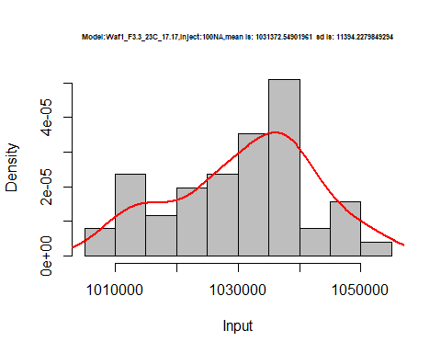

hist(d1_17.17$V2,  
 cex.main=0.5,  
 freq = FALSE,  
 main = paste('Model:Waf1_F3.3_23C_17.17,Inject:200NA,mean is:', mean(d1_17.17$V2),' sd is:', sd(d1_17.17$V2)),  
 xlab = "Input",  
 ylab = "Density",  
 col="grey")  
#plot density curve  
lines(density(d1_17.17$V2), # density plot  
 lwd = 2, # thickness of line  
 col = "red")

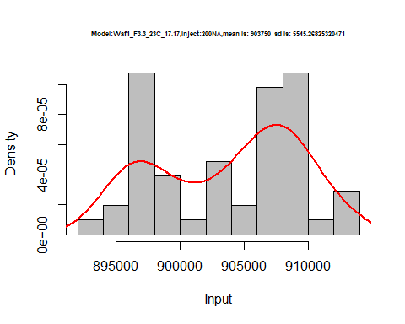

hist(d1_17.17$V3,  
 cex.main=0.5,  
 freq = FALSE,  
 main = paste('Model:Waf1_F3.3_23C_17.17,Inject:300NA,mean is:', mean(d1_17.17$V3),' sd is:', sd(d1_17.17$V3)),  
 xlab = "Input",  
 ylab = "Density",  
 col="grey")  
#plot density curve  
lines(density(d1_17.17$V3), # density plot  
 lwd = 2, # thickness of line  
 col = "red")

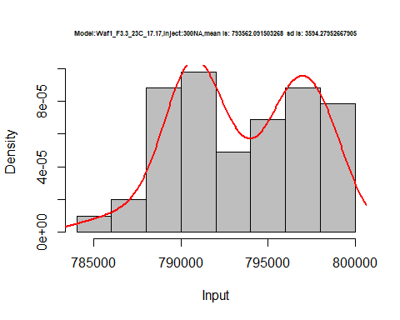

hist(d1_17.17$V4,  
 cex.main=0.5,  
 freq = FALSE,  
 main = paste('Model:Waf1_F3.3_23C_17.17,Inject:400NA,mean is:', mean(d1_17.17$V4),' sd is:', sd(d1_17.17$V4)),  
 xlab = "Input",  
 ylab = "Density",  
 col="grey")  
#plot density curve  
lines(density(d1_17.17$V4), # density plot  
 lwd = 2, # thickness of line  
 col = "red")

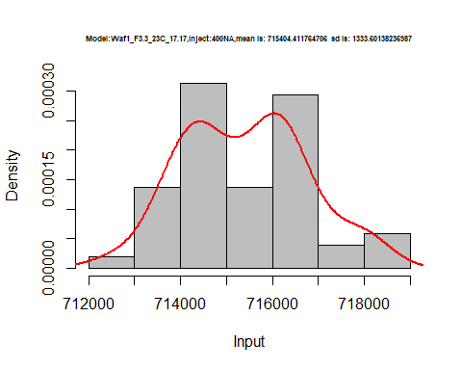

hist(d1_17.17$V5,  
 cex.main=0.5,  
 freq = FALSE,  
 main = paste('Model:Waf1_F3.3_23C_17.17,Inject:500NA,mean is:', mean(d1_17.17$V5),' sd is:', sd(d1_17.17$V5)),  
 xlab = "Input",  
 ylab = "Density",  
 col="grey")  
#plot density curve  
lines(density(d1_17.17$V5), # density plot  
 lwd = 2, # thickness of line  
 col = "red")

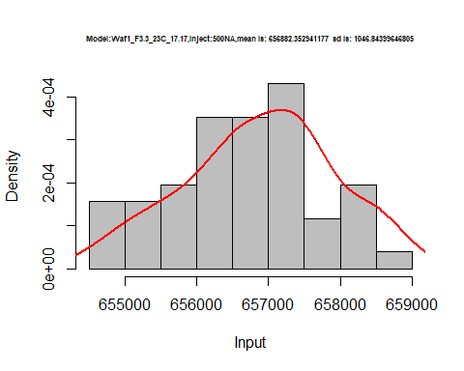

hist(d1_17.17$V6,  
 cex.main=0.5,  
 freq = FALSE,  
 main = paste('Model:Waf1_F3.3_23C_17.17,Inject:600NA,mean is:', mean(d1_17.17$V6),' sd is:', sd(d1_17.17$V6)),  
 xlab = "Input",  
 ylab = "Density",  
 col="grey")  
#plot density curve  
lines(density(d1_17.17$V6), # density plot  
 lwd = 2, # thickness of line  
 col = "red")

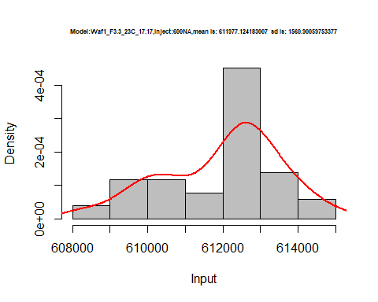

hist(d1_17.17$V7,  
 cex.main=0.5,  
 freq = FALSE,  
 main = paste('Model:Waf1_F3.3_23C_17.17,Inject:700NA,mean is:', mean(d1_17.17$V7),' sd is:', sd(d1_17.17$V7)),  
 xlab = "Input",  
 ylab = "Density",  
 col="grey")  
#plot density curve  
lines(density(d1_17.17$V7), # density plot  
 lwd = 2, # thickness of line  
 col = "red")

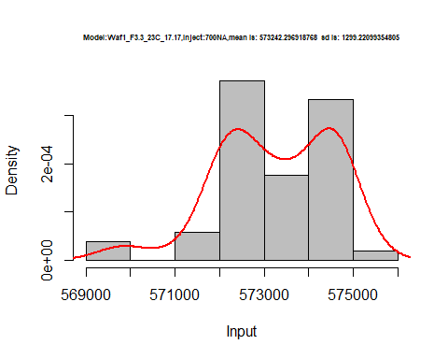

hist(d1_17.17$V8,  
 cex.main=0.5,  
 freq = FALSE,  
 main = paste('Model:Waf1_F3.3_23C_17.17,Inject:800NA,mean is:', mean(d1_17.17$V8),' sd is:', sd(d1_17.17$V8)),  
 xlab = "Input",  
 ylab = "Density",  
 col="grey")  
#plot density curve  
lines(density(d1_17.17$V8), # density plot  
 lwd = 2, # thickness of line  
 col = "red")

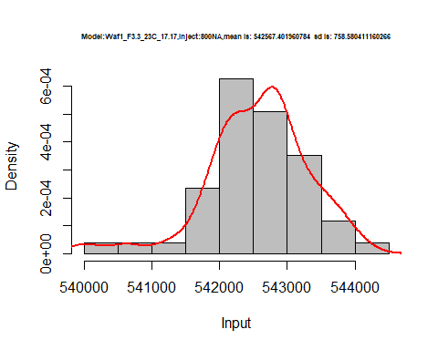

dens <- apply(d1_17.17, 2, density)  
plot('Model:Model:Waf1_F3.3_23C_17.17', xlim=range(sapply(dens, "[", "x")), ylim=range(sapply(dens, "[", "y")))

## Warning in xy.coords(x, y, xlabel, ylabel, log): NAs introduced by coercion

mapply(lines, dens, col=1:length(dens))

## $V1  
## NULL  
##   
## $V2  
## NULL  
##   
## $V3  
## NULL  
##   
## $V4  
## NULL  
##   
## $V5  
## NULL  
##   
## $V6  
## NULL  
##   
## $V7  
## NULL  
##   
## $V8  
## NULL

legend("topright", legend=names(dens), fill=1:length(dens))

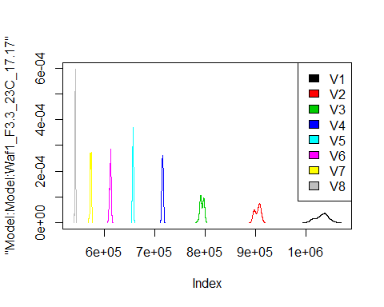

d2_17.17<-d_17.17[,c(9:16)]  
d2_17.17 <- head(d2_17.17,51)  
colnames(d2_17.17) <- c("V1", "V2","V3","V4","V5","V6","V7","V8")  
head(d2_17.17)

## V1 V2 V3 V4 V5 V6 V7 V8  
## 1 8745000 5087500 3846667 3066250 2591500 2346250 2245000 2055937  
## 2 8742500 5050000 3641667 3092500 2469500 2311250 2242500 2054375  
## 3 8870000 5067500 3468333 3073750 2549000 2347500 2245357 2053437  
## 4 8847500 5165000 3632500 3007500 2627500 2343750 2250714 2060312  
## 5 8930000 5147500 3705833 3041875 2482000 2302500 2239286 2053750  
## 6 8802500 5163750 3615833 3020000 2612500 2315000 2236071 2057187

hist(d2_17.17$V1,  
 cex.main=0.5,  
 freq = FALSE,  
 main = paste('Model:Waf1_F4.2_23C_.17.17,Inject:100NA,mean is:', mean(d2_17.17$V1),' sd is:', sd(d2_17.17$V1)),  
 xlab = "Input",  
 ylab = "Density",  
 col="grey")  
#plot density curve  
lines(density(d2_17.17$V1), # density plot  
 lwd = 2, # thickness of line  
 col = "red")

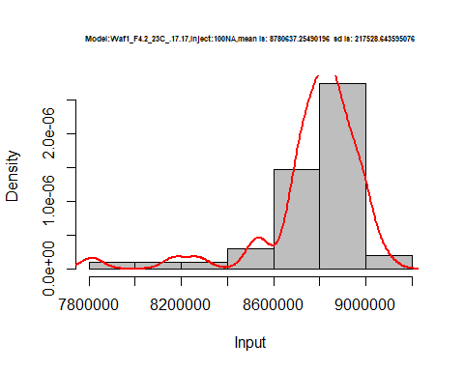

hist(d2_17.17$V2,  
 cex.main=0.5,  
 freq = FALSE,  
 main = paste('Model:Waf1_F4.2_23C_.17.17,Inject:200NA,mean is:', mean(d2_17.17$V2),' sd is:', sd(d2_17.17$V2)),  
 xlab = "Input",  
 ylab = "Density",  
 col="grey")  
#plot density curve  
lines(density(d2_17.17$V2), # density plot  
 lwd = 2, # thickness of line  
 col = "red")

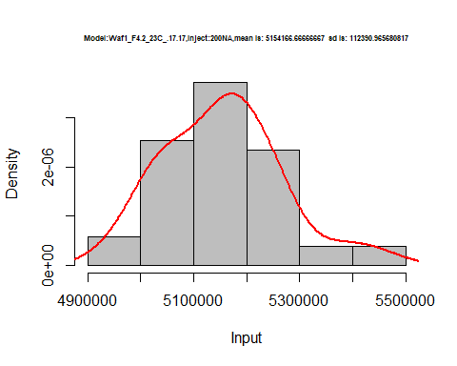

hist(d2_17.17$V3,  
 cex.main=0.5,  
 freq = FALSE,  
 main = paste('Model:Waf1_F4.2_23C_.17.17,Inject:300NA,mean is:', mean(d2_17.17$V3),' sd is:', sd(d2_17.17$V3)),  
 xlab = "Input",  
 ylab = "Density",  
 col="grey")  
#plot density curve  
lines(density(d2_17.17$V3), # density plot  
 lwd = 2, # thickness of line  
 col = "red")

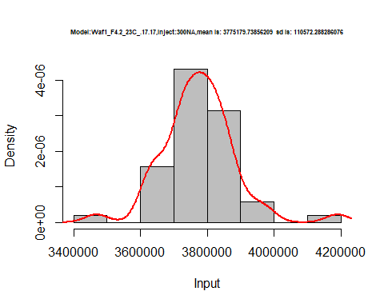

hist(d2_17.17$V4,  
 cex.main=0.5,  
 freq = FALSE,  
 main = paste('Model:Waf1_F4.2_23C_.17.17,Inject:400NA,mean is:', mean(d2_17.17$V4),' sd is:', sd(d2_17.17$V4)),  
 xlab = "Input",  
 ylab = "Density",  
 col="grey")  
#plot density curve  
lines(density(d2_17.17$V4), # density plot  
 lwd = 2, # thickness of line  
 col = "red")

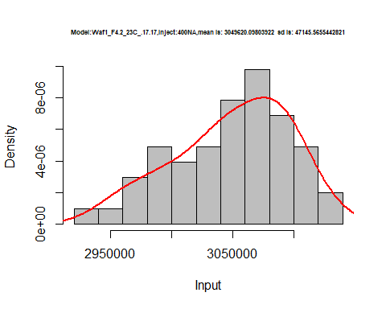

hist(d2_17.17$V5,  
 cex.main=0.5,  
 freq = FALSE,  
 main = paste('Model:Waf1_F4.2_23C_.17.17,Inject:500NA,mean is:', mean(d2_17.17$V5),' sd is:', sd(d2_17.17$V5)),  
 xlab = "Input",  
 ylab = "Density",  
 col="grey")  
#plot density curve  
lines(density(d2_17.17$V5), # density plot  
 lwd = 2, # thickness of line  
 col = "red")

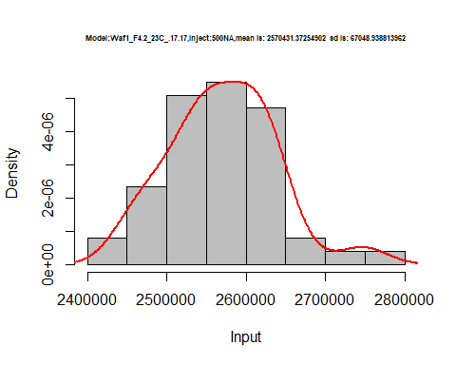

hist(d2_17.17$V6,  
 cex.main=0.5,  
 freq = FALSE,  
 main = paste('Model:Waf1_F4.2_23C_.17.17,Inject:600NA,mean is:', mean(d2_17.17$V6),' sd is:', sd(d2_17.17$V6)),  
 xlab = "Input",  
 ylab = "Density",  
 col="grey")  
#plot density curve  
lines(density(d2_17.17$V6), # density plot  
 lwd = 2, # thickness of line  
 col = "red")

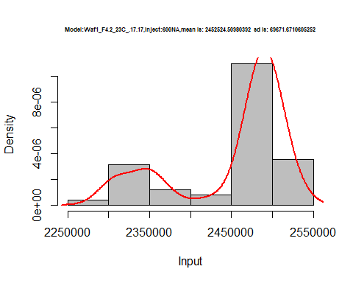

hist(d2_17.17$V7,  
 cex.main=0.5,  
 freq = FALSE,  
 main = paste('Model:Waf1_F4.2_23C_.17.17,Inject:700NA,mean is:', mean(d2_17.17$V7),' sd is:', sd(d2_17.17$V7)),  
 xlab = "Input",  
 ylab = "Density",  
 col="grey")  
#plot density curve  
lines(density(d2_17.17$V7), # density plot  
 lwd = 2, # thickness of line  
 col = "red")

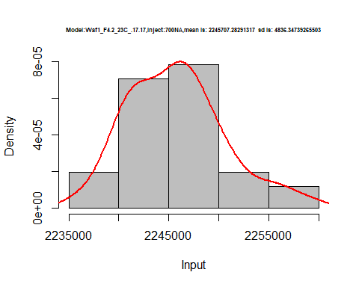

hist(d2_17.17$V8,  
 cex.main=0.5,  
 freq = FALSE,  
 main = paste('Model:Waf1_F4.2_23C_.17.17,Inject:800NA,mean is:', mean(d2_17.17$V8),' sd is:', sd(d2_17.17$V8)),  
 xlab = "Input",  
 ylab = "Density",  
 col="grey")  
#plot density curve  
lines(density(d2_17.17$V8), # density plot  
 lwd = 2, # thickness of line  
 col = "red")

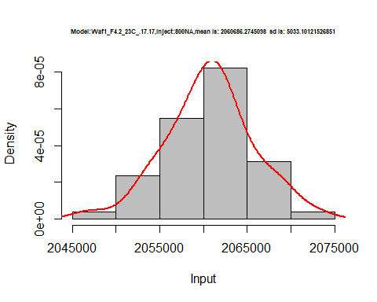

dens <- apply(d2_17.17, 2, density)  
plot('Model:Waf1_F4.2_23C_.17.17', xlim=range(sapply(dens, "[", "x")), ylim=range(sapply(dens, "[", "y")))

## Warning in xy.coords(x, y, xlabel, ylabel, log): NAs introduced by coercion

mapply(lines, dens, col=1:length(dens))

## $V1  
## NULL  
##   
## $V2  
## NULL  
##   
## $V3  
## NULL  
##   
## $V4  
## NULL  
##   
## $V5  
## NULL  
##   
## $V6  
## NULL  
##   
## $V7  
## NULL  
##   
## $V8  
## NULL

legend("topright", legend=names(dens), fill=1:length(dens))

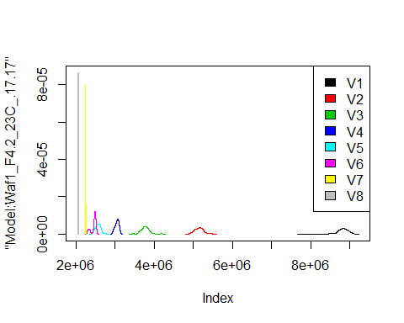

d3_17.17<-d_17.17[,c(17:24)]  
d3_17.17 <- head(d3_17.17,51)  
colnames(d3_17.17) <- c("V1", "V2","V3","V4","V5","V6","V7","V8")  
head(d3_17.17)

## V1 V2 V3 V4 V5 V6 V7 V8  
## 1 1002500 837500 729166.7 658750 603500 562916.7 528214.3 500312.5  
## 2 1002500 837500 729166.7 658750 603500 562500.0 528571.4 497500.0  
## 3 1002500 838750 728333.3 659375 604500 562916.7 528571.4 497500.0  
## 4 1000000 837500 727500.0 659375 604500 563750.0 527857.1 497812.5  
## 5 1002500 837500 727500.0 658750 603000 563750.0 528928.6 498750.0  
## 6 1002500 838750 728333.3 658750 604000 563333.3 528928.6 499687.5

hist(d3_17.17$V1,  
 cex.main=0.5,  
 freq = FALSE,  
 main = paste('Model:Waf1_F6.3_23C_.17.17,Inject:100NA,mean is:', mean(d3_17.17$V1),' sd is:', sd(d3_17.17$V1)),  
 xlab = "Input",  
 ylab = "Density",  
 col="grey")  
#plot density curve  
lines(density(d3_17.17$V1), # density plot  
 lwd = 2, # thickness of line  
 col = "red")

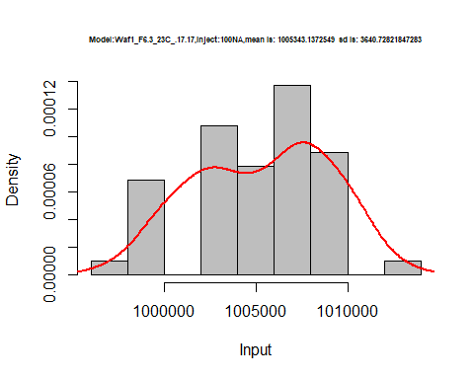

hist(d3_17.17$V2,  
 cex.main=0.5,  
 freq = FALSE,  
 main = paste('Model:Waf1_F6.3_23C_.17.17,Inject:200NA,mean is:', mean(d3_17.17$V2),' sd is:', sd(d3_17.17$V2)),  
 xlab = "Input",  
 ylab = "Density",  
 col="grey")  
#plot density curve  
lines(density(d3_17.17$V2), # density plot  
 lwd = 2, # thickness of line  
 col = "red")

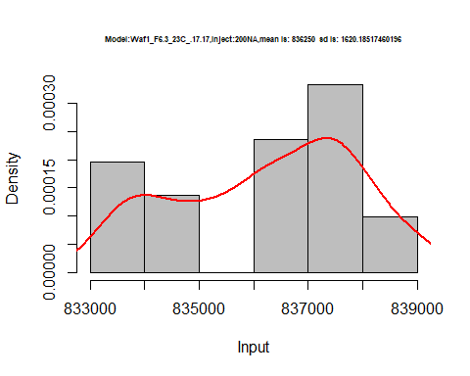

hist(d3_17.17$V3,  
 cex.main=0.5,  
 freq = FALSE,  
 main = paste('Model:Waf1_F6.3_23C_.17.17,Inject:300NA,mean is:', mean(d3_17.17$V3),' sd is:', sd(d3_17.17$V3)),  
 xlab = "Input",  
 ylab = "Density",  
 col="grey")  
#plot density curve  
lines(density(d3_17.17$V3), # density plot  
 lwd = 2, # thickness of line  
 col = "red")

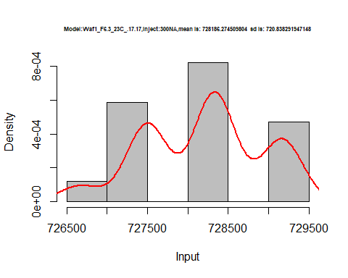

hist(d3_17.17$V4,  
 cex.main=0.5,  
 freq = FALSE,  
 main = paste('Model:Waf1_F6.3_23C_.17.17,Inject:400NA,mean is:', mean(d3_17.17$V4),' sd is:', sd(d3_17.17$V4)),  
 xlab = "Input",  
 ylab = "Density",  
 col="grey")  
#plot density curve  
lines(density(d3_17.17$V4), # density plot  
 lwd = 2, # thickness of line  
 col = "red")

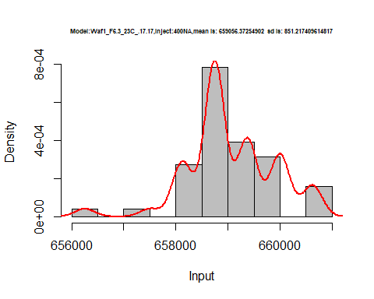

hist(d3_17.17$V5,  
 cex.main=0.5,  
 freq = FALSE,  
 main = paste('Model:Waf1_F6.3_23C_.17.17,Inject:500NA,mean is:', mean(d3_17.17$V5),' sd is:', sd(d3_17.17$V5)),  
 xlab = "Input",  
 ylab = "Density",  
 col="grey")  
#plot density curve  
lines(density(d3_17.17$V5), # density plot  
 lwd = 2, # thickness of line  
 col = "red")

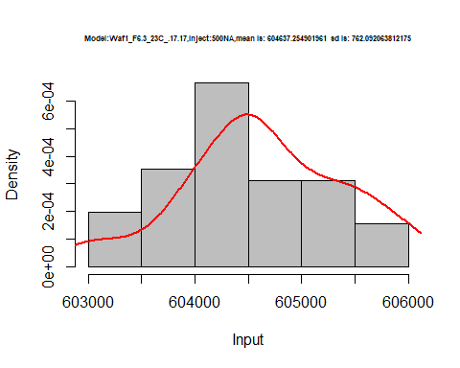

hist(d3_17.17$V6,  
 cex.main=0.5,  
 freq = FALSE,  
 main = paste('Model:Waf1_F6.3_23C_.17.17,Inject:600NA,mean is:', mean(d3_17.17$V6),' sd is:', sd(d3_17.17$V6)),  
 xlab = "Input",  
 ylab = "Density",  
 col="grey")  
#plot density curve  
lines(density(d3_17.17$V6), # density plot  
 lwd = 2, # thickness of line  
 col = "red")

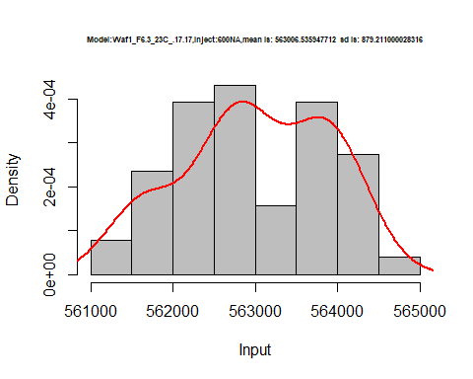

hist(d3_17.17$V7,  
 cex.main=0.5,  
 freq = FALSE,  
 main = paste('Model:Waf1_F6.3_23C_.17.17,Inject:700NA,mean is:', mean(d3_17.17$V7),' sd is:', sd(d3_17.17$V7)),  
 xlab = "Input",  
 ylab = "Density",  
 col="grey")  
#plot density curve  
lines(density(d3_17.17$V7), # density plot  
 lwd = 2, # thickness of line  
 col = "red")

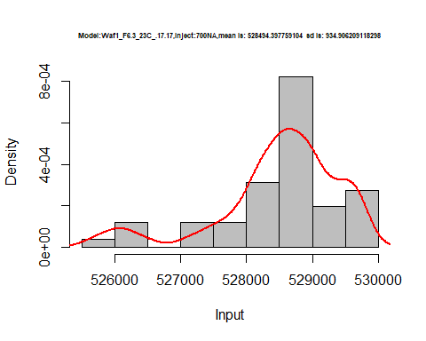

hist(d3_17.17$V8,  
 cex.main=0.5,  
 freq = FALSE,  
 main = paste('Model:Waf1_F6.3_23C_.17.17,Inject:800NA,mean is:', mean(d3_17.17$V8),' sd is:', sd(d3_17.17$V8)),  
 xlab = "Input",  
 ylab = "Density",  
 col="grey")  
#plot density curve  
lines(density(d3_17.17$V8), # density plot  
 lwd = 2, # thickness of line  
 col = "red")

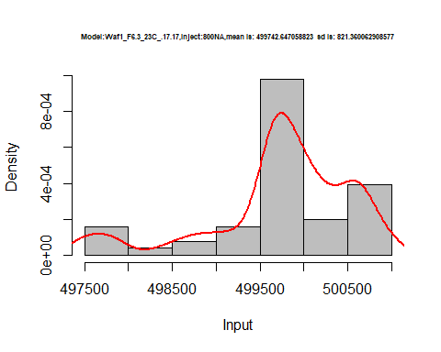

dens <- apply(d3_17.17, 2, density)  
plot('Model:Waf1_F6.3_23C_.17.17', xlim=range(sapply(dens, "[", "x")), ylim=range(sapply(dens, "[", "y")))

## Warning in xy.coords(x, y, xlabel, ylabel, log): NAs introduced by coercion

mapply(lines, dens, col=1:length(dens))

## $V1  
## NULL  
##   
## $V2  
## NULL  
##   
## $V3  
## NULL  
##   
## $V4  
## NULL  
##   
## $V5  
## NULL  
##   
## $V6  
## NULL  
##   
## $V7  
## NULL  
##   
## $V8  
## NULL

legend("topright", legend=names(dens), fill=1:length(dens))

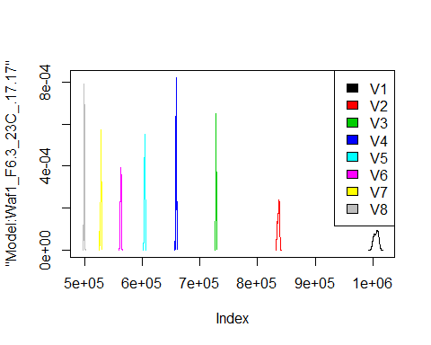

# Select columns whose names contains "18.18"  
d_18.18<-my_data %>% select(contains("18.18."))  
#d_15.15 <- head(d_15.15,51)  
#colnames(d_15.15) <- c("V1", "V2","V3","V4","V5","V6","V7","V8")  
head(d_18.18)

## Waf1_F5.1_23C_.100nA_.18.18. Waf1_F5.1_23C_.200nA_.18.18.  
## 1 4322500 3161250  
## 2 4315000 3155000  
## 3 4317500 3151250  
## 4 4310000 3153750  
## 5 4315000 3161250  
## 6 4325000 3160000  
## Waf1_F5.1_23C_.300nA_.18.18. Waf1_F5.1_23C_.400nA_.18.18.  
## 1 2833333 2230625  
## 2 2832500 2228750  
## 3 2835833 2225000  
## 4 2838333 2212500  
## 5 2836667 2207500  
## 6 2838333 2208125  
## Waf1_F5.1_23C_.500nA_.18.18. Waf1_F5.1_23C_.600nA_.18.18.  
## 1 2117000 1863333  
## 2 2115000 1861667  
## 3 2105500 1860417  
## 4 2099000 1861250  
## 5 2100000 1858750  
## 6 2108500 1862917  
## Waf1_F5.1_23C_.700nA_.18.18. Waf1_F5.1_23C_.800nA_.18.18.  
## 1 1797143 1670625  
## 2 1788214 1666563  
## 3 1789286 1664063  
## 4 1788929 1662187  
## 5 1788214 1665000  
## 6 1785714 1661250  
## Waf1_F6.2_23C_.100nA_.18.18. Waf1_F6.2_23C_.200nA_.18.18.  
## 1 710000 687500  
## 2 710000 687500  
## 3 710000 687500  
## 4 710000 687500  
## 5 710000 686250  
## 6 715000 685000  
## Waf1_F6.2_23C_.300nA_.18.18. Waf1_F6.2_23C_.400nA_.18.18.  
## 1 655833.3 616875  
## 2 656666.7 615625  
## 3 655000.0 615625  
## 4 659166.7 615625  
## 5 658333.3 616250  
## 6 658333.3 615625  
## Waf1_F6.2_23C_.500nA_.18.18. Waf1_F6.2_23C_.600nA_.18.18.  
## 1 591000 562916.7  
## 2 589500 561666.7  
## 3 591000 562916.7  
## 4 590000 563750.0  
## 5 591000 563750.0  
## 6 591500 564166.7  
## Waf1_F6.2_23C_.700nA_.18.18. Waf1_F6.2_23C_.800nA_.18.18.  
## 1 536428.6 517187.5  
## 2 536071.4 517812.5  
## 3 536071.4 517187.5  
## 4 534285.7 516562.5  
## 5 535000.0 517187.5  
## 6 533214.3 518125.0

d1_18.18<-d_18.18[,c(1:8)]  
d1_18.18 <- head(d1_18.18,51)  
colnames(d1_18.18) <- c("V1", "V2","V3","V4","V5","V6","V7","V8")  
head(d1_18.18)

## V1 V2 V3 V4 V5 V6 V7 V8  
## 1 4322500 3161250 2833333 2230625 2117000 1863333 1797143 1670625  
## 2 4315000 3155000 2832500 2228750 2115000 1861667 1788214 1666563  
## 3 4317500 3151250 2835833 2225000 2105500 1860417 1789286 1664063  
## 4 4310000 3153750 2838333 2212500 2099000 1861250 1788929 1662187  
## 5 4315000 3161250 2836667 2207500 2100000 1858750 1788214 1665000  
## 6 4325000 3160000 2838333 2208125 2108500 1862917 1785714 1661250

hist(d1_18.18$V1,  
 cex.main=0.5,  
 freq = FALSE,  
 main = paste('Model:Waf1_F5.1_23C_.18.18,Inject:100NA,mean is:', mean(d1_18.18$V1),' sd is:', sd(d1_18.18$V1)),  
 xlab = "Input",  
 ylab = "Density",  
 col="grey")  
#plot density curve  
lines(density(d1_18.18$V1), # density plot  
 lwd = 2, # thickness of line  
 col = "red")

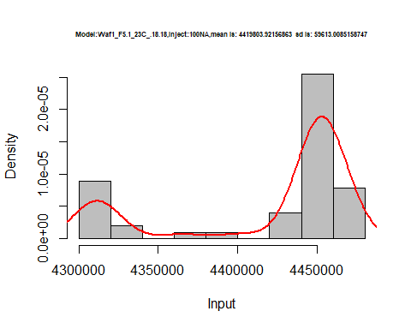

hist(d1_18.18$V2,  
 cex.main=0.5,  
 freq = FALSE,  
 main = paste('Model:Waf1_F5.1_23C_.18.18,Inject:200NA,mean is:', mean(d1_18.18$V2),' sd is:', sd(d1_18.18$V2)),  
 xlab = "Input",  
 ylab = "Density",  
 col="grey")  
#plot density curve  
lines(density(d1_18.18$V2), # density plot  
 lwd = 2, # thickness of line  
 col = "red")

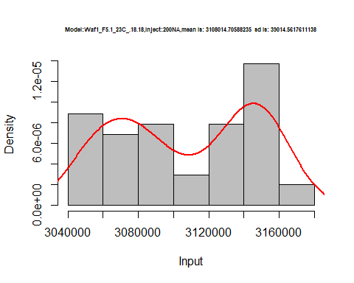

hist(d1_18.18$V3,  
 cex.main=0.5,  
 freq = FALSE,  
 main = paste('Model:Waf1_F5.1_23C_.18.18,Inject:300NA,mean is:', mean(d1_18.18$V3),' sd is:', sd(d1_18.18$V3)),  
 xlab = "Input",  
 ylab = "Density",  
 col="grey")  
#plot density curve  
lines(density(d1_18.18$V3), # density plot  
 lwd = 2, # thickness of line  
 col = "red")

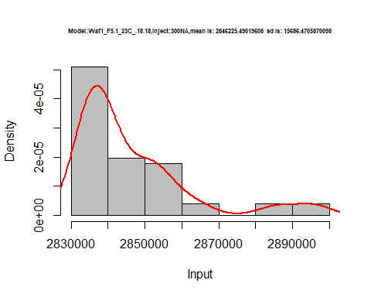

hist(d1_18.18$V4,  
 cex.main=0.5,  
 freq = FALSE,  
 main = paste('Model:Waf1_F5.1_23C_.18.18,Inject:400NA,mean is:', mean(d1_18.18$V4),' sd is:', sd(d1_18.18$V4)),  
 xlab = "Input",  
 ylab = "Density",  
 col="grey")  
#plot density curve  
lines(density(d1_18.18$V4), # density plot  
 lwd = 2, # thickness of line  
 col = "red")

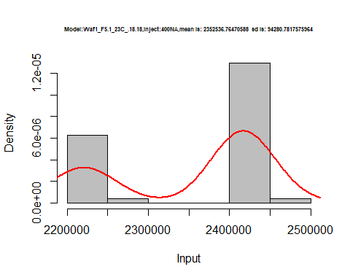

hist(d1_18.18$V5,  
 cex.main=0.5,  
 freq = FALSE,  
 main = paste('Model:Waf1_F5.1_23C_.18.18,Inject:500NA,mean is:', mean(d1_18.18$V5),' sd is:', sd(d1_18.18$V5)),  
 xlab = "Input",  
 ylab = "Density",  
 col="grey")  
#plot density curve  
lines(density(d1_18.18$V5), # density plot  
 lwd = 2, # thickness of line  
 col = "red")

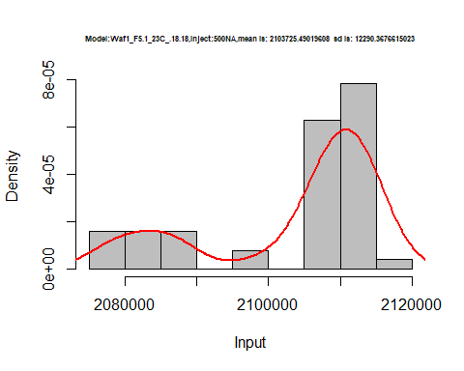

hist(d1_18.18$V6,  
 cex.main=0.5,  
 freq = FALSE,  
 main = paste('Model:Waf1_F5.1_23C_.18.18,Inject:600NA,mean is:', mean(d1_18.18$V6),' sd is:', sd(d1_18.18$V6)),  
 xlab = "Input",  
 ylab = "Density",  
 col="grey")  
#plot density curve  
lines(density(d1_18.18$V6), # density plot  
 lwd = 2, # thickness of line  
 col = "red")

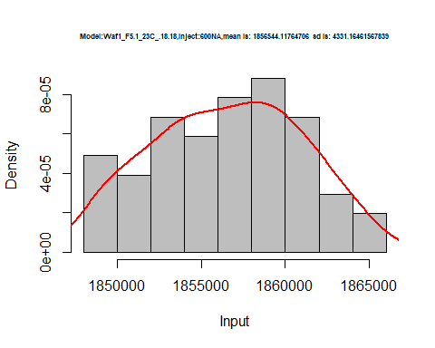

hist(d1_18.18$V7,  
 cex.main=0.5,  
 freq = FALSE,  
 main = paste('Model:Waf1_F5.1_23C_.18.18,Inject:700NA,mean is:', mean(d1_18.18$V7),' sd is:', sd(d1_18.18$V7)),  
 xlab = "Input",  
 ylab = "Density",  
 col="grey")  
#plot density curve  
lines(density(d1_18.18$V7), # density plot  
 lwd = 2, # thickness of line  
 col = "red")

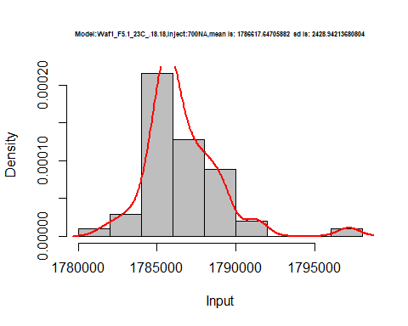

hist(d1_18.18$V8,  
 cex.main=0.5,  
 freq = FALSE,  
 main = paste('Model:Waf1_F5.1_23C_.18.18,Inject:800NA,mean is:', mean(d1_18.18$V8),' sd is:', sd(d1_18.18$V8)),  
 xlab = "Input",  
 ylab = "Density",  
 col="grey")  
#plot density curve  
lines(density(d1_18.18$V8), # density plot  
 lwd = 2, # thickness of line  
 col = "red")

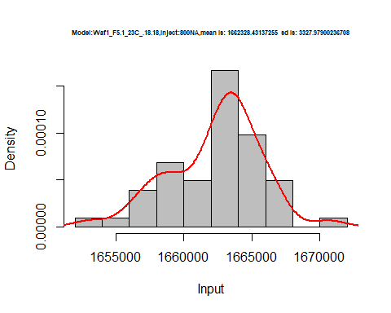

dens <- apply(d1_18.18, 2, density)  
plot('Model:Waf1_F5.1_23C_.18.18', xlim=range(sapply(dens, "[", "x")), ylim=range(sapply(dens, "[", "y")))

## Warning in xy.coords(x, y, xlabel, ylabel, log): NAs introduced by coercion

mapply(lines, dens, col=1:length(dens))

## $V1  
## NULL  
##   
## $V2  
## NULL  
##   
## $V3  
## NULL  
##   
## $V4  
## NULL  
##   
## $V5  
## NULL  
##   
## $V6  
## NULL  
##   
## $V7  
## NULL  
##   
## $V8  
## NULL

legend("topright", legend=names(dens), fill=1:length(dens))

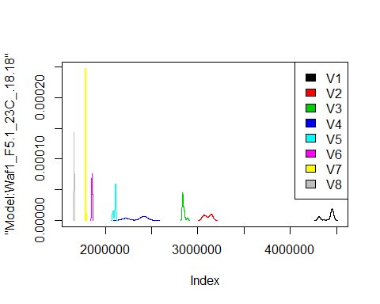

d2_18.18<-d_18.18[,c(9:16)]  
d2_18.18 <- head(d2_18.18,51)  
colnames(d2_18.18) <- c("V1", "V2","V3","V4","V5","V6","V7","V8")  
head(d2_18.18)

## V1 V2 V3 V4 V5 V6 V7 V8  
## 1 710000 687500 655833.3 616875 591000 562916.7 536428.6 517187.5  
## 2 710000 687500 656666.7 615625 589500 561666.7 536071.4 517812.5  
## 3 710000 687500 655000.0 615625 591000 562916.7 536071.4 517187.5  
## 4 710000 687500 659166.7 615625 590000 563750.0 534285.7 516562.5  
## 5 710000 686250 658333.3 616250 591000 563750.0 535000.0 517187.5  
## 6 715000 685000 658333.3 615625 591500 564166.7 533214.3 518125.0

hist(d2_18.18$V1,  
 cex.main=0.5,  
 freq = FALSE,  
 main = paste('Model:Waf1_F6.2_23C_.18.18,Inject:100NA,mean is:', mean(d2_18.18$V1),' sd is:', sd(d2_18.18$V1)),  
 xlab = "Input",  
 ylab = "Density",  
 col="grey")  
#plot density curve  
lines(density(d2_18.18$V1), # density plot  
 lwd = 2, # thickness of line  
 col = "red")

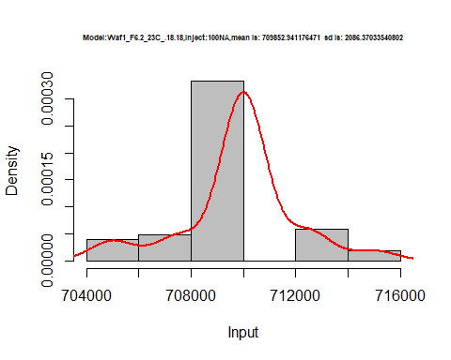

hist(d2_18.18$V2,  
 cex.main=0.5,  
 freq = FALSE,  
 main = paste('Model:Waf1_F6.2_23C_.18.18,Inject:200NA,mean is:', mean(d2_18.18$V2),' sd is:', sd(d2_18.18$V2)),  
 xlab = "Input",  
 ylab = "Density",  
 col="grey")  
#plot density curve  
lines(density(d2_18.18$V2), # density plot  
 lwd = 2, # thickness of line  
 col = "red")

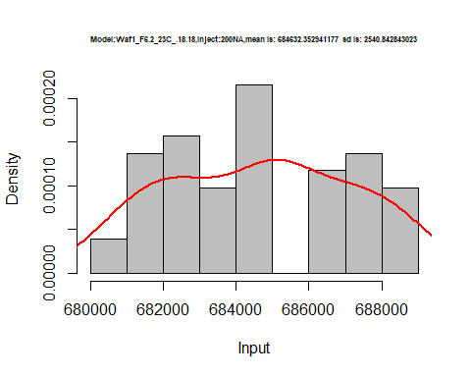

hist(d2_18.18$V3,  
 cex.main=0.5,  
 freq = FALSE,  
 main = paste('Model:Waf1_F6.2_23C_.18.18,Inject:300NA,mean is:', mean(d2_18.18$V3),' sd is:', sd(d2_18.18$V3)),  
 xlab = "Input",  
 ylab = "Density",  
 col="grey")  
#plot density curve  
lines(density(d2_18.18$V3), # density plot  
 lwd = 2, # thickness of line  
 col = "red")

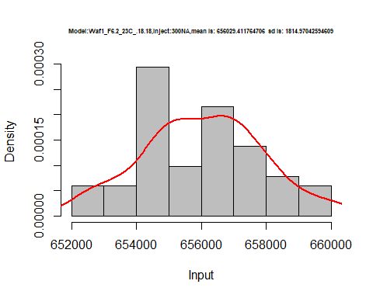

hist(d2_18.18$V4,  
 cex.main=0.5,  
 freq = FALSE,  
 main = paste('Model:Waf1_F6.2_23C_.18.18,Inject:400NA,mean is:', mean(d2_18.18$V4),' sd is:', sd(d2_18.18$V4)),  
 xlab = "Input",  
 ylab = "Density",  
 col="grey")  
#plot density curve  
lines(density(d2_18.18$V4), # density plot  
 lwd = 2, # thickness of line  
 col = "red")

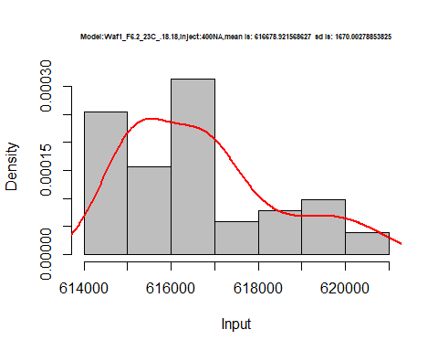

hist(d2_18.18$V5,  
 cex.main=0.5,  
 freq = FALSE,  
 main = paste('Model:Waf1_F6.2_23C_.18.18,Inject:500NA,mean is:', mean(d2_18.18$V5),' sd is:', sd(d2_18.18$V5)),  
 xlab = "Input",  
 ylab = "Density",  
 col="grey")  
#plot density curve  
lines(density(d2_18.18$V5), # density plot  
 lwd = 2, # thickness of line  
 col = "red")

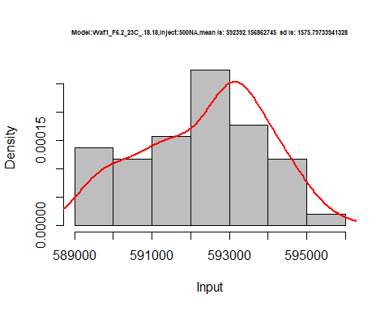

hist(d2_18.18$V6,  
 cex.main=0.5,  
 freq = FALSE,  
 main = paste('Model:Waf1_F6.2_23C_.18.18,Inject:600NA,mean is:', mean(d2_18.18$V6),' sd is:', sd(d2_18.18$V6)),  
 xlab = "Input",  
 ylab = "Density",  
 col="grey")  
#plot density curve  
lines(density(d2_18.18$V6), # density plot  
 lwd = 2, # thickness of line  
 col = "red")

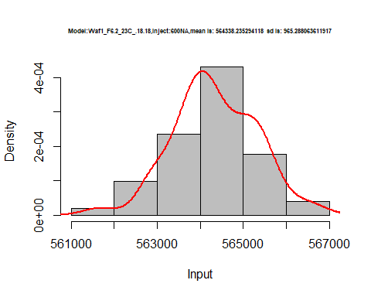

hist(d2_18.18$V7,  
 cex.main=0.5,  
 freq = FALSE,  
 main = paste('Model:Waf1_F6.2_23C_.18.18,Inject:700NA,mean is:', mean(d2_18.18$V7),' sd is:', sd(d2_18.18$V7)),  
 xlab = "Input",  
 ylab = "Density",  
 col="grey")  
#plot density curve  
lines(density(d2_18.18$V7), # density plot  
 lwd = 2, # thickness of line  
 col = "red")

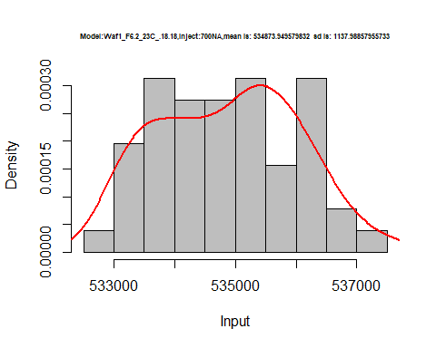

hist(d2_18.18$V8,  
 cex.main=0.5,  
 freq = FALSE,  
 main = paste('Model:Waf1_F6.2_23C_.18.18,Inject:800NA,mean is:', mean(d2_18.18$V8),' sd is:', sd(d2_18.18$V8)),  
 xlab = "Input",  
 ylab = "Density",  
 col="grey")  
#plot density curve  
lines(density(d2_18.18$V8), # density plot  
 lwd = 2, # thickness of line  
 col = "red")

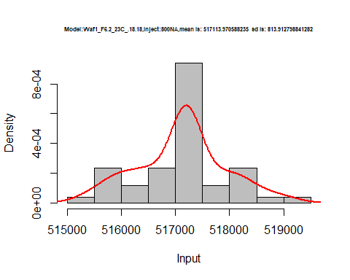

dens <- apply(d2_18.18, 2, density)  
plot('Model:Waf1_F6.2_23C_.18.18', xlim=range(sapply(dens, "[", "x")), ylim=range(sapply(dens, "[", "y")))

## Warning in xy.coords(x, y, xlabel, ylabel, log): NAs introduced by coercion

mapply(lines, dens, col=1:length(dens))

## $V1  
## NULL  
##   
## $V2  
## NULL  
##   
## $V3  
## NULL  
##   
## $V4  
## NULL  
##   
## $V5  
## NULL  
##   
## $V6  
## NULL  
##   
## $V7  
## NULL  
##   
## $V8  
## NULL

legend("topright", legend=names(dens), fill=1:length(dens))

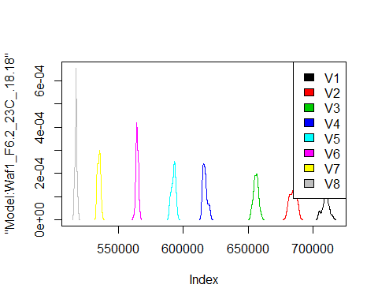

# Select columns whose names contains "19.19"  
d_19.19<-my_data %>% select(contains("19.19."))  
#d_15.15 <- head(d_15.15,51)  
#colnames(d_15.15) <- c("V1", "V2","V3","V4","V5","V6","V7","V8")  
head(d_19.19)

## Waf1_F2.5_23C_.100nA_.19.19. Waf1_F2.5_23C_.200nA_.19.19.  
## 1 1747500 1303750  
## 2 1740000 1306250  
## 3 1740000 1307500  
## 4 1740000 1302500  
## 5 1742500 1296250  
## 6 1752500 1300000  
## Waf1_F2.5_23C_.300nA_.19.19. Waf1_F2.5_23C_.400nA_.19.19.  
## 1 1093333 956875  
## 2 1085000 957500  
## 3 1083333 963125  
## 4 1083333 963125  
## 5 1085833 965625  
## 6 1085000 964375  
## Waf1_F2.5_23C_.500nA_.19.19. Waf1_F2.5_23C_.600nA_.19.19.  
## 1 864000 800000.0  
## 2 866000 797083.3  
## 3 861000 797916.7  
## 4 865000 800000.0  
## 5 869000 802916.7  
## 6 865000 800416.7  
## Waf1_F2.5_23C_.700nA_.19.19. Waf1_F2.5_23C_.800nA_.19.19.  
## 1 753214.3 710312.5  
## 2 749642.9 704687.5  
## 3 746785.7 706562.5  
## 4 754285.7 706250.0  
## 5 748928.6 707500.0  
## 6 748928.6 709062.5  
## Waf1_F4.4_23C_.100nA_.19.19. Waf1_F4.4_23C_.200nA_.19.19.  
## 1 2535000 1683750  
## 2 2545000 1683750  
## 3 2562500 1685000  
## 4 2552500 1682500  
## 5 2545000 1685000  
## 6 2547500 1686250  
## Waf1_F4.4_23C_.300nA_.19.19. Waf1_F4.4_23C_.400nA_.19.19.  
## 1 1281667 1071250  
## 2 1282500 1071250  
## 3 1280833 1070000  
## 4 1282500 1071875  
## 5 1283333 1073750  
## 6 1280000 1071250  
## Waf1_F4.4_23C_.500nA_.19.19. Waf1_F4.4_23C_.600nA_.19.19.  
## 1 919000 804583.3  
## 2 918000 806250.0  
## 3 879000 804166.7  
## 4 918500 805833.3  
## 5 918000 805000.0  
## 6 918500 806666.7  
## Waf1_F4.4_23C_.700nA_.19.19. Waf1_F4.4_23C_.800nA_.19.19.  
## 1 725357.1 655625.0  
## 2 725714.3 656562.5  
## 3 724642.9 656875.0  
## 4 724642.9 656562.5  
## 5 725357.1 656875.0  
## 6 726071.4 655937.5  
## Waf1_F4.7_23C_.100nA_.19.19. Waf1_F4.7_23C_.200nA_.19.19.  
## 1 3385000 2257500  
## 2 3445000 2258750  
## 3 3480000 2257500  
## 4 3497500 2260000  
## 5 3495000 2258750  
## 6 3500000 2258750  
## Waf1_F4.7_23C_.300nA_.19.19. Waf1_F4.7_23C_.400nA_.19.19.  
## 1 1785833 1522500  
## 2 1785833 1523750  
## 3 1789167 1520000  
## 4 1787500 1521250  
## 5 1789167 1520000  
## 6 1789167 1515625  
## Waf1_F4.7_23C_.500nA_.19.19. Waf1_F4.7_23C_.600nA_.19.19.  
## 1 1342500 1227083  
## 2 1345000 1224167  
## 3 1345000 1225000  
## 4 1344500 1225417  
## 5 1344000 1227500  
## 6 1344500 1226250  
## Waf1_F4.7_23C_.700nA_.19.19. Waf1_F4.7_23C_.800nA_.19.19.  
## 1 1111429 1032187  
## 2 1111786 1029063  
## 3 1111429 1028125  
## 4 1111429 1033437  
## 5 1111786 1034063  
## 6 1111071 1033750  
## Waf1_F5.7_23C_.100nA_.19.19. Waf1_F5.7_23C_.200nA_.19.19.  
## 1 2030000 1390000  
## 2 2030000 1393750  
## 3 2035000 1386250  
## 4 2035000 1386250  
## 5 2030000 1382500  
## 6 2032500 1386250  
## Waf1_F5.7_23C_.300nA_.19.19. Waf1_F5.7_23C_.400nA_.19.19.  
## 1 1084167 912500  
## 2 1078333 917500  
## 3 1080000 910000  
## 4 1081667 912500  
## 5 1081667 910000  
## 6 1082500 913125  
## Waf1_F5.7_23C_.500nA_.19.19. Waf1_F5.7_23C_.600nA_.19.19.  
## 1 800500 715416.7  
## 2 794000 715416.7  
## 3 798500 707916.7  
## 4 798000 712500.0  
## 5 794500 712500.0  
## 6 797500 712500.0  
## Waf1_F5.7_23C_.700nA_.19.19. Waf1_F5.7_23C_.800nA_.19.19.  
## 1 654285.7 604687.5  
## 2 650000.0 595625.0  
## 3 645000.0 597812.5  
## 4 650357.1 602187.5  
## 5 648928.6 595312.5  
## 6 645000.0 601562.5  
## Waf1_F6.4_23C_.100nA_.19.19. Waf1_F6.4_23C_.200nA_.19.19.  
## 1 2850000 2185000  
## 2 2855000 2188750  
## 3 2825000 2192500  
## 4 2810000 2192500  
## 5 2807500 2191250  
## 6 2807500 2187500  
## Waf1_F6.4_23C_.300nA_.19.19. Waf1_F6.4_23C_.400nA_.19.19.  
## 1 1755833 1527500  
## 2 1755833 1525625  
## 3 1756667 1530000  
## 4 1755833 1526250  
## 5 1755833 1527500  
## 6 1754167 1534375  
## Waf1_F6.4_23C_.500nA_.19.19. Waf1_F6.4_23C_.600nA_.19.19.  
## 1 1362000 1235833  
## 2 1361500 1235000  
## 3 1362000 1232500  
## 4 1359500 1230833  
## 5 1361000 1230833  
## 6 1356000 1233333  
## Waf1_F6.4_23C_.700nA_.19.19. Waf1_F6.4_23C_.800nA_.19.19.  
## 1 1135714 1043437  
## 2 1136071 1042500  
## 3 1136429 1045625  
## 4 1136071 1049688  
## 5 1137500 1049063  
## 6 1136071 1048750

d1_19.19<-d_19.19[,c(1:8)]  
d1_19.19 <- head(d1_19.19,51)  
colnames(d1_19.19) <- c("V1", "V2","V3","V4","V5","V6","V7","V8")  
head(d1_19.19)

## V1 V2 V3 V4 V5 V6 V7 V8  
## 1 1747500 1303750 1093333 956875 864000 800000.0 753214.3 710312.5  
## 2 1740000 1306250 1085000 957500 866000 797083.3 749642.9 704687.5  
## 3 1740000 1307500 1083333 963125 861000 797916.7 746785.7 706562.5  
## 4 1740000 1302500 1083333 963125 865000 800000.0 754285.7 706250.0  
## 5 1742500 1296250 1085833 965625 869000 802916.7 748928.6 707500.0  
## 6 1752500 1300000 1085000 964375 865000 800416.7 748928.6 709062.5

hist(d1_19.19$V1,  
 cex.main=0.5,  
 freq = FALSE,  
 main = paste('Model:Waf1_F2.5_23C_.19.19,Inject:100NA,mean is:', mean(d1_19.19$V1),' sd is:', sd(d1_19.19$V1)),  
 xlab = "Input",  
 ylab = "Density",  
 col="grey")  
#plot density curve  
lines(density(d1_19.19$V1), # density plot  
 lwd = 2, # thickness of line  
 col = "red")

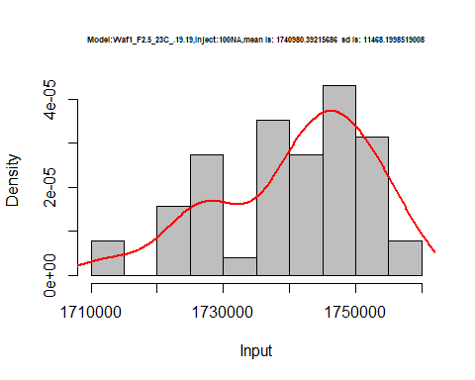

hist(d1_19.19$V2,  
 cex.main=0.5,  
 freq = FALSE,  
 main = paste('Model:Waf1_F2.5_23C_.19.19,Inject:200NA,mean is:', mean(d1_19.19$V2),' sd is:', sd(d1_19.19$V2)),  
 xlab = "Input",  
 ylab = "Density",  
 col="grey")  
#plot density curve  
lines(density(d1_19.19$V2), # density plot  
 lwd = 2, # thickness of line  
 col = "red")

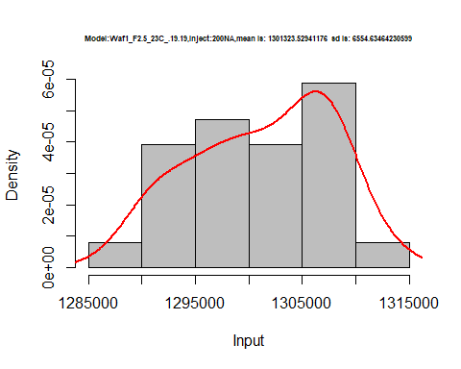

hist(d1_19.19$V3,  
 cex.main=0.5,  
 freq = FALSE,  
 main = paste('Model:Waf1_F2.5_23C_.19.19,Inject:300NA,mean is:', mean(d1_19.19$V3),' sd is:', sd(d1_19.19$V3)),  
 xlab = "Input",  
 ylab = "Density",  
 col="grey")  
#plot density curve  
lines(density(d1_19.19$V3), # density plot  
 lwd = 2, # thickness of line  
 col = "red")

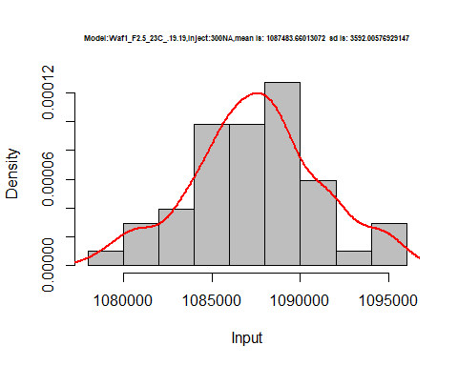

hist(d1_19.19$V4,  
 cex.main=0.5,  
 freq = FALSE,  
 main = paste('Model:Waf1_F2.5_23C_.19.19,Inject:400NA,mean is:', mean(d1_19.19$V4),' sd is:', sd(d1_19.19$V4)),  
 xlab = "Input",  
 ylab = "Density",  
 col="grey")  
#plot density curve  
lines(density(d1_19.19$V4), # density plot  
 lwd = 2, # thickness of line  
 col = "red")

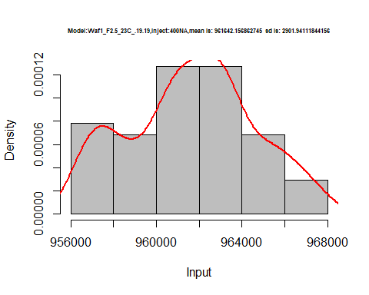

hist(d1_19.19$V5,  
 cex.main=0.5,  
 freq = FALSE,  
 main = paste('Model:Waf1_F2.5_23C_.19.19,Inject:500NA,mean is:', mean(d1_19.19$V5),' sd is:', sd(d1_19.19$V5)),  
 xlab = "Input",  
 ylab = "Density",  
 col="grey")  
#plot density curve  
lines(density(d1_19.19$V5), # density plot  
 lwd = 2, # thickness of line  
 col = "red")

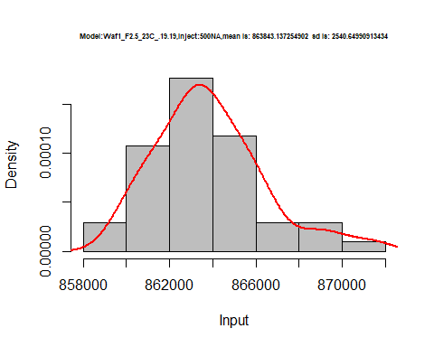

hist(d1_19.19$V6,  
 cex.main=0.5,  
 freq = FALSE,  
 main = paste('Model:Waf1_F2.5_23C_.19.19,Inject:600NA,mean is:', mean(d1_19.19$V6),' sd is:', sd(d1_19.19$V6)),  
 xlab = "Input",  
 ylab = "Density",  
 col="grey")  
#plot density curve  
lines(density(d1_19.19$V6), # density plot  
 lwd = 2, # thickness of line  
 col = "red")

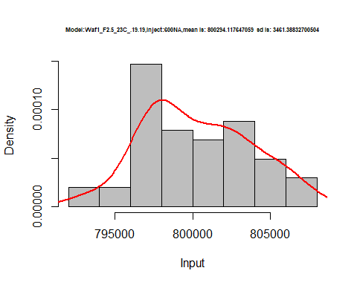

hist(d1_19.19$V7,  
 cex.main=0.5,  
 freq = FALSE,  
 main = paste('Model:Waf1_F2.5_23C_.19.19,Inject:700NA,mean is:', mean(d1_19.19$V7),' sd is:', sd(d1_19.19$V7)),  
 xlab = "Input",  
 ylab = "Density",  
 col="grey")  
#plot density curve  
lines(density(d1_19.19$V7), # density plot  
 lwd = 2, # thickness of line  
 col = "red")

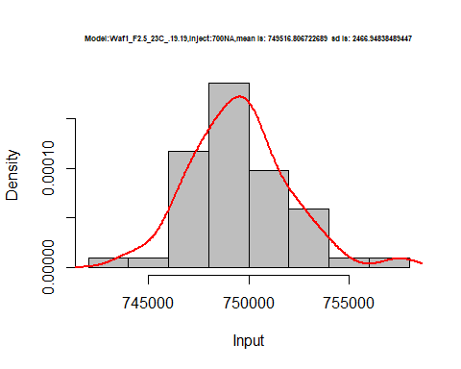

hist(d1_19.19$V8,  
 cex.main=0.5,  
 freq = FALSE,  
 main = paste('Model:Waf1_F2.5_23C_.19.19,Inject:800NA,mean is:', mean(d1_19.19$V8),' sd is:', sd(d1_19.19$V8)),  
 xlab = "Input",  
 ylab = "Density",  
 col="grey")  
#plot density curve  
lines(density(d1_19.19$V8), # density plot  
 lwd = 2, # thickness of line  
 col = "red")

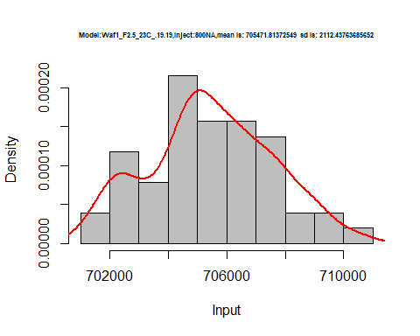

dens <- apply(d1_19.19, 2, density)  
plot('Model:Waf1_F2.5_23C_.19.19', xlim=range(sapply(dens, "[", "x")), ylim=range(sapply(dens, "[", "y")))

## Warning in xy.coords(x, y, xlabel, ylabel, log): NAs introduced by coercion

mapply(lines, dens, col=1:length(dens))

## $V1  
## NULL  
##   
## $V2  
## NULL  
##   
## $V3  
## NULL  
##   
## $V4  
## NULL  
##   
## $V5  
## NULL  
##   
## $V6  
## NULL  
##   
## $V7  
## NULL  
##   
## $V8  
## NULL

legend("topright", legend=names(dens), fill=1:length(dens))

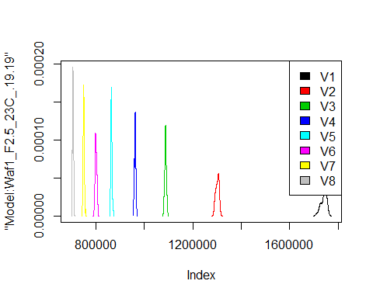

d2_19.19<-d_19.19[,c(9:16)]  
d2_19.19 <- head(d2_19.19,51)  
colnames(d2_19.19) <- c("V1", "V2","V3","V4","V5","V6","V7","V8")  
head(d2_19.19)

## V1 V2 V3 V4 V5 V6 V7 V8  
## 1 2535000 1683750 1281667 1071250 919000 804583.3 725357.1 655625.0  
## 2 2545000 1683750 1282500 1071250 918000 806250.0 725714.3 656562.5  
## 3 2562500 1685000 1280833 1070000 879000 804166.7 724642.9 656875.0  
## 4 2552500 1682500 1282500 1071875 918500 805833.3 724642.9 656562.5  
## 5 2545000 1685000 1283333 1073750 918000 805000.0 725357.1 656875.0  
## 6 2547500 1686250 1280000 1071250 918500 806666.7 726071.4 655937.5

hist(d2_19.19$V1,  
 cex.main=0.5,  
 freq = FALSE,  
 main = paste('Model:Waf1_F4.4_23C_.19.19,Inject:100NA,mean is:', mean(d2_19.19$V1),' sd is:', sd(d2_19.19$V1)),  
 xlab = "Input",  
 ylab = "Density",  
 col="grey")  
#plot density curve  
lines(density(d2_19.19$V1), # density plot  
 lwd = 2, # thickness of line  
 col = "red")

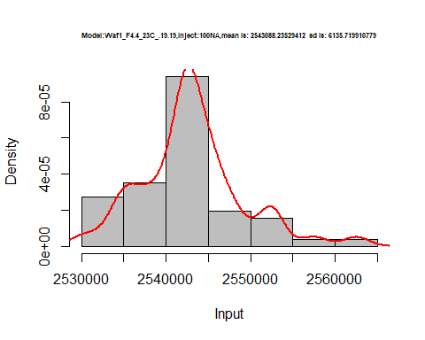

hist(d2_19.19$V2,  
 cex.main=0.5,  
 freq = FALSE,  
 main = paste('Model:Waf1_F4.4_23C_.19.19,Inject:200NA,mean is:', mean(d2_19.19$V2),' sd is:', sd(d2_19.19$V2)),  
 xlab = "Input",  
 ylab = "Density",  
 col="grey")  
#plot density curve  
lines(density(d2_19.19$V2), # density plot  
 lwd = 2, # thickness of line  
 col = "red")

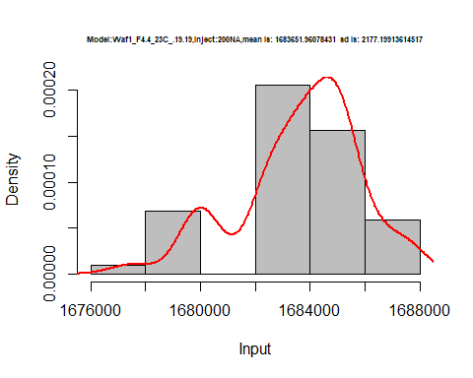

hist(d2_19.19$V3,  
 cex.main=0.5,  
 freq = FALSE,  
 main = paste('Model:Waf1_F4.4_23C_.19.19,Inject:300NA,mean is:', mean(d2_19.19$V3),' sd is:', sd(d2_19.19$V3)),  
 xlab = "Input",  
 ylab = "Density",  
 col="grey")  
#plot density curve  
lines(density(d2_19.19$V3), # density plot  
 lwd = 2, # thickness of line  
 col = "red")

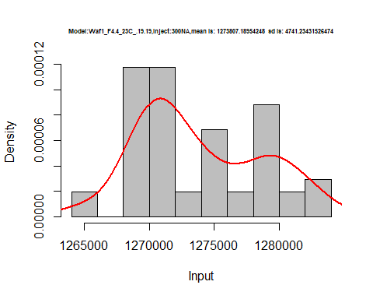

hist(d2_19.19$V4,  
 cex.main=0.5,  
 freq = FALSE,  
 main = paste('Model:Waf1_F4.4_23C_.19.19,Inject:400NA,mean is:', mean(d2_19.19$V4),' sd is:', sd(d2_19.19$V4)),  
 xlab = "Input",  
 ylab = "Density",  
 col="grey")  
#plot density curve  
lines(density(d2_19.19$V4), # density plot  
 lwd = 2, # thickness of line  
 col = "red")

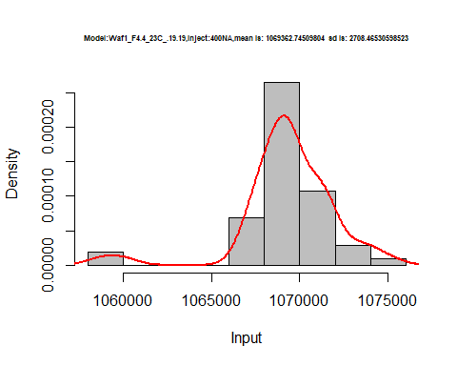

hist(d2_19.19$V5,  
 cex.main=0.5,  
 freq = FALSE,  
 main = paste('Model:Waf1_F4.4_23C_.19.19,Inject:500NA,mean is:', mean(d2_19.19$V5),' sd is:', sd(d2_19.19$V5)),  
 xlab = "Input",  
 ylab = "Density",  
 col="grey")  
#plot density curve  
lines(density(d2_19.19$V5), # density plot  
 lwd = 2, # thickness of line  
 col = "red")

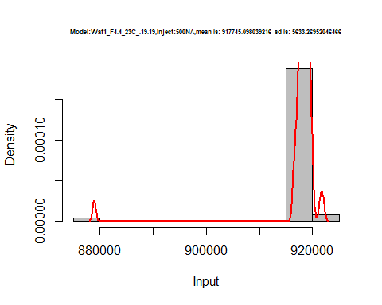

hist(d2_19.19$V6,  
 cex.main=0.5,  
 freq = FALSE,  
 main = paste('Model:Waf1_F4.4_23C_.19.19,Inject:600NA,mean is:', mean(d2_19.19$V6),' sd is:', sd(d2_19.19$V6)),  
 xlab = "Input",  
 ylab = "Density",  
 col="grey")  
#plot density curve  
lines(density(d2_19.19$V6), # density plot  
 lwd = 2, # thickness of line  
 col = "red")

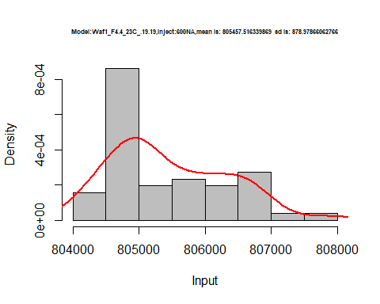

hist(d2_19.19$V7,  
 cex.main=0.5,  
 freq = FALSE,  
 main = paste('Model:Waf1_F4.4_23C_.19.19,Inject:700NA,mean is:', mean(d2_19.19$V7),' sd is:', sd(d2_19.19$V7)),  
 xlab = "Input",  
 ylab = "Density",  
 col="grey")  
#plot density curve  
lines(density(d2_19.19$V7), # density plot  
 lwd = 2, # thickness of line  
 col = "red")

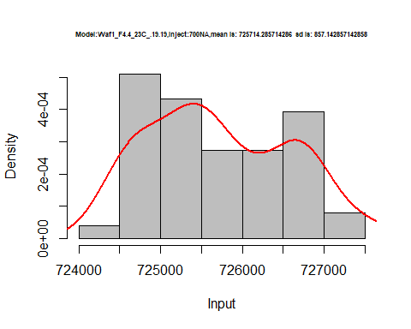

hist(d2_19.19$V8,  
 cex.main=0.5,  
 freq = FALSE,  
 main = paste('Model:Waf1_F4.4_23C_.19.19,Inject:800NA,mean is:', mean(d2_19.19$V8),' sd is:', sd(d2_19.19$V8)),  
 xlab = "Input",  
 ylab = "Density",  
 col="grey")  
#plot density curve  
lines(density(d2_19.19$V8), # density plot  
 lwd = 2, # thickness of line  
 col = "red")

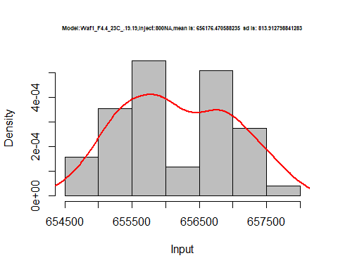

dens <- apply(d2_19.19, 2, density)  
plot('Model:Waf1_F4.4_23C_.19.19', xlim=range(sapply(dens, "[", "x")), ylim=range(sapply(dens, "[", "y")))

## Warning in xy.coords(x, y, xlabel, ylabel, log): NAs introduced by coercion

mapply(lines, dens, col=1:length(dens))

## $V1  
## NULL  
##   
## $V2  
## NULL  
##   
## $V3  
## NULL  
##   
## $V4  
## NULL  
##   
## $V5  
## NULL  
##   
## $V6  
## NULL  
##   
## $V7  
## NULL  
##   
## $V8  
## NULL

legend("topright", legend=names(dens), fill=1:length(dens))

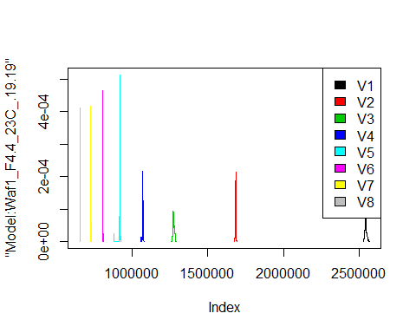

d3_19.19<-d_19.19[,c(17:24)]  
d3_19.19 <- head(d3_19.19,51)  
colnames(d3_19.19) <- c("V1", "V2","V3","V4","V5","V6","V7","V8")  
head(d3_19.19)

## V1 V2 V3 V4 V5 V6 V7 V8  
## 1 3385000 2257500 1785833 1522500 1342500 1227083 1111429 1032187  
## 2 3445000 2258750 1785833 1523750 1345000 1224167 1111786 1029063  
## 3 3480000 2257500 1789167 1520000 1345000 1225000 1111429 1028125  
## 4 3497500 2260000 1787500 1521250 1344500 1225417 1111429 1033437  
## 5 3495000 2258750 1789167 1520000 1344000 1227500 1111786 1034063  
## 6 3500000 2258750 1789167 1515625 1344500 1226250 1111071 1033750

hist(d3_19.19$V1,  
 cex.main=0.5,  
 freq = FALSE,  
 main = paste('Model:Waf1_F4.7_23C_.19.19,Inject:100NA,mean is:', mean(d3_19.19$V1),' sd is:', sd(d3_19.19$V1)),  
 xlab = "Input",  
 ylab = "Density",  
 col="grey")  
#plot density curve  
lines(density(d3_19.19$V1), # density plot  
 lwd = 2, # thickness of line  
 col = "red")

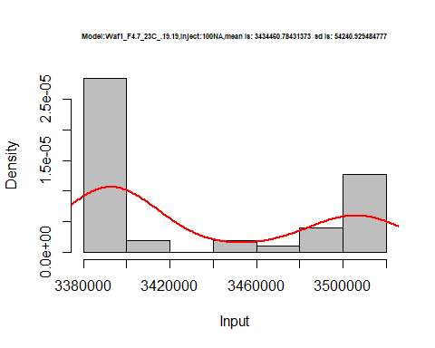

hist(d3_19.19$V2,  
 cex.main=0.5,  
 freq = FALSE,  
 main = paste('Model:Waf1_F4.7_23C_.19.19,Inject:200NA,mean is:', mean(d3_19.19$V2),' sd is:', sd(d3_19.19$V2)),  
 xlab = "Input",  
 ylab = "Density",  
 col="grey")  
#plot density curve  
lines(density(d3_19.19$V2), # density plot  
 lwd = 2, # thickness of line  
 col = "red")

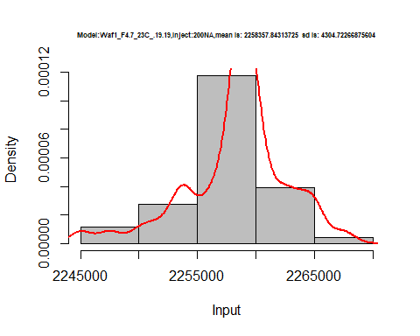

hist(d3_19.19$V3,  
 cex.main=0.5,  
 freq = FALSE,  
 main = paste('Model:Waf1_F4.7_23C_.19.19,Inject:300NA,mean is:', mean(d3_19.19$V3),' sd is:', sd(d3_19.19$V3)),  
 xlab = "Input",  
 ylab = "Density",  
 col="grey")  
#plot density curve  
lines(density(d3_19.19$V3), # density plot  
 lwd = 2, # thickness of line  
 col = "red")

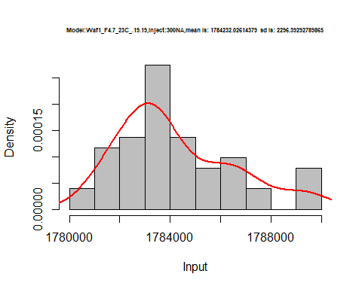

hist(d3_19.19$V4,  
 cex.main=0.5,  
 freq = FALSE,  
 main = paste('Model:Waf1_F4.7_23C_.19.19,Inject:400NA,mean is:', mean(d3_19.19$V4),' sd is:', sd(d3_19.19$V4)),  
 xlab = "Input",  
 ylab = "Density",  
 col="grey")  
#plot density curve  
lines(density(d3_19.19$V4), # density plot  
 lwd = 2, # thickness of line  
 col = "red")

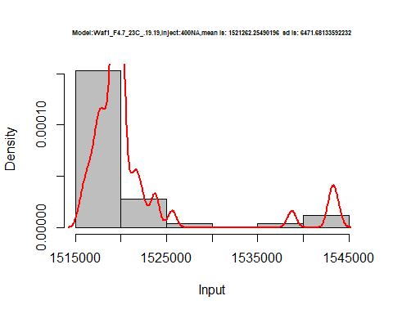

hist(d3_19.19$V5,  
 cex.main=0.5,  
 freq = FALSE,  
 main = paste('Model:Waf1_F4.7_23C_.19.19,Inject:500NA,mean is:', mean(d3_19.19$V5),' sd is:', sd(d3_19.19$V5)),  
 xlab = "Input",  
 ylab = "Density",  
 col="grey")  
#plot density curve  
lines(density(d3_19.19$V5), # density plot  
 lwd = 2, # thickness of line  
 col = "red")

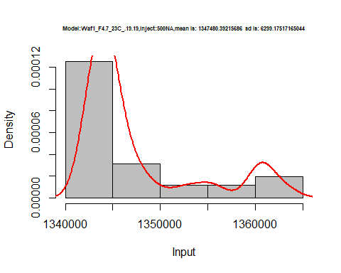

hist(d3_19.19$V6,  
 cex.main=0.5,  
 freq = FALSE,  
 main = paste('Model:Waf1_F4.7_23C_.19.19,Inject:600NA,mean is:', mean(d3_19.19$V6),' sd is:', sd(d3_19.19$V6)),  
 xlab = "Input",  
 ylab = "Density",  
 col="grey")  
#plot density curve  
lines(density(d3_19.19$V6), # density plot  
 lwd = 2, # thickness of line  
 col = "red")

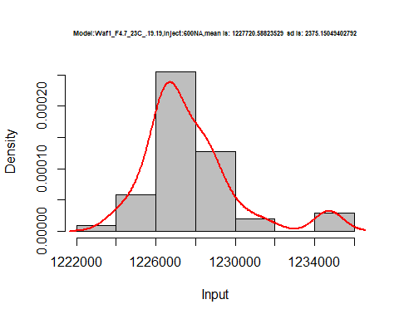

hist(d3_19.19$V7,  
 cex.main=0.5,  
 freq = FALSE,  
 main = paste('Model:Waf1_F4.7_23C_.19.19,Inject:700NA,mean is:', mean(d3_19.19$V7),' sd is:', sd(d3_19.19$V7)),  
 xlab = "Input",  
 ylab = "Density",  
 col="grey")  
#plot density curve  
lines(density(d3_19.19$V7), # density plot  
 lwd = 2, # thickness of line  
 col = "red")

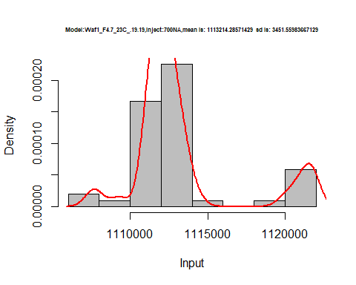

hist(d3_19.19$V8,  
 cex.main=0.5,  
 freq = FALSE,  
 main = paste('Model:Waf1_F4.7_23C_.19.19,Inject:800NA,mean is:', mean(d3_19.19$V8),' sd is:', sd(d3_19.19$V8)),  
 xlab = "Input",  
 ylab = "Density",  
 col="grey")  
#plot density curve  
lines(density(d3_19.19$V8), # density plot  
 lwd = 2, # thickness of line  
 col = "red")

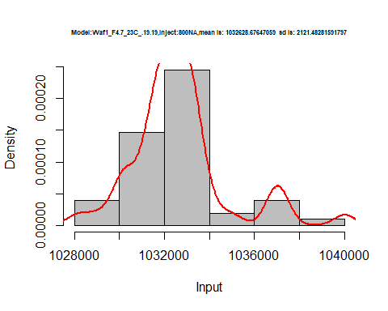

dens <- apply(d3_19.19, 2, density)  
plot('Model:Waf1_F4.7_23C_.19.19', xlim=range(sapply(dens, "[", "x")), ylim=range(sapply(dens, "[", "y")))

## Warning in xy.coords(x, y, xlabel, ylabel, log): NAs introduced by coercion

mapply(lines, dens, col=1:length(dens))

## $V1  
## NULL  
##   
## $V2  
## NULL  
##   
## $V3  
## NULL  
##   
## $V4  
## NULL  
##   
## $V5  
## NULL  
##   
## $V6  
## NULL  
##   
## $V7  
## NULL  
##   
## $V8  
## NULL

legend("topright", legend=names(dens), fill=1:length(dens))

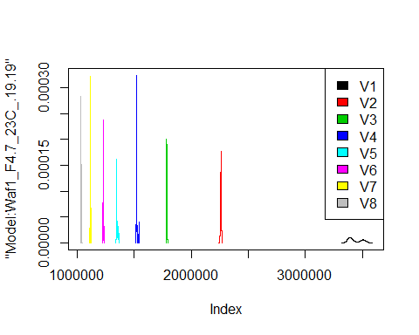

d4_19.19<-d_19.19[,c(25:32)]  
d4_19.19 <- head(d4_19.19,51)  
colnames(d4_19.19) <- c("V1", "V2","V3","V4","V5","V6","V7","V8")  
head(d4_19.19)

## V1 V2 V3 V4 V5 V6 V7 V8  
## 1 2030000 1390000 1084167 912500 800500 715416.7 654285.7 604687.5  
## 2 2030000 1393750 1078333 917500 794000 715416.7 650000.0 595625.0  
## 3 2035000 1386250 1080000 910000 798500 707916.7 645000.0 597812.5  
## 4 2035000 1386250 1081667 912500 798000 712500.0 650357.1 602187.5  
## 5 2030000 1382500 1081667 910000 794500 712500.0 648928.6 595312.5  
## 6 2032500 1386250 1082500 913125 797500 712500.0 645000.0 601562.5

hist(d4_19.19$V1,  
 cex.main=0.5,  
 freq = FALSE,  
 main = paste('Model:Waf1_F5.7_23C_.19.19.,Inject:100NA,mean is:', mean(d4_19.19$V1),' sd is:', sd(d4_19.19$V1)),  
 xlab = "Input",  
 ylab = "Density",  
 col="grey")  
#plot density curve  
lines(density(d4_19.19$V1), # density plot  
 lwd = 2, # thickness of line  
 col = "red")

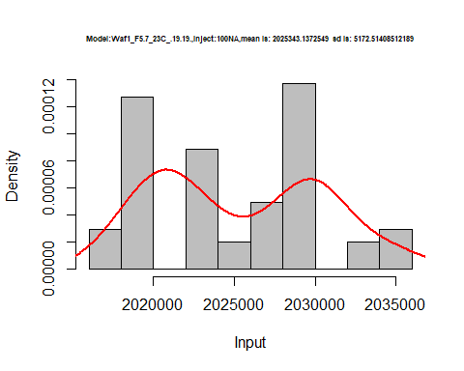

hist(d4_19.19$V2,  
 cex.main=0.5,  
 freq = FALSE,  
 main = paste('Model:Waf1_F5.7_23C_.19.19.,Inject:100NA,mean is:', mean(d4_19.19$V2),' sd is:', sd(d4_19.19$V2)),  
 xlab = "Input",  
 ylab = "Density",  
 col="grey")  
#plot density curve  
lines(density(d4_19.19$V2), # density plot  
 lwd = 2, # thickness of line  
 col = "red")

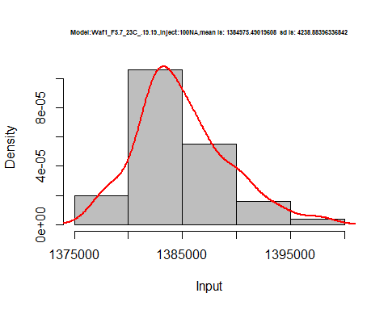

hist(d4_19.19$V3,  
 cex.main=0.5,  
 freq = FALSE,  
 main = paste('Model:Waf1_F5.7_23C_.19.19.,Inject:300NA,mean is:', mean(d4_19.19$V3),' sd is:', sd(d4_19.19$V3)),  
 xlab = "Input",  
 ylab = "Density",  
 col="grey")  
#plot density curve  
lines(density(d4_19.19$V3), # density plot  
 lwd = 2, # thickness of line  
 col = "red")

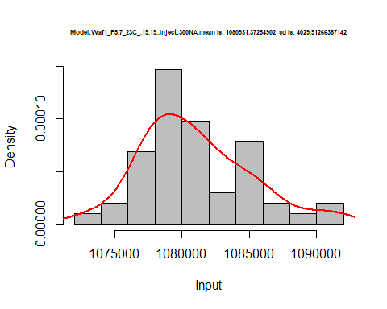

hist(d4_19.19$V4,  
 cex.main=0.5,  
 freq = FALSE,  
 main = paste('Model:Waf1_F5.7_23C_.19.19.,Inject:400NA,mean is:', mean(d4_19.19$V4),' sd is:', sd(d4_19.19$V4)),  
 xlab = "Input",  
 ylab = "Density",  
 col="grey")  
#plot density curve  
lines(density(d4_19.19$V4), # density plot  
 lwd = 2, # thickness of line  
 col = "red")

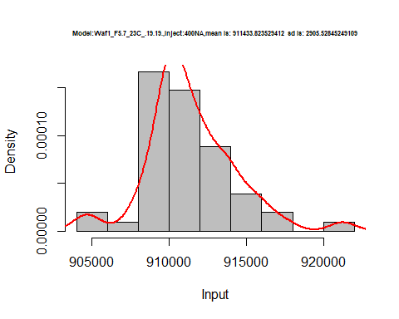

hist(d4_19.19$V5,  
 cex.main=0.5,  
 freq = FALSE,  
 main = paste('Model:Waf1_F5.7_23C_.19.19.,Inject:500NA,mean is:', mean(d4_19.19$V5),' sd is:', sd(d4_19.19$V5)),  
 xlab = "Input",  
 ylab = "Density",  
 col="grey")  
#plot density curve  
lines(density(d4_19.19$V5), # density plot  
 lwd = 2, # thickness of line  
 col = "red")

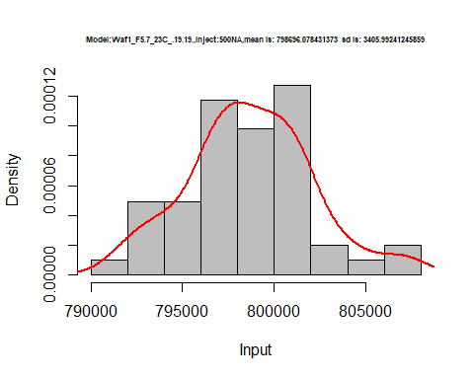

hist(d4_19.19$V6,  
 cex.main=0.5,  
 freq = FALSE,  
 main = paste('Model:Waf1_F5.7_23C_.19.19.,Inject:100NA,mean is:', mean(d4_19.19$V6),' sd is:', sd(d4_19.19$V6)),  
 xlab = "Input",  
 ylab = "Density",  
 col="grey")  
#plot density curve  
lines(density(d4_19.19$V6), # density plot  
 lwd = 2, # thickness of line  
 col = "red")

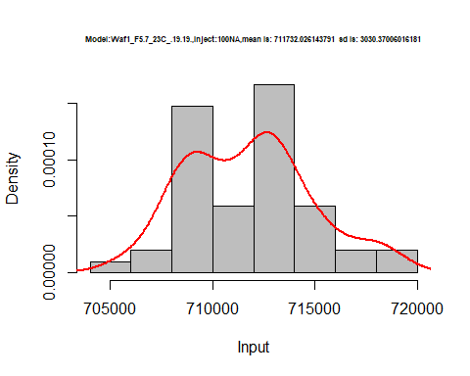

hist(d4_19.19$V7,  
 cex.main=0.5,  
 freq = FALSE,  
 main = paste('Model:Waf1_F5.7_23C_.19.19.,Inject:700NA,mean is:', mean(d4_19.19$V7),' sd is:', sd(d4_19.19$V7)),  
 xlab = "Input",  
 ylab = "Density",  
 col="grey")  
#plot density curve  
lines(density(d4_19.19$V7), # density plot  
 lwd = 2, # thickness of line  
 col = "red")

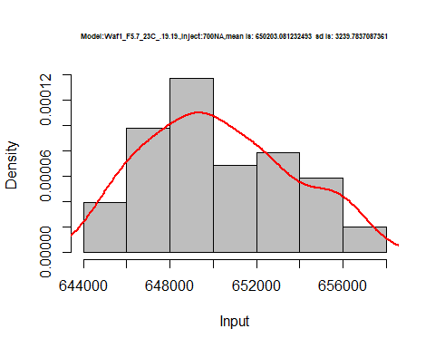

hist(d4_19.19$V8,  
 cex.main=0.5,  
 freq = FALSE,  
 main = paste('Model:Waf1_F5.7_23C_.19.19.,Inject:800NA,mean is:', mean(d4_19.19$V8),' sd is:', sd(d4_19.19$V8)),  
 xlab = "Input",  
 ylab = "Density",  
 col="grey")  
#plot density curve  
lines(density(d4_19.19$V8), # density plot  
 lwd = 2, # thickness of line  
 col = "red")

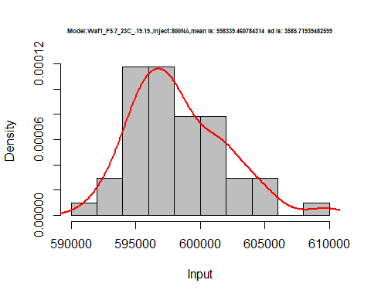

dens <- apply(d4_19.19, 2, density)  
plot('Model:Waf1_F5.7_23C_.19.19', xlim=range(sapply(dens, "[", "x")), ylim=range(sapply(dens, "[", "y")))

## Warning in xy.coords(x, y, xlabel, ylabel, log): NAs introduced by coercion

mapply(lines, dens, col=1:length(dens))

## $V1  
## NULL  
##   
## $V2  
## NULL  
##   
## $V3  
## NULL  
##   
## $V4  
## NULL  
##   
## $V5  
## NULL  
##   
## $V6  
## NULL  
##   
## $V7  
## NULL  
##   
## $V8  
## NULL

legend("topright", legend=names(dens), fill=1:length(dens))

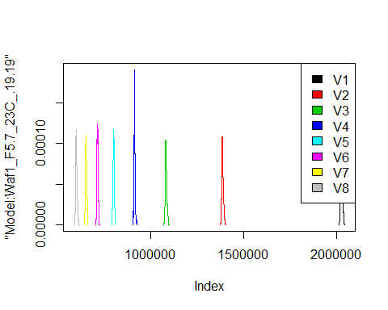

d5_19.19<-d_19.19[,c(33:40)]  
d5_19.19 <- head(d5_19.19,51)  
colnames(d5_19.19) <- c("V1", "V2","V3","V4","V5","V6","V7","V8")  
head(d5_19.19)

## V1 V2 V3 V4 V5 V6 V7 V8  
## 1 2850000 2185000 1755833 1527500 1362000 1235833 1135714 1043437  
## 2 2855000 2188750 1755833 1525625 1361500 1235000 1136071 1042500  
## 3 2825000 2192500 1756667 1530000 1362000 1232500 1136429 1045625  
## 4 2810000 2192500 1755833 1526250 1359500 1230833 1136071 1049688  
## 5 2807500 2191250 1755833 1527500 1361000 1230833 1137500 1049063  
## 6 2807500 2187500 1754167 1534375 1356000 1233333 1136071 1048750

hist(d5_19.19$V1,  
 cex.main=0.5,  
 freq = FALSE,  
 main = paste('Model:Waf1_F6.4_23C_.19.19,Inject:100NA,mean is:', mean(d5_19.19$V1),' sd is:', sd(d5_19.19$V1)),  
 xlab = "Input",  
 ylab = "Density",  
 col="grey")  
#plot density curve  
lines(density(d5_19.19$V1), # density plot  
 lwd = 2, # thickness of line  
 col = "red")

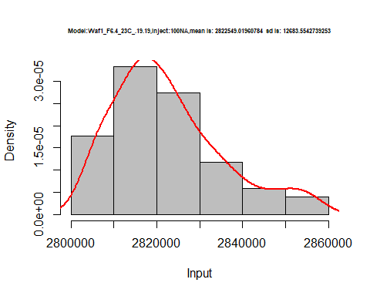

hist(d5_19.19$V2,  
 cex.main=0.5,  
 freq = FALSE,  
 main = paste('Model:Waf1_F6.4_23C_.19.19,Inject:200NA,mean is:', mean(d5_19.19$V2),' sd is:', sd(d5_19.19$V2)),  
 xlab = "Input",  
 ylab = "Density",  
 col="grey")  
#plot density curve  
lines(density(d5_19.19$V2), # density plot  
 lwd = 2, # thickness of line  
 col = "red")

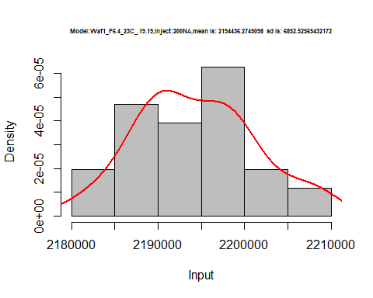

hist(d5_19.19$V3,  
 cex.main=0.5,  
 freq = FALSE,  
 main = paste('Model:Waf1_F6.4_23C_.19.19,Inject:300NA,mean is:', mean(d5_19.19$V3),' sd is:', sd(d5_19.19$V3)),  
 xlab = "Input",  
 ylab = "Density",  
 col="grey")  
#plot density curve  
lines(density(d5_19.19$V3), # density plot  
 lwd = 2, # thickness of line  
 col = "red")

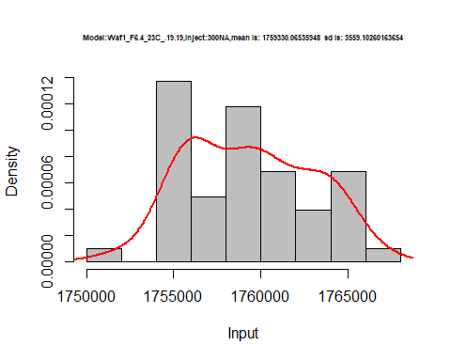

hist(d5_19.19$V4,  
 cex.main=0.5,  
 freq = FALSE,  
 main = paste('Model:Waf1_F6.4_23C_.19.19,Inject:300NA,mean is:', mean(d5_19.19$V4),' sd is:', sd(d5_19.19$V4)),  
 xlab = "Input",  
 ylab = "Density",  
 col="grey")  
#plot density curve  
lines(density(d5_19.19$V4), # density plot  
 lwd = 2, # thickness of line  
 col = "red")

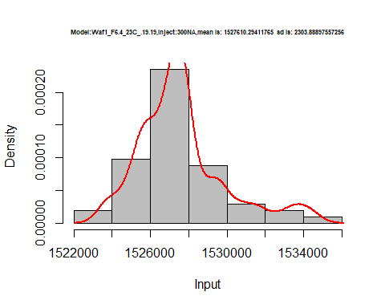

hist(d5_19.19$V5,  
 cex.main=0.5,  
 freq = FALSE,  
 main = paste('Model:Waf1_F6.4_23C_.19.19,Inject:300NA,mean is:', mean(d5_19.19$V5),' sd is:', sd(d5_19.19$V5)),  
 xlab = "Input",  
 ylab = "Density",  
 col="grey")  
#plot density curve  
lines(density(d5_19.19$V5), # density plot  
 lwd = 2, # thickness of line  
 col = "red")

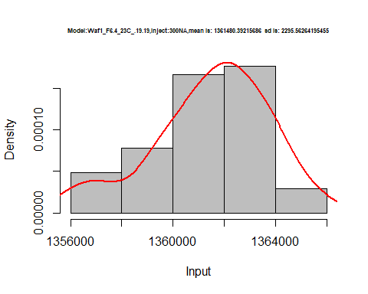

hist(d5_19.19$V6,  
 cex.main=0.5,  
 freq = FALSE,  
 main = paste('Model:Waf1_F6.4_23C_.19.19,Inject:600NA,mean is:', mean(d5_19.19$V6),' sd is:', sd(d5_19.19$V6)),  
 xlab = "Input",  
 ylab = "Density",  
 col="grey")  
#plot density curve  
lines(density(d5_19.19$V6), # density plot  
 lwd = 2, # thickness of line  
 col = "red")

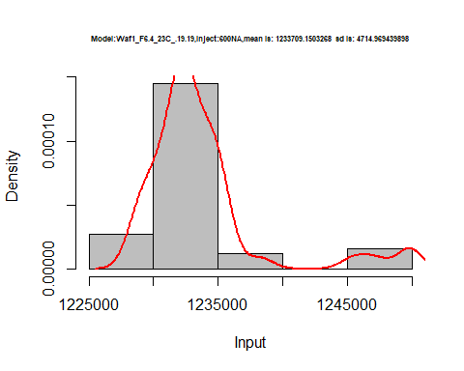

hist(d5_19.19$V7,  
 cex.main=0.5,  
 freq = FALSE,  
 main = paste('Model:Waf1_F6.4_23C_.19.19,Inject:700NA,mean is:', mean(d5_19.19$V7),' sd is:', sd(d5_19.19$V7)),  
 xlab = "Input",  
 ylab = "Density",  
 col="grey")  
#plot density curve  
lines(density(d5_19.19$V7), # density plot  
 lwd = 2, # thickness of line  
 col = "red")

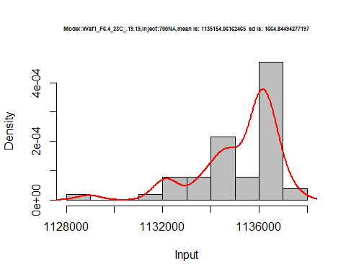

hist(d5_19.19$V8,  
 cex.main=0.5,  
 freq = FALSE,  
 main = paste('Model:Waf1_F6.4_23C_.19.19,Inject:300NA,mean is:', mean(d5_19.19$V8),' sd is:', sd(d5_19.19$V8)),  
 xlab = "Input",  
 ylab = "Density",  
 col="grey")  
#plot density curve  
lines(density(d5_19.19$V8), # density plot  
 lwd = 2, # thickness of line  
 col = "red")

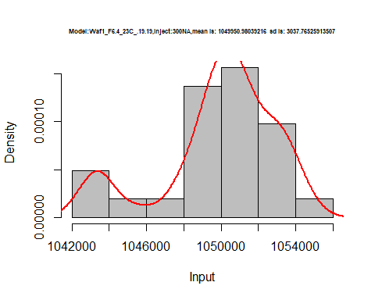

dens <- apply(d5_19.19, 2, density)  
plot('Model:Waf1_F6.4_23C_.19.19', xlim=range(sapply(dens, "[", "x")), ylim=range(sapply(dens, "[", "y")))

## Warning in xy.coords(x, y, xlabel, ylabel, log): NAs introduced by coercion

mapply(lines, dens, col=1:length(dens))

## $V1  
## NULL  
##   
## $V2  
## NULL  
##   
## $V3  
## NULL  
##   
## $V4  
## NULL  
##   
## $V5  
## NULL  
##   
## $V6  
## NULL  
##   
## $V7  
## NULL  
##   
## $V8  
## NULL

legend("topright", legend=names(dens), fill=1:length(dens))

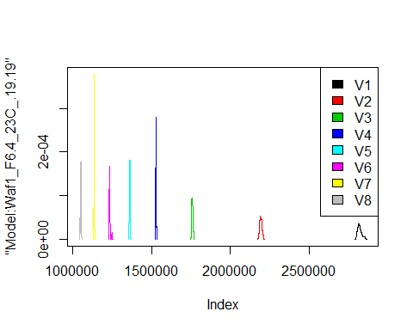

# Select columns whose names contains "20.20"  
d_20.20<-my_data %>% select(contains("20.20."))  
d_20.20 <- head(d_20.20,51)  
colnames(d_20.20) <- c("V1", "V2","V3","V4","V5","V6","V7","V8")  
head(d_20.20)

## V1 V2 V3 V4 V5 V6 V7 V8  
## 1 850000 776250 662500.0 621250 588000 546666.7 485000.0 470312.5  
## 2 850000 775000 689166.7 621250 587500 549166.7 493214.3 465625.0  
## 3 850000 768750 695000.0 619375 588000 546250.0 480714.3 470000.0  
## 4 850000 772500 694166.7 625625 588500 545416.7 486071.4 469062.5  
## 5 852500 771250 695000.0 621250 574500 545416.7 491785.7 468437.5  
## 6 857500 776250 696666.7 623125 582000 549166.7 489285.7 465937.5

hist(d_20.20$V1,  
 cex.main=0.5,  
 freq = FALSE,  
 main = paste('Model:Waf1_F6.2_23C_.20.20,Inject:100NA,mean is:', mean(d_20.20$V1),' sd is:', sd(d_20.20$V1)),  
 xlab = "Input",  
 ylab = "Density",  
 col="grey")  
#plot density curve  
lines(density(d_20.20$V1), # density plot  
 lwd = 2, # thickness of line  
 col = "red")

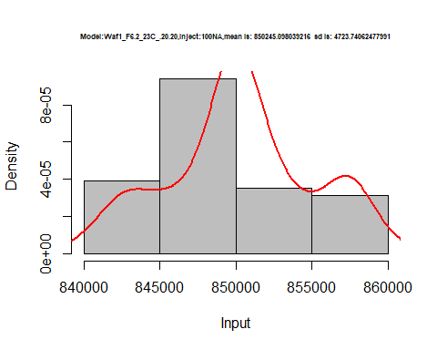

hist(d_20.20$V2,  
 cex.main=0.5,  
 freq = FALSE,  
 main = paste('Model:Waf1_F6.2_23C_.20.20,Inject:200NA,mean is:', mean(d_20.20$V2),' sd is:', sd(d_20.20$V2)),  
 xlab = "Input",  
 ylab = "Density",  
 col="grey")  
#plot density curve  
lines(density(d_20.20$V2), # density plot  
 lwd = 2, # thickness of line  
 col = "red")

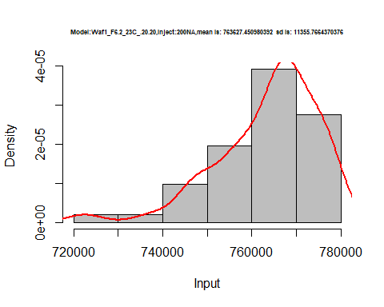

hist(d_20.20$V3,  
 cex.main=0.5,  
 freq = FALSE,  
 main = paste('Model:Waf1_F6.2_23C_.20.20,Inject:300NA,mean is:', mean(d_20.20$V3),' sd is:', sd(d_20.20$V3)),  
 xlab = "Input",  
 ylab = "Density",  
 col="grey")  
#plot density curve  
lines(density(d_20.20$V3), # density plot  
 lwd = 2, # thickness of line  
 col = "red")

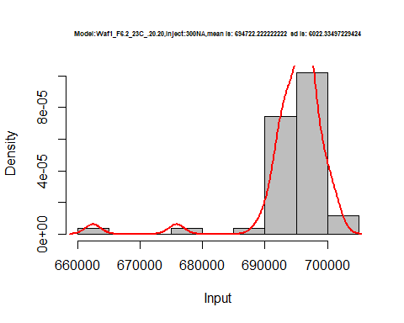

hist(d_20.20$V4,  
 cex.main=0.5,  
 freq = FALSE,  
 main = paste('Model:Waf1_F6.2_23C_.20.20,Inject:400NA,mean is:', mean(d_20.20$V4),' sd is:', sd(d_20.20$V4)),  
 xlab = "Input",  
 ylab = "Density",  
 col="grey")  
#plot density curve  
lines(density(d_20.20$V4), # density plot  
 lwd = 2, # thickness of line  
 col = "red")

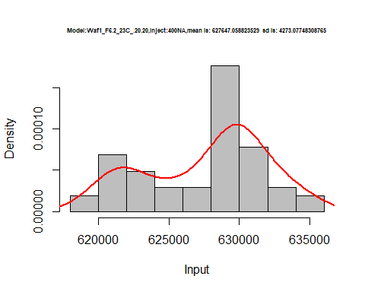

hist(d_20.20$V5,  
 cex.main=0.5,  
 freq = FALSE,  
 main = paste('Model:Waf1_F6.2_23C_.20.20,Inject:500NA,mean is:', mean(d_20.20$V5),' sd is:', sd(d_20.20$V5)),  
 xlab = "Input",  
 ylab = "Density",  
 col="grey")  
#plot density curve  
lines(density(d_20.20$V5), # density plot  
 lwd = 2, # thickness of line  
 col = "red")

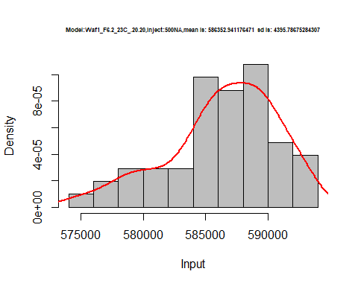

hist(d_20.20$V6,  
 cex.main=0.5,  
 freq = FALSE,  
 main = paste('Model:Waf1_F6.2_23C_.20.20,Inject:600NA,mean is:', mean(d_20.20$V6),' sd is:', sd(d_20.20$V6)),  
 xlab = "Input",  
 ylab = "Density",  
 col="grey")  
#plot density curve  
lines(density(d_20.20$V6), # density plot  
 lwd = 2, # thickness of line  
 col = "red")

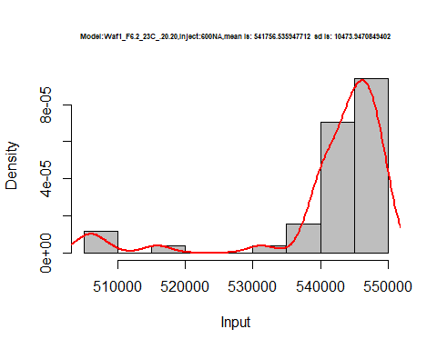

hist(d_20.20$V7,  
 cex.main=0.5,  
 freq = FALSE,  
 main = paste('Model:Waf1_F6.2_23C_.20.20,Inject:700NA,mean is:', mean(d_20.20$V7),' sd is:', sd(d_20.20$V7)),  
 xlab = "Input",  
 ylab = "Density",  
 col="grey")  
#plot density curve  
lines(density(d_20.20$V7), # density plot  
 lwd = 2, # thickness of line  
 col = "red")

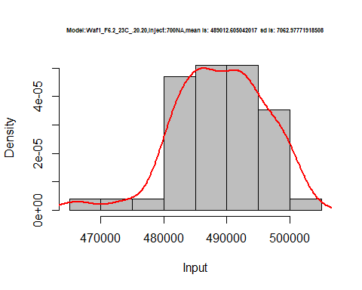

hist(d_20.20$V8,  
 cex.main=0.5,  
 freq = FALSE,  
 main = paste('Model:Waf1_F6.2_23C_.20.20,Inject:800NA,mean is:', mean(d_20.20$V8),' sd is:', sd(d_20.20$V8)),  
 xlab = "Input",  
 ylab = "Density",  
 col="grey")  
#plot density curve  
lines(density(d_20.20$V8), # density plot  
 lwd = 2, # thickness of line  
 col = "red")

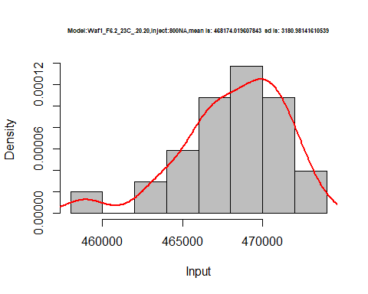

dens <- apply(d_20.20, 2, density)  
plot('Model:Waf1_F6.2_23C_.20.20', xlim=range(sapply(dens, "[", "x")), ylim=range(sapply(dens, "[", "y")))

## Warning in xy.coords(x, y, xlabel, ylabel, log): NAs introduced by coercion

mapply(lines, dens, col=1:length(dens))

## $V1  
## NULL  
##   
## $V2  
## NULL  
##   
## $V3  
## NULL  
##   
## $V4  
## NULL  
##   
## $V5  
## NULL  
##   
## $V6  
## NULL  
##   
## $V7  
## NULL  
##   
## $V8  
## NULL

legend("topright", legend=names(dens), fill=1:length(dens))

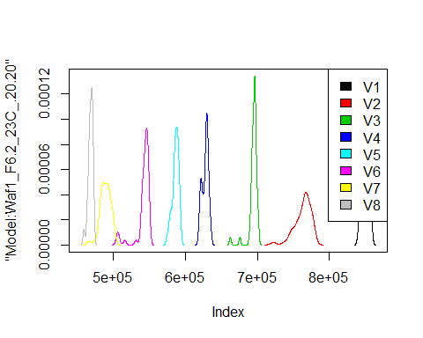

# Select columns whose names contains "21.21"  
d_21.21<-my_data %>% select(contains("21.21."))  
d_21.21 <- head(d_21.21,51)  
colnames(d_21.21) <- c("V1", "V2","V3","V4","V5","V6","V7","V8")  
head(d_21.21)

## V1 V2 V3 V4 V5 V6 V7 V8  
## 1 11735000 7047500 5155000 4081250 3483000 3032083 2711071 2447500  
## 2 11742500 7042500 5151667 4076250 3506000 3030000 2708929 2443438  
## 3 11717500 7040000 5154167 4066875 3488000 3040000 2709643 2447188  
## 4 11710000 7033750 5154167 4089375 3481500 3040833 2708214 2445313  
## 5 11717500 7035000 5153333 4118125 3486000 3026250 2709286 2444062  
## 6 11710000 7051250 5157500 4115000 3483500 3034583 2709286 2440000

hist(d_21.21$V1,  
 cex.main=0.5,  
 freq = FALSE,  
 main = paste('Model:Waf1_F2.3_23C_.21.21.,Inject:100NA,mean is:', mean(d_21.21$V1),' sd is:', sd(d_21.21$V1)),  
 xlab = "Input",  
 ylab = "Density",  
 col="grey")  
#plot density curve  
lines(density(d_21.21$V1), # density plot  
 lwd = 2, # thickness of line  
 col = "red")

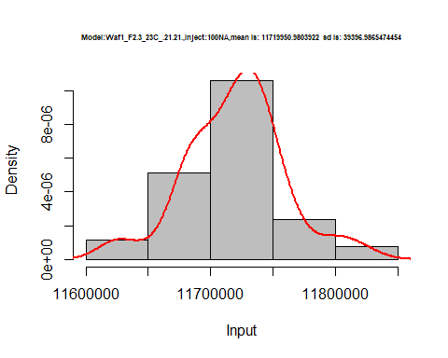

hist(d_21.21$V2,  
 cex.main=0.5,  
 freq = FALSE,  
 main = paste('Model:Waf1_F2.3_23C_.21.21.,Inject:200NA,mean is:', mean(d_21.21$V2),' sd is:', sd(d_21.21$V2)),  
 xlab = "Input",  
 ylab = "Density",  
 col="grey")  
#plot density curve  
lines(density(d_21.21$V2), # density plot  
 lwd = 2, # thickness of line  
 col = "red")

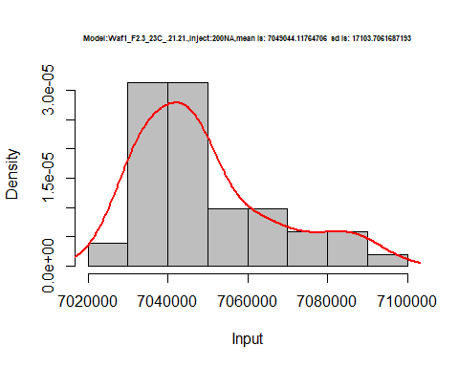

hist(d_21.21$V3,  
 cex.main=0.5,  
 freq = FALSE,  
 main = paste('Model:Waf1_F2.3_23C_.21.21.,Inject:300NA,mean is:', mean(d_21.21$V3),' sd is:', sd(d_21.21$V3)),  
 xlab = "Input",  
 ylab = "Density",  
 col="grey")  
#plot density curve  
lines(density(d_21.21$V3), # density plot  
 lwd = 2, # thickness of line  
 col = "red")

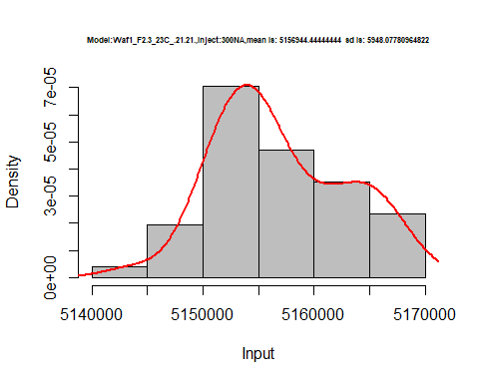

hist(d_21.21$V4,  
 cex.main=0.5,  
 freq = FALSE,  
 main = paste('Model:Waf1_F2.3_23C_.21.21.,Inject:400NA,mean is:', mean(d_21.21$V4),' sd is:', sd(d_21.21$V4)),  
 xlab = "Input",  
 ylab = "Density",  
 col="grey")  
#plot density curve  
lines(density(d_21.21$V4), # density plot  
 lwd = 2, # thickness of line  
 col = "red")

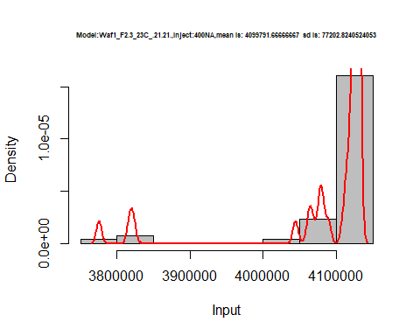

hist(d_21.21$V5,  
 cex.main=0.5,  
 freq = FALSE,  
 main = paste('Model:Waf1_F2.3_23C_.21.21.,Inject:500NA,mean is:', mean(d_21.21$V5),' sd is:', sd(d_21.21$V5)),  
 xlab = "Input",  
 ylab = "Density",  
 col="grey")  
#plot density curve  
lines(density(d_21.21$V5), # density plot  
 lwd = 2, # thickness of line  
 col = "red")

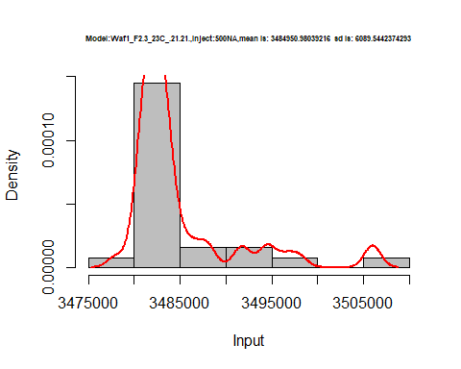

hist(d_21.21$V6,  
 cex.main=0.5,  
 freq = FALSE,  
 main = paste('Model:Waf1_F2.3_23C_.21.21.,Inject:600NA,mean is:', mean(d_21.21$V6),' sd is:', sd(d_21.21$V6)),  
 xlab = "Input",  
 ylab = "Density",  
 col="grey")  
#plot density curve  
lines(density(d_21.21$V6), # density plot  
 lwd = 2, # thickness of line  
 col = "red")

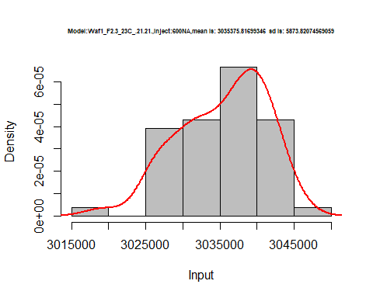

hist(d_21.21$V7,  
 cex.main=0.5,  
 freq = FALSE,  
 main = paste('Model:Waf1_F2.3_23C_.21.21.,Inject:700NA,mean is:', mean(d_21.21$V7),' sd is:', sd(d_21.21$V7)),  
 xlab = "Input",  
 ylab = "Density",  
 col="grey")  
#plot density curve  
lines(density(d_21.21$V7), # density plot  
 lwd = 2, # thickness of line  
 col = "red")

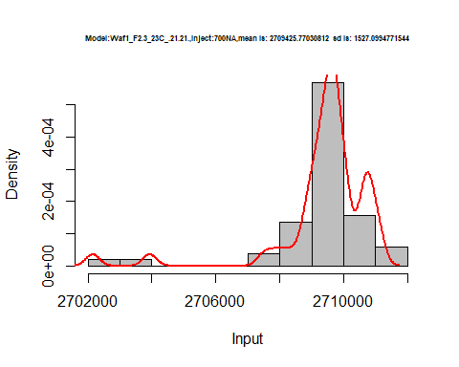

hist(d_21.21$V8,  
 cex.main=0.5,  
 freq = FALSE,  
 main = paste('Model:Waf1_F2.3_23C_.21.21.,Inject:800NA,mean is:', mean(d_21.21$V8),' sd is:', sd(d_21.21$V8)),  
 xlab = "Input",  
 ylab = "Density",  
 col="grey")  
#plot density curve  
lines(density(d_21.21$V8), # density plot  
 lwd = 2, # thickness of line  
 col = "red")

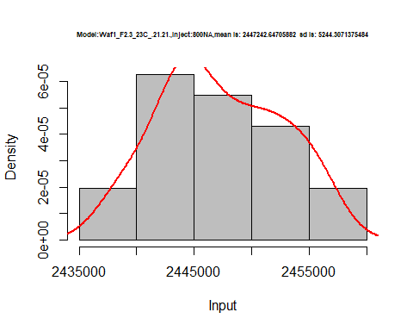

dens <- apply(d_21.21, 2, density)  
plot('Model:Waf1_F2.3_23C_.21.21', xlim=range(sapply(dens, "[", "x")), ylim=range(sapply(dens, "[", "y")))

## Warning in xy.coords(x, y, xlabel, ylabel, log): NAs introduced by coercion

mapply(lines, dens, col=1:length(dens))

## $V1  
## NULL  
##   
## $V2  
## NULL  
##   
## $V3  
## NULL  
##   
## $V4  
## NULL  
##   
## $V5  
## NULL  
##   
## $V6  
## NULL  
##   
## $V7  
## NULL  
##   
## $V8  
## NULL

legend("topright", legend=names(dens), fill=1:length(dens))

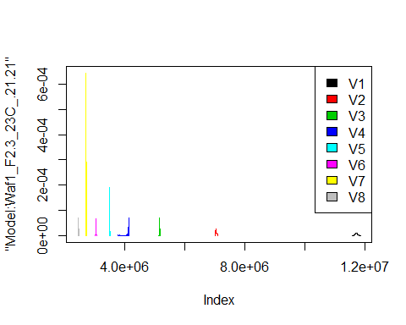

# Select columns whose names contains "23.23"  
d_23.23<-my_data %>% select(contains("23.23."))  
#d_22.22 <- head(d_22.22,51)  
#colnames(d_22.22) <- c("V1", "V2","V3","V4","V5","V6","V7","V8")  
head(d_23.23)

## Waf1_F2.3_23C_.100nA_.23.23. Waf1_F2.3_23C_.200nA_.23.23.  
## 1 1145000 972500  
## 2 1145000 973750  
## 3 1147500 975000  
## 4 1150000 975000  
## 5 1152500 972500  
## 6 1155000 972500  
## Waf1_F2.3_23C_.300nA_.23.23. Waf1_F2.3_23C_.400nA_.23.23.  
## 1 843333.3 780625  
## 2 844166.7 779375  
## 3 845833.3 780000  
## 4 845000.0 780625  
## 5 844166.7 778750  
## 6 845000.0 777500  
## Waf1_F2.3_23C_.500nA_.23.23. Waf1_F2.3_23C_.600nA_.23.23.  
## 1 728500 676250.0  
## 2 721500 674166.7  
## 3 722500 675833.3  
## 4 723000 677083.3  
## 5 722000 678333.3  
## 6 722500 677083.3  
## Waf1_F2.3_23C_.700nA_.23.23. Waf1_F2.3_23C_.800nA_.23.23.  
## 1 637142.9 597812.5  
## 2 637142.9 598125.0  
## 3 636785.7 597812.5  
## 4 636785.7 596875.0  
## 5 639285.7 597500.0  
## 6 637857.1 596562.5  
## Waf1_F2.7_23C_.100nA_.23.23. Waf1_F2.7_23C_.200nA_.23.23.  
## 1 6807500 4266250  
## 2 6805000 4258750  
## 3 6805000 4265000  
## 4 6785000 4276250  
## 5 6755000 4272500  
## 6 6742500 4261250  
## Waf1_F2.7_23C_.300nA_.23.23. Waf1_F2.7_23C_.400nA_.23.23.  
## 1 3261667 2727500  
## 2 3270000 2725000  
## 3 3269167 2725625  
## 4 3265833 2726875  
## 5 3265000 2725625  
## 6 3266667 2725625  
## Waf1_F2.7_23C_.500nA_.23.23. Waf1_F2.7_23C_.600nA_.23.23.  
## 1 2371500 2128333  
## 2 2371000 2126250  
## 3 2374000 2124167  
## 4 2374000 2120417  
## 5 2374500 2123333  
## 6 2371500 2120833  
## Waf1_F2.7_23C_.700nA_.23.23. Waf1_F2.7_23C_.800nA_.23.23.  
## 1 1925000 1773437  
## 2 1925357 1772812  
## 3 1927143 1774063  
## 4 1927500 1774375  
## 5 1925714 1775000  
## 6 1920357 1776250

d1_23.23<-d_23.23[,c(1:8)]  
d1_23.23 <- head(d1_23.23,51)  
colnames(d1_23.23) <- c("V1", "V2","V3","V4","V5","V6","V7","V8")  
head(d1_23.23)

## V1 V2 V3 V4 V5 V6 V7 V8  
## 1 1145000 972500 843333.3 780625 728500 676250.0 637142.9 597812.5  
## 2 1145000 973750 844166.7 779375 721500 674166.7 637142.9 598125.0  
## 3 1147500 975000 845833.3 780000 722500 675833.3 636785.7 597812.5  
## 4 1150000 975000 845000.0 780625 723000 677083.3 636785.7 596875.0  
## 5 1152500 972500 844166.7 778750 722000 678333.3 639285.7 597500.0  
## 6 1155000 972500 845000.0 777500 722500 677083.3 637857.1 596562.5

hist(d1_23.23$V1,  
 cex.main=0.5,  
 freq = FALSE,  
 main = paste('Model:Waf1_F2.3_23C_.23.23.,Inject:100NA,mean is:', mean(d1_23.23$V1),' sd is:', sd(d1_23.23$V1)),  
 xlab = "Input",  
 ylab = "Density",  
 col="grey")  
#plot density curve  
lines(density(d1_23.23$V1), # density plot  
 lwd = 2, # thickness of line  
 col = "red")

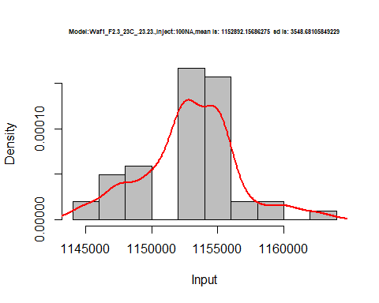

hist(d1_23.23$V2,  
 cex.main=0.5,  
 freq = FALSE,  
 main = paste('Model:Waf1_F2.3_23C_.23.23.,Inject:200NA,mean is:', mean(d1_23.23$V2),' sd is:', sd(d1_23.23$V2)),  
 xlab = "Input",  
 ylab = "Density",  
 col="grey")  
#plot density curve  
lines(density(d1_23.23$V2), # density plot  
 lwd = 2, # thickness of line  
 col = "red")

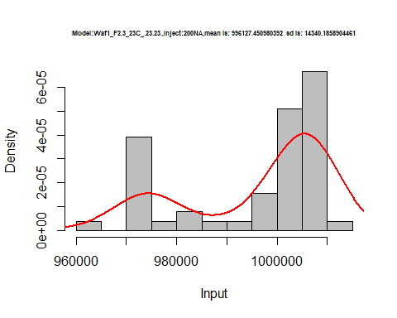

hist(d1_23.23$V3,  
 cex.main=0.5,  
 freq = FALSE,  
 main = paste('Model:Waf1_F2.3_23C_.23.23.,Inject:300NA,mean is:', mean(d1_23.23$V3),' sd is:', sd(d1_23.23$V3)),  
 xlab = "Input",  
 ylab = "Density",  
 col="grey")  
#plot density curve  
lines(density(d1_23.23$V3), # density plot  
 lwd = 2, # thickness of line  
 col = "red")

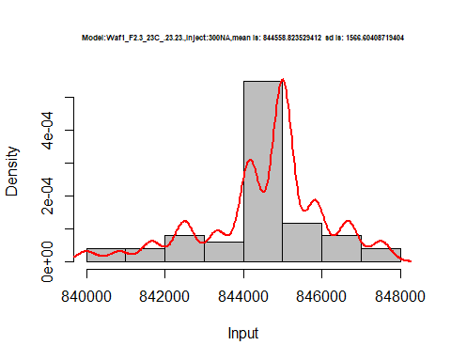

hist(d1_23.23$V4,  
 cex.main=0.5,  
 freq = FALSE,  
 main = paste('Model:Waf1_F2.3_23C_.23.23.,Inject:400NA,mean is:', mean(d1_23.23$V4),' sd is:', sd(d1_23.23$V4)),  
 xlab = "Input",  
 ylab = "Density",  
 col="grey")  
#plot density curve  
lines(density(d1_23.23$V4), # density plot  
 lwd = 2, # thickness of line  
 col = "red")

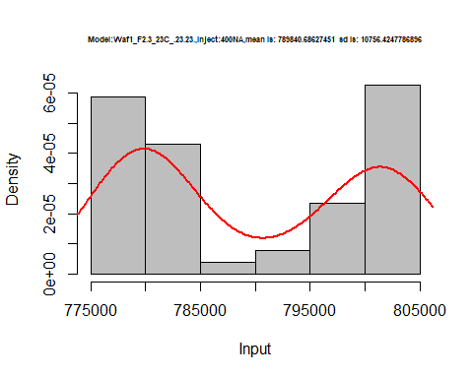

hist(d1_23.23$V5,  
 cex.main=0.5,  
 freq = FALSE,  
 main = paste('Model:Waf1_F2.3_23C_.23.23.,Inject:500NA,mean is:', mean(d1_23.23$V5),' sd is:', sd(d1_23.23$V5)),  
 xlab = "Input",  
 ylab = "Density",  
 col="grey")  
#plot density curve  
lines(density(d1_23.23$V5), # density plot  
 lwd = 2, # thickness of line  
 col = "red")

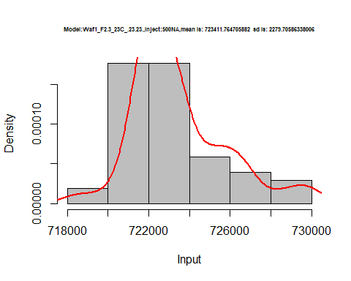

hist(d1_23.23$V6,  
 cex.main=0.5,  
 freq = FALSE,  
 main = paste('Model:Waf1_F2.3_23C_.23.23.,Inject:600NA,mean is:', mean(d1_23.23$V6),' sd is:', sd(d1_23.23$V6)),  
 xlab = "Input",  
 ylab = "Density",  
 col="grey")  
#plot density curve  
lines(density(d1_23.23$V6), # density plot  
 lwd = 2, # thickness of line  
 col = "red")

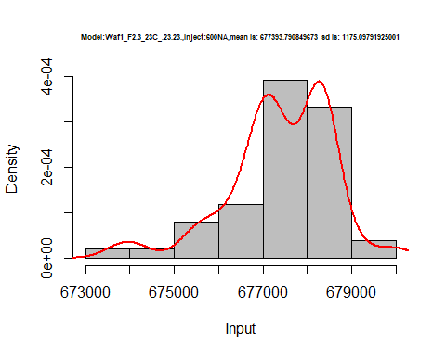

hist(d1_23.23$V7,  
 cex.main=0.5,  
 freq = FALSE,  
 main = paste('Model:Waf1_F2.3_23C_.23.23.,Inject:700NA,mean is:', mean(d1_23.23$V7),' sd is:', sd(d1_23.23$V7)),  
 xlab = "Input",  
 ylab = "Density",  
 col="grey")  
#plot density curve  
lines(density(d1_23.23$V7), # density plot  
 lwd = 2, # thickness of line  
 col = "red")

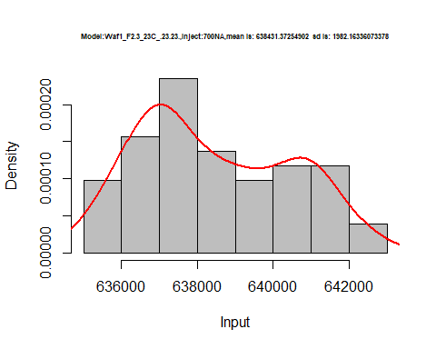

hist(d1_23.23$V8,  
 cex.main=0.5,  
 freq = FALSE,  
 main = paste('Model:Waf1_F2.3_23C_.23.23.,Inject:800NA,mean is:', mean(d1_23.23$V8),' sd is:', sd(d1_23.23$V8)),  
 xlab = "Input",  
 ylab = "Density",  
 col="grey")  
#plot density curve  
lines(density(d1_23.23$V8), # density plot  
 lwd = 2, # thickness of line  
 col = "red")

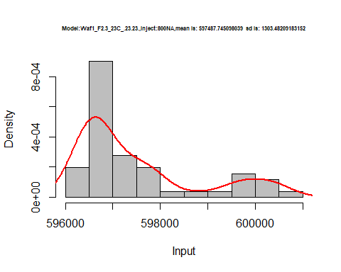

dens <- apply(d1_23.23, 2, density)  
plot('Model:Waf1_F2.3_23C_.23.23', xlim=range(sapply(dens, "[", "x")), ylim=range(sapply(dens, "[", "y")))

## Warning in xy.coords(x, y, xlabel, ylabel, log): NAs introduced by coercion

mapply(lines, dens, col=1:length(dens))

## $V1  
## NULL  
##   
## $V2  
## NULL  
##   
## $V3  
## NULL  
##   
## $V4  
## NULL  
##   
## $V5  
## NULL  
##   
## $V6  
## NULL  
##   
## $V7  
## NULL  
##   
## $V8  
## NULL

legend("topright", legend=names(dens), fill=1:length(dens))

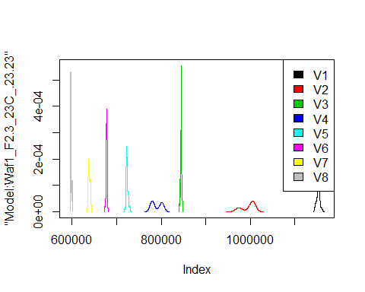

d2_23.23<-d_23.23[,c(9:16)]  
d2_23.23 <- head(d2_23.23,51)  
colnames(d2_23.23) <- c("V1", "V2","V3","V4","V5","V6","V7","V8")  
head(d2_23.23)

## V1 V2 V3 V4 V5 V6 V7 V8  
## 1 6807500 4266250 3261667 2727500 2371500 2128333 1925000 1773437  
## 2 6805000 4258750 3270000 2725000 2371000 2126250 1925357 1772812  
## 3 6805000 4265000 3269167 2725625 2374000 2124167 1927143 1774063  
## 4 6785000 4276250 3265833 2726875 2374000 2120417 1927500 1774375  
## 5 6755000 4272500 3265000 2725625 2374500 2123333 1925714 1775000  
## 6 6742500 4261250 3266667 2725625 2371500 2120833 1920357 1776250

hist(d2_23.23$V1,  
 cex.main=0.5,  
 freq = FALSE,  
 main = paste('Model:Waf1_F2.7_23C_.100nA_.23.23.,Inject:100NA,mean is:', mean(d2_23.23$V1),' sd is:', sd(d2_23.23$V1)),  
 xlab = "Input",  
 ylab = "Density",  
 col="grey")  
#plot density curve  
lines(density(d2_23.23$V1), # density plot  
 lwd = 2, # thickness of line  
 col = "red")

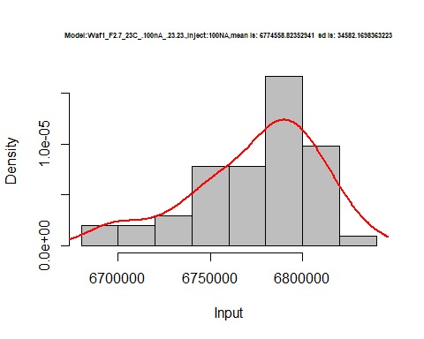

hist(d2_23.23$V2,  
 cex.main=0.5,  
 freq = FALSE,  
 main = paste('Model:Waf1_F2.7_23C_..23.23.,Inject:200NA,mean is:', mean(d2_23.23$V2),' sd is:', sd(d2_23.23$V2)),  
 xlab = "Input",  
 ylab = "Density",  
 col="grey")  
#plot density curve  
lines(density(d2_23.23$V2), # density plot  
 lwd = 2, # thickness of line  
 col = "red")

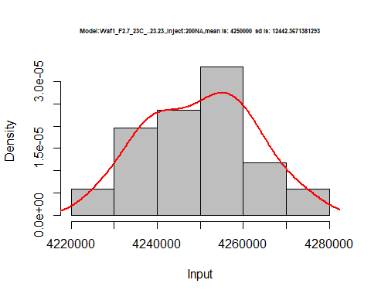

hist(d2_23.23$V3,  
 cex.main=0.5,  
 freq = FALSE,  
 main = paste('Model:Waf1_F2.7_23C_.23.23.,Inject:300NA,mean is:', mean(d2_23.23$V3),' sd is:', sd(d2_23.23$V3)),  
 xlab = "Input",  
 ylab = "Density",  
 col="grey")  
#plot density curve  
lines(density(d2_23.23$V3), # density plot  
 lwd = 2, # thickness of line  
 col = "red")

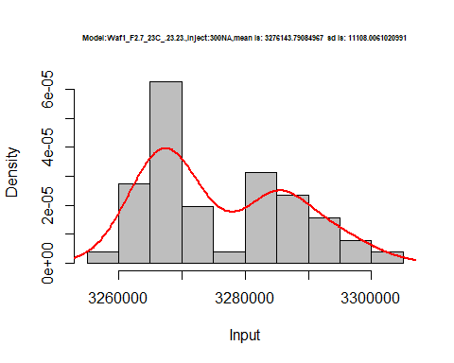

hist(d2_23.23$V4,  
 cex.main=0.5,  
 freq = FALSE,  
 main = paste('Model:Waf1_F2.7_23C_.23.23.,Inject:400NA,mean is:', mean(d2_23.23$V4),' sd is:', sd(d2_23.23$V4)),  
 xlab = "Input",  
 ylab = "Density",  
 col="grey")  
#plot density curve  
lines(density(d2_23.23$V4), # density plot  
 lwd = 2, # thickness of line  
 col = "red")

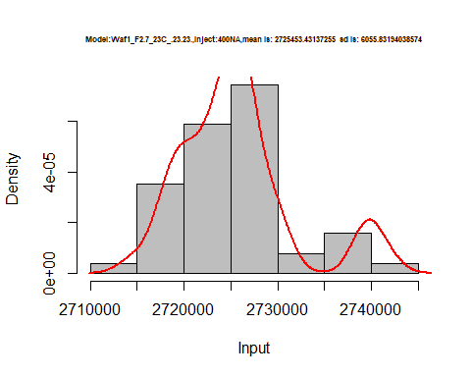

hist(d2_23.23$V5,  
 cex.main=0.5,  
 freq = FALSE,  
 main = paste('Model:Waf1_F2.7_23C_.23.23.,Inject:500NA,mean is:', mean(d2_23.23$V5),' sd is:', sd(d2_23.23$V5)),  
 xlab = "Input",  
 ylab = "Density",  
 col="grey")  
#plot density curve  
lines(density(d2_23.23$V5), # density plot  
 lwd = 2, # thickness of line  
 col = "red")

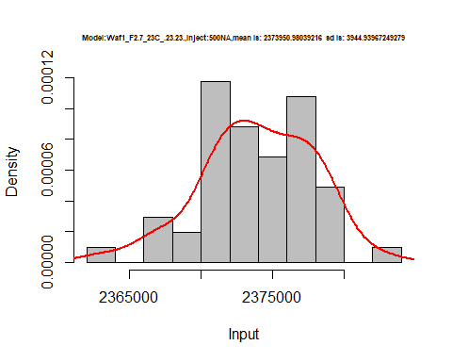

hist(d2_23.23$V6,  
 cex.main=0.5,  
 freq = FALSE,  
 main = paste('Model:Waf1_F2.7_23C_.23.23.,Inject:500NA,mean is:', mean(d2_23.23$V6),' sd is:', sd(d2_23.23$V6)),  
 xlab = "Input",  
 ylab = "Density",  
 col="grey")  
#plot density curve  
lines(density(d2_23.23$V6), # density plot  
 lwd = 2, # thickness of line  
 col = "red")

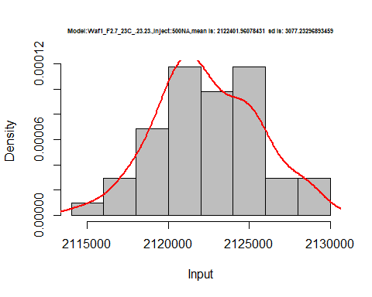

hist(d2_23.23$V7,  
 cex.main=0.5,  
 freq = FALSE,  
 main = paste('Model:Waf1_F2.7_23C_.23.23.,Inject:700NA,mean is:', mean(d2_23.23$V7),' sd is:', sd(d2_23.23$V7)),  
 xlab = "Input",  
 ylab = "Density",  
 col="grey")  
#plot density curve  
lines(density(d2_23.23$V7), # density plot  
 lwd = 2, # thickness of line  
 col = "red")

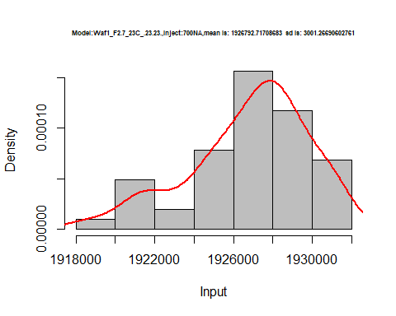

hist(d2_23.23$V8,  
 cex.main=0.5,  
 freq = FALSE,  
 main = paste('Model:Waf1_F2.7_23C_.23.23.,Inject:800NA,mean is:', mean(d2_23.23$V8),' sd is:', sd(d2_23.23$V8)),  
 xlab = "Input",  
 ylab = "Density",  
 col="grey")  
#plot density curve  
lines(density(d2_23.23$V8), # density plot  
 lwd = 2, # thickness of line  
 col = "red")

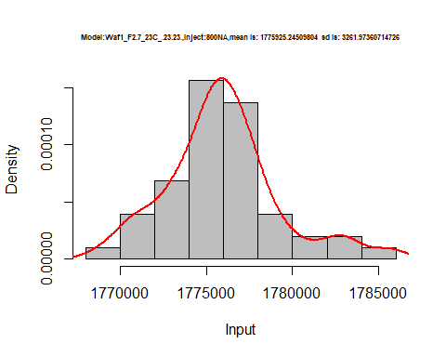

dens <- apply(d2_23.23, 2, density)  
plot('Model:Waf1_F2.7_23C_.23.23', xlim=range(sapply(dens, "[", "x")), ylim=range(sapply(dens, "[", "y")))

## Warning in xy.coords(x, y, xlabel, ylabel, log): NAs introduced by coercion

mapply(lines, dens, col=1:length(dens))

## $V1  
## NULL  
##   
## $V2  
## NULL  
##   
## $V3  
## NULL  
##   
## $V4  
## NULL  
##   
## $V5  
## NULL  
##   
## $V6  
## NULL  
##   
## $V7  
## NULL  
##   
## $V8  
## NULL

legend("topright", legend=names(dens), fill=1:length(dens))

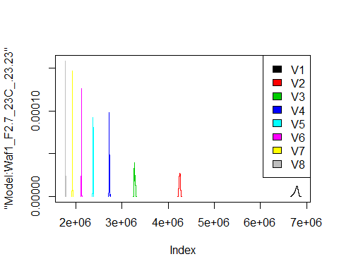

# Select columns whose names contains "24.24"  
d_24.24<-my_data %>% select(contains("24.24."))  
d_24.24 <- head(d_24.24,51)  
colnames(d_24.24) <- c("V1", "V2","V3","V4","V5","V6","V7","V8")  
head(d_24.24)

## V1 V2 V3 V4 V5 V6 V7 V8  
## 1 17165000 9681250 6732500 5340625 4375000 3929583 3360714 3112813  
## 2 17167500 9687500 6745000 5330000 4381000 3932917 3365357 3105625  
## 3 17157500 9690000 6747500 5335625 4373000 3938750 3362500 3062500  
## 4 17165000 9685000 6754167 5340000 4372500 3937917 3361071 3076563  
## 5 17180000 9690000 6755833 5348125 4373500 3935000 3357143 3060313  
## 6 17187500 9681250 6762500 5348125 4369000 3933333 3364643 3085000

hist(d_24.24$V1,  
 cex.main=0.5,  
 freq = FALSE,  
 main = paste('Model:Waf1_F1.5_23C_.24.24.,Inject:100NA,mean is:', mean(d_24.24$V1),' sd is:', sd(d_24.24$V1)),  
 xlab = "Input",  
 ylab = "Density",  
 col="grey")  
#plot density curve  
lines(density(d_24.24$V1), # density plot  
 lwd = 2, # thickness of line  
 col = "red")

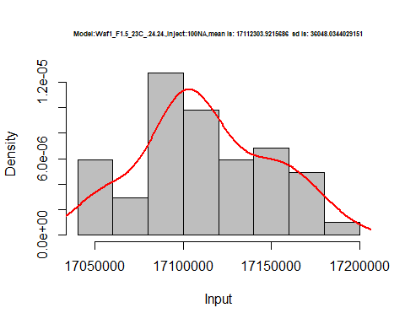

hist(d_24.24$V2,  
 cex.main=0.5,  
 freq = FALSE,  
 main = paste('Model:Waf1_F1.5_23C_.24.24.,Inject:200NA,mean is:', mean(d_24.24$V2),' sd is:', sd(d_24.24$V2)),  
 xlab = "Input",  
 ylab = "Density",  
 col="grey")  
#plot density curve  
lines(density(d_24.24$V2), # density plot  
 lwd = 2, # thickness of line  
 col = "red")

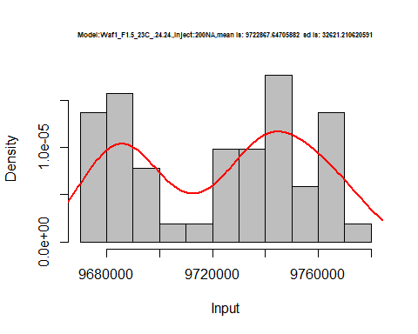

hist(d_24.24$V3,  
 cex.main=0.5,  
 freq = FALSE,  
 main = paste('Model:Waf1_F1.5_23C_.24.24.,Inject:300NA,mean is:', mean(d_24.24$V3),' sd is:', sd(d_24.24$V3)),  
 xlab = "Input",  
 ylab = "Density",  
 col="grey")  
#plot density curve  
lines(density(d_24.24$V3), # density plot  
 lwd = 2, # thickness of line  
 col = "red")

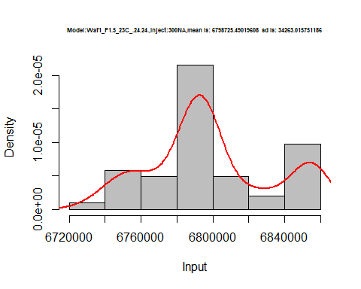

hist(d_24.24$V4,  
 cex.main=0.5,  
 freq = FALSE,  
 main = paste('Model:Waf1_F1.5_23C_.24.24.,Inject:400NA,mean is:', mean(d_24.24$V4),' sd is:', sd(d_24.24$V4)),  
 xlab = "Input",  
 ylab = "Density",  
 col="grey")  
#plot density curve  
lines(density(d_24.24$V4), # density plot  
 lwd = 2, # thickness of line  
 col = "red")

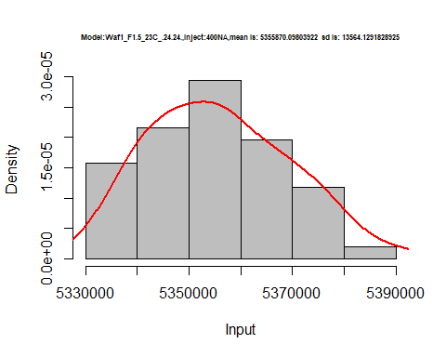

hist(d_24.24$V5,  
 cex.main=0.5,  
 freq = FALSE,  
 main = paste('Model:Waf1_F1.5_23C_.24.24.,Inject:500NA,mean is:', mean(d_24.24$V5),' sd is:', sd(d_24.24$V5)),  
 xlab = "Input",  
 ylab = "Density",  
 col="grey")  
#plot density curve  
lines(density(d_24.24$V5), # density plot  
 lwd = 2, # thickness of line  
 col = "red")

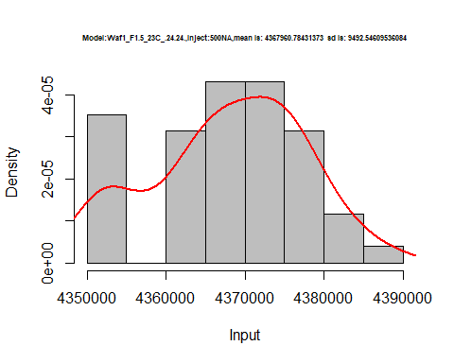

hist(d_24.24$V6,  
 cex.main=0.5,  
 freq = FALSE,  
 main = paste('Model:Waf1_F1.5_23C_.24.24.,Inject:600NA,mean is:', mean(d_24.24$V6),' sd is:', sd(d_24.24$V6)),  
 xlab = "Input",  
 ylab = "Density",  
 col="grey")  
#plot density curve  
lines(density(d_24.24$V6), # density plot  
 lwd = 2, # thickness of line  
 col = "red")

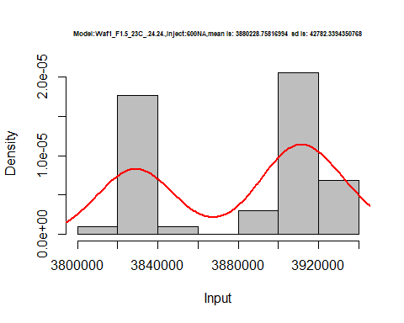

hist(d_24.24$V7,  
 cex.main=0.5,  
 freq = FALSE,  
 main = paste('Model:Waf1_F1.5_23C_.24.24.,Inject:700NA,mean is:', mean(d_24.24$V7),' sd is:', sd(d_24.24$V7)),  
 xlab = "Input",  
 ylab = "Density",  
 col="grey")  
#plot density curve  
lines(density(d_24.24$V7), # density plot  
 lwd = 2, # thickness of line  
 col = "red")

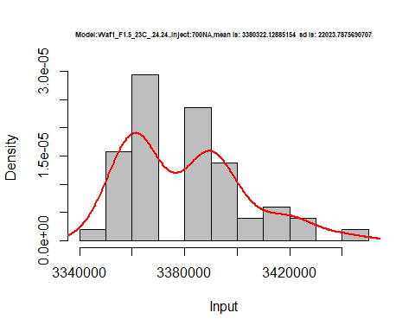

hist(d_24.24$V8,  
 cex.main=0.5,  
 freq = FALSE,  
 main = paste('Model:Waf1_F1.5_23C_.24.24.,Inject:800NA,mean is:', mean(d_24.24$V8),' sd is:', sd(d_24.24$V7)),  
 xlab = "Input",  
 ylab = "Density",  
 col="grey")  
#plot density curve  
lines(density(d_24.24$V8), # density plot  
 lwd = 2, # thickness of line  
 col = "red")

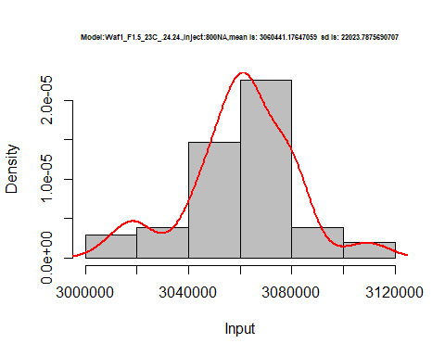

dens <- apply(d_24.24, 2, density)  
plot('Model:Waf1_F1.5_23C_.24.24', xlim=range(sapply(dens, "[", "x")), ylim=range(sapply(dens, "[", "y")))

## Warning in xy.coords(x, y, xlabel, ylabel, log): NAs introduced by coercion

mapply(lines, dens, col=1:length(dens))

## $V1  
## NULL  
##   
## $V2  
## NULL  
##   
## $V3  
## NULL  
##   
## $V4  
## NULL  
##   
## $V5  
## NULL  
##   
## $V6  
## NULL  
##   
## $V7  
## NULL  
##   
## $V8  
## NULL

legend("topright", legend=names(dens), fill=1:length(dens))

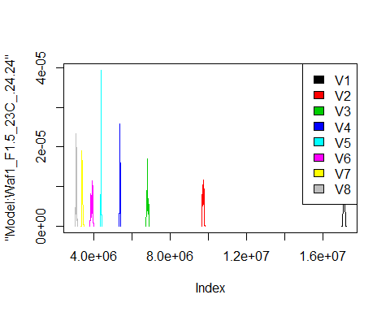

# Select columns whose names contains "25.25"  
d_25.25<-my_data %>% select(contains("25.25."))  
d_25.25 <- head(d_25.25,51)  
colnames(d_25.25) <- c("V1", "V2","V3","V4","V5","V6","V7","V8")  
head(d_25.25)

## V1 V2 V3 V4 V5 V6 V7 V8  
## 1 3045000 2137500 1685000 1416250 1244500 1102917 1003571 920625.0  
## 2 3047500 2137500 1684167 1413125 1244000 1104167 1005000 918437.5  
## 3 3045000 2136250 1685833 1411875 1243500 1102917 1004643 917500.0  
## 4 3042500 2133750 1687500 1413125 1240500 1103333 1005000 918750.0  
## 5 3040000 2135000 1687500 1414375 1238500 1102917 1002500 918750.0  
## 6 3040000 2137500 1690000 1416250 1239000 1102500 1003929 919375.0

hist(d_25.25$V1,  
 cex.main=0.5,  
 freq = FALSE,  
 main = paste('Model:Waf1_F3.4_23C_.25.25.,Inject:800NA,mean is:', mean(d_25.25$V1),' sd is:', sd(d_25.25$V1)),  
 xlab = "Input",  
 ylab = "Density",  
 col="grey")  
#plot density curve  
lines(density(d_25.25$V1), # density plot  
 lwd = 2, # thickness of line  
 col = "red")

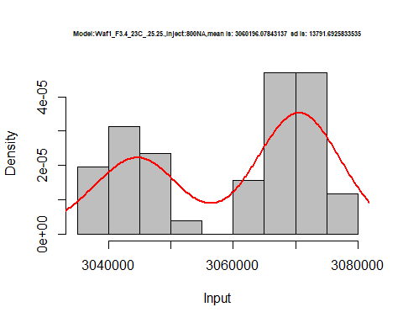

hist(d_25.25$V2,  
 cex.main=0.5,  
 freq = FALSE,  
 main = paste('Model:Waf1_F3.4_23C_.25.25.,Inject:200NA,mean is:', mean(d_25.25$V2),' sd is:', sd(d_25.25$V2)),  
 xlab = "Input",  
 ylab = "Density",  
 col="grey")  
#plot density curve  
lines(density(d_25.25$V2), # density plot  
 lwd = 2, # thickness of line  
 col = "red")

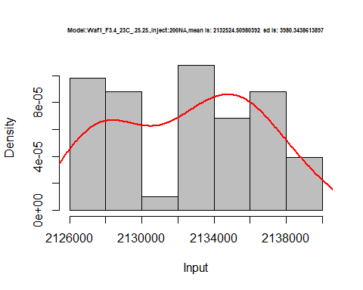

hist(d_25.25$V3,  
 cex.main=0.5,  
 freq = FALSE,  
 main = paste('Model:Waf1_F3.4_23C_.25.25.,Inject:300NA,mean is:', mean(d_25.25$V3),' sd is:', sd(d_25.25$V3)),  
 xlab = "Input",  
 ylab = "Density",  
 col="grey")  
#plot density curve  
lines(density(d_25.25$V3), # density plot  
 lwd = 2, # thickness of line  
 col = "red")

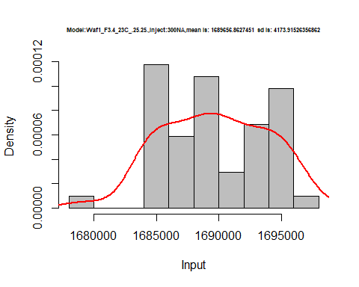

hist(d_25.25$V4,  
 cex.main=0.5,  
 freq = FALSE,  
 main = paste('Model:Waf1_F3.4_23C_.25.25.,Inject:400NA,mean is:', mean(d_25.25$V4),' sd is:', sd(d_25.25$V4)),  
 xlab = "Input",  
 ylab = "Density",  
 col="grey")  
#plot density curve  
lines(density(d_25.25$V4), # density plot  
 lwd = 2, # thickness of line  
 col = "red")

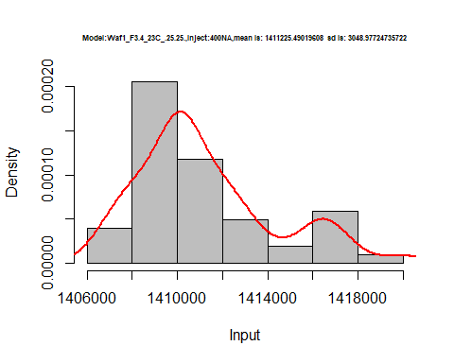

hist(d_25.25$V5,  
 cex.main=0.5,  
 freq = FALSE,  
 main = paste('Model:Waf1_F3.4_23C_.25.25.,Inject:500NA,mean is:', mean(d_25.25$V5),' sd is:', sd(d_25.25$V5)),  
 xlab = "Input",  
 ylab = "Density",  
 col="grey")  
#plot density curve  
lines(density(d_25.25$V5), # density plot  
 lwd = 2, # thickness of line  
 col = "red")

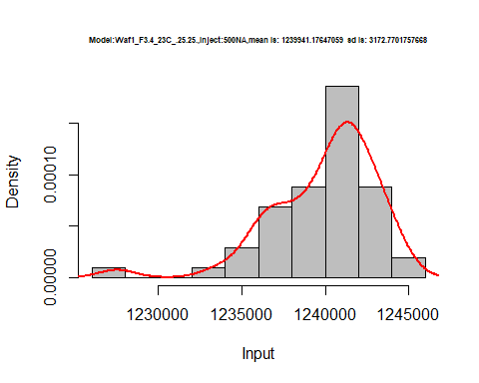

hist(d_25.25$V6,  
 cex.main=0.5,  
 freq = FALSE,  
 main = paste('Model:Waf1_F3.4_23C_.25.25.,Inject:600NA,mean is:', mean(d_25.25$V6),' sd is:', sd(d_25.25$V6)),  
 xlab = "Input",  
 ylab = "Density",  
 col="grey")  
#plot density curve  
lines(density(d_25.25$V6), # density plot  
 lwd = 2, # thickness of line  
 col = "red")

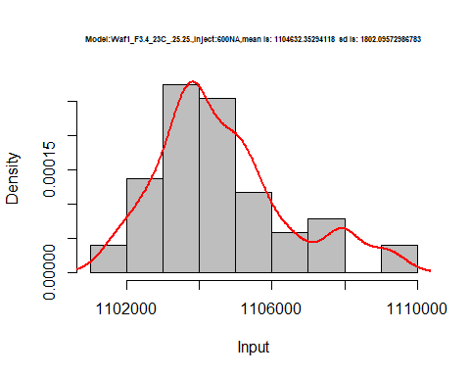

hist(d_25.25$V7,  
 cex.main=0.5,  
 freq = FALSE,  
 main = paste('Model:Waf1_F3.4_23C_.25.25.,Inject:700NA,mean is:', mean(d_25.25$V7),' sd is:', sd(d_25.25$V7)),  
 xlab = "Input",  
 ylab = "Density",  
 col="grey")  
#plot density curve  
lines(density(d_25.25$V7), # density plot  
 lwd = 2, # thickness of line  
 col = "red")

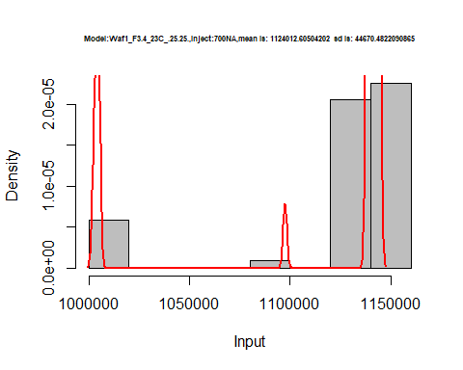

hist(d_25.25$V8,  
 cex.main=0.5,  
 freq = FALSE,  
 main = paste('Model:Waf1_F3.4_23C_.25.25.,Inject:800NA,mean is:', mean(d_25.25$V8),' sd is:', sd(d_25.25$V8)),  
 xlab = "Input",  
 ylab = "Density",  
 col="grey")  
#plot density curve  
lines(density(d_25.25$V8), # density plot  
 lwd = 2, # thickness of line  
 col = "red")

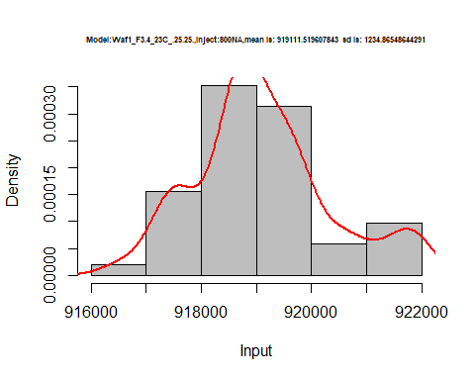

dens <- apply(d_25.25, 2, density)  
plot('Model:Waf1_F3.4_23C_.25.25', xlim=range(sapply(dens, "[", "x")), ylim=range(sapply(dens, "[", "y")))

## Warning in xy.coords(x, y, xlabel, ylabel, log): NAs introduced by coercion

mapply(lines, dens, col=1:length(dens))

## $V1  
## NULL  
##   
## $V2  
## NULL  
##   
## $V3  
## NULL  
##   
## $V4  
## NULL  
##   
## $V5  
## NULL  
##   
## $V6  
## NULL  
##   
## $V7  
## NULL  
##   
## $V8  
## NULL

legend("topright", legend=names(dens), fill=1:length(dens))

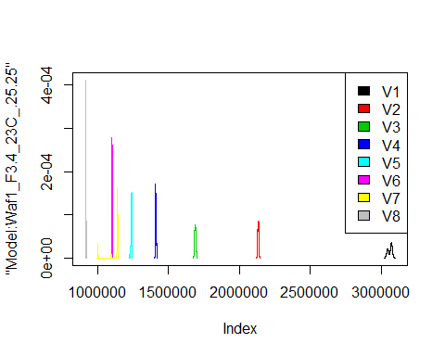

# Select columns whose names contains "26.26"  
d_26.26<-my_data %>% select(contains("26.26."))  
#d_26.26 <- head(d_26.26,51)  
#colnames(d_26.26) <- c("V1", "V2","V3","V4","V5","V6","V7","V8")  
head(d_26.26)

## Waf1_F2.4_23C_.100nA_.26.26. Waf1_F2.4_23C_.200nA_.26.26.  
## 1 7102500 4430000  
## 2 7105000 4430000  
## 3 7105000 4418750  
## 4 7110000 4418750  
## 5 7107500 4426250  
## 6 7117500 4428750  
## Waf1_F2.4_23C_.300nA_.26.26. Waf1_F2.4_23C_.400nA_.26.26.  
## 1 3310833 2786250  
## 2 3320000 2785625  
## 3 3322500 2786875  
## 4 3310833 2785000  
## 5 3320833 2790000  
## 6 3325000 2786875  
## Waf1_F2.4_23C_.500nA_.26.26. Waf1_F2.4_23C_.600nA_.26.26.  
## 1 2369500 2045417  
## 2 2365000 2045833  
## 3 2357500 2050417  
## 4 2355500 2047917  
## 5 2356000 2040417  
## 6 2356500 2047500  
## Waf1_F2.4_23C_.700nA_.26.26. Waf1_F2.4_23C_.800nA_.26.26.  
## 1 1838929 1661250  
## 2 1838214 1657812  
## 3 1808571 1678438  
## 4 1833571 1676875  
## 5 1834286 1664063  
## 6 1837143 1677187  
## Waf1_F2.6_23C_.100nA_.26.26. Waf1_F2.6_23C_.200nA_.26.26.  
## 1 1810000 1587500  
## 2 1807500 1590000  
## 3 1815000 1588750  
## 4 1812500 1588750  
## 5 1810000 1590000  
## 6 1810000 1588750  
## Waf1_F2.6_23C_.300nA_.26.26. Waf1_F2.6_23C_.400nA_.26.26.  
## 1 1449167 1335625  
## 2 1447500 1335000  
## 3 1449167 1336875  
## 4 1449167 1340000  
## 5 1450000 1340625  
## 6 1450833 1341250  
## Waf1_F2.6_23C_.500nA_.26.26. Waf1_F2.6_23C_.600nA_.26.26.  
## 1 1250000 1178750  
## 2 1251500 1179583  
## 3 1252500 1179583  
## 4 1251000 1179583  
## 5 1248500 1179583  
## 6 1248000 1179167  
## Waf1_F2.6_23C_.700nA_.26.26. Waf1_F2.6_23C_.800nA_.26.26.  
## 1 1120357 1071563  
## 2 1120714 1071250  
## 3 1122857 1071875  
## 4 1123571 1070000  
## 5 1122857 1070313  
## 6 1123571 1070938  
## Waf1_F3.5_23C_.100nA_.26.26. Waf1_F3.5_23C_.200nA_.26.26.  
## 1 3705000 2418750  
## 2 3705000 2415000  
## 3 3705000 2412500  
## 4 3707500 2415000  
## 5 3705000 2411250  
## 6 3705000 2410000  
## Waf1_F3.5_23C_.300nA_.26.26. Waf1_F3.5_23C_.400nA_.26.26.  
## 1 1500000 1462500  
## 2 1502500 1463750  
## 3 1502500 1464375  
## 4 1509167 1465625  
## 5 1505833 1465000  
## 6 1500833 1463750  
## Waf1_F3.5_23C_.500nA_.26.26. Waf1_F3.5_23C_.600nA_.26.26.  
## 1 1383500 1155000  
## 2 1383000 1154167  
## 3 1382500 1154167  
## 4 1383500 1153333  
## 5 1382000 1153333  
## 6 1382000 1154167  
## Waf1_F3.5_23C_.700nA_.26.26. Waf1_F3.5_23C_.800nA_.26.26.  
## 1 1056071 923125.0  
## 2 1056429 922500.0  
## 3 1056786 922812.5  
## 4 1056786 922500.0  
## 5 1055714 922187.5  
## 6 1055357 922187.5  
## Waf1_F6.3_23C_.100nA_.26.26. Waf1_F6.3_23C_.200nA_.26.26.  
## 1 2027500 1676250  
## 2 2072500 1653750  
## 3 2137500 1668750  
## 4 2162500 1642500  
## 5 2160000 1668750  
## 6 2090000 1647500  
## Waf1_F6.3_23C_.300nA_.26.26. Waf1_F6.3_23C_.400nA_.26.26.  
## 1 1451667 1315000  
## 2 1455833 1305625  
## 3 1450833 1306875  
## 4 1456667 1313125  
## 5 1432500 1315000  
## 6 1435833 1320625  
## Waf1_F6.3_23C_.500nA_.26.26. Waf1_F6.3_23C_.600nA_.26.26.  
## 1 1232000 1145000  
## 2 1220000 1154167  
## 3 1222000 1154167  
## 4 1224000 1145000  
## 5 1217500 1149583  
## 6 1217000 1140833  
## Waf1_F6.3_23C_.700nA_.26.26. Waf1_F6.3_23C_.800nA_.26.26.  
## 1 1080000 1040000  
## 2 1083929 1044063  
## 3 1088571 1040625  
## 4 1085000 1034063  
## 5 1082143 1043125  
## 6 1090357 1041563

d1_26.26<-d_26.26[,c(1:8)]  
d1_26.26 <- head(d1_26.26,51)  
colnames(d1_26.26) <- c("V1", "V2","V3","V4","V5","V6","V7","V8")  
head(d1_26.26)

## V1 V2 V3 V4 V5 V6 V7 V8  
## 1 7102500 4430000 3310833 2786250 2369500 2045417 1838929 1661250  
## 2 7105000 4430000 3320000 2785625 2365000 2045833 1838214 1657812  
## 3 7105000 4418750 3322500 2786875 2357500 2050417 1808571 1678438  
## 4 7110000 4418750 3310833 2785000 2355500 2047917 1833571 1676875  
## 5 7107500 4426250 3320833 2790000 2356000 2040417 1834286 1664063  
## 6 7117500 4428750 3325000 2786875 2356500 2047500 1837143 1677187

hist(d1_26.26$V1,  
 cex.main=0.5,  
 freq = FALSE,  
 main = paste('Model:Waf1_F2.4_23C_.26.26.,Inject:100NA,mean is:', mean(d1_26.26$V1),' sd is:', sd(d1_26.26$V1)),  
 xlab = "Input",  
 ylab = "Density",  
 col="grey")  
#plot density curve  
lines(density(d1_26.26$V1), # density plot  
 lwd = 2, # thickness of line  
 col = "red")

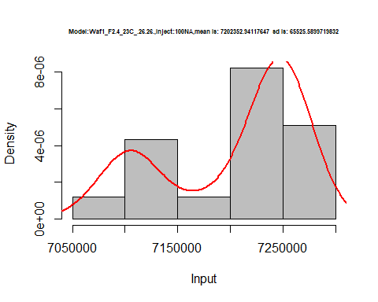

hist(d1_26.26$V2,  
 cex.main=0.5,  
 freq = FALSE,  
 main = paste('Model:Waf1_F2.4_23C_.26.26.,Inject:200NA,mean is:', mean(d1_26.26$V2),' sd is:', sd(d1_26.26$V2)),  
 xlab = "Input",  
 ylab = "Density",  
 col="grey")  
#plot density curve  
lines(density(d1_26.26$V2), # density plot  
 lwd = 2, # thickness of line  
 col = "red")

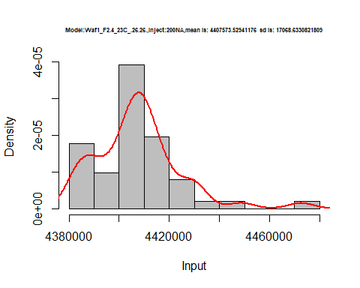

hist(d1_26.26$V3,  
 cex.main=0.5,  
 freq = FALSE,  
 main = paste('Model:Waf1_F2.4_23C_.26.26.,Inject:300NA,mean is:', mean(d1_26.26$V3),' sd is:', sd(d1_26.26$V3)),  
 xlab = "Input",  
 ylab = "Density",  
 col="grey")  
#plot density curve  
lines(density(d1_26.26$V3), # density plot  
 lwd = 2, # thickness of line  
 col = "red")

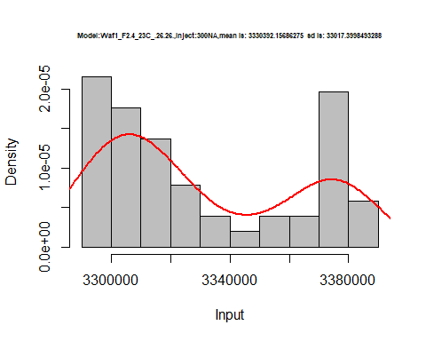

hist(d1_26.26$V4,  
 cex.main=0.5,  
 freq = FALSE,  
 main = paste('Model:Waf1_F2.4_23C_.26.26.,Inject:400NA,mean is:', mean(d1_26.26$V4),' sd is:', sd(d1_26.26$V4)),  
 xlab = "Input",  
 ylab = "Density",  
 col="grey")  
#plot density curve  
lines(density(d1_26.26$V4), # density plot  
 lwd = 2, # thickness of line  
 col = "red")

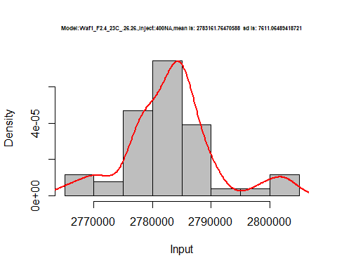

hist(d1_26.26$V5,  
 cex.main=0.5,  
 freq = FALSE,  
 main = paste('Model:Waf1_F2.4_23C_.26.26.,Inject:500NA,mean is:', mean(d1_26.26$V5),' sd is:', sd(d1_26.26$V5)),  
 xlab = "Input",  
 ylab = "Density",  
 col="grey")  
#plot density curve  
lines(density(d1_26.26$V5), # density plot  
 lwd = 2, # thickness of line  
 col = "red")

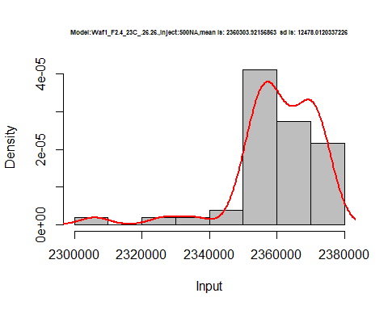

hist(d1_26.26$V6,  
 cex.main=0.5,  
 freq = FALSE,  
 main = paste('Model:Waf1_F2.4_23C_.26.26.,Inject:600NA,mean is:', mean(d1_26.26$V6),' sd is:', sd(d1_26.26$V6)),  
 xlab = "Input",  
 ylab = "Density",  
 col="grey")  
#plot density curve  
lines(density(d1_26.26$V6), # density plot  
 lwd = 2, # thickness of line  
 col = "red")

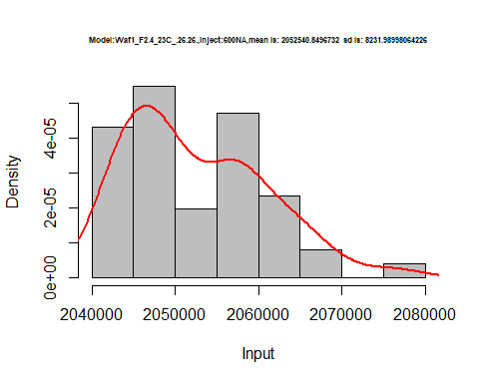

hist(d1_26.26$V7,  
 cex.main=0.5,  
 freq = FALSE,  
 main = paste('Model:Waf1_F2.4_23C_.26.26.,Inject:700NA,mean is:', mean(d1_26.26$V7),' sd is:', sd(d1_26.26$V7)),  
 xlab = "Input",  
 ylab = "Density",  
 col="grey")  
#plot density curve  
lines(density(d1_26.26$V7), # density plot  
 lwd = 2, # thickness of line  
 col = "red")

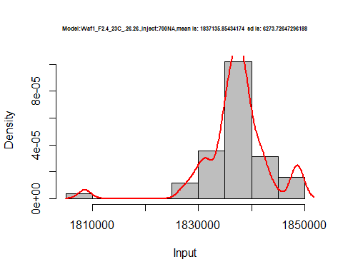

hist(d1_26.26$V8,  
 cex.main=0.5,  
 freq = FALSE,  
 main = paste('Model:Waf1_F2.4_23C_.26.26.,Inject:800NA,mean is:', mean(d1_26.26$V8),' sd is:', sd(d1_26.26$V8)),  
 xlab = "Input",  
 ylab = "Density",  
 col="grey")  
#plot density curve  
lines(density(d1_26.26$V8), # density plot  
 lwd = 2, # thickness of line  
 col = "red")

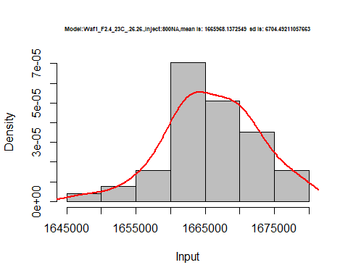

dens <- apply(d1_26.26, 2, density)  
plot('Model:Waf1_F2.4_23C_.26.26', xlim=range(sapply(dens, "[", "x")), ylim=range(sapply(dens, "[", "y")))

## Warning in xy.coords(x, y, xlabel, ylabel, log): NAs introduced by coercion

mapply(lines, dens, col=1:length(dens))

## $V1  
## NULL  
##   
## $V2  
## NULL  
##   
## $V3  
## NULL  
##   
## $V4  
## NULL  
##   
## $V5  
## NULL  
##   
## $V6  
## NULL  
##   
## $V7  
## NULL  
##   
## $V8  
## NULL

legend("topright", legend=names(dens), fill=1:length(dens))

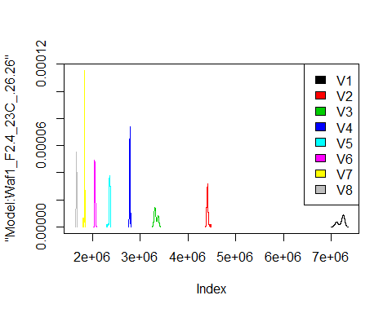

d2_26.26<-d_26.26[,c(9:16)]  
d2_26.26 <- head(d2_26.26,51)  
colnames(d2_26.26) <- c("V1", "V2","V3","V4","V5","V6","V7","V8")  
head(d2_26.26)

## V1 V2 V3 V4 V5 V6 V7 V8  
## 1 1810000 1587500 1449167 1335625 1250000 1178750 1120357 1071563  
## 2 1807500 1590000 1447500 1335000 1251500 1179583 1120714 1071250  
## 3 1815000 1588750 1449167 1336875 1252500 1179583 1122857 1071875  
## 4 1812500 1588750 1449167 1340000 1251000 1179583 1123571 1070000  
## 5 1810000 1590000 1450000 1340625 1248500 1179583 1122857 1070313  
## 6 1810000 1588750 1450833 1341250 1248000 1179167 1123571 1070938

hist(d2_26.26$V1,  
 cex.main=0.5,  
 freq = FALSE,  
 main = paste('Model:Waf1_F2.6_23C_.26.26.,Inject:100NA,mean is:', mean(d2_26.26$V1),' sd is:', sd(d2_26.26$V1)),  
 xlab = "Input",  
 ylab = "Density",  
 col="grey")  
#plot density curve  
lines(density(d2_26.26$V1), # density plot  
 lwd = 2, # thickness of line  
 col = "red")

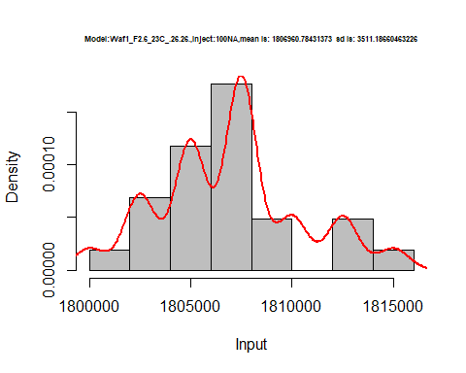

hist(d2_26.26$V2,  
 cex.main=0.5,  
 freq = FALSE,  
 main = paste('Model:Waf1_F2.6_23C_.26.26.,Inject:200NA,mean is:', mean(d2_26.26$V2),' sd is:', sd(d2_26.26$V2)),  
 xlab = "Input",  
 ylab = "Density",  
 col="grey")  
#plot density curve  
lines(density(d2_26.26$V2), # density plot  
 lwd = 2, # thickness of line  
 col = "red")

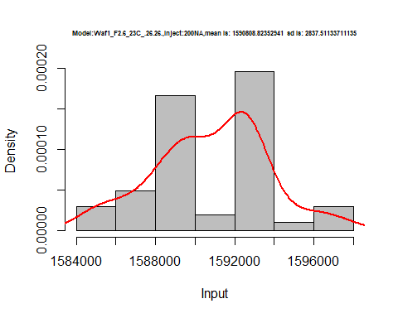

hist(d2_26.26$V3,  
 cex.main=0.5,  
 freq = FALSE,  
 main = paste('Model:Waf1_F2.6_23C_.26.26.,Inject:300NA,mean is:', mean(d2_26.26$V3),' sd is:', sd(d2_26.26$V3)),  
 xlab = "Input",  
 ylab = "Density",  
 col="grey")  
#plot density curve  
lines(density(d2_26.26$V3), # density plot  
 lwd = 2, # thickness of line  
 col = "red")

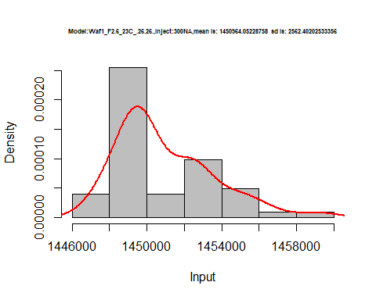

hist(d2_26.26$V4,  
 cex.main=0.5,  
 freq = FALSE,  
 main = paste('Model:Waf1_F2.6_23C_.26.26.,Inject:400NA,mean is:', mean(d2_26.26$V4),' sd is:', sd(d2_26.26$V4)),  
 xlab = "Input",  
 ylab = "Density",  
 col="grey")  
#plot density curve  
lines(density(d2_26.26$V4), # density plot  
 lwd = 2, # thickness of line  
 col = "red")

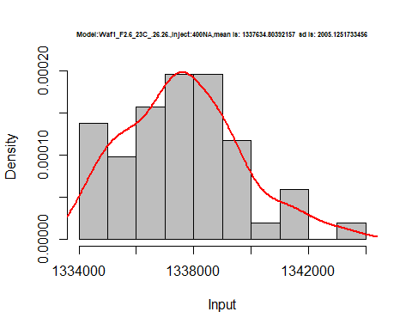

hist(d2_26.26$V5,  
 cex.main=0.5,  
 freq = FALSE,  
 main = paste('Model:Waf1_F2.6_23C_.26.26.,Inject:500NA,mean is:', mean(d2_26.26$V5),' sd is:', sd(d2_26.26$V5)),  
 xlab = "Input",  
 ylab = "Density",  
 col="grey")  
#plot density curve  
lines(density(d2_26.26$V5), # density plot  
 lwd = 2, # thickness of line  
 col = "red")

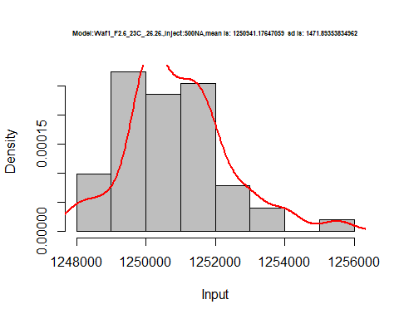

hist(d2_26.26$V6,  
 cex.main=0.5,  
 freq = FALSE,  
 main = paste('Model:Waf1_F2.6_23C_.26.26.,Inject:600NA,mean is:', mean(d2_26.26$V6),' sd is:', sd(d2_26.26$V6)),  
 xlab = "Input",  
 ylab = "Density",  
 col="grey")  
#plot density curve  
lines(density(d2_26.26$V6), # density plot  
 lwd = 2, # thickness of line  
 col = "red")

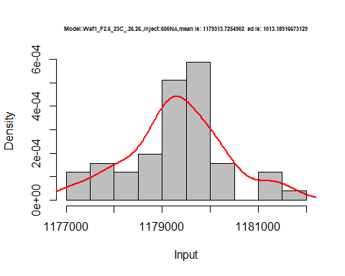

hist(d2_26.26$V7,  
 cex.main=0.5,  
 freq = FALSE,  
 main = paste('Model:Waf1_F2.6_23C_.26.26.,Inject:700NA,mean is:', mean(d2_26.26$V7),' sd is:', sd(d2_26.26$V7)),  
 xlab = "Input",  
 ylab = "Density",  
 col="grey")  
#plot density curve  
lines(density(d2_26.26$V7), # density plot  
 lwd = 2, # thickness of line  
 col = "red")

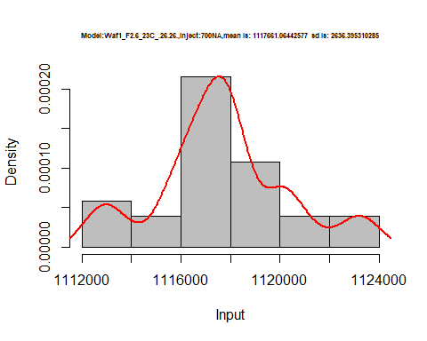

hist(d2_26.26$V8,  
 cex.main=0.5,  
 freq = FALSE,  
 main = paste('Model:Waf1_F2.6_23C_.26.26.,Inject:800NA,mean is:', mean(d2_26.26$V8),' sd is:', sd(d2_26.26$V8)),  
 xlab = "Input",  
 ylab = "Density",  
 col="grey")  
#plot density curve  
lines(density(d2_26.26$V8), # density plot  
 lwd = 2, # thickness of line  
 col = "red")

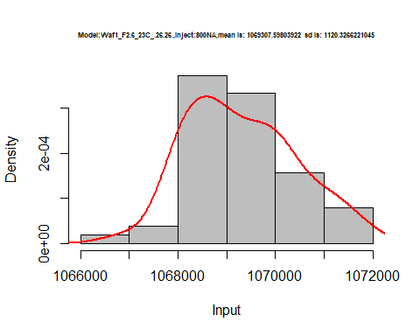

dens <- apply(d2_26.26, 2, density)  
plot('Model:Waf1_F2.6_23C_.26.26', xlim=range(sapply(dens, "[", "x")), ylim=range(sapply(dens, "[", "y")))

## Warning in xy.coords(x, y, xlabel, ylabel, log): NAs introduced by coercion

mapply(lines, dens, col=1:length(dens))

## $V1  
## NULL  
##   
## $V2  
## NULL  
##   
## $V3  
## NULL  
##   
## $V4  
## NULL  
##   
## $V5  
## NULL  
##   
## $V6  
## NULL  
##   
## $V7  
## NULL  
##   
## $V8  
## NULL

legend("topright", legend=names(dens), fill=1:length(dens))

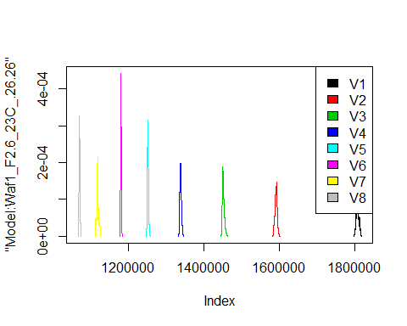

d3_26.26<-d_26.26[,c(17:24)]  
d3_26.26 <- head(d3_26.26,51)  
colnames(d3_26.26) <- c("V1", "V2","V3","V4","V5","V6","V7","V8")  
head(d3_26.26)

## V1 V2 V3 V4 V5 V6 V7 V8  
## 1 3705000 2418750 1500000 1462500 1383500 1155000 1056071 923125.0  
## 2 3705000 2415000 1502500 1463750 1383000 1154167 1056429 922500.0  
## 3 3705000 2412500 1502500 1464375 1382500 1154167 1056786 922812.5  
## 4 3707500 2415000 1509167 1465625 1383500 1153333 1056786 922500.0  
## 5 3705000 2411250 1505833 1465000 1382000 1153333 1055714 922187.5  
## 6 3705000 2410000 1500833 1463750 1382000 1154167 1055357 922187.5

hist(d3_26.26$V1,  
 cex.main=0.5,  
 freq = FALSE,  
 main = paste('Model:Waf1_F3.5_23C_.26.26.,Inject:100NA,mean is:', mean(d3_26.26$V1),' sd is:', sd(d3_26.26$V1)),  
 xlab = "Input",  
 ylab = "Density",  
 col="grey")  
#plot density curve  
lines(density(d3_26.26$V1), # density plot  
 lwd = 2, # thickness of line  
 col = "red")

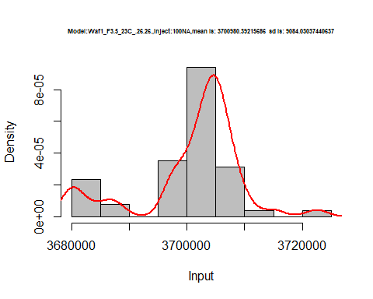

hist(d3_26.26$V2,  
 cex.main=0.5,  
 freq = FALSE,  
 main = paste('Model:Waf1_F3.5_23C_.26.26.,Inject:200NA,mean is:', mean(d3_26.26$V2),' sd is:', sd(d3_26.26$V2)),  
 xlab = "Input",  
 ylab = "Density",  
 col="grey")  
#plot density curve  
lines(density(d3_26.26$V2), # density plot  
 lwd = 2, # thickness of line  
 col = "red")

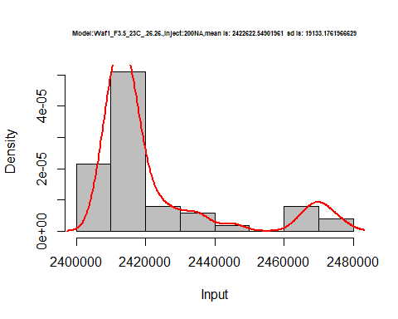

hist(d3_26.26$V3,  
 cex.main=0.5,  
 freq = FALSE,  
 main = paste('Model:Waf1_F3.5_23C_.26.26.,Inject:300NA,mean is:', mean(d3_26.26$V3),' sd is:', sd(d3_26.26$V3)),  
 xlab = "Input",  
 ylab = "Density",  
 col="grey")  
#plot density curve  
lines(density(d3_26.26$V3), # density plot  
 lwd = 2, # thickness of line  
 col = "red")

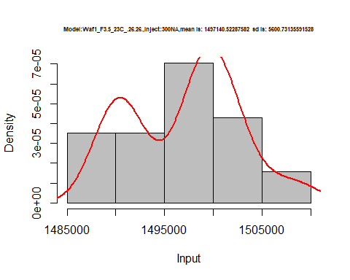

hist(d3_26.26$V4,  
 cex.main=0.5,  
 freq = FALSE,  
 main = paste('Model:Waf1_F3.5_23C_.26.26.,Inject:400NA,mean is:', mean(d3_26.26$V4),' sd is:', sd(d3_26.26$V4)),  
 xlab = "Input",  
 ylab = "Density",  
 col="grey")  
#plot density curve  
lines(density(d3_26.26$V4), # density plot  
 lwd = 2, # thickness of line  
 col = "red")

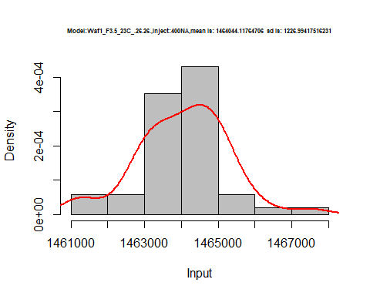

hist(d3_26.26$V5,  
 cex.main=0.5,  
 freq = FALSE,  
 main = paste('Model:Waf1_F3.5_23C_.26.26.,Inject:500NA,mean is:', mean(d3_26.26$V5),' sd is:', sd(d3_26.26$V5)),  
 xlab = "Input",  
 ylab = "Density",  
 col="grey")  
#plot density curve  
lines(density(d3_26.26$V5), # density plot  
 lwd = 2, # thickness of line  
 col = "red")

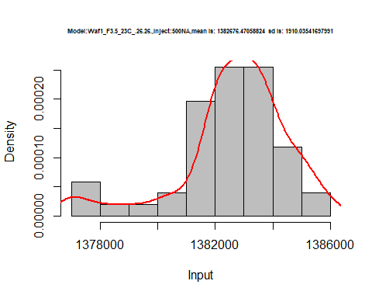

hist(d3_26.26$V6,  
 cex.main=0.5,  
 freq = FALSE,  
 main = paste('Model:Waf1_F3.5_23C_.26.26.,Inject:600NA,mean is:', mean(d3_26.26$V6),' sd is:', sd(d3_26.26$V6)),  
 xlab = "Input",  
 ylab = "Density",  
 col="grey")  
#plot density curve  
lines(density(d3_26.26$V6), # density plot  
 lwd = 2, # thickness of line  
 col = "red")

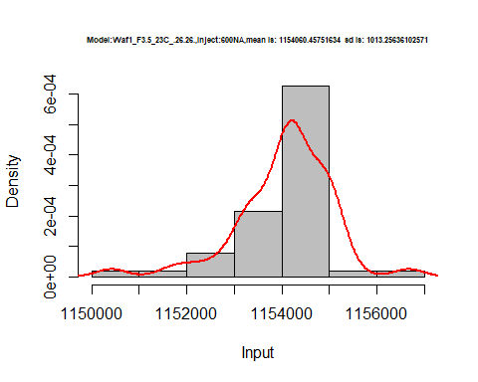

hist(d3_26.26$V7,  
 cex.main=0.5,  
 freq = FALSE,  
 main = paste('Model:Waf1_F3.5_23C_.26.26.,Inject:700NA,mean is:', mean(d3_26.26$V7),' sd is:', sd(d3_26.26$V7)),  
 xlab = "Input",  
 ylab = "Density",  
 col="grey")  
#plot density curve  
lines(density(d3_26.26$V7), # density plot  
 lwd = 2, # thickness of line  
 col = "red")

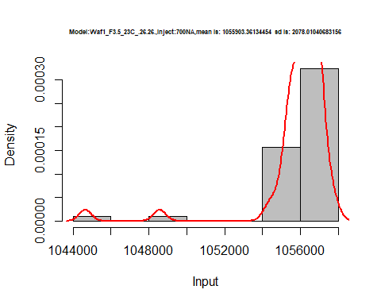

hist(d3_26.26$V8,  
 cex.main=0.5,  
 freq = FALSE,  
 main = paste('Model:Waf1_F3.5_23C_.26.26.,Inject:800NA,mean is:', mean(d3_26.26$V8),' sd is:', sd(d3_26.26$V8)),  
 xlab = "Input",  
 ylab = "Density",  
 col="grey")  
#plot density curve  
lines(density(d3_26.26$V8), # density plot  
 lwd = 2, # thickness of line  
 col = "red")

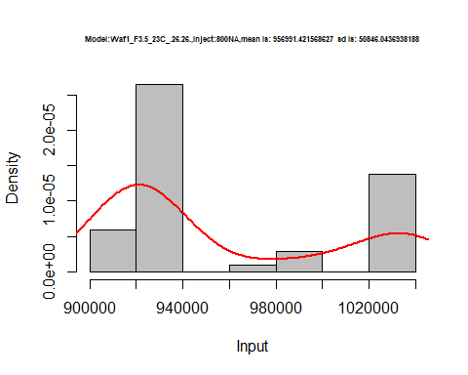

dens <- apply(d3_26.26, 2, density)  
plot('Model:Waf1_F3.5_23C_.26.26', xlim=range(sapply(dens, "[", "x")), ylim=range(sapply(dens, "[", "y")))

## Warning in xy.coords(x, y, xlabel, ylabel, log): NAs introduced by coercion

mapply(lines, dens, col=1:length(dens))

## $V1  
## NULL  
##   
## $V2  
## NULL  
##   
## $V3  
## NULL  
##   
## $V4  
## NULL  
##   
## $V5  
## NULL  
##   
## $V6  
## NULL  
##   
## $V7  
## NULL  
##   
## $V8  
## NULL

legend("topright", legend=names(dens), fill=1:length(dens))

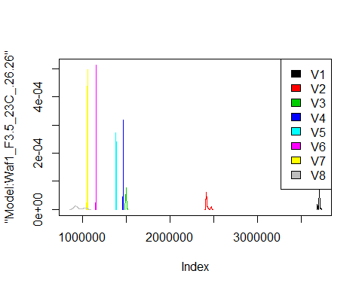

d4_26.26<-d_26.26[,c(25:32)]  
d4_26.26 <- head(d4_26.26,51)  
colnames(d4_26.26) <- c("V1", "V2","V3","V4","V5","V6","V7","V8")  
head(d4_26.26)

## V1 V2 V3 V4 V5 V6 V7 V8  
## 1 2027500 1676250 1451667 1315000 1232000 1145000 1080000 1040000  
## 2 2072500 1653750 1455833 1305625 1220000 1154167 1083929 1044063  
## 3 2137500 1668750 1450833 1306875 1222000 1154167 1088571 1040625  
## 4 2162500 1642500 1456667 1313125 1224000 1145000 1085000 1034063  
## 5 2160000 1668750 1432500 1315000 1217500 1149583 1082143 1043125  
## 6 2090000 1647500 1435833 1320625 1217000 1140833 1090357 1041563

hist(d4_26.26$V1,  
 cex.main=0.5,  
 freq = FALSE,  
 main = paste('Model:Waf1_F6.3_23C_.26.26.,Inject:100NA,mean is:', mean(d4_26.26$V1),' sd is:', sd(d4_26.26$V1)),  
 xlab = "Input",  
 ylab = "Density",  
 col="grey")  
#plot density curve  
lines(density(d4_26.26$V1), # density plot  
 lwd = 2, # thickness of line  
 col = "red")

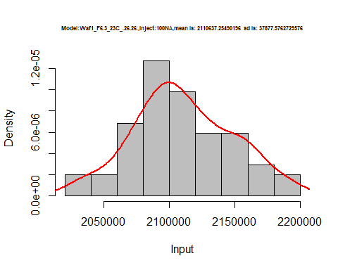

hist(d4_26.26$V2,  
 cex.main=0.5,  
 freq = FALSE,  
 main = paste('Model:Waf1_F6.3_23C_.26.26.,Inject:200NA,mean is:', mean(d4_26.26$V2),' sd is:', sd(d4_26.26$V2)),  
 xlab = "Input",  
 ylab = "Density",  
 col="grey")  
#plot density curve  
lines(density(d4_26.26$V2), # density plot  
 lwd = 2, # thickness of line  
 col = "red")

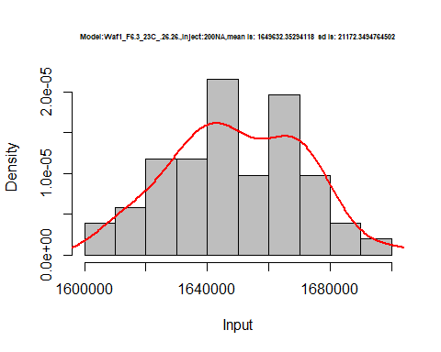

hist(d4_26.26$V3,  
 cex.main=0.5,  
 freq = FALSE,  
 main = paste('Model:Waf1_F6.3_23C_.26.26.,Inject:300NA,mean is:', mean(d4_26.26$V3),' sd is:', sd(d4_26.26$V3)),  
 xlab = "Input",  
 ylab = "Density",  
 col="grey")  
#plot density curve  
lines(density(d4_26.26$V3), # density plot  
 lwd = 2, # thickness of line  
 col = "red")

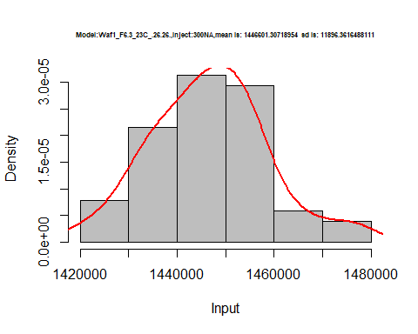

hist(d4_26.26$V4,  
 cex.main=0.5,  
 freq = FALSE,  
 main = paste('Model:Waf1_F6.3_23C_.26.26.,Inject:400NA,mean is:', mean(d4_26.26$V4),' sd is:', sd(d4_26.26$V4)),  
 xlab = "Input",  
 ylab = "Density",  
 col="grey")  
#plot density curve  
lines(density(d4_26.26$V4), # density plot  
 lwd = 2, # thickness of line  
 col = "red")

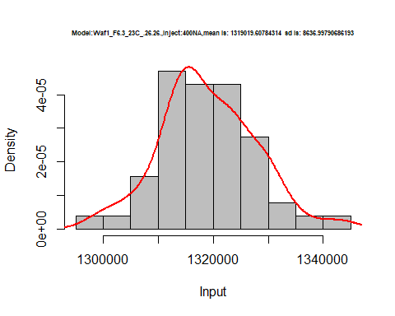

hist(d4_26.26$V5,  
 cex.main=0.5,  
 freq = FALSE,  
 main = paste('Model:Waf1_F6.3_23C_.26.26.,Inject:500NA,mean is:', mean(d4_26.26$V5),' sd is:', sd(d4_26.26$V5)),  
 xlab = "Input",  
 ylab = "Density",  
 col="grey")  
#plot density curve  
lines(density(d4_26.26$V5), # density plot  
 lwd = 2, # thickness of line  
 col = "red")

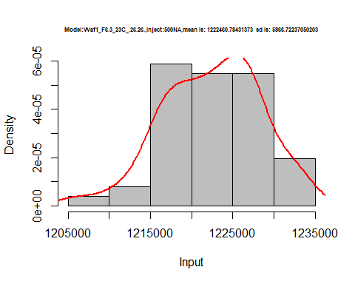

hist(d4_26.26$V6,  
 cex.main=0.5,  
 freq = FALSE,  
 main = paste('Model:Waf1_F6.3_23C_.26.26.,Inject:600NA,mean is:', mean(d4_26.26$V6),' sd is:', sd(d4_26.26$V6)),  
 xlab = "Input",  
 ylab = "Density",  
 col="grey")  
#plot density curve  
lines(density(d4_26.26$V6), # density plot  
 lwd = 2, # thickness of line  
 col = "red")

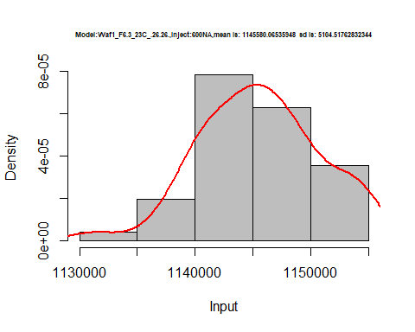

dens <- apply(d4_26.26, 2, density)  
plot('Model:Waf1_F6.3_23C_.26.26', xlim=range(sapply(dens, "[", "x")), ylim=range(sapply(dens, "[", "y")))

## Warning in xy.coords(x, y, xlabel, ylabel, log): NAs introduced by coercion

mapply(lines, dens, col=1:length(dens))

## $V1  
## NULL  
##   
## $V2  
## NULL  
##   
## $V3  
## NULL  
##   
## $V4  
## NULL  
##   
## $V5  
## NULL  
##   
## $V6  
## NULL  
##   
## $V7  
## NULL  
##   
## $V8  
## NULL

legend("topright", legend=names(dens), fill=1:length(dens))

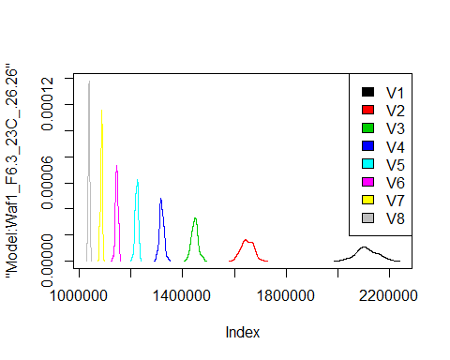

# Select columns whose names contains "27.27"  
d_27.27<-my_data %>% select(contains("27.27."))  
#d_26.26 <- head(d_26.26,51)  
#colnames(d_26.26) <- c("V1", "V2","V3","V4","V5","V6","V7","V8")  
head(d_27.27)

## Waf1_F3.4_23C_.100nA_.27.27. Waf1_F3.4_23C_.200nA_.27.27.  
## 1 6475000 4246250  
## 2 6475000 4252500  
## 3 6467500 4257500  
## 4 6467500 4245000  
## 5 6465000 4248750  
## 6 6462500 4252500  
## Waf1_F3.4_23C_.300nA_.27.27. Waf1_F3.4_23C_.400nA_.27.27.  
## 1 3346667 2795625  
## 2 3345000 2796875  
## 3 3344167 2797500  
## 4 3343333 2798750  
## 5 3342500 2808125  
## 6 3348333 2805625  
## Waf1_F3.4_23C_.500nA_.27.27. Waf1_F3.4_23C_.600nA_.27.27.  
## 1 2435000 2186667  
## 2 2428000 2182917  
## 3 2429500 2185000  
## 4 2425500 2184583  
## 5 2443500 2182917  
## 6 2449500 2182500  
## Waf1_F3.4_23C_.700nA_.27.27. Waf1_F3.4_23C_.800nA_.27.27.  
## 1 1993214 1813750  
## 2 1981786 1808750  
## 3 1978214 1805313  
## 4 1973929 1819062  
## 5 1989643 1819062  
## 6 1982500 1816875  
## Waf1_F3.5_23C_.100nA_.27.27. Waf1_F3.5_23C_.200nA_.27.27.  
## 1 4680000 2958750  
## 2 4677500 2960000  
## 3 4677500 2958750  
## 4 4672500 2963750  
## 5 4672500 2962500  
## 6 4672500 2961250  
## Waf1_F3.5_23C_.300nA_.27.27. Waf1_F3.5_23C_.400nA_.27.27.  
## 1 2284167 1905000  
## 2 2284167 1904375  
## 3 2280000 1905000  
## 4 2278333 1906250  
## 5 2278333 1906250  
## 6 2277500 1906875  
## Waf1_F3.5_23C_.500nA_.27.27. Waf1_F3.5_23C_.600nA_.27.27.  
## 1 1660500 1491250  
## 2 1660500 1487500  
## 3 1661500 1487500  
## 4 1661500 1487917  
## 5 1663000 1490000  
## 6 1663000 1489167  
## Waf1_F3.5_23C_.700nA_.27.27. Waf1_F3.5_23C_.800nA_.27.27.  
## 1 1353929 1249688  
## 2 1355000 1249688  
## 3 1353929 1248750  
## 4 1354643 1247812  
## 5 1355357 1250625  
## 6 1353929 1252500

d1_27.27<-d_27.27[,c(1:8)]  
d1_27.27 <- head(d1_27.27,51)  
colnames(d1_27.27) <- c("V1", "V2","V3","V4","V5","V6","V7","V8")  
head(d1_27.27)

## V1 V2 V3 V4 V5 V6 V7 V8  
## 1 6475000 4246250 3346667 2795625 2435000 2186667 1993214 1813750  
## 2 6475000 4252500 3345000 2796875 2428000 2182917 1981786 1808750  
## 3 6467500 4257500 3344167 2797500 2429500 2185000 1978214 1805313  
## 4 6467500 4245000 3343333 2798750 2425500 2184583 1973929 1819062  
## 5 6465000 4248750 3342500 2808125 2443500 2182917 1989643 1819062  
## 6 6462500 4252500 3348333 2805625 2449500 2182500 1982500 1816875

hist(d1_27.27$V1,  
 cex.main=0.5,  
 freq = FALSE,  
 main = paste('Model:Waf1_F3.4_23C_.27.27.,Inject:100NA,mean is:', mean(d1_27.27$V1),' sd is:', sd(d1_27.27$V1)),  
 xlab = "Input",  
 ylab = "Density",  
 col="grey")  
#plot density curve  
lines(density(d1_27.27$V1), # density plot  
 lwd = 2, # thickness of line  
 col = "red")

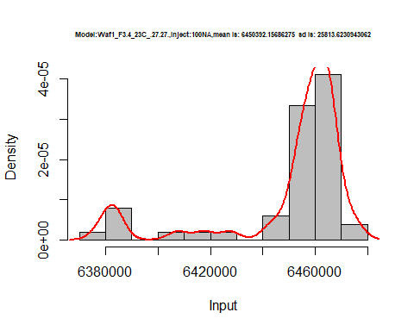

hist(d1_27.27$V2,  
 cex.main=0.5,  
 freq = FALSE,  
 main = paste('Model:Waf1_F3.4_23C_.27.27.,Inject:200NA,mean is:', mean(d1_27.27$V2),' sd is:', sd(d1_27.27$V2)),  
 xlab = "Input",  
 ylab = "Density",  
 col="grey")  
#plot density curve  
lines(density(d1_27.27$V2), # density plot  
 lwd = 2, # thickness of line  
 col = "red")

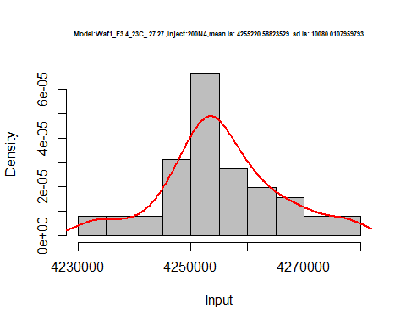

hist(d1_27.27$V3,  
 cex.main=0.5,  
 freq = FALSE,  
 main = paste('Model:Waf1_F3.4_23C_.27.27.,Inject:300NA,mean is:', mean(d1_27.27$V3),' sd is:', sd(d1_27.27$V3)),  
 xlab = "Input",  
 ylab = "Density",  
 col="grey")  
#plot density curve  
lines(density(d1_27.27$V3), # density plot  
 lwd = 2, # thickness of line  
 col = "red")

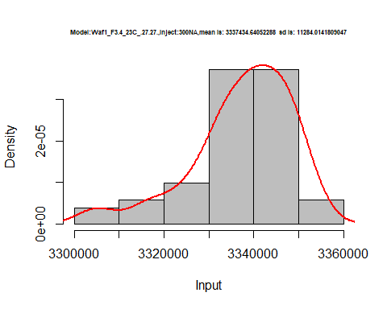

hist(d1_27.27$V4,  
 cex.main=0.5,  
 freq = FALSE,  
 main = paste('Model:Waf1_F3.4_23C_.27.27.,Inject:400NA,mean is:', mean(d1_27.27$V4),' sd is:', sd(d1_27.27$V4)),  
 xlab = "Input",  
 ylab = "Density",  
 col="grey")  
#plot density curve  
lines(density(d1_27.27$V4), # density plot  
 lwd = 2, # thickness of line  
 col = "red")

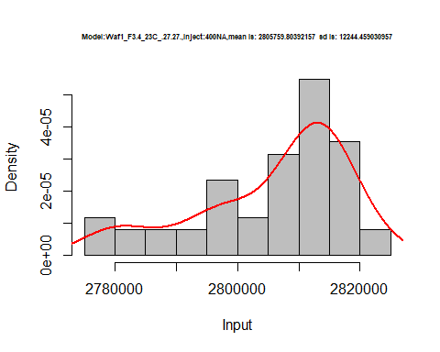

hist(d1_27.27$V5,  
 cex.main=0.5,  
 freq = FALSE,  
 main = paste('Model:Waf1_F3.4_23C_.27.27.,Inject:500NA,mean is:', mean(d1_27.27$V5),' sd is:', sd(d1_27.27$V5)),  
 xlab = "Input",  
 ylab = "Density",  
 col="grey")  
#plot density curve  
lines(density(d1_27.27$V5), # density plot  
 lwd = 2, # thickness of line  
 col = "red")

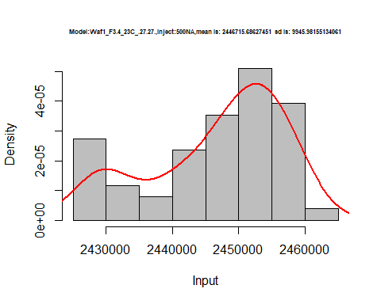

hist(d1_27.27$V6,  
 cex.main=0.5,  
 freq = FALSE,  
 main = paste('Model:Waf1_F3.4_23C_.27.27.,Inject:600NA,mean is:', mean(d1_27.27$V6),' sd is:', sd(d1_27.27$V6)),  
 xlab = "Input",  
 ylab = "Density",  
 col="grey")  
#plot density curve  
lines(density(d1_27.27$V6), # density plot  
 lwd = 2, # thickness of line  
 col = "red")

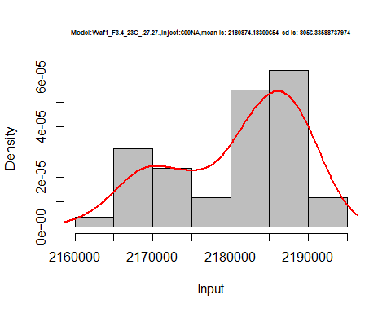

hist(d1_27.27$V7,  
 cex.main=0.5,  
 freq = FALSE,  
 main = paste('Model:Waf1_F3.4_23C_.27.27.,Inject:700NA,mean is:', mean(d1_27.27$V7),' sd is:', sd(d1_27.27$V7)),  
 xlab = "Input",  
 ylab = "Density",  
 col="grey")  
#plot density curve  
lines(density(d1_27.27$V7), # density plot  
 lwd = 2, # thickness of line  
 col = "red")

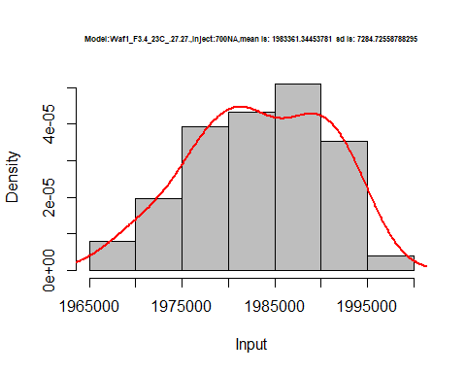

hist(d1_27.27$V8,  
 cex.main=0.5,  
 freq = FALSE,  
 main = paste('Model:Waf1_F3.4_23C_.27.27.,Inject:800NA,mean is:', mean(d1_27.27$V8),' sd is:', sd(d1_27.27$V8)),  
 xlab = "Input",  
 ylab = "Density",  
 col="grey")  
#plot density curve  
lines(density(d1_27.27$V8), # density plot  
 lwd = 2, # thickness of line  
 col = "red")

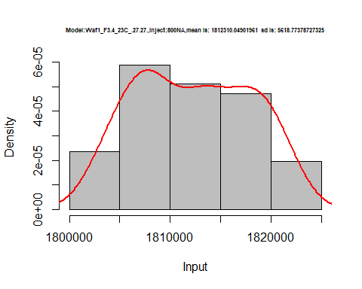

dens <- apply(d1_27.27, 2, density)  
plot('Model:Waf1_F3.4_23C_.27.27', xlim=range(sapply(dens, "[", "x")), ylim=range(sapply(dens, "[", "y")))

## Warning in xy.coords(x, y, xlabel, ylabel, log): NAs introduced by coercion

mapply(lines, dens, col=1:length(dens))

## $V1  
## NULL  
##   
## $V2  
## NULL  
##   
## $V3  
## NULL  
##   
## $V4  
## NULL  
##   
## $V5  
## NULL  
##   
## $V6  
## NULL  
##   
## $V7  
## NULL  
##   
## $V8  
## NULL

legend("topright", legend=names(dens), fill=1:length(dens))

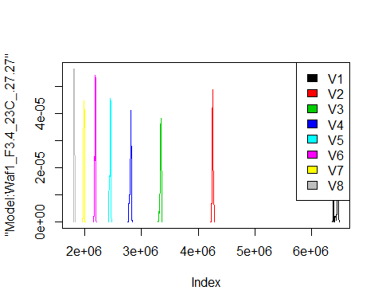

d2_27.27<-d_27.27[,c(9:16)]  
d2_27.27 <- head(d2_27.27,51)  
colnames(d2_27.27) <- c("V1", "V2","V3","V4","V5","V6","V7","V8")  
head(d2_27.27)

## V1 V2 V3 V4 V5 V6 V7 V8  
## 1 4680000 2958750 2284167 1905000 1660500 1491250 1353929 1249688  
## 2 4677500 2960000 2284167 1904375 1660500 1487500 1355000 1249688  
## 3 4677500 2958750 2280000 1905000 1661500 1487500 1353929 1248750  
## 4 4672500 2963750 2278333 1906250 1661500 1487917 1354643 1247812  
## 5 4672500 2962500 2278333 1906250 1663000 1490000 1355357 1250625  
## 6 4672500 2961250 2277500 1906875 1663000 1489167 1353929 1252500

hist(d2_27.27$V1,  
 cex.main=0.5,  
 freq = FALSE,  
 main = paste('Model:Waf1_F3.5_23C_.27.27.,Inject:100NA,mean is:', mean(d2_27.27$V1),' sd is:', sd(d2_27.27$V1)),  
 xlab = "Input",  
 ylab = "Density",  
 col="grey")  
#plot density curve  
lines(density(d2_27.27$V1), # density plot  
 lwd = 2, # thickness of line  
 col = "red")

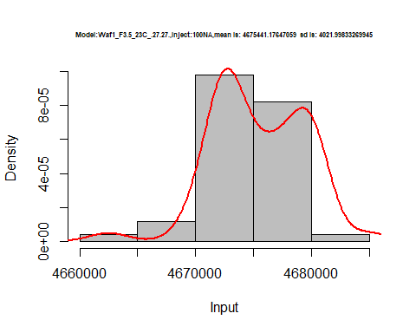

hist(d2_27.27$V2,  
 cex.main=0.5,  
 freq = FALSE,  
 main = paste('Model:Waf1_F3.5_23C_.27.27.,Inject:200NA,mean is:', mean(d2_27.27$V2),' sd is:', sd(d2_27.27$V2)),  
 xlab = "Input",  
 ylab = "Density",  
 col="grey")  
#plot density curve  
lines(density(d2_27.27$V2), # density plot  
 lwd = 2, # thickness of line  
 col = "red")

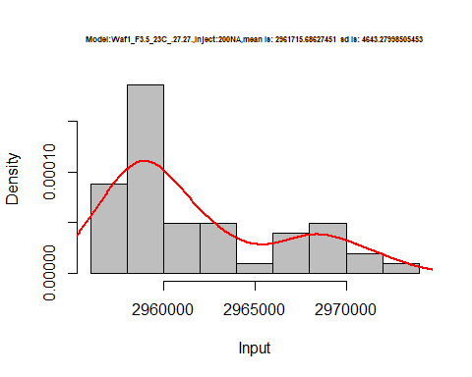

hist(d2_27.27$V3,  
 cex.main=0.5,  
 freq = FALSE,  
 main = paste('Model:Waf1_F3.5_23C_.27.27.,Inject:300NA,mean is:', mean(d2_27.27$V3),' sd is:', sd(d2_27.27$V3)),  
 xlab = "Input",  
 ylab = "Density",  
 col="grey")  
#plot density curve  
lines(density(d2_27.27$V3), # density plot  
 lwd = 2, # thickness of line  
 col = "red")

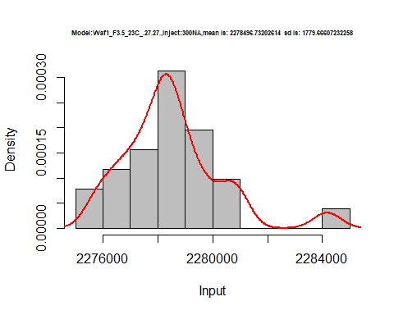

hist(d2_27.27$V4,  
 cex.main=0.5,  
 freq = FALSE,  
 main = paste('Model:Waf1_F3.5_23C_.27.27.,Inject:400NA,mean is:', mean(d2_27.27$V4),' sd is:', sd(d2_27.27$V4)),  
 xlab = "Input",  
 ylab = "Density",  
 col="grey")  
#plot density curve  
lines(density(d2_27.27$V4), # density plot  
 lwd = 2, # thickness of line  
 col = "red")

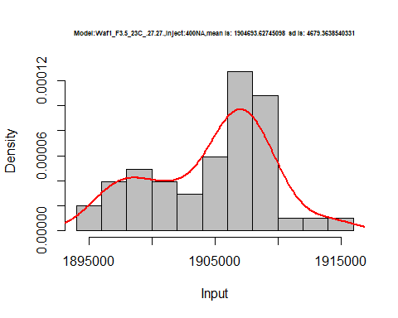

hist(d2_27.27$V5,  
 cex.main=0.5,  
 freq = FALSE,  
 main = paste('Model:Waf1_F3.5_23C_.27.27.,Inject:500NA,mean is:', mean(d2_27.27$V5),' sd is:', sd(d2_27.27$V5)),  
 xlab = "Input",  
 ylab = "Density",  
 col="grey")  
#plot density curve  
lines(density(d2_27.27$V5), # density plot  
 lwd = 2, # thickness of line  
 col = "red")

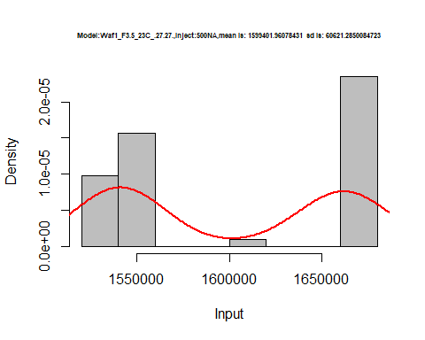

hist(d2_27.27$V6,  
 cex.main=0.5,  
 freq = FALSE,  
 main = paste('Model:Waf1_F3.5_23C_.27.27.,Inject:600NA,mean is:', mean(d2_27.27$V6),' sd is:', sd(d2_27.27$V6)),  
 xlab = "Input",  
 ylab = "Density",  
 col="grey")  
#plot density curve  
lines(density(d2_27.27$V6), # density plot  
 lwd = 2, # thickness of line  
 col = "red")

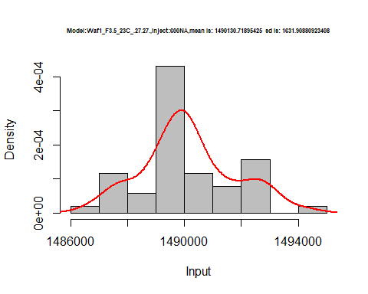

hist(d2_27.27$V7,  
 cex.main=0.5,  
 freq = FALSE,  
 main = paste('Model:Waf1_F3.5_23C_.27.27.,Inject:700NA,mean is:', mean(d2_27.27$V7),' sd is:', sd(d2_27.27$V7)),  
 xlab = "Input",  
 ylab = "Density",  
 col="grey")  
#plot density curve  
lines(density(d2_27.27$V7), # density plot  
 lwd = 2, # thickness of line  
 col = "red")

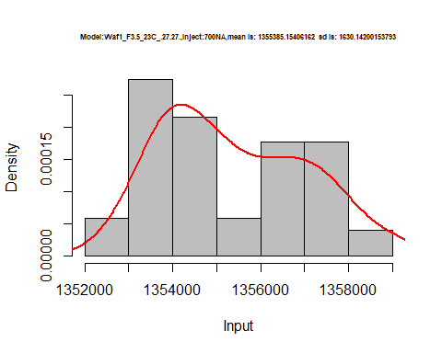

hist(d2_27.27$V8,  
 cex.main=0.5,  
 freq = FALSE,  
 main = paste('Model:Waf1_F3.5_23C_.27.27.,Inject:800NA,mean is:', mean(d2_27.27$V8),' sd is:', sd(d2_27.27$V8)),  
 xlab = "Input",  
 ylab = "Density",  
 col="grey")  
#plot density curve  
lines(density(d2_27.27$V8), # density plot  
 lwd = 2, # thickness of line  
 col = "red")

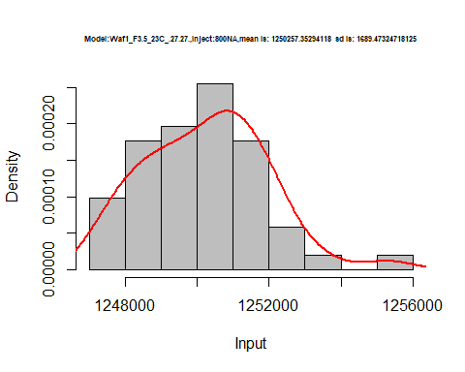

dens <- apply(d2_27.27, 2, density)  
plot('Model:Waf1_F3.5_23C_.27.27', xlim=range(sapply(dens, "[", "x")), ylim=range(sapply(dens, "[", "y")))

## Warning in xy.coords(x, y, xlabel, ylabel, log): NAs introduced by coercion

mapply(lines, dens, col=1:length(dens))

## $V1  
## NULL  
##   
## $V2  
## NULL  
##   
## $V3  
## NULL  
##   
## $V4  
## NULL  
##   
## $V5  
## NULL  
##   
## $V6  
## NULL  
##   
## $V7  
## NULL  
##   
## $V8  
## NULL

legend("topright", legend=names(dens), fill=1:length(dens))

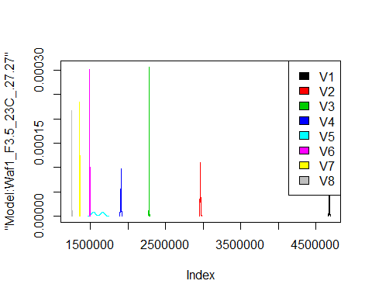

# Select columns whose names contains "28.28"  
d_28.28<-my_data %>% select(contains("28.28."))  
#d_28.28 <- head(d_28.28,51)  
#colnames(d_28.28) <- c("V1", "V2","V3","V4","V5","V6","V7","V8")  
head(d_28.28)

## Waf1_F2.7_23C_.100nA_.28.28. Waf1_F2.7_23C_.200nA_.28.28.  
## 1 5595000 3472500  
## 2 5587500 3476250  
## 3 5592500 3482500  
## 4 5592500 3471250  
## 5 5590000 3477500  
## 6 5605000 3481250  
## Waf1_F2.7_23C_.300nA_.28.28. Waf1_F2.7_23C_.400nA_.28.28.  
## 1 2510833 2099375  
## 2 2535833 2101250  
## 3 2534167 2100625  
## 4 2516667 2093750  
## 5 2512500 2091875  
## 6 2505833 2098125  
## Waf1_F2.7_23C_.500nA_.28.28. Waf1_F2.7_23C_.600nA_.28.28.  
## 1 1855000 1637083  
## 2 1859500 1634583  
## 3 1854500 1644583  
## 4 1859000 1630833  
## 5 1849500 1646667  
## 6 1844000 1645833  
## Waf1_F2.7_23C_.700nA_.28.28. Waf1_F2.7_23C_.800nA_.28.28.  
## 1 1477500 1327500  
## 2 1480000 1325938  
## 3 1480714 1327187  
## 4 1479643 1320000  
## 5 1479286 1326250  
## 6 1479643 1326250  
## Waf1_F3.3_23C_.100nA_.28.28. Waf1_F3.3_23C_.200nA_.28.28.  
## 1 2350000 1850000  
## 2 2330000 1841250  
## 3 2347500 1846250  
## 4 2372500 1843750  
## 5 2382500 1843750  
## 6 2387500 1843750  
## Waf1_F3.3_23C_.300nA_.28.28. Waf1_F3.3_23C_.400nA_.28.28.  
## 1 1465833 1268750  
## 2 1472500 1261875  
## 3 1470833 1265625  
## 4 1466667 1263125  
## 5 1470833 1256250  
## 6 1470000 1260000  
## Waf1_F3.3_23C_.500nA_.28.28. Waf1_F3.3_23C_.600nA_.28.28.  
## 1 1123000 997916.7  
## 2 1129500 1000416.7  
## 3 1127000 1000000.0  
## 4 1121000 1000000.0  
## 5 1128000 1001666.7  
## 6 1129000 999166.7  
## Waf1_F3.3_23C_.700nA_.28.28. Waf1_F3.3_23C_.800nA_.28.28.  
## 1 908571.4 830937.5  
## 2 906785.7 826875.0  
## 3 917857.1 827500.0  
## 4 895357.1 827500.0  
## 5 883571.4 828750.0  
## 6 900357.1 829687.5  
## Waf1_F5.3_23C_.100nA_.28.28. Waf1_F5.3_23C_.200nA_.28.28.  
## 1 11617500 7526250  
## 2 11557500 7696250  
## 3 11515000 7790000  
## 4 11395000 7778750  
## 5 11527500 7798750  
## 6 11532500 7530000  
## Waf1_F5.3_23C_.300nA_.28.28. Waf1_F5.3_23C_.400nA_.28.28.  
## 1 5675000 4558125  
## 2 5610000 4571250  
## 3 5642500 4586875  
## 4 5615000 4557500  
## 5 5634167 4541250  
## 6 5630000 4575000  
## Waf1_F5.3_23C_.500nA_.28.28. Waf1_F5.3_23C_.600nA_.28.28.  
## 1 3810000 3326250  
## 2 3803000 3302083  
## 3 3809500 3313333  
## 4 3805500 3307083  
## 5 3806000 3308750  
## 6 3814000 3297917  
## Waf1_F5.3_23C_.700nA_.28.28. Waf1_F5.3_23C_.800nA_.28.28.  
## 1 2965714 2704063  
## 2 2960714 2700625  
## 3 2940357 2700938  
## 4 2932143 2700313  
## 5 2936071 2699687  
## 6 2911786 2699687  
## Waf1_F6.8_23C_.100nA_.28.28. Waf1_F6.8_23C_.200nA_.28.28.  
## 1 2700000 1796250  
## 2 2720000 1807500  
## 3 2755000 1800000  
## 4 2750000 1840000  
## 5 2732500 1870000  
## 6 2667500 1853750  
## Waf1_F6.8_23C_.300nA_.28.28. Waf1_F6.8_23C_.400nA_.28.28.  
## 1 1471667 1280000  
## 2 1470833 1280625  
## 3 1475833 1282500  
## 4 1473333 1280000  
## 5 1475000 1276875  
## 6 1473333 1277500  
## Waf1_F6.8_23C_.500nA_.28.28. Waf1_F6.8_23C_.600nA_.28.28.  
## 1 1124500 1012500  
## 2 1123000 1015417  
## 3 1128000 1011250  
## 4 1123000 1014583  
## 5 1124500 1016250  
## 6 1122000 1021250  
## Waf1_F6.8_23C_.700nA_.28.28. Waf1_F6.8_23C_.800nA_.28.28.  
## 1 1041785.7 845312.5  
## 2 937857.1 842187.5  
## 3 911071.4 840312.5  
## 4 910000.0 845312.5  
## 5 916428.6 841562.5  
## 6 916428.6 844375.0

d1_28.28<-d_28.28[,c(1:8)]  
d1_28.28 <- head(d1_28.28,51)  
colnames(d1_28.28) <- c("V1", "V2","V3","V4","V5","V6","V7","V8")  
head(d1_28.28)

## V1 V2 V3 V4 V5 V6 V7 V8  
## 1 5595000 3472500 2510833 2099375 1855000 1637083 1477500 1327500  
## 2 5587500 3476250 2535833 2101250 1859500 1634583 1480000 1325938  
## 3 5592500 3482500 2534167 2100625 1854500 1644583 1480714 1327187  
## 4 5592500 3471250 2516667 2093750 1859000 1630833 1479643 1320000  
## 5 5590000 3477500 2512500 2091875 1849500 1646667 1479286 1326250  
## 6 5605000 3481250 2505833 2098125 1844000 1645833 1479643 1326250

hist(d1_28.28$V1,  
 cex.main=0.5,  
 freq = FALSE,  
 main = paste('Model:Waf1_F2.7_23C_.28.28.,Inject:100NA,mean is:', mean(d1_28.28$V1),' sd is:', sd(d1_28.28$V1)),  
 xlab = "Input",  
 ylab = "Density",  
 col="grey")  
#plot density curve  
lines(density(d1_28.28$V1), # density plot  
 lwd = 2, # thickness of line  
 col = "red")

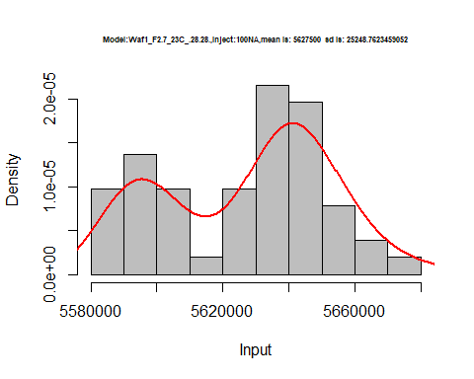

hist(d1_28.28$V2,  
 cex.main=0.5,  
 freq = FALSE,  
 main = paste('Model:Waf1_F2.7_23C_.28.28.,Inject:200NA,mean is:', mean(d1_28.28$V2),' sd is:', sd(d1_28.28$V2)),  
 xlab = "Input",  
 ylab = "Density",  
 col="grey")  
#plot density curve  
lines(density(d1_28.28$V2), # density plot  
 lwd = 2, # thickness of line  
 col = "red")

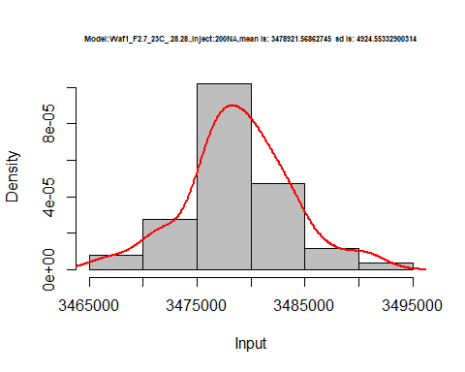

hist(d1_28.28$V3,  
 cex.main=0.5,  
 freq = FALSE,  
 main = paste('Model:Waf1_F2.7_23C_.28.28.,Inject:300NA,mean is:', mean(d1_28.28$V3),' sd is:', sd(d1_28.28$V3)),  
 xlab = "Input",  
 ylab = "Density",  
 col="grey")  
#plot density curve  
lines(density(d1_28.28$V3), # density plot  
 lwd = 2, # thickness of line  
 col = "red")

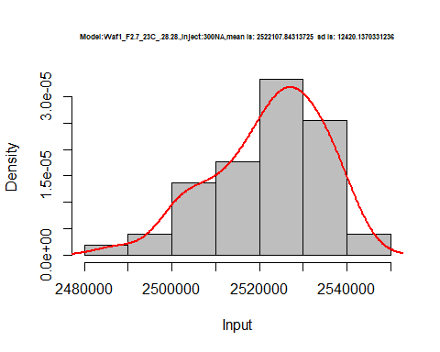

hist(d1_28.28$V4,  
 cex.main=0.5,  
 freq = FALSE,  
 main = paste('Model:Waf1_F2.7_23C_.28.28.,Inject:400NA,mean is:', mean(d1_28.28$V4),' sd is:', sd(d1_28.28$V4)),  
 xlab = "Input",  
 ylab = "Density",  
 col="grey")  
#plot density curve  
lines(density(d1_28.28$V4), # density plot  
 lwd = 2, # thickness of line  
 col = "red")

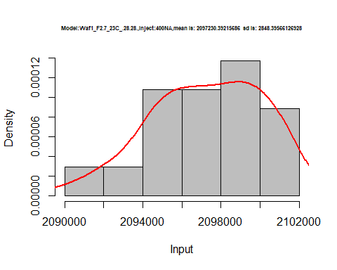

hist(d1_28.28$V5,  
 cex.main=0.5,  
 freq = FALSE,  
 main = paste('Model:Waf1_F2.7_23C_.28.28.,Inject:500NA,mean is:', mean(d1_28.28$V5),' sd is:', sd(d1_28.28$V5)),  
 xlab = "Input",  
 ylab = "Density",  
 col="grey")  
#plot density curve  
lines(density(d1_28.28$V5), # density plot  
 lwd = 2, # thickness of line  
 col = "red")

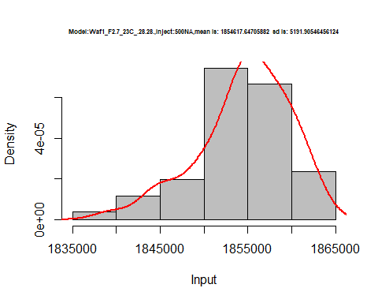

hist(d1_28.28$V6,  
 cex.main=0.5,  
 freq = FALSE,  
 main = paste('Model:Waf1_F2.7_23C_.28.28.,Inject:600NA,mean is:', mean(d1_28.28$V6),' sd is:', sd(d1_28.28$V6)),  
 xlab = "Input",  
 ylab = "Density",  
 col="grey")  
#plot density curve  
lines(density(d1_28.28$V6), # density plot  
 lwd = 2, # thickness of line  
 col = "red")

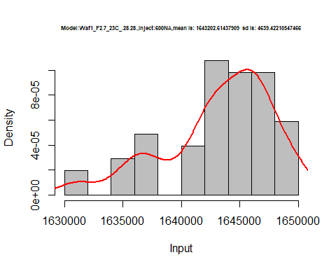

hist(d1_28.28$V7,  
 cex.main=0.5,  
 freq = FALSE,  
 main = paste('Model:Waf1_F2.7_23C_.28.28.,Inject:700NA,mean is:', mean(d1_28.28$V7),' sd is:', sd(d1_28.28$V7)),  
 xlab = "Input",  
 ylab = "Density",  
 col="grey")  
#plot density curve  
lines(density(d1_28.28$V7), # density plot  
 lwd = 2, # thickness of line  
 col = "red")

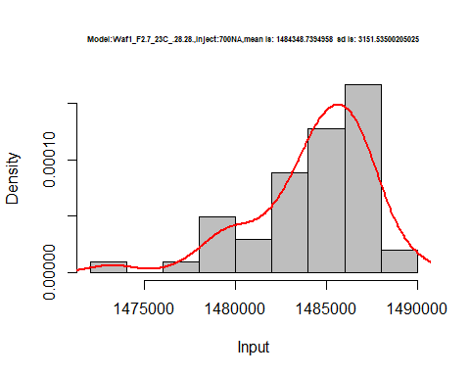

hist(d1_28.28$V8,  
 cex.main=0.5,  
 freq = FALSE,  
 main = paste('Model:Waf1_F2.7_23C_.28.28.,Inject:800NA,mean is:', mean(d1_28.28$V8),' sd is:', sd(d1_28.28$V8)),  
 xlab = "Input",  
 ylab = "Density",  
 col="grey")  
#plot density curve  
lines(density(d1_28.28$V8), # density plot  
 lwd = 2, # thickness of line  
 col = "red")

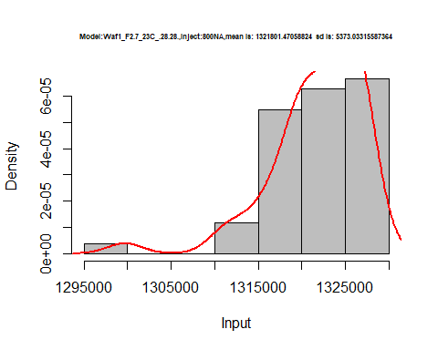

dens <- apply(d1_28.28, 2, density)  
plot('Model:Waf1_F2.7_23C_.28.28', xlim=range(sapply(dens, "[", "x")), ylim=range(sapply(dens, "[", "y")))

## Warning in xy.coords(x, y, xlabel, ylabel, log): NAs introduced by coercion

mapply(lines, dens, col=1:length(dens))

## $V1  
## NULL  
##   
## $V2  
## NULL  
##   
## $V3  
## NULL  
##   
## $V4  
## NULL  
##   
## $V5  
## NULL  
##   
## $V6  
## NULL  
##   
## $V7  
## NULL  
##   
## $V8  
## NULL

legend("topright", legend=names(dens), fill=1:length(dens))

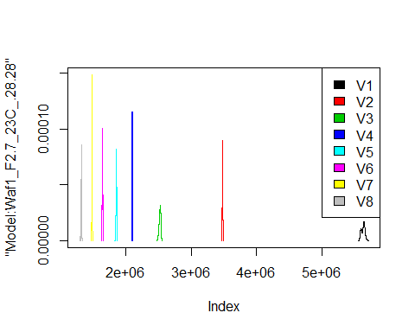

d2_28.28<-d_28.28[,c(9:16)]  
d2_28.28 <- head(d2_28.28,51)  
colnames(d2_28.28) <- c("V1", "V2","V3","V4","V5","V6","V7","V8")  
head(d2_28.28)

## V1 V2 V3 V4 V5 V6 V7 V8  
## 1 2350000 1850000 1465833 1268750 1123000 997916.7 908571.4 830937.5  
## 2 2330000 1841250 1472500 1261875 1129500 1000416.7 906785.7 826875.0  
## 3 2347500 1846250 1470833 1265625 1127000 1000000.0 917857.1 827500.0  
## 4 2372500 1843750 1466667 1263125 1121000 1000000.0 895357.1 827500.0  
## 5 2382500 1843750 1470833 1256250 1128000 1001666.7 883571.4 828750.0  
## 6 2387500 1843750 1470000 1260000 1129000 999166.7 900357.1 829687.5

hist(d2_28.28$V1,  
 cex.main=0.5,  
 freq = FALSE,  
 main = paste('Model:Waf1_F3.3_23C_.28.28.,Inject:100NA,mean is:', mean(d2_28.28$V1),' sd is:', sd(d2_28.28$V1)),  
 xlab = "Input",  
 ylab = "Density",  
 col="grey")  
#plot density curve  
lines(density(d2_28.28$V1), # density plot  
 lwd = 2, # thickness of line  
 col = "red")

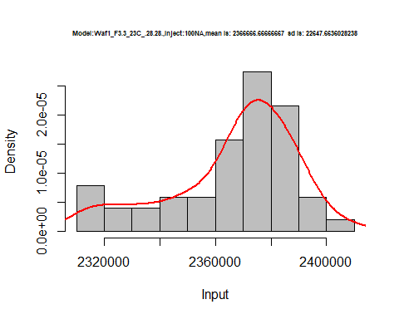

hist(d2_28.28$V2,  
 cex.main=0.5,  
 freq = FALSE,  
 main = paste('Model:Waf1_F3.3_23C_.28.28.,Inject:200NA,mean is:', mean(d2_28.28$V2),' sd is:', sd(d2_28.28$V2)),  
 xlab = "Input",  
 ylab = "Density",  
 col="grey")  
#plot density curve  
lines(density(d2_28.28$V2), # density plot  
 lwd = 2, # thickness of line  
 col = "red")

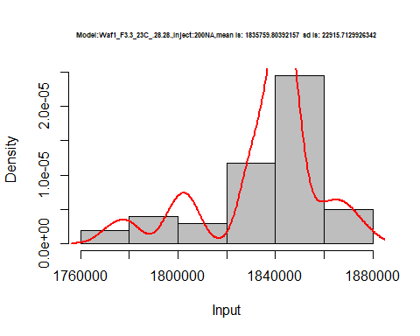

hist(d2_28.28$V2,  
 cex.main=0.5,  
 freq = FALSE,  
 main = paste('Model:Waf1_F3.3_23C_.28.28.,Inject:200NA,mean is:', mean(d2_28.28$V2),' sd is:', sd(d2_28.28$V2)),  
 xlab = "Input",  
 ylab = "Density",  
 col="grey")  
#plot density curve  
lines(density(d2_28.28$V2), # density plot  
 lwd = 2, # thickness of line  
 col = "red")



hist(d2_28.28$V3,  
 cex.main=0.5,  
 freq = FALSE,  
 main = paste('Model:Waf1_F3.3_23C_.28.28.,Inject:300NA,mean is:', mean(d2_28.28$V3),' sd is:', sd(d2_28.28$V3)),  
 xlab = "Input",  
 ylab = "Density",  
 col="grey")  
#plot density curve  
lines(density(d2_28.28$V3), # density plot  
 lwd = 2, # thickness of line  
 col = "red")

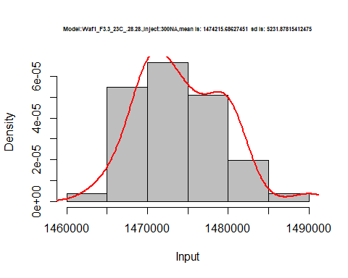

hist(d2_28.28$V4,  
 cex.main=0.5,  
 freq = FALSE,  
 main = paste('Model:Waf1_F3.3_23C_.28.28.,Inject:400NA,mean is:', mean(d2_28.28$V4),' sd is:', sd(d2_28.28$V4)),  
 xlab = "Input",  
 ylab = "Density",  
 col="grey")  
#plot density curve  
lines(density(d2_28.28$V4), # density plot  
 lwd = 2, # thickness of line  
 col = "red")

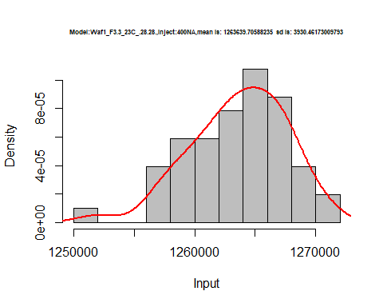

hist(d2_28.28$V5,  
 cex.main=0.5,  
 freq = FALSE,  
 main = paste('Model:Waf1_F3.3_23C_.28.28.,Inject:500NA,mean is:', mean(d2_28.28$V5),' sd is:', sd(d2_28.28$V5)),  
 xlab = "Input",  
 ylab = "Density",  
 col="grey")  
#plot density curve  
lines(density(d2_28.28$V5), # density plot  
 lwd = 2, # thickness of line  
 col = "red")

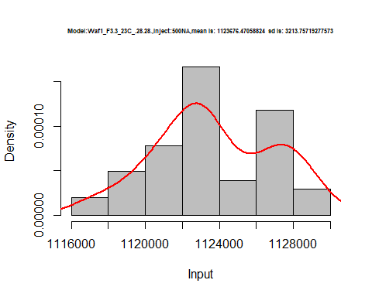

hist(d2_28.28$V6,  
 cex.main=0.5,  
 freq = FALSE,  
 main = paste('Model:Waf1_F3.3_23C_.28.28.,Inject:600NA,mean is:', mean(d2_28.28$V6),' sd is:', sd(d2_28.28$V6)),  
 xlab = "Input",  
 ylab = "Density",  
 col="grey")  
#plot density curve  
lines(density(d2_28.28$V6), # density plot  
 lwd = 2, # thickness of line  
 col = "red")

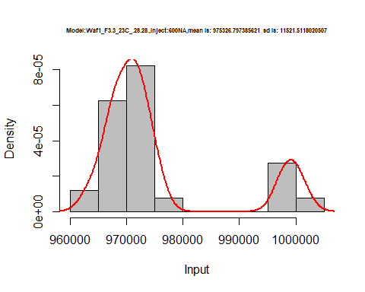

hist(d2_28.28$V7,  
 cex.main=0.5,  
 freq = FALSE,  
 main = paste('Model:Waf1_F3.3_23C_.28.28.,Inject:700NA,mean is:', mean(d2_28.28$V7),' sd is:', sd(d2_28.28$V7)),  
 xlab = "Input",  
 ylab = "Density",  
 col="grey")  
#plot density curve  
lines(density(d2_28.28$V7), # density plot  
 lwd = 2, # thickness of line  
 col = "red")

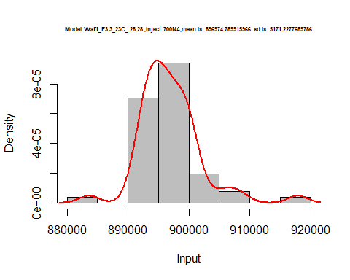

hist(d2_28.28$V8,  
 cex.main=0.5,  
 freq = FALSE,  
 main = paste('Model:Waf1_F3.3_23C_.28.28.,Inject:800NA,mean is:', mean(d2_28.28$V8),' sd is:', sd(d2_28.28$V8)),  
 xlab = "Input",  
 ylab = "Density",  
 col="grey")  
#plot density curve  
lines(density(d2_28.28$V8), # density plot  
 lwd = 2, # thickness of line  
 col = "red")

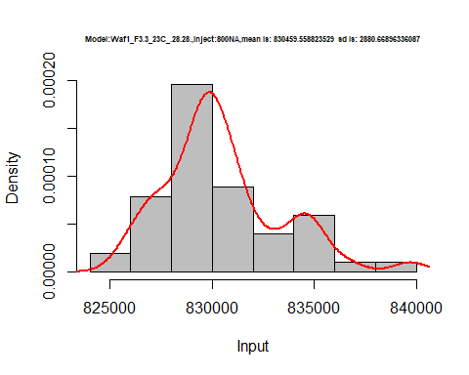

dens <- apply(d2_28.28, 2, density)  
plot('Model:Waf1_F3.3_23C_.28.28', xlim=range(sapply(dens, "[", "x")), ylim=range(sapply(dens, "[", "y")))

## Warning in xy.coords(x, y, xlabel, ylabel, log): NAs introduced by coercion

mapply(lines, dens, col=1:length(dens))

## $V1  
## NULL  
##   
## $V2  
## NULL  
##   
## $V3  
## NULL  
##   
## $V4  
## NULL  
##   
## $V5  
## NULL  
##   
## $V6  
## NULL  
##   
## $V7  
## NULL  
##   
## $V8  
## NULL

legend("topright", legend=names(dens), fill=1:length(dens))

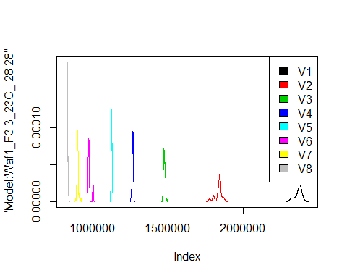

d3_28.28<-d_28.28[,c(17:24)]  
d3_28.28 <- head(d3_28.28,51)  
colnames(d3_28.28) <- c("V1", "V2","V3","V4","V5","V6","V7","V8")  
head(d3_28.28)

## V1 V2 V3 V4 V5 V6 V7 V8  
## 1 11617500 7526250 5675000 4558125 3810000 3326250 2965714 2704063  
## 2 11557500 7696250 5610000 4571250 3803000 3302083 2960714 2700625  
## 3 11515000 7790000 5642500 4586875 3809500 3313333 2940357 2700938  
## 4 11395000 7778750 5615000 4557500 3805500 3307083 2932143 2700313  
## 5 11527500 7798750 5634167 4541250 3806000 3308750 2936071 2699687  
## 6 11532500 7530000 5630000 4575000 3814000 3297917 2911786 2699687

hist(d3_28.28$V1,  
 cex.main=0.5,  
 freq = FALSE,  
 main = paste('Model:Waf1_F5.3_23C_.28.28.,Inject:100NA,mean is:', mean(d3_28.28$V1),' sd is:', sd(d3_28.28$V1)),  
 xlab = "Input",  
 ylab = "Density",  
 col="grey")  
#plot density curve  
lines(density(d3_28.28$V1), # density plot  
 lwd = 2, # thickness of line  
 col = "red")

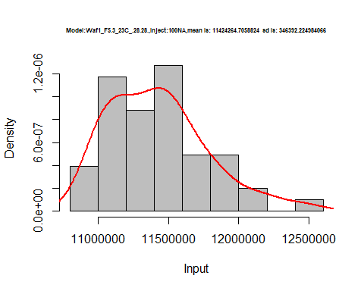

hist(d3_28.28$V2,  
 cex.main=0.5,  
 freq = FALSE,  
 main = paste('Model:Waf1_F5.3_23C_.28.28.,Inject:200NA,mean is:', mean(d3_28.28$V2),' sd is:', sd(d3_28.28$V2)),  
 xlab = "Input",  
 ylab = "Density",  
 col="grey")  
#plot density curve  
lines(density(d3_28.28$V2), # density plot  
 lwd = 2, # thickness of line  
 col = "red")

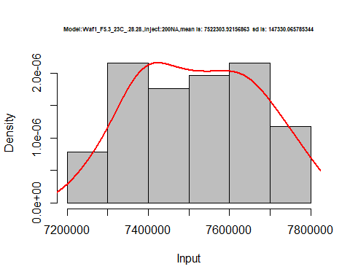

hist(d3_28.28$V3,  
 cex.main=0.5,  
 freq = FALSE,  
 main = paste('Model:Waf1_F5.3_23C_.28.28.,Inject:300NA,mean is:', mean(d3_28.28$V3),' sd is:', sd(d3_28.28$V3)),  
 xlab = "Input",  
 ylab = "Density",  
 col="grey")  
#plot density curve  
lines(density(d3_28.28$V3), # density plot  
 lwd = 2, # thickness of line  
 col = "red")

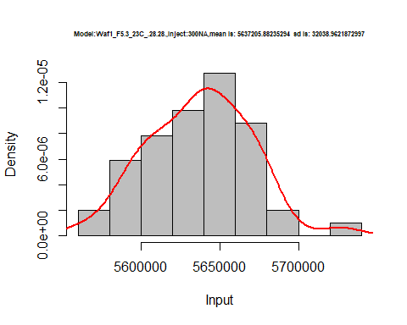

hist(d3_28.28$V4,  
 cex.main=0.5,  
 freq = FALSE,  
 main = paste('Model:Waf1_F5.3_23C_.28.28.,Inject:400NA,mean is:', mean(d3_28.28$V4),' sd is:', sd(d3_28.28$V4)),  
 xlab = "Input",  
 ylab = "Density",  
 col="grey")  
#plot density curve  
lines(density(d3_28.28$V4), # density plot  
 lwd = 2, # thickness of line  
 col = "red")

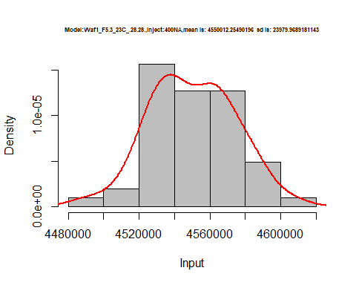

hist(d3_28.28$V5,  
 cex.main=0.5,  
 freq = FALSE,  
 main = paste('Model:Waf1_F5.3_23C_.28.28.,Inject:500NA,mean is:', mean(d3_28.28$V5),' sd is:', sd(d3_28.28$V5)),  
 xlab = "Input",  
 ylab = "Density",  
 col="grey")  
#plot density curve  
lines(density(d3_28.28$V5), # density plot  
 lwd = 2, # thickness of line  
 col = "red")

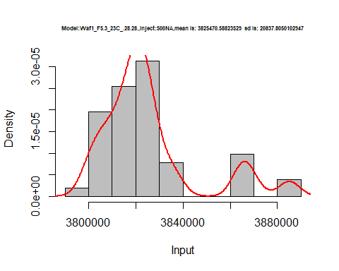

hist(d3_28.28$V6,  
 cex.main=0.5,  
 freq = FALSE,  
 main = paste('Model:Waf1_F5.3_23C_.28.28.,Inject:600NA,mean is:', mean(d3_28.28$V6),' sd is:', sd(d3_28.28$V6)),  
 xlab = "Input",  
 ylab = "Density",  
 col="grey")  
#plot density curve  
lines(density(d3_28.28$V6), # density plot  
 lwd = 2, # thickness of line  
 col = "red")

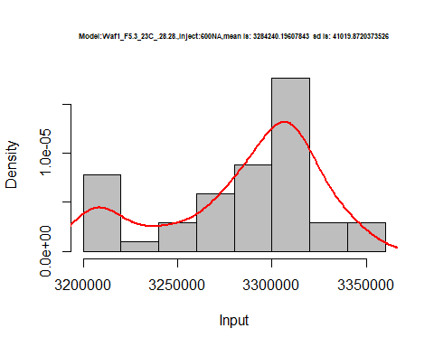

hist(d3_28.28$V7,  
 cex.main=0.5,  
 freq = FALSE,  
 main = paste('Model:Waf1_F5.3_23C_.28.28.,Inject:700NA,mean is:', mean(d3_28.28$V7),' sd is:', sd(d3_28.28$V7)),  
 xlab = "Input",  
 ylab = "Density",  
 col="grey")  
#plot density curve  
lines(density(d3_28.28$V7), # density plot  
 lwd = 2, # thickness of line  
 col = "red")

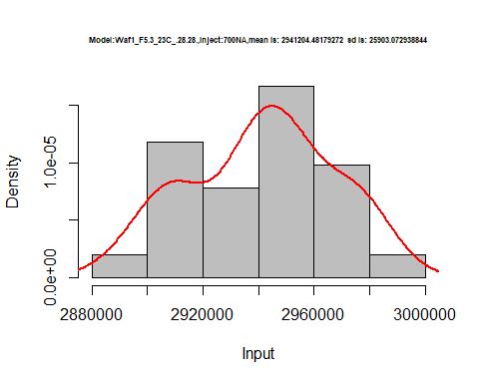

hist(d3_28.28$V8,  
 cex.main=0.5,  
 freq = FALSE,  
 main = paste('Model:Waf1_F5.3_23C_.28.28.,Inject:800NA,mean is:', mean(d3_28.28$V8),' sd is:', sd(d3_28.28$V8)),  
 xlab = "Input",  
 ylab = "Density",  
 col="grey")  
#plot density curve  
lines(density(d3_28.28$V8), # density plot  
 lwd = 2, # thickness of line  
 col = "red")

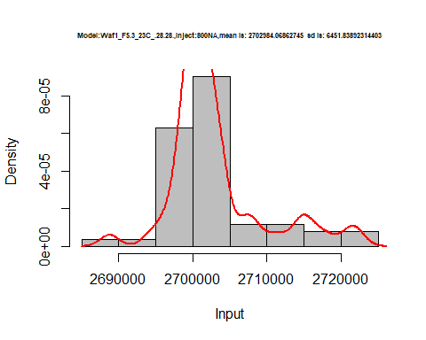

dens <- apply(d3_28.28, 2, density)  
plot('Model:Waf1_F5.3_23C_.28.28', xlim=range(sapply(dens, "[", "x")), ylim=range(sapply(dens, "[", "y")))

## Warning in xy.coords(x, y, xlabel, ylabel, log): NAs introduced by coercion

mapply(lines, dens, col=1:length(dens))

## $V1  
## NULL  
##   
## $V2  
## NULL  
##   
## $V3  
## NULL  
##   
## $V4  
## NULL  
##   
## $V5  
## NULL  
##   
## $V6  
## NULL  
##   
## $V7  
## NULL  
##   
## $V8  
## NULL

legend("topright", legend=names(dens), fill=1:length(dens))

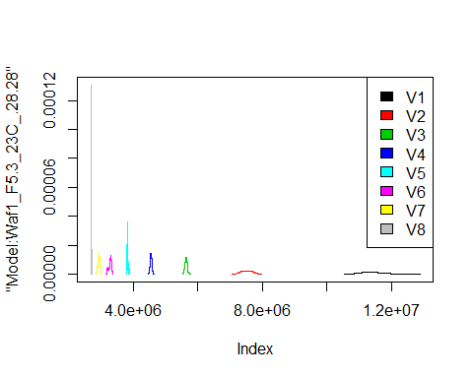

d4_28.28<-d_28.28[,c(25:32)]  
d4_28.28 <- head(d4_28.28,51)  
colnames(d4_28.28) <- c("V1", "V2","V3","V4","V5","V6","V7","V8")  
head(d4_28.28)

## V1 V2 V3 V4 V5 V6 V7 V8  
## 1 2700000 1796250 1471667 1280000 1124500 1012500 1041785.7 845312.5  
## 2 2720000 1807500 1470833 1280625 1123000 1015417 937857.1 842187.5  
## 3 2755000 1800000 1475833 1282500 1128000 1011250 911071.4 840312.5  
## 4 2750000 1840000 1473333 1280000 1123000 1014583 910000.0 845312.5  
## 5 2732500 1870000 1475000 1276875 1124500 1016250 916428.6 841562.5  
## 6 2667500 1853750 1473333 1277500 1122000 1021250 916428.6 844375.0

hist(d4_28.28$V1,  
 cex.main=0.5,  
 freq = FALSE,  
 main = paste('Model:Waf1_F6.8_23C_.28.28.,Inject:100NA,mean is:', mean(d4_28.28$V1),' sd is:', sd(d4_28.28$V1)),  
 xlab = "Input",  
 ylab = "Density",  
 col="grey")  
#plot density curve  
lines(density(d4_28.28$V1), # density plot  
 lwd = 2, # thickness of line  
 col = "red")

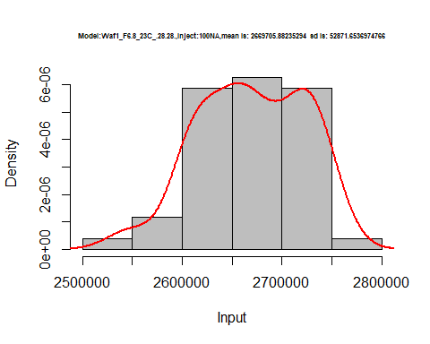

hist(d4_28.28$V2,  
 cex.main=0.5,  
 freq = FALSE,  
 main = paste('Model:Waf1_F6.8_23C_.28.28.,Inject:200NA,mean is:', mean(d4_28.28$V2),' sd is:', sd(d4_28.28$V2)),  
 xlab = "Input",  
 ylab = "Density",  
 col="grey")  
#plot density curve  
lines(density(d4_28.28$V2), # density plot  
 lwd = 2, # thickness of line  
 col = "red")

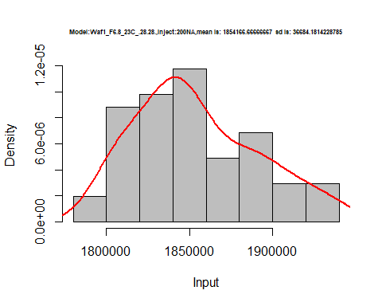

hist(d4_28.28$V3,  
 cex.main=0.5,  
 freq = FALSE,  
 main = paste('Model:Waf1_F6.8_23C_.28.28.,Inject:300NA,mean is:', mean(d4_28.28$V3),' sd is:', sd(d4_28.28$V3)),  
 xlab = "Input",  
 ylab = "Density",  
 col="grey")  
#plot density curve  
lines(density(d4_28.28$V3), # density plot  
 lwd = 2, # thickness of line  
 col = "red")

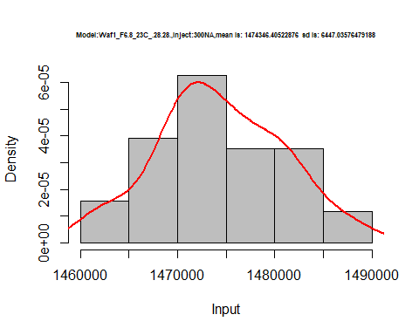

hist(d4_28.28$V4,  
 cex.main=0.5,  
 freq = FALSE,  
 main = paste('Model:Waf1_F6.8_23C_.28.28.,Inject:400NA,mean is:', mean(d4_28.28$V4),' sd is:', sd(d4_28.28$V4)),  
 xlab = "Input",  
 ylab = "Density",  
 col="grey")  
#plot density curve  
lines(density(d4_28.28$V4), # density plot  
 lwd = 2, # thickness of line  
 col = "red")

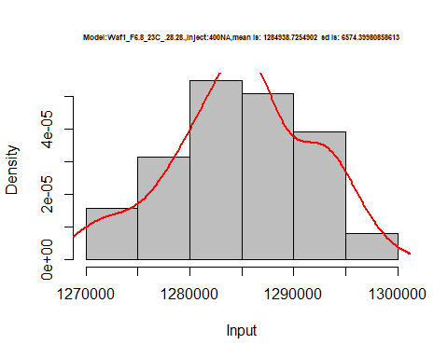

hist(d4_28.28$V5,  
 cex.main=0.5,  
 freq = FALSE,  
 main = paste('Model:Waf1_F6.8_23C_.28.28.,Inject:500NA,mean is:', mean(d4_28.28$V5),' sd is:', sd(d4_28.28$V5)),  
 xlab = "Input",  
 ylab = "Density",  
 col="grey")  
#plot density curve  
lines(density(d4_28.28$V5), # density plot  
 lwd = 2, # thickness of line  
 col = "red")

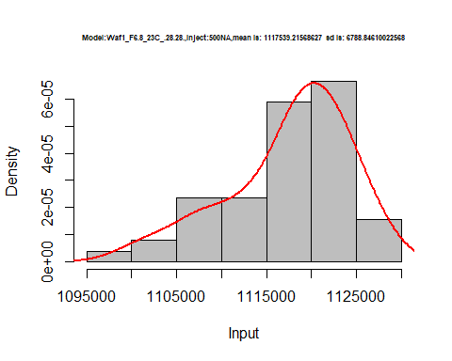

hist(d4_28.28$V6,  
 cex.main=0.5,  
 freq = FALSE,  
 main = paste('Model:Waf1_F6.8_23C_.28.28.,Inject:600NA,mean is:', mean(d4_28.28$V6),' sd is:', sd(d4_28.28$V6)),  
 xlab = "Input",  
 ylab = "Density",  
 col="grey")  
#plot density curve  
lines(density(d4_28.28$V6), # density plot  
 lwd = 2, # thickness of line  
 col = "red")

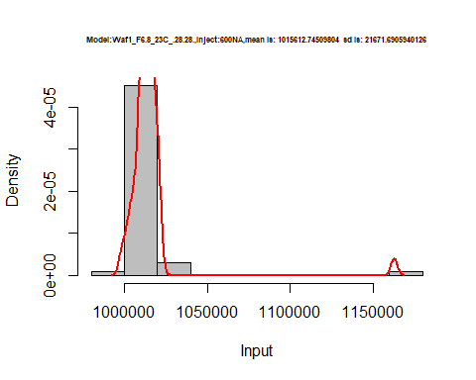

hist(d4_28.28$V7,  
 cex.main=0.5,  
 freq = FALSE,  
 main = paste('Model:Waf1_F6.8_23C_.28.28.,Inject:700NA,mean is:', mean(d4_28.28$V7),' sd is:', sd(d4_28.28$V7)),  
 xlab = "Input",  
 ylab = "Density",  
 col="grey")  
#plot density curve  
lines(density(d4_28.28$V7), # density plot  
 lwd = 2, # thickness of line  
 col = "red")

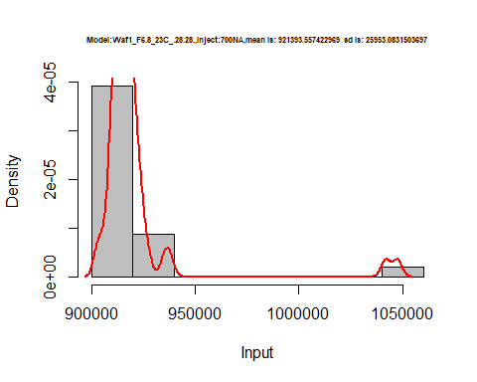

hist(d4_28.28$V8,  
 cex.main=0.5,  
 freq = FALSE,  
 main = paste('Model:Waf1_F6.8_23C_.28.28.,Inject:800NA,mean is:', mean(d4_28.28$V8),' sd is:', sd(d4_28.28$V8)),  
 xlab = "Input",  
 ylab = "Density",  
 col="grey")  
#plot density curve  
lines(density(d4_28.28$V8), # density plot  
 lwd = 2, # thickness of line  
 col = "red")

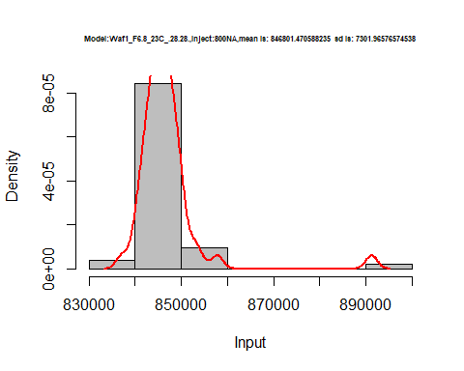

dens <- apply(d4_28.28, 2, density)  
plot('Model:Waf1_F6.8_23C_.28.28', xlim=range(sapply(dens, "[", "x")), ylim=range(sapply(dens, "[", "y")))

## Warning in xy.coords(x, y, xlabel, ylabel, log): NAs introduced by coercion

mapply(lines, dens, col=1:length(dens))

## $V1  
## NULL  
##   
## $V2  
## NULL  
##   
## $V3  
## NULL  
##   
## $V4  
## NULL  
##   
## $V5  
## NULL  
##   
## $V6  
## NULL  
##   
## $V7  
## NULL  
##   
## $V8  
## NULL

legend("topright", legend=names(dens), fill=1:length(dens))

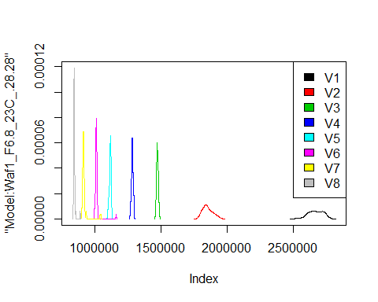

# Select columns whose names contains "29.29"  
d_29.29<-my_data %>% select(contains("29.29."))  
#d_28.28 <- head(d_28.28,51)  
#colnames(d_28.28) <- c("V1", "V2","V3","V4","V5","V6","V7","V8")  
head(d_29.29)

## Waf1_F2.6_23C_.100nA_.29.29. Waf1_F2.6_23C_.200nA_.29.29.  
## 1 5812500 3966250  
## 2 5827500 3962500  
## 3 5832500 3973750  
## 4 5842500 3962500  
## 5 5822500 3961250  
## 6 5842500 3948750  
## Waf1_F2.6_23C_.300nA_.29.29. Waf1_F2.6_23C_.400nA_.29.29.  
## 1 3130833 2637500  
## 2 3129167 2635000  
## 3 3133333 2636250  
## 4 3129167 2635625  
## 5 3129167 2637500  
## 6 3133333 2636250  
## Waf1_F2.6_23C_.500nA_.29.29. Waf1_F2.6_23C_.600nA_.29.29.  
## 1 2332500 2096250  
## 2 2333500 2095417  
## 3 2334500 2095833  
## 4 2332500 2098750  
## 5 2331500 2099167  
## 6 2332500 2098333  
## Waf1_F2.6_23C_.700nA_.29.29. Waf1_F2.6_23C_.800nA_.29.29.  
## 1 1909286 1758437  
## 2 1909643 1761250  
## 3 1909643 1759688  
## 4 1908571 1759688  
## 5 1909286 1760000  
## 6 1910000 1761875  
## Waf1_F3.3_23C_.100nA_.29.29. Waf1_F3.3_23C_.200nA_.29.29.  
## 1 2455000 1993750  
## 2 2455000 2001250  
## 3 2447500 2003750  
## 4 2450000 2006250  
## 5 2455000 2015000  
## 6 2455000 2020000  
## Waf1_F3.3_23C_.300nA_.29.29. Waf1_F3.3_23C_.400nA_.29.29.  
## 1 1665000 1473750  
## 2 1662500 1475625  
## 3 1665000 1471875  
## 4 1670000 1474375  
## 5 1668333 1473750  
## 6 1669167 1474375  
## Waf1_F3.3_23C_.500nA_.29.29. Waf1_F3.3_23C_.600nA_.29.29.  
## 1 1334500 1222083  
## 2 1336000 1222917  
## 3 1318000 1220000  
## 4 1299500 1220417  
## 5 1295000 1222083  
## 6 1294500 1222500  
## Waf1_F3.3_23C_.700nA_.29.29. Waf1_F3.3_23C_.800nA_.29.29.  
## 1 1103214 1035000  
## 2 1103571 1035937  
## 3 1105000 1035313  
## 4 1105357 1042187  
## 5 1105357 1055000  
## 6 1104286 1054688  
## Waf1_F4.3_23C_.100nA_.29.29. Waf1_F4.3_23C_.200nA_.29.29.  
## 1 4920000 3336250  
## 2 4917500 3332500  
## 3 4912500 3332500  
## 4 4912500 3332500  
## 5 4912500 3336250  
## 6 4915000 3332500  
## Waf1_F4.3_23C_.300nA_.29.29. Waf1_F4.3_23C_.400nA_.29.29.  
## 1 2615000 2203750  
## 2 2614167 2204375  
## 3 2614167 2203750  
## 4 2615000 2202500  
## 5 2615000 2205000  
## 6 2612500 2204375  
## Waf1_F4.3_23C_.500nA_.29.29. Waf1_F4.3_23C_.600nA_.29.29.  
## 1 1897500 1664167  
## 2 1899000 1664583  
## 3 1898000 1665417  
## 4 1900000 1664583  
## 5 1901000 1664167  
## 6 1899500 1663750  
## Waf1_F4.3_23C_.700nA_.29.29. Waf1_F4.3_23C_.800nA_.29.29.  
## 1 1497500 1366563  
## 2 1497857 1367812  
## 3 1497143 1368750  
## 4 1496429 1367812  
## 5 1495714 1369687  
## 6 1495714 1368125

d1_29.29<-d_29.29[,c(1:8)]  
d1_29.29 <- head(d1_29.29,51)  
colnames(d1_29.29) <- c("V1", "V2","V3","V4","V5","V6","V7","V8")  
head(d1_29.29)

## V1 V2 V3 V4 V5 V6 V7 V8  
## 1 5812500 3966250 3130833 2637500 2332500 2096250 1909286 1758437  
## 2 5827500 3962500 3129167 2635000 2333500 2095417 1909643 1761250  
## 3 5832500 3973750 3133333 2636250 2334500 2095833 1909643 1759688  
## 4 5842500 3962500 3129167 2635625 2332500 2098750 1908571 1759688  
## 5 5822500 3961250 3129167 2637500 2331500 2099167 1909286 1760000  
## 6 5842500 3948750 3133333 2636250 2332500 2098333 1910000 1761875

hist(d1_29.29$V1,  
 cex.main=0.5,  
 freq = FALSE,  
 main = paste('Model:Waf1_F2.6_23C_.29.29.,Inject:100NA,mean is:', mean(d1_29.29$V1),' sd is:', sd(d1_29.29$V1)),  
 xlab = "Input",  
 ylab = "Density",  
 col="grey")  
#plot density curve  
lines(density(d1_29.29$V1), # density plot  
 lwd = 2, # thickness of line  
 col = "red")

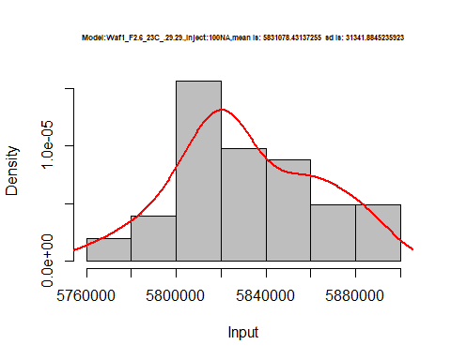

hist(d1_29.29$V2,  
 cex.main=0.5,  
 freq = FALSE,  
 main = paste('Model:Waf1_F2.6_23C_.29.29.,Inject:200NA,mean is:', mean(d1_29.29$V2),' sd is:', sd(d1_29.29$V2)),  
 xlab = "Input",  
 ylab = "Density",  
 col="grey")  
#plot density curve  
lines(density(d1_29.29$V2), # density plot  
 lwd = 2, # thickness of line  
 col = "red")

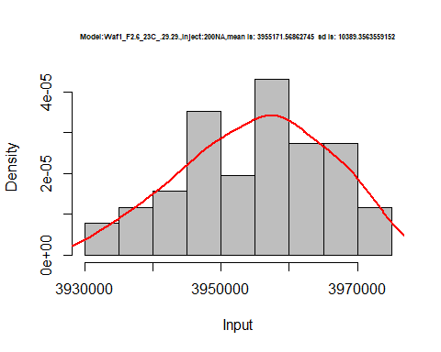

hist(d1_29.29$V3,  
 cex.main=0.5,  
 freq = FALSE,  
 main = paste('Model:Waf1_F2.6_23C_.29.29.,Inject:300NA,mean is:', mean(d1_29.29$V3),' sd is:', sd(d1_29.29$V3)),  
 xlab = "Input",  
 ylab = "Density",  
 col="grey")  
#plot density curve  
lines(density(d1_29.29$V3), # density plot  
 lwd = 2, # thickness of line  
 col = "red")

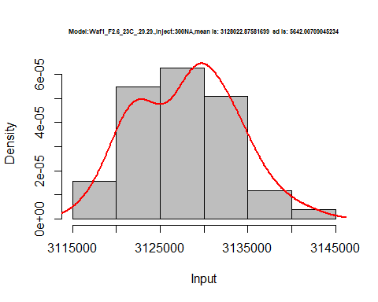

hist(d1_29.29$V4,  
 cex.main=0.5,  
 freq = FALSE,  
 main = paste('Model:Waf1_F2.6_23C_.29.29.,Inject:400NA,mean is:', mean(d1_29.29$V4),' sd is:', sd(d1_29.29$V4)),  
 xlab = "Input",  
 ylab = "Density",  
 col="grey")  
#plot density curve  
lines(density(d1_29.29$V4), # density plot  
 lwd = 2, # thickness of line  
 col = "red")

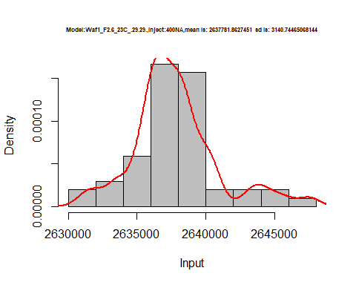

hist(d1_29.29$V5,  
 cex.main=0.5,  
 freq = FALSE,  
 main = paste('Model:Waf1_F2.6_23C_.29.29.,Inject:500NA,mean is:', mean(d1_29.29$V5),' sd is:', sd(d1_29.29$V5)),  
 xlab = "Input",  
 ylab = "Density",  
 col="grey")  
#plot density curve  
lines(density(d1_29.29$V5), # density plot  
 lwd = 2, # thickness of line  
 col = "red")

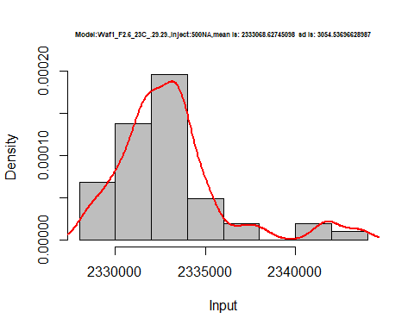

hist(d1_29.29$V6,  
 cex.main=0.5,  
 freq = FALSE,  
 main = paste('Model:Waf1_F2.6_23C_.29.29.,Inject:600NA,mean is:', mean(d1_29.29$V6),' sd is:', sd(d1_29.29$V6)),  
 xlab = "Input",  
 ylab = "Density",  
 col="grey")  
#plot density curve  
lines(density(d1_29.29$V6), # density plot  
 lwd = 2, # thickness of line  
 col = "red")

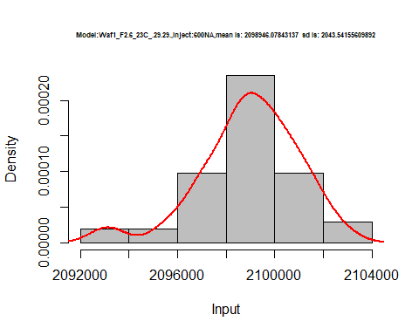

hist(d1_29.29$V7,  
 cex.main=0.5,  
 freq = FALSE,  
 main = paste('Model:Waf1_F2.6_23C_.29.29.,Inject:700NA,mean is:', mean(d1_29.29$V7),' sd is:', sd(d1_29.29$V7)),  
 xlab = "Input",  
 ylab = "Density",  
 col="grey")  
#plot density curve  
lines(density(d1_29.29$V7), # density plot  
 lwd = 2, # thickness of line  
 col = "red")

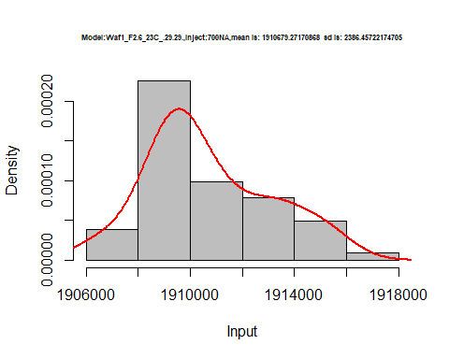

hist(d1_29.29$V8,  
 cex.main=0.5,  
 freq = FALSE,  
 main = paste('Model:Waf1_F2.6_23C_.29.29.,Inject:800NA,mean is:', mean(d1_29.29$V8),' sd is:', sd(d1_29.29$V8)),  
 xlab = "Input",  
 ylab = "Density",  
 col="grey")  
#plot density curve  
lines(density(d1_29.29$V8), # density plot  
 lwd = 2, # thickness of line  
 col = "red")

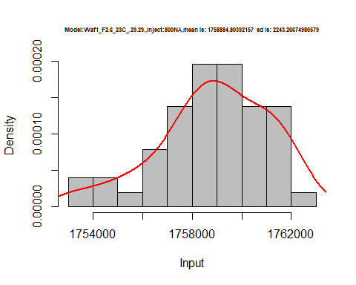

dens <- apply(d1_29.29, 2, density)  
plot('Model:Waf1_F2.6_23C_.29.29', xlim=range(sapply(dens, "[", "x")), ylim=range(sapply(dens, "[", "y")))

## Warning in xy.coords(x, y, xlabel, ylabel, log): NAs introduced by coercion

mapply(lines, dens, col=1:length(dens))

## $V1  
## NULL  
##   
## $V2  
## NULL  
##   
## $V3  
## NULL  
##   
## $V4  
## NULL  
##   
## $V5  
## NULL  
##   
## $V6  
## NULL  
##   
## $V7  
## NULL  
##   
## $V8  
## NULL

legend("topright", legend=names(dens), fill=1:length(dens))

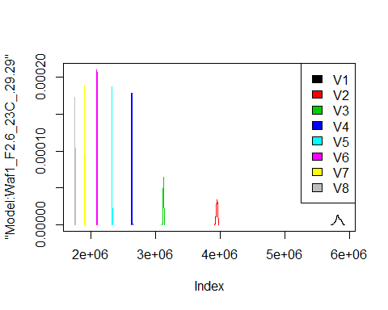

d2_29.29<-d_29.29[,c(9:16)]  
d2_29.29 <- head(d2_29.29,51)  
colnames(d2_29.29) <- c("V1", "V2","V3","V4","V5","V6","V7","V8")  
head(d2_29.29)

## V1 V2 V3 V4 V5 V6 V7 V8  
## 1 2455000 1993750 1665000 1473750 1334500 1222083 1103214 1035000  
## 2 2455000 2001250 1662500 1475625 1336000 1222917 1103571 1035937  
## 3 2447500 2003750 1665000 1471875 1318000 1220000 1105000 1035313  
## 4 2450000 2006250 1670000 1474375 1299500 1220417 1105357 1042187  
## 5 2455000 2015000 1668333 1473750 1295000 1222083 1105357 1055000  
## 6 2455000 2020000 1669167 1474375 1294500 1222500 1104286 1054688

hist(d2_29.29$V1,  
 cex.main=0.5,  
 freq = FALSE,  
 main = paste('Model:Waf1_F3.3_23C_.29.29.,Inject:100NA,mean is:', mean(d2_29.29$V1),' sd is:', sd(d2_29.29$V1)),  
 xlab = "Input",  
 ylab = "Density",  
 col="grey")  
#plot density curve  
lines(density(d2_29.29$V1), # density plot  
 lwd = 2, # thickness of line  
 col = "red")

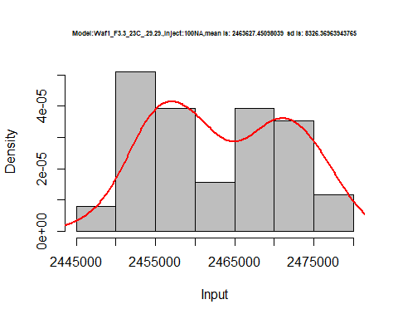

hist(d2_29.29$V2,  
 cex.main=0.5,  
 freq = FALSE,  
 main = paste('Model:Waf1_F3.3_23C_.29.29.,Inject:200NA,mean is:', mean(d2_29.29$V2),' sd is:', sd(d2_29.29$V2)),  
 xlab = "Input",  
 ylab = "Density",  
 col="grey")  
#plot density curve  
lines(density(d2_29.29$V2), # density plot  
 lwd = 2, # thickness of line  
 col = "red")

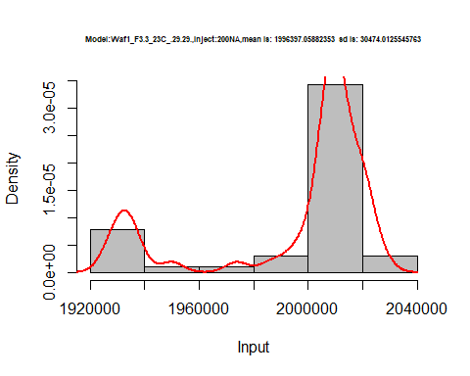

hist(d2_29.29$V3,  
 cex.main=0.5,  
 freq = FALSE,  
 main = paste('Model:Waf1_F3.3_23C_.29.29.,Inject:300NA,mean is:', mean(d2_29.29$V3),' sd is:', sd(d2_29.29$V3)),  
 xlab = "Input",  
 ylab = "Density",  
 col="grey")  
#plot density curve  
lines(density(d2_29.29$V3), # density plot  
 lwd = 2, # thickness of line  
 col = "red")

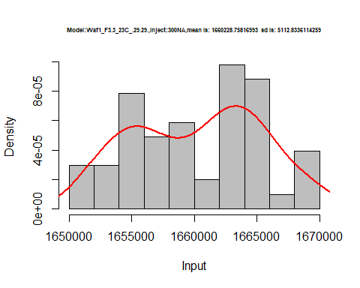

hist(d2_29.29$V4,  
 cex.main=0.5,  
 freq = FALSE,  
 main = paste('Model:Waf1_F3.3_23C_.29.29.,Inject:400NA,mean is:', mean(d2_29.29$V4),' sd is:', sd(d2_29.29$V4)),  
 xlab = "Input",  
 ylab = "Density",  
 col="grey")  
#plot density curve  
lines(density(d2_29.29$V4), # density plot  
 lwd = 2, # thickness of line  
 col = "red")

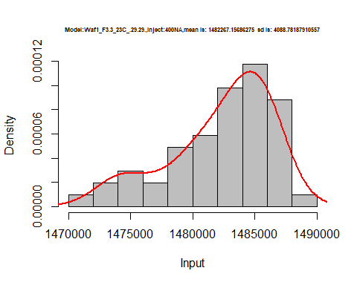

hist(d2_29.29$V5,  
 cex.main=0.5,  
 freq = FALSE,  
 main = paste('Model:Waf1_F3.3_23C_.29.29.,Inject:500NA,mean is:', mean(d2_29.29$V5),' sd is:', sd(d2_29.29$V5)),  
 xlab = "Input",  
 ylab = "Density",  
 col="grey")  
#plot density curve  
lines(density(d2_29.29$V5), # density plot  
 lwd = 2, # thickness of line  
 col = "red")

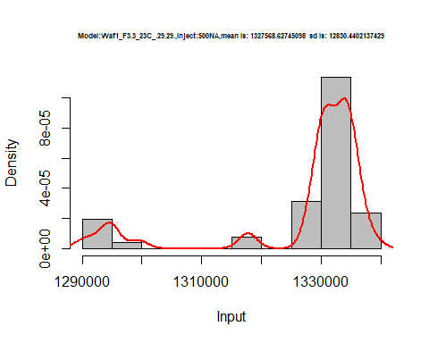

hist(d2_29.29$V6,  
 cex.main=0.5,  
 freq = FALSE,  
 main = paste('Model:Waf1_F3.3_23C_.29.29.,Inject:600NA,mean is:', mean(d2_29.29$V6),' sd is:', sd(d2_29.29$V6)),  
 xlab = "Input",  
 ylab = "Density",  
 col="grey")  
#plot density curve  
lines(density(d2_29.29$V6), # density plot  
 lwd = 2, # thickness of line  
 col = "red")

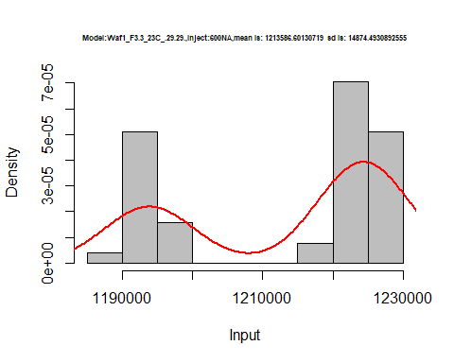

hist(d2_29.29$V7,  
 cex.main=0.5,  
 freq = FALSE,  
 main = paste('Model:Waf1_F3.3_23C_.29.29.,Inject:700NA,mean is:', mean(d2_29.29$V7),' sd is:', sd(d2_29.29$V7)),  
 xlab = "Input",  
 ylab = "Density",  
 col="grey")  
#plot density curve  
lines(density(d2_29.29$V7), # density plot  
 lwd = 2, # thickness of line  
 col = "red")

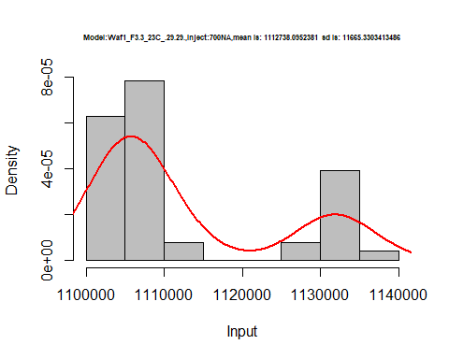

hist(d2_29.29$V8,  
 cex.main=0.5,  
 freq = FALSE,  
 main = paste('Model:Waf1_F3.3_23C_.29.29.,Inject:800NA,mean is:', mean(d2_29.29$V8),' sd is:', sd(d2_29.29$V8)),  
 xlab = "Input",  
 ylab = "Density",  
 col="grey")  
#plot density curve  
lines(density(d2_29.29$V8), # density plot  
 lwd = 2, # thickness of line  
 col = "red")

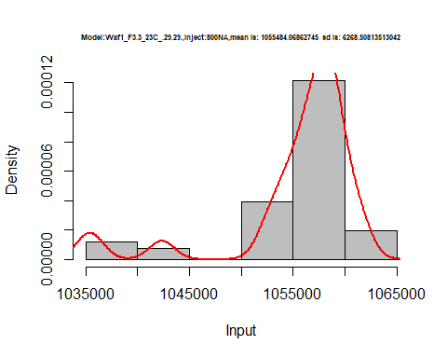

dens <- apply(d2_29.29, 2, density)  
plot('Model:Waf1_F3.3_23C_.29.29', xlim=range(sapply(dens, "[", "x")), ylim=range(sapply(dens, "[", "y")))

## Warning in xy.coords(x, y, xlabel, ylabel, log): NAs introduced by coercion

mapply(lines, dens, col=1:length(dens))

## $V1  
## NULL  
##   
## $V2  
## NULL  
##   
## $V3  
## NULL  
##   
## $V4  
## NULL  
##   
## $V5  
## NULL  
##   
## $V6  
## NULL  
##   
## $V7  
## NULL  
##   
## $V8  
## NULL

legend("topright", legend=names(dens), fill=1:length(dens))

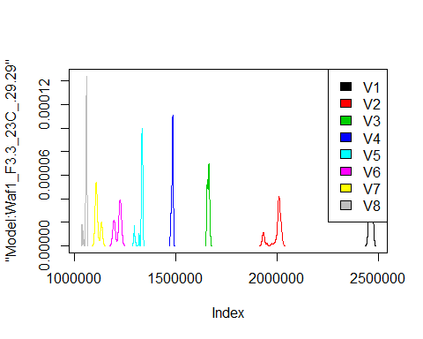

d3_29.29<-d_29.29[,c(17:24)]  
d3_29.29 <- head(d3_29.29,51)  
colnames(d3_29.29) <- c("V1", "V2","V3","V4","V5","V6","V7","V8")  
head(d3_29.29)

## V1 V2 V3 V4 V5 V6 V7 V8  
## 1 4920000 3336250 2615000 2203750 1897500 1664167 1497500 1366563  
## 2 4917500 3332500 2614167 2204375 1899000 1664583 1497857 1367812  
## 3 4912500 3332500 2614167 2203750 1898000 1665417 1497143 1368750  
## 4 4912500 3332500 2615000 2202500 1900000 1664583 1496429 1367812  
## 5 4912500 3336250 2615000 2205000 1901000 1664167 1495714 1369687  
## 6 4915000 3332500 2612500 2204375 1899500 1663750 1495714 1368125

hist(d3_29.29$V1,  
 cex.main=0.5,  
 freq = FALSE,  
 main = paste('Model:Waf1_F4.3_23C_.29.29.,Inject:100NA,mean is:', mean(d3_29.29$V1),' sd is:', sd(d3_29.29$V1)),  
 xlab = "Input",  
 ylab = "Density",  
 col="grey")  
#plot density curve  
lines(density(d3_29.29$V1), # density plot  
 lwd = 2, # thickness of line  
 col = "red")

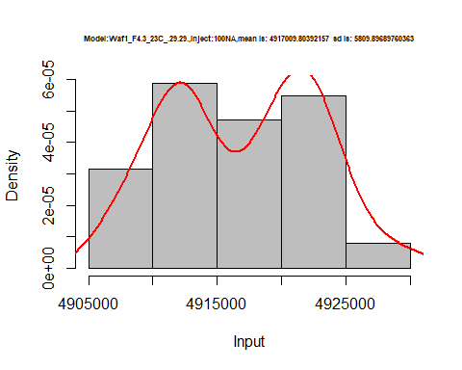

hist(d3_29.29$V2,  
 cex.main=0.5,  
 freq = FALSE,  
 main = paste('Model:Waf1_F4.3_23C_.29.29.,Inject:200NA,mean is:', mean(d3_29.29$V2),' sd is:', sd(d3_29.29$V2)),  
 xlab = "Input",  
 ylab = "Density",  
 col="grey")  
#plot density curve  
lines(density(d3_29.29$V2), # density plot  
 lwd = 2, # thickness of line  
 col = "red")

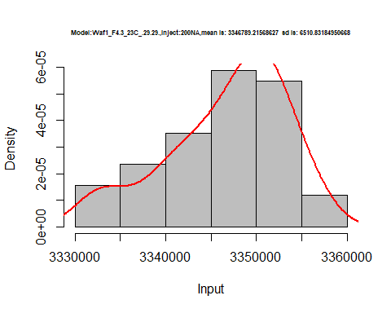

hist(d3_29.29$V3,  
 cex.main=0.5,  
 freq = FALSE,  
 main = paste('Model:Waf1_F4.3_23C_.29.29.,Inject:300NA,mean is:', mean(d3_29.29$V3),' sd is:', sd(d3_29.29$V3)),  
 xlab = "Input",  
 ylab = "Density",  
 col="grey")  
#plot density curve  
lines(density(d3_29.29$V3), # density plot  
 lwd = 2, # thickness of line  
 col = "red")

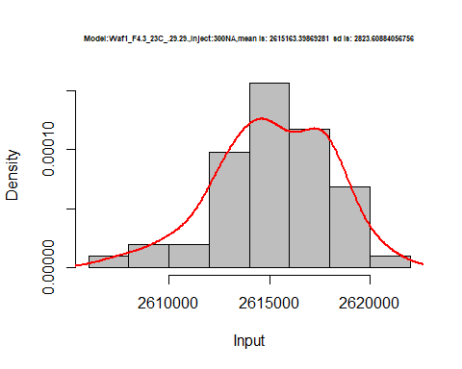

hist(d3_29.29$V4,  
 cex.main=0.5,  
 freq = FALSE,  
 main = paste('Model:Waf1_F4.3_23C_.29.29.,Inject:400NA,mean is:', mean(d3_29.29$V4),' sd is:', sd(d3_29.29$V4)),  
 xlab = "Input",  
 ylab = "Density",  
 col="grey")  
#plot density curve  
lines(density(d3_29.29$V4), # density plot  
 lwd = 2, # thickness of line  
 col = "red")

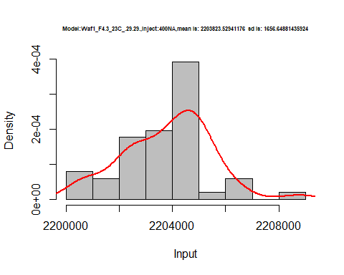

hist(d3_29.29$V5,  
 cex.main=0.5,  
 freq = FALSE,  
 main = paste('Model:Waf1_F4.3_23C_.29.29.,Inject:500NA,mean is:', mean(d3_29.29$V5),' sd is:', sd(d3_29.29$V5)),  
 xlab = "Input",  
 ylab = "Density",  
 col="grey")  
#plot density curve  
lines(density(d3_29.29$V5), # density plot  
 lwd = 2, # thickness of line  
 col = "red")

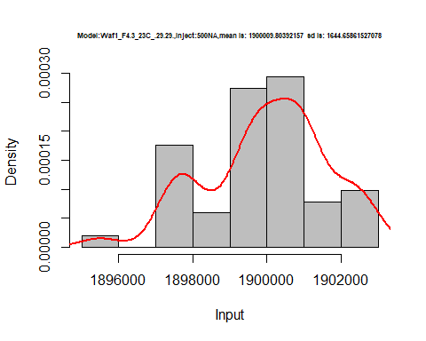

hist(d3_29.29$V6,  
 cex.main=0.5,  
 freq = FALSE,  
 main = paste('Model:Waf1_F4.3_23C_.29.29.,Inject:600NA,mean is:', mean(d3_29.29$V6),' sd is:', sd(d3_29.29$V6)),  
 xlab = "Input",  
 ylab = "Density",  
 col="grey")  
#plot density curve  
lines(density(d3_29.29$V6), # density plot  
 lwd = 2, # thickness of line  
 col = "red")

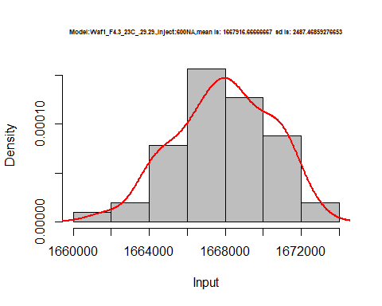

hist(d3_29.29$V7,  
 cex.main=0.5,  
 freq = FALSE,  
 main = paste('Model:Waf1_F4.3_23C_.29.29.,Inject:700NA,mean is:', mean(d3_29.29$V7),' sd is:', sd(d3_29.29$V7)),  
 xlab = "Input",  
 ylab = "Density",  
 col="grey")  
#plot density curve  
lines(density(d3_29.29$V7), # density plot  
 lwd = 2, # thickness of line  
 col = "red")

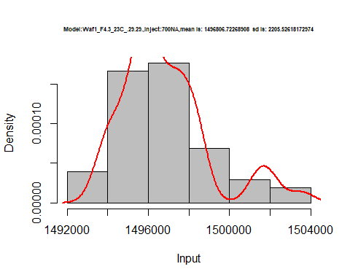

hist(d3_29.29$V8,  
 cex.main=0.5,  
 freq = FALSE,  
 main = paste('Model:Waf1_F4.3_23C_.29.29.,Inject:800NA,mean is:', mean(d3_29.29$V8),' sd is:', sd(d3_29.29$V8)),  
 xlab = "Input",  
 ylab = "Density",  
 col="grey")  
#plot density curve  
lines(density(d3_29.29$V8), # density plot  
 lwd = 2, # thickness of line  
 col = "red")

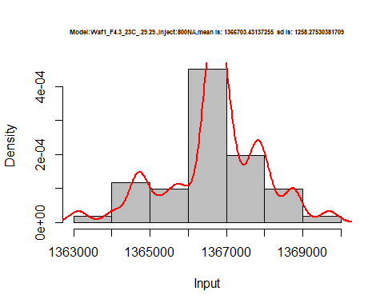

dens <- apply(d3_29.29, 2, density)  
plot('Model:Waf1_F4.3_23C_.29.29', xlim=range(sapply(dens, "[", "x")), ylim=range(sapply(dens, "[", "y")))

## Warning in xy.coords(x, y, xlabel, ylabel, log): NAs introduced by coercion

mapply(lines, dens, col=1:length(dens))

## $V1  
## NULL  
##   
## $V2  
## NULL  
##   
## $V3  
## NULL  
##   
## $V4  
## NULL  
##   
## $V5  
## NULL  
##   
## $V6  
## NULL  
##   
## $V7  
## NULL  
##   
## $V8  
## NULL

legend("topright", legend=names(dens), fill=1:length(dens))

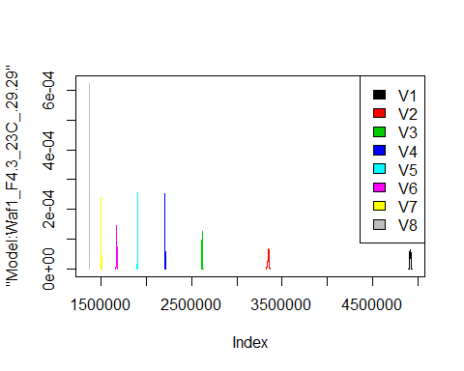

# Select columns whose names contains "30.30"  
d_30.30<-my_data %>% select(contains("30.30"))  
#d_22.22 <- head(d_22.22,51)  
#colnames(d_22.22) <- c("V1", "V2","V3","V4","V5","V6","V7","V8")  
head(d_30.30)

## Waf1_F5.2_23C_.100nA_.30.30. Waf1_F5.2_23C_.200nA_.30.30.  
## 1 2340000 1818750  
## 2 2367500 1823750  
## 3 2337500 1830000  
## 4 2325000 1841250  
## 5 2282500 1851250  
## 6 2397500 1867500  
## Waf1_F5.2_23C_.300nA_.30.30. Waf1_F5.2_23C_.400nA_.30.30.  
## 1 1524167 1261875  
## 2 1520833 1256875  
## 3 1524167 1259375  
## 4 1513333 1252500  
## 5 1518333 1254375  
## 6 1519167 1267500  
## Waf1_F5.2_23C_.500nA_.30.30. Waf1_F5.2_23C_.600nA_.30.30.  
## 1 1127500 1023333  
## 2 1124000 1032917  
## 3 1132500 1044167  
## 4 1130500 1049167  
## 5 1131000 1048333  
## 6 1126000 1059583  
## Waf1_F5.2_23C_.700nA_.30.30. Waf1_F5.2_23C_.800nA_.30.30.  
## 1 964642.9 898125  
## 2 989642.9 900000  
## 3 988571.4 901250  
## 4 969642.9 914375  
## 5 985000.0 901875  
## 6 985714.3 925000  
## Waf1_F5.7_23C_.100nA_.30.30. Waf1_F5.7_23C_.200nA_.30.30.  
## 1 4562500 3086250  
## 2 4630000 2973750  
## 3 4655000 3005000  
## 4 4670000 3056250  
## 5 4562500 2996250  
## 6 4605000 3050000  
## Waf1_F5.7_23C_.300nA_.30.30. Waf1_F5.7_23C_.400nA_.30.30.  
## 1 2318333 1916250  
## 2 2331667 1927500  
## 3 2375833 1922500  
## 4 2369167 1964375  
## 5 2286667 1963125  
## 6 2355000 1951875  
## Waf1_F5.7_23C_.500nA_.30.30. Waf1_F5.7_23C_.600nA_.30.30.  
## 1 1674500 1518333  
## 2 1707000 1520417  
## 3 1657000 1505833  
## 4 1719000 1476250  
## 5 1700500 1512083  
## 6 1670000 1510417  
## Waf1_F5.7_23C_.700nA_.30.30. Waf1_F5.7_23C_.800nA_.30.30.  
## 1 1357857 1245625  
## 2 1340714 1246562  
## 3 1362143 1262187  
## 4 1356429 1264687  
## 5 1357500 1240625  
## 6 1373929 1255313

d1_30.30<-d_30.30[,c(1:8)]  
d1_30.30 <- head(d1_30.30,51)  
colnames(d1_30.30) <- c("V1", "V2","V3","V4","V5","V6","V7","V8")  
head(d1_30.30)

## V1 V2 V3 V4 V5 V6 V7 V8  
## 1 2340000 1818750 1524167 1261875 1127500 1023333 964642.9 898125  
## 2 2367500 1823750 1520833 1256875 1124000 1032917 989642.9 900000  
## 3 2337500 1830000 1524167 1259375 1132500 1044167 988571.4 901250  
## 4 2325000 1841250 1513333 1252500 1130500 1049167 969642.9 914375  
## 5 2282500 1851250 1518333 1254375 1131000 1048333 985000.0 901875  
## 6 2397500 1867500 1519167 1267500 1126000 1059583 985714.3 925000

hist(d1_30.30$V1,  
 cex.main=0.5,  
 freq = FALSE,  
 main = paste('Model:Waf1_F5.2_23C_.30.30.,Inject:100NA,mean is:', mean(d1_30.30$V1),' sd is:', sd(d1_30.30$V1)),  
 xlab = "Input",  
 ylab = "Density",  
 col="grey")  
#plot density curve  
lines(density(d1_30.30$V1), # density plot  
 lwd = 2, # thickness of line  
 col = "red")

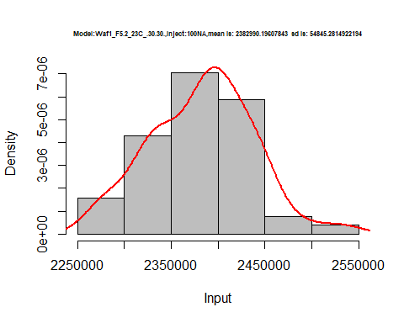

hist(d1_30.30$V2,  
 cex.main=0.5,  
 freq = FALSE,  
 main = paste('Model:Waf1_F5.2_23C_.30.30.,Inject:200NA,mean is:', mean(d1_30.30$V2),' sd is:', sd(d1_30.30$V2)),  
 xlab = "Input",  
 ylab = "Density",  
 col="grey")  
#plot density curve  
lines(density(d1_30.30$V2), # density plot  
 lwd = 2, # thickness of line  
 col = "red")

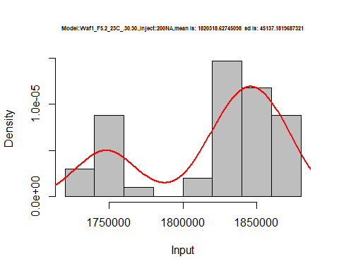

hist(d1_30.30$V3,  
 cex.main=0.5,  
 freq = FALSE,  
 main = paste('Model:Waf1_F5.2_23C_.30.30.,Inject:300NA,mean is:', mean(d1_30.30$V3),' sd is:', sd(d1_30.30$V3)),  
 xlab = "Input",  
 ylab = "Density",  
 col="grey")  
#plot density curve  
lines(density(d1_30.30$V3), # density plot  
 lwd = 2, # thickness of line  
 col = "red")

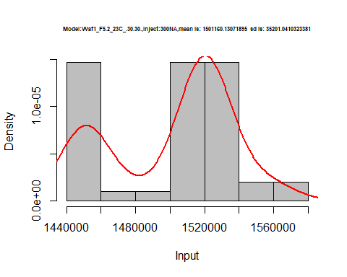

hist(d1_30.30$V4,  
 cex.main=0.5,  
 freq = FALSE,  
 main = paste('Model:Waf1_F5.2_23C_.30.30.,Inject:400NA,mean is:', mean(d1_30.30$V4),' sd is:', sd(d1_30.30$V4)),  
 xlab = "Input",  
 ylab = "Density",  
 col="grey")  
#plot density curve  
lines(density(d1_30.30$V4), # density plot  
 lwd = 2, # thickness of line  
 col = "red")

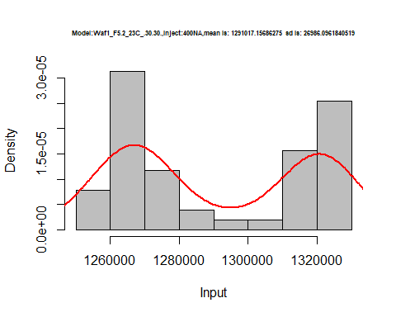

hist(d1_30.30$V5,  
 cex.main=0.5,  
 freq = FALSE,  
 main = paste('Model:Waf1_F5.2_23C_.30.30.,Inject:500NA,mean is:', mean(d1_30.30$V5),' sd is:', sd(d1_30.30$V5)),  
 xlab = "Input",  
 ylab = "Density",  
 col="grey")  
#plot density curve  
lines(density(d1_30.30$V5), # density plot  
 lwd = 2, # thickness of line  
 col = "red")

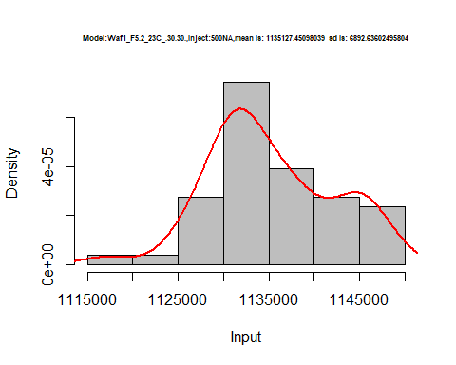

hist(d1_30.30$V6,  
 cex.main=0.5,  
 freq = FALSE,  
 main = paste('Model:Waf1_F5.2_23C_.30.30.,Inject:600NA,mean is:', mean(d1_30.30$V6),' sd is:', sd(d1_30.30$V6)),  
 xlab = "Input",  
 ylab = "Density",  
 col="grey")  
#plot density curve  
lines(density(d1_30.30$V6), # density plot  
 lwd = 2, # thickness of line  
 col = "red")

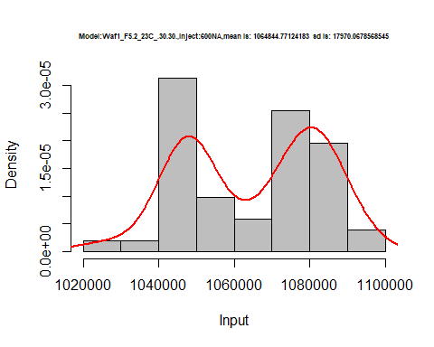

hist(d1_30.30$V7,  
 cex.main=0.5,  
 freq = FALSE,  
 main = paste('Model:Waf1_F5.2_23C_.30.30.,Inject:700NA,mean is:', mean(d1_30.30$V7),' sd is:', sd(d1_30.30$V7)),  
 xlab = "Input",  
 ylab = "Density",  
 col="grey")  
#plot density curve  
lines(density(d1_30.30$V7), # density plot  
 lwd = 2, # thickness of line  
 col = "red")

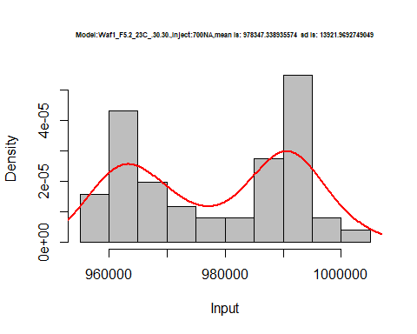

hist(d1_30.30$V8,  
 cex.main=0.5,  
 freq = FALSE,  
 main = paste('Model:Waf1_F5.2_23C_.30.30.,Inject:800NA,mean is:', mean(d1_30.30$V8),' sd is:', sd(d1_30.30$V8)),  
 xlab = "Input",  
 ylab = "Density",  
 col="grey")  
#plot density curve  
lines(density(d1_30.30$V8), # density plot  
 lwd = 2, # thickness of line  
 col = "red")

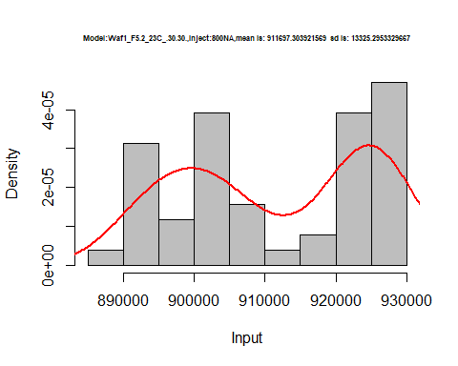

dens <- apply(d1_30.30, 2, density)  
plot('Model:Waf1_F5.2_23C_.30.30', xlim=range(sapply(dens, "[", "x")), ylim=range(sapply(dens, "[", "y")))

## Warning in xy.coords(x, y, xlabel, ylabel, log): NAs introduced by coercion

mapply(lines, dens, col=1:length(dens))

## $V1  
## NULL  
##   
## $V2  
## NULL  
##   
## $V3  
## NULL  
##   
## $V4  
## NULL  
##   
## $V5  
## NULL  
##   
## $V6  
## NULL  
##   
## $V7  
## NULL  
##   
## $V8  
## NULL

legend("topright", legend=names(dens), fill=1:length(dens))

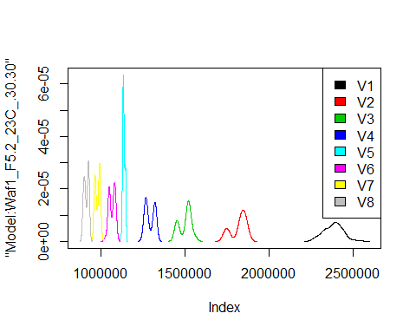

d2_30.30<-d_30.30[,c(9:16)]  
d2_30.30 <- head(d2_30.30,51)  
colnames(d2_30.30) <- c("V1", "V2","V3","V4","V5","V6","V7","V8")  
head(d2_30.30)

## V1 V2 V3 V4 V5 V6 V7 V8  
## 1 4562500 3086250 2318333 1916250 1674500 1518333 1357857 1245625  
## 2 4630000 2973750 2331667 1927500 1707000 1520417 1340714 1246562  
## 3 4655000 3005000 2375833 1922500 1657000 1505833 1362143 1262187  
## 4 4670000 3056250 2369167 1964375 1719000 1476250 1356429 1264687  
## 5 4562500 2996250 2286667 1963125 1700500 1512083 1357500 1240625  
## 6 4605000 3050000 2355000 1951875 1670000 1510417 1373929 1255313

hist(d2_30.30$V1,  
 cex.main=0.5,  
 freq = FALSE,  
 main = paste('Model:Waf1_F5.7_23C_.30.30.,Inject:100NA,mean is:', mean(d2_30.30$V1),' sd is:', sd(d2_30.30$V1)),  
 xlab = "Input",  
 ylab = "Density",  
 col="grey")  
#plot density curve  
lines(density(d2_30.30$V1), # density plot  
 lwd = 2, # thickness of line  
 col = "red")

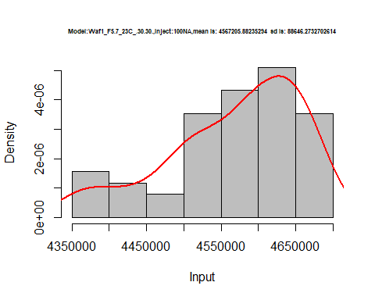

hist(d2_30.30$V2,  
 cex.main=0.5,  
 freq = FALSE,  
 main = paste('Model:Waf1_F5.7_23C_.30.30.,Inject:200NA,mean is:', mean(d2_30.30$V2),' sd is:', sd(d2_30.30$V2)),  
 xlab = "Input",  
 ylab = "Density",  
 col="grey")  
#plot density curve  
lines(density(d2_30.30$V2), # density plot  
 lwd = 2, # thickness of line  
 col = "red")

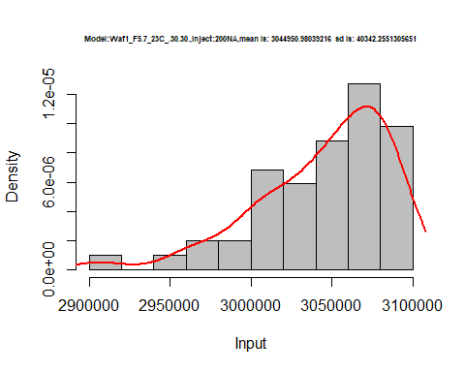

hist(d2_30.30$V3,  
 cex.main=0.5,  
 freq = FALSE,  
 main = paste('Model:Waf1_F5.7_23C_.30.30.,Inject:300NA,mean is:', mean(d2_30.30$V3),' sd is:', sd(d2_30.30$V3)),  
 xlab = "Input",  
 ylab = "Density",  
 col="grey")  
#plot density curve  
lines(density(d2_30.30$V3), # density plot  
 lwd = 2, # thickness of line  
 col = "red")

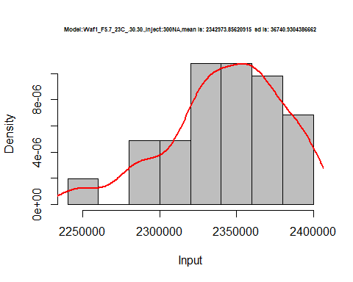

hist(d2_30.30$V4,  
 cex.main=0.5,  
 freq = FALSE,  
 main = paste('Model:Waf1_F5.7_23C_.30.30.,Inject:400NA,mean is:', mean(d2_30.30$V4),' sd is:', sd(d2_30.30$V4)),  
 xlab = "Input",  
 ylab = "Density",  
 col="grey")  
#plot density curve  
lines(density(d2_30.30$V4), # density plot  
 lwd = 2, # thickness of line  
 col = "red")

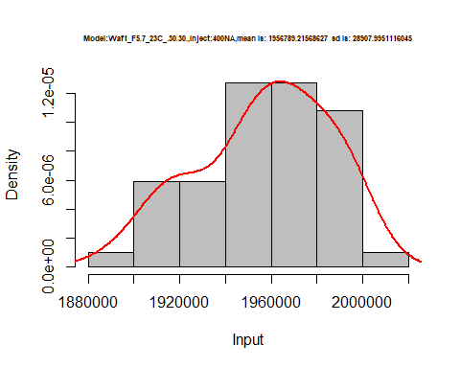

hist(d2_30.30$V5,  
 cex.main=0.5,  
 freq = FALSE,  
 main = paste('Model:Waf1_F5.7_23C_.30.30.,Inject:500NA,mean is:', mean(d2_30.30$V5),' sd is:', sd(d2_30.30$V5)),  
 xlab = "Input",  
 ylab = "Density",  
 col="grey")  
#plot density curve  
lines(density(d2_30.30$V5), # density plot  
 lwd = 2, # thickness of line  
 col = "red")

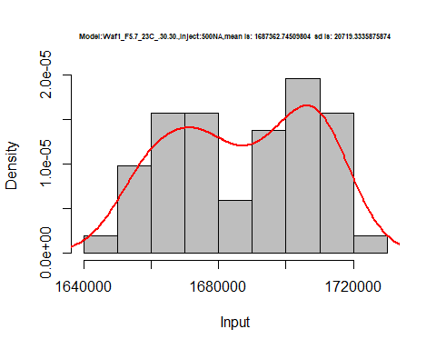

hist(d2_30.30$V6,  
 cex.main=0.5,  
 freq = FALSE,  
 main = paste('Model:Waf1_F5.7_23C_.30.30.,Inject:600NA,mean is:', mean(d2_30.30$V6),' sd is:', sd(d2_30.30$V6)),  
 xlab = "Input",  
 ylab = "Density",  
 col="grey")  
#plot density curve  
lines(density(d2_30.30$V6), # density plot  
 lwd = 2, # thickness of line  
 col = "red")

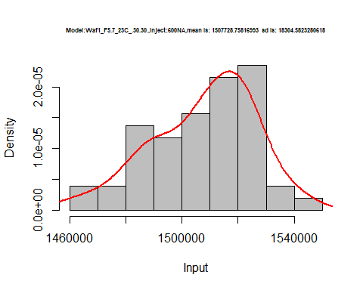

hist(d2_30.30$V7,  
 cex.main=0.5,  
 freq = FALSE,  
 main = paste('Model:Waf1_F5.7_23C_.30.30.,Inject:700NA,mean is:', mean(d2_30.30$V7),' sd is:', sd(d2_30.30$V7)),  
 xlab = "Input",  
 ylab = "Density",  
 col="grey")  
#plot density curve  
lines(density(d2_30.30$V7), # density plot  
 lwd = 2, # thickness of line  
 col = "red")

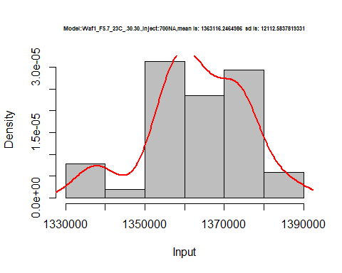

hist(d2_30.30$V8,  
 cex.main=0.5,  
 freq = FALSE,  
 main = paste('Model:Waf1_F5.7_23C_.30.30.,Inject:800NA,mean is:', mean(d2_30.30$V8),' sd is:', sd(d2_30.30$V8)),  
 xlab = "Input",  
 ylab = "Density",  
 col="grey")  
#plot density curve  
lines(density(d2_30.30$V8), # density plot  
 lwd = 2, # thickness of line  
 col = "red")

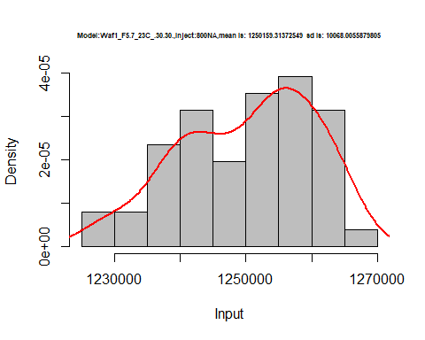

dens <- apply(d2_30.30, 2, density)  
plot('Model:Waf1_F5.7_23C_.30.30', xlim=range(sapply(dens, "[", "x")), ylim=range(sapply(dens, "[", "y")))

## Warning in xy.coords(x, y, xlabel, ylabel, log): NAs introduced by coercion

mapply(lines, dens, col=1:length(dens))

## $V1  
## NULL  
##   
## $V2  
## NULL  
##   
## $V3  
## NULL  
##   
## $V4  
## NULL  
##   
## $V5  
## NULL  
##   
## $V6  
## NULL  
##   
## $V7  
## NULL  
##   
## $V8  
## NULL

legend("topright", legend=names(dens), fill=1:length(dens))

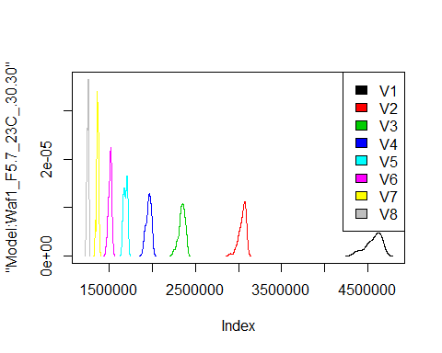

# Select columns whose names contains "31.31"  
d_31.31<-my_data %>% select(contains("31.31"))  
#d_22.22 <- head(d_22.22,51)  
#colnames(d_22.22) <- c("V1", "V2","V3","V4","V5","V6","V7","V8")  
head(d_31.31)

## Waf1_F2.6_23C_.100nA_.31.31. Waf1_F2.6_23C_.200nA_.31.31.  
## 1 1117500 977500  
## 2 1125000 962500  
## 3 1132500 968750  
## 4 1145000 961250  
## 5 1150000 966250  
## 6 1137500 958750  
## Waf1_F2.6_23C_.300nA_.31.31. Waf1_F2.6_23C_.400nA_.31.31.  
## 1 839166.7 773750  
## 2 848333.3 771875  
## 3 849166.7 775000  
## 4 852500.0 774375  
## 5 860833.3 774375  
## 6 863333.3 764375  
## Waf1_F2.6_23C_.500nA_.31.31. Waf1_F2.6_23C_.600nA_.31.31.  
## 1 691500 559583.3  
## 2 691500 564583.3  
## 3 688500 649583.3  
## 4 686500 648750.0  
## 5 687500 656666.7  
## 6 693000 656666.7  
## Waf1_F2.6_23C_.700nA_.31.31. Waf1_F2.6_23C_.800nA_.31.31.  
## 1 605000.0 572812.5  
## 2 598928.6 570625.0  
## 3 608214.3 571250.0  
## 4 602500.0 572812.5  
## 5 601428.6 571875.0  
## 6 606785.7 572500.0  
## Waf1_F3.3_23C_.100nA_.31.31. Waf1_F3.3_23C_.200nA_.31.31.  
## 1 1402500 1155000  
## 2 1417500 1157500  
## 3 1422500 1156250  
## 4 1405000 1155000  
## 5 1407500 1155000  
## 6 1410000 1158750  
## Waf1_F3.3_23C_.300nA_.31.31. Waf1_F3.3_23C_.400nA_.31.31.  
## 1 1003333 901875  
## 2 1001667 903125  
## 3 1001667 906250  
## 4 1004167 905000  
## 5 1004167 903750  
## 6 1005833 906250  
## Waf1_F3.3_23C_.500nA_.31.31. Waf1_F3.3_23C_.600nA_.31.31.  
## 1 809000 761666.7  
## 2 810000 765833.3  
## 3 805500 758333.3  
## 4 804500 757916.7  
## 5 804000 760833.3  
## 6 804500 757916.7  
## Waf1_F3.3_23C_.700nA_.31.31. Waf1_F3.3_23C_.800nA_.31.31.  
## 1 723214.3 686875.0  
## 2 719642.9 686875.0  
## 3 719285.7 687812.5  
## 4 718928.6 689375.0  
## 5 721428.6 690625.0  
## 6 720357.1 688750.0  
## Waf1_F3.5_23C_.100nA_.31.31. Waf1_F3.5_23C_.200nA_.31.31.  
## 1 2632500 2216250  
## 2 2647500 2212500  
## 3 2647500 2228750  
## 4 2642500 2227500  
## 5 2645000 2223750  
## 6 2635000 2225000  
## Waf1_F3.5_23C_.300nA_.31.31. Waf1_F3.5_23C_.400nA_.31.31.  
## 1 1975833 1409375  
## 2 1970833 1411875  
## 3 1976667 1413750  
## 4 1975833 1410625  
## 5 1975000 1411875  
## 6 1972500 1411250  
## Waf1_F3.5_23C_.500nA_.31.31. Waf1_F3.5_23C_.600nA_.31.31.  
## 1 1283000 935833.3  
## 2 1282000 936666.7  
## 3 1282500 937083.3  
## 4 1283000 909166.7  
## 5 1286000 915833.3  
## 6 1290500 932500.0  
## Waf1_F3.5_23C_.700nA_.31.31. Waf1_F3.5_23C_.800nA_.31.31.  
## 1 981071.4 927812.5  
## 2 981071.4 928437.5  
## 3 980000.0 930000.0  
## 4 982500.0 931562.5  
## 5 979285.7 932187.5  
## 6 978928.6 933125.0

d1_31.31<-d_31.31[,c(1:8)]  
d1_31.31 <- head(d1_31.31,51)  
colnames(d1_31.31) <- c("V1", "V2","V3","V4","V5","V6","V7","V8")  
head(d1_31.31)

## V1 V2 V3 V4 V5 V6 V7 V8  
## 1 1117500 977500 839166.7 773750 691500 559583.3 605000.0 572812.5  
## 2 1125000 962500 848333.3 771875 691500 564583.3 598928.6 570625.0  
## 3 1132500 968750 849166.7 775000 688500 649583.3 608214.3 571250.0  
## 4 1145000 961250 852500.0 774375 686500 648750.0 602500.0 572812.5  
## 5 1150000 966250 860833.3 774375 687500 656666.7 601428.6 571875.0  
## 6 1137500 958750 863333.3 764375 693000 656666.7 606785.7 572500.0

hist(d1_31.31$V1,  
 cex.main=0.5,  
 freq = FALSE,  
 main = paste('Model:Waf1_F2.6_23C_.31.31.,Inject:100NA,mean is:', mean(d1_31.31$V1),' sd is:', sd(d1_31.31$V1)),  
 xlab = "Input",  
 ylab = "Density",  
 col="grey")  
#plot density curve  
lines(density(d1_31.31$V1), # density plot  
 lwd = 2, # thickness of line  
 col = "red")

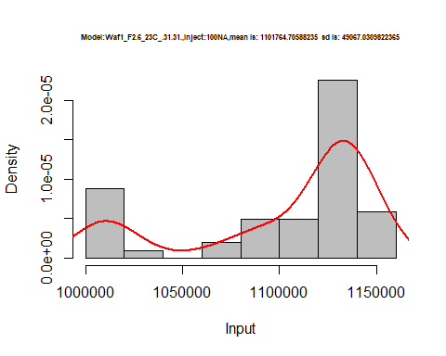

hist(d1_31.31$V2,  
 cex.main=0.5,  
 freq = FALSE,  
 main = paste('Model:Waf1_F2.6_23C_.31.31.,Inject:200NA,mean is:', mean(d1_31.31$V2),' sd is:', sd(d1_31.31$V2)),  
 xlab = "Input",  
 ylab = "Density",  
 col="grey")  
#plot density curve  
lines(density(d1_31.31$V2), # density plot  
 lwd = 2, # thickness of line  
 col = "red")

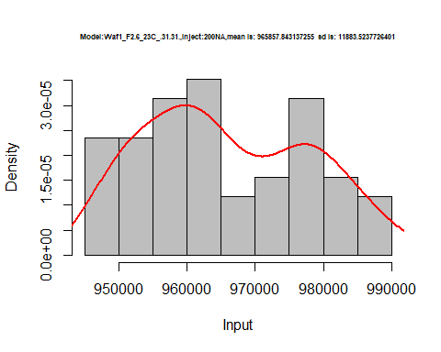

hist(d1_31.31$V3,  
 cex.main=0.5,  
 freq = FALSE,  
 main = paste('Model:Waf1_F2.6_23C_.31.31.,Inject:300NA,mean is:', mean(d1_31.31$V3),' sd is:', sd(d1_31.31$V3)),  
 xlab = "Input",  
 ylab = "Density",  
 col="grey")  
#plot density curve  
lines(density(d1_31.31$V3), # density plot  
 lwd = 2, # thickness of line  
 col = "red")

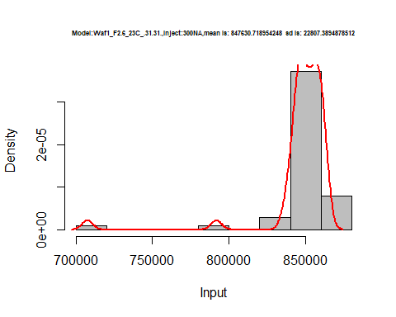

hist(d1_31.31$V4,  
 cex.main=0.5,  
 freq = FALSE,  
 main = paste('Model:Waf1_F2.6_23C_.31.31.,Inject:400NA,mean is:', mean(d1_31.31$V4),' sd is:', sd(d1_31.31$V4)),  
 xlab = "Input",  
 ylab = "Density",  
 col="grey")  
#plot density curve  
lines(density(d1_31.31$V4), # density plot  
 lwd = 2, # thickness of line  
 col = "red")

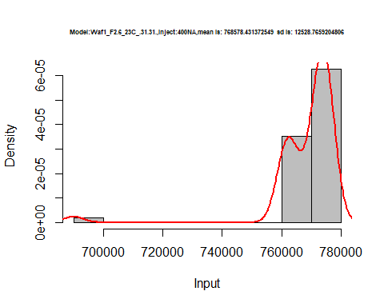

hist(d1_31.31$V5,  
 cex.main=0.5,  
 freq = FALSE,  
 main = paste('Model:Waf1_F2.6_23C_.31.31.,Inject:500NA,mean is:', mean(d1_31.31$V5),' sd is:', sd(d1_31.31$V5)),  
 xlab = "Input",  
 ylab = "Density",  
 col="grey")  
#plot density curve  
lines(density(d1_31.31$V5), # density plot  
 lwd = 2, # thickness of line  
 col = "red")

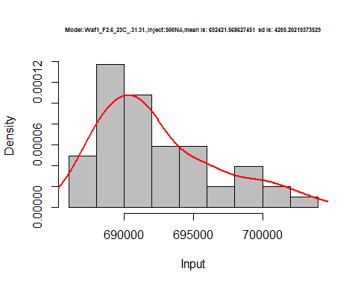

hist(d1_31.31$V6,  
 cex.main=0.5,  
 freq = FALSE,  
 main = paste('Model:Waf1_F2.6_23C_.31.31.,Inject:600NA,mean is:', mean(d1_31.31$V6),' sd is:', sd(d1_31.31$V6)),  
 xlab = "Input",  
 ylab = "Density",  
 col="grey")  
#plot density curve  
lines(density(d1_31.31$V6), # density plot  
 lwd = 2, # thickness of line  
 col = "red")

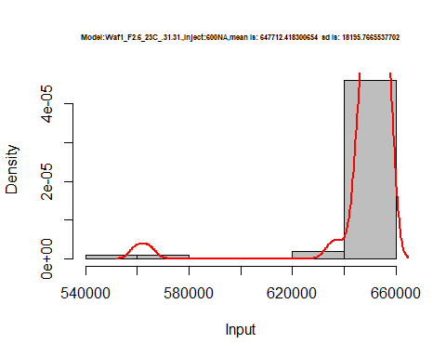

hist(d1_31.31$V7,  
 cex.main=0.5,  
 freq = FALSE,  
 main = paste('Model:Waf1_F2.6_23C_.31.31.,Inject:700NA,mean is:', mean(d1_31.31$V7),' sd is:', sd(d1_31.31$V7)),  
 xlab = "Input",  
 ylab = "Density",  
 col="grey")  
#plot density curve  
lines(density(d1_31.31$V7), # density plot  
 lwd = 2, # thickness of line  
 col = "red")

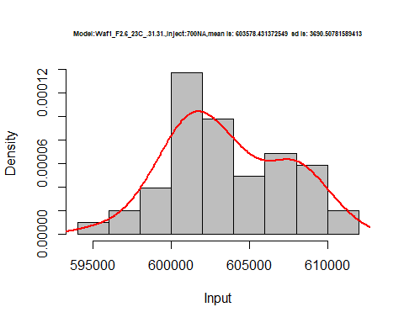

hist(d1_31.31$V8,  
 cex.main=0.5,  
 freq = FALSE,  
 main = paste('Model:Waf1_F2.6_23C_.31.31.,Inject:800NA,mean is:', mean(d1_31.31$V8),' sd is:', sd(d1_31.31$V8)),  
 xlab = "Input",  
 ylab = "Density",  
 col="grey")  
#plot density curve  
lines(density(d1_31.31$V8), # density plot  
 lwd = 2, # thickness of line  
 col = "red")

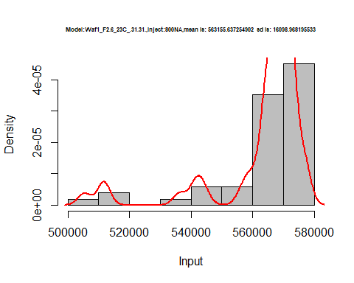

dens <- apply(d1_31.31, 2, density)  
plot('Model:Waf1_F2.6_23C_.31.31', xlim=range(sapply(dens, "[", "x")), ylim=range(sapply(dens, "[", "y")))

## Warning in xy.coords(x, y, xlabel, ylabel, log): NAs introduced by coercion

mapply(lines, dens, col=1:length(dens))

## $V1  
## NULL  
##   
## $V2  
## NULL  
##   
## $V3  
## NULL  
##   
## $V4  
## NULL  
##   
## $V5  
## NULL  
##   
## $V6  
## NULL  
##   
## $V7  
## NULL  
##   
## $V8  
## NULL

legend("topright", legend=names(dens), fill=1:length(dens))

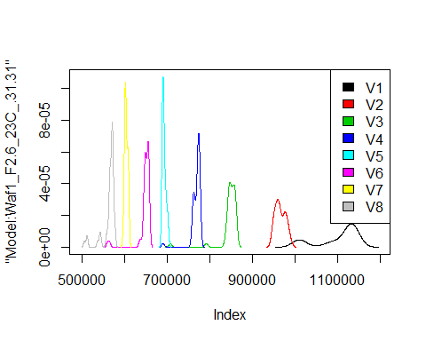

d2_31.31<-d_31.31[,c(9:16)]  
d2_31.31 <- head(d2_31.31,51)  
colnames(d2_31.31) <- c("V1", "V2","V3","V4","V5","V6","V7","V8")  
head(d2_31.31)

## V1 V2 V3 V4 V5 V6 V7 V8  
## 1 1402500 1155000 1003333 901875 809000 761666.7 723214.3 686875.0  
## 2 1417500 1157500 1001667 903125 810000 765833.3 719642.9 686875.0  
## 3 1422500 1156250 1001667 906250 805500 758333.3 719285.7 687812.5  
## 4 1405000 1155000 1004167 905000 804500 757916.7 718928.6 689375.0  
## 5 1407500 1155000 1004167 903750 804000 760833.3 721428.6 690625.0  
## 6 1410000 1158750 1005833 906250 804500 757916.7 720357.1 688750.0

hist(d2_31.31$V1,  
 cex.main=0.5,  
 freq = FALSE,  
 main = paste('Model:Waf1_F3.3_23C_.31.31.,Inject:100NA,mean is:', mean(d2_31.31$V1),' sd is:', sd(d2_31.31$V1)),  
 xlab = "Input",  
 ylab = "Density",  
 col="grey")  
#plot density curve  
lines(density(d2_31.31$V1), # density plot  
 lwd = 2, # thickness of line  
 col = "red")

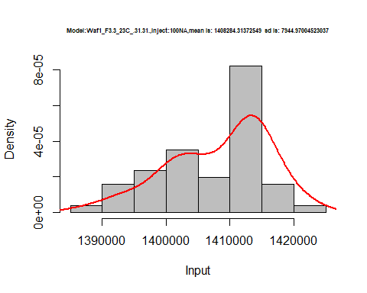

hist(d2_31.31$V2,  
 cex.main=0.5,  
 freq = FALSE,  
 main = paste('Model:Waf1_F3.3_23C_.31.31.,Inject:100NA,mean is:', mean(d2_31.31$V2),' sd is:', sd(d2_31.31$V2)),  
 xlab = "Input",  
 ylab = "Density",  
 col="grey")  
#plot density curve  
lines(density(d2_31.31$V2), # density plot  
 lwd = 2, # thickness of line  
 col = "red")

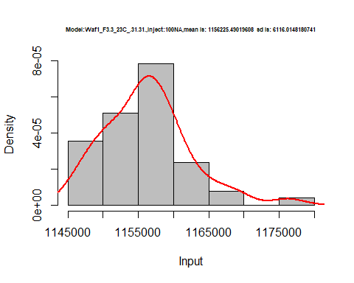

hist(d2_31.31$V3,  
 cex.main=0.5,  
 freq = FALSE,  
 main = paste('Model:Waf1_F3.3_23C_.31.31.,Inject:300NA,mean is:', mean(d2_31.31$V3),' sd is:', sd(d2_31.31$V3)),  
 xlab = "Input",  
 ylab = "Density",  
 col="grey")  
#plot density curve  
lines(density(d2_31.31$V3), # density plot  
 lwd = 2, # thickness of line  
 col = "red")

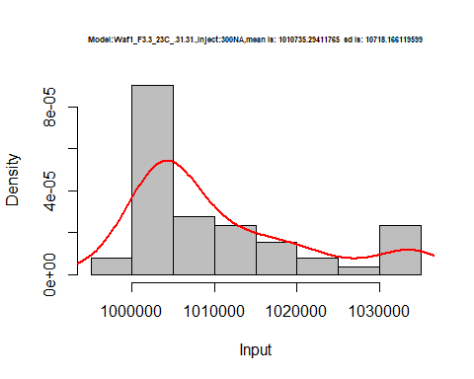

hist(d2_31.31$V4,  
 cex.main=0.5,  
 freq = FALSE,  
 main = paste('Model:Waf1_F3.3_23C_.31.31.,Inject:400NA,mean is:', mean(d2_31.31$V4),' sd is:', sd(d2_31.31$V4)),  
 xlab = "Input",  
 ylab = "Density",  
 col="grey")  
#plot density curve  
lines(density(d2_31.31$V4), # density plot  
 lwd = 2, # thickness of line  
 col = "red")

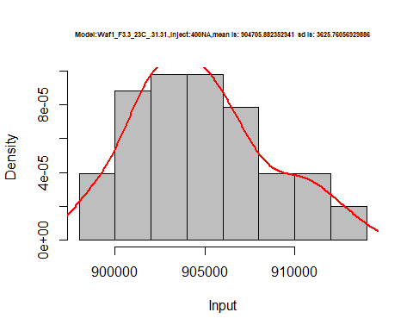

hist(d2_31.31$V5,  
 cex.main=0.5,  
 freq = FALSE,  
 main = paste('Model:Waf1_F3.3_23C_.31.31.,Inject:500NA,mean is:', mean(d2_31.31$V5),' sd is:', sd(d2_31.31$V5)),  
 xlab = "Input",  
 ylab = "Density",  
 col="grey")  
#plot density curve  
lines(density(d2_31.31$V5), # density plot  
 lwd = 2, # thickness of line  
 col = "red")

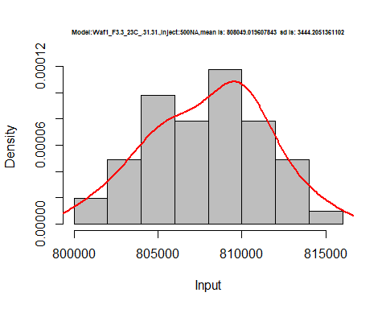

hist(d2_31.31$V6,  
 cex.main=0.5,  
 freq = FALSE,  
 main = paste('Model:Waf1_F3.3_23C_.31.31.,Inject:600NA,mean is:', mean(d2_31.31$V6),' sd is:', sd(d2_31.31$V6)),  
 xlab = "Input",  
 ylab = "Density",  
 col="grey")  
#plot density curve  
lines(density(d2_31.31$V6), # density plot  
 lwd = 2, # thickness of line  
 col = "red")

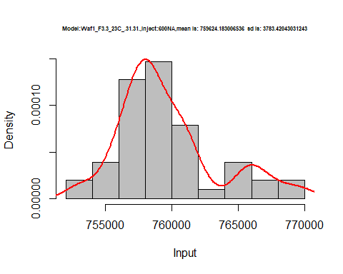

hist(d2_31.31$V7,  
 cex.main=0.5,  
 freq = FALSE,  
 main = paste('Model:Waf1_F3.3_23C_.31.31.,Inject:700NA,mean is:', mean(d2_31.31$V7),' sd is:', sd(d2_31.31$V7)),  
 xlab = "Input",  
 ylab = "Density",  
 col="grey")  
#plot density curve  
lines(density(d2_31.31$V7), # density plot  
 lwd = 2, # thickness of line  
 col = "red")

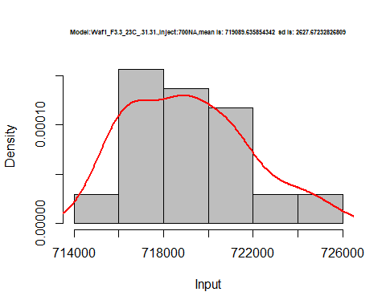

hist(d2_31.31$V8,  
 cex.main=0.5,  
 freq = FALSE,  
 main = paste('Model:Waf1_F3.3_23C_.31.31.,Inject:800NA,mean is:', mean(d2_31.31$V8),' sd is:', sd(d2_31.31$V8)),  
 xlab = "Input",  
 ylab = "Density",  
 col="grey")  
#plot density curve  
lines(density(d2_31.31$V8), # density plot  
 lwd = 2, # thickness of line  
 col = "red")

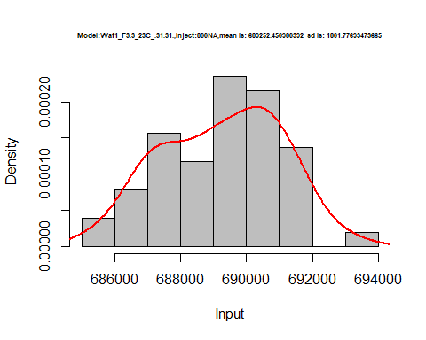

dens <- apply(d2_31.31, 2, density)  
plot('Model:Waf1_F3.3_23C_.31.31', xlim=range(sapply(dens, "[", "x")), ylim=range(sapply(dens, "[", "y")))

## Warning in xy.coords(x, y, xlabel, ylabel, log): NAs introduced by coercion

mapply(lines, dens, col=1:length(dens))

## $V1  
## NULL  
##   
## $V2  
## NULL  
##   
## $V3  
## NULL  
##   
## $V4  
## NULL  
##   
## $V5  
## NULL  
##   
## $V6  
## NULL  
##   
## $V7  
## NULL  
##   
## $V8  
## NULL

legend("topright", legend=names(dens), fill=1:length(dens))

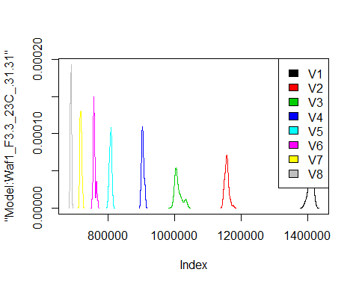

d3_31.31<-d_31.31[,c(17:24)]  
d3_31.31 <- head(d3_31.31,51)  
colnames(d3_31.31) <- c("V1", "V2","V3","V4","V5","V6","V7","V8")  
head(d3_31.31)

## V1 V2 V3 V4 V5 V6 V7 V8  
## 1 2632500 2216250 1975833 1409375 1283000 935833.3 981071.4 927812.5  
## 2 2647500 2212500 1970833 1411875 1282000 936666.7 981071.4 928437.5  
## 3 2647500 2228750 1976667 1413750 1282500 937083.3 980000.0 930000.0  
## 4 2642500 2227500 1975833 1410625 1283000 909166.7 982500.0 931562.5  
## 5 2645000 2223750 1975000 1411875 1286000 915833.3 979285.7 932187.5  
## 6 2635000 2225000 1972500 1411250 1290500 932500.0 978928.6 933125.0

hist(d3_31.31$V1,  
 cex.main=0.5,  
 freq = FALSE,  
 main = paste('Model:Waf1_F3.5_23C_.31.31.,Inject:100NA,mean is:', mean(d3_31.31$V1),' sd is:', sd(d3_31.31$V1)),  
 xlab = "Input",  
 ylab = "Density",  
 col="grey")  
#plot density curve  
lines(density(d3_31.31$V1), # density plot  
 lwd = 2, # thickness of line  
 col = "red")

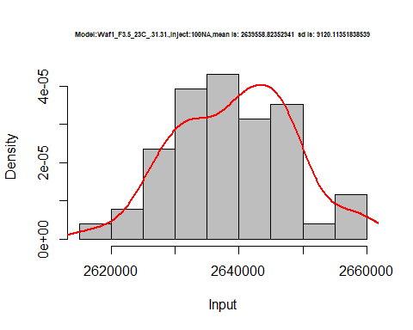

hist(d3_31.31$V2,  
 cex.main=0.5,  
 freq = FALSE,  
 main = paste('Model:Waf1_F3.5_23C_.31.31.,Inject:200NA,mean is:', mean(d3_31.31$V2),' sd is:', sd(d3_31.31$V2)),  
 xlab = "Input",  
 ylab = "Density",  
 col="grey")  
#plot density curve  
lines(density(d3_31.31$V2), # density plot  
 lwd = 2, # thickness of line  
 col = "red")

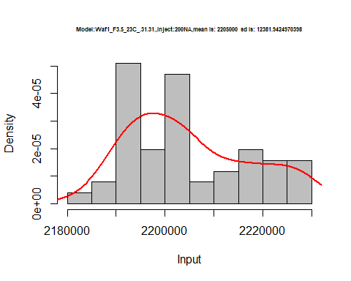

hist(d3_31.31$V3,  
 cex.main=0.5,  
 freq = FALSE,  
 main = paste('Model:Waf1_F3.5_23C_.31.31.,Inject:300NA,mean is:', mean(d3_31.31$V3),' sd is:', sd(d3_31.31$V3)),  
 xlab = "Input",  
 ylab = "Density",  
 col="grey")  
#plot density curve  
lines(density(d3_31.31$V3), # density plot  
 lwd = 2, # thickness of line  
 col = "red")

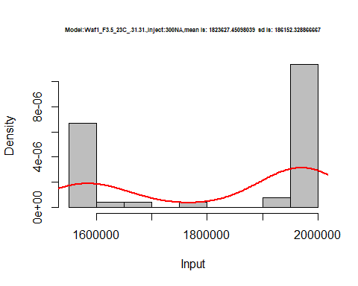

hist(d3_31.31$V4,  
 cex.main=0.5,  
 freq = FALSE,  
 main = paste('Model:Waf1_F3.5_23C_.31.31.,Inject:200NA,mean is:', mean(d3_31.31$V4),' sd is:', sd(d3_31.31$V4)),  
 xlab = "Input",  
 ylab = "Density",  
 col="grey")  
#plot density curve  
lines(density(d3_31.31$V4), # density plot  
 lwd = 2, # thickness of line  
 col = "red")

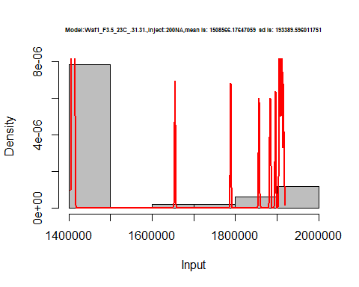

hist(d3_31.31$V5,  
 cex.main=0.5,  
 freq = FALSE,  
 main = paste('Model:Waf1_F3.5_23C_.31.31.,Inject:500NA,mean is:', mean(d3_31.31$V5),' sd is:', sd(d3_31.31$V5)),  
 xlab = "Input",  
 ylab = "Density",  
 col="grey")  
#plot density curve  
lines(density(d3_31.31$V5), # density plot  
 lwd = 2, # thickness of line  
 col = "red")

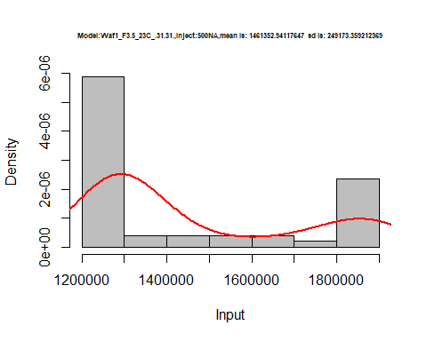

hist(d3_31.31$V6,  
 cex.main=0.5,  
 freq = FALSE,  
 main = paste('Model:Waf1_F3.5_23C_.31.31.,Inject:200NA,mean is:', mean(d3_31.31$V6),' sd is:', sd(d3_31.31$V6)),  
 xlab = "Input",  
 ylab = "Density",  
 col="grey")  
#plot density curve  
lines(density(d3_31.31$V6), # density plot  
 lwd = 2, # thickness of line  
 col = "red")

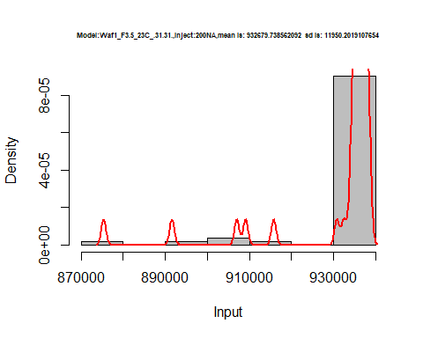

hist(d3_31.31$V7,  
 cex.main=0.5,  
 freq = FALSE,  
 main = paste('Model:Waf1_F3.5_23C_.31.31.,Inject:700NA,mean is:', mean(d3_31.31$V7),' sd is:', sd(d3_31.31$V7)),  
 xlab = "Input",  
 ylab = "Density",  
 col="grey")  
#plot density curve  
lines(density(d3_31.31$V7), # density plot  
 lwd = 2, # thickness of line  
 col = "red")

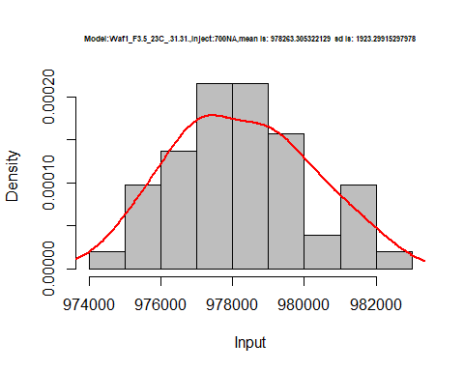

hist(d3_31.31$V8,  
 cex.main=0.5,  
 freq = FALSE,  
 main = paste('Model:Waf1_F3.5_23C_.31.31.,Inject:800NA,mean is:', mean(d3_31.31$V8),' sd is:', sd(d3_31.31$V8)),  
 xlab = "Input",  
 ylab = "Density",  
 col="grey")  
#plot density curve  
lines(density(d3_31.31$V8), # density plot  
 lwd = 2, # thickness of line  
 col = "red")

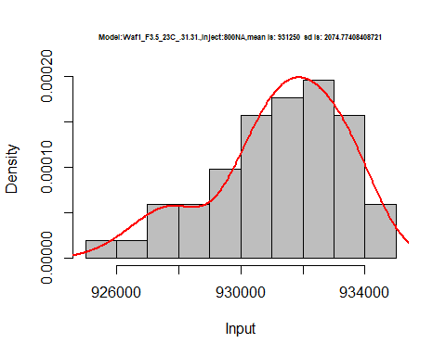

dens <- apply(d3_31.31, 2, density)  
plot('Model:Waf1_F3.5_23C_.31.31', xlim=range(sapply(dens, "[", "x")), ylim=range(sapply(dens, "[", "y")))

## Warning in xy.coords(x, y, xlabel, ylabel, log): NAs introduced by coercion

mapply(lines, dens, col=1:length(dens))

## $V1  
## NULL  
##   
## $V2  
## NULL  
##   
## $V3  
## NULL  
##   
## $V4  
## NULL  
##   
## $V5  
## NULL  
##   
## $V6  
## NULL  
##   
## $V7  
## NULL  
##   
## $V8  
## NULL

legend("topright", legend=names(dens), fill=1:length(dens))

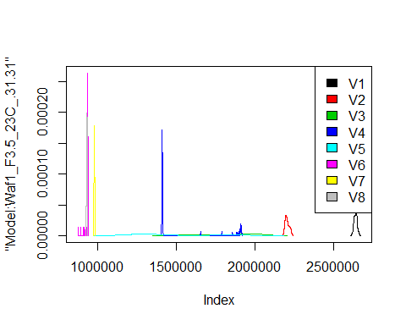

# Select columns whose names contains "32.32"  
d_32.32<-my_data %>% select(contains("32.32"))  
d_32.32 <- head(d_32.32,51)  
colnames(d_32.32) <- c("V1", "V2","V3","V4","V5","V6","V7","V8")  
head(d_32.32)

## V1 V2 V3 V4 V5 V6 V7 V8  
## 1 1197500 1010000 878333.3 784375 721500 666250.0 620357.1 575312.5  
## 2 1192500 1011250 879166.7 786875 723500 664166.7 622142.9 574062.5  
## 3 1185000 1013750 884166.7 785000 730500 665000.0 621785.7 574687.5  
## 4 1185000 1011250 880000.0 788750 723500 665833.3 620357.1 575000.0  
## 5 1180000 1011250 878333.3 786250 723500 667083.3 621785.7 574687.5  
## 6 1182500 1012500 876666.7 788750 721000 663750.0 622857.1 576250.0

hist(d_32.32$V1,  
 cex.main=0.5,  
 freq = FALSE,  
 main = paste('Model:Waf1_F3.3_23C_.32.32.,Inject:100NA,mean is:', mean(d_32.32$V1),' sd is:', sd(d_32.32$V1)),  
 xlab = "Input",  
 ylab = "Density",  
 col="grey")  
#plot density curve  
lines(density(d_32.32$V1), # density plot  
 lwd = 2, # thickness of line  
 col = "red")

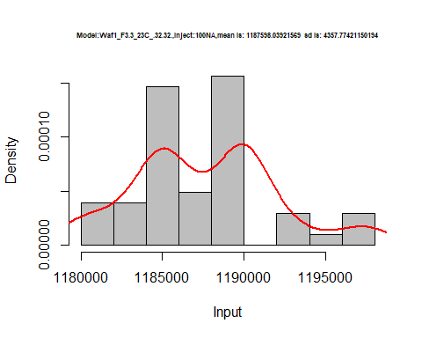

hist(d_32.32$V2,  
 cex.main=0.5,  
 freq = FALSE,  
 main = paste('Model:Waf1_F3.3_23C_.32.32.,Inject:200NA,mean is:', mean(d_32.32$V2),' sd is:', sd(d_32.32$V2)),  
 xlab = "Input",  
 ylab = "Density",  
 col="grey")  
#plot density curve  
lines(density(d_32.32$V2), # density plot  
 lwd = 2, # thickness of line  
 col = "red")

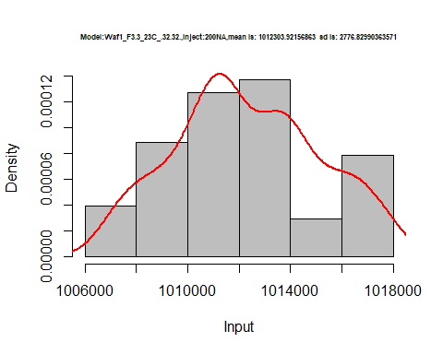

hist(d_32.32$V3,  
 cex.main=0.5,  
 freq = FALSE,  
 main = paste('Model:Waf1_F3.3_23C_.32.32.,Inject:300NA,mean is:', mean(d_32.32$V3),' sd is:', sd(d_32.32$V3)),  
 xlab = "Input",  
 ylab = "Density",  
 col="grey")  
#plot density curve  
lines(density(d_32.32$V3), # density plot  
 lwd = 2, # thickness of line  
 col = "red")

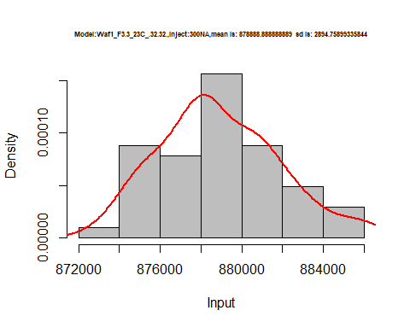

hist(d_32.32$V4,  
 cex.main=0.5,  
 freq = FALSE,  
 main = paste('Model:Waf1_F3.3_23C_.32.32.,Inject:400NA,mean is:', mean(d_32.32$V4),' sd is:', sd(d_32.32$V4)),  
 xlab = "Input",  
 ylab = "Density",  
 col="grey")  
#plot density curve  
lines(density(d_32.32$V4), # density plot  
 lwd = 2, # thickness of line  
 col = "red")

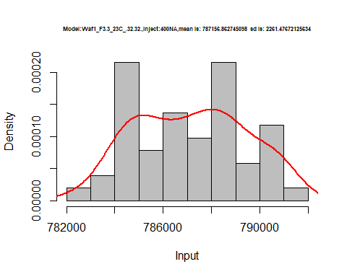

hist(d_32.32$V5,  
 cex.main=0.5,  
 freq = FALSE,  
 main = paste('Model:Waf1_F3.3_23C_.32.32.,Inject:300NA,mean is:', mean(d_32.32$V5),' sd is:', sd(d_32.32$V5)),  
 xlab = "Input",  
 ylab = "Density",  
 col="grey")  
#plot density curve  
lines(density(d_32.32$V5), # density plot  
 lwd = 2, # thickness of line  
 col = "red")

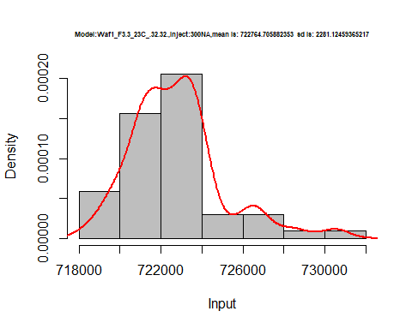

hist(d_32.32$V6,  
 cex.main=0.5,  
 freq = FALSE,  
 main = paste('Model:Waf1_F3.3_23C_.32.32.,Inject:600NA,mean is:', mean(d_32.32$V6),' sd is:', sd(d_32.32$V6)),  
 xlab = "Input",  
 ylab = "Density",  
 col="grey")  
#plot density curve  
lines(density(d_32.32$V6), # density plot  
 lwd = 2, # thickness of line  
 col = "red")

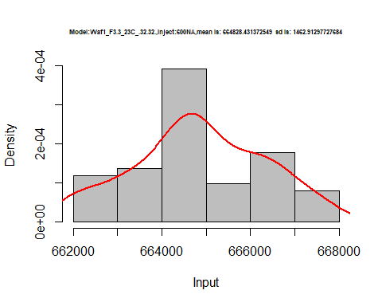

hist(d_32.32$V7,  
 cex.main=0.5,  
 freq = FALSE,  
 main = paste('Model:Waf1_F3.3_23C_.32.32.,Inject:700NA,mean is:', mean(d_32.32$V7),' sd is:', sd(d_32.32$V7)),  
 xlab = "Input",  
 ylab = "Density",  
 col="grey")  
#plot density curve  
lines(density(d_32.32$V7), # density plot  
 lwd = 2, # thickness of line  
 col = "red")

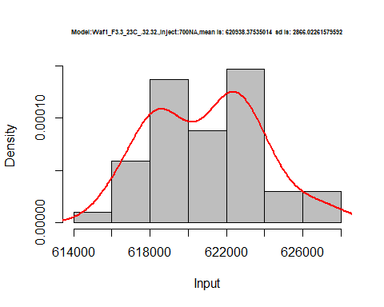

hist(d_32.32$V8,  
 cex.main=0.5,  
 freq = FALSE,  
 main = paste('Model:Waf1_F3.3_23C_.32.32.,Inject:800NA,mean is:', mean(d_32.32$V8),' sd is:', sd(d_32.32$V8)),  
 xlab = "Input",  
 ylab = "Density",  
 col="grey")  
#plot density curve  
lines(density(d_32.32$V8), # density plot  
 lwd = 2, # thickness of line  
 col = "red")

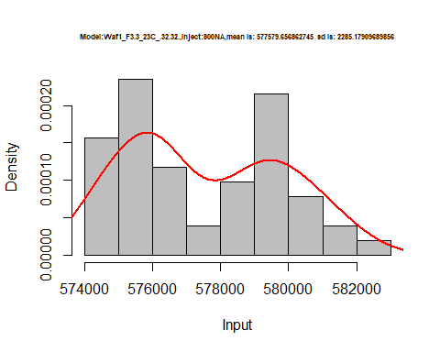

dens <- apply(d_32.32, 2, density)  
plot('Model:Waf1_F3.3_23C_.32.32', xlim=range(sapply(dens, "[", "x")), ylim=range(sapply(dens, "[", "y")))

## Warning in xy.coords(x, y, xlabel, ylabel, log): NAs introduced by coercion

mapply(lines, dens, col=1:length(dens))

## $V1  
## NULL  
##   
## $V2  
## NULL  
##   
## $V3  
## NULL  
##   
## $V4  
## NULL  
##   
## $V5  
## NULL  
##   
## $V6  
## NULL  
##   
## $V7  
## NULL  
##   
## $V8  
## NULL

legend("topright", legend=names(dens), fill=1:length(dens))

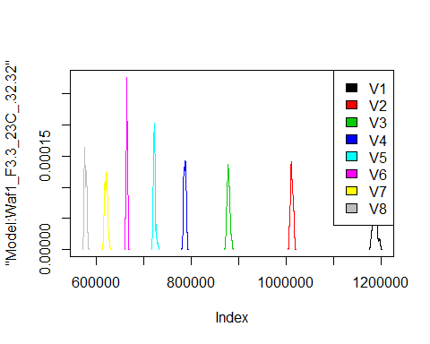

# Select columns whose names contains "34.34"  
d_36.36<-my_data %>% select(contains("36.36"))  
d_36.36 <- head(d_36.36,51)  
#colnames(d_33.33) <- c("V1", "V2","V3","V4","V5","V6","V7","V8")  
head(d_36.36)

## data frame with 0 columns and 6 rows