3GPP TSG-SA WG4 Meeting #131 SA4-250088
Geneva, Switzerland, 17 – 21 February 2025

Source: HEAD acoustics GmbH
Title: Toward Test Setup and Room Conditions for Send Tests with Complex Sound Scenes
Agenda item: 7.7 (ATIAS_Ph2)
Document for: Discussion

Introduction
The WID for ATIAS_Ph2 specifically addresses the definition of “new test methods and performance requirements/objectives, for the assessment of capture and playback of complex sound scenes, i.e., sound scenes with more than one source and from more than one defined direction.” [1] for 3GPP TS 26.260 [2] and TS 26.261 [3]. Moreover, UE behavior in the presence of reverberation and moving sources are relevant aspects to be tested.
In the past, several proposals for such test methods and test setups have been made, e.g., [5][6][7]. However, no consensus was found due to several reasons. The generation of complex acoustic reference scenes that are reproducible across test labs requires a great deal of effort. Moreover, different test methods have different requirements regarding loudspeaker setup and room conditions.
In this contribution, the source proposes to work toward harmonized loudspeaker setup and room conditions to obtain a viable compromise between effectiveness to generate reproducible complex acoustic scenes on the one hand and cost and effort on the other hand.

Viable Options for Reproducible Test Methods involving Complex Acoustic Scenes
The reproducibility of measurements, even across test labs, is absolutely crucial. The seemingly most straight forward way is to require exactly identical test setups. In the case of complex acoustic scenes, this refers to both the loudspeaker setup and the acoustic room conditions. From an academic point of view, it is appealing to demand no interfering room at all, i.e. anechoic conditions, and as many loudspeakers as possible in a hemispherical and (quasi-)uniform arrangement.
On the other hand, a measurement specification can only survive if it is accepted by the market. Cost and complexity of the setup have a significant impact on viability. Moreover, reuse of existing equipment from related measurement specifications leverages the acceptance of a specification. It should therefore be considered very carefully whether extremely sophisticated measuring equipment is essential for the objective of the respective measurement.
For classical telephone tests, test engineers typically use low-reverberation measurement booths, studio booths, or even acoustically treated offices. There is a detailed analysis of this in Annex A.1. Often enough, anechoic rooms are avoided for reasons of cost and effort. Measurement setups are deliberately kept simple and only as complex as necessary.
Moreover, demanding anechoic conditions seems inefficient if the ultimate goal is to create realistic complex sound scenes that typically contain reverberation.
In light of these considerations, the requirement for a fixed or mobile installation of a large, hemispherical loudspeaker array in an anechoic chamber such as proposed in clause 4.1.1.3.1 of 3GPP TS 26.260 appears to be a drastic departure from previous orders of magnitude in terms of cost and will be difficult to justify.
Instead, it is suggested to depart from free-field conditions for the generation of complex acoustic scenes and to consider a more efficient approach to reproducible test methods.

Choice of Reference
In general, test methods capture a quantity and compare it to a given reference, e.g., a spectrum or signal. Performance can be quantified by measuring the similarity to this reference with respect to specific attributes.
If the measurement equipment has only a minor influence on the attribute to be investigated or the impact of the measurement system can be compensated, the signal from the device under test (DUT) can be directly compared to the test signal to obtain an error metric. Such an approach is followed by the architecture shown in Figure 1. A measurement result is obtained by comparing the measurement signal from the DUT to the original test signal. A reference measurement with a reference microphone array (here: spherical microphone array, SMA) is only needed for the qualification of the test setup and should yield near equality to the test signal with respect to the attributes of interest.
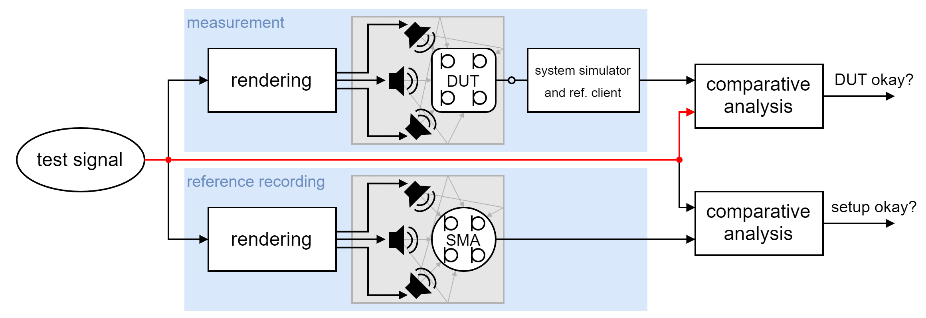
Figure 1: Measured signal is compared to test signal. Reference measurement is only required to verify setup qualification. Reproducibility of measurements across labs is subject to low variation of room properties and loudspeaker setup.
An example reproduction system that is eligible for such an architecture is ETSI TS 103 224 [10]. It is an eight-speaker background noise reproduction standard that targets reproducible background noise reproduction by eliminating room and loudspeaker setup effects by inversion of acoustic paths. It is a well-established standard that allows for accurate reproduction of background noise with high inter-lab reproducibility with respect to sound pressure levels at reference positions. However, it is not known to what extent spatial attributes are preserved and further investigations are needed.
In order to increase flexibility of room conditions and loudspeaker arrangement, a different measurement architecture is beneficial. The architecture shown in Figure 2 compares the measured signal from the DUT with a reference recording obtained with a reference microphone array. This approach makes measurement results more comparable when a variation of reproduction setups across labs is eventually unavoidable. The downside of this approach compared to the approach from Figure 1 is that an additional reference recording is necessary.
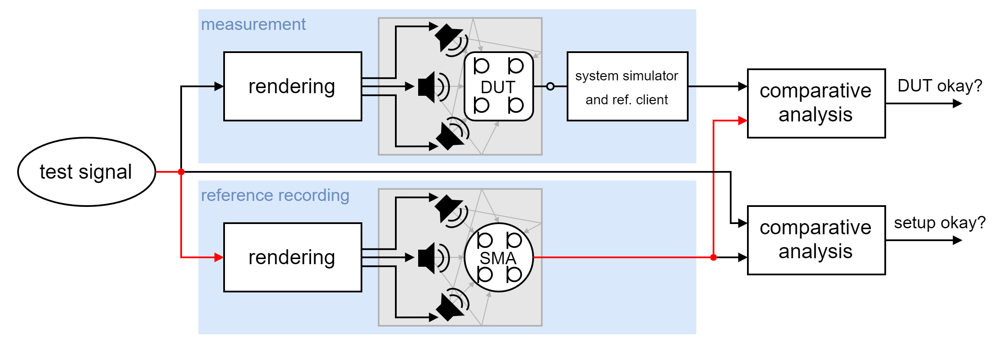
Figure 2: Measured signal is compared to reference recording. Reference measurement is part of the measurement method. Compensation for test setup improves reproducibility of measurements across labs.
In both approaches, it is important to impose meaningful setup qualification criteria.

Possible Reproduction Setups
Table 1 lists several existing reproduction setups that are potential candidates for the reproduction of complex sound scenes for UE testing.
Table 1: Existing setups for the reproduction of spatial audio
 | Reproduction setup | Loudspeaker setup | Room | Comment
A | ETSI TS 103 224 [10] | 8 loudspeakers, near-horizontal placement | room with C₈₀ > 20 dB, e.g., acoustically treated office room or anechoic chamber | Method for reproducible background noise reproduction based on inversion of the acoustic paths. Widely used for testing noise suppression performance of telephones.  Complete ecosystem including equalization of room and speaker setups, focus on reproducibility and flexibility.
B | Hemispherical Ambisonics reproduction, anechoic  (clause 4.1.1.3.1 in 3GPP TS 26.260) | 25 loudspeakers, hemispherical arrangement [5] | anechoic chamber | Specifically optimized for Ambisonics reproduction. Hemispherical loudspeaker distribution allows for constant spatial resolution for all directions.
C | 7.1.4 Ambisonics reproduction, low-reverberation listening room | 11 loudspeakers plus subwoofer, non-uniform coverage of upper hemisphere with frontal weight | low-reverberation listening room, e.g., ITU-R BS.1116 [11] | 7.1.4 is used in IVAS and is also widely used beyond that.  ITU-R BS.1116 specifies a standardized listening room.  No standard procedure for equalization.

The source considers Setup B as not suitable due to the arguments mentioned above. Setup A is appealing as it is already used for telephone testing and is specifically designed to yield reproducible sound pressure between labs. The approach comes with a standardized room equalization procedure, which is an essential key feature. However, it has not yet been investigated to which extent spatial attributes are preserved. Setup C seems appealing, since 7.1.4 is a well-established and widely used standard for spatial audio and has been used also in selection testing of IVAS. On the downside, no suitable standardized procedure is known to the source for equalization (level, frequency, spatial aspects, …) of such playback systems. In the source's experience, compliance with ITU-R BS.1116 [11] alone is not sufficient to circumvent the need for equalization.
Since speech is arguably the most important signal type for communication, it may also be a suitable option to divide the generation of complex sound scenes into speech/talker(s) and ambient sound. One or more artificial mouth simulators may be used for speech and an additional loudspeaker setup may only be used to generate ambient sound.
The discussion of a loudspeaker setup must of course not be viewed independently of the intended test methods and must be aligned. Finally, although specialized setups may be more appropriate for highly specialized tests, different setups for different send tests should be avoided at all costs.

Summary
This contribution aims to kick off a discussion of how to approach standardized reproduction of complex acoustic scenes for send tests. It is aimed to work toward a viable compromise between effectiveness to generate reproducible complex acoustic scenes on the one hand and cost and effort on the other hand. The focus here is on how measurements can be reproduced across lab boundaries, if a certain variability of the measurement setup is to be tolerated. Moreover, the source emphasizes the importance of using a harmonized loudspeaker setup for all send tests.

References
- HEAD acoustics GmbH, Qualcomm Incorporated, Nokia Corporation, Dolby Sweden AB, Orange, Xiaomi, Melbourne, “WID on Terminal Audio quality performance and Test methods for Immersive Audio Services, Phase 2,” 3GPP input document SP-241314 to 3GPP TSG SA Meeting #SP-105, Melbourne, Australia, September 2024.
- 3GPP TS 26.260, “Objective test methodologies for the evaluation of immersive audio systems,” Release-18, 2024.
- 3GPP TS 26.261, “Terminal audio quality performance requirements for immersive audio services,” Release-18, 2024.
- HEAD acoustics GmbH, “Harmonization of setups for ATIAS send tests”, 3GPP input document S4-240541 to 3GPP TSG-SA4 Meeting #127-bis-e, Online, April 2024.
- Qualcomm Technologies Int., “On Speaker Array for ATIAS testing”, 3GPP input document S4-240699 to 3GPP TSG-SA4 Meeting #127-bis-e, Online, April 2024.
- Nokia Corporation, “On sending directional frequency response testing for MASA capture”, 3GPP input document S4-240680 to 3GPP TSG-SA4 Meeting #127-bis-e, Online, April 2024.
- Bytedance, “Objective Test Methods for Capturing Immersive Audio with Moving Sound Source,” 3GPP input document SA4aA250002 to 3GPP SA4 WG4#130-e, Online, January 2025.
- 3GPP TS 26.132, “Speech and video telephony terminal acoustic test specification,” Release-18, 2024.
- ITU-T Recommendation P.340, “Transmission characteristics and speech quality parameters of hands-free terminals,” May 2000.
- ETSI TS 103 224, “Speech and multimedia Transmission Quality (STQ); A sound field reproduction method for terminal testing including a background noise database”, v1.6.1, March 2022.
- ITU-R Recommendation BS.1116-3, “Methods for the subjective assessment of small impairments in audio systems,” February 2015.

- Annex

Anechoic Conditions Depend on Source Distance
Typical acoustic telephone testing methods require a “free field volume” as room condition or that test rooms shall be “practically free-field”. It seems logical to adapt these room conditions and demand a “free field volume” also for immersive tests of IVAS-capable UE. However, it a misleading conclusion to assume that the overall room conditions for classical telephone and immersive UE will be in the same ballpark, even though a “free field volume” is demanded for both cases. In fact, the room conditions to ensure a free field volume for immersive UE are significantly more stringent due to increased source-microphone distances compared to conventional telephone UE testing.
Classical telephone UE test specification ask for a “free field volume” or that test rooms shall be “practically free-field” (e.g., 3GPP TS 26.132 [8]). However, low-reverberation measuring chambers (or even studio booths) are sufficient that have significantly reduced reverberation requirements compared to true anechoic chambers (cf. DIN EN ISO 3745). Using such low-reverberation measuring chambers significantly reduces the measurement effort and is ultimately a driver for the acceptance of test specifications in the market. Qualification of test rooms is typically performed locally in the vicinity of the test setup instead of the whole room. Often, ITU-T P.340 clause 5.4 [9] is cited, in which a free field volume is considered with distances from the acoustic source up to 1 m.
It is important to understand that typical measurement methods require a certain signal-to-reverberant energy ratio at the microphone, but not a specific absolute threshold for the level of reverberant energy. The signal-to-reverberant energy ratio depends strongly on the distance between source and microphone $d$. This distance $d$ is typically small for telephone Realistic background noise fields. diffuse UE testing.
The distance effect can be explained using a simple acoustic model in which reverberation is assumed perfectly diffuse and therefore independent of location, whereas the direct sound pressure decays by 1/d. This is illustrated in Figure 3. Typically, a certain maximum deviation from anechoic conditions is demanded, such as 1 dB. A 1 dB limit is fulfilled if the receiving microphone is within 51% of the critical distance $d_{c}$ at which the sound pressure level of the direct and reverberant sound are equal.
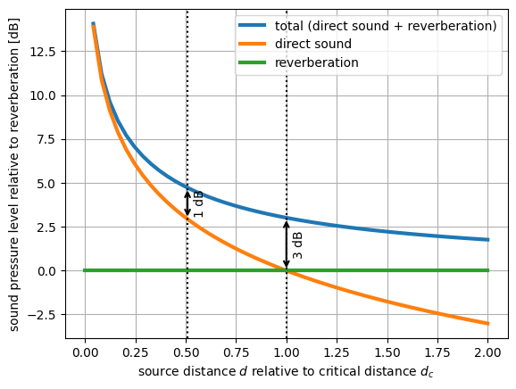
Figure 3: Whether a measurement is close to free-field conditions depends not only on the absolute level of reverberation but especially on the distance between source and microphone.
In some classic telephone test setups such as handheld or headset mode, this distance is only a few centimeters and therefore much lower than $0.51⋅d_{c}$ even in acoustically untreated rooms with low critical distance $d_{c}$, e.g., $d_{c}=1m.$
In contrast, if a periphonic loudspeaker array is used to generate a complex acoustic sound scene, source distances are significantly higher. The required free-field volume may have a diameter of several meters. However, this has drastic consequences for the acoustic requirements of the room. In rough approximation, based on Sabine’s reverberation formula, we can assume $d_{c}∝\sqrt{1/T_{60}}$. Hence, to double the diameter of a free-field volume, the reverberation time $T_{60}$ has to be reduced by factor four. Therefore, in order to ensure a free-field volume in the dimension of the periphonic loudspeaker array, a true anechoic chamber is needed instead of a low-reverberation measuring chamber.
In summary, extending the “free field volume” to enclose a periphonic loudspeaker array (immersive UE testing) instead of only the HATS and UE (classical telephone testing) is a significant tightening of the classical “practically free-field” requirements with significant impacts of effort and costs. However, since the goal is to test realistic, complex acoustic scenes, typically consisting of multiple sources and reverberation, the costs for true anechoic conditions are hardly justifiable.

The acoustic model is a vast simplification and only serves as a very rough approximation of the acoustic phenomena. Especially with very low reverberation, the diffuseness assumption is a very strong simplification and room properties such as critical distance and reverberation time are applicable only to a limited extent.

