Datamodel Static Real Estate Solution

Required Rest Services:

* Search-Request -> List Result Response
* Read Offer/Advertisement Details
* Offer/Advertisement create/modify/delete
* List of own Offers/Advertisements

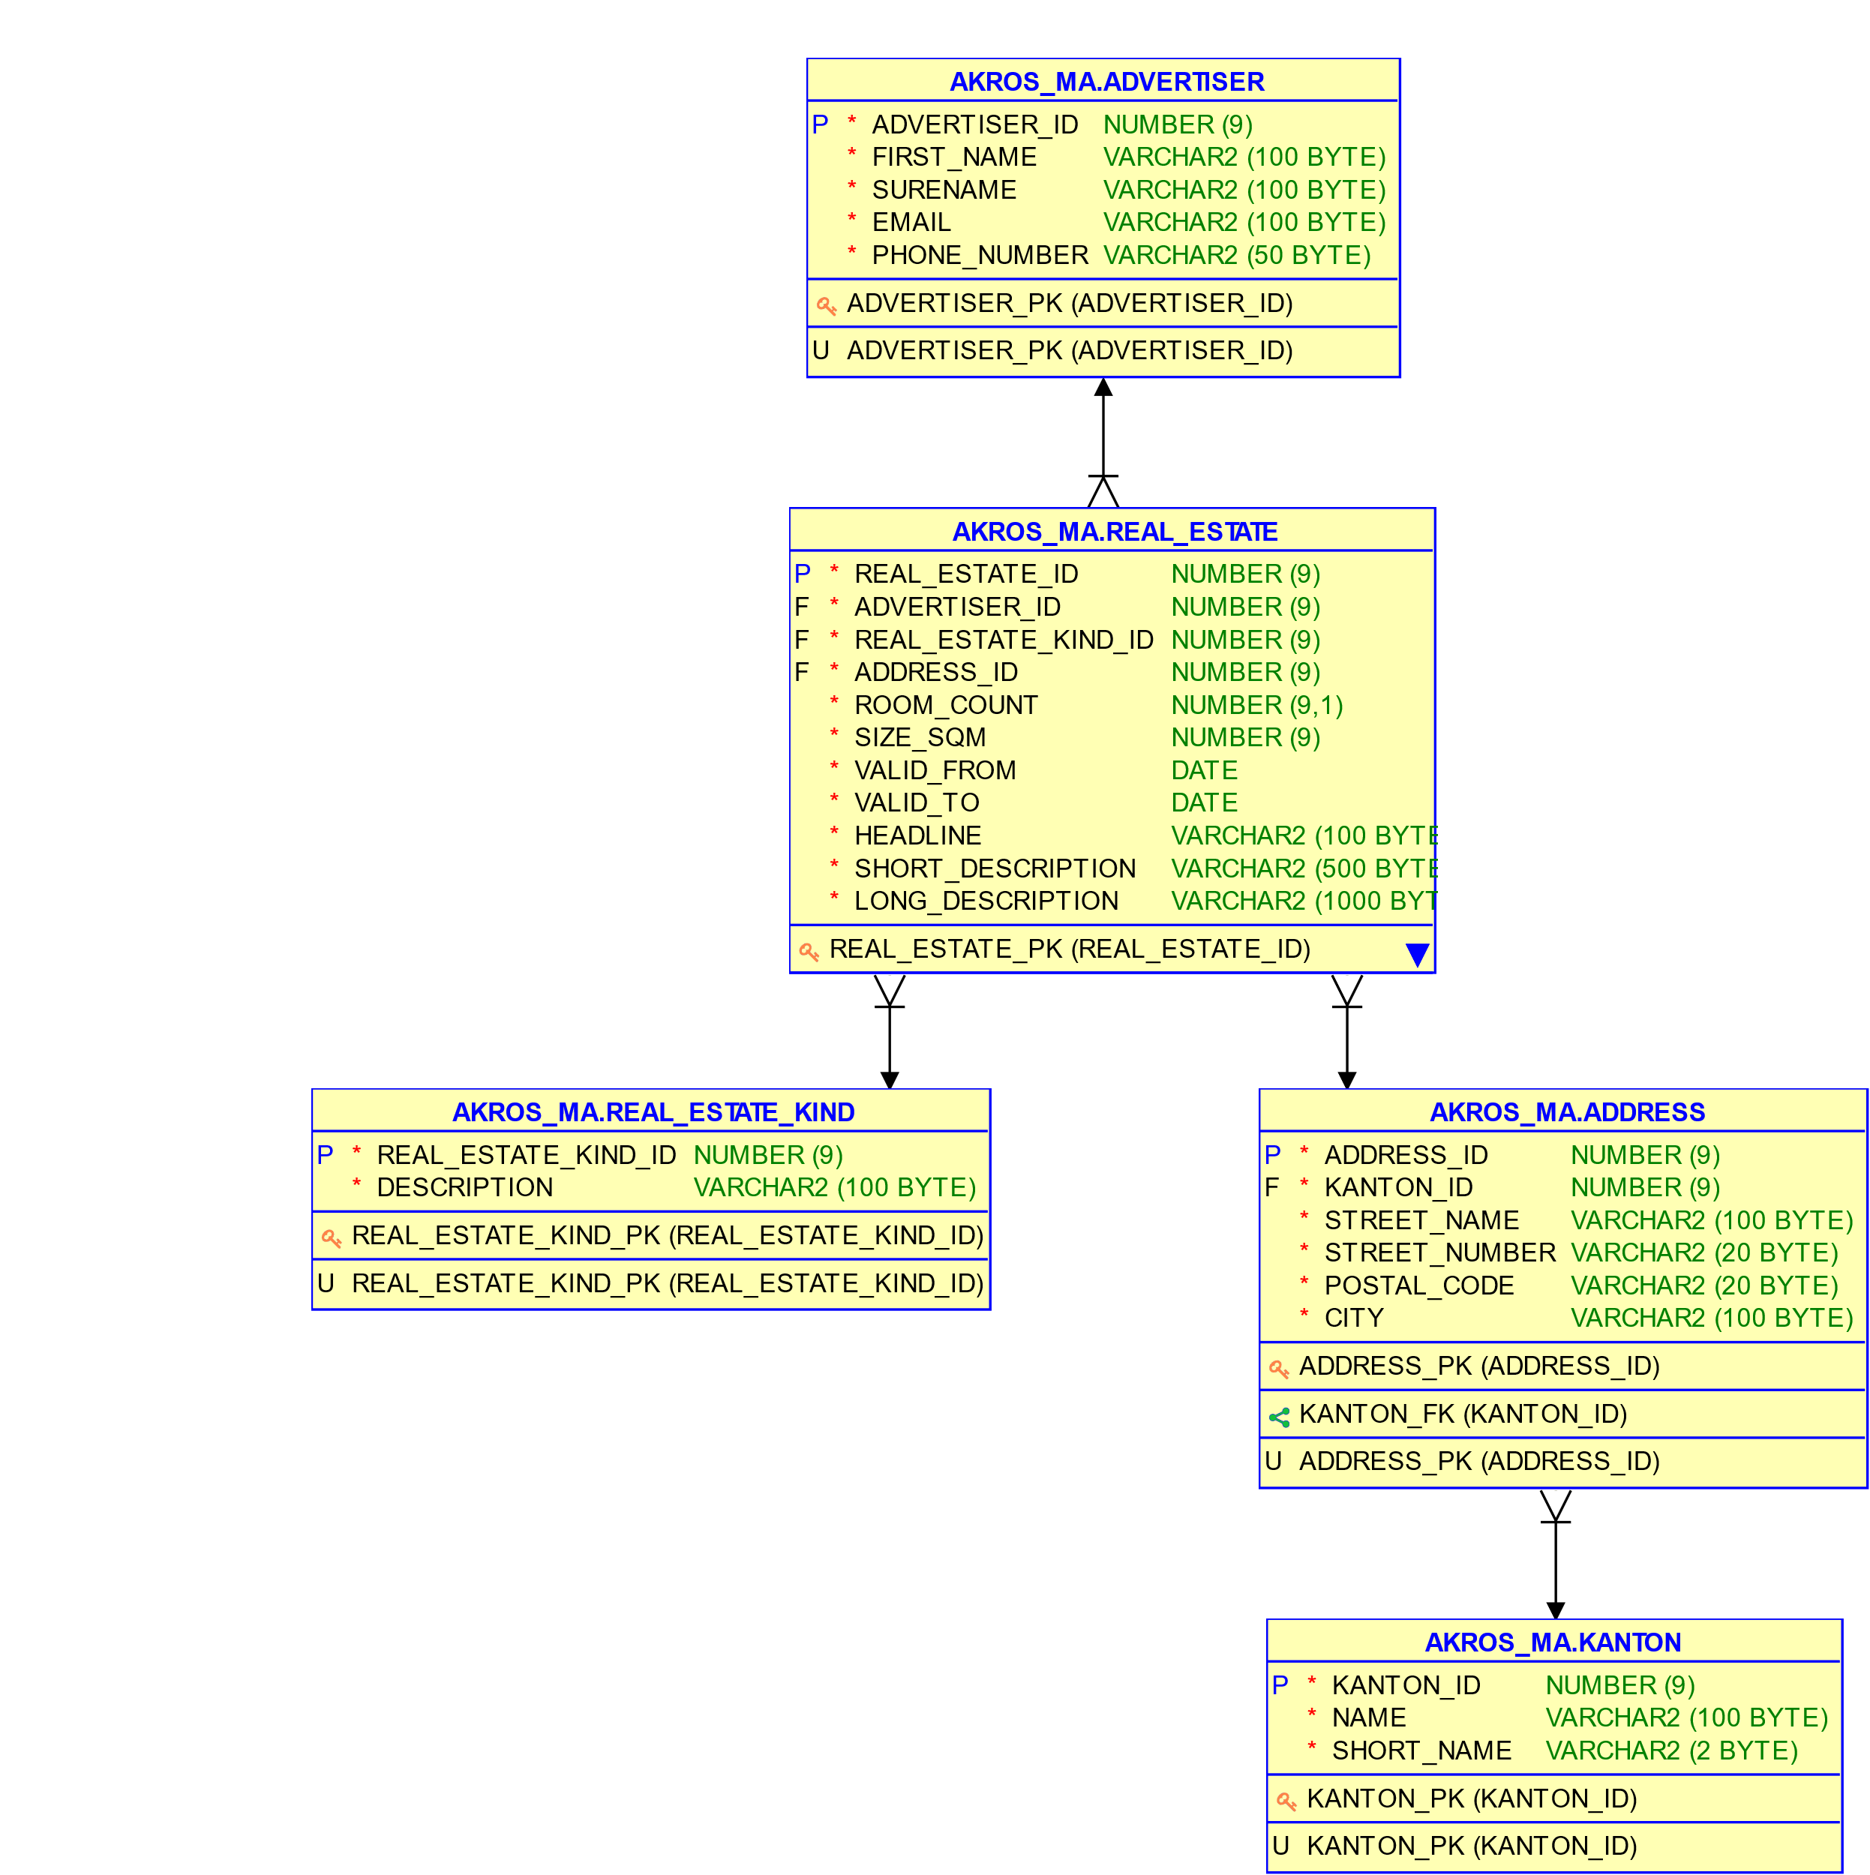

Datamodel Dynamic Real Estate Solution

Restservices:

* List Main Subjects
* List of Search Elements
* Search Request -> List Topic Result Response
* Read Topic Details
* Topic create/modify/delete
* List of own/self created Topics

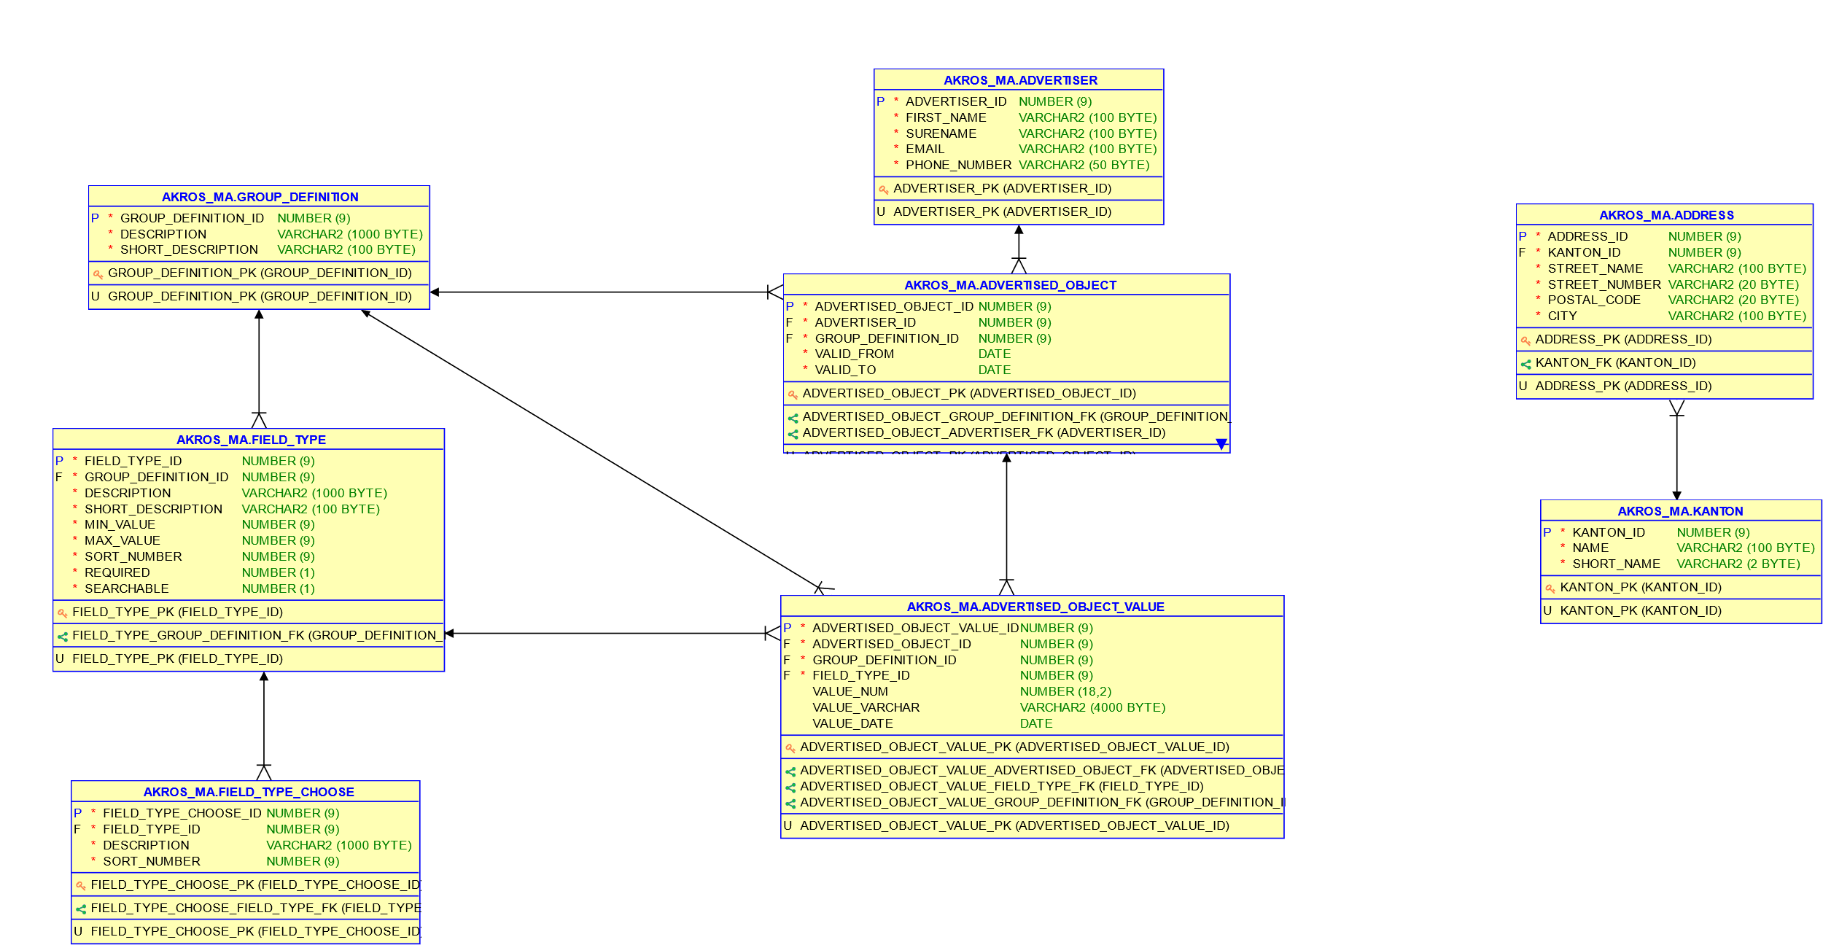

Additional Administration Functionality

* Main Subject create/modify/delete
* Field Types create/modify/delete
* Choose Field Types create/modify/delete