Screenshot 1 – Django Server Running
The screenshot below shows the default Django page after creating the project and successfully starting the development server with python manage.py runserver.
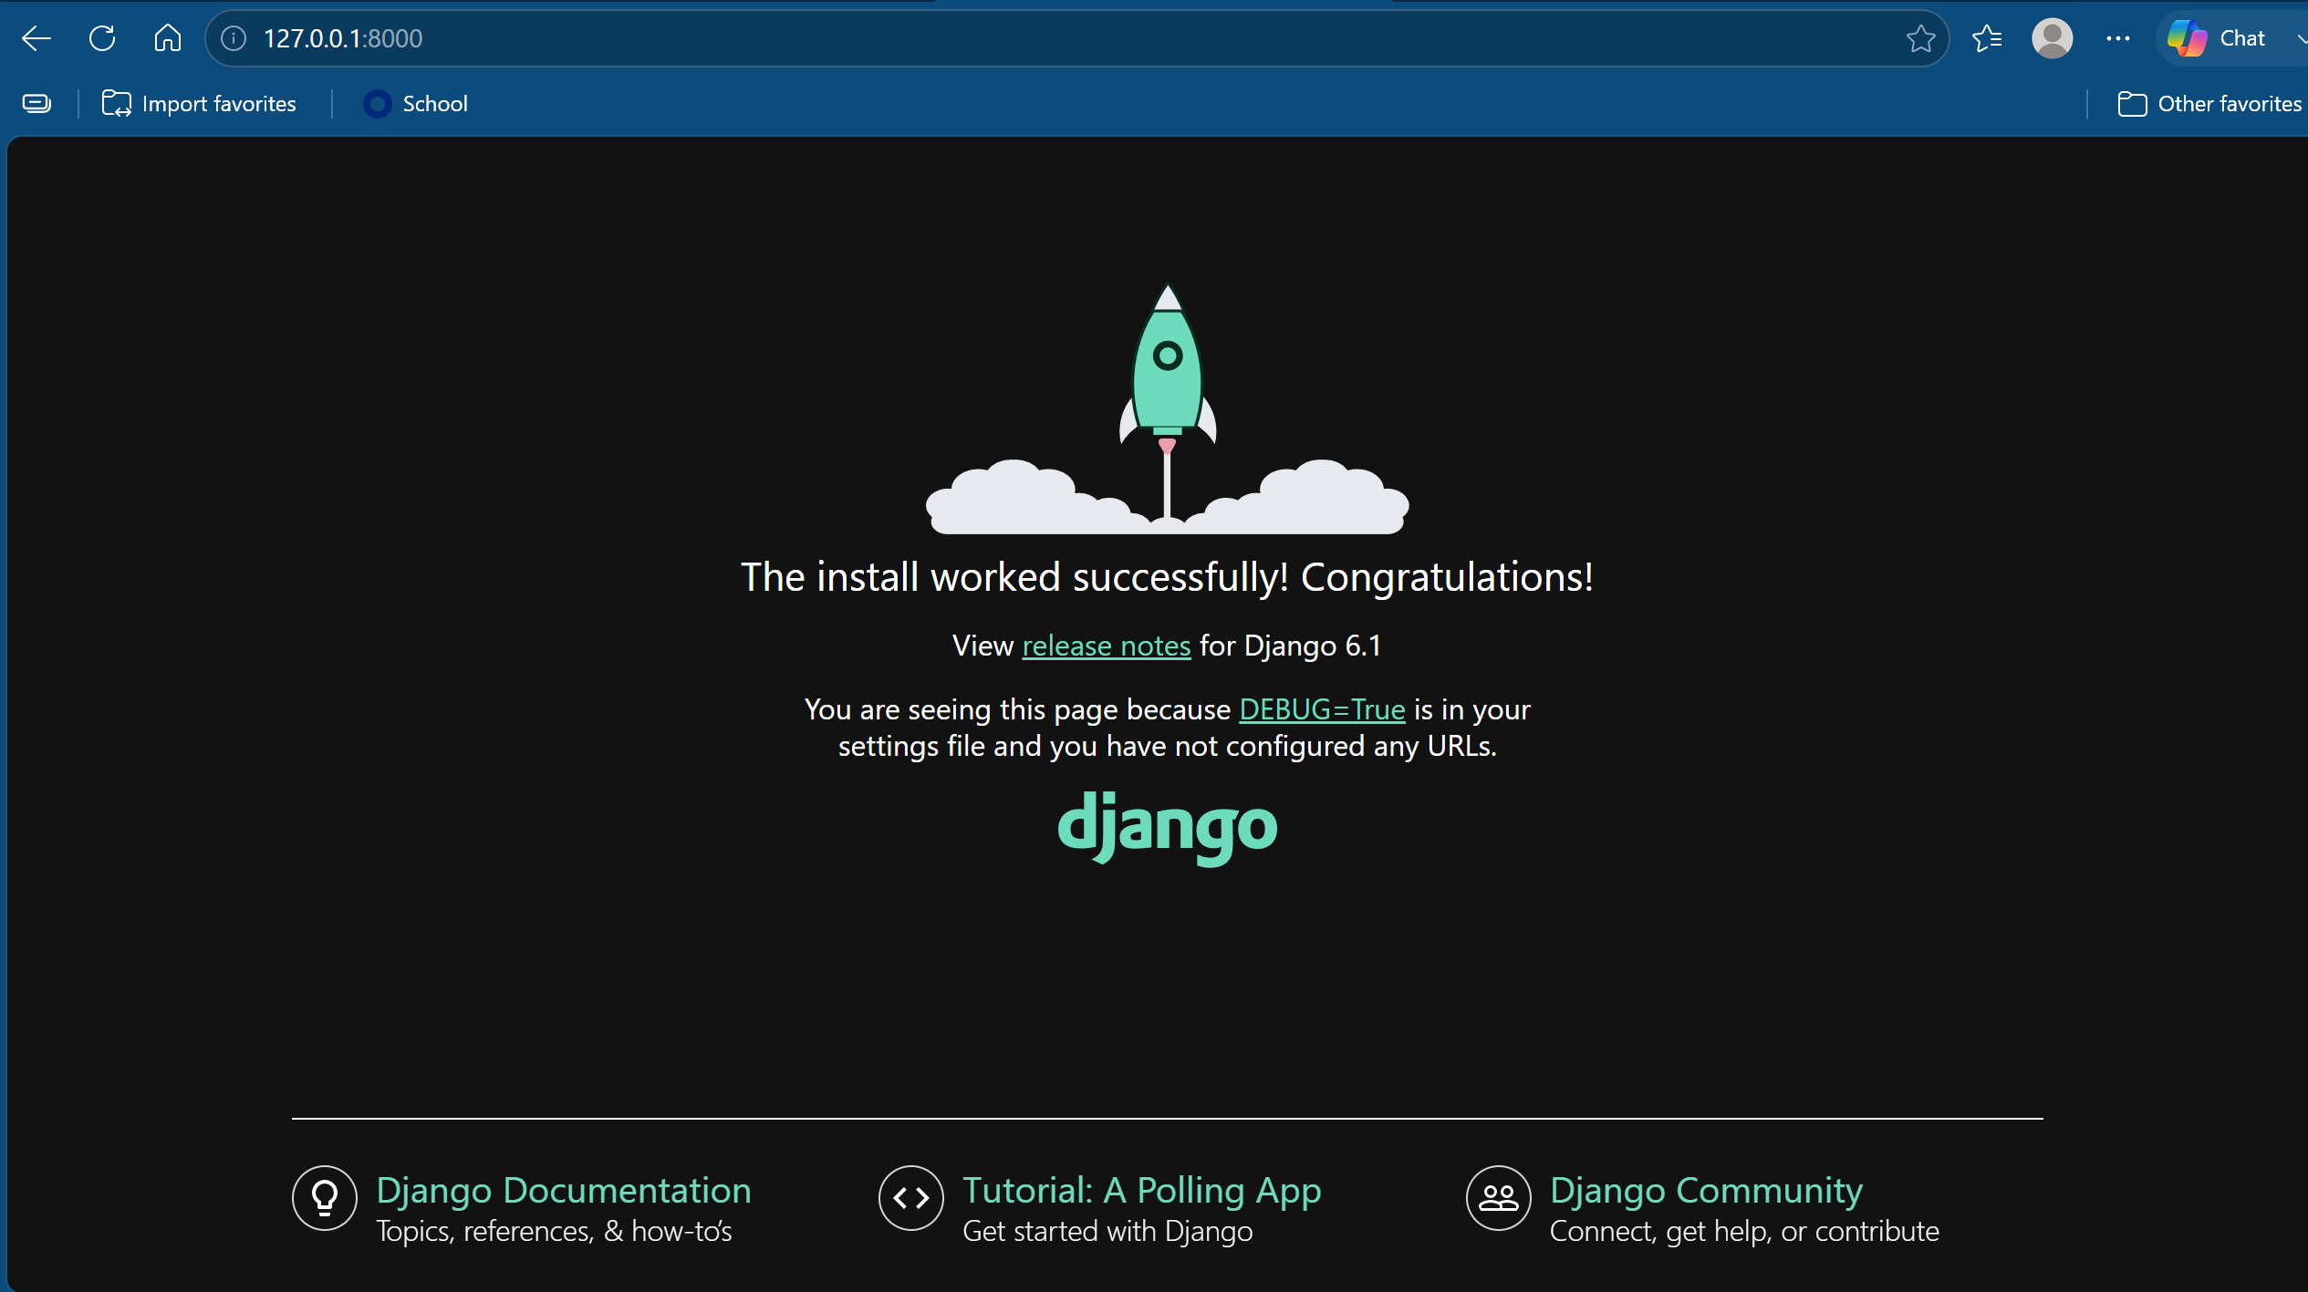

Screenshot 2 – Modified Django Page
The screenshot below shows the modified Django application displaying "Morris says Hello!" at the local host address.
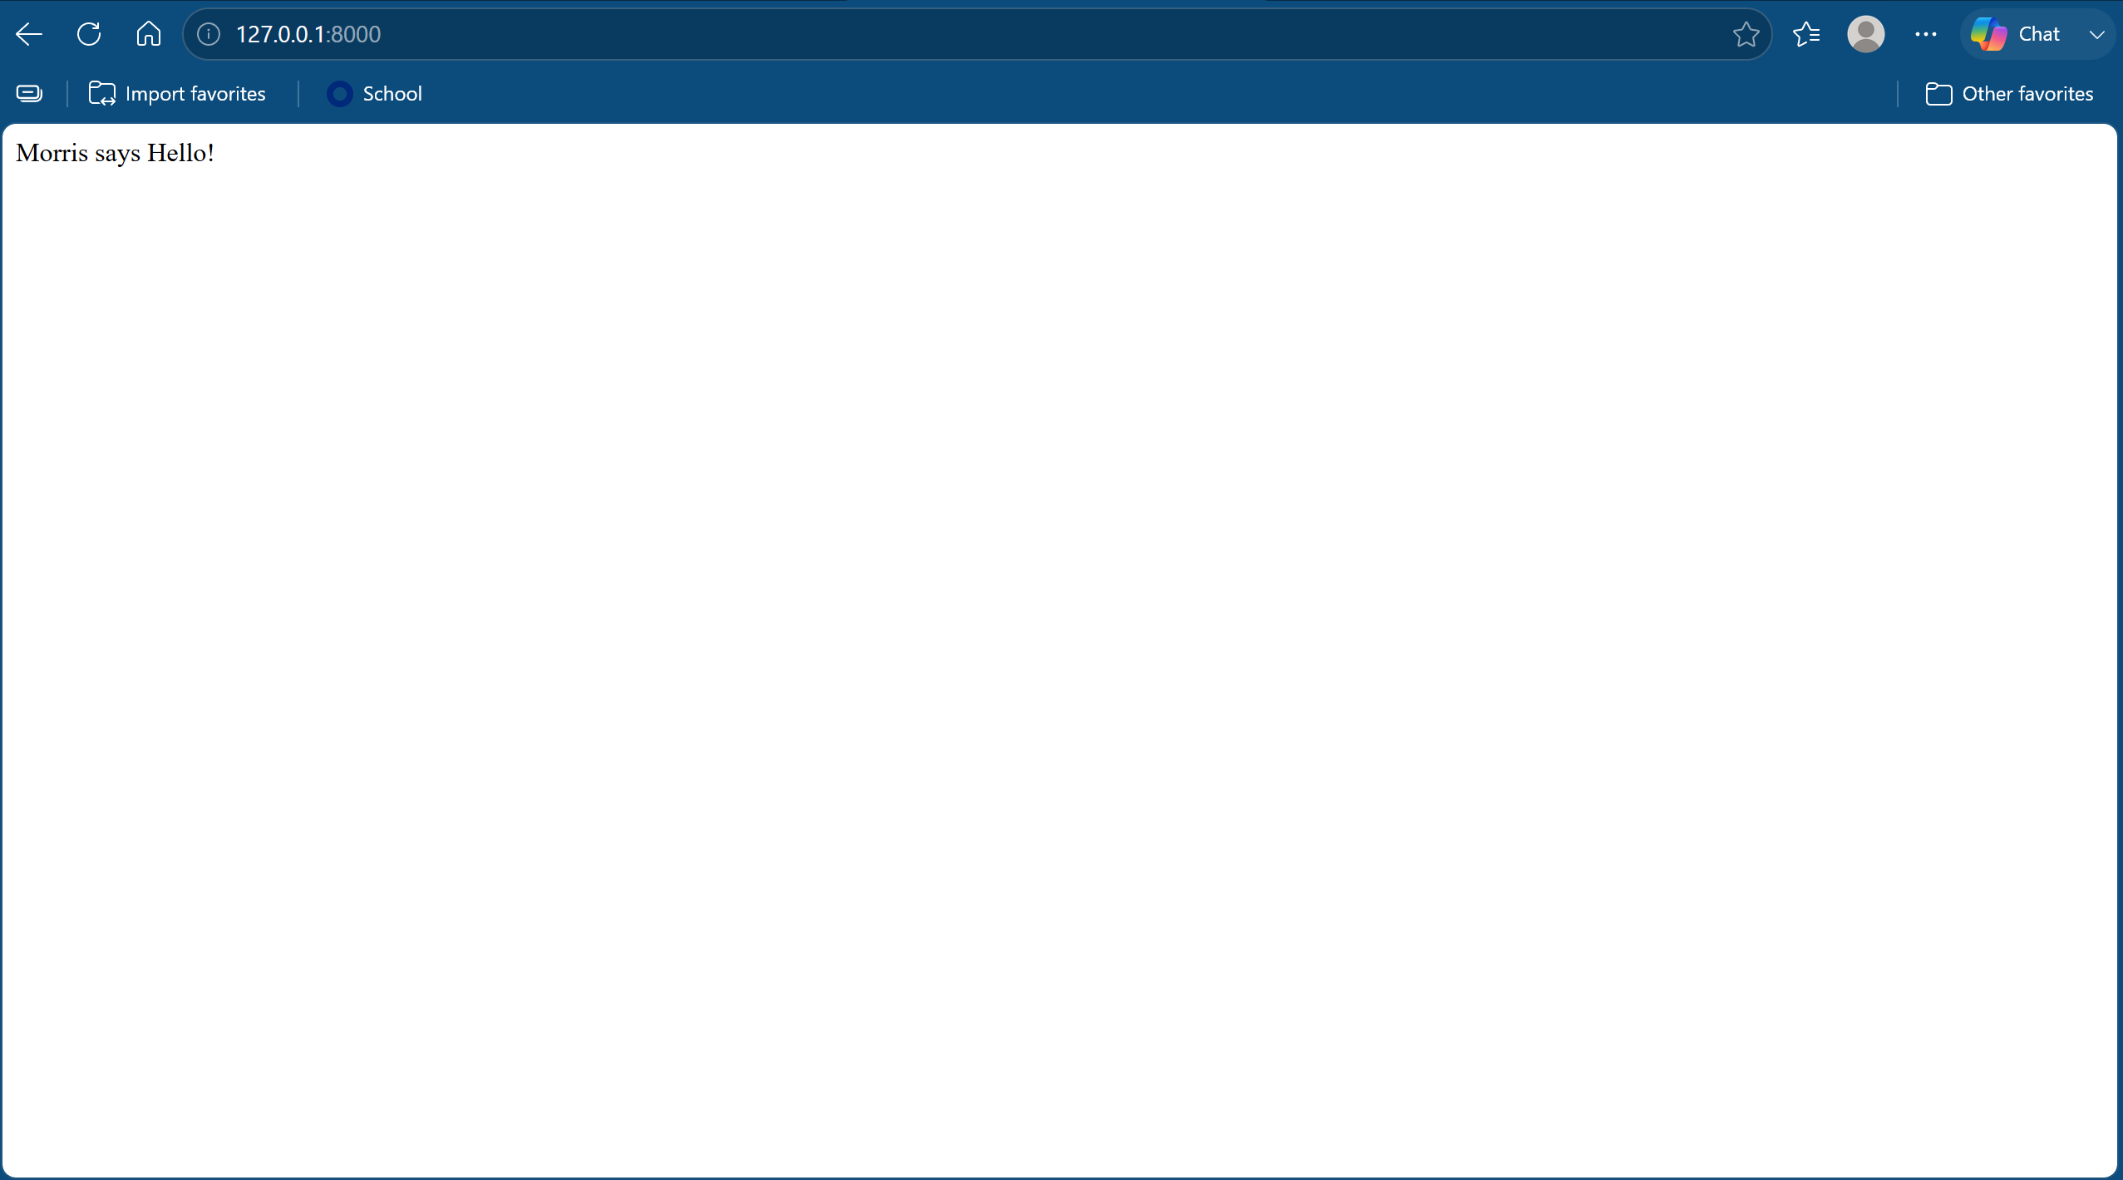

Assignment files: The completed demo directory will be zipped and saved in the module-11 directory as demo.zip.

