1. Initial city_country() Program Output
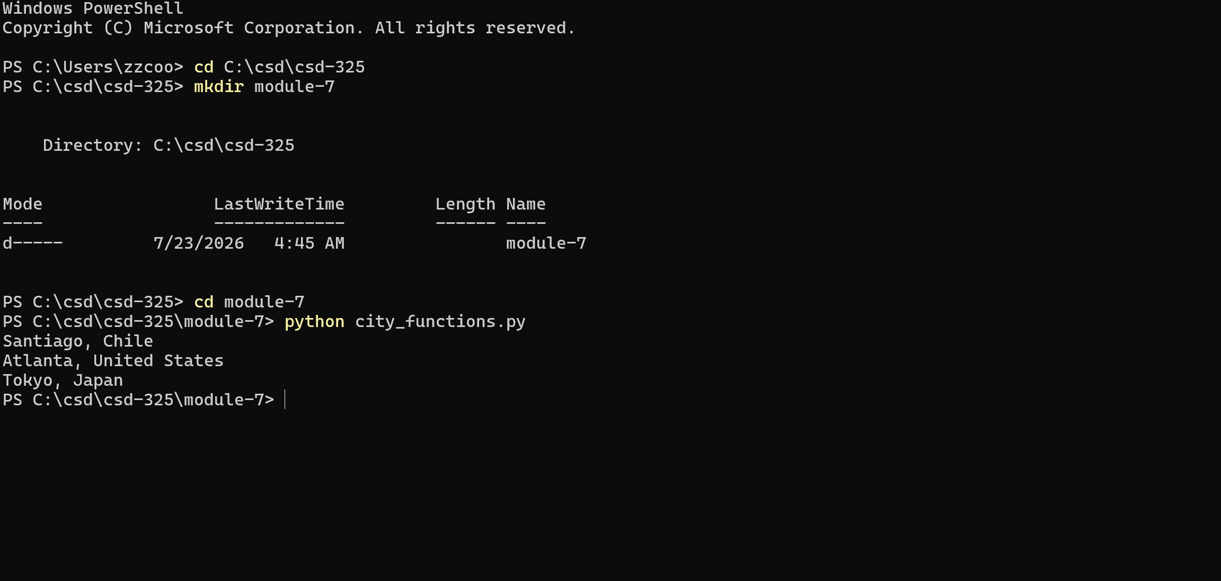

2. Initial Unit Test - Pass
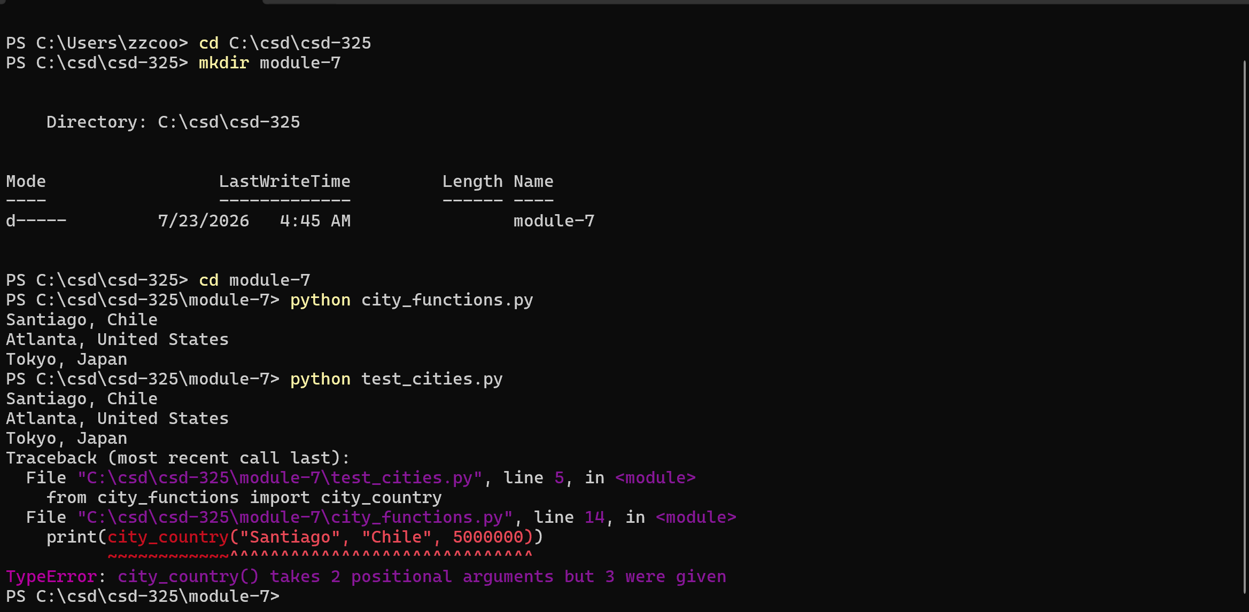
3. Required Population Parameter - Failed Test
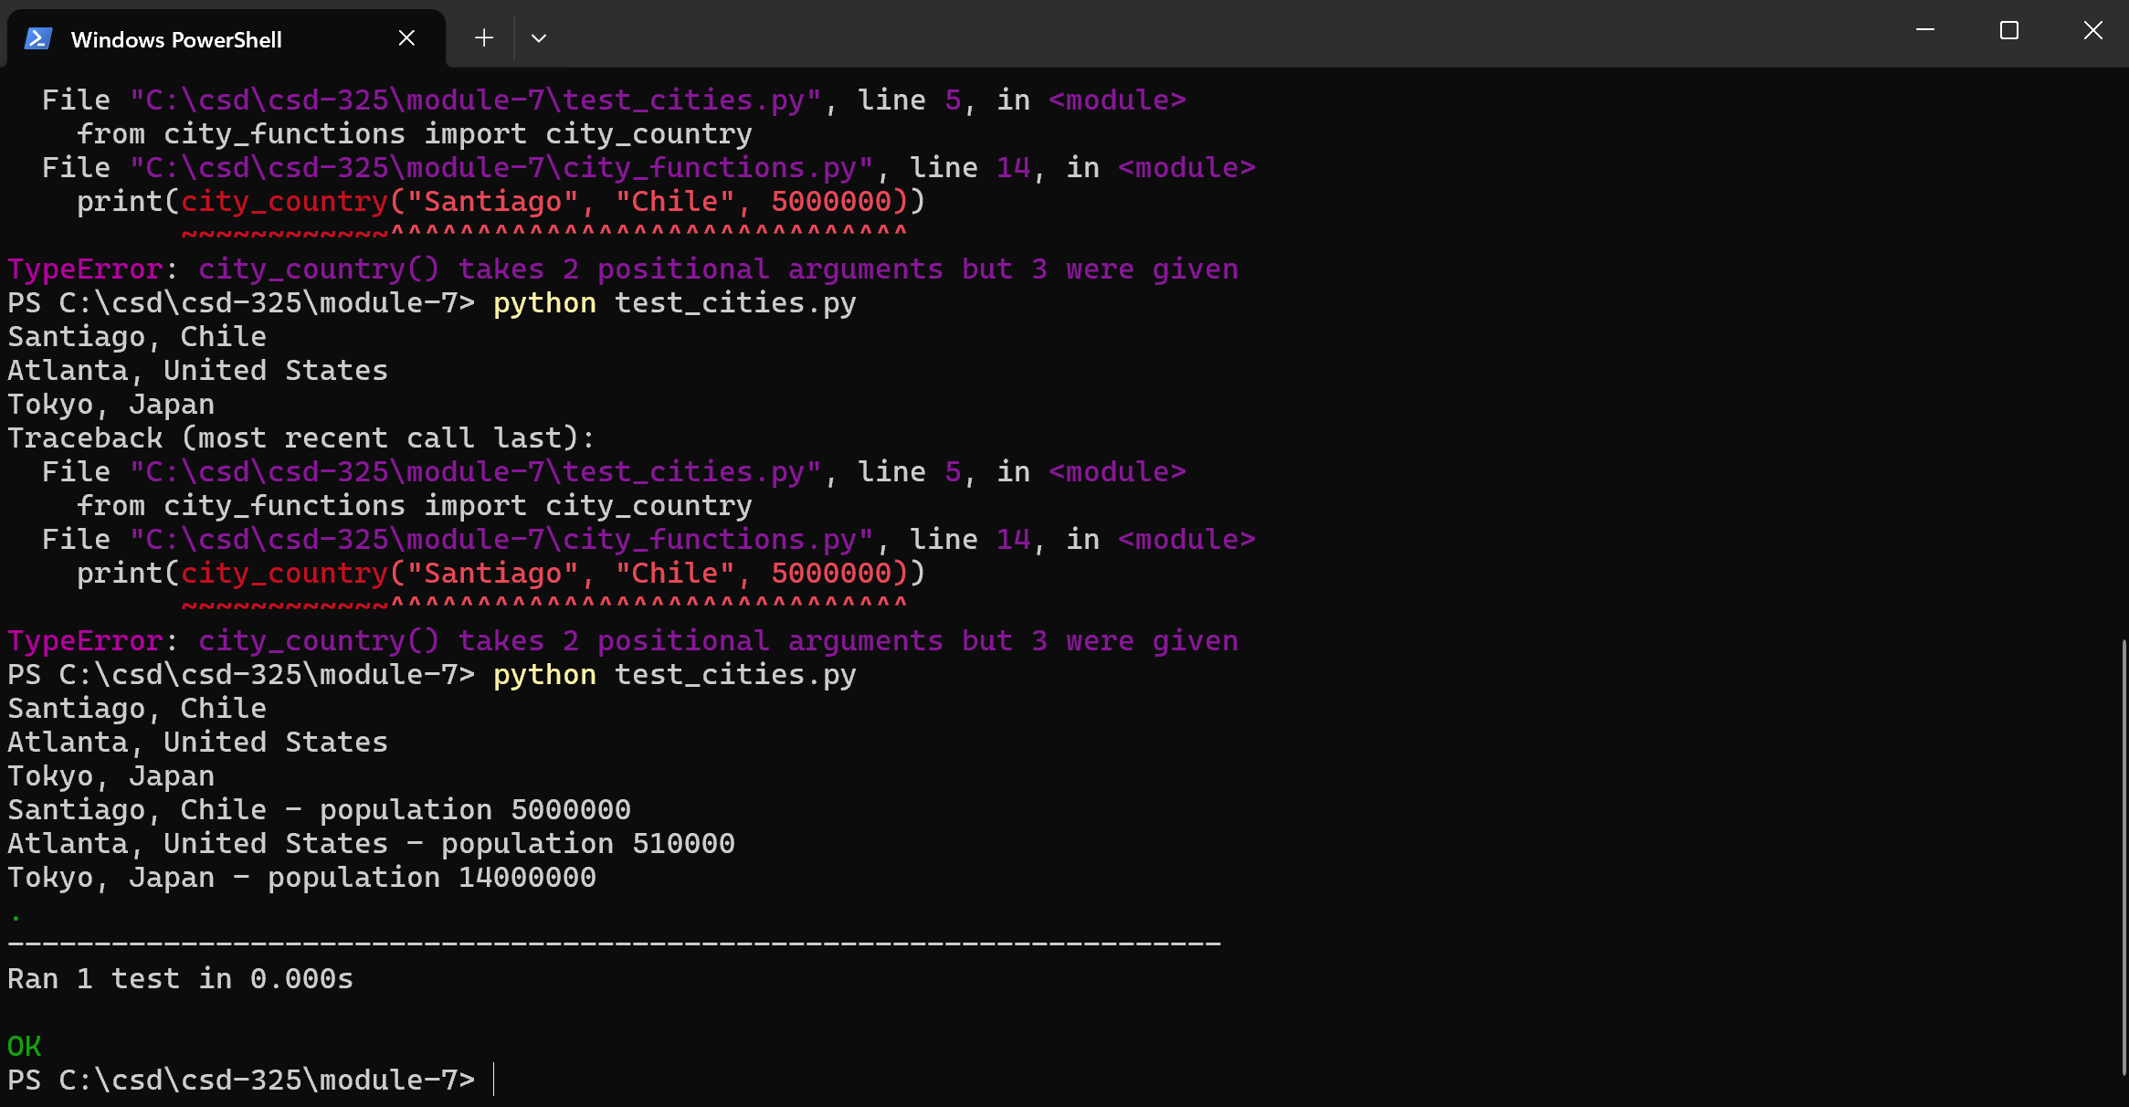
4. Optional Population Parameter - Passed Test
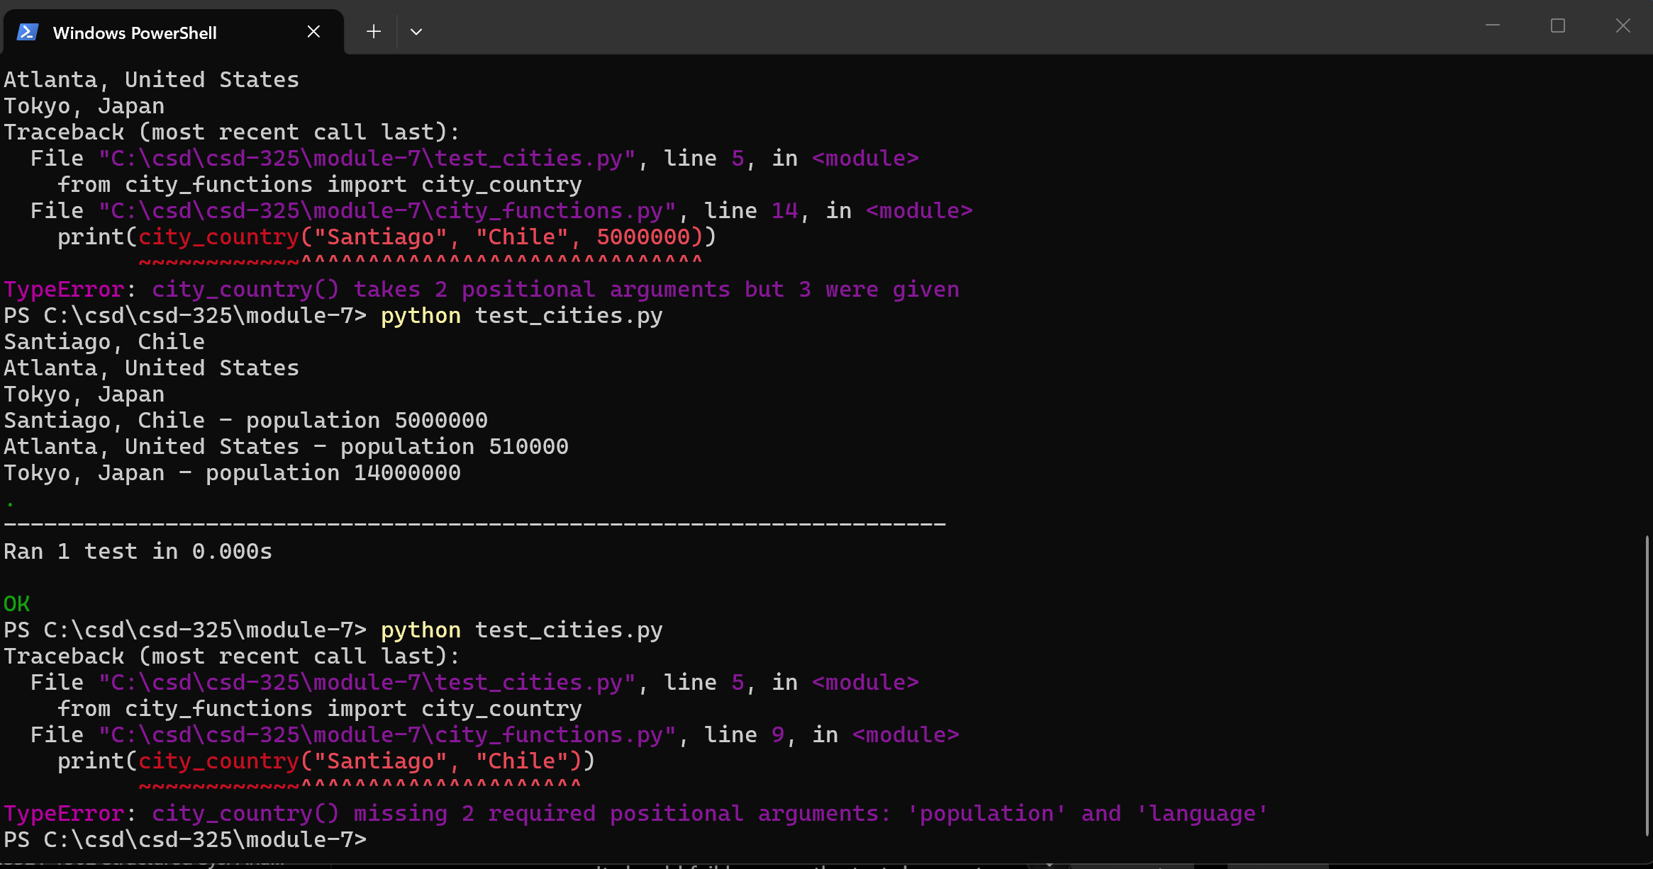
5. Required Language Parameter - Failed Test

6. Optional Language Parameter - Passed Test
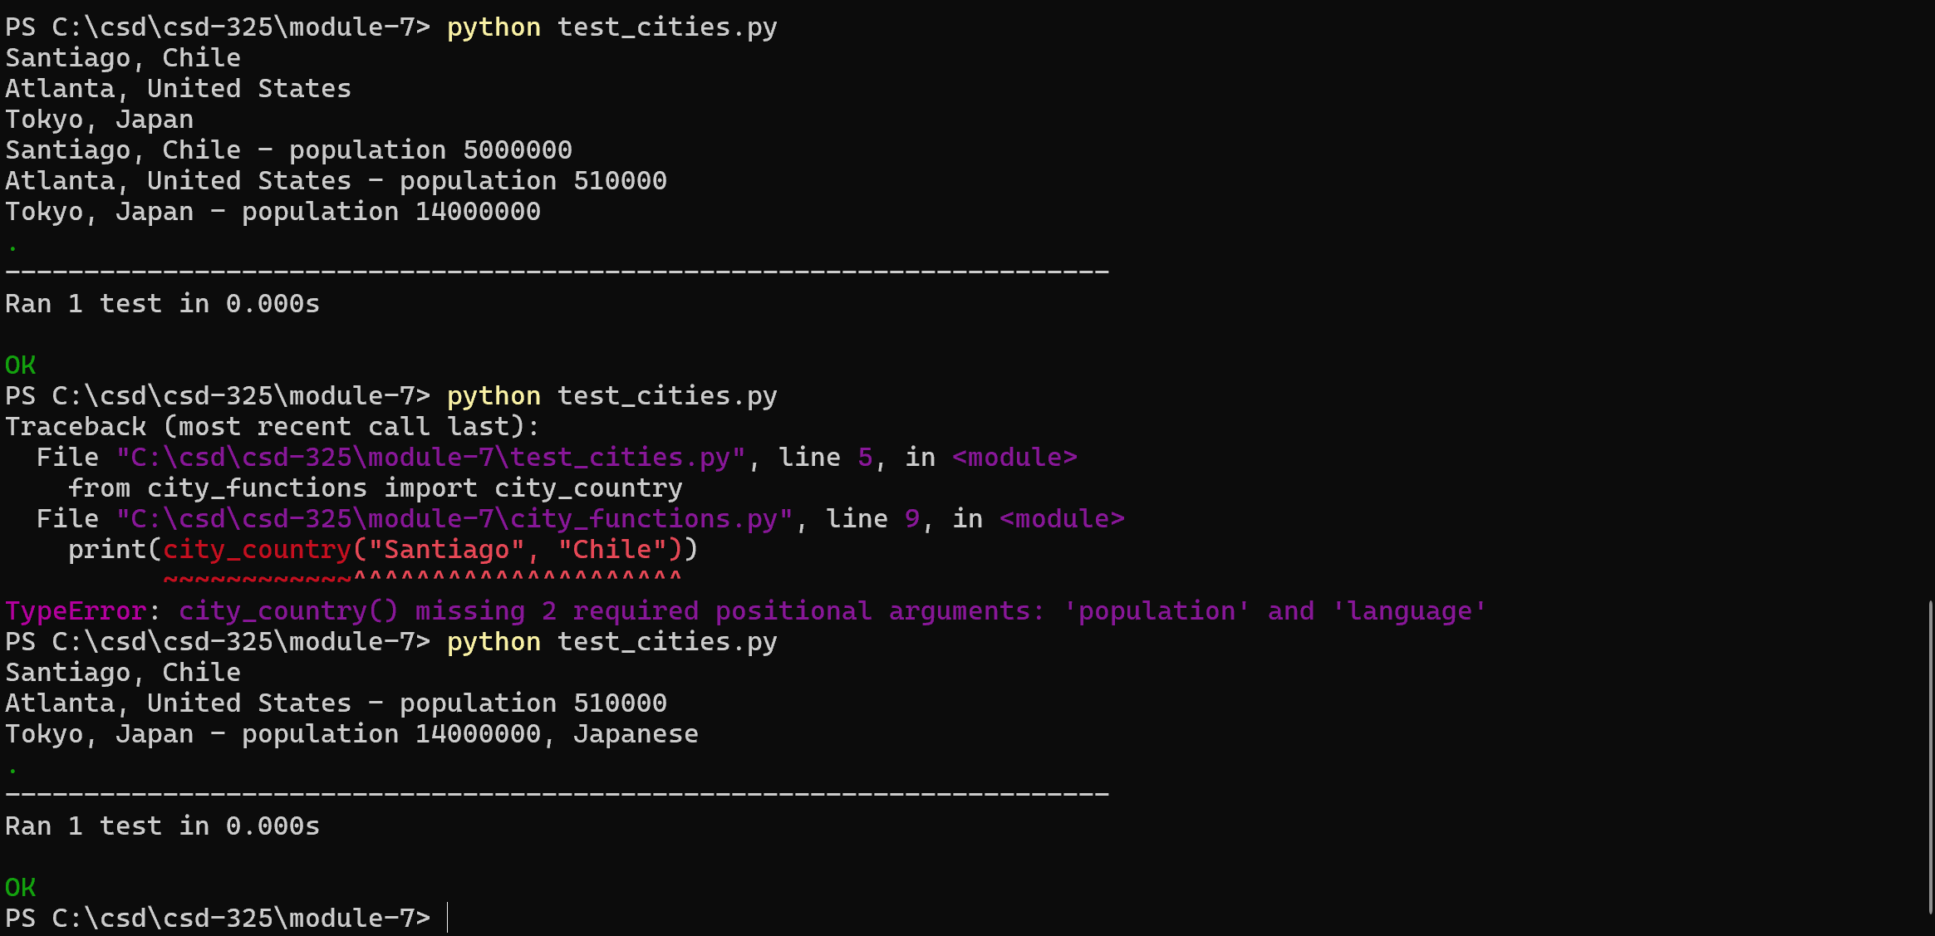
7. Final city_functions.py Output
