1. Original To-Do Program
Run the original Listing 2.2 program, add at least two tasks, and paste the screenshot below.
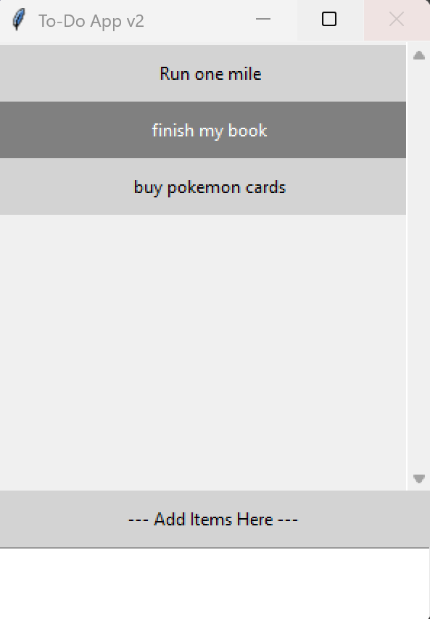

2. Modified Morris-ToDo Program
Run the modified program and add several tasks. The screenshot should show the Morris-ToDo window title, the complementary task colors, the instructions for deleting a task, and the File menu.
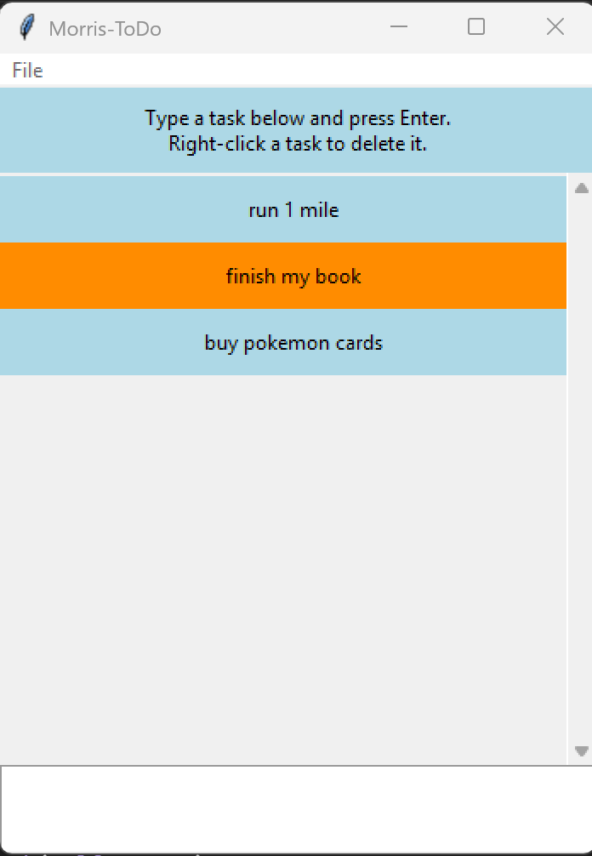

3. Right-Click Delete Confirmation
Right-click one of the tasks. Paste a screenshot of the deletion confirmation window below.
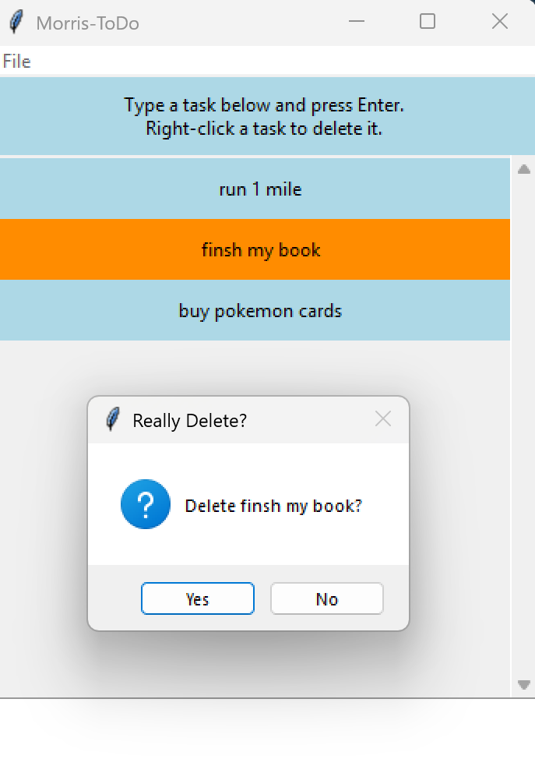

4. Task Deleted
After confirming the deletion, paste a screenshot showing that the selected task has been removed.
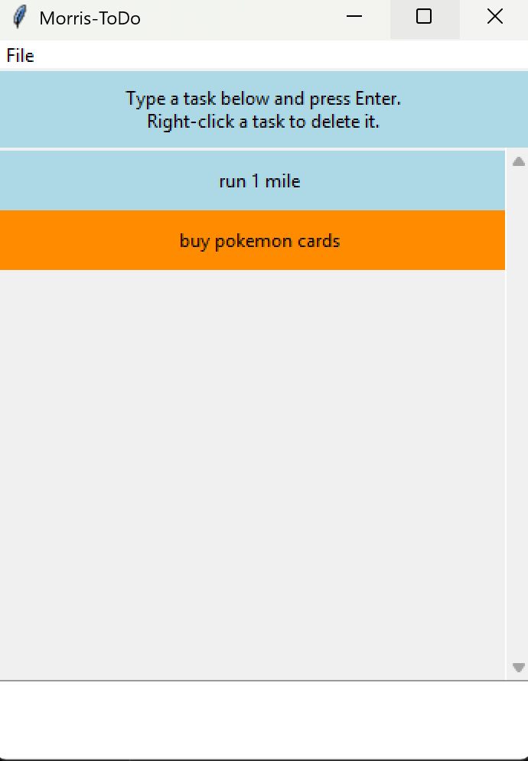

Program Modifications
The modified version changes the window title to Morris-ToDo, uses two complementary colors for the task items, changes task deletion from the left mouse button to the right mouse button, provides instructions explaining how to delete a task, and adds a File > Exit menu option.

