@Author : Moumita

User Set up for UCWAR-1196 (ProducerCode_DocumentsTab_1196)

1. Open PC
2. Go to Administration tab
3. Users & Security > Users
4. Search for the user and open the user
5. Go to Access Tab
6. Click on Edit
7. **Set User Producer code security as yes**
8. **Add Group as CarGarantie**
9. **Additional Producer Codes**

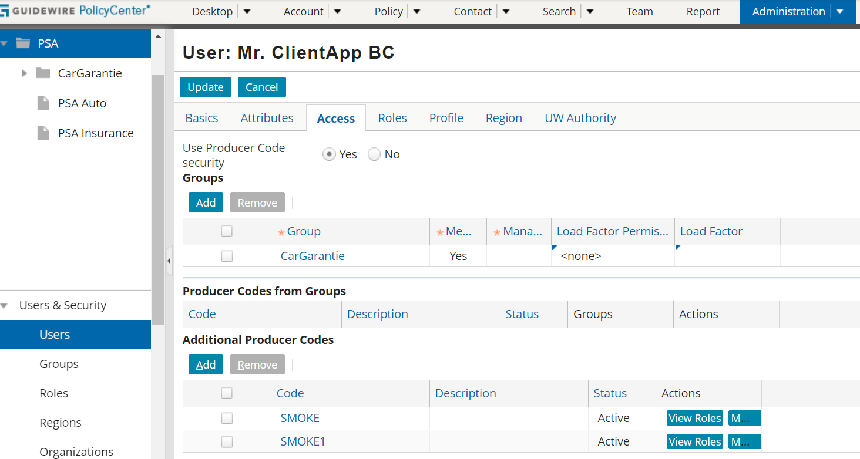

User set up for UCWAR- 445 & UCWAR-472 (UCWAR_445_France & UCWAR_472_CancellationEGVO_Spain)

1. Open PC
2. Go to Administration tab
3. Users & Security > Users
4. Search for the user and open the user
5. Click on Edit
6. Go to Access Tab
7. Add **CarGarantie, Operational provider sales France/Spain and Service center France/Spain**
8. Go to Role Tab
9. Add **Dealerlead, Delearteam, Service Center team, service center team lead**

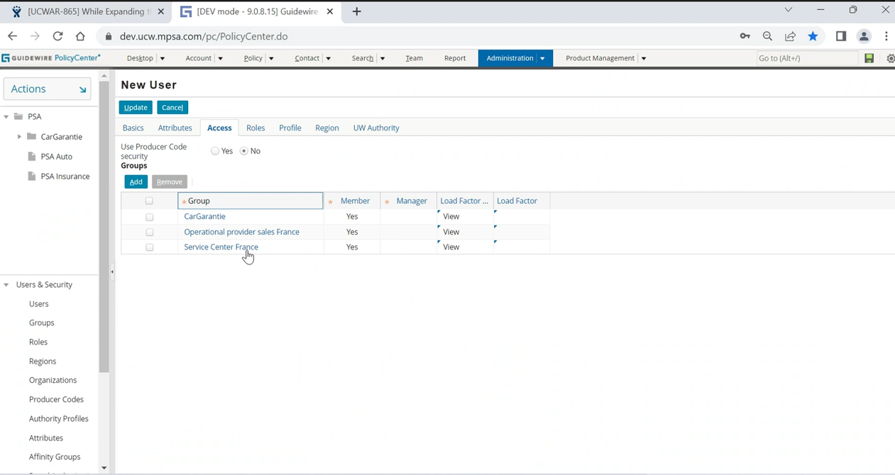

**Car Garantie user**

Permission to create reserve

