AIP-C01 Study Treatise
Author
AWS Certified Generative AI Developer, Professional · AIP-C01

Study treatise: one path from first principles to exam answer
Scope: the five exam domains, their task statements, the services they name, and the traps AWS reuses. Built to be read in order, top to bottom. Read each section before the next.
Sources. AWS documentation pages and the AWS exam guide for AIP-C01. The study guide repository was excluded as a knowledge source. Claims marked Not in source could not be confirmed on an official page in this build. Claims marked Inference are reasoning from the sources, not AWS statements. Figures in examples are illustrative.
Status of checks. Domains 1 to 5 were each fact-checked against AWS documentation by a review pass. Two checks were re-run on the official pages in the last pass. Items marked Not in source stay open. Re-check every open item before exam day.
Part 0

The exam at a glance
The exam has 75 questions. Sixty-five are scored and ten are unscored. The exam uses multiple choice and multiple response questions. The passing score is 750 on a scale from 100 to 1,000.
Item | Value
Exam name | AWS Certified Generative AI Developer, Professional
Exam code | AIP-C01
Questions | 75 total. 65 scored. 10 unscored.
Question types | Multiple choice (one correct answer) and multiple response (two or more correct answers)
Passing score | 750 on a scale from 100 to 1,000
Scoring by section | Not in source. The pass decision uses the whole exam.
Duration and fee | 180 minutes and 300 USD. Confirmed on the official AWS certification page.

Domain weights
Domain | Name | Weight in the official exam guide | Approximate question count (Inference)
1 | Foundation model integration, data management, and compliance | 31% | about 20
2 | Implementation and integration | 26% | about 17
3 | AI safety, security, and governance | 20% | about 13
4 | Operational efficiency and optimization | 12% | about 8
5 | Testing, validation, and troubleshooting | 11% | about 7
The weights match the official AWS exam guide.

Target candidate
AWS expects two or more years of production application experience. It also expects one year of hands-on generative AI work. The exam assumes working knowledge of AWS compute, storage, networking, security, and infrastructure as code. Model training, advanced machine learning, and data engineering are outside the scope.
Part 1

How AWS asks questions
Each question has a company, a constraint, and a design that is broken or incomplete. Several options look correct. One option meets every constraint at the same time.
- Read the last sentence of the stem. Note what it asks for.
- List each constraint. Examples are a cost ceiling, a latency budget, a compliance rule, and an existing AWS footprint.
- Pick the option that meets all constraints.
- Choose the simplest managed option. Choose custom work only when a constraint forces it.

Part 1A · Components and architecture

The components, how they connect, and where each one sits in the exam
This part introduces each AWS component before the domain detail. Read the six architectures first. Each architecture shows one request or one lifecycle. Then read the component table. Each row names the domain and task that test the component.
Diagram key. Solid boxes are components. Red outline marks a safety or control point. Animated lines show data flow. Official AWS images follow each group where a page provides one.

Architecture 1 · The request path
Every production call passes through an entry point, a compute step, a safety check, and a model. The request path puts those parts in order. Configuration sits beside the compute step. Telemetry sits below the path.


Architecture 2 · The agent path
An agent plans steps and calls tools. Bedrock Agents and AgentCore both fit this path. The agent calls an action group or an MCP tool through a gateway. Policy and identity sit in front of each tool call. Trace records each step.


Architecture 3 · The safety and privacy path
Safety has layers. Each layer uses a different control. A gap in one layer is covered by another. Data controls sit below the path. They protect data at rest and in transit, and they restrict who reads it.


Architecture 4 · The knowledge path
Knowledge Bases manage the ingest path and the query path. You choose the vector store. You choose the chunking strategy when you create the data source. Retrieval returns citations. Governance keeps tenant data apart.

Architecture 5 · The operations path
Operations answers three questions. Is the system slow? Is it spending too much? Is the answer wrong? Metrics answer the first two. Traces find the slow step. Logs hold the payloads that show the wrong answer.


Architecture 6 · The release path
A change to a prompt, a model, a chunk setting, or a guardrail is a release. Each release passes the same gates. A failed gate blocks the release. A canary limits the blast radius. Rollback returns to the last approved version.


Component table
Each row names one component, its job, the architecture box it sits in, and the tasks that test it.
Component | Job | Sits in | Tasks
Bedrock Converse and InvokeModel | Call foundation models. Converse for chat and tools. InvokeModel for embeddings and provider bodies. | Model call | 1.2, 2.4
Provisioned Throughput | Reserves model units for steady traffic. Calls must use the provisioned model ARN. | Capacity | 2.2, 4.1
Cross-Region inference profile | Spreads requests across Regions in the profile for throughput and availability. | Model call | 1.2, 4.1
Batch inference | Offline jobs from S3 to S3. Not supported for provisioned models. The discount is on the pricing page, not the batch docs page. | Offline lane | 2.2, 4.1
Prompt caching | Reuses an exact prefix marked with a cache checkpoint. Stable content first. | Prompt build | 2.5, 4.1
Bedrock Guardrails | Six policies on input and output. Draft, then version. | Safety boxes | 3.1, 2.3
ApplyGuardrail | Checks content from any model. Does not call the model. | Safety boxes | 2.3, 3.1
Knowledge Bases | Managed RAG: sync, chunk, embed, retrieve, and cite. | Knowledge path | 1.4, 1.5, 5.2
Bedrock Agents | Agents with action groups, DRAFT, versions, and aliases. No longer open to new customers. AgentCore is the documented alternative. | Agent path | 2.1
AgentCore Runtime | Hosts agent code from any framework. Remote MCP servers need Streamable HTTP. | Agent path | 2.2
AgentCore Gateway | Exposes tools as MCP tools through one endpoint. | Agent path | 1.5, 2.3
AgentCore Memory | Short-term and long-term context for an agent. | Agent path | 2.1
AgentCore Identity | Controls who and what can call agents and tools. | Agent path | 3.2
AgentCore Policy | Checks each tool call through Gateway before the tool runs. | Agent path | 2.1, 3.1
AgentCore Observability | Traces and metrics for agent steps. | Operations path | 4.3
Prompt Management | Templates, variables, versions, and variants. | Release path | 1.6, 2.5
Prompt Flows | Console prompt chains with branches and Knowledge Base or Lambda nodes. | Workflow | 1.6
Model evaluation with a judge | Scores responses on your dataset. Calibrate the judge first. | Release path | 5.1
Bedrock Data Automation | Extracts fields from documents, images, audio, and video. | Data | 1.3, 2.5
Amazon Comprehend | Detects entities and PII. Real-time entity detection takes single documents up to 100 KB. Sentiment and syntax take 5 KB. | Pre-filter | 1.3, 3.2
Amazon Transcribe | Speech to text with speaker labels. | Data | 1.3
Amazon Macie | Finds sensitive data in S3 objects at rest. | Data at rest | 3.2
AWS Glue Data Quality | Rule-based quality checks written in DQDL. | Validation | 1.3
AWS Lake Formation | Column and row access for lake tables. | Access | 3.2, 3.3
SageMaker Model Cards | Versioned record of intended use, limits, and evaluation results. | Governance | 3.3, 3.4
SageMaker Model Registry | Groups model versions and tracks approval status. | Lifecycle | 1.2
SageMaker endpoints | Real-time, serverless, and asynchronous hosting. | Deploy | 2.2
SageMaker Model Monitor | Drift on structured features and predictions. Not free-text quality. The docs say it is no longer open to new customers. | Operations path | 4.3
OpenSearch Serverless | Managed vector search that combines filters and vectors. | Vector store | 1.4
S3 Vectors | Vector storage for large, infrequent search with no cluster to run. | Vector store | 1.4
Aurora with pgvector | Vector search in a relational database. | Vector store | 1.4
Amazon Neptune | Graph queries for GraphRAG over explicit relationships. | Vector store | 1.4
DynamoDB | Session and customer memory with TTL. | Agent path | 2.1
AWS Step Functions | Durable workflows with waits, retries, and callback task tokens. Standard runs up to one year. | Orchestration | 1.6, 2.2
AWS Lambda | Short compute steps. Standard functions run up to 15 minutes. | Compute | 2.2
API Gateway | Entry point with throttling. REST integrations default to 29 seconds. Not in source on the quotas page. | Request path | 2.3, 3.1
AWS AppConfig | Runtime configuration, such as the model ID. | Request path | 1.2
CloudWatch | Metrics, alarms, anomaly detection, and Logs Insights. | Operations path | 4.3, 5.2
AWS X-Ray | Traces requests and downstream calls across services. | Operations path | 4.3
AWS CloudTrail | Records API calls for audit. Does not show row content. | Governance | 3.3
AWS KMS | Keys for encryption at rest. | Security | 3.2
AWS PrivateLink | VPC interface endpoints for Bedrock planes. | Network | 3.2
SCP and IAM condition keys | Enforce a rule across accounts, such as a required guardrail identifier. | Governance | 3.3
AWS Outposts | AWS infrastructure on premises for data that must stay on site. | Network | 2.3
Amazon Q Developer | Coding help in the IDE. | Apps | 2.5
Amazon Q Business | Company chat over company data. No longer open to new customers. Amazon Quick is the documented alternative. | Apps | 2.5
Amazon Kendra | Enterprise search. No longer open to new customers. Knowledge Bases is the documented alternative. | Legacy | 1.3

Official images for these components
These six images come from new official pages. Earlier sections already use the other official images.
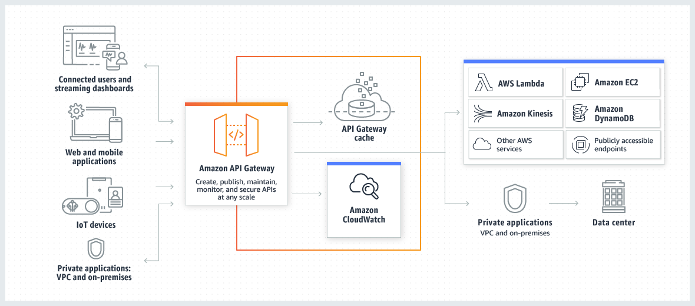
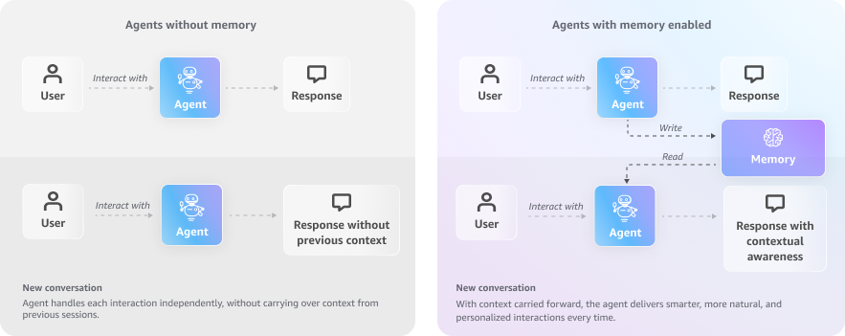
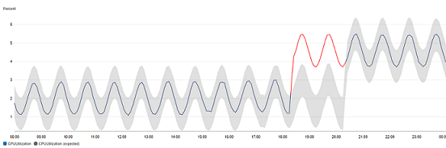
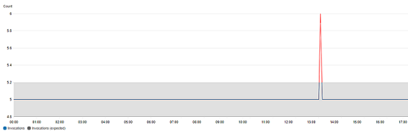
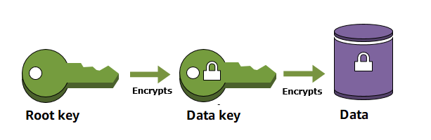
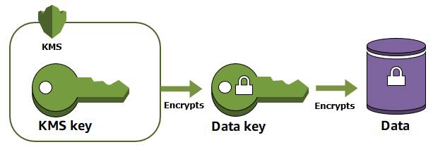

How the components tie to the domains
Domain | Main components | Architecture
1. Foundation models, data, compliance | Converse, InvokeModel, Knowledge Bases, vector stores, AppConfig, Data Automation, Comprehend, Glue Data Quality, Model Registry | Architectures 1 and 4
2. Implementation and integration | Bedrock Agents, AgentCore, Step Functions, Lambda, API Gateway, SageMaker endpoints, Batch inference | Architectures 1, 2, and 6
3. Safety, security, governance | Guardrails, Comprehend, PrivateLink, KMS, Macie, Lake Formation, CloudTrail, Model Cards, SCP | Architecture 3
4. Operational efficiency | Provisioned Throughput, Cross-Region profiles, prompt caching, Batch, CloudWatch, X-Ray, AgentCore Observability | Architecture 5
5. Testing, validation, troubleshooting | Judge evaluations, golden sets, CloudWatch Logs Insights, X-Ray, Glue Data Quality, Step Functions for release gates | Architectures 5 and 6
Part 1B · Concepts course

Build the vocabulary first, then the services
Each lesson starts from one first principle. The next lesson depends on the one before it. Read the lessons in order. The exam uses these ideas in every domain. If a question uses a word you cannot define, return to the lesson for that word.

Lesson 1 · Tokens and the context window
First principle. A model reads and writes tokens. A token is a piece of text, often a word part. The model has a fixed limit on the tokens it can hold in one call. That limit is the context window.
Input tokens include the instructions, the conversation, and any retrieved text. Output tokens are the reply. Both count toward the context window. Both are billed. Output tokens usually cost more per token than input tokens. Count tokens before the call to avoid overflow. CountTokens estimates the count for a supported model.

Exam tie. Domain 4 task 4.1 uses token price. Domain 1 task 1.2 uses the context window as a model axis. Domain 5 task 5.2 uses token count for truncated output.
Exam trap. Context overflow drops the end of a long input. The output looks cut off or ignores the last section.

Lesson 2 · Inference
First principle. Inference is the step where a trained model reads input and produces output. Each call has two phases. The model first reads the whole input. It then writes the output one token at a time.
Time to first token depends mostly on the input length and the queue. Tokens per second depends on the model and capacity. Streaming sends each token as it appears, which improves perceived speed. It does not shorten the total generation time. Three AWS modes serve inference. On-demand charges per token and has no commitment. Provisioned Throughput reserves model units for a steady rate. Batch inference runs offline from S3 to S3 at a lower price for select models.

Exam tie. Domain 2 task 2.2 chooses the mode. Domain 4 task 4.2 measures time to first token and throughput. Domain 4 task 4.1 uses the mode as a cost lever.
Exam trap. Buying Provisioned Throughput does not change the speed of one call. It changes the reserved capacity. The call must use the provisioned model ARN.

Lesson 3 · Embeddings and similarity
First principle. An embedding maps text to a list of numbers, called a vector. Texts with similar meaning get vectors that point in similar directions. Similarity is a score that compares two vectors.
Titan Text Embeddings v2 outputs 1024, 512, or 256 dimensions. More dimensions hold more detail and cost more storage and compute. Cohere Embed separates queries from documents with an input type value. Use search_query for questions and search_document for passages. Embedding calls use InvokeModel with an embedding model. Converse does not produce embeddings.

Exam tie. Domain 1 task 1.4 and task 1.5 test the dimension choice and the input type. Domain 2 task 2.3 tests the API choice.
Exam trap. A bigger embedding model does not fix a bad chunk. The chunk must hold one complete answer.

Lesson 4 · Vector search and reranking
First principle. Vector search finds the stored vectors closest to a query vector. It returns the top-k results. Closest is not the same as most relevant. A reranker scores each candidate against the question.
Hybrid search adds keyword matching to vector search. Keyword search finds exact codes and citation strings. Vector search finds related meaning. Metadata filters narrow the search. Check the store documentation for when the filter applies.
Exam tie. Domain 1 task 1.4 selects the store. Domain 1 task 1.5 selects hybrid search, reranking, and query rewrite.
Exam trap. Reranking fixes order. It does not add a chunk that retrieval missed.

Lesson 5 · Retrieval-augmented generation (RAG)
First principle. A model answers from its weights, which are fixed at training time. RAG adds facts at query time. The system retrieves text from your documents and places it in the prompt. The model answers from that text and cites it.
RAG has two paths. The ingest path runs ahead of time. It chunks, embeds, and stores documents. The query path runs per request. It embeds the question, retrieves chunks, optionally reranks, and generates an answer with citations. Knowledge Bases runs both paths for you.
The RAG diagram in Part 2 shows both paths. Read it after this lesson.
Exam tie. Domain 1 tasks 1.4 and 1.5 cover RAG. Domain 3 task 3.1 uses grounding checks on the answer. Domain 5 task 5.1 splits retriever metrics from generator metrics.
Exam trap. Fine-tuning does not add changing facts. Use RAG for facts that change.

Lesson 6 · Chunking
First principle. A chunk is the unit of text that retrieval returns. A chunk must hold one complete answer. Too large, and the chunk adds noise. Too small, and the chunk loses context.
Fixed-size chunking works for short, self-contained text such as FAQs. Hierarchical chunking uses small child chunks for matching and larger parent chunks for context. It suits manuals and contracts. Semantic chunking splits on meaning and costs more to process. Custom chunking with Lambda keeps tables and figures whole. The chunking strategy is set when the data source is created. To change it, create a new data source and sync it.
Exam tie. Domain 1 task 1.3 selects the chunking strategy. Domain 5 task 5.2 traces quality drops to a changed chunking setting.
Exam trap. A table split across chunks can lose its values. A chunk can look correct alone and still be wrong.

Lesson 7 · Customization: from prompts to LoRA and distillation
First principle. Customization changes the model or its input. Each rung changes more and costs more. Start with the cheapest rung. Stop when the requirement is met.
Prompt engineering changes only the instructions. RAG adds facts at query time. Fine-tuning changes the model weights with labeled examples. LoRA is a parameter-efficient method. It freezes the base weights and trains small adapter matrices. The update is the product of two small matrices, so the adapter is much smaller than the base model. You can store several adapters and load the one that fits the task. Distillation trains a smaller student model to copy a larger teacher model on one task. The student is cheaper and faster for that task.

Exam tie. Domain 1 task 1.2 covers the customization ladder. Domain 2 task 2.2 covers SageMaker AI deployment of a custom model. Domain 3 task 3.4 covers model documentation for a tuned model.
Exam trap. LoRA does not fix facts that change. A tuned adapter still holds the facts from its training data. Use RAG for changing facts.

Lesson 8 · Agents and tools
First principle. An agent is a loop. The model reasons about the next step. It calls a tool. It observes the result. It repeats until a stop condition is met. A loop needs limits, because each step costs time and money.
A tool has a schema, which names its inputs. An action group in Bedrock Agents links the agent to a Lambda function. AgentCore Gateway exposes tools through MCP. Each tool call can pass through Policy in AgentCore before it runs. Trace records each step, the chosen tool, and the observation.
Exam tie. Domain 2 task 2.1 covers the agent loop, action groups, and aliases. Domain 2 task 2.2 covers AgentCore. Domain 3 task 3.1 covers the policy check.
Exam trap. A prompt that says "stop after three steps" is not a control. Enforce the limit in the workflow or the tool layer.

Lesson 9 · Safety layers
First principle. No single control stops every failure. Each layer checks something different. Input checks run before the model. Output checks run after it. Data controls protect storage and access.
Guardrails apply six policy types on input and output. Contextual grounding checks test whether the answer is supported by the source. The prompt attack filter detects jailbreak and injection patterns on input. Comprehend detects PII in text. Macie finds sensitive data in S3 at rest. KMS encrypts data at rest. PrivateLink keeps API traffic inside the VPC.
Exam tie. Domain 3 tasks 3.1 and 3.2 cover these layers. Domain 3 task 3.3 covers the audit side.
Exam trap. A denied topic is not a prompt attack detector. Use the prompt attack filter for attacks.

Lesson 10 · Evaluation
First principle. An evaluation compares outputs with a standard. The standard can be a known answer, a rubric, or a human judgment. The method must match the claim.
Automatic metrics suit facts with known answers. An LLM judge scores qualities such as faithfulness at scale. A judge must be calibrated against human ratings first. A golden set holds trusted prompts and answers. Regression suites rerun the golden set on each change. Canary releases send a small share of traffic to a new version.
Exam tie. Domain 5 tasks 5.1 and 5.2 cover evaluation methods, golden sets, and release gates.
Exam trap. An uncalibrated judge gives opinions, not measurements.

Lesson 11 · Operations signals
First principle. A production system emits three kinds of signal. Metrics count things over time. Traces follow one request across services. Logs hold the payloads. Each signal answers a different question.
CloudWatch metrics track tokens, invocations, and throttles. Anomaly detection builds a band from history and alarms when a value leaves it. X-Ray traces requests and downstream calls. Invocation logs hold prompts and completions. Logs Insights searches them. Model Monitor watches drift in structured features, not free-text quality.
Exam tie. Domain 4 task 4.3 covers monitoring. Domain 5 task 5.2 covers debugging.
Exam trap. Metrics alone cannot rebuild what the model received. Keep the payload logs under access control.
Part 1C · Service deep dives

AWS AppConfig and Amazon SageMaker AI, from first principles
Both services appear in many questions. AppConfig controls how a running application reads its settings. SageMaker AI hosts and prepares models. Read each service from the purpose, then the parts, then the exam tie.

AWS AppConfig
First principle. A running application reads its settings from somewhere. If a setting changes, the application must pick up the change without a code release. AppConfig is the place that holds the settings and rolls them out.
Parts. A configuration profile defines where the settings live. The stores are the AppConfig hosted configuration store, AWS Secrets Manager, Systems Manager Parameter Store, and Amazon S3. A deployment strategy sets how fast a change reaches the application. It can roll out in steps over a period of time. Validators check the configuration before deployment. They check syntax and meaning. Alarms watch CloudWatch metrics during a deployment. If an alarm fires, AppConfig rolls the change back. Feature flags let you release a capability to some users first.
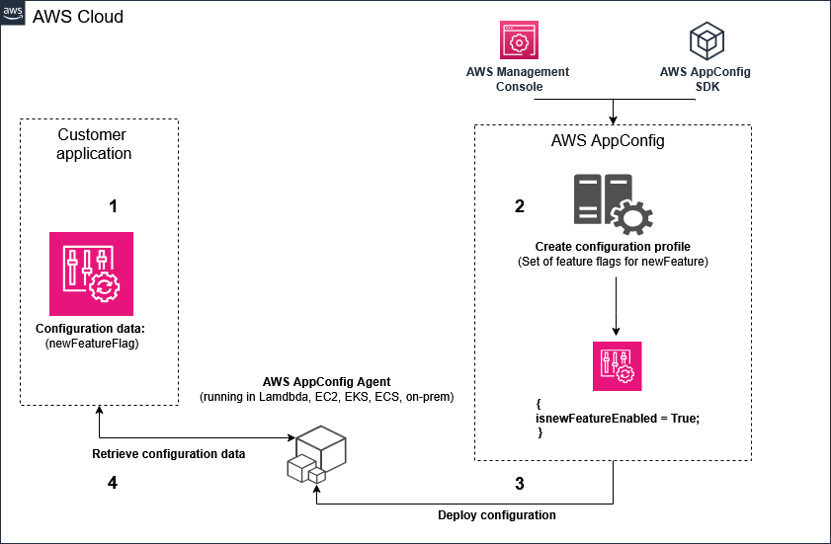

Model switch pattern. Store the model ID in a hosted configuration profile. The Lambda function reads the ID at runtime. A change to the ID rolls out with a deployment strategy. A CloudWatch alarm on errors rolls it back. No code release is needed. This is the pattern in Domain 1 task 1.2.
Exam trap. AppConfig controls settings. It does not route traffic to a model by prompt complexity. It does not host the model.

Amazon SageMaker AI
First principle. A custom or fine-tuned model needs a place to run, a way to track versions, and a way to watch its behavior. SageMaker AI covers those three needs. Read its parts in that order.
Hosting. A real-time endpoint serves steady traffic with autoscaling. A serverless endpoint serves intermittent traffic and scales to zero. Its memory runs from 1 GB to 6 GB. Provisioned Concurrency keeps capacity warm for predictable bursts. The first request after idle time can have a cold start. An asynchronous endpoint queues long requests. Its payload comes from S3. The result goes to S3. It supports processing times up to one hour and near real-time latency.
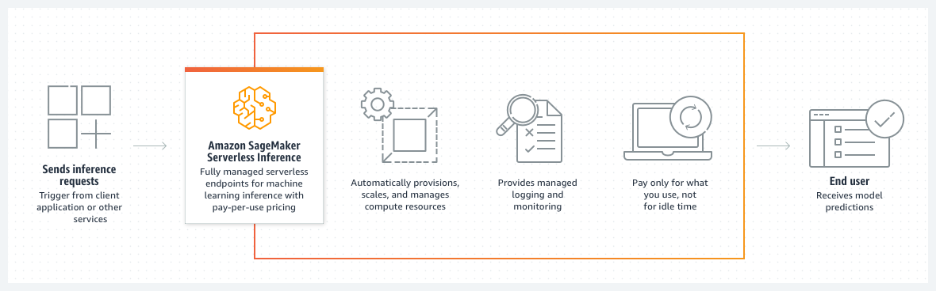
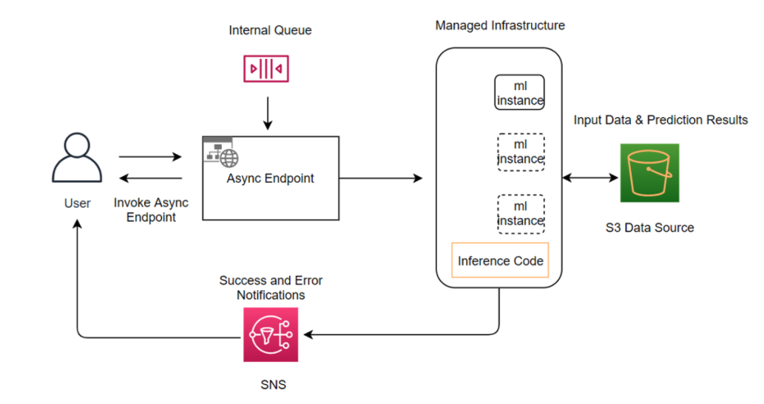
Registry. The model registry groups model versions. Each version has an approval status. A registry can share versions across accounts. Pipelines can require approval before deployment. A rollback points the endpoint to an earlier approved version.
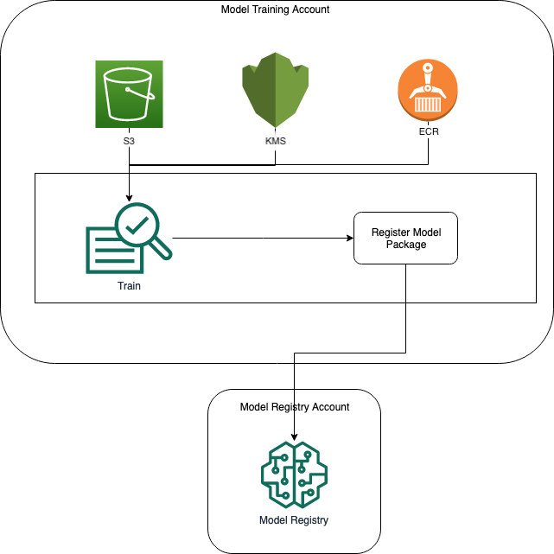
Monitoring. Model Monitor watches drift in structured features and predictions. It does not score free-text answer quality. The SageMaker documentation states that Model Monitor is no longer open to new customers. Check that status before you rely on it.
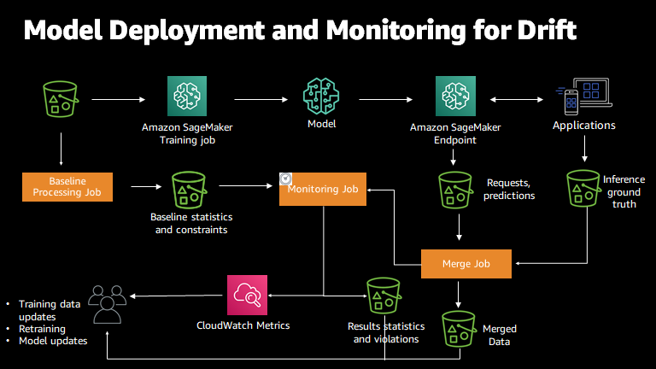
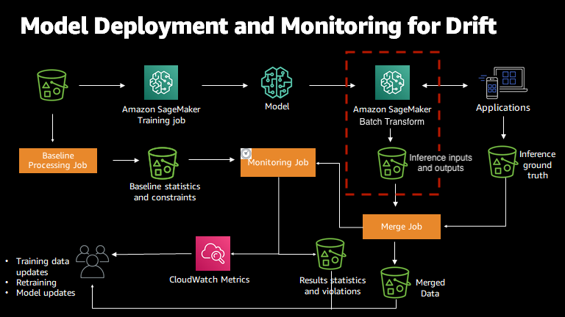
Customization. SageMaker AI fine-tunes a model. LoRA trains small adapters on top of frozen base weights. Distillation trains a smaller student from a teacher. Register each tuned version. Deploy it to an endpoint. Track the approval status.
Exam trap. SageMaker AI endpoints host models. Bedrock hosts the managed foundation models. Pick by who owns the model.
Part 1D · Tie-in

How the lessons and services connect to the domains
Idea | Lesson | Service | Domain and task
Inference modes and cost | 2 | Bedrock on-demand, Provisioned Throughput, Batch | 2.2, 4.1, 4.2
Tokens and context window | 1 | Bedrock Converse, CountTokens | 1.2, 4.1, 5.2
Embeddings and vector search | 3, 4 | Titan Text Embeddings v2, Cohere Embed, OpenSearch Serverless, S3 Vectors | 1.4, 1.5
RAG and citations | 5, 6 | Knowledge Bases, RetrieveAndGenerate | 1.5, 5.1
LoRA and distillation | 7 | SageMaker AI fine-tuning, Model Registry, endpoints | 1.2, 2.2, 3.4
Agents and tools | 8 | Bedrock Agents, AgentCore Gateway, Policy, Memory | 2.1, 2.2, 3.1
Safety layers | 9 | Guardrails, Comprehend, Macie, KMS, PrivateLink | 3.1, 3.2
Evaluation and judges | 10 | Model evaluation jobs, golden sets, canary releases | 5.1, 5.2
Runtime configuration and rollback | 1 and 11 | AppConfig, CloudWatch alarms | 1.2, 4.3, 5.2
Monitoring signals | 11 | CloudWatch, X-Ray, invocation logs, Model Monitor | 4.3, 5.2
Read the table from left to right. A question that names one idea points to one lesson, one service, and one task.
Part 1E · Visual units

Visual units for the components and ideas
Each unit explains one idea. Units 1 to 20 cover components. Units 21 to 68 cover the domain tasks. Practical units p1 to p11 in Part 1F give the console and API steps. Read one unit at a time. Each unit starts with the first principle, then the picture, then the exam tie. Every diagram in this part is a schematic drawn from the official behavior. Official images appear in the component parts.
How to read a unit. Look at the picture first. Read the first principle second. Then check the trap.
Visual unit 1

Converse and InvokeModel: two doors to one model
First principle. Your application sends a request. Converse uses one request format for chat and tools across models. InvokeModel sends the body that one provider expects.

- Use Converse for chat, tool use, and multimodal input on supported models.
- Use InvokeModel for embeddings and provider-specific fields.
- A Claude body needs anthropic_version and max_tokens when you call InvokeModel.
Exam tie. Domain 2 task 2.3 and Domain 1 task 1.2 test this choice. Embeddings always use InvokeModel.
Exam trap. Converse does not produce embeddings. A Titan body sent to Claude fails.
Visual unit 2

On-demand, Provisioned Throughput, and batch: three load shapes
First principle. Capacity is a shape problem. Spiky, steady, and offline load need different purchases. Match the purchase to the shape of the traffic.

- On-demand pays per token and has no commitment. It suits spiky or unknown traffic.
- Provisioned Throughput reserves model units. It suits a steady baseline.
- Batch runs offline from S3 to S3. It suits work that can wait for hours.
Exam tie. Domain 2 task 2.2 and Domain 4 task 4.1. Mixed traffic uses a reserved baseline and on-demand spikes.
Exam trap. More model units do not help a call that still uses the base model ID.
Visual unit 3

Cross-Region inference profiles
First principle. A profile ID names a set of Regions. A request that uses the profile can run in any Region in that set. The profile spreads load. It does not keep data in one place.

- Call the profile ID, such as one with the us. or eu. prefix.
- A geographic profile keeps routing inside its listed Regions.
- A global profile can route outside a strict residency boundary.
Exam tie. Domain 1 task 1.2 and Domain 4 task 4.1. Domain 3 task 3.2 covers data scope.
Exam trap. Cross-Region inference is not automatic failover for your app. Add retries and fallback in the application.
Visual unit 4

Prompt caching: the stable prefix pays once
First principle. A model reads the prompt from the start. If the start is the same as an earlier call, the system can reuse that work. The reused part must match exactly and sit before the changing text.

- Mark the static prefix with a cache checkpoint.
- Keep the user message at the end.
- The default time to live is 5 minutes.
Exam tie. Domain 4 task 4.1 and Domain 2 task 2.5. The API marks the checkpoint with a cachePoint block. Caching lowers the cost of a repeated prefix.
Exam trap. A changing value inside the prefix breaks the cache. Move it to the end.
Visual unit 5

Semantic cache: match the meaning, not the words
First principle. A semantic cache stores answers next to the embedding of each question. A new question is embedded. If a stored question is close enough, the stored answer returns. Otherwise the model answers and the pair is stored.

- Hit: return the stored answer. No model call.
- Miss: call the model, then store the answer.
- Works when many questions repeat with different words.
Exam tie. Domain 4 task 4.1 and Domain 4 task 4.2. Embeddings come from Domain 1 task 1.4.
Exam trap. Personal or unique questions rarely hit. A semantic cache saves little for them.
Visual unit 6

Chunk shape: fixed, hierarchical, and whole tables
First principle. A chunk is one piece of a document that retrieval can return. A chunk must hold one complete answer. The shape of the document decides the shape of the chunk.

- Fixed size suits FAQs and short text.
- Hierarchical keeps small child chunks for matching and larger parents for context.
- Custom Lambda chunking keeps a table or figure whole.
Exam tie. Domain 1 task 1.3. Domain 5 task 5.2 traces quality drops to chunking.
Exam trap. A table split across two chunks loses its values. Each half can look correct alone.
Visual unit 7

Hybrid search and reranking: a funnel
First principle. Retrieval returns many candidates. Each search method finds different candidates. Merge the lists. Then score each candidate against the question and keep the best few.

- Keyword search finds exact codes and citation strings.
- Vector search finds related meaning.
- The reranker orders candidates by relevance. It does not add missing chunks.
Exam tie. Domain 1 task 1.5. Domain 5 task 5.1 measures retriever quality.
Exam trap. Similarity is not relevance. Rerank before generation.
Visual unit 8

Agent versions: DRAFT, version, alias
First principle. Editing an agent changes DRAFT. Callers do not use DRAFT. A version is a frozen snapshot. An alias points to one version. Callers use the alias, so you can move traffic without changing the caller.

- Edit DRAFT, then prepare the agent.
- Create a version from the prepared DRAFT.
- Point the alias to the new version.
Exam tie. Domain 2 task 2.1. Domain 5 task 5.2 covers the old-behavior symptom.
Exam trap. A passing console test on DRAFT does not prove the alias works.
Visual unit 9

AgentCore components around one agent
First principle. An agent needs a place to run, memory, tools, identity, rules, and traces. AgentCore puts those parts behind one service. Each part answers one question about the agent.

- Runtime hosts the agent code from any framework.
- Memory keeps context. Gateway exposes tools as MCP tools.
- Identity decides who can call. Policy checks each tool call. Observability records traces.
Exam tie. Domain 2 task 2.2. Domain 3 tasks 3.1 and 3.2. Domain 4 task 4.3.
Exam trap. AgentCore is not a model. It hosts and governs the agent around the model.
Visual unit 10

Lambda limit versus a waiting workflow
First principle. A Lambda invocation ends after at most 15 minutes for a standard function. A wait for a person can last days. A durable workflow stores its state and resumes later.

- Keep each Lambda step short.
- Step Functions Standard keeps state for waits and runs up to one year.
- A callback task token pauses the flow until a person or system responds.
Exam tie. Domain 2 task 2.2 and Domain 1 task 1.6.
Exam trap. A Lambda that waits for a person pays for the wait and hits the limit.
Visual unit 11

API Gateway timeout versus a stream
First principle. An API Gateway REST integration has a default timeout of 29 seconds. A slow model call that runs longer loses its connection at that point. A stream that stays open can carry tokens for longer.

- Raising the Lambda timeout does not change the gateway limit.
- WebSocket APIs keep a connection open for streams.
- An asynchronous job returns a job ID, then the client polls or receives the result.
Exam tie. Domain 2 tasks 2.3 and 2.4.
Exam trap. Streaming improves perceived speed. It does not extend a REST timeout.
Visual unit 12

Retry with backoff and jitter
First principle. A failed call can succeed later. Retrying at once adds load to a service that is already busy. Waiting longer after each failure spreads the load. Random jitter stops many clients from retrying at the same moment.

- Wait longer after each failure.
- Add random jitter to each wait.
- Stop after a maximum number of attempts, then fall back.
Exam tie. Domain 2 task 2.4. Domain 4 task 4.1 covers quotas and throttling.
Exam trap. A tight retry loop makes an overload worse. It is never the correct answer.
Visual unit 13

Judge calibration before trust
First principle. An LLM judge gives a score. A score means something only when it agrees with people. Rate a fixed golden set with humans. Run the judge on the same set. Compare the two.

- Low agreement means the judge is not valid for the claim.
- Pin the judge model ID. A new judge gives new scores.
- Human review covers tone and voice.
Exam tie. Domain 5 task 5.1. Domain 3 task 3.4 uses judges for fairness checks.
Exam trap. An uncalibrated judge gives opinions, not measurements.
Visual unit 14

Canary and rollback: release in steps
First principle. A new version can fail on real users. A canary sends a small share of traffic to it first. Metrics decide the next step. If a metric breaks, traffic returns to the last approved version.

- Start at a small share, such as 10 percent.
- Move traffic only when the alarms stay quiet.
- Rollback points traffic to the last approved version.
Exam tie. Domain 5 tasks 5.1 and 5.2. Domain 2 task 2.3 covers AppConfig and aliases.
Exam trap. A re-sync or a prompt edit is a release. It needs the same gate.
Visual unit 15

Four monitoring signals, four questions
First principle. Each signal answers one question. Metrics count. Traces follow one request. Logs hold payloads. Quality checks score answers over time.

- Metrics: is it slow or expensive?
- Traces: which step is slow?
- Logs: what did the model receive? Judge: is the answer good?
Exam tie. Domain 4 task 4.3. Domain 5 task 5.2.
Exam trap. Metrics alone cannot rebuild a wrong answer. Keep the payloads.
Visual unit 16

Who called versus what was sent
First principle. CloudTrail records who called which API, when, and from where. Invocation logs record the prompt and the response. These are two different records. Each one answers a different audit question.

- CloudTrail answers identity and timing.
- Invocation logs answer content.
- Encryption with KMS protects both at rest.
Exam tie. Domain 3 task 3.2 and task 3.3.
Exam trap. CloudTrail does not show row content. Invocation logs show the original request even when output is masked.
Visual unit 17

PrivateLink and the VPC boundary
First principle. A VPC endpoint gives private IP access to an AWS service. Traffic from the VPC stays on the AWS network. Each Bedrock plane has its own endpoint.

- bedrock-runtime serves model invocations.
- bedrock-agent and bedrock-agent-runtime serve agents.
- bedrock serves the control plane.
Exam tie. Domain 3 task 3.2.
Exam trap. One runtime endpoint does not cover agent calls. Check each plane.
Visual unit 18

Organization rules with SCPs and condition keys
First principle. A service control policy sets the most a member account can do. A condition key limits one action. A condition on the guardrail identifier can make the guardrail mandatory on each call.

- The IAM layer applies even if application code changes.
- A call without the guardrail identifier is denied.
- This is a rule across accounts, not a setting in one app.
Exam tie. Domain 3 task 3.3.
Exam trap. A guardrail that only the app calls can be skipped. Enforce it in IAM.
Visual unit 19

Outposts versus a Region
First principle. A Region runs in AWS data centers. Outposts runs AWS services on your premises. Data processed on Outposts stays at the site for the rule that requires it.

- Use a Region for most workloads.
- Use Outposts when a rule says the data stays on site.
- The same AWS programming interfaces apply on Outposts.
Exam tie. Domain 2 task 2.3.
Exam trap. A Region in the cloud does not keep data on your premises.
Visual unit 20

Distillation and cascade routing
First principle. A large model is accurate and costly. A small model is cheaper and faster. Distillation trains the small model to copy the large one on one task. Cascade routing tries the small model first and escalates only when needed.

- Distillation builds a cheaper student for a narrow task.
- Cascade escalates on uncertainty or complexity.
- Routing needs a signal. Without a signal the router cannot decide.
Exam tie. Domain 1 task 1.2. Domain 4 task 4.1 and task 4.2.
Exam trap. Sending every request to the largest model wastes money.

Which unit explains which component
Component or idea | Unit
Converse, InvokeModel | Unit 1
Provisioned Throughput, on-demand, batch | Unit 2
Cross-Region inference profiles | Unit 3
Prompt caching | Unit 4
Semantic cache | Unit 5
Chunking | Unit 6
Hybrid search, reranker | Unit 7
Bedrock Agents DRAFT, version, alias | Unit 8
AgentCore components | Unit 9
Lambda, Step Functions | Unit 10
API Gateway | Unit 11
Retries and throttling | Unit 12
Judge calibration | Unit 13
Canary and rollback, AppConfig | Unit 14
CloudWatch, X-Ray, logs, judge | Unit 15
CloudTrail and invocation logs, KMS | Unit 16
PrivateLink | Unit 17
SCP and IAM condition keys | Unit 18
Outposts | Unit 19
Distillation, cascade routing | Unit 20
Part 1F · Practical console and API steps

What to do in the console and the API
Each unit lists the steps that the official page states. Each step cites its page. The exam tests whether you know where a setting lives and which setting fixes a symptom. A step marked Not in source does not appear in the page this build could read. Check that step on the live console before exam day.
Screenshots below are official AWS documentation images. No account screenshots appear in this treatise.
Practical unit 1

Create a knowledge base from a data source
Where. Source: Create a knowledge base by connecting to a data source.
- In the left navigation pane, choose Knowledge bases.
- Choose an AWS Identity and Access Management (IAM) service role that gives Amazon Bedrock access to the knowledge base.
- Choose the data source to connect the knowledge base to.
- Choose an embeddings model. For multimodal data, the page names Amazon Titan Multimodal Embeddings G1 or Cohere Embed v3.
- Choose a vector store. Use one you created, or let Bedrock create one.
- Set the security configuration for the knowledge base.
API route. Sync the source with StartIngestionJob. Query with the retrieve and generate operations.
Not in source. The page does not list every field on each screen.
Practical unit 2

Test a knowledge base retrieval
Where. Source: Query a knowledge base and retrieve data.
- In the left navigation pane, choose Knowledge bases.
- Choose the knowledge base you want to test.
- In the test window, enter a query in the text box and select the run action.
- Read the retrieved chunks and their sources before you judge the answer.
API route. Use the retrieve operation to return chunks without generation.
Not in source. Not in source for the other console fields on this page.
Practical unit 3

Create and configure an agent manually
Where. Source: Create and configure agent manually.
- Choose a service role. Create and use a new role, or use an existing role.
- Add action groups to define the actions the agent can perform.
- Add a knowledge base so the agent can search and query data.
- Test the agent in the test window and troubleshoot its behavior.
- For several agents, configure multi-agent collaboration.
API route. Invoke the agent with the invoke agent operation, using an agent alias ID.
Not in source. The fetched page does not show the prepare or alias steps. See Domain 2 for the alias rule.
Practical unit 4

Create a batch inference job
Where. Source: Create a batch inference job.
- Choose a service role. Use an existing role, or create a custom service role for batch inference.
- Create the batch inference job and choose the model.
- Point the job at an input location in S3 and an output location in S3.
API route. Create the job with the create model invocation job operation.
Not in source. Not in source for the other console fields on this page.
Practical unit 5

Enable model invocation logging
Where. Source: Monitor model invocation using CloudWatch Logs and Amazon S3.
- Choose an S3 destination. Create an S3 bucket for the logs.
- Add a bucket policy to the bucket. Replace the example values with your own.
- Or choose a CloudWatch Logs destination and set its log group.
- Turn on invocation logging in the Bedrock settings. The fetched page does not give the screen path.
Not in source. The fetched page does not give the exact toggle name on the settings screen.
Practical unit 6

Create a prompt in Prompt management
Where. Source: Create a prompt using Prompt management.
- Provide a name and an optional description for the prompt.
- Write the prompt message. Use double curly braces for each variable, such as a variable name in double braces.
- Set a system prompt when you need to give instructions or context.
- Test the prompt. Setting a base inference parameter as an additional field does not override the value in the prompt configuration.
Not in source. Not in source for the other console fields on this page.
Practical unit 7

Turn on prompt caching in the console
Where. Source: Prompt caching for faster model inference.
- Open the prompt caching setting in the console. The page shows the toggle as an image.
- Place the stable content first. Place the changing content last.
- Read the cache metrics panel that the page shows as an image.
Not in source. The fetched page shows the toggle as an image only. The menu path is Not in source.
Practical unit 8

Create a configuration and feature flags in AppConfig
Where. Source: Creating feature flags and free form configuration data in AWS AppConfig.
- Create a configuration profile. Choose a feature flag or a free-form configuration.
- Choose the store for free-form data. The options include the hosted store, Secrets Manager, Parameter Store, and Amazon S3.
- Set the configuration profile IAM role when the store requires one.
- Create multi-variant feature flags when you need variants for an experiment.
Not in source. Not in source for the other console fields on this page.
Practical unit 9

Create a deployment strategy in AppConfig
Where. Source: Working with deployment strategies.
- Create a deployment strategy. Check the rollout field names on the console. The fetched page does not list them.
- Attach the strategy to the deployment of the configuration.
- Let the alarms watch the rollout. A firing alarm rolls the change back.
Not in source. Not in source for the other console fields on this page.
Practical unit 10

Create an asynchronous endpoint in SageMaker AI
Where. Source: How to create an Asynchronous Inference Endpoint.
- Create a model with the create model operation.
- Create an endpoint configuration with the create endpoint configuration operation. Set the asynchronous settings.
- Create the HTTPS endpoint with the create endpoint operation.
- Send the request payload to S3. Read the result from the S3 output location.
Not in source. Not in source for the other console fields on this page.
Practical unit 11

Build a Step Functions state machine from a template
Where. Source: Learn how to get started with Step Functions.
- Open the Step Functions console and create a state machine from a template.
- Select states on the canvas to review their settings.
- Start an execution. Review the execution details and the state output.
- Choose the IAM role for the state machine. Use the IAM console when the role needs changes.
Not in source. The fetched page does not show the callback task token steps. See Domain 2 unit 10.

Screenshots from the official pages
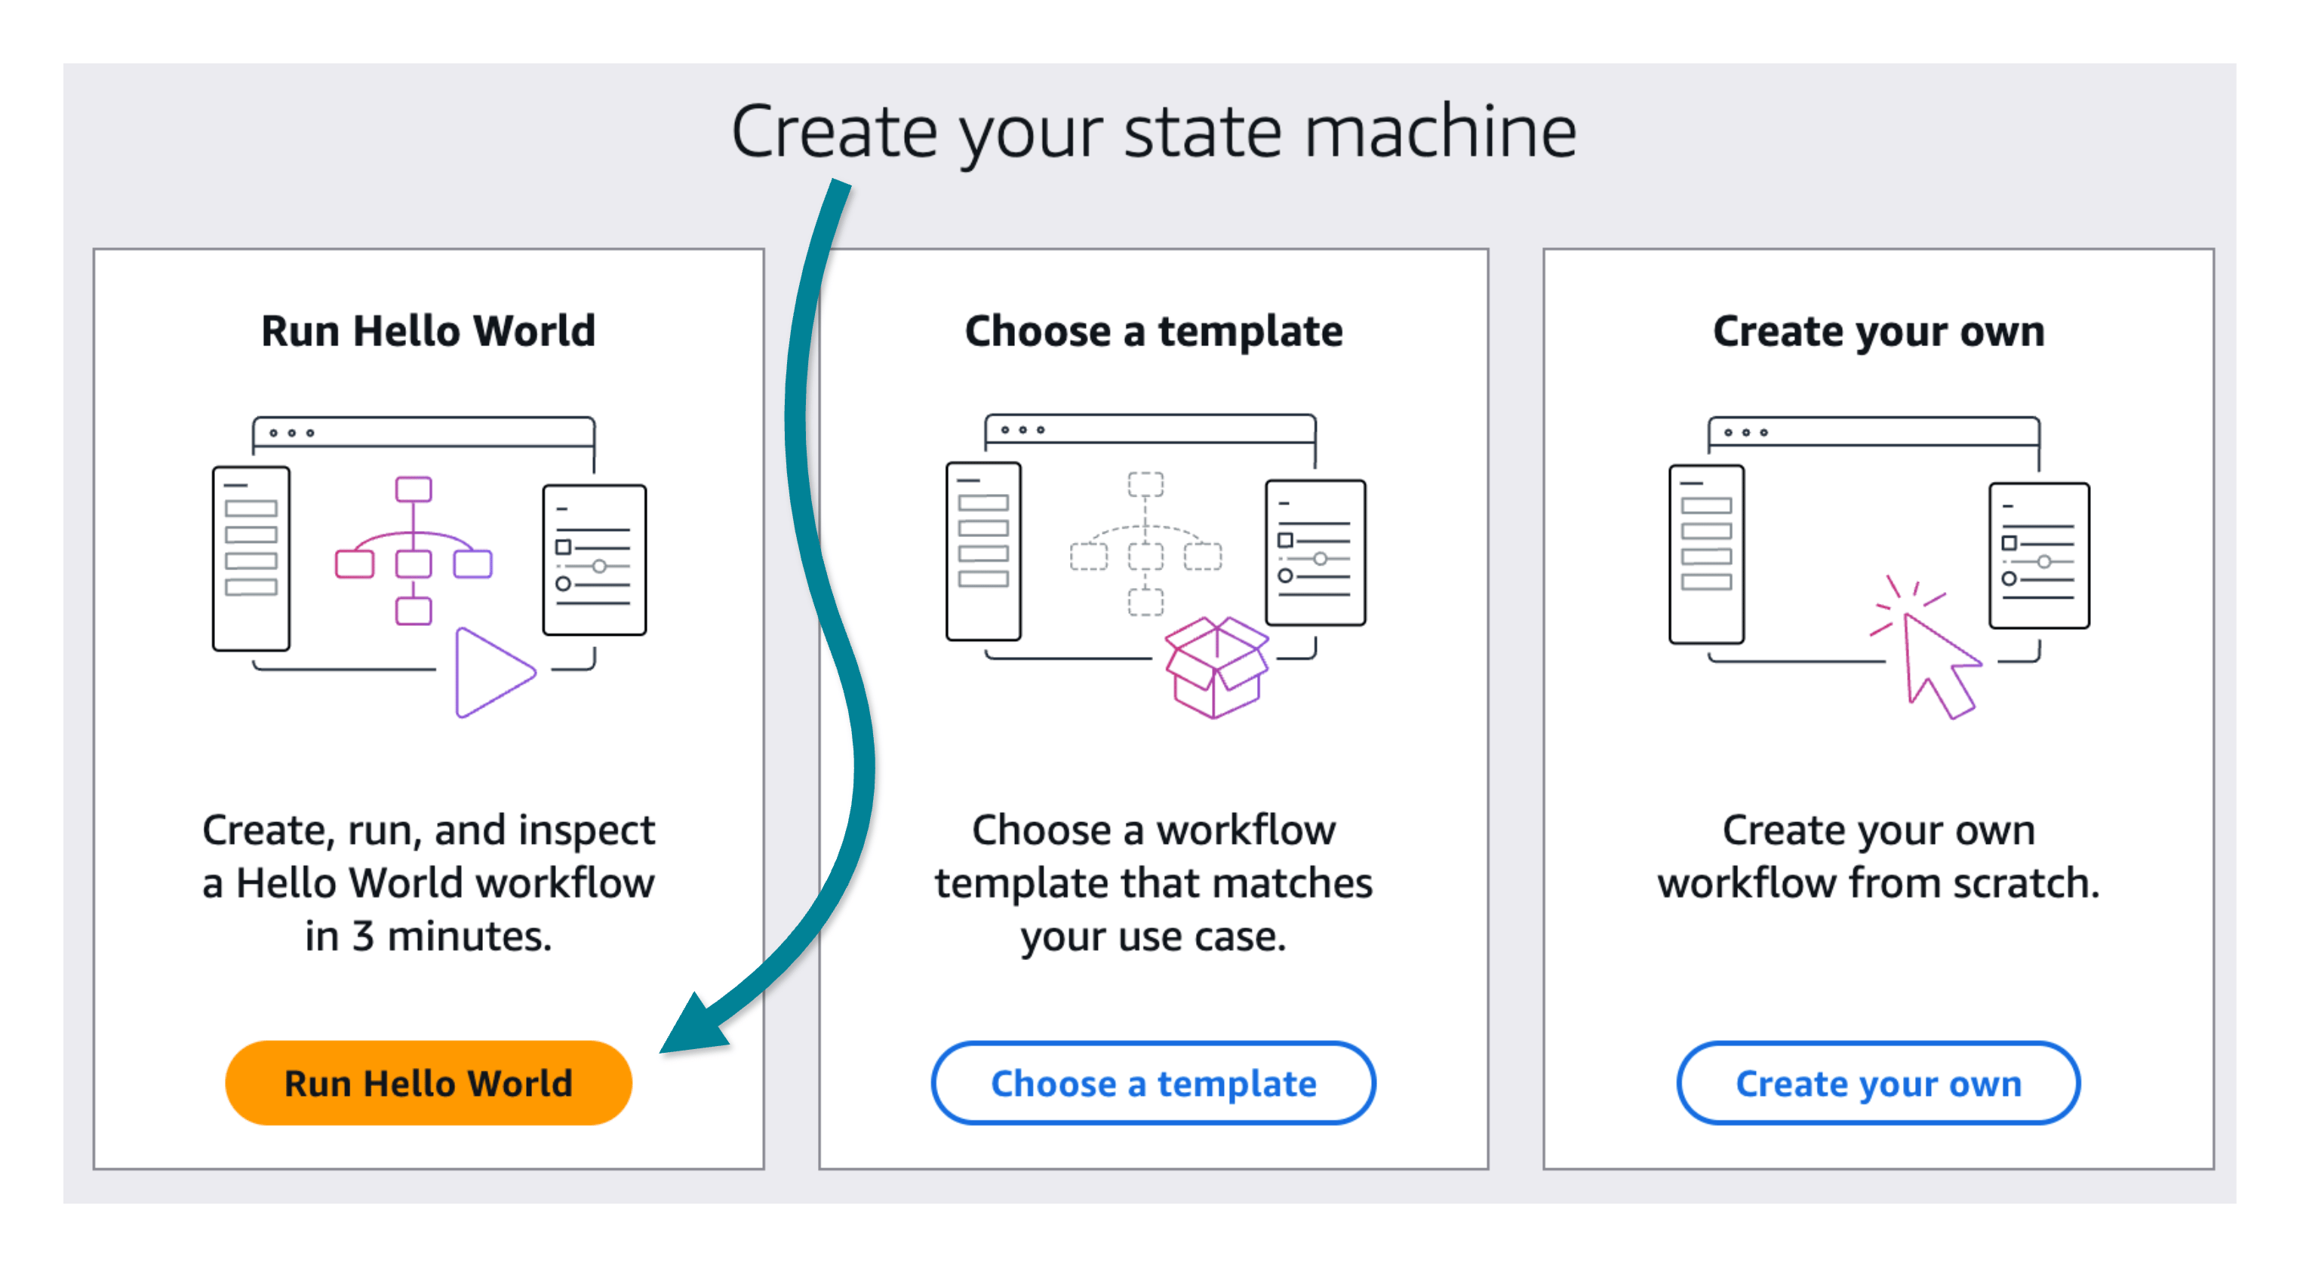
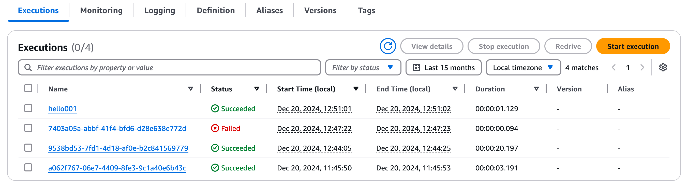
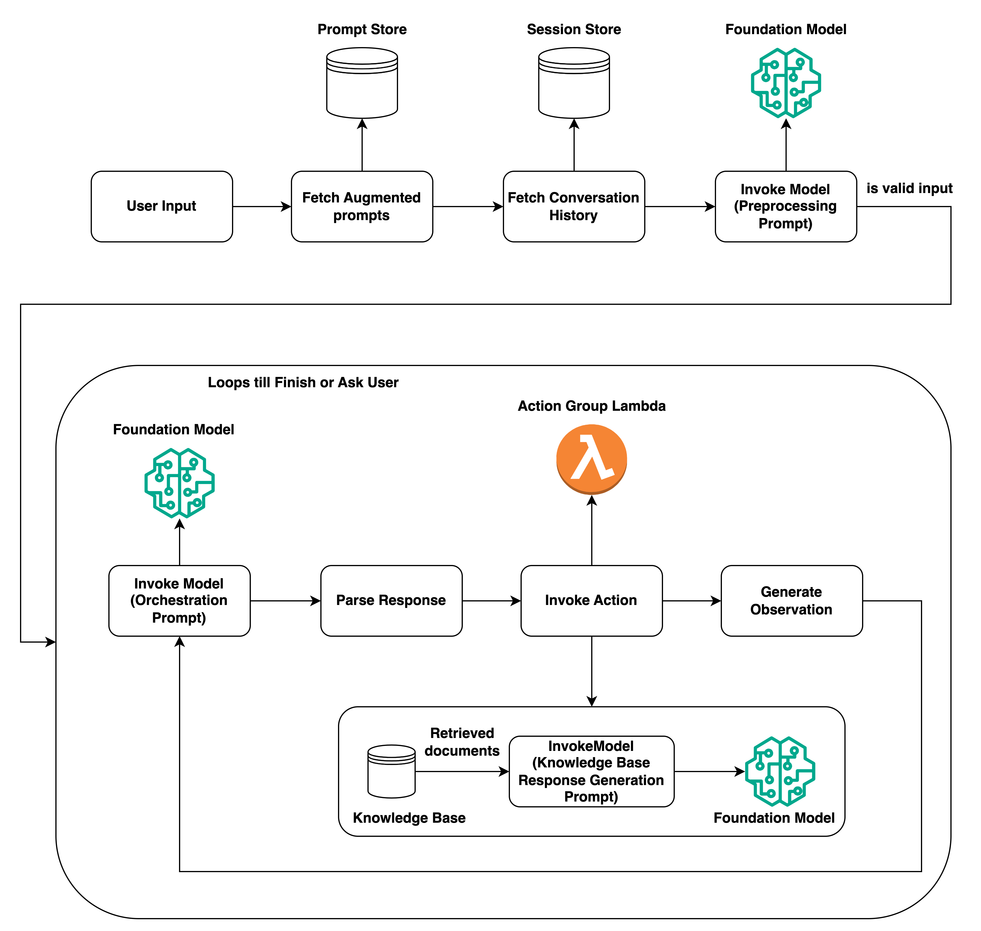

Topics with no fetched console steps
These topics have no console steps in the pages this build could read. Each one is marked Not in source for steps.
Topic | Console or API steps
Provisioned Throughput purchase | Resolved. Steps in section 8B.
Guardrail creation steps (the page title is confirmed) | Not in source
SageMaker real-time endpoint creation (page stub) | Not in source
Lambda timeout setting | Resolved. Steps in section 8B.
API Gateway integration timeout setting | Not in source
Macie, Lake Formation, CloudTrail, KMS, and PrivateLink console steps | Not in source
Comprehend, Transcribe, Glue Data Quality, and Data Automation steps | Not in source
OpenSearch Serverless, S3 Vectors, Neptune, and DynamoDB TTL steps | Not in source
CloudWatch anomaly alarm and X-Ray steps | Not in source
Model Monitor and judge evaluation job steps | Not in source
Model Registry approval steps | Resolved. Steps in section 8B.
Part 2 · Domain 1 · Weight 31 percent (official exam guide)

Foundation model integration, data management, and compliance
Visual units for this domain
Visual unit 21

The approach ladder: cheapest rung first
First principle. Each rung adds more change and more cost. Prompts change instructions. RAG adds facts at query time. Agents add actions. Fine-tuning changes weights. Stop at the first rung that meets the requirement.

- Start with prompt engineering.
- Add RAG when facts change or citations are needed.
- Add agents when the model must act. Fine-tune only for a stable, high-volume behavior.
Exam tie. Domain 1 task 1.1 and task 1.2.
Exam trap. Fine-tuning on documents that change is wrong. Use RAG.
Visual unit 22

Model choice as a constraint filter
First principle. A model choice is a filter. Remove each candidate that breaks one hard constraint. Keep the cheapest model that passes all of them.

- Check capability, cost per token, latency, context window, and Region.
- Test the final choice on your own data.
- The flagship model is not the default. It can break a latency budget.
Exam tie. Domain 1 task 1.2.
Exam trap. A model that is cheap but unavailable in your Region is not a choice.
Visual unit 23

Data pipeline: four stages before the model
First principle. A model reads what it receives. Bad data gives bad answers. Clean the data in stages. Each stage uses one tool for one job.

- Validate with Glue Data Quality rules.
- Process documents, audio, and video with Data Automation or Transcribe.
- Format, then enhance with Comprehend for PII.
Exam tie. Domain 1 task 1.3.
Exam trap. Guardrails do not validate data quality or extract fields.
Visual unit 24

Vector store choice follows the data shape
First principle. A vector store holds vectors and answers nearest-neighbor queries. The right store depends on query rate, latency, and whether you already run a database.

- Knowledge Bases is the default for private documents with citations.
- S3 Vectors fits large corpora with infrequent queries.
- Neptune is for graph traversal, not plain document search.
Exam tie. Domain 1 task 1.4.
Exam trap. ElastiCache is not a durable store of record.
Visual unit 25

Embedding dimensions and the input type
First principle. An embedding is a list of numbers. More numbers hold more detail and cost more storage. Retrieval also needs the right encoding for a query and for a document.

- Titan Text Embeddings v2 outputs 1024, 512, or 256 dimensions.
- Cohere Embed uses search_query for questions and search_document for passages.
- Test both sizes on a golden set.
Exam tie. Domain 1 tasks 1.4 and 1.5.
Exam trap. Do not guess the size. Measure it.
Visual unit 26

Prompt governance: templates in version control
First principle. A prompt changes behavior like code does. Store it, version it, test it, and roll it back. An untracked prompt has no rollback point.

- Store variables and roles in Prompt Management.
- Approve before publication. Track use in CloudTrail.
- Test with a golden set before each release.
Exam tie. Domain 1 task 1.6 and Domain 2 task 2.5.
Exam trap. A prompt that changes in place has no safe rollback point.
Visual unit 27

Prompt Flows versus Step Functions
First principle. A flow is a fixed chain of nodes. A workflow is a durable state machine. Pick the flow for predictable steps. Pick Step Functions for waits, retries, and human approval.

- Prompt Flows: console chain with branches.
- Step Functions: callback tokens and waits up to one year in Standard.
- A multi-day approval needs Step Functions Standard.
Exam tie. Domain 1 task 1.6.
Exam trap. A Lambda that waits for a person hits the 15-minute limit.
Visual unit 55

Structured output: a schema, not a request
First principle. A model writes text. A request for JSON is a hope. A schema is a contract. The response must match the schema before your code reads it.

- Structured output support depends on the model and the API. Check the API reference for the exact field.
- Check the model card before you rely on it.
- Validate the output anyway at the boundary.
Exam tie. Domain 1 task 1.3, Domain 3 task 3.1, and Domain 5 task 5.2.
Exam trap. A prompt that asks for JSON does not guarantee valid JSON.
Visual unit 56

Model lifecycle: every release is a version
First principle. A model changes over time. A registry gives each version a number and an approval status. A rollback needs a previous approved version to return to.

- Register each version.
- Approve before deployment.
- Keep the previous approved version for rollback.
Exam tie. Domain 1 task 1.2. Domain 3 task 3.3 covers the audit trail.
Exam trap. A model or prompt that changes in place has no rollback point.
Visual unit 57

Retrieval failures: wrong chunks, not wrong model
First principle. An answer uses retrieved text. If the answer is wrong while the chunks look right, the fault is in how the chunks were built or ranked. Changing the generator model does not repair retrieval.

- Check whether the chunks split a complete answer.
- Check whether similarity matched meaning or only words.
- After a re-sync, check the chunking setting and the embedding model version.
Exam tie. Domain 1 task 1.5 and Domain 5 task 5.2.
Exam trap. Changing the generator does not fix broken retrieval.
Visual unit 58

Knowledge Bases or hand-built RAG
First principle. Knowledge Bases runs the RAG pipeline for you. You sync sources, then call one API. Hand-built RAG gives you control over each stage. Choose hand-built only when a stated requirement needs that control.

- Least custom effort: Knowledge Bases.
- Custom retrieval algorithm: hand-built.
- Web sources: check connector support for your knowledge base type.
Exam tie. Domain 1 tasks 1.4 and 1.5.
Exam trap. A hand-built pipeline is wrong when the scenario asks for least effort.
Visual unit 59

Knowledge Base data sources: sync or ingest
First principle. A data source tells the knowledge base where its documents live. A sync reads the source and updates the index. Ingestion through the direct API adds, updates, or deletes single files. Check the chunking setting on the data source before a change.

- Sync on a schedule with a scheduler that calls StartIngestionJob.
- Ingest on an event with your own handler.
- Direct ingestion uses the KnowledgeBaseDocuments API for S3 and custom sources.
Exam tie. Domain 1 task 1.4.
Exam trap. To change chunking, create a new data source. Then sync it.
Visual unit 60

Citations: the audit trail for an answer
First principle. A citation links one answer span to the source chunk that supports it. A grounding score rates whether the answer is supported. Auditors sample both.

- Knowledge Bases can return citations with generated answers. Check the API reference for the fields.
- Contextual grounding returns a score per answer.
- Citations are attribution, not proof of truth.
Exam tie. Domain 1 task 1.5, Domain 3 tasks 3.3 and 3.4.
Exam trap. A hand-built citation layer is wrong when the scenario asks for least effort.
Visual unit 61

Tenant isolation is structural
First principle. Tenant data must stay apart. A prompt that tells the model to ignore other tenants is not isolation. Isolation comes from the platform: separate knowledge bases, IAM roles, and metadata filters.

- One knowledge base for each tenant.
- IAM role scoped to its own knowledge base.
- Metadata filters for region or product line.
Exam tie. Domain 1 task 1.4 and Domain 3 task 3.2.
Exam trap. Prompt instructions are not isolation.
Visual unit 62

MCP tools: one standard for tool access
First principle. Model Context Protocol (MCP) is a standard for agents to find and call tools. One protocol replaces a custom client for each tool. A remote server uses Streamable HTTP.

- Tools announce what they do.
- Agents call tools through one client.
- MCP is not a model and not a guardrail.
Exam tie. Domain 1 task 1.5 and Domain 2 task 2.1.
Exam trap. MCP is the tool connection standard. It is not a safety control.
Visual unit 63

Service distractors: read what the service stores
First principle. Some services look right for a GenAI need. Each one stores or returns a different thing. Kendra is not open to new customers. Translate changes language, not PII. ElastiCache is a cache, not a durable store.

- Kendra: no longer open to new customers. Knowledge Bases is the documented alternative.
- Translate: translates text. It does not detect PII.
- ElastiCache: an in-memory cache. Check its durability settings before you use it as a store.
Exam tie. Domain 1 tasks 1.3 and 1.4.
Exam trap. Speed does not make a service durable.
Domain 1 asks one question. How do you get the correct model, the correct data, and the correct controls into a working system on AWS? It has six task statements. Read each one in order.

1.1 Design the solution first, then prove it
Design from the constraints. Then build a proof of concept. Use on-demand inference first. Buying Provisioned Throughput or hardware before a proof of concept is a distractor pattern. Prove the approach on real data, then commit capacity.
Use the AWS Well-Architected Framework and the Generative AI Lens to keep designs consistent across teams.

1.1 The approach ladder
Climb the ladder from the cheapest rung. Stop at the first rung that meets the requirement.
Rung | Use when | Signal words
1. Prompt engineering | Start here. The cheapest step. | Format, tone, instructions
2. RAG | Documents change often, or answers must cite sources. | Private, current, cite, sources
3. Agents | The model must take actions, such as calling tools or APIs. | Take action, call, update a system
4. Fine-tuning | Stable behavior and a large, repeated task volume. | Fixed format at high volume, distill
Exam trap. Fine-tuning a model on documents that change is wrong. Use RAG. Knowledge goes to retrieval. Behavior goes to weights.

1.1 Knowledge or behavior
Need | Approach
Private, current, or cited facts | RAG with a Knowledge Base
Fixed format, tone, or voice at high volume | Fine-tune a small model (distillation)
Calls to APIs or databases | Agents

1.2 Choose a model on five axes
Axis | What to check
Capability | Reasoning, multilingual, code, vision
Cost per token | Input and output prices differ. Output tokens often cost more.
Latency | Time to first token and tokens per second. Streaming improves perceived speed.
Context window | How much text fits in one call, including retrieved chunks.
Regional availability | Is the model offered in the Region where you run?
Order of decision: latency needs, then reasoning difficulty, then cost. Test the final choice on your own data. The flagship model is not the default answer. It can break a latency budget.

1.2 Routing mechanisms
Mechanism | Routes by | Use when
Cross-Region inference profile | Regional availability and throughput | More throughput across Regions. Same model family.
Intelligent prompt routing | Predicted response quality and cost | Chooses between two models in one model family. Official docs: optimized for English prompts only.
Lambda routing with AppConfig | Rules you write | You need your own policy and a model ID read at runtime.
Exam trap. A cross-Region profile routes for throughput and availability. It does not choose a model by prompt complexity.

1.2 Cross-Region inference and data scope
Call the inference profile ID, such as one with the us. or eu. prefix. Requests route to Regions listed in the profile.
A global profile can send requests outside a strict EU boundary. A geographic EU profile keeps routing inside the EU Regions it lists. Check the profile scope against the residency rule.
Cross-Region inference does not provide automatic failover for your application. Add retries and fallback in the application for an availability target.

1.2 Switch, survive, and customize
- Switch without a redeploy. Read the model ID from configuration. AWS AppConfig with Lambda and API Gateway supports this pattern.
- Survive disruptions. A circuit breaker stops calls to a failing model. Graceful degradation returns a smaller model or a cached answer.
- Customize with the least effort. Fine-tune on SageMaker AI when prompts and RAG fail. Use parameter-efficient methods such as LoRA.
- Retire safely. Register each model version in SageMaker Model Registry. Plan rollback before you deploy.
Exam trap. "No code changes" or "no redeploy" points to the configuration-driven pattern only.

1.2 Customization ladder
Rung | What changes | Use when
Prompt engineering | Instructions only | Try this first.
RAG | Private or current facts at query time | Facts change, and citations are needed.
Supervised fine-tuning | Model parameters, from labeled examples | Stable behavior that prompts cannot hold.
Distillation | A smaller student model learns from a larger teacher | A narrow task at high volume.
Fine-tuning does not fix facts that change. Use RAG for those facts.

1.2 Model lifecycle
Every release should be a version you can roll back. A model registry groups versions and tracks approval status. CloudTrail records Amazon Bedrock API calls, including InvokeModel and Converse, for the audit trail.
Exam trap. A model or prompt that changes in place has no safe rollback point.

1.2 Three ways to call a model
API | Use it for | Limit
Converse | Chat and tool use through one request format | Text, images, documents, and video for supported models. Not an embeddings API.
InvokeModel | Provider-specific bodies and embeddings | You build each provider's request body.
ConverseStream | Tokens as they arrive | The client must read a stream.
Streaming does not shorten total generation time. It shortens the time to the first visible token.

1.2 Structured output
A schema is stronger than a request for JSON. Structured output support depends on the model and the API. Check the API reference for the exact field. Check the model card before you rely on it.
Exam trap. A prompt that asks for JSON does not guarantee valid JSON. Add the schema.

1.3 Data validation and processing in four stages
- Validate. AWS Glue Data Quality rules, Lambda checks, and CloudWatch metrics.
- Process. Amazon Bedrock Data Automation for documents, images, audio, and video. SageMaker Processing for batch jobs. Amazon Transcribe for speech.
- Format. JSON for Bedrock API requests. Conversation format for dialog apps.
- Enhance. Amazon Comprehend extracts entities and detects PII. Lambda normalizes records.
Need | Service
Extract fields from documents, images, video, and audio | Amazon Bedrock Data Automation
Rule-based data quality checks | AWS Glue Data Quality, with rules written in DQDL
Speech to text with speaker labels | Amazon Transcribe
Find and redact PII in text | Amazon Comprehend PII detection
Exam trap. Guardrails block, mask, or filter content. They do not validate data quality or extract invoice fields.

1.3 Services that look right and are wrong
Status notice. Amazon Kendra is no longer open to new customers. The Kendra documentation names Amazon Bedrock Knowledge Bases as the alternative.
Service | Looks right because | Why it is wrong here
Amazon Kendra | Enterprise search over documents | Not open to new customers. AWS points new work to Bedrock Knowledge Bases.
Amazon ElastiCache | Fast in-memory reads | Not a durable store of record. Durable only with durability enabled on node-based Valkey clusters.
Bedrock Guardrails | Reads document text | Checks content against safety policies. Does not extract data.
Amazon Translate | Changes the language of text | Translates text. Use Comprehend to detect PII.
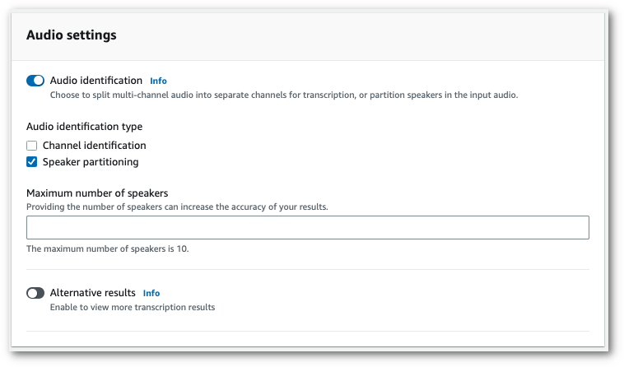

1.3 Chunking by document type
Strategy | Use when | Note
Fixed size | FAQs and short, self-contained text | Simple to run.
Hierarchical | Manuals, contracts, long documents with headings | Small child chunks match. Parent chunks give context.
Semantic | Quality matters more than cost | Splits on meaning. Costs more to process.
Custom with Lambda | Tables, equations, figures with captions | Boundaries follow the document structure.
Exam trap. A table split at a chunk boundary loses its values. Each part can look correct alone.

1.3 Retrieval symptoms
Chunks look relevant and answers are wrong. The failure is in retrieval, not generation. Changing the generator model does not fix broken retrieval. After a re-sync, check the embedding model version and the chunking configuration. To change chunking on a Knowledge Base data source, add a new data source with the new setting, then sync it.

1.4 Vector stores
Option | Fits
Bedrock Knowledge Bases | Private documents with citations. Managed RAG. The default answer.
OpenSearch Serverless | Managed vector search that scales with usage. Combines filters and vectors.
Aurora with pgvector | Vector search in a relational database the team already runs.
S3 Vectors | Large corpus, infrequent queries, no cluster to run.
DynamoDB | Metadata and embeddings in one table design.
Neptune | GraphRAG. Traverses explicit relationships between entities.
S3 Vectors fits large, rare searches. An always-on cluster costs money even when few queries arrive. For steady, interactive search with high query volume, an always-on store fits better. The cheapest store is wrong when the latency need is strict.
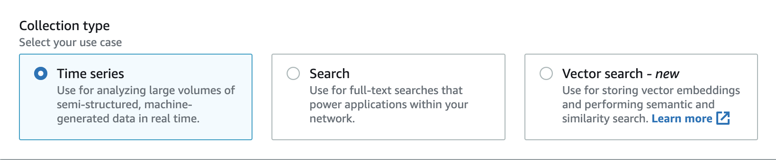
Exam trap. Neptune is a distractor for plain document search. ElastiCache is a trap when the question needs a durable store.

1.4 Embeddings
Embeddings turn meaning into vectors. Amazon Titan Text Embeddings v2 outputs 1024 (default), 512, or 256 dimensions. Cohere Embed uses an input_type value. Use search_query for questions and search_document for passages. Call embedding models with InvokeModel, not Converse.
Keyword search misses paraphrases such as "reset my password" and "change my credentials". Vector search matches them. Smaller dimensions cost less and may lower quality. Test both sizes on a golden set and pick the one that passes.

1.5 RAG end to end

Each stage is a design decision. A failure in one stage looks like a failure in the answer. Diagnose the stage that failed.
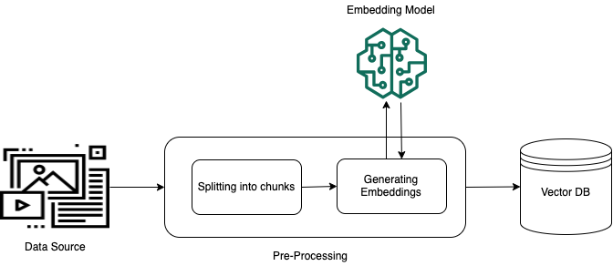
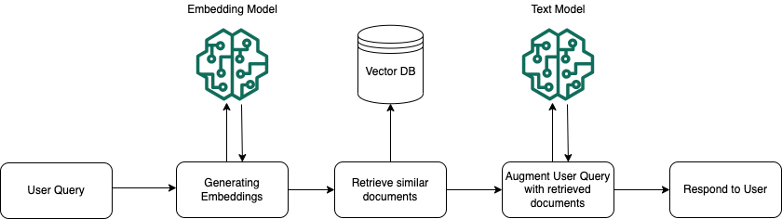

1.5 Retrieval fixes
Problem | Fix
Keyword-heavy queries drift | Hybrid search that combines semantic and keyword signals
Top results are related but not right | Reranker that scores candidates for relevance before generation
Vocabulary gap, such as refund and return | Query expansion
Multi-hop question | Query decomposition into sub-questions, then merge the results
Hybrid search finds exact codes and citation strings with keywords. It finds related meaning with vectors. A reranker orders candidates. It does not add chunks that retrieval missed.
Exam trap. Bigger models do not fix broken retrieval or broken chunking.

1.5 Knowledge Bases or hand-built RAG
Choose Bedrock Knowledge Bases for private documents with citations and the least custom effort. A sync and one API call cover the flow. Choose hand-built RAG only when a stated requirement, such as a custom retrieval algorithm, needs it.
Web crawler connectors cannot be created on customer-managed knowledge bases after September 30, 2026. Use Amazon Bedrock Managed Knowledge Base for web sources. This date comes from the Domain 1 fact-check. Confirm it on the Knowledge Base documentation before exam day.
Exam trap. A hand-built pipeline is a distractor when the scenario asks for least effort.

1.5 Citations and grounding
RetrieveAndGenerate returns a generated answer with source citations. Citations give attribution for audits. Contextual grounding checks return a score for each answer. Auditors can sample those scores.

1.6 Prompt governance
- Instruct. Store role definitions and variables in Amazon Bedrock Prompt Management. Enforce responsible AI rules with Bedrock Guardrails.
- Govern. Keep parameterized templates under version control. Use approval workflows before publication. Track use with CloudTrail.
- Test. Use Lambda to check expected output. Use Step Functions to run edge cases.
- Improve. Give structured inputs, a stated output format, and feedback loops.

1.6 Prompt Flows or Step Functions
Need | Use
A fixed prompt chain with branches, built in the console | Amazon Bedrock Prompt Flows
A durable workflow with waits, retries, and human approval | AWS Step Functions with callback task tokens
A workflow that waits about two days for a person | Step Functions Standard. Runs for up to one year.
Exam trap. For a multi-day approval, use Step Functions Standard. A Lambda that waits for a person hits the 15-minute limit.

1.6 Tenant and region isolation
Isolation must be structural. Use one knowledge base for each tenant. Use IAM to scope each role to its own knowledge base. Use metadata filters for region or product line. The model receives only what retrieval returns. A prompt that says "ignore other tenants" is not isolation.

Tools for agents: MCP
The Model Context Protocol (MCP) sets a standard way for agents to find and call tools. Remote MCP servers use Streamable HTTP. MCP is the tool connection standard. It is not a model choice or a guardrail.

Domain 1 gaps
Not in source: official sample questions for Domain 1. Named multimodal embedding models such as Titan Multimodal. Amazon SageMaker JumpStart, Neo, and Unified Studio.

Row map for Domain 1
Each table row points to its visual unit. Rows marked Text only have no unit yet.
Table row or topic | Unit or status
Approach ladder: four rungs | #u21
Knowledge or behavior table | #u21
Five model axes | #u22
Routing mechanisms | #u3 and #u20
Customization ladder | #u20 and #u21
Converse, InvokeModel, ConverseStream | #u1
Structured output with a schema | #u55
Model lifecycle and rollback | #u56
Data tools table | #u23
Services that look right and are wrong | #u24 for vector stores. #u63 for Kendra, Translate, ElastiCache.
Chunking by document type | #u6
Chunk shape for tables and structure | #u6
Retrieval symptoms and re-sync | #u57
Retrieval fixes | #u7
Vector stores | #u24
S3 Vectors for large, infrequent search | #u24
Embedding dimensions | #u25
Embeddings and input type | #u25
Prompt governance | #u26
Prompt Flows or Step Functions | #u27
Knowledge Bases or hand-built RAG | #u58
Knowledge Base data sources | #u59
Citations and grounding | #u60
Tenant and region isolation | #u61
MCP tools | #u62
Part 3 · Domain 2 · Weight 26 percent (official exam guide)

Implementation and integration
Visual units for this domain
Visual unit 28

Agent loop with limits
First principle. An agent repeats reason, act, and observe until a stop condition. Each repetition costs time and money. Limits belong in the workflow or the tool layer, not only in the prompt.

- Stop conditions bound the number of steps.
- Timeouts in Lambda and Step Functions bound time.
- IAM bounds what each tool can touch.
Exam tie. Domain 2 task 2.1.
Exam trap. A prompt that says stop is not a control.
Visual unit 29

Agent versions: DRAFT, prepare, alias
First principle. Changes go to DRAFT first. Callers use an alias that points to a version. Move the alias to put a change in production.

- Prepare the agent after you edit it.
- Create a version. Point the alias to it.
- Test the alias, not only DRAFT.
Exam tie. Domain 2 task 2.1 and Domain 5 task 5.2.
Exam trap. A console test on DRAFT does not prove the alias works.
Visual unit 30

Multi-agent collaboration: supervisor and collaborators
First principle. A supervisor reads the request and routes each part to a collaborator. Each collaborator has its own tools. The supervisor does not call the tools itself.

- The supervisor classifies intent in natural language.
- Each collaborator calls its own action group.
- A DRAFT collaborator cannot take delegations.
Exam tie. Domain 2 task 2.1.
Exam trap. Delegation is not an action group.
Visual unit 31

Deployment: match the purchase to the traffic
First principle. Model capacity is bought in shapes. On-demand suits spiky traffic. Provisioned Throughput suits a steady baseline. Batch suits offline work. Use a SageMaker endpoint for a model you own.

- Real-time endpoints for steady traffic.
- Serverless endpoints for intermittent traffic with cold starts.
- Asynchronous endpoints for jobs up to one hour.
Exam tie. Domain 2 task 2.2.
Exam trap. A real-time endpoint for a 45-minute job is the wrong choice.
Visual unit 32

Streaming and the gateway timeout
First principle. Streaming sends tokens as they appear. It lowers the wait for the first visible token. It does not extend a REST timeout of 29 seconds by default.

- Use WebSockets to hold a long stream.
- Use an asynchronous job for a very long call.
- Lambda timeout does not change the gateway limit.
Exam tie. Domain 2 tasks 2.3 and 2.4.
Exam trap. Raising the Lambda timeout does not fix a gateway timeout.
Visual unit 33

ApplyGuardrail on any model
First principle. A guardrail is a policy check. ApplyGuardrail runs the same check on text from any model. It does not call the model. Input and output checks are separate.

- Send content to ApplyGuardrail.
- Read the allow or block result.
- Use it for models outside Bedrock.
Exam tie. Domain 2 task 2.3 and Domain 3 task 3.1.
Exam trap. A non-Bedrock model does not need Converse to use ApplyGuardrail.
Visual unit 49

Session memory versus customer memory
First principle. An agent session expires. Customer memory must outlive the session. Store the memory in a table with a key and a time to live. The key is the customer or session ID.

- DynamoDB gives key lookup in single-digit milliseconds.
- Native TTL removes old records.
- The agent session TTL is between 60 and 5400 seconds.
Exam tie. Domain 2 task 2.1.
Exam trap. The agent session is not the memory store. It expires.
Visual unit 50

MCP hosting and open-source frameworks
First principle. MCP is a standard way for an agent to find and call tools. A light, stateless tool can run on Lambda. A remote MCP server on AgentCore Runtime must use Streamable HTTP. Strands Agents and AWS Agent Squad are open-source frameworks named in the exam guide.

- Light, bursty tools: Lambda.
- Remote MCP server on AgentCore Runtime: Streamable HTTP.
- Frameworks give code-level control. Managed agents need less code.
Exam tie. Domain 2 tasks 2.1 and 2.2.
Exam trap. A remote MCP server on AgentCore Runtime does not use another transport here.
Visual unit 51

Enterprise gateway for agent and model traffic
First principle. One gateway in front of many models and agents gives one place for identity, policy, logs, and cost tags. AgentCore Gateway routes agent traffic through one endpoint. Identity Center gives workforce users federated access.

- One endpoint for teams and apps.
- Logs and audit come from the gateway.
- Guardrail identifier and IAM policy apply on each call.
Exam tie. Domain 2 task 2.3 and Domain 3 task 3.3.
Exam trap. A gateway does not replace the guardrail. Enforce the guardrail at IAM as well.
Visual unit 52

Application tools: pick by user and task
First principle. The tool follows the user. A developer needs code help. An employee needs company chat. A web team needs hosting and sign-in. Match the tool to the person and the task.

- Q Developer: code help in the IDE.
- Q Business: company chat. No longer open to new customers.
- Amplify: managed web app with sign-in. AppSync: real-time editing.
Exam tie. Domain 2 task 2.5.
Exam trap. Q Business and Q Developer have similar names. The user decides the tool.
Domain 2 covers agents, deployment, enterprise integration, API patterns, and application tools. Its fact-check is still open. Read the official Bedrock Agents and Step Functions pages before exam day.

2.1 Anatomy of an agent
Status notice. Amazon Bedrock Agents is no longer open to new customers. The Bedrock Agents documentation names Amazon Bedrock AgentCore as the alternative. This section still teaches the agent model, because the exam guide tests it.

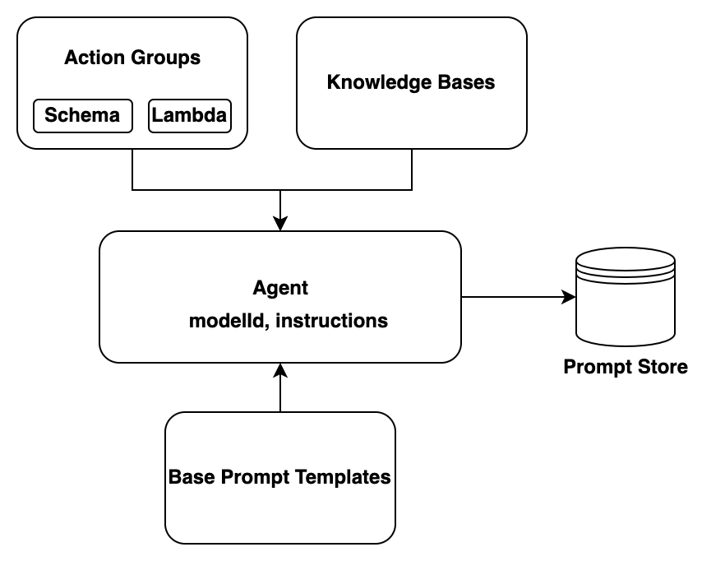
- invoke_agent takes agentId, agentAliasId, sessionId, and inputText. It returns a stream.
- The sessionId is the memory key for one conversation.
- Set enableTrace to get a record for each step.
Exam trap. After a change, prepare the agent and move the alias. Otherwise callers run the old version.

2.1 DRAFT, versions, and aliases
Configuration changes go to DRAFT. Callers reach a new version only after you create a version and point an alias to it. Console tests run against DRAFT. A passing console test does not prove alias traffic works. A new tool that works in the console but not in production usually means the alias still points to an older version.
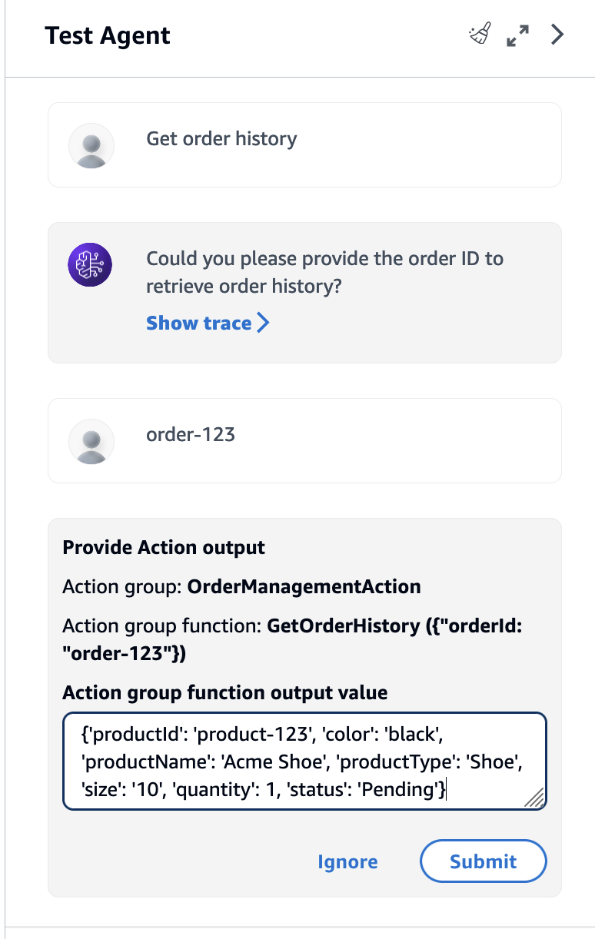

2.1 Session memory and customer memory
The agent session expires. Customer memory must outlive it. Use DynamoDB for memory that lasts weeks. DynamoDB gives single-digit millisecond lookup by a key such as customer or session ID. It encrypts data at rest. Native TTL expires old records. The agent session TTL is set in seconds, between 60 and 5400.

2.1 Agent loop limits
Limit | Control
Stop | Stopping conditions bound the number of steps.
Time | Timeouts in Lambda and Step Functions.
Access | IAM policies set resource boundaries on every tool call.
Failure | Circuit breakers stop repeated failures to a tool.

2.1 Multi-agent collaboration
Bedrock multi-agent collaboration uses a supervisor agent and collaborator agents. Each collaborator calls its own tools through its own action group. Delegation is not an action group.
Exam trap. A DRAFT collaborator cannot take delegations. Prepare and alias it first.

2.1 Open-source frameworks and MCP hosting
Strands Agents and AWS Agent Squad are open-source frameworks named in the exam guide. Choose a framework when the team needs code-level control. Choose a managed agent when the console is enough.
Host light, stateless, bursty MCP tools on Lambda. Heavy, stateful servers need a different host. Their host is Not in source for this build. AgentCore Runtime requires Streamable HTTP for remote MCP servers.

2.2 Deployment patterns
Option | Fits
On-demand | Spiky or unknown traffic. Pay per token. No commitment.
Provisioned Throughput | A predictable baseline. Reserved model units. Hourly billing with a commitment term.
SageMaker AI endpoints | Custom or fine-tuned models. Real-time, serverless, or asynchronous.
Batch inference | Offline sets that can wait for hours. Lower price than on-demand. The exact discount is Not in source on the docs page.
For mixed traffic, use Provisioned Throughput for the baseline and on-demand for spikes.
Exam trap. After buying Provisioned Throughput, calls to the base model ID still use on-demand capacity. Call the provisioned model ARN instead. Adding model units is the distractor.

2.2 SageMaker endpoints
Endpoint | Fit
Real-time | Steady traffic. Autoscaling. Blue-green and rolling deployments.
Serverless Inference | Intermittent traffic. Scales to zero. Trade-off: cold start on the first request.
Asynchronous | Long jobs, up to one hour. Queued. Results go to S3.
Exam trap. A real-time endpoint for a job that runs 45 minutes is the wrong pick. Use asynchronous inference.

2.2 Lambda limits and long work
A standard Lambda function runs for at most 15 minutes in a single invocation. Lambda Managed Instances functions invoked asynchronously allow up to 90 minutes. Do not assume the 90-minute case applies to a standard function. Put long flows in Step Functions and keep each Lambda step short. Waits in Lambda bill for the full duration. API Gateway REST integrations use a default integration timeout of 29 seconds. The quotas page fetched in this pass did not print that value, so confirm it on the API Gateway quotas page. Streaming does not change the timeout.
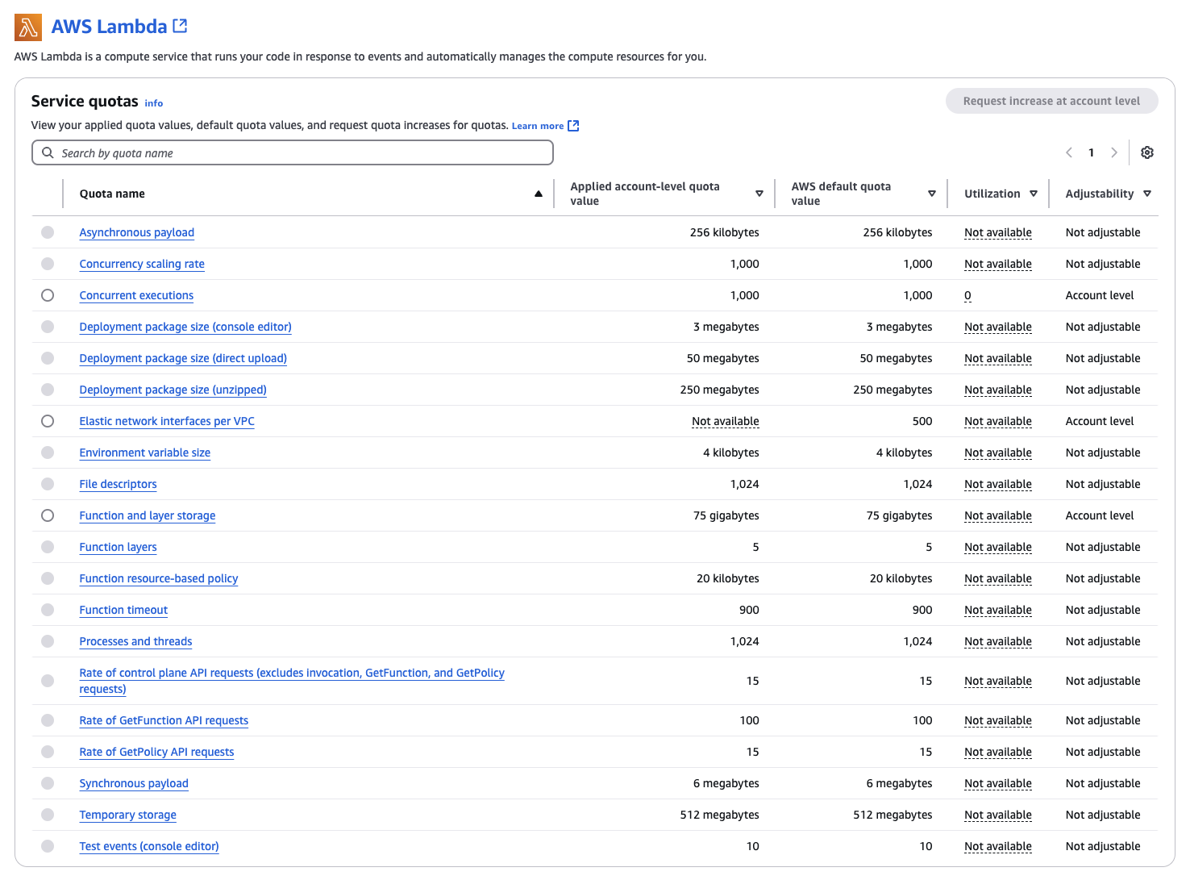
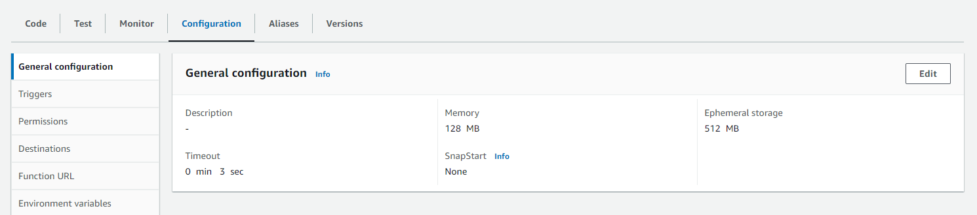

2.2 Human approval with a task token
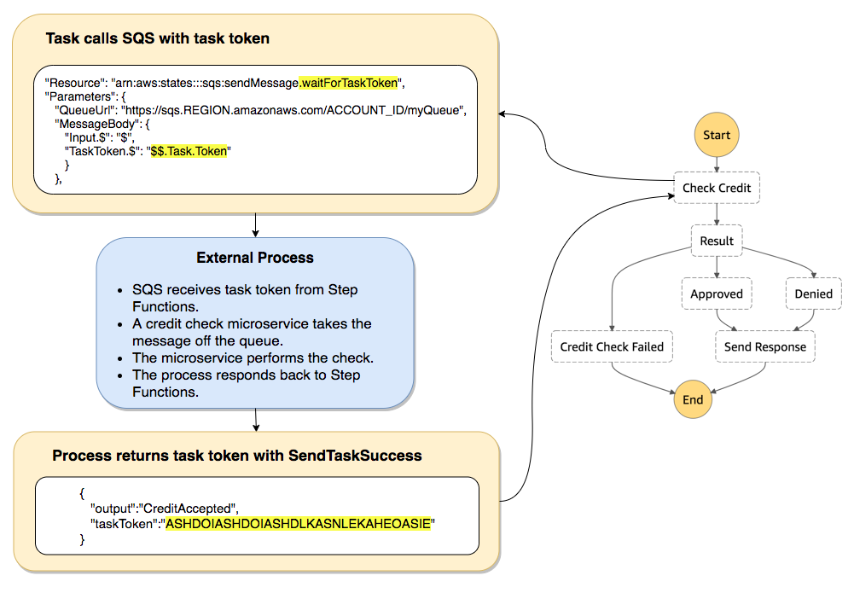
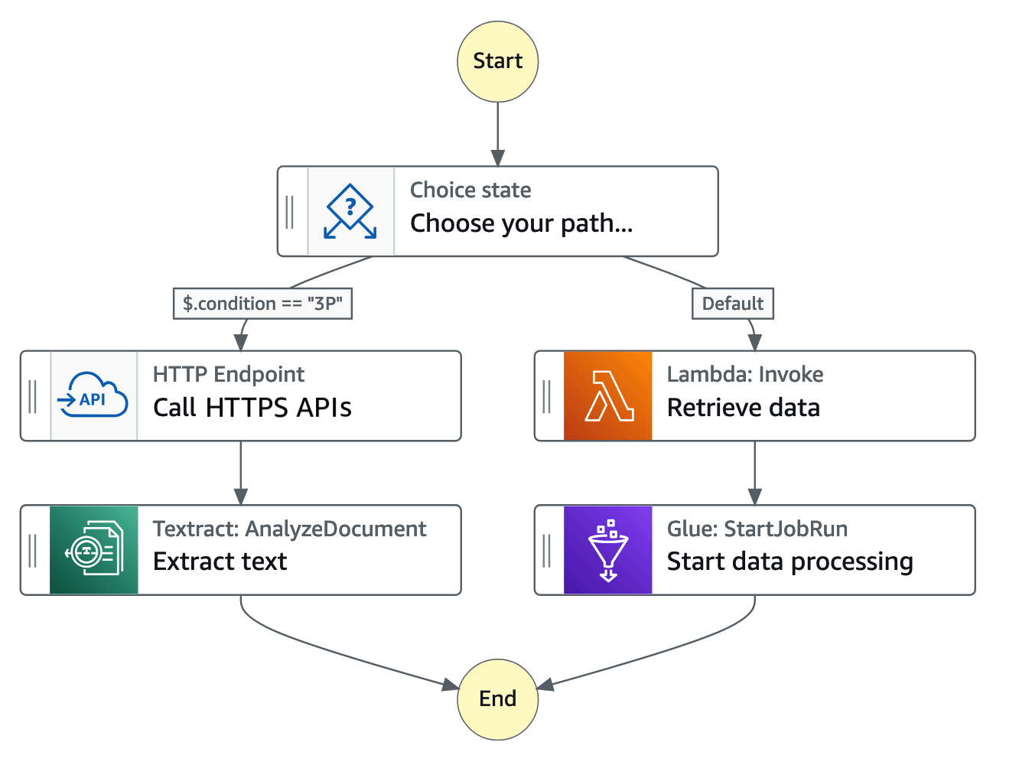
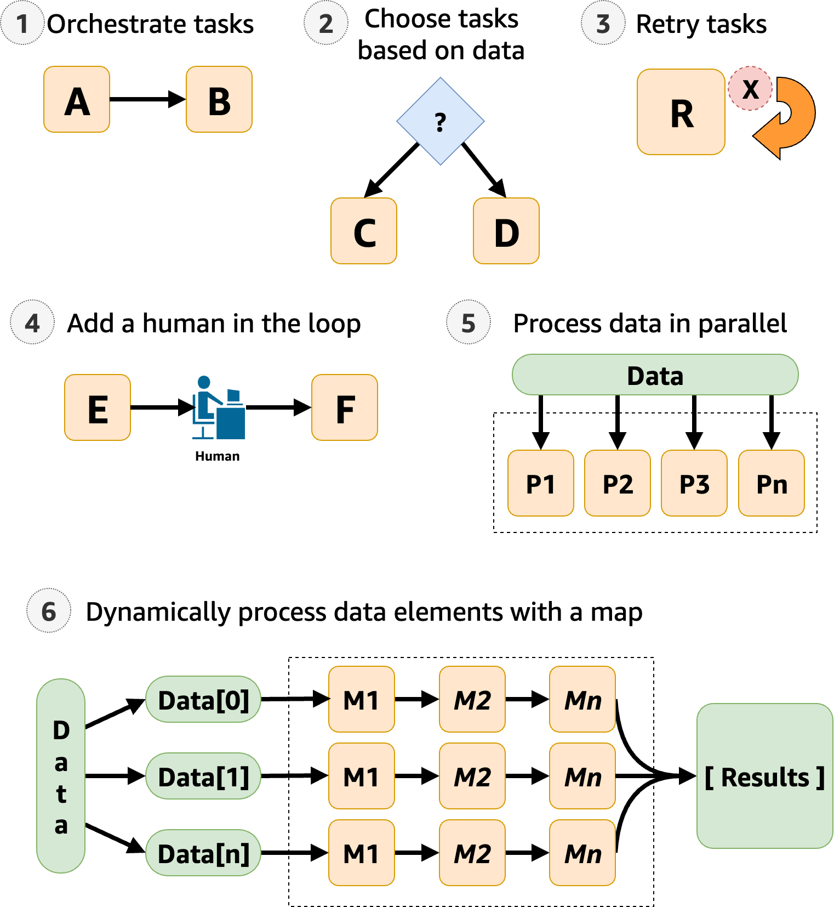

The execution history gives the audit trail. Standard workflows keep execution history for up to 90 days. Use Standard for waits measured in hours or days.

2.2 AgentCore components
AgentCore runs agents built with any framework behind one interface. Runtime hosts the agent code. Memory holds context. Gateway exposes tools as MCP tools. Identity controls who can call agents and tools. Observability records traces and metrics.
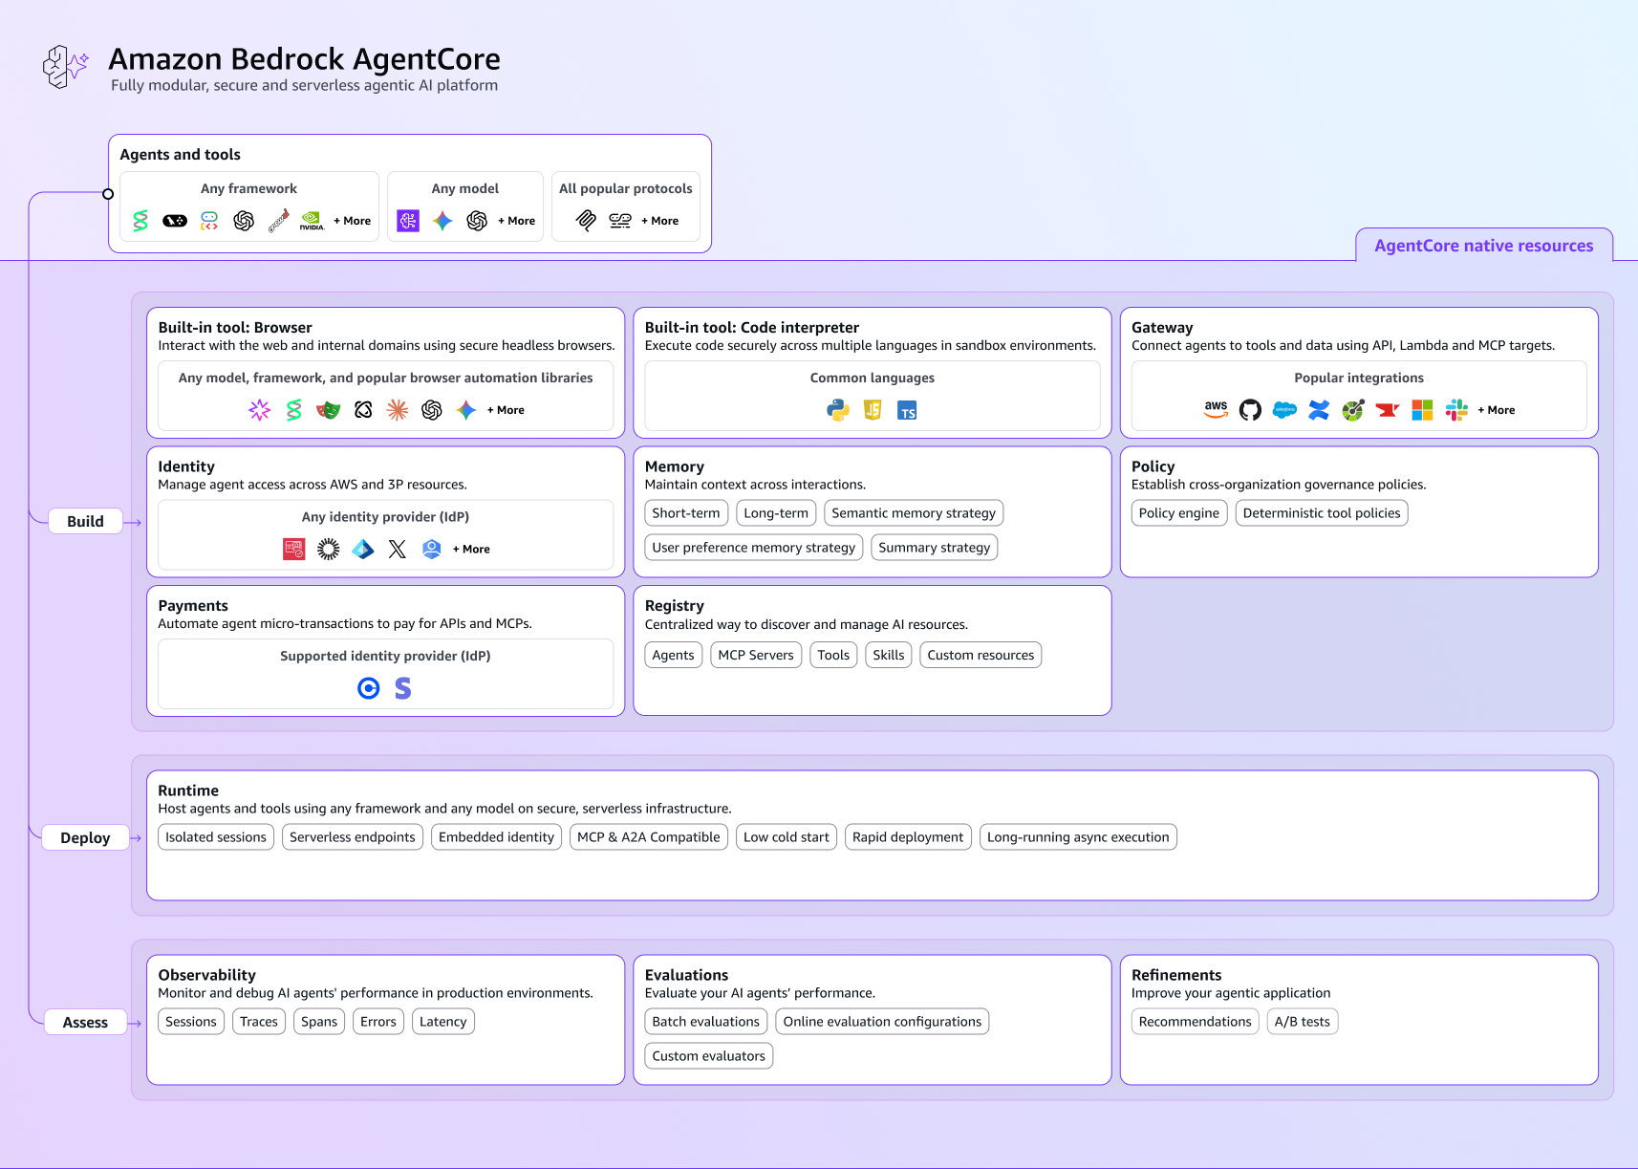

2.3 Enterprise gateway and access
Put one controlled entry in front of the models. API Gateway, Lambda or EventBridge, and then Bedrock or SageMaker AI. One gateway enforces guardrail identifiers, IAM policy, uniform logs, and team cost tags. AWS Outposts keeps data on premises for rules that keep data on site. AgentCore Gateway routes agent traffic through one endpoint and includes observability and auditing.

2.3 Converse or InvokeModel
Task | API
Chat and tool use, one code path for many models | Converse
Embeddings | InvokeModel with an embedding model
Provider-specific body or parameter | InvokeModel. Claude requires anthropic_version and max_tokens in the body.
Exam trap. Converse is for text generation and chat. It is not the embeddings API.

2.3 ApplyGuardrail on any model
ApplyGuardrail applies a Bedrock safety policy to content from any model. It takes content and returns an allow or block result. It does not call the model. Input screening and output screening are separate checks.

2.4 Streaming to the browser
ConverseStream and InvokeModelWithResponseStream send tokens as they arrive. WebSocket APIs or server-sent events carry the stream to the browser. A REST integration still stops at the 29-second limit. Pick a path that can hold the stream.
Exam trap. A 90-second model call fails at the gateway. Raising the Lambda timeout does not fix it.

2.4 Call models reliably
- Call. Use Bedrock APIs for synchronous calls. Use SQS for asynchronous work that can finish later.
- Recover. Use exponential backoff with jitter. Set a maximum attempt count. Use a fallback model.
- Observe. Trace calls with AWS X-Ray. Log token counts per call.
- Route. Use static configuration, Step Functions for content-based routing, or metric-based routing.
Exam trap. A tight retry loop is never correct. Retries need jitter, a maximum attempt count, and a fallback.

2.5 Application tools
Need | Service
Coding help in the IDE, code changes, test generation | Amazon Q Developer
Chat over company data for employees | Amazon Q Business. No longer open to new customers. The documentation names Amazon Quick as the alternative.
Web app with managed hosting and sign-in | AWS Amplify
Real-time collaborative editing | AWS AppSync with DynamoDB
Extract data from documents, images, audio, and video | Amazon Bedrock Data Automation
No-code prompt chains with branches | Amazon Bedrock Prompt Flows
Exam trap. Q Business and Q Developer have similar names. One does company chat. The other writes code.

2.5 Prompt variants, versions, and caching
A variant compares two wordings side by side. A version is an immutable snapshot that you can roll back to. Prompt caching reuses a repeated prefix. The cached part must match exactly and sit before the changing content. Cache writes cost extra, so caching pays off only with repeat volume.
Exam trap. Prompt caching lowers the cost of a repeated prefix. It does not reserve throughput. Provisioned Throughput reserves capacity.

Domain 2 gaps
Not in source: official sample questions for Domain 2. AWS CodeDeploy, Kiro, and Amazon Managed Streaming for Apache Kafka. The fact-check for this domain has not closed.

Row map for Domain 2
Each table row points to its visual unit. Rows marked Text only have no unit yet.
Table row or topic | Unit or status
Agent parts and invoke_agent | #u28
DRAFT, versions, and aliases | #u29
Multi-agent collaboration | #u30
Agent loop limits | #u28
Open-source frameworks and MCP hosting | #u50
Session and customer memory | #u49
Deployment patterns | #u31
SageMaker endpoints | #u31
Lambda limits and long work | #u10
Human approval with a task token | #u10
AgentCore components | #u9
Enterprise gateway and access | #u51
Converse or InvokeModel | #u1
ApplyGuardrail on any model | #u33
Streaming and the gateway timeout | #u32
Call models reliably | #u12
Application tools | #u52
Prompt variants, versions, and caching | #u4 and #u26
Part 4 · Domain 3 · Weight 20 percent (official exam guide)

AI safety, security, and governance
Visual units for this domain
Visual unit 34

Six guardrail policies, each for one failure
First principle. Each policy stops one kind of failure. Denied topics stop a subject. Word filters stop exact strings. Content filters stop harm and prompt attacks. Sensitive information filters stop PII. Grounding checks stop unsupported claims. Automated Reasoning checks stop claims that break formal rules.

- Denied topics: subject in plain language.
- Word filters: exact strings.
- Content and prompt attack: harm and injection on input.
Exam tie. Domain 3 task 3.1.
Exam trap. A word list cannot stop every phrasing of a subject.
Visual unit 35

Detect and redact: privacy at each stage
First principle. PII can appear in documents at rest, in input text, and in model output. Each place needs its own control.

- Macie finds sensitive data in S3 at rest.
- Comprehend detects PII in single text documents. Real-time entity detection takes up to 100 KB. The PII-only limit is Not in source as a separate line.
- Guardrails redact or block PII at the model call.
Exam tie. Domain 3 task 3.2.
Exam trap. Macie does not watch live model traffic.
Visual unit 36

Grounding versus safety
First principle. A grounding check asks whether the answer is supported by the source. A safety check asks whether the text is harmful. These are different questions with different controls.

- Contextual grounding: supported and relevant.
- Content filters: harmful text.
- Automated Reasoning: formal policy rules.
Exam tie. Domain 3 task 3.1 and Domain 5 task 5.2.
Exam trap. Grounding checks test support, not safety.
Visual unit 37

Defense in depth: four layers
First principle. Each layer uses a different control. A gap in one layer is covered by another. Put the cheapest check first and the strictest check at the model boundary.

- Pre-filter with PII detection and an abuse classifier.
- Guardrails on input and output.
- Lambda format checks. API Gateway throttling.
Exam tie. Domain 3 task 3.1.
Exam trap. No single control prevents all injection.
Visual unit 38

Logs that hold prompts
First principle. Invocation logs hold the request and response. Masking in the output does not mask the log. Protect the log store with KMS and access rules.

- Enable invocation logging for content.
- Encrypt with KMS. Restrict access.
- Object Lock gives write-once retention in S3.
Exam tie. Domain 3 task 3.2 and Domain 4 task 4.3.
Exam trap. Invocation logs keep the original request even when output is masked.
Visual unit 64

Lake Formation and Model Cards: two different questions
First principle. Lake Formation controls who reads which rows and columns in a data lake. Model Cards document what a model is for and how it performed. One answers who reads data. The other answers what the model is.

- Column and row access: Lake Formation.
- Intended use and risk rating: Model Cards.
- Neither replaces CloudTrail.
Exam tie. Domain 3 tasks 3.2 and 3.3.
Exam trap. Model Cards describe the model. Lake Formation controls data access. Check the Model Card JSON schema for the fields.
Visual unit 65

Responsible AI: transparent, fair, policy-checked
First principle. Responsible AI is three checks on one system. This is design guidance, not an AWS rule. Transparency shows sources and reasoning. Fairness is measured against defined metrics. Policy checks apply the rules the business requires.

- Transparent: sources, traces, citations on each claim.
- Fair: metrics defined before launch, A/B tests, judge evaluations.
- Policy-checked: guardrails and compliance checks in Lambda.
Exam tie. Domain 3 task 3.4.
Exam trap. A model card alone does not explain one decision. Add the citations and the trace.
Visual unit 66

Continuous fairness: a snapshot is not a guarantee
First principle. A fairness test before launch shows the state at one time. Data drift and demographic drift change behavior later. Design guidance: monitor fairness over time, and let a remediation workflow act on each alert.

- Define the fairness metrics before the build.
- Monitor the metrics after launch.
- Act on each alert with a remediation workflow.
Exam tie. Domain 3 tasks 3.3 and 3.4, and Domain 4 task 4.3.
Exam trap. A one-time bias test before launch does not prove fairness later.
Domain 3 covers guardrails, data privacy, compliance evidence, and responsible AI. Four failure modes need four controls. No single control covers all four.
Failure | Control | Layer
Confident wrong answer | Contextual grounding checks | Output
Prompt injection and jailbreak | Prompt attack filter | Input
PII leak | Sensitive information filters | Input and output
Harmful content | Content filters and denied topics | Input and output

3.1 One guardrail, six policies

Policy | Blocks or checks
Content filters | Harmful categories. The prompt attack category applies to input.
Denied topics | A whole subject, described in natural language.
Word filters | Exact words or phrases.
Sensitive information filters | PII entities. Redact or block.
Contextual grounding checks | Whether the answer is supported by the source and relevant to the question.
Automated Reasoning checks | Whether the response agrees with formal policy rules.
A draft is editable. A version is a frozen snapshot. Production points at a version. Input and output checks are separate switches.


3.1 Choose the right filter
- Use a denied topic for a whole subject. A word list cannot stop every phrasing of a subject.
- Use a word filter for exact strings. It misses rephrased requests.
- Use the prompt attack filter for jailbreak and injection patterns. A denied topic does not detect prompt attacks.
Exam trap. Turn off the prompt attack filter and jailbreaks reach the model. Attack detection runs on input.

3.1 Grounding is not safety
Contextual grounding checks test support from the source. They do not test harm. Use content filters for harmful text. Grounding reduces hallucination. It does not remove it.
Exam trap. Answers that say a control "prevents all prompt injection" or "eliminates hallucinations" are wrong. No control is absolute.

3.1 Defense in depth
- Pre-filter with Amazon Comprehend PII detection and an abuse classifier.
- Guardrails on input and output.
- Lambda format checks, allow-list checks, and business rules.
- API Gateway throttling and usage plans.
Each layer fails sometimes. Layers use different controls, so a gap in one layer can be covered by another.

3.1 Detect mode
Detect mode runs the classifier and reports the verdict. It does not refuse the message. Use detect mode to measure a new rule before you block with it.
Exam trap. Detect mode is not a block. A blocked message needs the Block action.

3.2 Privacy: detect, then redact or block
Service | Where | Job
Amazon Macie | Data at rest in Amazon S3 | Discovers sensitive data in S3 objects.
Amazon Comprehend | Single text documents | Real-time entity detection for single documents up to 100 KB. The PII-only limit is Not in source as a separate line.
Bedrock Guardrails | Model input and output | Sensitive information filters block or mask PII at the model call.
Exam trap. Macie does not watch live model traffic. Guardrails does not scan a whole bucket.

3.2 Private network access
VPC interface endpoints (AWS PrivateLink) keep API traffic on the AWS network. Create one endpoint for each Bedrock plane the workload uses. The bedrock-runtime plane runs invocations. The bedrock-agent and bedrock-agent-runtime planes serve agents.
Exam trap. One runtime endpoint does not cover agent calls. Check each plane.

3.2 Logs that hold prompts
Model invocation logs can hold prompts and completions. In a clinical setting, those logs can hold protected health information. Encrypt the logs with AWS KMS and restrict access. In a strict compliance setting, disable logging.
S3 Object Lock gives write-once-read-many retention. S3 Lifecycle expiration deletes objects at the end of their lifetime. Invocation logs keep the original, unmodified request, even when a guardrail masks PII in the output.
Exam trap. Masked output does not mean the log is masked. Protect the log store.

3.2 Data security plane
Plane | Control
Network | VPC interface endpoints keep traffic off the public internet.
Access | IAM least privilege. Lake Formation for column and row access to lake tables.
Encryption | AWS KMS for data at rest. TLS for data in transit.
Monitoring | CloudTrail records API calls. CloudWatch Logs holds invocation logs.
Encryption answers the storage risk. It does not answer a question about training use. Check the data terms and the retention settings for that question.

3.2 Cross-Region guardrail inference
Cross-Region guardrail inference routes requests to another Region in the same geography. Input prompts and outputs can move to that Region. A strict single-Region rule conflicts with that routing. Check whether the guardrail allows cross-Region inference before you choose it for a strict residency rule.

3.3 Data lake access and model documentation
Need | Control
One team sees a salary column and another does not | Lake Formation column-level access
A team sees only its own rows | Lake Formation row-level access
Versioned record of intended use, limits, and evaluation results | SageMaker Model Cards linked to the model package
Exam trap. Model Cards describe the model. Lake Formation controls who reads the data.

3.3 Audit and lineage
CloudTrail shows who called which API, when, and from where. It does not show row content. Lineage shows which documents support an answer. Combine catalog metadata with citations on each output. No single feature gives full lineage.

3.3 Governance mapping
Need | Service
Model documentation for audit | SageMaker Model Cards
Data lineage and source registry | AWS Glue Data Catalog
Audit of API calls | AWS CloudTrail
Decision and runtime logs | Amazon CloudWatch Logs
Runtime safety | Bedrock Guardrails
Map each regulation to one control, one proof, and one review cadence.

3.3 Organization-wide controls
Service control policies (SCPs) apply rules across accounts. A condition on the bedrock:GuardrailIdentifier key can require a guardrail on each request. Application code can be changed or skipped. The IAM layer still applies.
Exam trap. A guardrail that only the application code calls can be skipped. Enforce it at IAM.

3.4 Responsible AI
Principle | How to show it
Transparent | Show sources and reasoning. Use agent traces. Cite sources on each claim.
Fair | Define fairness metrics before launch. A/B test prompt variants. Evaluate at scale with an LLM-as-a-judge.
Policy-checked | Apply guardrails from policy requirements. Run compliance checks in Lambda.
Fairness is continuous. A launch test is a snapshot. Data drift and demographic drift change model behavior after launch. A one-time bias test before launch does not prove fairness later.
Exam trap. A model card alone does not explain one loan decision. Add the citations and the trace.

Domain 3 gaps
Not in source: official sample questions for Domain 3. The Lake Formation permission model details. IAM Access Analyzer. AWS WAF rule configuration.

Row map for Domain 3
Each table row points to its visual unit. Rows marked Text only have no unit yet.
Table row or topic | Unit or status
Four failures and their controls | Text plus #u37
Denied topics, word filters, prompt attacks | #u34
Six guardrail policies | #u34
Content filters table | #u34
Privacy controls | #u35
PII across the lifecycle | #u35
Grounding and reasoning checks | #u36
Defense in depth | #u37
Logs that hold prompts | #u38
Data security plane | #u17 and #u16
Audit and lineage | #u16
Organization-wide controls with SCPs | #u18
Governance mapping | #u16 and #u18
Cross-Region guardrail scope | #u3
Lake Formation and Model Cards | #u64
Responsible AI table | #u65
Continuous fairness | #u66
Part 5 · Domain 4 · Weight 12 percent (official exam guide)

Operational efficiency and optimization
Visual units for this domain
Visual unit 39

Token cost: input plus output
First principle. Each token costs money. Input and output have different prices. Cost equals input tokens times the input price, plus output tokens times the output price, per million tokens.

- Output usually costs more per token.
- Cap output length to cap cost.
- Prices in examples are illustrative.
Exam tie. Domain 4 task 4.1.
Exam trap. More capacity does not fix a cost that comes from long prompts.
Visual unit 40

Cost levers match the waste
First principle. Each waste has one lever. Long repeated prefixes need caching. Simple requests need smaller models. Off-hours work needs batch. Steady load needs reserved capacity.

- Prefix repeats: prompt caching.
- Simple queries: tiered routing.
- Offline work: batch. Steady load: Provisioned Throughput.
Exam tie. Domain 4 task 4.1.
Exam trap. Buying more capacity does not fix long prompts.
Visual unit 41

Latency: find the slow step first
First principle. End-to-end latency adds the steps. Measure each step before a fix. A slow retrieval step needs a retrieval fix, not a bigger model.

- Streaming improves perceived speed.
- Index tuning and query preprocessing fix search.
- Precompute predictable answers.
Exam tie. Domain 4 task 4.2.
Exam trap. A bigger model does not fix a slow search step.
Visual unit 42

Throttling: backoff, jitter, limit, fallback
First principle. Quotas cap tokens per minute and per day. A throttled call should wait, retry with jitter, and then fall back. Count tokens before the call to avoid overflow.

- Watch InvocationThrottles in CloudWatch.
- Retry with exponential backoff and jitter.
- Use CountTokens to check the context limit first.
Exam tie. Domain 4 task 4.2 and Domain 2 task 2.4.
Exam trap. Retries that add load make an overload worse.
Visual unit 43

Monitoring: which signal answers which question
First principle. Metrics show rate and cost. Traces show the slow step. Logs show the content. Anomaly alarms catch spikes that a fixed threshold misses.

- CloudWatch metrics and anomaly detection for spend.
- X-Ray for the slow step.
- Invocation logs for exact content.
Exam tie. Domain 4 task 4.3.
Exam trap. A fixed threshold alarm misses slow growth.
Visual unit 53

Sampling and variance: randomness is a setting
First principle. A model picks each token from a distribution. Temperature sets how wide the choice is. Top K limits the candidate count. Top P limits the probability mass. Lower values give more repeatable output.

- Temperature: lower gives more repeatable output.
- Top K and Top P narrow the candidates.
- Sampling does not change the price per token.
Exam tie. Domain 4 task 4.2 and Domain 5 task 5.2.
Exam trap. Buying capacity does not fix different answers to the same input.
Visual unit 54

Three similar concepts: profile, router, reserved capacity
First principle. Three different objects look alike. A cross-Region profile spreads requests across Regions. A router picks between two models in one family. Provisioned Throughput reserves model units. Each one answers a different question.

- Profile: throughput and availability.
- Router: cost, by predicted quality.
- Reserved capacity: steady traffic, called with the provisioned ARN.
Exam tie. Domain 4 tasks 4.1 and 4.2.
Exam trap. Code that calls the base model ID does not use reserved capacity.
Visual unit 67

Retrieval cost: fewer, better chunks
First principle. Retrieval adds tokens to every call. Each chunk you send costs input tokens. Send fewer chunks, but rank them first so the best ones remain.

- Lower the number of results the retriever returns.
- Rerank, then cut to the top results.
- Keep chunks sized so one answer stays whole.
Exam tie. Domain 4 tasks 4.1 and 4.2.
Exam trap. Sending more chunks raises token cost.
Domain 4 covers cost, latency, capacity, throttling, and monitoring. Match each observed fact to one lever.

4.1 Token economics
You pay for each input token and each output token. The formula uses the price per million tokens.
At these illustrative prices, output costs five times as much as input per token. Long replies raise cost. Set a maximum output length to cap the reply. Check current AWS prices before exam day.

4.1 Cost levers
Observed fact | Lever
Most requests are simple | Tiered routing to a smaller model
The same long prefix repeats | Prompt caching with a cache checkpoint
Steady baseline load with a latency target | Provisioned Throughput for the baseline
Short spikes above the baseline | On-demand inference
Work that can wait for hours | Batch inference
Many paraphrases of the same question | Semantic cache
Exam trap. Buying more capacity does not fix a cost that comes from long prompts.

4.1 Prompt caching
A cache checkpoint marks the static prefix of a prompt as cacheable. Keep the variable part at the end. A changing user message in the prefix breaks the cache. The default time to live is 5 minutes. The prefix must meet a minimum token count. The fact-check found minimums from 512 to 4,096 tokens, depending on the model.
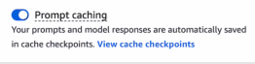
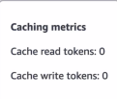


4.1 Semantic cache
A semantic cache matches paraphrases of the same question by embedding similarity. It returns the stored answer before the model runs. Prompt caching is different. It reuses an exact prompt prefix at the model. A semantic cache needs repeated, similar questions to get a good hit rate. Highly personal questions rarely repeat.

4.1 Batch for work that can wait
Batch inference reads input from S3 and writes output to S3. The price is lower than on-demand. The exact discount is Not in source on the docs page. Batch is not supported for provisioned models. Set the job time limit with the timeout duration in hours. A user waiting for a chat reply needs on-demand, not batch.

4.1 Model right-sizing
Pattern | How it works
Cascade | Try the small model first. Escalate when the answer is uncertain or the query is complex.
Route by complexity | A classifier or router sends each query to a model. Bedrock intelligent prompt routing picks between two models in one family by predicted response quality and cost.
Fine-tune a small model | For a narrow, repeated task at high volume.
Exam trap. Sending every request to the largest model wastes cost.

4.1 Capacity concepts that look alike
Concept | Purpose | Choose for
Cross-Region inference profile | Routes requests across Regions for throughput and availability | Availability and resilience
Intelligent prompt routing | Routes between two models in one family | Cost
Provisioned Throughput | Reserves model units | Steady, predictable traffic
Exam trap. Code that calls the base model ID does not use reserved capacity. Call the provisioned model ARN.

4.1 Quotas, retries, and pre-call checks
- Quotas. Tokens per minute (TPM) and tokens per day (TPD) cap token use. Watch the InvocationThrottles metric in CloudWatch.
- Retry. Use exponential backoff with jitter. Set a maximum number of attempts.
- Fall back. Use a second model or a cached answer when retries end.
- Check first. Count tokens before the call with CountTokens. Compare the count with the model limit.
Exam trap. Retries that add load can make an overload worse. Back off with jitter.

4.2 Latency: find the slow step
Latency is what the user feels. Throughput is what the system handles. Stream the response to improve perceived speed. Streaming does not raise throughput. For a slow retrieval step, use index optimization, query preprocessing, or hybrid search. A bigger model does not fix a slow search step.
Goal | Lever
Perceived speed | Stream the response as it generates
Speed for predictable questions | Precompute answers ahead of time
Volume | Batch inference for offline work. Provisioned Throughput for steady capacity.

4.2 Sampling and variance
Temperature sets how wide sampling is. Lower values give more repeatable output. Top K limits the candidate tokens. Top P limits the share of the probability distribution that is considered. Sampling settings do not change the price per token. Buying capacity does not fix different answers to the same input.
Not in source: effect of a fixed seed on output. Effect of a versioned prompt on output variance. Effect of sampling on token counts.

4.3 Monitoring signals
Signal | Tool and use
Token and invocation metrics | CloudWatch metrics: InputTokenCount, OutputTokenCount, Invocations
Spend spikes | CloudWatch anomaly detection and alarms. Cost Anomaly Detection for spend.
Exact requests and responses | Model invocation logs. Search with CloudWatch Logs Insights.
Slow or failing step | AWS X-Ray traces requests and downstream calls.
Pattern: find the slow step with X-Ray, then audit the exact prompts in the invocation logs.
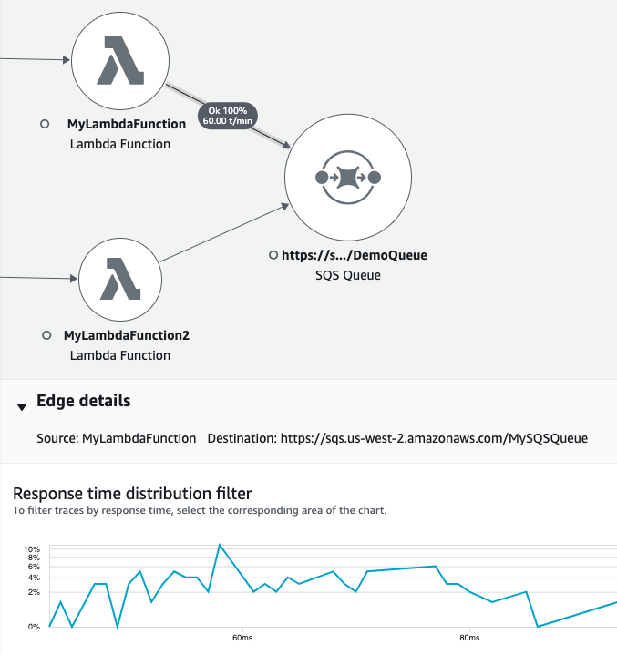
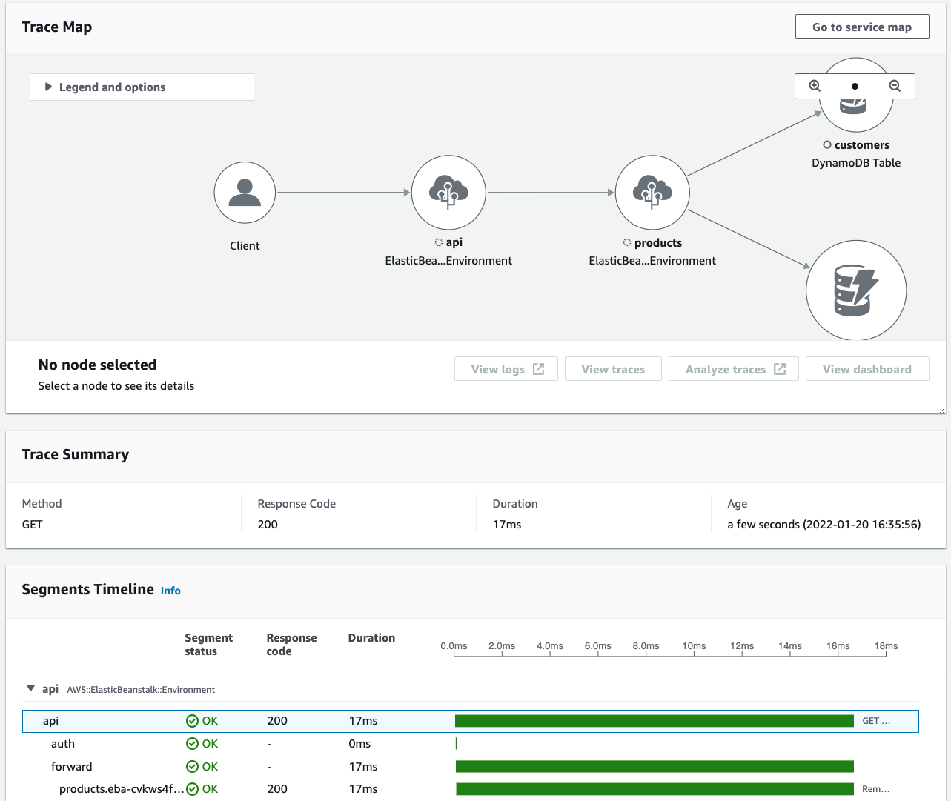
Exam trap. Model Monitor watches statistical drift in structured features and predictions. It does not score free-text answer quality. Use a judge or a golden set for that.

Domain 4 gaps
Not in source: official sample questions for Domain 4. Amazon CloudWatch Synthetics. AWS Auto Scaling for GenAI workloads. AWS Cost Explorer.

Row map for Domain 4
Each table row points to its visual unit. Rows marked Text only have no unit yet.
Table row or topic | Unit or status
Token economics | #u39
Cost levers | #u40
Prompt caching | #u4
Semantic cache | #u5
Batch for work that can wait | #u2
Model right-sizing | #u20
Capacity concepts that look alike | #u54
Quotas, retries, and pre-call checks | #u42
Latency and the slow step | #u41
Sampling and variance | #u53
Monitoring signals | #u43
Tracing, drift, and forensics | #u15
Retrieval cost and retrieval tuning | #u67
Part 6 · Domain 5 · Weight 11 percent (official exam guide)

Testing, validation, and troubleshooting
Visual units for this domain
Visual unit 44

Choose the cheapest evaluation method that measures the claim
First principle. A claim needs a method. Automatic metrics suit known answers. A judge suits quality at scale after calibration. Humans judge tone and voice.

- Automatic: accuracy, robustness, toxicity.
- Judge: correctness and faithfulness at scale.
- Human: brand voice and custom criteria.
Exam tie. Domain 5 task 5.1.
Exam trap. Automatic accuracy does not measure tone.
Visual unit 45

Split retriever from generator in RAG evaluation
First principle. A RAG answer has two parts. The retriever finds chunks. The generator writes the answer. A good answer can hide weak retrieval. Measure each part.

- Retriever: context relevance and context coverage.
- Generator: faithfulness to the chunks.
- A drop in retriever-only scores points at retrieval.
Exam tie. Domain 5 task 5.1.
Exam trap. Fine-tuning does not fix retrieval.
Visual unit 46

Golden set and hallucination tests
First principle. A golden set holds trusted prompts with known answers. A hallucination test needs questions whose answers are not in the documents. Without them, the set only confirms what the documents already support.

- Include out-of-scope questions.
- Rerun the set after every change.
- Compare answers across runs for inconsistency.
Exam tie. Domain 5 tasks 5.1 and 5.2.
Exam trap. A passing suite with new user failures means the golden set lacks those cases.
Visual unit 47

Troubleshooting: start at the failed step
First principle. A GenAI fault sits in one stage. Trace the request from input to output. Check the stage that changed last.

- Output cut off: check the maximum tokens.
- Answer ignores documents: check retrieved chunks.
- Throttling after buying capacity: check the model ARN.
Exam tie. Domain 5 task 5.2.
Exam trap. Temperature does not fix bad retrieval.
Visual unit 48

Release gates and canaries
First principle. A change to a prompt, model, chunking setting, or guardrail is a release. Each release passes the same gates. A failed gate blocks it. A canary limits the blast radius.

- Run the golden set on each change.
- Gate on the quality threshold.
- Canary first, then full traffic.
Exam tie. Domain 5 task 5.1 and Domain 2 task 2.3.
Exam trap. A re-sync is a change. It needs the same gate.
Visual unit 68

Adversarial and safety testing: test before users do
First principle. An attacker tries inputs you did not plan for. An automated test set sends known attack patterns to the system. Run the set again after each guardrail or prompt change.

- Build a test set of injection and jailbreak patterns.
- Run it after every guardrail or prompt change.
- Check the Bedrock evaluation documentation for the agent evaluation methods.
Exam tie. Domain 5 task 5.1 and Domain 3 task 3.1.
Exam trap. Red-team procedures are not in the source. Plan them separately.
Domain 5 covers evaluation methods, golden datasets, A/B tests, debugging, and release gates.

5.1 Evaluation matrix
Method | Measures | Use when
Automatic | Accuracy, robustness, toxicity. Accuracy needs ground-truth labels. | Objective, repeatable checks
LLM-as-a-judge | Correctness, faithfulness, harmfulness, style. Custom metrics. | Quality at scale. RAG and agent evaluation.
Human | Relevance, brand voice, custom criteria | Subjective judgment
Bring your own inference | The same metrics on your own responses | Non-Bedrock models or external RAG sources
Retrieve-only | Context relevance and context coverage | Isolate the retriever
Pick the cheapest method that measures the claim. Escalate only for what the cheap method cannot judge.
Exam trap. Automatic accuracy metrics do not measure tone, style, or voice. Use human review for brand voice.

5.1 Judges need calibration
- Rate a fixed golden set with humans.
- Run the same set through the judge.
- Measure judge-human agreement. Low agreement means the judge is not valid.
- Pin the judge model ID. A changed judge changes the scores.
Exam trap. An uncalibrated judge gives opinions, not measurements.

5.1 RAG evaluation: split retrieval from generation
Part | Metrics
Retriever | Context relevance and context coverage. Did the system get the correct articles?
Generator | Faithfulness. Are the claims supported by the retrieved chunks?
Citation precision and citation coverage are Not in source for this build. Context relevance and context coverage come from an AWS blog post, not a reference page.
Exam trap. A good final answer can hide weak retrieval. Measure both parts.

5.1 Golden datasets, regression, and canaries
Practice | What it does
Golden dataset | Trusted prompts with known good answers. Run them after every change.
Regression suite | Reruns the golden set on each change to catch drift.
Canary | Releases a new version to a small share of traffic first.
A/B test | Compares two variants on live or sampled traffic.
Exam trap. A re-sync or a prompt edit is a change. It needs the same release gate.


5.1 Safety tests
Run automated adversarial test sets against prompt injection and jailbreak patterns. Run them again after every guardrail or prompt change. Agent evaluations measure task completion and tool usage. Step-by-step red-team procedures are Not in source.

5.2 Troubleshooting by symptom
Symptom | Likely cause | First check
Output cut off mid-sentence | Maximum output tokens too low, or context overflow | Maximum tokens and the token count against the limit
Answer ignores the documents | Retrieval or chunking | Retrieved chunks, before the model
Output changes between runs | Sampling settings or prompt drift | Temperature, Top P, prompt version
Throttling after buying capacity | Base model ID used | Provisioned model ARN in the call
Agent runs old behavior | Agent not prepared, or alias not moved | Prepare the agent. Check the alias version.
Works on Titan, fails on Claude | Wrong InvokeModel body | anthropic_version and max_tokens in the body
AccessDeniedException in one Region only | IAM permissions for that call | IAM policy and resource ARNs for that Region
Quality dropped after a re-sync | Changed chunking or embedding model | What the sync changed. Then the golden set.
Exam trap. Temperature does not fix bad retrieval. Start the debug at the step that failed.

5.2 Debugging tools
CloudWatch Logs shows what the model received. Logs Insights finds patterns by time, caller identity, or request metadata. CloudTrail shows who called which API and when. CloudTrail is for audit, not for debugging answers.

5.2 Grounding and hallucination
Tool | Detects
Golden dataset with out-of-scope questions | Hallucinations
Output comparison across runs | Inconsistent answers to the same input
Contextual grounding check and grounding score | Claims that the retrieved source does not support
A hallucination test needs out-of-scope questions. Without them, the set only confirms answers that the documents already support.

Domain 5 gaps
Not in source: official sample questions for Domain 5. Setup steps for Bedrock Model Evaluations jobs. Step-by-step red-team procedures. Bedrock Agents Classic is closed to new customers per the docs. The agent rows here apply to existing use.

Row map for Domain 5
Each table row points to its visual unit. Rows marked Text only have no unit yet.
Table row or topic | Unit or status
Evaluation matrix | #u44
Evaluation methods within a budget | #u44
Choose the evaluation method | #u44
Judge calibration | #u13
Subjective quality | #u44
RAG evaluation and RAG metrics | #u45
Golden datasets, regression, and canaries | #u46 and #u14
Release gates in the pipeline | #u48
Troubleshooting by symptom | #u47
Debugging tools and debug table | #u47
Hallucination control | #u46
Adversarial and safety testing | #u68
Part 7

Traps AWS reuses
Wrong answer | Correct idea
Fine-tune on documents that change | RAG with a Knowledge Base
Neptune for plain document search | A vector store. Neptune is for graph queries.
Converse for embeddings | InvokeModel with an embedding model
Batch for a user waiting on a reply | On-demand, real-time calls
Guardrails to extract invoice fields | Bedrock Data Automation
CloudTrail as a data trigger | S3 events and EventBridge
Prompt attack filter off | Keep it on for input
ElastiCache as the durable vector store | OpenSearch Serverless, Aurora with pgvector, or S3 Vectors
Absolute claims about injection or hallucination | No control is absolute
Agent runs without prepare | Prepare, then move the alias
Action group to link two agents | Built-in supervisor and collaborator pattern
More model units after throttling | Call the provisioned model ARN
Raise the Lambda timeout past 900 seconds | 900 seconds is the Lambda maximum. Use asynchronous jobs or Step Functions.
Tight retry loop | Backoff, jitter, maximum attempts, fallback
Prompt caching for throughput | Provisioned Throughput for reserved capacity
Automatic accuracy metric for tone | LLM-as-a-judge and human review
Temperature to fix retrieval | Fix chunking and retrieval first
Hand-built RAG when the scenario asks for least effort | Bedrock Knowledge Bases
Part 8

Method for each question
- Read the last sentence. Note what it asks for.
- List each constraint in the stem. Cost, latency, compliance, and existing footprint.
- Match each constraint to one service or pattern.
- Eliminate each option that breaks one constraint.
- For multiple response, count the answers the stem requires. Select all of them.
Part 8D

Four gap units from the cursor branch
Each unit below covers a topic that the master did not cover. Facts come from official pages. Design guidance and arithmetic are labeled. Items marked Not in source are not confirmed.

G1 · Vector quantization: fewer bits, less memory
First principle. A float32 vector dimension uses 4 bytes. Quantization stores fewer bits per dimension. Smaller vectors need less index memory, and index memory is often the largest cost in a RAG system.
Facts. In OpenSearch with the Faiss engine, FP16 scalar quantization (SQfp16) halves memory. It needs OpenSearch 2.13 or later. Source: OpenSearch k-NN vector quantization, an OpenSearch project page, not an AWS page. Binary quantization stores 1 bit per dimension, which is 32 times smaller than float32. 2-bit and 4-bit options give 16 and 8 times. Those figures come from an AWS blog post, a secondary source.
Arithmetic (design guidance). One 1,536-dimension float32 vector is 6,144 bytes, about 6 KB. Ten million vectors need about 60 GB. One binary vector is 1,536 bits, or 192 bytes. Ten million binary vectors need about 1.9 GB.
Accuracy. The 2 percent accuracy loss in the cursor branch is one example. It is Not in source as a general figure. Measure the loss on your data. Rescore the top candidates with full-precision vectors or a reranker.
Exam tie. Domain 1 task 1.5 (vector search), Domain 4 tasks 4.1 and 4.2 (cost and retrieval performance).
Exam trap. Binary quantization without rescoring can lose accuracy. Choose it for a first-pass search over a large index, not for final ranking.

G2 · Red-teaming your own app with AWS tools
First principle. A safety control is a hypothesis until someone attacks it. Red-teaming is systematic adversarial testing. You attack your own app before a user does, then fix each break.
Facts. The Guardrails prompt attack filter detects jailbreaks and prompt injection. Prompt leakage is detected on the Standard tier only. Source: Detect prompt attacks with Amazon Bedrock Guardrails. With InvokeModel or InvokeModelWithResponseStream, you must tag user input. Untagged input is not checked for prompt attacks. The filter does not evaluate tool results or tool definitions.
Facts. Automated Reasoning checks do not detect prompt injection. They run in detect mode only. They support English only and do not support streaming. Use content filters together with them. Source: What are Automated Reasoning checks.
Suite design (design guidance). Cover direct jailbreaks, indirect injection in retrieved documents and tool outputs, PII extraction probes, and multi-turn attacks. Run the suite after each guardrail or prompt change. Test the retrieval layer with poisoned documents.
Not in source. A managed AWS red-team service. The harmfulness and refusal metric names used in the cursor branch for evaluation jobs.
Exam tie. Domain 3 task 3.1 (task 3.1.5, adversarial threats), Domain 5 task 5.1 (regression and judges).
Exam trap. Automated Reasoning checks do not stop prompt injection. The prompt attack filter does, on tagged input.

G3 · Security hardening: private paths, layered controls, one PII service per plane
First principle. Each control covers one layer. A network path, an identity, a data store, and a model call need different controls. No single service covers all four.
Facts. VPC interface endpoints (PrivateLink) keep Bedrock traffic off the public internet. Source: the Amazon Bedrock data protection page, which links the Amazon VPC and AWS PrivateLink topic. Macie finds sensitive data in S3 objects at rest. Comprehend detects PII in text. Guardrails sensitive-information filters block or mask PII at the model call. KMS encrypts data at rest. Translate does not protect PII. Rekognition is a vision service.
Design guidance. Use Macie for data at rest, Comprehend for text before the call, and Guardrails at the model boundary. Use a pre-filter, guardrails on input and output, grounding checks, and a post-processing step for sensitive audiences. A NAT gateway gives outbound internet access. It is not a private path to Bedrock. WAF filters web requests. It does not make a network path private.
Exam tie. Domain 3 tasks 3.1 and 3.2.
Exam trap. Encryption (KMS) does not change the network path. Private paths (PrivateLink) do not encrypt data at rest.

G4 · Decision ladders: pick the cheapest rung that works
First principle. Start with the cheapest change. Move up only when the cheaper rung fails a measured test.
Design guidance. The ladder is prompt engineering, then RAG, then fine-tuning, then continued pre-training. Each rung costs more and needs more data. Changing documents and citations point to RAG. Stable behavior at high volume points to fine-tuning or distillation.
Facts. On-demand inference pays per token with no commitment. Provisioned Throughput is billed hourly, with a commitment of none, 1 month, or 6 months. Batch inference is offline, with input and output in S3. Source: Provisioned Throughput and batch inference.
Not in source. A 1-year Savings Plan for inference. The claim that RetrieveAndGenerate always returns citations in this build.
Choice rule (design guidance). Traffic is spiky or unknown: on-demand. Traffic is steady and measured: Provisioned Throughput. The user waits for a reply: real-time calls, not batch.
Exam tie. Domain 1 task 1.2 (customization ladder), Domain 4 task 4.1 (cost levers).
Exam trap. A commitment does not fit spiky traffic. Batch does not fit a user waiting on a reply.
Part 8A3

Cursor branch read, pass 1: errors, batch input, and the GenAI lens
Pass 1 covers three topics from the cursor volumes that the master did not state. Facts come from the official AWS pages named in each unit.

H1 · Error codes: which errors to retry
First principle. An error tells you who must act. A quota error needs a slower rate, a capacity error needs a retry, and an input error needs a code fix. Retrying an input error never works.
Facts. ThrottlingException (HTTP 429) means the request exceeded an account quota. The docs recommend retries with exponential backoff and random jitter, a quota increase, or Provisioned Throughput for sustained traffic. ServiceUnavailable (503) and overloaded_error (529) are capacity errors, not quota errors. Retry them with backoff and jitter, and consider cross-Region inference. ValidationError (400) means the input breaks a constraint. Fix the request, do not retry. AccessDeniedException (403) means missing IAM permissions. ResourceNotFound (404) means a wrong model ID or resource name. Source: Troubleshooting Amazon Bedrock API error codes.
Facts. NAT gateways, interface VPC endpoints, and Network Load Balancers drop idle TCP connections after 350 seconds. Enable TCP keep-alive in the SDK client and set the OS keep-alive interval below 350 seconds. Both settings are needed. Source: the same page, section on connection timeouts.
Exam tie. Domain 4 task 4.3 (monitoring), Domain 5 task 5.2 (troubleshooting), Domain 2 task 2.4 (resilient API integration).
Exam trap. A 429 quota error and a 503 capacity error need different fixes. Quota: request an increase or buy capacity. Capacity: retry with backoff, or change Region.

H2 · Batch input: the JSONL file
First principle. A batch job reads files from S3. Each line is one record. The record has an ID and a model input in the format of the chosen API.
Facts. The input is one or more JSONL files in S3. Each line has a recordId and a modelInput. If you omit recordId, Bedrock adds one to the output. The output order is not guaranteed to match the input order. The modelInput format matches the InvokeModel body (the default type) or the Converse request body (type Converse). Quotas apply to records per file, records per job, and file size. Source: Format and upload your batch inference data.
Facts. Batch does not support Provisioned Throughput models. Batch with Converse does not support tool calling. Use the InvokeModel type for tool calls in batch. Source: Process multiple prompts with batch inference.
Exam tie. Domain 2 task 2.2 (deployment), Domain 4 task 4.1 (cost).
Exam trap. Sort the output by your input order only after you map recordId. Do not assume the order matches.

H3 · The Well-Architected Generative AI Lens
First principle. A lens extends the Well-Architected Framework to one workload type. Its questions use the six pillars.
Facts. The Generative AI Lens covers LLM applications. It excludes model training and advanced customization. Its six pillars are operational excellence, security, reliability, performance efficiency, cost optimization, and sustainability. It runs across lifecycle phases from scoping to continuous improvement. Source: Generative AI Lens, AWS Well-Architected.
Not in source. The full list of design principles. The official design-principles page surfaced only partly in this build. Controlled autonomy and observability are named in secondary coverage only.
Exam tie. Domain 1 task 1.1 (task 1.1.3 names the Generative AI Lens).
Exam trap. The lens does not cover model training. A training question points to another source.
Part 8A4

Question-bank gap units
The 250 review questions were checked against this treatise. Each unit below covers a topic that the treatise did not state, or stated only once. Facts come from the official AWS pages named in each unit. Items marked Not in source are not confirmed.

Q1 · Action groups: keep tokens and filtering in code
First principle. The agent chooses an action. Your code performs the action. Credentials, token refresh, and response filtering belong in code, because a model cannot enforce them.
Design guidance. An action group Lambda function, the executor, calls the external API. The executor holds the OAuth bearer token, refreshes it when it expires, and removes fields that the agent must not see. It returns only the filtered result to the agent.
Not in source. The token lifetime for any specific API, and the exact response size limit for action groups.
Exam tie. Domain 2 task 2.1 (agents) and task 2.3 (secure access).
Exam trap. Telling the model to refresh the token or hide fields does not enforce either rule. Put both in the executor.

Q2 · Provider-specific fields in the Converse API
First principle. Converse gives one request shape for many models. A parameter that only one model supports needs a separate field, so the shared shape stays the same.
Facts. The field additionalModelRequestFields holds additional inference parameters that the model supports. These parameters go beyond the base set in inferenceConfig. The response field additionalModelResponseFieldPaths returns model-specific fields as JSON Pointer values. Source: Converse API reference. The reference example passes top_k in additionalModelRequestFields.
Facts. A prompt from Prompt management cannot include additionalModelRequestFields in the request. Define those fields in the prompt itself. Source: the same page.
Exam tie. Domain 2 task 2.4 (API integration) and task 1.3 (input formatting).
Exam trap. Converse does not produce embeddings. For embeddings, use InvokeModel with an embedding model.

Q3 · Workforce access: IAM Identity Center permission sets
First principle. Staff sign in once to a portal with their company identity. The portal gives short-lived role sessions. No long-term access key is needed.
Facts. A permission set is a template of IAM policies. IAM Identity Center assigns it to users or groups in one or more accounts. It creates matching roles in each account. The default session duration is one hour, and the maximum is 12 hours. The default portal session is eight hours, and the maximum is 90 days. You can attach a permissions boundary to a permission set. Source: Manage AWS accounts with permission sets.
Design guidance. Give each team a permission set that names only the models and knowledge bases it needs. Do not give everyone the administrator set. Assign a narrower set for daily work.
Not in source. A specific permission set for Bedrock model access, if one exists in this build.
Exam tie. Domain 2 task 2.3 (secure access).
Exam trap. A permission set grants access through roles. It does not replace the resource policy of a knowledge base or a guardrail.

Q4 · Failed messages: dead-letter queues and retries
First principle. A message that fails repeatedly must leave the main queue. Otherwise it blocks the work behind it. A dead-letter queue (DLQ) holds that message for inspection.
Facts. The redrive policy sets maxReceiveCount. After a consumer receives a message that many times without deleting it, SQS moves the message to the DLQ. The DLQ must be in the same account and Region as the source queue. Redrive moves messages back to the source. Set the DLQ retention longer than the source retention. Source: Using dead-letter queues in Amazon SQS.
Design guidance. For urgent document changes, start a knowledge base sync when a document lands in S3, and keep a scheduled sync as a backstop.
Not in source. A built-in S3 event trigger for knowledge base sync jobs. Use a Lambda function that calls the sync API, and confirm that design in the API reference.
Exam tie. Domain 2 task 2.2 (deployment patterns) and task 1.4 (freshness of vector stores).
Exam trap. A DLQ does not fix the failing code. It isolates the failed messages so you can find the cause.

Q5 · Chunk size: whole documents, Q-A pairs, and when not to chunk
First principle. Chunking trades match precision against context. A small chunk matches exactly but may lack context. A large chunk keeps context but dilutes the match. A larger context window does not fix retrieval.
Design guidance. Putting a 200-page PDF into one prompt is not a retrieval design. Later sections can be ignored, and requests can fail when the input is too large. Retrieve chunks instead.
Design guidance. When each item is already a short, self-contained question and answer pair, keep one pair per chunk. Hierarchical chunking adds cost without benefit for those pairs.
Not in source. A numeric size for a chunk that suits any particular model.
Exam tie. Domain 1 task 1.5 (chunking) and task 5.2 (troubleshooting).
Exam trap. The answer to poor retrieval is a chunking or retrieval change. Changing the generation model is a later step.

Q6 · Bring-your-own-inference evaluation
First principle. Evaluation scores responses. It does not need to generate them. If you already have responses from your own system, you can score those.
Facts. A model evaluation job with a judge model can evaluate a model outside Amazon Bedrock. You provide your own inference responses in the prompt dataset. Amazon Bedrock skips the model invoke step and scores the data you supply. Source: Evaluate model performance using another LLM as a judge.
Design guidance. To score a full application, store the final response that users see in the dataset. This tests the business logic as well as the model call.
Not in source. A separate named feature for end-to-end application evaluation in this build.
Exam tie. Domain 5 task 5.1 (evaluation).
Exam trap. Scoring only the model call misses errors in the code around it.

Q7 · Cross-Region routing: data paths and logs
First principle. A cross-Region profile sends a request to another Region. Where the request goes decides where the data goes and which laws apply.
Facts. A geographic profile routes inside its geography, such as the US or the EU. A global profile routes to any supported commercial Region. The page gives approximately 10 percent savings for global profiles. All data during cross-Region operations stays on the AWS network and is encrypted in transit. CloudTrail logs the requests in the source Region, with the field additionalEventData.inferenceRegion. Source: Route model inference requests across AWS Regions.
Not in source. Which Region's quotas are used for a routed request. Do not state it as fact. Confirm it in the quota documentation before the exam.
Exam tie. Domain 1 task 1.2 (model selection and resilience) and task 3.2 (data protection).
Exam trap. A global profile does not meet an EU data residency rule. Use a geographic EU profile.

Q8 · Machine learning terms the question bank uses
First principle. These terms are general machine learning definitions. They are not AWS features.
Definitions. Supervised learning trains on labeled examples. Classification predicts a category. Regression predicts a number. Overfitting means a model memorizes training data and fails on new data. Few-shot prompting puts a few input and output examples in the prompt, so the model copies the pattern. A diffusion model generates images by removing noise step by step.
Metrics. Precision is the share of predicted positives that are correct. Recall is the share of actual positives that the model finds. On data with 1 percent fraud, a model can reach 99 percent accuracy and still miss most fraud. Check precision and recall, not accuracy alone.
Not in source. AWS-specific names for these methods. The treatise does not confirm an AWS service for each one.
Exam tie. Domain 1 task 1.1 (foundation model basics) and task 1.3 (input formatting and prompts).
Exam trap. High accuracy on imbalanced data hides missed positives. Read precision and recall first.
Part 8A5

Gap units, round 2: versioning, data preparation, logs, shared responsibility, and prerequisites
Each unit is short. Facts come from the official AWS pages named in the unit. Design guidance is labeled. Items marked Not in source are not confirmed in this build.

Q9 · S3 versioning: keep every version of a draft
First principle. An overwrite destroys the old data unless the store keeps it. Versioning keeps each version, so you can restore an earlier draft.
Facts. With versioning enabled, an overwrite creates a new version, and the previous version stays. A delete adds a delete marker, and the object data stays until you delete the version. Versioning is off by default. After you enable it, a bucket can only be suspended, not returned to unversioned. Each stored version is billed. Source: S3 Versioning.
Design guidance. For draft history, enable versioning on the bucket that holds the drafts. Add a lifecycle rule that expires noncurrent versions after a set age, so cost stays bounded.
Exam tie. Domain 2 task 2.3 (secure and governed storage) and task 5.2 (rollback).
Exam trap. Versioning is not a live collaboration tool. For real-time editing, use a sync service such as AppSync with DynamoDB, and use S3 versioning for the history.

Q10 · Bedrock Data Automation: managed extraction from documents
First principle. Documents are unstructured. Extraction turns them into fields that a system can store and check. Data Automation runs that extraction as a managed service.
Facts. Bedrock Data Automation (BDA) uses generative AI to convert documents, images, video, and audio into structured formats through one API. It includes built-in safeguards such as visual grounding and confidence scores. You can customize the output to fit your systems. Source: Bedrock Data Automation.
Not in source. The exact custom blueprint mechanics, including how a blueprint defines a fixed invoice schema. The blueprint page did not load in this pass. Confirm the blueprint steps in the console before the exam.
Exam tie. Domain 1 task 1.3 (data pipelines) and task 2.5 (integration).
Exam trap. For document fields, choose BDA or a parser. Guardrails filter content and do not extract fields.

Q11 · Invocation logs: query them with Athena, and keep them as long as required
First principle. A log that you cannot search does not answer an audit question. Choose a store that you can query by date and user.
Facts. Model invocation logging is off by default. It records requests and responses for Converse, ConverseStream, InvokeModel, and InvokeModelWithResponseStream. Logs go to S3, CloudWatch Logs, or both. Logs stay until you delete the logging configuration. The S3 delivery is gzipped JSON, and Amazon S3 Select and Amazon Athena can query it. Each entry records the identity ARN, request metadata, and token counts. Source: Monitor model invocation using CloudWatch Logs and Amazon S3.
Facts. The Converse response includes a trace object with guardrail results, when a guardrail runs. Source: Converse API reference.
Design guidance. For a seven-year rule, set an S3 retention or lifecycle rule on the log bucket. Query by date and user with Athena.
Not in source. A Bedrock retention period for logs. The logging page says logs stay until the configuration is deleted.
Exam tie. Domain 3 task 3.3 (governance and audit) and task 4.3 (monitoring).
Exam trap. Logs in CloudWatch Logs Insights answer operations questions. For a long audit trail, use S3 with Athena.

Q12 · Responsible AI features: what this build confirms
First principle. A responsibility list is only useful if the exam guide names it. This build does not confirm the exact list.
Confirmed in this build. The treatise uses three checks: transparency through sources and traces, fairness through defined metrics, and policy checks through Guardrails and Automated Reasoning. Bedrock Data Automation names confidence scores and visual grounding as safeguards. Sources are the pages named in Parts 3 and 8A4.
Not in source. The AWS exam guide list of responsible AI features. The term veracity is not confirmed as an AWS feature name. A search for the exam guide did not return its responsible AI section.
Exam tie. Domain 3, tasks 3.1 to 3.4.
Exam trap. Do not memorize a feature name that this guide cannot confirm. Check the official exam guide before the exam.

Q13 · Shared responsibility: who patches, who controls data access
First principle. AWS and the customer each own part of security. The split depends on the service type.
Facts. AWS protects the infrastructure that runs all AWS services. On Amazon EC2, the customer manages the guest operating system, including updates and security patches. Source: AWS Shared Responsibility Model.
Design guidance. The customer always controls who can read its data. Use IAM policies, KMS key policies, and bucket policies to set that control. A managed service does not remove this duty.
Exam tie. Domain 3 task 3.2 (data protection) and task 3.3 (governance).
Exam trap. A managed service still needs your IAM policy. AWS does not decide who in your company reads the training bucket.

P1 · Storage: presigned URLs, EFS, Glacier, and SSE-KMS
First principle. Storage choices depend on who reads the data, how fast, and how long it stays.
Presigned URLs. A presigned URL grants time-limited access to one object without changing the bucket policy. The creator's credentials sign it. A URL created with the console lasts from 1 minute to 12 hours. A URL created with the CLI or SDK can last up to 7 days. The URL stops working when the signing credentials expire. Source: Download and upload objects with presigned URLs.
Shared files. Amazon EFS is a shared file system over NFSv4. Many EC2, ECS, EKS, and Lambda clients can mount it. A Regional file system stores data across multiple Availability Zones. Source: What is Amazon EFS.
Archive. S3 Glacier Flexible Retrieval is for archives that need minutes to hours of retrieval. Objects must be restored before access. The minimum storage duration is 90 days. Each archived object adds 40 KB of metadata. Source: Understanding S3 storage classes.
Encryption. SSE-KMS encrypts S3 objects with a KMS key. The caller needs kms:Decrypt to read the object. Disabling or changing the key policy revokes access. Source: Using SSE-KMS.
Exam tie. Domain 3 task 3.2 and Domain 2 task 2.3.
Exam trap. A presigned URL does not outlive its signing credentials. Revoke the key or the role to stop access.

P2 · Compute pricing: Spot instances for interruptible batch work
First principle. A cheaper price usually comes with a risk. Spot trades lower price for the chance of interruption.
Facts. A Spot Instance uses spare EC2 capacity at a price below On-Demand. Amazon EC2 can interrupt it when capacity is needed, with a two-minute interruption notice. Savings Plans do not apply to Spot. Spot suits batch jobs and background work that can restart. Source: Spot Instances.
Exam tie. Domain 4 task 4.1 (cost).
Exam trap. Spot is wrong for a user waiting on a reply. It fits a retryable batch job.

P3 · Network: security groups, network ACLs, and DynamoDB endpoints
First principle. Traffic passes two filters in a VPC. A network ACL filters at the subnet edge, and a security group filters at the instance.
Facts. A network ACL is stateless. It checks each rule in order by rule number, from lowest to highest. The first matching rule applies. A security group is stateful. Return traffic for an allowed request is allowed. Source: Control subnet traffic with network ACLs.
Facts. A gateway VPC endpoint for DynamoDB adds a route to the route table. It needs no internet gateway and no NAT device. It has no extra charge. It does not serve on-premises networks, peered VPCs, or transit gateways. Source: Gateway endpoints for DynamoDB.
Not in source. The NAT gateway placement rule. Confirm it in the VPC NAT page before the exam.
Exam tie. Domain 3 task 3.2 (private network paths).
Exam trap. A timeout to DynamoDB from a private subnet often means a missing route, not a security group rule.

P4 · Data and messaging: DynamoDB global tables, SNS fan-out, Firehose, DataBrew, Organizations
First principle. Replicate data for speed or survival, fan out events for independent consumers, and centralize billing for many accounts.
Global tables. A global table holds replicas in several Regions. Writes replicate to all replicas, usually within seconds. Cross-Region reads are eventually consistent. Strongly consistent reads must stay in one Region. Conflicts resolve by last writer wins. Transactions apply only within the Region where they start. Source: Global tables: How it works.
Fan-out. Amazon SNS sends a message from one topic to many subscribers, such as SQS queues, Lambda, Firehose, and HTTP endpoints. Each queue scales and fails on its own. Source: What is Amazon SNS.
Streaming and cleaning. Amazon Data Firehose delivers streaming records to S3, Redshift, OpenSearch, and other destinations. AWS Glue DataBrew cleans data with more than 250 visual transforms, with no code. Its output goes to S3. Sources: What is Amazon Data Firehose and What is AWS Glue DataBrew.
Accounts. AWS Organizations gives one consolidated bill for all accounts. It groups accounts into organizational units and applies service control policies. Use cost allocation tags and Cost Explorer for per-team cost. Source: What is AWS Organizations.
Not in source. Kinesis Data Streams details. This pass did not fetch that page.
Exam tie. Domain 1 task 1.3, Domain 2 task 2.2, and Domain 4 task 4.1.
Exam trap. Global tables do not give cross-Region transactions. Keep writes to one Region when you need strong consistency.

P5 · Permissions boundaries and the wrong place for a secret
First principle. A boundary sets a ceiling. It grants nothing alone. A permission applies only when every layer allows it.
Facts. A permissions boundary is a managed policy that sets the maximum permissions for a user or role. The effective permissions are the intersection of the identity policy and the boundary. An explicit deny in either policy wins. A boundary does not limit a resource-based policy that grants access to a role session. Source: Permissions boundaries for IAM entities.
Design guidance. Keep a long-term access key out of environment variables. Give the Lambda function an execution role instead. Use Secrets Manager for secrets that the function must read.
Not in source. Lambda environment variable encryption details. This pass did not fetch that page.
Exam tie. Domain 3 task 3.2 and Domain 2 task 2.3.
Exam trap. A boundary does not grant access on its own. An allow in the identity policy and the boundary are both needed.

P6 · ML basics for the prerequisite items: XGBoost and category encoding
First principle. Pick the simplest model that fits the data type. Tabular data with labels often suits gradient-boosted trees.
Facts. XGBoost is a gradient-boosted trees algorithm for supervised learning. It handles regression, binary and multiclass classification, and ranking. SageMaker AI provides it as a built-in algorithm. Source: XGBoost algorithm with Amazon SageMaker AI.
General definition, not an AWS claim. A column with many distinct values, such as a city column with 8,000 values, can be encoded with embeddings or the hashing trick. Both produce a fixed number of features. Not in source for an AWS page that names this rule.
Exam tie. Domain 1 task 1.1 (foundation model basics) for the ML terms only.
Exam trap. One-hot encoding a column with thousands of values makes the feature set too large. Use a compact encoding.

Q14 · Prompt caching: checkpoints, TTL, and the prefix rule
First principle. A cache reuses a prefix that matches exactly. Put the static text first, and put the changing text last.
Facts. Implicit caching is on by default and is best effort. Explicit caching uses cache checkpoints. In Converse, add a cachePoint block. In InvokeModel for Claude, add cache_control. A checkpoint needs a minimum of 512 to 4,096 tokens before it, depending on the model. Claude models allow up to four checkpoints per request. Checkpoints are processed in this order: tools, system, then messages. Source: Prompt caching for faster model inference.
Facts. The default TTL is five minutes, and each cache hit resets it. Some models also accept a one-hour TTL with "ttl": "1h". Adding the ttl field to a model that supports only five minutes causes a ValidationException. Caching works for on-demand inference, not batch inference. Cached tokens are billed at the cache-read rate. The inputTokens field excludes cached tokens, so total input equals inputTokens plus cacheReadInputTokens plus cacheWriteInputTokens. Source: the same page.
Design guidance. For calls that arrive more than five minutes apart, use the one-hour TTL on a supported model. For a steady stream of calls, the five-minute TTL stays warm at no extra cost.
Exam tie. Domain 4 task 4.1 (cost) and task 4.2 (performance).
Exam trap. A timestamp or a user name at the top of the prompt changes the prefix on every call. The cache then misses on every call.

Q15 · Deploy across accounts: StackSets and service control policies
First principle. One template can deploy the same stack to many accounts. A policy at the organization level sets the ceiling for those accounts.
Facts. CloudFormation StackSets create, update, or delete stacks across many accounts and Regions with one operation. An administrator account defines the template. Source: Managing stacks across accounts and Regions with StackSets.
Facts. A service control policy (SCP) grants no permissions. It sets the maximum permissions for IAM users and roles in member accounts. SCPs do not affect the management account. SCPs do not affect service-linked roles. A user still needs an identity policy that allows the action. Source: Service control policies.
Design guidance. To force a guardrail on every team, deploy the guardrail with a StackSet and deny the model calls that omit the guardrail identifier in an SCP. Test the SCP on one organizational unit first.
Exam tie. Domain 3 task 3.1 (controls) and task 3.3 (governance).
Exam trap. An SCP does not give a team access. It only limits what the team's identity policies can grant.

Q16 · Cost attribution: request metadata or inference profiles
First principle. Attribution has two jobs. One job is per-call detail for analysis. The other is a line on the bill that finance can read.
Facts. Request metadata attaches up to 16 key-value pairs to a call. The pairs appear in model invocation logs. They are not delivered as AWS cost allocation tags and do not appear in Cost Explorer or the Cost and Usage Report. Source: Per-request metadata tagging.
Facts. The same page names application inference profiles, projects, and workspaces as the route to cost allocation tags in Cost Explorer and the Cost and Usage Report.
Correction. The quiz answer for item 119 says to tag token metrics per feature and reconcile them with the bill. The official page says per-request tags do not reach the bill. For bill-level attribution per feature, use an application inference profile per feature. Reconcile logs to the bill at the model and usage-type level.
Exam tie. Domain 4 task 4.1 (cost) and task 4.3 (monitoring).
Exam trap. Request metadata is not a cost allocation tag. Choose an inference profile when finance needs the bill split by feature.

Q17 · Knowledge base freshness, chunking limits, and error causes
First principle. A knowledge base answers from its last sync. Freshness depends on when you run the sync, and chunk settings decide what a result contains.
Facts. Sync is incremental. Amazon Bedrock processes only added, modified, or deleted documents since the last sync. A deleted document leaves the vector store. Start a sync with the console Sync button or with StartIngestionJob. Track it with GetIngestionJob. The page names no automatic S3 event trigger. Source: Sync your data with your knowledge base.
Facts. Default chunking makes chunks of about 300 tokens and keeps sentences whole. No chunking treats each document as one chunk. Hierarchical chunking uses parent and child chunks, and it is not recommended with an S3 vector bucket. For content that needs custom structure, use a custom transformation Lambda function. Source: How content chunking works.
Facts. AccessDeniedException (403) means missing or expired IAM permissions. ResourceNotFound (404) means a wrong model ID or resource identifier. The error page lists no region-based cause for AccessDeniedException. Source: Troubleshooting Amazon Bedrock API error codes.
Correction. The quiz answer for item 126 says a model that is not in the Region causes AccessDeniedException. The official error page does not say that. Confirm the Region availability of the model before you rely on that answer.
Exam tie. Domain 1 task 1.4 (vector store freshness), task 1.5 (chunking), and task 5.2 (troubleshooting).
Exam trap. A re-sync is needed after every file change. Syncing once a quarter does not keep urgent changes searchable.
Part 8A6

Gap units, round 3: evaluation, shards, secrets, events, workflow limits, and corrections
Each unit names its official page. Items still marked Not in source are not confirmed in this build: items 38, 98, 99, 108, 145, 149, 156, 186, 218, and 245.

R1 · Knowledge base evaluation: which metric answers which question
First principle. A RAG system can fail in two places. Retrieval can miss the right text. Generation can ignore the text or add text that is not in it. Measure each place with its own metric.
Facts. A retrieve-only evaluation job has two built-in metrics. Context relevance measures how relevant the retrieved texts are to the question. Context coverage measures how much of the ground truth the retrieved texts cover. Context coverage needs a ground truth in the prompt dataset. Source: Use metrics to understand RAG system performance.
Facts. A retrieve-and-generate evaluation job has built-in metrics for correctness, completeness, helpfulness, logical coherence, faithfulness, citation precision, citation coverage, harmfulness, stereotyping, and refusal. Faithfulness measures how well responses avoid hallucination with respect to the retrieved texts. Source: the same page.
Design guidance. When answers are wrong, run retrieve-only first and read context relevance. When the retrieved text is good but the answer ignores it, run retrieve-and-generate and read faithfulness.
Exam tie. Domain 5 (evaluation and troubleshooting).
Exam trap. Faithfulness checks support from the retrieved text. It does not check the answer against outside facts.

R2 · OpenSearch shard count: size the shards first
First principle. A shard is a unit of storage and search work. Too few large shards slow recovery. Too many small shards waste CPU and memory.
Facts. By default, OpenSearch Service creates five primary shards, and each has one replica. That is ten shards for each index. You cannot easily change the number of primary shards of an existing index. Decide the count before you index the first document. Source: Choosing the number of shards.
Facts. Keep each shard between 10 and 30 GiB for search latency. Keep each shard between 30 and 50 GiB for write-heavy log analytics. Estimate the primary shard count with this formula: (source data plus room to grow) times (1 plus indexing overhead), divided by the desired shard size. For 66 GiB that does not grow, 30 GiB shards give about three shards. Keep no more than 25 shards for each GiB of Java heap on a node. Source: the same page.
Design guidance. Size the index from current data and expected growth. Then check the shard count against the heap of each node.
Exam tie. Domain 1 (vector store setup and scale).
Exam trap. More shards do not make search faster. Each shard uses CPU and memory, so many small shards can cause performance problems.

R3 · Lambda environment variables: encryption is not a secret store
First principle. A value in function configuration is visible to anyone who can read that configuration. Store credentials in a service built to hold secrets.
Facts. Lambda stores environment variables encrypted at rest. You can set a customer managed key with KMSKeyARN. The variables total 4 KB at most. Keys start with a letter, have at least two characters, and contain only letters, numbers, and underscores. Source: Working with Lambda environment variables.
Facts. AWS recommends AWS Secrets Manager instead of environment variables for database credentials and API keys or authorization tokens. Source: the same page.
Facts. An update to the environment with update-function-configuration replaces the whole Variables structure. Include every existing value in the request. Source: the same page.
Design guidance. Keep non-secret settings, such as a bucket name or a log level, in environment variables. Read credentials from Secrets Manager at run time.
Exam tie. Domain 3 (controls and secrets).
Exam trap. Encryption at rest does not make a value a secret. The page still recommends Secrets Manager for credentials.

R4 · S3 events invoke Lambda: permission and loop risk
First principle. A storage event can start code. The code must have permission to run. The event must not start the same code again without end.
Facts. Amazon S3 invokes the Lambda function asynchronously when an object is created or deleted. You configure the bucket notification, or the Lambda console adds the trigger for you. The function's resource-based policy must allow S3 to invoke it. If the function uses the AWS SDK to manage S3, its execution role needs S3 permissions. Source: Process Amazon S3 event notifications with Lambda.
Design guidance. Write function output to a second bucket. Or limit the trigger to one prefix that holds incoming objects.
Exam tie. Domain 2 (event-driven integration).
Exam trap. If a function writes to the bucket that triggers it, the function can run in a loop. The official page gives this warning.

R5 · Step Functions: timeouts, retries, and catchers
First principle. A workflow must stop a slow step, retry a transient failure, and route a final failure to a safe path.
Facts. A Task state reports States.Timeout when it runs longer than TimeoutSeconds. The whole execution also reports States.Timeout when it runs longer than its own TimeoutSeconds. Source: Handling errors in Step Functions workflows.
Facts. A Retry field defaults to IntervalSeconds 1, MaxAttempts 3, and BackoffRate 2.0. JitterStrategy defaults to NONE. MaxDelaySeconds caps the wait between retries. A Catch field sends the error to a Next state. When both fields exist, Retry runs first. Source: the same page.
Facts. States.Runtime is not retriable. A retry or catch on States.ALL does not catch it. Source: the same page.
Exam tie. Domain 2 (orchestration).
Exam trap. A catch on States.ALL does not handle States.Runtime. Fix the input so the runtime error does not occur.

R6 · Corrections from round 3 for two quiz answers
First principle. A study answer must match the official page that it cites.
Correction, item 22. The sync page starts ingestion with the console Sync button, or with StartIngestionJob. The page names no S3-event trigger for ingestion. Do not choose an answer that says S3 events start ingestion. Source: Sync your data with your knowledge base.
Correction, item 104. Structured outputs make the response match a JSON schema, and strict tool use validates tool inputs. The structured outputs page does not describe confidence scores. Remove the confidence claim from any answer. Source: Get validated JSON results from models.
Design guidance. If a team needs a confidence signal, build it as a separate check and label it as the team's design. It is not an AWS structured outputs feature.
Exam tie. Domain 5 (evaluation) and Domain 3 (responsible AI controls).
Exam trap. Schema compliance is not the same as accuracy. A valid JSON answer can still be wrong.
Part 8A

Reference terms from the question bank
Each term below appears in the repo question bank, and the treatise did not cover it before. Each entry gives the official AWS source. A term marked Not in source has no official confirmation in this build.

CloudFormation
AWS CloudFormation creates and deletes a collection of resources as one unit, called a stack, from a template file. It is infrastructure as code. Source: AWS CloudFormation documentation.

Amazon Textract
Textract detects typed and handwritten text. It extracts text, forms, and tables. It also has Queries, AnalyzeExpense for invoices and receipts, AnalyzeID for ID documents, and Analyze Lending. Use it for document input before a model call. Source: What is Amazon Textract.

Amazon Cognito
Cognito is an identity platform. A user pool authenticates users and issues JSON web tokens (JWTs). An identity pool exchanges a trusted token for temporary AWS credentials. Use a user pool for sign-in. Use an identity pool for direct AWS access. Source: What is Amazon Cognito.

Amazon Verified Permissions
Verified Permissions is an authorization service. It evaluates policies written in the Cedar policy language. The application asks whether a request is allowed. Source: What is Amazon Verified Permissions.

Amazon SageMaker Clarify
Clarify measures bias in data and models. It also explains how input features affect predictions. It can create governance reports. Source: AWS sample notebooks and the Clarify launch material. The official developer guide page did not load in this build.

Continued pre-training
Continued pre-training trains a foundation model on unlabeled text. Use it to teach the model a domain. Fine-tuning uses labeled examples. Source: Customize a model with fine-tuning or continued pre-training. The LoRA link in a third-party FAQ is Not in source.

Top P and top K
Top P limits the model to the smallest set of next tokens whose probabilities add up to P. Top K limits the model to the K most likely tokens. Temperature changes the spread of the probabilities. Source: Influence response generation with inference parameters.

Max tokens
Max tokens sets the most tokens the model returns. It sets a limit on the length of the output. Source: Influence response generation with inference parameters. The exact field name per model is Not in source here. Check the model parameter page.

BLEU and ROUGE
BLEU and ROUGE are text overlap metrics. BLEU compares n-gram overlap for translation. ROUGE compares overlap for summaries. Whether Bedrock built-in evaluation includes them is Not in source. Check the Bedrock automatic evaluation metrics page before the exam.

Pricing
Cost depends on input tokens, output tokens, and the throughput mode. The units in Domain 4 cover these levers. A single price table is Not in source for this build. Check the Amazon Bedrock pricing page for current prices.
Part 8B

Console and API steps confirmed in this pass
Each step below comes from the official AWS page named under it. Guardrail creation steps are Not in source. The page fetched in this build did not show them.

Purchase Provisioned Throughput (Amazon Bedrock console)
- Open the Amazon Bedrock console. Select Provisioned Throughput in the left navigation pane.
- Choose Purchase Provisioned Throughput.
- Enter a name. Under Select model, select the base model or custom model.
- Under Provisioning mode, select By Model Units.
- Select the commitment term. Enter the number of model units.
- Choose Purchase Provisioned Throughput. Acknowledge the price and choose Confirm purchase.
- Wait for the status to change from Creating to In service.
Commitment needs an AWS support request for model units first. Source: Purchase a Provisioned Throughput. The API call is CreateProvisionedModelThroughput. It returns a provisionedModelArn. Check the status with GetProvisionedModelThroughput until it is InService.

Set the Lambda timeout
- Open the Lambda console. Choose the function.
- Choose the Configuration tab. Then choose General configuration.
- Choose Edit.
- For Timeout, enter a value from 1 to 900 seconds.
- Choose Save.
The default is 3 seconds. The maximum is 900 seconds. The CLI option is --timeout. Source: Configure Lambda function timeout.

Approve a model version in SageMaker Model Registry
- Open the Studio console. Choose Models. Choose the Registered models tab.
- Choose the model group. Select the model version.
- On the Deploy tab, choose the approval status dropdown. Select Approved or Rejected.
The API call is update_model_package with ModelApprovalStatus set to Approved or Rejected. Source: Update the Approval Status of a Model. Approved can start CI/CD deployment when a project template is used.
Part 8C

Glossary
Short definitions for the terms that the exam uses. Each definition matches a unit or section in this treatise. Terms marked by a task number come from the official exam guide.
Term | Meaning
Token | A piece of text the model reads or writes. Often a word part. Input and output tokens both count toward the context window.
Context window | The fixed limit of tokens in one call. Instructions, history, retrieved text, and the question share it.
Embedding | A list of numbers that represents the meaning of text. Similar meanings give nearby vectors. Titan Text Embeddings v2 and Cohere Embed are Bedrock embedding models.
RAG (retrieval-augmented generation) | Retrieve source text first, then send it with the question to the model. Use it when facts are private or change often. Bedrock Knowledge Bases is the managed form.
Chunking | Splitting documents into pieces before embedding. Fixed size, hierarchical, semantic, and custom are the options named in the treatise.
Knowledge Base | Bedrock managed RAG. It syncs a data source, chunks and embeds it, retrieves, and can return citations.
Hybrid search | Combines keyword matching and vector similarity in one query. Task 1.5.4 names it.
Reranker | A model that scores retrieved candidates for relevance before generation. Task 1.5.4 names Bedrock reranker models.
Temperature | A sampling setting. Lower values make the next-token choice more deterministic. Higher values make it more varied. Bedrock inference parameters page.
Top K | The number of most likely candidate tokens the model considers for the next token.
Top P | The share of the cumulative probability distribution the model considers for the next token.
Max tokens | The maximum number of tokens the model returns. It sets a limit on output length.
Prompt caching | Reuses an exact prefix marked with a cache checkpoint. The cached tokens are read at a lower charge.
Batch inference | Offline jobs. Input and output are in S3. Not supported for provisioned models.
Provisioned Throughput | A purchase of model units for a steady throughput. Billed hourly. Commitment options are none, 1 month, and 6 months.
Cross-Region inference profile | A profile that routes requests across Regions in one geography for throughput and availability.
Intelligent prompt routing | Routes each request between two models in one family, by predicted response quality and cost. Optimized for English prompts.
Guardrail | A Bedrock control with six policy types. It checks input and output. ApplyGuardrail checks content from any model.
DRAFT, version, alias | DRAFT is the editable agent state. A version is a frozen copy. An alias points callers to a version.
MCP (Model Context Protocol) | A standard for agents to find and call tools. A remote server uses Streamable HTTP. It is not a safety control.
Cedar | The policy language that Amazon Verified Permissions uses to decide if a request is allowed.
Cognito user pool | Authenticates users and issues JSON web tokens (JWTs).
Cognito identity pool | Exchanges a trusted token for temporary AWS credentials.
CloudFormation stack | A set of resources created and deleted together from one template file.
Textract | Document service. Detects and extracts text, forms, and tables. Supports AnalyzeExpense for invoices and AnalyzeID for ID documents.
LLM-as-a-judge | A model scores another model's output against criteria. Named in exam task 3.4.2 and 5.1.5. Calibrate the judge before use.
Part 8A7

Official AWS diagrams, matched to the topics
Each diagram comes from an official AWS documentation page. The page links are in the reference list at the end. Read the caption first, then the diagram.
Knowledge base: pre-processing for RAG. Topic: vector store and ingestion, Domain 1. Official AWS description: Pre-processing data for retrieval-augmented generation.
Knowledge base: retrieval-augmented generation at runtime. Topic: retrieval and generation, Domain 1. Official AWS description: Retrieval-augmented generation at runtime.
Agents: build-time APIs. Topic: agent build, Domain 2. Official AWS description: How build-time APIs construct your agent with action groups and knowledge bases.
Agents: runtime orchestration. Topic: agent runtime, Domain 2. Official AWS description: How your agent processes user input at runtime through orchestration and action execution.
Step Functions: example workflow. Topic: orchestration, Domain 2. Official AWS description: Illustrative example of a Step Functions workflow diagram.
Step Functions: six common use cases. Topic: orchestration, Domain 2. Official AWS description: Visual examples of six common workflow use cases, described in the following text.
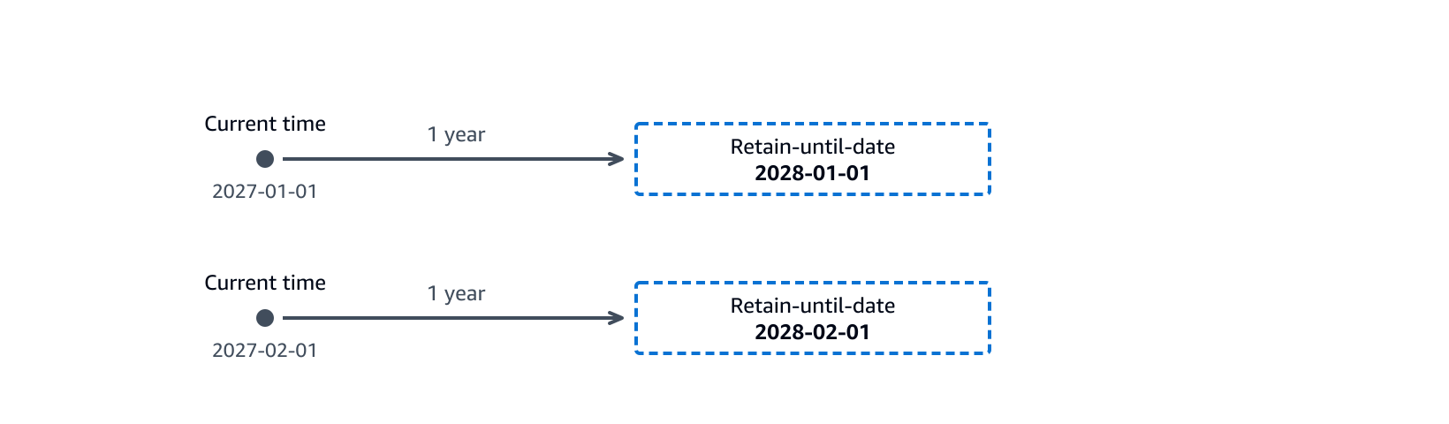
S3 Object Lock: active retention timeline. Topic: retention, Domain 3. Official AWS description: A timeline for a 1-year duration. When the current time is 2027-01-01, the retain-until-date is 2028-01-01. When the current time is 2027-02-01, it is 2028-02-01. The date moves forward as the current time advances.
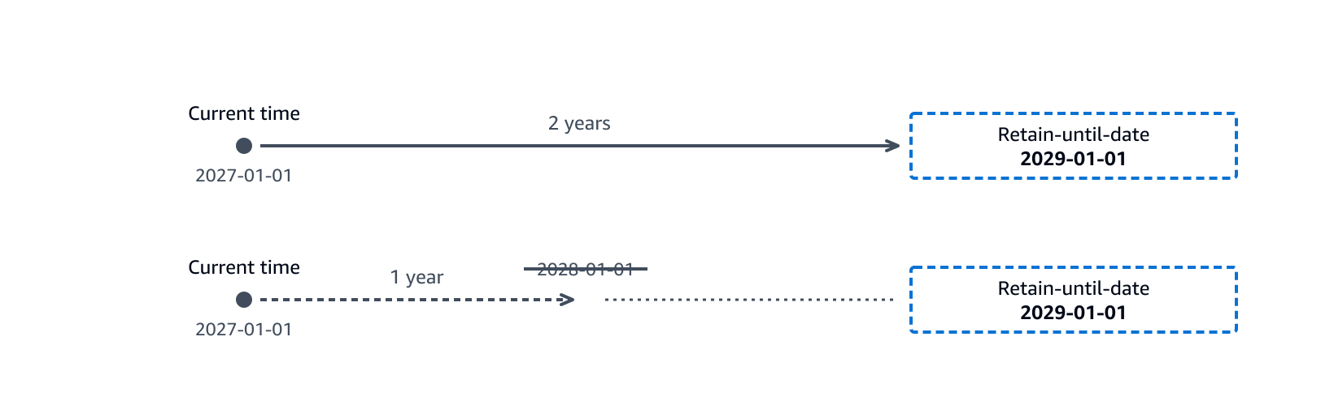
S3 Object Lock: retention decrease. Topic: retention, Domain 3. Official AWS description: A timeline showing that a 2-year duration sets the retain-until-date to 2029-01-01. Decreasing the duration to 1 year does not reduce it. A 1-year duration would compute 2028-01-01, but Amazon S3 does not apply that date. The retain-until-date remains 2029-01-01.
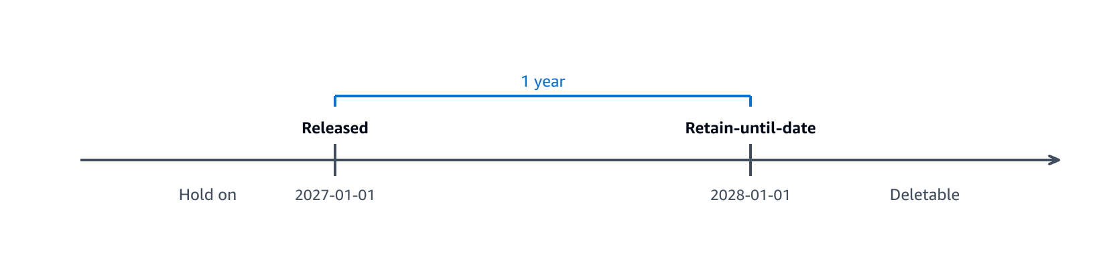
S3 Object Lock: hold release. Topic: retention, Domain 3. Official AWS description: A timeline showing two phases. While the hold is on, the retain-until-date is dynamic. When the hold is released, the date is fixed at the release time plus the duration. After that date, the object becomes deletable.
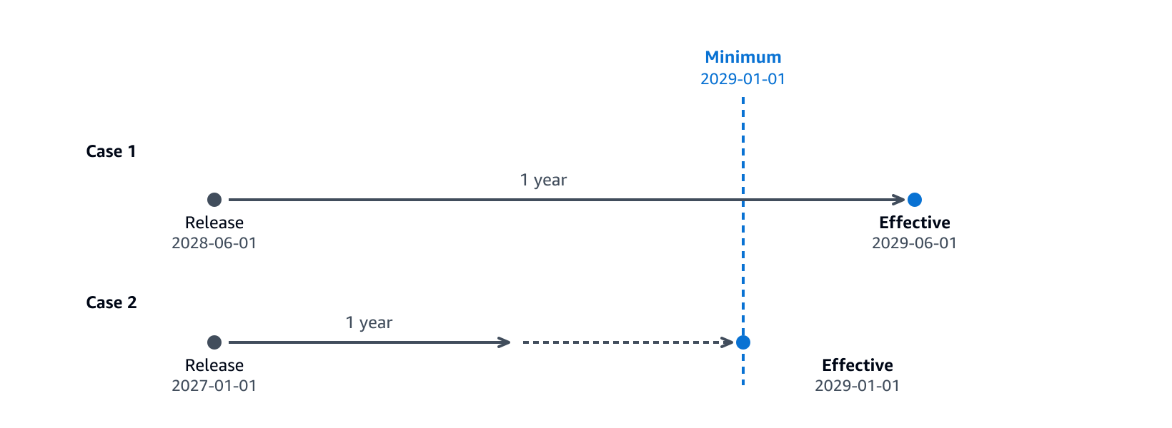
S3 Object Lock: minimum retention comparison. Topic: retention, Domain 3. Official AWS description: A comparison of two cases. When the release time plus the duration is later than the minimum retain-until-date, that later date applies. When it is earlier, the minimum retain-until-date applies.
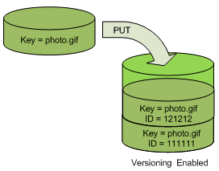
S3 Versioning: PUT in a versioning-enabled bucket. Topic: versioning, unit Q9. Official AWS description: How S3 Versioning works when you PUT an object in a versioning-enabled bucket.
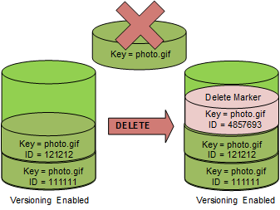
S3 Versioning: delete marker insertion. Topic: versioning, unit Q9. Official AWS description: A delete marker insertion.
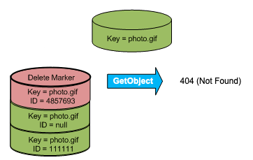
S3 Versioning: GET on a delete marker. Topic: versioning, unit Q9. Official AWS description: A GetObject call for a delete marker returning a 404 (Not Found) error.
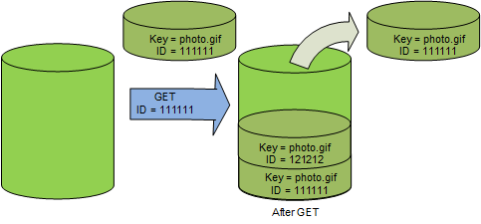
S3 Versioning: GET of a noncurrent version. Topic: versioning, unit Q9. Official AWS description: How S3 Versioning works when you GET a noncurrent version in a versioning-enabled bucket.
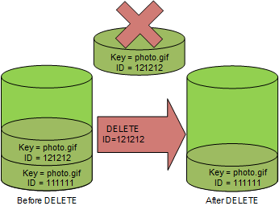
S3 Versioning: DELETE with versionId. Topic: versioning, unit Q9. Official AWS description: How DELETE versionId permanently deletes a specific object version.
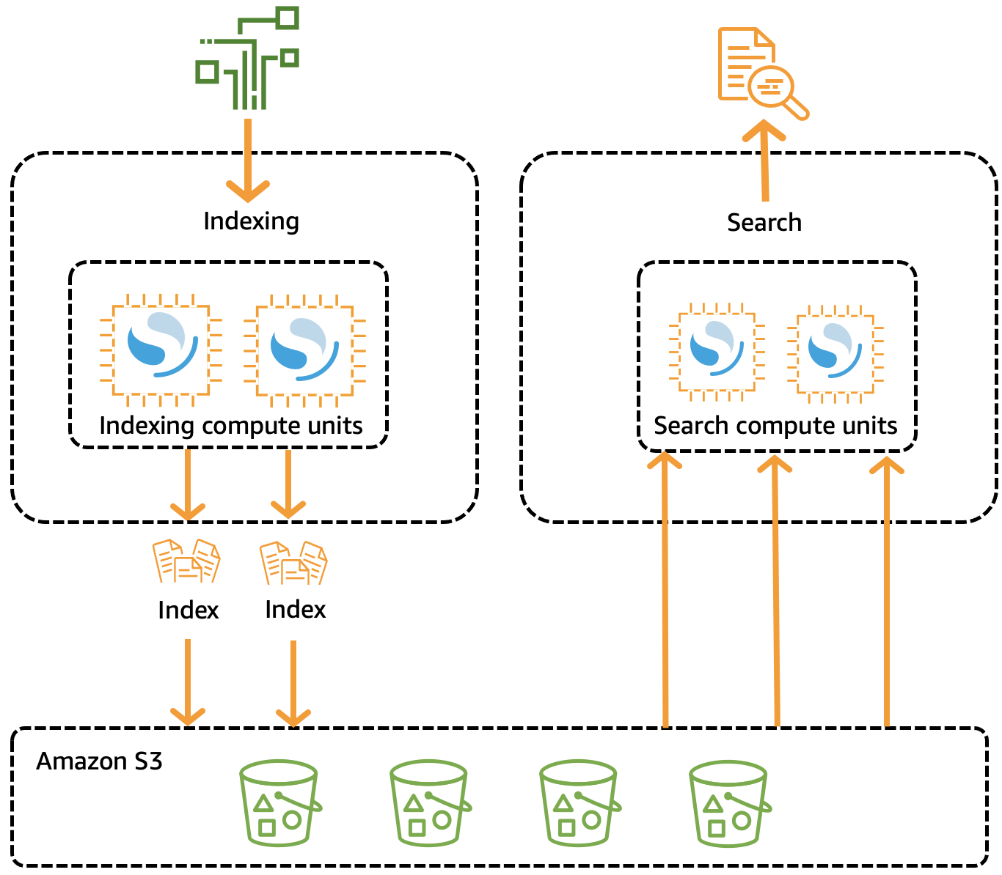
OpenSearch Serverless: how it processes data. Topic: vector store, unit R2. Official AWS description: Indexing compute units process data and store indexes in Amazon S3 for search compute units.
OpenSearch Serverless: collection types. Topic: vector store, unit R2. Official AWS description: Collection type options: Time series, Search, and Vector search with their descriptions.
Prompt caching: console toggle. Topic: prompt caching, unit Q14. Official AWS description: UI toggle for prompt caching in an Amazon Bedrock text playground.
Part 8A8

Topic units from the syllabus check
Each unit names its official page. Design guidance is labeled. Items marked Not in source are not confirmed on an official page in this build.

N1 · Prompt management: versions and variants
First principle. A prompt is code that people change. Store each approved version, and test a new version before users see it.
Facts. A prompt variant is an alternative configuration of a prompt. It can change the message, the model, or the inference configuration. You test variants and save the variant that you want to keep. You save versions while you iterate. Your application deploys a prompt by using a version. Source: Prompt management in Amazon Bedrock.
Facts. A prompt node in a flow uses a prompt from Prompt management. Source: the same page.
Design guidance. Test each variant on the same test values. Compare the outputs before you choose a variant for production.
Exam tie. Domain 2 (implementation and prompt management) and Domain 5 (testing).
Common misconception. A prompt in application code has no version history. Prompt management keeps saved versions and lets an application deploy a chosen version.

N2 · Converse API: tool use and guardrails in one call
First principle. One request format for every chat model keeps application code stable when the model changes.
Facts. The Converse API sends messages to a model. You call Converse for a full response, or ConverseStream for a streamed response. You can use Converse to implement tool use and guardrails in your application. Converse needs permission for bedrock:InvokeModel. Source: Carry out a conversation with the Converse API.
Facts. The Converse API is available on the bedrock-runtime endpoint. Source: the same page.
Design guidance. Put the tool definitions and guardrail settings in the Converse request. Keep the tool result handling in your code.
Exam tie. Domain 2 (implementation and integration).
Common misconception. Converse needs the bedrock:InvokeModel permission. ConverseStream needs its own streaming permission, as the same page states.

N3 · SageMaker AI real-time endpoints for low-latency inference
First principle. A real-time endpoint serves one request at a time with low latency. Use it when a user waits for the answer.
Facts. Real-time inference suits interactive workloads with low-latency requirements. You deploy a model to SageMaker AI hosting services and get an endpoint. The endpoint is fully managed. Source: Real-time inference.
Design guidance. Use Bedrock when you need managed foundation models. Use a SageMaker AI endpoint when you host your own model artifact in S3.
Exam tie. Domain 1 (model deployment) and Domain 4 (performance).
Common misconception. A batch job is the right pattern for an interactive chat. Real-time endpoints serve interactive, low-latency requests.

N4 · Bedrock Flows: linked prompts, models, and AWS services
First principle. A workflow links steps. Each step passes its output to the next step.
Facts. Amazon Bedrock Flows links prompts, foundation models, knowledge bases, and other AWS services into one workflow. The flow uses a visual builder. A flow can call AWS Lambda. Charges depend on the resources the flow uses. Source: Amazon Bedrock Flows.
Design guidance. Use a flow when the steps are fixed. Use Lambda code or Step Functions when the steps depend on complex branching in your code. Source for the Step Functions comparison: unit R5.
Exam tie. Domain 2 (orchestration).
Common misconception. A flow runs for free because the builder is in the console. Each model call in a flow is billed.

N5 · AgentCore Gateway: one entry point for tools and models
First principle. Agents need one controlled path to tools. A gateway puts that path in one place.
Facts. Amazon Bedrock AgentCore Gateway is a fully managed AI gateway. It gives one secure entry point for agent traffic. It connects agents to tools, to other agents, and to large language models. Source: Amazon Bedrock AgentCore Gateway.
Facts. The protocol details for MCP tool servers are Not in source in this build. The fetched page describes the gateway at the level above.
Design guidance. Put tool access rules in the gateway. Keep the tool code behind it.
Exam tie. Domain 2 (agents and tool integration) and Domain 3 (access control).
Common misconception. A gateway is only a model router. The official page describes it as the entry point for agents, tools, other agents, and models.

N6 · API Gateway as the front door for AI APIs
First principle. A stable API hides the backend. Clients call one contract, and the backend can change behind it.
Facts. Amazon API Gateway creates, publishes, maintains, monitors, and secures REST, HTTP, and WebSocket APIs. The APIs can access AWS services and other web services. Source: What is Amazon API Gateway.
Design guidance. Put API Gateway in front of a Lambda function that calls Bedrock. Clients keep one contract. The Lambda function owns the model choice.
Exam tie. Domain 2 (integration) and Domain 3 (security).
Common misconception. A GenAI gateway is an AWS product name. The official API Gateway page does not name a GenAI gateway product. Treat the GenAI gateway as a design pattern built from API Gateway and Lambda. Its exact product form is Not in source.

N7 · Amazon Q Developer: an assistant for building and operating AWS
First principle. A developer assistant helps people. It does not serve end users in your application.
Facts. Amazon Q Developer is a generative AI assistant. It helps you understand, build, extend, and operate AWS applications. In an IDE, it gives software development help, such as code chat and inline code completions. It is built on Amazon Bedrock. Source: What is Amazon Q Developer.
Facts. The page states an IDE plugin support end date. Check the page for the current support status before you plan a rollout.
Design guidance. Use Amazon Q Developer for staff who build AWS applications. Build a Bedrock application for your own end users.
Exam tie. Domain 1 (service selection).
Common misconception. Amazon Q Developer replaces a Bedrock application for customers. It is a developer assistant. Your customers need your own application.

Topic coverage index
Each topic names its unit and the official page that the unit cites. The topics come from the syllabus check. Not in source marks a topic with no confirmed official page.
Topic | Unit | Official page
Prompt versions and variants | N1 | Prompt management in Amazon Bedrock
Converse tool use and guardrails | N2 | Carry out a conversation with the Converse API
SageMaker AI real-time endpoints | N3 | Real-time inference
Bedrock Flows | N4 | Amazon Bedrock Flows
AgentCore Gateway | N5 | Amazon Bedrock AgentCore Gateway
API Gateway front door | N6 | What is Amazon API Gateway
Amazon Q Developer scope | N7 | What is Amazon Q Developer
GenAI gateway as a product | N6 | Not in source
MCP protocol details | N5 | Not in source
Multimodal document input | Not in source | Not in source
Sources

Sources and status
Images below are official AWS images from the AWS documentation pages named. Diagrams in this treatise are schematic drawings. They are not AWS images. Claims marked Not in source were not confirmed on an official page in this build.

Official AWS images
File | Status | Page | Link
Product-Page-Diagram_Amazon-API-Gateway-How-Works.png | Official AWS image | Amazon API Gateway, welcome | https://docs.aws.amazon.com/apigateway/latest/developerguide/welcome.html
memory-overview.png | Official AWS image | AgentCore Memory | https://docs.aws.amazon.com/bedrock-agentcore/latest/devguide/memory.html
Anomaly_Detection_Graph5.png | Official AWS image | CloudWatch anomaly detection | https://docs.aws.amazon.com/AmazonCloudWatch/latest/monitoring/CloudWatch_Anomaly_Detection.html
Anomaly_Detection_Graph7.png | Official AWS image | CloudWatch anomaly detection | https://docs.aws.amazon.com/AmazonCloudWatch/latest/monitoring/CloudWatch_Anomaly_Detection.html
key-hierarchy-root.png | Official AWS image | AWS KMS overview | https://docs.aws.amazon.com/kms/latest/developerguide/overview.html
key-hierarchy-kms-key.png | Official AWS image | AWS KMS overview | https://docs.aws.amazon.com/kms/latest/developerguide/overview.html
AppConfigHowItWorks.png | Official AWS image | What is AWS AppConfig | https://docs.aws.amazon.com/appconfig/latest/userguide/what-is-appconfig.html
serverless-endpoints-how-it-works.png | Official AWS image | SageMaker AI serverless endpoints | https://docs.aws.amazon.com/sagemaker/latest/dg/serverless-endpoints.html
async-architecture.png | Official AWS image | SageMaker AI asynchronous inference | https://docs.aws.amazon.com/sagemaker/latest/dg/async-inference.html
model_registry_cross_account.png | Official AWS image | SageMaker Model Registry versions | https://docs.aws.amazon.com/sagemaker/latest/dg/model-registry-version.html
mmv2-architecture.png | Official AWS image | SageMaker AI Model Monitor | https://docs.aws.amazon.com/sagemaker/latest/dg/model-monitor.html
mmv2-architecture-batch.png | Official AWS image | SageMaker AI Model Monitor | https://docs.aws.amazon.com/sagemaker/latest/dg/model-monitor.html
create-hello-world.png | Official AWS image | Learn how to get started with Step Functions | https://docs.aws.amazon.com/step-functions/latest/dg/getting-started.html
hello-executions.png | Official AWS image | Learn how to get started with Step Functions | https://docs.aws.amazon.com/step-functions/latest/dg/getting-started.html
agents-runtime.png | Official AWS image | Amazon Bedrock Agents, how agents work | https://docs.aws.amazon.com/bedrock/latest/userguide/agents-how.html
AppConfigHowItWorks.png | Official AWS image | AWS AppConfig User Guide, What is AppConfig | https://docs.aws.amazon.com/appconfig/latest/userguide/what-is-appconfig.html
diarization-batch.png | Official AWS image | Speaker diarization in Amazon Transcribe | https://docs.aws.amazon.com/transcribe/latest/dg/diarization.html
serverless-collection-type.png | Official AWS image | Amazon OpenSearch Serverless overview | https://docs.aws.amazon.com/opensearch-service/latest/developerguide/serverless-overview.html
rag-preprocess.png | Official AWS image | How Knowledge Bases work | https://docs.aws.amazon.com/bedrock/latest/userguide/kb-how-it-works.html
rag-runtime.png | Official AWS image | How Knowledge Bases work | https://docs.aws.amazon.com/bedrock/latest/userguide/kb-how-it-works.html
agents-runtime.png | Official AWS image | Amazon Bedrock Agents, how agents work | https://docs.aws.amazon.com/bedrock/latest/userguide/agents-how.html
agents-buildtime.png | Official AWS image | Amazon Bedrock Agents, how agents work | https://docs.aws.amazon.com/bedrock/latest/userguide/agents-how.html
roc-testwindow.png | Official AWS image | Test an agent | https://docs.aws.amazon.com/bedrock/latest/userguide/agents-test.html
serverless-endpoints-how-it-works.png | Official AWS image | SageMaker AI serverless endpoints | https://docs.aws.amazon.com/sagemaker/latest/dg/serverless-endpoints.html
async-architecture.png | Official AWS image | SageMaker AI asynchronous inference | https://docs.aws.amazon.com/sagemaker/latest/dg/async-inference.html
application-design-figure-1.png | Official AWS image | Lambda quotas and limits | https://docs.aws.amazon.com/lambda/latest/dg/gettingstarted-limits.html
configuration-tab.png | Official AWS image | Lambda function timeout | https://docs.aws.amazon.com/lambda/latest/dg/configuration-timeout.html
wait-for-task-token.png | Official AWS image | Step Functions, connect to resources | https://docs.aws.amazon.com/step-functions/latest/dg/connect-to-resource.html
step-functions-example.png | Official AWS image | Wait for a callback with a task token | https://docs.aws.amazon.com/step-functions/latest/dg/concepts-wait-for-task-token.html
use-case-examples.png | Official AWS image | Wait for a callback with a task token | https://docs.aws.amazon.com/step-functions/latest/dg/concepts-wait-for-task-token.html
agentcore_all_components_final.png | Official AWS image | What is Amazon Bedrock AgentCore | https://docs.aws.amazon.com/bedrock-agentcore/latest/devguide/what-is-bedrock-agentcore.html
configurations.png | Official AWS image | Test a Knowledge Base | https://docs.aws.amazon.com/bedrock/latest/userguide/kb-test-retrieve.html
bedrock-prompt-caching-ui-toggle.png | Official AWS image | Prompt caching in Amazon Bedrock | https://docs.aws.amazon.com/bedrock/latest/userguide/prompt-caching.html
bedrock-prompt-caching-metrics.png | Official AWS image | Prompt caching in Amazon Bedrock | https://docs.aws.amazon.com/bedrock/latest/userguide/prompt-caching.html
scorekeep-cw-servicemap-instrumented-edge.png | Official AWS image | AWS X-Ray concepts | https://docs.aws.amazon.com/xray/latest/devguide/xray-concepts.html
xray-trace-details-cw.png | Official AWS image | AWS X-Ray concepts | https://docs.aws.amazon.com/xray/latest/devguide/xray-concepts.html
mmv2-architecture.png | Official AWS image | SageMaker AI Model Monitor | https://docs.aws.amazon.com/sagemaker/latest/dg/model-monitor.html
mmv2-architecture-batch.png | Official AWS image | SageMaker AI Model Monitor | https://docs.aws.amazon.com/sagemaker/latest/dg/model-monitor.html

Pages cited in this treatise
- https://docs.aws.amazon.com/appconfig/latest/userguide/appconfig-creating-configuration-and-profile.html
- https://docs.aws.amazon.com/appconfig/latest/userguide/appconfig-creating-deployment-strategy.html
- https://docs.aws.amazon.com/bedrock/latest/userguide/agents-create.html
- https://docs.aws.amazon.com/bedrock/latest/userguide/batch-inference-create.html
- https://docs.aws.amazon.com/bedrock/latest/userguide/custom-model-fine-tuning.html
- https://docs.aws.amazon.com/bedrock/latest/userguide/inference-parameters.html
- https://docs.aws.amazon.com/bedrock/latest/userguide/kb-test-retrieve.html
- https://docs.aws.amazon.com/bedrock/latest/userguide/knowledge-base-create.html
- https://docs.aws.amazon.com/bedrock/latest/userguide/model-invocation-logging.html
- https://docs.aws.amazon.com/bedrock/latest/userguide/prompt-caching.html
- https://docs.aws.amazon.com/bedrock/latest/userguide/prompt-management-create.html
- https://docs.aws.amazon.com/bedrock/latest/userguide/prov-thru-purchase.html
- https://docs.aws.amazon.com/cloudformation/index.html
- https://docs.aws.amazon.com/cognito/latest/developerguide/what-is-amazon-cognito.html
- https://docs.aws.amazon.com/lambda/latest/dg/configuration-timeout.html
- https://docs.aws.amazon.com/sagemaker/latest/dg/async-inference-create-endpoint.html
- https://docs.aws.amazon.com/sagemaker/latest/dg/model-registry-approve.html
- https://docs.aws.amazon.com/step-functions/latest/dg/getting-started.html
- https://docs.aws.amazon.com/textract/latest/dg/what-is.html
- https://docs.aws.amazon.com/verifiedpermissions/latest/userguide/what-is-avp.html
- https://fonts.googleapis.com
- https://docs.aws.amazon.com/bedrock/latest/userguide/knowledge-base-evaluation-metrics.html
- https://docs.aws.amazon.com/opensearch-service/latest/developerguide/bp-sharding.html
- https://docs.aws.amazon.com/lambda/latest/dg/configuration-envvars.html
- https://docs.aws.amazon.com/lambda/latest/dg/with-s3.html
- https://docs.aws.amazon.com/step-functions/latest/dg/concepts-error-handling.html
- https://docs.aws.amazon.com/bedrock/latest/userguide/kb-data-source-sync-ingest.html
- https://docs.aws.amazon.com/bedrock/latest/userguide/structured-output.html
- https://docs.aws.amazon.com/AmazonS3/latest/userguide/object-lock-overview.html
- https://docs.aws.amazon.com/AmazonS3/latest/userguide/versioning-workflows.html
- https://docs.aws.amazon.com/bedrock/latest/userguide/agents-how.html
- https://docs.aws.amazon.com/bedrock/latest/userguide/kb-how-it-works.html
- https://docs.aws.amazon.com/opensearch-service/latest/developerguide/serverless-overview.html
- https://docs.aws.amazon.com/step-functions/latest/dg/welcome.html
- https://docs.aws.amazon.com/bedrock/latest/userguide/prompt-management.html
- https://docs.aws.amazon.com/bedrock/latest/userguide/conversation-inference.html
- https://docs.aws.amazon.com/sagemaker/latest/dg/realtime-endpoints.html
- https://docs.aws.amazon.com/bedrock/latest/userguide/flows.html
- https://docs.aws.amazon.com/bedrock-agentcore/latest/devguide/gateway.html
- https://docs.aws.amazon.com/apigateway/latest/developerguide/welcome.html
- https://docs.aws.amazon.com/amazonq/latest/qdeveloper-ug/what-is.html
Part 9

Gaps, limits, and checks

Not in source for this build
- Official sample questions for any domain. Only third-party practice sets were found.
- Amazon SageMaker JumpStart, Neo, and Unified Studio.
- AWS CodeDeploy, Kiro, and Amazon Managed Streaming for Apache Kafka.
- Amazon CloudWatch Synthetics, Auto Scaling for GenAI workloads, and AWS Cost Explorer.
- Lake Formation permission model details, IAM Access Analyzer, and AWS WAF rules.
- Step-by-step red-team procedures and Model Evaluations job setup.

Open checks before exam day
- Confirm the Domain 2 API Gateway integration timeout. The quotas page does not list it. The 29 second value is Not in source.
- Confirm the Knowledge Base web crawler end date. The docs page did not show one. The date is Not in source.
- Resolved: the Amazon Bedrock FAQ says AWS and model providers do not use inputs or outputs to train Amazon Nova, Amazon Titan, or third-party models.
- Confirm the batch discount on the Amazon Bedrock pricing page. The docs page gives no percentage.

Images
The images in this treatise come from AWS documentation pages. Each caption names its source page. They are for personal study. Icons and other decorative items from the pages were left out.

