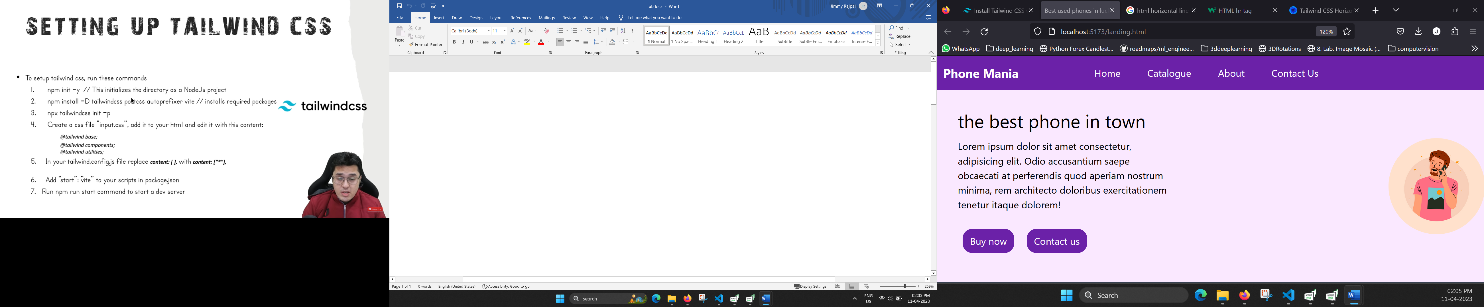

npm install -D tailwindcss@latest postcss@latest autoprefixer@latest vite

npx tailwindcss init -p

**create input.css and in that**

@tailwind base;

@tailwind components;

@tailwind utilities;

**In tailwind.config.js**

/** @type {import('tailwindcss').Config} */

module.exports = {

  content: ["*"],

  theme: {

    extend: {},

  },

  plugins: [],

}

**In package.json**

{

  "name": "chapter3",

  "version": "1.0.0",

  "description": "",

  "main": "index.js",

  "scripts": {

    "start": "vite"

  },

  "keywords": [],

  "author": "",

  "license": "ISC",

  "devDependencies": {

    "autoprefixer": "^10.4.14",

    "postcss": "^8.4.21",

    "tailwindcss": "^3.3.1"

  },

  "dependencies": {

    "vite": "^4.2.1"

  }

}