The missing sibling of the Interview Piscine...

Engineering Piscine
@jaleman



Why an Engineering Piscine?
This project is focused on developing some basic engineering skills, at least what a software engineer at 42 School Silicon Valley should know. When applying to any kind of company as a software engineer, they expect at least some kind of basic engineering skills.

Read This!
I want to make clear, this project might work better as a Piscine, but it may also work as a standalone project. This is up to the pedagogic team to decide.

An Overview
42 School Silicon Valley is aimed, and focus on self-development. An ideal student is one who succeed at the program, by being someone with the necessary skills, surviving in a work environment, requiring skills like teamwork, a seek for knowledge and someone who is committed to finish a working, bulletproof project (or at least an mvp of one).
Yet, I have seen, as a veteran cadet/student, that there are a lot of people who don’t even know the basic concepts of a flowchart; the correct, or at least a good way to refactor code (not just splitting code to cheat norminette), architectural, relational and design patterns, etc...
Of course, this project is aimed at getting familiar with, at least some of the very basics skills needed to be a somewhat decent software engineer, and to be a better 42 cadet/student, a better representation of what an ideal software engineer student must be.
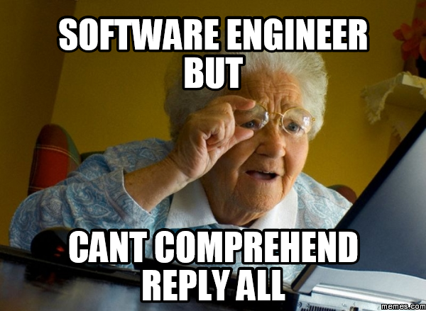
Image 1: This should be the only concern of the hiring company :)

An Insight
I have made a small table considering the twelve (12) most important skills that a software engineer should know and dominate:
Engineering Skill | Status | Where / when to learn it?
Fundamentals of Emotional Intelligence | { true } | Piscine, during corrections
Algorithms & Big-O-Notation | { true } | Interview Piscine
Basics of Project Management | { true } | During the main program
Mainstream Development Paradigms | { false } | N/A
Basics about Software Security | { true } | Piscine/Program
Know your Development Tools | { true } | Rushes, self-discipline
Don't Trust Code without Adequate Test | { true } | Piscine and lib-unit
Key Metrics of Software Development | { false } | N/A
Manage your time efficiently | { true } | Piscine
Conventions and Templates | { true } | Norminette, C++ Piscine
Layering of a Project | { false } | N/A
Application Interfaces | { false } | N/A
Table 1: The Twelve basic skills a software engineer should know. ^{[1] [2] [3] [4]}
As we can see, there are at least four skills that are missing. I might be wrong, but I have analyzed this trend for a while, and I fear that people who are looking for software engineering jobs might fail to get one because of this lack of experience.
Now, you might wonder that it should be responsibility of the student, but I am afraid that is not the case in here. People usually don’t get into a skill because there is a lack of self-motivation and confusion in where to start, or what to do. Questions like: “WTF is a design pattern?!” and “OMG! There are like a lot of things to learn and I don’t know where to start?” are asked a lot, not only here at 42, but also in the software development community, particularly people who go to bootcamps and aim to get a job after 12 weeks.
There is a clear difference between what a software developer and software engineer is, and 42 is getting there… but it’s not there yet.

A Proposal
Keeping this in mind, I propose to the pedagogic team the following (in order of importance):
- Flowcharts
- Architectural and design patterns
- Project layering and application interfaces
- Refactor code ;)

Flowcharts
This is super, super, super, super, and duper important, because, not only it’s a quick and easy way to read the logical flow of a program or application, but a good mean to communicate your logic, and for other people to understand it, or get an idea of what you’re trying to explain.
Also, I think this is something international students, or those who English isn’t their mother tongue, or people who find it difficult to explain a project (such as me, that’s why I am making this proposal), to dissect and describe the project to someone else, for example, during a correction or an interview.
A basic flowchart is something like this:
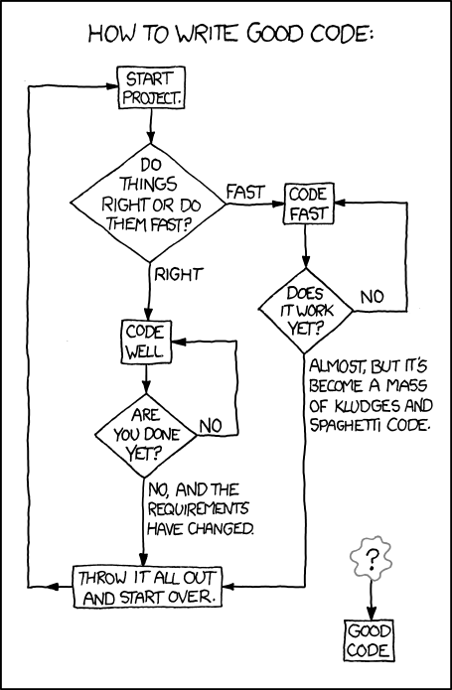
Image 2: xkcd explains it better. [5]

Architectural and Design Patterns
Put differently, a good software system consists of small, reusable building blocks, each carrying its own responsibility. In a good system, no cyclic dependencies between components are present and the whole system is a stack of layers of functionality, forming a pyramid.

Project Layering and Application Interfaces
Layering is probably the simplest way to discuss software architecture. It first got serious attention when John Lakos published his book about Large-scale C++ systems. Lakos argued that software consists of layers. The book introduced the concept of layering. ^{[6]}
For each software component, count the number of other components it relies on. That is the metric of how complex the component is. Lakos contended a good software follows the shape of a pyramid; i.e., there’s a progressive increase in the cumulative complexity of each component, but not in the immediate complexity.
The most important concept in software is interface. Any good software is a model of a real (or imaginary) system. Understanding how to model the problem in terms of correct and simple interfaces is crucial. Lots of systems suffer from the extremes:
- Clumped and lengthy code, with little abstractions,
- An overly designed system, with unnecessary complexity
- Unused code, with an underwhelm amundance of it.

Refactor Code
Lakos’s work was a precursor to many developments in software engineering, most notably Refactoring. The idea behind refactoring is continuously sculpting the software to ensure it’is structurally sound and flexible. Another major contribution was by Dr Robert Martin from Object Mentor, who wrote about dependencies and acyclic architectures. ^{[6]}
A Schedule
This will be up to the pedagogic team, but if wanted, I can make a small schedule to follow. Of course, this depends if this proposal will turn out as a Piscine, or as a stand-alone project that can be found in the galaxy map.
A Conclusion
In my opinion, I believe this project is necessary for the greater good of the educational development of the students.

Image 3: Let’s do this.

Sources
- Top 12 Things Every Software Engineer Should Know. (n.d.).
Retrieved from http://www.sw-engineering-candies.com/blog-1/top10thingseverysoftwareengineershouldknow
- 6 Things Every Engineer Should Know. (2018, May 02).
Retrieved from http://interestingengineering.com/6-things-every-engineer-know
- Top 10 Concepts That Every Software Engineer Should Know. (n.d.).
Retrieved from https://readwrite.com/2008/07/22/top_10_concepts_that_every_software_engineer_should_know/
- http://www.quora.com/What-are-some-things-that-every-software-engineer-should-know
- http://i0.kym-cdn.com/photos/images/newsfeed/000/989/215/804.png
- Lakos, J. (2011). Large-scale C software design. Boston, MA: Addison-Wesley.

