The other missing sibling of the Interview Piscine...

Teamwork (GIT) Piscine
@jaleman

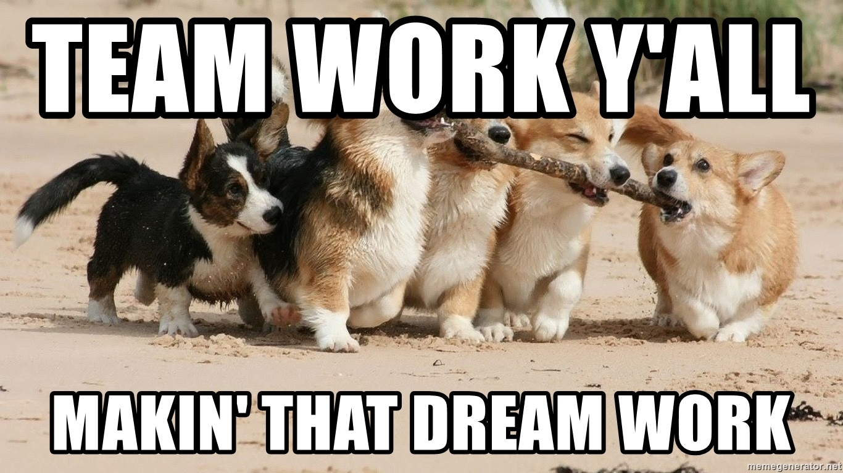

Why a Teamwork Piscine?
This project is focused on developing some basic git and teamwork skills, at least what a software engineer at 42 School Silicon Valley should know. When applying to any kind of company as a software engineer, they expect at least some kind of basic, but necessary git skills (life isn’t just git add, git commit, git push).

Read This!
I want to make clear, this project might work better as a Piscine, but it may also work as a standalone project. This is up to the pedagogic team to decide.

An Overview
42 School Silicon Valley is aimed, and focus on self-development. An ideal student is one who succeed at the program, by being someone with the necessary skills, surviving in a work environment, requiring skills like teamwork, a seek for knowledge and someone who is committed to finish a working, bulletproof project (or at least an mvp of one).
Yet, I have seen, as a veteran cadet/student, that there some people who don’t even know the basics of git, or even how to do a Pull Request. or know what a PR actually is! Imaging this conversation -- Interviewer: “Do you know git?” ; Cadet: “Yes! git add, git commit, git push”
Of course, this project is aimed at getting familiar with, at least some of the very basics skills, needed to be a somewhat decent software engineer, and to be a better 42 cadet/student (in the teamwork area, and using git at least in a decent way).
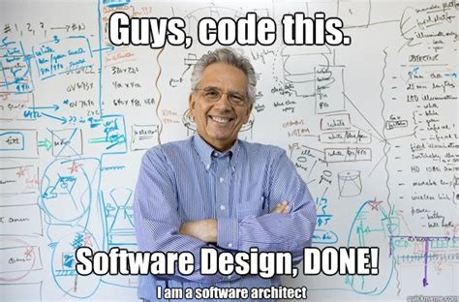
Image 1: This is not how teamwork `works` :(


An Opportunity
I remember there used to be a few cases where the staff has asked for someone with good Git skills to help design and do a project based on Git. I think this is the perfect opportunity, because I will be doing something similar for my work, so I can also help out 42 in a way.
Image 2: It’s probably your only one.

A Proposal
Keeping this in mind, I propose to the pedagogic team the following:
- Simulating a small startup
  - Group of two (2) to four (4) people.
  - Freedom with naming conventions (but most be consistent).
  - Freedom with branch naming (but must be consistent, and branch names such as a their login are allowed).
  - This is more focused to those who are entrepreneurs and founders of startups.
- Simulating a large company
  - Group of six (6) to eight (8) people.
  - Follow a strict naming convention (depending on the programming language).
  - Follow the git workflow of a big company, like Google, and use that as a base. Take a look at the end of this document for the source.
  - This is conducted to those who aim to work at a medium-large company, like the classics (Google, Facebook, Tesla, etc…)
I believe it would be fair if people have the chance on how they want to work, such as a small startup (where there is more informality and it’s up to them to decide what to follow), or in a medium-large company (where there is a strict guideline to follow).

Clear Documentation, Commit Messages, etc..
A software engineer is just a title, what you’ll be working on or doing in a company may depends on the company’s needs. It’s important to distinguish each role. I consider that a basic contemporary-software project must have people with, six (6) of the basics roles:
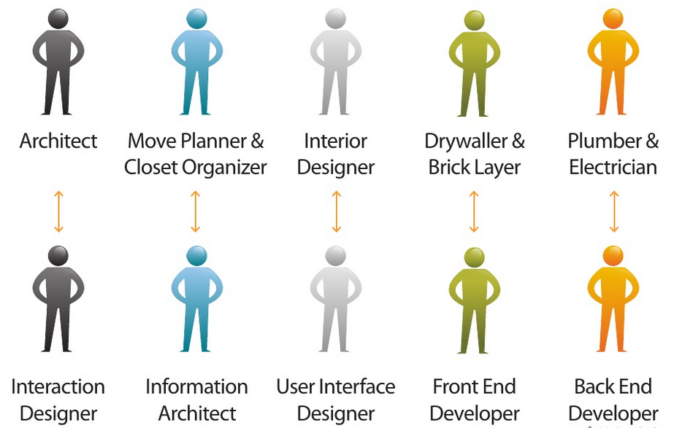
Image 3: A software engineer might also be one of the above, or all of the above ;)

Contribution to an Open Source Project
This might be a small, some, or significant contribution to an already established open source project. I recommend this to be a pre-requirement to be able to subscribe to the Open Source Project in the galaxy map. Of course, the project will have certain number of requisites, like a minimum number of stars, or forks, or issues, or it being part of a company.

Knowing How to Use Git in-depth

This is self-explanatory. ^{[1]}

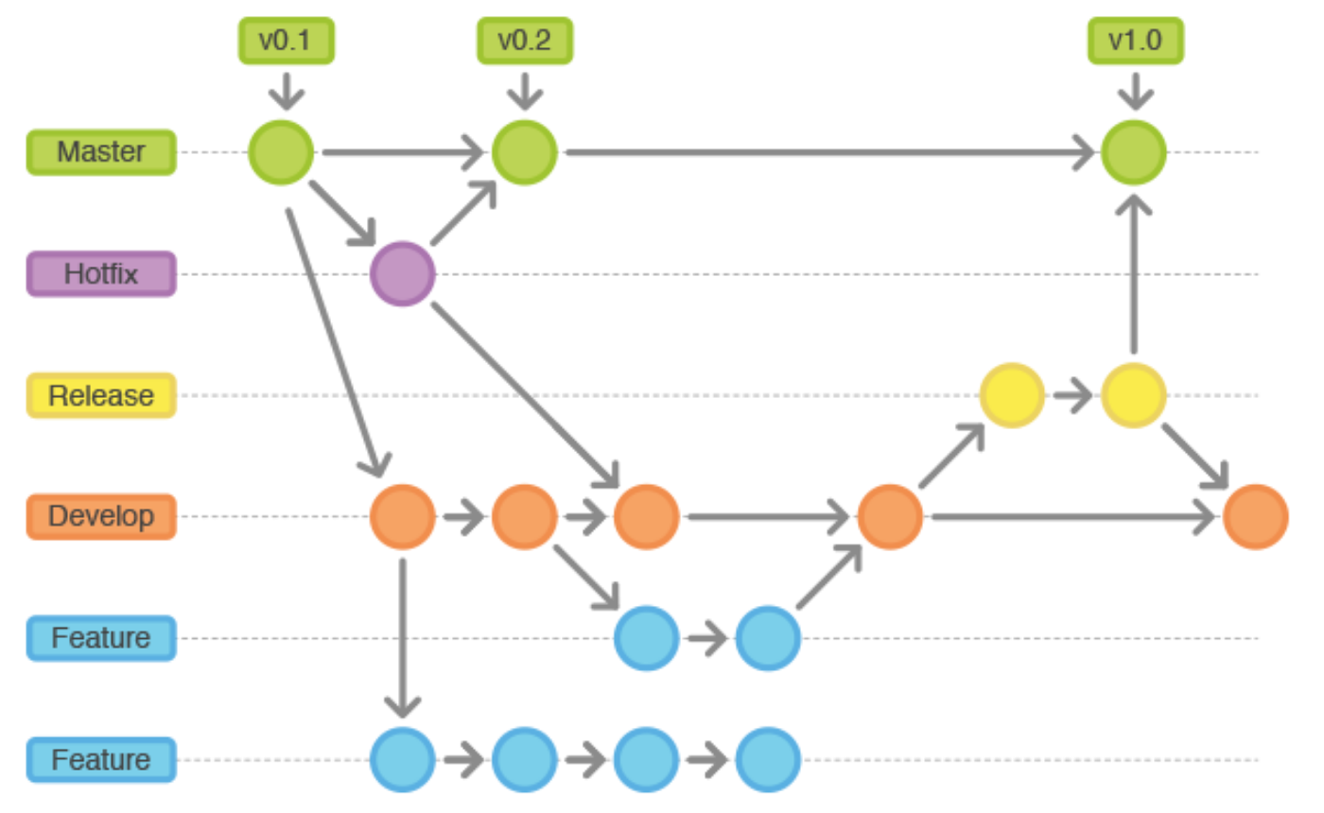
Image 4: An example of a git workflow. ^{[2]}

A Schedule
This will be up to the pedagogic team, but if wanted, I can make a small schedule to follow. Of course, this depends if this proposal will turn out as a Piscine, or as a stand-alone project that can be found in the galaxy map.
A Conclusion
In my opinion, I believe this project is necessary for the greater good of the educational development of the students.

Image 5: Dew it.

Sources
- G. (n.d.). Google/qpp. Retrieved from https://github.com/google/qpp/wiki/Development-Workflow
- Ofili, C. (2018, April 09). Gitflow Workflow, Continuous Integration & Delivery.
Retrieved from https://medium.com/devsondevs/gitflow-workflow-continuous-integration-continuous-delivery-7f4643abb64f

