Introduction

In geoscience, computed tomography (CT) images allow the modelling of internal structures within analysed samples, resulting in the straightforward and intuitive digital modeling of rock properties for interpretation. The information contained in CT images, however, is primarily related to material density, being generally used for porosity estimations (Tanaka et al., 2011). In order to integrate visual data from high definition rock core photos with CT images from these same rock cores and to provide the interpreter with additional information regarding rock texture and composition, we develop deep learning models based on neural style transfer and generative adversarial networks capable of transferring mineral color information from photos to the CT images.

Method and/or Theory

Deep learning has recently emerged as the state-of-the-art dealing with computer vision related problems [2], meanwhile, neural style transfer is a domain within computer vision focused on algorithms capable of manipulating digital images or vídeos to take on the appearance or visual style of another image by applying deep neural networks as the means to perform this image transformation. The seminal work on neural style transfer by Gatys et al. (2015) proposes a workflow where a content image is iteratively modified by an optimizer and eventually takes on the style of another given image (called the style image). This workflow, however, is computationally intensive and cannot be generalized, requiring the optimization workflow to be redone in order to apply the same style to a new image. The process of neural style transfer is later optimized by Johnson et al. (2016) and Ulyanov et al. (2016) by proposing convolutional neural networks capable of not only automatizing the previously established workflows, but also estimating the style of a given image and applying it to any input image, bypassing much of the lengthy optimization process.
Generative adversarial networks (GANs) consist of two different neural networks, a generative model that captures the data distribution and a discriminative model that estimates the probability of a sample being from real data or originated by the generator (Goodfellow et al., 2014). GANs have recently shown promising results in multiple fields of computer vision, notably being used to generate computer generated human faces in NVidia’s StyleGAN project (Karras et al., 2018). Meanwhile, Cycle-Consistent Adversarial Networks (CycleGANs) utilize adversarial models in order to perform image-to-image translation from one domain into another. When applied to neural style transfer problems, CycleGANs help generalize the results by considering two different groups of images as two different domains instead of needing to define an individual style image (Zhu et al., 2017). In this study, we develop an adversarial model capable of generating HD photographs from CT images by considering CT images and HD core photos as two different domains and applying CycleGANs to capture the underlying data distribution of each domain and seamlessly convert images between those two domains (Fig 1.). The training data used consists of CTs and high definition photos from various offshore carbonate reservoirs in the Santos Basin, SE Brazil.

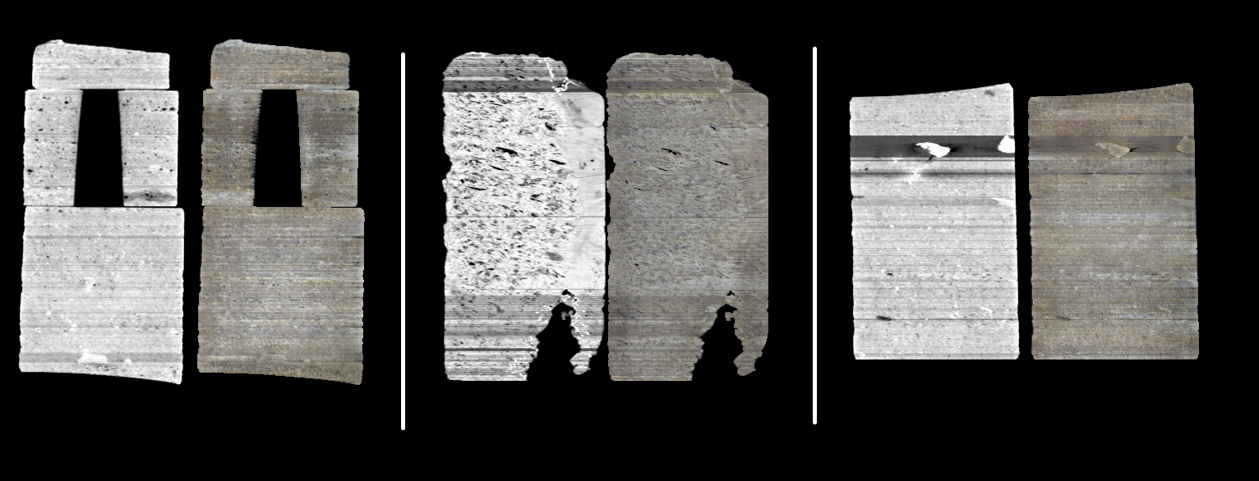
Figure 1 Results of the generative model for sections of three different cores. The grayscale images on the left are the original CT images while the color images on the right are the results from the models converting the CT scans to the photo domain.

Conclusions

Conclusions
Compared to traditional neural style transfer techniques, the output images from generative models show results more closely resembling actual HD photos (Fig 2.) and also show numerous advantages such as the capability of applying the trained model to new data, being able to generate a single model from multiple training images and not needing training data to be paired.
The generative models also allow for the visual data in HDI photos to be extrapolated to the entire 3D scanned area, allowing for the building of lifelike 3D core models and making it possible to infer color and texture information from within the rock core while previously this information would only be available at the core surface.

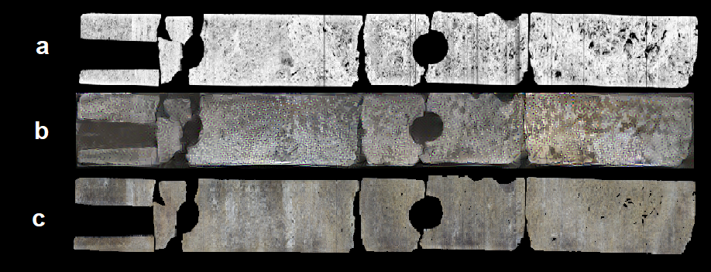
Figure 2 Comparison between generated results for a single core using different techniques for style transfer. (a) is the original CT image, (b) represents the results obtained with Neural Style Transfer and (c) represents the results obtained with CycleGAN.

References

[1] Tanaka, A., Nakano, T., & Ikehara, K. (2011). X-ray computerized tomography analysis and density estimation using a sediment core from the Challenger Mound area in the Porcupine Seabight, off Western Ireland. Earth, planets and space, 63(2), 103-110.
[2] LeCun, Y., Bengio, Y., & Hinton, G. (2015). Deep learning. nature, 521(7553), 436-444.
[3] Gatys, L. A.; Ecker, A. S.; Bethge, M. (2015). A Neural Algorithm of Artistic Style
[4] Johnson, J; Alahi, A; Li, F (2016). "Perceptual Losses for Real-Time Style Transfer and Super-Resolution"
[5] Ulyanov, D., Vedaldi, A., & Lempitsky, V. (2016). Instance normalization: The missing ingredient for fast stylization. arXiv preprint arXiv:1607.08022.
[6] Goodfellow, I., Pouget-Abadie, J., Mirza, M., Xu, B., Warde-Farley, D., Ozair, S., ... & Bengio, Y. (2014). Generative adversarial nets. In Advances in neural information processing systems (pp. 2672-2680).
[7] Karras, T., Laine, S., & Aila, T. (2018). A Style-Based Generator Architecture for Generative Adversarial Networks. ArXiv. preprint.
[8] Zhu, J. Y., Park, T., Isola, P., & Efros, A. A. (2017). Unpaired image-to-image translation using cycle-consistent adversarial networks. In Proceedings of the IEEE international conference on computer vision (pp. 2223-2232).

