[**http://localhost:8080/jersey-medium/rest/corporationService/getDefault**](http://localhost:8080/jersey-medium/rest/corporationService/getDefault)

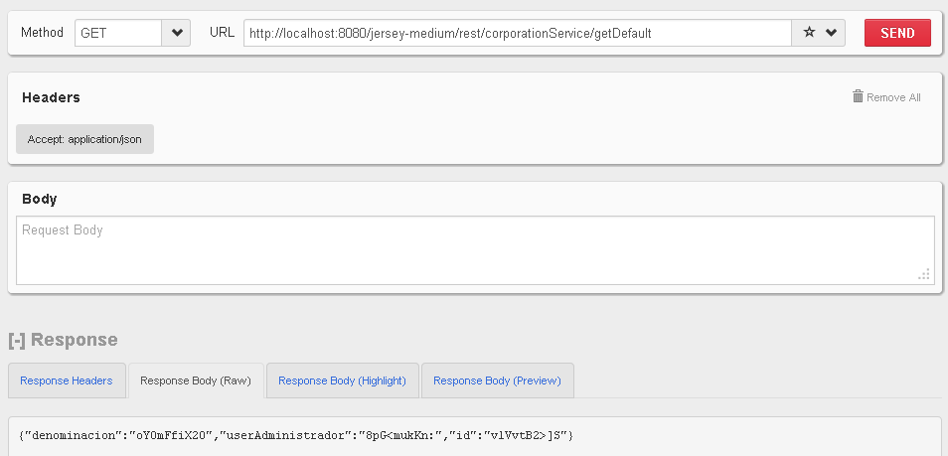

@GET

@Path("/getDefault")

@Produces(MediaType.*APPLICATION_JSON*)

**public** Corporation getDefaultEvent() {

PodamFactory factory = **new** PodamFactoryImpl();

Corporation myPojo = factory.manufacturePojo(Corporation.**class**);

**return** myPojo;

}

[**http://localhost:8080/jersey-medium/rest/corporationService/getEmployeeById/125**](http://localhost:8080/jersey-medium/rest/corporationService/getEmployeeById/125)

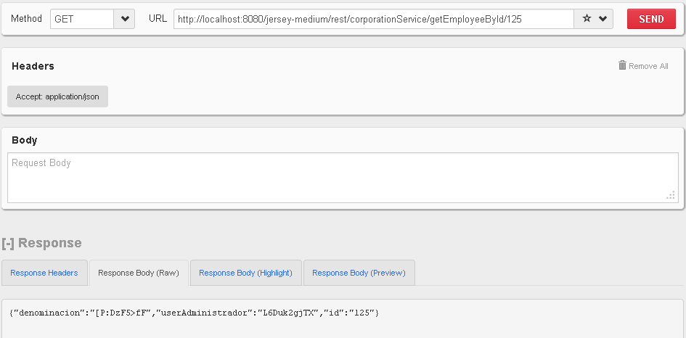

@GET

@Path("/getEmployeeById/{id}")

@Produces(MediaType.*APPLICATION_JSON*)

**public** Corporation getEventById(@PathParam("id") String id) {

PodamFactory factory = **new** PodamFactoryImpl();

Corporation myPojo = factory.manufacturePojo(Corporation.**class**);

myPojo.setId(id);

**return** myPojo;

}

[**http://localhost:8080/jersey-medium/rest/corporationService/getEmployeeByUri?uri=5**](http://localhost:8080/jersey-medium/rest/corporationService/getEmployeeByUri?uri=5)

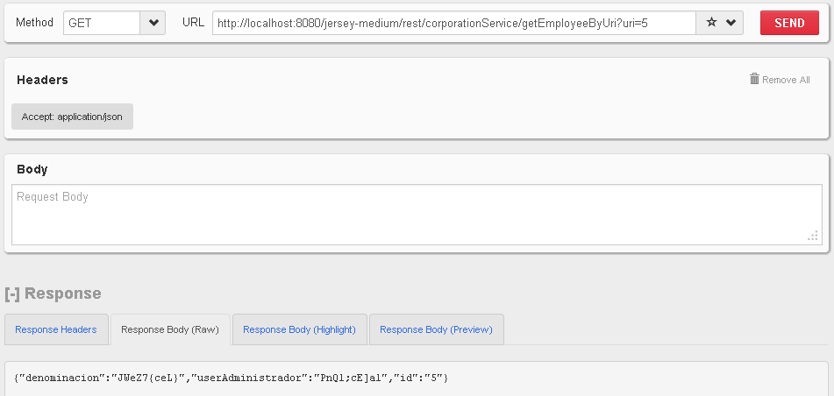

@GET

@Path("/getEmployeeByUri")

@Produces(MediaType.*APPLICATION_JSON*)

**public** Corporation getEventByUri(@QueryParam("uri") String uri) {

PodamFactory factory = **new** PodamFactoryImpl();

Corporation myPojo = factory.manufacturePojo(Corporation.**class**);

myPojo.setId(uri);

**return** myPojo;

}