**http://localhost:8080/jersey-simple/rest/hello**

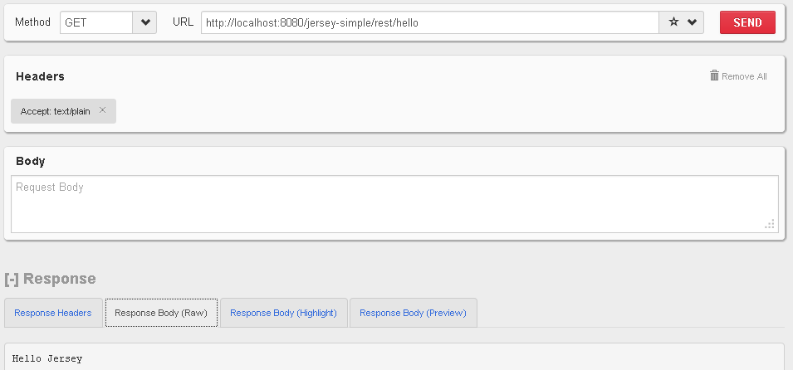

// This method is called if TEXT_PLAIN is request

@GET

@Produces(MediaType.*TEXT_PLAIN*)

**public** String sayPlainTextHello() {

**return** "Hello Jersey";

}

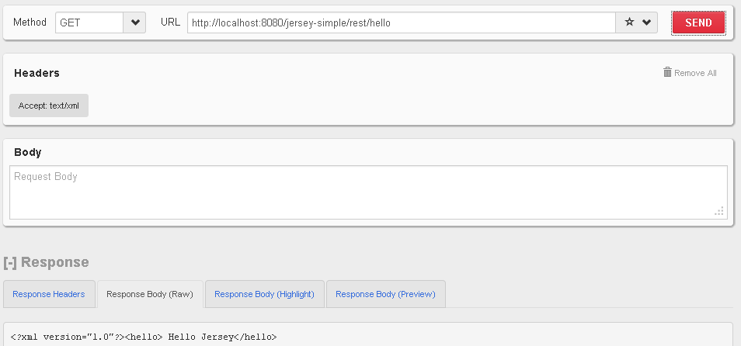

// This method is called if XML is request

@GET

@Produces(MediaType.*TEXT_XML*)

**public** String sayXMLHello() {

**return** "<?xml version=\"1.0\"?>" + "<hello> Hello Jersey" + "</hello>";

}

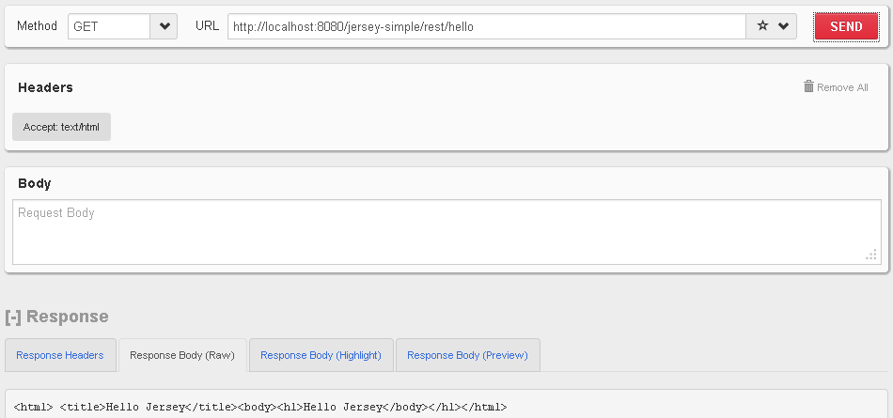

// This method is called if HTML is request

@GET

@Produces(MediaType.*TEXT_HTML*)

**public** String sayHtmlHello() {

**return** "<html> " + "<title>" + "Hello Jersey" + "</title>"

+ "<body><h1>" + "Hello Jersey" + "</body></h1>" + "</html> ";

}

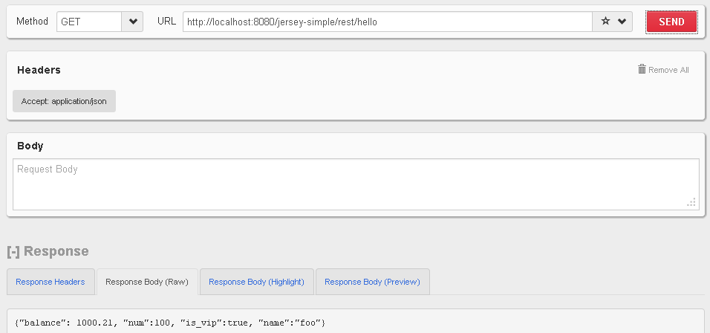

// This method is called if JSON is request

@GET

@Produces(MediaType.*APPLICATION_JSON*)

**public** String sayJsonHello() {

**return** "{\"balance\": 1000.21, \"num\":100, \"is_vip\":true, \"name\":\"foo\"}";

}