Project Step 1

Group 1: Grant Wu and Jessica Ramirez

The Oaklaura Bike Cooperative is a non-profit organization that accepts donations of old or broken bicycles, refurbishes them, and then sells them at an affordable price. Due to limited funding, the co-op operates with a small team of employees and relies heavily on volunteers to assist with bicycle repairs.

Store Personnel consist of both volunteers and employees. Most volunteers are not experienced bike mechanics, so they often can't fully repair a bike during the few hours the co-op is open for volunteer work. To maintain continuity and organization, volunteers are expected to repair what they can during their shift and document their progress in a report. This allows the next volunteer and/or employee to review the logs and continue the work where the previous one left off. Once a volunteer believes a bike is fully repaired, a trained employee inspects it to ensure it meets safety standards before placing it on the sales floor.

Historically, the co-op tracked repair progress and sales using handwritten notecards stored in a filing cabinet. However, as the organization grows, this system has become increasingly difficult to manage. Implementing a database would be an ideal solution for organizing and sharing information between volunteers and employees about the status of each bicycle.

* **Bikes:** contains details on a particular bike within the co-op
  + **bikeID** [PK]: int, not NULL, auto_increment
  + **color:** enum('Black', 'White', 'Red', 'Blue', 'Green', 'Pink', ‘Purple’, 'Yellow', 'Orange', 'Silver', 'Other'), not NULL
  + **style:** enum('Mountain', 'Road', 'Fat', 'Hybrid', ‘Enduro’, 'BMX', 'Cruiser', 'Kids', ‘Electric’), not NULL
  + **brand:** varchar(45)
  + **status:** enum(‘In Repair’, ‘Employee Review’, ‘For Sale’, ‘Sold’), not NULL
  + **dateReceived:** date, not NULL
  + **completed:** tinyint(default 0=false), not NULL
  + Relationships:
    - M:M relationship between Bikes and StorePersonnel is implemented with bikeID and personnelID as FK’s within both RepairReports and within SalesReports.
    - 1:1 relationship between Bikes and SalesReports is implemented by bikeID as a FK within SalesReports. *Note that due to our outdated POS system, only one bike can be sold at a time (i.e. only one Bike instance per SalesReport instance).*
    - 1:M relationship between Bikes and RepairReports is implemented with bikeID as a FK within RepairReports.
    - 1:M relationship between Bikes and SalesReports is implemented with bikeID as a FK within SalesReports.
* **StorePersonnel:** holds information on store employees and volunteers
  + **personnelID** [PK]: int, not NULL, auto_increment
  + **firstName**: varchar(45) not NULL
  + **lastName:** varchar(45) not NULL
  + **phone:** varchar(20)
  + **email:** varchar(100), not NULL, unique
  + **role:** enum(‘Employee’, ‘Volunteer’), not NULL
  + Relationships:
    - M:M relationship between StorePersonnel and Bikes is implemented with bikeID and personnelID as FK’s within both RepairReports and within SalesReports.
    - 1:M relationship between StorePersonnel and RepairReports is implemented with personnelID as a FK within RepairReports.
    - 1:M relationship between StorePersonnel and SalesReports is implemented with personnelID as a FK within SalesReports.
* **Customers:** holds customer information
  + **customerID** [PK]: int, not NULL, auto_increment
  + **firstName:** varchar(45) not NULL
  + **lastName:** varchar(45) not NULL
  + **phone:** varchar(20)
  + **email:** varchar(100), not NULL, UNIQUE
  + Relationships:
    - 1:M relationship between Customers and SalesReports is implemented with customerID as a FK inside of SalesReports.
* **RepairReports:** holds repair information performed on a particular bikes (Bikes_StorePersonnel Intersection Table that includes additional repair information)
  + **repairID** [PK]: int, not NULL, auto_increment
  + **personnelID** [FK - StorePersonnel]: int, not NULL
  + **bikeID** [FK - Bikes]: int, not NULL
  + **dateRepaired**: datetime, not NULL
  + **hoursSpent:** decimal(4,2), not NULL
  + **description**: varchar(255)
  + Relationships:
    - 1:M relationship between RepairReports and StorePersonnel is implemented with personnelID as a FK inside RepairReports.
    - 1:M relationship between RepairReports and Bikes is implemented with bikeID as a FK inside RepairReports.
* **SalesReports:** holds information pertaining to the sale of a particular bike (Bikes_StorePersonnel Intersection Table that includes additional sale information)
  + **salesID** [PK]: int, not NULL, auto_increment
  + **personnelID** [FK - StorePersonnel]: int, not NULL
  + **bikeID** [FK - Bikes]: int, not NULL
  + **customerID** [FK - Customers]: int, not NULL
  + **dateSold:** date, not NULL
  + **price:** decimal(5,2), not NULL
  + Relationships:
    - 1:1 relationship between Bikes and SalesReports is implemented by bikeID as a FK within SalesReports. *Note that due to our outdated POS system, only one bike can be sold at a time (i.e. only one Bike instance per SalesReport instance).*
    - 1:M relationship between SalesReports and StorePersonnel is implemented with personnelID as a FK within SalesReports.
    - 1:M relationship between SalesReports and Customers is implemented with customerID as a FK within SalesReports.

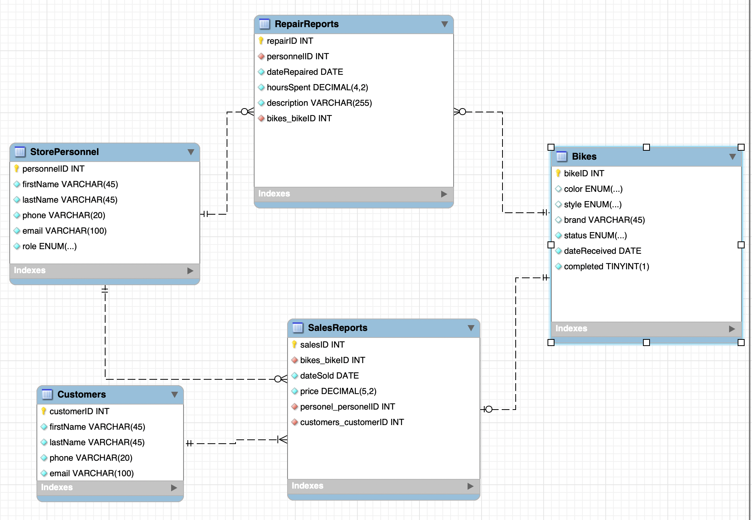

**Citations:**

* Inspiration for the Bike Co-Op came from The Recyclery, a non-profit bike shop based out of Chicago, IL (last retrieved on 4/9/2025): [https://www.therecyclery.org](https://www.therecyclery.org/)/
* MySQL workbench was used to create the ERD diagram shown above.
* The LaTeX template used here was adapted from the Cleese-Assignment template v.2.0 (retrieved on 4/2/2025): <https://latextemplates.com/template/cleese-assignment>
* TeXShop was used for all LaTeX related compilations.
* All database and design related work is original.