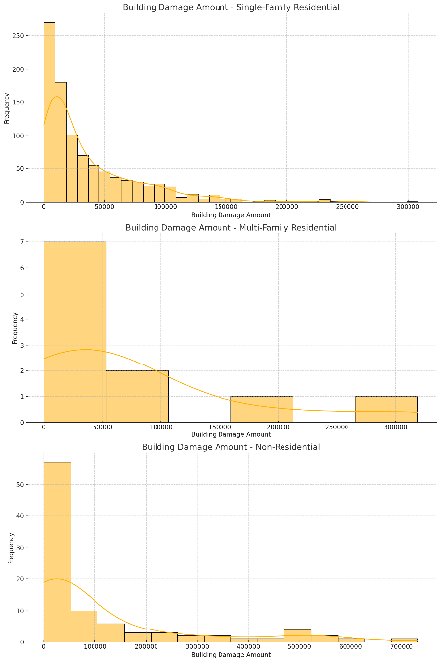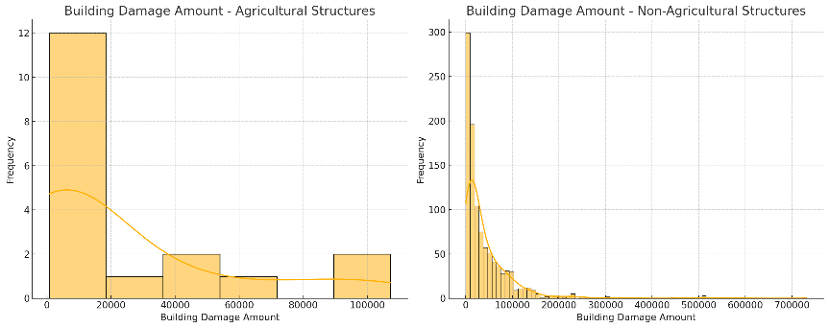**2019 Flood Analysis Report: Damage by Structure Type**

**Introduction**

This report analyzes the impact of the 2019 Nebraska flooding on various types of structures based on FEMA anonymized claim reports.

*Data Overview*

The dataset comprises 1,165 flood-damaged structures across Nebraska.

**Summary of Structure Types by Primary Use**

| Structure Type | Count |
| --- | --- |
| Single-family Residential | 1,040 |
| Multi-family (2-4 units) | 6 |
| Multi-family (5+ units) | 11 |
| Non-residential Building | 15 |
| Non-residential Business | 93 |

| **Agricultural Use** | **Count** |
| --- | --- |
| Agricultural | 18 |
| Non-Agricultural | 1,147 |

Structures were categorized based on primary use. Additionally, an agricultural use indicator was applied across all primary use categories. The primary metric for flood impact is the building damage amount, measured in dollars.

Damage by Structure Type

| Structure Type | Count | Mean Damage | Std Dev | Median |
| --- | --- | --- | --- | --- |
| Single-family Residential | 1,040 | 36,890.43 | 42,216.43 | 19,961 |
| Multi-family (2-4 units) | 6 | 20,097.60 | 18,544.31 | 16,772 |
| Multi-family (5+ units) | 11 | 123,345.00 | 114,054.05 | 81,939 |
| Non-residential Building | 15 | 21,275.77 | 30,501.02 | 8,848 |
| Non-residential Business | 93 | 122,592.95 | 176,415.92 | 39,274 |

Damage for Agricultural Uses

| Statistic | Value |
| --- | --- |
| Mean | 23,136 |
| StDev | 33,440 |
| Minimum | 784 |
| Maximum | 107,168 |

Single-family homes, the most common structure type, show an average damage of $36,890.43. Multi-family residences with 5+ units experienced higher average damage at $123,345.00. Non-residential businesses had the highest average damage at $122,592.95 and the widest range, from $420 to $731,679.

Structures classified for agricultural use show a mean damage amount of $23,136.78, with a range from $784 to $107,168.

**Key Observations**

1. Single-family homes constitute 89.3% of the dataset.
2. Non-residential structures, particularly businesses, show the highest variability in damage amounts.
3. Larger multi-family residences (5+ units) show high average damage amounts.
4. Agricultural use structures show lower average damage compared to most other categories.

Data Insights

The agricultural use classification applies across primary structure types, providing an additional dimension to the analysis. The wide range of damage amounts within each category suggests factors beyond primary use or agricultural classification influence flood damage.