An Approach to Probabilistic Disaggregation of National Flood Insurance Program (NFIP) Claims onto Building Footprints
Zhenghong Tang
Jesse Andrews
Yunwoo Nam
Jiyoung Lee
2026-01-02
Abstract
Aggregated National Flood Insurance Program (NFIP) claims data restrict granular flood risk analysis and the identification of localized damage patterns. This study presents a probabilistic spatial disaggregation workflow that assigns anonymized NFIP claims to building footprints while quantifying uncertainty. The approach combines hierarchical filtering with bootstrap resampling to generate building-level claim likelihood indices and uncertainty diagnostics. We apply the method to the March 2019 flood in eastern Nebraska (Dodge and Douglas counties) using OpenFEMA claims with Microsoft building footprints, parcel data, and FEMA flood zones. The baseline configuration uses ZIP/ZCTA and flood-zone matching and retains the largest structure per parcel. Sensitivity tests examine alternative spatial units, coarse coordinate constraints, construction-year tolerances, and additional covariates intended to improve matching outside mapped floodplains. Validation uses a remotely sensed inundation footprint and an independent ZIP-level comparison against FEMA Housing Assistance Owners totals. The baseline shows strong discrimination in 2019, while stratified analyses are more variable in the upper tail. Policy-based bootstraps and ACS-derived uptake rates provide context for insurance coverage. This workflow produces building-level likelihood surfaces from public NFIP data, supporting post-event analysis and local risk communication where precise claim locations are unavailable.

1. Introduction
Flooding generates over $17 billion in annual economic damage in the United States, ranking as one of the most destructive and pervasive natural hazards confronting communities nationwide (Armal et al., 2020; National Weather Service, 2020). A March 2019 flooding in eastern Nebraska exemplifies this challenge—an unprecedented event that impacted thousands of properties across multiple states, resulting in substantial financial losses and federal disaster declarations (Congressional Research Service, 2019). In the aftermath of these types of events, understanding which structures sustain flood damage is critical for effective risk management and targeted mitigation strategies.
The National Flood Insurance Program (NFIP) which serves as a vital source for national flood-loss data, anonymizes and aggregates records to preserve policyholder confidentiality. Consequently, planners, emergency managers, and researchers must often rely on aggregated spatial units, significantly limiting their ability to accurately pinpoint and analyze highly localized patterns typical of flood losses. To address this data gap, we introduce an ensemble-based probabilistic spatial disaggregation method specifically designed to link anonymized NFIP claims to individual building footprints. Our approach combines principles from probabilistic record linkage and bootstrap resampling to allocate aggregated claim records to specific structures in a statistically appropriate manner. Rather than replacing existing modeled inundation datasets, our method complements them by integrating actual NFIP claims, thereby offering a more complete picture of flood impacts and enabling identification of previously overlooked micro hotspots of flood damages.

1.1 National Flood Insurance Program
The NFIP, launched in 1968 when private coverage was scarce, now insures millions of properties (Federal Emergency Management Agency, 2024b; Michel-Kerjan, 2010; Michel-Kerjan & Kousky, 2010). To safeguard policyholder privacy, the Federal Emergency Management Agency (FEMA) releases only aggregated claim data—omitting precise building coordinates and other identifiers—which curtails use of the dataset by planners and researchers who need structure-level loss information to target mitigation. March 2019 flooding in Nebraska exposed this gap: damage spanned multiple jurisdictions, yet the public NFIP file does not reveal building level data on policy claims (Federal Emergency Management Agency, 2025). To address these limitations, we propose a probabilistic method that reallocates anonymized claims to individual footprints, bridging the divide between privacy protection and actionable risk assessment.

1.2 Current Approaches and Limitations
Current approaches to flood risk assessment offer valuable but incomplete insights into flood impacts. The First Street Foundation (First Street Foundation, 2023) has developed detailed property-level inundation models for events like the 2019 Nebraska flood, estimating flood depths at individual parcels and assigning risk ratings based on modeled water levels. Similarly, we have independently derived a detailed flood extent map using remote sensing data. These high-resolution spatial datasets reveal properties that potentially experienced flooding, but neither directly captures dimensions of insured financial losses—they cannot indicate which specific buildings submitted NFIP claims or quantify the magnitude of those losses. Furthermore, while FSF’s data provide valuable insights, the high costs associated with bulk API access often preclude widespread usage by local governments, academic researchers, and nonprofit organizations. These limitations in current approaches create an opportunity for methodological innovation in spatial disaggregation of the NFIP data. The challenge lies in developing a method that can reliably connect anonymized claims to specific structures while quantifying the inherent uncertainty in this process.

1.3 Research Objectives and Questions
To address this challenge, our research focuses on developing and validating an ensemble-based spatial disaggregation method through three core questions:
- How do spatial-unit choices such as ZCTA, ZIP, and census block group, together with attribute filters like flood zone, elevation, and construction year, affect claim assignment accuracy, and which configurations yield robust performance?
- How well do the disaggregated claim assignments align with observed inundation data across two counties, and which conditions influence performance?
- What practical insights do these building-level likelihoods provide for local floodplain managers and researchers when precise claim locations are unavailable?

2. Literature Review

2.1 Spatial Disaggregation
Methods of spatial disaggregation have evolved from early dasymetric maps into modern ensemble frameworks that leverage progressively richer ancillary data and represent uncertainty more explicitly. Wright (1936) first used land-cover boundaries to refine population densities, and Tobler’s (1979) pycnophylactic interpolation introduced volume-preserving smoothing between zones. Subsequent areal-interpolation work by Goodchild and Lam (1980) and Goodchild et al. (1993) formalized proportional transfer across intersecting polygons, establishing the baseline “areal-weighting” paradigm. Multi-class dasymetric studies then sharpened these surfaces with satellite land-cover and parcel attributes (Eicher & Brewer, 2001; Fisher & Langford, 1996; Langford & Unwin, 1994; Mennis & Hultgren, 2006; Yuan et al., 1997). More recent applications harness social-media check-ins and night-time lights (Comber & Zeng, 2019). As researchers sought to quantify error, ancillary data were embedded in expectation-maximization, regression or geostatistical models (Flowerdew & Green, 1994; Kyriakidis, 2004; Wu & Murray, 2005), and Bayesian or copula-based schemes propagated variance across scales (Bradley et al., 2016; Custer & Nishijima, 2018). Today, hybrid machine learning ensembles combine dasymetric, geostatistical and deep-learning components, achieving state-of-the-art accuracy while systematically characterizing uncertainty (Patil et al., 2024).

2.2 Probabilistic Record Linkage
Fellegi and Sunter’s classic model (1969) cast record linkage as a classification problem, weighting field agreements with m- and u- probabilities and setting decision thresholds that still anchor modern practice. Later refinements improved both estimation and scalability: Jaro (1989) and Winkler (1988) introduced the EM algorithm to infer agreement probabilities from data, while Winkler (2000) and Herzog et al. (2007) surveyed blocking, indexing, and advanced string metrics that enable large-scale implementations.
Building on this foundation, Bayesian and machine learning approaches treat match status as a latent variable, place priors on agreement parameters, and return posterior match probabilities that propagate through downstream analyses (Fortini et al., 2001; Larsen, 2002, 2005; Sadinle, 2017; Tancredi & Liseo, 2011). Open-source toolkits such as fastLink and Splink combine probabilistic weighting with supervised learning and distributed computing to link millions of administrative records efficiently (Enamorado et al., 2019; Linacre et al., 2022). Probabilistic linkage is especially critical in spatial applications where datasets lack unique identifiers: recent work, for example, links overlapping LiDAR tree inventories while jointly modelling positional error and growth dynamics (Drew et al., 2025), and similar methods underpin studies in geographic epidemiology and historical map reconciliation. Across these use cases, Bayesian and machine learning linkers not only improve match quality but, crucially, provide an explicit confidence measure for every candidate pair—information we later propagate through our flood-claim disaggregation ensemble.

2.3 Bootstrap Sampling and Uncertainty Quantification
Bootstrapping was introduced by Efron (1979) as a method to quantify uncertainty without strong parametric assumptions. By repeatedly resampling the data and recalculating results, one can empirically estimate the sampling distribution of almost any statistic. This approach, later popularized by Efron & Tibshirani (1993), provides confidence intervals and error estimates, and it has become a staple for error propagation in spatial analysis as well (Davison & Hinkley, 1997). A key advantage to this approach is its flexibility; bootstraps can be applied to complex spatial models where analytic error formulas are intractable.
This ensemble approach shares methodological parallels with bootstrap aggregating (bagging), introduced by Breiman (1996). Both approaches rely on creating multiple bootstrap samples and aggregating their outcomes to produce robust estimates with quantified uncertainty; bagging typically targets predictive accuracy in classification and regression, whereas the present implementation addresses probabilistic spatial record linkage under anonymization constraints.

2.4 Error Propagation in Spatial Analysis
Many spatial researchers have adopted bootstrap and related Monte Carlo methods to gauge the reliability of spatial predictions. For example, Heuvelink (1998) detailed techniques for stochastic error propagation in GIS, laying groundwork for using resampling to assess uncertainty in map outputs. In practice, this means treating input data or model residuals as samples to generate multiple plausible realizations of the data or model output. Applications range from interpolated surfaces to location-allocation models. One hydrology study illustrates this well: Zhang et al. (2018) use a bootstrap approach to quantify how uncertainty in rainfall measurements translates into uncertainty in modeled runoff. They resampled rain gauge data to produce numerous rainfall maps, ran each through a hydrological simulation, and then examined the spread of the resulting streamflow predictions. This bootstrapping of inputs revealed the sensitivity of flood modeling to rain spatial patterns and provided error bounds for the simulations. Similarly, in spatial epidemiology and ecology, moving-block bootstraps are used when data are spatially autocorrelated.

2.5 Flood Risk Assessment and NFIP Claims Data
Analyses of NFIP claims have been crucial for understanding flood loss patterns. For example, Highfield et al. (2013), after examining NFIP claims in Texas, questioned the adequacy of the 100-year floodplain as a comprehensive risk metric. They found that significant damage frequently occurs outside these officially mapped high-risk zones, highlighting the limitations of relying solely on regulatory maps for true risk assessment. In a subsequent landmark study, Kousky & Michel-Kerjan (2015) conducted a nationwide analysis of more than 35 years of NFIP claims, distilling “six key findings” about flood insurance losses. They quantified patterns such as the concentration of repetitive losses, the distribution of claims between major events, chronic flooding, and the NFIP’s overall financial performance. This extensive data analysis established a clearer understanding of flood loss characteristics, revealing key principles—such as a small fraction of properties accounting for a large share of claims—that have become foundational to many subsequent risk models.

2.5.1 Spatial Risk Modeling with Claims
Researchers have increasingly used NFIP claims to calibrate and validate flood-risk models. Blessing et al. (2017) evaluated the proportion of losses captured by current flood-hazard delineations; by overlaying historical claims on flood maps they showed that a notable portion of damage occurs outside designated floodplains, suggesting that official maps under-represent true risk. Such findings have spurred improvements in risk mapping. Brody et al. (2014) combined land-use data with NFIP claims and found that increased impervious cover and loss of wetlands correlate with higher claim frequencies and payouts, underscoring the role of planning in flood-loss mitigation (Brody et al., 2008, 2009; Zahran et al., 2010). On a national scale, Wing et al. (2018) fused an advanced flood-hazard model with exposure data and validated results against recorded NFIP losses to estimate present and future flood risks across the conterminous United States. Their ensemble of climate and hydrologic simulations aligned modeled loss distributions with observed claims, revealing far more Americans at risk than previously thought and illustrating the power of integrating NFIP big-data resources with physics-based models.
Wagner (2022) demonstrates that publicly available NFIP data can support economic and policy analysis at sub-county scales by linking aggregated records to census tracts. The present study extends this line of work to building-level matching with explicit uncertainty quantification.

2.5.2 Probabilistic Loss Estimation
A significant recent advancement is the move toward probabilistic methods in flood risk assessment. Traditional approaches used deterministic depth-damage curves; however, studies leveraging NFIP claims have revealed large variability. Wing et al. (2020), using over two million NFIP claims, demonstrated that actual building losses do not follow the simple monotonic depth-damage assumption. Instead, the relationship is better described by a probabilistic beta distribution—shallow floods sometimes cause surprisingly high damage and vice versa. They argue that uncertainty in flood losses has been the main bottleneck in flood risk studies, and their empirical analysis shows the need to replace deterministic curves with probabilistic damage functions. In line with this, McGrath et al. (2019) developed probabilistic depth-damage curves for buildings, explicitly modeling the variance in damage outcomes at each depth. Such models output a distribution of possible losses rather than a single value, improving loss estimates for modeling and benefit-cost analysis of mitigation. Additionally, efforts like Dottori et al. (2016) use Monte Carlo simulations to produce synthetic damage datasets, integrating cost uncertainties in a flood loss model. These probabilistic approaches allow risk managers to calculate metrics like exceedance probability curves for losses or the likelihood of insurance portfolio outcomes under various scenarios.
In summary, the literature demonstrates significant advancements in spatial disaggregation, probabilistic record linkage, and methods for uncertainty quantification such as bootstrap sampling and ensemble techniques. Concurrently, research utilizing NFIP claims data highlights both its immense value and the persistent challenges posed by data aggregation for fine-scaled flood risk assessment. While these fields offer powerful tools, a critical need remains for a method that integrates these approaches to probabilistically disaggregate anonymized flood claims to individual building footprints while rigorously quantifying the inherent uncertainties.

3. Data and Methods

3.1 NFIP Data
The OpenFEMA NFIP claims file (Federal Emergency Management Agency, 2024c) provides anonymized claim records with reported ZIP codes, flood-zone information, basic property attributes, and coarse coordinates, along with census identifiers. Each record carries a unique claim identifier that supports linkage without revealing policyholder locations. We focus on residential claims for the March 2019 event in Dodge and Douglas counties. Reported ZIP codes are treated as ZCTA identifiers for claims, while buildings are assigned ZCTA via TIGER/Line polygons. We do not use the coarse coordinates or census identifiers in the baseline because their spatial precision is limited; these fields are evaluated in sensitivity analyses. The March 2019 Nebraska case is used because statewide parcel data and an event-specific inundation footprint are available, enabling building-level validation; comparable inundation layers are not available for other candidate events in this study.
We do not attempt multi-event replication because event-specific inundation layers and contemporaneous building-stock data are not available for other candidate events, limiting comparable validation outside 2019.
We also use the OpenFEMA policies file (Federal Emergency Management Agency, 2024d) to characterize insurance coverage and compare policy-derived spatial distributions with claim-derived distributions for the same event window. Policies are not disaggregated in the main algorithm; they are used to contextualize candidate pools and penetration rates.
For external validation, we use the OpenFEMA Housing Assistance Owners dataset (Federal Emergency Management Agency, 2024e) to compare ZIP-level claim likelihoods with FEMA Individual Assistance totals for disaster 4420 (2019). We also use 2019 ACS ZCTA housing and income estimates (U.S. Census Bureau, 2019) to contextualize policy uptake.
In this analysis, NFIP records are integrated with ancillary datasets, including the Microsoft building footprint (Microsoft, 2018) and supplementary geographic data such as USGS 3DEP elevation. These additional data sources provide the necessary context for disaggregating the claim records into building-based estimates. Thus, by applying a probabilistic matching framework—which leverages shared spatial characteristics such as flood zone, census block, and building type—we can refine the allocation of claims to potential building locations. This integrated approach not only mitigates the limitations imposed by the aggregated nature of the NFIP data but also enables subsequent spatial analyses, such as the calculation of Moran’s I and hotspot detection.

3.2 Building Footprint Data
The Microsoft Building Footprints dataset provides the core spatial framework for linking aggregated NFIP claims to individual structures. This dataset comprises high-resolution building polygons generated via computer-vision techniques applied to aerial imagery, encompassing both urban and rural areas of eastern Nebraska. While the base dataset includes only building geometries, we enhance it with Nebraska statewide parcel-assessor records from 2023, which are proprietary and available for purchase from the State of Nebraska. These records provide structural characteristics such as land-use/classification codes, assessed improvement values, parcel ZIP codes, and year of construction. These attributes support the largest-building-per-parcel filter and the construction-year sensitivity test described below. Microsoft Building Footprints were selected for their statewide coverage and compatibility with parcel joins; alternative structure datasets such as the National Structures Inventory or FEMA structures could be substituted in future applications.
Each building footprint was assigned a unique identifier and linked to its corresponding attributes in a unified database, thereby aligning structural details with the building’s precise location. This integration step was especially critical for the subsequent probabilistic matching of aggregated NFIP claims to potential building candidates. By incorporating attributes such as building value or construction year, the matching algorithm could better narrow the set of candidate structures for each claim group, improving the fidelity of the final disaggregation. Ultimately, these enriched building footprints serve as the essential spatial reference points for modeling how NFIP claims are distributed at the level of individual structures.

3.3 Event-Specific Inundation Layer
To create an observed flood footprint for validation, we refined the flood-inundation polygon provided by the Nebraska Department of Natural Resources (Nebraska Department of Natural Resources, 2019) using additional imagery and manual review to capture recession areas outside the original boundary. The refined footprint preserves the major inundation signatures while better reflecting areas that were recently flooded but no longer water-covered at the time of observation. For robustness, we tested performance under modest spatial uncertainty around the footprint boundary and found that discrimination metrics were effectively unchanged. Comparable inundation layers are not available for other events in this study, so ROC/PR evaluation is limited to the 2019 event.

3.4 Data Sources and Versions
Dataset | Source | Year / version | Key attributes | Notes
NFIP claims | OpenFEMA (Federal Emergency Management Agency, 2024c) | March 2019 event | reported ZIPs, flood-zone information, elevation, coarse coordinates, census identifiers | Dodge and Douglas counties
NFIP policies | OpenFEMA (Federal Emergency Management Agency, 2024d) | In-force March 2019 | reported ZIPs, flood zones, policy counts | used for coverage context
FEMA housing assistance | OpenFEMA (Federal Emergency Management Agency, 2024e) | Disaster 4420 (2019) | ZIP-level registrations and assistance totals | external validation
Flood hazard (NFHL) | FEMA NFHL (Federal Emergency Management Agency, 2024a) | latest panels for Dodge and Douglas | flood-zone and SFHA indicators | flood-zone matching
Building footprints | Microsoft Building Footprints (Microsoft, 2018) | 2018 release | building polygons | joined to parcels
Parcel assessor data | Nebraska statewide parcels | 2023 | construction year, assessed value, parcel ZIP | building attributes
ZCTA boundaries | U.S. Census TIGER/Line (U.S. Census Bureau, 2022) | 2022 | ZCTA polygons | building ZCTA assignment
Census block groups | U.S. Census TIGER/Line (U.S. Census Bureau, 2020) | 2020 | block group polygons | sensitivity analysis
ACS housing/income | U.S. Census ACS 5-year (U.S. Census Bureau, 2019) | 2019 | housing counts, tenure, income | policy uptake context (ZCTA)
Elevation | USGS 3DEP (U.S. Geological Survey, 2024) | tiles covering study area | elevation and slope | terrain sensitivity
Inundation footprint | Nebraska DNR + Sentinel-2 (Nebraska Department of Natural Resources, 2019) | March 2019 | flood extent | validation layer

3.5 Geographic and Flood-Zone Distribution
Flood-zone designations provide critical context for understanding the risk environment of affected properties. Most claims fall inside the Special Flood-Hazard Area (SFHA), with a smaller share outside mapped floodplains. Policies in force indicate that SFHA penetration is well below full coverage when compared to the candidate building stock. Because Zone X records do not include base flood elevation values, the elevation filter can be enforced for most SFHA records but not for Zone X claims and policies, which must rely on coarser spatial constraints.

3.6 Methodological Framework
Our approach employs a three-stage probabilistic framework that transforms aggregate-level claim data into building-specific probability distributions. This methodology systematically narrows potential building matches while quantifying the inherent uncertainty in claim allocation.
The first stage establishes logical groupings of NFIP claims that share key spatial and structural attributes, such as reported ZIP and flood zone. Claims with identical attribute combinations are grouped together, maintaining the fidelity of the original data while reducing computational complexity. This grouping mechanism facilitates efficient parallel execution during subsequent stages, as each constraint group can be evaluated independently.
Following grouping, we identify candidate buildings for each claim through a hierarchical filtering process that progressively narrows potential matches. We focus on residential buildings and, for the baseline configuration, retain only the largest building footprint per parcel. We then apply spatial constraints to include only buildings within the same ZCTA and flood zone as the claim, harmonizing flood-zone labels for consistency. Optional filters include elevation, construction-year tolerance, assessed-value tolerance, slope, and distance-to-SFHA for outside-floodplain claims. Each filter is applied only when relevant fields are available and only if it does not eliminate all candidates, ensuring claims with limited ancillary data still yield matches.
Unless otherwise noted, the analyses that follow use a parsimonious baseline configuration: largest building per parcel with ZCTA and FEMA flood-zone matching. This configuration balances discrimination, calibration, and interpretability and serves as the reference specification for all sensitivity experiments.

3.7 Bootstrap Assignment
Instead of deterministically selecting a single most likely match for each claim, our methodology employs a bootstrap sampling procedure. This approach inherently generates an ensemble of results by recalculating across multiple samples. For every NFIP claim (policy $p$), we perform $n$ independent draws with replacement from its pool of candidate structures, selecting one candidate structure per draw. Candidates are sampled uniformly after filtering; filters constrain the candidate set rather than impose a ranking rule. The collection of these $n$ draws for each claim constitutes the bootstrap ensemble.
The primary output of this stage is a dataset of raw bootstrap selection counts, structured as a building $×$ claim $×$ count matrix. These per-claim selection counts indicate how many times each candidate building $b$ was drawn for a given NFIP policy $p$ during the $n$ bootstrap iterations performed for that policy. The algorithm subsequently uses these counts to derive measures of claim likelihood. These raw counts represent the model’s foundational output, prior to the normalization and aggregation steps detailed below, and can be used to develop various analytical products to meet specific research or practical needs.
For the primary building-level validation in this study, these raw counts are aggregated across all matched claims. We sum the per-policy bootstrap selection counts $c_{p,b}$ for each building across all policies $p$ for which it was a candidate, yielding a total aggregated bootstrap count $C_{b}^{agg}$ for that building; see the Appendix for the full mathematical formulation. We then normalize by the total number of draws across all matched claims, $n×N_{\text{matched}}$, to obtain a building-level likelihood score:
$$L_{b}=C_{b}^{agg}/\left(n×N_{\text{matched}}\right) \left(1\right)$$
where $N_{\text{matched}}$ is the number of claims with at least one viable candidate. This score can be interpreted as an index of evidence reflecting the strength and consistency of a building’s selection across the relevant claims, rather than a formal probability in the classical sense. The resulting scores are used to compute discrimination and calibration statistics in Section 4.

3.8 Naive Spatial Aggregation Baselines
To effectively benchmark our model, we first estimated four naive models in which every structure within a coarse spatial unit receives the same claim probability. Spatial units were defined (1) by ZCTA and (2) by the intersection of ZCTA with FEMA flood-zone boundaries; each definition was applied to all mapped buildings and, separately, to only the largest building on each parcel.
For a unit $g$ containing $N_{g}$ buildings and $C_{g}$ recorded claims, the probability $P_{b}$ assigned to any specific building within that unit is calculated as:
$$P_{b}=C_{g}/N_{g} \left(2\right)$$
This formula represents the probability that building $b$ is selected by at least one claim within that spatial unit.
Table 1: Naive Model Results: Dodge County, March 2019
Spatial Constraints | Building Selection | ROC-AUC | PR-AUC | Brier Score | Log-Loss
ZCTA | All Buildings | 0.812 | 0.491 | 0.096 | 0.627
ZCTA | Largest Building | 0.829 | 0.501 | 0.056 | 0.454
ZCTA + FZ | All Buildings | 0.857 | 0.733 | 0.090 | 0.994
ZCTA + FZ | Largest Building | 0.868 | 0.722 | 0.049 | 0.542

3.9 Sensitivity and Robustness Tests
Beyond the baseline ZCTA+flood-zone configuration, we conduct focused sensitivity tests to address data and specification uncertainties. We compare spatial units such as ZIP, ZCTA, and census block group, evaluate whether coarse OpenFEMA latitude/longitude can further constrain candidate pools, test construction-year tolerances, and assess slope and distance-to-SFHA filters intended to improve matching for outside-floodplain claims. We also compare the spatial distribution of bootstrapped claim likelihoods to distributions derived from in-force NFIP policies to contextualize coverage and penetration. External validation aggregates building-level likelihoods to ZIPs and compares them to FEMA Housing Assistance Owners totals for disaster 4420 (2019) using Pearson and Spearman correlations. Finally, we stratify claims by total payment to assess sensitivity to loss-size heterogeneity. These tests hold the largest-building-per-parcel filter constant unless otherwise noted.

4. Results

4.1 Baseline Performance and Candidate Pools
Using the baseline ZCTA+flood-zone configuration with the largest-building-per-parcel filter, the model matches nearly all claims in both counties. Candidate pools are large but tractable, and thousands of buildings receive nonzero probability in each county.
Validation against the inundation footprint indicates strong discrimination for the baseline ZCTA+flood-zone configuration, with ROC-AUC 0.959 in Dodge and 0.899 in Douglas and PR-AUC 0.866 and 0.691, respectively. Because PR-AUC depends on class prevalence, Table Table 2 reports PR-AUC normalized by prevalence, defined as PR-AUC divided by prevalence, for the baseline model; the normalized lift remains higher in Dodge but indicates separation in both counties.
Table 2: Prevalence-adjusted PR comparison (baseline ZCTA+FZ)
County | PR-AUC | Prevalence | PR-AUC / prevalence
Dodge | 0.866 | 0.279 | 3.108
Douglas | 0.691 | 0.296 | 2.333

Figure Figure 1 presents receiver operating characteristic curves for the baseline and sensitivity variants in Dodge and Douglas Counties, highlighting differences in discrimination. Figure Figure 2 provides the corresponding precision–recall curves, emphasizing performance under class imbalance. Figure Figure 3 reports decile-based calibration for the baseline model with log-scaled predicted probabilities, and Figure Figure 4 compares ROC-AUC, PR-AUC, and Brier scores across spatial-unit variants.
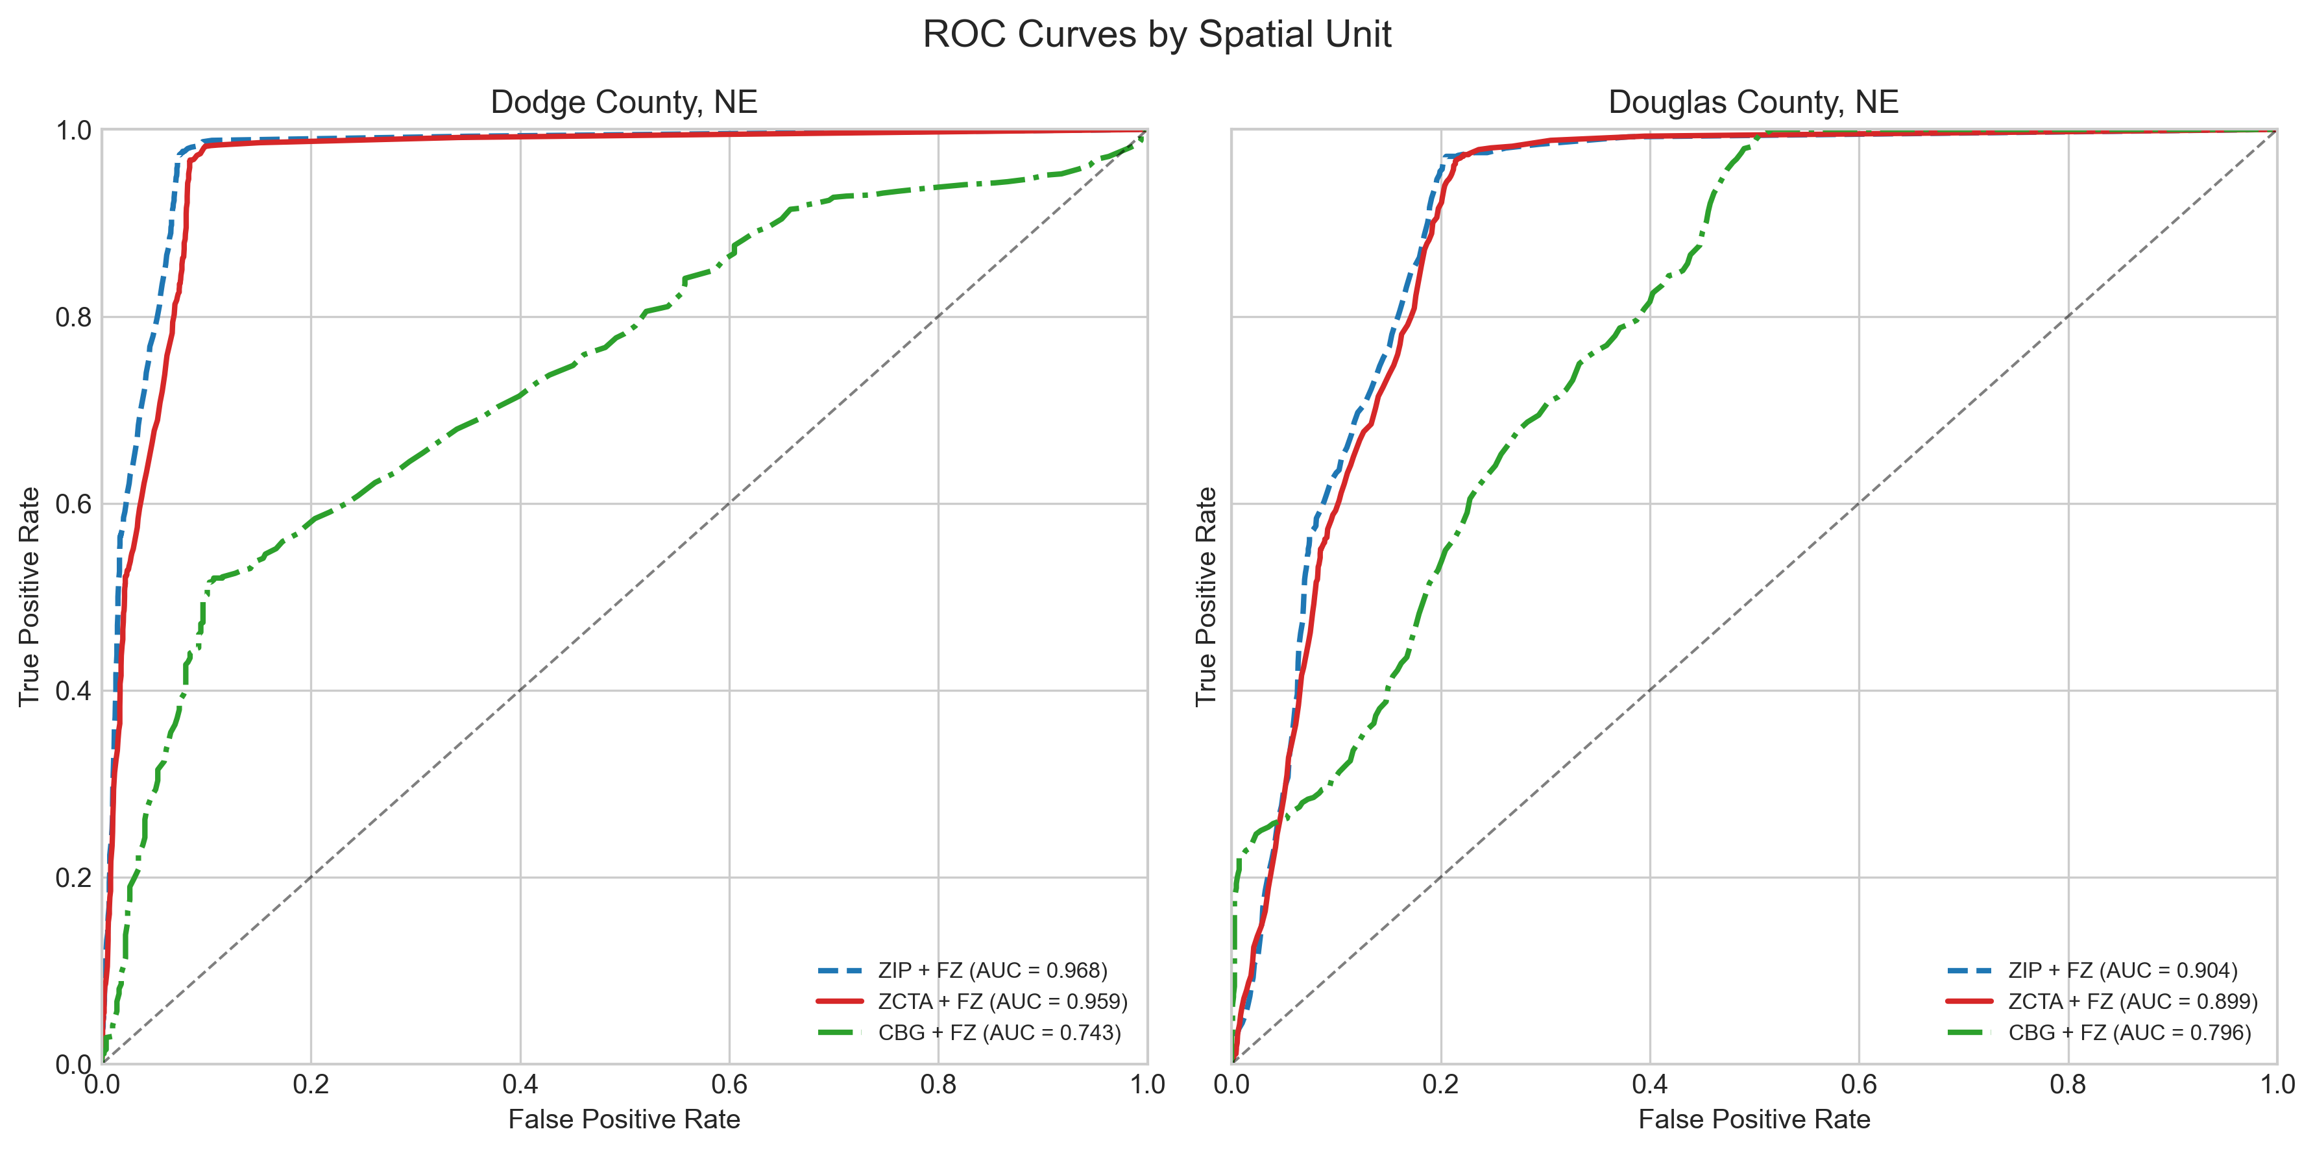
Figure 1: Receiver operating characteristic curves comparing baseline and sensitivity variants in Dodge and Douglas Counties; higher curves indicate stronger discrimination.

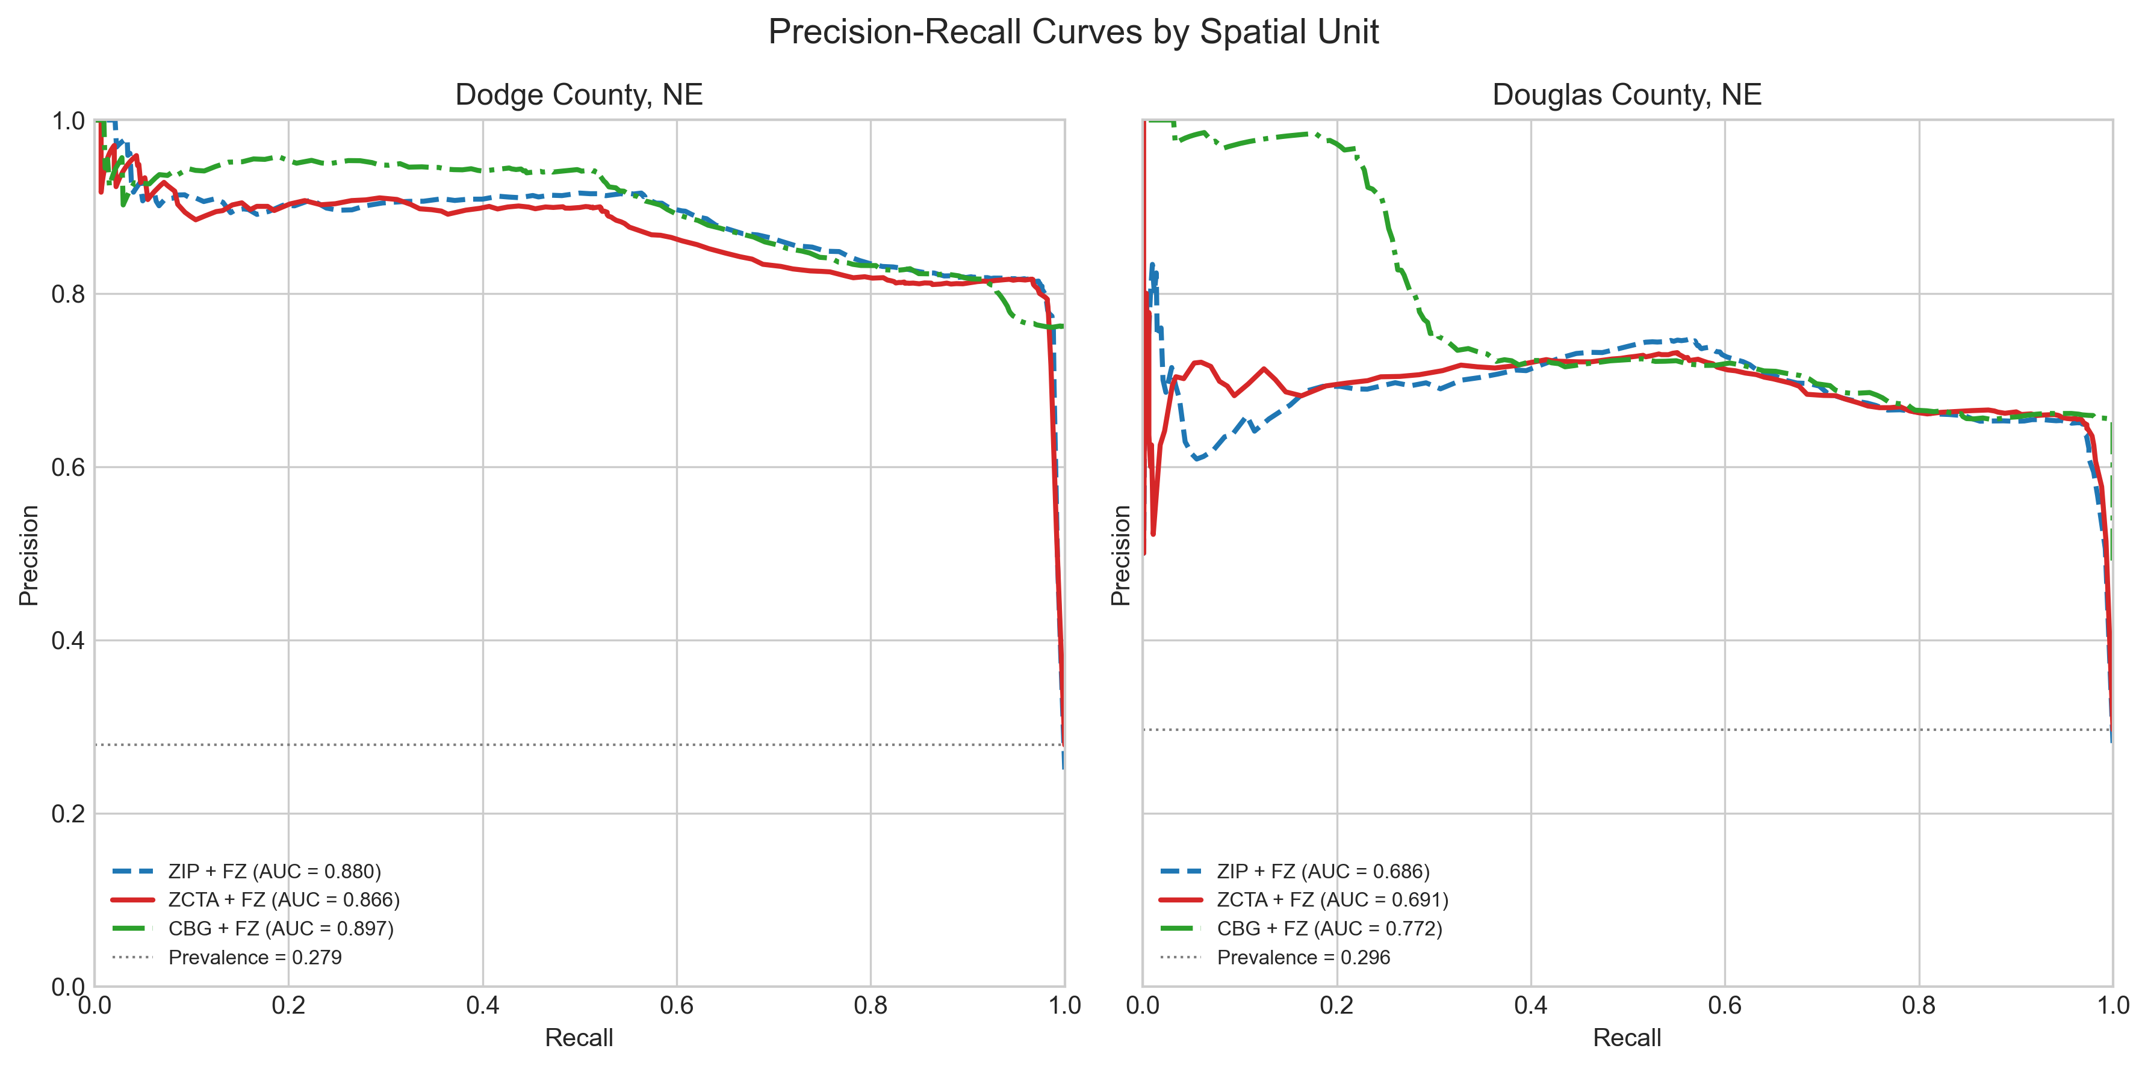
Figure 2: Precision–recall curves comparing baseline and sensitivity variants in Dodge and Douglas Counties; curves nearer the upper-right indicate better precision at a given recall.

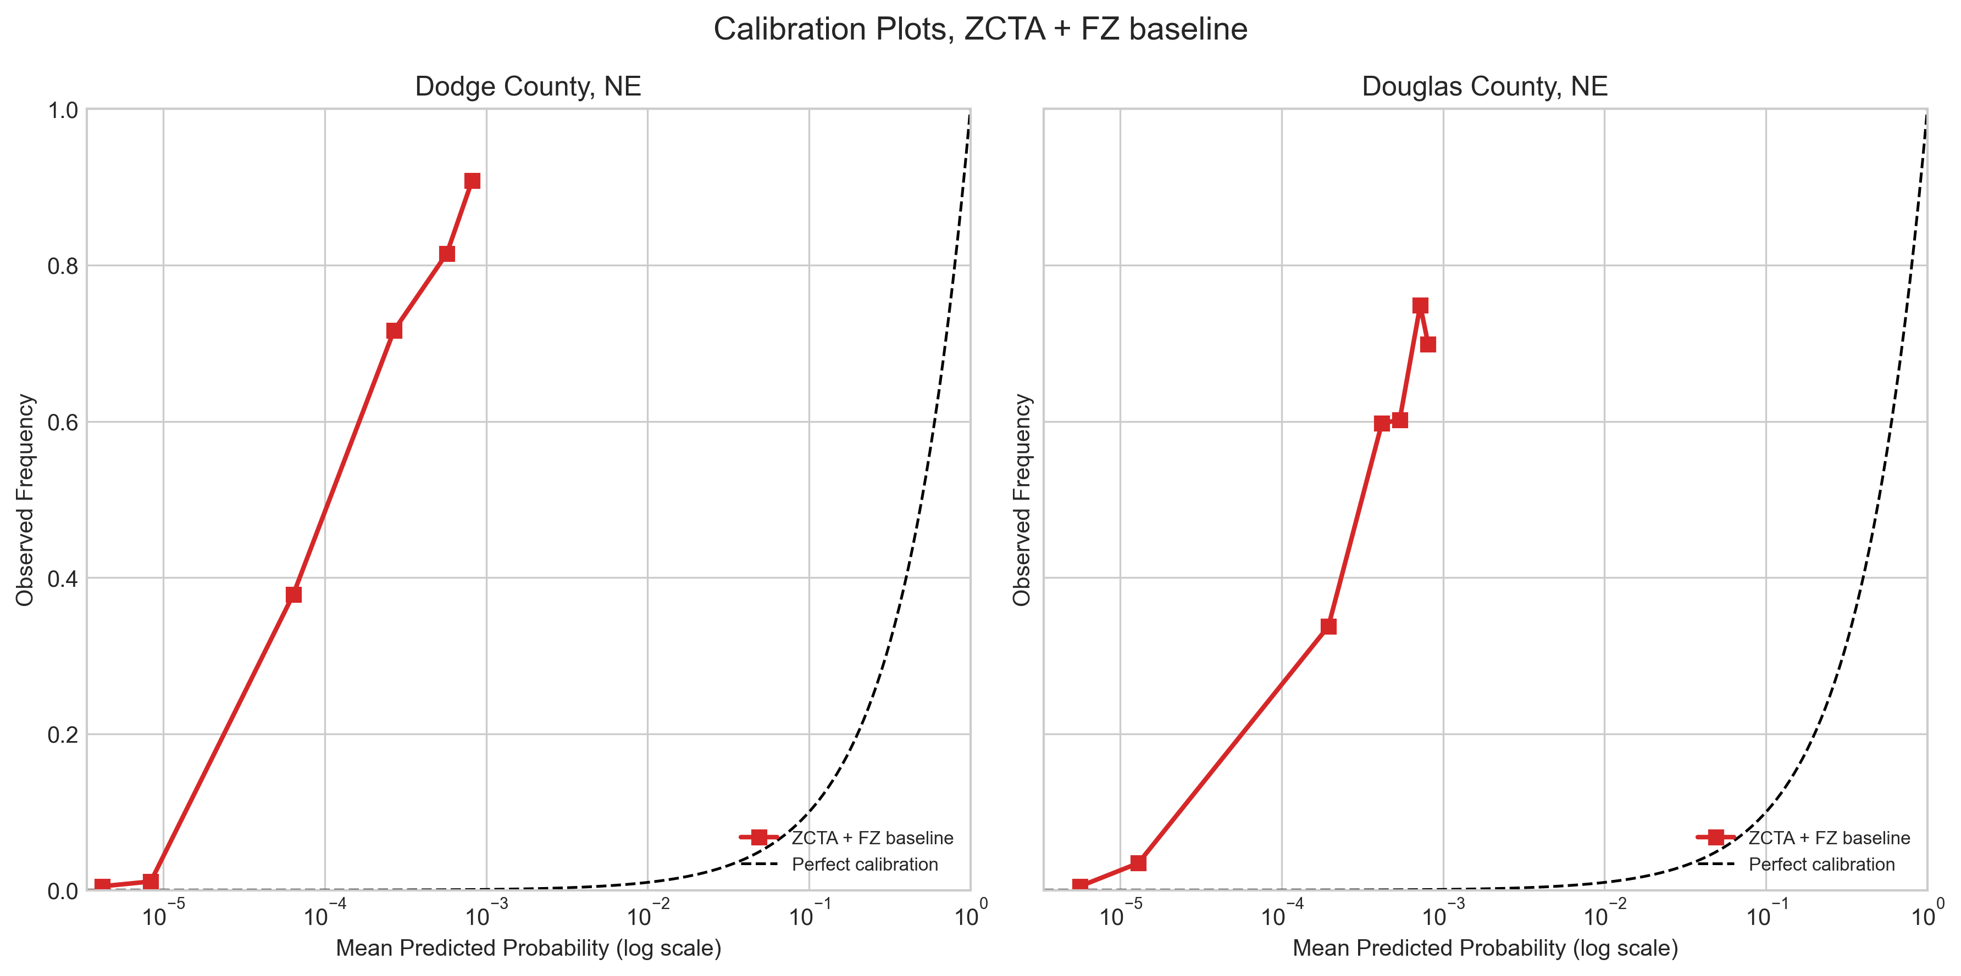
Figure 3: Calibration plots for the baseline model using decile bins with a log-scaled x-axis to emphasize low predicted probabilities; departures from perfect calibration indicate over- or underestimation.

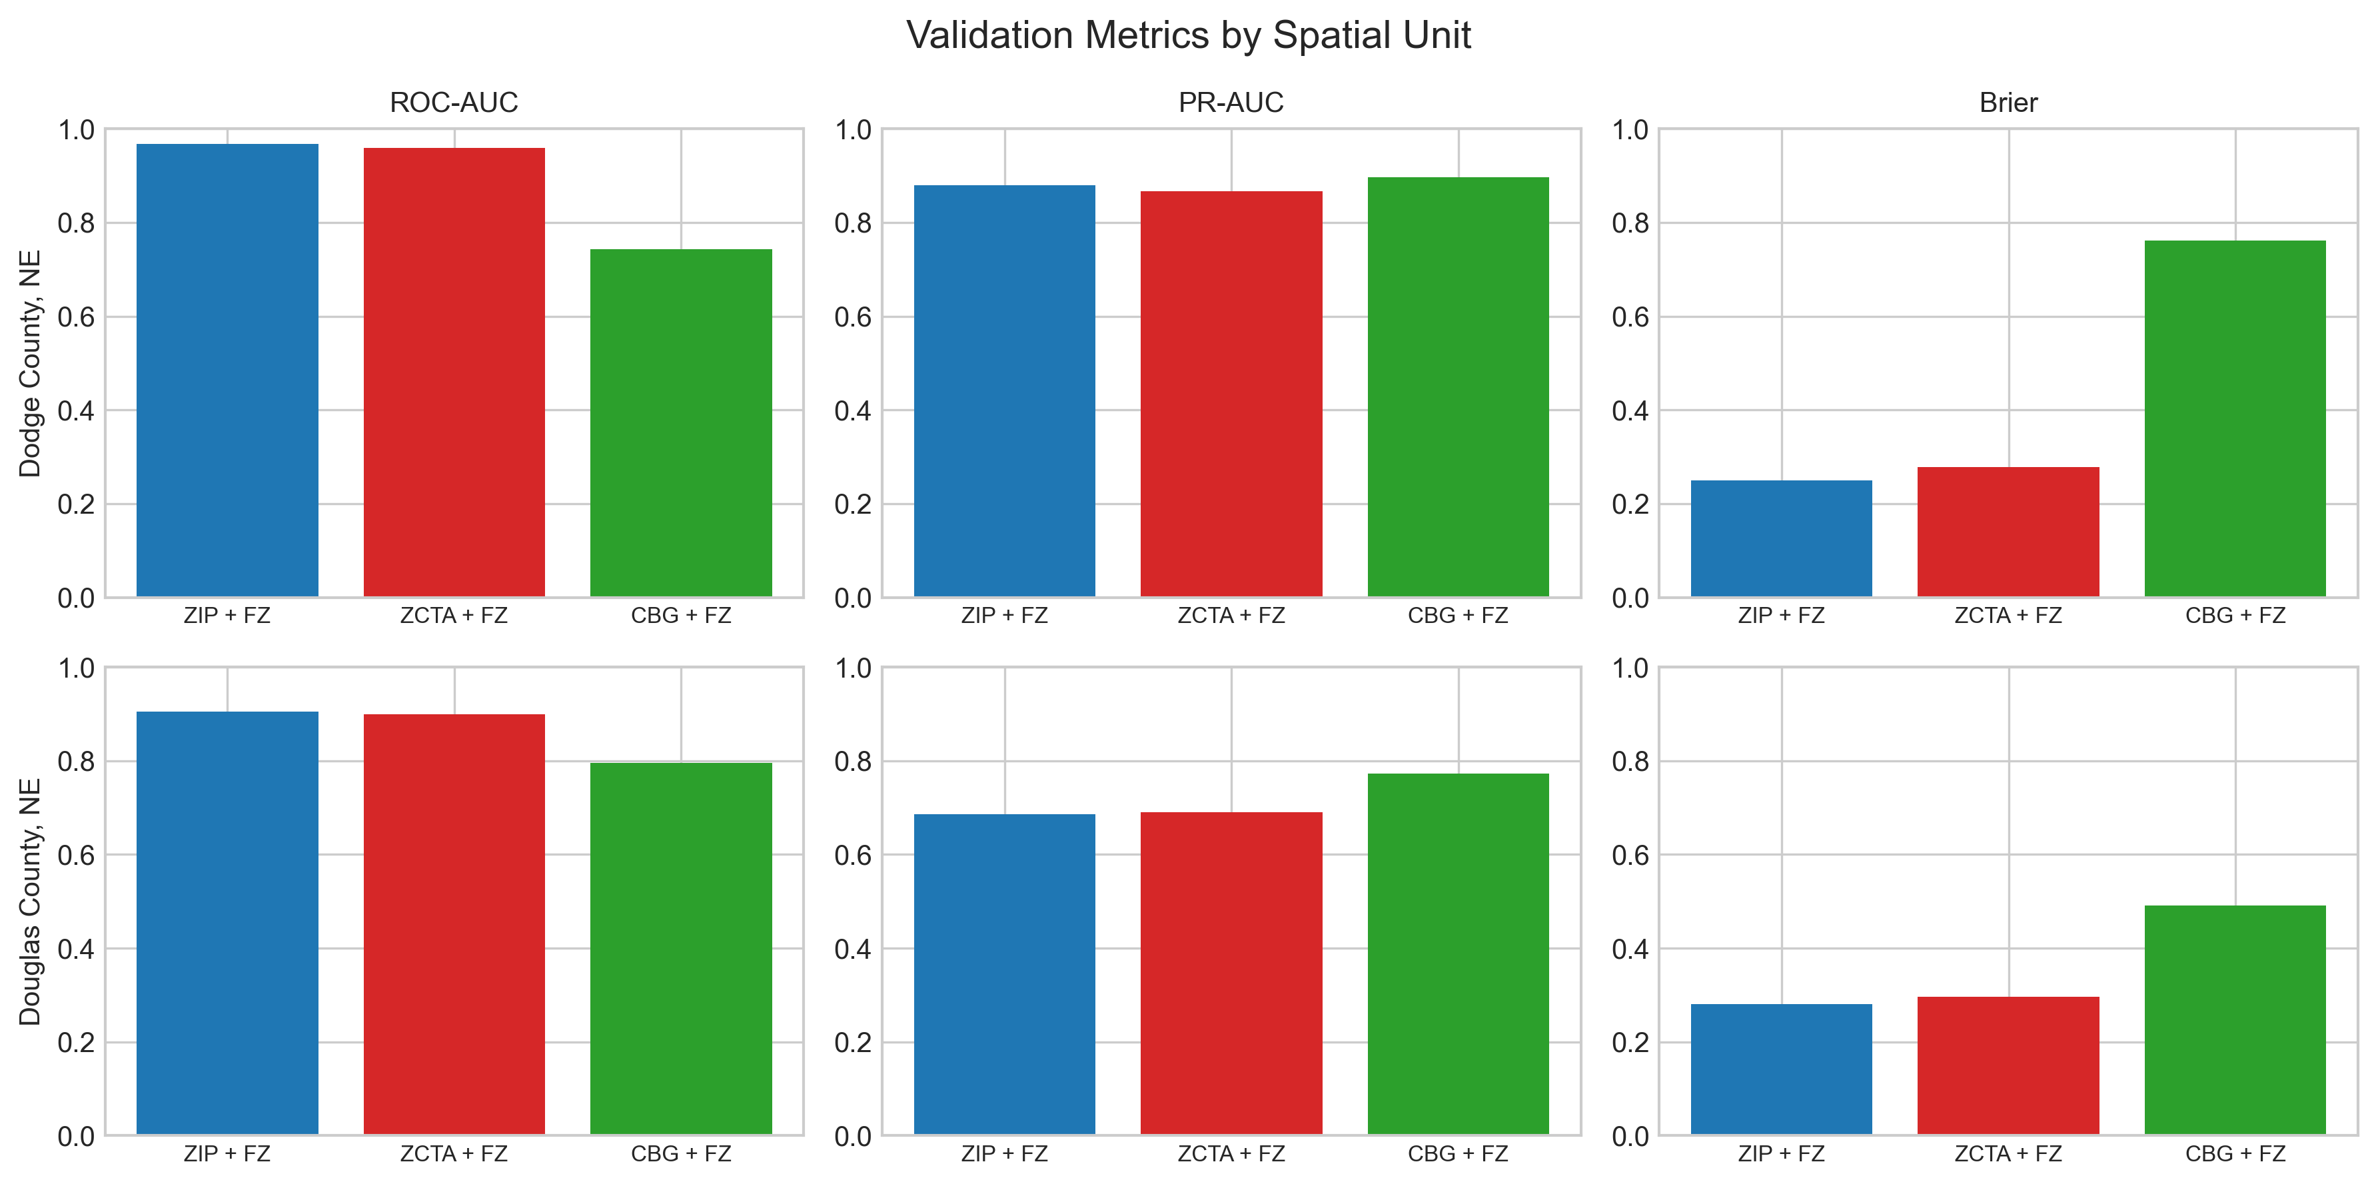
Figure 4: ROC-AUC, PR-AUC, and Brier score comparisons across spatial-unit variants in Dodge and Douglas Counties; higher ROC/PR and lower Brier indicate better performance.

4.2 Spatial Likelihood Surfaces
Figure Figure 5 maps county-level hex aggregations of bootstrap draw counts for Dodge County with the inundation footprint overlay, and Figure Figure 6 provides the corresponding view for Douglas County. Figure Figure 7 zooms to a high-frequency area in Dodge County to show building-footprint detail relative to the inundation footprint, and Figure Figure 8 provides the same building-level view for Douglas County. Together these views emphasize spatial clustering along mapped floodplains and channel-adjacent corridors.
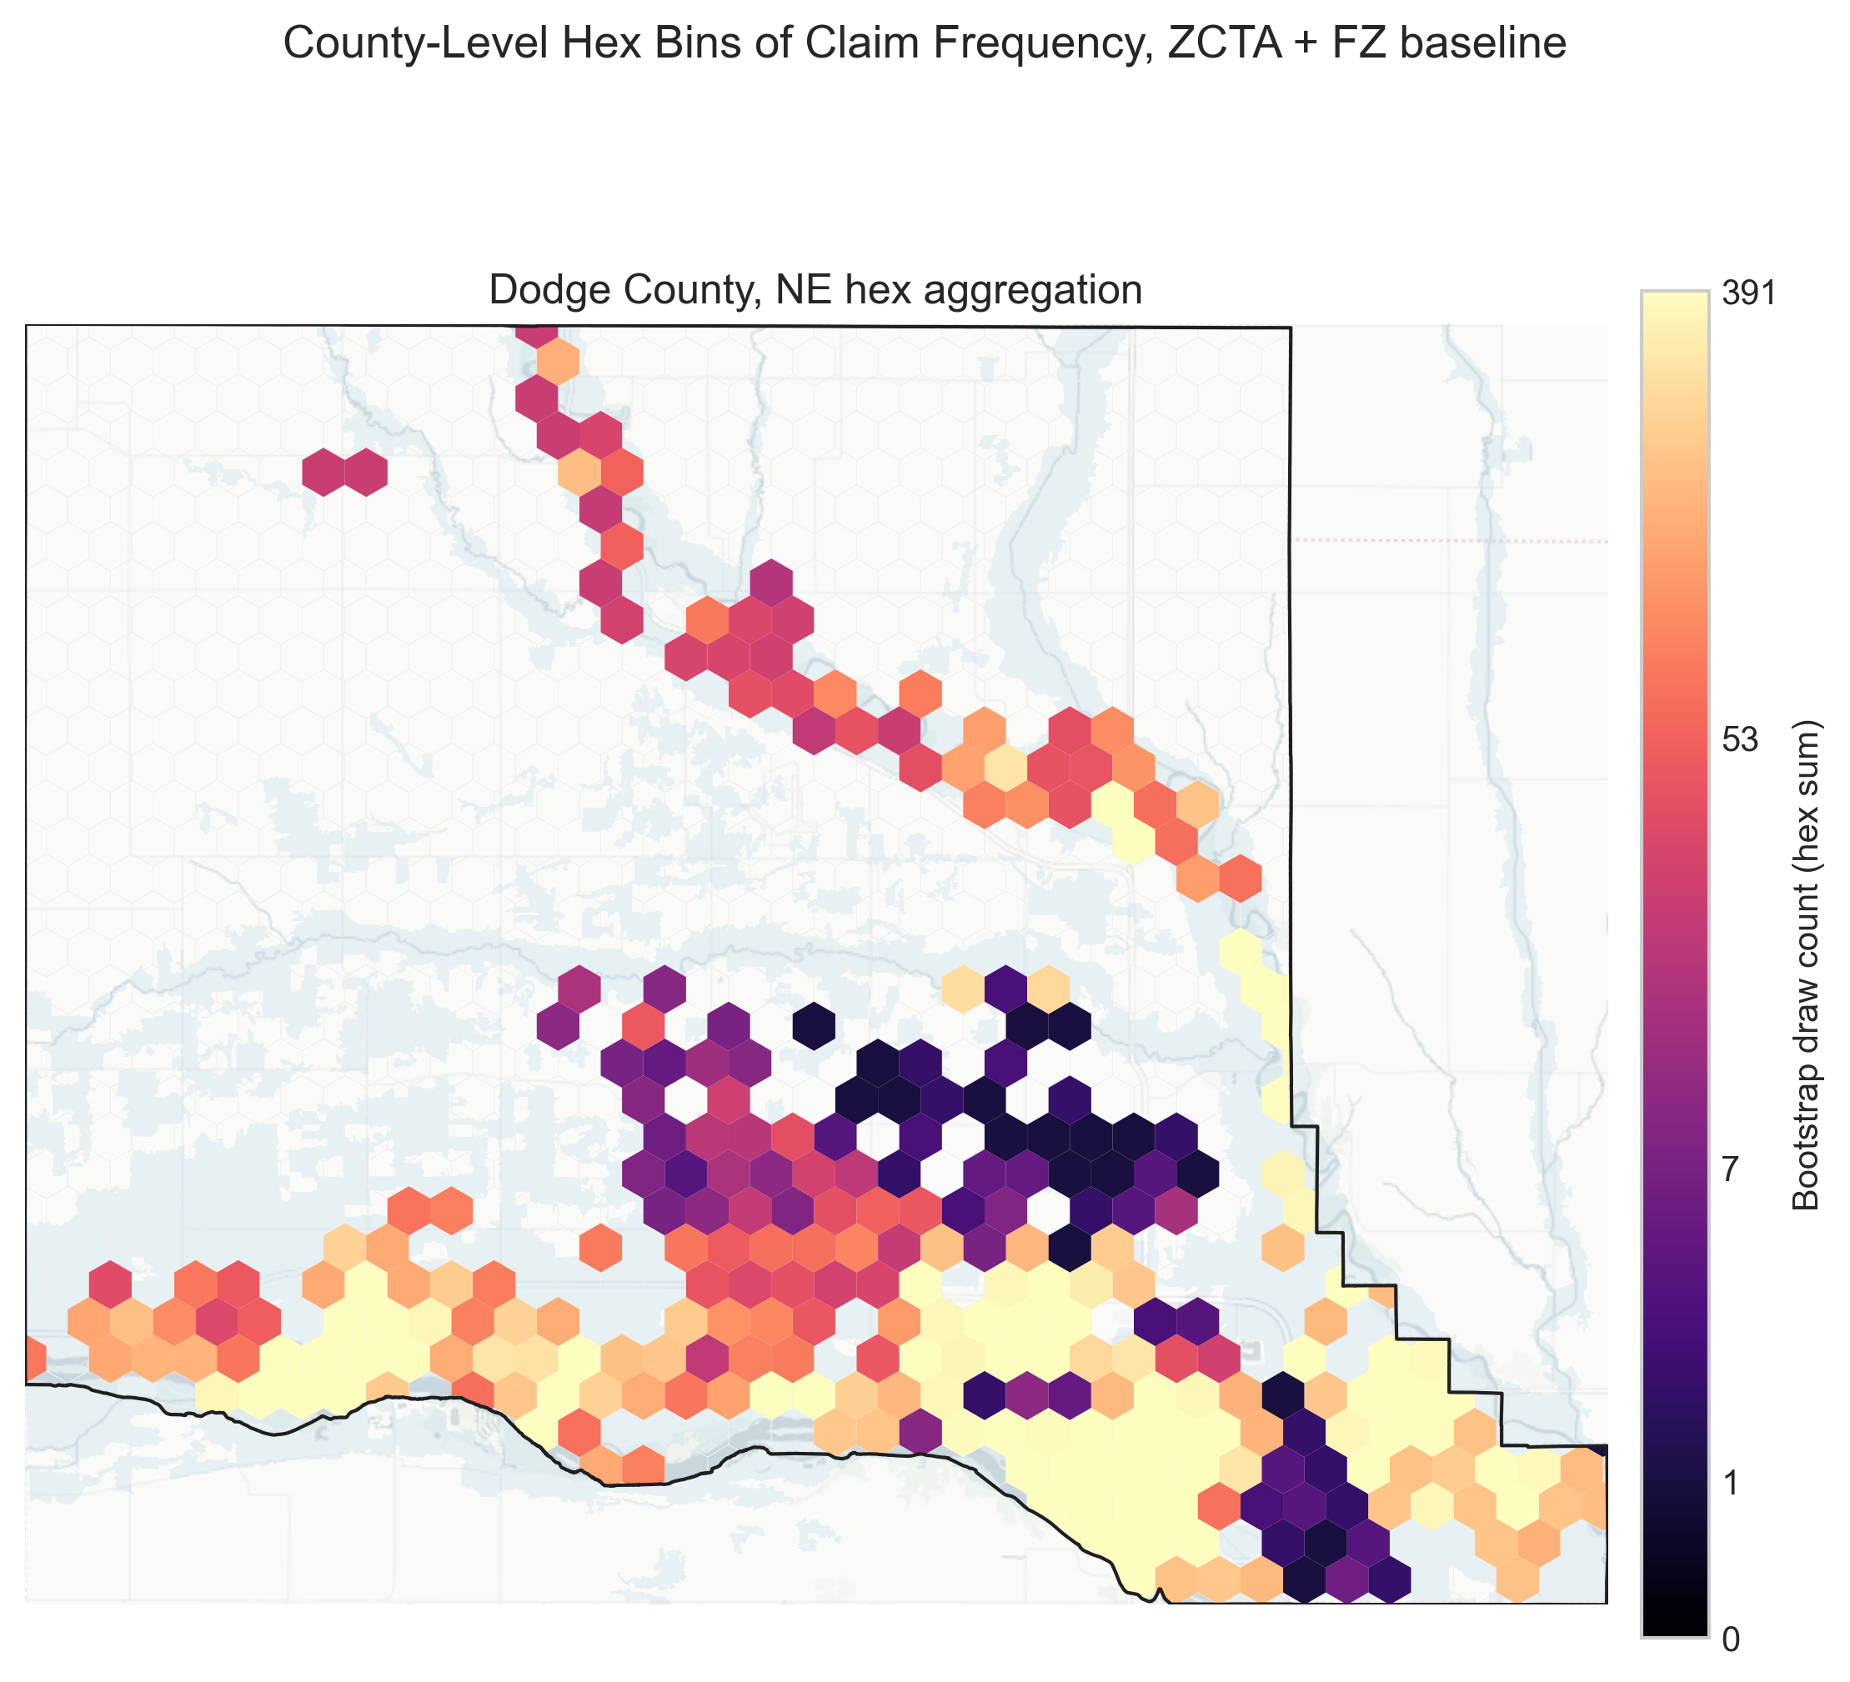
Figure 5: County-level hex aggregation of bootstrapped draw counts for Dodge County with the inundation footprint overlay; hex shading reflects aggregated draw intensity.

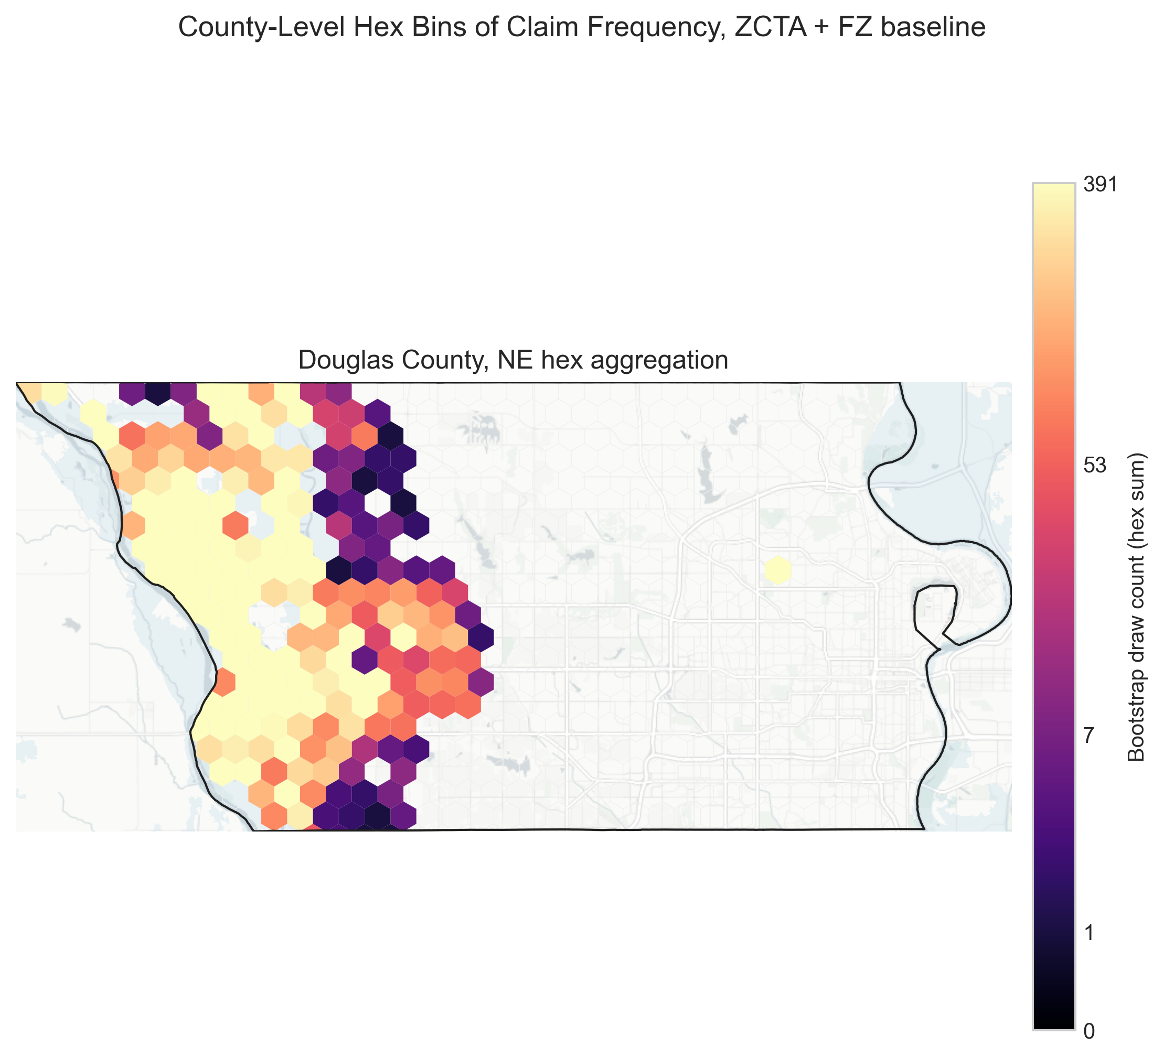
Figure 6: County-level hex aggregation of bootstrapped draw counts for Douglas County with the inundation footprint overlay; hex shading reflects aggregated draw intensity.

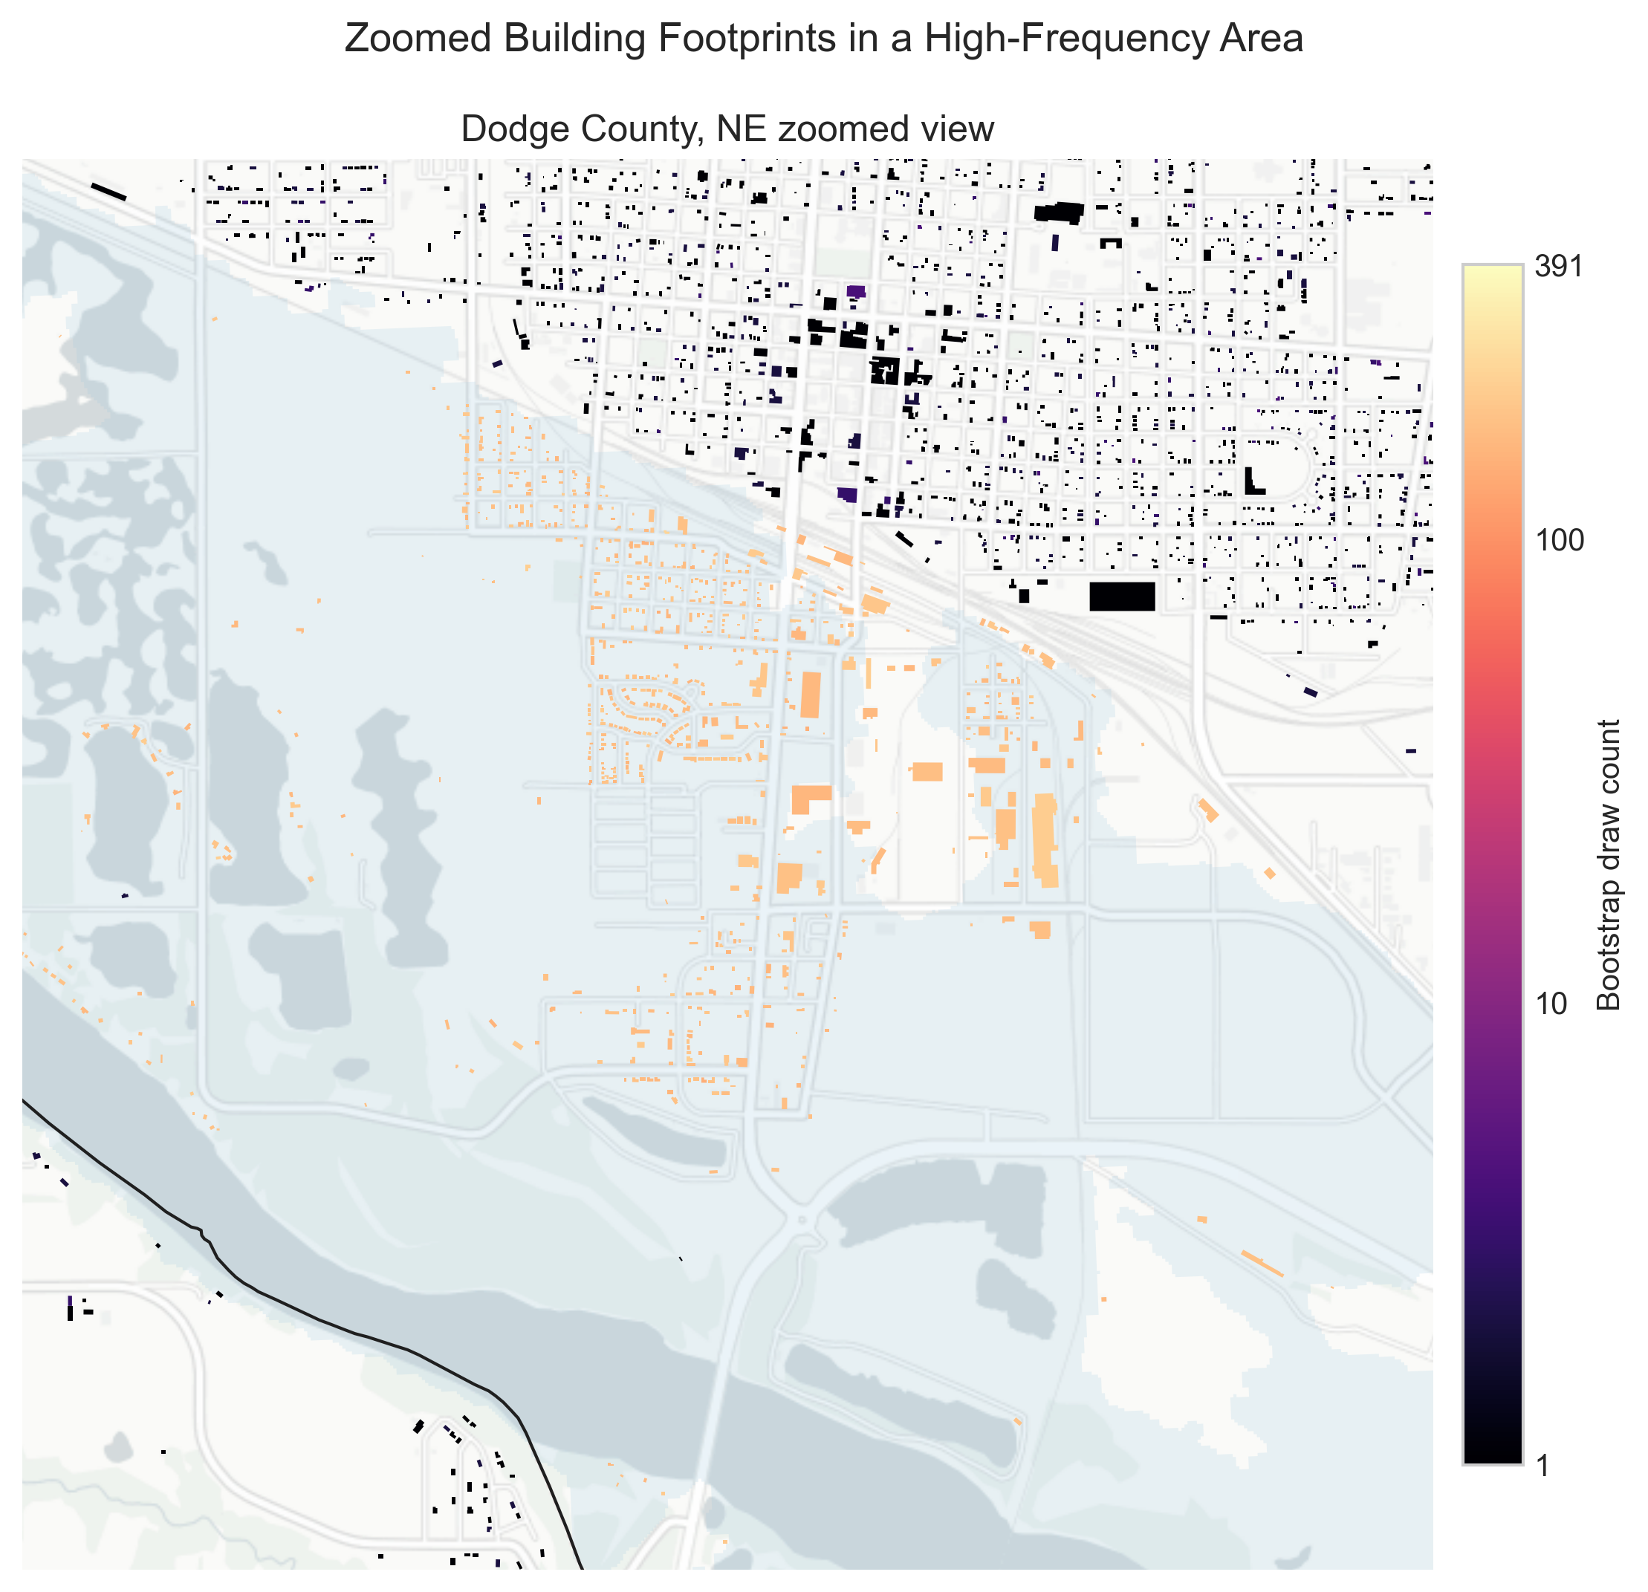
Figure 7: Zoomed building-footprint detail in a high-frequency area of Dodge County with the inundation footprint overlay, showing fine-scale clustering of draw counts.

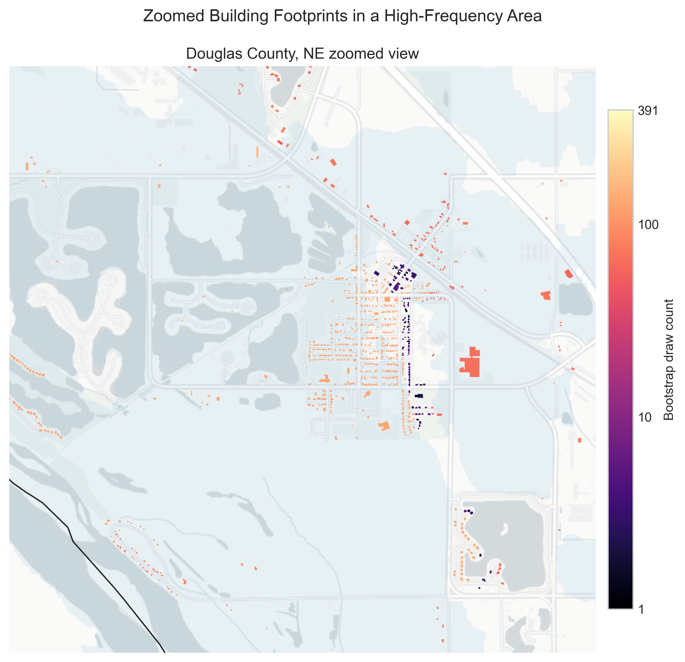
Figure 8: Zoomed building-footprint detail in a high-frequency area of Douglas County with the inundation footprint overlay, showing fine-scale clustering of draw counts.

4.3 Spatial-Unit Sensitivity
Table Table 3 compares spatial-unit choices while holding other filters constant. ZCTA performs comparably to ZIP and avoids temporal instability in ZIP boundaries. Census block groups increase precision–recall in some cases but reduce ROC-AUC and calibration, indicating a narrower candidate pool that can over-concentrate probabilities.
Table 3: Spatial-Unit Sensitivity Results
County | Variant | Matched claims | ROC-AUC | PR-AUC | Brier
Dodge | ZIP + FZ | 239 | 0.968 | 0.880 | 0.250
Dodge | ZCTA + FZ | 239 | 0.959 | 0.866 | 0.278
Dodge | CBG + FZ | 231 | 0.743 | 0.897 | 0.761
Douglas | ZIP + FZ | 178 | 0.904 | 0.686 | 0.281
Douglas | ZCTA + FZ | 178 | 0.899 | 0.691 | 0.296
Douglas | CBG + FZ | 176 | 0.796 | 0.772 | 0.491

4.4 Latitude/Longitude and Construction-Year Sensitivity
OpenFEMA latitude/longitude fields are rounded to 0.1 degrees and often fall outside county boundaries (5 of 240 Dodge claims; 44 of 183 Douglas claims). When used as a strict filter, discrimination declines in Douglas (ROC-AUC 0.870). A weighted approach that down-weights distant candidates performs comparably to the ZCTA baseline (ROC-AUC 0.969 in Dodge; 0.911 in Douglas), but does not improve calibration enough to justify inclusion in the baseline.
Construction-year matching is also sensitive to data coverage. Exact-year matching substantially reduces performance (ROC-AUC 0.629 Dodge; 0.693 Douglas), while a +/-5-year tolerance yields performance comparable to baseline (ROC-AUC 0.963 Dodge; 0.904 Douglas). Given incomplete year coverage in Dodge County parcel data, construction year is retained as a sensitivity test rather than a core constraint.

4.5 Topographic and SFHA-Distance Filters
We evaluate two additional covariates to improve matches outside mapped floodplains: a slope threshold (<=2 degrees) derived from 3DEP elevation and a distance-to-SFHA threshold (<=500 m) applied only to Zone X claims. Table Table 4 shows that slope filtering modestly improves discrimination and precision–recall in both counties, while the SFHA-distance filter yields limited or mixed changes in aggregate metrics.
Table 4: Additional Covariate Sensitivity Results
County | Variant | Matched claims | ROC-AUC | PR-AUC | Brier
Dodge | ZIP + FZ | 239 | 0.968 | 0.880 | 0.250
Dodge | ZIP + FZ + slope <= 2° | 239 | 0.969 | 0.889 | 0.244
Dodge | ZIP + FZ + dist <= 500 m (Zone X) | 239 | 0.954 | 0.880 | 0.333
Douglas | ZIP + FZ | 178 | 0.904 | 0.686 | 0.281
Douglas | ZIP + FZ + slope <= 2° | 178 | 0.926 | 0.768 | 0.324
Douglas | ZIP + FZ + dist <= 500 m (Zone X) | 178 | 0.892 | 0.684 | 0.302

4.6 Loss-Size Stratification
To assess sensitivity to loss-size heterogeneity, we stratify claims by total payment below the median, between the median and P90, and above P90. Table Table 5 shows that high-loss strata are more variable, especially in Douglas County, where the highest-payment group is small and discrimination deteriorates.
Table 5: Loss-Size Stratification Results
County | Stratum | Claims | ROC-AUC | PR-AUC | Brier
Dodge | <= median | 120 | 0.950 | 0.871 | 0.374
Dodge | median–P90 | 96 | 0.923 | 0.900 | 0.506
Dodge | > P90 | 24 | 0.978 | 0.943 | 0.297
Douglas | <= median | 92 | 0.871 | 0.709 | 0.362
Douglas | median–P90 | 72 | 0.859 | 0.724 | 0.400
Douglas | > P90 | 19 | 0.371 | 0.565 | 0.648

4.7 External Validation
We aggregate building-level likelihoods to ZIPs and compare them to FEMA Housing Assistance Owners totals for disaster 4420 (2019). Table Table 6 reports Pearson and Spearman correlations with total approved IHP amounts and approved counts, reporting correlations when ZIP overlap is at least four. Dodge County and Douglas County meet this threshold in 2019 (Douglas sits at the minimum), so those correlations should be interpreted cautiously; with only a handful of ZIPs, rank correlations are unstable.
Table 6: FEMA Housing Assistance Validation (ZIP aggregates)
Event | County | ZIPs | Pearson (IHP total) | Spearman (IHP total) | Pearson (approved count) | Spearman (approved count)
2019 Midwest flood | Dodge | 7 | 0.991 | 0.964 | 0.997 | 0.937
2019 Midwest flood | Douglas | 4 | 0.962 | 1.000 | 0.958 | 1.000

Note: Douglas 2019 correlations are based on four ZIPs and should be interpreted cautiously.

4.8 Policy vs. Claim Distributions
Policy-based bootstraps provide a coverage benchmark for the claim-based likelihoods. Table Table 7 shows that policy distributions are more diffuse than claim distributions, reflecting partial insurance penetration. In Dodge County, the policy and claim distributions differ significantly; KS = 0.346 with $p≈0$, but they are positively correlated across buildings, Pearson $r=0.878$ with $n=5,398$. In Douglas County, distributions differ sharply; KS = 0.909 with $p≈0$, yet they retain strong rank correlation, Pearson $r=0.949$ with $n=3,535$. ACS ZCTA-level housing counts indicate low median uptake in both counties (median 0.011 in Dodge; 0.002 in Douglas), consistent with substantial uninsured exposure even within SFHAs.
Table 7: Policy vs. Claim Probability Distributions
County | Group | Mean | Median | P95 | P99
Dodge | Claims | 0.0001830 | 0.0000080 | 0.0008580 | 0.0009830
Dodge | Policies | 0.0000880 | 0.0000060 | 0.0004160 | 0.0004460
Douglas | Claims | 0.0002790 | 0.0000110 | 0.0008710 | 0.0009330
Douglas | Policies | 0.0000100 | 0.0000020 | 0.0000070 | 0.0003760

5. Discussion
This study demonstrates a transparent, reproducible approach for disaggregating anonymized NFIP claims to building footprints using only public data. The primary contribution is not a new matching algorithm, but a workflow that produces building-level likelihood surfaces and uncertainty diagnostics that can be integrated with flood-inundation mapping and local mitigation planning. The strong discrimination observed in both Dodge and Douglas Counties, along with high ZIP-level correlations to FEMA housing assistance totals, suggests that ZIP/flood-zone constraints capture meaningful spatial signal even when exact claim locations are unavailable.
The method serves practitioners and researchers working with publicly available data, for whom confidential NFIP coordinates are inaccessible. Although FOIA requests can yield more precise locations, such requests involve processing delays and are not routinely feasible for local governments or time-sensitive post-event analysis. In this context, disaggregated likelihood scores can support post-event assessments, micro-hotspot identification, and communication about where insured losses were concentrated. These outputs should not be interpreted as direct forecasts of future losses; rather, they offer a structured way to spatialize historical claim evidence under anonymization constraints. Loss-size stratification underscores this point: upper-tail performance is noisy, consistent with fat-tailed loss behavior that limits deterministic prediction from historical claims alone.
Several limitations warrant emphasis. NFHL flood-zone boundaries may be outdated or inconsistent with event conditions, and insurance penetration within SFHAs is well below full coverage. ZCTA boundaries are a stable proxy for ZIP codes but reflect 2022 geometry rather than 2019, introducing temporal mismatch. OpenFEMA latitude/longitude fields are coarse and can fall outside county boundaries, limiting their utility for fine-scale matching. Construction-year data are incomplete in some counties, and the primary validation relies on a remote-sensing inundation footprint; the external FEMA housing assistance validation is aggregated to ZIPs and reported only when ZIP overlap is at least four, so small ZIP counts can yield unstable correlations. Zone X claims are sparse in both counties, limiting inference about outside-floodplain performance despite the slope and distance-to-SFHA tests. Loss-size strata also become small in the upper tail, making high-loss results noisier. Repeat-claim dynamics cannot be evaluated because public claims lack persistent property identifiers across events, and uninsured loss likelihoods cannot be estimated without additional exposure data or calibrated uptake models. Finally, multi-event replication is not attempted because event-specific inundation layers and contemporaneous building-stock data are unavailable for other events; broader generalizability requires additional regions, flood types, and time-matched datasets.
Future research should extend this workflow across additional flood events and regions, incorporate covariates such as distance to water bodies, drainage infrastructure, and land-cover characteristics, and evaluate performance where repeat claims are observed. Integrating policy uptake models with disaggregation outputs would further illuminate uninsured exposure.

6. Conclusion
We present a probabilistic disaggregation workflow that maps aggregated NFIP claims to building footprints while preserving privacy. Using March 2019 flooding in Nebraska, the ZCTA+flood-zone baseline performs strongly in both Dodge and Douglas Counties and yields building-level likelihood surfaces suitable for post-event analysis and risk communication. Slope and distance-to-SFHA filters provide additional covariate checks, and loss-size stratification highlights greater variability in the upper tail. A ZIP-level comparison to FEMA housing assistance totals provides external context. These results support the use of public NFIP data for spatially explicit loss assessment and provide a foundation for broader multi-region validation.

Data and Code Availability
Code, derived outputs, and documentation are available at https://github.com/jrandre2/NFIP-Disaggregation-CENTAUR. All input datasets are publicly available from OpenFEMA, FEMA NFHL, USGS 3DEP, and the U.S. Census Bureau; Nebraska parcel data are sourced from statewide assessor records. The FEMA Housing Assistance Owners dataset used for external validation is available at https://www.fema.gov/openfema-data-page/housing-assistance-owners.

References
Armal, S., Porter, J. R., Lingle, B., Chu, Z., Marston, M. L., & Wing, O. E. J. (2020). Assessing property level economic impacts of climate in the US, new insights and evidence from a comprehensive flood risk assessment tool. Climate, 8(10), 116. https://doi.org/10.3390/cli8100116
Blessing, R., Sebastian, A., & Brody, S. D. (2017). Flood risk delineation in the united states: How much loss are we capturing? Natural Hazards Review, 18(3), 04017002. https://doi.org/10.1061/(ASCE)NH.1527-6996.0000242
Bradley, J. R., Wikle, C. K., & Holan, S. H. (2016). Bayesian spatial change of support for count-valued survey data. Journal of the American Statistical Association, 111(514), 472–487. https://doi.org/10.1080/01621459.2015.1117471
Breiman, L. (1996). Bagging predictors. Machine Learning, 24(2), 123–140. https://doi.org/10.1007/BF00058655
Brody, S. D., Blessing, R., Sebastian, A., & Bedient, P. B. (2014). Examining the impact of land-use/land-cover characteristics on flood losses. Journal of Environmental Planning and Management, 57(8), 1252–1265. https://doi.org/10.1080/09640568.2013.802228
Brody, S. D., Zahran, S., Highfield, W. E., Bernhardt, S. P., & Vedlitz, A. (2009). Policy learning for flood mitigation: A longitudinal assessment of the community rating system in florida. Risk Analysis, 29(6), 912–929. https://doi.org/10.1111/j.1539-6924.2009.01210.x
Brody, S. D., Zahran, S., Highfield, W. E., Grover, H., & Vedlitz, A. (2008). Identifying the impact of the built environment on flood damage in texas. Disasters, 32(1), 1–18. https://doi.org/10.1111/j.1467-7717.2007.01036.x
Comber, A., & Zeng, W. (2019). Spatial interpolation using ancillary data: A combined quantitative and qualitative framework. ISPRS International Journal of Geo-Information, 8(7), 303. https://doi.org/10.3390/ijgi8070303
Congressional Research Service. (2019). 2019 midwest flooding: FEMA and other federal programs and resources (IN11084). Congressional Research Service. https://crsreports.congress.gov/product/pdf/IN/IN11084
Custer, R., & Nishijima, K. (2018). Probabilistic disaggregation of a spatial portfolio of exposure for natural-hazard risk assessment. Georisk: Assessment and Management of Risk for Engineered Systems and Geohazards, 12(1), 1–13. https://doi.org/10.1080/17499518.2017.1371761
Davison, A. C., & Hinkley, D. V. (1997). Bootstrap methods and their application. Cambridge University Press.
Dottori, F., Figueiredo, R., Martina, M. L., Molinari, D., & Scorzini, A. R. (2016). INSYDE: A synthetic, probabilistic flood-damage model based on explicit cost analysis. Natural Hazards and Earth System Sciences, 16(12), 2577–2591. https://doi.org/10.5194/nhess-16-2577-2016
Drew, L., Kaplan, A., & Breckheimer, I. (2025). A bayesian record linkage approach to applications in tree demography using overlapping LiDAR scans. The Annals of Applied Statistics, 19(3), 1–26. https://doi.org/10.1214/25-AOAS2061
Efron, B. (1979). Bootstrap methods: Another look at the jackknife. The Annals of Statistics, 7(1), 1–26. https://doi.org/10.1214/aos/1176344552
Efron, B., & Tibshirani, R. J. (1993). An introduction to the bootstrap. Chapman; Hall.
Eicher, C., & Brewer, C. A. (2001). A revised dasymetric method for spatial allocation. International Journal of Geographical Information Science, 15(7), 639–659. https://doi.org/10.1080/13658810110061154
Enamorado, T., Fifield, B., & Imai, K. (2019). Using a probabilistic model to assist merging of large-scale administrative records. American Political Science Review, 113(2), 353–371. https://doi.org/10.1017/S0003055418000783
Federal Emergency Management Agency. (2024a). National flood hazard layer (NFHL). https://www.fema.gov/flood-maps/national-flood-hazard-layer.
Federal Emergency Management Agency. (2024b). OpenFEMA dataset: FIMA NFIP redacted claims. https://www.fema.gov/openfema-data-page/fima-nfip-redacted-claims.
Federal Emergency Management Agency. (2024c). OpenFEMA dataset: FimaNfipClaims. https://www.fema.gov/openfema-data-page/fima-nfip-claims.
Federal Emergency Management Agency. (2024d). OpenFEMA dataset: FimaNfipPolicies. https://www.fema.gov/openfema-data-page/fima-nfip-policies.
Federal Emergency Management Agency. (2024e). OpenFEMA dataset: Housing assistance owners. https://www.fema.gov/openfema-data-page/housing-assistance-owners.
Federal Emergency Management Agency. (2025). OpenFEMA dataset: FIMA NFIP redacted claims - v2. https://www.fema.gov/openfema-data-page/fima-nfip-redacted-claims-v2.
Fellegi, I. P., & Sunter, A. B. (1969). A theory for record linkage. Journal of the American Statistical Association, 64(328), 1183–1210. https://doi.org/10.1080/01621459.1969.10501049
First Street Foundation. (2023). Risk factor dataset v3: Property-level flood risk estimates for the united states. https://firststreet.org/research-library/risk-factor-methodology.
Fisher, P. F., & Langford, M. (1996). Modeling sensitivity to accuracy in classified imagery: A study of areal interpolation by dasymetric mapping. The Professional Geographer, 48(3), 299–309. https://doi.org/10.1111/j.0033-0124.1996.00299.x
Flowerdew, R., & Green, M. (1994). Are weights the solution to areal interpolation problems? The Professional Geographer, 46(3), 272–280. https://doi.org/10.1111/j.0033-0124.1994.00272.x
Fortini, M., Liseo, B., Scanu, M., & Torelli, N. (2001). On bayesian record linkage. Research in Official Statistics, 4(1), 185–198.
Goodchild, M. F., Anselin, L., & Deichmann, U. (1993). A framework for the areal interpolation of socioeconomic data. Environment and Planning A, 25(3), 383–397. https://doi.org/10.1068/a250383
Goodchild, M. F., & Lam, N. S.-N. (1980). Areal interpolation: A variant of the traditional spatial problem. Geo-Processing, 1, 297–312.
Herzog, T. N., Scheuren, F. J., & Winkler, W. E. (2007). Data quality and record linkage techniques. Springer.
Heuvelink, G. B. M. (1998). Error propagation in environmental modelling with GIS. Taylor; Francis.
Highfield, W. E., Norman, S. A., & Brody, S. D. (2013). Examining the 100-year floodplain as a metric of risk, loss, and household adjustment. Risk Analysis, 33(2), 186–191. https://doi.org/10.1111/j.1539-6924.2012.01840.x
Jaro, M. A. (1989). Advances in record-linkage methodology as applied to matching the 1985 census of tampa, florida. Journal of the American Statistical Association, 84(406), 414–420. https://doi.org/10.1080/01621459.1989.10478785
Kousky, C., & Michel-Kerjan, E. (2015). Examining flood insurance claims in the united states: Six key findings. Journal of Risk and Insurance, 82(4), 819–850. https://doi.org/10.1111/jori.12106
Kyriakidis, P. C. (2004). Areal interpolation and cokriging for areal-to-point spatial disaggregation. International Journal of Geographical Information Science, 18(2), 149–164. https://doi.org/10.1080/13658810310001629653
Langford, M., & Unwin, D. J. (1994). Generating and mapping population density surfaces within a geographical information system. The Cartographic Journal, 31(1), 21–26. https://doi.org/10.1179/000870494787073718
Larsen, M. D. (2002). Record linkage using finite mixture models. Statistics in Medicine, 21(2), 2173–2187. https://doi.org/10.1002/sim.1207
Larsen, M. D. (2005). Advances in record linkage methodology as applied to administrative data. Proceedings of the Survey Research Methods Section, American Statistical Association, 3277–3284.
Linacre, R., Lindsay, S., Manassis, T., Slade, Z., Hepworth, T., Kennedy, R., & Bond, A. (2022). Splink: Free software for probabilistic record linkage at scale. International Journal of Population Data Science, 7(3). https://doi.org/10.23889/ijpds.v7i3.1794
McGrath, H., Stephens, E., & Schumann, G. (2019). Probabilistic depth-damage curves for U.S. buildings. Water, 11(5), 1035. https://doi.org/10.3390/w11051035
Mennis, J., & Hultgren, T. (2006). Intelligent dasymetric mapping and its application to areal interpolation. Cartography and Geographic Information Science, 33(3), 179–194. https://doi.org/10.1559/152304006779077309
Michel-Kerjan, E. O. (2010). Catastrophe economics: The national flood insurance program. Journal of Economic Perspectives, 24(4), 165–186. https://doi.org/10.1257/jep.24.4.165
Michel-Kerjan, E. O., & Kousky, C. (2010). Come rain or shine: Evidence on flood-insurance purchases in florida. Journal of Risk and Insurance, 77(2), 369–397. https://doi.org/10.1111/j.1539-6975.2009.01345.x
Microsoft. (2018). US building footprints. https://github.com/microsoft/USBuildingFootprints.
National Weather Service. (2020). Summary of flood losses in the united states, 1903–2019. https://www.nws.noaa.gov/hic/summaries/.
Nebraska Department of Natural Resources. (2019). March 2019 flood inundation extent. Data provided by Nebraska Department of Natural Resources.
Patil, S., Pflugradt, N., Weinand, J. M., Stolten, D., & Kropp, J. P. (2024). A systematic review of spatial disaggregation methods for climate action planning. Energy and AI, 17, 100386. https://doi.org/10.1016/j.egyai.2024.100386
Sadinle, M. (2017). Bayesian estimation of bipartite matchings for record linkage. Journal of the American Statistical Association, 112(518), 600–612. https://doi.org/10.1080/01621459.2016.1148612
Tancredi, A., & Liseo, B. (2011). A hierarchical Bayesian approach to record linkage and population size problems. The Annals of Applied Statistics, 5(2B), 1553–1585. https://doi.org/10.1214/11-AOAS464
Tobler, W. R. (1979). Smooth pycnophylactic interpolation for geographical regions. Journal of the American Statistical Association, 74(367), 519–529. https://doi.org/10.1080/01621459.1979.10481647
U.S. Census Bureau. (2019). American community survey 5-year data. https://api.census.gov/data/2019/acs/acs5.html.
U.S. Census Bureau. (2020). TIGER/line shapefiles: Census block groups. https://www.census.gov/geographies/mapping-files/time-series/geo/tiger-line-file.html.
U.S. Census Bureau. (2022). TIGER/line shapefiles: ZIP code tabulation areas (ZCTA). https://www.census.gov/geographies/mapping-files/time-series/geo/tiger-line-file.html.
U.S. Geological Survey. (2024). 3D elevation program (3DEP) 10-meter DEM. https://www.usgs.gov/3d-elevation-program.
Wagner, K. R. H. (2022). Adaptation and adverse selection in markets for natural disaster insurance. American Economic Journal: Economic Policy, 14(3), 380–421. https://doi.org/10.1257/pol.20200378
Wing, O. E. J., Bates, P. D., Smith, A. M., Johnson, K. A., & Sampson, C. C. (2018). Estimates of present and future flood risk in the conterminous united states. Environmental Research Letters, 13(3), 034023. https://doi.org/10.1088/1748-9326/aaac65
Wing, O. E. J., Pinter, N., Bates, P. D., & Kousky, C. (2020). New insights into US flood vulnerability revealed from flood insurance big data. Nature Communications, 11, 1444. https://doi.org/10.1038/s41467-020-15264-2
Winkler, W. E. (1988). Using the EM algorithm for weight computation in the fellegi-sunter model of record linkage. Proceedings of the Section on Survey Research Methods, American Statistical Association, 667–671.
Winkler, W. E. (2000). Machine learning, information retrieval, and record linkage (RR2000/05). U.S. Census Bureau.
Wright, J. K. (1936). A method of mapping densities of population. Geographical Review, 26(1), 103–110. https://doi.org/10.2307/209784
Wu, C., & Murray, A. T. (2005). A cokriging method for estimating population density in urban areas. Computers, Environment and Urban Systems, 29(5), 558–579. https://doi.org/10.1016/j.compenvurbsys.2005.01.001
Yuan, Y., Smith, R. M., & Limp, W. F. (1997). Remodeling census population with spatial information from landsat TM imagery. Computers, Environment and Urban Systems, 21(3), 245–258. https://doi.org/10.1016/S0198-9715(97)01003-X
Zahran, S., Brody, S. D., Highfield, W. E., & Vedlitz, A. (2010). Non-linear incentives, plan design, and flood mitigation: The case of FEMA’s community rating system. Journal of Environmental Planning and Management, 53(2), 219–239. https://doi.org/10.1080/09640560903550317
Zhang, F., Chen, Y., & Yang, J. (2018). Analysis of the influence of rainfall spatial uncertainty on hydrological simulations using the bootstrap method. Atmosphere, 9(2), 71. https://doi.org/10.3390/atmos9020071

Appendix A. Likelihood Score Formulation
This appendix provides the mathematical formulation for the building-level likelihood score used in the bootstrap disaggregation.
Let $p$ index claims and $b$ index buildings. For each claim $p$, the algorithm draws one candidate building per iteration from its candidate set $S_{p}$ for a total of $n$ iterations. Let $c_{p,b}$ denote the number of times building $b$ is selected for claim $p$ across the $n$ draws. The aggregated count for building $b$ is:
Cbagg=p∈P​cp,b
where $P$ denotes the set of matched claims (claims with at least one candidate). The building-level likelihood score is then:
$$L_{b}=\frac{C_{b}^{agg}}{n×N_{\text{matched}}}$$
where $N_{\text{matched}}$ is the number of matched claims. In this study, we set $n=1000$ bootstrap iterations per claim. The resulting $L_{b}$ values are interpreted as relative evidence indices for claim association rather than formal probabilities.

