State and Local Governmental Capacity in Disaster Recovery: Evidence from CDBG-DR
Kai-Fa Lu ¹, Jesse Andrews ¹, Ali Nejat ¹
¹ CECREH: Center of Excellence in Capacity-building for REsilient Housing, Department of Civil, Environmental and Construction Engineering, Texas Tech University, Lubbock, TX, 79409, USA

Abstract:
As disaster recovery programs at state and local governments have expanded in scale, duration, and administrative complexity, understanding how governmental capacity shapes recovery outcomes has become an increasingly critical policy issue. This study examines variation in the capacity of U.S. state agencies and local governments to manage Community Development Block Grant-Disaster Recovery (CDBG-DR) funds and assesses how these differences influence recovery performance and timeliness. Using quarterly performance reporting data from the U.S. Department of Housing and Urban Development (HUD) covering federally declared disasters from 2003 to 2023 across 31 state agencies and 546 counties, we used covariance-based Structural Equation Modeling (SEM) to estimate latent constructs of governmental capacity – distinguishing between administrative resources and burden capacity – and recovery outcomes. The results demonstrate that governmental capacity is inherently multidimensional, with administrative burden capacity – capturing workload pressure per staff – emerging as the more influential determinant of both recovery performance and timeliness. Jurisdictions with lower administrative workload achieved faster and more effective recovery, while administrative resources alone were insufficient predictors and may reflect underlying program complexity. Social vulnerability further conditioned recovery dynamics, with minority status & language dimensions affecting performance, and socioeconomic and household composition & disability dimensions influencing timeliness. Additionally, spatial analyses revealed pronounced geographic disparities in recovery governance, with persistent constraints concentrated along the Gulf Coast and in the southern United States. These regions were characterized by the convergence of high disaster exposure, elevated social vulnerability, and limited administrative capacity. To capture these patterns, we introduced recovery implementation and performance gap measures, along with a recovery governance risk index that identified priority jurisdictions where recovery systems were most constrained. Our findings highlight the importance of workload-sensitive capacity and suggest that improving disaster recovery outcomes requires aligning administrative capacity with workload demands and local vulnerability conditions, rather than focusing solely on increasing resources.
Keywords: Disaster recovery; Governmental capacity; Administrative burden; Social vulnerability; Structural Equation Modeling (SEM)

1. Introduction
The effective administration of disaster recovery funds from the U.S. Department of Housing and Urban Development (HUD) across affected jurisdictions is central to advancing equitable and timely community recovery. In the United States, the Community Development Block Grant-Disaster Recovery (CDBG-DR) program has become one of the largest and most flexible sources of long-term recovery assistance following major disaster declarations (Costa et al., 2026). Yet despite its national importance, the pace at which grantees (e.g., states, counties, and cities) obligate, disburse, and expend CDBG-DR funds varies markedly across jurisdictions and disaster events. Slow or inconsistent financial performance has been repeatedly linked to delayed housing reconstruction, prolonged displacement, uneven economic recovery, and persistent inequities for low-income households and historically marginalized communities (Rouhanizadeh et al., 2020 & 2022).
A key factor influencing financial performance and program outcomes is the capacity of grantees to administer CDBG-DR funds (Miao et al., 2025). However, governmental capacity in disaster recovery is inherently difficult to measure directly. Prior studies have often relied on single-period financial indicators (Cevik & Huang, 2018; Dzigbede et al., 2020; Lindsay, 2014) or case-based assessments (Hamideh, 2015; Rosas et al., 2021), which limit the ability to compare capacity across time, jurisdictions, and disaster contexts. The Quarterly Performance Reports (QPRs) submitted through HUD’s Disaster Recovery Grant Reporting (DRGR) system provide a valuable opportunity to develop comprehensive and comparable indicators of capacity. These reports consistently record quarterly obligated, disbursed, and expended amounts for each grantee and activity, generating rich panel data that enable systematic evaluation of financial performance and program timeliness. Nevertheless, raw financial measures alone cannot fully capture the multidimensional nature of governmental capacity in disaster recovery, which reflects the combined effects of administrative resources, administrative burden capacity, and recovery outcomes (Kusumasari et al., 2010).
Therefore, this research aims to answer the following research questions:
- How can state and local governmental capacity to administer CDBG-DR funds be conceptualized, operationalized, and empirically measured?
- How does variation in state and local governmental capacity influence disaster recovery program outcomes, and which institutional, socioeconomic, and programmatic factors shape the relationship between capacity and recovery performance?
- What are the spatial patterns of governmental capacity and disaster recovery outcomes, and which regions exhibit elevated capacity gaps, program implementation disparities, recovery performance gaps, or broader governance risks?
To address these questions, this study develops a Structural Equation Modeling (SEM) framework to conceptualize, measure, and compare state and local governmental capacity in administering CDBG-DR funds and implementing disaster recovery programs. Using quarterly data on obligations, disbursements, and expenditures across grantees and program activities, together with indicators such as administrative staffing levels, quarterly payroll, jurisdiction size, and social vulnerability, we conceptualize governmental capacity as a latent construct that reflects underlying administrative capability. This construct is assumed to be relatively stable across disaster events but varies systematically across jurisdictions. The SEM framework is used to estimate latent governmental capacity, evaluate cross-jurisdictional differences, and examine how capacity relates to disaster recovery program outcomes, as well as how key contextual factors influence this relationship. Additionally, the study analyzes spatial patterns of governmental capacity and recovery outcomes and introduces a set of diagnostic indicators, including capacity gaps, implementation gaps, performance gaps, and a governance risk index, to identify regions that face greater vulnerability to disaster impacts and may require prioritized capacity enhancement.
This approach advances literature in three important ways. First, it provides a systematic and empirically grounded method for measuring governmental capacity in disaster recovery, particularly in the administration of CDBG-DR funds and the implementation of recovery programs. Second, it establishes a comparative analytical framework to examine differences between state and local grantees and to assess how these differences are associated with variations in recovery outcomes, with particular attention to the moderating role of social vulnerability. Third, the study develops practical diagnostic indicators, such as financial ratios, administrative burden capacity measures, and governance risk index, that can be readily integrated into HUD’s monitoring (U.S. Government Accountability Office, 2019) and technical assistance processes, offering a more comprehensive understanding of how different jurisdictions respond to disaster exposure and recovery demands. These contributions clarify how administrative capacity influences financial performance and recovery outcomes and provide actionable insights to support institutional improvement and evidence-based program design.
2. Literature Review
2.1. Institutional context of CDBG-DR administration and implementation performance
CDBG-DR funding has expanded substantially over the past two decades, allocating billions of dollars in response to major hurricanes, floods, wildfires, and other disasters (Costa et al., 2026). As a block-grant program, CDBG-DR provides grantees with considerable flexibility in designing and implementing recovery programs. However, this flexibility also introduces significant administrative burden, particularly in ensuring that funds are obligated, disbursed, and expended efficiently and in compliance with federal requirements. Numerous evaluations have documented persistent delays in grant implementation, including challenges related to procurement processes, environmental reviews, and program start-up activities (Costa et al., 2026; Martín, 2018; Miao et al., 2025; U.S. Department of Housing and Urban Development, 2026). Additionally, grantees or governments vary substantially in their prior experience with disaster recovery programs, staffing capacity, and administrative procedures – factors that can significantly influence the timeliness and effectiveness of fund deployment and program implementation (Martin et al., 2022; Melendez, 2020; Van Niekerk et al., 2018).
Despite the growing scale and importance of CDBG-DR funding, relatively limited research has systematically measured grantees’ governmental capacity or examined its role in shaping fund administration and program implementation. One major challenge is the historical lack of comprehensive, structured datasets that enable consistent analysis of CDBG-DR fund deployment. Although HUD requires quarterly reporting through the DRGR system via QPRs, which document obligated, disbursed, and expended amounts by grantee, activity, and reporting period, these data have not yet been widely leveraged by auditors, HUD practitioners, or researchers to model the latent dimensions or underlying determinants of administrative capacity. Instead, prior studies have generally relied on descriptive summaries or aggregate comparisons to evaluate financial performance (Costa et al., 2026; Martín, 2018). This limitation constrains a more comprehensive understanding of how governmental capacity influences fund utilization and, ultimately, the effectiveness and performance of disaster recovery efforts.
2.2. Methodological approaches for disaster recovery administration assessments
In general, four primary approaches have been used to evaluate fund administration performance in disaster recovery. The first approach consists of descriptive and programmatic analyses. For example, the U.S. HUD and the Government Accountability Office (GAO) frequently publish summary reports that highlight variation in fund utilization rates across grantees (U.S. Government Accountability Office, 2026; U.S. Department of Housing and Urban Development, 2026). Academic and think-tank studies similarly document patterns in program launch timelines, housing completions, and expenditure trajectories (Drew, 2024). While these studies reveal substantial variation in performance, they generally do not examine the institutional mechanisms that drive differences in disaster recovery outcomes. The second approach involves regression-based and panel-data analyses. Many studies in public administration and planning apply regression or longitudinal panel models to examine how factors such as staffing levels, administrative experience, governance structure, or disaster severity influence the pace of fund implementation, recovery outcomes, and broader disaster resilience (Cutter et al., 2016; Lee, 2019; Nor, 2025). Although these approaches provide useful empirical insights, they typically treat financial indicators as directly observed outcome variables and do not account for the possibility that governmental capacity is a latent construct reflected through multiple interrelated indicators.
The third approach consists of case studies and qualitative evaluations. Qualitative research provides an in-depth understanding of administrative processes and identifies common implementation barriers, including complex procurement requirements, extensive environmental review procedures, and coordination challenges across agencies (Jordan et al., 2014; Ospina et al., 2018; Rouhanizadeh et al., 2020). These studies offer valuable contextual insights but are generally limited in their ability to support systematic comparison across jurisdictions or disasters. The fourth approach involves latent-variable methods, particularly Structural Equation Modeling (SEM). Within the broader disaster research literature, SEM has been applied to measure multidimensional constructs such as preparedness, perceived risk, institutional resilience, and adaptive capacity (Geddam & Kiran, 2024; Gendeshmin et al., 2025; Gerona & Nabe, 2026). However, applications of SEM to federal disaster recovery finance remain limited. In particular, few studies have utilized longitudinal QPR data to develop latent measures of governmental capacity in administering CDBG-DR funds. To date, no study has systematically constructed a latent representation of governmental capacity to examine its relationship with disaster recovery outcomes or to assess how contextual factors moderate the capacity-outcome relationship.
2.3. Administrative capacity in disaster recovery: Patterns, gaps, and research needs
Building on the four approaches discussed above, two consistent patterns emerge in the study of disaster recovery administration. First, there is substantial variation across grantees in how disaster recovery funds are administered (Costa et al., 2026). For example, grantees differ widely in their pace of obligations, disbursements, and expenditures, as well as in the implementation and outcomes of disaster recovery programs (Martin, 2018). Second, administrative processes strongly influence recovery timelines (Martin et al., 2019; Safapour et al., 2021). Delays often arise from procurement rules, environmental reviews, inconsistent staffing, and challenges in inter-agency coordination. Moreover, institutional capacity and social vulnerability – not merely disaster severity – play a critical role in shaping the speed and effectiveness of recovery efforts (Miao et al., 2025; Peacock et al., 2014).
Despite progress in understanding disaster recovery administration, several gaps remain. First, there is no latent, multidimensional measure of governmental capacity, as existing studies do not integrate multiple administrative indicators – such as staffing levels, resources, payroll, workload, recovery programs, and disaster events – into a unified construct. Second, cross-hazard and cross-jurisdiction comparisons are limited; few analyses systematically compare performance across disaster types or evaluate differences in administrative capacity between state and local governments. Third, the relationship between governmental capacity and disaster recovery outcomes, including the moderating effects of factors such as social vulnerability, remains insufficiently explored. Fourth, a weak operational linkage persists between research metrics and management tools. For instance, although QPR data are widely used, there are no validated diagnostic indicators that connect observed financial performance to underlying capacity metrics for HUD or grantees.
In summary, a critical need exists to model governmental capacity and conduct comparative analyses to provide a comprehensive understanding of how state and local governments manage obligated, disbursed, and expended CDBG-DR funds, particularly regarding their impact on disaster recovery performance and timeliness across jurisdictions. This study addresses this gap by constructing a latent measure of governmental capacity using existing administrative resources and QPR data, and by applying an SEM approach to evaluate the relationship between administrative capacity and disaster recovery outcomes, as well as the influence of key moderating factors. Furthermore, this study develops the capacity gap, implementation gap, performance gap, and governance risk index to analyze how different governments respond to disaster recovery following disaster events and to quantify capacity differences across jurisdictions. By integrating administrative resources, recovery outcomes, and control variables (e.g., social vulnerability and jurisdiction size) into a unified analytic framework, the study establishes a rigorous, replicable, and policy-relevant method for understanding governmental capacity in the administration of CDBG-DR funds and supporting effective disaster recovery implementation.
3. Data
3.1 Data Description and Sources
The QPR dataset was obtained from the U.S. HUD’s DRGR system and contains quarterly information on obligated, disbursed, and expended CDBG-DR funds for each grant and program activity. The dataset covers 3,148 state and local governmental entities (e.g., state agencies, authorities, counties, parishes, and municipalities) across 18 disaster events from 2001 to 2023 (U.S. Department of Housing and Urban Development, 2026). Based on these data, several performance indicators were constructed at the jurisdiction-quarter level, including the disbursed-to-obligated ratio, expended-to-disbursed ratio, and the percentage of obligated funds fully expended. Additional measures include the proportion of programs completed, the duration of grant completion, and the average program completion time for each jurisdiction. Detailed variable definitions and calculations are provided in Section 4.3.
In addition, administrative resource data were obtained from the U.S. Bureau of Labor Statistics (BLS) Quarterly Census of Employment and Wages (QCEW). Specifically, we extracted quarterly employment and payroll data associated with the North American Industry Classification System (NAICS) code 925110 (Administration of Housing Programs) at both the county and state levels (U.S. Bureau of Labor Statistics, 2026). To ensure comparability across jurisdictions, we calculated housing administration employment per 10,000 residents and payroll per 10,000 residents.
Finally, annual measures of social vulnerability were derived from the Centers for Disease Control and Prevention / Agency for Toxic Substances and Disease Registry (CDC/ATSDR) Social Vulnerability Index (SVI) database at the state and county levels. The SVI indicators include four thematic dimensions: (1) socioeconomic status, (2) household composition and disability, (3) minority status and language, and (4) housing type and transportation (CDC/ATSDR, 2026).
3.2. Data Cleaning and Preprocessing
To prepare the QPR dataset for subsequent modeling analysis, a series of systematic data cleaning procedures were implemented to standardize key geographic and organizational variables and enhance data reliability. First, the “Grantee State” variable was standardized to ensure consistent formatting across observations. State names were cleaned by removing extra whitespace and correcting inconsistent capitalization. A formatted state identifier was then generated by appending the suffix “state” (e.g., Texas state) to improve clarity and consistency in later processing steps. Second, the “Activity Responsible Org” field was normalized to reduce inconsistencies in organization names. This process included trimming leading and trailing whitespace, removing punctuation and special characters, and standardizing common abbreviations (e.g., Co. to County, Dept. to Department, Auth. to Authority). These procedures improved naming consistency and reduced potential matching errors in subsequent geographic identification.
Third, a new geographic identifier was constructed to determine the county and state associated with each “Activity Responsible Org”. The matching algorithm first searched for explicit county or parish names within organization titles and aligned them with an official county reference table (Gigasheet, 2026). When the county name was not explicitly provided, the script attempted to infer the county using a city-to-county crosswalk table (Gigasheet, 2026). This hierarchical matching approach enabled systematic derivation of geographic identifiers while minimizing arbitrary assumptions. Based on the resulting classifications, city-level entities were aggregated to the county level, while statewide departments, agencies, authorities, and non-governmental organizations were aggregated to the state-agency level.
Finally, a quality-control framework was implemented to evaluate the reliability of the inferred geographic information. Each record was categorized by match type (e.g., explicit county match, city-to-county match, unresolved) and assigned a corresponding confidence level. Observations requiring further verification were flagged using a review indicator to enable manual validation when automated matching was uncertain. This structured data cleaning process produced a standardized dataset with consistent state identifiers, normalized organization names, and verified geographic classifications, ensuring suitability for subsequent preprocessing, aggregation, and statistical modeling. Additionally, records with fewer than four quarterly observations were removed, as such limited temporal coverage provides insufficient information to reliably assess state and local governmental capacity to administer CDBG-DR funds. After applying these filtering criteria, the final analytical dataset consisted of 130,490 valid quarterly records, representing 31 state agencies and 546 counties, which were used as inputs for the subsequent SEM framework.
4. Methods: Structural Equation Modeling (SEM)
4.1. Model selection and unit of analysis
This study employs structural equation modeling (SEM) to develop a latent construct representing state and local governmental capacity and to examine its relationship with disaster recovery program outcomes. The analysis also investigates the moderating effects of the state-versus-local jurisdiction indicator, jurisdiction size, and social vulnerability on this relationship. SEM is particularly appropriate for this study because it enables both governmental capacity and recovery outcomes to be conceptualized as latent constructs measured by multiple observed indicators, while simultaneously estimating the structural relationships among these constructs. In addition, SEM allows for the assessment of moderation effects by incorporating control variables or multi-group comparisons within a unified modeling framework (Hair et al., 2021; Mueller & Hancock, 2018; Owolabi et al., 2020).
This approach is especially valuable because governmental capacity is not directly observable and must instead be inferred from measurable proxies, such as administrative resources and workload characteristics (El-Taliawi & Van Der Wal, 2019). By integrating measurement and structural components into a single analytical framework, SEM provides a rigorous method for evaluating both the validity of latent constructs and the strength of their relationships with disaster recovery performance outcomes.
Building on the SEM framework, the analysis utilizes a cross-sectional dataset consisting of 577 grantees, including 31 state agencies and 546 local governments. Each observation represents a grantee-level profile that aggregates administrative characteristics and disaster recovery performance outcomes across the study period. The aggregated dataset includes indicators related to recovery fund management, program completion, implementation timeliness, administrative employment and payroll, disaster- and program-related workload, population size, and social vulnerability. These variables serve as observed indicators for the latent constructs and control variables incorporated into the SEM model.
4.2. Conceptualization of governmental capacity
In this study, state and local governmental capacity is conceptualized as the institutional ability of public agencies to effectively administer CDBG-DR funds and implement disaster recovery programs (Costa et al., 2026). Based on the available data, we operationalize this latent construct using four observed indicators that capture both administrative resources and administrative workload pressures. Two indicators measure the level of administrative resources available to support disaster recovery activities: employment per 10,000 residents (avg_employment) and average quarterly payroll per 10,000 residents (avg_payroll). These variables represent per-capita measures of staffing capacity and financial resources dedicated to housing program administration.
Two additional indicators reflect administrative workload intensity relative to staffing levels: the number of disaster recovery programs per staff (programs_per_staff) and the number of disaster events per staff (disasters_per_staff). Higher workload per staff indicates greater administrative burden and, therefore, lower governmental capacity. To ensure consistent interpretation across indicators, both workload measures are reverse-coded so that higher values (rev_programs_per_staff;rev_disasters_per_staff) indicate stronger governmental capacity. Based on these definitions, the following derived indicators are constructed:
- avg_employment = total_employments / total_population
- avg_payroll = quarter_total_payroll / total_population
- programs_per_staff = Num_Program / total_employments
- disasters_per_staff = Num_Disaster / total_employments
- rev_programs_per_staff = - programs_per_staff
- rev_disasters_per_staff = - disasters_per_staff
4.3. Conceptualization of disaster recovery outcomes
Disaster recovery outcomes are modeled as two latent constructs: Recovery Performance and Recovery Timeliness. Recovery Performance captures the effectiveness of financial management and program implementation and is measured using four indicators. These include the quarter-by-quarter ratio of disbursed to obligated funds (ratio_disbursed_to_obligated), the quarter-by-quarter ratio of expended to disbursed funds (ratio_expended_to_disbursed), the ratio of total obligated funds fully expended across all quarters (ratio_total_obligated_funds_fully_expended), and the ratio of completed programs to total programs (ratio_program_completed). The indicator ratio_total_obligated_funds_fully_expended reflects the proportion of total obligated funds that have been fully expended by the most recent (or final) quarter of the grant. A program is considered completed when no additional funding activity occurs or when at least 95% of the obligated funds have been expended.
In contrast, Recovery Timeliness represents the speed and consistency of program and grant implementation. This construct is measured using two indicators: the duration of grant completion (duration_of_grant_completion) and the average duration of program completion (average_duration_program_completion). The duration of grant completion is defined as the time interval between the start quarter (i.e., the quarter in which funds were first obligated for the grant) and the end quarter (i.e., the earlier of either the most recent reporting quarter or the quarter in which at least 95% of obligated funds were expended for the grant). Similarly, the average duration of program completion represents the mean time required to complete individual programs, calculated as the difference between the quarter in which funds were first obligated to the program and the earlier of either the current reporting quarter or the quarter in which at least 95% of program funds were expended.
Because longer completion durations indicate slower implementation and therefore weaker performance, both duration variables are reverse-coded prior to model estimation. After reverse coding, higher values for all Recovery Timeliness indicators consistently represent faster and more efficient disaster recovery implementation.
- rev_duration_of_grant_completion = - duration_of_grant_completion
- rev_average_duration_program_completion = - average_duration_program_completion
4.4. Control variables
To account for contextual differences across jurisdictions, the SEM incorporates several control variables, including governmental level, jurisdiction size, and social vulnerability (Peacock et al., 2014; CDC/ATSDR, 2026). The governmental level is represented by a binary indicator (state_or_local) that distinguishes state agencies from local governments, coded as 1 for state agencies and 0 for local governments (counties). Jurisdiction size is measured by the total population (total_population) within each state or county, capturing potential scale effects associated with administrative capacity and program implementation (Yabe et al., 2019). Social vulnerability is controlled using the four thematic indicators from the CDC SVI, adapted from CDC/ATSDR (2026). These include THEME1 (socioeconomic vulnerability), THEME2 (household composition and disability), THEME3 (minority status and language), and THEME4 (housing type and transportation). Together, these variables capture underlying social and demographic conditions that may influence both governmental capacity and disaster recovery outcomes. All control variables are specified as exogenous predictors of the latent constructs representing governmental capacity and recovery outcomes within the SEM framework.
4.5. SEM modeling framework
The SEM specification was estimated by decomposing governmental capacity into two related latent dimensions: Administrative Resources and Administrative Burden Capacity. Similarly, disaster recovery outcomes were represented by two related latent constructs: Recovery Performance and Recovery Timeliness. As discussed in Sections 4.2 and 4.3, Administrative Resources reflects the administrative and fiscal resource base available to support recovery implementation, while Administrative Burden Capacity captures the extent to which governments face a manageable recovery workload relative to available staffing levels. Recovery Performance represents the effectiveness of financial management and program implementation, whereas Recovery Timeliness reflects the speed and consistency of program and grant execution.
Figure 1 presents the integrated conceptual and empirical framework guiding this study. The framework conceptualizes disaster recovery outcomes as the result of interactions among contextual conditions, governmental capacity, and administrative processes. Specifically, jurisdiction size, social vulnerability, and governmental level define the contextual environment within which recovery administration occurs and may influence both governmental capacity and recovery outcomes. These relationships ultimately shape variation in recovery performance and recovery timeliness across jurisdictions, as well as the spatial distribution of administrative governance risk.
The SEM framework enables the analysis to distinguish between the effects of greater administrative resources and those associated with lower relative workload burdens. Both latent capacity dimensions are specified as predictors of the two disaster recovery outcome constructs – Recovery Performance and Recovery Timeliness – while controlling for governmental level (state agencies versus county governments), jurisdiction size, and the four dimensions of social vulnerability. The two capacity dimensions are allowed to covary, reflecting the expectation that governments with greater administrative resources may also experience relatively lower effective administrative burdens. Additionally, the two latent outcome constructs are allowed to covary, reflecting the expectation that financial and programmatic effectiveness is conceptually related to the speed and consistency of implementation. Because these dimensions jointly characterize the overall quality of disaster recovery, allowing covariance between them accounts for their potential interdependence within the SEM framework.
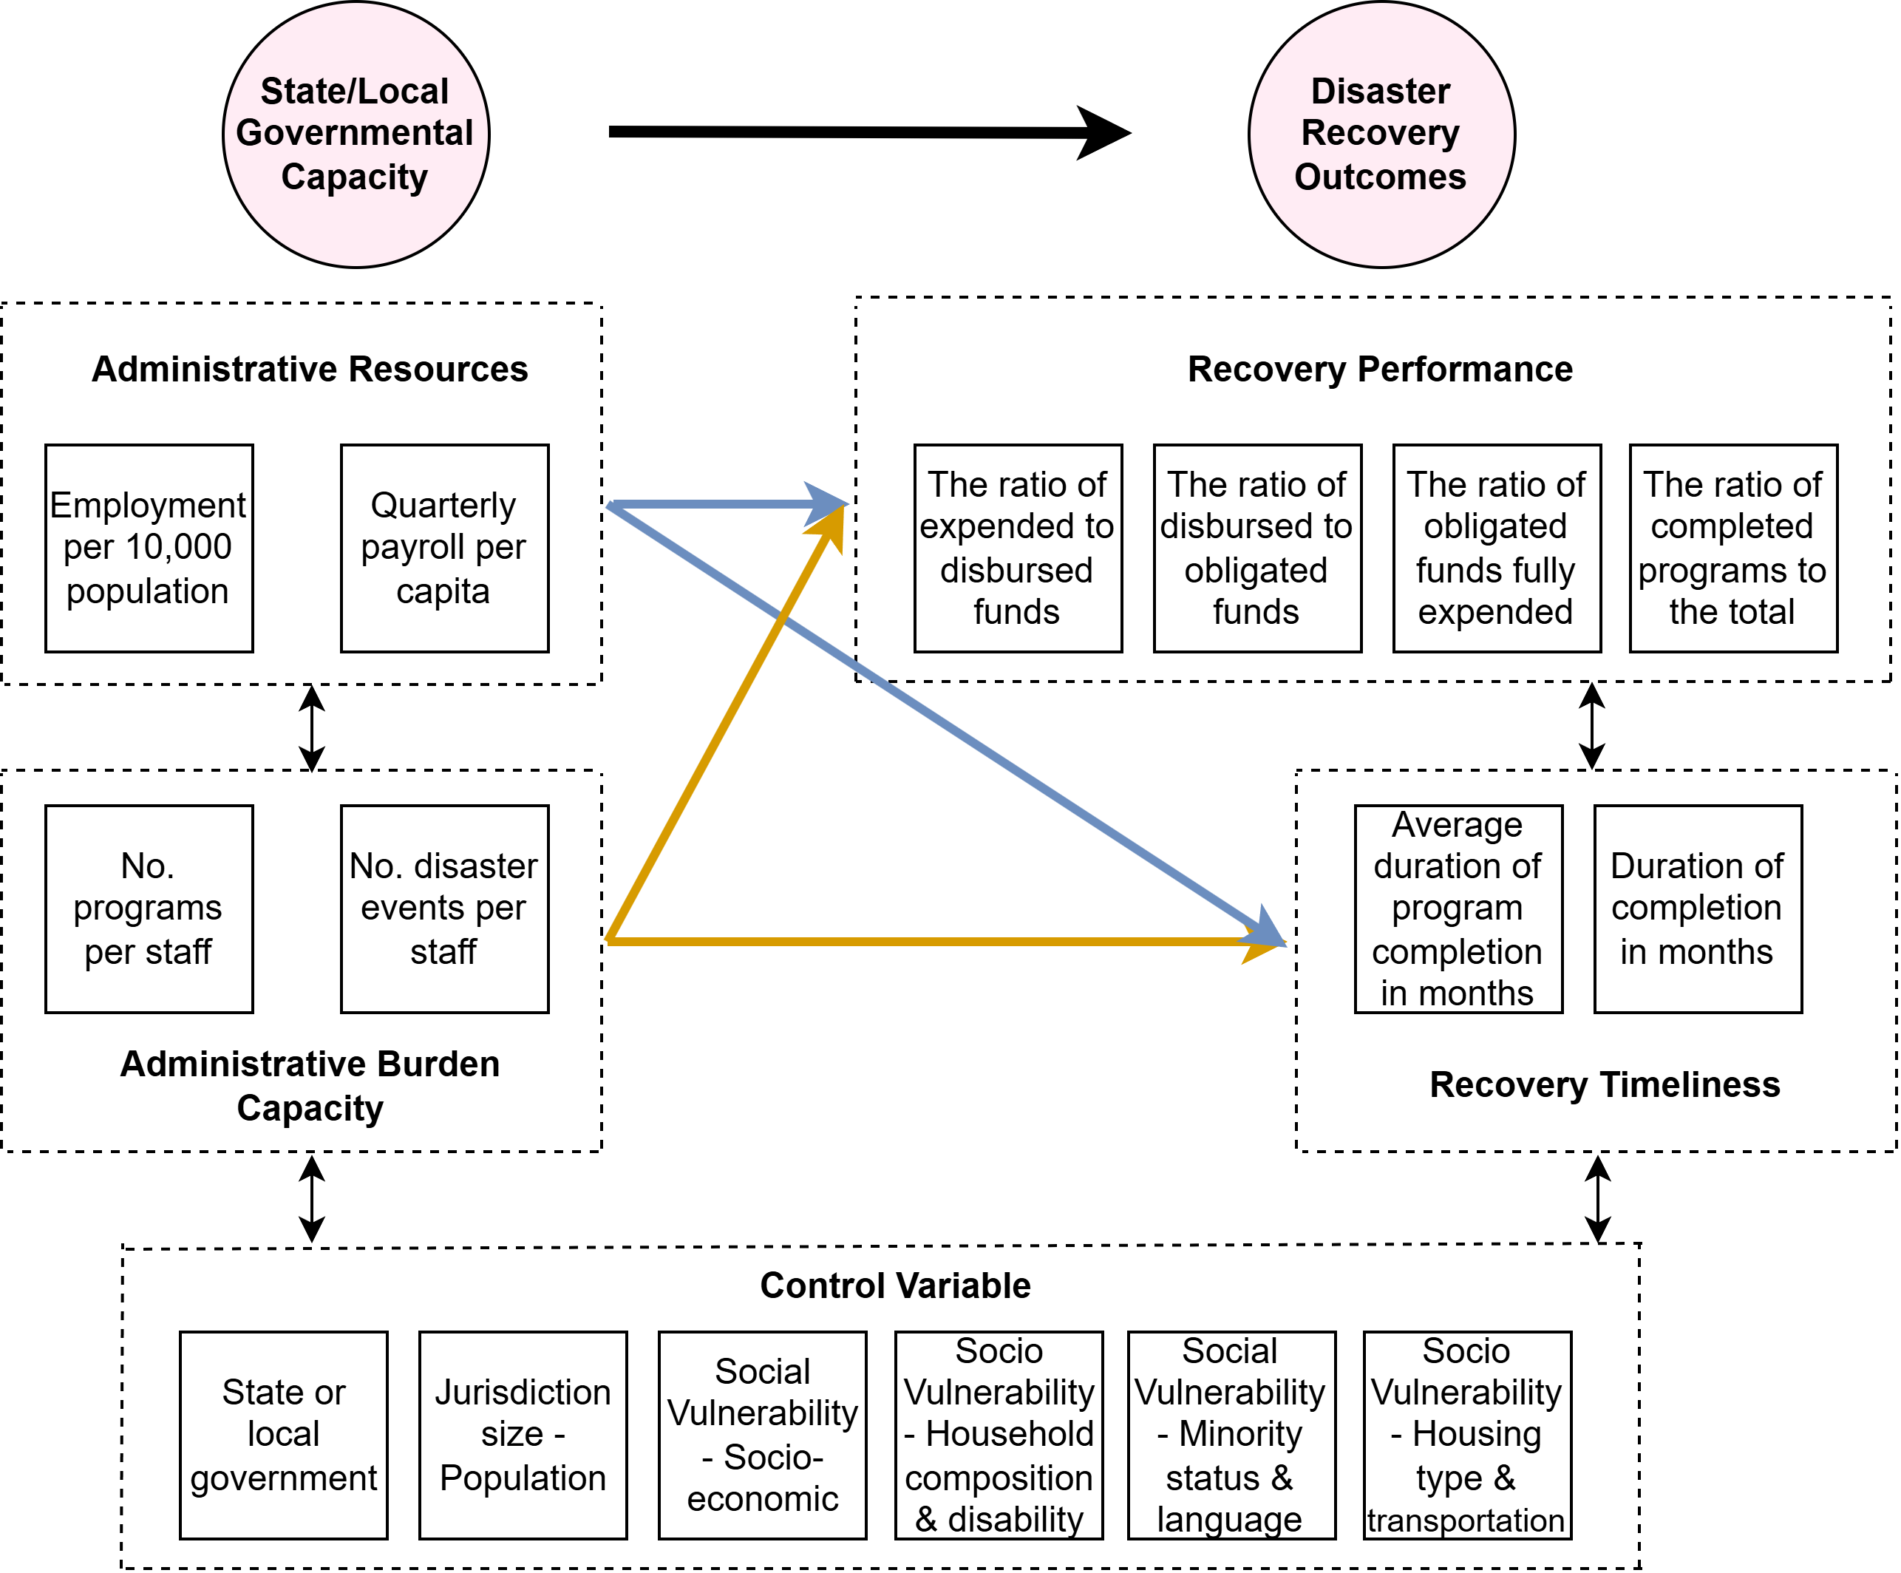
Figure 1. Structural equation model of governmental capacity and disaster recovery outcomes.
Specifically, the SEM framework consists of two components: a measurement model and a structural model, which together are used to examine the mechanisms influencing disaster recovery program outcomes. The measurement model defines the relationships between latent constructs and their observed indicators, ensuring that key concepts – such as governmental capacity and recovery outcomes – are reliably represented by multiple empirical measures.
- AdminResources ← avg_employment, avg_payroll
- AdminBurdenCapacity ← rev_programs_per_staff, rev_disasters_per_staff
- RecoveryPerformance ← ratio_disbursed_to_obligated, ratio_expended_to_disbursed, ratio_total_obligated_funds_fully_expended, ratio_program_completed
- RecoveryTimeliness ← rev_duration_of_grant_completion, rev_average_duration_program_completion
The structural model specifies the relationships between governmental capacity, control variables, and the latent outcome constructs of Recovery Performance and Recovery Timeliness, and is defined as follows:
- RecoveryPerformance ∼ AdminResources + AdminBurdenCapacity + state_or_local + total_population + SVI controls
- RecoveryTimeliness ∼ AdminResources + AdminBurdenCapacity + state_or_local + total_population + SVI controls
The central hypothesis posits that higher levels of governmental capacity are associated with stronger disaster recovery outcomes. In particular, grantees with greater administrative resources and lower administrative workload pressures are expected to demonstrate both higher recovery performance and faster recovery timeliness.
4.6. Experimental design and model estimation
To assess the robustness of the results, two strategies were implemented. First, potential outliers were removed from the cleaned dataset, including grantees with unusually high fund management ratios or limited financial reporting records relative to other observations. This step helps reduce the influence of extreme values that may distort parameter estimates. Second, an alternative SEM specification was developed in which Administrative Resources and Administrative Burden Capacity were combined into a single latent construct representing Governmental Capacity. In other words, the alternative specification treats governmental capacity as a unidimensional latent variable rather than two related dimensions.
In the alternative SEM framework, the measurement model for Governmental Capacity (GovCapacity) is defined using four observed indicators: avg_employment, avg_payroll, rev_programs_per_staff, and rev_disasters_per_staff, while the measurement models for the disaster recovery outcome constructs remain unchanged. The structural model then estimates the extent to which governmental capacity influences recovery outcomes – Recovery Performance and Recovery Timeliness – while controlling for governmental level, jurisdiction size, and social vulnerability. The structural relationships are specified as follows:
- RecoveryPerformance ∼ GovCapacity + state_or_local + total_population + SVI controls
- RecoveryTimeliness ∼ GovCapacity + state_or_local + total_population + SVI controls
Prior to SEM estimation, all continuous indicators were standardized as z-scores to improve comparability across variables and facilitate model convergence (Guo et al., 2025). In constructing workload measures, a small constant was added to denominators where necessary to avoid division-by-zero issues. The SEM models were estimated using maximum likelihood estimation (Lee & Zhu, 2002). Model fit was evaluated using standard SEM fit indices, including the chi-square statistic (χ²), Comparative Fit Index (CFI), Tucker-Lewis Index (TLI), Root Mean Square Error of Approximation (RMSEA), Akaike Information Criterion (AIC), and Bayesian Information Criterion (BIC) (Zheng & Bentler, 2025). Standardized factor loadings and standardized path coefficients were used for substantive interpretation. The two SEM specifications were subsequently compared based on these evaluation metrics to determine which framework provides a better representation of governmental capacity in relation to disaster recovery outcomes.

5. Results
5.1. SEM model comparison
Both SEM specifications were estimated to examine the relationship between governmental capacity and disaster recovery outcomes: (1) a standard SEM that decomposes governmental capacity into two latent dimensions – Administrative Resources and Administrative Burden Capacity – and (2) an alternative SEM that represents governmental capacity as a single latent construct (Governmental Capacity). Table 1 presents the comparison of evaluation metrics between the standard and alternative SEM frameworks.
Table 1. SEM model fit comparison
Fit index | χ² | CFI | TLI | RMSEA | AIC | BIC
Standard SEM model | 803.83 | 0.843 | 0.804 | 0.110 | 67.21 | 219.74
Alternative SEM model | 507.25 | 0.909 | 0.883 | 0.085 | 74.24 | 239.84
The alternative SEM model demonstrated only modest fit to the data (χ² = 507.25, CFI = 0.909, TLI = 0.883, RMSEA = 0.085). In contrast, the standard SEM specification substantially improved model fit (χ² = 803.83, CFI = 0.843, TLI = 0.804, RMSEA = 0.110). Improvements were observed across all major fit indices, including higher CFI and TLI values and a notable reduction in RMSEA, indicating a better representation of the underlying covariance structure. Although the standard SEM exhibited slightly higher AIC and BIC values, the overall improvements in model fit and theoretical interpretability suggest that distinguishing between administrative resources and workload-related capacity provides a more appropriate and nuanced representation of institutional capacity in disaster recovery administration. Accordingly, the standard SEM specification was adopted as the primary model for interpretation.
As an additional robustness check, potential outliers were removed from the dataset, and the standard SEM was re-estimated. The resulting model produced comparable fit statistics and similar structural relationships between governmental capacity and recovery outcomes (results not shown). This indicates that the influence of abnormal observations was minimal, thereby reinforcing the robustness and reliability of the key SEM findings.
5.2. Structural relationships between governmental capacity and recovery outcomes
The structural results indicate distinct effects of Administrative Resources and Administrative Burden Capacity on disaster recovery outcomes, including Recovery Performance and Recovery Timeliness. Table 2 reports the standardized structural path coefficients for the standard SEM specification. Figures 2 and 3 present the predicted relationship plots, illustrating how Recovery Performance and Recovery Timeliness vary across the range of key explanatory variables while holding other factors constant.
Table 2. Structural path estimates in the standard SEM framework
Recovery outcome | Predictor | Standardized β | p-value
Recovery Performance | Administrative Resources | −0.180*** | <0.001
Recovery Performance | Administrative Burden Capacity | 0.169*** | <0.001
Recovery Performance | State or local government | −0.090 | 0.104
Recovery Performance | SVI Theme 3: Minority status & language | −0.233*** | <0.001
Recovery Timeliness | Administrative Resources | 0.079* | 0.071
Recovery Timeliness | Administrative Burden Capacity | 0.267*** | <0.001
Recovery Timeliness | State or local government | −0.093* | 0.083
Recovery Timeliness | SVI Theme 1: Socioeconomic | −0.190*** | 0.004
Recovery Timeliness | SVI Theme 2: Household composition & disability | −0.166*** | 0.003
Note: ***, **, and * denote statistical significance at the 99%, 95%, and 90% confidence levels, respectively, while those insignificant coefficient estimates are not presented.
5.2.1. Relationships with Recovery Performance
Administrative Resources exhibited a negative association with Recovery Performance (β = −0.180, p < 0.001), which suggests that jurisdictions with higher levels of administrative payroll and staffing intensity did not necessarily achieve stronger financial execution or higher program completion rates after accounting for workload pressures and contextual factors. In contrast, Administrative Burden Capacity, which reflects lower disaster- and program-related workload per staff, showed a positive and statistically significant relationship with Recovery Performance (β = 0.169, p < 0.001). This result indicates that jurisdictions facing lower administrative burden relative to their staffing capacity tended to manage recovery funds more effectively and complete programs at higher rates. The finding suggests that Administrative Burden Capacity provides a more informative measure of governmental capacity to administer CDBG-DR funds than Administrative Resources alone.
Among the control variables, SVI Theme 3 (minority status and language vulnerability) demonstrated a significant negative association with Recovery Performance (β = −0.233, p < 0.001). The predicted relationship plot in Figure 2(a) showed a clear downward trend, indicating that Recovery Performance tended to decline as minority and language vulnerability increased. This indicates that jurisdictions with higher levels of vulnerability related to minority status and language barriers may encounter greater challenges in achieving timely program completion and effective fund utilization. This result highlights the importance of directing additional administrative attention and supportive resources to vulnerable communities in order to facilitate more efficient recovery implementation.
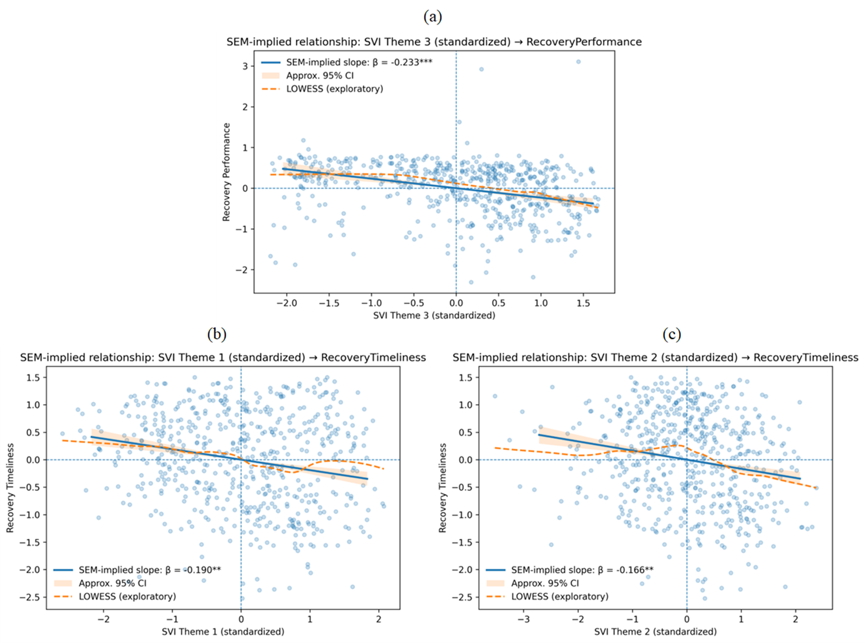
Figure 2. SEM-implied predicted relationship: (a) SVI Theme 3: minority status and language → Recovery Performance, (b) SVI Theme 1: socioeconomic → Recovery Timeliness, and (c) SVI Theme 2: household composition/disability → Recovery Timeliness. Note: LOWESS (Locally Weighted Scatterplot Smoothing) is a nonparametric regression method that fits localized weighted regressions to subsets of the data, producing a smooth curve that reveals underlying patterns and relationships without imposing a predetermined functional specification (Sharma et al., 2015).
5.2.2. Relationships with Recovery Timeliness
For Recovery Timeliness, Administrative Burden Capacity again played a central role. Lower workload pressure relative to staffing capacity was strongly associated with faster and more consistent recovery implementation (β = 0.267, p < 0.001), indicating that administrative strain represents a major constraint affecting the pace and stability of disaster recovery activities. Administrative Resources showed a positive but only marginally significant association with Recovery Timeliness (β = 0.079, p = 0.071), suggesting that greater staffing and payroll resources may modestly contribute to faster recovery implementation. However, this relationship was notably weaker than the effect associated with Administrative Burden Capacity, further emphasizing the importance of manageable workload conditions in facilitating timely recovery.
Two dimensions of social vulnerability were also significantly associated with Recovery Timeliness. Higher values of SVI Theme 1 (socioeconomic vulnerability) and SVI Theme 2 (household composition and disability) were associated with slower recovery implementation (β = −0.190, p = 0.004; β = −0.166, p = 0.003), indicating that socially vulnerable communities may encounter greater structural and administrative barriers that delay recovery progress. The predicted relationship plots in Figures 2(b) and 2(c) further show that jurisdictions with higher levels of socioeconomic vulnerability and greater vulnerability related to household composition and disability tended to experience slower recovery implementation. These findings highlight the importance of allocating additional administrative support and targeted resources to jurisdictions with elevated socioeconomic and demographic vulnerability in order to promote more timely disaster recovery outcomes.
Finally, the state-or-local government indicator was not statistically significant for Recovery Performance but showed modest statistical significance for Recovery Timeliness, with negative coefficients (β = −0.090, p = 0.104; β = −0.093, p = 0.083) for both recovery outcome dimensions. This suggests that, after accounting for differences in administrative capacity and social vulnerability, there was no big systematic difference between state agencies and local governments in terms of recovery outcomes, particularly for Recovery Performance. However, the consistently negative coefficients imply that local governments may demonstrate slightly greater efficiency in administering CDBG-DR funds compared to state agencies, although these differences remained relatively small in magnitude and only marginally statistically significant.
5.2.3. Partial dependence plots between capacity and outcomes
The partial dependence plots (PDPs) further indicate that Administrative Burden Capacity played the most influential role in explaining variation in disaster recovery outcomes across jurisdictions, consistent with the structural results presented in Table 2. Specifically, the predicted relationship plots in Figures 3(a) and 3(b) show a clear upward trend, indicating that jurisdictions with higher Administrative Burden Capacity – that is, jurisdictions facing lower disaster- and program-related workload per staff – tended to achieve stronger recovery outcomes. This effect was particularly pronounced for Recovery Timeliness, suggesting that workload pressure represents a key constraint affecting the speed and stability of recovery program implementation.

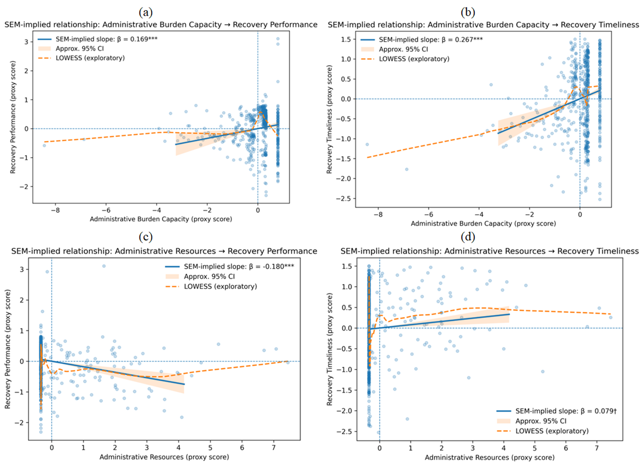
Figure 3. SEM-implied predicted relationship: (a) Administrative Burden Capacity → Recovery Performance, (b) Administrative Burden Capacity → Recovery Timeliness, (c) Administrative Resources → Recovery Performance, and (d) Administrative Resources → Recovery Performance.
In contrast, Administrative Resources exhibited a more complex relationship with recovery outcomes. As shown in Table 2 and illustrated in Figure 3(c), Administrative Resources were negatively associated with Recovery Performance (β = −0.180, p < 0.001). Meanwhile, the relationship between Administrative Resources and Recovery Timeliness was positive but only marginally significant (β = 0.079, p < 0.10), as illustrated in Figure 3(d). This pattern suggests that higher levels of staffing and payroll intensity alone did not necessarily translate into improved recovery performance once workload pressures and contextual conditions were considered. Instead, the findings imply that administrative resources, when not accompanied by manageable workload levels, may be insufficient to produce effective recovery outcomes.
It is also important to note that most state agencies and local governments (counties) maintained relatively limited staffing resources dedicated to administering CDBG-DR housing recovery programs, as illustrated in Figure 3. As a result, the standardized values of both Administrative Resources and Administrative Burden Capacity were concentrated near zero for many jurisdictions, leading to more modest and sometimes less stable marginal effects across recovery outcomes. This suggests that improving recovery outcomes requires not only reducing administrative workload pressures but also strengthening staffing and fiscal resources. However, increasing administrative resources alone is insufficient to ensure effective recovery implementation. Rather, enhancing administrative capacity requires a balanced combination of adequate resources and manageable program demands, although the results indicate that manageable workload conditions played a particularly critical role in supporting successful recovery outcomes.
In addition to the SEM-implied predicted relationship plots, supplementary PDPs were generated using the observed indicators underlying the latent capacity constructs. These supplementary plots are presented in Appendix Figures A1-A5. Although these figures exhibited greater dispersion and localized irregularities due to skewness and outliers in the observed variables, they generally supported the SEM results. For example, the reverse-coded indicators for disasters per staff and programs per staff showed positive associations with recovery outcomes, consistent with the interpretation that lower workload pressure contributed to improved disaster recovery implementation. However, because these supplementary plots relied on proxy-score regressions rather than the latent SEM framework itself, they were interpreted as descriptive supporting evidence rather than primary inferential results.
5.3. Spatial patterns of governmental capacity and recovery outcomes
To complement the SEM results, spatial analyses were conducted to examine the geographic distribution of governmental capacity and disaster recovery outcomes across U.S. counties. Figures 4(a)-4(d) illustrate the standardized county-level patterns of Administrative Resources, Administrative Burden Capacity, Recovery Performance, and Recovery Timeliness, respectively, while Figures 5(a) and 5(b) present quadrant classifications that jointly characterize Administrative Burden Capacity with Recovery Performance and Recovery Timeliness, respectively.
5.3.1. Spatial patterns of latent capacity-outcome constructs
The spatial distribution of Administrative Resources (Figure 4(a)) revealed a highly uneven pattern, with relatively high levels concentrated in a limited number of counties, particularly in parts of the Northeast, Midwest, and selected metropolitan areas. In contrast, many counties across the South and interior regions exhibited comparatively lower levels of staffing and payroll intensity. This pattern reflects broader regional disparities in governmental fiscal and institutional capacity, suggesting that administrative resources were spatially clustered rather than uniformly distributed. Further, the results indicate that administrative resources remained limited in most counties, highlighting persistent constraints in local staffing and fiscal capacity for administering disaster recovery programs.
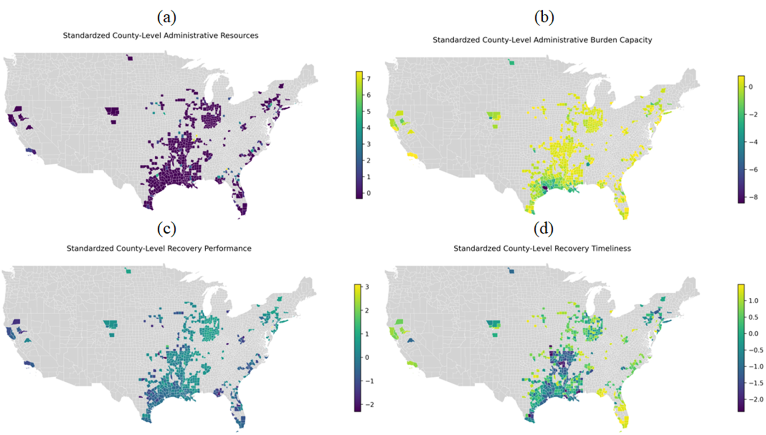
Figure 4. Spatial distributions of standardized latent constructs at county levels: (a) Administrative Resources, (b) Administrative Burden Capacity, (c) Recovery Performance, and (d) Recovery Timeliness.
In contrast, Administrative Burden Capacity (Figure 4(b)) exhibited a distinct spatial pattern. Many counties in the Midwest and portions of the Northeast demonstrated relatively high burden capacity (i.e., lower administrative workload per staff), whereas several counties in the Gulf Coast and other disaster-prone southern regions displayed lower burden capacity, indicating higher programmatic and disaster-related workloads relative to available staffing levels. The differences between the spatial distributions of Administrative Resources and Administrative Burden Capacity suggest that resource availability alone did not fully capture governments’ operational ability to manage disaster recovery demands.
The spatial patterns of Recovery Performance (Figure 4(c)) and Recovery Timeliness (Figure 4(d)) further revealed substantial geographic heterogeneity. Higher levels of Recovery Performance were observed in parts of the Midwest and Northeast, whereas relatively lower performance was more common in the Gulf Coast and southern regions. A similar spatial pattern emerged for Recovery Timeliness, with slower implementation concentrated in areas experiencing higher administrative burden. These spatial patterns are broadly consistent with the SEM results, reinforcing the finding that Administrative Burden Capacity played a more influential role than resource levels alone in shaping disaster recovery outcomes.
5.3.2. Quadrant distributions of burden capacity and recovery constructs
Focusing on Administrative Burden Capacity as the central dimension of governmental capacity, we further developed quadrant maps illustrating its joint distribution with Recovery Performance and Recovery Timeliness. These maps provide a spatial typology of jurisdictions based on the interaction between administrative workload conditions and recovery outcomes.
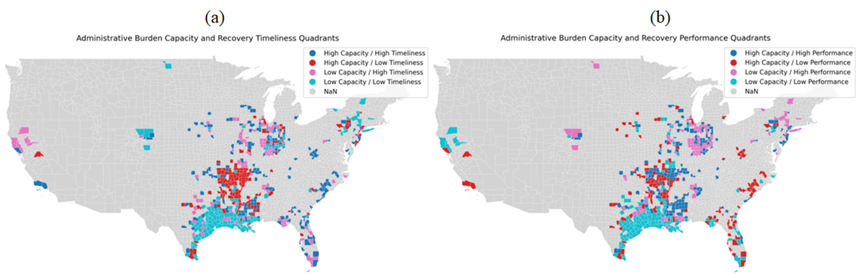Figure 5. Quadrant map of the joint distribution of standardized administrative burden capacity and (a) recovery performance and (b) recovery timeliness at the county level.
Figure 5(a) compares Administrative Burden Capacity and Recovery Timeliness, revealing four distinct county typologies. Counties classified as high capacity (above the median) and high timeliness (above the median) were distributed across several regions, indicating strong alignment between manageable administrative workload and efficient program implementation across jurisdictions in different geographic regions. In contrast, clusters of low capacity and low timeliness counties appeared prominently in the Gulf Coast and southern regions, suggesting that administrative constraints may substantially hinder the pace of recovery in these areas. Counties characterized by high capacity but low timeliness, particularly in parts of the central United States, indicate that factors beyond administrative workload, such as institutional complexity or contextual barriers (Peacock et al., 2014), may also delay recovery implementation. Conversely, counties with low capacity but high timeliness may reflect the presence of adaptive governance strategies, compensatory institutional mechanisms, or relatively lower disaster impacts (Berke et al., 2014; Tierney, 2012), enabling comparatively efficient recovery despite limited administrative capacity.
A similar pattern was observed in Figure 5(b), which illustrates the joint distribution of Administrative Burden Capacity and Recovery Performance. Counties exhibiting high capacity and high performance were more prevalent in parts of the Midwest and Northeast, reinforcing the importance of manageable administrative workloads for achieving effective recovery outcomes. Meanwhile, clusters of low capacity and low performance were again concentrated in the Gulf Coast and southern regions, highlighting persistent governance challenges in areas facing both high disaster exposure and elevated administrative strain. The presence of counties with high capacity but low performance, as well as low capacity but high performance, further suggests that recovery effectiveness was shaped not only by Administrative Burden Capacity but also by broader contextual and institutional factors (Peacock et al., 2014).
Overall, these spatial analyses reinforce the central conclusion that Administrative Burden Capacity, which captures the balance between workload demands and available staffing, was more closely aligned with recovery outcomes than the absolute level of Administrative Resources alone. The quadrant maps also reveal that mismatches between capacity and recovery outcomes were geographically clustered, helping to identify areas where targeted administrative support or institutional adjustments may improve recovery effectiveness. Collectively, the spatial patterns highlight substantial regional disparities in disaster recovery governance and suggest that reducing administrative workload pressures may be particularly important for improving recovery performance and timeliness in high-risk jurisdictions.
5.4. Spatial patterns of disaster-capacity-outcome gaps
To account for the influence of disaster exposure, this study further introduced three disaster-related metrics: the administrative burden capacity gap, the recovery implementation gap, and the recovery performance gap. These metrics were defined to compute the discrepancies between disaster-related demand, proxied by the number of disasters, and (1) available administrative capacity – Administrative Burden Capacity, (2) realized recovery implementation outcomes – Recovery Timeliness, and (3) overall recovery performance – Recovery Performance. While all three measures showed similar patterns of persistent challenges along the Gulf Coast and southern United States (Figures 6-8), each captured a distinct dimension of recovery governance.
5.4.1. Spatial patterns of administrative burden capacity gap
The capacity gap quantified the mismatch between disaster demand and administrative capability, highlighting structural constraints in recovery governance. At the county level (Figure 6(a)), high gaps were concentrated along the Gulf Coast and southern states, particularly Texas and Louisiana, where frequent disasters coincided with limited administrative burden capacity. These areas represented potential hotspots of administrative strain. In contrast, many counties in the Midwest and Northeast exhibited low or negative gaps, indicating closer alignment between administrative capacity and disaster demands.
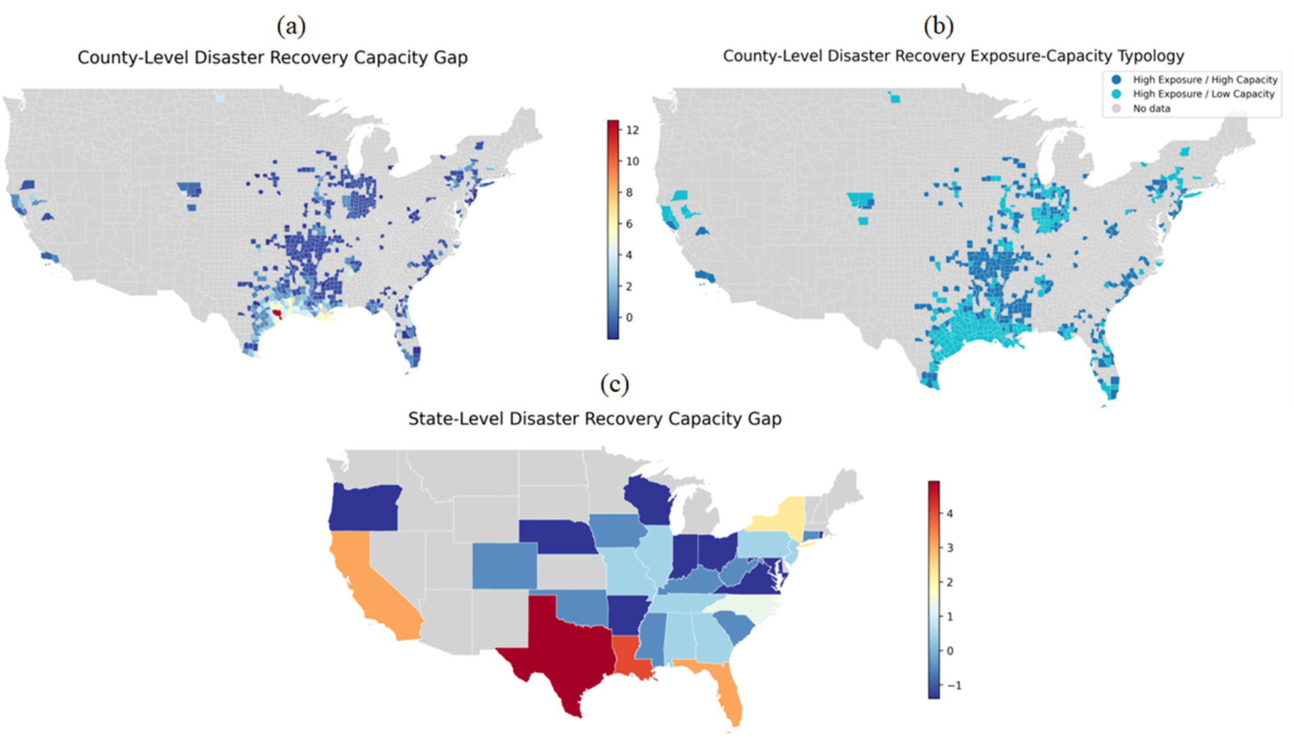Figure 6. Spatial distributions of (a) county-level administrative burden capacity gap, (b) county-level disaster recovery exposure-capacity typology, and (c) state-level administrative burden capacity gap.
The exposure-capacity typology (Figure 6(b)) further illustrated that counties with high exposure-low capacity faced the greatest institutional stress, whereas high exposure-high capacity counties, more common in the Midwest and Northeast, reflected more resilient administrative systems. State-level patterns (Figure 6(c)) reinforced these disparities: Gulf Coast states displayed the largest gaps, while Midwestern and northern states generally showed stronger alignment between capacity and disaster exposure. Uniquely, this gap emphasized upstream administrative constraints, identifying regions where institutional resources were insufficient relative to disaster demand, independent of recovery timelines or outcomes.
5.4.2. Spatial patterns of disaster recovery implementation gap
The implementation gap measured whether administrative capacity was effectively translated into timely recovery, capturing operational efficiency. At the county level (Figure 7(a)), high implementation gaps were concentrated along the Gulf Coast, particularly in Texas and Louisiana, where high disaster exposure coincided with slower recovery timelines. Counties with high exposure-low timeliness highlighted persistent delays in recovery, while high exposure-high timeliness counties, more common in the Midwest and Northeast, demonstrated effective operational response under high-demand conditions.
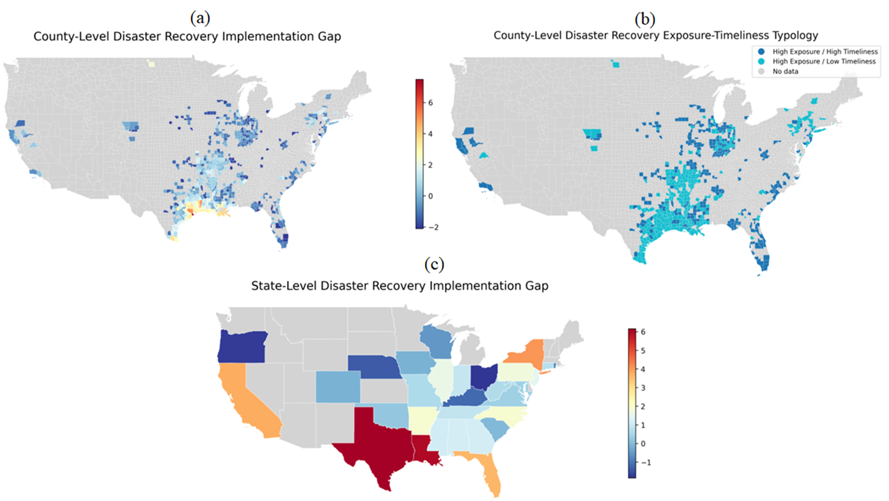Figure 7. Spatial distributions of (a) county-level disaster recovery implementation gap, (b) county-level disaster recovery exposure-implementation typology, and (c) state-level disaster recovery implementation gap.
The county-level exposure-timeliness typology (Figure 7(b)) identified regions where administrative processes or procedural delays may hinder recovery, even if capacity existed. State-level patterns (Figure 7(c)) confirmed that Texas and Louisiana exhibited the largest gaps, with Florida and California moderately elevated, whereas several Midwestern and northern states showed closer alignment between disaster exposure and recovery speed. Distinct from the capacity gap, this measure focused on the efficiency of translating capacity into timely action, pinpointing operational bottlenecks in disaster recovery governance.
5.4.3. Spatial patterns of disaster recovery performance gap
The performance gap evaluated whether recovery efforts achieved effective outcomes (e.g., fund allocation and program completion) relative to disaster demand. At the county level (Figure 8(a)), high gaps were concentrated along the Gulf Coast, especially in Texas and Louisiana, where high disaster exposure coincided with comparatively weaker recovery outcomes. Additional clusters appeared in parts of the Southeast, including Florida and along the Atlantic coast. Counties with high exposure-low performance faced persistent challenges in allocating CDBG-DR funds and converting recovery capacity and effort into meaningful results, whereas high exposure-high performance counties, more frequent in the Midwest and Northeast, demonstrate a stronger ability to translate capacity into successful outcomes under high-demand conditions.
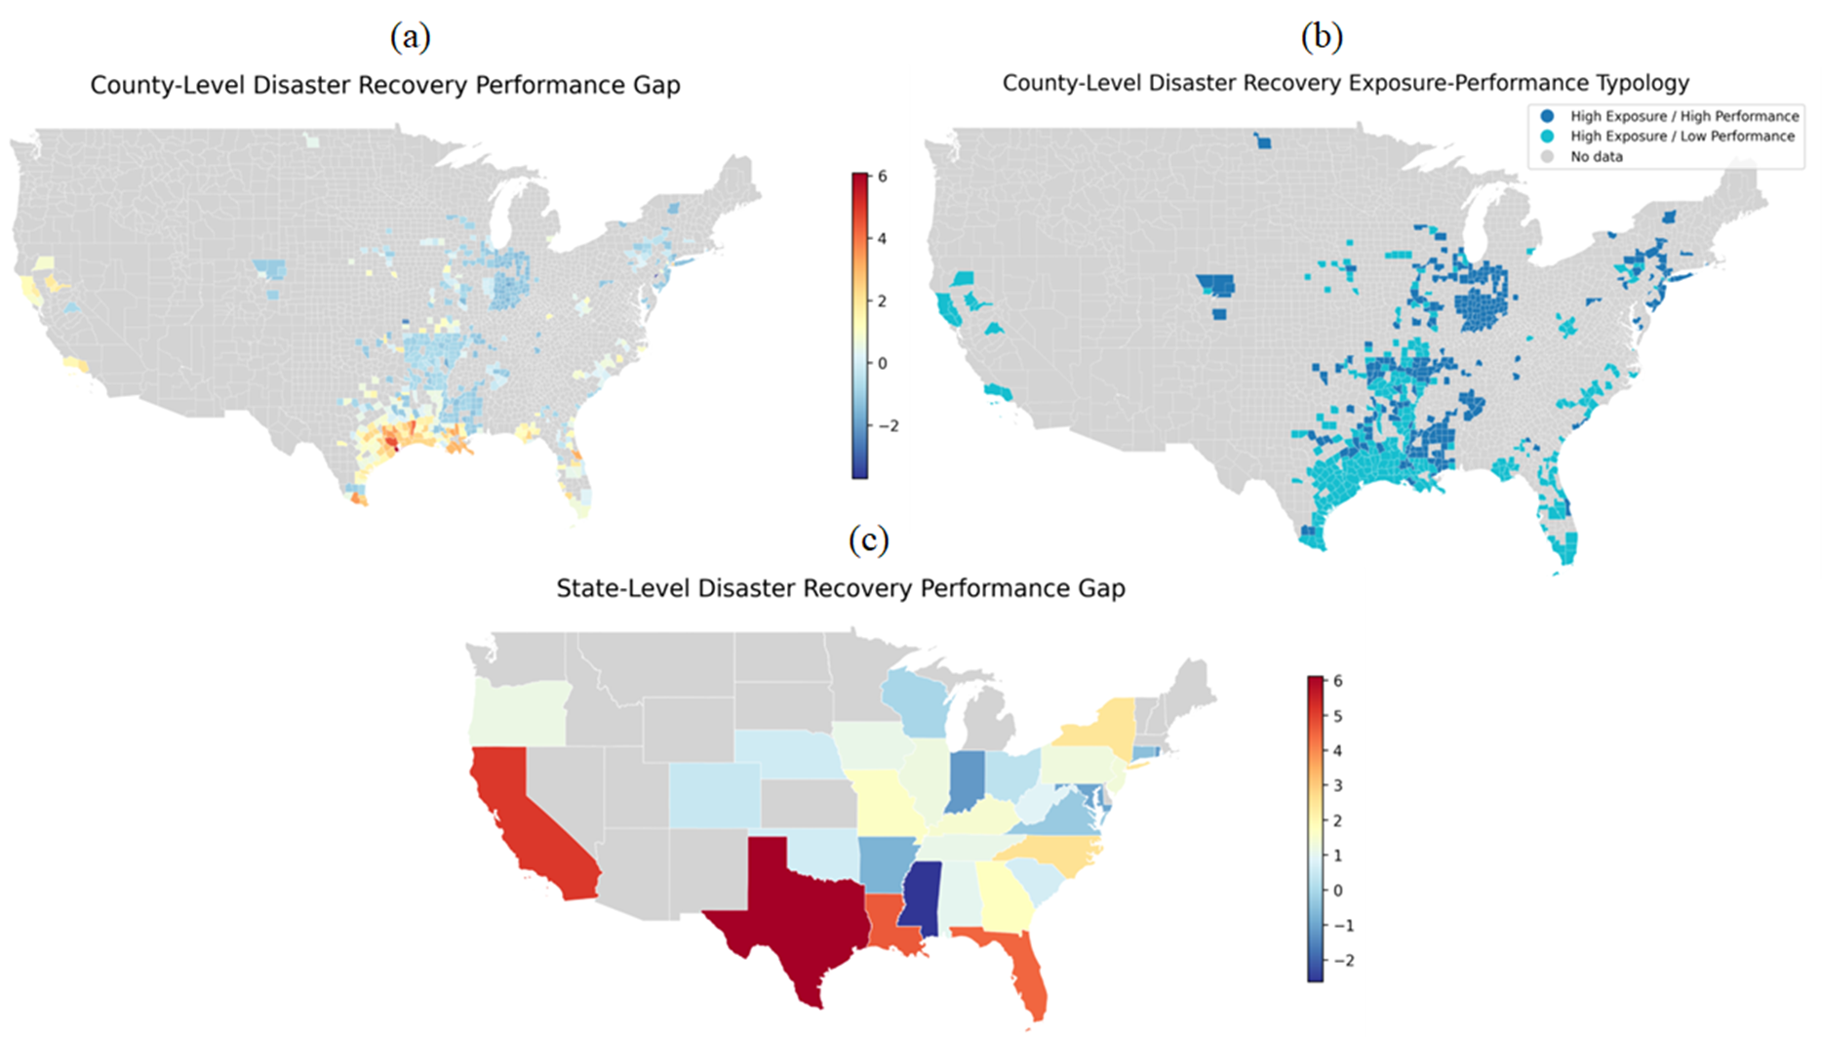Figure 8. Spatial distributions of (a) county-level disaster recovery performance gap, (b) county-level disaster recovery exposure-performance typology, and (c) state-level disaster recovery performance gap.
State-level patterns (Figure 8(c)) showed Texas and California with the largest gaps, while Midwestern and northern states generally exhibited lower gaps, reflecting a more balanced relationship between disaster demand and recovery performance. This measure uniquely captured fund allocation and program outcome effectiveness, complementing the capacity and implementation gaps by revealing where CDBG-DR funds or recovery programs underperformed despite available resources or timely execution.
Together, these three gap measures provide a comprehensive picture of disaster recovery governance. All three measures highlighted persistent challenges along the Gulf Coast and southern United States. However, by disentangling structural capacity, operational timeliness, and outcome effectiveness, the analysis clarified where targeted interventions were most needed. For example, high capacity gaps suggest a need for administrative surge support (Khorram-Manesh, 2020), high implementation gaps indicate process streamlining and coordination improvements (Okunola, 2025), and high performance gaps call for program design improvements and stronger accountability mechanisms (Ishiwatari, 2021). These findings further emphasize that improving disaster recovery requires not only sufficient administrative resources but also effective and efficient translation of capacity into meaningful recovery outcomes.
5.5. Disaster recovery governance risk analysis
To further investigate the institutional and contextual drivers underlying the three gap measures, we constructed a Recovery Governance Risk Index. This index captured the combined effects of disaster exposure and social vulnerability, offset by Administrative Burden Capacity, to identify jurisdictions where disaster recovery governance was most constrained. In other words, it highlighted areas where high levels of disaster need coincided with limited institutional capacity, emphasizing structural and institutional constraints rather than operational performance. Specifically, the index pinpointed counties facing both high disaster exposure and elevated social vulnerability while possessing relatively low administrative capacity. Figure 9 illustrates the spatial distribution of governance risk, highlighting priority counties where targeted administrative support and capacity-building interventions may be most critical.
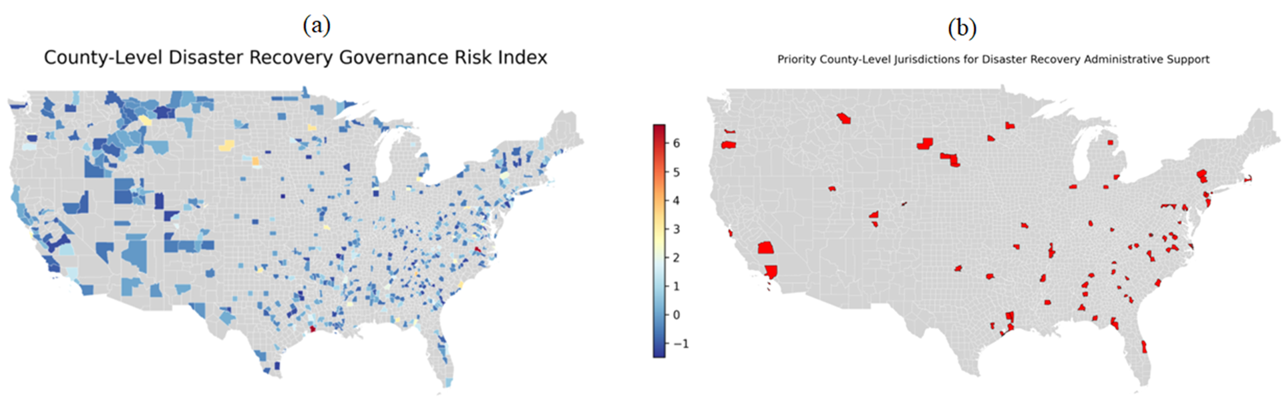Figure 9. Spatial distributions of (a) county-level disaster recovery governance risk and (b) high-governance-risk counties with high priorities on disaster recovery.
The county-level governance risk map (Figure 9(a)) reveals a highly uneven spatial distribution of recovery governance risk across the United States. Elevated risk levels were most concentrated along the Gulf Coast, particularly in Texas and Louisiana, where high disaster exposure and social vulnerability coincided with relatively constrained administrative capacity. Additional clusters of high-risk counties appeared in parts of the Southeast, including Mississippi, Alabama, and portions of Florida, as well as selected areas in Appalachia and the inland South. In contrast, much of the Midwest and northern regions exhibited lower governance risk, reflecting a more favorable balance between disaster exposure, social vulnerability, and administrative capacity. Beyond these broad regional patterns, localized pockets of elevated risk were also visible in parts of the western United States and the Northeast. Although less extensive than those along the Gulf Coast, these areas demonstrate that governance constraints were not limited to traditionally high-disaster regions but can arise wherever institutional capacity did not keep pace with disaster exposure and underlying vulnerability conditions. This spatial heterogeneity highlights the importance of examining recovery governance at finer geographic scales rather than relying solely on state-level aggregates.
Figure 9(b) further refines this analysis by identifying priority counties with governance risk scores above 1, translating the index into actionable insights for targeted policy intervention. These priority jurisdictions were heavily clustered along the Gulf Coast and across the southern United States, forming a contiguous belt of high-risk counties that closely corresponded with areas previously identified as having significant capacity constraints, implementation delays, and performance shortfalls. Additional clusters appeared in parts of the Mid-Atlantic and selected metropolitan or peri-urban counties, where elevated social vulnerability and administrative complexity may further intensify recovery challenges. The overlap between high governance risk counties and those characterized by high disaster exposure-low Administrative Burden Capacity, high disaster exposure-low Recovery Timeliness, and high disaster exposure-low Recovery Performance suggests persistent structural constraints in local disaster recovery systems. In these jurisdictions, recovery challenges stem not only from the scale of disaster impacts but also from limited institutional capacity to effectively manage, allocate, and implement recovery resources.
Overall, the results indicate that disaster recovery governance risk in the United States was geographically concentrated yet structurally persistent, with the Gulf Coast and broader southern regions representing the most critical areas for targeted intervention. Strengthening administrative surge capacity (Khalid & Ashraf, 2024), investing in workforce development (Santos et al., 2020), improving intergovernmental coordination mechanisms (Shan et al., 2025), and simplifying program design (Ortiz-Ortiz, 2026) may help reduce governance risk and improve recovery outcomes in these high-priority areas. Table 3 further identifies the twenty jurisdictions with the highest governance risk scores, which were characterized by frequent disaster exposure, relatively high administrative workload pressures, and elevated social vulnerability. The results shown in Table 3 also suggest that recovery outcomes in such contexts were particularly sensitive to institutional capacity constraints and may require additional administrative support beyond standard program funding (Saputra et al., 2025).
Table 3. Top 20 jurisdictions with the highest disaster recovery governance risk index
Rank | Jurisdiction | Exposure | Capacity | Vulnerability | Risk Index
1 | Harris County, TX | 3.9092 | -8.4353 | 0.5128 | 6.6466
2 | Galveston County, TX | 5.7159 | -6.8706 | 0.0870 | 6.5516
3 | Jefferson Parish, LA | 3.0059 | -3.9143 | 0.1655 | 3.6649
4 | Newton County, TX | 3.9092 | -3.0389 | 0.1322 | 3.6621
5 | Terrebonne Parish, LA | 3.0059 | -2.7047 | 0.5468 | 3.2370
6 | Jefferson County, TX | 2.1026 | -3.1707 | 0.9033 | 3.1952
7 | Jasper County, TX | 3.0059 | -2.4256 | 0.6773 | 3.1602
8 | Plaquemines Parish, LA | 3.0059 | -2.7605 | 0.0153 | 2.9913
9 | Grimes County, TX | 3.0059 | -2.0906 | 0.6694 | 2.9831
10 | Orange County, TX | 2.1026 | -3.6732 | -0.0240 | 2.9758
11 | San Jacinto County, TX | 3.0059 | -2.3680 | 0.3075 | 2.9403
12 | Cameron County, TX | 2.1023 | -2.2589 | 1.2879 | 2.9229
13 | Lafourche Parish, LA | 3.0059 | -2.1092 | 0.3287 | 2.8167
14 | Montgomery County, TX | 3.0059 | -2.7419 | -0.3093 | 2.8139
15 | Willacy County, TX | 2.1026 | -1.9054 | 1.3717 | 2.7835
16 | Liberty County, TX | 2.1026 | -2.1659 | 1.0405 | 2.7470
17 | Brazoria County, TX | 2.1026 | -2.9288 | 0.0142 | 2.6110
18 | Washington Parish, LA | 2.1026 | -1.3471 | 1.2866 | 2.4512
19 | Calcasieu Parish, LA | 2.1026 | -2.2031 | 0.2772 | 2.3719
20 | Gregg County, TX | 2.1026 | -1.6821 | 0.7955 | 2.3705
6. Discussion
6.1. Rethinking governmental capacity: A multi-dimensional and relational perspective
This study advances a more differentiated understanding of governmental capacity in disaster recovery, demonstrating that capacity is not a singular construct, but a multi-dimensional and relational phenomenon shaped by the interaction between administrative resources, workload pressures, and contextual vulnerability. Across the SEM results, spatial analyses, and gap-based diagnostics, a consistent pattern emerges – disaster recovery outcomes are influenced less by the absolute level of administrative resources and more by the balance between institutional capacity and administrative burden. In this sense, governmental capacity reflects not only what governments possess but also what they are able to manage effectively.
Consistent with Annan-Prah & Andoh (2023), this study conceptualizes governmental capacity as a joint reflection of resources and performance. However, it further refines this perspective by introducing Administrative Burden Capacity, defined as the effective capacity remaining after accounting for workload pressures and contextual constraints such as social vulnerability. This conceptualization highlights that capacity is inherently relational: administrative resources only translate into effective recovery outcomes when workload demands remain within manageable levels.
A central contribution of this study is the distinction between Administrative Resources and Administrative Burden Capacity. While staffing and payroll reflect the scale of government, burden capacity captures the extent to which those resources are stretched across competing responsibilities. The findings show that Administrative Burden Capacity is the more decisive factor in shaping recovery outcomes. Jurisdictions with fewer disasters and programs per staff consistently achieve faster recovery implementation (Recovery Timeliness), more efficient CDBG-DR fund allocation, and stronger program completion (Recovery Performance). These findings suggest that disaster recovery systems are highly sensitive to workload saturation: even well-resourced governments may underperform when administrative responsibilities exceed manageable levels.
The observed negative association between Administrative Resources and Recovery Performance further supports this interpretation. Rather than implying that additional resources hinder recovery, this relationship likely reflects underlying complexity effects: jurisdictions with larger administrative structures often manage more complex and demanding recovery portfolios. Once workload pressure is explicitly considered, the limitations of resource-based indicators as proxies for governmental capacity become apparent. Importantly, the results also indicate that administrative resources remain limited for many jurisdictions, suggesting that improving recovery outcomes requires not only reducing excessive administrative workload pressures but also increasing staffing and fiscal capacity. These findings support a more nuanced understanding of governmental capacity as a function of both resource availability and workload manageability.
6.2. A burden-capacity framework for understanding spatial inequality in disaster recovery
This study further contributes to disaster governance research by demonstrating how workload pressures and contextual vulnerability jointly shape recovery inequality across space. The results show that different dimensions of social vulnerability influence recovery outcomes through distinct mechanisms. Minority status and language barriers are associated with weaker fund allocation and lower recovery performance, while socioeconomic disadvantage and household composition constraints (e.g., disability and elderly populations) are linked to slower recovery implementation. These findings suggest that socially vulnerable communities often require more intensive administrative effort, including outreach, coordination, and verification processes (Peacock et al., 2014). In this way, social vulnerability amplifies administrative burden, compounding the challenges faced by already capacity-constrained jurisdictions.
The spatial analyses reinforce this interpretation by revealing persistent geographic inequalities in recovery governance. Across multiple indicators, including Administrative Burden Capacity quadrant maps with Recovery Timeliness and Recovery Performance, capacity gaps, implementation gaps, performance gaps, and the Recovery Governance Risk Index, there is strong convergence in identifying the Gulf Coast and broader southern United States as regions facing sustained recovery constraints. These areas frequently experience a “double disadvantage”, characterized by high disaster exposure combined with limited administrative burden capacity and elevated social vulnerability. The recovery implementation and performance gap analyses further demonstrate that these jurisdictions face challenges not only in recovery speed but also in achieving effective recovery outcomes. The Recovery Governance Risk Index synthesizes these dimensions by identifying counties where institutional constraints, exposure, and vulnerability intersect most acutely.
Importantly, the spatial patterns are not purely regional. The analysis also identifies localized pockets of elevated governance risk in other parts of the United States, including the West and Northeast. This spatial heterogeneity suggests that disaster recovery challenges are structural rather than geographically deterministic, emerging wherever administrative workload pressures exceed institutional capacity.
Overall, the study advances a burden-capacity framework for understanding disaster recovery governance. This perspective helps explain why jurisdictions with similar funding levels may experience substantially different recovery outcomes and highlights the importance of incorporating operational constraints and contextual vulnerability into models of governmental capacity. Future research can extend this framework by integrating dynamic measures of recovery processes (Yabe et al., 2022), more granular indicators of administrative procedures (Kyrkou et al., 2022), and longitudinal approaches that capture how institutional capacity evolves throughout the recovery lifecycle (Zhang et al., 2026).
6.3. Practical implications
The findings provide decision-makers and practitioners with a more comprehensive understanding of governmental capacity and its relationship with disaster recovery outcomes, emphasizing how institutional resources, workload pressures, and contextual vulnerability jointly shape recovery effectiveness. By moving beyond single indicators of capacity or performance, the analysis highlights the importance of considering how administrative systems function under varying levels of demand, particularly in jurisdictions facing repeated disaster exposure or elevated social vulnerability. This perspective can help practitioners better diagnose whether recovery challenges stem from insufficient resources, excessive administrative burden, or misalignment between institutional capacity and recovery needs.
The proposed Recovery Governance Risk Index offers an integrated diagnostic lens that complements conventional indicators of disaster exposure or recovery performance. While exposure measures capture the scale of recovery need and performance metrics reflect realized outcomes, the governance risk index identifies where these pressures converge with underlying institutional constraints. As such, the index helps identify jurisdictions where high demand coincides with limited administrative burden capacity, making it particularly useful for prioritizing areas where additional technical assistance, administrative support, or institutional strengthening may yield the greatest marginal improvements in recovery outcomes. In this way, the index supports more targeted and evidence-informed allocation of limited public resources.
From a policy perspective, the findings suggest that improving disaster recovery outcomes requires shifting from resource-centric approaches toward workload-sensitive and context-aware interventions. Simply increasing funding or staffing may have a limited impact if administrative systems remain overextended or if program complexity continues to impose substantial procedural burdens. Instead, policy efforts may benefit from strategies that improve the alignment between institutional capacity and recovery demand. These strategies may include: (1) reducing administrative burden through program simplification, streamlined eligibility procedures, and standardized reporting requirements (Ortiz-Ortiz, 2026); (2) enhancing surge capacity through temporary staffing mechanisms, technical assistance teams, and rapid deployment support during peak recovery periods (Khalid & Ashraf, 2024); (3) strengthening intergovernmental coordination to enable more flexible allocation of administrative responsibilities across federal, state, and local levels (Shan et al., 2025); (4) prioritizing high-risk jurisdictions identified by the governance risk index for targeted institutional support; and (5) addressing barriers associated with social vulnerability by investing in community-based outreach, language access services, and more inclusive program design (Peacock et al., 2014).
Although the real-world effectiveness of these strategies requires further empirical validation, the findings suggest that successful disaster recovery depends not only on the availability of resources but also on how well institutional capacity is aligned with the complexity, scale, and social context of recovery environments. This perspective underscores the importance of designing recovery policies that are both administratively feasible and responsive to local conditions.
6.4. Study limitations
Several limitations should be acknowledged. First, the SEM-based analyses rely on cross-sectional data and estimated structural relationships; therefore, the results should be interpreted as associational rather than causal (Hu et al., 2025). Although the modeling framework provides useful insights into the relationships among institutional capacity, contextual factors, and recovery outcomes, the absence of longitudinal variation limits the ability to fully capture temporal dynamics in disaster recovery processes. Second, while the partial dependence and predicted relationship plots help illustrate potential functional relationships, some curves display irregular patterns due to skewed data distributions and limited observations in extreme value ranges. These irregularities do not necessarily invalidate the underlying relationships but suggest caution when interpreting marginal effects at the tails of the distributions.
Third, the measurement of Administrative Burden Capacity, although conceptually meaningful, remains a proxy indicator and may not fully capture the institutional complexity of recovery governance. Administrative processes often involve qualitative factors, such as organizational learning, interagency collaboration, leadership effectiveness, and procedural flexibility, that are difficult to observe using publicly available data. As a result, the operationalization of administrative burden capacity may only partially reflect the multidimensional nature of institutional capacity in disaster recovery contexts. Finally, the spatial analyses, while comprehensive at the county level, may mask substantial variation within jurisdictions. Disaster recovery implementation often varies across cities, municipalities, or neighborhoods, particularly in large or socioeconomically diverse counties. More spatially disaggregated data could provide a more refined understanding of localized recovery dynamics and institutional constraints.
These limitations highlight several directions for future research. Longitudinal or quasi-experimental research designs could help establish stronger causal inference regarding the relationship between governmental capacity and recovery outcomes (Campbell & Riecken, 1968). Incorporating process-level administrative data, such as application processing times, staffing workflows, and interagency coordination mechanisms (Grefen et al., 2003), would enable more direct measurement of administrative burden and improve the operationalization of institutional capacity. In addition, integrating higher-resolution spatial and demographic data may reveal within-jurisdiction disparities that remain obscured at the county level, thereby supporting more precise policy targeting (Klinsky & Mavrogianni, 2020). Advances in machine learning and natural language processing also offer promising opportunities to systematically extract institutional characteristics from administrative reports, planning documents, and program records (Ofori-Boateng et al., 2024; U.S. Department of Housing and Urban Development, 2026).
Despite these limitations, the study provides a coherent and empirically grounded perspective on disaster recovery governance. Evidence from SEM modeling, spatial typologies, gap-based diagnostics, and governance risk indexing consistently suggests that the most critical constraint in disaster recovery is not simply the scarcity of resources, but the misalignment between administrative capacity, workload demands, and contextual vulnerability. Addressing this imbalance is essential for improving both the efficiency and equity of disaster recovery systems.
7. Conclusions
This study develops an integrated, data-driven framework to quantify governmental capacity and examine how it shapes disaster recovery outcomes across the United States. By combining structural equation modeling (SEM) with multi-scalar spatial analysis, the research moves beyond conventional resource-based indicators to capture the interaction among administrative resources, workload pressures, and contextual vulnerability. The introduction of gap-based diagnostics, including administrative burden capacity, recovery implementation, and recovery performance gaps, along with a composite Recovery Governance Risk Index, enables systematic identification of jurisdictions where recovery systems face the greatest constraints.
Several key insights emerge. First, governmental capacity is not a unidimensional construct. The findings distinguish between Administrative Resources and Administrative Burden Capacity, showing that the latter – reflecting the balance between institutional resources and workload demand – plays a more influential role in shaping both Recovery Timeliness and Performance. Jurisdictions facing lower workload pressure tend to demonstrate more effective recovery outcomes, suggesting that manageable administrative burden is a critical condition for successful program implementation. Second, the relationship between Administrative Resources and Recovery Performance is conditioned by underlying complexity, indicating that higher-resource jurisdictions often operate in more demanding recovery environments. Third, social vulnerability significantly influences recovery dynamics, with different dimensions of vulnerability affecting both the pace and effectiveness of recovery processes.
Spatial analyses further reveal that recovery constraints are unevenly distributed yet structurally consistent. Regions along the Gulf Coast and across parts of the southern United States frequently experience overlapping challenges, including high disaster exposure, constrained administrative burden capacity, slower implementation, and relatively weaker recovery performance. The combined gap diagnostics and governance risk index highlight jurisdictions where institutional capacity, exposure, and vulnerability intersect, providing a practical analytical basis for identifying areas that may benefit from targeted administrative or technical support.
To sum up, this study contributes to the literature in three key ways. Conceptually, it advances a workload-sensitive perspective on governmental capacity that emphasizes the relationship between institutional resources and administrative demand. Methodologically, it demonstrates the value of integrating SEM with spatial analytical approaches to evaluate complex governance processes. Empirically, it provides one of the first nationwide, multi-scalar assessments of disaster recovery capacity, offering insights into how institutional and contextual factors jointly influence recovery outcomes.
Finally, our findings suggest that improving disaster recovery governance depends not only on the availability of resources but also on how effectively those resources align with the scale and complexity of recovery needs. As disaster risks continue to increase, strengthening the balance between administrative capacity, workload pressures, and local vulnerability conditions will be essential for supporting more effective, equitable, and resilient recovery systems.
Acknowledgements
This study is partially supported by funding from the U.S. Department of Housing and Urban Development (Award# H21749CA). The findings and conclusions in this manuscript are those of the authors and do not represent the official position or views of the U.S. Department of Housing and Urban Development.
Disclosure Statement
The authors declared no potential conflicts of interest with respect to the research, authorship, and/or publication of this article. ChatGPT 4o was used to check the grammar of the manuscript.
Data Availability Statement
The data supporting the findings of this study are available from the corresponding author upon reasonable request. Access to the data is subject to restrictions due to data-sharing agreements with the U.S. Department of Housing and Urban Development and confidentiality requirements.
References
Annan-Prah, E. C., & Andoh, R. P. K. (2023). Administrative capacity and local level development in metropolitan, municipal and district assemblies in Ghana: mediating role of resource capacity. International Journal of Public Sector Management, 36(3), 253-270. https://doi.org/10.1108/IJPSM-07-2022-0168
Berke, P., Cooper, J., Aminto, M., Grabich, S., & Horney, J. (2014). Adaptive planning for disaster recovery and resiliency: An evaluation of 87 local recovery plans in eight states. Journal of the American Planning Association, 80(4), 310-323. https://doi.org/10.1080/01944363.2014.976585
Campbell, D. T., & Riecken, H. W. (1968). Quasi-experimental design. International Encyclopedia of the Social Sciences, 5(3), 259-263. http://www.asasrms.org/Proceedings/y1965/Quasi-Experimental%20Design.pdf
CDC/ATSDR (Centers for Disease Control and Prevention / Agency for Toxic Substances and Disease Registry). (2026). Geospatial Research, Analysis, and Services Program. CDC/ATSDR Social Vulnerability Index 2022, 2020, 2018, 2016, 2014, 2010, & 2000 Database U.S. https://www.atsdr.cdc.gov/placeandhealth/svi/data_documentation_download.html
Cevik, M. S., & Huang, G. (2018). How to manage the fiscal costs of natural disasters. International Monetary Fund.
Costa, R., Mann, B., Sobhani, A., Hamideh, S., Nejat, A., & Ross, A. (2026). From Allocation to Action: A Comparative Analysis of CDBG-DR Funding Expenditures for 2017 Disasters in California, Florida, and Texas. http://dx.doi.org/10.2139/ssrn.6153946
Cutter, S. L., Ash, K. D., & Emrich, C. T. (2016). Urban-rural differences in disaster resilience. Annals of the American Association of Geographers, 106(6), 1236-1252. https://doi.org/10.1080/24694452.2016.1194740
Drew, R. B. (2024). New Research: Federal recovery funds temper rent increases after disaster. Enterprise Community Partners. https://www.enterprisecommunity.org/story/new-research-federal-recovery-funds-temper-rent-increases-after-disaster
Dzigbede, K. D., Gehl, S. B., & Willoughby, K. (2020). Disaster resiliency of US local governments: Insights to strengthen local response and recovery from the COVID‐19 pandemic. Public Administration Review, 80(4), 634-643. https://doi.org/10.1111/puar.13249
El-Taliawi, O. G., & Van Der Wal, Z. (2019). Developing administrative capacity: An agenda for research and practice. Policy Design and Practice, 2(3), 243-257. https://doi.org/10.1080/25741292.2019.1595916
Geddam, S. M., & Kiran, C. R. (2024). Enhancing disaster management effectiveness: an integrated analysis of key factors and practical strategies through structural equation modeling (SEM) and Scopus data text mining. Geohazard Mechanics, 2(2), 95-107. https://doi.org/10.1016/j.ghm.2024.03.001
Gendeshmin, S. B., Rostamzadeh, S., & Dowlati, M. (2025). Evaluation of disaster risk perception and influencing factors among hospital personnel using structural equation modeling. Scientific Reports, 15(1), 12780. https://doi.org/10.1038/s41598-025-97747-0
Gerona, J., & Nabe, N. (2026). SEM of Disaster Preparedness, Resiliency, Risk Perception, Protective Behavior, and Social Media Use. Journal of Interdisciplinary Perspectives, 4(2), 267-276. https://doi.org/10.69569/jip.2025.797
Gigasheet. (2026). List of All U.S. Counties and Cities Spreadsheet. https://www.gigasheet.com/sample-data/list-of-all-us-counties-and-cities-spreadsheet
Grefen, P., Ludwig, H., & Angelov, S. (2003). A three-level framework for process and data management of complex e-services. International Journal of Cooperative Information Systems, 12(04), 487-531. https://doi.org/10.1142/S0218843003000838
Guo, L., Liu, F., Zhu, W., Cheng, J., Zhang, L., Zhang, B., ... & Yu, C. (2025). Pathways from early-life urbanicity to adult neurobehavioral traits via menarche timing. Nature Cities, 2(12), 1226-1239. https://doi.org/10.1038/s44284-025-00352-5
Hamideh, S. (2015). Planning for disaster recovery: Lessons from Hurricane Ike for theory and practice (Doctoral dissertation). https://hdl.handle.net/1969.1/155735
Hair, J.F., Hult, G.T.M., Ringle, C.M., Sarstedt, M., Danks, N.P., Ray, S. (2021). An Introduction to Structural Equation Modeling. In: Partial Least Squares Structural Equation Modeling (PLS-SEM) Using R. Classroom Companion: Business. Springer, Cham. https://doi.org/10.1007/978-3-030-80519-7_1
Hu, J., Tan, C., Jiao, Y., Mou, X., & Wu, P. (2025). The associational relationships between multidimensional digital literacy and wage income: evidence from urban–rural heterogeneity. Scientific Reports, 15(1), 42830. https://doi.org/10.1038/s41598-025-28467-8
Ishiwatari, M. (2021). Institutional coordination of disaster management: Engaging national and local governments in Japan. Natural Hazards Review, 22(1), 04020059. https://doi.org/10.1061/(ASCE)NH.1527-6996.000042
Jordan, E., Javernick-Will, A., & Amadei, B. (2014). A qualitative comparative analysis of neighborhood recovery following Hurricane Katrina. International Journal of Disaster Resilience in the Built Environment, 5(4), 391-412. https://doi.org/10.1108/IJDRBE-03-2013-0006
Khalid, S., & Ashraf, I. (2024). The Role of Administrative Capacity in Disaster Management. Social Trends and Policy Review, 2(2), 97-133. https://socialtrendsreview.com/index.php/journal/article/download/45/44
Khorram-Manesh, A. (2020). Flexible surge capacity-public health, public education, and disaster management. Health promotion perspectives, 10(3), 175. https://doi.org/10.34172/hpp.2020.30
Klinsky, S., & Mavrogianni, A. (2020). Climate justice and the built environment. Buildings and Cities, 1(1), 412-428. http://doi.org/10.5334/bc.65
Kusumasari, B., Alam, Q., & Siddiqui, K. (2010). Resource capability for local government in managing disaster. Disaster Prevention and Management: An International Journal, 19(4), 438-451. https://doi.org/10.1108/09653561011070367
Kyrkou, C., Kolios, P., Theocharides, T., & Polycarpou, M. (2022). Machine learning for emergency management: A survey and future outlook. Proceedings of the IEEE, 111(1), 19-41. https://doi.org/10.1109/JPROC.2022.3223186
Lee, D. W. (2019). Local government’s disaster management capacity and disaster resilience. Local Government Studies, 45(6), 803-826. https://doi.org/10.1080/03003930.2019.1653284
Lee, S. Y., & Zhu, H. T. (2002). Maximum likelihood estimation of nonlinear structural equation models. Psychometrika, 67(2), 189-210. https://doi.org/10.1007/BF02294842
Lindsay, B. R. (2014). FEMA's disaster relief fund: overview and selected issues. Washington, DC, USA: Congressional Research Service. https://budgetcounsel.com/wp-content/uploads/2017/12/crs-fema_s-disaster-relief-fund-overview-and-selected-issues-r43537-may-7-2014.pdf
Martín, C. (2018). The Evidence Base on How CDBG-DR Works for State and Local Stakeholders. Urban Institute. https://www.urban.org/sites/default/files/publication/98463/the_evidence_base_on_how_cdbg-dr_works_for_state_and_local_stakeholders_0.pdf
Martin, C., Gilbert, B., Teles, D., & Theodos, B. (2019). Housing Recovery and CDBG-DR. Urban Institute. https://www.urban.org/research/publication/housing-recovery-and-cdbg-dr
Martín, C., Teles, D., & DuBois, N. (2022). Understanding the pace of HUD’s disaster housing recovery efforts. Housing Policy Debate, 32(1), 102-127. https://doi.org/10.1080/10511482.2021.1875258
Melendez, E. (2020). Puerto Rico Housing and Community Development Industry’s Capacity for Disaster Recovery. Centro Journal, 32(3). https://research.ebsco.com/c/zdnshz/viewer/pdf/4yx3o67qxb
Miao, Q., Best, K., Reilly, A., & Davlasheridze, M. (2025). Where Did the Money Go? Assessing the Distribution of the Community Development Block Grant-Disasters Recovery Funds. The American Review of Public Administration, 55(3), 227-248. https://doi.org/10.1177/02750740241308272
Mueller, R. O., & Hancock, G. R. (2018). Structural equation modeling. In The Reviewer’s Guide to Quantitative Methods in the Social Sciences (pp. 445-456). Routledge. https://doi.org/10.4324/9781315755649
Nor, M. I. (2025). Investigating the dynamics of climate finance disbursements: A panel data approach from 2003 to 2022. PLOS One, 20(3), e0318170. https://doi.org/10.1371/journal.pone.0318170
Ofori-Boateng, R., Aceves-Martins, M., Wiratunga, N., & Moreno-Garcia, C. F. (2024). Towards the automation of systematic reviews using natural language processing, machine learning, and deep learning: a comprehensive review. Artificial intelligence review, 57(8), 200. https://doi.org/10.1007/s10462-024-10844-w
Okunola, O. H. (2025). Exploring multi-level governance arrangements in disaster recovery: A study of Lagos, Nigeria. International Journal of Disaster Risk Reduction, 118, 105254. https://doi.org/10.1016/j.ijdrr.2025.105254
Ortiz-Ortiz, J. (2026). At the Intersection of Property and Disaster Recovery. Probate and Property, 40, 38. https://scholarship.law.stjohns.edu/faculty_publications/922/
Owolabi, H. O., Ayandele, J. K., & Olaoye, D. D. (2020). A systematic review of structural equation model (SEM). Open Journal of Educational Development (ISSN: 2734-2050), 1(2), 27-39. https://doi.org/10.52417/ojed.v1i2.163
Ospina, S. M., Esteve, M., & Lee, S. (2018). Assessing qualitative studies in public administration research. Public Administration Review, 78(4), 593-605. https://doi.org/10.1111/puar.12837
Peacock, W. G., Van Zandt, S., Zhang, Y., & Highfield, W. E. (2014). Inequities in long-term housing recovery after disasters. Journal of the American Planning Association, 80(4), 356-371. https://doi.org/10.1080/01944363.2014.980440
Rosas, E., Roberts, P. S., Lauland, A., Gutierrez, I. A., & Nuñez-Neto, B. (2021). Assessing the impact of municipal government capacity on recovery from Hurricane Maria in Puerto Rico. International Journal of Disaster Risk Reduction, 61, 102340. https://doi.org/10.1016/j.ijdrr.2021.102340
Rouhanizadeh, B., Kermanshachi, S., & Nipa, T. J. (2020). Exploratory analysis of barriers to effective post-disaster recovery. International Journal of Disaster Risk Reduction, 50, 101735. https://doi.org/10.1016/j.ijdrr.2020.101735
Rouhanizadeh, B., Kermanshachi, S., & Safapour, E. (2022). An investigation of causal relationships among barriers that delay post-hurricane recovery of human communities. International Journal of Disaster Risk Reduction, 67, 102666. https://doi.org/10.1016/j.ijdrr.2021.102666
Safapour, E., Kermanshachi, S., & Pamidimukkala, A. (2021). Post-disaster recovery in urban and rural communities: Challenges and strategies. International Journal of Disaster Risk Reduction, 64, 102535. https://doi.org/10.1016/j.ijdrr.2021.102535
Santos, J., Yip, C., Thekdi, S., & Pagsuyoin, S. (2020). Workforce/Population, Economy, Infrastructure, Geography, Hierarchy, and Time (WEIGHT): reflections on the plural dimensions of disaster resilience. Risk Analysis, 40(1), 43-67. https://doi.org/10.1111/risa.13186
Saputra, N., Putera, R. E., Zetra, A., & Azwar, A. (2025). Innovative capacity building strategies for sustainable disaster risk management: a systematic review, conceptual framework, and future research directions. In E3S web of conferences (Vol. 604, p. 03004). EDP Sciences. https://doi.org/10.1051/e3sconf/202560403004
Shan, H., An, Y., Bai, H., & Shi, J. (2025). Intergovernmental collaborative governance of emergency response logistics: an evolutionary game study. Natural Hazards, 121(1), 705-730. https://doi.org/10.1007/s11069-024-06785-w
Sharma, S., Swayne, D. A., & Obimbo, C. (2015). Automating the smoothing of time series data. Journal of Environmental & Analytical Toxicology, 5(5), 304. https://doi.org/10.4172/2161-0525.1000304
Tierney, K. (2012). Disaster governance: Social, political, and economic dimensions. Annual review of Environment and Resources, 37, 341-363. https://doi.org/10.1146/annurev-environ-020911-095618
U.S. Bureau of Labor Statistics. (2026). Quarterly Census of Employment and Wages. https://www.bls.gov/cew/downloadable-data-files.htm
U.S. Department of Housing and Urban Development. (2026). CDBG-DR Reports. https://www.hud.gov/hud-partners/community-cdbg-dr-reports
U.S. Government Accountability Office. (2019). Disaster recovery: Better monitoring of block grant funds is needed. https://www.gao.gov/products/gao-19-232
U.S. Government Accountability Office. (2026). Reports & Testimonies. https://www.gao.gov/reports-testimonies
Van Niekerk, D., Nemakonde, L.D., Kruger, L., Forbes-Genade, K. (2018). Community-Based Disaster Risk Management. In: Rodríguez, H., Donner, W., Trainor, J. (eds) Handbook of Disaster Research. Handbooks of Sociology and Social Research. Springer, Cham. https://doi.org/10.1007/978-3-319-63254-4_20
Yabe, T., Rao, P. S. C., Ukkusuri, S. V., & Cutter, S. L. (2022). Toward data-driven, dynamical complex systems approaches to disaster resilience. Proceedings of the National Academy of Sciences, 119(8), e2111997119. https://doi.org/10.1073/pnas.2111997119
Yabe, T., Tsubouchi, K., Fujiwara, N., Sekimoto, Y., & Ukkusuri, S. V. (2019). Universality of population recovery patterns after disasters. arXiv preprint arXiv:1905.01804. https://doi.org/10.48550/arXiv.1905.01804
Zhang, Z., Kapucu, N., Li, R., & Lu, Y. (2026). Sustainable disaster response and recovery networks: a longitudinal study. Natural Hazards, 122(1), 4. https://doi.org/10.1007/s11069-025-07741-y
Zheng, B. Q., & Bentler, P. M. (2025). Enhancing model fit evaluation in SEM: Practical tips for optimizing chi-square tests. Structural Equation Modeling: A Multidisciplinary Journal, 32(1), 136-141. https://doi.org/10.1080/10705511.2024.2354802

Appendix
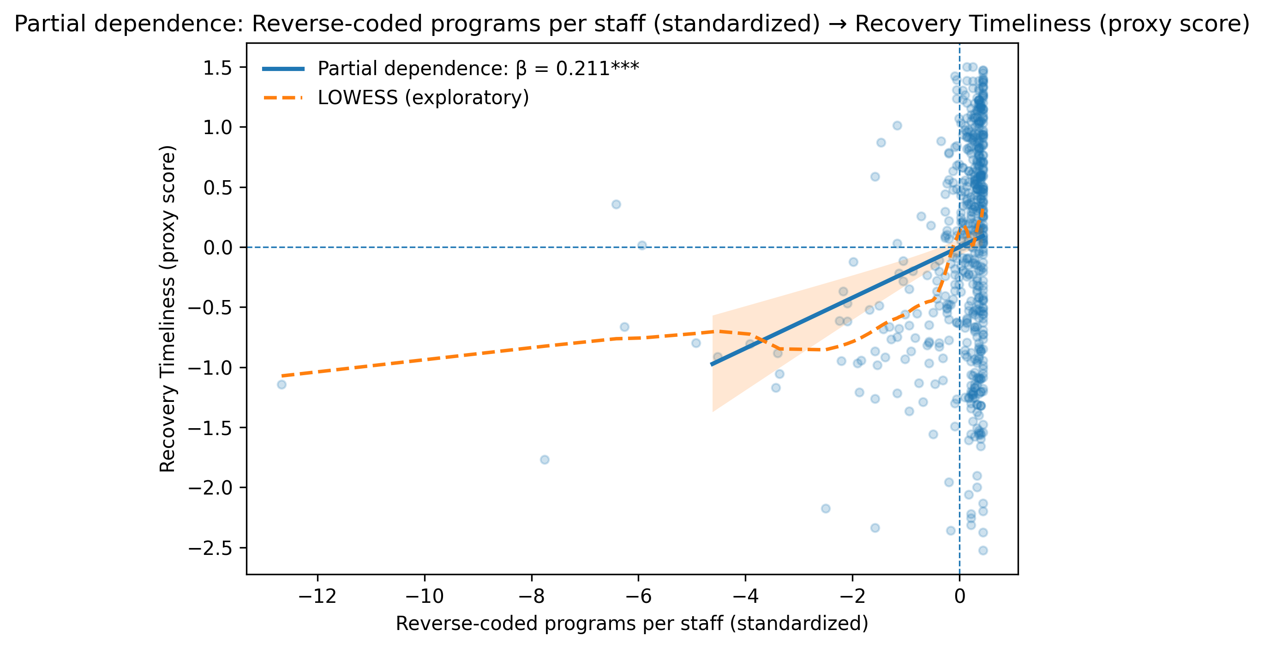Figure A1. Indicator-level partial dependence plots between programs per staff and recovery timeliness.
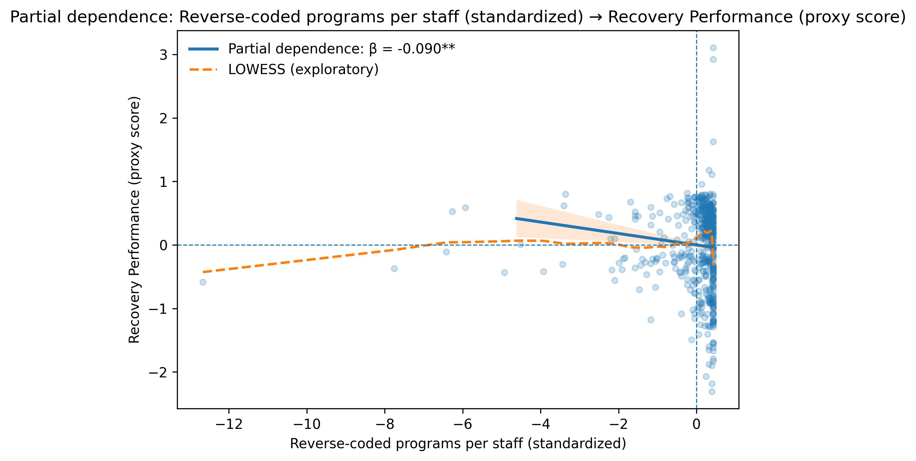Figure A2. Indicator-level partial dependence plots between programs per staff and recovery performance.
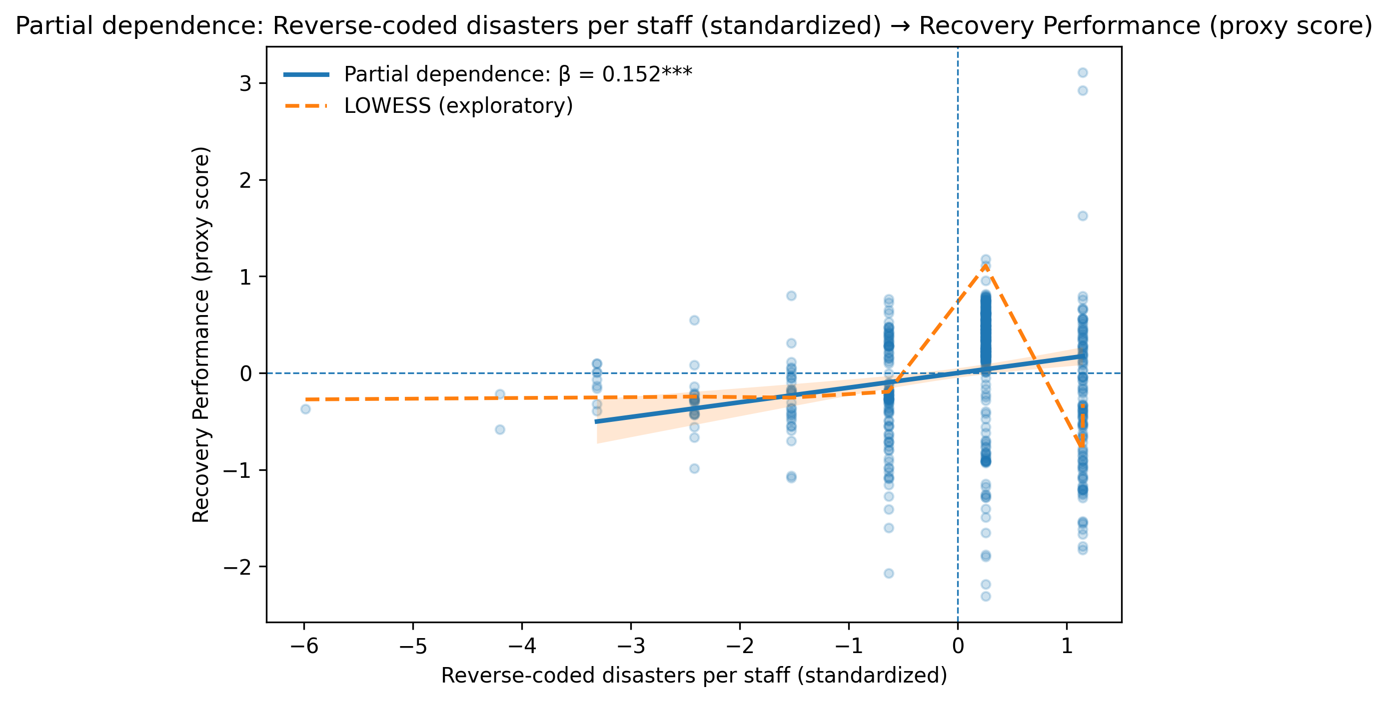Figure A3. Indicator-level partial dependence plots between disasters per staff and recovery performance.
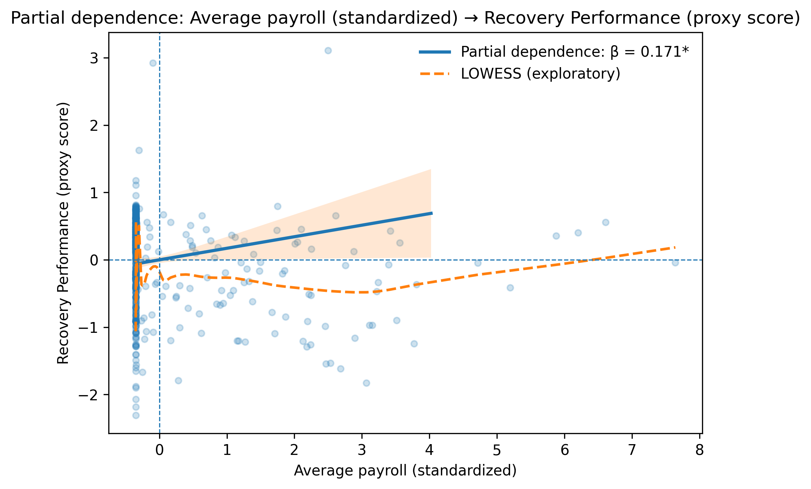Figure A4. Indicator-level partial dependence plots between average payroll and recovery performance.
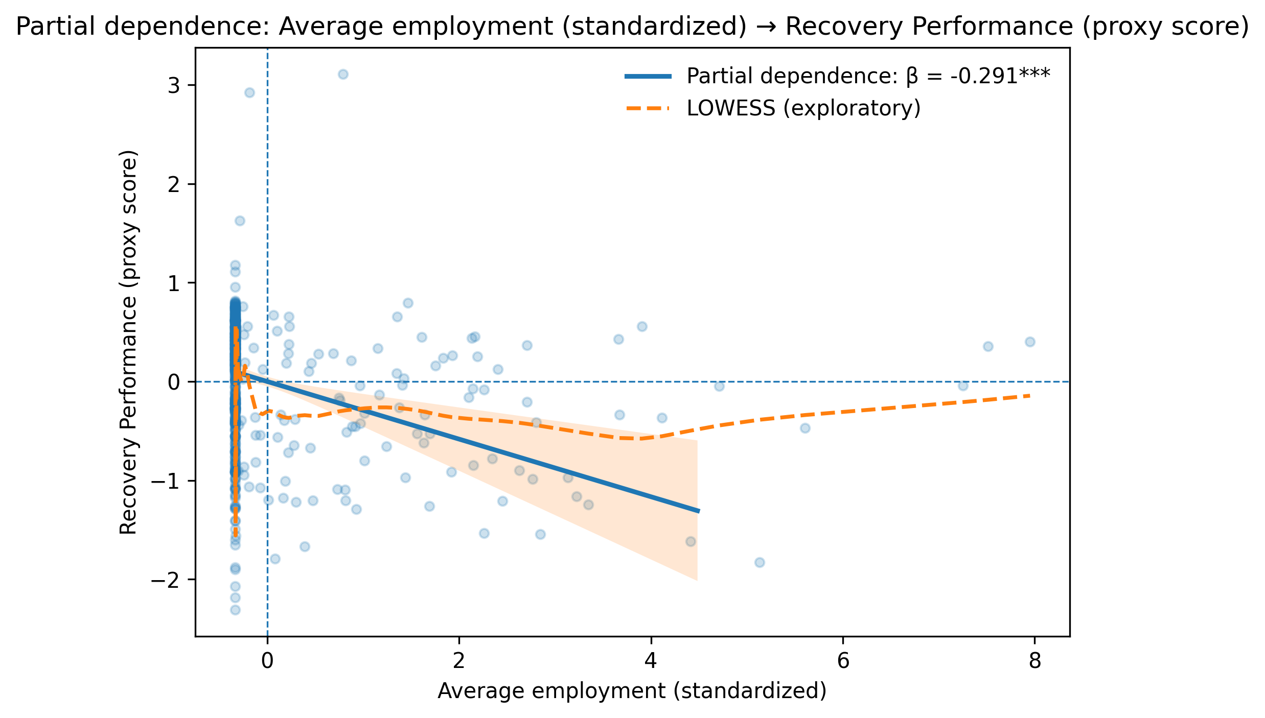
Figure A5. Indicator-level partial dependence plots between average employment and recovery performance.

