State and Local Governmental Capacity in Disaster Recovery: Evidence from CDBG-DR
Kai-Fa Lu ¹, Jesse Andrews ¹, Ali Nejat ¹
¹ CECREH: Center of Excellence in Capacity-building for REsilient Housing, Department of Civil, Environmental and Construction Engineering, Texas Tech University, Lubbock, TX, 79409, USA

Abstract:
As disaster recovery programs administered through the Community Development Block Grant-Disaster Recovery (CDBG-DR) program have expanded in scale, duration, and administrative complexity, understanding state and local governmental capacity has become increasingly important for both planning research and practice. This study revises and extends an earlier manuscript by treating the available evidence as a cross-sectional, associational SEM analysis rather than as a causal or moderation design. Using HUD DRGR/QPR records aggregated to 573 grantee-level profiles (30 state agencies and 543 local governments) for disaster cohorts spanning 2003 through 2023, together with QCEW-based staffing/payroll proxies, contextual population measures, and CDC/ATSDR SVI covariates, we compare a one-factor and a two-factor model of governmental capacity. The two-factor specification distinguishes Administrative Resources from Administrative Burden Capacity and fits the data better on chi-square, CFI, TLI, and RMSEA, whereas the one-factor model retains lower AIC and BIC. We therefore interpret the two-factor model as the main substantive specification, but not as an unambiguously superior confirmatory model. In the revised results, Administrative Burden Capacity is most consistently associated with Recovery Timeliness (standardized beta = 0.266, p < 0.001), while Administrative Resources are negatively associated with Recovery Performance (standardized beta = -0.170, p < 0.001). Social vulnerability also matters: minority/language vulnerability is negatively associated with Recovery Performance, and socioeconomic as well as household composition/disability vulnerability are negatively associated with Recovery Timeliness. Spatial maps, gap diagnostics, and the Recovery Governance Risk Index are retained as descriptive screening tools rather than as fully audited causal metrics. Overall, the revised manuscript supports a workload-sensitive and explicitly exploratory interpretation of governmental capacity in disaster recovery.
Keywords: Disaster recovery; Governmental capacity; Administrative burden; Social vulnerability; Structural Equation Modeling (SEM)

1. Introduction
The effective administration of disaster recovery funds from the U.S. Department of Housing and Urban Development (HUD) across affected jurisdictions is central to advancing equitable and timely community recovery. In the United States, the Community Development Block Grant-Disaster Recovery (CDBG-DR) program has become one of the largest and most flexible sources of long-term recovery assistance following major disaster declarations (Costa et al., 2026). Yet despite its national importance, the pace at which grantees (e.g., states, counties, and cities) obligate, disburse, and expend CDBG-DR funds varies markedly across jurisdictions and disaster events. Slow or inconsistent financial performance has been repeatedly linked to delayed housing reconstruction, prolonged displacement, uneven economic recovery, and persistent inequities for low-income households and historically marginalized communities (Rouhanizadeh et al., 2020 & 2022).
A key factor influencing financial performance and program outcomes is the capacity of grantees to administer CDBG-DR funds (Miao et al., 2025). However, governmental capacity in disaster recovery is inherently difficult to measure directly. Prior studies have often relied on single-period financial indicators (Cevik & Huang, 2018; Dzigbede et al., 2020; Lindsay, 2014) or case-based assessments (Hamideh, 2015; Rosas et al., 2021), which limit the ability to compare capacity across time, jurisdictions, and disaster contexts. The Quarterly Performance Reports (QPRs) submitted through HUD’s Disaster Recovery Grant Reporting (DRGR) system provide a valuable opportunity to develop comprehensive and comparable indicators of capacity. These reports consistently record quarterly obligated, disbursed, and expended amounts for each grantee and activity, generating rich panel data that enable systematic evaluation of financial performance and program timeliness. Nevertheless, raw financial measures alone cannot fully capture the multidimensional nature of governmental capacity in disaster recovery, which reflects the combined effects of administrative resources, administrative burden capacity, and recovery outcomes (Kusumasari et al., 2010).
Therefore, this research aims to answer the following research questions:
- How can state and local governmental capacity to administer CDBG-DR funds be conceptualized, operationalized, and empirically measured?
- How is variation in state and local governmental capacity associated with disaster recovery program outcomes, and which institutional, socioeconomic, and programmatic conditions covary with recovery performance and timeliness?
- What are the spatial patterns of governmental capacity and disaster recovery outcomes, and which regions exhibit elevated capacity gaps, program implementation disparities, recovery performance gaps, or broader governance risks?
To address these questions, this revised manuscript develops a cross-sectional Structural Equation Modeling (SEM) framework to conceptualize, measure, and compare state and local governmental capacity in administering CDBG-DR funds and implementing disaster recovery programs. Using grantee-level profiles constructed from quarterly QPR records and linked contextual covariates, we treat governmental capacity as a latent construct that is observed indirectly through staffing, payroll, and workload-sensitive indicators. The revised paper does not treat this framework as a causal design and does not model formal moderation. Instead, state-versus-local differences, jurisdiction size, and social vulnerability enter as covariates in the main SEM and as descriptive subset checks in the supporting discussion. In addition to the SEM analysis, the manuscript retains county- and state-level spatial summaries, gap diagnostics, and a governance risk screen to identify places where disaster demand, institutional workload, and vulnerability appear to overlap most strongly.
This approach advances the literature in three more carefully bounded ways. First, it provides a systematic method for operationalizing governmental capacity in CDBG-DR administration using both resource and workload-sensitive indicators rather than a single throughput ratio. Second, it compares a one-factor and a two-factor SEM so that the measurement tradeoffs are visible instead of being hidden behind a single preferred specification. Third, it retains spatial and gap-based diagnostics as policy-screening tools while making clear that these extensions are descriptive, exploratory, and only as strong as the underlying linkage and measurement assumptions.
2. Literature Review
2.1. Institutional context of CDBG-DR administration and implementation performance
CDBG-DR funding has expanded substantially over the past two decades, allocating billions of dollars in response to major hurricanes, floods, wildfires, and other disasters (Costa et al., 2026). As a block-grant program, CDBG-DR provides grantees with considerable flexibility in designing and implementing recovery programs. However, this flexibility also introduces significant administrative burden, particularly in ensuring that funds are obligated, disbursed, and expended efficiently and in compliance with federal requirements. Numerous evaluations have documented persistent delays in grant implementation, including challenges related to procurement processes, environmental reviews, and program start-up activities (Costa et al., 2026; Martín, 2018; Miao et al., 2025; U.S. Department of Housing and Urban Development, 2026). Additionally, grantees or governments vary substantially in their prior experience with disaster recovery programs, staffing capacity, and administrative procedures – factors that can significantly influence the timeliness and effectiveness of fund deployment and program implementation (Martin et al., 2022; Melendez, 2020; Van Niekerk et al., 2018).
Despite the growing scale and importance of CDBG-DR funding, relatively limited research has systematically measured grantees’ governmental capacity or examined its role in shaping fund administration and program implementation. One major challenge is the historical lack of comprehensive, structured datasets that enable consistent analysis of CDBG-DR fund deployment. Although HUD requires quarterly reporting through the DRGR system via QPRs, which document obligated, disbursed, and expended amounts by grantee, activity, and reporting period, these data have not yet been widely leveraged by auditors, HUD practitioners, or researchers to model the latent dimensions or underlying determinants of administrative capacity. Instead, prior studies have generally relied on descriptive summaries or aggregate comparisons to evaluate financial performance (Costa et al., 2026; Martín, 2018). This limitation constrains a more comprehensive understanding of how governmental capacity influences fund utilization and, ultimately, the effectiveness and performance of disaster recovery efforts.
2.2. Methodological approaches for disaster recovery administration assessments
In general, four primary approaches have been used to evaluate fund administration performance in disaster recovery. The first approach consists of descriptive and programmatic analyses. For example, the U.S. HUD and the Government Accountability Office (GAO) frequently publish summary reports that highlight variation in fund utilization rates across grantees (U.S. Government Accountability Office, 2026; U.S. Department of Housing and Urban Development, 2026). Academic and think-tank studies similarly document patterns in program launch timelines, housing completions, and expenditure trajectories (Drew, 2024). While these studies reveal substantial variation in performance, they generally do not examine the institutional mechanisms that drive differences in disaster recovery outcomes. The second approach involves regression-based and panel-data analyses. Many studies in public administration and planning apply regression or longitudinal panel models to examine how factors such as staffing levels, administrative experience, governance structure, or disaster severity influence the pace of fund implementation, recovery outcomes, and broader disaster resilience (Cutter et al., 2016; Lee, 2019; Nor, 2025). Although these approaches provide useful empirical insights, they typically treat financial indicators as directly observed outcome variables and do not account for the possibility that governmental capacity is a latent construct reflected through multiple interrelated indicators.
The third approach consists of case studies and qualitative evaluations. Qualitative research provides an in-depth understanding of administrative processes and identifies common implementation barriers, including complex procurement requirements, extensive environmental review procedures, and coordination challenges across agencies (Jordan et al., 2014; Ospina et al., 2018; Rouhanizadeh et al., 2020). These studies offer valuable contextual insights but are generally limited in their ability to support systematic comparison across jurisdictions or disasters. The fourth approach involves latent-variable methods, particularly Structural Equation Modeling (SEM). Within the broader disaster research literature, SEM has been applied to measure multidimensional constructs such as preparedness, perceived risk, institutional resilience, and adaptive capacity (Geddam & Kiran, 2024; Gendeshmin et al., 2025; Gerona & Nabe, 2026). However, applications of SEM to federal disaster recovery finance remain limited. In particular, few studies have utilized longitudinal QPR data to develop latent measures of governmental capacity in administering CDBG-DR funds. To date, no study has systematically constructed a latent representation of governmental capacity to examine its relationship with disaster recovery outcomes or to assess how contextual factors moderate the capacity-outcome relationship.
2.3. Administrative capacity in disaster recovery: Patterns, gaps, and research needs
Building on the four approaches discussed above, two consistent patterns emerge in the study of disaster recovery administration. First, there is substantial variation across grantees in how disaster recovery funds are administered (Costa et al., 2026). For example, grantees differ widely in their pace of obligations, disbursements, and expenditures, as well as in the implementation and outcomes of disaster recovery programs (Martin, 2018). Second, administrative processes strongly influence recovery timelines (Martin et al., 2019; Safapour et al., 2021). Delays often arise from procurement rules, environmental reviews, inconsistent staffing, and challenges in inter-agency coordination. Moreover, institutional capacity and social vulnerability – not merely disaster severity – play a critical role in shaping the speed and effectiveness of recovery efforts (Miao et al., 2025; Peacock et al., 2014).
Despite progress in understanding disaster recovery administration, several gaps remain. First, there is no latent, multidimensional measure of governmental capacity, as existing studies do not integrate multiple administrative indicators – such as staffing levels, resources, payroll, workload, recovery programs, and disaster events – into a unified construct. Second, cross-hazard and cross-jurisdiction comparisons are limited; few analyses systematically compare performance across disaster types or evaluate differences in administrative capacity between state and local governments. Third, the relationship between governmental capacity and disaster recovery outcomes, including the moderating effects of factors such as social vulnerability, remains insufficiently explored. Fourth, a weak operational linkage persists between research metrics and management tools. For instance, although QPR data are widely used, there are no validated diagnostic indicators that connect observed financial performance to underlying capacity metrics for HUD or grantees.
In summary, a critical need exists to model governmental capacity and conduct comparative analyses to provide a comprehensive understanding of how state and local governments manage obligated, disbursed, and expended CDBG-DR funds, particularly regarding their impact on disaster recovery performance and timeliness across jurisdictions. This study addresses this gap by constructing a latent measure of governmental capacity using existing administrative resources and QPR data, and by applying an SEM approach to evaluate the relationship between administrative capacity and disaster recovery outcomes, as well as the influence of key moderating factors. Furthermore, this study develops the capacity gap, implementation gap, performance gap, and governance risk index to analyze how different governments respond to disaster recovery following disaster events and to quantify capacity differences across jurisdictions. By integrating administrative resources, recovery outcomes, and control variables (e.g., social vulnerability and jurisdiction size) into a unified analytic framework, the study establishes a rigorous, replicable, and policy-relevant method for understanding governmental capacity in the administration of CDBG-DR funds and supporting effective disaster recovery implementation.
3. Data
3.1 Data Description and Sources
The QPR dataset was obtained from the U.S. Department of Housing and Urban Development's DRGR reporting system and contains quarterly information on obligated, disbursed, and expended CDBG-DR funds for grants and reporting activities. In the raw archive, these records span 18 disaster contexts from 2003 through 2023 and include thousands of organization labels that appear in grantee and activity fields (U.S. Department of Housing and Urban Development, 2026). For the present manuscript, the quarterly records were first used to construct performance indicators at the jurisdiction-quarter level, including the disbursed-to-obligated ratio, the expended-to-disbursed ratio, the share of obligated funds fully expended, the proportion of programs completed, the duration of grant completion, and the average duration of program completion. In this manuscript, grant denotes the disaster-specific CDBG-DR allocation, whereas activity denotes the underlying DRGR/QPR reporting unit nested within a grantee's disaster portfolio. Those quarterly indicators were then aggregated to grantee-level profiles for the cross-sectional SEM.
Administrative resource data were drawn from the U.S. Bureau of Labor Statistics Quarterly Census of Employment and Wages (QCEW). The later SEM workflow represented in the imported external export bundle uses employment and payroll measures tied to NAICS 925110 (Administration of Housing Programs) as indirect proxies for disaster-recovery administrative resources (U.S. Bureau of Labor Statistics, 2026). These measures are useful because they provide a standardized national frame, but they should not be interpreted as direct counts of staff assigned specifically to CDBG-DR. Disaster recovery administration may be distributed across agencies, temporary teams, contract support, and cross-departmental arrangements that are only partially captured by this industry code. Accordingly, employment and payroll are used here as coarse administrative-resource indicators rather than exact staffing measures.
Finally, contextual measures of social vulnerability were derived from the CDC/ATSDR Social Vulnerability Index (SVI) at the state and county levels. The analysis uses the four standard SVI themes - socioeconomic status, household composition and disability, minority status and language, and housing type and transportation - as broad contextual covariates rather than as precise longitudinal trend measures (CDC/ATSDR, 2026). Because CDC warns against literal cross-vintage comparison of SVI percentiles without careful harmonization, the revised manuscript interprets these variables as standardized contextual descriptors in the final SEM-ready dataset, not as year-by-year measures of change.
3.2. Data Cleaning and Preprocessing
To prepare the QPR dataset for subsequent modeling analysis, a series of systematic data cleaning procedures were implemented to standardize key geographic and organizational variables and enhance data reliability. First, the “Grantee State” variable was standardized to ensure consistent formatting across observations. State names were cleaned by removing extra whitespace and correcting inconsistent capitalization. A formatted state identifier was then generated by appending the suffix “state” (e.g., Texas state) to improve clarity and consistency in later processing steps. Second, the “Activity Responsible Org” field was normalized to reduce inconsistencies in organization names. This process included trimming leading and trailing whitespace, removing punctuation and special characters, and standardizing common abbreviations (e.g., Co. to County, Dept. to Department, Auth. to Authority). These procedures improved naming consistency and reduced potential matching errors in subsequent geographic identification.
Third, a new geographic identifier was constructed to determine the county and state associated with each Activity Responsible Org. The matching workflow followed a hierarchical approach: explicit county or parish names embedded in organization titles were matched first, and remaining records were linked through city-to-county lookup tables and manual review of unresolved cases. City-level entities were then aggregated to counties, while statewide departments, agencies, authorities, and similar organizations were aggregated to state-agency profiles. This procedure provided a workable geography layer for descriptive mapping, but it should not be treated as a fully audited Census relationship-file reconstruction. Geography-dependent findings are therefore interpreted as informative spatial summaries rather than as exact administrative-boundary measures.
Finally, a quality-control framework was implemented to evaluate the reliability of the inferred geographic information. Each record was categorized by match type (for example, explicit county match, city-to-county match, or unresolved) and flagged for manual review when automated inference was uncertain. Records with fewer than four quarterly observations were excluded from the cross-sectional SEM input because such short reporting histories do not provide enough information to summarize recovery performance or timeliness reliably. After filtering, the cleaned quarterly input contained 130,490 valid jurisdiction-quarter records. These records were subsequently aggregated to 573 grantee-level profiles - 30 state agencies and 543 local governments - which form the analytical sample used in the revised SEM reported below.
4. Methods: Structural Equation Modeling (SEM)
4.1. Model selection and unit of analysis
This study employs structural equation modeling (SEM) to develop latent constructs representing governmental capacity and disaster recovery outcomes and to evaluate the cross-sectional associations among them. The revised design does not estimate moderation effects. Instead, the state-versus-local indicator, jurisdiction size, and social vulnerability measures enter the SEM as observed covariates, and any state/local contrasts discussed later in the paper are treated as descriptive subset comparisons rather than as formal interaction tests. SEM remains useful in this setting because both governmental capacity and recovery outcomes are not directly observable and must be inferred from multiple indicators measured on different scales.
This approach is especially valuable because governmental capacity is not directly observable and must instead be inferred from measurable proxies, such as administrative resources and workload characteristics (El-Taliawi & Van Der Wal, 2019). By integrating measurement and structural components into a single analytical framework, SEM provides a rigorous method for evaluating both the validity of latent constructs and the strength of their relationships with disaster recovery performance outcomes.
Building on that framework, the revised analysis uses a cross-sectional dataset of 573 grantee profiles, including 30 state agencies and 543 local governments. Each observation summarizes a grantee's administrative-resource and recovery-outcome profile across the study window rather than representing a single quarter or a single disaster episode. This aggregation permits a national SEM, but it is also a strong modeling assumption: it treats a jurisdiction's recovery administration as sufficiently stable to be summarized as one profile despite variation across disaster cohorts, federal policy periods, staffing arrangements, and portfolio complexity. The revised manuscript therefore interprets the SEM as a cross-sectional synthesis of grantee tendencies, not as a longitudinal model of within-jurisdiction change.
4.2. Conceptualization of governmental capacity
In this study, governmental capacity is conceptualized as the institutional ability of public agencies to administer CDBG-DR funds under differing levels of workload and contextual constraint. The revised two-factor specification decomposes that capacity into Administrative Resources and Administrative Burden Capacity. Administrative Resources are represented by staffing and payroll intensity proxies derived from QCEW-based employment and payroll measures, while Administrative Burden Capacity is represented by workload ratios that scale the number of disaster programs and disaster events by available staffing. This two-part conceptualization makes the measurement logic more transparent than a one-factor specification because it separates resource levels from workload pressure.
Two additional indicators reflect administrative workload intensity relative to staffing levels: the number of disaster recovery programs per staff (programs_per_staff) and the number of disaster events per staff (disasters_per_staff). Higher workload per staff implies greater administrative strain, not greater capacity. To keep coefficient signs interpretable, both workload measures are reverse-coded so that higher values on the SEM input correspond to lower relative burden and, therefore, more favorable workload conditions.
- avg_employment = total_employments / total_population
- avg_payroll = quarter_total_payroll / total_population
- programs_per_staff = Num_Program / total_employments
- disasters_per_staff = Num_Disaster / total_employments
- rev_programs_per_staff = - programs_per_staff
- rev_disasters_per_staff = - disasters_per_staff
4.3. Conceptualization of disaster recovery outcomes
Disaster recovery outcomes are modeled as two latent constructs: Recovery Performance and Recovery Timeliness. Recovery Performance captures the effectiveness of financial management and program implementation and is measured using four indicators: the disbursed-to-obligated ratio, the expended-to-disbursed ratio, the share of obligated funds fully expended, and the proportion of programs completed. Together, these measures summarize how effectively jurisdictions move funds through the recovery pipeline and convert those funds into completed programs.
Recovery Timeliness represents the speed and consistency of program and grant implementation. It is measured using the duration of grant completion and the average duration of program completion, both reverse-coded so that higher values indicate faster implementation. These are useful summary indicators, but they are also sensitive to maturity and right-censoring. Newer grants and ongoing portfolios have had less time to close out, so the revised manuscript treats timeliness as a cross-sectional summary of observed completion pace, not as a fully uncensored event-history outcome.
Because longer completion durations indicate slower implementation and therefore weaker performance, both duration variables are reverse-coded prior to model estimation. After reverse coding, higher values for all Recovery Timeliness indicators consistently represent faster and more efficient disaster recovery implementation.
- rev_duration_of_grant_completion = - duration_of_grant_completion
- rev_average_duration_program_completion = - average_duration_program_completion
4.4. Control variables
To account for contextual differences across jurisdictions, the SEM includes governmental level, jurisdiction size, and social vulnerability covariates (Peacock et al., 2014; CDC/ATSDR, 2026). Governmental level is represented by a binary indicator coded 1 for state agencies and 0 for local governments. This variable is modeled as a direct predictor and later used to organize descriptive subset comparisons; it is not a moderation term. Jurisdiction size is captured through total population, and the four SVI themes are included as broad contextual controls. Because the final SEM-ready dataset stores these covariates in standardized form, coefficients reflect cross-sectional associations within the aggregated grantee sample rather than temporal effects of changing population or SVI conditions.
4.5. SEM modeling framework
The primary SEM specification decomposes governmental capacity into two related latent dimensions - Administrative Resources and Administrative Burden Capacity - while representing disaster recovery outcomes as two related latent constructs - Recovery Performance and Recovery Timeliness. This specification is used as the main interpretive model because it better separates resource levels from workload pressure and produces stronger conventional fit indices than the one-factor alternative, even though the alternative retains lower AIC and BIC.
Figure 1 presents the integrated conceptual and empirical framework guiding this study. The framework conceptualizes disaster recovery outcomes as the result of interactions among contextual conditions, governmental capacity, and administrative processes. Specifically, jurisdiction size, social vulnerability, and governmental level define the contextual environment within which recovery administration occurs and may influence both governmental capacity and recovery outcomes. These relationships ultimately shape variation in recovery performance and recovery timeliness across jurisdictions, as well as the spatial distribution of administrative governance risk.
The SEM framework enables the analysis to distinguish between the effects of greater administrative resources and those associated with lower relative workload burdens. Both latent capacity dimensions are specified as predictors of Recovery Performance and Recovery Timeliness while controlling for governmental level, jurisdiction size, and the four SVI dimensions. The two capacity dimensions are allowed to covary, as are the two outcome constructs. These are modeled as direct relationships rather than as interaction or moderation effects.
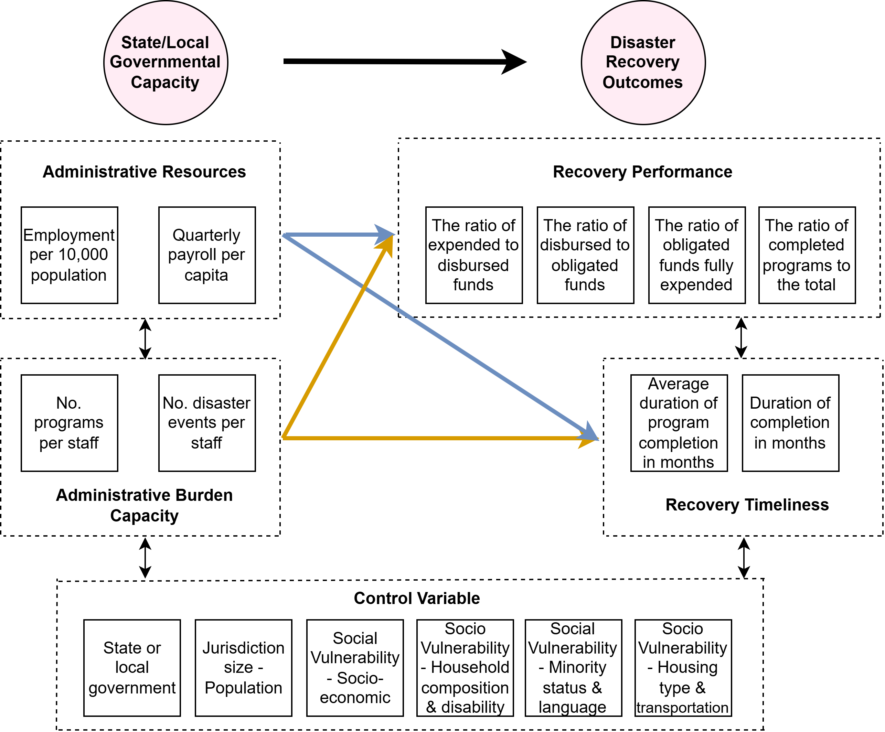
Figure 1. Structural equation model of governmental capacity and disaster recovery outcomes.
Specifically, the SEM framework consists of two components: a measurement model and a structural model, which together are used to examine the mechanisms influencing disaster recovery program outcomes. The measurement model defines the relationships between latent constructs and their observed indicators, ensuring that key concepts – such as governmental capacity and recovery outcomes – are reliably represented by multiple empirical measures.
- AdminResources ← avg_employment, avg_payroll
- AdminBurdenCapacity ← rev_programs_per_staff, rev_disasters_per_staff
- RecoveryPerformance ← ratio_disbursed_to_obligated, ratio_expended_to_disbursed, ratio_total_obligated_funds_fully_expended, ratio_program_completed
- RecoveryTimeliness ← rev_duration_of_grant_completion, rev_average_duration_program_completion
The structural model specifies the relationships between governmental capacity, control variables, and the latent outcome constructs of Recovery Performance and Recovery Timeliness, and is defined as follows:
- RecoveryPerformance ∼ AdminResources + AdminBurdenCapacity + state_or_local + total_population + SVI controls
- RecoveryTimeliness ∼ AdminResources + AdminBurdenCapacity + state_or_local + total_population + SVI controls
The working expectation is that jurisdictions with greater administrative resources and lower relative workload pressure will exhibit stronger recovery outcomes. In the revised manuscript, however, this expectation is treated as a cross-sectional associational hypothesis rather than as a claim of causal identification.
4.6. Experimental design and model estimation
Two model-comparison and sensitivity strategies were implemented. First, the analysis compares a two-factor SEM, in which Administrative Resources and Administrative Burden Capacity are estimated separately, with a one-factor SEM that combines all four indicators into a single Governmental Capacity factor. Second, the manuscript reviews a smaller imported robustness bundle (baseline_sem_admin_4; N = 169) that preserves an alternative cleaned sample from the later Kaifa workflow. Because the original filtering script for that smaller sample is not currently recovered, it is interpreted as a secondary robustness check rather than as a fully auditable outlier-removal procedure.
In the alternative SEM framework, the measurement model for Governmental Capacity (GovCapacity) is defined using four observed indicators: avg_employment, avg_payroll, rev_programs_per_staff, and rev_disasters_per_staff, while the measurement models for the disaster recovery outcome constructs remain unchanged. The structural model then estimates the extent to which governmental capacity influences recovery outcomes – Recovery Performance and Recovery Timeliness – while controlling for governmental level, jurisdiction size, and social vulnerability. The structural relationships are specified as follows:
- RecoveryPerformance ∼ GovCapacity + state_or_local + total_population + SVI controls
- RecoveryTimeliness ∼ GovCapacity + state_or_local + total_population + SVI controls
Prior to SEM estimation, all continuous indicators were standardized as z-scores to improve comparability across variables and to support model convergence. Workload measures use staff-scaled denominators, and the imported later-model bundle indicates that small denominator protections were used where necessary. The SEMs were estimated with maximum likelihood estimation (Lee & Zhu, 2002). Model evaluation relies on a combination of fit statistics - chi-square, CFI, TLI, RMSEA, AIC, and BIC - rather than on a single threshold. The revision therefore treats model comparison as a tradeoff exercise: the two-factor model is substantively more informative and fits better on the main incremental and absolute fit measures, while the one-factor model remains more parsimonious by information criteria.

5. Results
5.1. SEM model comparison
Both SEM specifications were estimated to examine the relationship between governmental capacity and disaster recovery outcomes: (1) a one-factor model in which all four capacity indicators load on a single Governmental Capacity factor and (2) a two-factor model that separates Administrative Resources from Administrative Burden Capacity. Table 1 reports the comparison using the imported later-model SEM export bundle that best matches the current Word manuscript.
Table 1. SEM model fit comparison
Fit index | chi-square | CFI | TLI | RMSEA | AIC | BIC
One-factor capacity model | 741.72 | 0.854 | 0.818 | 0.105 | 67.41 | 219.69
Two-factor capacity model | 469.82 | 0.915 | 0.891 | 0.081 | 74.36 | 239.69
The model comparison reveals a genuine tradeoff rather than an unambiguous winner. The one-factor model has lower information criteria (AIC = 67.41; BIC = 219.69), but the two-factor model fits the covariance structure more convincingly on the conventional SEM diagnostics (chi-square = 469.82 versus 741.72; CFI = 0.915 versus 0.854; TLI = 0.891 versus 0.818; RMSEA = 0.081 versus 0.105). Because the two-factor model aligns more closely with the theory that resources and workload are distinct dimensions of administrative capacity, and because it improves the main fit indices materially, it is used as the primary substantive model in the remainder of the paper. At the same time, the revision explicitly acknowledges that the one-factor alternative is more parsimonious by AIC/BIC, so the two-factor model should be interpreted as preferred conditionally rather than as definitively superior on every criterion.
The measurement parameters of the two-factor model also motivate a cautious but interpretable reading. Within Administrative Resources, standardized loadings are strong for employment (0.953) and payroll (0.992). Within Administrative Burden Capacity, the reverse-coded disasters-per-staff and programs-per-staff indicators load positively, although the programs-per-staff indicator is notably weaker. The two latent capacity dimensions are positively correlated (standardized covariance = 0.402), suggesting that better-resourced jurisdictions also tend to face somewhat more manageable workloads. Outcome measurement is more mixed: three Recovery Performance indicators load positively, but the expended-to-disbursed ratio has a weak negative loading, and the timeliness factor remains heavily duration-based. In the smaller baseline_sem_admin_4 robustness bundle, fit weakens and the burden-capacity paths are no longer statistically distinguishable from zero. These features do not invalidate the two-factor model, but they do argue for interpreting it as an exploratory cross-sectional measurement structure rather than as a final, fully settled confirmatory SEM.
5.2. Structural relationships between governmental capacity and recovery outcomes
The structural results indicate that Administrative Resources and Administrative Burden Capacity relate to different recovery outcomes in different ways. Table 2 reports the standardized structural path coefficients from the two-factor SEM. Figures 2 and 3 show SEM-implied predicted relationship plots to illustrate the direction and relative strength of the main associations.
Table 2. Structural path estimates in the standard SEM framework
Recovery outcome | Predictor | Standardized beta | p-value
Recovery Performance | Administrative Resources | -0.170 | <0.001
Recovery Performance | Administrative Burden Capacity | 0.077 | 0.086
Recovery Performance | State or local government | -0.038 | 0.505
Recovery Performance | SVI Theme 3: Minority status & language | -0.226 | <0.001
Recovery Timeliness | Administrative Resources | 0.080 | 0.072
Recovery Timeliness | Administrative Burden Capacity | 0.266 | <0.001
Recovery Timeliness | State or local government | -0.106 | 0.050
Recovery Timeliness | SVI Theme 1: Socioeconomic | -0.194 | 0.004
Recovery Timeliness | SVI Theme 2: Household composition & disability | -0.159 | 0.004
Note: Table 2 reports standardized coefficients from the two-factor SEM. Exact p-values are shown because several relationships are substantively interesting but only marginal by conventional thresholds.
5.2.1. Relationships with Recovery Performance
Administrative Resources exhibit a negative association with Recovery Performance (beta = -0.170, p < 0.001), indicating that jurisdictions with higher staffing and payroll intensity do not necessarily display stronger financial execution or program completion once workload pressure and contextual conditions are taken into account. By contrast, Administrative Burden Capacity is positive but only marginally associated with Recovery Performance (beta = 0.077, p = 0.086). The revised interpretation is therefore more restrained than in the earlier draft: manageable workload appears helpful for performance, but the evidence is much stronger for timeliness than for the broader Recovery Performance construct.
Among the covariates, SVI Theme 3 (minority status and language vulnerability) shows the clearest association with Recovery Performance (beta = -0.226, p < 0.001). The predicted relationship plot in Figure 2(a) indicates that Recovery Performance tends to decline as minority and language vulnerability increase. This pattern is consistent with the view that socially complex and linguistically diverse recovery environments may require more intensive administrative outreach, coordination, and verification, thereby making financial throughput and completion more difficult.
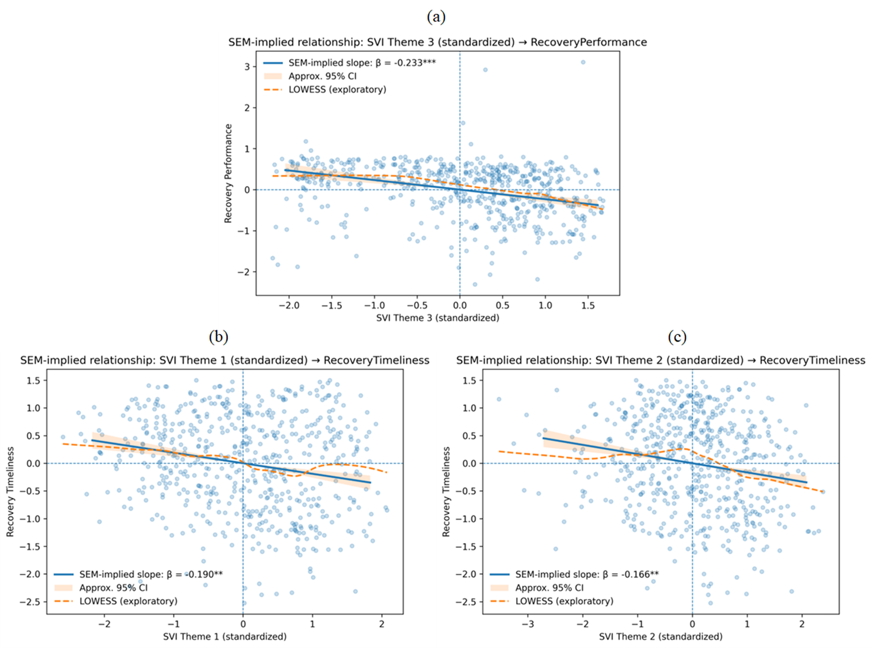
Figure 2. SEM-implied predicted relationship: (a) SVI Theme 3: minority status and language → Recovery Performance, (b) SVI Theme 1: socioeconomic → Recovery Timeliness, and (c) SVI Theme 2: household composition/disability → Recovery Timeliness. Note: LOWESS (Locally Weighted Scatterplot Smoothing) is a nonparametric regression method that fits localized weighted regressions to subsets of the data, producing a smooth curve that reveals underlying patterns and relationships without imposing a predetermined functional specification (Sharma et al., 2015).
5.2.2. Relationships with Recovery Timeliness
For Recovery Timeliness, Administrative Burden Capacity plays the clearest role. Lower workload pressure relative to available staffing is strongly associated with faster and more consistent recovery implementation (beta = 0.266, p < 0.001), indicating that administrative strain is an important constraint on implementation speed. Administrative Resources are positively associated with Recovery Timeliness as well, but only marginally (beta = 0.080, p = 0.072). This contrast reinforces the main substantive message of the revised paper: resource levels matter, but workload manageability appears to be the more consistent cross-sectional correlate of timely recovery administration.
Two dimensions of social vulnerability are also significantly associated with Recovery Timeliness. Higher values of SVI Theme 1 (socioeconomic vulnerability) and SVI Theme 2 (household composition and disability) are associated with slower implementation (beta = -0.194, p = 0.004; beta = -0.159, p = 0.004). Figures 2(b) and 2(c) show these downward patterns. The results suggest that jurisdictions serving more socioeconomically vulnerable and demographically constrained populations may face additional administrative frictions that slow recovery even after capacity proxies are taken into account.
The state-versus-local indicator is not statistically meaningful for Recovery Performance (beta = -0.038, p = 0.505) and is only borderline negative for Recovery Timeliness (beta = -0.106, p = 0.050). The revised manuscript therefore does not describe governmental level as a moderator of capacity effects. Instead, the state/local indicator functions as a control variable and a descriptive comparison device. The negative sign for timeliness suggests that local governments may, on average, move somewhat faster than state agencies once other covariates are controlled, but the evidence is too modest to support strong claims about institutional superiority.
5.2.3. SEM-implied predicted relationship plots between capacity and outcomes
The SEM-implied predicted relationship plots further indicate that Administrative Burden Capacity explains more of the visible variation in recovery outcomes than Administrative Resources alone. Figures 3(a) and 3(b) show upward associations between Administrative Burden Capacity and both Recovery Performance and Recovery Timeliness, with the relationship appearing substantially stronger for timeliness. These plots are useful visualization tools, but they should not be interpreted as machine-learning partial dependence plots or as evidence of nonlinear causal effects. They are derived from the fitted SEM and are therefore best read as model-implied association curves.

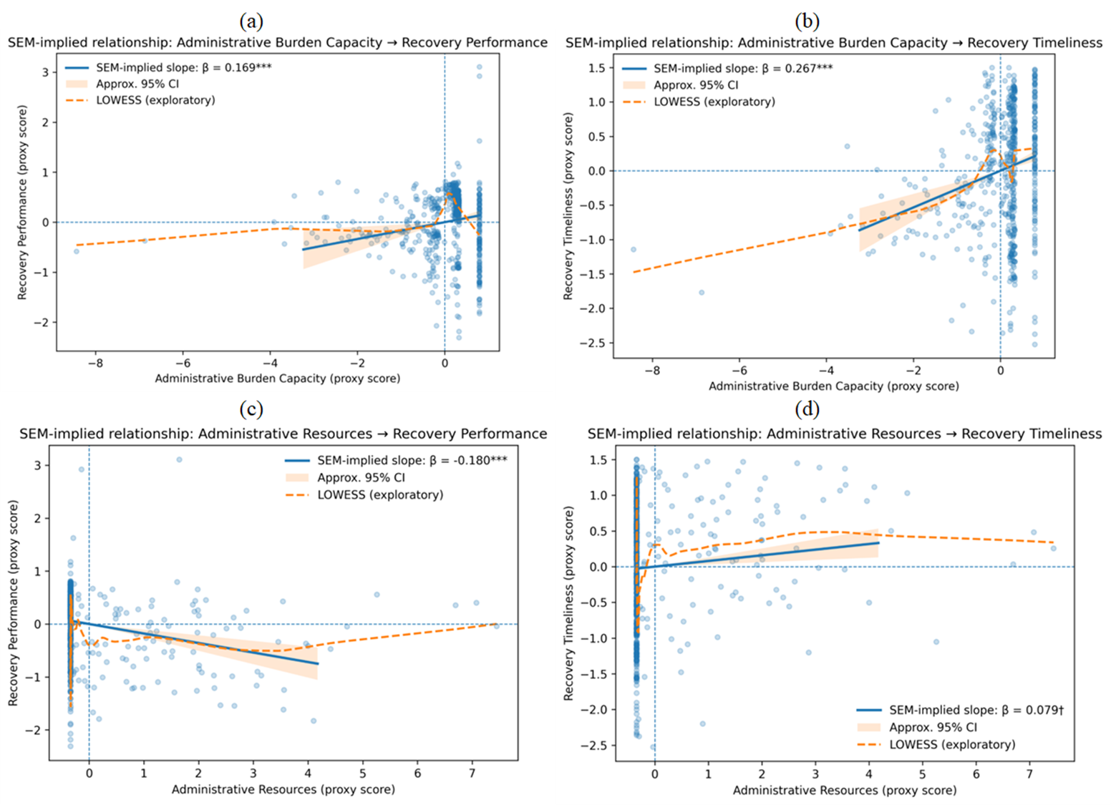
Figure 3. SEM-implied predicted relationship: (a) Administrative Burden Capacity -> Recovery Performance, (b) Administrative Burden Capacity -> Recovery Timeliness, (c) Administrative Resources -> Recovery Performance, and (d) Administrative Resources -> Recovery Timeliness.
Administrative Resources exhibit a more complex relationship with recovery outcomes. Figure 3(c) mirrors the negative coefficient reported in Table 2 for Recovery Performance, whereas Figure 3(d) reflects the weaker positive association with Recovery Timeliness. One plausible interpretation is that larger staffing and payroll footprints are characteristic of more complex or higher-demand recovery portfolios. Once workload is modeled explicitly, the resource indicators no longer behave like simple monotonic measures of administrative effectiveness.
It is also important to note that most state agencies and local governments (counties) maintained relatively limited staffing resources dedicated to administering CDBG-DR housing recovery programs, as illustrated in Figure 3. As a result, the standardized values of both Administrative Resources and Administrative Burden Capacity were concentrated near zero for many jurisdictions, leading to more modest and sometimes less stable marginal effects across recovery outcomes. This suggests that improving recovery outcomes requires not only reducing administrative workload pressures but also strengthening staffing and fiscal resources. However, increasing administrative resources alone is insufficient to ensure effective recovery implementation. Rather, enhancing administrative capacity requires a balanced combination of adequate resources and manageable program demands, although the results indicate that manageable workload conditions played a particularly critical role in supporting successful recovery outcomes.
In addition to the SEM-implied predicted relationship plots, supplementary indicator-level predicted relationship plots were generated using the observed variables that underlie the latent capacity constructs. These figures are presented in Appendix Figures A1-A5. They display greater dispersion because the observed variables are skewed and include more extreme values, but they generally support the same broad interpretation: staff-scaled workload measures are more consistently aligned with recovery timeliness than raw resource intensity alone.
5.3. Spatial patterns of governmental capacity and recovery outcomes
To complement the SEM results, descriptive spatial analyses were conducted to examine the geographic distribution of governmental capacity and disaster recovery outcomes across U.S. counties. Figures 4(a)-4(d) illustrate the standardized county-level patterns of Administrative Resources, Administrative Burden Capacity, Recovery Performance, and Recovery Timeliness, respectively, while Figures 5(a) and 5(b) present quadrant classifications that jointly characterize Administrative Burden Capacity with Recovery Timeliness and Recovery Performance. These maps are intended as descriptive overlays and screening tools rather than as statistical tests of spatial dependence.
5.3.1. Spatial patterns of latent capacity-outcome constructs
The spatial distribution of Administrative Resources (Figure 4(a)) revealed a highly uneven pattern, with relatively high levels concentrated in a limited number of counties, particularly in parts of the Northeast, Midwest, and selected metropolitan areas. In contrast, many counties across the South and interior regions exhibited comparatively lower levels of staffing and payroll intensity. This pattern reflects broader regional disparities in governmental fiscal and institutional capacity, suggesting that administrative resources were spatially clustered rather than uniformly distributed. Further, the results indicate that administrative resources remained limited in most counties, highlighting persistent constraints in local staffing and fiscal capacity for administering disaster recovery programs.
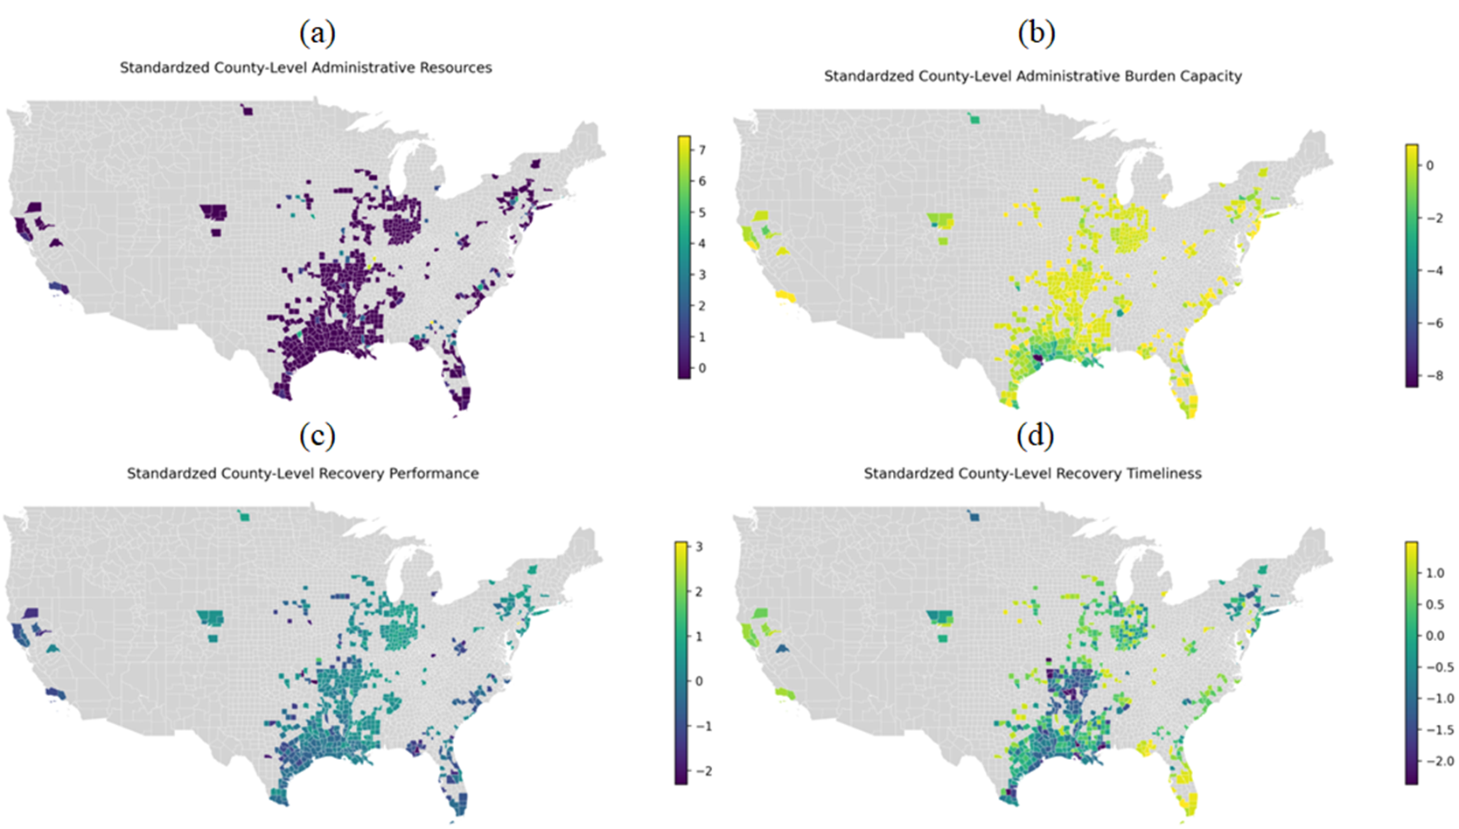
Figure 4. Spatial distributions of standardized latent constructs at county levels: (a) Administrative Resources, (b) Administrative Burden Capacity, (c) Recovery Performance, and (d) Recovery Timeliness.
In contrast, Administrative Burden Capacity (Figure 4(b)) exhibited a distinct spatial pattern. Many counties in the Midwest and portions of the Northeast demonstrated relatively high burden capacity (i.e., lower administrative workload per staff), whereas several counties in the Gulf Coast and other disaster-prone southern regions displayed lower burden capacity, indicating higher programmatic and disaster-related workloads relative to available staffing levels. The differences between the spatial distributions of Administrative Resources and Administrative Burden Capacity suggest that resource availability alone did not fully capture governments’ operational ability to manage disaster recovery demands.
The spatial patterns of Recovery Performance (Figure 4(c)) and Recovery Timeliness (Figure 4(d)) further revealed substantial geographic heterogeneity. Higher levels of Recovery Performance were observed in parts of the Midwest and Northeast, whereas relatively lower performance was more common in the Gulf Coast and southern regions. A similar spatial pattern emerged for Recovery Timeliness, with slower implementation concentrated in areas experiencing higher administrative burden. These spatial patterns are broadly consistent with the SEM results, reinforcing the finding that Administrative Burden Capacity played a more influential role than resource levels alone in shaping disaster recovery outcomes.
5.3.2. Quadrant distributions of burden capacity and recovery constructs
Focusing on Administrative Burden Capacity as the central dimension of governmental capacity, we further developed quadrant maps illustrating its joint distribution with Recovery Performance and Recovery Timeliness. These maps provide a spatial typology of jurisdictions based on the interaction between administrative workload conditions and recovery outcomes.
Figure 5. Quadrant map of the joint distribution of standardized Administrative Burden Capacity and (a) Recovery Timeliness and (b) Recovery Performance at the county level.
Figure 5(a) compares Administrative Burden Capacity and Recovery Timeliness, revealing four distinct county typologies. Counties classified as high capacity and high timeliness are distributed across several regions, indicating strong alignment between manageable administrative workload and efficient program implementation. In contrast, clusters of low capacity and low timeliness appear prominently in the Gulf Coast and southern regions, suggesting that administrative constraints may substantially hinder the pace of recovery in these areas. Counties characterized by high capacity but low timeliness indicate that factors beyond workload - such as institutional complexity or regulatory bottlenecks - can also delay implementation.
Figure 5(b) shows a similar but less clean relationship for Recovery Performance. Counties exhibiting high capacity and high performance are more common in parts of the Midwest and Northeast, reinforcing the practical importance of manageable administrative workloads. At the same time, the presence of high-capacity but low-performance counties, and vice versa, underscores the earlier SEM result that the performance construct is more multidimensional and less tightly linked to the burden-capacity factor than timeliness is.
Overall, the spatial summaries reinforce the central descriptive conclusion that Administrative Burden Capacity is more closely aligned with recovery outcomes than the absolute level of Administrative Resources alone. The quadrant maps also reveal that mismatches between capacity and recovery outcomes are geographically clustered. However, because the geography layer relies on hierarchical name matching and county aggregation, these patterns should be interpreted as screening evidence for follow-up investigation rather than as definitive jurisdictional rankings.
5.4. Spatial patterns of disaster-capacity-outcome gaps
To account descriptively for the influence of disaster exposure, the study introduces three gap diagnostics: the administrative burden capacity gap, the recovery implementation gap, and the recovery performance gap. In conceptual terms, these can be written as standardized difference scores comparing disaster exposure with (1) Administrative Burden Capacity, (2) Recovery Timeliness, and (3) Recovery Performance. Positive values indicate that disaster demand exceeds the corresponding capacity or outcome measure. These gap metrics are retained in the revision as descriptive heuristics designed to show where exposure appears large relative to capacity or outcomes; they are not treated as fully audited causal estimands.
5.4.1. Spatial patterns of administrative burden capacity gap
The capacity gap quantifies the mismatch between disaster demand and Administrative Burden Capacity, thereby highlighting potential structural constraints in recovery governance. At the county level (Figure 6(a)), high gaps are concentrated along the Gulf Coast and in several southern states, particularly Texas and Louisiana, where frequent disasters coincide with limited burden capacity. In contrast, many counties in the Midwest and Northeast exhibit lower or negative gaps, indicating closer alignment between workload conditions and disaster demand. Interpreted cautiously, this metric flags places where administrative strain may emerge before weak performance is visible in downstream outcomes.
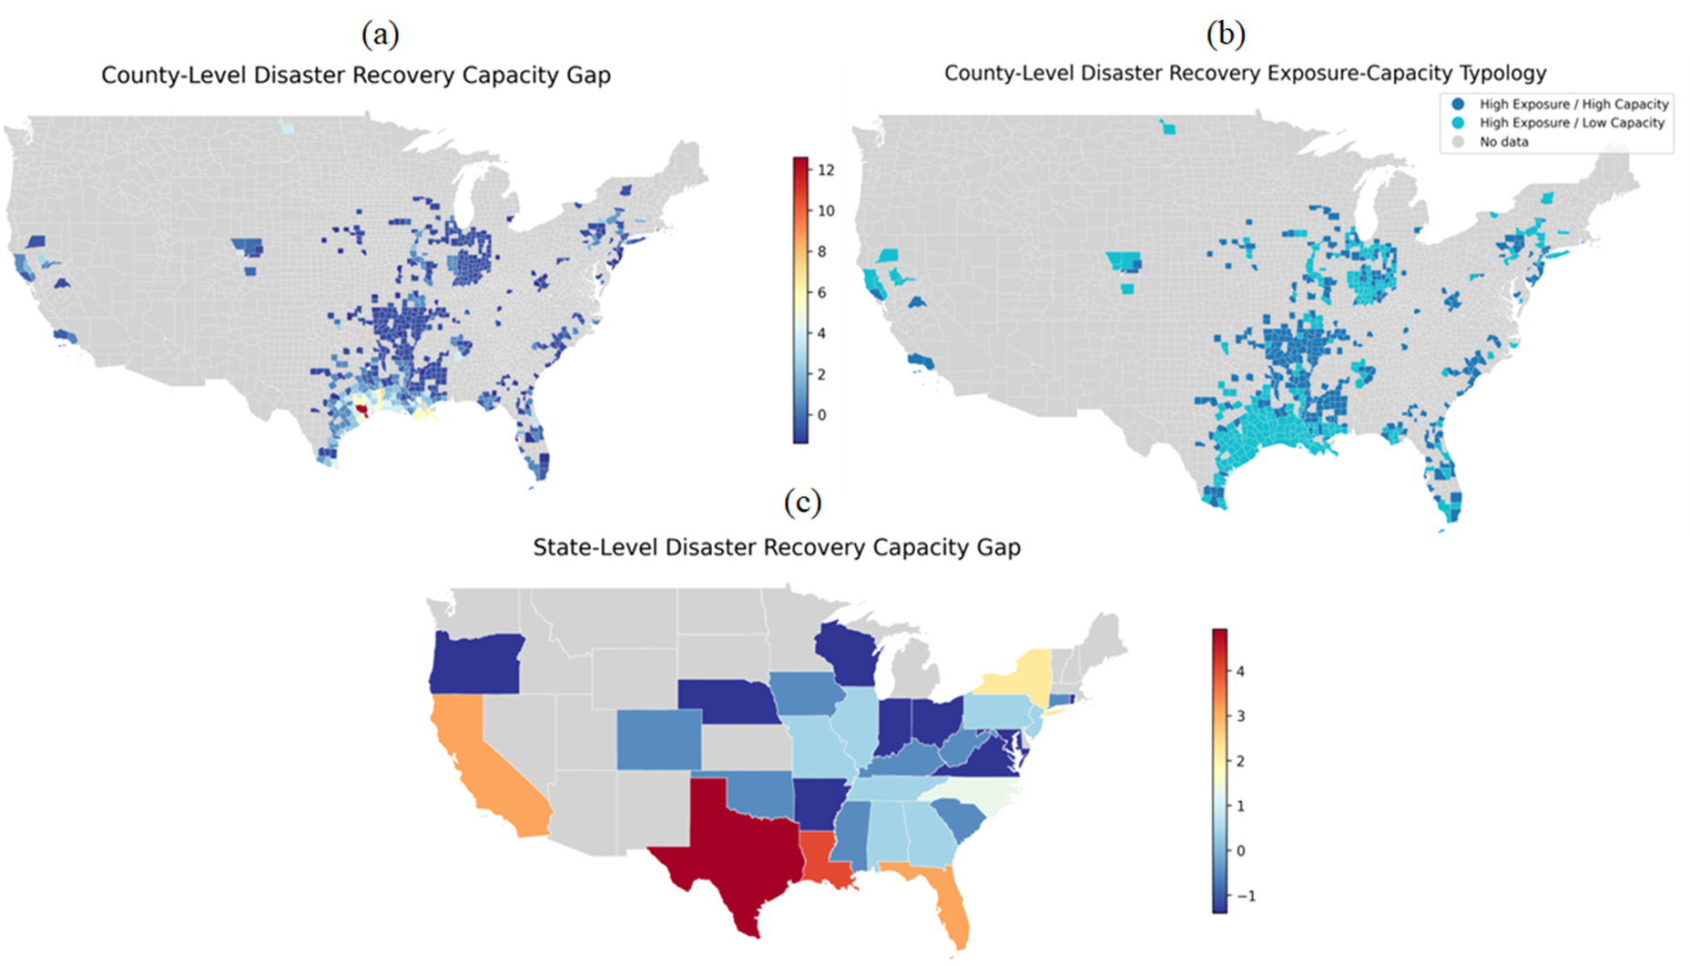Figure 6. Spatial distributions of (a) county-level administrative burden capacity gap, (b) county-level disaster recovery exposure-capacity typology, and (c) state-level administrative burden capacity gap.
The exposure-capacity typology (Figure 6(b)) further illustrated that counties with high exposure-low capacity faced the greatest institutional stress, whereas high exposure-high capacity counties, more common in the Midwest and Northeast, reflected more resilient administrative systems. State-level patterns (Figure 6(c)) reinforced these disparities: Gulf Coast states displayed the largest gaps, while Midwestern and northern states generally showed stronger alignment between capacity and disaster exposure. Uniquely, this gap emphasized upstream administrative constraints, identifying regions where institutional resources were insufficient relative to disaster demand, independent of recovery timelines or outcomes.
5.4.2. Spatial patterns of disaster recovery implementation gap
The implementation gap measures whether disaster exposure is accompanied by comparatively slow recovery implementation, using Recovery Timeliness as the outcome side of the difference score. At the county level (Figure 7(a)), high implementation gaps again concentrate along the Gulf Coast, particularly in Texas and Louisiana, where high exposure coincides with slower recovery timelines. High exposure-high timeliness counties are more common in the Midwest and Northeast, suggesting more efficient translation of administrative capacity into timely action under heavy recovery demand.
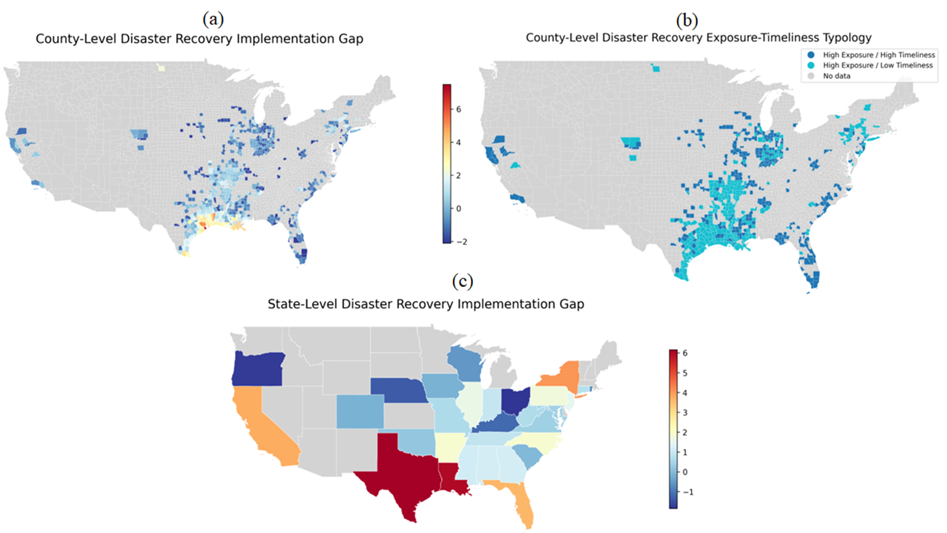Figure 7. Spatial distributions of (a) county-level disaster recovery implementation gap, (b) county-level disaster recovery exposure-implementation typology, and (c) state-level disaster recovery implementation gap.
The county-level exposure-timeliness typology (Figure 7(b)) identified regions where administrative processes or procedural delays may hinder recovery, even if capacity existed. State-level patterns (Figure 7(c)) confirmed that Texas and Louisiana exhibited the largest gaps, with Florida and California moderately elevated, whereas several Midwestern and northern states showed closer alignment between disaster exposure and recovery speed. Distinct from the capacity gap, this measure focused on the efficiency of translating capacity into timely action, pinpointing operational bottlenecks in disaster recovery governance.
5.4.3. Spatial patterns of disaster recovery performance gap
The performance gap evaluates whether recovery efforts achieve comparatively strong outcomes relative to disaster demand. At the county level (Figure 8(a)), high performance gaps are concentrated along the Gulf Coast, especially in Texas and Louisiana, where high disaster exposure coincides with weaker Recovery Performance scores. Additional clusters appear in parts of the Southeast and along the Atlantic coast. As with the earlier maps, these patterns are descriptive rather than causal, but they help distinguish places where slow implementation is accompanied by broader difficulties in converting funding and administrative effort into completed programs and fully expended obligations.
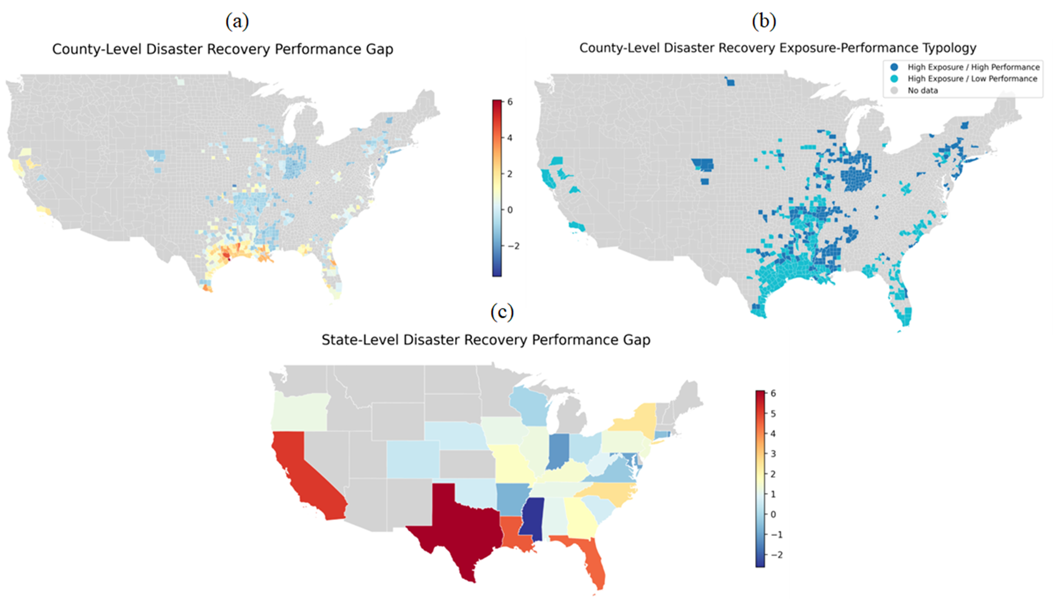Figure 8. Spatial distributions of (a) county-level disaster recovery performance gap, (b) county-level disaster recovery exposure-performance typology, and (c) state-level disaster recovery performance gap.
State-level patterns (Figure 8(c)) showed Texas and California with the largest gaps, while Midwestern and northern states generally exhibited lower gaps, reflecting a more balanced relationship between disaster demand and recovery performance. This measure uniquely captured fund allocation and program outcome effectiveness, complementing the capacity and implementation gaps by revealing where CDBG-DR funds or recovery programs underperformed despite available resources or timely execution.
Taken together, the three gap measures provide a descriptive picture of disaster recovery governance across structural capacity, operational timeliness, and realized performance. All three point to persistent pressure along the Gulf Coast and in parts of the southern United States. By separating capacity gaps from implementation and performance gaps, the analysis suggests different intervention logics: high capacity gaps point to the need for administrative surge support, high implementation gaps suggest process streamlining and coordination improvements, and high performance gaps raise questions about program design, targeting, and accountability. These metrics should be used as screening devices, not as stand-alone proof of causal institutional failure.
5.5. Disaster recovery governance risk analysis
To investigate the institutional and contextual drivers underlying those gap patterns, we retain a Recovery Governance Risk Index as a descriptive composite. Conceptually, the index increases with disaster exposure and social vulnerability and decreases with Administrative Burden Capacity. Because the later external workflow preserves the mapped outputs and ranked jurisdictions but not the original weighting script, the index is interpreted here as a heuristic screening tool rather than as a fully audited latent or causal measure. Figure 9 therefore should be read as highlighting candidate priority areas for further investigation, not as establishing a formal threshold of governance failure.
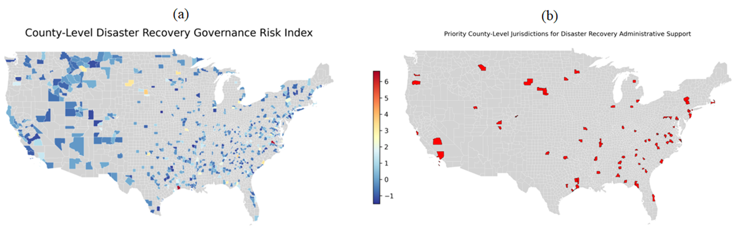Figure 9. Spatial distributions of (a) county-level disaster recovery governance risk and (b) high-governance-risk counties with high priorities on disaster recovery.
The county-level governance risk map (Figure 9(a)) reveals a highly uneven spatial distribution of recovery governance risk across the United States. Elevated risk levels are concentrated along the Gulf Coast, particularly in Texas and Louisiana, where high disaster exposure and social vulnerability coincide with relatively constrained burden capacity. Additional clusters of higher-risk counties appear in parts of the Southeast, Appalachia, and the inland South, while much of the Midwest and northern regions exhibit lower composite risk. Localized pockets of elevated risk are also visible in parts of the West and Northeast. This spatial heterogeneity suggests that governance constraints are not confined to one region, although the index should be interpreted as a descriptive overlay built from standardized components rather than as a validated prediction model.
Figure 9(b) further refines this analysis by identifying counties with risk scores above 1. In the revised manuscript, that threshold is treated as a practical screening cutoff rather than as a statistical break point. The priority jurisdictions identified by this rule are heavily clustered along the Gulf Coast and across the southern United States, closely corresponding to areas previously identified as having sizable capacity, implementation, and performance gaps. Additional clusters appear in parts of the Mid-Atlantic and selected metropolitan or peri-urban counties, where elevated social vulnerability and administrative complexity may intensify recovery challenges.
Overall, the governance risk results indicate that disaster recovery constraints in the United States are geographically concentrated yet not exclusively regional. The counties at the top of Table 3 combine high exposure, high vulnerability, and limited capacity, making them sensible candidates for targeted technical assistance, workforce support, and intergovernmental coordination efforts. At the same time, because the risk index is retained as a heuristic composite, the ranking should not be treated as a definitive league table. Its value lies in helping planners and program managers identify where more detailed institutional diagnostics may be most useful.
Table 3. Top 20 jurisdictions with the highest disaster recovery governance risk index
Rank | Jurisdiction | Exposure | Capacity | Vulnerability | Risk Index
1 | Harris County, TX | 3.9092 | -8.4353 | 0.5128 | 6.6466
2 | Galveston County, TX | 5.7159 | -6.8706 | 0.0870 | 6.5516
3 | Jefferson Parish, LA | 3.0059 | -3.9143 | 0.1655 | 3.6649
4 | Newton County, TX | 3.9092 | -3.0389 | 0.1322 | 3.6621
5 | Terrebonne Parish, LA | 3.0059 | -2.7047 | 0.5468 | 3.2370
6 | Jefferson County, TX | 2.1026 | -3.1707 | 0.9033 | 3.1952
7 | Jasper County, TX | 3.0059 | -2.4256 | 0.6773 | 3.1602
8 | Plaquemines Parish, LA | 3.0059 | -2.7605 | 0.0153 | 2.9913
9 | Grimes County, TX | 3.0059 | -2.0906 | 0.6694 | 2.9831
10 | Orange County, TX | 2.1026 | -3.6732 | -0.0240 | 2.9758
11 | San Jacinto County, TX | 3.0059 | -2.3680 | 0.3075 | 2.9403
12 | Cameron County, TX | 2.1023 | -2.2589 | 1.2879 | 2.9229
13 | Lafourche Parish, LA | 3.0059 | -2.1092 | 0.3287 | 2.8167
14 | Montgomery County, TX | 3.0059 | -2.7419 | -0.3093 | 2.8139
15 | Willacy County, TX | 2.1026 | -1.9054 | 1.3717 | 2.7835
16 | Liberty County, TX | 2.1026 | -2.1659 | 1.0405 | 2.7470
17 | Brazoria County, TX | 2.1026 | -2.9288 | 0.0142 | 2.6110
18 | Washington Parish, LA | 2.1026 | -1.3471 | 1.2866 | 2.4512
19 | Calcasieu Parish, LA | 2.1026 | -2.2031 | 0.2772 | 2.3719
20 | Gregg County, TX | 2.1026 | -1.6821 | 0.7955 | 2.3705
6. Discussion
6.1. Rethinking governmental capacity: A multi-dimensional and relational perspective
This study advances a more differentiated understanding of governmental capacity in disaster recovery by showing that capacity is not well captured by a single resource proxy. Across the revised SEM, descriptive spatial maps, and gap diagnostics, the most consistent pattern is that recovery outcomes are more closely aligned with workload manageability than with staffing and payroll intensity alone. That does not mean resources are irrelevant; rather, it suggests that resources must be interpreted relative to the disaster and program burdens they are expected to absorb.
Consistent with Annan-Prah & Andoh (2023), this study conceptualizes governmental capacity as a joint reflection of resources and performance. However, it further refines this perspective by introducing Administrative Burden Capacity, defined as the effective capacity remaining after accounting for workload pressures and contextual constraints such as social vulnerability. This conceptualization highlights that capacity is inherently relational: administrative resources only translate into effective recovery outcomes when workload demands remain within manageable levels.
A central contribution of the revised paper is the distinction between Administrative Resources and Administrative Burden Capacity. Staffing and payroll reflect the scale of the administrative system, whereas burden capacity reflects how stretched that system is across disasters and programs. The empirical evidence is strongest for Recovery Timeliness, where lower workload pressure is associated with faster implementation. For Recovery Performance, the burden-capacity path is positive but only marginal, which suggests that the performance construct also reflects other dimensions of organizational context, program design, and reporting complexity. The revised interpretation is therefore more precise than the earlier draft: burden capacity appears especially important for timing, and plausibly relevant for performance, but not sufficient by itself to explain all observed differences in recovery execution.
The negative association between Administrative Resources and Recovery Performance further supports this interpretation. Rather than implying that additional staff or payroll harms recovery, the coefficient likely reflects portfolio complexity, organizational layering, or the fact that more administratively intensive jurisdictions often manage more demanding recovery contexts. Once workload is modeled explicitly, pure resource intensity ceases to function as a simple proxy for effectiveness. This finding is useful substantively because it cautions against equating larger bureaucratic scale with stronger recovery administration.
6.2. A burden-capacity framework for understanding spatial inequality in disaster recovery
The revised results also show that different dimensions of social vulnerability relate to recovery outcomes through distinct channels. Minority status and language vulnerability are most clearly associated with weaker Recovery Performance, whereas socioeconomic vulnerability and household composition/disability are more strongly associated with slower Recovery Timeliness. One plausible interpretation is that vulnerability intensifies the administrative demands of outreach, verification, coordination, and service delivery in different ways. The SEM does not identify those mechanisms directly, but the differentiated theme coefficients are consistent with the idea that recovery governance becomes more difficult when vulnerability and administrative burden overlap.
The spatial analyses reinforce this interpretation by showing convergence across multiple descriptive lenses. Administrative Burden Capacity quadrant maps, gap diagnostics, and the governance risk screen all highlight parts of the Gulf Coast and the broader South as places where disaster exposure, social vulnerability, and administrative strain frequently coincide. The important revision, however, is interpretive: these maps are best read as spatial screening tools rather than as self-sufficient proofs of governance failure. They help identify where recovery systems may be under the greatest stress, but they do not by themselves establish why that stress occurs or whether it reflects resources, rules, market conditions, or disaster severity.
The patterns are also not purely regional. Localized pockets of elevated risk appear in the West and Northeast as well, indicating that recovery governance constraints can emerge wherever institutional workload outpaces local administrative capacity and social conditions complicate implementation.
Overall, the study advances a burden-capacity framework for understanding spatial inequality in disaster recovery governance. That framework helps explain why jurisdictions with similar funding volumes may experience different administrative trajectories, and it suggests that future work should combine dynamic process data, clearer measurement validation, and longitudinal designs to determine which parts of this burden-capacity story remain stable once stronger temporal evidence is introduced.
6.3. Practical implications
The findings provide decision-makers and practitioners with a more nuanced understanding of governmental capacity by distinguishing resource levels from workload strain. For practice, the key implication is diagnostic: when recovery performance is weak or implementation is slow, the problem may not be simple resource scarcity. It may instead reflect the way staffing, portfolio complexity, disaster exposure, and community vulnerability interact. This perspective can help practitioners diagnose whether recovery challenges stem from insufficient resources, excessive administrative burden, or a broader misalignment between institutional capacity and local recovery needs.
The Recovery Governance Risk Index and the related gap diagnostics provide an integrated descriptive lens that complements conventional indicators of disaster exposure or financial performance. Used carefully, these screening tools can help identify jurisdictions where high demand appears to coincide with limited burden capacity and elevated vulnerability. Their main value is triage: they highlight where additional technical assistance, closer institutional review, or targeted administrative support may be warranted.
From a policy perspective, the revised manuscript suggests that improving disaster recovery outcomes requires moving beyond resource-centric approaches toward workload-sensitive and context-aware interventions. Simply increasing funding or staffing may have limited effect if administrative systems remain overextended or if program complexity continues to impose substantial procedural burden. More promising strategies may include simplifying program rules, standardizing reporting and eligibility workflows, deploying temporary surge-capacity teams during high-demand periods, improving intergovernmental coordination, and prioritizing high-risk jurisdictions for language access, community outreach, and implementation support. These recommendations remain associationally motivated rather than experimentally verified, but they follow directly from the burden-sensitive interpretation of the results.
Although the real-world effectiveness of these strategies requires additional evaluation, the revised findings suggest that successful disaster recovery depends not only on the amount of resources available but also on whether those resources are adequate for the complexity, scale, and vulnerability of the recovery environment in which they are deployed.
6.4. Study limitations
Several limitations should be acknowledged. First, the SEM relies on a cross-sectional grantee-level dataset, so the results are associational rather than causal. The aggregation from quarterly QPR activity data to one profile per grantee discards within-jurisdiction variation across disasters, policy regimes, staffing arrangements, and maturation windows. Second, the timeliness construct remains duration-based and therefore sensitive to right-censoring and disaster maturity. Newer grants and grantees with ongoing portfolios have had less time to complete recovery activities, which limits how strongly the timeliness factor can be interpreted.
Third, the measurement of capacity remains indirect. QCEW NAICS 925110 employment and payroll are useful national proxies but do not directly measure CDBG-DR administrative teams, contractors, or interagency support structures. Similarly, the SVI covariates are used as cross-sectional contextual controls rather than as audited longitudinal trajectories across changing vintages. Fourth, the geography layer is derived from hierarchical name matching and county aggregation rather than from a fully reconstructed official Census relationship-file workflow. Finally, the gap diagnostics and governance risk index are retained as descriptive composites, but the original weighting and ranking scripts for those metrics are not yet fully recovered. For these reasons, the spatial and gap-based sections should be read as informative policy screens rather than as final measurement products.
These limitations point to a clear future research agenda. Longitudinal or event-history designs would address maturity and censoring more directly. Reconstructing the full external-data workflow would allow researchers to audit QCEW extraction rules, SVI harmonization decisions, and geography matching against official Census files. More detailed administrative-process data - such as staffing assignments, contractor use, application processing times, and intergovernmental coordination mechanisms - would also make it possible to move from proxy capacity measures toward more direct operational indicators of recovery governance.
Despite these limitations, the study still provides a useful empirical and conceptual contribution. Across the revised SEM and the descriptive spatial screens, the most consistent message is that disaster recovery governance is shaped not simply by how many resources a jurisdiction has, but by whether those resources are proportionate to disaster workload and to the social conditions of implementation. That is a meaningful insight even when treated explicitly as exploratory rather than causal.
7. Conclusions
This revised study develops an integrated but explicitly exploratory framework for examining governmental capacity and disaster recovery outcomes across the United States. By combining cross-sectional structural equation modeling with descriptive spatial summaries, the manuscript moves beyond purely resource-based indicators and evaluates how staffing proxies, workload pressure, and contextual vulnerability co-occur with recovery performance and timeliness. The revised framing is narrower and more defensible than the earlier draft: it presents the SEM as an associational measurement exercise and treats the gap diagnostics and governance risk index as descriptive policy screens.
Several key insights emerge. First, governmental capacity is not well captured as a unidimensional construct. The two-factor model shows that Administrative Resources and Administrative Burden Capacity behave differently and should not be collapsed without checking the measurement tradeoff. Second, the strongest capacity-outcome association in the revised SEM is between lower workload pressure and faster Recovery Timeliness, whereas the relationship with the broader Recovery Performance construct is weaker and more conditional. Third, social vulnerability matters, but different SVI themes relate to different parts of the recovery process, reinforcing the view that capacity is embedded in broader institutional and community contexts.
The descriptive spatial analyses add an important geographic dimension to those findings. They suggest that parts of the Gulf Coast and southern United States repeatedly appear where exposure, workload pressure, vulnerability, and weaker recovery outcomes overlap, while also showing that smaller clusters of governance strain occur elsewhere in the country.
Taken together, the study contributes conceptually by advancing a workload-sensitive view of governmental capacity, methodologically by making the one-factor versus two-factor SEM tradeoff explicit, and practically by offering spatial screening tools for identifying jurisdictions that may benefit from targeted administrative support. The paper should therefore be read as a full revised manuscript for an exploratory cross-sectional SEM argument, not as a definitive causal account of CDBG-DR recovery governance.
Improving disaster recovery governance will require more than funding alone. It will require institutions whose staffing, workload, and social context are better aligned with the scale and complexity of recovery needs. The revised manuscript provides an empirical starting point for that discussion and a clearer foundation for the next round of critique.
Acknowledgements
This study is partially supported by funding from the U.S. Department of Housing and Urban Development (Award# H21749CA). The findings and conclusions in this manuscript are those of the authors and do not represent the official position or views of the U.S. Department of Housing and Urban Development.
Disclosure Statement
The authors declared no potential conflicts of interest with respect to the research, authorship, and/or publication of this article. ChatGPT 4o was used to check the grammar of the manuscript.
Data Availability Statement
The public source datasets used in this study are HUD CDBG-DR DRGR/QPR reports, U.S. Bureau of Labor Statistics QCEW files, and CDC/ATSDR SVI data. The revised manuscript also relies on manuscript-specific derived files, including cleaned geography assignments and imported SEM-ready external export bundles, which are archived in the project repository. Code and nonrestricted derived outputs can be shared with the manuscript package; however, some manually validated linkage artifacts are not yet packaged as a standalone public release.
References
Annan-Prah, E. C., & Andoh, R. P. K. (2023). Administrative capacity and local level development in metropolitan, municipal and district assemblies in Ghana: mediating role of resource capacity. International Journal of Public Sector Management, 36(3), 253-270. https://doi.org/10.1108/IJPSM-07-2022-0168
Berke, P., Cooper, J., Aminto, M., Grabich, S., & Horney, J. (2014). Adaptive planning for disaster recovery and resiliency: An evaluation of 87 local recovery plans in eight states. Journal of the American Planning Association, 80(4), 310-323. https://doi.org/10.1080/01944363.2014.976585
Campbell, D. T., & Riecken, H. W. (1968). Quasi-experimental design. International Encyclopedia of the Social Sciences, 5(3), 259-263. http://www.asasrms.org/Proceedings/y1965/Quasi-Experimental%20Design.pdf
CDC/ATSDR (Centers for Disease Control and Prevention / Agency for Toxic Substances and Disease Registry). (2026). Geospatial Research, Analysis, and Services Program. CDC/ATSDR Social Vulnerability Index 2022, 2020, 2018, 2016, 2014, 2010, & 2000 Database U.S. https://www.atsdr.cdc.gov/placeandhealth/svi/data_documentation_download.html
Cevik, M. S., & Huang, G. (2018). How to manage the fiscal costs of natural disasters. International Monetary Fund.
Costa, R., Mann, B., Sobhani, A., Hamideh, S., Nejat, A., & Ross, A. (2026). From Allocation to Action: A Comparative Analysis of CDBG-DR Funding Expenditures for 2017 Disasters in California, Florida, and Texas [working paper / SSRN preprint]. http://dx.doi.org/10.2139/ssrn.6153946
Cutter, S. L., Ash, K. D., & Emrich, C. T. (2016). Urban-rural differences in disaster resilience. Annals of the American Association of Geographers, 106(6), 1236-1252. https://doi.org/10.1080/24694452.2016.1194740
Drew, R. B. (2024). New Research: Federal recovery funds temper rent increases after disaster. Enterprise Community Partners. https://www.enterprisecommunity.org/story/new-research-federal-recovery-funds-temper-rent-increases-after-disaster
Dzigbede, K. D., Gehl, S. B., & Willoughby, K. (2020). Disaster resiliency of US local governments: Insights to strengthen local response and recovery from the COVID‐19 pandemic. Public Administration Review, 80(4), 634-643. https://doi.org/10.1111/puar.13249
El-Taliawi, O. G., & Van Der Wal, Z. (2019). Developing administrative capacity: An agenda for research and practice. Policy Design and Practice, 2(3), 243-257. https://doi.org/10.1080/25741292.2019.1595916
Geddam, S. M., & Kiran, C. R. (2024). Enhancing disaster management effectiveness: an integrated analysis of key factors and practical strategies through structural equation modeling (SEM) and Scopus data text mining. Geohazard Mechanics, 2(2), 95-107. https://doi.org/10.1016/j.ghm.2024.03.001
Gendeshmin, S. B., Rostamzadeh, S., & Dowlati, M. (2025). Evaluation of disaster risk perception and influencing factors among hospital personnel using structural equation modeling. Scientific Reports, 15(1), 12780. https://doi.org/10.1038/s41598-025-97747-0
Gerona, J., & Nabe, N. (2026). SEM of Disaster Preparedness, Resiliency, Risk Perception, Protective Behavior, and Social Media Use. Journal of Interdisciplinary Perspectives, 4(2), 267-276. https://doi.org/10.69569/jip.2025.797
Gigasheet. (2026). List of All U.S. Counties and Cities Spreadsheet (public lookup table used for preliminary city-to-county matching). https://www.gigasheet.com/sample-data/list-of-all-us-counties-and-cities-spreadsheet
Grefen, P., Ludwig, H., & Angelov, S. (2003). A three-level framework for process and data management of complex e-services. International Journal of Cooperative Information Systems, 12(04), 487-531. https://doi.org/10.1142/S0218843003000838
Guo, L., Liu, F., Zhu, W., Cheng, J., Zhang, L., Zhang, B., ... & Yu, C. (2025). Pathways from early-life urbanicity to adult neurobehavioral traits via menarche timing. Nature Cities, 2(12), 1226-1239. https://doi.org/10.1038/s44284-025-00352-5
Hamideh, S. (2015). Planning for disaster recovery: Lessons from Hurricane Ike for theory and practice (Doctoral dissertation). https://hdl.handle.net/1969.1/155735
Hair, J.F., Hult, G.T.M., Ringle, C.M., Sarstedt, M., Danks, N.P., Ray, S. (2021). An Introduction to Structural Equation Modeling. In: Partial Least Squares Structural Equation Modeling (PLS-SEM) Using R. Classroom Companion: Business. Springer, Cham. https://doi.org/10.1007/978-3-030-80519-7_1
Hu, J., Tan, C., Jiao, Y., Mou, X., & Wu, P. (2025). The associational relationships between multidimensional digital literacy and wage income: evidence from urban–rural heterogeneity. Scientific Reports, 15(1), 42830. https://doi.org/10.1038/s41598-025-28467-8
Ishiwatari, M. (2021). Institutional coordination of disaster management: Engaging national and local governments in Japan. Natural Hazards Review, 22(1), 04020059. https://doi.org/10.1061/(ASCE)NH.1527-6996.000042
Jordan, E., Javernick-Will, A., & Amadei, B. (2014). A qualitative comparative analysis of neighborhood recovery following Hurricane Katrina. International Journal of Disaster Resilience in the Built Environment, 5(4), 391-412. https://doi.org/10.1108/IJDRBE-03-2013-0006
Khalid, S., & Ashraf, I. (2024). The Role of Administrative Capacity in Disaster Management. Social Trends and Policy Review, 2(2), 97-133. https://socialtrendsreview.com/index.php/journal/article/download/45/44
Khorram-Manesh, A. (2020). Flexible surge capacity-public health, public education, and disaster management. Health promotion perspectives, 10(3), 175. https://doi.org/10.34172/hpp.2020.30
Klinsky, S., & Mavrogianni, A. (2020). Climate justice and the built environment. Buildings and Cities, 1(1), 412-428. http://doi.org/10.5334/bc.65
Kusumasari, B., Alam, Q., & Siddiqui, K. (2010). Resource capability for local government in managing disaster. Disaster Prevention and Management: An International Journal, 19(4), 438-451. https://doi.org/10.1108/09653561011070367
Kyrkou, C., Kolios, P., Theocharides, T., & Polycarpou, M. (2022). Machine learning for emergency management: A survey and future outlook. Proceedings of the IEEE, 111(1), 19-41. https://doi.org/10.1109/JPROC.2022.3223186
Lee, D. W. (2019). Local government’s disaster management capacity and disaster resilience. Local Government Studies, 45(6), 803-826. https://doi.org/10.1080/03003930.2019.1653284
Lee, S. Y., & Zhu, H. T. (2002). Maximum likelihood estimation of nonlinear structural equation models. Psychometrika, 67(2), 189-210. https://doi.org/10.1007/BF02294842
Lindsay, B. R. (2014). FEMA's disaster relief fund: overview and selected issues. Washington, DC, USA: Congressional Research Service. https://budgetcounsel.com/wp-content/uploads/2017/12/crs-fema_s-disaster-relief-fund-overview-and-selected-issues-r43537-may-7-2014.pdf
Martín, C. (2018). The Evidence Base on How CDBG-DR Works for State and Local Stakeholders. Urban Institute. https://www.urban.org/sites/default/files/publication/98463/the_evidence_base_on_how_cdbg-dr_works_for_state_and_local_stakeholders_0.pdf
Martin, C., Gilbert, B., Teles, D., & Theodos, B. (2019). Housing Recovery and CDBG-DR. Urban Institute. https://www.urban.org/research/publication/housing-recovery-and-cdbg-dr
Martín, C., Teles, D., & DuBois, N. (2022). Understanding the pace of HUD’s disaster housing recovery efforts. Housing Policy Debate, 32(1), 102-127. https://doi.org/10.1080/10511482.2021.1875258
Melendez, E. (2020). Puerto Rico Housing and Community Development Industry’s Capacity for Disaster Recovery. Centro Journal, 32(3). https://research.ebsco.com/c/zdnshz/viewer/pdf/4yx3o67qxb
Miao, Q., Best, K., Reilly, A., & Davlasheridze, M. (2025). Where Did the Money Go? Assessing the Distribution of the Community Development Block Grant-Disasters Recovery Funds. The American Review of Public Administration, 55(3), 227-248. https://doi.org/10.1177/02750740241308272
Mueller, R. O., & Hancock, G. R. (2018). Structural equation modeling. In The Reviewer’s Guide to Quantitative Methods in the Social Sciences (pp. 445-456). Routledge. https://doi.org/10.4324/9781315755649
Nor, M. I. (2025). Investigating the dynamics of climate finance disbursements: A panel data approach from 2003 to 2022. PLOS One, 20(3), e0318170. https://doi.org/10.1371/journal.pone.0318170
Ofori-Boateng, R., Aceves-Martins, M., Wiratunga, N., & Moreno-Garcia, C. F. (2024). Towards the automation of systematic reviews using natural language processing, machine learning, and deep learning: a comprehensive review. Artificial intelligence review, 57(8), 200. https://doi.org/10.1007/s10462-024-10844-w
Okunola, O. H. (2025). Exploring multi-level governance arrangements in disaster recovery: A study of Lagos, Nigeria. International Journal of Disaster Risk Reduction, 118, 105254. https://doi.org/10.1016/j.ijdrr.2025.105254
Ortiz-Ortiz, J. (2026). At the Intersection of Property and Disaster Recovery. Probate and Property, 40, 38. https://scholarship.law.stjohns.edu/faculty_publications/922/
Owolabi, H. O., Ayandele, J. K., & Olaoye, D. D. (2020). A systematic review of structural equation model (SEM). Open Journal of Educational Development (ISSN: 2734-2050), 1(2), 27-39. https://doi.org/10.52417/ojed.v1i2.163
Ospina, S. M., Esteve, M., & Lee, S. (2018). Assessing qualitative studies in public administration research. Public Administration Review, 78(4), 593-605. https://doi.org/10.1111/puar.12837
Peacock, W. G., Van Zandt, S., Zhang, Y., & Highfield, W. E. (2014). Inequities in long-term housing recovery after disasters. Journal of the American Planning Association, 80(4), 356-371. https://doi.org/10.1080/01944363.2014.980440
Rosas, E., Roberts, P. S., Lauland, A., Gutierrez, I. A., & Nuñez-Neto, B. (2021). Assessing the impact of municipal government capacity on recovery from Hurricane Maria in Puerto Rico. International Journal of Disaster Risk Reduction, 61, 102340. https://doi.org/10.1016/j.ijdrr.2021.102340
Rouhanizadeh, B., Kermanshachi, S., & Nipa, T. J. (2020). Exploratory analysis of barriers to effective post-disaster recovery. International Journal of Disaster Risk Reduction, 50, 101735. https://doi.org/10.1016/j.ijdrr.2020.101735
Rouhanizadeh, B., Kermanshachi, S., & Safapour, E. (2022). An investigation of causal relationships among barriers that delay post-hurricane recovery of human communities. International Journal of Disaster Risk Reduction, 67, 102666. https://doi.org/10.1016/j.ijdrr.2021.102666
Safapour, E., Kermanshachi, S., & Pamidimukkala, A. (2021). Post-disaster recovery in urban and rural communities: Challenges and strategies. International Journal of Disaster Risk Reduction, 64, 102535. https://doi.org/10.1016/j.ijdrr.2021.102535
Santos, J., Yip, C., Thekdi, S., & Pagsuyoin, S. (2020). Workforce/Population, Economy, Infrastructure, Geography, Hierarchy, and Time (WEIGHT): reflections on the plural dimensions of disaster resilience. Risk Analysis, 40(1), 43-67. https://doi.org/10.1111/risa.13186
Saputra, N., Putera, R. E., Zetra, A., & Azwar, A. (2025). Innovative capacity building strategies for sustainable disaster risk management: a systematic review, conceptual framework, and future research directions. In E3S web of conferences (Vol. 604, p. 03004). EDP Sciences. https://doi.org/10.1051/e3sconf/202560403004
Shan, H., An, Y., Bai, H., & Shi, J. (2025). Intergovernmental collaborative governance of emergency response logistics: an evolutionary game study. Natural Hazards, 121(1), 705-730. https://doi.org/10.1007/s11069-024-06785-w
Sharma, S., Swayne, D. A., & Obimbo, C. (2015). Automating the smoothing of time series data. Journal of Environmental & Analytical Toxicology, 5(5), 304. https://doi.org/10.4172/2161-0525.1000304
Tierney, K. (2012). Disaster governance: Social, political, and economic dimensions. Annual review of Environment and Resources, 37, 341-363. https://doi.org/10.1146/annurev-environ-020911-095618
U.S. Bureau of Labor Statistics. (2026). Quarterly Census of Employment and Wages. https://www.bls.gov/cew/downloadable-data-files.htm
U.S. Department of Housing and Urban Development. (2026). CDBG-DR Reports. https://www.hud.gov/hud-partners/community-cdbg-dr-reports
U.S. Government Accountability Office. (2019). Disaster recovery: Better monitoring of block grant funds is needed. https://www.gao.gov/products/gao-19-232
U.S. Government Accountability Office. (2026). Reports & Testimonies. https://www.gao.gov/reports-testimonies
Van Niekerk, D., Nemakonde, L.D., Kruger, L., Forbes-Genade, K. (2018). Community-Based Disaster Risk Management. In: Rodríguez, H., Donner, W., Trainor, J. (eds) Handbook of Disaster Research. Handbooks of Sociology and Social Research. Springer, Cham. https://doi.org/10.1007/978-3-319-63254-4_20
Yabe, T., Rao, P. S. C., Ukkusuri, S. V., & Cutter, S. L. (2022). Toward data-driven, dynamical complex systems approaches to disaster resilience. Proceedings of the National Academy of Sciences, 119(8), e2111997119. https://doi.org/10.1073/pnas.2111997119
Yabe, T., Tsubouchi, K., Fujiwara, N., Sekimoto, Y., & Ukkusuri, S. V. (2019). Universality of population recovery patterns after disasters. arXiv preprint arXiv:1905.01804. https://doi.org/10.48550/arXiv.1905.01804
Zhang, Z., Kapucu, N., Li, R., & Lu, Y. (2026). Sustainable disaster response and recovery networks: a longitudinal study. Natural Hazards, 122(1), 4. https://doi.org/10.1007/s11069-025-07741-y
Zheng, B. Q., & Bentler, P. M. (2025). Enhancing model fit evaluation in SEM: Practical tips for optimizing chi-square tests. Structural Equation Modeling: A Multidisciplinary Journal, 32(1), 136-141. https://doi.org/10.1080/10705511.2024.2354802

Appendix
Figure A1. Indicator-level predicted relationship plots between programs per staff and recovery timeliness.
Figure A2. Indicator-level predicted relationship plots between programs per staff and recovery performance.
Figure A3. Indicator-level predicted relationship plots between disasters per staff and recovery performance.
Figure A4. Indicator-level predicted relationship plots between average payroll and recovery performance.
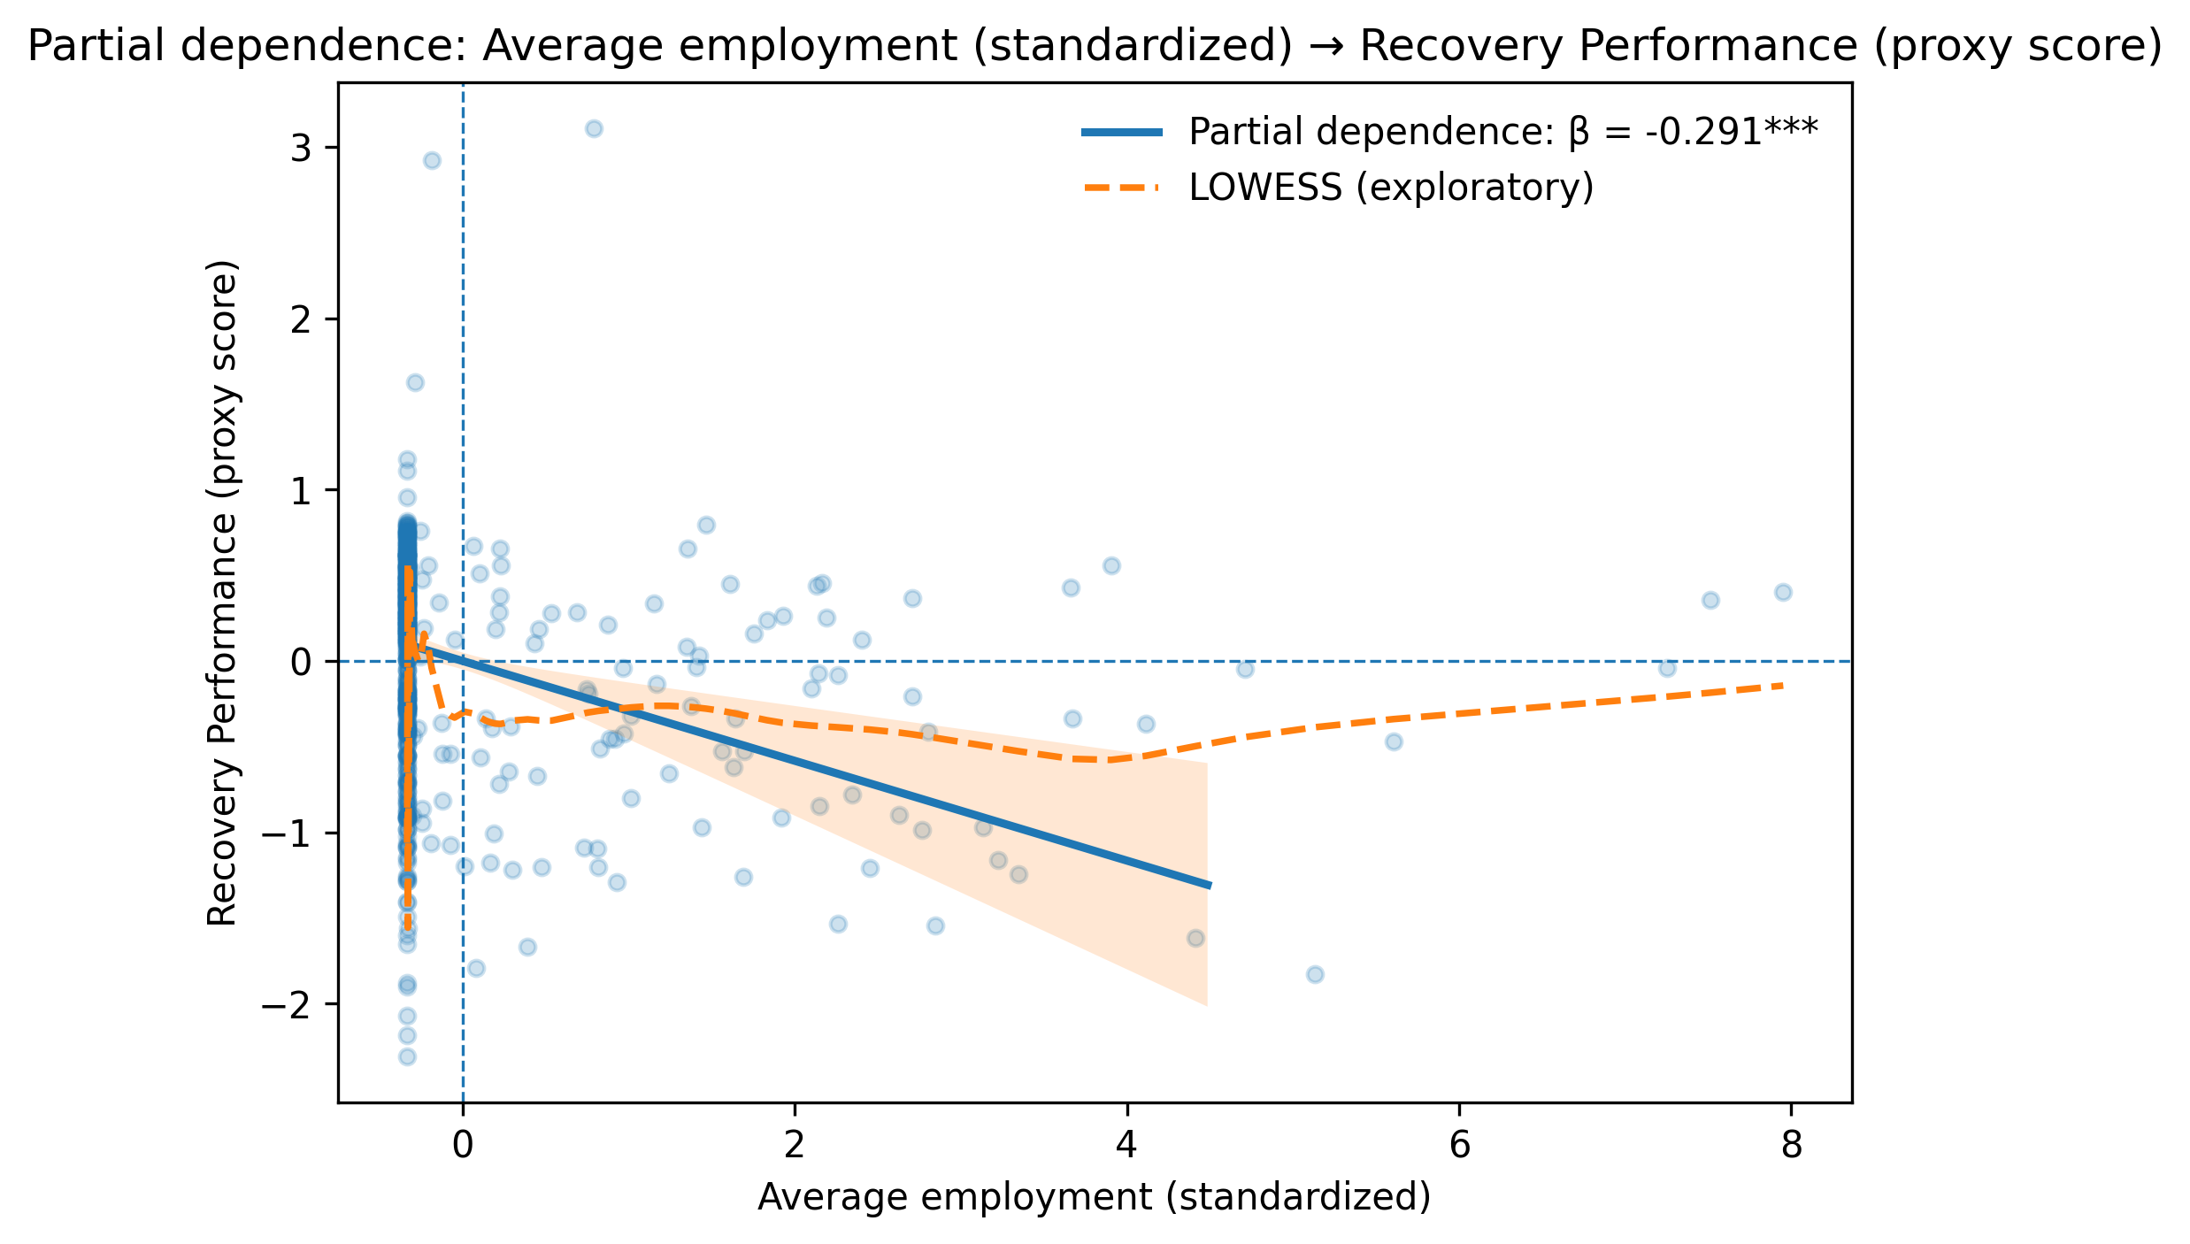
Figure A5. Indicator-level predicted relationship plots between average employment and recovery performance.

