State and Local Governmental Capacity in Disaster Recovery: Exploratory Cross-Sectional Evidence from CDBG-DR
Kai-Fa Lu 1, Jesse Andrews 1, Ali Nejat 1
1 CECREH: Center of Excellence in Capacity-building for REsilient Housing, Department of Civil, Environmental and Construction Engineering, Texas Tech University, Lubbock, TX, 79409, USA
Table of contents

Abstract:
This archived manuscript evaluates whether grantee-level financial-flow indicators from HUD’s Disaster Recovery Grant Reporting (DRGR) Quarterly Performance Reports (QPRs) can support a defensible cross-sectional structural equation model (SEM) of administrative capacity in the Community Development Block Grant-Disaster Recovery (CDBG-DR) program. The reproducible archive supports descriptive comparisons across 156 grantee-disaster observations, 78 unique grantees, and 18 disaster contexts linked to disaster cohorts from 2003 through 2023; however, the SEM evidence is substantially weaker than the latest Word manuscript claims. Across the archived model-comparison files, no single specification is preferred on all fit criteria. The legacy three-indicator state replication can reproduce a large positive path from latent capacity to recovery outcome, but that result depends on right-censored duration and the use of timeliness as the inverse of the same duration measure. Simpler non-circular models with complete-case samples of 40 to 41 grantees and subset samples of 23 states or 17 local governments do not yield stable or statistically persuasive structural paths. Accordingly, this redraft treats the SEM results as exploratory associations rather than confirmatory evidence that governmental capacity determines recovery outcomes. The main contribution of the archive is therefore methodological: it documents how grantee-level aggregation, maturity censoring, and indicator choice shape the feasibility of SEM in this setting and why a longitudinal or event-history redesign is needed for stronger causal or policy claims.
Keywords: Disaster recovery; Governmental capacity; Administrative burden; Social vulnerability; Structural Equation Modeling (SEM)

1. Introduction
Administrative capacity is central to long-run disaster recovery, but it is hard to observe directly. In the CDBG-DR program, state agencies, counties, cities, and territories receive flexible federal funds for recovery and mitigation, yet they move those funds through obligation, disbursement, and expenditure at very different rates. The practical question is whether those differences reflect an underlying capacity construct that can be measured consistently across jurisdictions.
The archived Kaifa manuscript attempted to answer that question with a cross-sectional SEM built from quarterly QPR data. That ambition remains worth pursuing, but the current repository no longer supports the stronger claims made in the latest Word draft. The active project audit found three core problems. First, the quantitative backbone is internally inconsistent: the later Word draft, the archived Quarto source, and the reproducible diagnostic tables do not tell the same model-selection story. Second, the main positive SEM result depends on a legacy design that censors duration at the current observation window and then uses timeliness as the inverse of that same duration, creating mathematical coupling between the latent constructs. Third, the available complete-case SEM samples are too small for confident state-versus-local comparisons.
This redraft therefore narrows the manuscript to a more defensible goal: an exploratory assessment of whether grantee-level financial throughput indicators can sustain a cross-sectional SEM at all. The paper makes four claims.
- The descriptive QPR ratios show meaningful cross-grantee variation in the movement of funds from obligation to disbursement.
- The archived SEM specifications do not produce a single robust, confirmatory measurement model.
- The strong positive state-level path reported in the later Word draft is reproducible only under a legacy specification with known design flaws.
- Any future manuscript that wants to reintroduce staffing, social vulnerability, or geography-sensitive covariates needs a separate reproducibility rebuild before those variables can be interpreted with confidence.
The current manuscript is therefore a salvage and transparency exercise, not a submission-ready empirical paper.

2. Background
Public administration and disaster-recovery scholarship both emphasize that capacity is multidimensional. It involves organizational resources, administrative routines, institutional coordination, and the ability to translate formal allocations into implemented programs. Financial flow data do not measure those traits directly, but they can provide observable signals of throughput and implementation discipline if the measurement logic is clear.
SEM is attractive in this context because it can represent capacity as a latent construct rather than a single ratio. That advantage comes with a cost: the measurement model itself must be empirically defensible. A latent factor model is only as credible as its indicators, fit diagnostics, and identification logic. Small samples, overlapping indicators, and unstable subset estimates can make an elegant SEM narrative look stronger than the underlying evidence warrants.
That tension is what makes the Kaifa archive useful. The repository contains both the legacy replication path that produced a large positive coefficient and several alternative non-circular specifications that do not support the same conclusion. Rather than hide that divergence, this redraft uses it to clarify what the current archive can and cannot support.

3. Data And Cross-Sectional Design
The reproducible archive uses the project-standardized QPR pipeline and its derived grantee-disaster panel. The working parquet files show quarterly QPR observations from September 30, 2002 through June 30, 2025. To keep the manuscript aligned with the disaster cohorts actually discussed in the archived SEM figures and tables, the redraft refers to disaster events from 2003 through 2023. The panel used for SEM sensitivity work contains 156 grantee-disaster pairs, 78 unique grantees, and 18 disaster types.
Terminology is fixed as follows throughout the manuscript:
- grantee: the state or local governmental recipient responsible for a CDBG-DR allocation.
- grant or disaster allocation: the disaster-specific CDBG-DR award associated with a grantee-disaster pair.
- activity: an underlying DRGR/QPR record inside a grantee-disaster quarter.
- grantee-disaster pair: the main unit of analysis before cross-sectional aggregation.
The main cross-sectional SEM collapses the grantee-disaster panel to one mean profile per grantee. That choice assumes a jurisdiction’s administrative style is stable enough across disasters to summarize as a cross-sectional trait. The manuscript no longer treats that assumption as innocuous. It is a strong modeling decision that trades away within-grantee variation, cohort differences, and institutional change over time. State and local results are therefore presented only as subset sensitivity checks, not as formal moderation analyses.
The redraft also distinguishes clearly between the current Quarto archive and the later April 7, 2026 Word draft. The Word draft refers to BLS QCEW staffing measures, CDC/ATSDR Social Vulnerability Index (SVI) data, and city-to-county geography matching. Those extensions are not fully reconstructed in the current reproducible Quarto archive and are therefore not treated as active empirical inputs in the results reported here. Their provenance boundary is documented in Appendix A.

4. Measures

4.1 Capacity Indicators
The archive contains several candidate indicators for latent governmental capacity:
- Ratio_disbursed_to_obligated: the share of obligated funds that have moved into disbursement.
- Ratio_expended_to_disbursed: the share of disbursed funds that have been expended.
- Timeliness_censored: the inverse of a right-censored duration variable used only in the legacy replication model.
The first two indicators capture financial throughput. The third is a legacy indicator retained only to document how the original positive result was obtained; it is not used as a preferred measure because it is mechanically linked to the duration outcome.

4.2 Recovery Outcome Indicators
The archive also contains several outcome-side indicators:
- Duration_log: log-transformed completion time for grantee-disaster pairs that reach the completion threshold.
- Spending_CV: the coefficient of variation of quarterly expenditure flows.
- Duration_censored: a legacy duration that substitutes observed program age when completion is not reached.
- Ratio_obligated_funds_fully_expended: the share of obligated funds fully expended by the end of the observation window.
- Quarter_by_quarter_variance_expended: normalized quarter-to-quarter variability in expenditures.
- Time_to_50pct: the normalized quarters needed to reach 50 percent completion.
The manuscript treats the duration-based measures cautiously. Any outcome defined at 95 percent completion is vulnerable to maturity bias and right-censoring, especially for more recent disasters. That is why the cross-sectional SEM is framed as exploratory and why the preferred baseline specification avoids the direct timeliness-versus-duration overlap used in the legacy replication.

5. Audit-Informed Model Comparison
The first priority in the revision plan was to reconcile the model comparison narrative with the archived outputs. Table 1 reproduces the specification comparison from the manuscript-specific robustness file in the Quarto archive.
Model | N | CFI | TLI | RMSEA | AIC | BIC | Audit note
full | 41 | 0.938 | 0.883 | 0.152 | 25.250 | 47.526 | Best conventional CFI/TLI among archived models, but uses overlapping timing indicators.
reduced | 41 | 0.498 | -0.256 | 0.572 | 19.253 | 38.102 | Clearly poor fit.
exp_optimal_v1 | 40 | 0.790 | -0.259 | 0.000 | 17.999 | 33.199 | Lowest AIC/BIC and non-circular baseline, but low incremental fit.
exp_optimal_v2 | 40 | 0.758 | 0.394 | 0.000 | 21.865 | 40.442 | No fit improvement over exp_optimal_v1.
improved_3x3 | 40 | 1.486 | 1.911 | 0.000 | 25.795 | 47.751 | Apparent overfit with inadmissible CFI/TLI values in a very small sample.
improved_3x3_progress | 40 | 0.238 | -0.430 | 0.396 | 23.150 | 45.105 | Poor fit and not interpretable.
Table 1 eliminates the contradiction that appeared in the Word manuscript: the archive does not support a clean statement that one model is best on all major indices. The full model has the strongest conventional CFI/TLI among the archived specifications, but its RMSEA is poor and its indicator set is conceptually compromised by the timing overlap. The non-circular exp_optimal_v1 model has the lowest AIC and BIC, but its low CFI means it cannot be presented as a well-fitting confirmatory solution. The improved_3x3 values exceed the usual upper bound for CFI and TLI, which is another sign that the sample is too small for confident interpretation.
The manuscript therefore adopts the following transparent rule. The exp_optimal_v1 model is treated as the least problematic baseline because it avoids the timeliness-duration circularity. The full 3x3 model is reported only as a legacy comparison that helps explain how the original positive manuscript result was generated. No specification is treated as a validated measurement model.

6. Results

6.1 Descriptive Throughput Patterns
The descriptive ratio figures remain the strongest part of the archive. State-level average ratios show that once funds are disbursed they are usually expended efficiently, whereas the main throughput bottleneck occurs earlier in the pipeline between obligation and disbursement.
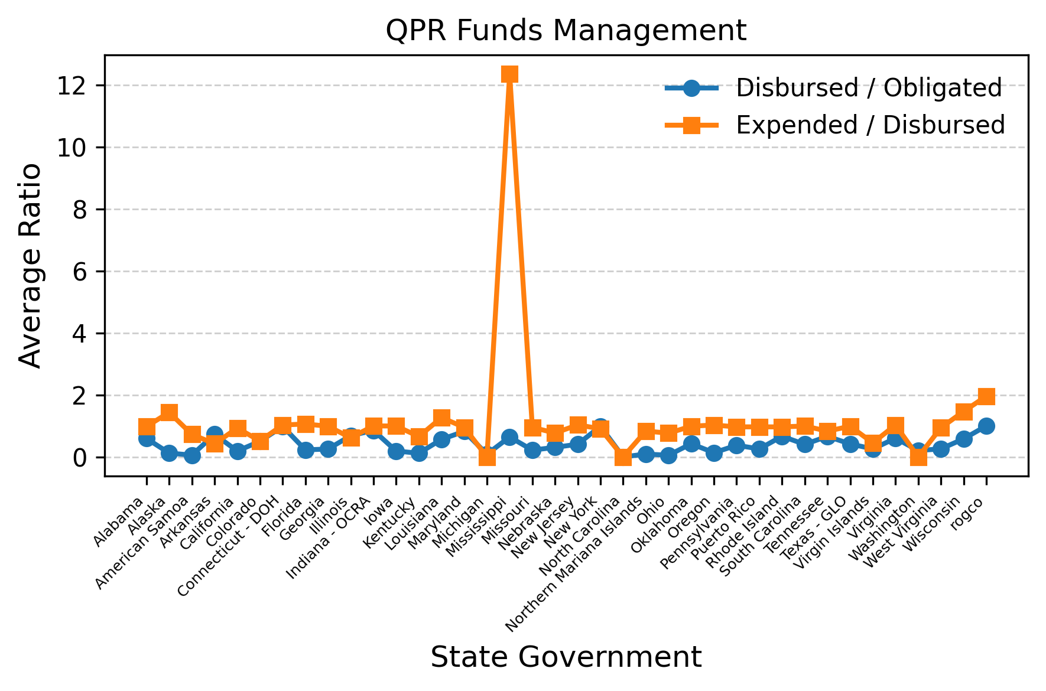
Quarterly average state-level QPR ratios, showing greater variation in the movement from obligation to disbursement than in the movement from disbursement to expenditure across disaster cohorts from 2003 through 2023.
Local governments display a similar pattern but with generally lower disbursed-to-obligated ratios and more visible heterogeneity in a small number of jurisdictions. The descriptive contrast is useful, but it should not be overstated as direct evidence of a latent state-versus-local capacity difference because the later SEM subset samples are small and unstable.
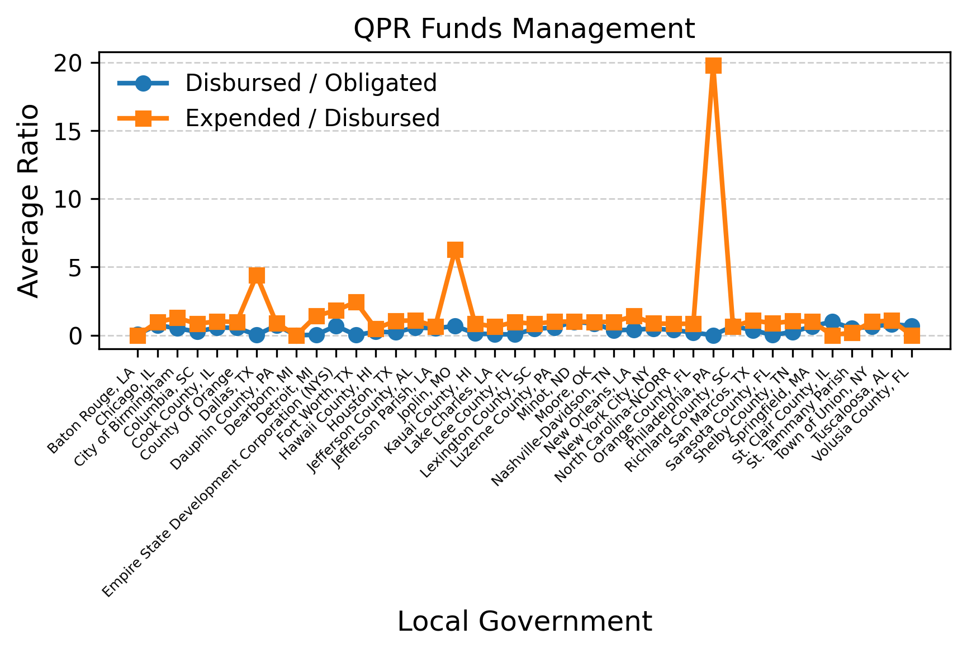
Quarterly average local-level QPR ratios, again showing that the main variation occurs before disbursement rather than after disbursement.

6.2 Structural Estimates From Archived Models
The structural results reinforce the exploratory reading. Table 2 reports selected coefficients from the archived diagnostics that matter most for the audit.
Specification | Analysis level | Subset | N | Capacity effect | p-value | Interpretation
Legacy kaifa_3x3_full | grantee | state | 36 | 113.652 | <0.001 | Reproduces a large positive path, but only under censored duration plus inverse-duration timeliness.
exp_optimal_v1 | grantee | all | 40 | 0.320 | 0.958 | Non-significant baseline.
exp_optimal_v1 | grantee | state | 15 | 10.031 | 0.834 | Non-significant and unstable.
exp_optimal_v1 | grantee-disaster | state | 23 | 0.362 | 0.970 | Non-significant and unstable.
exp_time_to_milestone | grantee-disaster | state | 52 | -0.753 | 0.783 | Milestone timing alternative remains non-significant.
duration_free_cv | grantee-disaster | all | 156 | 0.360 | 0.132 | Larger sample moves closer to zero-centered uncertainty, not to a stable positive effect.
Two conclusions follow. First, the later Word manuscript’s large positive state coefficient cannot be treated as a general result of the Kaifa framework. The archived replication can reproduce a large positive path, but only in the specific legacy setup that combines right-censored duration with its inverse on the capacity factor. Second, once the indicator overlap is removed, the cross-sectional SEM does not produce a robust or statistically convincing capacity-outcome relationship.

6.3 State And Local Subsets Are Sensitivity Checks, Not Moderation Tests
The archive contains subset fit diagnostics for state and local grantees, but the effective complete-case samples are 23 states and 17 local governments in the principal subset comparison. Those sample sizes are too small to support formal claims that state and local governments respond to capacity constraints in substantively different ways. This is why the manuscript no longer uses the language of moderation. At most, the subset results suggest that any state-versus-local comparison is fragile and highly dependent on indicator choice.

7. Discussion
The core lesson from the audit is methodological rather than substantive. The CDBG-DR QPR archive does contain useful information about throughput variation, but it does not automatically yield a stable cross-sectional SEM of latent governmental capacity. Three constraints dominate.
First, the unit of analysis is difficult to justify. Aggregating grantee-disaster histories to grantee means assumes that capacity is stable enough across disaster events and policy periods to be summarized as a single trait. That may be acceptable for exploratory screening, but it is not a neutral choice. It removes temporal variation precisely where a long-run administrative capacity story should be most informative.
Second, the timing outcomes remain maturity-sensitive. Newer disasters have had less time to reach any high completion threshold, and a 95 percent completion rule creates substantial right-censoring. The legacy replication responds by treating incomplete programs as if they completed at the current observation window, which mechanically biases duration downward for ongoing programs. This is why the manuscript no longer uses causal or deterministic language such as “capacity improves recovery outcomes” or “capacity shapes timeliness.” The archive supports only associational and design-diagnostic statements.
Third, the later Word draft extends beyond the reproducible archive. QCEW staffing proxies, SVI covariates, and geography-matching logic may be analytically valuable, but they need their own provenance rebuild. In the current repository, those pieces cannot yet be documented with the level of detail needed for publication-quality claims about suppression handling, cross-vintage harmonization, or match-rate validation.
The practical implication is straightforward. If this manuscript is to move beyond archival salvage, the next version should either:
- remain a narrow exploratory note centered on transparent model feasibility, or
- be rebuilt around a longitudinal or survival-style design that respects event timing and censoring.
The current redraft chooses the first path.

8. Conclusion
The Kaifa SEM archive remains useful, but not for the reason originally claimed. It does not provide strong confirmatory evidence that a stable latent governmental capacity construct explains cross-sectional variation in CDBG-DR recovery outcomes. What it does provide is an auditable record of why that conclusion is hard to sustain with the available complete-case samples and indicator design.
For that reason, the present manuscript is best read as an exploratory working paper and methodological archive. It documents descriptive throughput differences across grantees, reconciles the archived model comparison outputs, and shows that the strong positive legacy SEM result is design-dependent. Future work can build on this record, but it should do so with a redesigned temporal framework rather than by treating the archived cross-sectional SEM as settled evidence.
Data Availability Statement
The current reproducible manuscript archive relies primarily on public HUD DRGR/QPR administrative data and project-generated derivative tables stored in this repository. The archived robustness tables, Quarto source files, and analysis code used for this redraft are available in the repository. The April 7, 2026 Word draft also refers to external covariates such as BLS QCEW and CDC/ATSDR SVI measures; those raw sources are public, but the later joined linkage artifacts and geography-validation files are not yet packaged as a reproducible release in this archive. The current manuscript therefore distinguishes between public raw sources, shareable code and nonrestricted derivatives, and historical linkage artifacts that would need a separate curation pass before distribution.
References
Bollen, K. A. (1989). Structural Equations with Latent Variables. John Wiley & Sons.
Boyd, E. (2011). Community Development Block Grant Disaster Recovery Assistance. Congressional Research Service.
Chang, S. E. (2010). Urban disaster recovery: A measurement framework and its application to the 1995 Kobe earthquake. Disasters, 34(2), 303-327.
Cutter, S. L., Ash, K. D., & Emrich, C. T. (2019). Urban-rural differences in disaster resilience. Annals of the American Association of Geographers, 109(5), 1237-1252.
Geddam, S. M., Garg, P., & Tyagi, A. (2024). Enhancing disaster management effectiveness: A structural equation modeling approach. International Journal of Disaster Risk Reduction, 99, 104123.
Gerber, B. J., & Robinson, S. E. (2022). Local government capacity and disaster resilience: The role of institutional arrangements and administrative resources. Public Administration Review, 82(2), 340-352.
HUD Office of Inspector General. (2021). HUD Did Not Adequately Oversee Community Development Block Grant-Disaster Recovery Grantees. Office of Inspector General, U.S. Department of Housing and Urban Development.
Kline, R. B. (2016). Principles and Practice of Structural Equation Modeling (4th ed.). Guilford Press.
Wu, X., Ramesh, M., & Howlett, M. (2015). Policy capacity: A conceptual framework for understanding policy competences and capabilities. Policy and Society, 34(3-4), 165-171.

Appendix A: Data Description And Provenance

10.1 A.1 Reproducible Source Boundary
The current Quarto archive is anchored to the reproducible project pipeline rather than to the full set of variables discussed in the April 7, 2026 Word draft. The empirical results reported in this redraft come from three repository artifacts:
- the standardized QPR archive (data_work/qpr_standardized.parquet),
- the grantee-disaster feature panel (data_work/panel_features.parquet),
- manuscript-specific robustness tables stored in manuscript_kaifa_archive/data/ and data_work/diagnostics/.
The standardized QPR archive contains 130,605 activity-quarter rows. Those rows are not one row per quarter; they are one row per activity within a grantee-disaster-quarter. The cross-sectional SEM does not estimate on that file directly. Instead, the canonical feature pipeline collapses the QPR records to a grantee-disaster panel of 156 observations and then, for the Kaifa cross-sectional SEM, to one mean profile per grantee.

10.2 A.2 Transformation Chain
The transformation chain relevant to the current manuscript is:
- QPR raw exports are cleaned and standardized into quarter-aware records.
- Grantee-disaster features are computed, including financial ratios and timing summaries.
- The archived Kaifa replication applies a legacy censoring rule: Duration_censored = N_Quarters whenever 95 percent completion is not observed.
- The same legacy replication defines Timeliness_censored as 1 / Duration_censored.
- The Kaifa cross-sectional SEM aggregates grantee-disaster measures to the grantee level using means.
That chain matters because the positive legacy SEM result appears only after steps 3 through 5. The current manuscript therefore treats those steps as objects of audit, not as innocuous preprocessing choices.

10.3 A.3 Sample Sizes Used In The Archive
The main sample counts used in this redraft are:
Sample | N | Notes
Grantee-disaster feature panel | 156 | All grantee-disaster pairs in the working panel.
Unique grantees | 78 | Cross-sectional aggregation target.
Disaster types | 18 | Disaster contexts represented in the panel.
full and reduced SEM complete cases | 41 | Overall cross-sectional SEM sample in the manuscript archive.
exp_optimal_v1 and related non-circular SEMs | 40 | Overall baseline cross-sectional SEM sample.
State subset fit comparison | 23 | Complete cases in archived subset-comparison table.
Local subset fit comparison | 17 | Complete cases in archived subset-comparison table.
Legacy Kaifa state replication | 36 | Grantee-level state sample after right-censoring and aggregation.
These counts should be read as complete-case estimation samples, not as the total amount of information in the QPR archive.

10.4 A.4 Timing And Maturity Limits
The current redraft refers to disaster cohorts from 2003 through 2023. Internally, the standardized QPR archive contains quarterly observations from September 30, 2002 through June 30, 2025. The absolute dates matter because the 95 percent completion rule is maturity-sensitive. More recent disasters have had fewer reporting quarters in which to approach the completion threshold, which is why duration-based outcomes are vulnerable to right-censoring and cohort bias.
The archive also documents a minimum-quarter filter and ratio winsorization. The historical Kaifa workflow excluded very short reporting histories and used ratio trimming or winsorization to reduce extreme values. The current redraft reports only those preprocessing rules that can be traced in the repository and does not claim an additional outlier-deletion procedure that cannot be reconstructed cleanly.

10.5 A.5 External Data Referenced In The Later Word Draft
The April 7, 2026 Word manuscript references additional external sources, including:
- BLS QCEW staffing and payroll measures, including NAICS 925110,
- CDC/ATSDR Social Vulnerability Index (SVI) vintages,
- organization-name cleaning and city-to-county geography matching.
Those inputs were not initially reconstructed in the repository. A later manual import added two external SEM export bundles under manuscript_kaifa_archive/data/external_sem_exports/:
- baseline_sem/ with a 573-row z-scored ready dataset and associated one-factor/two-factor SEM exports;
- baseline_sem_admin_4/ with a 169-row robustness version of the same variable family.
These imports are useful for provenance and for reconstructing the later Word manuscript’s SEM tables, but they still do not by themselves document the upstream QCEW acquisition, SVI harmonization, or geography-matching workflow. If those variables are reintroduced as active empirical inputs, the following documentation is still required:
- for QCEW: extraction year coverage, suppression or missingness handling, and a clear statement that NAICS 925110 is an indirect proxy for CDBG-DR administrative capacity rather than a direct staff count;
- for SVI: either a harmonization protocol across vintages or a design that avoids direct comparison of percentile scores across incompatible releases;
- for geography matching: a source hierarchy, match shares by method, unresolved cases, and validation against official Census relationship or gazetteer files.

10.6 A.6 Public, Shareable, And Controlled Artifacts
For the current manuscript archive, the data-availability boundary is:
- public raw sources: HUD DRGR/QPR administrative exports used in the repository, plus public federal data sources that may be used in future extensions such as Census population series, BLS QCEW, and CDC/ATSDR SVI;
- shareable derivative materials: the Quarto manuscript sources, the repository code, and the archived robustness or audit tables used in this redraft;
- controlled or not-yet-packaged materials: any historical manual linkage tables, reviewed geography crosswalks, or joined external-data artifacts referenced only in the later Word draft.

Appendix B: Methodological Details

10.7 B.1 SEM Families Compared In The Archive
The current Quarto archive compares three classes of SEM specification.
- full legacy models, which use censored duration and inverse-duration timeliness.
- non-circular baseline models such as exp_optimal_v1, which remove the deterministic overlap between capacity and outcome timing.
- alternative indicator models, such as milestone and duration-free variants, used only for sensitivity checks.
No moderation model is estimated in the reproducible archive. State versus local results are subset comparisons, not interaction tests, multi-group invariance analyses, or moderation estimates.

10.8 B.2 Legacy Replication Versus Preferred Baseline
The legacy Kaifa replication is:
$$\text{gov_cap}= \text{Ratio_disbursed_to_obligated}+\text{Ratio_expended_to_disbursed}+\text{Timeliness_censored}$$
$$\text{recovery_outcome}= \text{Duration_censored}+\text{Ratio_obligated_funds_fully_expended}+\text{Quarter_by_quarter_variance_expended}$$
$$\text{recovery_outcome}∼\text{gov_cap}$$
The preferred baseline for this redraft is the simpler non-circular model:
$$\text{gov_cap}= \text{Ratio_disbursed_to_obligated}+\text{Ratio_expended_to_disbursed}$$
$$\text{recovery_outcome}= \text{Duration_log}+\text{Spending_CV}$$
$$\text{recovery_outcome}∼\text{gov_cap}$$
The baseline is not presented as a well-validated measurement model. It is simply the least problematic archived specification because it avoids the timeliness-duration circularity.

10.9 B.3 Why The Legacy Timing Construction Is Problematic
The legacy manuscript replication defines:
$${\text{Duration_censored}}_{i}=\left\{\begin{matrix}{\text{Duration}}_{i}, & \text{if 95\%completion is observed} \\ {\text{N_Quarters}}_{i}, & \text{otherwise}\end{matrix}\right.$$
and then
$${\text{Timeliness_censored}}_{i}=\frac{1}{{\text{Duration_censored}}_{i}}$$
This means a single underlying duration quantity enters the SEM twice: once directly on the outcome factor and once inversely on the capacity factor. That is why the legacy positive path cannot be treated as clean evidence for an underlying capacity effect.

10.10 B.4 Measurement Evidence Available In The Archive
The archive contains parameter tables for selected specifications, but it does not contain a complete package of residual matrices, construct reliability statistics, or standardized latent-correlation tables for every model in the later Word draft. The current manuscript therefore reports the available evidence transparently and states what is missing.

10.10.1 Baseline exp_optimal_v1 Loadings And Structural Path (All Grantees)
Parameter | Estimate | Standard error | p-value
recovery_outcome ~ gov_cap | 0.320 | 6.137 | 0.958
Ratio_expended_to_disbursed ~ gov_cap | -0.102 | 1.977 | 0.959
Spending_CV ~ recovery_outcome | -0.367 | 2.174 | 0.866

10.10.2 Legacy kaifa_3x3_full State Replication
Parameter | Estimate | Standard error | p-value
recovery_outcome ~ gov_cap | 113.652 | 17.535 | <0.001
Ratio_expended_to_disbursed ~ gov_cap | 1.254 | 1.305 | 0.337
Timeliness_censored ~ gov_cap | -0.273 | 0.075 | <0.001
Ratio_obligated_funds_fully_expended ~ recovery_outcome | 0.0106 | 0.0011 | <0.001
Quarter_by_quarter_variance_expended ~ recovery_outcome | -0.0001 | 0.0006 | 0.831
These tables are enough to show why the legacy result looks strong and why the baseline result does not. They are not enough to claim full construct validation. The missing elements are therefore treated as a methodological limitation, not as information that can be inferred away.

10.11 B.5 Fit Interpretation
Fit indices are reported exactly as archived, but they are interpreted with two cautions.
- Very small SEM samples with low degrees of freedom can produce unstable or non-intuitive fit values, including CFI or TLI estimates above 1.
- No model in the current archive satisfies a clean combination of strong incremental fit, acceptable absolute fit, and conceptually non-overlapping indicators.
For that reason, the redraft does not declare a single preferred confirmatory measurement model. It instead uses the comparison table to document the tradeoffs across archived specifications.

10.12 B.6 Metrics Excluded From The Current Redraft
The later Word draft introduced administrative gap measures and a Recovery Governance Risk Index. Those metrics are not interpreted in the current Quarto redraft because the repository does not contain a fully reproducible set of equations, weights, and sensitivity tables for that extension. The review concern is handled by removing unsupported metric claims from the current manuscript rather than by reverse-engineering unverified formulas.

10.13 B.7 Interpretation Rule
All capacity-outcome relationships in this manuscript are interpreted as associational and exploratory. The manuscript does not claim moderation, causal identification, or stable state-versus-local effect heterogeneity.

Appendix C: Robustness And Audit Tables

10.14 C.1 Archived Specification Comparison
Model | chi2 | chi2 p-value | CFI | TLI | RMSEA | AIC | BIC | N
full | 15.384 | 0.052 | 0.938 | 0.883 | 0.152 | 25.250 | 47.526 | 41
reduced | 56.315 | <0.001 | 0.498 | -0.256 | 0.572 | 19.253 | 38.102 | 41
exp_optimal_v1 | 0.022 | 0.882 | 0.790 | -0.259 | 0.000 | 17.999 | 33.199 | 40
exp_optimal_v2 | 2.710 | 0.608 | 0.758 | 0.394 | 0.000 | 21.865 | 40.442 | 40
improved_3x3 | 4.094 | 0.848 | 1.486 | 1.911 | 0.000 | 25.795 | 47.751 | 40
improved_3x3_progress | 57.005 | <0.001 | 0.238 | -0.430 | 0.396 | 23.150 | 45.105 | 40

10.15 C.2 Archived Subset Comparison
Subset | chi2 | chi2 p-value | CFI | TLI | RMSEA | AIC | BIC | N
all grantees | 0.022 | 0.882 | 0.790 | -0.259 | 0.000 | 17.999 | 33.199 | 40
state grantees | 2.134 | 0.144 | 1.379 | 3.276 | 0.227 | 17.814 | 28.034 | 23
local grantees | 2.209 | 0.137 | 1.372 | 3.233 | 0.275 | 17.740 | 25.239 | 17
The subset table is retained only as a sensitivity check. The fit values are too unstable for strong inference, and the sample sizes are too small to support a formal state-versus-local comparison.

10.16 C.3 Alternative Outcome Specifications
Model | Subset | N | CFI | RMSEA | Capacity beta | p-value
duration_free_cv | all | 156 | 0.990 | 0.105 | 0.360 | 0.132
duration_free_cv | state | 94 | 0.979 | 0.163 | 0.326 | 0.179
duration_free_cv | local | 61 | 0.968 | 0.164 | 0.337 | 0.431
milestone_time_to_50 | all | 156 | 0.758 | 0.308 | -0.365 | 0.354
milestone_time_to_50 | state | 94 | 0.983 | 0.093 | -0.442 | 0.404
milestone_time_to_50 | local | 61 | 0.691 | 0.434 | -0.266 | 0.617
milestone_progress_rate | all | 156 | 0.847 | 0.092 | 0.091 | 0.685
milestone_velocity | all | 156 | 0.995 | 0.209 | 0.014 | 0.669
Across the alternative designs, the non-circular SEMs remain non-significant. Expanding the sample through duration-free or milestone-based outcomes does not recover a stable positive capacity effect.

10.17 C.4 Outlier And Preprocessing Note
The current archive documents winsorization or trimming of extreme ratio values in preprocessing, but it does not contain a manuscript-specific table that cleanly reconstructs an additional outlier-removal robustness pass from the later Word draft. For transparency, the redraft does not claim a separate outlier-deletion result. The reader should treat the archived robustness evidence as limited to the specification, subset, and alternative outcome tables reported here.

10.18 C.5 Robustness Conclusion
The robustness archive points in one direction. The large positive SEM path appears only in the legacy censored-duration replication. Once the timing overlap is removed or the outcome is redefined, the structural path is no longer statistically persuasive.

