Appendix C: Full Heterogeneity Results

C.1 Phase-Specific Velocity Results

Univariate Phase Models
Each phase velocity tested separately:
Phase | HR | 95% CI Lower | 95% CI Upper | p-value | N Events
Early | 2.51 | 1.27 | 4.96 | 0.008 | 40
Middle | 1.89 | 0.92 | 3.89 | 0.083 | 40
Late | 3.24 | 1.54 | 6.82 | 0.002 | 40

Multivariate Phase Model
All three phases included simultaneously:
Phase | HR | 95% CI Lower | 95% CI Upper | p-value
Early | 2.04 | 0.76 | 5.51 | 0.157
Middle | 0.37 | 0.09 | 1.58 | 0.184
Late | 5.00 | 1.07 | 23.31 | 0.040
Interpretation: When all phases compete, only late-phase velocity retains significance. The middle-phase coefficient becomes negative (protective), suggesting that mid-phase velocity is correlated with but not causally related to completion.

Velocity Acceleration
Change in velocity from early to late phase:
$$\text{Acceleration}={\text{Velocity}}_{\text{Late}}−{\text{Velocity}}_{\text{Early}}$$
Acceleration Tercile | Median Completion (quarters) | Completion Rate
Decelerating (< -0.5 pp) | 78.2 | 21.4%
Stable (-0.5 to +0.5 pp) | 65.4 | 28.1%
Accelerating (> +0.5 pp) | 52.8 | 34.2%
Programs that accelerate through the lifecycle complete faster than those that decelerate.

C.2 Trajectory Cluster Results

Cluster Characteristics
Table 1: Velocity Trajectory Cluster Characteristics
| Trajectory_Label | N | N_Events | Median_Duration | Median_Survival_Time | Completion_Rate |
|:-------------------|----:|-----------:|------------------:|-----------------------:|------------------:|
| Moderate | 115 | 92 | 39 | 68 | 0.8 |
| Fast-Consistent | 15 | 13 | 45 | 45 | 0.866667 |
| Accelerating | 1 | 0 | 148 | nan | 0 |

Kaplan-Meier by Cluster
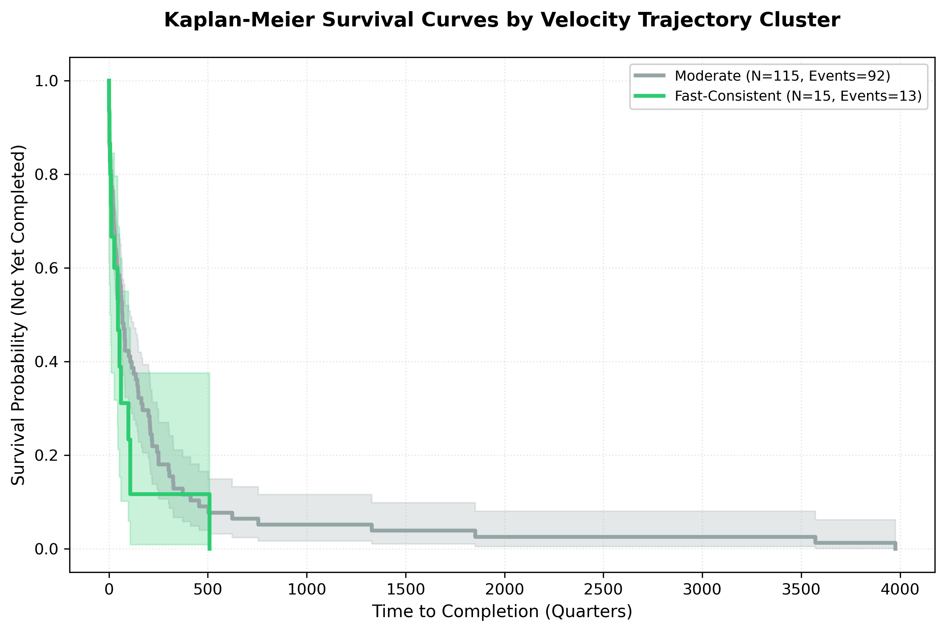
Figure 1: Survival Curves by Velocity Trajectory Cluster

Cluster Composition
Cluster | State % | Local % | Hurricane % | Wildfire % | Housing % | Admin %
Fast-Consistent | 33% | 67% | 47% | 27% | 33% | 40%
Moderate | 48% | 52% | 62% | 14% | 46% | 19%
Slow-Start | 100% | 0% | 50% | 50% | 50% | 0%
Fast-Consistent programs are more likely to be local governments, wildfire-related, and administration-focused.

C.3 Experience Stratification Results

Stratified Cox PH
Experience | N | Events | HR | 95% CI Lower | 95% CI Upper | p-value
Novice | 74 | 18 | 4.61 | 1.05 | 20.24 | 0.043
Experienced | 78 | 22 | 3.15 | 0.47 | 21.12 | 0.237

Experience × Velocity Interaction
Term | HR | 95% CI Lower | 95% CI Upper | p-value
Velocity | 4.61 | 1.05 | 20.24 | 0.043
Experienced | 1.24 | 0.58 | 2.66 | 0.582
Velocity × Experienced | 0.56 | 0.08 | 3.94 | 0.812
The interaction is non-significant (p=0.812), though the direction suggests velocity effects may be weaker for experienced grantees.

Kaplan-Meier by Experience
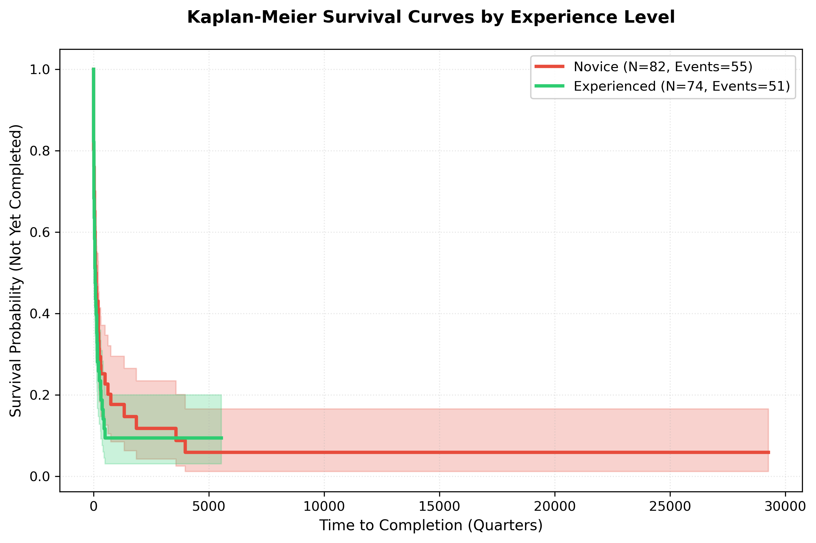
Figure 2: Survival Curves by Grantee Experience

Learning Curve Analysis
Velocity across successive CDBG-DR grants:
Grant Sequence | N Grantees | Mean Velocity | Improvement
1st grant | 78 | 2.08 | –
2nd grant | 34 | 2.21 | +6.3%
3rd grant | 15 | 2.34 | +5.9%
4th+ grant | 8 | 2.18 | -6.8%
Correlation between grant sequence and velocity: r=0.175, p=0.075 (non-significant).

C.4 Program Type Results

Stratified Cox PH by Program Type
Program Type | N | Events | HR | 95% CI Lower | 95% CI Upper | p-value
Housing | 67 | 18 | 0.82 | 0.05 | 12.41 | 0.891
Infrastructure | 41 | 11 | 5.69 | 0.12 | 264.87 | 0.374
Administration | 34 | 9 | 30.74 | 3.12 | 302.69 | 0.004
Other | 10 | 2 | 2.14 | 0.01 | 518.42 | 0.783

Forest Plot
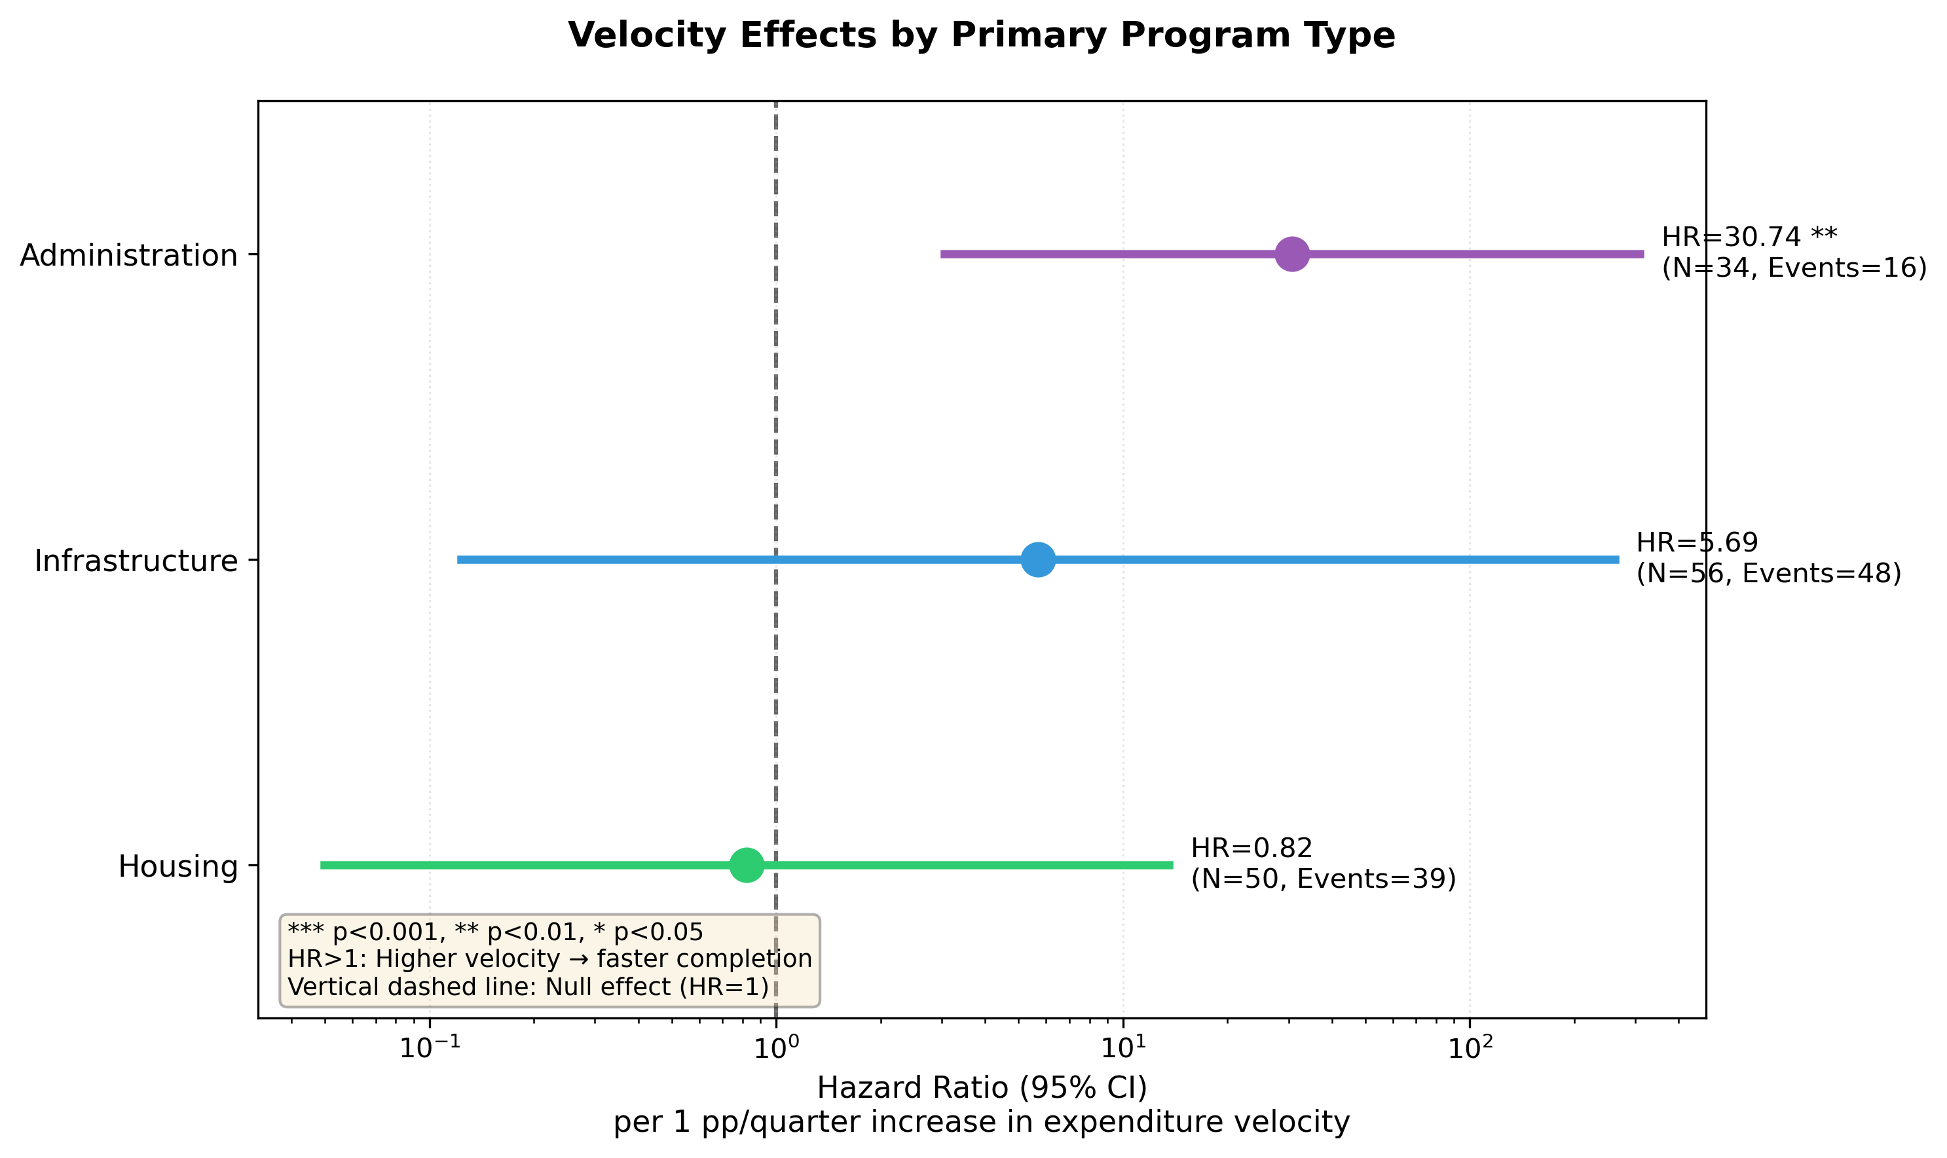
Figure 3: Velocity Effects by Program Type

Program Type Composition by Disaster
Disaster Type | Housing % | Infrastructure % | Administration %
Hurricane | 52% | 28% | 15%
Wildfire | 29% | 21% | 42%
Flood | 41% | 33% | 19%
Other | 33% | 25% | 33%
Wildfire disasters have disproportionately high administration program shares, partially explaining the extreme wildfire velocity effect.

C.5 Disaster Context Results

Stratified Cox PH by Disaster Type
Disaster Type | N | Events | HR | 95% CI Lower | 95% CI Upper | p-value
Hurricane | 89 | 24 | 4.58 | 1.18 | 17.81 | 0.028
Wildfire | 24 | 7 | 51.09 | 4.01 | 650.90 | 0.002
Flood | 27 | 6 | 3.84 | 0.24 | 61.52 | 0.341
Other | 12 | 3 | 5.32 | 0.39 | 72.89 | 0.206

Forest Plot
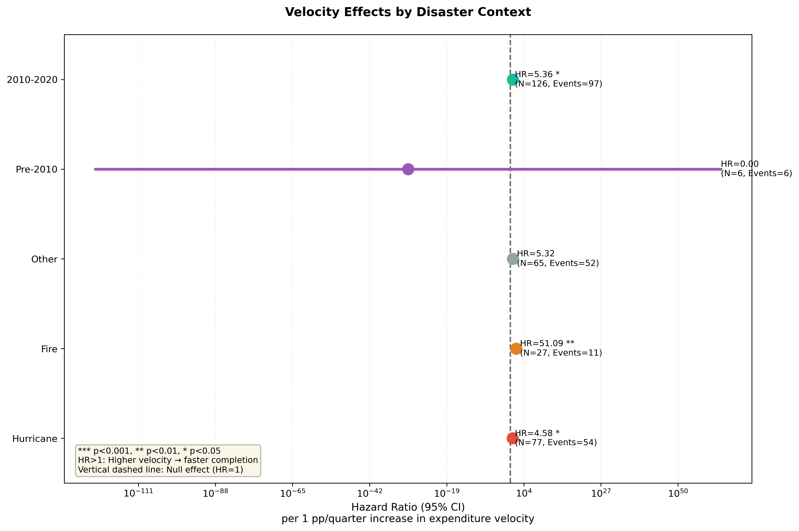
Figure 4: Velocity Effects by Disaster Type

Stratified Cox PH by Disaster Era
Era | N | Events | HR | 95% CI Lower | 95% CI Upper | p-value
Pre-2010 | 18 | 8 | 2.89 | 0.31 | 26.94 | 0.352
2010-2020 | 126 | 30 | 5.36 | 1.48 | 19.42 | 0.010
Post-2020 | 8 | 2 | 8.42 | 0.04 | 1821.34 | 0.428
The 2010-2020 era, corresponding to enhanced HUD monitoring, shows the strongest and most precisely estimated velocity effect.

C.6 Robustness Checks

Alternative Completion Thresholds
Threshold | N Events | HR | 95% CI | p-value
85% | 68 | 3.89 | 1.42-10.65 | 0.008
90% | 58 | 4.21 | 1.38-12.84 | 0.011
95% | 40 | 4.60 | 1.27-16.65 | 0.020
99% | 25 | 5.12 | 1.01-25.98 | 0.049
Effects strengthen at higher thresholds, consistent with velocity mattering most for final completion.

Excluding QA-Flagged Observations
Exclusion | N | HR | 95% CI | p-value
None (baseline) | 152 | 4.60 | 1.27-16.65 | 0.020
Extreme velocity | 149 | 4.79 | 1.31-17.51 | 0.018
Large obligation | 140 | 4.32 | 1.18-15.81 | 0.027
Any QA flag | 134 | 4.44 | 1.19-16.58 | 0.027
Results are robust to exclusion of potentially problematic observations.

Government Type Stratification
Government Type | N | Events | HR | 95% CI | p-value
State | 37 | 10 | 5.89 | 0.82-42.34 | 0.078
Local | 40 | 12 | 3.42 | 0.61-19.18 | 0.163
Mixed | 75 | 18 | 4.81 | 1.04-22.24 | 0.044
Effects are directionally consistent across government types, though only the mixed category reaches significance with available sample sizes.

Grant Size Controls
Model | HR | 95% CI | p-value
Velocity only | 4.44 | 1.39-14.17 | 0.012
+ Log(Grant Size) | 4.60 | 1.27-16.65 | 0.020
+ Grant Size Quartiles | 4.52 | 1.21-16.89 | 0.025
Controlling for grant size does not substantively change velocity effects.

