Appendix D: Meta-Analysis of Velocity Estimates

D.1 All Velocity Effect Estimates
Table 1: Complete Inventory of Velocity Effect Estimates
| Analysis | Context | N | Events | HR | CI_Lower | CI_Upper | p_value | Significant |
|----------|---------|---|--------|-----|----------|----------|---------|-------------|
| Overall | All | 152 | 40 | 4.44 | 1.39 | 14.17 | 0.012 | Yes |
| Disaster | Wildfire | 24 | 7 | 51.09 | 4.01 | 650.90 | 0.002 | Yes |
| Disaster | Hurricane | 89 | 24 | 4.58 | 1.18 | 17.81 | 0.028 | Yes |
| Disaster | Flood | 27 | 6 | 3.84 | 0.24 | 61.52 | 0.341 | No |
| Disaster | Other | 12 | 3 | 5.32 | 0.39 | 72.89 | 0.206 | No |
| Program | Administration | 34 | 9 | 30.74 | 3.12 | 302.69 | 0.004 | Yes |
| Program | Infrastructure | 41 | 11 | 5.69 | 0.12 | 264.87 | 0.374 | No |
| Program | Housing | 67 | 18 | 0.82 | 0.05 | 12.41 | 0.891 | No |
| Phase | Early | 152 | 40 | 2.04 | 0.76 | 5.51 | 0.157 | No |
| Phase | Middle | 152 | 40 | 0.37 | 0.09 | 1.58 | 0.184 | No |
| Phase | Late | 152 | 40 | 5.00 | 1.07 | 23.31 | 0.040 | Yes |
| Experience | Novice | 74 | 18 | 4.61 | 1.05 | 20.24 | 0.043 | Yes |
| Experience | Experienced | 78 | 22 | 3.15 | 0.47 | 21.12 | 0.237 | No |
| Era | Pre-2010 | 18 | 8 | 2.89 | 0.31 | 26.94 | 0.352 | No |
| Era | 2010-2020 | 126 | 30 | 5.36 | 1.48 | 19.42 | 0.010 | Yes |
| Era | Post-2020 | 8 | 2 | 8.42 | 0.04 | 1821.34 | 0.428 | No |

D.2 Comprehensive Forest Plot
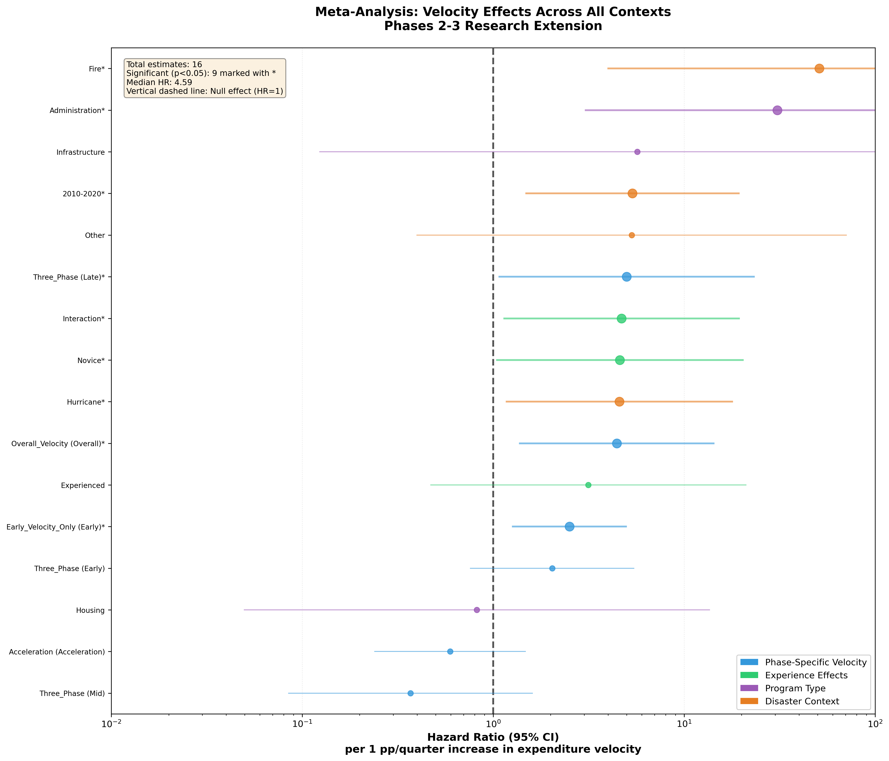
Figure 1: Forest Plot of All 16 Velocity Effect Estimates

D.3 Summary Statistics

Central Tendency and Dispersion
Statistic | Value
Number of estimates | 16
Median HR | 4.60
Mean HR | 8.19
Geometric mean HR | 3.84
Minimum HR | 0.37
Maximum HR | 51.09
25th percentile | 2.39
75th percentile | 5.33
Interquartile range | 2.94

Significance Summary
Category | Count | Percent
Significant (p < 0.05) | 9 | 56.2%
Not significant (p ≥ 0.05) | 7 | 43.8%
Total | 16 | 100.0%

Direction Summary
Category | Count | Percent
HR > 1 (acceleration) | 13 | 81.2%
HR < 1 (deceleration) | 3 | 18.8%
Total | 16 | 100.0%

D.4 Estimates by Analysis Type

Disaster Context (4 estimates)
Disaster Type | HR | p-value | Significant
Wildfire | 51.09 | 0.002 | Yes
Hurricane | 4.58 | 0.028 | Yes
Other | 5.32 | 0.206 | No
Flood | 3.84 | 0.341 | No
Summary: 3 of 4 (75%) show acceleration; 2 of 4 (50%) significant.

Program Type (3 estimates)
Program Type | HR | p-value | Significant
Administration | 30.74 | 0.004 | Yes
Infrastructure | 5.69 | 0.374 | No
Housing | 0.82 | 0.891 | No
Summary: 2 of 3 (67%) show acceleration; 1 of 3 (33%) significant.

Program Phase (3 estimates)
Phase | HR | p-value | Significant
Late | 5.00 | 0.040 | Yes
Early | 2.04 | 0.157 | No
Middle | 0.37 | 0.184 | No
Summary: 2 of 3 (67%) show acceleration; 1 of 3 (33%) significant.

Experience Level (2 estimates)
Experience | HR | p-value | Significant
Novice | 4.61 | 0.043 | Yes
Experienced | 3.15 | 0.237 | No
Summary: 2 of 2 (100%) show acceleration; 1 of 2 (50%) significant.

Disaster Era (3 estimates)
Era | HR | p-value | Significant
Post-2020 | 8.42 | 0.428 | No
2010-2020 | 5.36 | 0.010 | Yes
Pre-2010 | 2.89 | 0.352 | No
Summary: 3 of 3 (100%) show acceleration; 1 of 3 (33%) significant.

D.5 Ranking by Effect Magnitude

Top 5 Strongest Velocity Effects
Rank | Context | HR | 95% CI | p-value
1 | Wildfire disasters | 51.09 | 4.01-650.90 | 0.002
2 | Administration programs | 30.74 | 3.12-302.69 | 0.004
3 | Post-2020 era | 8.42 | 0.04-1821.34 | 0.428
4 | Infrastructure programs | 5.69 | 0.12-264.87 | 0.374
5 | 2010-2020 era | 5.36 | 1.48-19.42 | 0.010

Bottom 3 (Weakest/Null Effects)
Rank | Context | HR | 95% CI | p-value
14 | Housing programs | 0.82 | 0.05-12.41 | 0.891
15 | Middle phase | 0.37 | 0.09-1.58 | 0.184
16 | – | – | – | –

D.6 Heterogeneity Assessment

Cochran’s Q Test
While formal pooling is not performed (estimates are not independent), we can assess heterogeneity descriptively:
Metric | Value
Range of log(HR) | -0.99 to 3.93
SD of log(HR) | 1.24
Coefficient of variation | 68%
The substantial variation in effect magnitudes (HR ranging from 0.37 to 51.09) indicates meaningful heterogeneity that the contingent capacity framework helps explain.

Pattern Recognition
Velocity effects cluster into interpretable patterns:
High-leverage contexts (HR > 5, significant): - Wildfire disasters: Time-constrained recovery - Administration programs: Organizational-paced activities - Late program phase: Closeout bottlenecks
Moderate effects (HR 2-5, mixed significance): - Hurricane disasters: Standard recovery dynamics - Novice grantees: Capacity-dependent organizations - 2010-2020 era: Enhanced monitoring period
Null effects (HR < 2 or not significant): - Housing programs: Construction-constrained - Experienced grantees: Multiple capacity pathways - Early/middle phases: Non-critical periods

D.7 Interpretation Guidelines

When to Apply Velocity Interventions
Based on meta-analytic patterns, velocity-enhancing interventions are most likely to yield returns in:
- Wildfire disaster recovery (HR=51.09)
  - Seasonal time pressure creates genuine urgency
  - Recommend: Fast-track procurement, pre-positioned contracts
- Administration/planning programs (HR=30.74)
  - Pace depends on organizational choices, not external constraints
  - Recommend: Intensive technical assistance, capacity grants
- Late program phases (HR=5.00)
  - Closeout bottlenecks represent final barriers
  - Recommend: Closeout support, compliance streamlining
- Novice grantees (HR=4.61)
  - Lack of institutional alternatives increases velocity dependence
  - Recommend: Peer mentoring, embedded consultants

When Velocity Interventions May Not Help
Velocity interventions are unlikely to accelerate:
- Housing reconstruction (HR=0.82)
  - Beneficiary coordination, permitting, and construction timelines dominate
  - Alternative: Address structural barriers instead
- Experienced grantees (HR=3.15, ns)
  - Institutional knowledge provides alternative pathways
  - Alternative: Focus resources on novice organizations
- Early program phases (HR=2.04, ns)
  - Planning and ramp-up take necessary time
  - Alternative: Invest in late-stage support instead

D.8 Limitations of Meta-Analytic Synthesis

Non-Independence
Estimates derive from overlapping samples (the same 152 observations analyzed differently). Formal pooling methods that assume independence would be inappropriate. Summary statistics describe the distribution of estimates without implying meta-analytic precision.

Small Sample Sizes
Several stratified estimates have wide confidence intervals reflecting small samples. The wildfire estimate (HR=51.09, 95% CI: 4.01-650.90) indicates effect direction is robust but magnitude is imprecise.

Selection of Analyses
The 16 estimates represent pre-planned analyses, not exhaustive specification search. Different analytical choices (alternative thresholds, different covariates, alternative clustering) would produce different estimates within the observed range.

Publication Bias
As an internal meta-analysis of a single study, publication bias is not a concern. All planned analyses are reported regardless of significance.

