From Narrative Signals to Recovery Execution
  - Temporal Persistence, Program Heterogeneity, and Stage-Specific Dynamics in Texas Disaster Recovery
Jesse R. Andrews
Ali Nejat
Kaifa Lu
2026-03-02
Abstract
Disaster recovery programs generate rich streams of narrative reporting that remain largely untapped as monitoring instruments, leaving agencies reliant on financial indicators that reflect execution conditions only after the fact. Drawing on 442 quarterly disaster recovery reports spanning Texas grant portfolios from 2009 to 2025, we extract topically classified narrative signals and evaluate whether their prevalence anticipates program execution outcomes over one- and two-quarter horizons. We find that two substantively distinct signals — emphasizing homeowner assistance and roadway reconstruction, respectively — exhibit robust temporal persistence, with statistically stable directional associations that survive leave-one-unit deletion and multiplicity correction. However, this predictive structure is strongly conditioned by context: signal-outcome associations vary substantially across activity-composition strata and across the stages of the execution pipeline, from obligation through disbursement to final expenditure. Decomposing pooled from within-unit associations reveals that some aggregate patterns reflect cross-portfolio program composition rather than temporal dynamics within any given recovery program. These findings support integrating computational text analysis with structured financial monitoring, while cautioning that narrative indicators require explicit stratification and robustness discipline before they can serve as reliable early-warning diagnostics.

1. Introduction
Disaster recovery programs generate rich streams of narrative reporting that remain largely untapped as monitoring instruments, leaving agencies reliant on financial indicators that reflect execution conditions only after the fact. Drawing on 442 quarterly disaster recovery reports spanning Texas grant portfolios from 2009 to 2025, we extract topically classified narrative signals and evaluate whether their prevalence anticipates program execution outcomes over one- and two-quarter horizons. We find that two substantively distinct signals — emphasizing homeowner assistance and roadway reconstruction, respectively — exhibit robust temporal persistence, with statistically stable directional associations that survive leave-one-unit deletion and multiplicity correction. However, this predictive structure is strongly conditioned by context: signal-outcome associations vary substantially across activity-composition strata and across the stages of the execution pipeline, from obligation through disbursement to final expenditure. Decomposing pooled from within-unit associations reveals that some aggregate patterns reflect cross-portfolio program composition rather than temporal dynamics within any given recovery program. These findings support integrating computational text analysis with structured financial monitoring, while cautioning that narrative indicators require explicit stratification and robustness discipline before they can serve as reliable early-warning diagnostics.

Disaster recovery agencies face a recurring measurement problem: the most visible indicators of performance are financial and lagging, while implementation frictions emerge earlier in narrative reporting. Quarterly narrative text can capture shifts in priorities, bottlenecks, and operational sequencing before these shifts fully appear in aggregate accounting ratios. Yet in most operational and academic workflows, narrative content remains descriptive rather than analytic.
This paper evaluates whether narrative-signal prevalence is systematically linked to disaster-quarter execution outcomes in the Texas recovery context. We focus on two substantively distinct themes — homeowner-assistance language and roadway-reconstruction language — that represent contrasting implementation pathways and therefore constitute a demanding test of whether narrative composition tracks measurable execution dynamics. Signal prevalence is measured as a within-quarter share derived from a 40-signal topic classification of 442 quarterly DRGR report narratives, and is evaluated against a set of execution-stage outcomes constructed from financial and completion data in the same reporting system.
The central empirical questions are whether signal-outcome associations persist at one- and two-quarter leads, how those associations vary across the composition of program activity within a given quarter, and whether they concentrate at particular stages of the execution pipeline — obligation, drawdown, expenditure, and completion. A further question concerns whether pooled associations, which aggregate across structurally distinct disaster portfolios, reflect genuine within-portfolio temporal dynamics or are instead artifacts of cross-portfolio composition. We address all of these using a common diagnostic framework that separates pooled from within-unit estimands, controls false discovery rates with Benjamini-Hochberg q-values [1], and stress-tests findings against unit-influence and outlier-sensitivity checks.
The paper’s contribution sits at the intersection of text-as-data methodology and disaster recovery implementation research. Substantively, it provides the first structured evidence — in the CDBG-DR context — that narrative signals from routine administrative reporting can anticipate execution outcomes at short horizons, while also demonstrating that these signals carry meaningfully different implications depending on program mix and pipeline stage. Methodologically, it introduces a mechanism-bounding logic that uses timing, stratification, decomposition, and compositional re-parameterization to discipline interpretation without overstating what observational text-based evidence can deliver. The goal is a framework rigorous enough to inform monitoring practice, while transparent enough to guide further causal inquiry.
The remainder of the manuscript proceeds as follows. Section 2 situates the design in text-as-data and disaster implementation literatures. Section 3 documents data construction and analytic strategy. Section 4 presents the empirical findings, including robustness boundaries. Section 5 interprets implications for policy and research. Section 6 summarizes contributions and next steps.

2. Literature Review
This review positions the study at the intersection of implementation theory, performance governance, and computational text analysis in disaster recovery. It draws on five strands that directly motivate the empirical design: implementation and administrative burden theory, narrative-policy scholarship, text-as-data validation norms, the institutional architecture of Community Development Block Grant Disaster Recovery (CDBG-DR) and Disaster Recovery Grant Reporting (DRGR), and empirical evidence on recovery-stage heterogeneity and equity barriers.

2.1 Implementation Theory, Capacity, and Administrative Burden
Implementation scholarship emphasizes that policy outcomes are produced through multi-step administrative chains rather than by formal policy adoption alone. Classic work on implementation failure shows how delays and slippage accumulate across organizations and procedural stages [2]. Street-level bureaucracy further clarifies that front-line workload, discretion, and coping behavior shape realized service delivery under resource constraints [3]. In performance-governance terms, reporting systems are not single-purpose evaluation tools: they serve overlapping functions of control, learning, accountability, and adaptation [4].
For disaster recovery, these ideas imply that execution frictions are likely to surface first in routine implementation communication, not only in lagged financial aggregates. Administrative burden theory reinforces this expectation by showing how compliance complexity, documentation demands, and procedural friction create uneven access and pace of delivery [5].

2.2 Narrative Policy Scholarship and Measurable Administrative Text
Narrative policy research provides a conceptual bridge between qualitative reporting language and empirical measurement. The Narrative Policy Framework (NPF) established that policy narratives have analyzable structure and can be studied systematically rather than purely interpretively [6]. Subsequent reviews show broadening application and methodological consolidation while still calling for more cross-domain operational work [7]; [8].
This manuscript does not use narratives to study persuasion or coalition conflict; instead, it extends the same measurement logic to administrative implementation text. In this setting, narrative fields are treated as recurring operational records that can contain early evidence of bottlenecks, sequencing constraints, and coordination problems.

2.3 Text-as-Data Methods and Validation Discipline
Text-as-data literature argues that institutional text can be transformed into policy-relevant indicators at scale, but only when validation is design-central [9]; [10]. Methodological progression from topic models to embeddings and transformer-based representations has expanded what can be measured in administrative corpora [11]; [12]; [13]. At the same time, these advances increase the risk of over-interpretation if model-derived structure is not stress-tested against substantive and statistical alternatives.
Systematic evidence on NLP adoption in government also indicates rapid growth in operational applications, but uneven translation into high-rigor oversight diagnostics, especially for internal implementation monitoring rather than citizen-facing service automation [14].
That concern motivates the inferential safeguards used in this paper. Within/between distinctions are necessary to avoid conflating cross-unit composition with within-unit temporal movement [15], and multiplicity control is necessary when evaluating many signals across outcomes and horizons [1]. The review therefore supports a design in which robustness diagnostics are not auxiliary, but integral to interpretation.

2.4 Disaster Recovery Reporting Infrastructure as Measurement Substrate
Disaster recovery literature characterizes recovery as a staged, institutionally mediated process shaped by underlying social vulnerability and governance capacity [16]; [17]. In the U.S. context, CDBG-DR operates as a long-horizon recovery backstop, and oversight depends heavily on DRGR-based quarterly reporting requirements and public disclosure expectations [18]; [19].
Crucially for this study, DRGR and Quarterly Performance Report (QPR) workflows embed narrative fields alongside financial and outcome reporting. This institutional feature justifies treating narrative text as a standardized administrative input rather than unstructured anecdote [20]. It also creates a testable proposition: narrative emphasis in quarter $t$ may encode operational conditions that become visible in disbursement, expenditure, and completion metrics in quarter $t+h$.

2.5 Stage Heterogeneity, Equity Barriers, and Remaining Empirical Gap
Empirical recovery studies document that execution timing varies substantially by activity type, program structure, and administrative process burdens, with grant-execution phases often dominating total timelines [21]. Equity-focused reviews and case evidence likewise identify recurring implementation barriers, including process complexity, coordination burden, and exclusionary dynamics that can suppress or delay measurable progress [22]; [23].
Despite these advances, most adjacent work still uses narratives primarily for qualitative triangulation rather than as formally validated, high-frequency operational indicators. The unresolved gap is therefore not whether narratives matter, but how to convert them into defensible oversight diagnostics that account for timing, composition, stage differences, and inferential uncertainty.
This paper addresses that gap by linking narrative-signal prevalence to stage-specific execution outcomes under a common diagnostic framework that combines lead-horizon checks, activity-stratum heterogeneity, pooled-versus-within decomposition, and explicit robustness boundaries. The next section operationalizes that framework in the Texas disaster-quarter panel.

3. Methods
The analysis is designed to produce associations that are interpretable and bounded, rather than maximally comprehensive. Each component — data construction, estimand definition, lead alignment, activity stratification, and robustness testing — is chosen to keep the resulting evidence connected to substantive questions about implementation timing, program mix, and stage-specific execution dynamics.

3.1 Data Architecture and Unit of Analysis
The study links quarterly narrative-signal prevalence to SEM-adapter outcomes at the disaster-quarter level. The reporting context is the DRGR quarterly performance system used in CDBG-DR and Community Development Block Grant Mitigation (CDBG-MIT) program administration [18]; [20].
Figure 1 provides a compact provenance view from source reports to the merged analytic panel used in estimation.
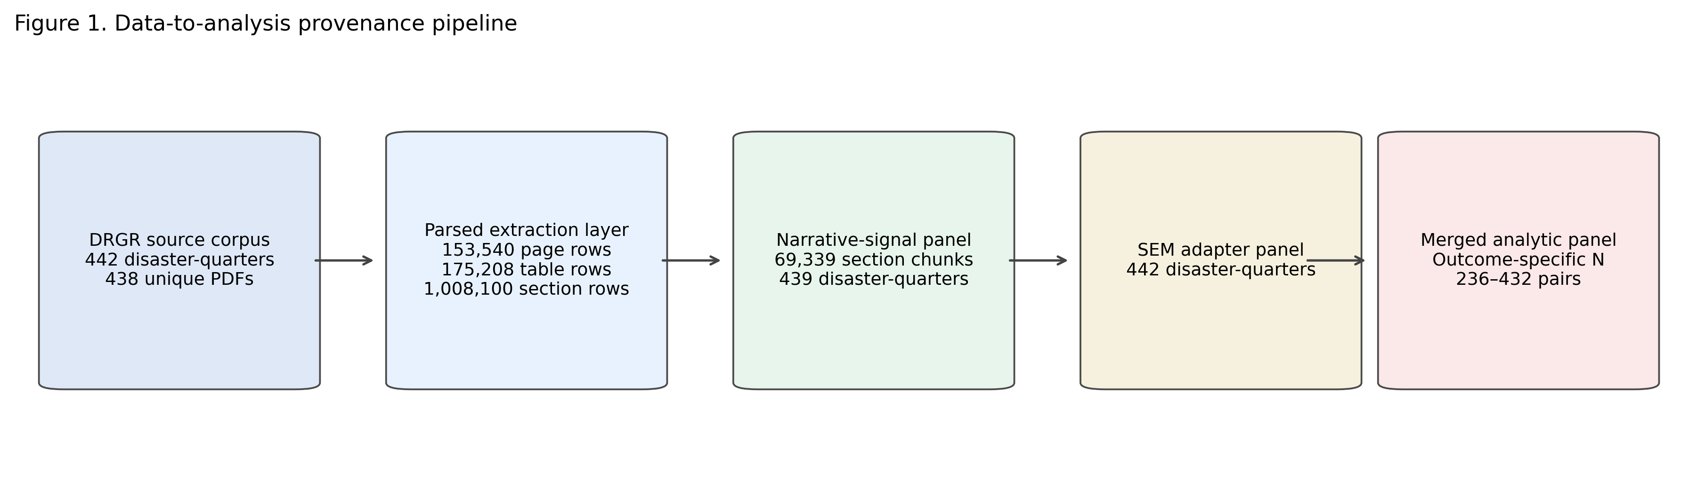
Figure 1: Data provenance pipeline from DRGR source documents to merged disaster-quarter analytic panel, with record counts at each stage.
The primary corpus contains 442 disaster-quarter document records drawn from DRGR quarterly reporting streams and representing 438 unique PDF files. Coverage spans 2009 Q3 through 2025 Q4, across 18 reporting categories and 24 disaster codes. The corpus contains 153,540 pages in total, with a mean of 347 pages per report and a range from 1 to 2,742 pages. Four duplicate filenames appear in both action-plan and performance streams and are retained as separate category-context records for quarter-level accounting.
Table 1: Document provenance and coverage in the DRGR corpus.
DRGR document stream | Disaster-quarter records | Distinct disaster codes | Coverage
Legacy hazard/disaster reporting streams | 225 | 9 | 2009-2025
Harvey action-plan/performance streams | 106 | 6 | 2018-2025
2018/2019 action-plan/performance streams | 70 | 5 | 2021-2025
Mitigation action-plan/performance streams | 38 | 2 | 2021-2025
Timely expenditure reports | 3 | 2 | 2020

Figure 2 visualizes quarter-level coverage and the outcome-specific sample attrition profile.
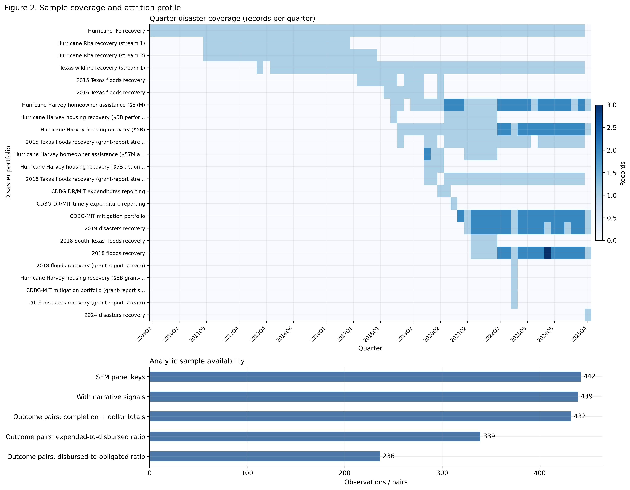
Figure 2: Quarter-disaster coverage heatmap in the left panel and analytic sample availability by merge/denominator gate in the right panel.
In Figure 2, row labels use reader-facing disaster portfolio names, with the raw DRGR disaster code retained in brackets for traceability.
Alongside the PDF corpus, structured DRGR workbook exports provide activity-level financial and implementation data. These include quarterly financial records by project and activity, activity progress narratives, accomplishment measures, and household characteristics by tenure and ethnicity. Together these structured sources contribute roughly 28,000 records that supplement the narrative panel with financial and beneficiary signals at the activity level.
Construction of the analytic panel proceeds from source documents to estimation-ready observations in three steps. Page text and table content are parsed into heading-delimited sections, which are then classified into 40 thematic signal channels, yielding 1,008,100 sections and 69,339 assigned narrative chunks. Financial and completion fields from the same reporting system are aggregated into a disaster-quarter panel capturing stage-specific execution outcomes. Finally, the narrative and financial panels are merged with activity-composition indicators that classify each quarter by the predominant type of programmatic activity — whether housing, infrastructure, a mix of both, or neither.
The unit of analysis is a disaster-quarter — a single reporting period for a given disaster portfolio, identified by reporting category, disaster code, year, and quarter. The full panel contains 442 disaster-quarters across 32 category-disaster portfolios, of which 439 have narrative signal assignments; the three unmatched records are expenditure-only quarters that lacked narrative content. Reporting category here denotes a distinct DRGR program portfolio — such as action-plan versus performance streams — with its own implementation cadence, compliance workflow, and activity mix. Each category-disaster combination is therefore treated as a coherent execution portfolio rather than as repeated observations of a single administrative unit. Outcome-specific coverage varies with denominator availability and missingness, as detailed in Section A.2.

3.2 Key Variables
The focal explanatory variables are quarterly shares for a homeowner-assistance narrative signal and a roadway-reconstruction narrative signal. The stage-specific outcome set includes two rate outcomes: disbursed-to-obligated ratio and expended-to-disbursed ratio. It also includes two scale outcomes, total obligated dollars and total expended dollars, plus one completion proxy, program completion rate. To evaluate compositional heterogeneity, each disaster-quarter is assigned to an activity stratum: housing, mixed, infrastructure, or neither.

3.3 Variable Derivation and Transformations
Signal intensity is measured as a within-quarter share rather than a raw count. For narrative signal $k$ in disaster-quarter $\left(i,t\right)$, signal share is computed as:
si,t,k=Ci,t,kk′​Ci,t,k′.
where $C_{i,t,k}$ is the number of narrative chunks assigned to signal $k$ in quarter $\left(i,t\right)$. This normalization adjusts for quarter-level variation in total narrative volume and makes coefficients comparable across units and periods. Because signal shares are compositional and obey a constant-sum constraint within each quarter, coefficients are interpreted as relative narrative emphasis, not absolute narrative intensity.
To assess compositional sensitivity, key focal-signal estimates are re-computed with two alternative constructions: a log-ratio transform, $log\left(\frac{C_{i,t,k}+0.5}{C_{i,t,\text{other}}+0.5}\right)$, and a volume-adjusted log-count residual defined as the residual from regressing $log\left(1+C_{i,t,k}\right)$ on $log\left(1+C_{i,t,\text{total}}\right)$. These diagnostics test whether core signs depend on the share parameterization.
The SEM adapter variables are derived from quarterly financial and completion rollups. Specifically, the disbursed-to-obligated ratio is defined as drawdown dollars divided by obligated dollars, the expended-to-disbursed ratio as expended dollars divided by drawdown dollars, and the program completion rate as an alias of the source completion field. Timeliness, which is used in auxiliary checks, is defined as the inverse of mean program duration in quarters. Ratio variables are treated as missing when denominators are zero or unavailable; the resulting outcome-specific coverage is documented in Section A.1 and Section A.2.

3.4 Empirical Strategy
A unified set of diagnostic estimands is applied consistently across pooled samples, within-unit transforms, lead horizons, activity strata, and outcome stages. Holding the estimand definition constant across these comparisons ensures that differences in results reflect genuine heterogeneity rather than changes in the underlying metric.

3.4.1 Pooled and Within-Unit Correlations
The baseline diagnostic is Spearman rank correlation between signal share and each outcome. We report two estimators: a pooled Spearman correlation over all merged disaster-quarters and a within-unit Spearman correlation constructed from within-disaster ranks and then pooled. This dual-estimator design separates associations driven by cross-unit composition from associations that reflect within-unit temporal movement. Spearman is used because the core variables are skewed, potentially nonlinear in levels, and more plausibly related through monotonic rather than strictly linear structure [24].

3.4.2 Lead-Lag Design
To evaluate temporal persistence, outcomes are shifted forward by one and two quarters. For lead horizon $h$, the reported statistic correlates signal share at quarter $t$ with outcome at quarter $t+h$. This design tests whether narrative composition has predictive continuity over short operational horizons, while avoiding causal interpretation.
Because lead associations can be inflated by outcome autocorrelation and reporting-template inertia, supplementary diagnostics estimate two quantities: correlations with change outcomes $Δy_{t→t+h}$ and correlations with residualized leads after regressing $y_{t+h}$ on $y_{t}$. Signal autocorrelation is also reported as a narrative-inertia check.

3.4.3 Stratum and Stage Analyses
The correlation framework is re-estimated within activity strata to evaluate implementation-context heterogeneity, and across the stage-specific outcome set to identify where associations concentrate in the execution pipeline. This stratum-by-stage mapping is central to interpretation because a single pooled estimate can mask offsetting patterns across program types and administrative stages.

3.4.4 Robustness Framework
Four robustness diagnostics bound interpretation. Leave-one-disaster-out (LOO) re-estimation identifies whether any single portfolio drives the pooled result. Ratio-cap sensitivity progressively trims the expended-to-disbursed ratio to evaluate dependence on extreme denominator realizations. Compositional re-parameterization re-estimates key associations using log-ratio and volume-adjusted count constructions to guard against artifacts of the share normalization. Lead incremental-content diagnostics compare baseline lead associations against change-outcome and residualized-lead alternatives to separate signal content from outcome persistence. False discovery rates across method families are controlled using Benjamini-Hochberg q-values [1].

3.5 Scope and Identification
This is an exploratory, diagnostic study. The design establishes structured associations and characterizes their heterogeneity and stability, but does not support causal claims. The temporal lead-horizon checks provide evidence of predictive persistence, not anticipatory causation, and the observational design cannot rule out common causes, reporting inertia, or selection into program activity types. We interpret results as hypothesis-organizing evidence that can motivate more targeted identification strategies in subsequent work.

4. Results
The results build the empirical argument in four stages. We first establish that both focal signals carry forward-looking information about execution outcomes over one- and two-quarter horizons. We then show that this predictive structure is conditioned by program composition, that signals concentrate at different stages of the execution pipeline, and that the two signals exhibit characteristically different decomposition profiles. Robustness boundaries and asymmetries between the signals are addressed throughout and synthesized at the end of the section.

4.1 Temporal Persistence: Lead-Horizon Evidence
Both focal signals show consistent directional persistence across lead horizons. The homeowner-assistance signal is negatively associated with the expended-to-disbursed ratio contemporaneously ($ρ=−0.331$, $q=8.16×{10}^{−9}$) and remains so at one-quarter ($ρ=−0.362$, $q=1.84×{10}^{−9}$) and two-quarter ($ρ=−0.328$, $q=1.57×{10}^{−7}$) leads. The roadway-reconstruction signal runs in the opposite direction, with a positive association that likewise holds at lag 0 ($ρ=0.339$, $q=5.74×{10}^{−9}$), lag 1 ($ρ=0.339$, $q=2.08×{10}^{−8}$), and lag 2 ($ρ=0.352$, $q=1.54×{10}^{−8}$).
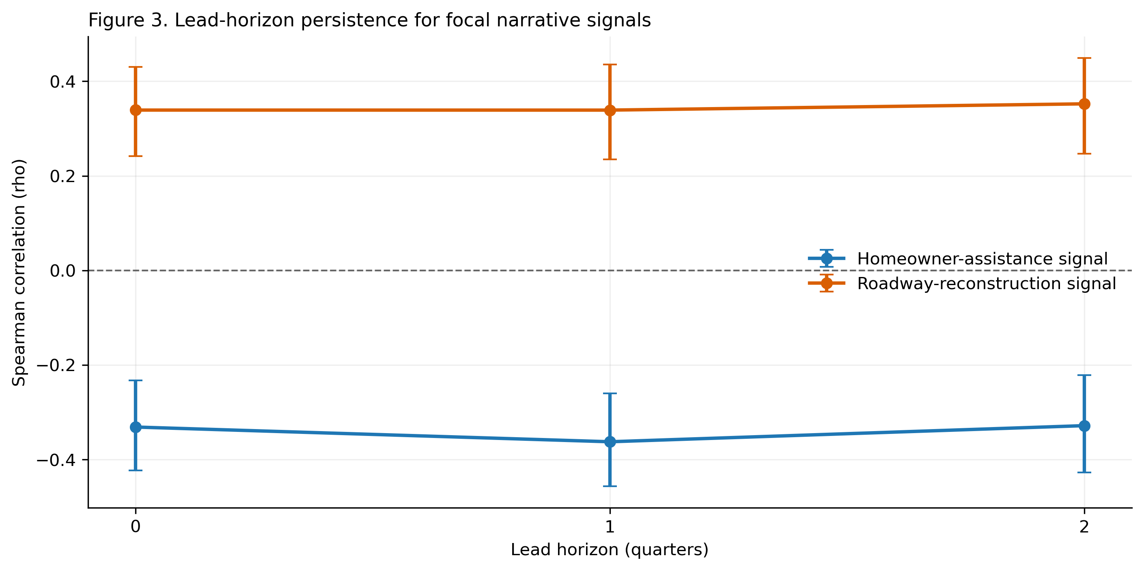
Figure 3: Lead-horizon persistence for focal signals on the expended-to-disbursed ratio, with 95% confidence intervals computed using the Fisher-z approximation.
This persistence indicates that signal composition is not only contemporaneous description; it tracks near-term execution dynamics. The result supports narrative monitoring use cases where agencies require forward-looking triage rather than purely retrospective reporting.
This persistence is not reducible to simple outcome carry-over. After partialing out the contemporaneous value of the expended-to-disbursed ratio, residualized-lead correlations remain directionally aligned and statistically meaningful for both signals. For homeowner assistance, the residualized associations are $ρ=−0.313$ ($q=3.75×{10}^{−7}$) at lag 1 and $ρ=−0.257$ ($q=3.60×{10}^{−5}$) at lag 2; for roadway reconstruction, $ρ=0.271$ ($q=1.02×{10}^{−5}$) and $ρ=0.209$ ($q=8.37×{10}^{−4}$) respectively. By contrast, change-outcome correlations are considerably weaker, in several cases approaching zero. Together, these diagnostics suggest that the baseline lead associations combine genuine incremental information with mechanically persistent outcome trajectories — rather than reflecting either component alone.

4.2 Program-Mix Heterogeneity: Stratum Evidence
Stratifying by activity composition substantially changes what the associations imply. Among quarters with a mix of housing and infrastructure activity — the largest stratum — both focal signals retain their baseline direction and statistical strength: homeowner assistance remains negative ($ρ=−0.345$, $q=2.37×{10}^{−6}$) and roadway reconstruction remains positive ($ρ=0.348$, $q=2.37×{10}^{−6}$). In housing-dominant quarters, by contrast, both signals weaken to statistical non-significance ($ρ=0.144$, $q=0.302$ and $ρ=0.228$, $q=0.109$, respectively). The infrastructure and neither strata offer limited sample power, but sign shifts in these smaller cells reinforce the broader interpretation: the pooled results aggregate across operationally distinct program contexts rather than reflecting a single common mechanism.
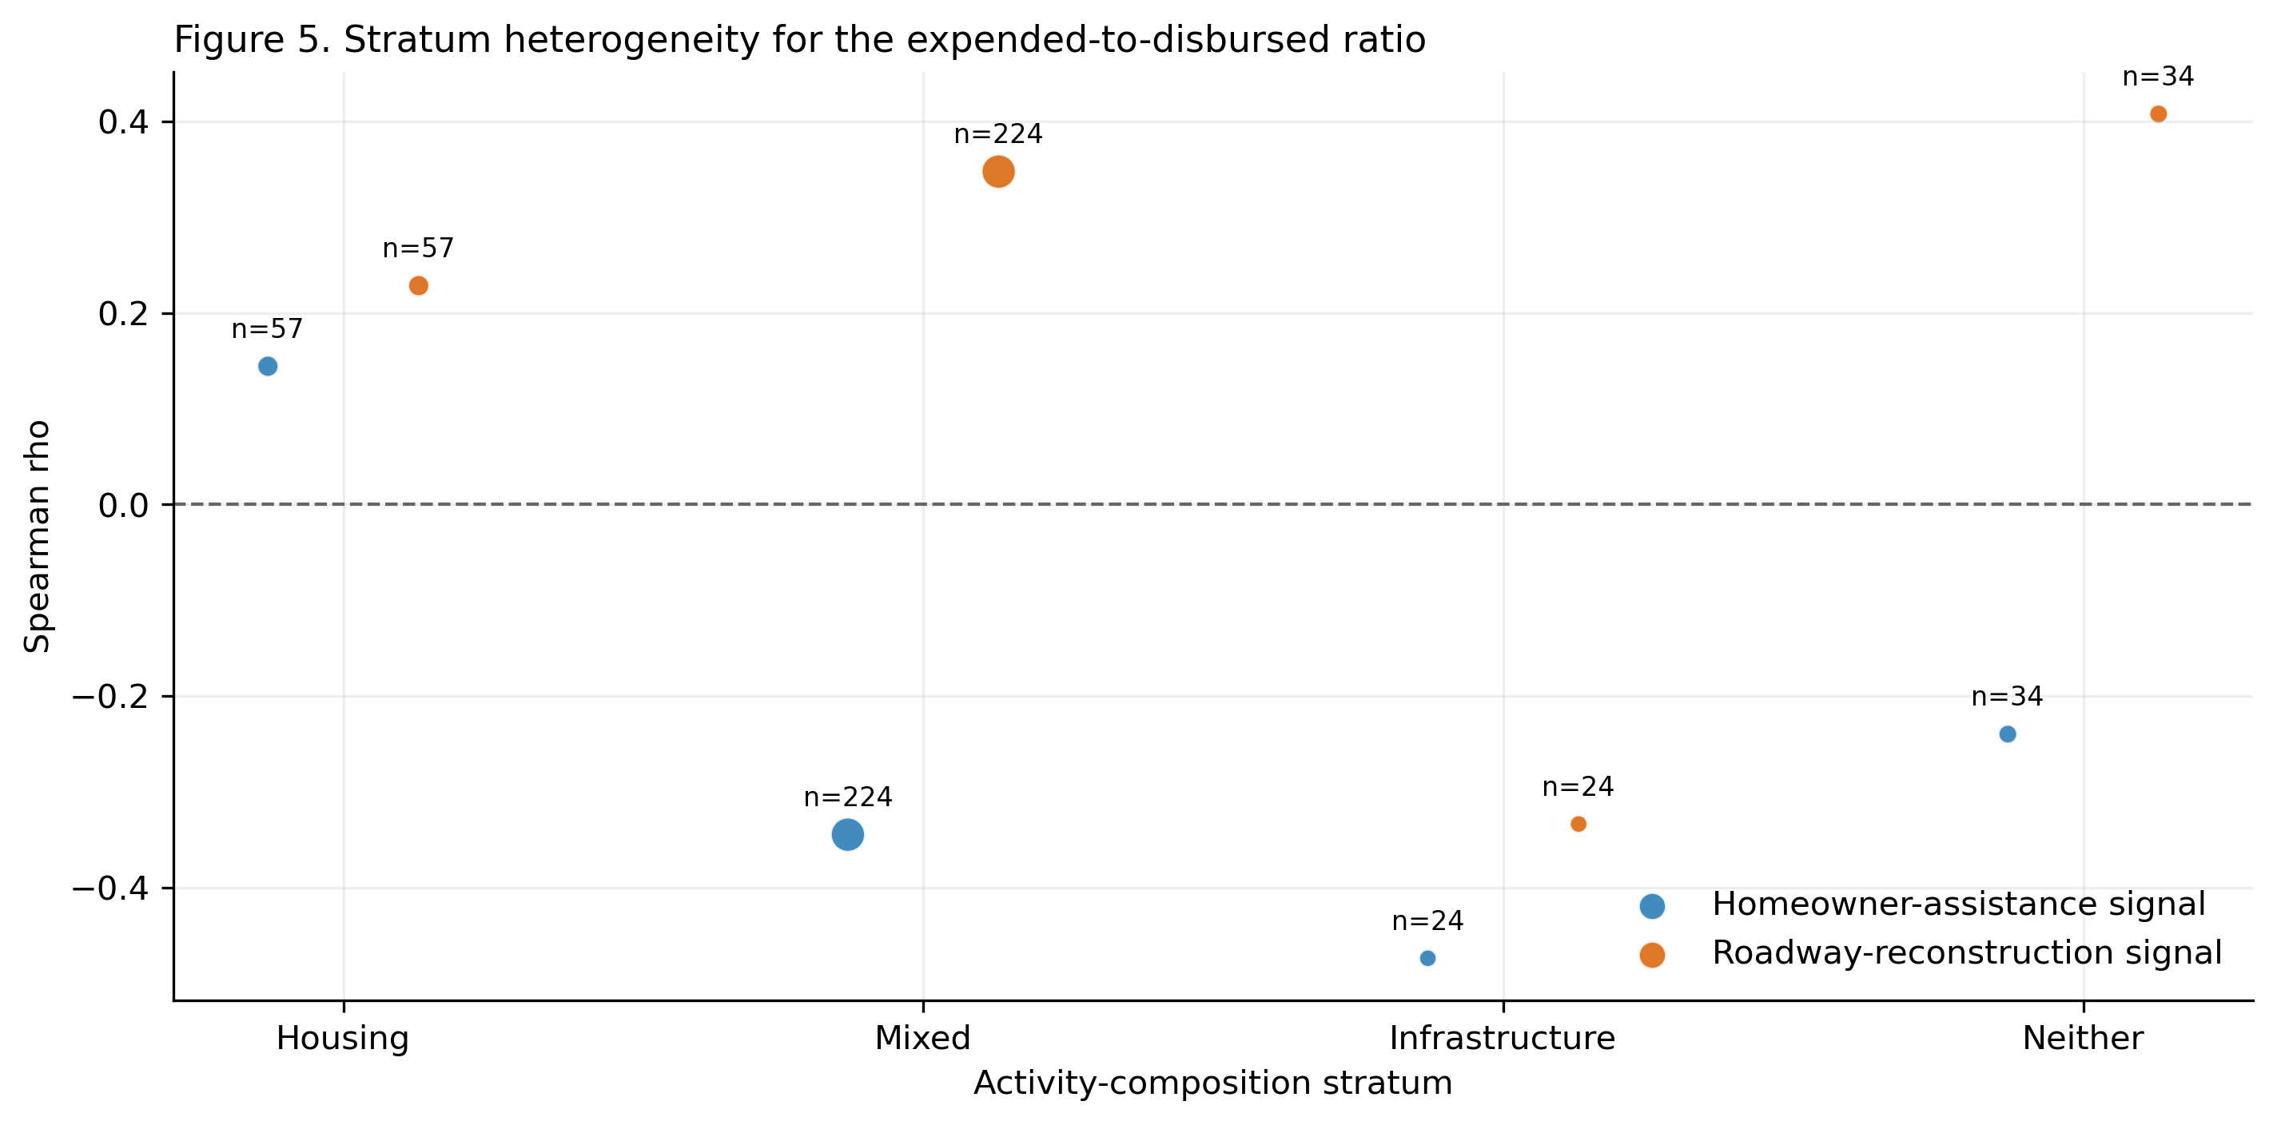
Figure 4: Activity-stratum heterogeneity for focal signals on the expended-to-disbursed ratio; marker size is proportional to the observation-pair count.

4.3 Stage-Specific Dynamics: Outcome Mapping
The two signals occupy strikingly different positions in the execution pipeline. The homeowner-assistance signal is positively associated with the disbursed-to-obligated ratio ($ρ=0.342$, $q=2.07×{10}^{−7}$) — the early drawdown stage — but negatively associated with all downstream outcomes: expended-to-disbursed ratio ($ρ=−0.331$, $q=1.43×{10}^{−9}$), total obligated ($ρ=−0.360$, $q=7.87×{10}^{−14}$), total expended ($ρ=−0.304$, $q=4.23×{10}^{−10}$), and program completion ($ρ=−0.188$, $q=2.04×{10}^{−4}$). The roadway-reconstruction signal shows the opposite pattern: it is essentially unrelated to early drawdown ($ρ=−0.071$, $q=0.365$), while exhibiting positive and significant associations with expenditure conversion, obligation volume, expenditure volume, and completion (ranging from $ρ=0.146$ to $ρ=0.354$ across outcomes). A signal can therefore be favorable at one stage of the pipeline while appearing unfavorable — or irrelevant — at another, making single-metric summaries of performance misleading.
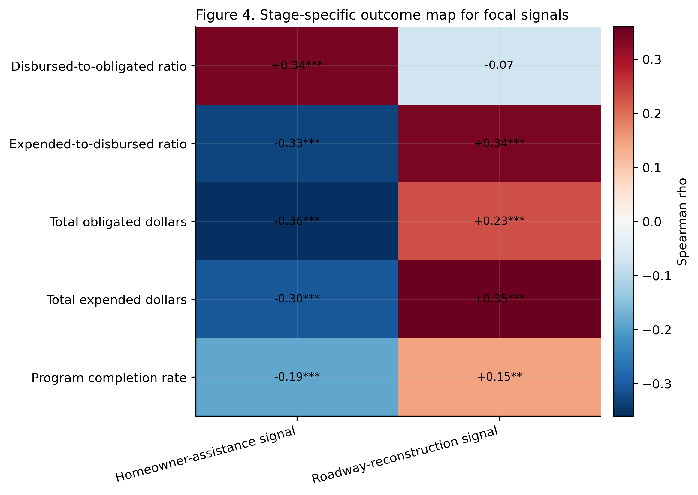
Figure 5: Stage-specific outcome map for focal signals. Asterisks denote q-value thresholds: * q < 0.05, ** q < 0.01, *** q < 0.001.
These patterns reinforce a core design claim of the paper: stage-specific interpretation is necessary for valid monitoring use. A narrative signal can be favorable on one stage metric and unfavorable on another, so single-metric summaries can misclassify implementation state.

4.4 Composition Versus Within-Unit Dynamics
Decomposing pooled from within-unit associations clarifies a central interpretive ambiguity. For the homeowner-assistance signal, the pooled correlation with the expended-to-disbursed ratio is $−0.331$, while the within-portfolio correlation is $+0.500$ — a sign reversal that indicates the aggregate negative pattern is at least partly compositional: portfolios that are structurally homeowner-intensive tend to exhibit slower expenditure conversion relative to other portfolios, even if, within a given portfolio, periods of heightened homeowner-assistance emphasis do not coincide with deteriorating conversion rates. For the roadway-reconstruction signal, pooled and within-unit correlations align in direction, with within-unit associations ($+0.673$) actually stronger than pooled ($+0.339$), suggesting a more consistent temporal pattern across contexts.
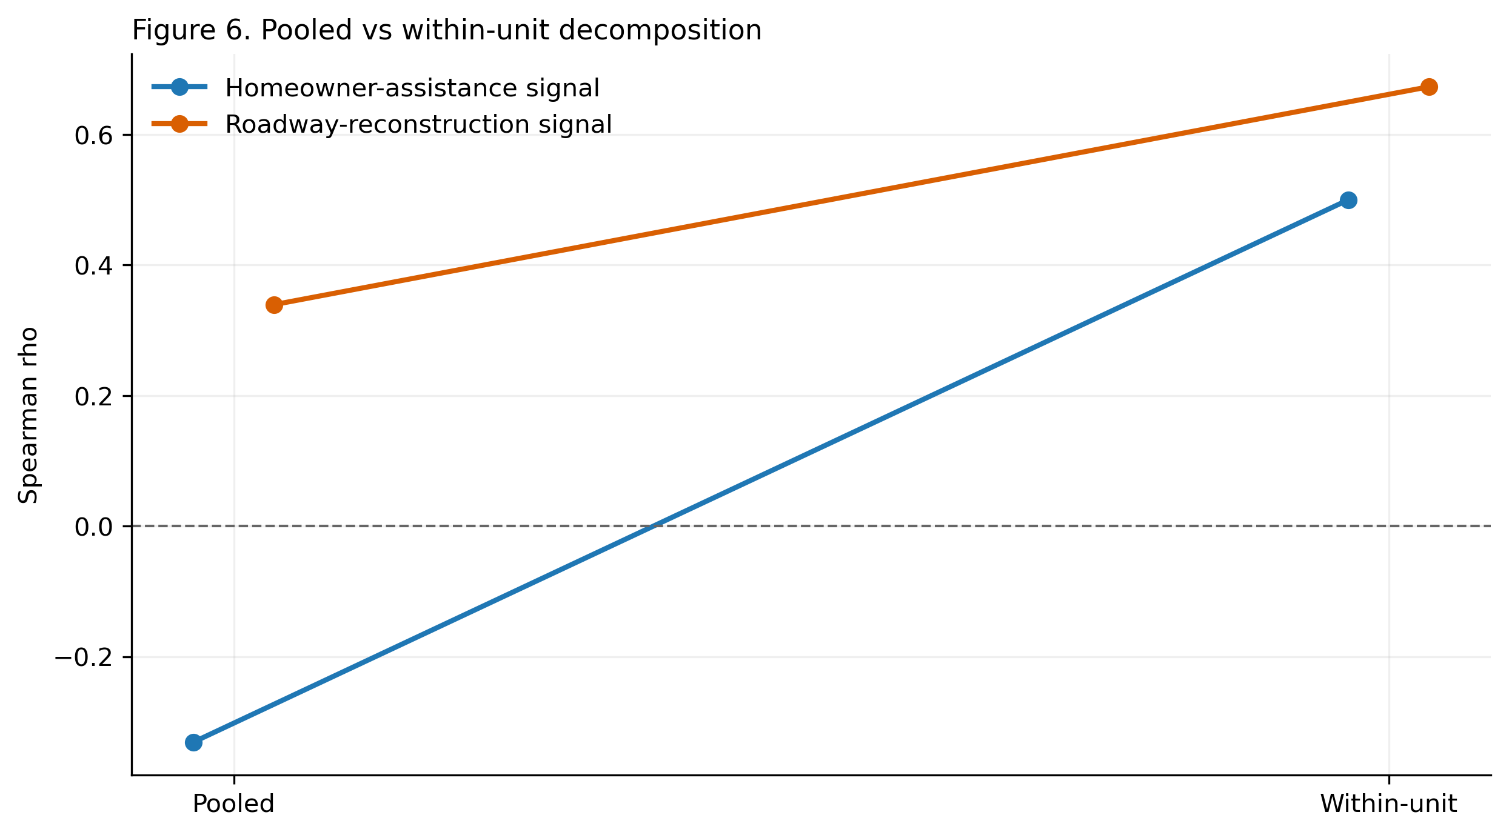
Figure 6: Pooled versus within-unit decomposition for focal signals on the expended-to-disbursed ratio.
This distinction matters for how monitoring systems should be designed: treating the homeowner-assistance signal as a within-portfolio early warning for expenditure conversion would reverse its population-level sign and therefore mislead.

4.5 Robustness Boundaries
The robustness profile differs substantially between the two signals. Both pass leave-one-disaster-out stability: across 30 deletion runs, the homeowner-assistance correlation ranges from $−0.453$ to $−0.265$ with zero sign flips, and the roadway-reconstruction correlation ranges from $+0.281$ to $+0.390$ with zero sign flips. Neither result appears to be driven by a single influential portfolio.
The signals diverge, however, on sensitivity to extreme ratio values. The homeowner-assistance signal retains a negative sign as the expended-to-disbursed ratio is progressively capped. The roadway-reconstruction signal reverses to negative under the same caps (e.g., $ρ=−0.256$ at cap $≤2$), indicating that its positive pooled association for this specific outcome depends on observations with exceptionally high ratio values. This asymmetry does not undermine the roadway signal’s evidence on expenditure volume or completion, where no ratio capping is involved, but it cautions against treating the expenditure-conversion ratio as the primary evidence base for that signal.
Alternative signal parameterizations are largely reassuring. Replacing the share with a log-ratio or a volume-adjusted residualized count preserves the baseline direction in 9 out of 10 and 10 out of 10 stage-outcome comparisons, respectively, with the one exception being the roadway signal on program completion rate under the log-ratio specification. For the central expended-to-disbursed outcome, both signals are directionally stable across all three parameterizations.
Finally, the lead associations should be read in light of substantial persistence in both signals and outcomes. The homeowner-assistance signal is highly autocorrelated ($ρ=0.925$ at one-quarter lead; $0.921$ at two), reflecting language that changes slowly, likely due to reporting templates and portfolio composition inertia. Outcome persistence is also strong ($ρ=0.725$ and $0.651$ for the expended-to-disbursed ratio at one and two quarters). The residualized-lead evidence establishes that signals carry monitoring information beyond what outcome persistence alone predicts, but claims of anticipatory power should acknowledge this structural backdrop.
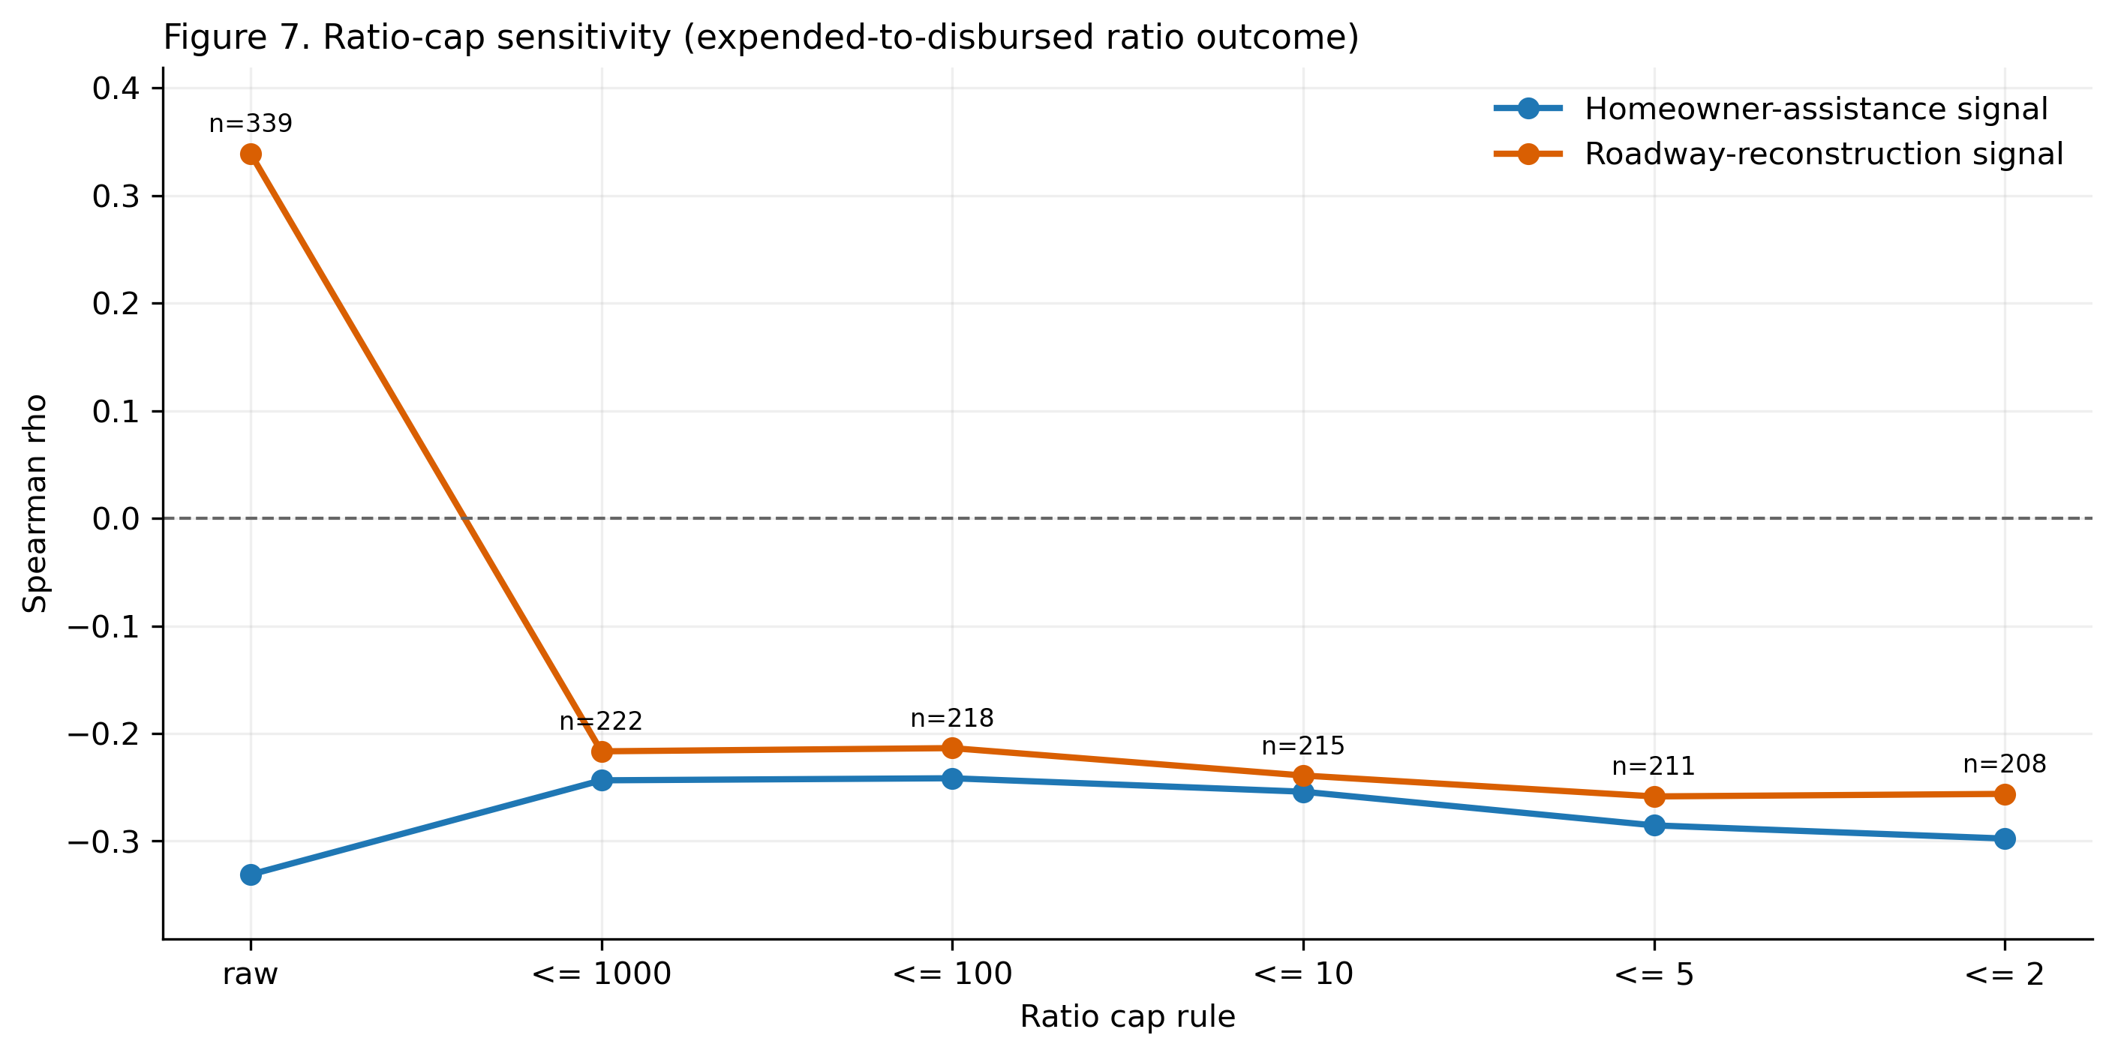
Figure 7: Ratio-cap sensitivity for focal signals across progressively stricter cap rules on the expended-to-disbursed ratio.

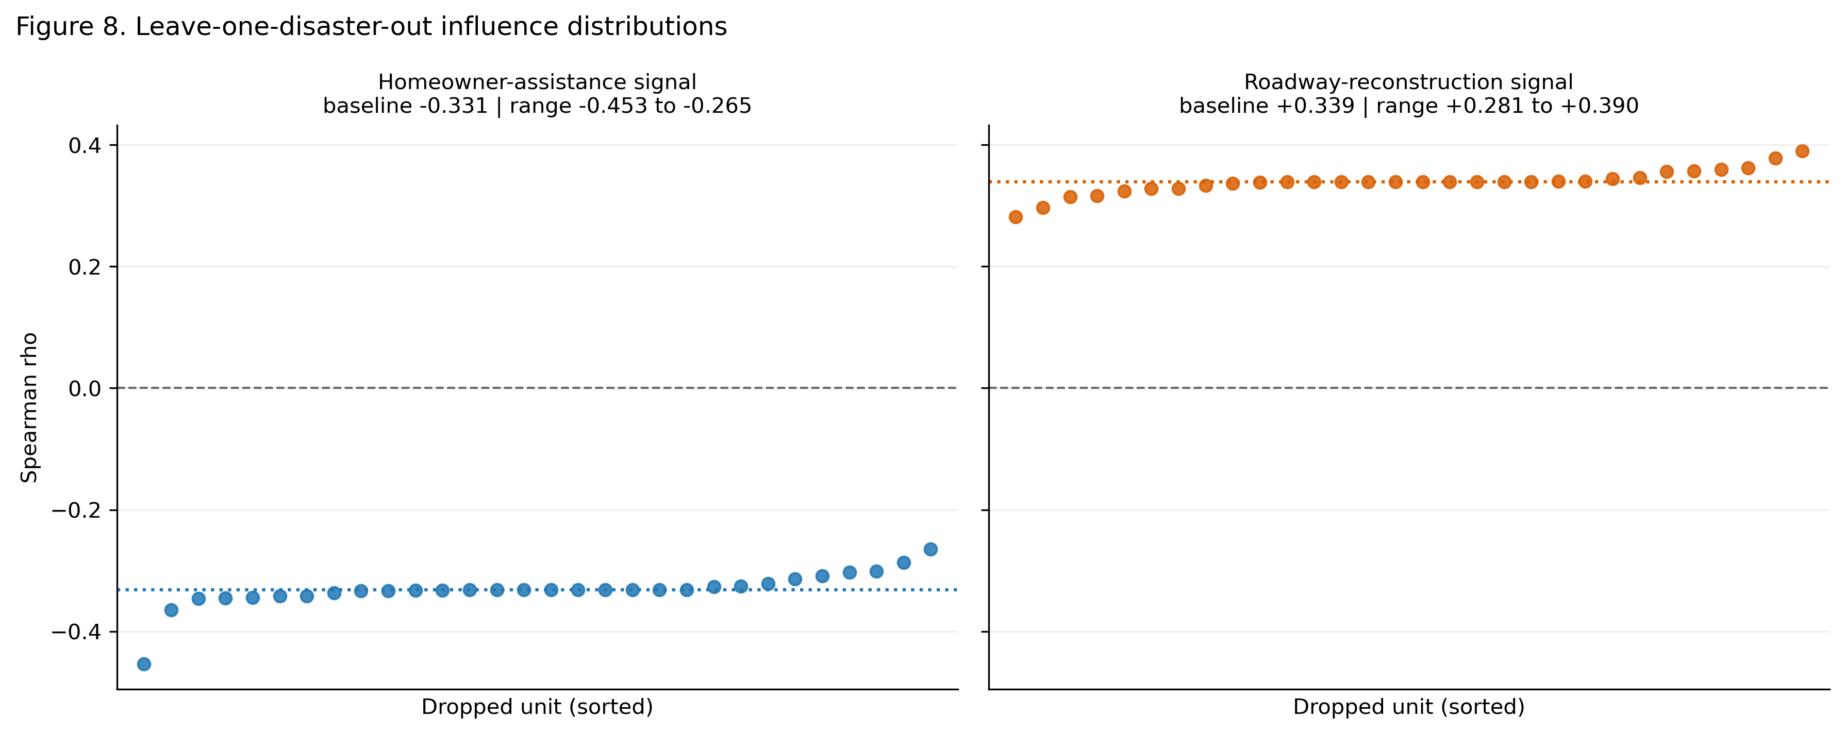
Figure 8: Leave-one-disaster-out influence distributions for focal signals; dotted lines denote full-sample baselines.
Table 2 provides an integrated view of which claims survive robustness scrutiny and which require qualification.
Table 2: Integrated diagnostic summary for the two focal narrative signals.
Diagnostic | Homeowner-Assistance Signal | Roadway-Reconstruction Signal | Finding
Lead persistence | Stable | Stable | Directional associations hold at 1- and 2-quarter horizons
Residualized-lead content | Stable | Stable | Signal carries monitoring value beyond outcome persistence
Stratum heterogeneity | Present | Present | Associations vary substantially with activity composition
Stage contrast | Present | Present | Signals concentrate at different execution stages
Compositional parameterization | Stable | Mostly stable (1 exception) | Core directions hold under alternative signal constructions
Pooled vs. within decomposition | Sign conflict | Aligned | Homeowner-assistance pooled pattern is partly compositional
Leave-one-out stability | Stable | Stable | No sign reversals under unit deletion
Ratio-cap sensitivity | Stable | Sensitive | Roadway expenditure-conversion result depends on extreme values

5. Discussion
The results establish that narrative signals carry systematic information about near-term execution dynamics, but that this information is conditional, asymmetric, and sensitive to how it is measured. The strongest evidence — temporal persistence, stratum coherence, and compositional stability — supports treating narrative monitoring as a meaningful supplement to financial indicators. The important qualifications — decomposition conflicts, ratio sensitivity, and signal inertia — define the interpretive discipline required before that supplement becomes reliable.

5.1 Mechanisms Linking Narrative Emphasis to Execution Outcomes
The patterns are consistent with multiple co-occurring mechanisms, and the design is intentionally positioned to bound rather than identify among them. In the administrative burden and implementation literatures, both the attention/prioritization and friction/bottleneck interpretations receive theoretical support [5]; [3]. Narrative emphasis may rise when a program domain commands heightened managerial attention and resource allocation, or conversely when operational difficulties — eligibility screening, procurement delays, contractor management — generate more reportable activity without corresponding financial throughput. These two interpretations predict the same positive covariation between narrative emphasis and early-stage drawdown, but diverge in their implications for later-stage expenditure and completion.
The stage-marker interpretation — that signals shift predictably as portfolios advance through obligation, drawdown, expenditure, and closeout — is especially consistent with lifecycle theories of implementation [2] and with the observed asymmetry between early and late execution-stage associations. The homeowner-assistance signal’s positive early-stage and negative late-stage pattern is precisely what one would expect if homeowner-oriented language tracks the initial phases of program engagement, when funds are moving from obligation to drawdown but have not yet converted to expended activity. The roadway-reconstruction signal’s absent early-stage and strong late-stage associations suggest a different lifecycle rhythm, consistent with capital projects that require extended procurement and mobilization before generating expenditure and completion activity.
A fourth interpretation — that language partly reflects reporting templates and compliance boilerplate rather than real-time execution conditions — cannot be dismissed given the high signal autocorrelation documented in the robustness analysis. The homeowner-assistance signal’s autocorrelation of $0.925$ at one-quarter lead is consistent with slowly evolving reporting language that may lag operational conditions rather than anticipate them. This interpretation reinforces the residualized-lead design as a necessary diagnostic rather than a secondary check: the persistence of associations after conditioning on current-period outcomes establishes that signals contain genuine monitoring content, even if that content is partly conveyed through the accumulated weight of templated language.

5.2 Implications for Theory, Monitoring, and Research Design
The results carry several implications that extend beyond the Texas context. For the text-as-data literature, they demonstrate that administrative narrative indicators can exhibit the kind of leading associations with outcome variables that are required for monitoring use, but that these associations are fragile to context and construction in ways that demand explicit diagnostic testing before operational deployment [9]. The heterogeneity by activity composition and execution stage is particularly consequential: it means that a signal useful for mixed-activity portfolios may be uninformative — or actively misleading — for housing-only programs, and that the same signal can be favorable at one stage while unfavorable at another. These patterns should encourage the field to move away from portfolio-wide signal averages toward stratified monitoring designs.
For implementation and performance-governance research, the decomposition result for homeowner assistance — where pooled and within-unit associations run in opposite directions — exemplifies the ecological inference problem that arises when cross-sectional variation in program composition is conflated with longitudinal variation in program performance [15]. Recovery agencies that use aggregate portfolio comparisons as management tools risk misclassifying what drives observed differences. Within-portfolio temporal analysis, combined with explicit activity-composition controls, provides a more interpretable diagnostic layer for understanding whether an individual program is improving or deteriorating over time.
For research practice, the framework developed here — pairing signal-outcome correlations with lead-horizon persistence tests, pooled-versus-within decomposition, stratum-specific estimation, and multi-parameterization checks — offers a transferable template for text-as-data studies that aim to move from exploratory association toward monitoring-ready inference. The next empirical priority is causal identification: quasi-experimental variation in reporting requirements, program eligibility rules, or administrative capacity that could isolate specific mechanisms would substantially advance understanding of when and why narrative signals predict execution outcomes.

6. Conclusion
Disaster recovery agencies currently monitor program performance primarily through lagging financial indicators, even as implementation problems surface first in the narrative records that programs generate every quarter. This paper develops and applies a diagnostic framework for evaluating whether that narrative content carries systematic forward-looking information about execution outcomes. Using a text-classified panel drawn from 442 quarterly Texas DRGR reports spanning 2009 to 2025, we show that two focal signals — emphasizing homeowner assistance and roadway reconstruction — exhibit robust temporal persistence across one- and two-quarter horizons, surviving multiplicity correction and leave-one-unit deletion.
The more important finding, however, concerns the conditionality of this persistence. The same signal that anticipates slower expenditure conversion in aggregate mixed-activity portfolios is uninformative within housing-dominant programs, and the same signal that is negatively associated with late-stage execution is positively associated with early drawdown. A signal that appears to function as an early warning indicator at the portfolio level may reverse sign within a given program over time. These patterns are not anomalies to be explained away; they reflect the genuine complexity of multi-stage, multi-activity implementation systems that existing performance-monitoring frameworks tend to flatten into single composite measures.
The framework developed here — pairing standard correlation analysis with pooled-versus-within decomposition, activity-composition stratification, execution-stage mapping, and multi-parameterization robustness checks — is intended as a transferable template for text-as-data oversight studies in disaster recovery and analogous policy domains. Its core logic is that interpretive discipline must accompany computational scale: extracting signals from large narrative corpora is feasible and increasingly routine, but those signals cannot be reliably operationalized without systematic evidence on their temporal stability, contextual heterogeneity, and dependence on outcome construction. The next step is to extend this diagnostic foundation toward causal identification, using variation in program design, administrative capacity, or reporting requirements to isolate the mechanisms through which narrative composition and execution outcomes are linked.

7. Acknowledgements
The authors thank colleagues and practitioners who provided feedback on disaster-recovery reporting workflows and manuscript framing. Any remaining errors are the authors’ responsibility.

8. Author Contributions (CRediT)
Jesse R. Andrews, Ali Nejat, and Kaifa Lu jointly contributed to conceptualization, data curation, methodology, formal analysis, visualization, validation, and manuscript drafting and revision.

9. Funding
This research did not receive any specific grant from funding agencies in the public, commercial, or not-for-profit sectors.

10. Declaration of Competing Interest
The authors declare that they have no known competing financial interests or personal relationships that could have appeared to influence the work reported in this paper.

11. Data Availability
The analytic dataset is constructed from quarterly DRGR disaster-recovery reports and derived panel variables described in the Data and Methods and appendices. Replication materials are available from the corresponding author upon reasonable request and will be deposited in a public repository upon acceptance.

12. Declaration of Generative AI and AI-Assisted Technologies in the Manuscript Preparation Process
During the preparation of this work, the authors used generative AI and AI-assisted tooling to accelerate draft structuring, copyediting support, and formatting alignment with journal requirements. After using these tools, the authors reviewed and edited the content as needed and take full responsibility for the content of the published article.

References
[1] Benjamini Y, Hochberg Y. Controlling the false discovery rate: A practical and powerful approach to multiple testing. Journal of the Royal Statistical Society: Series B (Methodological) 1995;57:289–300. https://doi.org/10.1111/j.2517-6161.1995.tb02031.x.
[2] Pressman JL, Wildavsky A. Implementation: How great expectations in washington are dashed in oakland. Berkeley: University of California Press; 1980. https://doi.org/10.1525/9780520353497.
[3] Lipsky M. Street-level bureaucracy: Dilemmas of the individual in public services. New York: Russell Sage Foundation; 1980.
[4] Behn RD. Why measure performance? Different purposes require different measures. Public Administration Review 2003;63:586–606. https://doi.org/10.1111/1540-6210.00322.
[5] Herd P, Moynihan DP. Administrative burden: Policymaking by other means. New York: Russell Sage Foundation; 2018. https://doi.org/10.7758/9781610448789.
[6] Jones MD, McBeth MK. A narrative policy framework: Clear enough to be wrong? Policy Studies Journal 2010;38:329–53. https://doi.org/10.1111/j.1541-0072.2010.00364.x.
[7] Schlaufer C, Kuenzler J, Jones MD, Shanahan EA. The narrative policy framework: A traveler’s guide to policy stories. Politische Vierteljahresschrift 2022;63:249–73. https://doi.org/10.1007/s11615-022-00379-6.
[8] Kuenzler J, Stauffer B, Schlaufer C, Song G, Smith-Walter A, Jones MD. A systematic review of the narrative policy framework: A future research agenda. Policy & Politics 2025;53:129–51. https://doi.org/10.1332/03055736y2024d000000046.
[9] Grimmer J, Stewart BM. Text as data: The promise and pitfalls of automatic content analysis methods for political texts. Political Analysis 2013;21:267–97. https://doi.org/10.1093/pan/mps028.
[10] Gentzkow M, Kelly B, Taddy M. Text as data. Journal of Economic Literature 2019;57:535–74. https://doi.org/10.1257/jel.20181020.
[11] Blei DM, Ng AY, Jordan MI. Latent dirichlet allocation. Journal of Machine Learning Research 2003;3:993–1022.
[12] Mikolov T, Chen K, Corrado G, Dean J. Efficient estimation of word representations in vector space. arXiv 2013;abs/1301.3781. https://doi.org/10.48550/arXiv.1301.3781.
[13] Devlin J, Chang M-W, Lee K, Toutanova K. BERT: Pre-training of deep bidirectional transformers for language understanding. Proceedings of the 2019 conference of the north american chapter of the association for computational linguistics: Human language technologies, volume 1 (long and short papers), Minneapolis, Minnesota: Association for Computational Linguistics; 2019, p. 4171–86. https://doi.org/10.18653/v1/N19-1423.
[14] Jiang Y, Pang PC-I, Wong D, Kan HY. Natural language processing adoption in governments and future research directions: A systematic review. Applied Sciences 2023;13:12346. https://doi.org/10.3390/app132212346.
[15] Bell A, Jones K. Explaining fixed effects: Random effects modeling of time-series cross-sectional and panel data. Political Science Research and Methods 2015;3:133–53. https://doi.org/10.1017/psrm.2014.7.
[16] Tierney K. The social roots of risk: Producing disasters, promoting resilience. Stanford: Stanford University Press; 2014. https://doi.org/10.1515/9780804791403.
[17] Norris FH, Stevens SP, Pfefferbaum B, Wyche KF, Pfefferbaum RL. Community resilience as a metaphor, theory, set of capacities, and strategy for disaster readiness. American Journal of Community Psychology 2008;41:127–50. https://doi.org/10.1007/s10464-007-9156-6.
[18] U.S. Department of Housing and Urban Development. Disaster recovery grant reporting (DRGR) public data portal 2025.
[19] U.S. Government Accountability Office. Disaster recovery: Better information is needed on the progress of block grant funds. U.S. Government Accountability Office; 2022.
[20] Texas General Land Office. HUD DRGR / QPR Reports 2025.
[21] Martin C, Gilbert B, Teles D, Theodos B, O’Brien A, Whaley K, et al. Housing recovery and CDBG-DR: A roadmap for better building and better outcomes. U.S. Department of Housing & Urban Development, Office of Policy Development & Research; 2021.
[22] Enterprise Community Partners. Evaluating equity efforts and outcomes of CDBG-DR funded flood resilience efforts in four communities. U.S. Department of Housing & Urban Development, Office of Policy Development & Research; 2024.
[23] Ferreira R, Davidson T, Buttell F, Contillo CM, Leddie C, Leahy C, et al. Barriers to equitable disaster recovery: A scoping literature review. International Journal of Disaster Risk Reduction 2024;110:104628. https://doi.org/10.1016/j.ijdrr.2024.104628.
[24] Spearman C. The proof and measurement of association between two things. The American Journal of Psychology 1904;15:72–101. https://doi.org/10.2307/1412159.

Appendix A — Data Sources and Sample Construction
This appendix describes the sources, provenance, and sample construction for the analytic panel used in the study. It provides the coverage details, variable derivation rules, and merge logic that underlie the estimates reported in the main text.

A.1 Source Data and Provenance
The analysis uses a multi-source Disaster Recovery Grant Reporting (DRGR) corpus maintained in a unified project database. Source records come from Texas General Land Office (GLO) quarterly DRGR reporting artifacts and are transformed into narrative-signal and SEM-ready panels under fixed, script-based processing rules.
Layer | Source and provenance | Coverage/count | Role in analysis
DRGR quarterly report corpus | Texas GLO DRGR PDF reporting streams | 442 disaster-quarter records from 438 unique PDFs, 18 categories, 24 disaster codes, 2009 Q3-2025 Q4 | Primary narrative and reporting source
Parsed text/tables/sections | Page extraction + table parsing + heading segmentation from the PDF corpus | 153,540 page-text rows, 175,208 table rows, 1,008,100 section rows | Input substrate for natural language processing (NLP) signals and activity rollups
Narrative signal panel | 40-signal embedding/KMeans assignment on section chunks | 69,339 assigned chunks across 439 disaster-quarters | Quarterly narrative-signal prevalence
SEM adapter panel | Disaster-quarter rollups from program, finance, and progress fields | 442 disaster-quarter rows | Stage-specific outcome variables and unit identifiers
Structured DRGR workbook supplement | Quarterly Performance Report (QPR) XLSX ingestion from financial-by-project/quarter workbooks (F31), activity progress narrative workbooks (A32), actual accomplishments workbooks (P31), and household characteristics workbooks (P33) | 6,518 financial rows; 592 payroll rows; 13,248 accomplishment rows; 8,096 beneficiary rows | Supplemental structured inputs for financial/implementation constructs
Activity composition and synthesis | Quarterly activity-type indicators + diagnostic aggregation | Full merged panel support | Stratum assignment and manuscript decision checks

A.2 Unit of Analysis and Merge Keys
The primary unit is a disaster-quarter observation keyed by reporting category, disaster code, year, and quarter. For within-unit diagnostics, we define a category-disaster portfolio identifier and rank variables within that unit before pooled estimation. Narrative-signal and SEM layers are merged on the disaster-quarter key with exact key matching; no fuzzy joins are used.
Sample construction proceeds in three deterministic gates. First, the SEM base panel provides 442 keyed disaster-quarters across 32 category-disaster units. Second, narrative-signal coverage for the selected 40-signal configuration retains 439 keyed disaster-quarters; the three unmatched quarters are expenditure-only records without narrative signal assignments. Third, outcome-specific denominator/availability rules determine the final pairwise samples reported in Section 4 and Table 3.
Rows with undefined outcome values after derivation, such as denominator-zero ratios, are excluded from that outcome’s pairwise correlation sample but remain available for other outcomes.

A.3 Outcome-Specific Analytic Coverage
Table 3: Outcome-level analytic coverage used in pooled signal correlations.
Outcome | Valid observation pairs | Units reported in pooled output
Program completion rate | 432 | 30
Disbursed-to-obligated ratio | 236 | 30
Expended-to-disbursed ratio | 339 | 30
Total obligated dollars | 432 | 30
Total expended dollars | 432 | 30

A.4 Focus Signal Definitions
The paper centers on two ex ante narrative signals: homeowner assistance/reimbursement language and roadway reconstruction/paving language. These signals represent distinct implementation channels, one centered on household-facing recovery operations and the other centered on infrastructure delivery, and therefore provide an informative contrast for evaluating temporal persistence, stage mapping, and activity-mix heterogeneity.
Signal labels are interpretation aids rather than statistical inputs. Estimation uses model indices and derived signal shares; thematic labels are assigned from representative excerpts and top-term context to support substantive interpretation.

A.5 Stratum Construction
Strata are derived from quarterly activity composition. A quarter is classified as housing when housing/buyout activity is present and infrastructure activity is absent; mixed when both are present; infrastructure when infrastructure activity is present and housing is absent; and neither when neither major activity class is present, which typically indicates administration/planning-dominant periods. This classification is designed to proxy differences in implementation mechanics that could alter signal-outcome relationships.
Stratum-level coverage used in focus analyses:
Stratum | Observation pairs for expended-to-disbursed ratio | Units
Housing | 57 | 12
Mixed | 224 | 23
Infrastructure | 24 | 7
Neither | 34 | 10

A.6 Data Quality and Interpretation Notes
Three constraints materially shape interpretation. First, the study is disaster-quarter observational exploratory data analysis (EDA) and is not designed for causal identification. Second, ratio outcomes can be sensitive to denominator behavior and high-leverage realizations. Third, some strata, especially infrastructure, are sample-limited and therefore produce wider uncertainty bands. These constraints are addressed through explicit robustness procedures reported in Section D.

A.7 Variable Derivation Details
The key SEM variables used in the manuscript are deterministic transformations of quarterly rollups. Total obligated dollars and total expended dollars are direct disaster-quarter aggregates from activity-level records. The disbursed-to-obligated ratio is derived as drawdown dollars divided by obligated dollars, and the expended-to-disbursed ratio as expended dollars divided by drawdown dollars. Program completion rate is a direct alias of the source completion field in the SEM estimation input. Expenditure variability is computed within portfolio as the coefficient of variation of quarterly expenditures, with a minimum three-quarter requirement.
Narrative-signal variables are constructed in two steps. First, chunk counts are computed for each signal channel within disaster-quarter. Second, each signal count is divided by total signal chunks in the same disaster-quarter to yield a normalized quarterly signal share. This ensures that signal intensity is comparable across quarters with different narrative volume.

A.8 Provenance Chain and Reproducibility
The full provenance chain is: DRGR quarterly reports -> parsed activity/narrative tables -> model-ready long and panel outputs -> SEM adapter estimation panel -> narrative-signal-to-SEM merged analytic panel. Each stage preserves quarter/disaster keys and unit identifiers, enabling row-level auditability from final estimates back to source-derived intermediate layers. This design supports deterministic rebuilds and transparent sensitivity analysis under alternative sample restrictions.

Appendix B — Identification and Methods
This appendix formalizes the estimands, lead-lag construction, stratification design, and robustness protocol described in the Methods section, and documents the scope conditions that govern interpretation of the results.

B.1 Core Estimands and Ranking Logic
For each narrative signal $k$ and outcome $y$, the pooled diagnostic is Spearman’s rank correlation:
$$ρ_{k,y}^{\text{pooled}}=corr\left(rank\left(s_{i,t,k}\right),rank\left(y_{i,t}\right)\right),$$
where $s_{i,t,k}$ is the signal share for unit $i$ in quarter $t$.
Within-unit diagnostics are computed by ranking both variables within each category-disaster portfolio identifier, then pooling ranked values:
$$ρ_{k,y}^{\text{within}}=corr\left({rank}_{i}\left(s_{i,t,k}\right),{rank}_{i}\left(y_{i,t}\right)\right).$$
This transformation attenuates between-unit level differences and emphasizes within-unit temporal co-movement, which is essential when disaster portfolios differ structurally in program scale and composition.

B.2 Lead-Lag Construction
For lead horizon $h∈\{1,2\}$, outcomes are aligned as:
$$ρ_{k,y}^{\left(h\right)}=corr\left(s_{i,t,k},y_{i,t+h}\right).$$
Lead alignment requires exact quarter continuity within unit.
Interpretation is predictive persistence, not causal anticipation.
To diagnose persistence-driven inflation, two supplementary estimands are computed for focal signals and outcomes:
$$ρ_{k,Δy}^{\left(h\right)}=corr\left(s_{i,t,k},y_{i,t+h}−y_{i,t}\right),$$
and
$$ρ_{k,\tilde{y}}^{\left(h\right)}=corr\left(s_{i,t,k},{\tilde{y}}_{i,t+h}\right), {\tilde{y}}_{i,t+h}=y_{i,t+h}−\hat{α}−\hat{β}y_{i,t}.$$
The first is a change-outcome diagnostic; the second residualizes future outcomes on current outcomes to test incremental signal content beyond autoregressive structure.

B.3 Activity-Stratum Design
The merged panel is subset by quarterly activity composition across housing, mixed, infrastructure, and neither strata, and the pooled/within diagnostics are re-estimated within each stratum. This design tests whether signal-outcome relationships are stable across implementation contexts or whether pooled estimates reflect aggregation across distinct operational regimes.

B.4 Stage-Contrast Design
Stage mapping evaluates signal-association patterns across disbursed-to-obligated ratio, expended-to-disbursed ratio, total obligated dollars, total expended dollars, and program completion rate. The objective is to identify whether narrative signals are concentrated at particular execution stages rather than assumed to reflect a single general notion of performance.
Because signal shares are compositional, stage diagnostics are supplemented with two alternative signal parameterizations for focal topics:
$$z_{i,t,k}^{\text{logratio}}=log\left(\frac{C_{i,t,k}+0.5}{C_{i,t,\text{other}}+0.5}\right),$$
and a volume-adjusted residualized count:
$$z_{i,t,k}^{\text{adjcount}}=log\left(1+C_{i,t,k}\right)−{\hat{γ}}_{0}−{\hat{γ}}_{1}log\left(1+C_{i,t,\text{total}}\right).$$
These checks bound interpretation against constant-sum share dependence and pure narrative-volume effects.

B.5 Multiple Testing and Reporting Rules
P-values are adjusted to q-values via Benjamini-Hochberg within method families [1]. Reporting is standardized to include effect direction and magnitude as $ρ$, multiplicity-adjusted significance as q-values, and sample context defined by observation-pair counts and unit coverage, so interpretation is not detached from coverage variation across outcomes and strata.

B.6 Robustness Protocol
Four diagnostics define interpretive boundaries. The leave-one-disaster-out (LOO) protocol drops one category-disaster portfolio identifier per iteration and evaluates sign stability and median deviation from baseline estimates. The ratio-cap protocol progressively caps the expended-to-disbursed ratio and re-estimates focal-signal correlations to test sensitivity to extreme ratio realizations. Compositional diagnostics re-estimate focal-stage correlations under log-ratio and adjusted-count constructions. Lead incremental-content diagnostics compare baseline lead associations to change and residualized-lead estimands, and report signal/outcome autocorrelation as inertia context. These checks are not substitutes for identification; they are safeguards against over-interpretation in an observational diagnostic design.

B.7 Scope Conditions
This is a descriptive, hypothesis-organizing design, and the inferences reported should be read accordingly. The results are structured association evidence, not causal estimates. Several features of the data constrain interpretation: ratio outcomes are constructed from financial fields that may reflect accounting timing as much as operational throughput; signal shares are compositional, so associations capture relative emphasis rather than absolute narrative volume; signal autocorrelation is high, consistent with reporting-template inertia; and smaller strata — particularly infrastructure and neither — support only limited within-stratum inference. These constraints motivate the robustness protocol described in B.6 rather than serving as reasons to discount the findings. Future causal work should preserve the decomposition and stratification architecture introduced here so that stronger identification does not come at the cost of the interpretive discipline this design was built to provide.

Appendix C — —

Appendix C — Robustness Checks
This appendix reports the primary robustness diagnostics referenced in Section 5.

C.1 Leave-One-Disaster-Out Sensitivity
The leave-one-disaster-out (LOO) design evaluates whether pooled focal-signal estimates are driven by a single high-influence disaster unit. Each iteration drops one category-disaster portfolio identifier, re-estimates the pooled correlation, and records the range and sign behavior relative to the baseline.
Leave-one-disaster-out sensitivity for pooled expended-to-disbursed ratio correlations.
Narrative signal | Baseline $ρ$ | Min LOO $ρ$ | Median LOO $ρ$ | Max LOO $ρ$ | Sign-flip rate
Homeowner-assistance signal | -0.331 | -0.453 | -0.331 | -0.265 | 0.000
Roadway-reconstruction signal | 0.339 | 0.281 | 0.339 | 0.390 | 0.000
Interpretation: both focal signals pass the predefined stability rule requiring sign-flip rate <= 0.20 and a median near baseline, indicating that pooled signs are not attributable to a single disaster-unit outlier.

C.2 Ratio-Cap Sensitivity
Ratio-cap sensitivity assesses whether expended-to-disbursed ratio associations remain directionally stable as extreme values are progressively trimmed. This test is critical for interpretation because ratio measures can be unstable under denominator compression.

C.2.1 Homeowner-Assistance Signal
Cap rule | $ρ$ | p-value | Observation pairs
raw | -0.331 | 4.08e-10 | 339
<= 2 | -0.298 | 1.26e-05 | 208
<= 5 | -0.285 | 2.57e-05 | 211
<= 10 | -0.254 | 1.66e-04 | 215

C.2.2 Roadway-Reconstruction Signal
Cap rule | $ρ$ | p-value | Observation pairs
raw | 0.339 | 1.44e-10 | 339
<= 2 | -0.256 | 1.89e-04 | 208
<= 5 | -0.258 | 1.47e-04 | 211
<= 10 | -0.239 | 4.07e-04 | 215
Interpretation: the homeowner-assistance signal retains directional stability under progressively tighter caps, while the roadway-reconstruction signal reverses sign. The contrast implies that homeowner-signal conclusions for this ratio are robust to trimming, whereas roadway-signal conclusions for this particular ratio require explicit outlier caution.

C.3 Pooled vs. Within-Unit Decomposition
The decomposition diagnostic compares pooled and within-unit correlations to distinguish composition effects from temporal co-movement.
Narrative signal | Pooled $ρ$ | Within-unit $ρ$ | Sign conflict
Homeowner-assistance signal | -0.331 | 0.500 | Yes
Roadway-reconstruction signal | 0.339 | 0.673 | No
Interpretation: pooled-negative evidence for the homeowner-assistance signal should be interpreted with explicit composition caution.

C.4 Compositional Parameterization Checks
Because focal explanatory variables are within-quarter shares, this check re-estimates stage-outcome correlations under alternative signal constructions: log-ratio and volume-adjusted log-count residuals.
Narrative signal | Share vs log-ratio sign matches across 5 outcomes | Share vs adjusted-count sign matches across 5 outcomes | Notable exception
Homeowner-assistance signal | 5/5 | 5/5 | None
Roadway-reconstruction signal | 4/5 | 5/5 | Program completion rate crosses zero under log-ratio
For the key expended-to-disbursed ratio outcome, both focal signals remain directionally stable under all three parameterizations:
Narrative signal | Share $ρ$ | Log-ratio $ρ$ | Adjusted-count $ρ$
Homeowner-assistance signal | -0.331 | -0.109 | -0.213
Roadway-reconstruction signal | 0.339 | 0.300 | 0.247
Interpretation: core focal conclusions are not an artifact of the share construction, but share-based estimates should still be read as relative-emphasis effects.

C.5 Lead Incremental-Content and Inertia Diagnostics
This diagnostic evaluates whether lead persistence remains after accounting for autoregressive outcome structure, and whether high signal autocorrelation is consistent with narrative-template inertia.
Narrative signal | Lead $h$ | Baseline lead $ρ$ for expended-to-disbursed ratio | Residualized lead $ρ$ | Outcome autocorr $ρ\left(y_{t},y_{t+h}\right)$ | Signal autocorr $ρ\left(s_{t},s_{t+h}\right)$
Homeowner-assistance signal | 1 | -0.362 | -0.313 | 0.725 | 0.925
Homeowner-assistance signal | 2 | -0.328 | -0.257 | 0.651 | 0.921
Roadway-reconstruction signal | 1 | 0.339 | 0.271 | 0.725 | 0.753
Roadway-reconstruction signal | 2 | 0.352 | 0.209 | 0.651 | 0.691
Interpretation: outcome and signal persistence are both substantial, but residualized-lead signs remain aligned for the focal expenditure-conversion outcome, indicating non-trivial incremental monitoring content beyond pure persistence.

C.6 Consolidated Decision Scorecard
The consolidated scorecard summarizes the core decision rules used in manuscript interpretation.
Diagnostic | Homeowner-Assistance Signal | Roadway-Reconstruction Signal
Ratio-cap robustness | PASS | FAIL
Lead persistence | PASS | PASS
Lead incremental content for expended-to-disbursed ratio | PASS | PASS
Compositional parameterization sensitivity | PASS | PASS; 1 pairing sensitive
Between vs within decomposition | YES; conflict | NO; no conflict
Stratum heterogeneity | PASS | PASS
Stage contrast | PASS | PASS
Leave-one-out sensitivity | PASS | PASS
In manuscript terms, the scorecard formalizes the interpretation boundary: most diagnostics support stable directional evidence for both signals, with the primary exceptions that roadway effects on the expenditure-conversion ratio are sensitive to ratio capping and roadway program completion rate is parameterization-sensitive under log-ratio construction.

