Supplementary Material

Figure Captions
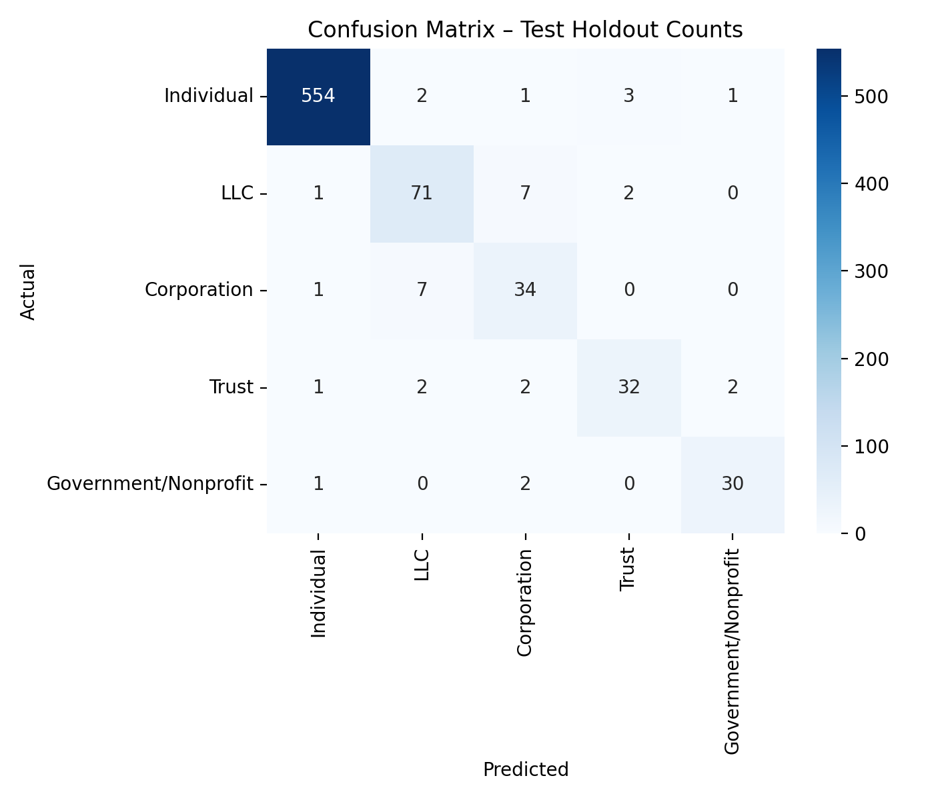
Figure S1. Confusion Matrix for the BERT model
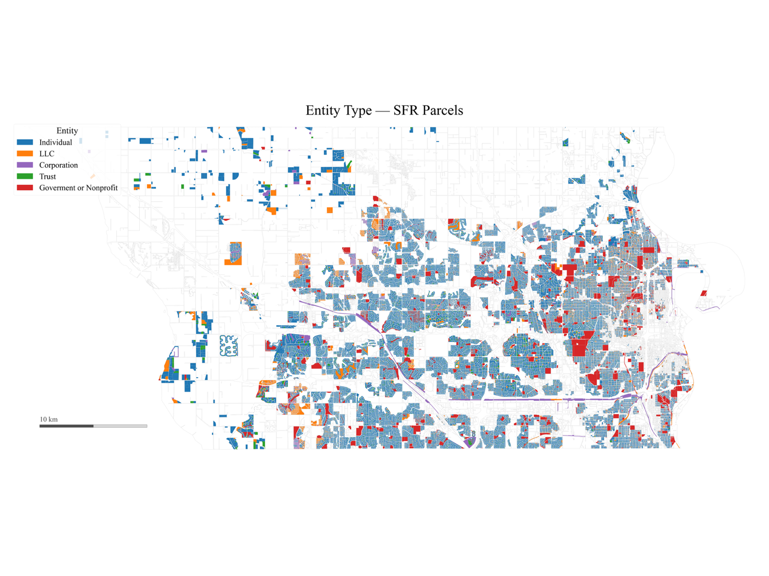
Figure S2. Map of Douglas County Single Family Residential Parcels by Entity Type
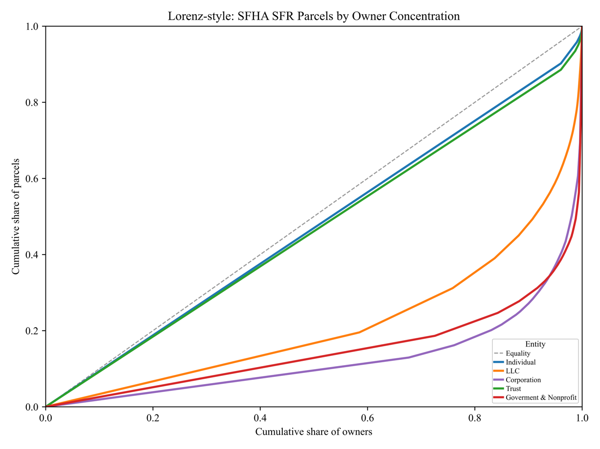
Figure S3. Concentration of single family SFHA‑located parcels by organizational form
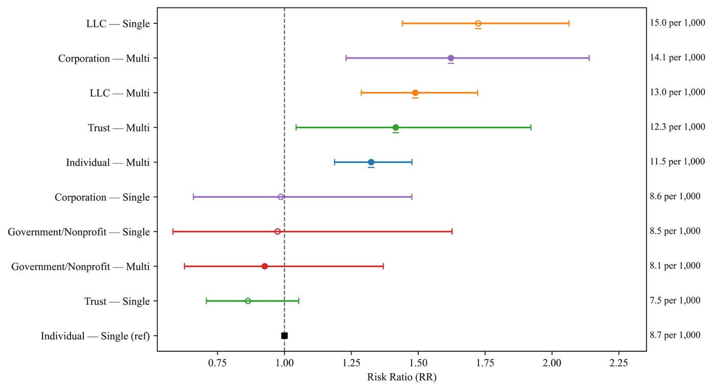
Figure S4. Adjusted RRs for SFHA Locations by Ownership Structure and Portfolio Size
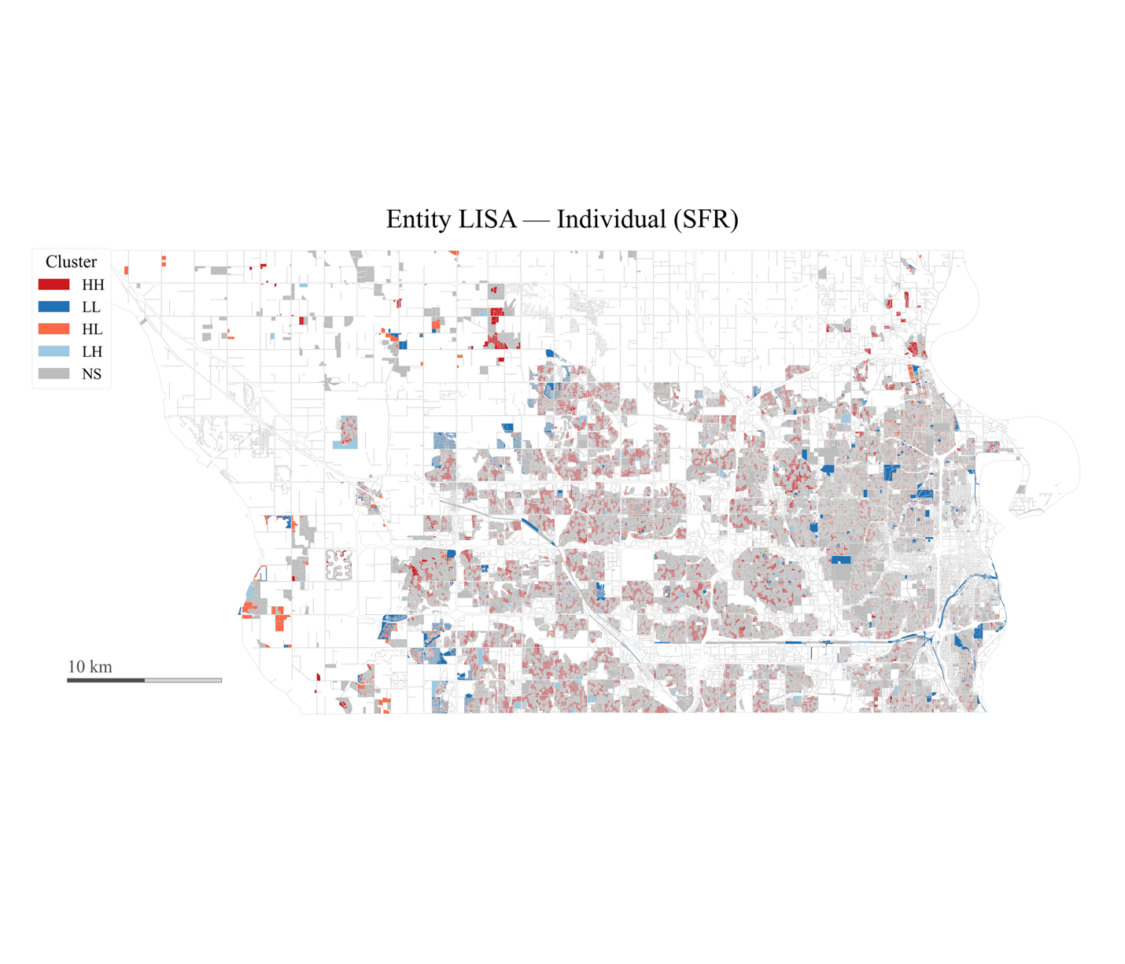
Figure S5. Individual Owner Spatial Clustering by Parcel
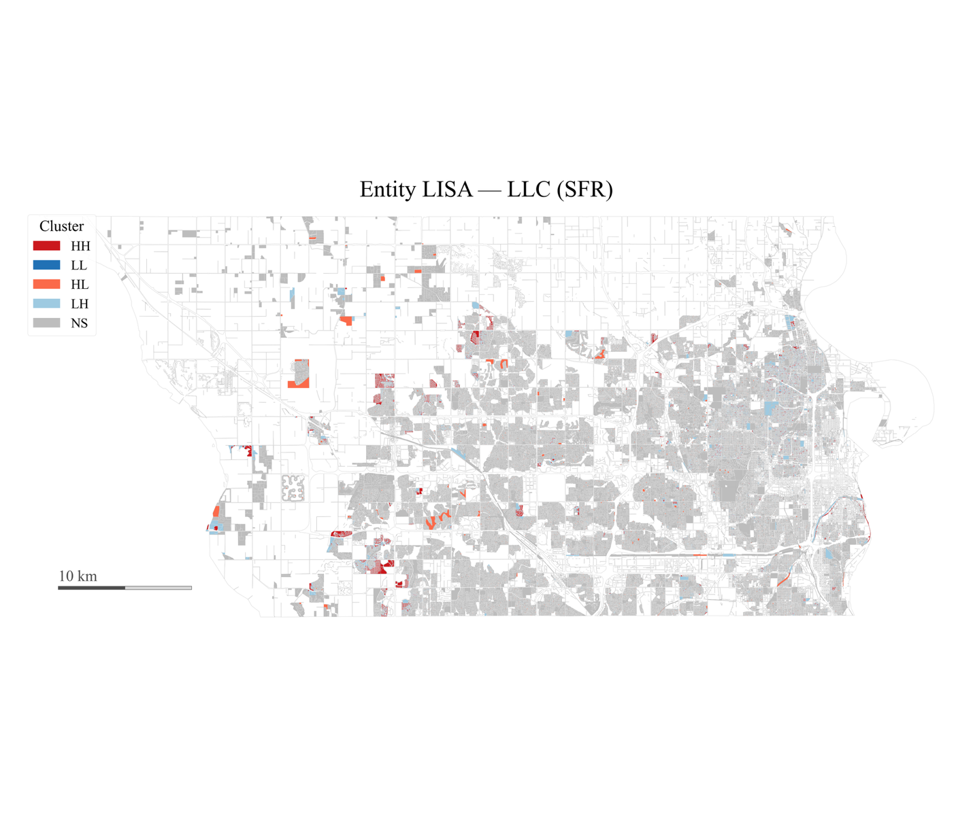
Figure S6. LLC Owners Spatial Clustering (LISA) by Parcel
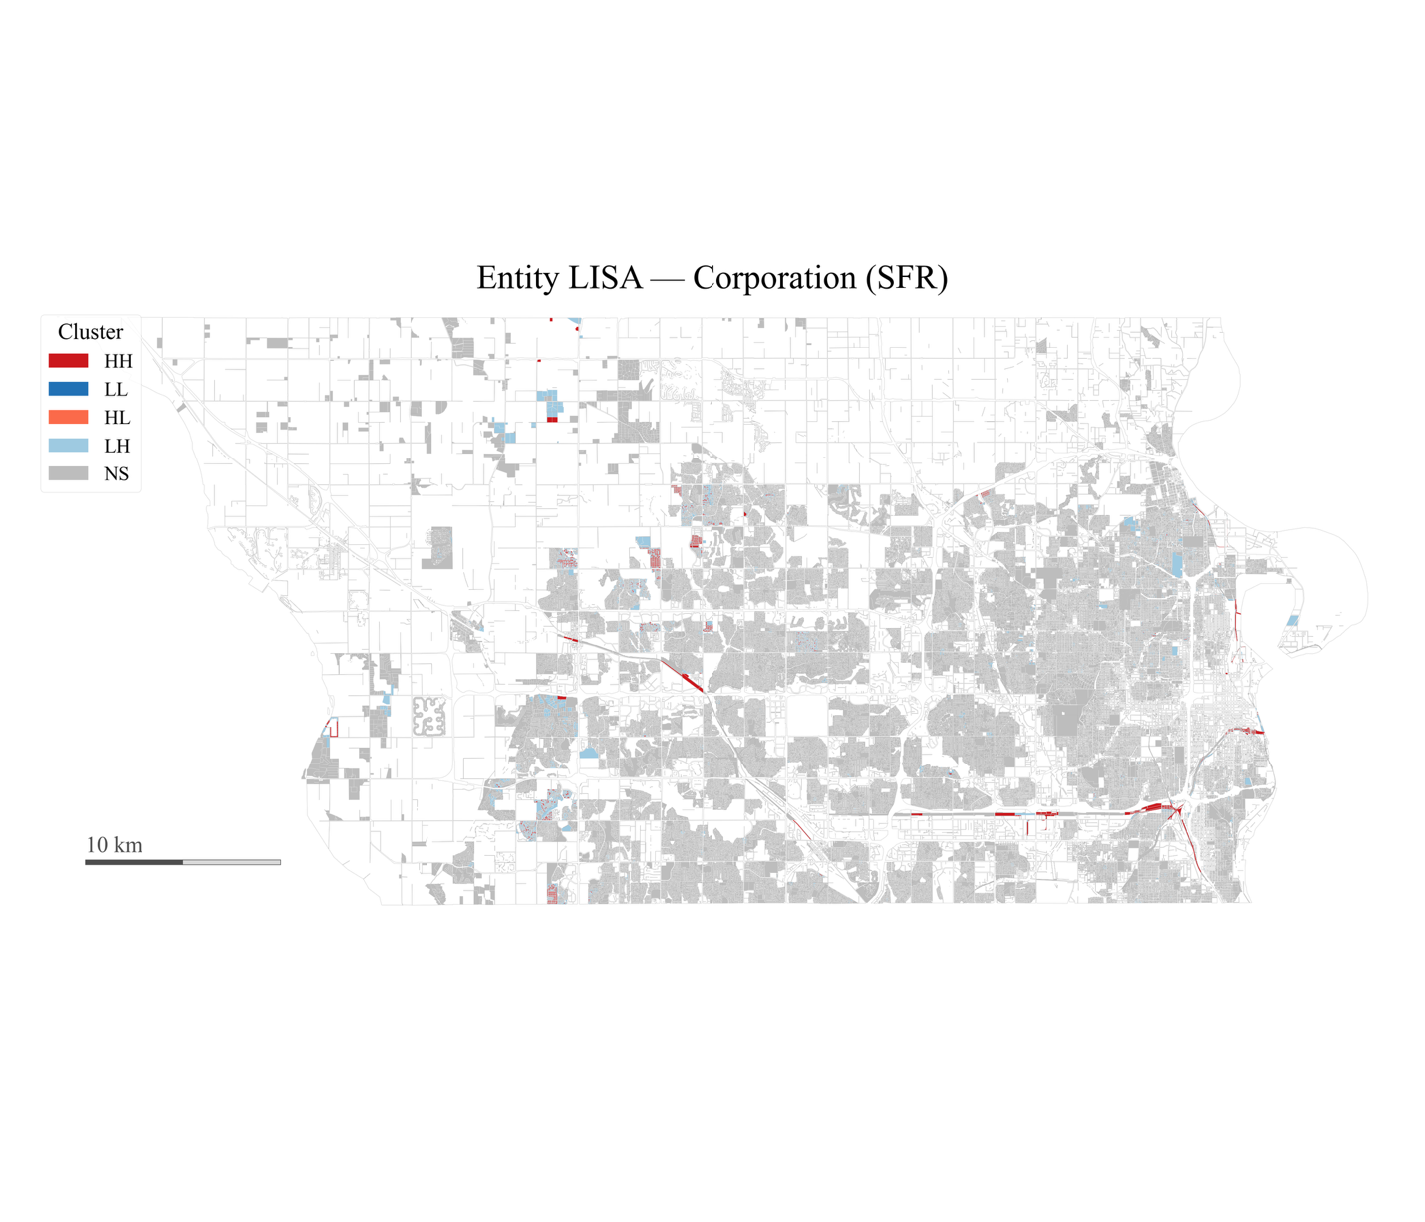

Figure S7. Corporate Owners Spatial Clustering (LISA) by Parcel
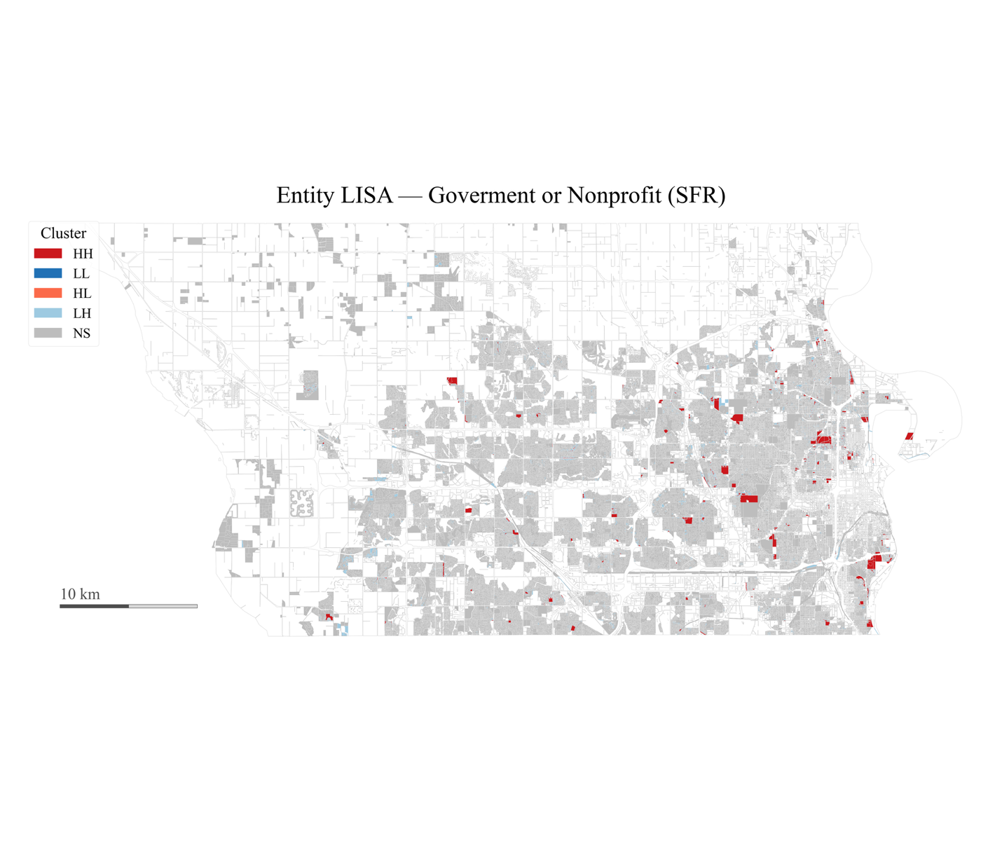

Figure S8. Government/Nonprofit Owners Spatial Clustering (LISA) by Parcel

Table S1: Alignment between clusters and production labels
Method | Clusters | Noise % | Weighted purity (overall) | Weighted purity (nonnoise) | NMI | ARI
Kmeans (K=2) | 2 | 0.00% | 95.1% | 95.1% | 0.806 | 0.955
Kmeans (K=3) | 3 | 0.00% | 98.0% | 98.0% | 0.891 | 0.980
Kmeans (K=4) | 4 | 0.00% | 98.1% | 98.1% | 0.522 | 0.281
Kmeans (K=5) | 5 | 0.00% | 98.4% | 98.4% | 0.882 | 0.968
HDBSCAN (leaf) | 44 | 46.16% | 95.2% | 99.0% | 0.162 | 0.018

Table S2: Kmeans cluster composition by production label
Cluster | Size | Individual | LLC | Trust | Corporation | Gov/Nonprofit | Dominant label | Purity
0 | 143,362 | 143,358 | 4 | 0 | 0 | 0 | Individual | 100.0%
1 | 2,059 | 7 | 924 | 2 | 1,126 | 0 | Corporation | 54.7%
2 | 7,790 | 0 | 7,790 | 0 | 0 | 0 | LLC | 100.0%
3 | 5,482 | 688 | 3 | 4,790 | 0 | 1 | Trust | 87.4%
4 | 1,985 | 92 | 83 | 264 | 1,052 | 494 | Corporation | 53.0%

Appendix Tables
Table S3. Ownership classifier configuration and training
Component | Setting
Base model | BERT base uncased with 5-way Softmax head
Labels emitted | Individual; LLC; Corporation; Trust; Gov/Nonprofit
Training data | 2,520 hand-labeled names (augmented to 5,040)
Loss & regularization | Focal loss; classification-head dropout = 0.20
Model selection | 3-fold CV; early stopping on validation weighted F1
Reliability checks | Probability calibration; stratified human audit
High-confidence rule | p-hat max >= 0.80 used for robustness subset
Deployment scope | 212,310 owner records countywide

Table S4. Production classification coverage and high-confidence shares (countywide)
Owner type | Count | Percent | High-confidence count | High-confidence coverage %
Individual | 162,079 | 76.3 | 161,409 | 99.6
LLC | 29,161 | 13.7 | 27,722 | 95.1
Corporation | 5,588 | 2.6 | 4,169 | 74.6
Trust | 7,006 | 3.3 | 6,844 | 97.7
Gov/Nonprofit | 8,476 | 4.0 | 7,516 | 88.7
Total | 212,310 | 100.0 | 207,660 | 97.8

