Homework 1

John Randis

9/20/2016

a)

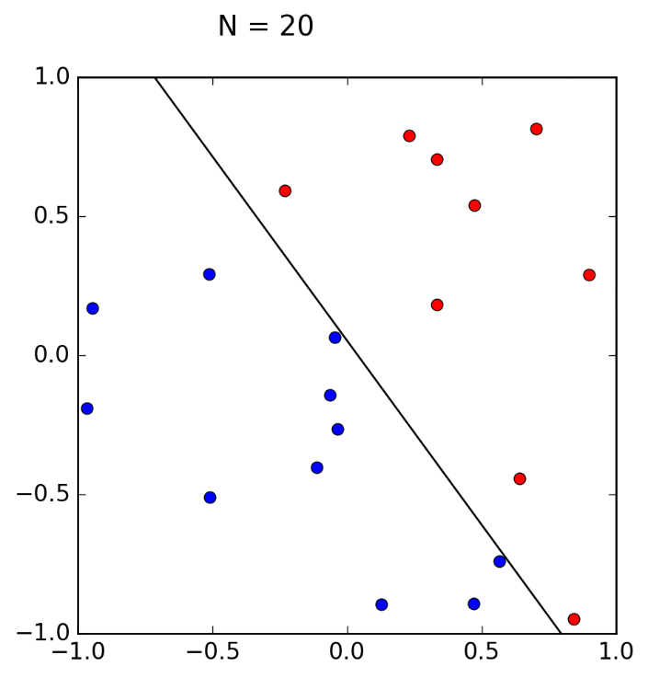

b)

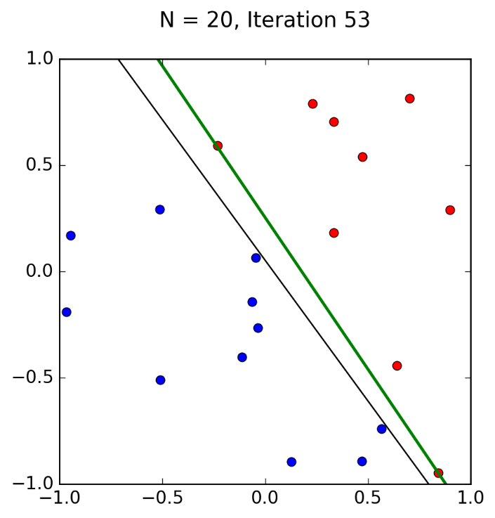

The perceptron learning algorithm took 53 Iterations to find a line that fits. *f* is somewhat close to *g*, but it is still not the best fit line.

c)

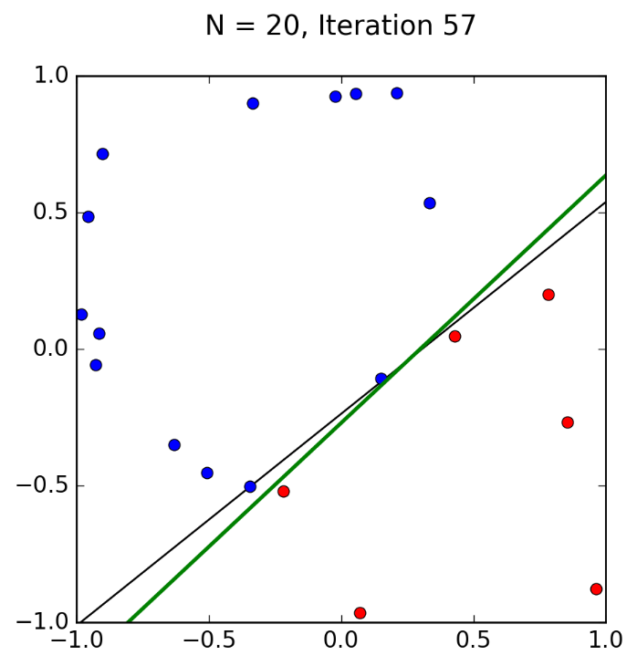

The perceptron learning algorithm took 57 iterations to find a line that fits in another randomly generated data set of 20. This one took about the same amount of iterations as of that in step b, only 4 more.

d)

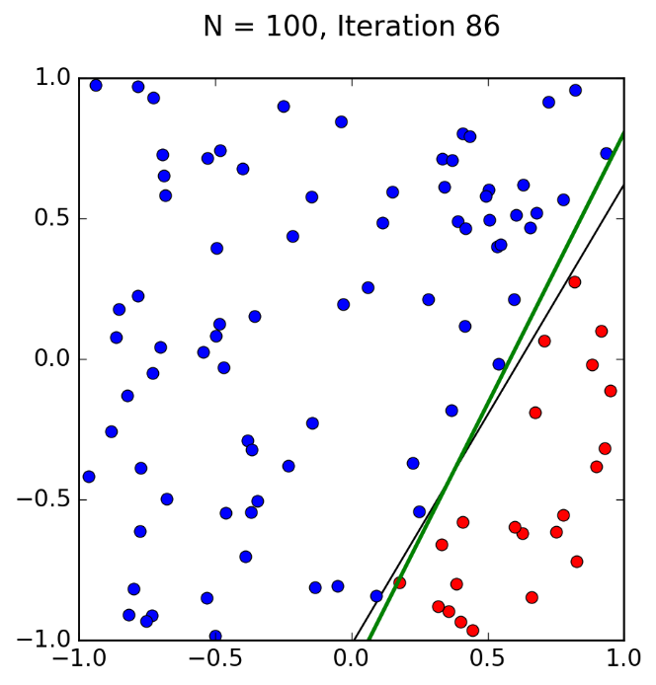

With a randomly generated data set of 100 points, the perceptron learning algorithm took 86 iterations to find a line that fits *f*. This is drastically increased from step b with only 20 data points. The iterations have almost doubled.

e)

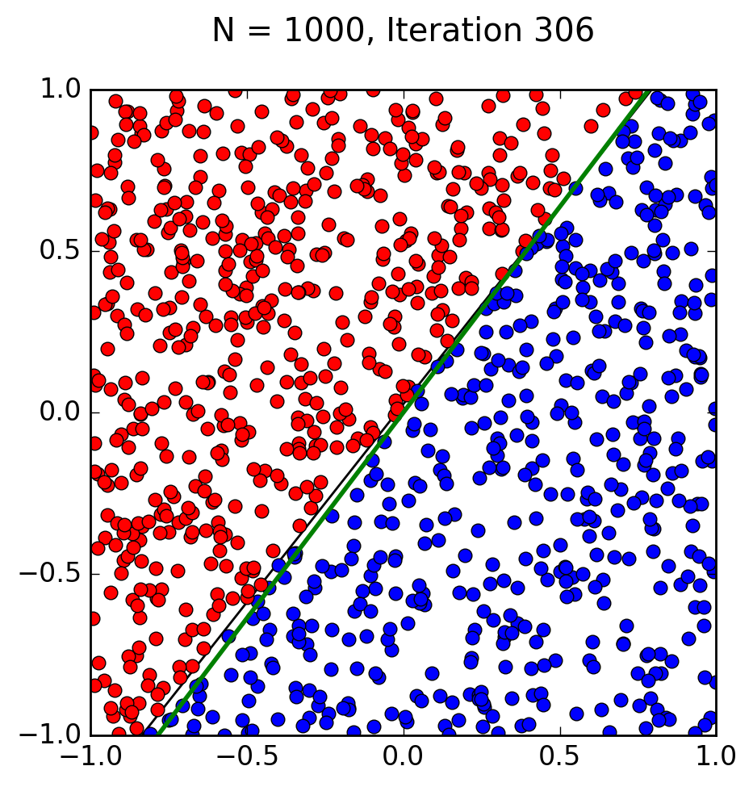

With a randomly generated data set of 1000 points, the perceptron learning algorithm took significantly longer than it would have with only 20, and still significantly more iterations than it did with 100. With 306 iterations, the usefulness of the algorithm definitely drops off once too many data points are introduced.