Homework 2

John Randis

9/27/2016

2.1

a)

b)

c)

2.11

Theorem:

1. N = 100:

The out-of-sample error is less than or equal to 1.043161247 + Ein(g).

1. N = 1000:

The out-of-sample error is less than or equal to.+ Ein(g).

2.12

Theorem: )

3.1

a)

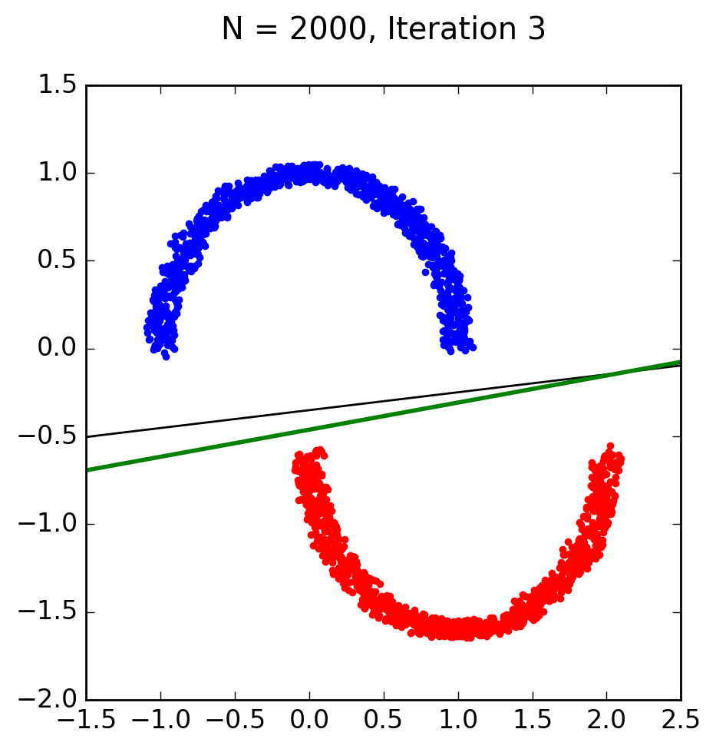

The perceptron learning algorithm took 3 iterations to converge and find the best fit line in between the two semi-circles. w is equal to [-1. 0.33415214 -2.16534827].

b)

Using linear regression, w ends up being [-0.32193933 0.09342563 -0.91802757]. It seemed to run faster than with the perceptron learning algorithm. I find it very interesting that w0 is -1 when using PLA and -0.32193933 when using linear regression. Both w’s fit the data, but they are very different results.