Homework 4

John Randis

11/1/2016

a)

|  |
| --- |
| import numpy as np  from matplotlib import pyplot as plt  def genDataSet(N):  x = np.random.normal(0, 1, N)  ytrue = (np.cos(x) + 2) / (np.cos(x * 1.4) + 2)  noise = np.random.normal(0, 0.2, N)  y = ytrue + noise  return x, y, ytrue  x, y, ytrue = genDataSet(1000)  plt.plot(x, y, '.')  plt.plot(x, ytrue, 'rx')  plt.show() |

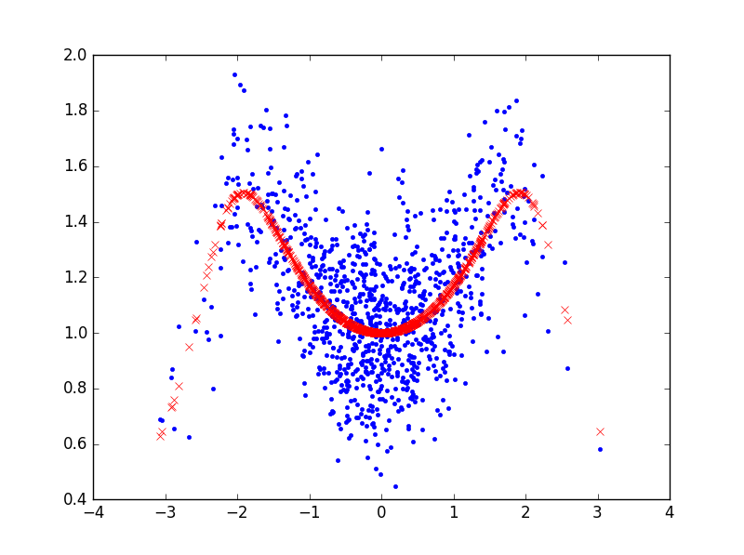

b)

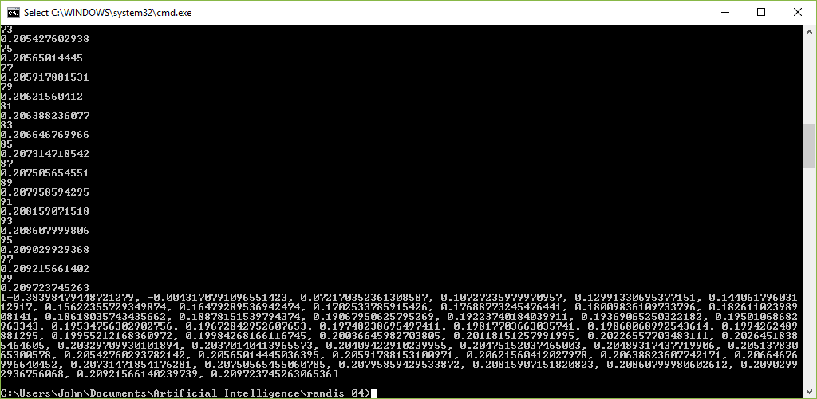

c) After running the nearest neighbors program, the best values for k were: 0.072170352361308587, 0.10727235979970957, and 0.12991330695377151.