Homework 5

John Randis

11/15/2016

1.

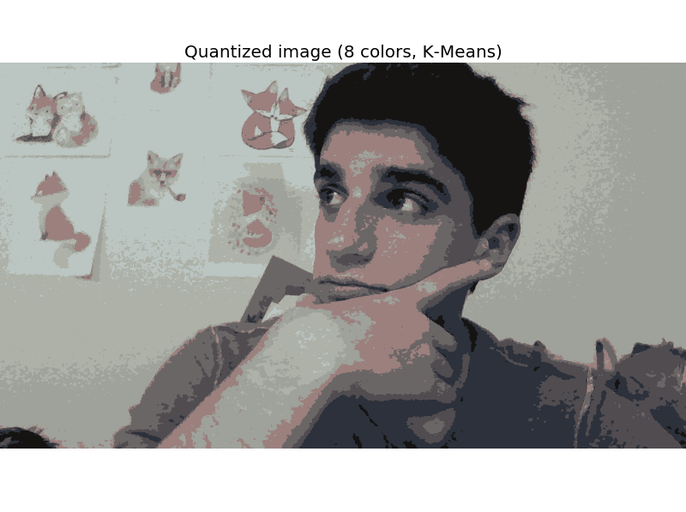

1. Increasing the value of n_colors will add more colors to the image. Decreasing the value of n_colors will remove colors from the image by finding the most common occurences of a given color and averaging nearby pixels together.
2. This is probably most useful in compression algorithms in order to make file sizes smaller and easier to transfer. Less colors = smaller file size.
3. I’m generally pretty funny looking so less colors make it even moreso. Also the foxes in the background are pretty cute.

2.

1. The best number of neurons is 35. The best value for eta is 0.2.
2. What is happening is that the neurons in the hidden layer are working to determine the best fit line for the given data set. The hidden layer gives the perceptron the power to find a model with a specified training rate in order to accommodate the data, but not overfit it.