Final Exam

John Randis

12/16/2016

1. After running the sinc program, the hyperparamers that I ended up with were as follows:

The best value for C was 8.0

The best value for epsilon was 0.0

The best value for gamma was 0.5

*C* is the parameter that represents the penalty factor of the support vector machine. If *C* is too large, there could be overfitting while a *C* that is too small could lead to unwanted training errors.

The epsilon value more or less controls the complexity of the support vector machine. A higher *e* means reduction in requirements. Since epsilon is 0 in this case, that means there is no penalty associated with the training loss function.

The gamma parameter defines the influence of a single training parameter. A gamma value of 0.5 is very large. This means that the radius of the support vectors in this example is very large and they extend a lot of influence

1. After running the digits program, the hyperparamers that I ended up with were as follows:

The best value for C was 4096.0

The best value for epsilon was 2.5

The best value for gamma was 0.25

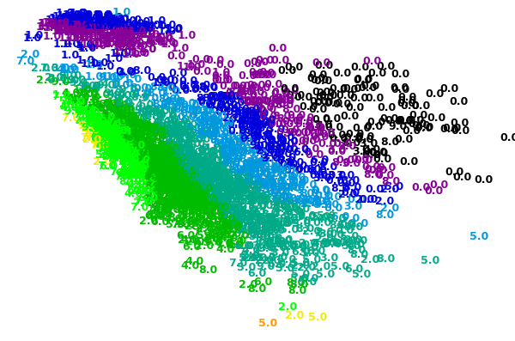

The plot definitely produced some interesting results. There is a large clump of data separate from the rest in the top left. Many of the 0’s on the right seem to be very dispersed. Whereas the digits seem to get more densely packed as you move towards the left. This is definitely reflective of the hyperparameters which were chosen.

In this run through, the penalty parameter is much greater this time. The *C* valueis 4096. This is a pretty strict C value, but gives the model more freedom to select more samples as support vectors.

The best epsilon value was 2.5. Since this is a larger value the number of support vectors is decreased, conversely to how *C* affects the model.

The best gamma value ended up being 0.25. This means that each support vector has less influence, which makes sense as this compensates for more support vectors in the model. We would not want give them all too much influence. It is clear how all of these hyperparamers relate and work together to best fit the model.